Data Exchange Toolkit – Stage 2
  - Commonwealth Home Support Program


- Introduction

About this Toolkit
This toolkit provides information and guidance for Commonwealth Home Support Program (CHSP) providers about the changes to their Data Exchange (DEX) reporting requirements that are being implemented in the Stage 2 release from January 2026.
This toolkit only applies to Stage 2 of the DEX changes.
This is version 1.0 published November 2025. To ensure you are using the latest version of this document, regularly check the CHSP Resources web page.
The Stage 1 toolkit will remain available on the CHSP Resources web page for the remainder of 2025-26.

Staged implementation of DEX changes
The development and implementation of the necessary Information and Communication Technology (ICT) changes to DEX will occur in multiple stages.
Stage | Timeline | Reporting Change | Details
Stage 1 | 1 July 2025 | Service Type (recorded in DEX as Program Activity) | - Service delivery against the Activity Work Plan aligned to the new CHSP Service List.  - New service type ‘Therapeutic services for independent living’ included in DEX Program Activity list.  - Specialised support services required to report cost and time.  - Home modifications have new sub-items to select from.
 |  | My Aged Care ID  (MAC ID) | - Providers need to record their client’s MAC ID information in their own client management systems for all services delivered from 1 July 2025.
Stage 2 | January 2026 | MAC ID | - All My Aged Care (MAC) ID information, collected by providers in their own systems during Stage 1, is required to be reported into the new MAC ID fields in the client record in DEX.  - Due to resourcing requirements, the fields will be opened (go ‘live’) in mid-December. While providers will be able to access the fields in December, providers are not required to begin populating the fields until after 1 January 2026.
Stage 3 | Mid-2026 | Service specific information | - Additional session-level data fields for more detailed reporting.  - Fields to assist in identifying hidden costs of delivery.
 |  | Social engagement | - Additional metrics to capture the extra benefits provided in particular delivery models for Meal delivery and Transport.

Why is client MAC ID now required to be provided in DEX?
With the governance of CHSP transitioning to the Aged Care Act 2024 (the Act), from 1 November 2025:
- All Commonwealth Home Support Program (CHSP) clients must be registered with My Aged Care, have an assessment and be approved to access CHSP services.
- Under the Act (subsection 265(2), Commonwealth aged care funding can only be used to deliver services to people who have been approved for the service or service type.
- It is a statutory funding condition that CHSP registered providers deliver funded aged care services to clients who have been assessed and approved to access the services (section 267 of the Act).
CHSP registered providers must ensure that funded CHSP aged care services they deliver are only delivered to clients who have had an aged care assessment and are approved to access the particular CHSP service(s) or service type(s) identified in their approval record.
CHSP Financial reporting now includes a statement of compliance that Commonwealth funds have been spent on eligible assessed clients.
To streamline the process for CHSP providers to demonstrate that their CHSP funding is only being used to support approved clients, providers will include the client’s My Aged Care ID (MAC ID) in their DEX client record. This will allow the department to cross reference the approval data for that client with the actual service delivery received to confirm your organisation is meeting these requirements.

Reporting of MAC IDs is compulsory
Compliance action may be taken with providers that deliver services to clients who do not have the correct approvals, which may include recovery of CHSP funds spent on non-approved clients.
Recording the MAC ID in a client’s profile is not subject to client consent as it is required to monitor provider compliance (refer to Chapter 5 of the CHSP Data Exchange Protocols for further information on client consent in DEX).
The department has previously communicated the requirement for CHSP Providers to ensure they are capturing client My Aged Care IDs in their own client management systems from 1 July 2025. Accordingly, providers are expected to have this information available to input into DEX once these new fields are available (expected to be live in December 2025 for January 2026 reporting).
However, given the compressed timeframe for providers and software vendors to implement the required changes to collect client My Aged Care IDs in DEX, the Stage 2 changes will initially be implemented as non-mandatory (optional) fields.
These fields will be made mandatory from mid-2026 onwards, with specific timing to be confirmed by the department at a later date.
Providers should have all MAC ID information for existing clients saved in DEX as early as possible during the non-mandatory phase, so there will only be a need to add MAC IDs to new client records when the fields become mandatory.

DEX for CHSP - General information
CHSP service providers must continue to provide activity and performance data in line with their CHSP Grant Agreement and Activity Work Plan. Monthly performance reports containing client and service delivery information are submitted via DEX in accordance with the CHSP DEX Protocols and Program Specific Guidance.
- Refer to the Data Exchange Toolkit - Stage 1 for information about using DEX for CHSP.
- Refer to the DEX Training Resources for general assistance in using DEX.
- Please refer to the Commonwealth Home Support Program (CHSP) Manual for an overview of the CHSP service types and requirements for delivering those services.

2. What providers need to do to prepare for Stage 2 changes

Collection of My Aged Care CHSP Client IDs (MAC ID)
During Stage 1 (from 1 July 2025) Providers have been required to collect their client’s My Aged Care IDs in their own client management systems. Stage 2 enables the recording of the MAC ID in the clients’ DEX Client record.

Prerequisites
Providers must have successfully completed the implementation of CHSP Stage 1 DEX changes into their monthly reporting (refer to the Stage 1 toolkit for further information).
- All clients who have received at least one session of CHSP service delivery from 1 July 2025 onward must have an up-to-date client record in DEX.
- All sessions of CHSP service delivery completed since 1 July 2025 must have an accurate and completed session record in DEX.
- All session records must be assigned to the correct program activity case in DEX.

Actions for Providers
Providers who use the DEX User Portal:
- Familiarise relevant staff with the changes to the client record in DEX.
- Ensure you understand the processes to both update existing client records and include the MAC ID in new client records.
Providers who use bulk XML upload or system-to-system transfers:
- Ensure a copy of this document is provided to your organisation’s relevant team and/or third-party vendor.
- Your systems will need to prepare XML files or data transfers that align with the new client record profiles.
- Organisations are responsible for downloading the updated reference data from the DEX Resources website when it is published.

The Stage 2 testing/staging environment
Providers who do not currently use the staging environment are not required to use it. This toolkit contains the information required and will be updated and broadcast whenever changes are made prior to the official rollout of the MAC ID functionality.
The Stage 2 changes will be released into the DEX Staging Environment from 27 October 2025 and be available for review using existing staging environment credentials.
The updated staging environment Bulk file upload technical specifications and the Web Services Technical Specifications were made available in DEX Resources on 28 October 2025, allowing software providers who develop solutions for the XML file upload method and/or system-to-system upload method to get an indication of the changes to the client record configuration.
Existing users of the DEX Staging environment may see the release available earlier. This is to allow the department to conduct initial testing. All settings within the staging environment are subject to change based on feedback and error identification, so providers and vendors should keep up to date with any advice sent via DEX Swift Digital or departmental communications.
To support software developers and ICT staff with development and testing of these new fields, in the staging environment some service types are set to optional and some to mandatory, to enable testing of both sets of functionalities.
The following Program Activities, in the staging environment, will reflect a final (mandatory) field (however will be ‘optional’ non-mandatory on go live):
- Domestic assistance
- Group social support
- Home or community general respite.
For these Program Activities, test data will not upload successfully unless all clients have a response to the MAC ID questions.
The remaining Program Activities will reflect the initial (non-mandatory) field in both the staging and production environment:
- Allied health and therapy services
- Community cottage respite
- Equipment and products
- Hoarding and squalor assistance
- Home adjustments
- Home maintenance and repairs
- Individual social support
- Meal delivery
- Meal preparation
- Nursing care
- Personal care
- Specialised support services
- Therapeutic services for independent living
- Transport.

3. Stage 2 DEX changes for CHSP

New DEX fields

Two new fields are being added to the Client profile record in DEX
As the client record is linked to the session records in DEX, you only need to update the client record once, and the reporting application(s) will link the record to all the sessions and cases the client is attached to.

Field One - Is the client registered for My Aged Care (MAC)?
A Yes/No field to confirm if the client is registered in the My Aged Care system.

Field Two - Enter MAC ID
An Alphanumeric field to input the unique My Aged Care identifier for the CHSP client. The field will only be accessible when field one has a “Yes” response.
The MAC ID will only be accepted in the following format “ACNNNNNNNN” i.e. you must include the “AC” and the eight (8) numerical digits to be a valid entry, for example “AC12345678”.
What if my clients are still waiting for their Aged Care Assessment?
For existing clients still going through the My Aged Care registration and approval process (i.e. “unregistered clients”) you should include the client’s MAC ID in their DEX Client record as soon as it is provided to your organisation.
The department will source the most up to date status for the client in aged care records at the time of review.

Keeping MAC IDs secure in DEX
To minimise the risk of adverse privacy impacts to clients the MAC ID will be managed in DEX in the following ways:
- The full MAC ID will not be visible in DEX. Once submitted to DEX as part of a client record, the MAC ID will be encrypted before being saved in the DEX database.
- DEX will not be linked to any of the department’s online aged care records systems (e.g. MAC Portal, GPMS).
- o This means that DEX will only validate the format of the MAC ID entered
- (i.e. AC12345678) and will not “check” if it is the correct MAC ID for that client.
- When the DEX data is transmitted to the department, it will be sent to an offline database where the data will be decrypted using decryption keys provided in a separate transmission.
If the encryption of the MAC ID fails, an error message will appear:
“Technical error, please try later”
Providers should exit from the record they were updating and logout of DEX.
A further attempt can be made next time you login.
This error message will automatically trigger an email to the DEX Helpdesk who will investigate and contact your organisation if they see it has not resolved.

Including the MAC ID in the Client record – using the XML file upload or system-to-system upload methods
Validation rule | Error message
MAC ID format validation “ACNNNNNNNN” | “Entered MAC ID format is incorrect. Please re-enter.”
Client registered for MAC ID is ‘No’ or empty and MAC ID field has a value and format validated. | “MAC ID provided cannot be saved as the client MAC registration status field is no or empty. Please verify client registration status.”
MAC ID Encryption failure | “Technical error, please try later.”
As the Client record will introduce the new fields for MAC ID, there will be a DEX schema change. Updated Bulk file upload technical specifications and Web Services Technical Specifications for the production environment will be available in DEX Resources from early December 2025.
Software providers who develop solutions for the XML file upload method and/or system-to-system upload method will be able to get an indication of the changes to the client record configuration in the DEX Staging Environment using their existing credentials from 28 October 2025.
For System-to-System upload method: please note that the GetClient web service will only be able to retrieve the last three digits of the MAC ID due to the encryption process.

DSS DEX Client Record – Location of new MAC ID fields
- Bulk file upload: the elements are added to the bottom of the XML client node.
- System-to-system (UpdateClient) the fields are included after NDISEligibilityCode.

Including the MAC ID in the Client record – using the DEX User Portal interface
The two new fields have been added to the bottom of the Program specific client details section of the Client record.
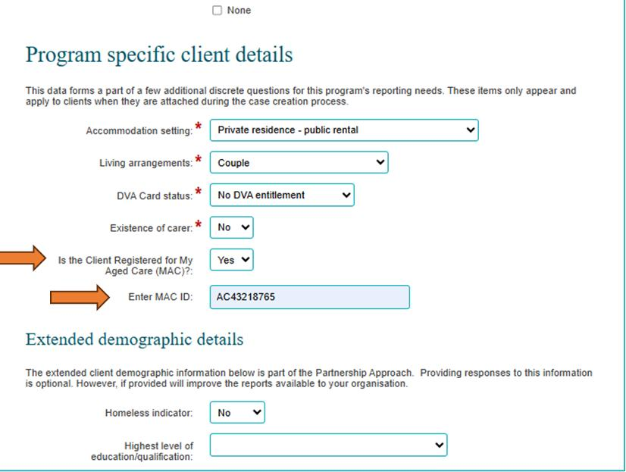

Existing CHSP clients
The method to find and edit an existing client remains the same. Please refer to the “Find and edit a client” task card on the DEX resources webpage.
Once the “Edit client details” screen is open, the MAC ID details need to be included in the “Program specific client details” section.

New CHSP Clients
The method to add a new client remains the same. Please refer to the “Add a client” task card on the DEX resources webpage. The client record should then be attached to a CHSP program activity Case, which will trigger the requirement to open and edit the client details screen to include the “Program specific client details.”

Edit client details
- On first viewing, only the first field will be visible, and it will be blank.
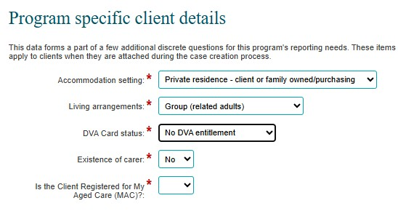

- You must select an option in the dropdown (Yes or No)
- A ‘Yes’ response will trigger the display of the second field to enter the MAC ID.
- If the first field is ‘Yes’ you must enter a MAC ID into the second field, it will not save the update with the MAC ID field blank.
- If the first field is ‘No’ the field for entering the MAC ID will not be visible.
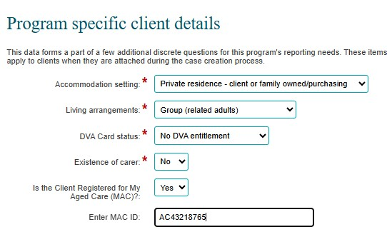

- When you click “SAVE” the MAC ID field will show an encrypted version, with only the last three (3) digits visible, to demonstrate the record has saved correctly.
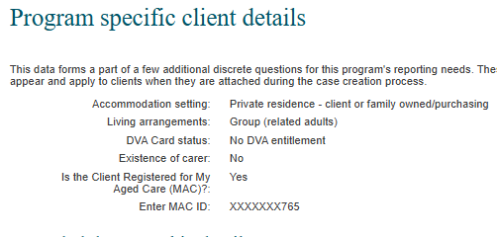

Further information

DEX Helpdesk
Providers or software vendors who have questions or require support for technical DEX issues can seek this through a user-friendly online contact form or via email. The DEX Helpdesk team will make outbound calls as required in response to these requests.
For more information on how to seek DEX support, please visit the Contact us | Data Exchange webpage.

Funding Arrangement Manager (FAM)
Providers should contact their FAM in the first instance for any Funding Agreement related enquiries. Details for state specific enquiries can be found here.
Improving Australia’s aged care system
The Australian Government has delivered major changes to improve aged care.
Visit health.gov.au/aged-care-reforms
Phone 1800 200 422 (My Aged Care’s free-call phone line)
For translating and interpreting services, call 131 450 and ask for 1800 318 209.
To use the National Relay Service, visit nrschat.nrscall.gov.au/nrs to choose your preferred access point on their website, or call the NRS Helpdesk on 1800 555 660.

