  As of 15 November 2025 | Pfizer (COMIRNATY) LP.8.1  6 months – <5 years  3 mcg/0.3 mL  concentrated suspension for injection multi-dose vial  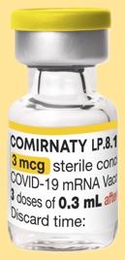 | Pfizer (COMIRNATY) LP.8.1  5 – <12 years  10 mcg/0.3 mL  suspension for injection single-dose vial  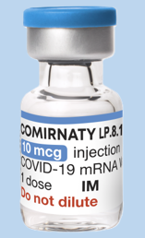 | Pfizer (COMIRNATY) LP.8.1  12 years+  30 mcg/0.3 mL  suspension for injection single-dose glass prefilled syringes  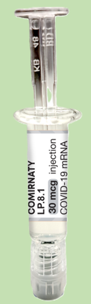
CVAS naming convention | Pfizer (LP.8.1) 6 months – <5 years (Yellow) | Pfizer (LP.8.1) 5 – <12 years (Light Blue) | Pfizer (LP.8.1) 12 years+ (PFS)
Vaccine type | mRNA (nucleic acid) | mRNA (nucleic acid) | mRNA (nucleic acid)
Approved age | 6 months – <5 years | 5 – <12 years | 12 years and older
Dose volume | 0.3 mL | 0.3 mL | 0.3mL
Doses per vial | 3 | 1 | 1
Dilution required | Yes (1.1 mL) | No | No
ULT freezer storage time | 18 months (shelf life) at -90°C to -60°C | 18 months (shelf life) at -90°C to -60°C | DO NOT STORE
Freezer storage time (unopened) | DO NOT STORE at -25°C to -15°C | DO NOT STORE at -25°C to -15°C | DO NOT FREEZE
Refrigeration storage time (unopened)¹ | 10 weeks (+2°C to +8°C) within the 18-month shelf life | 10 weeks (+2°C to +8°C) within the 18-month shelf life | Expiry date printed on the carton and syringe label
Room temperature storage time (unopened) | 24 hours pre- and post- dilution (up to +30°C) | 24 hours pre- and post-initial puncture (up to +30°C) | 12 hours (up to +30°C)
Storing opened vials | 6 hours (up to +30°C) | 6 hours (up to +30°C) | NA
Storing pre-drawn doses | 1 hour (up to +30°C) or 6 hours (+2°C to +8°C) | 1 hour (up to +30°C) or 6 hours (+2°C to +8°C) | NA
TGA Product Information (PI) and Consumer Medicine Information (CMI) | PI  CMI | PI  CMI | PI  CMI
Notes:
For the latest information on COVID-19 primary course and additional doses advise, please refer to the Australian Immunisation Handbook:
- All adults aged 18 years and over are recommended a single primary dose. Children and adolescents aged under 18 years are not routinely recommended a primary dose.
- People with severe immunocompromise conditions, who are over 6 months of age or older are recommended 2 primary doses and are eligible for a 3rd primary dose based on an individual risk-benefit assessment.
- Infants, children and adolescents aged 6 months to <18 years with conditions other than severe immunocompromise that may increase the risk of severe COVID-19 are eligible for primary dose(s) based on a risk benefit assessment.
If vaccines are stored or handled outside the conditions listed, complete the Cold Chain Breach (CCB) reporting form and email it to the Vaccine Operations Centre (VOC) COVID19VaccineOperationsCentre@health.gov.au.
It is mandatory under the Australian Immunisation Register Act 2015 for vaccination providers to report all vaccinations administered in Australia to the AIR. For more information, please visit Advice for COVID-19 vaccine providers and administrators.
Images © 2025 Pfizer Inc. All rights reserved.

