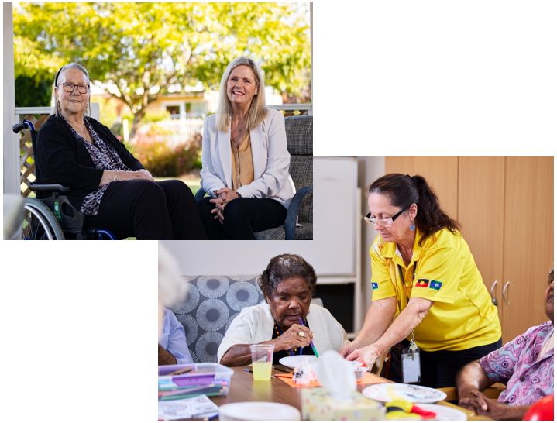

Volunteering in Aged care and the Aged Care Volunteer Visitors Scheme (ACVVS)
health.gov.au/topics/aged-care/volunteers 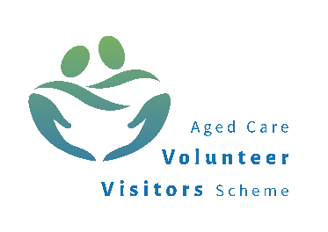

Contents
About volunteering in aged care 3
Support and training for aged care volunteers 6
Case studies: aged care volunteering 8
Information for providers and Volunteer Managers 10
Aged Care Volunteer Visitors Scheme 12
ACVVS volunteer visitor stories 15

About volunteering in aged care
Volunteers are an essential part of the aged care system ensuring person-centred quality care meets the individual’s needs. Volunteering in aged care contributes to positive outcomes for the older person such as increased mental health and wellbeing, social connectedness, reduced isolation and supporting ageing in place.
Volunteering is rewarding for volunteers too. They can benefit from meeting new people, learning new skills and contributing positively to the community.
There are two types of volunteers:
Formal volunteers
Formal volunteers in aged care give their time freely by supporting older people in their own or residential aged care home:
- for the common good
- without financial gain.
Informal volunteers
Informal volunteers in aged care do things like:
- help out a neighbour
- care for a family member or friend.
‘Aged care volunteering’ in this booklet refers to formal volunteers in aged care.

What aged care volunteers do
Aged care volunteers can spend their time supporting older people in many ways, not all volunteering opportunities are the same.
You can volunteer in a wide variety of roles such as leisure and social activities, music, arts and craft, entertainment, gardening, transport and meal delivery or simply just having a chat.
Volunteers give support to older people in:
- residential aged care homes
- respite care
- Support at Home services
- support under the Commonwealth Home Support Program (CHSP).
The time commitment varies between roles and aged care providers work with volunteers to find a role that best suits. Roles can be in person or virtual.

Who can volunteer in aged care
Aged care volunteers don’t need any specialist qualifications or experience and anyone with a willingness to help others will be highly valued.

Eligibility and requirements
Each aged care provider has specific requirements for aged care volunteers. Typically, volunteers need to:
- provide evidence of their recent flu and/or COVID-19 vaccination history
- receive a National Police Check or National Disability Insurance Scheme (NDIS) Worker Screening Check, depending on the circumstances.
Some states and territories may require volunteers to also have a Working with Vulnerable People Check.
Volunteers must abide by the Code of Conduct for Aged Care and uphold the Aged Care Statement of Rights.
For more information about eligibility and requirements, visit health.gov.au/topics/aged-care/volunteers/about

How to become an aged care volunteer
There are many different pathways you can take to become an aged care volunteer.

Opportunities in your state or territory
See below or check in with your council for local aged care volunteering opportunities:
Organisations | Website
The Centre for Volunteering (NSW) | volunteering.com.au
Volunteering Victoria | volunteeringvictoria.org.au
Volunteering SA & NT | volunteeringsa-nt.org.au
Volunteering Queensland | volunteeringqld.org.au
Volunteering WA | volunteeringwa.org.au
Volunteering Tasmania | volunteeringtas.org.au
Volunteering ACT | volunteeringact.org.au
GoVolunteer | govolunteer.com.au/volunteering

Organisation | Website
Seek Volunteer | volunteer.com.au/seniors-aged-care-volunteering
Meals on Wheels™ | mealsonwheels.org.au/get-involved/volunteer
Palliative Care NSW | volunteerhub.com.au
Palliative Care Victoria | pallcarevic.asn.au/
Palliative Care QLD | palliativecareqld.org.au/volunteer-village
Palliative Care ACT | pallcareact.org.au/become-a-volunteer
Palliative Care TAS | pallcaretas.org.au/for-volunteers
Palliative Care WA | palliativecarewa.asn.au/volunteering
Dementia Australia | dementia.org.au
LGBTIQ+ Health Australia | lgbtiqhealth.org.au/volunteer

Volunteering with specific providers
Contact aged care providers in your local area to express interest in aged care volunteering. Find your nearest provider and their contact details by visiting myagedcare.gov.au/find-a-provider
Alternatively, if you already know a provider in your area you can contact them directly.

The Aged Care Volunteer Visitors Scheme (ACVVS)
ACVVS is a life-changing program that supports regular volunteer visits to give friendship and companionship to older people. You can become a volunteer visitor through the ACVVS by visiting health.gov.au/our-work/ aged-care-volunteer-visitors-scheme-acvvs/volunteer
Turn to 11 of this booklet to learn more about this heart-warming program.

Support and training for aged care volunteers
Volunteers will be supported and trained by the aged care provider they volunteer with.

What to expect
Volunteers are given training and support from their provider and Volunteer Manager. When you become an aged care volunteer, you should receive:
- appropriate volunteer insurance cover
- induction and training in line with your role
- respect for your involvement
- the ability to provide feedback
- a warm welcome and encouragement
- on-site supervision and access to a Volunteer Manager.

Training
To ensure the safety, dignity and respect of older people, volunteers are encouraged to undertake training so they feel confident in their role.
The new legal and regulatory requirements in aged care mean registered providers need to provide volunteers with suitable training and support to help you undertake your volunteer role confidently and safely and protect older people in aged care.
The department is currently consulting with the aged care volunteer sector, to ensure safety, quality, and consistency in volunteer involvement across aged care services in alignment with the rights of older people.
You can also access a collection of suggested free, publicly available training resources that you can use for volunteer training. Use of these resources is entirely optional. Topics you can choose from include:
- Aged care basics
- Communication skills
- Understanding older peoples unique needs and preferences
- Looking out for older people
Visit health.gov.au/topics/aged-care/volunteers/support-and-training for more information about volunteer training.

Pathways into a career in aged care
You may be considering a transition from volunteering to a career in the aged care sector. Learn more about careers in aged care, formal qualifications and available training programs by visiting health.gov.au/topics/aged-care-workforce
You can also find other resources that may help you with the transition at health.gov.au/topics/aged-care/volunteers/support-and-training
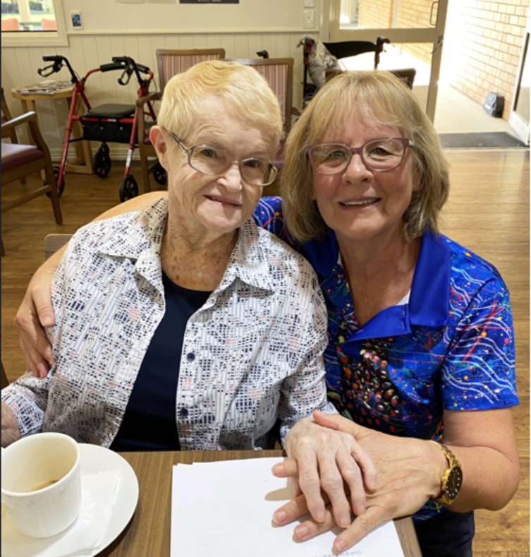

Case studies: aged care volunteering
If you want to see what volunteering in aged care is really like, you can check out:
case studies at health.gov.au/topics/aged-care/volunteers/volunteer-stories

Kevin: Volunteering for Connection: Supporting Men’s Wellbeing in Residential Aged Care
When chronic pain ended Kevin James’ nursing career, he faced isolation and depression.
But volunteering gave him a new mission – to bring social connection and camaraderie to men in aged care.
At Bolton Clarke’s Cazna Gardens in Brisbane, Kevin leads weekly round-table sessions
where older men share stories, laugh, and connect. “It’s a safe space where men open up. The connection benefits everyone.”
Now Secretary of Circle of Men Inc., Kevin helps coordinate volunteers across 16 aged
care homes, handling everything from compliance to recruitment.
“Volunteering gave me back my purpose. It’s uplifting and mentally rewarding,” Kevin shares.
His message to others: “Just show up. You’ll be amazed at the difference you can make.”
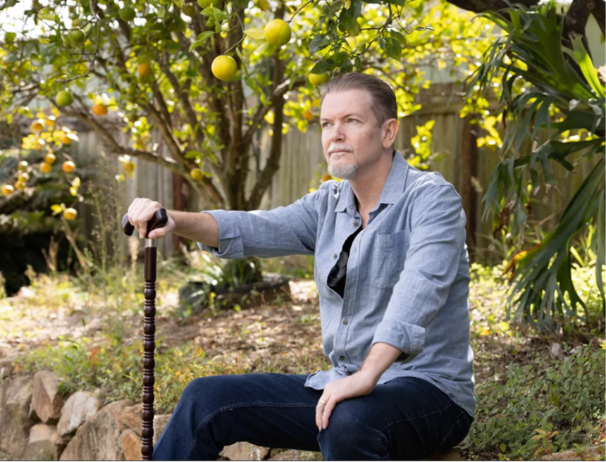

Cherry: The benefits of volunteering as an international student
Cherry began volunteering at Benetas Broughton Hall during the university break, hoping
to learn more about Australian culture while giving back.
“I loved seeing the residents’ happy faces when they recognised me,” she says. “I heard
incredible life stories and formed precious bonds.”
Cherry helped with morning walks, games, tea service, and chats – building friendships and
gaining valuable experience.
“As an international student, volunteering helped me feel less lonely and more connected.
I learned so much from the residents’ wisdom.”
She also gained skills in supporting people with dementia.
“It’s a meaningful experience I’d recommend to anyone – especially fellow students.”


Information for providers and Volunteer Managers
Volunteer Managers are essential for volunteers in aged care and are responsible for overseeing volunteer activities within an organisation.
It is important that providers and Volunteer Managers understand how to best engage volunteers to support older people receiving aged care services. There are a variety of resources available to support you at health.gov.au/topics/aged-care/volunteers.

Recruiting aged care volunteers
Volunteer programs are most effective when they are well-planned and resourced. Planning will involve:
- being aware of any existing volunteer programs in your region and how they can complement each other.
- understanding the regulatory requirements that apply to volunteers, including the Aged Care Quality Standards, the Code of Conduct for Aged Care, and privacy laws.
- designing volunteer roles with the demographics, diversity and needs of your organisation, older person and volunteering mind.
- resourcing and budgeting for volunteer management and retention activities.
You can find further details on how to plan for volunteer engagement by visiting health.gov.au/topics/aged-care/volunteers/provider-requirements-and-responsibilities

Expectations and requirements
Aged care providers need to ensure that volunteers are:
- covered by appropriate volunteer insurance
- given an induction and role specific training
- given access to a Volunteer Manager
- treated with respect and are valued
- able to provide feedback to the organisation
- welcomed and encouraged.
For more information, visit health.gov. au/topics/aged-are/volunteers/provider-requirements-and responsibilities

Training and support for providers and Volunteer Managers
Training is available from the Aged Care Quality and Safety Commission for Volunteer Managers on the:
- Code of Conduct for Aged Care
- Serious Incident Response Scheme
- Aged Care Quality and Safety Commission’s complaints handling processes.
You can access this training by visiting agedcarequality.gov.au/resource-library/ volunteers-aged-care
You can also check out the Volunteer Manager handbook by visiting health.gov.au/resources/publications/managing-volunteers-in-aged-care-guidance-handbook-for-volunteer-managers.
This includes a collection of free, publicly available resources that you can use for Volunteer Manager training, covering:
- recruitment
- onboarding
- retention
- administration
- the aged care volunteering landscape.
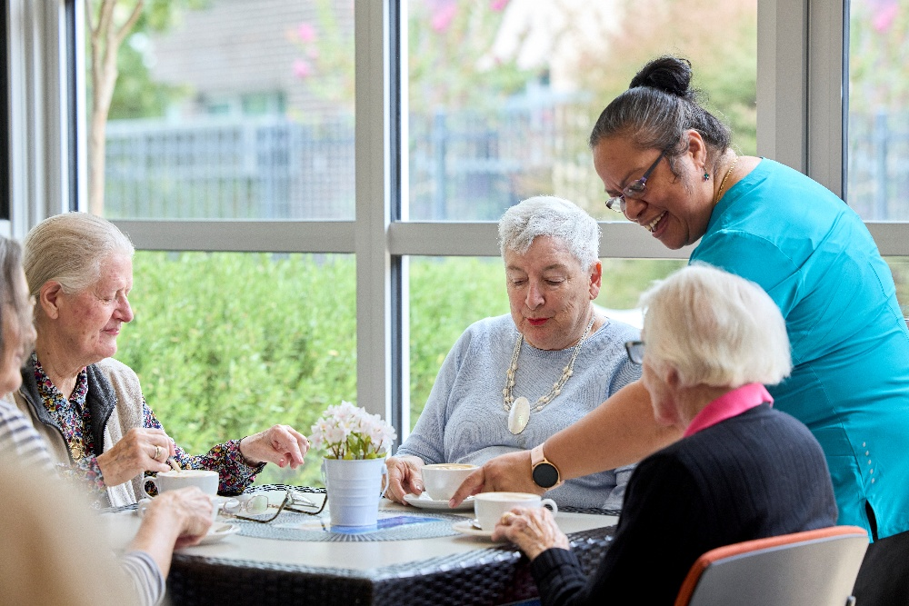

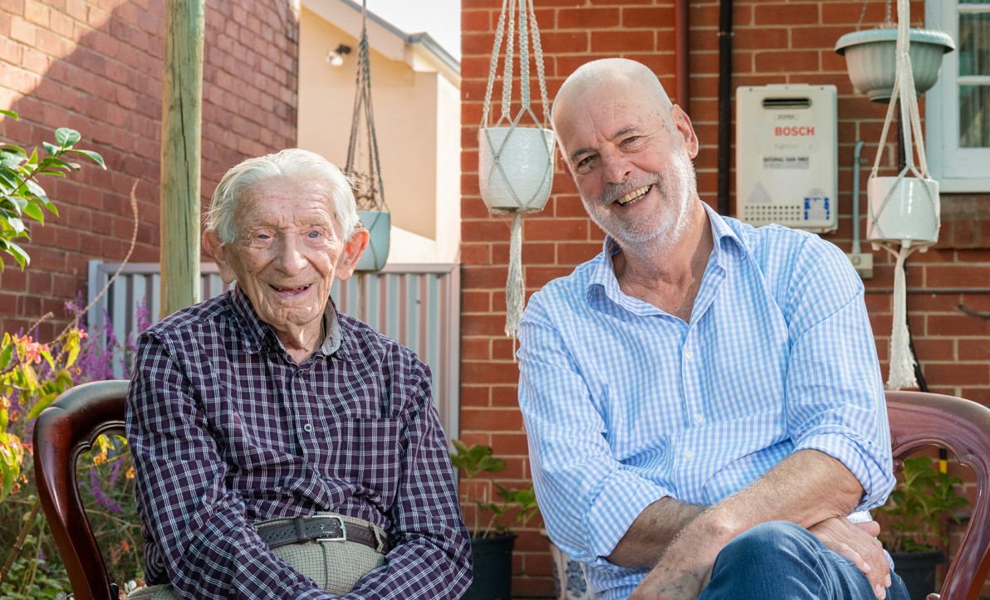
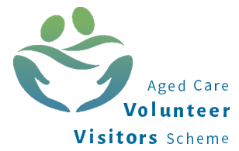

Aged Care Volunteer Visitors Scheme
The Aged Care Volunteer Visitors Scheme (ACVVS) is a life-changing program that supports regular volunteer visits to give friendship and companionship to older people. It has a particular focus on the needs of older people from linguistic, cultural and complex vulnerability backgrounds who may be at greater risk of social isolation.
The free program commenced on 1 July 2023, replacing the Community Visitors Scheme (CVS) which ran for over 30 years.

How it works
The department funds around 130 community organisations nationally to recruit, train and match volunteer visitors with aged care recipients in their local area.
The program requires volunteer visitors to make at least 20 visits a year to their recipient which should occur for around one hour a fortnight.
Volunteer visitors can visit their matched older person in:
- their own home
- their residential aged care home
- a public venue, including heading out for a coffee.
Under the Aged Care Act 2024, the ACVVS volunteer visitor is defined as an ‘aged care volunteer visitor’ with their own unique role and purpose.
ACVVS volunteer visitors do not undertake any clinical, personal or home care duties as part of their visits.
All visits are conducted in person, but a virtual visit may occur in exceptional circumstances (e.g., illness or recipient choice). These are one to one, so the recipient and volunteer visitor get to know each other over time.
During the visit, a volunteer visitor and older person can do anything they both feel like doing, such as:
- enjoy a chat over a cup of tea
- take a walk
- work on a joint hobby together.

For volunteer visitors
Becoming a volunteer visitor can be a rewarding and life-changing experience. You will make a friend, share stories and help someone who might be feeling isolated or lonely.

Experience
You don’t need any experience or qualifications to become an ACVVS volunteer visitor, just the capacity to give friendship and companionship to someone who needs it.
Applicants need to be at least 18 years of age.

How to apply
Make this the year you volunteer and brighten the life of an older person.
To register, go to health.gov.au/our-work/aged-care-volunteer-visitors-scheme-acvvs/volunteer.

For providers
Aged care providers are responsible for identifying and referring eligible aged care recipients to the ACVVS.
You can find more out about the benefits, roles and responsibilities of the ACVVS for aged care providers by visiting health.gov.au/our-work/aged-care-volunteer-visitors-scheme-acvvs/resources

Recipient eligibility
Volunteer visits are available to those who are socially isolated and lonely and are receiving government-subsidised residential aged care or Support at Home services, including recipients approved or on the Support at Home Priority System.
It excludes those with a Commonwealth Home Support Program (CHSP).

Residential aged care providers
ACVVS supports residential aged care providers to meet their requirements under the Strengthened Quality Standards for the provision of person-centred care. This includes meeting the older person’s daily living needs and valuing their identity, culture and diversity.

Support at Home providers
Volunteer visits to the Support at Home recipient does not impact their Support at Home services. The ACVVS is designed to complement the services from the Support at Home provider.

Refer an older person
ACVVS accepts referrals from aged care service providers, health professionals, family members or friends, with consent from the older person. Older people can also refer themselves.
To request a volunteer visitor, go to health.gov.au/our-work/aged-care-volunteer-visitors-scheme-acvvs/request.

Contacts and links
The department’s website provides detailed information including the National Guidelines, volunteer visitor stories and referral pathways at health.gov.au/acvvs
For questions relating to the program, you can contact the department’s ACVVS team at acvvs@health.gov.au

ACVVS Network Members
There are ACVVS Network Members representing each state and territory. Their role is to:
- support community organisations to deliver the program
- coordinate volunteer visitors and services in each state and territory
- liaise between community organisations and the department.
To find and contact your local ACVVS Network Member, visit
health.gov.au/our-work/aged-care-volunteer-visitors-scheme-acvvs/contacts

ACVVS volunteer visitor stories
You can watch heart-warming case studies of real ACVVS participants by scanning the QR code or visiting health.gov.au/our-work/aged-care-volunteer-visitors-scheme-acvvs/stories
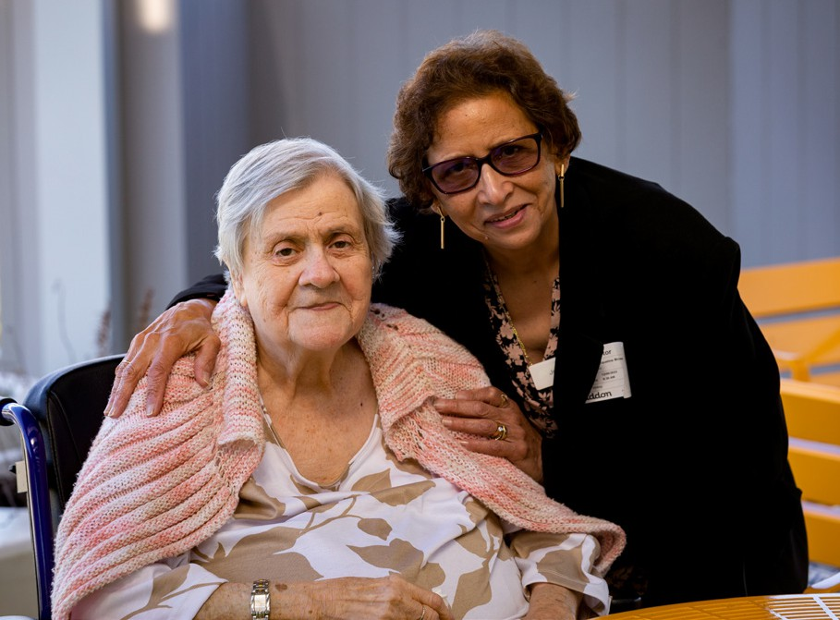

Jacqueline and Monique
When Monique moved into a nursing home, Jacqueline started visiting her as a volunteer visitor through the ACVVS.
For elderly migrants, having a friend that speaks their language can help reduce feelings of isolation. For Monique, it also creates a sense of community.
‘I don’t have the opportunity to speak French with anybody here and when you come, we can speak together. It’s wonderful because I can find myself back in Mauritius.’

Watch Jacqueline and Monique’s full story at health.gov.au/resources/ videos/volunteer-visitor-stories-jacqueline-and-monique

Fergus and Ron
‘I’ve been lucky to befriend someone who’s lived a really positive and fulfilling life.’
Fergus started visiting Ron as a volunteer visitor through the ACVVS while studying for his degree.
‘The reason I started volunteering was because I felt like I’d spent a lot of time thinking a little bit too much about myself.
That was a good motivation to step out of my comfort zone a little bit and explore volunteering. It’s been good fun. I’ve enjoyed it from the get-go.’
Fergus has also struck up a strong friendship with Ron, despite the age gap.
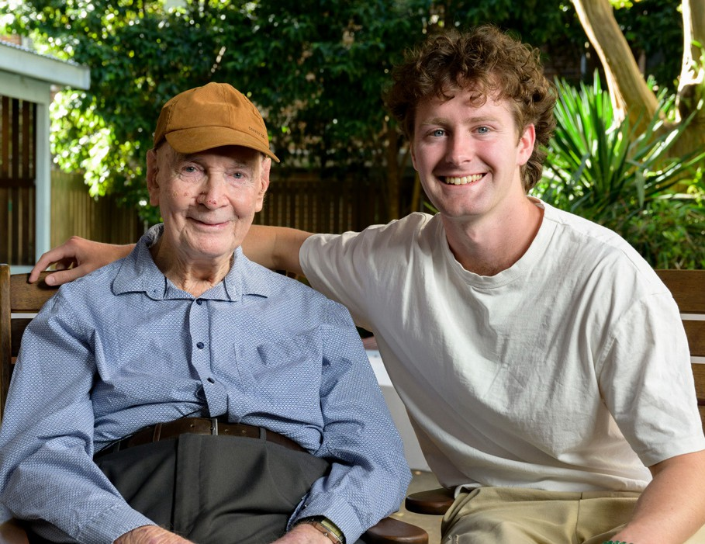
‘You think of making friendships as something that mainly happens when you’re younger, but it’s nice to flip that on its head.’

You can watch Fergus and Ron’s full story at health.gov.au/resources/ videos/volunteer-visitor-stories-fergus-and-ron

