Supported Decision-Making: Provider training package

How to use this training package

This training package is for providers to use when educating their workers on supported decision-making.
It provides guidance on how to use the Supported Decision-Making Presentation pack, including facilitation tips and speaking notes.

Facilitation tips
As a facilitator, your role is to help workers make sense of these concepts within your organisation’s culture, processes, and challenges. By aligning discussions, activities, and examples with real-world work environments, you bridge the gap between learning and application, ensuring that workers walk away with practical insights they can confidently implement in their roles.
Below are some tips on how you can contextualise the workshop content.

Use relevant organisational examples
- When introducing a concept, provide real-world examples from your organisation where possible.
- Reference organisation-specific challenges and success stories that illustrate key principles.
- If possible, incorporate pre-existing frameworks, policies or processes that align with the training content.
Facilitator Tip
Before the session, gather insights on organisational examples that can be woven into discussions. If unsure, prompt participants to share their own experiences related to the topic.

Align concepts to organisational processes and culture
- Relate theories to how work gets done in your organisation, ensuring practical relevance.
- Highlight how your organisation’s values or mission align with the concepts being discussed.
- Draw connections between the workshop content and existing organisational frameworks, tools, and policies to help workers see how they can apply learnings in their roles.
Facilitator Tip
Ask: “How does this concept show up in our organisation?” or “Where do you see opportunities to apply this within our team’s current processes?”

Encourage reflection and participant contributions
- Use open-ended questions to prompt workers to reflect on their own experiences and insights.
- Encourage discussion to explore how best practice theories apply in your organisation’s context.
- Ask workers to share challenges they have faced and work as a group to apply workshop concepts to real situations.
Facilitator Tip
Use prompts such as:
“Have you encountered a situation where applying this practice would have been useful?” [and prompt for examples].
“What aspects of this resonate with your experience in the organisation?”
“How might this approach need to be adapted to fit our organisational culture?”

Be flexible and adapt to worker needs
- Recognise that each worker brings different experiences and perspectives. Adapt discussions to address real concerns and interests.
- If a particular topic resonates strongly, spend more time exploring it with examples relevant to your organisation.
- If some content seems abstract, simplify it using familiar workplace terminology and practices.
Facilitator Tip
Regularly check in:
“Does this content make sense in the context of our organisation?”
“What additional insights or examples would help make this more relevant to you?”

Presentation slides and talking points
Slide 1 – Introduction

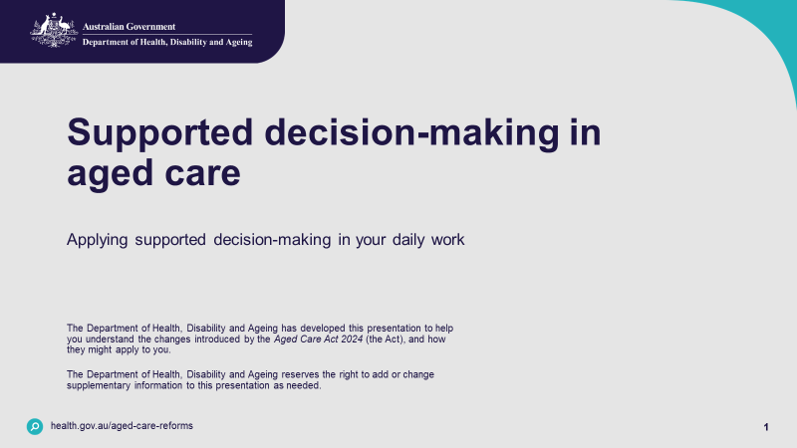

Talking points:
- Welcome participants
- Facilitator introduction
- Purpose: today we will be talking about supporting decision-making in aged care and how you can apply it in your daily work.

Slide 2 – Overview

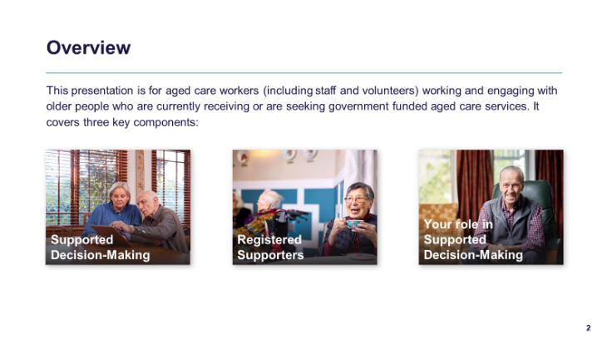
Talking points:
This presentation is for aged care workers working and engaging with older people who are currently receiving or are seeking government funded aged care services. It covers three key components:
- What is supported decision-making?
- What is a registered supporter?
- Your role in supported decision-making.

Slide 3 – Part 1: Supported decision-making

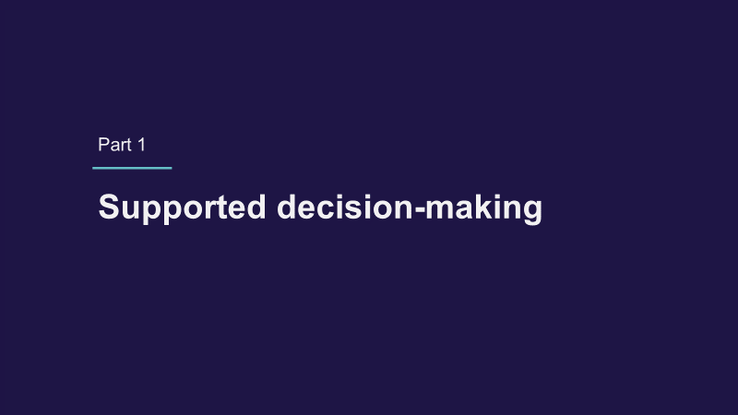

Talking points:
- In the first part of this session, we will explore what is supported decision-making.

Slide 4 – Why is it important?

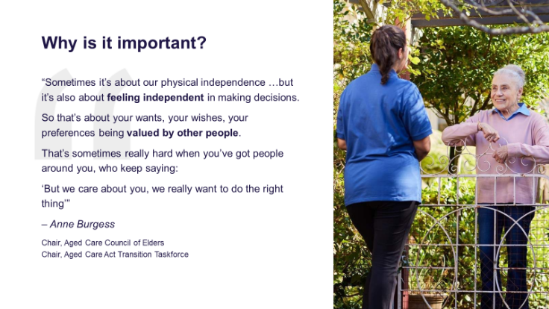

Talking points:
- Let us start by understanding why supported decision-making is important.
- Older people have the same rights and freedoms as anyone else.
- Even if you disagree with their choices (for example about relationships, lifestyle, or activities) your role is to support them, not to judge or make decisions for them.
- This includes enabling access and engaging with someone the older person wants to support them in their decision-making, including a registered supporter.

Slide 5 – What is supported decision-making?

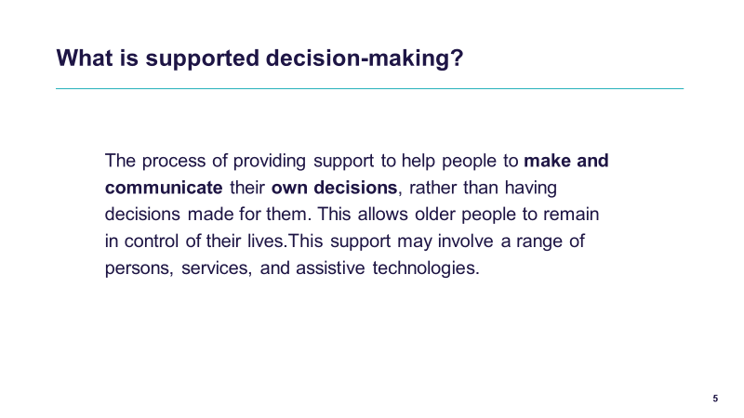

Talking points:
- When we talk about supported decision-making, we are talking about a process that helps older people stay in control of their own lives. We assume that each person can make decisions for themselves.
- Supported decision-making is not about making decisions for them. It is about providing the supports that each person may want or need so that they can make and communicate their own choices.
- That support might look different for different people, it could be breaking information down into plain language, offering visual aids, or giving someone extra time to decide.
- The key idea is that an older person should always be supported to make their own decisions, if possible. Our role is to make sure they have what they need to do that, instead of stepping in and taking the decision away from them or allowing someone else to make a decision for them.
- In other words, supported decision-making is about empowerment. It acknowledges that everyone has the right to be the decision-maker in their own life, and our job is to walk alongside them when they want us to, not take over.

Slide 6 – Principles of supported decision-making under the new Act?

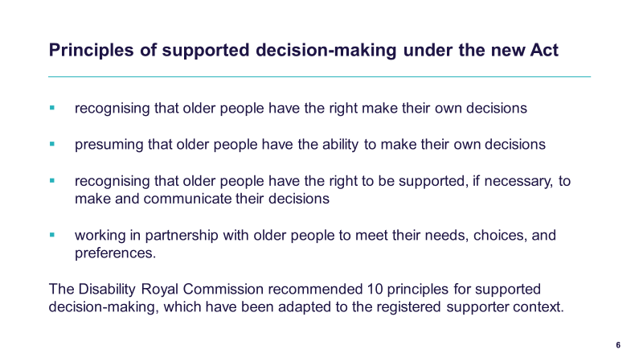

Talking points:
- The principles of supported decision-making are embedded in the Statement of Rights and the Statement of Principles, which apply to all aged care providers.
- The Statement of Rights makes it clear that older people have the right to exercise choice and make decisions, whether about their aged care services, their finances, or even their personal belongings. At its heart, it’s about respecting their autonomy and recognising that older people, like all of us, want control over their own lives.
- Importantly, older people are presumed to have the ability to make their own decisions. And where they want or need support, they also have the right to receive that support, and to have their decisions respected, even if they involve taking some personal risk.
- One of the changes under the Aged Care Act 2024 (the Act) is the introduction of the registered supporter role. This role exists to make sure older people can get the support they need to make and communicate their decisions. But it is vital to remember supported decision making is more than just interacting with a registered supporter. It must always centre on empowering the older person to express their own will, preferences, and decisions, with support only when wanted or needed.
- That means workers should only be engaging with a registered supporter, or anyone else who supports the person, if the older person asks for that support. For example, the older person may say, ‘I would like my daughter to help me talk through this decision.’ In that case, it is appropriate to involve the daughter (if the worker has confirmed they are a registered supporter), while also making it clear that the older person is the decision-maker.
- The Disability Royal Commission recommended 10 principles for supported decision-making, which have been adapted to the registered supporter context, these are explained more on the following slide.

Slide 7 – Principles of supported decision-making under the new Act

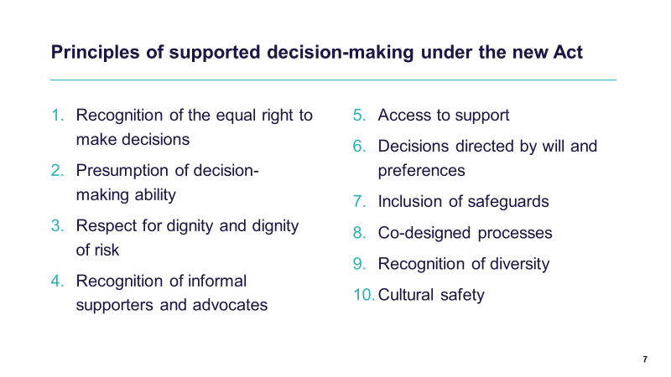

Talking Points:
- The Act reflects the principles of supported decision-making recommended by the Royal Commission into Violence, Abuse, Neglect and Exploitation of People with Disability (‘Disability Royal Commission’).
- These principles have been adapted to the registered supporter context as follows:
Principle 1 – Recognition of the equal right to make decisions
All people have an equal right to make decisions that affect their lives and to have those decisions respected.
Principle 2 – Presumption of decision-making ability
All people must be presumed to be able to make decisions.
Principle 3 – Respect for dignity and dignity of risk
All people must be treated with dignity and respect and supported to take risks to enable them to live their lives the way they choose, including in their social and intimate relationships.
Principle 4 – Recognition of informal supporters and advocates
The role of informal supporters, support networks and advocates who provide support for decision-making should be acknowledged and respected.
Principle 5 – Access to support
People who may require supported decision-making should be provided with equitable access to appropriate support to enable them, as far as practicable in the circumstances, to:
- make and participate in decisions affecting them
- communicate their will and preferences
- develop their decision-making ability.
Note: Decision-making support includes universal design and accessibility measures and recognition of diverse, non-conventional methods of communication.
Principle 6 – Decisions directed by will and preferences
The will and preferences of people who may require supported decision-making must direct decisions that affect their lives.
Note: This includes respecting decisions that are expressed in non-conventional ways including non-verbally or through observed behaviour.
Principle 7 – Inclusion of safeguards
There must be appropriate and effective safeguards where people may require supported decision-making, including to prevent abuse and undue influence.
Principle 8 – Co-designed processes
People with disability, in particular people with cognitive disability, their supporters and representative organisations, should be involved in the development and delivery of policies and practices on supported decision-making.
Principle 9 – Recognition of diversity
The diverse experiences, identities and needs of people who may require supported decision-making must be actively considered.
Principle 10 – Cultural safety
First Nations people and culturally and linguistically diverse people with disability are entitled to supported decision-making that is culturally safe, sensitive and responsive. This includes recognising the importance of maintaining a person’s cultural and linguistic environment and set of values.

Slide 8 – What is not supported decision-making?

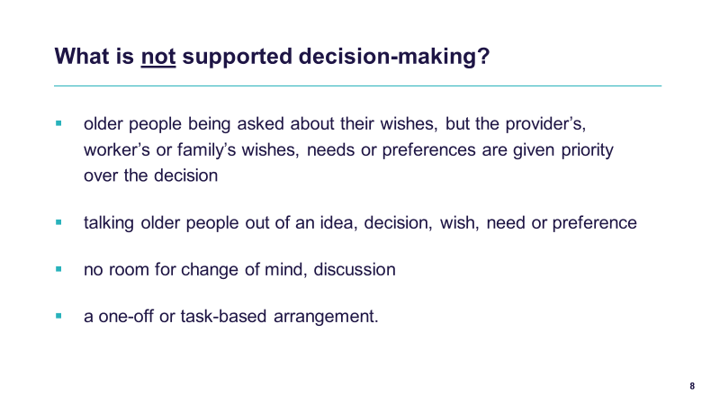

Talking points:
- It is just as important to understand what supported decision-making is not.
- Firstly, it is not when older people are asked about their wishes, but then the provider, the worker, or even the family’s wishes are given priority instead. Asking but not respecting their choice is not genuine supported decision-making.
- Think about a time when you haven’t had autonomy or were not listened to and how it made you feel. What effect did it have on your wellbeing?
- Think about how you would feel if your choice of what you were eating every day was made without anyone talking to you.
- Supported decision-making is also not about talking older people out of an idea or preference because we think it is inconvenient, risky, or unrealistic. Our role is to explore how we can support them safely to achieve their wishes, not to dismiss them.
- It is also not a rigid or one-off occurrence. Older people must always have room to change their mind, to revisit or discuss a decision as their situation changes.
- And finally, it is not a one-off or task-based arrangement (a transactional process), it is not about ticking a box or recording a choice. It is about a respectful, ongoing relationship where the person is genuinely supported to express and act on their own will and preferences.
- So, when we say, ‘supported decision-making,’ we are talking about a living process centred on the person, not just a form or a conversation.

Slide 9 – Part 2: Registered supporters

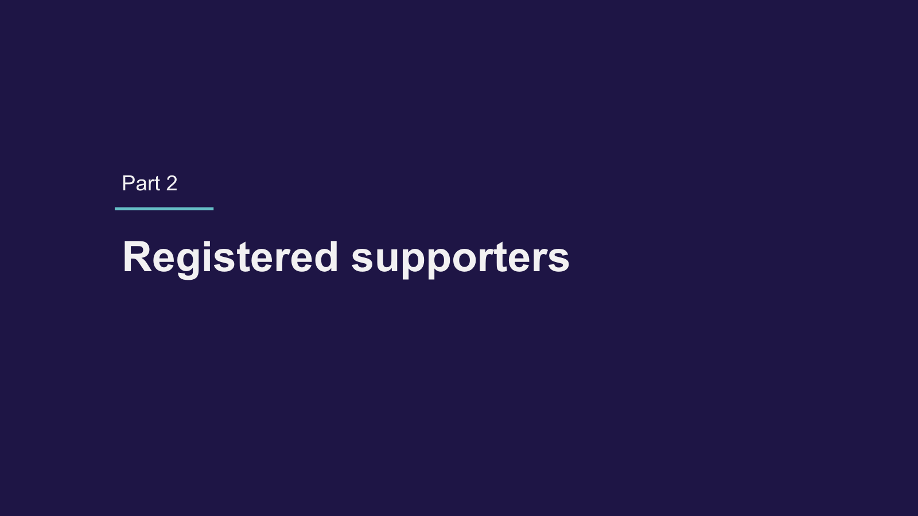

Talking points:
- In this second part of today’s session, we will explore the definition and role of a registered supporter.

Slide 10 – Registered supporters

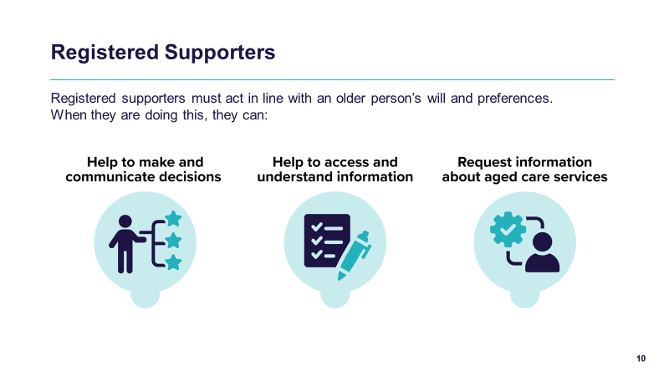

Talking points:
- The Act establishes a legal framework for the registration of supporters. This framework helps to embed supported decision-making across the aged care system.
- Older people can seek to register their own people who can support them to make aged care decisions, if they want or need this support. These people are called ‘registered supporters’.
- Registered supporters can:
  - help an older person make and communicate their own decisions about aged care, if they want. This might include speaking to My Aged Care, aged care assessors, aged care providers and workers, and the Aged Care Quality and Safety Commission
  - help an older person to access and understand information relevant to their aged care decisions
  - request, access and receive information about an older person’s aged care services and needs.

Slide 11 – Duties of a registered supporter

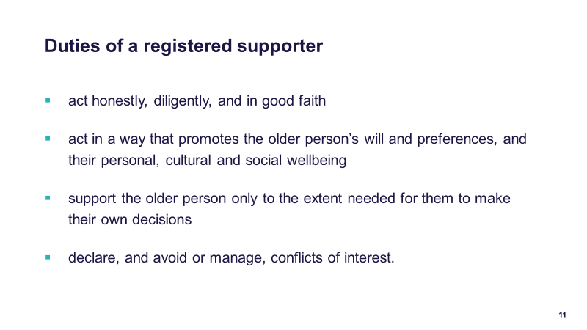

Talking points:
- All registered supporters have duties under the Act that they must comply with. These duties are intended to promote an older person’s safety, rights, will, and preferences.
- Registered supporters must:
  - act honestly, diligently, and in good faith
  - act in a way that promotes the older person’s will and preferences, and their personal, cultural and social wellbeing
- support the older person only to the extent needed for them to make their own decisions
  - Declare and avoid and manage conflicts of interest (including declaring any or potential conflicts of interest to the System Governor via My Aged Care).

Slide 12 – Appointed decision-makers

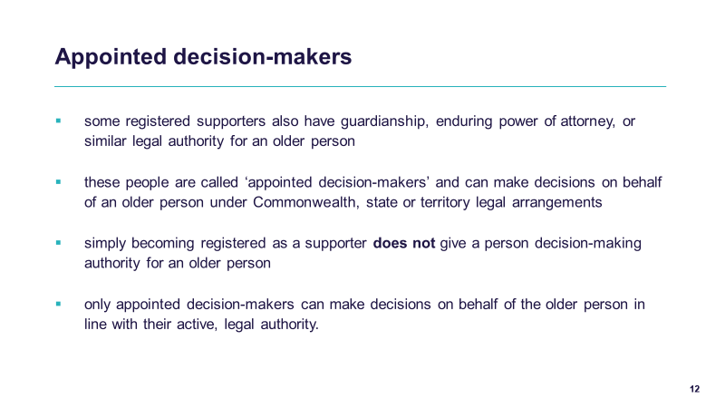

Talking points:
- There is a difference between a registered supporter and an appointed decision-maker. Appointed decision-makers are people who have decision-making authority for an older person under a Commonwealth, state or territory legal arrangement.
- Some people are registered supporters who also hold guardianship, enduring power of attorney, or another form of legal authority. They can make decisions on behalf of the older person, but only in line with the legal authority they have been given, and only when that authority is active. If they make decisions for an older person, they would be acting as an appointed decision-maker, not as a registered supporter.
- Appointed decision-makers can be appointed in different ways, by the older person themselves, or by a court, tribunal, board, or panel under Commonwealth, state, or territory law.
- But here is the key point: being a registered supporter does not give someone the right to make decisions for the older person. The role of a registered supporter is to help the older person understand and communicate their own decisions, not to take over by influencing the decisions of the older person or by making decisions on behalf of the older person.
- So, whenever you are working with a registered supporter, always assume the older person is the decision-maker, unless there is clear evidence of an active legal authority in place. Also make sure that the person is a registered supporter or appointed decision-maker before involving them.

Slide 13 – Part 3: your role in supporting decision-making

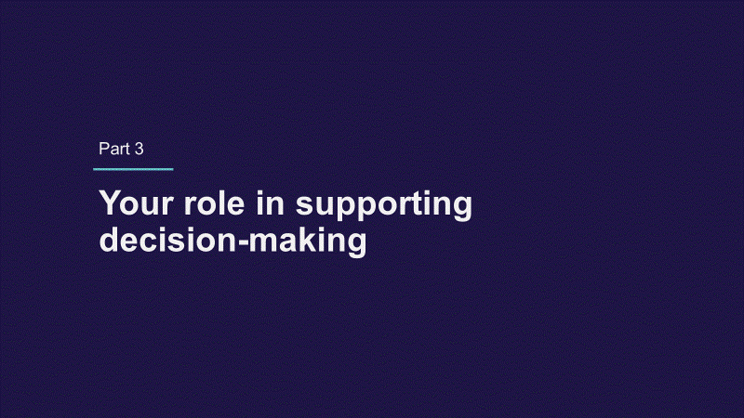

Talking points:
- In this next part of the session, we will explore what role workers play in the supported decision-making process.

Slide 14 – Your role in supporting an older person’s autonomy

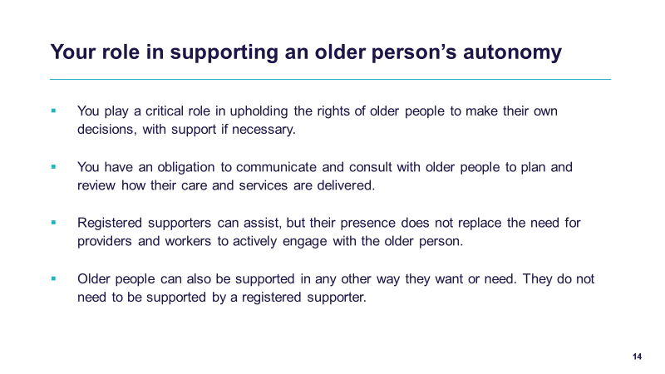

Talking points:
- As an aged care worker, you play a critical role in upholding the rights of older people to make their own decisions, with support, when needed.
- You have an obligation to communicate and consult with older people to plan and review how their care and services are delivered.
- Registered supporters can assist, but their presence does not replace the need for providers and workers to actively communicate and consult with the older person.
- Older people can also be supported in any other way they want or need. They do not need to be supported by a registered supporter.

Slide 15 – Support is directed by the older person

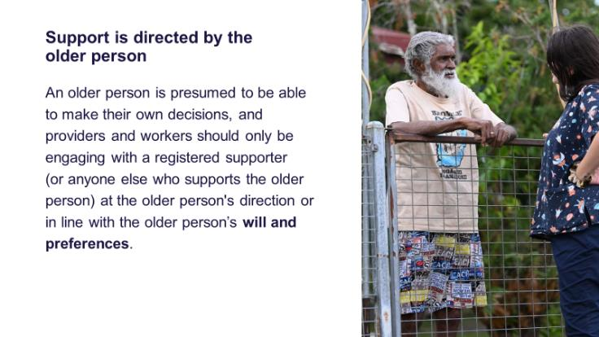

Talking points:
- An older person is presumed to be able to make their own decisions, and providers and workers should only be engaging with a registered supporter at the older person's direction or in line with the older person’s will and preferences.
- For example, when the older person communicates that they want their registered supporter or another person to help them make or communicate their own decision – this is to be listened to and respected.
- Always ask the older person first and give them the time they need to decide what they want.

Slide 16 – It is not a transactional process

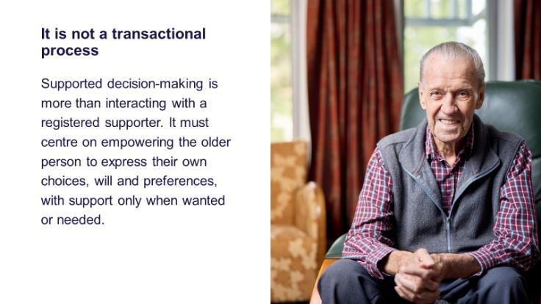

Talking points:
- Supported decision-making is more than interacting with a registered supporter.
- It must centre on empowering the older person to express their own decisions, will and preferences, with support only when wanted or needed.
- Supported decision-making is a process which maintains an older persons decision-making capability for as long as possible.
Slide 17 – It is not a transactional process – an example

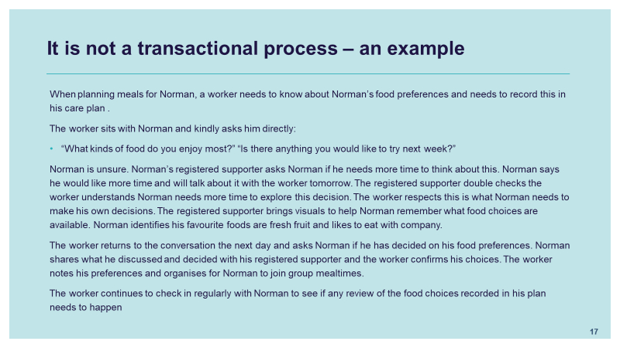

Talking points:
- Here’s an example of how you can ensure supported decision-making is not just a transactional process.
- When planning meals for Norman, a worker needs to know about Norman’s food preferences and needs to record this in his care plan .
- The worker sits with Norman and kindly asks him directly:
- “What kinds of food do you enjoy most?” “Is there anything you would like to try next week?”
- Norman is unsure. Norman’s registered supporter asks Norman if he needs more time to think about this. Norman says he would like more time and will talk about it with the worker tomorrow. The registered supporter double checks the worker understands Norman needs more time to explore this decision. The worker respects this is what Norman needs to make his own decisions. The registered supporter brings visuals to help Norman remember what food choices are available. Norman identifies his favourite foods are fresh fruit and likes to eat with company.
- The worker returns to the conversation the next day and asks Norman if he has decided on his food preferences. Norman shares what he discussed and decided with his registered supporter and the worker confirms his choices. The worker notes his preferences and organises for Norman to join group mealtimes.
- The worker also continues to check in regularly with Norman to see if any review of the food choices recorded in his plan needs to happen.
- In this way, the process is not a quick transaction (just recording a menu choice) but an ongoing relationship-building conversation that empowers Norman to express his preferences, with the supporter only stepping in when needed. Norman experiences respect, dignity and autonomy in this process and the worker knows they are providing quality care.

(Slide 18 note I have suggested the input of this slide

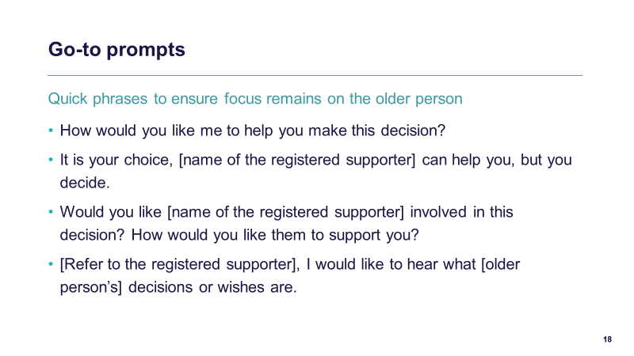

Talking Points:
- Here are some quick go to prompts which can help you ensure yours and others around the older person – remains focussed on the older person.
- These are questions which can help the older person have a common experience of people asking for their decisions, promoting their decision-making and asking what supports would be useful to help them make decisions.

Slide 19 – Be alert to the risk of abuse

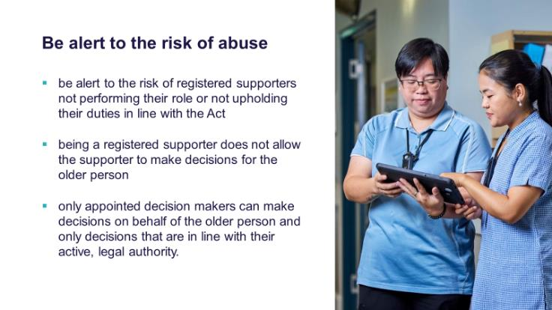

Talking points:
- Be alert to the risk of registered supporters not performing their role or upholding their duties, in line with the Act.
- Being a registered supporter does not allow the supporter to make decisions for the older person.
- It is important to be aware of the risk of registered supporters pressuring or coercing older people to make certain decisions.
- A registered supporter’s role is to support the older person to make their own decisions. Doing so would not be in line with the duties of a supporter and would undermine person-centred care and the older person’s autonomy.
- Only appointed decision-makers can make decisions on behalf of the older person, and only about decisions that are in line with their active, legal authority.
- For example: if the supporter has Financial Enduring Power of Attorney that is active/enlivened (the legal term) the appointed decision-maker cannot make decisions about what the older person eats or does for activities, they can only make decisions about financial aspects of aged care. The older person is in charge of their food and activity decisions.

Slide 20 – Be alert to the risk of abuse

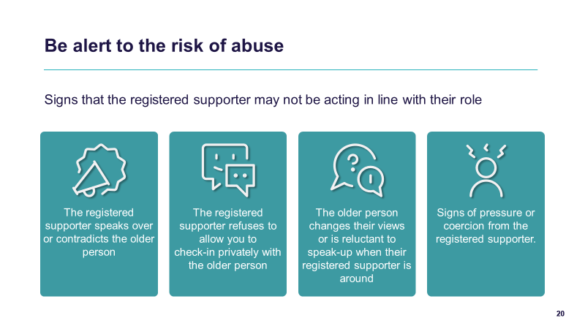

Talking points:
- When you are working with registered supporters, it is really important to be alert to signs that the registered supporter may not be acting in line with their role.
- One red flag is if the registered supporter speaks over the older person or contradicts them. That tells us the older person’s voice is not being heard.
- Another is if the registered supporter refuses to let you check in privately with the older person. A private check-in is essential to make sure the person’s true wishes are being heard.
- Sometimes you will notice that the older person changes their views or becomes reluctant to speak when the registered supporter is around. That can be a sign they do not feel safe to express themselves.
- And finally, any signs of pressure or coercion from the registered supporter, such as pushing the older person toward a decision, need to be taken seriously.

Slide 21 – What to do if you observe signs of abuse

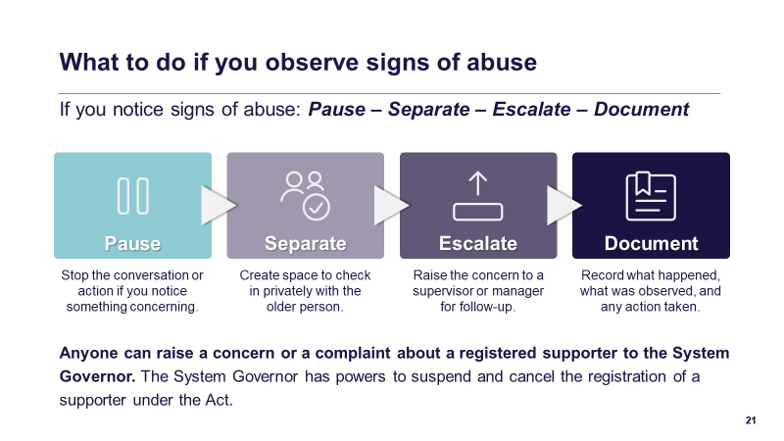

Talking points:
- If you do notice any of those warning signs, there is a simple four-step approach to follow: Pause – Separate – Escalate – Document.
- Pause means stopping the conversation or action if something feels concerning. Do not just go along with it, take a moment.
- Separate means creating space to check in privately with the older person. This is your chance to hear their views without influence.
- Escalate means raising the concern with your supervisor or manager so that it can be followed up and addressed properly. You do not have to handle it alone.
- And finally, Document. Always record what happened, what you observed, the older person’s views, and what actions you took. That way there is a clear record to support the person’s rights and safety.
- These four steps are quick, practical, and they help make sure the older person’s voice remains at the centre.
- Anyone can raise a concern or complaint with the System Governor about a registered supporter.
- The System Governor has powers to suspend and cancel the registration of a supporter. This includes if a registered supporter is not complying with their duties, has caused or may cause harm to an older person, has misused information they received in their position as a registered supporter, is no longer that person’s active appointed decision-maker, or there is any other reason they should no longer be registered as a supporter under the Act.
- It is also an offence under the Act for a current or former registered supporter to abuse their position as a supporter.
- Complaints and concerns can be made to the System Governor by contacting My Aged Care or raising a complaint directly with the department.

Slide 22 – Be alert to the risk of abuse – an example

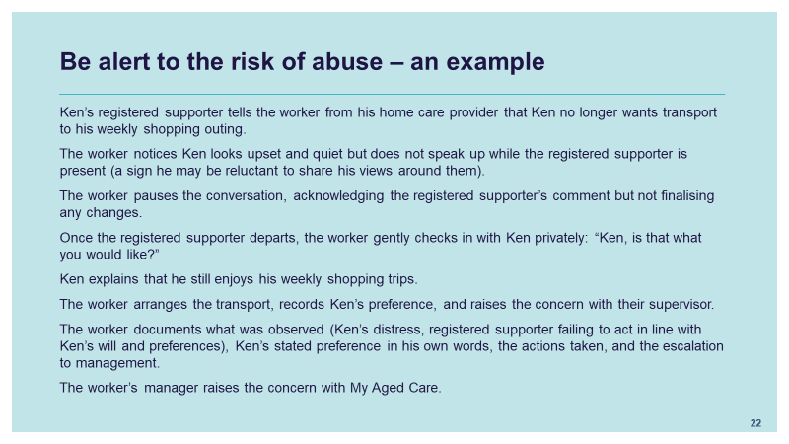

Talking points:
- Here is an example of how a worker is alert to the risk of misuse and how they manage a situation using clear communication and seeking to confirm a decision directly with the older person.
- Ken’s registered supporter tells the worker from his home care provider that Ken no longer wants transport to his weekly shopping outing.
- The worker notices Ken looks upset and quiet but does not speak up while the registered supporter is present (a sign he may be reluctant to share his views around them).
- The worker pauses the conversation, acknowledging the registered supporter’s comment but not finalising any changes.
- Once the registered supporter departs, the worker gently checks in with Ken privately: “Ken, is that what you would like?”
- Ken explains that he still enjoys his weekly shopping trips.
- The worker arranges the transport, records Ken’s preference, and raises the concern with their supervisor.
- The worker documents what was observed (Ken’s distress, registered supporter speaking on his behalf), Ken’s stated preference in his own words, the actions taken, and the escalation to management.
- The worker’s manager raises the concern with My Aged Care.

Slide 23 – Manage differing views respectfully

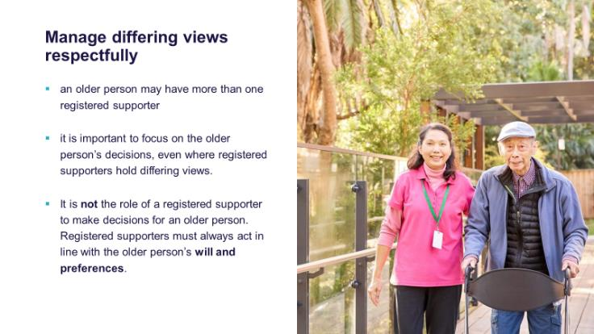

Talking points:
- An older person may have more than one registered supporter.
- It is important to focus on the older person’s decisions, even where registered supporters hold differing views.
- Providers should remember that it is not the role of a registered supporter to make a decision for the older person, and disagreements between registered supporters should not override the older person’s voice.
- Ultimately, registered supporters must always act in line with the older person’ will and preferences and the older person must be at the centre of their own decision-making.

Slide 24 – Manage differing views respectfully – an example

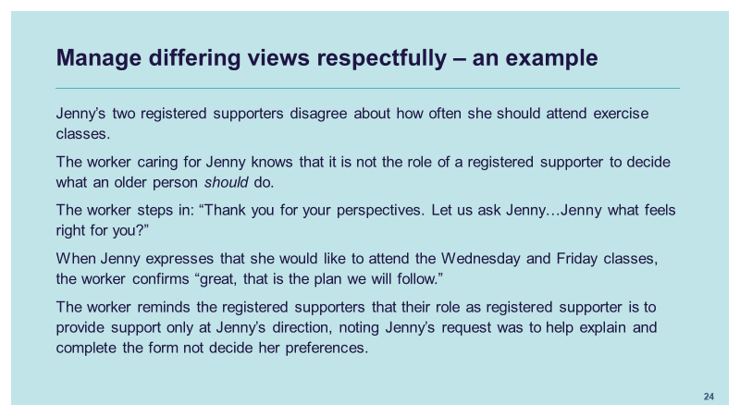

Talking points:
- Here is an example of how a worker can manage the differing views of more than one registered supporter by focusing on the preferences of the older person.
- Jenny asked her two registered supporters to help her understand and complete a form indicating her recreational / physical activity preferences for the upcoming month.
- Jenny’s two registered supporters disagree about how often she should attend exercise classes.
- The worker caring for Jenny knows that it is not the role of a registered supporter to decide what an older person should do.
- The worker steps in and says: “Thank you for your perspectives let us ask Jenny…Jenny what feels right for you?”
- When Jenny expresses that she would like to attend the Wednesday and Friday classes, the worker confirms “great, that is the plan we will follow”.
- The worker reminds the registered supporters that their role as registered supporter is to provide support only at Jenny’s direction, noting Jenny’s request was to help explain and complete the form not decide her preferences, they are to support Jenny only to the extend needed for her to make her own decisions.

Slide 25 – Direct communication is essential

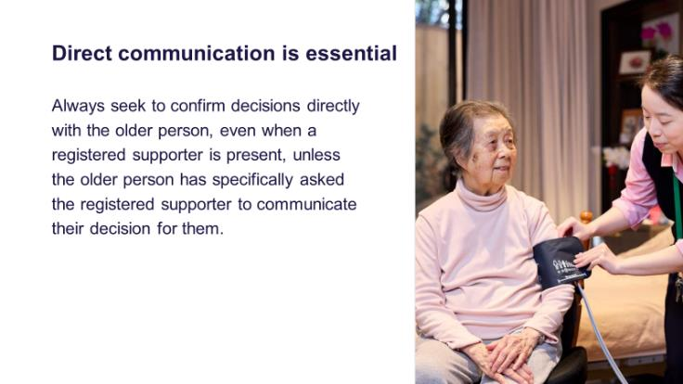

Talking points:
- Direct communication is essential. Even when a registered supporter is present, always check and confirm decisions directly with the older person.
- The only time you would not do this is if the older person has clearly told you that they would like their registered supporter to communicate on their behalf.
- This makes sure the older person’s own voice stays at the centre of every decision.

Slide 26 – Direct communication is essential – an example

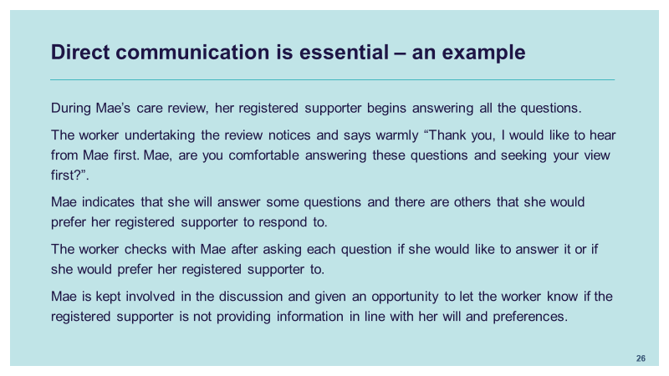
Talking points:
- Here is an example of how a worker ensures that direct communication with the older person remains central in the decision-making process.
- During Mae’s care review, her registered support begins answering all the questions.
- The worker undertaking the review notices and says warmly “Thank you, I would like to hear from Mae first. Mae, are you comfortable answering these questions and seeking your view first?”.
- Mae indicates that she will answer some questions and there are others that she would prefer her registered supporter to respond to.
- The worker checks with Mae after asking each question if she would like to answer it or if she would prefer her registered support to.
- Mae is kept involved in the discussion and given an opportunity to let the worker know if the registered supporter is not providing information in line with her will and preferences.

Slide 27 – Decision-making abilities may fluctuate

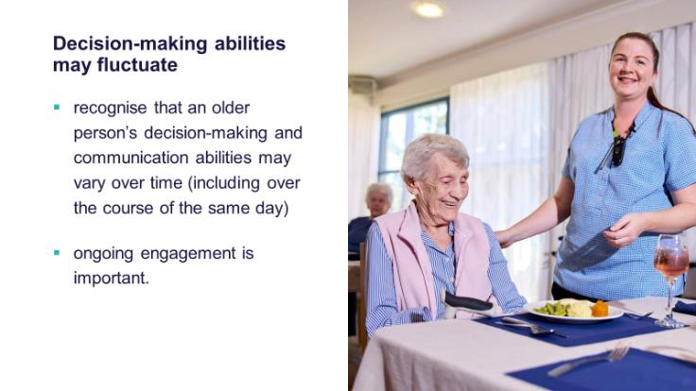

Talking points:
- The decision-making capacity and ability of all people is not fixed, it can change from day to day, or even within the same day.
- An older person might want or need more support at one time and less at another.
- That is why ongoing engagement is so important.
- We do not just ask once and assume a decision is settled, we keep checking in, giving the older person opportunities to express their views and adjusting the support they need over time.

Slide 28 – Know who the registered supporters are

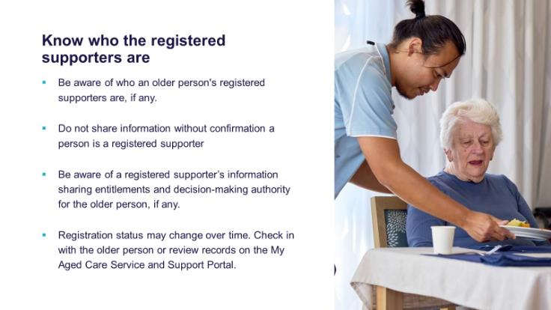

Talking points:
- Be aware of who an older person's registered supporters are, if any, including if they have any relevant legal or medical documentation. It is important not to assume, always check.
- Do not share information without confirmation a person is a registered supporter.
- You should also be aware of the information or documents about the older person a registered supporter may be authorised to automatically receive under the Act.
- Remember that a supporter’s registration status can change over time. That is why it is best practice to confirm with the older person themselves, and if you are unsure, review the records on the My Aged Care Service and Support Portal.
- This helps ensure you are involving the right people in the decision-making process while keeping the older person at the centre and meeting privacy obligations.

Slide 29 – No exclusion in the absence of a registered supporter

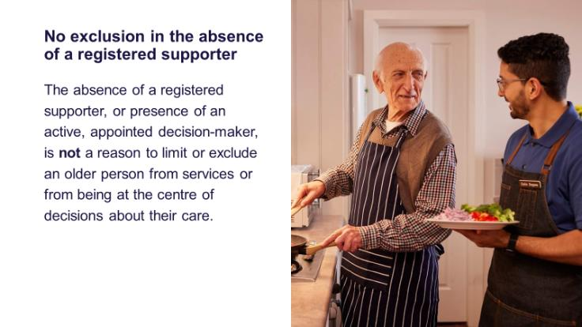

Talking points:
- It is also important to remember that the absence of a registered supporter, or even the presence of an appointed decision-maker, is never a reason to limit or exclude an older person from services, or from being at the centre of decisions about their care.
- No matter the situation, the older person’s rights, choices and preferences remain central. They should always be involved in the decision-making process to the greatest extent possible.
- This practice is in line with making sure the older person experiences their right to dignity and respect.

Slide 30 – Supported decision-making steps

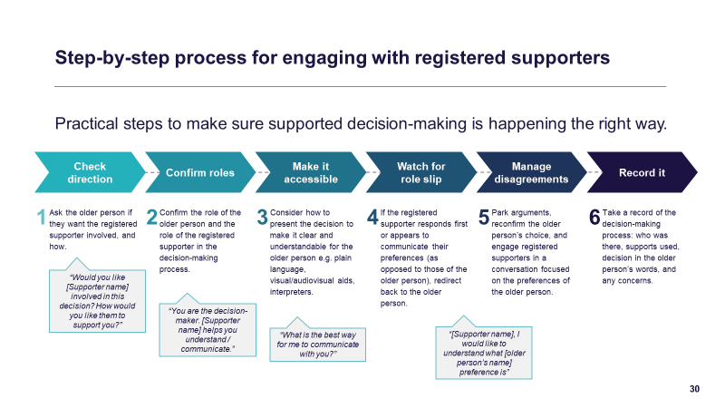

Talking points:
- Here are some practical steps to make sure supported decision-making is happening the right way.
- Step 1: Check direction.
Always begin with the older person. Ask if they want their registered supporter involved, and how. For example, you might say: ‘Would you like [supporter’s name] involved in this decision? How would you like them to support you?’ This makes it clear that the choice of support lies with the older person.
- Step 2: Confirm roles.
Be clear that the older person is the decision-maker, and the registered supporter is there to assist. A simple reminder like: ‘You are the decision-maker. [Supporter’s name] helps you understand or communicate’ reinforces that distinction.
- Step 3: Make it accessible.
Think about how you present the information. Is it clear and easy to understand? You might use plain language, pictures, visual aids, or interpreters. You could check in by asking: ‘What is the best way for me to communicate with you?’
- Step 4: Watch for role slip.
Sometimes a registered supporter may jump in and answer on behalf of the older person. If this happens, redirect gently back to the older person. You could say: ‘[Supporter’s name], I would like to hear what [older person’s name] prefers.’ This keeps the older person’s voice central.
- Step 5: Manage disagreements.
If there are arguments or differing views, park those for later. Reconfirm the older person’s choice and refocus the conversation on their preferences. This prevents registered supporters’ voices from overtaking the person’s rights.
- Step 6: Record it.
Finally, always document the process. Note who was involved, what supports were used, what the decision was in the older person’s own words, and any concerns. This shows that the decision was made with the person at the centre, and gives transparency if questions arise later.

Slide 31 – Conclusion

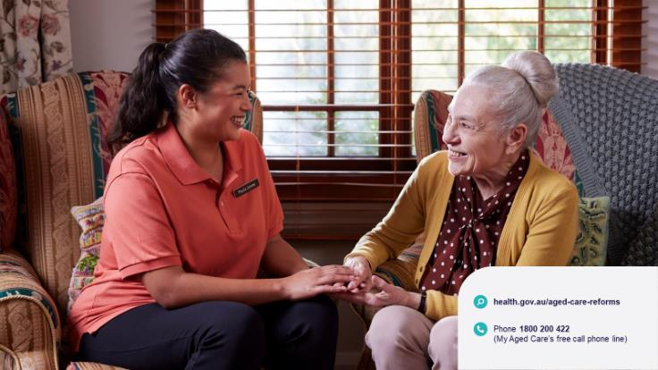

Talking points:
- Thank you for attending today’s session
- There is a lot further information and support on this topic - please feel free to ask if you would like assistance in this area.
- This concludes the session.

