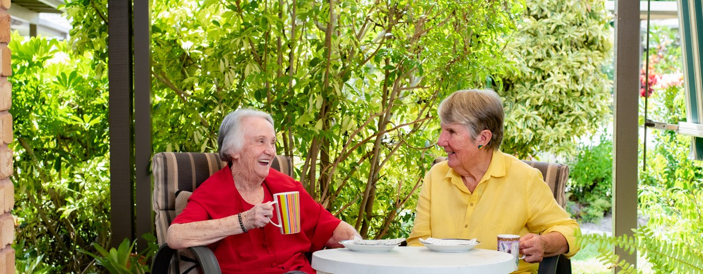
November 2025


Support at Home providers and ACVVS
The Aged Care Volunteer Visitors Scheme (ACVVS) commenced on 1 July 2023, replacing the Community Visitors Scheme (CVS), a Commonwealth-funded program which ran for over 30 years.

Overview
The ACVVS is a free program which matches eligible aged care recipients who are lonely or socially isolated with aged care volunteer visitors to provide companionship, social support or friendship.
Visits are available to anyone receiving government-subsidised residential aged care or Support at Home services, who are socially isolated or lonely. This includes care recipients approved or on the Support at Home Priority System and excludes those accessing the Commonwealth Home Support Program (CHSP).
Under the Aged Care Act 2024, ACVVS is recognised as a grant that supports and uphold the rights and entitlements of care recipients. Registered providers must allow and facilitate access to ACVVS aged care volunteer visitors to visit aged care recipients.
The program focuses on the needs of older people from particular linguistic, cultural and complex vulnerability backgrounds who may be at greater risk of social isolation.
The department funds over 130 community organisations nationally to recruit, train and match aged care volunteer visitors to aged care recipients. Roles and responsibilities are detailed in the ACVVS National Guidelines.
The program requires aged care volunteer visitors to make a minimum of 20 visits per year to their matched aged care recipient, for approximately an hour a fortnight. Visits can include anything the aged care volunteer visitor and older person feel like doing such as:
sharing stories over a cup of tea
working on a joint hobby
taking a walk.
ACVVS accepts referrals from aged care service providers, health professionals, family members and friends, with consent from the older person. Older people can also refer themselves.
The preference is that all ACVVS visits are conducted in person, but a virtual visit may occur in exceptional circumstances (e.g. illness or recipient choice). Visits are one to one, so the recipient and volunteer visitor get to know each other over time.
If an ACVVS community organisation is also a home care or residential care provider, they are required to provide 25% or more of their total ACVVS placements to aged care clients outside of their organisation.
Aged care volunteer visits to a Support at Home participant do not impact their Support at Home funding. The ACVVS will complement the services from the Support at Home provider.

Aged care providers role
- Identify and refer eligible care recipients to ACVVS, including for people from diverse backgrounds and experiences.
- Recognise and respect the role of aged care volunteer visitors as a significant person to the ACVVS recipients to provide companionship and friendship.
- Ensure the individual’s rights to stay connected with the ACVVS volunteer visitor are upheld as is consistent with the Statement of Rights.
- Visits to recipients by the volunteer visitor can occur any day of the week, including weekends and after 5pm on a weekday, just like visits from family and friends.
- Liaise with the ACVVS Volunteer Coordinator and advise them when the recipient is unable to receive visits (e.g. in hospital).
- Advise the ACVVS volunteer visitor as soon as possible if their recipient passes away, preferably through the Volunteer Coordinator.
- A memorandum of understanding (MOU) or Service Agreement between the ACVVS organisation and the Support at Home provider is not required.


ACVVS volunteer visitor role
- Must complete a mandatory National Police Check. The volunteer visitor’s ACVVS community organisation will provide confirmation of check (reference number and expiry date) to the Support at Home provider where contact between the community organisation and the provider has occurred prior to commencement of visits.
- Are not required to complete a NDIS check, unless matched to a recipient who is a NDIS participant.
- Are not required to undertake Support at Home registered provider training. They are trained through ACVVS community organisations to ensure they can confidently take on their role and are aware of their obligations and responsibilities.
- Are required to work within their ACVVS community organisations policies, procedures and role description.
- Are not required to register as a volunteer with the Support at Home registered provider or enter personnel details into their employee database. The volunteer visitor is registered with their ACVVS community organisation.
- Are matched and visit the same recipient to build a genuine friendship.
- Are instructed to NOT attend the recipient’s location for visits when unwell.
- Must not access a recipient’s personal or care records. They must not be involved in any aspect of the recipient’s financial affairs, perform the duties of a paid worker or provide nursing and personal care to the care recipient.
- Must not advocate for any change of aged care services.
The ACVVS aged care volunteer visitor role description is available in the ACVVS National Guidelines (section 5.1).

ACVVS Volunteer Coordinator role
- Recruit, train and support aged care volunteer visitors to ensure compliance with legislation and procedures.
- Promote and increase awareness of all aspects of the ACVVS to residential aged care homes, home care providers and the broader community.
- Actively seek referrals and match aged care volunteer visitors.
- Maintain a high level of communication and positive relationships with aged care providers, Support at Home providers and participants.
- Ensure the aged care volunteer visitor’s actions are consistent with the Statement of Rights.
- Address any issues or concerns raised by the aged care volunteer visitor or the aged care provider regarding the relationship or the recipient’s needs.
The ACVVS Volunteer Coordinator role description is available in the ACVVS National Guidelines (section 5.3).

ACVVS Network Members
ACVVS Network Members represent and support ACVVS community organisations and volunteer coordinators within each state and territory. The Network Member role description is available in the ACVVS National Guidelines (section 5.2).

Contacts and links
- The department’s website provides detailed information including the National Guidelines, volunteer visitor stories and referral pathways at health.gov.au/acvvs
- Contact the department’s ACVVS team at acvvs@health.gov.au
- Request an aged care volunteer visitor for a Support at Home participant at
health.gov.au/our-work/aged-care-volunteer-visitors-scheme-acvvs/request
Aged care provider staff can speak directly to ACVVS Network Members to find their local ACVVS community organisation by visiting health.gov.au/our-work/aged-care-volunteer-visitors-scheme-acvvs/contacts
