Service and Support Portal User Guide - Serious Incident Response Scheme (SIRS) Portal
This My Aged Care user guide is designed for administrators, team leaders and staff members.
It explains how to access and use the Serious Incident Response Scheme (SIRS) functions for residential aged care services, in-home care, and Support at Home services within the Service and Support Portal.
! | The following services are considered residential aged care services:  residential aged care facility (RACF)  multi-purpose service (MPS) or  National Aboriginal and Torres Strait Islander Flexible Aged Care Program (NATSIFACP) service.  The Aged Care Act (2024) is implemented from 1 November 2025. MPS and NATSIFACP programs are transitioning. For more information visit the Department’s website.
Table of contents
SIRS functions and roles 2
Granting users access to the SIRS portal 2
Submitting a new SIRS notice 5
Viewing existing SIRS notices 8
Finding SIRS notices using the basic and advanced searches 10
Basic Search 11
Advanced Search 11
Editing or deleting draft SIRS notices 13
Exporting a list of draft SIRS notices 16
Viewing SIRS follow-up notifications 18
Uploading multiple SIRS notices at once 20
Accessing SIRS help and further information 20

! | Throughout this guide, additional useful instructions and information can be found by hovering over the help icons next to each question.

SIRS functions and roles
Role | Description of access
Administrator | Administrators have access at either an organisation or outlet level to:  - Provide staff access to the SIRS portal  - Manage the roles within the SIRS portal  - View all SIRS notifications  - Edit and delete all draft SIRS notifications  - Submit SIRS notifications  - Upload multiple SIRS notices at once.
Team Leader | Team leaders have access at either an organisation or outlet level to:  - View all SIRS notifications  - Edit or delete all draft SIRS notifications  - Submit SIRS notifications.
Staff Member | Staff members have access at an outlet level to:  - View their created SIRS notifications  - Edit or delete their draft SIRS notifications  - Submit SIRS notifications.

Granting users access to the SIRS portal
If you are an administrator, you can provide staff access to the SIRS Notice dashboard tile and corresponding portal by following the steps below:
- Log in to the My Aged Care Service and Support Portal, and select the Staff Administration tile from the home page.
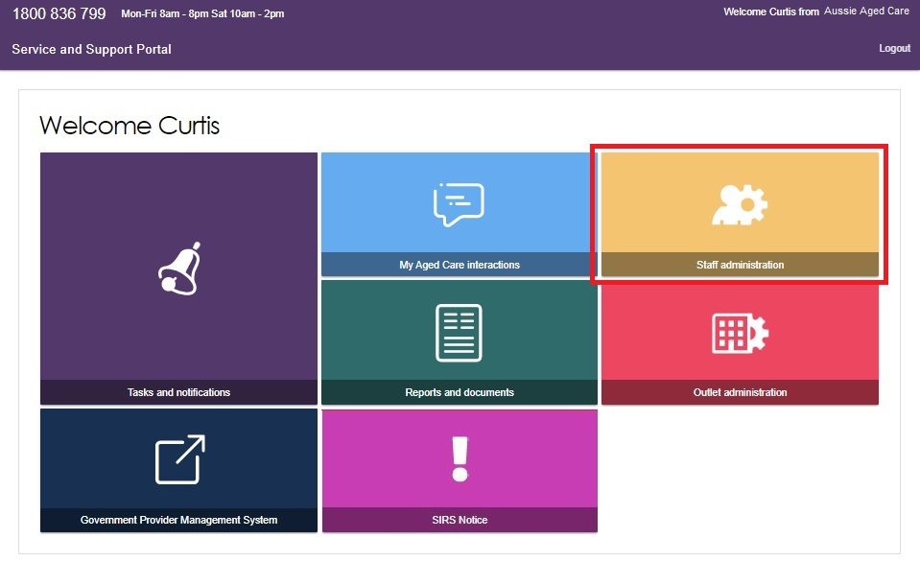
- Scroll down to the staff section of the Staff administration page. Use the search fields to filter for the correct staff member. Then, select the name of the staff member who requires access to the SIRS portal.
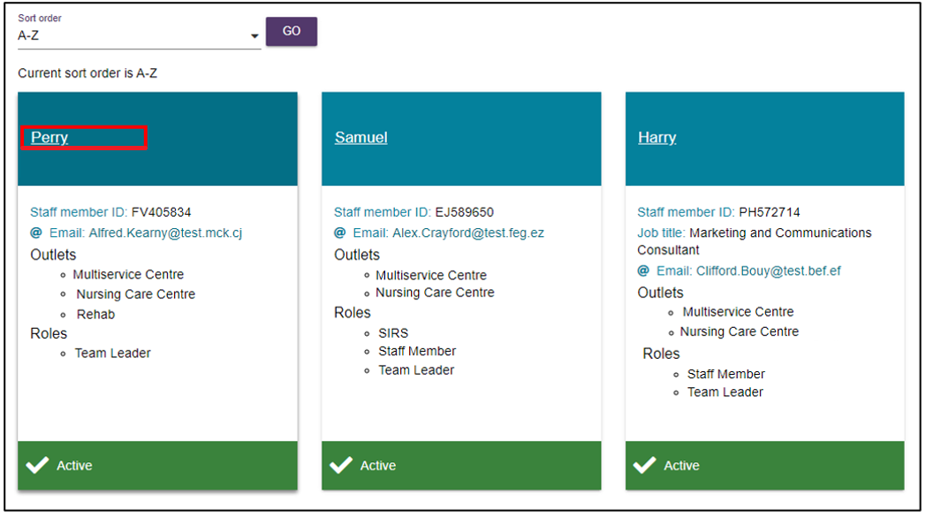
! | For more information on how to add a staff member to your facility in the My Aged Care Service and Support Portal, please refer to the My Aged Care Assessor Portal – Organisation Administrator User Guide.
- Select the EDIT STAFF DETAILS button.
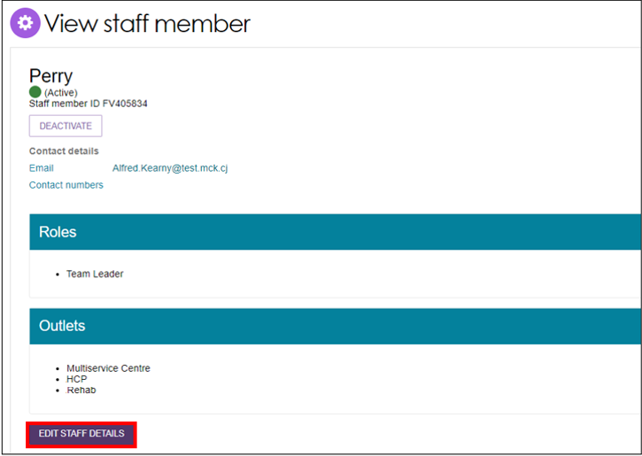
- Select the MANAGE ROLES button.
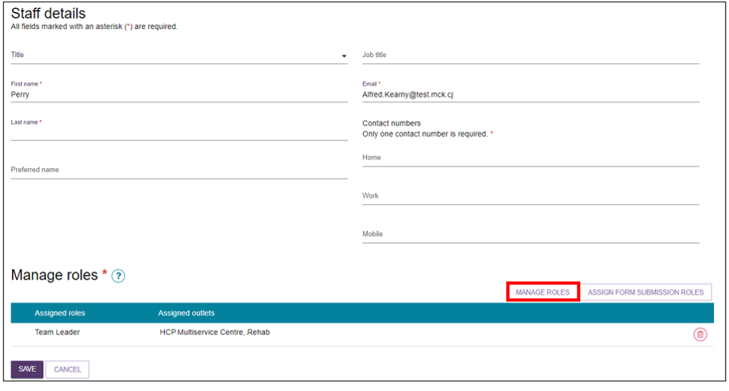
- A pop-up box will appear displaying a series of checkboxes. If the staff member already has a role, the corresponding box will be checked. Check the corresponding SIRS checkbox by selecting it. Then, select the SAVE button.
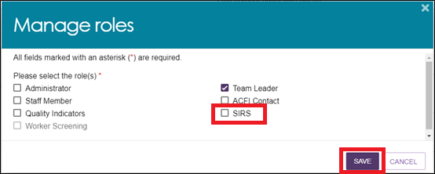
The staff member will now be able to view and select the new SIRS Notice tile on their dashboard, enabling them to view, edit, and submit SIRS notices and associated information.
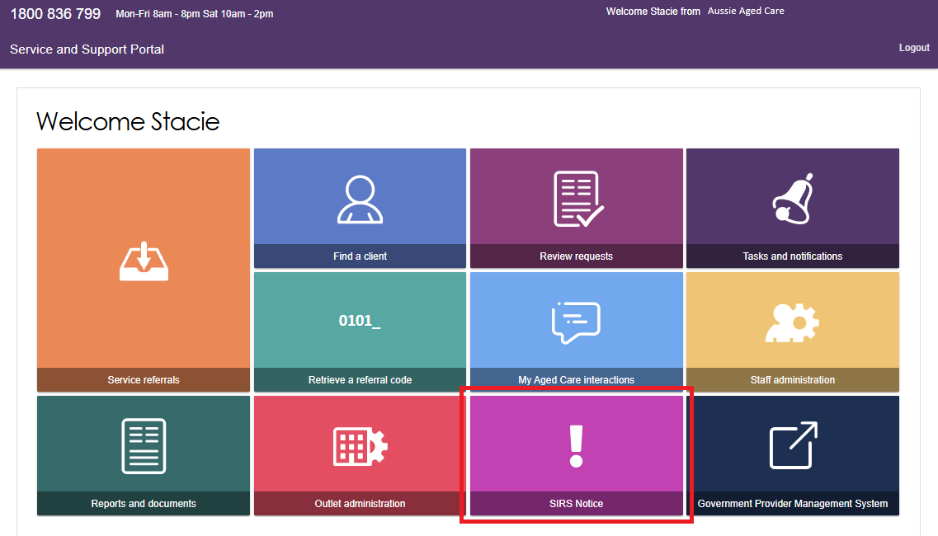

Submitting a new SIRS notice
! | For information on what incidents must be reported in a SIRS notice, visit the Aged Care Quality and Safety Commission’s website.
- Log in to the My Aged Care Service and Support Portal, then select the SIRS Notice tile from the home page.
- Select the Submit new notice tile to begin filling out a new SIRS notice form.
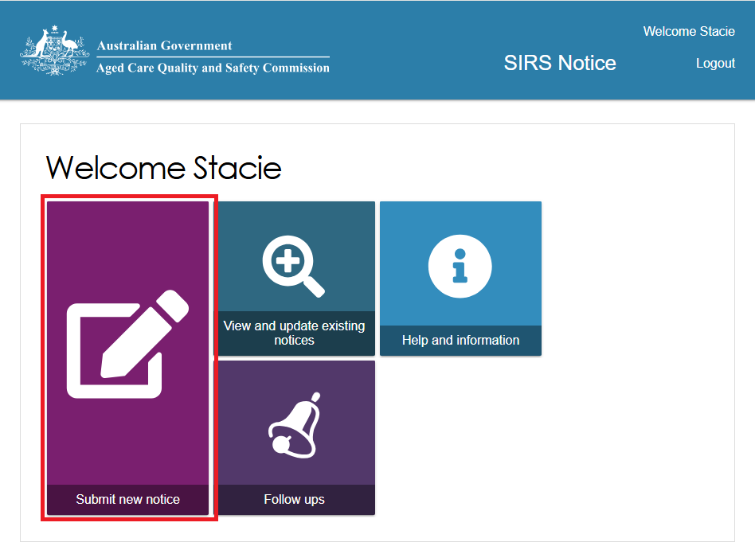
- A new tab will open containing important information about the SIRS notice. Read the information carefully, then select the NEXT button to proceed.
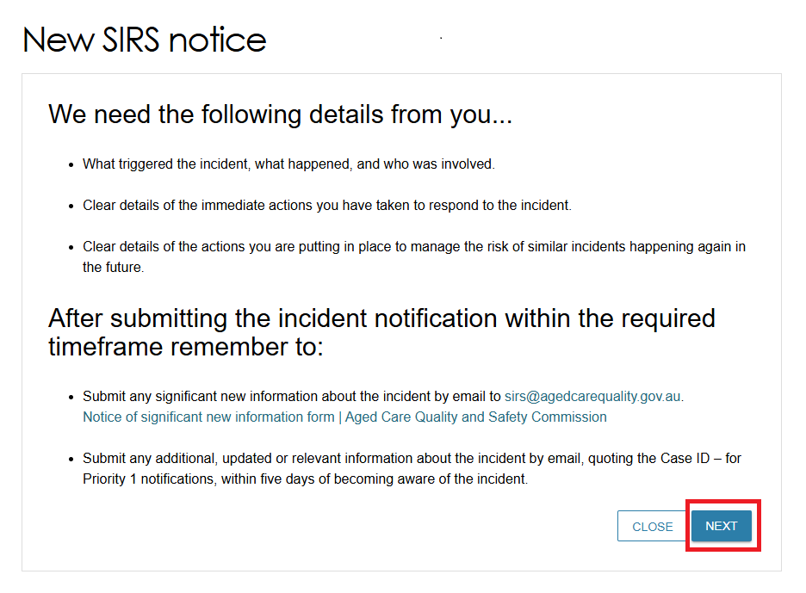
- Complete the required information on the Your details tab, including selecting the appropriate setting where the incident occurred in.
Ensure you have entered information for each field marked with an asterisk (*), including the two (2) notices of collection acknowledgements located near the top of the Your details page
To access help text detailing what information is required for each input field, select the question mark symbols next to each field.
Once you have finished, navigate to the Incident details page by selecting the NEXT button.
! | You can also save the SIRS Notice by selecting the Save button at the bottom of each page. This will turn the SIRS Notice into Draft status.
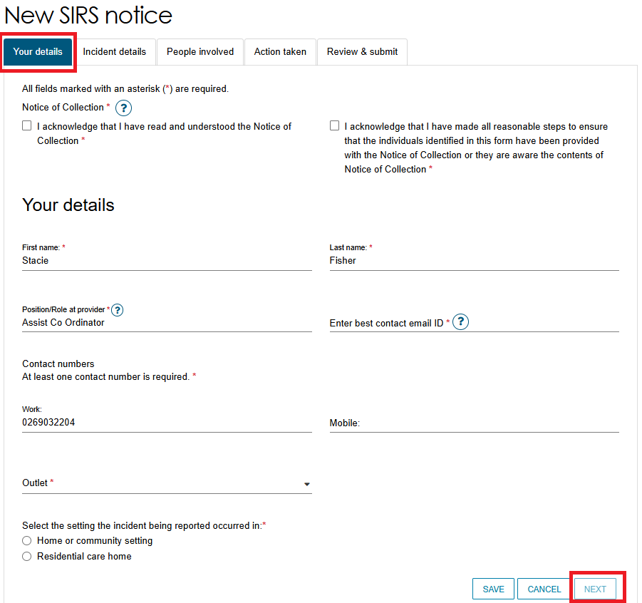
- Complete the required information on the Incident details page and the People involved page. The SIRS notification form allows you to capture details for up to a maximum of six (6) Subjects of allegation within a single notification on the People involved page.
Complete the required information on the Action taken page. Ensure you have entered information for each field marked with an asterisk (*) for every page. To access help text detailing what information is required for each input field, select the question mark symbols next to each field.
! | The SIRS form will look slightly different depending on whether you are submitting the notice for a residential aged care facility, in-home care, or Support at Home service.
- After completing all four data collection pages of the SIRS form, you will be taken to the Review & Submit page. This page summarises the information you have provided, please review it carefully.
If mandatory information is missing, a large red X will appear next to the relevant page summary. There will also be a warning message. To return to and edit a page, select the pencil symbol on the right-hand side of the page summary.
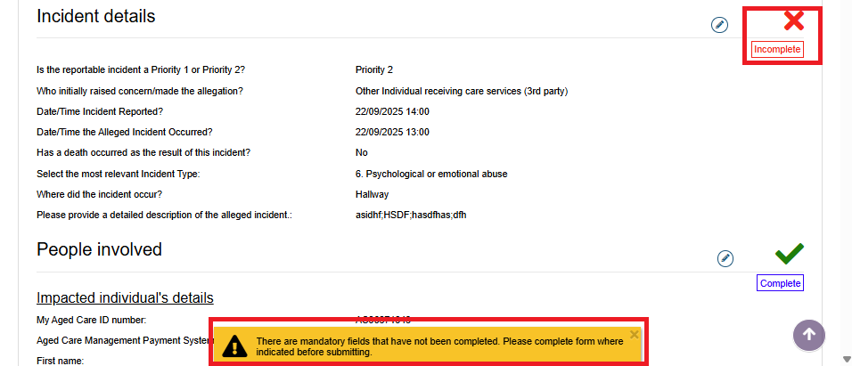
- Select the acknowledgement checkbox, and then select the SUBMIT button to proceed.
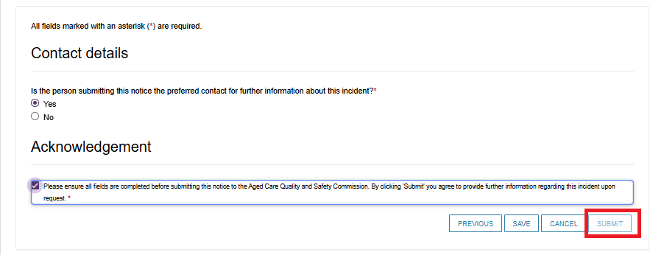
- A pop-up box will appear, prompting you to confirm that the notice is ready for submission.
Select the SUBMIT button to submit your SIRS notice.
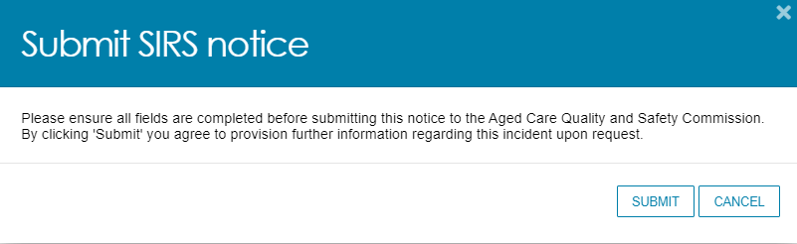
The submitted notice can now be viewed in the list of existing notices. Refer to the Viewing existing SIRS notices section of this guide for more information.

Viewing existing SIRS notices
Administrators, team leaders, and staff members can view existing SIRS notices based on their permissions. Refer to the SIRS functions and roles section of this guide for more information.
- Log in to the My Aged Care Service and Support Portal, and select the SIRS Notice tile on the homepage.
- Select the View and update existing notices tile.
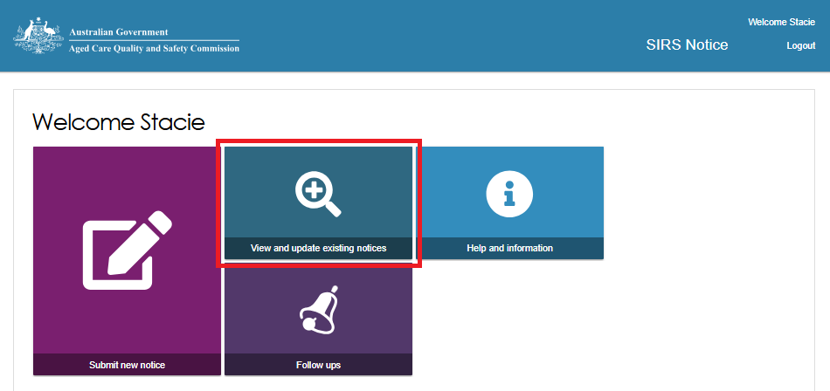
- Use the search fields and the FILTER button near the top of the page to search for the appropriate SIRS notice. Once you have found the appropriate notice in the table, select the Incident ID to view the notice.
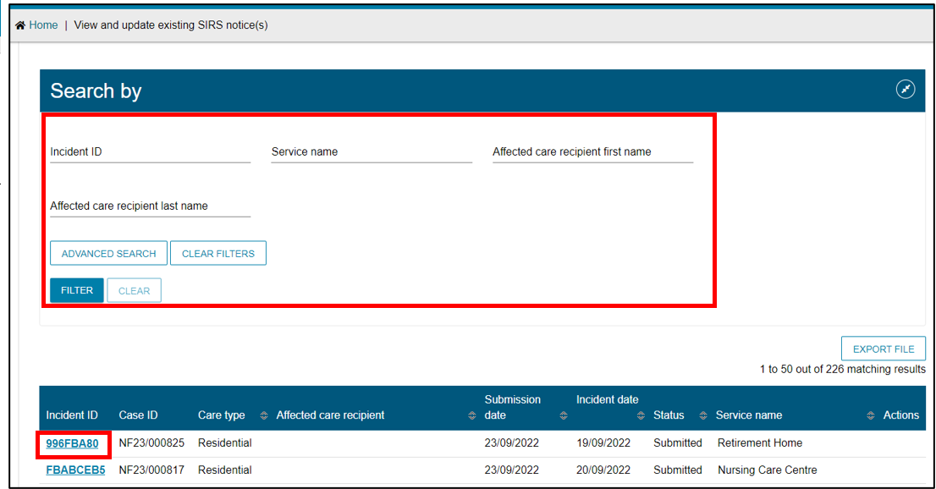
! | If you are an administrator or team leader at the organisation level, you can view a list of all in-draft and completed notifications for your organisation.  If you are an administrator or team leader for only your outlet, you can view a list of all draft and completed notifications for your outlet. Drafts will be deleted after 60 days.
- You can now view and navigate through the draft or submitted notifications using the Next and Previous buttons.
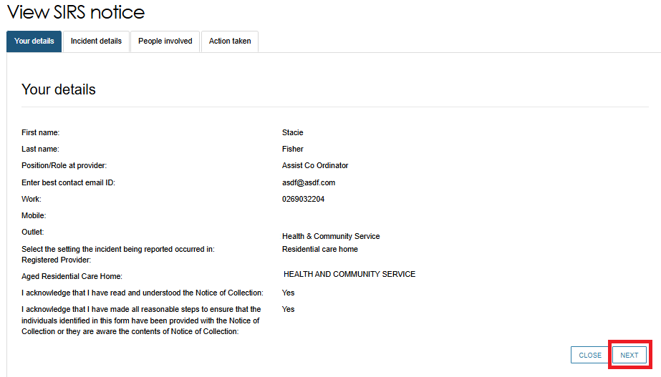

Finding SIRS notices using the basic and advanced searches
- Log in to the My Aged Care Service and Support Portal, and select the SIRS Notice tile from the home page.
- Select the View and update existing notices tile.

Basic Search
- To perform a basic search, type the appropriate terms into either of the Incident ID, Service name, Affected care recipient first name, or Affected care recipient last name input field(s).
Then, select the FILTER button to filter the list of SIRS notices using your terms. The results of your basic search will appear in the table below.
- To clear a basic search, select the CLEAR button.
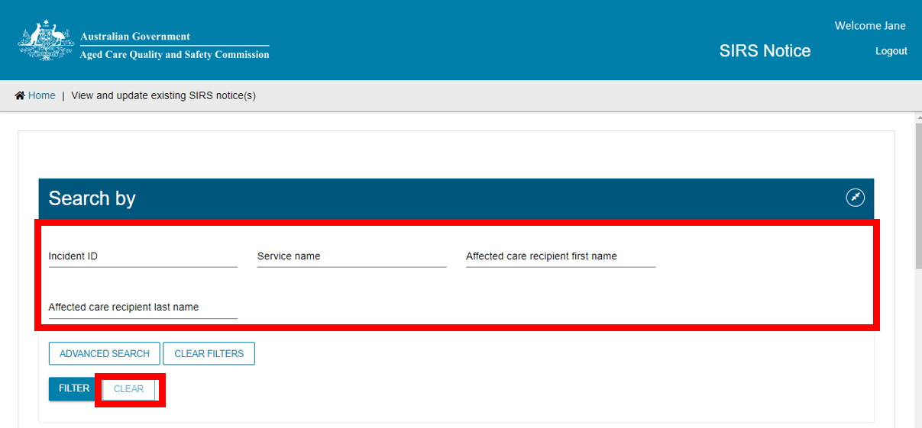

Advanced Search
- To perform an advanced search, select the ADVANCED SEARCH button.
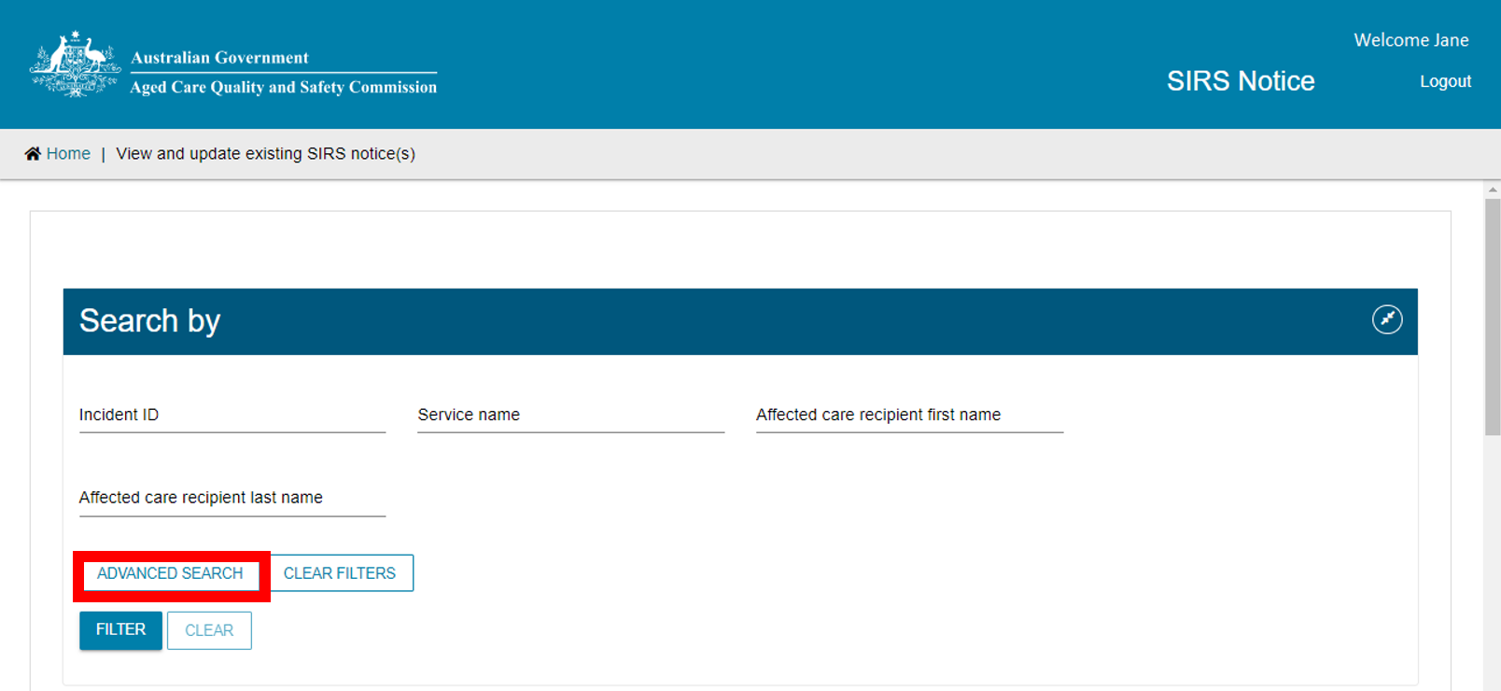
- A pop-up window will appear. Use the drop-down menu to select the advanced filter you wish to use, then select the ADD FILTER button to reveal the input field for that filter.
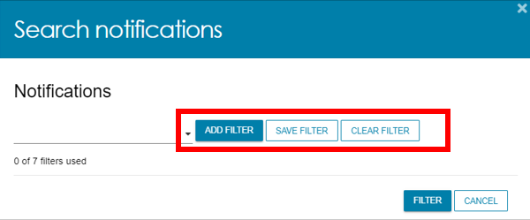
- In the newly revealed input field for your chosen filter, input your chosen terms.
For some filters, terms are selected from a drop-down menu. For other filters, terms are typed into the input field.
Select the FILTER button to begin your advanced search using your chosen filters and terms. Up to seven filters can be added together this way.
Delete filters by selecting the bin icon on the right-hand side of the filter.
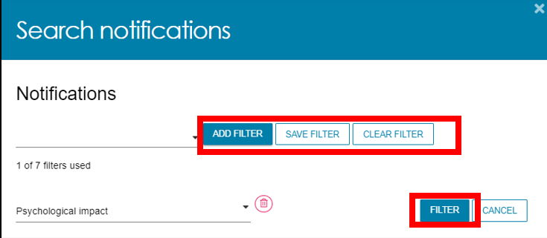
- After selecting FILTER the popup will close, and your results will appear in the table below.
To clear an advanced search, select the CLEAR FILTERS button.
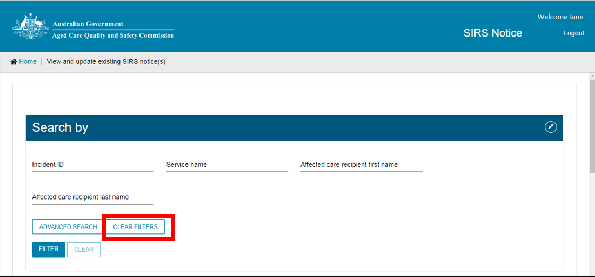

Editing or deleting draft SIRS notices
Administrators, team leaders, and staff members can edit or delete draft SIRS notices based on their permissions. Refer to the SIRS functions and roles section of this guide for more information.
- Log in to the My Aged Care Service and Support Portal, and select the SIRS Notice tile from the home page.
- Select the View and update existing notices tile.
- Use the search fields and the FILTER button near the top of the page to search for the appropriate SIRS notice. Refer to Finding SIRS notices using the basic and advanced searches for more information.
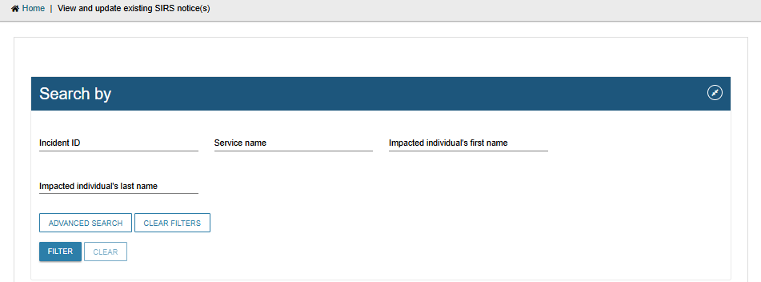
- Once you have found the appropriate draft notice in the table, you can select the pencil symbol to edit the draft notice.
The process for editing a draft notice is similar to creating a new notice. Refer to the Submitting a new SIRS notice section of this guide for more information.
Notices with other statuses will not have the Edit or Delete icons available.
There is also a button to create a New SIRS Notice in this page if required.
! | If you are an administrator or team leader at the organisation level, you will see a list of all in-draft and completed notifications for your organisation. If you are an administrator or team leader for only your outlet, you will see a list of all draft and completed notifications for your outlet. Drafts will be deleted after 60 days.
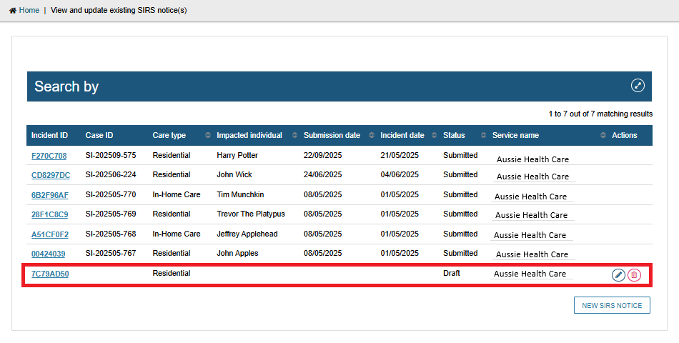
- Draft notices can also be deleted by selecting the bin symbol to the right of the notice.
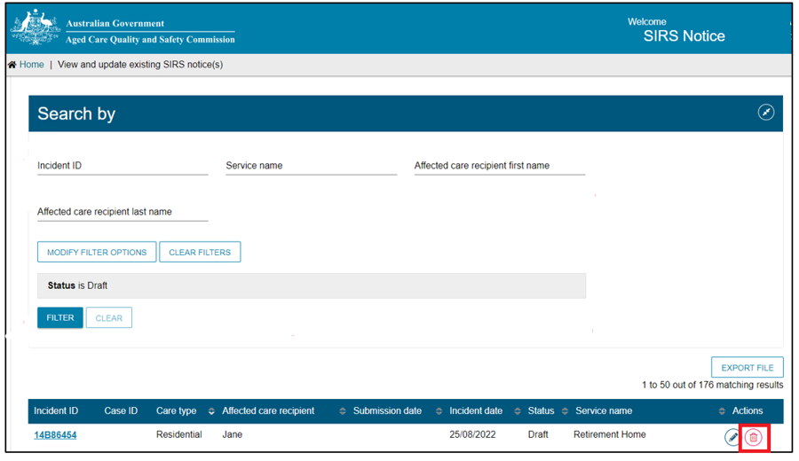
A pop-up will appear, prompting you to confirm your deletion.
Select OK to delete the draft notice.
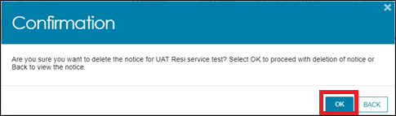

Exporting a list of draft SIRS notices
If you are an Organisation Administrator, you will be able to export a list of draft SIRS notices. Outlet Administrators and staff, however, cannot export draft SIRS notices.
- Log in to the My Aged Care Service and Support Portal, and select the SIRS Notice tile from the home page.
- Select the View and update existing notices tile.
- Select the EXPORT FILE button on the right-hand side of the page. If this button is not visible, check your permissions as it will only be visible for Organisation Administrators.
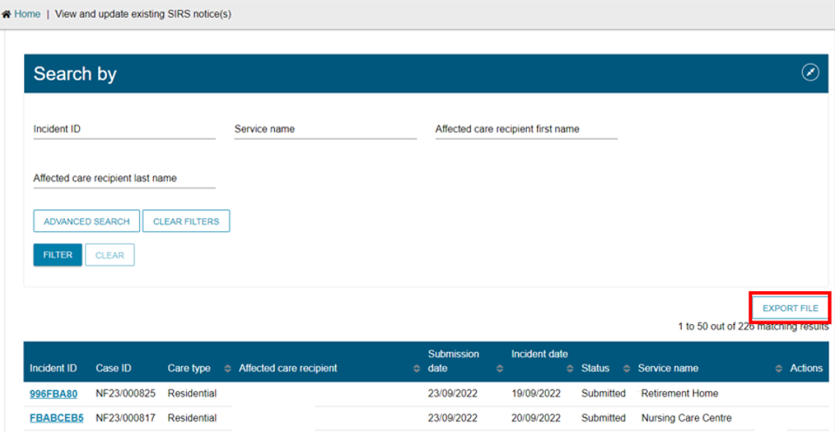
- A .csv file will be automatically downloaded to your computer with the following name format:
“DraftNotices_” + “YYYY” + “MM” + “DD” + “hhmmss” + “#” + “.csv”.
For example, “DraftNotices_202206101504556.csv” (where “hh” is 24hr time).
The file contains the following information about each draft SIRS notice as a table:
- Notification status
- Care Type
- Service name
- Date/time incident reported
- Date/time incident occurred
- Incident type
- Affected care recipient first name
- Affected care recipient last name
- Psychological impact
- Physical impact
- Provider determined priority level
Use Microsoft Excel or an equivalent spreadsheet editor to open the .csv file.
! | .csv files cannot store anything beyond numbers and text.  If you edit a .csv file in Excel, and then use any of Excel’s formatting or formula tools, you must save as an .xlsx file to keep your changes

Viewing SIRS follow-up notifications
- Log in to the My Aged Care Service and Support Portal and select the SIRS Notice tile on the home page.
- Select the Follow ups tile.
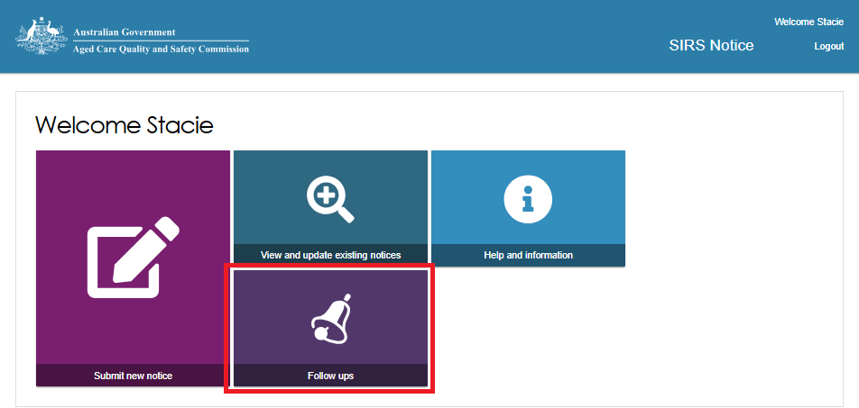
To search for a specified follow up, input search terms into the Incident ID, or Service name search fields, and select the FILTER button. The results will be listed in the table below.
Once you have found the appropriate follow-up in the table, select the name of the follow-up under the Category column to view it.
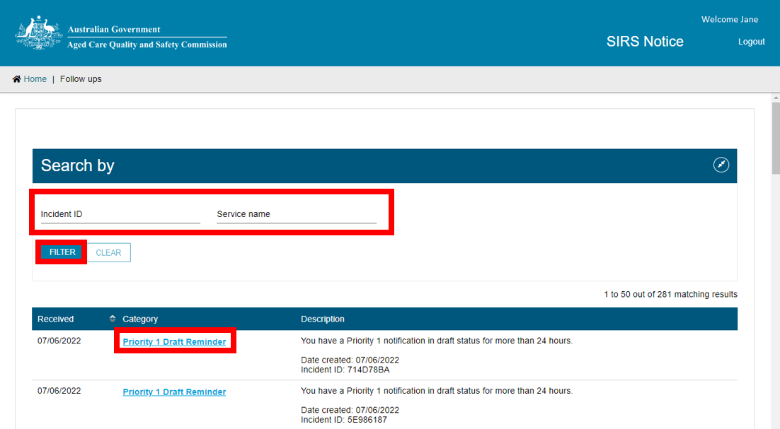
! | If you are an administrator or team leader you will be able to view all follow up emails concerning cases relevant to your organisation and outlet respectively.  Staff members can only view follow ups concerning draft notifications created by themselves.
- A pop-up window will appear, detailing the chosen follow-up. When you have finished reading the follow-up, select the CLOSE button.
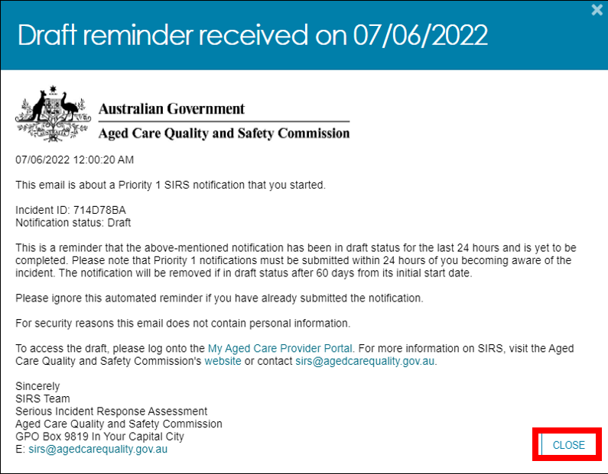
You can also use the Follow ups page to easily create a new SIRS notice.
Select the NEW SIRS NOTICE button at the bottom of the page to begin creating a new notice.
For more information, refer to the Submitting a new SIRS notice section of this guide.
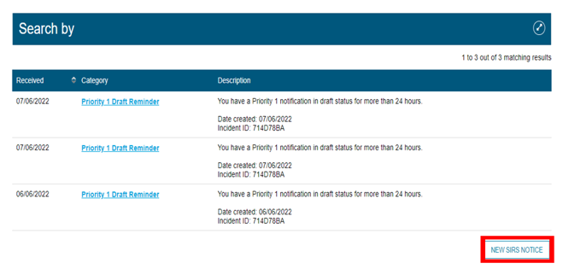
! | Follow-ups concerning drafts will remain in your list for 60 days, after which they will be deleted.

Uploading multiple SIRS notices at once
From 1 November 2025, the Bulk Upload function of the SIRS Portal will not be available.

Accessing SIRS help and further information
- Log in to the My Aged Care Service and Support Portal, and select the SIRS Notice tile.
- Select the Help and information tile.
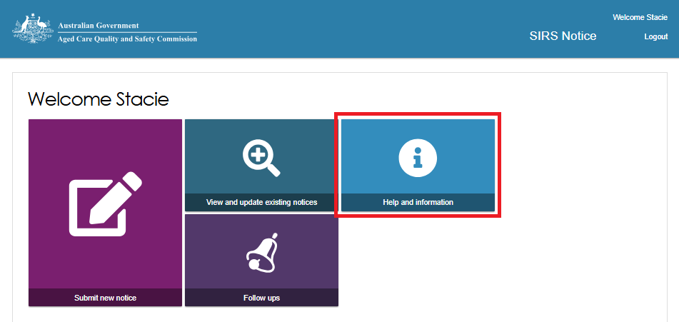
- The various channels for additional help and information will be displayed. Select the links within each information column to navigate to the corresponding information or help resource.
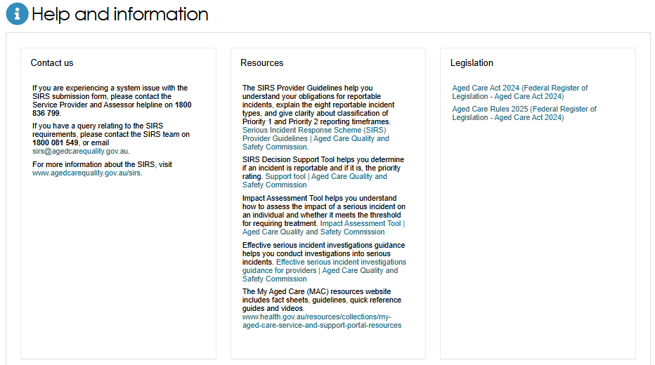
! | If you require further assistance, please contact the My Aged Care Service Provider and Assessor helpline on 1800 836 799, Monday to Friday (8am to 8pm) and Saturday (10am to 2pm) local time across Australia.  If you have a query relating to the SIRS requirements, please contact the SIRS team on 1800 081 549, or email sirs@agedcarequality.gov.au.

