Service and Support Portal User Guide – Managing Referrals for Service
This User Guide is designed for Team Leaders within the My Aged Care Service and Support Portal and describes the procedures for managing referrals.
Each provider outlet needs at least one person assigned the 'Team Leader' role in the portal. This person will be responsible for managing referrals for service (accepting, accepting to waitlist, rejecting referrals and revoking referrals after acceptance) within the portal.
This guide contains the following topics:

Introduction 2
Viewing Referrals 2
Accepting or Rejecting a Referral for Service 7
Accepting a Referral 11
Rejecting a Referral 13
Revoking a Referral After Acceptance 17
Revoking a Referral - Client Deceased 19
Accepting a Referral to Waitlist 20
Retrieving a Referral Code 22
Drawing a Client into Service from a Waitlist 24
Notifications for Overdue Referrals 26
Referral History 26
Referral Priority Status 27
More Information and Support 27

Introduction
Service Providers may receive referrals from clients for services via four different pathways:
- Clients with existing approvals for care types under the Aged Care Act 2024 can approach service providers directly. These clients may not be registered with My Aged Care.
- Providers can receive electronic referrals for service via the Portal.
- Clients can approach providers directly with a referral code issued by assessors or the My Aged Care contact centre; or
- Providers can accept electronic referrals to their waitlist, if a waitlist is available.
These pathways are described in detail in this guide.
For further detail regarding the procedures for managing referrals, please refer to the My Aged Care Service and Support Portal User Guide: Part 2 - Team Leader and Staff Member functions.
! Referrals for service mentioned in this guide are for Support at Home referrals, which may include multiple service types and services (excluding self-referrals). Providers either receive referrals electronically or via a referral code, depending on the client’s preferences, and incoming referrals have a priority status (low, medium, high).
! All clients with existing approvals should be registered in My Aged Care. Please contact the My Aged Care Assessor and Service Provider helpline on 1800 836 799 for further assistance.

Viewing Referrals
To view referrals and search for a particular client:
- Select Service referrals from the homepage.
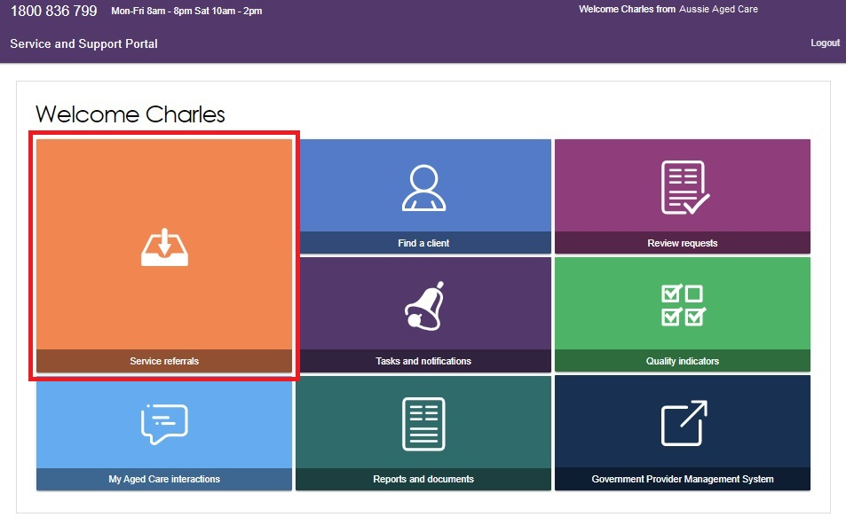
Team Leaders and Staff Members can view referrals, however only Team Leaders can accept, accept to waitlist, and reject referrals or revoke referrals after acceptance. You may have multiple roles within the provider portal. Your homepage will display different tiles depending on the role(s) you are assigned.
Alternatively, from any other page in the Service and Support portal, you can choose the Service referrals option from the tool bar displayed at the top of the portal.
You will need to select the relevant outlet name to ensure that you are looking for referrals in the correct outlet. This can be done by selecting the outlet name from the top right corner of the portal, next to the Logout link.
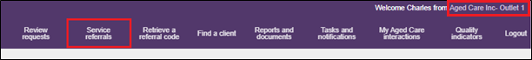
- The Incoming referrals page will now display a list of incoming referrals (those that have not been actioned). You can alternate between card and list view by using the toggle at the top of the page.
LIST VIEW
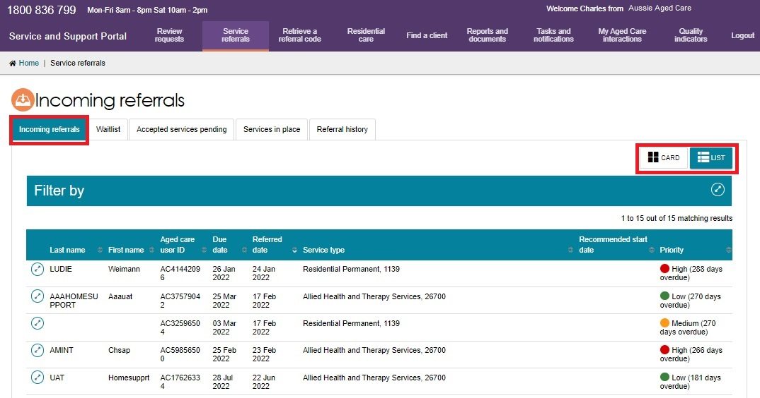
CARD VIEW
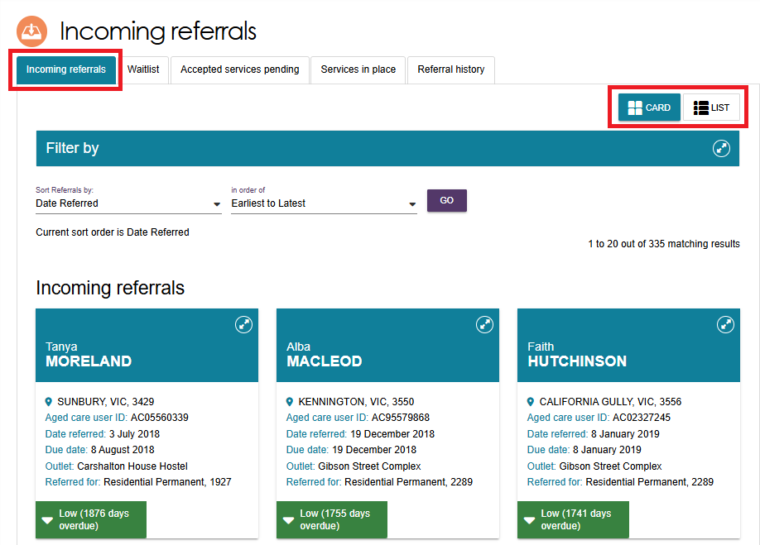
- Select the Expander icon in Card or List view next to each person’s listing, to display more information about the referral.
In the case of Support at Home services, If the client has more than one Support at Home classification assigned or approved, they will all be listed in the expanded Card or List view, along with their funding status.
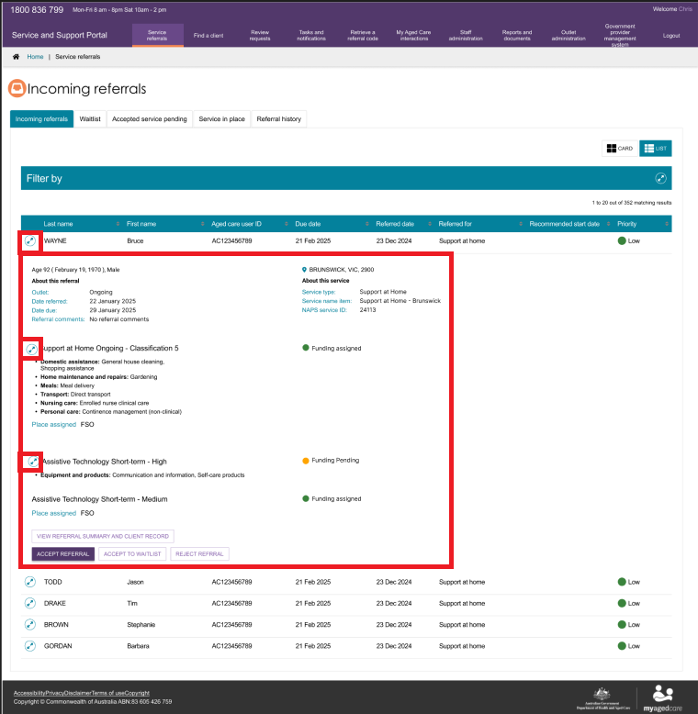
- You can refine the search results by entering a client’s First name, Last name, or Aged Care User ID. You can show the filter option by clicking the double arrows (expander) icon at the right of the filter bar.
You can use the Advanced search button to expand search parameters.
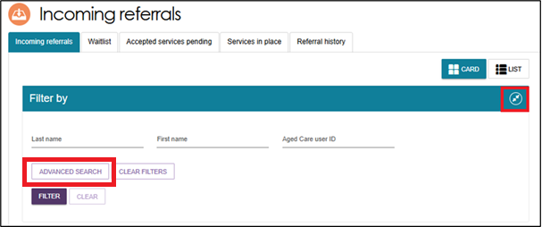
The Search incoming referrals pop up then displays. The following search filters can be chosen from the Optional Filter Field drop down box and applied to your search by clicking Add Filter. You can save any filters that have been applied by selecting Save filter, so that they may be quickly used again through the Advanced search option.
- Aged Care User ID
- Due date
- First name
- Last name
- Locality
- Outlet
- Postcode
- Priority
- Recommended start date
- Referred date
- Service type
- State
- Suburb.
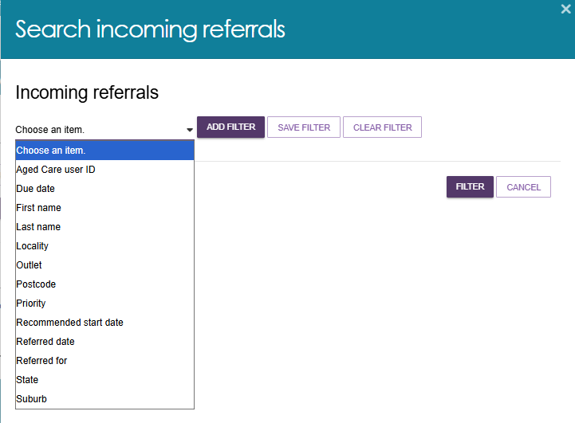
When finished, select Filter.
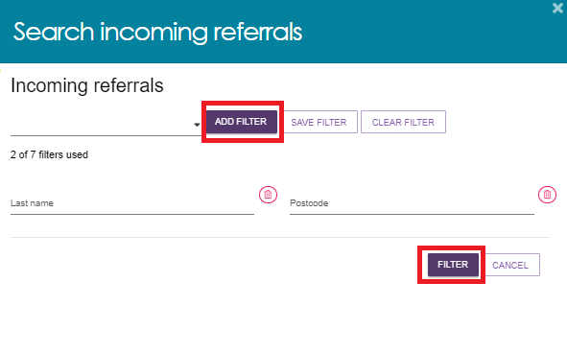
Alternatively, these referrals can also be sorted by the following fields, in either ascending/descending or alphabetical A-Z/Z-A:
- Client Last Name
- Client First Name
- Aged Care User ID
- Suburb
- State
- Postcode
- Locality
- Date Referred
- Due Date
- Recommended Start Date
- Priority
- Service Type.
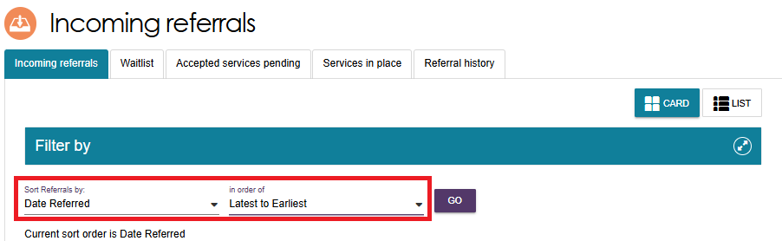

Accepting or Rejecting a Referral for Service
To accept a referral for service, select Service referrals from the home page, the toolbar at the top of the portal, or the side-bar from the Menu option at the top left of the portal and follow the procedure below.
For Support at Home services, once funding has been assigned, providers can view the provision of a referral code to the client. Providers should note the take up deadline by which they must have commenced services with a client, or else funding will be withdrawn.
! Referrals for waitlists are no longer sent as a specific waitlist referral. If a waitlist is available for the service the client has been referred to, a team leader can accept the referral to start service immediately or accept the referral to waitlist.
- From the Incoming referrals tab in Service referrals select the expanding arrows at the top right of the referral in card view, that you wish to view to display information about the referral.
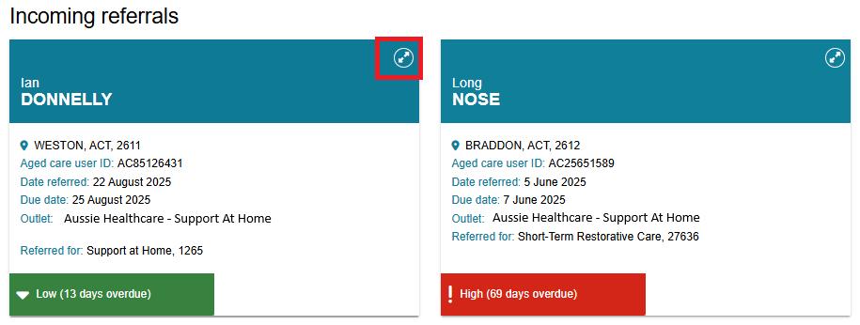
Or in list view, select the expanding arrows to the left.
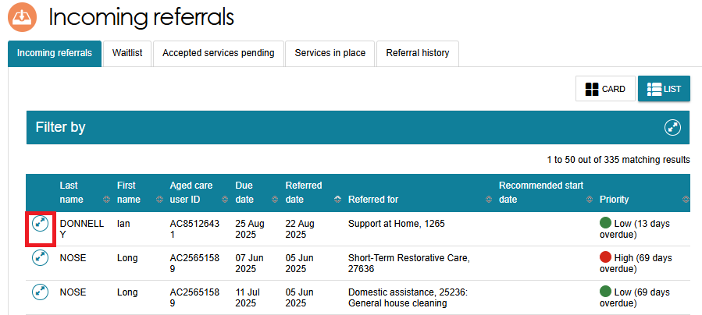
The expanded information will provide, in addition to what was already visible, the NAPS Service ID that the referral was issued to, any referral comments made by the assessor or contact centre, and whether or not the client has multiple referrals for additional service types to your outlet.
You may decide to accept, reject or waitlist referrals based on the information available on the referral card. However, if you want to see more client information prior to accepting a referral, select View referral summary and client record to view details of the referral, the client’s assessment and assessment outcomes and more detailed information about the client.
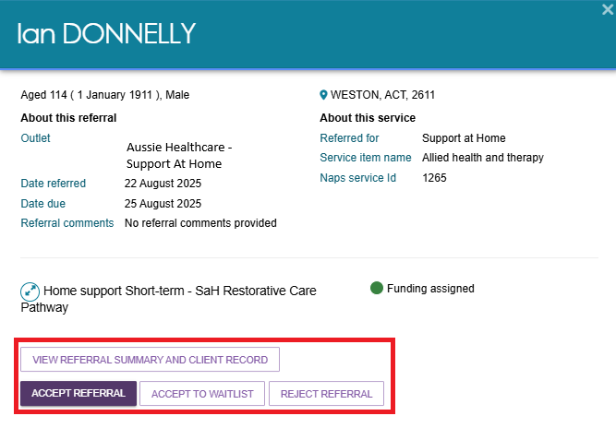
! For Support at Home services, the detailed referral view will display the recommended frequency and intensity.
! The detailed referral view will also display the recommended frequency and intensity of recommended CHSP services. This is a recommendation only to assist providers when discussing service options with the client. This information is also available from the Services and Referrals for my Organisation tabs in the client record.
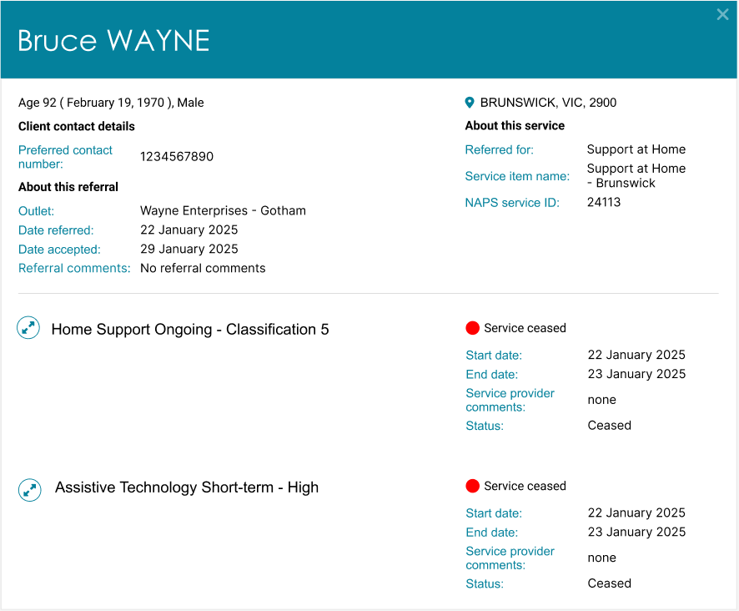
- If you select View referral summary and client record, the Referrals for my organisation screen will display. Any referrals issued to your organisation for the client will be displayed.
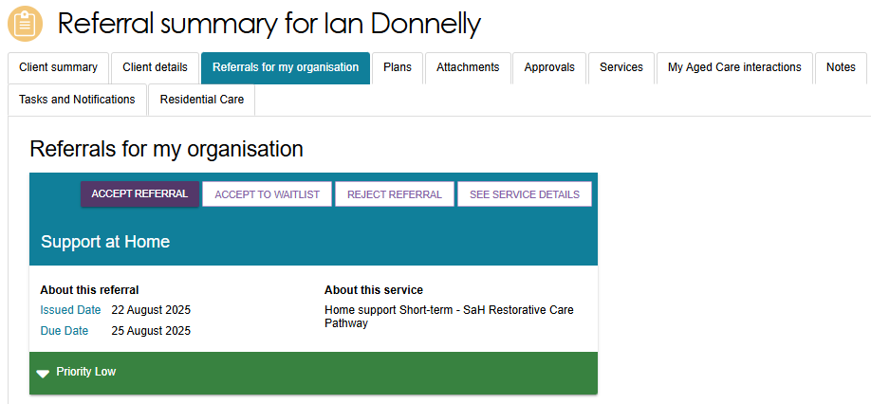
Referrals are also shown on the Services tab.
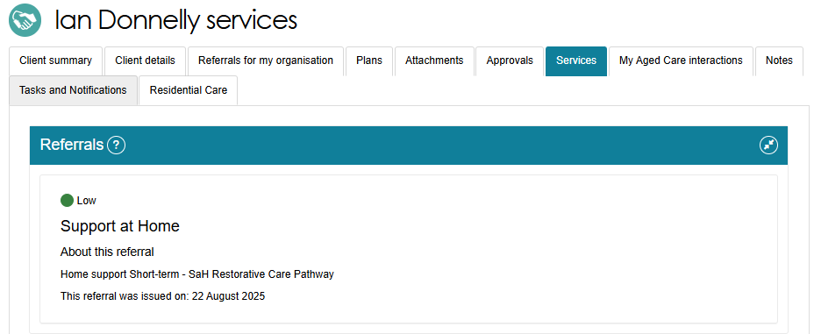
- You must review the referral and client information and that you have decided to provide services to the client prior to accepting the referral.
The information is located in the Client Details tab. These details include:
- Primary contact person
- Identity information and status of identity check
- Communication requirements
- Address and contact details (Suburb, State/Territory and postcode only) (viewable only once a referral has been accepted)
- Payment details
- Health insurance details
- Service information
- Current notes
- A Notify My Aged Care of Death button.
You can view the following information on the other tabs of the client record:
- Client Summary
- Referrals
- Attachments
- Approvals under the Act
- Services in place
- Tasks and notifications for that client
- My Aged Care interactions
- Current and previous assessment and support plan review information.
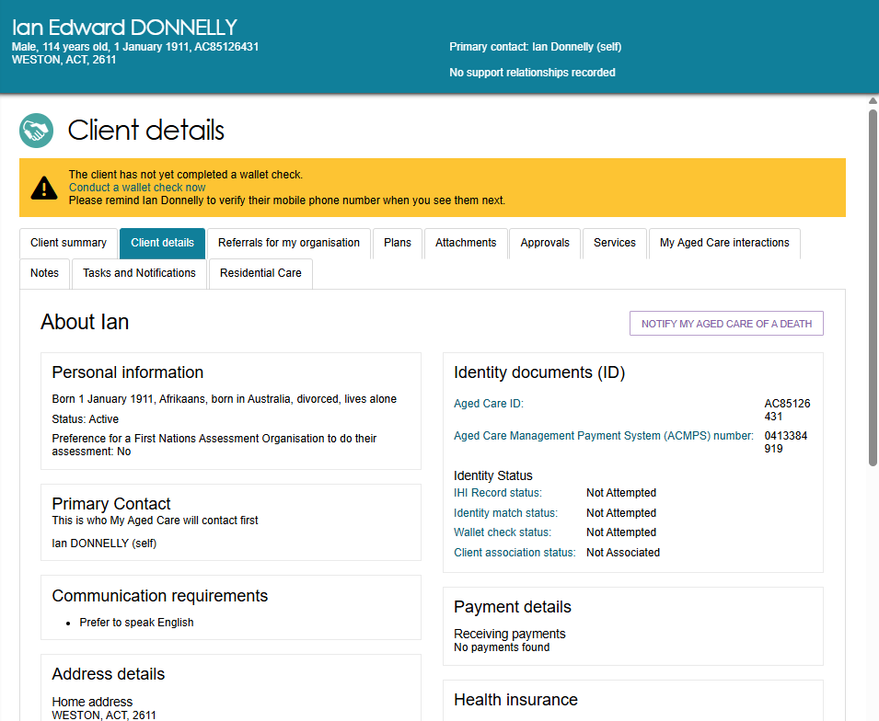
- Finally:
To accept the referral, refer to Accepting a Referral.
To reject the referral, refer to Rejecting a Referral.
To accept the referral to waitlist, refer to Accepting a Referral to Waitlist.
The Service and Support Portal User Guide – The Client Record contains further information about navigating the client record and what information can be viewed.

! It is critical that you review the referral and client information and that you have decided to provide services to the client prior to accepting the referral.
! Only accept the referral once the provider has confirmed the capacity to deliver the required services. Client agreement to proceed should also be confirmed prior to acceptance.
! Client contact details and full address details can only be viewed once a referral has been accepted.

Accepting a Referral
- To accept the referral, select ACCEPT REFERRAL from the Referral summary page or from the expanded card or list view in incoming referrals tab.
Accepting Referral from Referral Summary
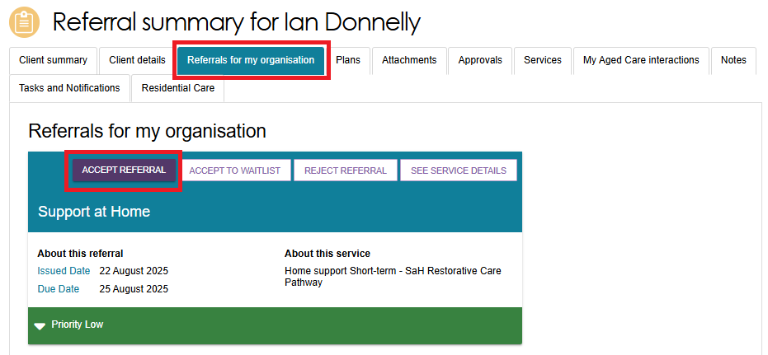
Accepting Referral from Incoming Referrals Tab (Card View)
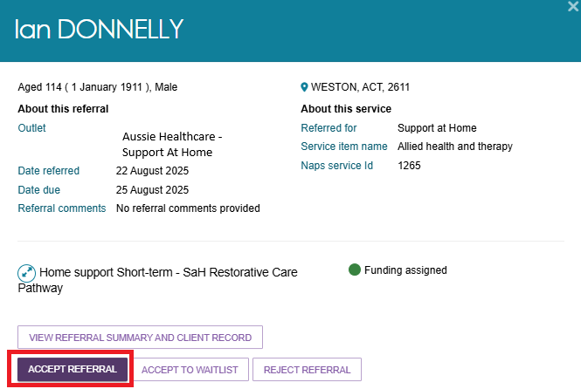
Accepting Referral from Incoming Referrals Tab (List View)
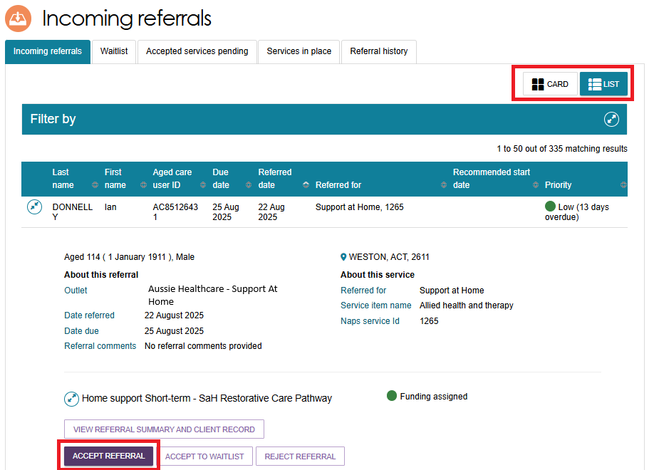
- Select the correct service item name or NAPS Service ID (if your organisational has more than one service or NAPS ID available for the service type) you wish to link the referral to. Confirm that you want to accept the referral by selecting ACCEPT.
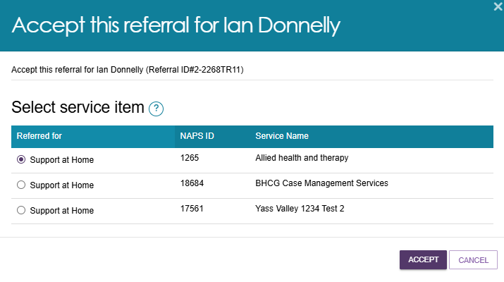
- A confirmation banner will appear at the bottom of your screen confirming your acceptance of the referral and advising that the referral.

- Access to the client’s full record including complete address and contact information, will be available through the Accepted services pending tab.
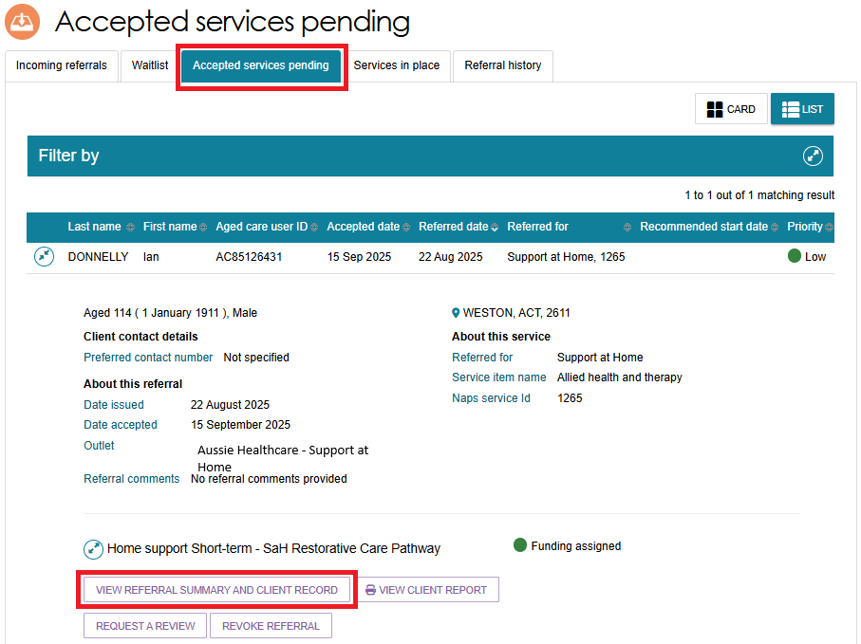
! Once a referral has been accepted, service delivery information must be provided within the priority status timeframes; details regarding this can be found in the My Aged Care - Service and Support Portal Resources page on the Department’s Website.

Rejecting a Referral
- To reject the referral, select REJECT REFERRAL located next to ACCEPT REFERRAL on the referral card or Referral summary page.
Rejecting Referral from the Referral Summary Page
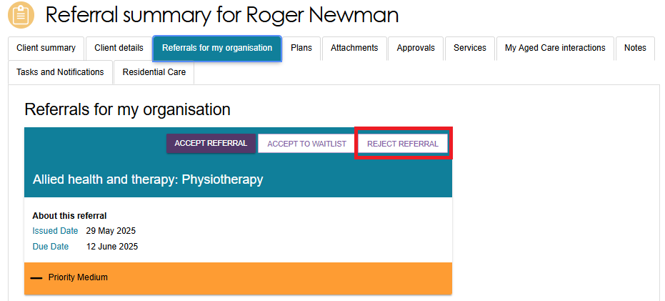
Rejecting Referral from Incoming Referrals Tab (Card View)
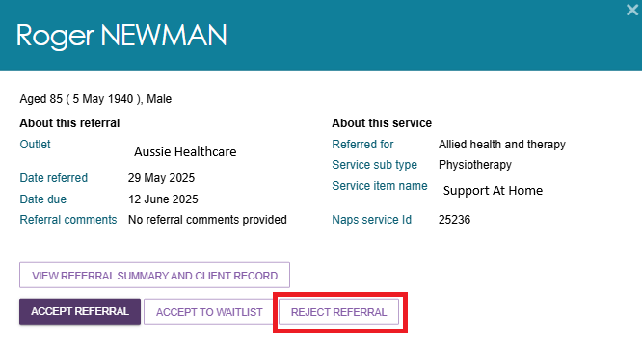
Rejecting Referral from Incoming Referrals Tab (List View)
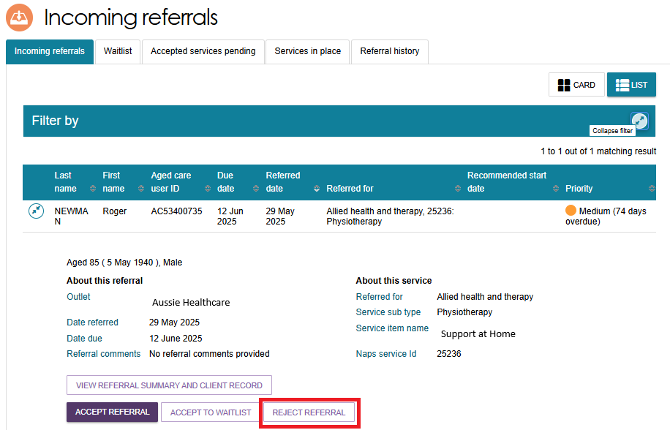
- You will be asked to select a reason for rejecting the referral from the drop-down list. You may also elect to enter additional information in the Rejection reason free text field. If a client has passed away during an assessment period, Team Leaders will need to select Client deceased from the drop-down list.
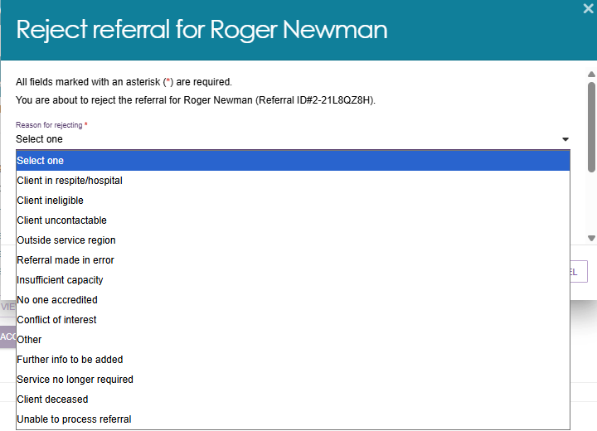
- Comments regarding the Rejection reason are displayed in the Assessor portal but not in the client’s Online Account. Providing a rejection reason assists assessors and the My Aged Care contact centre to support clients in accessing services.
Upon rejection, a confirmation banner will appear at the bottom of the screen.
! If you do not have capacity to provide the service type, your Administrator should update your service availability and information in the portal. This process is described in the Adding service items section of the Service and Support Portal User Guide Part 1 – Administrator Functions.
- If you are unable to provide the service at the time and you have a waitlist available, you can accept the referral to your waitlist. The referral will appear in your outlet’s Waitlist tab. This process is described in Service and Support Portal User Guide Part 1 – Administrator Functions. This option is only available if the service is configured by your Administrator to offer waitlist.

Rejecting a Referral – Client Deceased
! Rejecting a referral with the reason of Client deceased will change the client’s status to Deceased and make the client record read-only.
Any unaccepted service referrals will be recalled, services in place will be ceased,
assessments will be cancelled and the client’s access to the client portal will be revoked.
My Aged Care will not send correspondence to the client or their supporters after the status is changed to Deceased.
Where a client is active in the Support at Home Priority System or has been assigned Support at Home funding, this will remove the client from the Support at Home Priority System and withdraw any assigned Support at Home funding.
- After selecting ‘Client Deceased’ from Step 2, You will be redirected to the Reject referral screen and will need to enter the following information:
- Who, when and how you were informed that this person is deceased. For example, “Mrs Smith rang to inform us that Mr Smith has passed away on Saturday”
- Date of Death (if known)
- Add Attachments, for example Death Certificate, Hospital Discharge documents
- Enter additional information in the Rejection reason free text field (not mandatory).
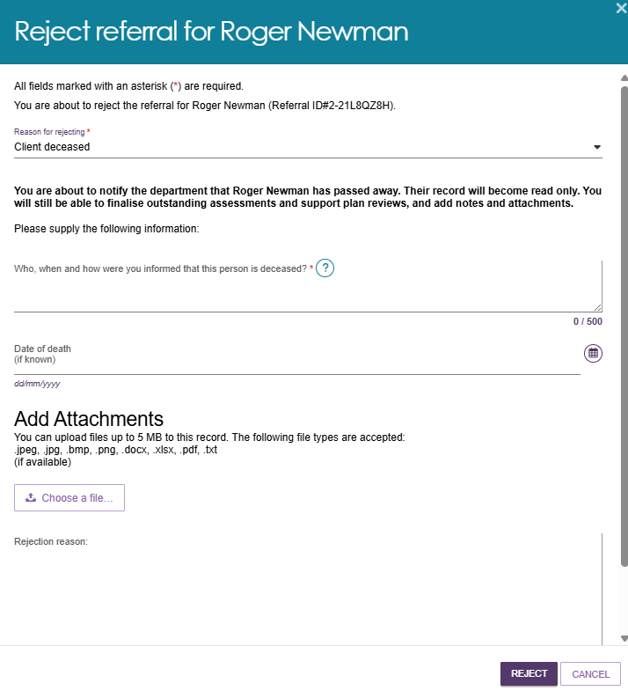
! The provider can add notes and attachments to the client record for 14 days after ceasing services for their client.

Revoking a Referral After Acceptance
There may be circumstances after you have accepted a referral for service that affect your ability to provide services to that client. For example, the client withdraws their consent for service provision, or their circumstances change.
You can only revoke accepted referrals where service delivery information has not been entered and/or services haven’t commenced.
The Department will monitor the use of this functionality, and notifications will be sent to service providers where 20% or more of referrals issued to the outlet over a period of 12 months have been revoked after acceptance.
Follow these steps to revoke a referral after acceptance:
- Navigate to the Accepted services pending tab in the Service referrals section of the provider portal and locate the accepted referral that you wish to revoke. You are able to filter the results by expanding the Filter functionality, sort the results by editing the sort order and selecting GO, or change the display of information between Card or List views.
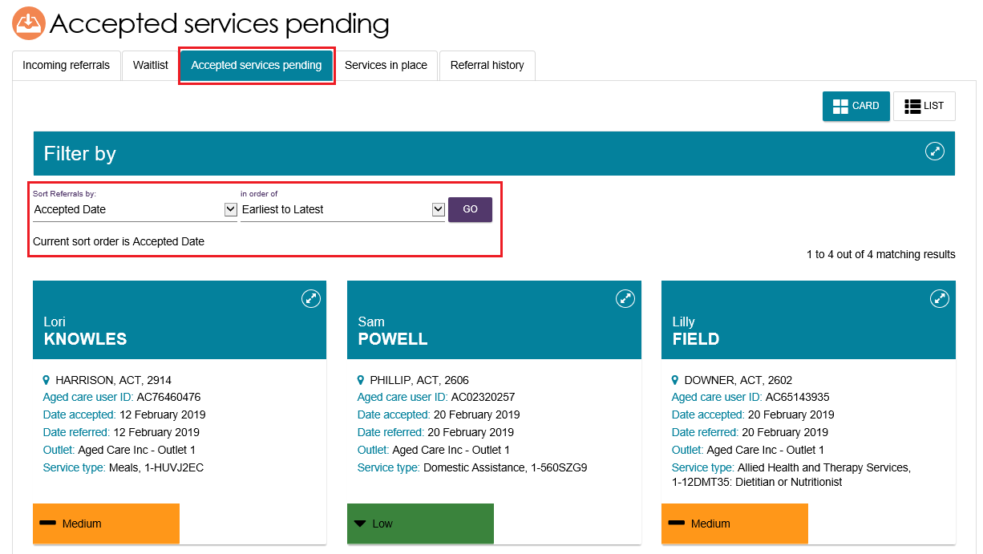
- Select the accepted referral you wish to revoke and expand the information. You are then able to select REVOKE REFERRAL.
CARD VIEW
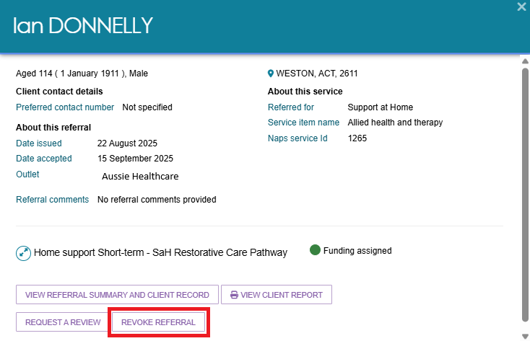
LIST VIEW
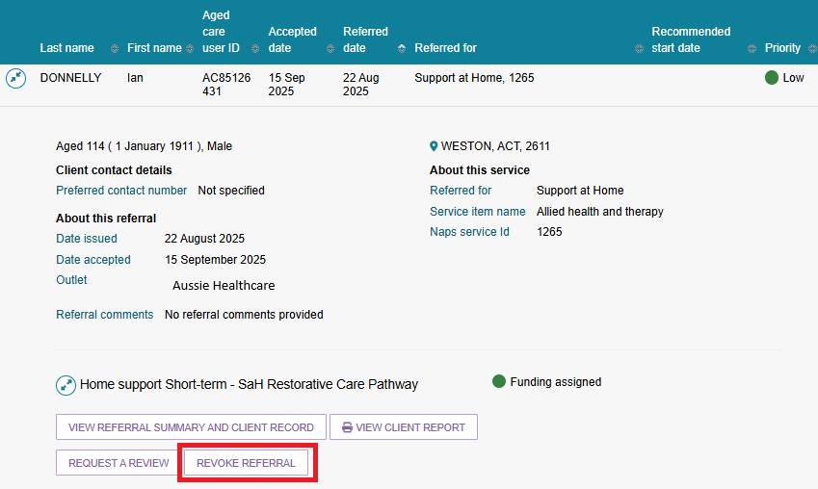
- Select the reason for revocation from the drop-down menu and enter detailed information in the Comments section to explain why you are revoking the referral after acceptance. Select REVOKE REFERRAL.
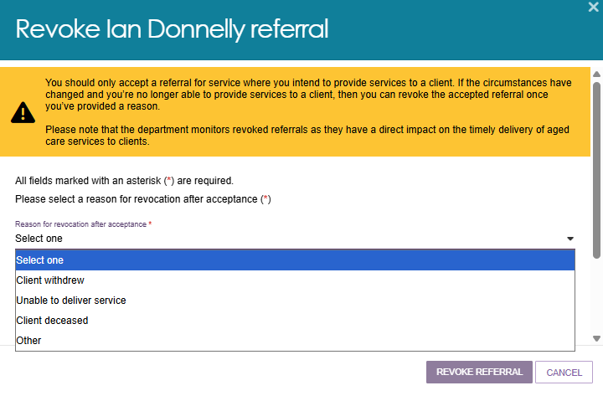
- You will receive confirmation that the referral has been revoked, and it will no longer appear in your Accepted services pending tab.
! When a referral is revoked after acceptance, other referrals (such as from a broadcast or preference referral) will be automatically issued.

Revoking a Referral - Client Deceased
Revoking a referral with the reason of Client deceased will change the client’s status to Deceased and make the client record read-only. Any unaccepted service referrals will be recalled, services in place will be ceased, assessments will be cancelled and the client’s access to the My Aged Care Online Account will be revoked. My Aged Care will not send correspondence to the client or their support network after the status is changed to Deceased.
Where a client is active in the Support at Home Priority System or has been assigned a Support at Home service, updating the client to deceased will remove the client from the Support at Home Priority System and withdraw any assigned Support at Home services.
When the Client deceased option is selected, you will be prompted to enter the following details:
- Who, when and how you were informed that this person is deceased. For example “Mrs. Smith rang to inform us that Mr. Smith passsed away on Saturday”.
- Date of death (if known)
- Attachments to be added. For example Death certificate, hospital discharge doccuments.
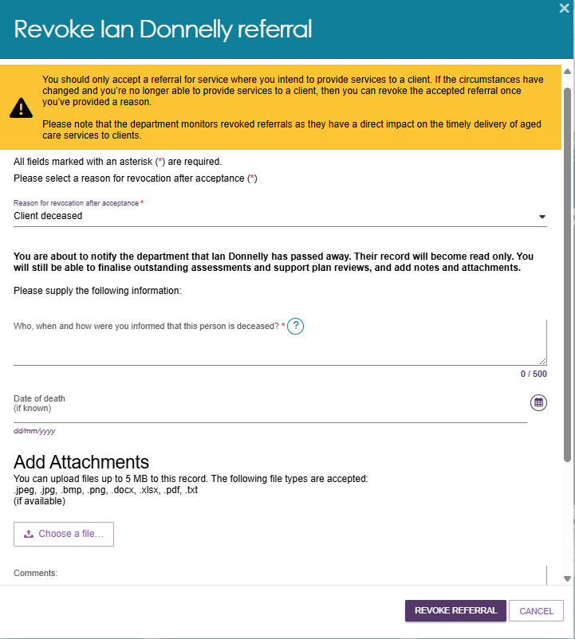

Accepting a Referral to Waitlist
If a service provider chooses to turn on the waitlist function in the provider portal, they will be able to accept electronic referrals to a waitlist. Accepting a referral to waitlist allows a client to be placed on a waitlist for a particular service until the service becomes available.
To accept waitlist referrals, the Administrator for your organisation must ensure that Waitlist availability for specific services is set to On. This procedure is described in Service and Support Portal User Guide - Create Service Delivery outlets and add Service information.
- Navigate to the Service referrals page and view the Incoming referrals tab.
- Expand the client’s information in either the card or list view and select Accept to Waitlist.
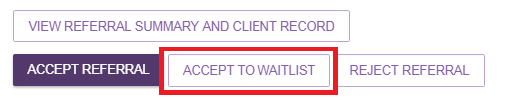
- Select Accept.
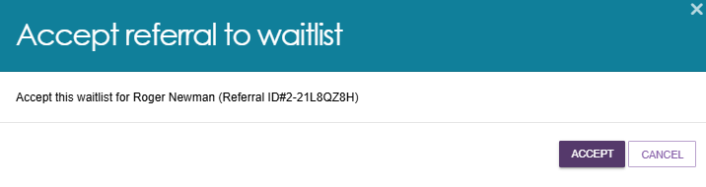
- You will receive confirmation that the referral has been waitlisted. The referral will now appear in the Waitlist tab in the Service referrals page.
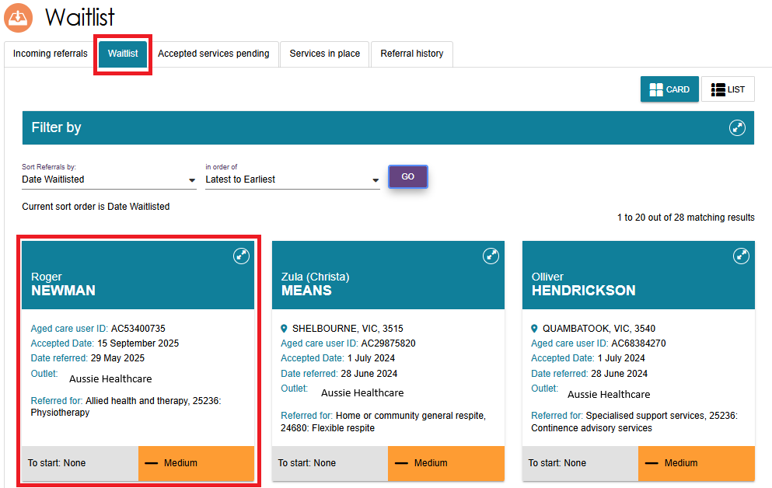

Retrieving a Referral Code
A client may choose to be issued with a referral code by assessors or My Aged Care contact centre staff. A referral code allows clients to visit different service providers to discuss their needs prior to choosing their preferred provider. If a service provider Team Leader has been given a referral code, they should follow the procedure below to retrieve the referral.
- From the homepage select Retrieve a referral code.
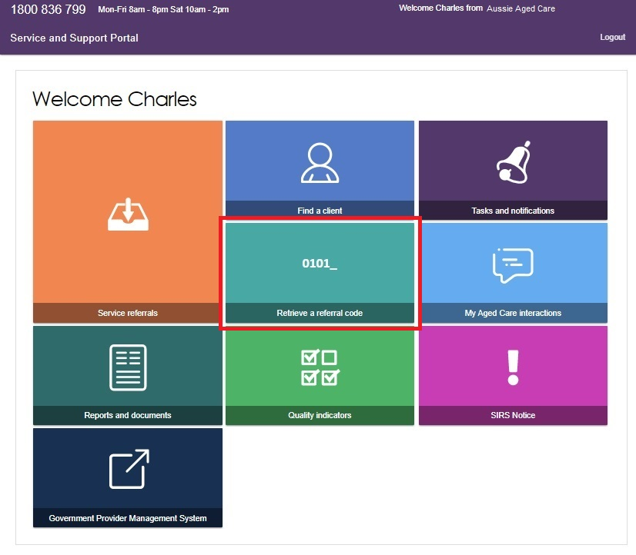
Alternatively, from any other page you can select Retrieve a referral code from the toolbar displayed at the top right corner of the portal.
- Enter the client’s referral code and select the outlet in which services will be provided from. Then select Retrieve referral.
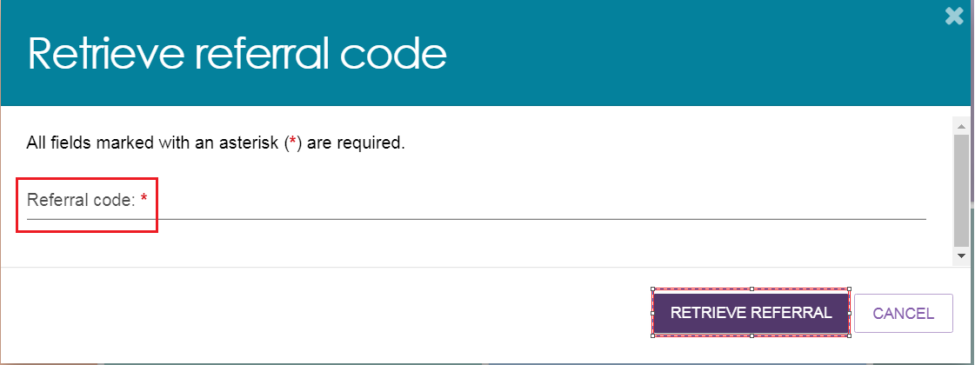
If you are a team leader at the organisation, select the outlet you wish to refer the client to. Outlet team leaders will not have this option.
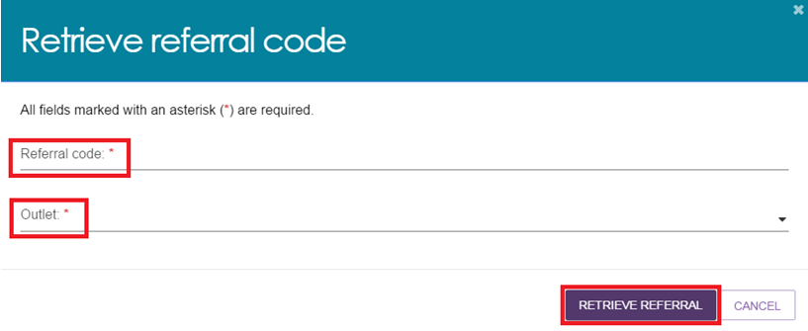
- A confirmation message will display confirming the successful retrieval of the referral, and the referral will be added to your Incoming referrals tab within the Service referrals tile.
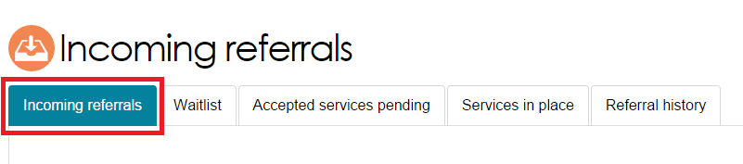
- You will be directed to the Incoming referrals page where you can view details of the referral. Depending on client preferences, and your capacity to provide services, you can either:
- accept or reject the referral for service(s);
- accept the referral to waitlist; or
- revoke the referral after acceptance.
! It is critical that you review the referral and client information and that you have decided to provide services to the client prior to accepting the referral. Only accept the referral if both the provider and client agree to commence services.
! A referral code will need to be reactivated if it has previously been accepted by another provider, a previously commenced service has ceased, or the time limited approval has lapsed. Clients and their supporter can now manage their referral codes via their My Aged Care Online Account.
! Home Support services
If you are a Support at Home service provider and encounter a client who would like to change their provider, they can reactivate their referral code via the My Aged Care Online Account. For further information, refer the client to the Access Your Online Account website or call the My Aged Care contact centre on 1800 200 422.
Referrals for Support at Home services will only be issued, usually via the provision of a referral code to the client once a service has been assigned. Providers should not use the take up deadline by which they must have commenced services with a client for the Support at Home program, or else the assigned service/s will be withdrawn.

Drawing a Client into Service from a Waitlist
When a service becomes available for a corresponding referral in your waitlist, you can draw the client into service and commence service delivery.
Clients may be on more than one waitlist, with other providers, at any one time. If a service becomes available, and the client is drawn down into service, the client will be removed from all other provider waitlists for that same service type.
- Navigate to the Waitlist tab in the Service referrals tile of the Service and Support Portal.
Referrals that have been accepted to waitlist will be displayed here.
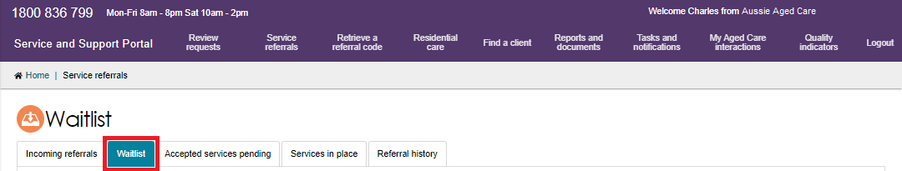
- Find the client referral that you want to accept to service and expand the client’s information by selecting the arrows on the card or list view. You can filter the results by expanding the Filter functionality, sort the results by editing the sort order and selecting Go, or change the display of information between Card or List views.
! Prior to drawing down a client into service, be sure to review the referral summary and client record to confirm that you are still able to provide this service to the client.
Select Draw down into service.
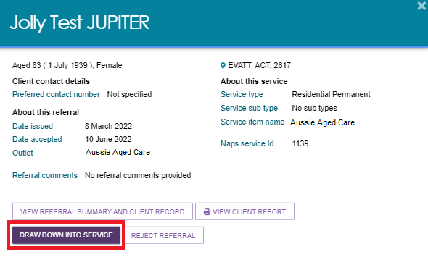
- Select the correct service item name or NAPS Service ID (if your organisation has more than one service/NAPS ID available for a service type) you wish to link the referral to. Confirm that you want to accept the referral by selecting Accept.
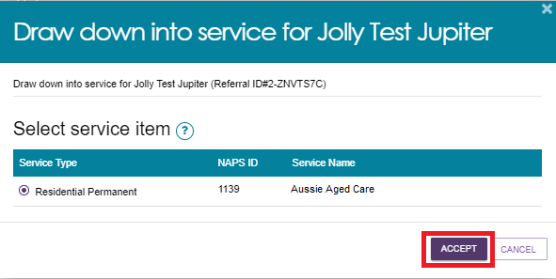
A confirmation message will appear confirming the acceptance of the referral. The referral has now been accepted into service and the client’s referral will now appear in the Accepted services pending tab until service delivery information is recorded for the service.
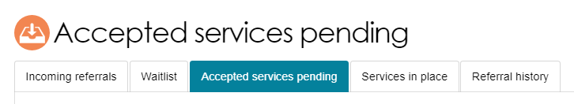
- To reject a referral that is on your waitlist, select Reject referral and a reason for rejection, then select Reject. Providing a rejection reason assists assessors and the My Aged Care contact centre to support clients in accessing services.
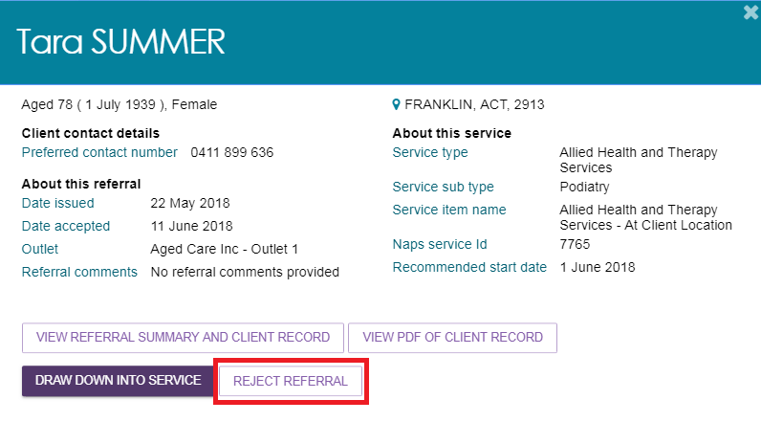
The referral will be removed from your waitlist and will no longer be visible in the Service and Support Portal.

Notifications for Overdue Referrals
Team Leaders will see visual indicators in their incoming referral tab for referrals that have not been actioned (accepted, rejected or waitlisted) within priority timeframes.
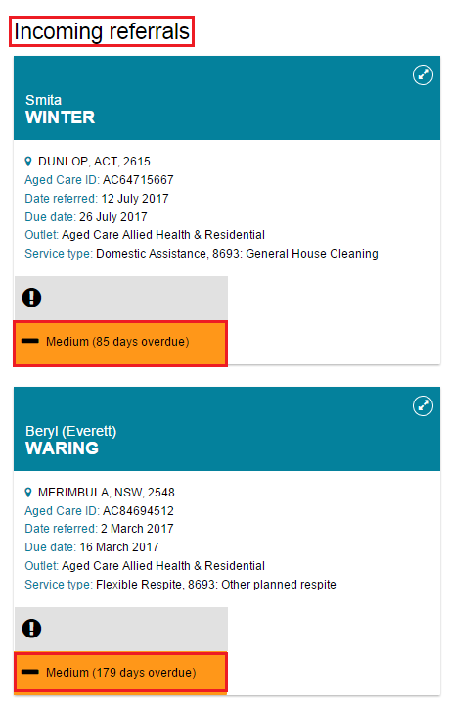
An email will also be sent to the email address connected to the outlet prompting them to action the referrals. These notifications will also display in the Tasks and notifications section of the provider portal, displaying as Overdue referral tasks.
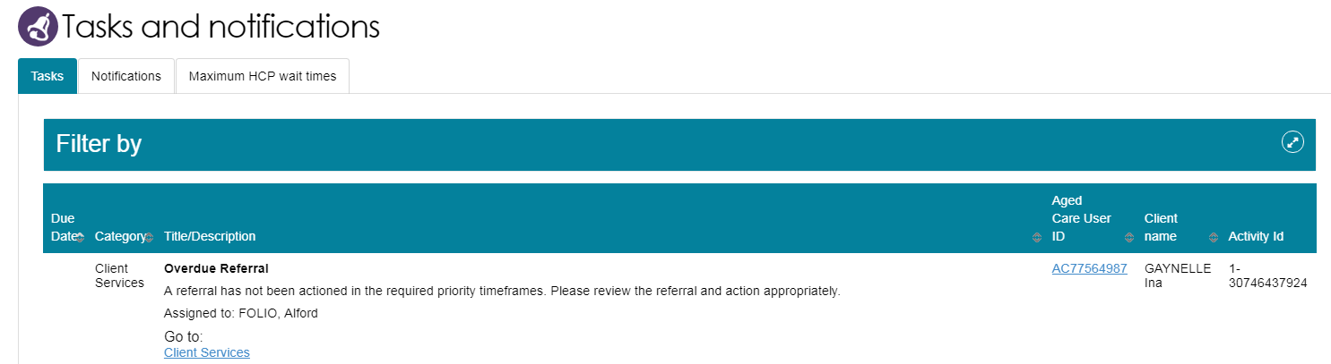

Referral History
The Referral history tab allows service provider Team Leaders and Staff Members to view referral history, including information on whether a referral was revoked or recalled.
Detailed referral information is available by selecting the arrow to the left or right of the referral (in list view or card view, respectively).
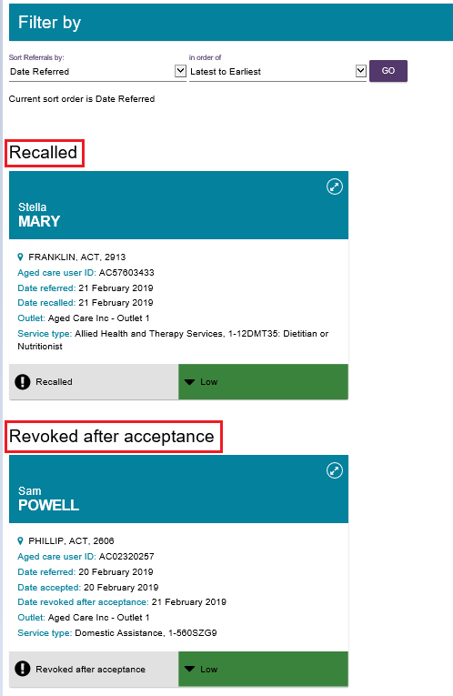
In the case of Support at Home services, If the client has more than one Support at Home classification assigned or approved, they will all be listed in the expanded Card or List view, along with their service history.

Referral Priority Status
Incoming service referrals are assigned a priority status (low, medium, high) based on a client’s level of function, the level of risk in relation to the care situation, and any other concerns that are relevant to the client’s circumstances identified during the screening or assessment process.
Service providers are required to action referrals (accept, reject or waitlist) within 3 calendar days of receiving an electronic referral for service or electronic referral for waitlist.
! Support at Home program approvals will not display as a service priority.

More Information and Support
Further information is available from the My Aged Care Service and Support Portal Resources webpage.
The My Aged Care Service Provider and Assessor Helpline is available by calling 1800 836 799.

