Quarterly Financial Snapshot
Aged Care Sector
Quarter 4 2024-25
1 April to 30 June 2025

Contents
Introduction 3
Aged care reform priorities 4
Summary of findings 6
Residential care 7
Home care 8
Residential aged care 8
Financial performance 8
Average care minutes 12
Staff cost and time 15
Hourly rates 18
Food and nutrition 20
Home care 20
Financial performance 20
Staff cost and time 24
Hourly rates 26
Care and package management 27
Unspent funds 28
Glossary 29
Appendix 32

Introduction
The Australian Government is committed to transparency in aged care. The publication of financial information gives valuable insights to the sector and community.
The Department of Health, Disability, and Ageing (the department) publishes a Quarterly Financial Snapshot (QFS) on the Australian aged care sector. The QFS:
- provides transparency about providers’ finances and operations and helps older people and their families make informed decisions about their care
- provides information for aged care providers to compare and benchmark their performance with sector-level results
- supports the monitoring of critical financial metrics across the aged care system
- complements other publications such as:
- the annual Financial Report on the Australian Aged Care Sector (FRAACS)
- registered nurse coverage in aged care dashboard
- care minutes in residential aged care dashboard
- the quarterly reporting of service-level financial and operations information on My Aged Care through the ‘Find a Provider’ tool.
This QFS covers 1 April to 30 June 2025 (quarter 4 of 2024-25). It has three sections:

The Appendix contains tips on how to read the QFS, including provider type definitions, information about data sources, and methodologies used.
An Excel data extract containing all headline figures from QFS reports published to date is available on the department’s website. It includes a breakdown of results by provider types.
The department would like to thank all aged care providers who completed the Quarterly Financial Report (QFR) and helped develop the QFS.

Aged care reform priorities
The Australian Government is continuing to develop programs and initiatives that underpin high quality and safe aged care in Australia. These reforms strengthen choice and transparency for older people, their families and carers. They also improve the sustainability of the aged care sector.

Data reference: Timeframe for data presented in this report
The financial results presented in this report are the year-to-date (YTD) results for the financial year ending 30 June 2025. Additionally, comparisons have been provided to the YTD results for the financial year ending 30 June 2024. For readability, results are presented as being for ‘quarter 4 2024-25’ and ‘quarter 4 2023-24’ respectively.
Reform impacts on quarter 4 2024-25 results
The quarter 4 2024-25 results show the impact on aged care providers of the following reforms and initiatives:
- additional investment to fund the Fair Work Commission’s (FWC) further decisions in the Aged Care Work Value Case:
- $3.8 billion from 1 January 2025 for the Stage 3 decision, which increased the award wages for approximately 340,000 aged care workers
- $2.6 billion from 1 March 2025 for the aged care nurses decision, increasing award wages for approximately 60,000 enrolled and registered nurses employed in aged care.
consecutive increases in the AN-ACC price, from $253.82 to $280.01 from
1 October 2024, and to $282.44 from 1 March 2025. Similarly, consecutive increases to the hotelling supplement from $11.24 to $12.55 from 20 September 2024, and to $13.46 from 20 March 2025. These uplifts support residential aged care providers to meet increased costs.
- an increase of 2.8% to the 24/7 registered nurse (RN) supplement on
1 March 2025 to assist providers to meet the FWC’s Stage 3 decision.
an increase in the mandatory care minutes responsibility requiring providers to deliver an average of 215 care minutes per resident per day from 1 October 2024. This includes 44 minutes of registered nurse care, of which up to 10% can be met by enrolled nurses.
an increase to the maximum room prices a provider can charge without approval from the Independent Health and Aged Care Pricing Authority (IHACPA) from $550,000 to $750,000 on 1 January 2025.
Home Care Package (HCP) subsidy rates increased by 0.93% on 1 January 2025 and 0.10% on 1 March 2025 to assist providers to meet the FWC’s Stage 3 decision.
the release of an additional 31,715 HCPs in 2024-25.
Future reform impacts
In future QFS reports the department expects to see further operational and financial impacts on the sector following the introduction of the following initiatives:
provider preparations for the commencement of the Aged Care Act 2024, regulatory model, and Support at Home program. These will mark changes to provider operations, including to provider registration and renewal processes, the strengthened Aged Care Quality Standards, and worker screening for aged care.
- the implementation, from April 2026, of the new care minutes supplement, which will see non-specialised residential aged care services in MM1 areas receive their full care minutes funding only if they meet their care minutes targets in
quarter 2 2025-26. This change is intended to incentivise providers to meet their care minutes targets.
- measures announced in the Government response to the Aged Care Taskforce.
- requiring providers to permanently retain 2% per annum of Refundable Accommodation Deposits and Refundable Accommodation Contributions (capped at five years of retentions) from 1 November 2025, and
- requiring providers to index Daily Accommodation Payments twice per year by the consumer price index for residents that enter care on or after
1 November 2025.
More information on aged care reform is available on the department’s website.

Summary of findings
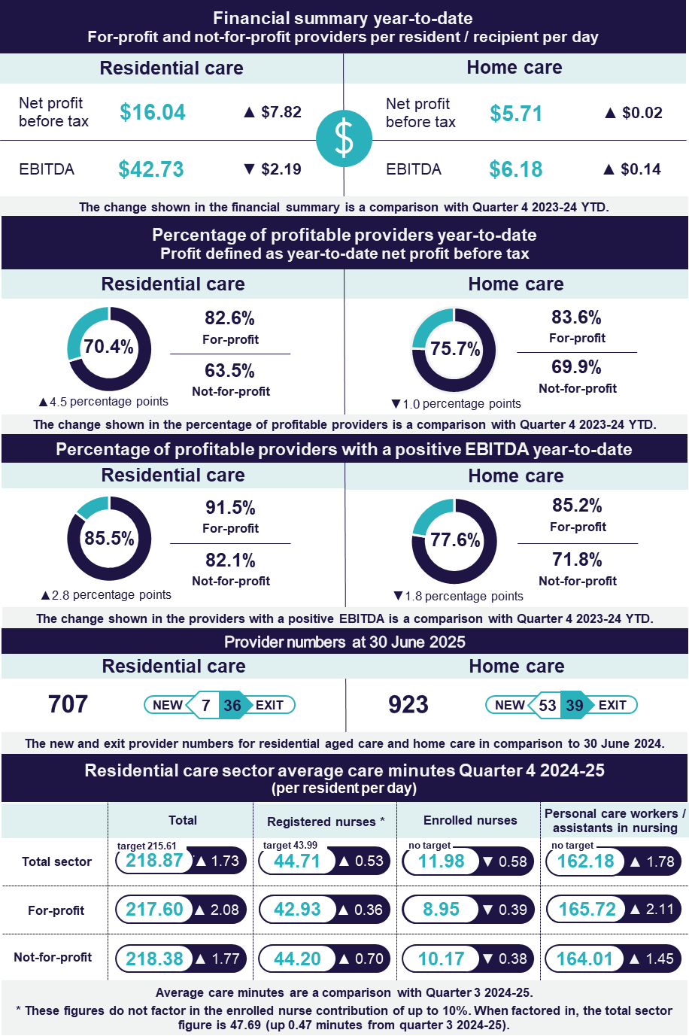

Residential care
The net profit position of the residential aged care sector improved between quarter 4 2023-24 and quarter 4 2024-25.
- EBITDA was $42.73 per resident per day, down by $2.19.
- 85.5% of providers reported a positive EBITDA position, up
2.8 percentage points.
- Sector EBITDA was a positive $3.0 billion, down from $3.1 billion.
- The median EBITDA margin was 8.0%, down 1.0 percentage point.
- NPBT was $16.04 per resident per day, up by $7.82.
- 70.4% of providers reported a positive NPBT position, up 4.5 percentage points.
- Sector NPBT was a profit of $1,124.8 million, up from $571.3 million.
- Average occupancy rate increased to 90.6%, up 2.1 percentage points.
Key points:
- The net profit position of the sector improved between 2023-24 and 2024-25.
The sector NPBT improved by $553.5 million, with a NPBT of $1,124.8 million in quarter 4 2024-25, compared to $571.3 million 12 months prior. The increase was driven by sector revenue growth of 8.9% exceeding sector expense growth of 7.2% in 2024-25.
Strong sector revenue growth was driven by significant increases in AN-ACC funding, with growth in sector expenses attributed to increased wages for direct care staff; and increased direct care staff time, with providers increasing their compliance with their care minute and 24/7 registered nursing requirements and increasing acuity of resident needs. Comparatively, the smaller increase in the sector expense growth was attributable to providers having written off a higher proportion of their bed licenses in 2023-24 than in 2024-25.
The department anticipates seeing continued increases in expenses, as a result of increased direct care staff time to meet care minutes targets, in the lead up to care minute funding changes that will link care funding to the delivery of care minutes for providers of non-specialised services in metropolitan areas.
- Total care minutes delivered increased between quarter 3 and 4 2024-25. Compliance still remains short of targets for many services.
In quarter 4 2024-25, providers delivered an average of 218.87 care minutes per resident per day (up 1.73 minutes from quarter 3 2024-25) and exceeding the target for the quarter (215.61 minutes) by 3.26 minutes. This included
47.69 minutes delivered by a registered nurse (including the enrolled nurse contribution) (up 0.47 minutes from quarter 3 2024-25). Sector-wide, 54.2% of services now meet both their service level total care and registered nurse care minute targets (with enrolled nurse contribution), up 5.2 percentage points from quarter 3 2024-25.
Further trends in compliance with care minutes responsibilities can be found in the Residential aged care section of this QFS, below.

Home care
The EBITDA and NPBT positions of the home care sector were stable between quarter 4 2023-24 and quarter 4 2024-25.
- EBITDA was $6.18 per care recipient per day, up by $0.14.
- 77.6% of providers reported a positive EBITDA position, down
1.8 percentage points.
- Sector EBITDA was a positive $598.4 million, up from $561.6 million.
- The median EBITDA margin was 6.7%, down 0.8 percentage points.
- NPBT was $5.71 per care recipient per day, up by $0.02.
- 75.7% of providers reported a positive NPBT position, down
1.0 percentage point.
- Sector NPBT was a profit of $553.1 million, up from $528.8 million.
Key point:
- While the sector maintained its NPBT position, there was a decline in the NPBT margin between 2023-24 and 2024-25.
The average NPBT margin decreased from 7.7% in quarter 4 2023-24 to 7.0% in quarter 4 2024-25. The decrease was driven by sector expense growth of 10.6% exceeding sector revenue growth of 9.8% in 2024-25.
The increase in revenue was attributed to a 4.2% increase in claim days and increased utilisation of HCPs from 82.7% in 2023-24 to 86.4% in 2024-25. The change in expenses was driven by an increase in labour costs, up 9.3% between quarter 4 2023-24 and quarter 4 2024-25.

Residential aged care

Financial performance

Financial summary
The net profit position of the residential aged care sector improved slightly between quarter 4 2023-24 and quarter 4 2024-25. In quarter 4 2024-25:
- Sector EBITDA was $3.0 billion (Table 1), with an average EBITDA margin of 9.4% (down from 10.6% in quarter 4 2023-24).
- Sector NPBT was $1,124.8 million, with an average NPBT margin of 3.5% (up from 1.9% in quarter 4 2023-24).
- Revenue grew by $33.59 per resident per day (up 8.0%). This was primarily driven by a $0.8 billion increase in AN-ACC funding, from $5.1 billion in quarter 4 2023-24 to $5.9 billion in quarter 4 2024-25.
- Expenses grew by $25.77 per resident per day (up 6.2%). This was driven by higher labour costs, specifically, increased wage costs and employee benefits.
Table 1: Quarter 4 2024-25 and comparison with quarter 4 2023-24, summary of financial performance of residential for-profit and not-for-profit aged care providers
 | Total | Per resident per day | Change from Q4 2023-24 per resident per day
Revenue | $31,987.3m | $456.17 | ▲ $33.59
Operating expenses | $28,991.0m | $413.44 | ▲ $35.78
EBITDA | $2,996.3m | $42.73 | ▼ $2.19
Average EBITDA margin | 9.4% | 9.4% | ▼ 1.2  percentage points
Non-operating expenses | $1,871.6m | $26.69 | ▼ $10.01
Net profit before tax | $1,124.8m | $16.04 | ▲ $7.82
Average NPBT margin | 3.5% | 3.5% | ▲ 1.6  percentage points
Note: The average EBITDA margin (which indicates the EBITDA return on revenue) is calculated by dividing the sector EBITDA result by the sector total revenue.

Profitable providers
At quarter 4 2024-25:
- 70.4% of providers were profitable (defined by NPBT) (up 4.5 percentage points from quarter 4 2023-24) (Figure 1).
- profitable providers serviced 75.9% of residential care recipients
(up 11.8 percentage points from quarter 4 2023-24).
Figure 1: Percentage of profitable providers and percentage of residents serviced by profitable providers at quarter 4 2024-25, and comparison with quarter 4 2023-24
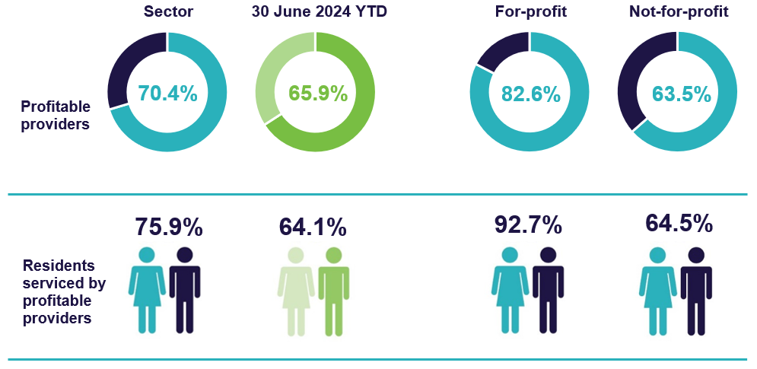

EBITDA margin
In quarter 4 2024-25, the median EBITDA margin for the sector was 8.0% (down
1.0 percentage point from quarter 4 2023-24) (Chart 1), which means an EBITDA return of $8.00 for every $100 of revenue earned.
Chart 1: Median and quartile EBITDA margin (quarter 4 2023-24 to quarter 4 2024-25)

Occupancy
In quarter 4 2024-25, the average occupancy rate was 90.6% (up 2.1 percentage points from quarter 4 2023-24) (Chart 2).
Chart 2: Average occupancy rate (quarter 4 2023-24 to quarter 4 2024-25)

Note: The occupancy rate is calculated by dividing the total number of days an operational place is occupied by a resident in the year by the total number of days an operational place was available to be occupied per year, as reported by providers. The rates published above include mainstream operational places only. They exclude flexible places under the National Aboriginal and Torres Strait Islander Flexible Aged Care Program, Innovative Pool programs, and care provided by Multi-Purpose Services. They also exclude allocated places that are not operational (due to factors including workforce shortages or site redevelopments).

Liquidity
In quarter 4 2024-25, the median liquidity ratio for the sector was 0.42 (up 0.04 from quarter 4 2023-24) (Chart 3), meaning providers had around two-fifths of cash and financial assets available compared to their debt obligations.
Chart 3: Median and quartile liquidity ratio (quarter 4 2023-24 to quarter 4 2024-25)

Liquidity ratio = (cash and cash equivalents + financial assets) ÷ (total liabilities - lease liabilities).
Calculations do not include undrawn credit facilities as liquid assets. Total liabilities do not include RADs that residents have agreed to pay but have not yet been received by the provider.

Capital adequacy
In quarter 4 2024-25, the median capital adequacy ratio for the sector was 0.28 (down 0.01 from quarter 4 2023-24) (Chart 4), meaning for every $100 of assets owned, $28 was funded through equity and $72 through debt or other liabilities.
Chart 4: Median and quartile capital adequacy ratio (quarter 4 2023-24 to quarter 4 2024-25)

Capital adequacy ratio = (net assets - intangible assets) ÷ (total assets - intangible assets).
Intangible assets are removed as they are not considered to have value in the event of insolvency. This provides a more realistic reflection of the available capital to absorb unforeseen circumstances.

Wages to revenue
In quarter 4 2024-25, wages as a proportion of revenue for the sector was a median of 71.4% (up 1.0 percentage point from quarter 4 2023-24) (Chart 5). Wages are inclusive of all residential aged care employees.
Chart 5: Median and quartile wages to revenue percentage (quarter 4 2023-24 to quarter 4 2024-25)

Average care minutes
In quarter 4 2024-25, the sector average target for total care minutes was 215.61 minutes per resident per day, and 43.99 per resident per day for registered nurse care minutes.
- The sector delivered above the care minute targets with residents receiving an average of 218.87 total care minutes per day (up 1.73 minutes, or 0.8% from quarter 3 2024-25).
- This includes 47.69 minutes delivered by a registered nurse (up 0.47 minutes, or 1.0% from quarter 3 2024-25). This includes enrolled nurse time, which can contribute up to 10.0% of the registered nurse care minutes target from quarter 2 2024-25).
- 62.4% of services met their service-level total care minutes targets up
5.7 percentage points from quarter 3 2024-25.
- 78.6% of services met their service-level registered nurse targets (with enrolled nurse contribution), up 3.9 percentage points from quarter 3 2024-25.
- 54.2% of services met both their service-level total care and registered nurse care minute targets (with enrolled nurse contribution), up 5.2 percentage points from quarter 3 2024-25.
Table 2: Quarter 4 2024-25 and comparison with quarter 3 2024-25, average care minutes met per resident per day (sector and by provider type)
 | Sector | Change in average sector care minutes from Q3 2024-25 | For-profit | Not-for-profit | Local, state, or territory government
Registered nurses | 44.71 | ▲ 0.53 | 42.93 | 44.20 | 76.42
Enrolled nurses | 11.98 | ▼ 0.58 | 8.95 | 10.17 | 83.61
Personal care workers / assistants in nursing | 162.18 | ▲ 1.78 | 165.72 | 164.01 | 83.92
Total | 218.87 | ▲ 1.73 | 217.60 | 218.38 | 243.95
Total sector care minutes does not equal the sum of care minutes by role due to rounding. Average care minutes per resident per day is calculated using occupied bed days rather than claim days.
Average care minutes = Total care minutes / Occupied bed days.


Insights: Trends in compliance with care minutes responsibilities
- Increasing care minutes compliance from providers in MM1 areas.
For quarter 4 2024-25, 54.2% of services met both their service-level total care minutes and registered nurse care minute targets.
The largest improvement in performance has been in metropolitan (MM1) services, which improved from 48.6% of services meeting both targets in quarter 3 2024-25, to 54.2% in quarter 3 2024-25 (up 5.6 percentage points). In comparison, 54.2% of regional providers (MM2 – MM7) met both targets in quarter 4 2024-25 (up from 49.6% in quarter 3 2024-25). The increase in compliance in MM1 homes occurred following the announcement in December 2024 that care minutes delivered from October 2025 will be linked to funding.
- Increasing registered nurse minutes compliance (sector level).
From 1 October 2024 (quarter 2 2024-25), the sector-wide average target for registered nurse care minutes increased from 40 to 44 minutes. From this time, providers have also been able to meet up to 10% of their registered nurse care minutes target with care time delivered by enrolled nurses. This adjustment was informed by sector feedback and recognises the important role of enrolled nurses and improves recruitment and retention of these skilled workers. It also helps providers meet their care minutes if they face registered nurse workforce shortages.
Chart 6 highlights the positive impact of this policy change on compliance with registered nurse care minutes requirements.
Chart 6: Registered nurse minutes delivered (quarter 4 2023-24 to quarter 4 2024-25)

Staff cost and time

Total median staff cost and time
Total median staff costs and time increased from quarter 4 2023-24 to
quarter 4 2024-25. Costs increased to $251.51 per resident per day (up $27.09 or 12.1% from quarter 4 2023-24) and total time increased to 235.94 minutes per resident per day (up 10.53 minutes or 4.7% from quarter 4 2023-24) (Table 3).
Personal care workers and assistants in nursing saw the largest proportionate change over the past 12 months in costs with the increase in costs of $19.73 representing a 15.1% increase. Registered nurses had the largest proportionate change over the past 12 months in minutes delivered, with an increase of 7.6% (3.13 minutes).
Table 3: Quarter 4 2024-25 and comparison with quarter 4 2023-24, median staff cost and time per resident per day ¹
 | Cost per resident per day | Change in cost from Q4 2023-24 | Minutes per resident per day | Change in minutes from Q4 2023-24
Registered nurses | $63.96 | ▲ $6.64 | 44.33 | ▲ 3.13
Enrolled nurses | $11.31 | ▲ $0.04 | 10.45 | ▼ 0.47
Personal care workers / assistants in nursing | $150.11 | ▲ $19.73 | 161.50 | ▲ 8.96
Allied health | $5.52 | ▲ $0.11 | 4.04 | ▼ 0.12
Diversional / lifestyle / recreation / activities officer | $6.58 | ▲ $1.00 | 8.10 | ▲ 0.56
Care management staff | $6.17 | ▲ $0.14 | 3.52 | ▼ 0.13
Total median 2 | $251.51 | ▲ $27.09 | 235.94 | ▲ 10.53
Notes:
Direct labour costs include all on-costs for engaging staff (such as superannuation, leave, allowances), whereas the hourly rates presented in this QFS are the base gross hourly rates of pay and do not include on-costs.
Total median staff cost and time is derived from the totals calculated in the individual QFR submissions and is not the sum of the medians in the sub-categories listed above. Local, state or territory government providers are included in this data.

Agency staff cost and time
Agency staff costs represented 6.8% of the total direct care labour cost in quarter 4 2024-25 (Table 4). Agency staff hours represented 5.3% of the total direct care labour hours to the sector in quarter 4 2024-25. Agency staff costs and hours decreased for all staff roles.
Table 4: Quarter 4 2024-25 and comparison with quarter 4 2023-24, agency staff costs and hours as a percentage of direct care costs and hours
 | Agency staff costs as % of total | Change in cost from Q4 2023-24 | Agency staff hours as % of total | Change in hours from Q4 2023-24
Total direct care | 6.8%` | ▼2.5  percentage points | 5.3% | ▼1.1  percentage points
Registered nurses | 8.0% | ▼5.1  percentage points | 6.1% | ▼2.9  percentage points
Enrolled nurses | 4.9% | ▼2.8  percentage points | 3.8% | ▼1.6  percentage points
Personal care workers / assistants in nursing | 4.6% | ▼1.2  percentage points | 3.9% | ▼0.6  percentage points
 Insights: Changes in agency usage over time
In recent years, there has been a reduction in the proportion of agency staff costs to total direct care labour costs, across all worker types (Chart 7). This change has occurred whilst care minute targets, and sector compliance with these targets, have increased. This indicates that at a sector-level, providers are increasingly recruiting and retaining directly employed staff.
While the use of agency personnel remains more prevalent in regional areas (MM2– 7), a downward trend has been observed. In quarter 4 2024-25, agency staff represented 9.6% of total direct care labour costs in regional areas, down from 14.7% in quarter 4 2023-24. In metropolitan areas (MM1), agency staff accounted for 6.1% of total direct care labour costs in quarter 4 2024-25, down from 7.7% in quarter 4 2023-24.
Chart 7: Agency staff costs as a proportion of the total direct care labour cost (quarter 4 2022-23, quarter 4 2023-24 and quarter 3 2024-25)

Allied health median staff cost and time
In quarter 4 2024-25, 98.7% of providers delivered allied health care (98.9% in
quarter 4 2023-24). As shown in Table 3, the median total cost and time for allied health services per resident per day were $5.52 and 4.04 minutes, respectively, in quarter 4 2024-25.
The highest median allied health cost and time per resident per day was for physiotherapists. The median cost was $3.44 per resident per day (up $0.03 or 0.9% from quarter 4 2023-24) (Table 5). The median cost per resident per day equates to a median spend on physiotherapy of $312.95 per resident per quarter (up $2.88 from quarter 4 2023-24). The median minutes delivered by physiotherapists was 2.60 minutes per resident per day (down 0.06 from quarter 4 2023-24). The median minutes per resident per day equates to 236.46 minutes per resident per quarter (down 5.92 minutes from quarter 4 2023-24).
Table 5: Quarter 4 2024-25 and comparison with quarter 4 2023-24, median allied health cost and time per resident per day
 | Cost per resident per day | Change in cost from Q4 2023-24 | Allied health minutes of care per resident per day | Change in minutes from Q4 2023-24
Physiotherapist | $3.44 | ▲ $0.03 | 2.60 | ▼ 0.06
Podiatrist | $0.38 | ▲ $0.06 | 0.24 | ▲ 0.02
Dietetic Care | $0.30 | ▲ $0.04 | 0.16 | ▲ 0.01
Speech pathologist | $0.19 | ▲ $0.04 | 0.08 | ▲ 0.01
Note: Results for occupational therapists, allied health assistants, and other allied health have not been included as over half of QFR respondents did not report expenditure for these categories. Local, state or territory government providers are included in this data.

Hourly rates
In quarter 4 2024-25, median sector hourly rates increased for all direct care staff compared to quarter 4 2023-24. The sector median of the average hourly rate was:
- $51.60 for registered nurses (up $2.56 or 5.2% from quarter 4 2023-24) (Chart 8)
- $38.15 for enrolled nurses (up $2.15 or 6.0% from quarter 4 2023-24) (Chart 9)
- $33.00 for personal care workers and assistants in nursing (up $1.92 or 6.2% from quarter 4 2023-24) (Chart 10).
These average hourly rates are for staff employed per the employee award, enterprise agreement or contract. It does not include on-costs, penalty rates or casual rates. Nil-value responses are excluded.
Chart 8: Highest, average, and lowest hourly rates (medians) paid to registered nurses (quarter 4 2023-24 to quarter 4 2024-25)
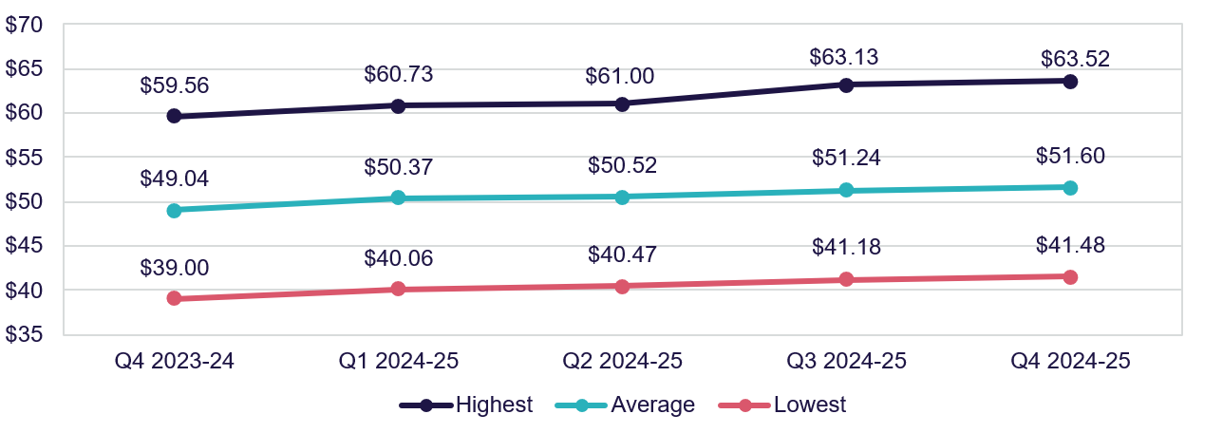
Chart 9: Highest, average, and lowest hourly rates (medians) paid to enrolled nurses (quarter 4 2023-24 to quarter 4 2024-25)
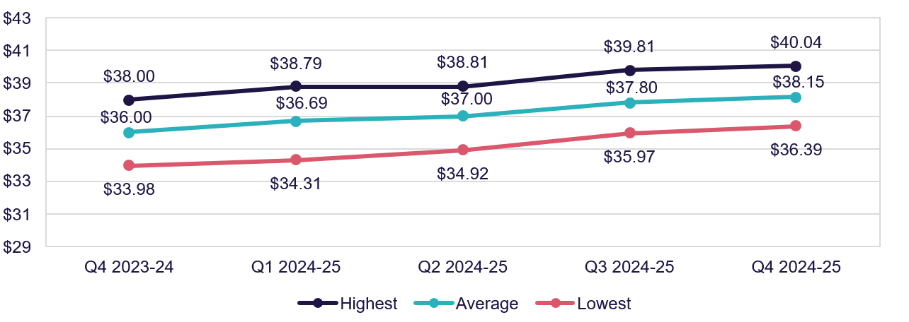
Chart 10: Highest, average, and lowest hourly rates (medians) paid to personal care workers and assistants in nursing (quarter 4 2023-24 to quarter 4 2024-25)
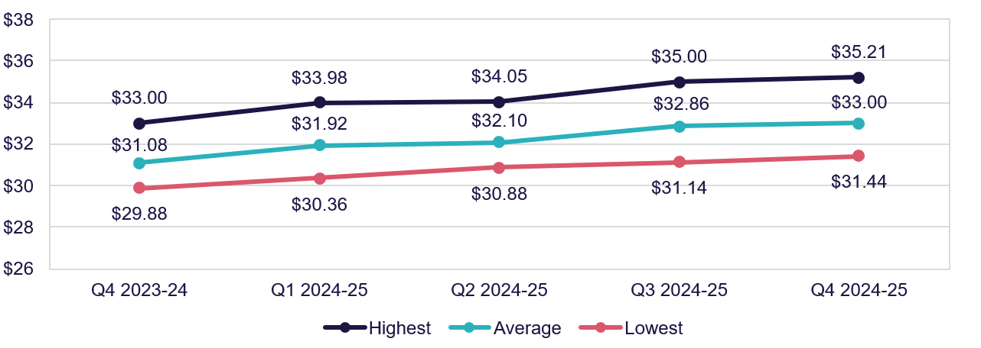

Food and nutrition
In quarter 4 2024-25, at a sector level:
- the median total cost of food and ingredients was $15.59 per resident per day (up $1.12 or 7.7% from quarter 4 2023-24) (Chart 11).
- the proportion of the total cost of food and ingredients spent on fresh food and ingredients (foods free of GST as per itemised purchase receipts) was 83.0% (down 0.6 percentage points from quarter 4 2023-24) (Chart 12).
The amount spent on food and ingredients per resident per day is only one indicator of food quality. It should not be taken in isolation, as it does not consider factors such as residents’ satisfaction, cooking preparation method and overall nutritional status.
Chart 11: Median food and ingredients cost per resident per day (quarter 4 2023-24 to quarter 4 2024-25)

Chart 12: Proportion of the total cost of food and ingredients spent on fresh food and ingredients (quarter 4 2023-24 to quarter 4 2024-25)

Home care

Financial performance

Financial summary
The EBITDA and NPBT position of the home care sector was stable between quarter 4 2023-24 and quarter 4 2024-25. In quarter 4 2024-25:
- Sector EBITDA was $598.4 million (Table 6), with an average EBITDA margin of 7.6% (down from 8.2% in quarter 4 2023-24).
- Sector NPBT was $553.1 million, with an average NPBT margin of 7.0% (down from 7.7% in quarter 4 2023-24).
- Revenue grew by $7.28 per care recipient per day (up 9.8%). This was driven by the annual indexation of home care subsidy and supplement rates and increased utilisation of HCPs from 82.7% in 2023-24 to 86.4% in 2024-25.
- Expenses grew by $7.26 per care recipient per day (up 10.6%). This was driven by an increase in labour costs, due to the associated increase in labour hours (higher claim days and utilisation) and increase in hourly pay rates for home care workers.
Table 6: Quarter 4 2024-25 and comparison with quarter 4 2023-24, summary of financial performance of home care for-profit and not-for-profit providers
 | Total | Per care recipient per day | Change from Q4 2023-24 per care recipient per day
Revenue | $7,875.8m | $81.31 | ▲ $7.28
Operating expenses | $7,277.4m | $75.13 | ▲ $7.14
EBITDA | $598.4m | $6.18 | ▲ $0.14
Average EBITDA margin | 7.6% | 7.6% | ▼ 0.6  percentage points
Non-operating expenses | $45.2m | $0.47 | ▲ $0.12
Net profit before tax | $553.1m | $5.71 | ▲ $0.02
Average NPBT margin | 7.0% | 7.0% | ▼ 0.7  percentage points
Note: The average EBITDA margin (which indicates the EBITDA return on revenue) is calculated by dividing the sector EBITDA result by the sector total revenue.

Profitable providers
At quarter 4 2024-25:
- 75.7% of providers were profitable (defined by NPBT) (Figure 2). This was a decrease of 1.0 percentage point from quarter 4 2023-24.
- profitable providers serviced 83.5% of HCP recipients. This was an increase of
1.6 percentage points from quarter 4 2023-24.
Figure 2: Percentage of profitable providers and percentage of home care recipients serviced by profitable providers at quarter 4 2024-25, and comparison with quarter 4 2023-24
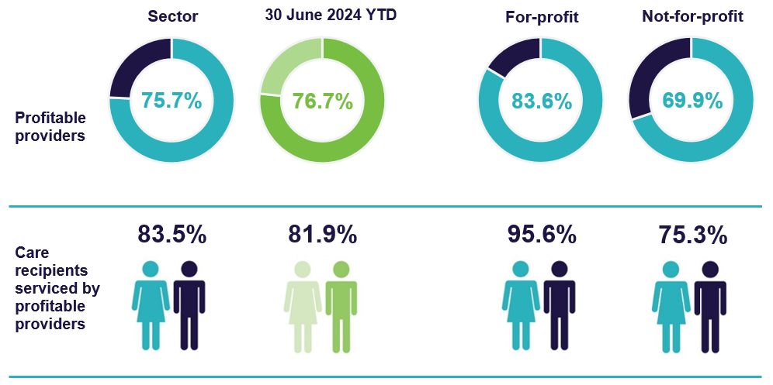

EBITDA margin
In quarter 4 2024-25, the median EBITDA margin for the sector was 6.7% (Chart 13), a 0.8 percentage point decrease on the quarter 4 2023-24 result. This means an EBITDA return of $6.70 for every $100 of revenue earned.
Chart 13: Median and quartile EBITDA margin (quarter 4 2023-24 to quarter 4 2024-25)

Liquidity
In quarter 4 2024-25, the median sector liquidity ratio was 0.79 (Chart 14), a decrease of 0.03 on the quarter 4 2023-24 position. This means for every $100 of debt obligations, providers had $79 in liquid assets.
Chart 14: Median and quartile liquidity ratio (quarter 4 2023-24 to quarter 4 2024-25)

Liquidity ratio = (cash and cash equivalents + financial assets) ÷ (total liabilities – lease liabilities).
Calculations do not include undrawn credit facilities as liquid assets.

Capital adequacy
In quarter 4 2024-25, the sector median capital adequacy ratio was 0.55 (Chart 15), an increase of 0.02 on the quarter 4 2023-24 position. This means for every $100 of assets owned, $55 was funded through equity and $45 was funded through debt or other liabilities.
Chart 15: Median and quartile capital adequacy ratio (quarter 4 2023-24 to quarter 4 2024-25)

Capital adequacy ratio = (net assets - intangible assets) ÷ (total assets - intangible assets)

Wages to revenue
In quarter 4 2024-25, wages as a proportion of revenue for the sector was a median of 60.4% (Chart 16), a decrease of 1.0 percentage point from quarter 4 2023-24. Wages include salaries and employment benefits, agency and subcontractor costs, and management fees. Wages do not include staff training and development.
Chart 16: Median and quartile wages to revenue percentage (quarter 4 2023-24 to quarter 4 2024-25)

Staff cost and time
In quarter 4 2024-25, total median staff costs increased to $58.05 per care recipient per day (up $4.92 or 9.3% from quarter 4 2023-24). Total median time increased to 56.90 minutes per care recipient per day (up 0.3 minutes or 0.5% from quarter 4
2023-24).
Table 7: Quarter 4 2024-25 and comparison with quarter 4 2023-24, median staff cost and time per care recipient per day ¹
 | Cost per care recipient per day | Change in cost from Q4 2023-24 | Minutes per care per recipient per day | Change in minutes from Q4 2023-24
Registered nurses ² | $1.22 | ▲ $0.10 | 0.84 | ▲ 0.06
Personal care staff | $28.58 | ▲ $2.70 | 31.34 | ▲ 1.33
Allied health | $4.84 | ▲ $1.22 | 2.05 | ▲ 0.31
Other direct care | $0.36 | ▼ $0.32 | 0.25 | ▼ 0.13
Care management | $7.72 | ▲ $0.52 | 7.80 | ▼ 0.13
Administration and non-care staff | $7.28 | ▲ $0.40 | 7.51 | ▼ 0.19
Total median 3 | $58.05 | ▲ $4.92 | 56.90 | ▲ 0.30
Notes:
Staff travel, or work done on administration tasks during care staff paid hours, is included in the results of
Chart 16, which shows the median wages to revenue percentage. All provider types are included in this data, including local, state or territory government providers.
Data for enrolled nurses has not been included as 69.0% of home care providers did not report expenditure in this category.
Total median staff cost and time is derived from the totals calculated in the individual QFR submissions and is not the sum of the medians in the sub-categories listed above.

Hourly rates
In quarter 4 2024-25, the sector median of the average hourly rates increased for all direct care staff in comparison to quarter 4 2023-24:
- $52.50 for registered nurses (up $2.50 or 5.0% from quarter 4 2023-24) (Chart 17)
- $39.51 for enrolled nurses (up $2.01 or 5.4% from quarter 4 2023-24) (Chart 18)
- $34.93 for personal care workers (up $1.40 or 4.2% from quarter 4 2023-24)
(Chart 19).
Average hourly rates are for staff employed per the employee award, enterprise agreement or contract. These do not include on-costs, penalty rates, casual rates, agency fees and subcontracting arrangements. Nil-value responses are excluded.
Chart 17: Highest, average, and lowest hourly rates (medians) paid to registered nurses
(quarter 4 2023-24 to quarter 4 2024-25)

Chart 18: Highest, average, and lowest hourly rates (medians) paid to enrolled nurses
(quarter 4 2023-24 to quarter 4 2024-25)

Chart 19: Highest, average, and lowest hourly rates (medians) paid to personal care staff
(quarter 4 2023-24 to quarter 4 2024-25)

Care and package management
At 30 June 2025, all HCP levels had a median care management percentage of 17% per HCP, and a median package management percentage of 12% per HCP (Chart 20). This is unchanged since 30 June 2024.
Chart 20: 30 June 2024 and 30 June 2025, median care and package management percentage per HCP level

Care management percentage = published fortnightly national median price for care management (for each level) ÷ subsidy per fortnight (for each level)
Package management percentage = published fortnightly national median price for package management (for each level) ÷ subsidy per fortnight (for each level)
Insights: Care management fees and expenses
Reporting through the Financial Report on the Australian Aged Care Sector (FRAACS) between 2020-21 and 2023-24 has shown that while care management charges represent 16.5% – 18.0% of total revenue for providers, the cost to providers of delivering care management services is between 10.5% – 11.0%.
These results indicate that providers may be using margins on care management services to cross-subsidise losses in other services. The department will continue to monitor prices set by home care providers, including through the transition to the Support at Home program from 1 November 2025 to ensure they are reasonable and transparent.

Unspent funds
At 30 June 2025, there was $4.1 billion in unspent HCP funds (up $0.5 billion from
30 June 2024) (Chart 21). This includes:
- $3.8 billion of unspent funds in the Home Care Account (up $0.6 billion)
- $0.3 billion in the Provider Held Portion of unspent funds (down $0.1 billion).
Chart 21: Unspent funds (quarter 4 2023-24 to quarter 4 2024-25)

Glossary
Term | Description
Australian National Aged Care Classification (AN-ACC) funding model | Is a case mix funding model that represents the care component of residential aged care funding. AN-ACC is designed to provide equitable care funding to approved residential aged care services, by linking subsidy to characteristics of services and residents. The Independent Health and Aged Care Pricing Authority provides annual pricing advice to the Minister for Aged Care, Disability and Seniors on the AN-ACC model. This ensures funding is based on advice on the actual cost of care.
Care management | Is a service that home care providers must deliver to all care recipients to ensure recipients receive the appropriate level of support in a way that meets their care needs. Providers must not charge more than 20% of the Australian Government Subsidy for care management.
Care minutes | Refers to the amount of care time people in government-funded residential aged care services receive from registered nurses, enrolled nurses, personal care workers and assistants in nursing.  From 1 October 2023, the sector-wide care minutes benchmark was an average of 200 total care minutes per resident per day, including  40 minutes of care per resident per day by a registered nurse.  Sector-wide care minutes requirements increased to 215 total care minutes on 1 October 2024, including 44 minutes of registered nurse time. Providers can now meet up to 10% of their registered nurse targets with care time provided by enrolled nurses. Approved providers of residential care services have a responsibility to meet service-level care minutes targets for each service.  Allied health, diversional / lifestyle / recreation / activities officer and care management staff minutes do not contribute to care minute targets. Providers must, however, continue to deliver allied health and lifestyle services to their residents in line with requirements under Schedule 1 of the Quality of Care Principles 2014. Care minutes data in this QFS report is consistent with the care minutes in residential aged care dashboard.
Capital adequacy ratio | Measures a provider's net asset position divided by total asset position (not including intangibles). This ratio can be used as an indicator of a provider's ability to absorb unexpected losses through their net asset position (also known as an asset buffer). If a provider has a stronger (higher) capital adequacy ratio, they will be able to fund and absorb the impacts of unforeseen circumstances by using business equity. Intangible assets are removed as they are not considered to have value in the event of insolvency.
EBITDA margin | Is used as an indicator of a provider’s financial performance and underlying profitability before accounting for depreciation assumptions, tax obligations or financing choices. EBITDA margins focus on a provider’s operating profitability and cash flow. The higher the EBITDA margin is, the lower operating expenses are in comparison to total revenue.
Fair Work Commission (FWC) decisions | The Australian Government is providing funding to support the FWC’s decisions under the Aged Care Work Value Case. The Government also provides funding to support FWC decisions relating to Annual Wage Reviews through usual program funding arrangements. Annual Wage Review increases take effect on 1 July each year. These decisions are collectively referred to as ‘FWC decisions’ in this report.
Home Care Package subsidy | The Australian Government pays a monthly subsidy amount into each care recipient’s Home Care Account which Services Australia creates and holds. The subsidy includes a basic subsidy amount and any supplements. Providers are paid in arrears for care and services delivered based on a monthly claim to Services Australia made against the care recipient’s Home Care Account.
Hotelling supplement | Supports residential aged care providers to meet hotelling costs for services such as catering, cleaning, and laundry. The supplement is indexed on 20 March and 20 September each year.
Total labour (staff) costs | Includes salaries for all care and non-care staff, superannuation, bonuses and incentives, allowances, termination payments, value of fringe benefits, salary sacrifice and leave entitlements. Training costs for all employment categories are included under ‘Administration and non-care staff’ costs. Total worked staff hours excludes leave and training hours and only includes the time spent delivering care.
Liquidity ratio | Measures the availability of cash and financial assets to cover providers' debt obligations (without raising external capital) if they were to become immediately due and payable. If the ratio result is greater than 1.0, the provider has more cash and financial assets than their debt obligations.  If the ratio result is less than 1.0, the provider’s debt obligations are more than their cash and financial assets.
Package management | Is the ongoing administration and organisational activities associated with ensuring the smooth delivery of a HCP. Providers must not charge more than 15% of the Australian Government subsidy for package management.
Refundable Accommodation Deposit (RAD) and Daily Accommodation Payment (DAP) | A RAD is the lump-sum payment for a room (or part of a room) in an aged care service. Providers can earn a return on RADs by investing the funds, either by making capital improvements on their facilities or by investing in approved financial products.  A DAP is an ongoing, non-refundable rental-style payment, paid instead of a RAD. The DAP is calculated by multiplying the RAD of a room by the Maximum Permissible Interest Rate (set by the Government) and divided by 365.
Support at Home Program | The Support at Home program will replace the HCP Program and the Short-Term Restorative Care Programme from 1 November 2025. The Commonwealth Home Support Programme will transition to the program no earlier than 1 July 2027. More information on the program can be found in the Support at Home program handbook.
Unspent funds | Since 1 September 2021, unspent Government subsidy for HCPs has accrued in a Home Care Account set up for care recipients by Services Australia. These funds are available for providers to use for care and services provided to the care recipient. Some providers also have access to the Provider Held Portion of unspent funds accrued prior to  1 September 2021. These funds can be used towards a care recipient’s care and services.

Appendix

How to read the QFS

Comparison data
Comparison with the prior four quarters is presented in most charts to understand trends in performance over time. The exception is Chart 20: 30 June 2024 and
30 June 2025, median care and package management percentage per HCP level, which compares to the corresponding quarter from the previous financial year.
Comparison with the corresponding quarter from the previous financial year results are reported at the sector-level in most tables to understand the change in performance, excluding seasonality. The exception is data presented in relation to the average care minutes delivered by residential aged care providers (sector and by provider type), which compares to the immediate prior quarter.
Benchmarking calculations: Throughout the document, this grey box gives guidance on calculations, to support aged care providers to benchmark their performance against sector-level results.
Quartile charts show the median, and the upper quartile (50th to the 75th percentile) and lower quartile (25th to the 50th percentile). This highlights the spread of reported results.

Insights
Insights
Throughout the document, these boxes are used to highlight key findings in relation to the data presented, including the trend in the data over time.

Provider type definitions
Percentage of services is calculated using the proportion of claim days from a provider.
Provider type | Definition
Sector | Consolidated view of the provider types shown in the chart, figure or table.
For-profit | Providers that are either a Private Incorporated Body or a Publicly Listed Company.
Not-for-profit | Providers that are either charitable, community based or religious organisations.
Local, state or territory government | Providers owned by a local, state or territory government. This acronym is used in tables and charts. These providers are included in labour cost and hours, Home Care Account balance, unspent funds, and food and nutrition data only.

Data sources and method
The QFS primarily draws on data collected from aged care providers through the QFR. The QFS quarter 4 2024-25 publishes data collected from 97.7% of residential aged care providers and 95.0% of HCP providers.
Collection and analysis notes:
- QFR data published in this QFS report was extracted from the department’s Ageing and Aged Care Data Warehouse (CASPER).
- QFR data is unaudited but must be authorised by a director of a provider’s board, a member of the governing body, or one of the provider’s Key Personnel (for government providers). The department undertakes data validation processes, and providers may be invited to re-submit data if anomalies are identified.
- The QFS presents the financial summary, wages to revenue percentage, EBITDA margin and percentage of profitable providers in YTD format. This ensures information is presented the way it has been collected, and consistent with standard accounting practices. Care minutes, labour costs and food and nutrition are reported as quarter-specific results only.
- Provider entry and exit data is extracted from the GPMS. Some providers may be counted in both residential and home care for entry and exit data.
- The QFS draws on data collected through My Aged Care and other departmental sources. Sector-level results published in the QFS may differ from information on the My Aged Care website. The QFS presents median results at the provider-level, while My Aged Care website presents median results at a service-level.

Previous snapshots and feedback
Previous QFS publications are available on the department’s website. The QFS will evolve over time, and the department is committed to working with the sector to inform future publications. Feedback is welcome and should be directed to QFS.FRAACS@health.gov.au.

