National Aged Care Quality Indicator Program (QI Program)

Quick Reference Guide: Workforce
This guide helps registered providers of approved residential care homes (providers) to collect and report data on workforce for the QI Program.
You must report the workforce quality indicator against:
 | - Percentage of staff turnover
Providers are expected to have a workforce that is sufficient, skilled and qualified, to provide safe, person-centred and quality care and services. Workforce turnover reduces familiarity with residents and continuity of care.
For the purposes of the QI Program, staff are considered employed when they have worked at least 120 hours in the previous reporting period (quarter). All staff that meet this definition are included, irrespective of the type of employment (e.g. this includes permanent, part-time, casual, contractors, and agency staff).

For the purposes of the QI Program, staff who stopped working refers to staff members who have a period of at least 60 consecutive days in the current quarter in which they have not worked at the aged care home.

Collect workforce data
Complete a single review of staff records for each staff member who worked any hours at the aged care home as either service managers, nurse practitioners or registered nurses, enrolled nurses or personal care workers or nursing assistants during the previous quarter.
The review must be:
- after the end of the current quarter
- before data is due (the 21st day of the month after the quarter ended).
Record the staff who worked any hours in the previous quarter as either service managers, nurse practitioners or registered nurses, enrolled nurses, or personal care workers or nursing assistants
Record the staff who met the QI program definition of employed as either service managers, nurse practitioners or registered nurses, enrolled nurses, or personal care workers or nursing assistants at the start of the quarter (i.e. they worked at least 120 hours at the aged care home in the previous quarter)

For staff who met the QI program definition of employed, record the number of staff who stopped working during the current quarter (i.e. they had a period of at least 60 consecutive days in the current quarter in which they did not work at the aged care home)

Workforce data collection summary
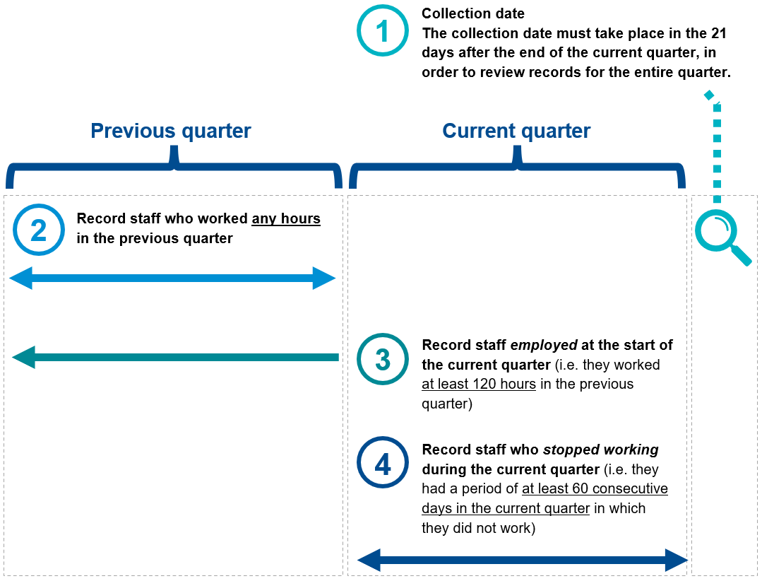

Report workforce data
Report the number of staff:
- who were employed at the start of the quarter as:
    - service managers
    - nurse practitioners or registered nurses
    - enrolled nurses
    - personal care workers or nursing assistants
- who stopped working during the quarter as:
    - service managers
    - nurse practitioners or registered nurses
    - enrolled nurses
    - personal care workers or nursing assistants
Additionally, report the number of staff:
- who worked any hours during the previous quarter as:
    - service managers
    - nurse practitioners or registered nurses
    - enrolled nurses
    - personal care workers or nursing assistants

Registered providers of approved residential care homes must collect and report on workforce data quarterly. See the QI Program Manual– Part A.

Example
Staff member A  - works at the aged care home as a registered nurse  - worked more than 120 hours at the aged care home in the previous quarter  - retired at the end of the current quarter  - did not stop working for a period of 60 consecutive days during the current quarter | Staff member B  - works as a nursing assistant at the aged care home (through an agency)  - worked less than 120 hours at the aged care home in the previous quarter | Staff member C  - works as a service manager, at the aged care home  - worked more than 120 hours at the aged care home in the previous quarter  - stopped working for a period of 60 consecutive days during the current quarter
Number of staff who worked any hours as service managers in the previous quarter
Number of staff who worked any hours as nurse practitioners or registered nurses in the previous quarter
Number of staff who worked any hours as enrolled nurses in the previous quarter
Number of staff who worked any hours as personal care workers or nursing assistants in the previous quarter
Number of staff employed as service managers at the start of the quarter
Number of staff employed as nurse practitioners or registered nurses at the start of the quarter
Number of staff employed as enrolled nurses at the start of the quarter
Number of staff employed as personal care workers or nursing assistants at the start of the quarter
Number of staff employed as services managers who stopped working during the quarter
Number of staff employed as nurse practitioners or registered nurses who stopped working during the quarter
Number of staff employed as enrolled nurses who stopped working during the quarter
Number of staff employed as personal care workers or nursing assistants who stopped working during the quarter

Data recording templates for each quality indicator are available on the QI Program resources webpage. Use the templates to calculate and summarise data to submit through the Government Provider Management System (GPMS).

Submit QI Program data
There are 3 ways you can submit QI Program data:
through the GPMS
via a bulk file upload
through a third-party benchmarking company
Data must be submitted by the 21st day of the month after the end of each quarter

More information
You can find the QI Program Manual and other guidance on the QI Program’s resources webpage.
For QI Program assistance, contact the My Aged Care provider and assessor helpline on 1800 836 799 and select option 5.
The helpline is closed on Sunday and public holidays. It is open:
- between 8am and 8pm Monday to Friday
- between 10am and 2pm on Saturday.
Improving Australia’s aged care system
The Australian Government has delivered major changes to improve aged care.
Visit health.gov.au/aged-care-reforms
Phone 1800 200 422 (My Aged Care’s free-call phone line)
For translating and interpreting services, call 131 450 and ask for 1800 318 209.
To use the National Relay Service, visit nrschat.nrscall.gov.au/nrs to choose your preferred access point on their website, or call the NRS Helpdesk on 1800 555 660.

