**Price of Pharmaceutical Benefits Scheme prescriptions (30-day v 60-day)**

Many people living with a stable ongoing health condition can receive twice the medication on a single prescription for selected Pharmaceutical Benefits Scheme (PBS) medicines. This can save you both time and money.

A range of PBS medicines are available for 60-day prescriptions. More PBS medicines can continue to become available for 60-day prescriptions after the Pharmaceutical Benefits Advisory Committee (PBAC) reviews their suitability.

You can search the PBS medicines available for 60-day prescriptions on the [Cheaper medicines website](https://www.health.gov.au/cheaper-medicines).

The PBS is funded by the Australian Government and helps reduce the cost of most prescription medicines for all eligible Australians. Patients pay a co-payment for each PBS prescription.

In 2025, if you have a Medicare card but no concession card, the maximum cost for most PBS medicines is $31.60. If you have a concession card, the maximum cost is $7.70. Co-payment amounts are subject to change, you can find up-to-date information for the [patient co-payment amounts](https://www.pbs.gov.au/info/healthpro/explanatory-notes/front/fee) on the PBS website.

If you choose a more expensive brand with a brand price premium, you will pay a premium in addition to your PBS co-payment amount. Please refer to the last page for more information regarding brand price premiums.

**How to check the price of your medication**

* Go to the [Pharmaceutical Benefits Scheme website](https://www.pbs.gov.au/pbs/home).
* Enter your medication at the magnifying glass, then select ‘PBS MEDICINE SEARCH’. Below shows a search for an example medication.



* Select your specific medication from the ‘Name, form & strength and pack size’.

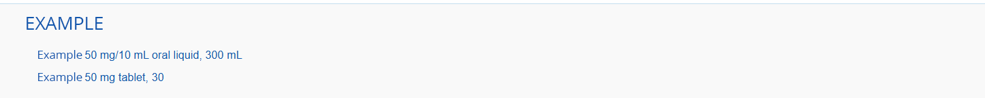

* You will see a range of information about the medication including the maximum number of packs that can be dispensed at one time, the number of units in each pack, the number of repeats allowed and the General Patient Charge.

**Check if your prescription is for 30 or 60 days**

You can check whether your medicine is available for a 30-day or 60-day supply and find out how much it will cost using the PBS website.

* In the example below, the maximum quantity is one, with 30 units. This generally means the medicine is available for a 30-day supply.
* The ‘General Patient Charge’ is the maximum amount you should pay for a medication. In this example, it’s $21.43 for a 30-day supply. However, you may pay less than the General Patient Charge if your pharmacy discount prescriptions.



* In the example below, the maximum quantity is two, with 60 units. This generally means the medicine is available for a 60-day supply. The ‘General Patient Charge’ is the maximum amount you should pay for this medication. In this case, it’s $24.15 for a 60-day supply. This is $2.72 more than the cost of a 30-day supply.
* Look for the green icon under the ‘Code & Prescriber’ column. This icon indicates that a medicine can be prescribed for a 60-day supply.

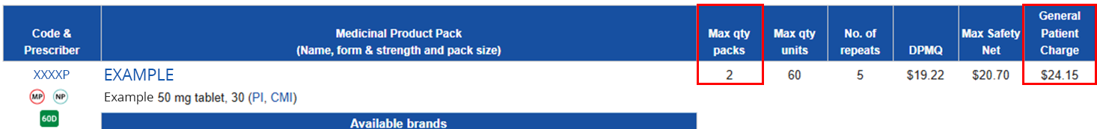

* Both the 30-and-60-day prescription costs in the examples above are below the 2025 general co-payment of $31.60.

**Compare pharmacy prices**

* Pharmacies can set the price for medicines that cost less than the general patient co-payment of $31.60. **For medicines under this amount, what you pay for 60-days won’t be the same as for 30-days, but it’s usually cheaper than buying two 30-day prescriptions.** You can compare prices in-store and online to save money on your prescription.
* Pharmacies can discount both 30-day and 60-day prescriptions, so prices can vary depending on where you fill your prescription. If you have a Medicare card but no concession card, you won’t pay more than the General Patient Charge. But you may have to pay extra for more expensive brands with a brand premium.
* Pharmacy discounting practises may result in situations where a 60-day quantity may cost twice the cost of a 30-day quantity. The maximum patient cost would remain below the 2025 general patient co-payment of $31.60 for a 60-day quantity of these medicines.

**How discounting can change savings for 60-day prescriptions**

This table shows how pharmacy discounts can impact the cost of 60-day prescriptions when the medicine is priced below the 2025 PBS general patient co-payment of $31.60.

* Pharmacy A does not offer any discounts and charges the General Patient Charge
* Pharmacies B and C offer discounts and charge less than the General Patient Charge.

|  |  |  |  |  |  |  |
| --- | --- | --- | --- | --- | --- | --- |
| Example of 30-day and 60-medicine pricing with pharmacy discounts. | | | | | | |
| Pharmacy | 30-day prescription | | | 60-day prescription | |
| General Patient Charge (30-day) as published on pbs.gov.au | Price for 30-day supply of medicine (1 prescription) | Price for  2 single supplies of a 30-day prescription | General Patient Charge (60-day) as published on pbs.gov.au | Price for 60-day supply of medicine (1 prescription) | |
| Pharmacy A (No discount) | $18.50 | $18.50 | **$37.00** | $22.75 | **$22.75** |
| Pharmacy B (some discount) | $15.00 | **$30.00** | **$21.75** | |
| Pharmacy C  (larger discount) | $10.00 | **$20.00** | **$20.00** | |

For a PBS medicine with a General Patient Charge of $18.50 for a 30-day supply:

* At Pharmacy A, filling two 30-day prescriptions over 2 months would cost $37.00.
* At Pharmacy B the same would cost $30.00.
* At Pharmacy C it would cost $20.00.

For the same PBS medicine with a General Patient Charge of $22.75 for a 60-day supply:

* A 60-day prescription at Pharmacy A costs $22.75, saving $14.25 compared to two 30-day prescriptions.
* At Pharmacy B, it costs $21.75, saving $8.25.
* At Pharmacy C, it still costs $20.00, the same as two 30-day prescriptions due to the larger discount.

**PBS Safety Net and brand premiums:**

* If you reach the PBS Safety Net threshold, the amount you pay for PBS medicines will be reduced. Find out what happens [when you spend a lot on PBS medicines on the Services Australia website](https://www.servicesaustralia.gov.au/when-you-spend-lot-pbs-medicines?context=22016).
* In some cases, you may be charged a brand premium. This extra cost applies to certain brands and is kept by the pharmaceutical companies that supply the relevant brand of medicine. Brand premiums are only allowed when there’s a premium-free alternative on the PBS. Patients are required to pay the brand premiums should they choose a more expensive brand, and this extra amount does not contribute towards their safety net. To save more, talk to your pharmacist about switching to a premium-free alternative brand.
* If a brand premium applies to a 30-day supply of a medicine, a 60 days’ supply of medicine would attract two brand premiums.
* In the example below, a 30-day supply of ‘Brand Premium’ includes a brand premium of $13.44 in addition to the ‘General Patient Charge’ for the other brands.

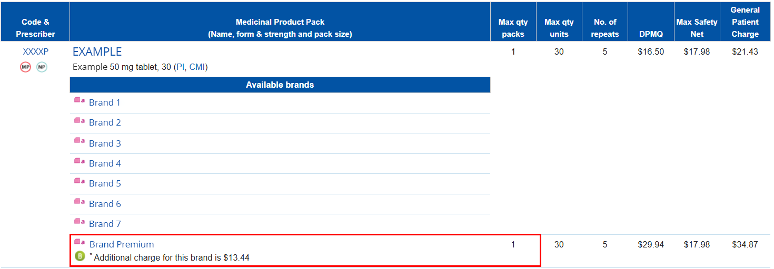

* In the example below, a 60-day supply of ‘Brand Premium’ includes a brand premium of $26.88 in addition to the ‘General Patient Charge’ for the other brands. The brand premium must be paid for each pack of medicine. For a 60-day supply of this medicine you would pay two brand premiums of $13.44, $26.88 in total.

