# Header banner with an illustration of a group of health professionals, a pregnant lady and a couple going for a walk with their babies.Newborn bloodspot screening open call – frequently asked questions (FAQ)

## Does the condition need to align with the decision-making criteria in the Newborn Bloodspot Screening (NBS) National Policy Framework?

Yes. To be considered for inclusion in Australia's screening program, the condition must align with the decision-making criteria in Australia’s [NBS National Policy Framework](https://www.health.gov.au/sites/default/files/documents/2020/10/newborn-bloodspot-screening-national-policy-framework.pdf). These include:

1. the condition is a serious health problem[1] and benefits from early diagnosis in the newborn period.
2. there is a suitable test available, which is socially and ethically acceptable[2].
3. there is an acceptable and effective intervention[3] or treatment available.

Conditions with low alignment to the criteria will not be included in NBS programs at this time.

## What can lead to a condition having low alignment with the decision-making criteria?

Some issues that can lead to low alignment with the criteria are:

* No suitable screening test, for example, if the available test:
  + misses many cases (poor sensitivity)
  + produces many false positive results (poor specificity)
  + cannot be performed on a dried bloodspot
  + is not suitable for the large volume of samples in NBS programs.
* No accepted intervention exists that can alleviate symptoms or slow or stop the condition’s progression.
* The accepted intervention is not available in Australia.

## Do I need to submit research/evidence to support my completed form?

No, you do not need to submit research or evidence on the condition you have identified. The Department of Health, Disability and Ageing (the department) will gather the best available Australian and international evidence on the condition. This will include information on the condition, interventions and treatments, screening tests and any other issues relevant to the consideration of the condition.

If you have specific research or information you wish to share, you are welcome to include references in the form or email it to [NBS@Health.gov.au](mailto:NBS@Health.gov.au).

Submitting additional information is optional and will not impact the outcome for the condition.

## Should I submit a form for a condition that has already been considered for screening in Australia?

No, you do not need to submit a condition that has already been considered for screening in Australian NBS programs.

If a condition has gone through the decision-making pathway but was not agreed for inclusion in NBS programs at this time, you do not need to complete this form. The department will monitor developments in treatments, technology and international screening programs. If sufficient new evidence becomes available for a previously considered condition, it will be reconsidered.

To check whether a condition has already been considered please see the conditions listed [here](https://www.health.gov.au/our-work/newborn-bloodspot-screening/what-is-screened) on the department’s website. If the condition appears in any table on the page, you do not need to complete this form.

If you submit a form for a condition that has already been considered for screening, you will receive an email notifying you that it has already been considered and does not need to be resubmitted.

## If a condition has already been considered, can I submit evidence in relation to that condition?

Yes, if you would like to share evidence relevant to a condition that has already been considered you can email it to [NBS@health.gov.au](mailto:NBS@health.gov.au). This evidence will be considered as part of the department’s monitoring of developments in treatments, technology and international screening programs. You do not need to complete a form to provide this information.

## Can I include more than one condition on a single form?

No, each condition must be submitted on a separate form to allow each condition to be considered individually. This includes conditions identified by targeted biomarker or gene sequencing panels that can detect multiple conditions simultaneously.

If submitting multiple conditions, please complete a separate form for each. You can note any links between conditions in the ‘additional information’ section.

## Should I encourage others to submit a form for the same condition, to show support for a condition to be included in NBS?

No, the number of forms submitted through the open call does not impact the consideration of a condition.

Conditions that are identified are assessed based on how well they align with the NBS National Policy Framework criteria.

## What are the next steps for conditions identified via the open call?

All Australian governments have agreed a national decision-making pathway to consider conditions for inclusion in Australia’s NBS programs. The pathway has four main stages:

1. Condition identification
2. Technical advice
3. Assessment
4. Advice and recommendation

The open call is part of the first stage in the pathway: **condition identification**. Conditions identified through open call, along with information on how well they align with the NBS National Policy Framework criteria, will be considered by the Cancer and Population Screening Committee.[4]

Conditions that have sufficient alignment with the criteria will move to the second stage in the decision-making pathway: **technical advice**. If a condition does not sufficiently align with the criteria, it will not proceed to technical advice at this time.

Click [here](https://www.health.gov.au/resources/publications/newborn-bloodspot-screening-nbs-our-national-decision-making-pathway-fact-sheet) for more information on the pathway and the stages that follow technical advice.

## Apart from submitting the form, how else can I contribute to the decision-making process?

For conditions that progress to the third stage in the pathway - **health technology assessment** through the **Medical Services Advisory Committee (MSAC)** - the public can submit comments and feedback via the MSAC process. See the [MSAC webpages](https://www.msac.gov.au/how-msac-works/consultation) for more details.

## When will I hear more about the condition I have identified?

**Confirmation email**: You will receive an email confirming receipt of your form within 5 business days of submission.

**Outcome notification email**: Once the Cancer and Population Screening Committee has considered your condition, you will receive an email advising whether the condition will progress to the next stage in the decision-making pathway: technical advice.

**Public outcomes**: a list of all conditions identified through the open call – and which ones will proceed to technical advice – will be published on the department’s website and shared by email through our subscription service.

Click [here](https://www.health.gov.au/resources/publications/newborn-bloodspot-screening-nbs-our-national-decision-making-pathway-fact-sheet?language=en) for more information on public communication points in the decision-making pathway.

**Timing**: We anticipate outcomes will be available in mid-2026, depending on the number of conditions identified. A high volume may extend the time needed to gather evidence.

**Evidence gathering**: After the open call closes, the department will gather and analyse the best available Australian and international evidence on each condition submitted. This includes research on the condition, interventions and treatments, screening tests and any other issues relevant to the consideration of the condition. This evidence will support the Cancer Screening and Population Committee’s consideration of each condition.

**Stay updated:** You can subscribe to receive NBS updates by:

* ticking the box in Question 1 on the form
* signing up via our website [here](https://www.health.gov.au/using-our-websites/subscriptions/subscribe-to-newborn-bloodspot-screening-updates).

This ensures you will receive updates on all conditions identified, including the one you submitted.

## How long will a condition take to progress through the decision-making pathway?

From the close of open call, a decision on whether the condition will progress to the next stage of assessment (technical advice) is expected within **6 months**. This time allows for evidence on all newly identified conditions to be collated and presented to decision-makers. The time taken will depend on the number of conditions identified. A high volume of conditions may extend the timeframe for reaching an outcome, as more evidence will need to be gathered.

Conditions that progress to technical advice will then move through the steps in the decision-making pathway. From the point a condition is identified for technical advice, a decision on whether to include it in NBS programs is expected within **2 years**, depending on the complexity of the condition. Implementation follows a decision to screen for a condition.

Therefore, it is expected to take around **2.5 years** from the close of open call to a final decision on screening for conditions identified and referred for technical advice. This timeframe is influenced by the complexity of the condition and volume of conditions under assessment.

This timeframe for outcomes supports careful collation of evidence and review by experts and decision makers. A collaborative approach is key to maintaining the consistency, safety and quality of the programs.

## What is ‘technical advice’?

**Technical advice** on conditions is provided by the **NBS Program Management Committee (PMC)** as part of the decision-making pathway.

**PMC** is a joint state, territory and Australian Government technical advisory committee. It comprises:

* senior clinical and laboratory scientists
* clinicians
* program managers and policy makers
* additional experts as needed.

PMC considers all available clinical, scientific and technical evidence for a condition against the NBS National Policy Framework criteria. It considers:

* the health benefits and harms to newborns
* screening tests available
* benefits of early detection and intervention
* clinical impacts
* broader impacts on the programs.

Based on this, PMC provides advice on the suitability of conditions to progress to a health technology assessment through the Medical Services Advisory Committee process.

PMC technical advice is considered by the following decision-making committees:

* Cancer and Population Screening Committee
* Health Chief Executives Forum
* Health Ministers Meeting

Click [here](https://www.health.gov.au/resources/publications/newborn-bloodspot-screening-nbs-our-national-decision-making-pathway-fact-sheet?language=en) for more information on the decision-making pathway and the roles and responsibilities involved.

## Need help with the form?

If you have questions or need help, you are welcome to contact the department at [NBS@health.gov.au](mailto:NBS@health.gov.au).

## When is the form due?

The closing date for the 2025 intake of conditions is 14 January 2026. However, you may submit this form at any time, and it will be included in the next intake.

## Will there be other opportunities to identify a condition?

Yes. If you are not ready to identify a condition now, there will be opportunities in future rounds.

## Can I go over the word limit if I have more information to share?

The word limit helps ensure timely review of forms. If you have more to share, you can include it in the optional information box (Question 3d).

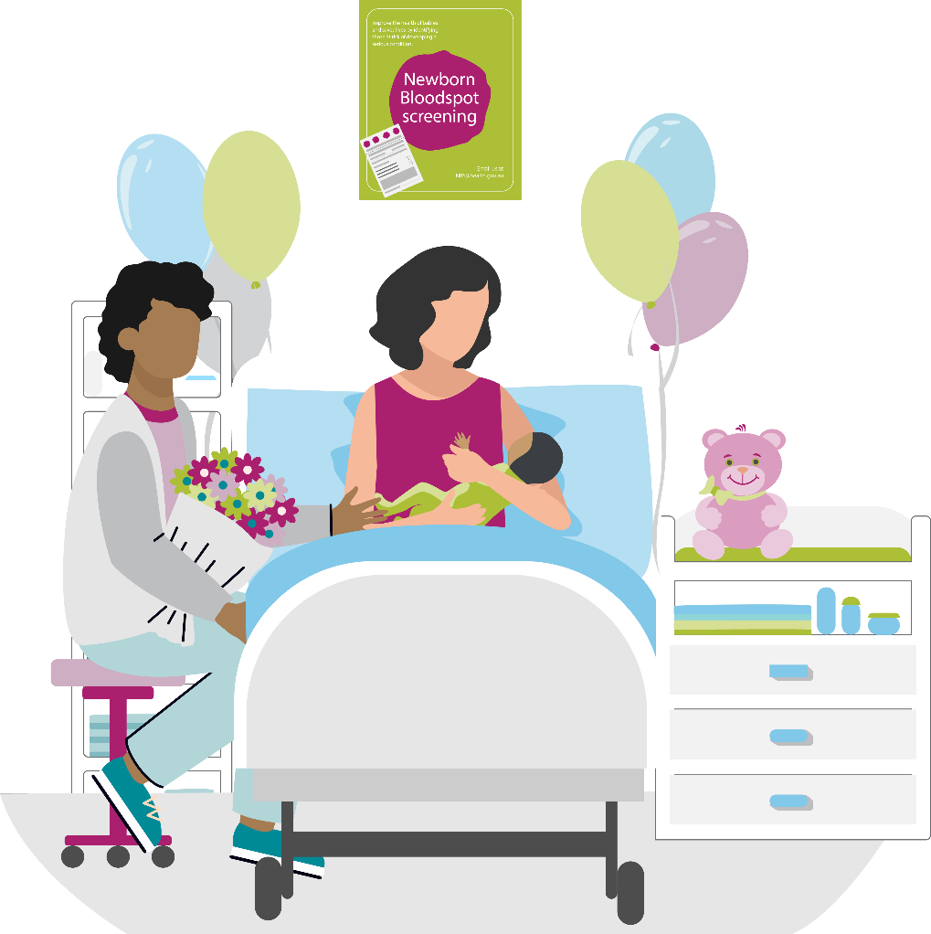

1. A ‘*serious health problem’* is one that leads to significant illness (morbidity) or death (mortality).
2. Examining ‘*social and ethical acceptability*’ includes consideration of the potential benefits and harms of the test.
3. An ‘*intervention*’ is an action designed to change the outcome or course of a condition, such as a treatment or option to help manage the symptoms.
4. The Cancer and Population Screening Committee provides strategic policy direction for national population screening and cancer control. Committee members are deputy chief executives of health departments in each jurisdiction.