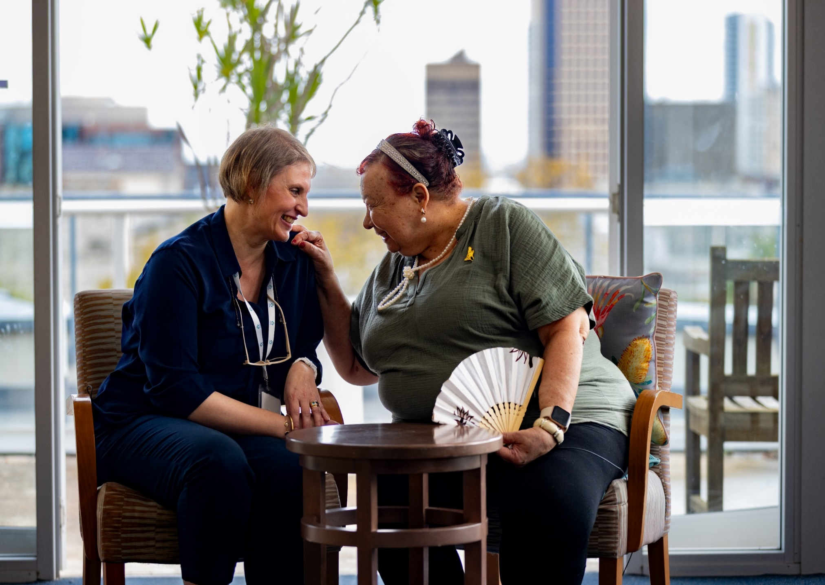


New Aged Care Act and ACVVS
The Aged Care Volunteer Visitors Scheme (ACVVS) commenced on 1 July 2023, replacing the Community Visitors Scheme (CVS), a Commonwealth-funded program which ran for more than 30 years.

Overview
The ACVVS is a free program which matches eligible aged care recipients who are lonely or socially isolated with aged care volunteer visitors to provide companionship, social support or friendship.
Visits are available to anyone receiving government-subsidised residential aged care or Support at Home services. This includes care recipients approved or on the Support at Home Priority System and excludes those accessing the Commonwealth Home Support Program (CHSP).
The program focuses on the needs of older people from particular linguistic, cultural and complex vulnerability backgrounds who may be at greater risk of social isolation.
The department funds over 130 community organisations nationally to recruit, train and match aged care volunteer visitors to aged care recipients. Roles and responsibilities are detailed in the ACVVS National Guidelines.
- sharing stories over a cup of tea
- working on a joint hobby
- taking a walk.
The program requires aged care volunteer visitors to make a minimum of 20 visits per year to their matched aged care recipient. These occur for approximately an hour a fortnight and can be anything the volunteer visitor and older person feel like doing such as:
ACVVS accepts referrals from aged care service providers, health professionals, family members and friends, with consent from the older person. Older people can also refer themselves.
The preference is that all ACVVS visits are conducted in person, but a virtual visit may occur in exceptional circumstances (e.g. illness or recipient choice). Most visits are one to one, so the recipient and volunteer visitor can get to know each other over time.
The ACVVS is an activity which supports registered providers to meet their requirements under the Strengthened Quality Standards, ensuring the older person is at the centre of their aged care. This includes meeting the older person's daily living needs and valuing their identity, culture and diversity.

The Aged Care Act 2024 and ACVVS
- The Aged Care Act 2024, which commenced on 1 November 2025, puts the rights, dignity, preferences and needs of older people at the centre of their aged care.
- The ACVVS is recognised under the Act as a grant that supports and uphold the rights and entitlements of care recipients.
- The role of an ACVVS volunteer visitor is defined as an aged care volunteer visitor who volunteers for or is otherwise engaged by a person or body that receives financial assistance under grants recognised by the Act to visit individuals accessing funded aged care services to provide companionship, social support or friendship to those individuals who are socially isolated or are at risk of social isolation.
- An aged care volunteer visitor is NOT an aged care provider volunteer and is not expected to meet the requirements under an approved provider, such as onboarding, training and record keeping. This is undertaken by the ACVVS community organisation.
- The Australian Government recognises and supports the important role of aged care volunteer visitors in improving care recipients’ experience in the aged care system, ensuring they can continue to provide meaningful social connection.
- Aged care providers must allow and facilitate access to ACVVS volunteer visitors to visit aged care services.
It is a condition of registration that a registered provider must allow and facilitate access by aged care volunteer visitors to an individual to whom the provider delivers funded aged care services.
Chapter 1, Part 4, Section 156, Aged Care Act 2024

Statement of Rights and ACVVS
The Statement of Rights ensures the older person is at the centre of their aged care. It is a reference point for providers and workers to consider when delivering funded aged care services under the Act.
It gives the older person the right to:
- make decisions about their own life
- have their decisions not just accepted, but respected
- get information and support to help them make decisions
- communicate their wishes, needs and preferences
- feel safe and respected
- have their culture and identity respected
- stay connected with their community.
This means aged care providers must uphold the right of the individual to stay connected with their ACVVS volunteer visitor and to have the role of their volunteer visitor acknowledged and respected as a significant person to them.

Contacts and links
- The department’s website provides detailed information for aged care providers, older people, their families and carers on the new Aged Care Act at health.gov.au/aged-care-act
- Request a volunteer visitor for a residential aged care recipient or Support at Home participant at health.gov.au/our-work/aged-care-volunteer-visitors-scheme-acvvs/request
- For more information about the ACVVS including the National Guidelines, volunteer visitor stories and referral pathways visit health.gov.au/acvvs
- Contact the department’s ACVVS team at acvvs@health.gov.au
Aged care staff can speak directly to ACVVS Network Members to find their local ACVVS community organisation by visiting health.gov.au/our-work/aged-care-volunteer-visitors-scheme-acvvs/contacts
