


National standards for counsellors and psychotherapists

Summary report
13 October 2025

Allen + Clarke Consulting have been commissioned by the Department of Health, Disability and Aged Care to support their development of national standards for counsellors and psychotherapists.



Executive summary
Counsellors and psychotherapists serve Australia’s community by delivering a range of services that seek to promote greater wellbeing. These services are delivered by individuals who have a range of skills and experience including different education levels and training.
The professions of counselling and psychotherapy are self-regulated in Australia. There are no nationally established laws, regulations, guidelines, or standards to prescribe the requirements of these professions. No regulatory body has oversight of the delivery of counselling and psychotherapy services. Instead, there are a number of industry membership associations which counsellors and psychotherapists can register with, subject to meeting the association’s professional guidelines.
In May 2023, the Australian Government committed to developing national standards for counsellors and psychotherapists. The announcement followed an Australian Parliament committee inquiry in 2021, which noted reservations about the current self-regulatory approach for counsellors and psychotherapists. The committee highlighted the lack of consensus on the academic and experiential requirements for registration from the membership associations and the impacts on the safe delivery of mental health services.
The Department of Health, Disability and Aged Care (the department) is developing the national standards for counsellors and psychotherapists. It engaged Allen + Clarke Consulting to support this process, including undertaking research and consulting with Australia’s counselling and psychotherapy sector to understand its expectations and preferences of the national standards and to refine the draft national standards.
Allen + Clarke developed the national standards, set out by this document, informed by research and stakeholder engagement during 2024.
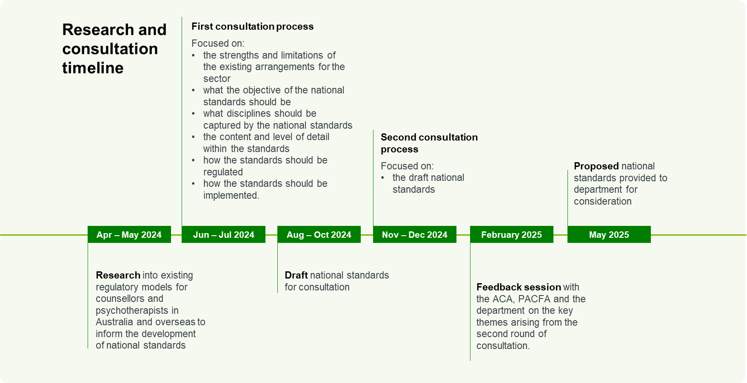

Overview of research and consultation

Research
Allen + Clarke researched existing regulatory models for counsellors and psychotherapists in Australia and overseas to inform the development of national standards. Notably, international research identified different regulatory models, and professional standards for counsellors and psychotherapists that share some commonalities which can be considered in the Australian Government’s design of national standards. However, the lack of uniformity across the global community in the regulation and standards for counsellors and psychotherapists also demonstrated limited global consensus on better practice regulation of counsellors and psychotherapists.

Consultation

1. First consultation process
The first consultation process was undertaken between June and July 2024. The first consultation process aimed to understand:
- the strengths and limitations of the existing arrangements for the sector
- what the objective of the national standards should be
- what disciplines should be captured by the national standards
- the content and level of detail within the standards
- how the standards should be regulated
- how the standards should be implemented.
During this period, the Allen + Clarke team provided opportunities for the sector to engage through three different mechanisms:
- Individual and small group interviews
- An online survey hosted by the department’s Consultation Hub
- Written submissions.
To support promotion and recruitment of stakeholders, communications were sent through the department’s website, Primary Health Network (PHN) newsletter, and peak bodies’ newsletters.
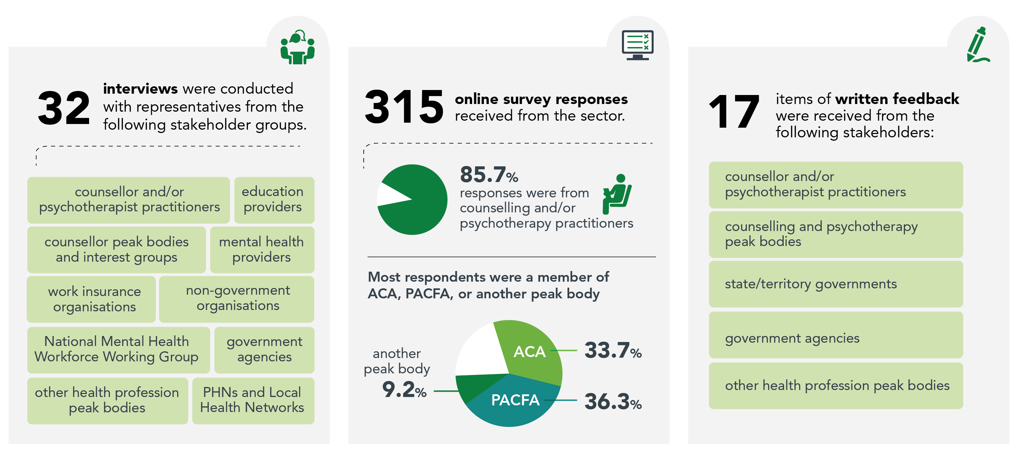

What was heard from stakeholders  The first consultation process demonstrated a high level of interest from stakeholders in the development of national standards, and optimism for what they could potentially deliver to the profession and clients. There were broadly consistent views on which areas should be covered by the national standards, including education and training, supervision, and CPD. Stakeholders recognised these areas provided a strong foundation for high performing counsellors and psychotherapists, and therefore needed to be recognised by the national standards.  There was less consensus and clarity on the specifics of the national standards, and how they should be regulated. For example, stakeholders did not provide a uniform view on what types and levels of education and training should be required for counselling and psychotherapists. They also did not provide a consistent view on the type of regulatory model should govern the national standards, such as self-regulatory, quasi-regulatory, or government regulation. However, most stakeholders in the consultation process considered compliance with any national standards should be mandatory.  Above all, there was a strong interest from stakeholders to continue to participate in the development of the national standards. This included being able to comment on a draft version. Stakeholders felt it was important to share with the department their views on the national standards, including being able to propose changes before they were formalised. |  | How did it inform the draft national standards  A draft set of national standards was developed based on the feedback provided in the first round of stakeholder consultation. Despite the lack of a uniform view on the content of the standards, the general support for a domain-led approach covering education and training, supervision, CPD, and a recognition of the different capabilities at each career stage, helped guide the structure and content of the draft national standards. An expectation of compliance with national standards within a sector of varying experience levels, also meant a more prescriptive-based approach in the drafting of the standards. For example, the draft national standards set out the number of supervision hours required. Another outcome of the first round of consultation process was to engage on the draft national standards. The second consultation process is summarised below.

2. Second consultation process
The second consultation process was undertaken between 11 November and 13 December 2024. It sought feedback on the draft national standards, which were developed by Allen + Clarke and approved by the department for public consultation.
During this period, the sector provided feedback on the draft national standards through the following mechanisms:
- individual interviews and group testing workshops
- an online survey hosted by the department’s Consultation Hub
- written submissions.
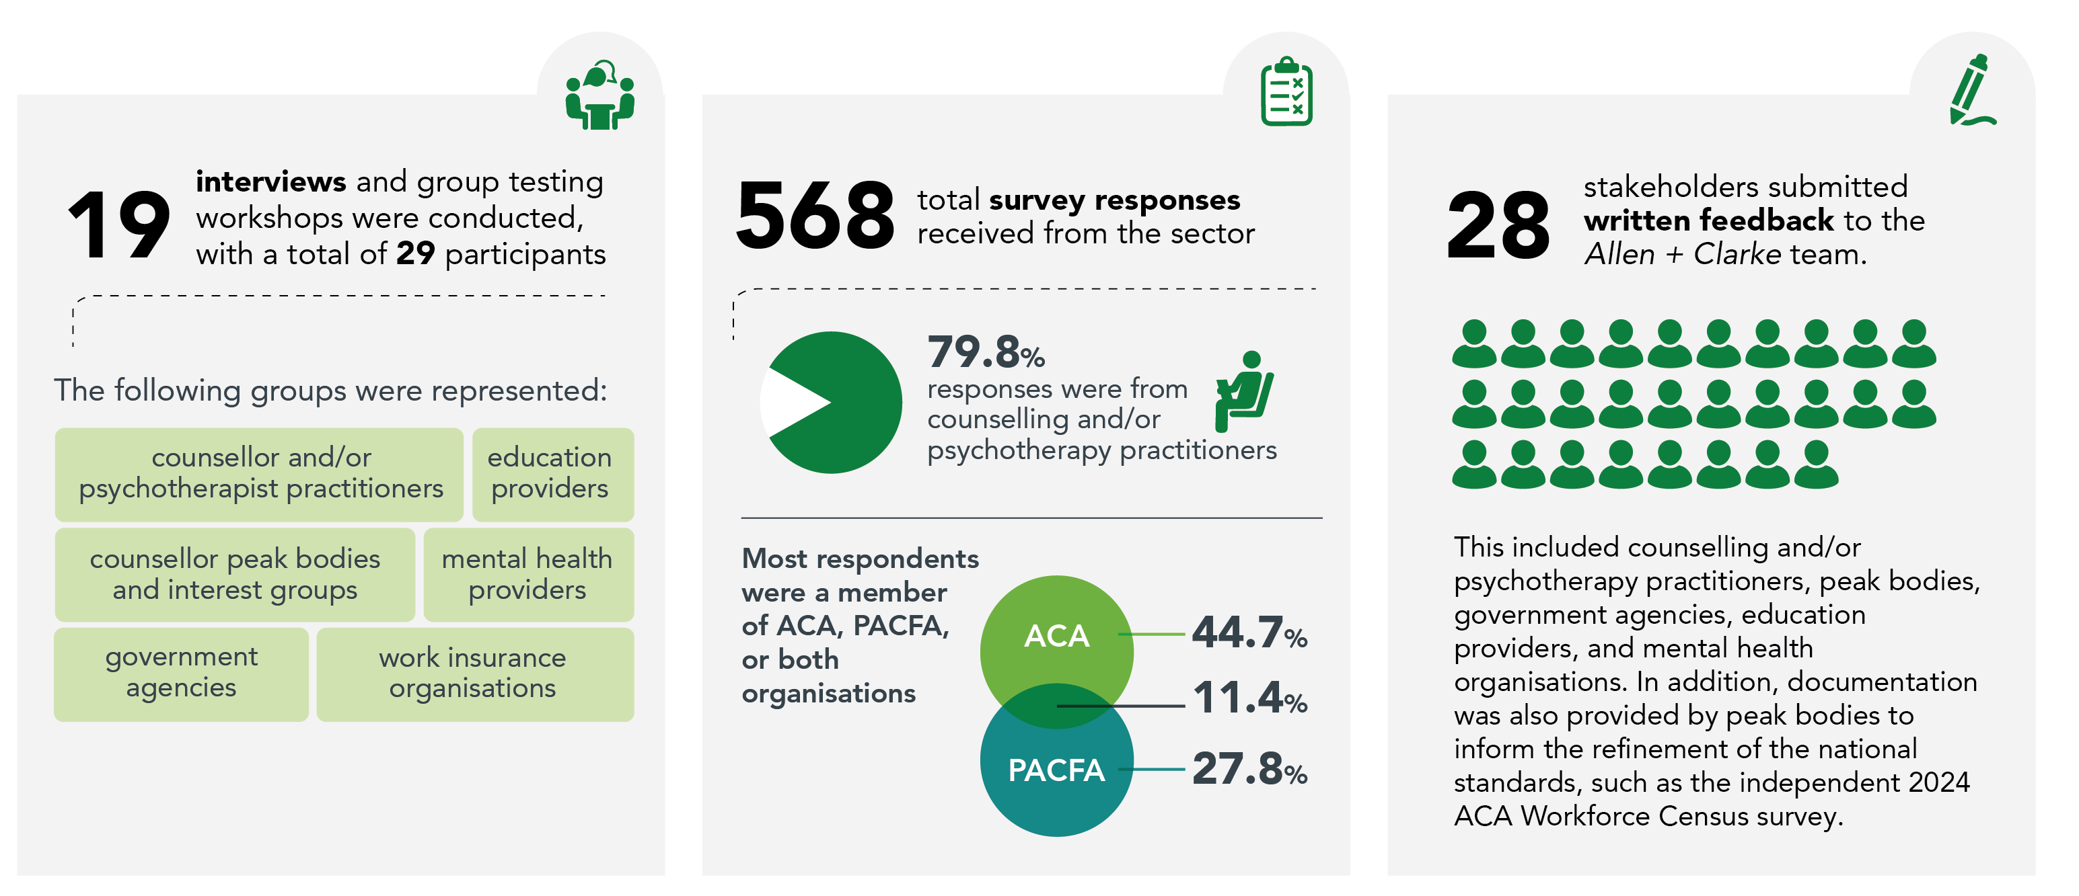
Summary of key consultation themes following second consultation process
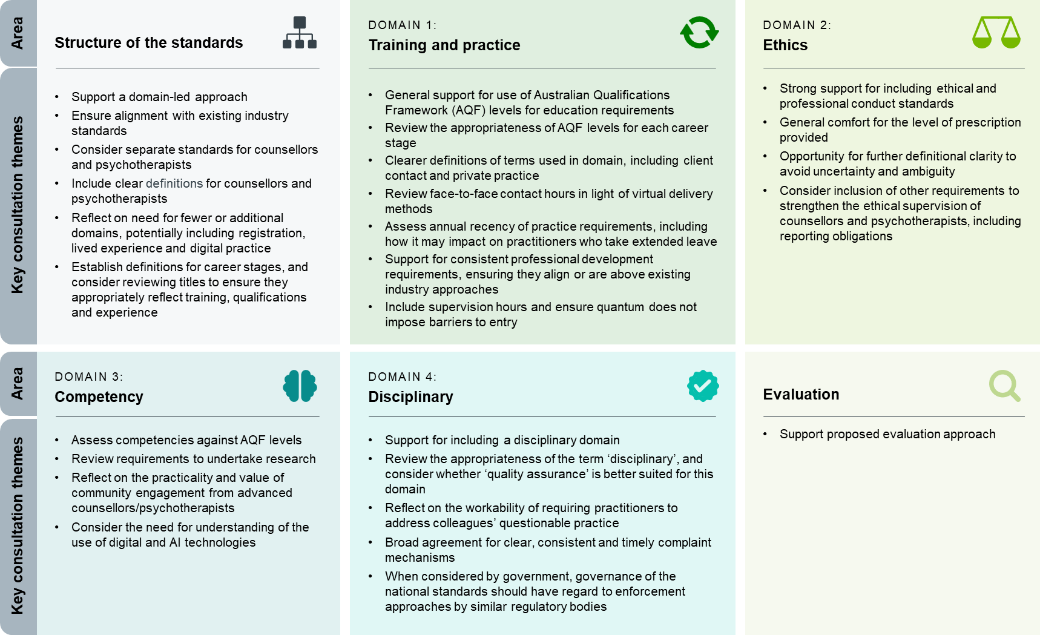
Feedback session with the ACA, PACFA and the department
On 10 February 2025, Allen + Clarke presented the key themes arising from the second round of consultation to the ACA, PACFA and the department. The peaks also provided written feedback on draft national standards.
How did it inform the revised draft national standards
Following the second round of stakeholder consultation, a revised draft set of national standards was developed. The changes were informed by the feedback provided in the consultation process, and whole of government regulatory design guidance, such as the Australian Government Regulatory Policy, Practice and Framework.
Overall, the main changes include increasing the number of the domains, reducing the career stages, and further strengthening the requirements of the standards against the AQF. For example, the domains have been restructured to provide better focus and clarity to key professional areas. This includes separating domain 1, training and practice, to education and training (domain 1) and profession practice (domain 2), and adding a diversity and inclusion domain in response to feedback on a need for a strengthened focus. Career stage titles have been replaced with numbers, and definitions, to promote more neutral terms and provide greater clarity. The fourth career stage has been deleted, since it was considered duplicative of career stage 3. The new career stages have also been reviewed and strengthened to better promote alignment with the AQF e.g. career stage 1 to AQF 5-6, career stage 2 to AQF 7-9 with less than 750 hours of client contact, and career stage 3 to AQF 7-9 with over 750 hours of client contact.
The table below sets out a summary of the key changes to the draft national standards that have been adopted in the national standards which are set out by the next chapter of this document. Since the domains have changed, the table identifies the changes under a standards area based on the previous domains.

Summary of key changes to draft national standards following second consultation process
Standards area | Key changes
Structure of the standards | - Added descriptions for career stages and each domain for clarity  - Removed a specialist career stage  - Relabelled career stage descriptors to 1, 2, 3  - Added a diversity and inclusion domain  - Split domain 1 and 2 into different domains - Education & Training and Professional Practice, respectively
Training and practice | - Created a clearer distinction between career stages  - Amended placement requirements to clarify face-to-face includes online delivery  - Removed minimum client contact hours for the career stage 1, recognising new status  - Provided for virtual client contact during supervised practice placements, with preference for face to face whenever possible  - Amendments made to clarify supervision at career stage 1 to be undertaken at individual whenever possible, while still allowing for group supervision if not possible  - Changed client contact hours at career stage 2 from 450 to 750, <750 hours, to recognise new entrants at this stage  - Removed AQF level 10 as it is considered a non-practicing qualification
Professional practice | - Changed eligibility for private practice for the career stage 1, allowing work within a limited scope of practice with conditional licence, irrespective of location
Ethics | - Included standard of care when clients are referred to another counsellor or professional  - Clarified informed consent needs to be provided in writing  - Included specific standard for working with children, including the information can be shared with parents​  - Referred to legal requirements relating to confidentiality and record keeping  - Inserted a standard on the use of social media  - Strengthened requirements for the ethical supervision of counsellors and psychotherapists  - Clarified standard about personal and business relationships ​(specifically, entering into a sexual relationship with a former client)
Competency | - Made changes to better align focus areas to AQF:  - career stage 1 to AQF 5-6  - career stage 2 to AQF 7-9 with less than 750 hours of client contact  - career stage 3 to AQF 7-9 with over 750 hours of client contact  - Reframed research requirements, to limit the expectation to undertake research to career stage 3, facilitating better alignment with the AQF  - Created a new digital practice standard for each career stage  - Created new focus area for evaluation, with the reference to audit deleted, on the basis that evaluation can include audit
Disciplinary | - Relabelled ‘disciplinary’ domain to ‘quality assurance’  - Revised terminology from "questionable practices" to "professional conduct concerns" for more neutral language  - Defined more explicit criteria regarding reporting expectations  - Provided further guidance on ‘unwarranted complaints’ to provide clearer guidance  - Added a line on responding to complaints in a timely and professional manner  - Clarified removal from practice as last resort, with graduated responses.

Overview of national standards
The national standards propose six domains, including education and training, professional practice, ethics, competency, diversity and inclusion, and quality assurance. Each domain prescribes requirements for an identified focus area, with graduated requirements for each career stage where relevant (e.g. educational attainment). The national standards also provide for review and evaluation in accordance with the Commonwealth Evaluation Policy.
Each domain is graduated into three categories based on the career stage of practitioner (1, 2 and 3). The career stages have specified requirements in the level of education, training and experience expected of counsellors or psychotherapists at each level.
CAREER STAGE 1
Practitioners with an AQF 5-6 qualification, with some experience in their field, who can undertake their work with support from other practitioners, and who always uphold ethical standards.
CAREER STAGE 2
Practitioners with an AQF 7-9 qualification, with experience in their field, who can manage some complexity, and always upholds ethical standards
CAREER STAGE 3
Practitioners with an AQF 7-9 qualification, with considerable experience in their field, who effectively manage complexity, always uphold ethical standards, and are able to provide supervision to other practitioners.
Domain 1: education and training

Domain 2: PROFESSIONAL practice

Domain 1: Education and training
Domain 5: diversity and inclusion
Domain 3: ETHICS
Domain 6: quality assurance
Evaluation
Domain 4: Competency

Domain 1: Education and training focuses on the key education requirements for counsellors and psychotherapists at each career stage. This includes formal qualification requirements, and requirements for supervised placement delivered within the formal training program.

Standard 1.1: Education and training
Descriptor for career stage
1 | 2 | 3

Focus area 1.1.1 Education

Accredited qualification in counselling at AQF level 5-6. | Accredited qualification in counselling at AQF level 7-9, with less than 750 hours of client contact. | Accredited qualification in counselling or psychotherapy at AQF level 7-9, with greater than 750 hours of client contact.

Focus area 1.1.2 Placement

At least 100 hours of supervised practice placements within the training program, with a minimum of 40 hours of in-person client contact whenever possible, or online (video/telephone). | At least 200 hours of supervised practice placements within the training program, with a minimum of 80 hours of in-person client contact whenever possible, or online (video/telephone). | At least 200 hours of supervised practice placements within the training program, with a minimum of 80 hours of in-person client contact whenever possible, or online (video/telephone).

Domain 2: Professional practice
Domain 2: Professional practice focuses on the practice requirements of counsellors and psychotherapists. This domain includes three standards: recency of practice and professional development, clinical supervision, and private practice. Each of the standards are graduated based on career stage.

Standard 2.1: Recency of practice and professional development
Descriptor for career stage
1 | 2 | 3

Focus area 2.1.1 Recency of practice

At least 150 practice hours per year or 450 practice hours over the past 3-year period. | At least 150 practice hours per year or 450 practice hours over the past 3-year period. | At least 150 practice hours per year or 450 practice hours over the past 3-year period.

Focus area 2.1.2 Professional development

A minimum of 20 hours CPD annually. | A minimum of 20 hours CPD annually. | A minimum of 20 hours CPD annually.

Standard 2.2: Professional/clinical supervision
Descriptor for career stage
1 | 2 | 3

Focus area 2.2.1 Focus and form of supervision

The focus of supervision is on the optimum outcomes for the client, and the professional development and self-care of the supervisee.  Should be undertaken as individual supervision (1 supervisor to 1 supervisee) whenever possible or group supervision (1 supervisor to up to 6 supervisees) if individual supervision is not available. | The focus of supervision is on the optimum outcomes for the client, and the professional development and self-care of the supervisee.  Can be undertaken as individual supervision (1 supervisor to 1 supervisee) or group supervision (1 supervisor to up to 6 supervisees). | The focus of supervision is on the optimum outcomes for the client, and the professional development and self-care of the supervisee.  Can be undertaken as professional supervision (individual or group) or peer supervision. Peers work together for mutual benefit as they rotate the roles of supervisor and supervisee – providing collegial critiquing and enhancement of each other’s clinical client work.

Focus area 2.2.2 Supervision hours

Undertakes 20 hours of supervision per year for 0-399 hours of client contact.  Undertakes 30 hours of supervision per year for over 400 hours of client contact. | Undertakes 10 hours of supervision per year for 0-399 hours of client contact.  Undertakes 15 hours of supervision per year for over 400 hours of client contact. | Undertakes 10 hours of supervision per year for 0-399 hours of client contact.  Undertakes 15 hours of supervision per year for supervisors and over 400 hours of client contact.

Focus area 2.2.3 Ability to provide supervision

Has no ability to provide supervision to others. | Has no ability to provide supervision to others. | Able to provide supervision with completion of a recognised training program.  The supervisor should have more experience than the supervisee with regard to professional seniority and skill development, except for when peer supervision is undertaken.

Descriptor for career stage
1 | 2 | 3

Focus area 2.2.4 Audit

Maintains a record of supervision for the duration of the supervisory relationship.  An audit of clinical supervision records will be conducted on a rolling 3 yearly basis with all practitioners being audited once every 3 years. | Maintains a record of supervision for the duration of the supervisory relationship.  An audit of clinical supervision records will be conducted on a rolling 3 yearly basis with all practitioners being audited once every 3 years. | Maintains a record of supervision for the duration of the supervisory relationship.  An audit of clinical supervision records will be conducted on a rolling 3 yearly basis with all practitioners being audited once every 3 years.

Standard 2.3 Private practice
Descriptor for career stage
1 | 2 | 3

Focus area 2.3.1 Eligibility for private practice

 | Able to work in private practice with limited scope of practice when a conditional licence is obtained and endorsement from peak body is received. | Able to work in private practice when a licence is obtained and endorsement from peak body (where relevant) is received |  | Able to work in private practice when a licence is obtained and endorsement from peak body (where relevant) is received.
Descriptor for career stage
1 |  |  | 2 | 3

Focus area 2.3.2 Requirements for private practice

Works within specified scope of practice, operating in private practice only for low-risk presentations.  Meets the legal and ethical dimensions specific to the practitioner’s state/territory and federal legislation.  Works to professional standards by practising within the bounds of individual professional competence and by keeping skills and knowledge up to date.  Provides clients with an agreement that includes information about the services they want to receive, how these services will be delivered and how information or data about them will be protected. This agreement needs to be in language and a format that can easily be understood. | Meets the legal and ethical dimensions specific to the practitioner’s state/territory and federal legislation.  Works to professional standards by practising within the bounds of individual professional competence and by keeping skills and knowledge up to date.  Provides clients with an agreement that includes information about the services they want to receive, how these services will be delivered and how information or data about them will be protected. This agreement needs to be in language and a format that can easily be understood. | Meets the legal and ethical dimensions specific to the practitioner’s state/territory and federal legislation.  Works to professional standards by practising within the bounds of individual professional competence and by keeping skills and knowledge up to date.  Provides clients with an agreement that includes information about the services they want to receive, how these services will be delivered and how information or data about them will be protected. This agreement needs to be in language and a format that can easily be understood.

Domain 3: Ethics
Domain 3: Ethics provides specific guidance on ethics related to practicing as a counsellor or psychotherapist. The ethics domain has six focus areas: best interests of clients, informed consent, confidentiality, personal and professional development, professional boundaries and ethical supervision of counsellors.

Standard 3.1: Ethics and professional conduct

Descriptor for career stage
1 | 2 | 3

Focus area 3.1.1 Best interests of clients

Acts in the client’s best interests, treating them with care and compassion.  Delivers non-judgmental professional services to the client, respecting their individuality and autonomy.  Takes all reasonable steps not to harm the client during counselling sessions and, if they are unable to continue to be of professional assistance, refers the client to a colleague or other professional, as appropriate.  Avoids conflicts of interest and does not exploit the client for personal, professional, political, or financial gain. | Acts in the client’s best interests, treating them with care and compassion.  Delivers non-judgmental professional services to the client, respecting their individuality and autonomy.  Takes all reasonable steps not to harm the client during counselling sessions and, if they are unable to continue to be of professional assistance, refers the client to a colleague or other professional, as appropriate.  Avoids conflicts of interest and does not exploit the client for personal, professional, political, or financial gain. | Acts in the client’s best interests, treating them with care and compassion.  Delivers non-judgmental professional services to the client, respecting their individuality and autonomy.  Takes all reasonable steps not to harm the client during counselling sessions and, if they are unable to continue to be of professional assistance, refers the client to a colleague or other professional, as appropriate.  Avoids conflicts of interest and does not exploit the client for personal, professional, political, or financial gain.

Descriptor for career stage
1 | 2 | 3

Focus area 3.1.2 Informed consent

Informs the client about the purpose, risks, limits, and costs of the proposed services at or before the first meeting and throughout the relationship.  Confirms that the client understands this information and obtains written consent to participate in counselling.  Ensures that the client freely consents to participate at all stages of the counselling process and respects their right to discontinue at any time. | Informs the client about the purpose, risks, limits, and costs of the proposed services at or before the first meeting and throughout the relationship.  Confirms that the client understands this information and obtains written consent to participate in counselling.  Ensures that the client freely consents to participate at all stages of the counselling process and respects their right to discontinue at any time. | Informs the client about the purpose, risks, limits, and costs of the proposed services at or before the first meeting and throughout the relationship.  Confirms that the client understands this information and obtains written consent to participate in counselling.  Ensures that the client freely consents to participate at all stages of the counselling process and respects their right to discontinue at any time.

Focus area 3.1.3 Confidentiality

Provides the highest levels of confidentiality to protect the privacy of clients and create the trust necessary for counselling or psychotherapy.  Informs the client of their right to confidentiality and explains the limits of this duty of care.  Takes steps to prevent the unauthorised disclosure of the client’s personal information.  Respects the right of a child or young person to confidentiality unless there are issues of significant harm to that person or other people, or other statutory requirements. Sharing information with their parents, carers or teachers should be with the full agreement of the child or young person.  Complies with any legal requirements relating to confidentiality and record-keeping and where necessary informs clients of these legal responsibilities in so far as it may affect them. | Provides the highest levels of confidentiality to protect the privacy of clients and create the trust necessary for counselling or psychotherapy.  Informs the client of their right to confidentiality and explains the limits of this duty of care.  Takes steps to prevent the unauthorised disclosure of the client’s personal information.  Respects the right of a child or young person to confidentiality unless there are issues of significant harm to that person or other people, or other statutory requirements. Sharing information with their parents, carers or teachers should be with the full agreement of the child or young person.  Complies with any legal requirements relating to confidentiality and record-keeping and where necessary informs clients of these legal responsibilities in so far as it may affect them. | Provides the highest levels of confidentiality to protect the privacy of clients and create the trust necessary for counselling or psychotherapy.  Informs the client of their right to confidentiality and explains the limits of this duty of care.  Takes steps to prevent the unauthorised disclosure of the client’s personal information.  Respects the right of a child or young person to confidentiality unless there are issues of significant harm to that person or other people, or other statutory requirements. Sharing information with their parents, carers or teachers should be with the full agreement of the child or young person.  Complies with any legal requirements relating to confidentiality and record-keeping and where necessary informs clients of these legal responsibilities in so far as it may affect them.

Descriptor for career stage
1 | 2 | 3

Focus area 3.1.4 Personal and professional development

Practices within the boundaries of their training, experience and competence, and accurately represents their credentials and services when advertising.  Maintains professional competence through ongoing CPD and by attending to their personal well-being.  Maintains professional standards online, just as they would in person, and avoids engaging in online activities that could harm their professional reputation, or the trust placed in the profession.  Undertakes appropriate, regular, and ongoing supervision and debriefing to develop skills, monitor performance, and sustain professional accountability. | Practices within the boundaries of their training, experience, and competence, and accurately represents their credentials and services when advertising.  Maintains professional competence through ongoing CPD and by attending to their personal well-being.  Maintains professional standards online, just as they would in person, and avoids engaging in online activities that could harm their professional reputation, or the trust placed in the profession.  Undertakes appropriate, regular, and ongoing supervision and debriefing to develop skills, monitor performance, and sustain professional accountability. | Practices within the boundaries of their training, experience and competence, and accurately represents their credentials and services when advertising.  Maintains professional competence through ongoing CPD and by attending to their personal well-being.  Maintains professional standards online, just as they would in person, and avoids engaging in online activities that could harm their professional reputation, or the trust placed in the profession.  Undertakes appropriate, regular, and ongoing supervision and debriefing to develop skills, monitor performance, and sustain professional accountability.

Focus area 3.1.5 Ethical supervision of counsellors

Not applicable. | Not applicable. | Maintains clear and appropriate boundaries between the supervisory relationship and any other personal, professional, or evaluative relationship they may have with a supervisee (an individual over whom they have a supervisory, evaluative, or instructional role).  Does not engage in nor allow any form of exploitative or coercive behaviour in the supervisor process, including any undue influence, manipulation, or abuse of power.  Actively works to promote the supervisee’s professional development while safeguarding their well-being and autonomy.

Descriptor for career stage
1 | 2 | 3

Focus area 3.1.6 Professional boundaries

Establishes and maintains appropriate boundaries around the counselling relationship.  Where possible, avoids dual and multiple relationships with clients that could impair their objectivity professionalism, or create conflicts of interest. If such relationships are unavoidable, for example in a rural or regional community, takes responsibility for clarifying and managing boundaries and protecting confidentiality, including discussing this within professional supervision.  Does not provide counselling or psychotherapy services when their functioning is impaired by alcohol or drugs (whether illicit or licit).  Exercises all reasonable care before entering into a personal or business relationship with former clients, taking into account the time that has elapsed since counselling or psychotherapy ended. Counsellors should not engage in sexual activity with a former client, or anyone closely related to the former client for at least five years after the end of the professional relationship. | Establishes and maintains appropriate boundaries around the counselling relationship.  Where possible, avoids dual and multiple relationships with clients that could impair their objectivity professionalism, or create conflicts of interest. If such relationships are unavoidable, for example in a rural or regional community, takes responsibility for clarifying and managing boundaries and protecting confidentiality, including discussing this within professional supervision.  Does not provide counselling or psychotherapy services when their functioning is impaired by alcohol or drugs (whether illicit or licit).  Exercises all reasonable care before entering into a personal or business relationship with former clients, taking into account the time that has elapsed since counselling or psychotherapy ended. Counsellors should not engage in sexual activity with a former client, or anyone closely related to the former client for at least five years after the end of the professional relationship. | Establishes and maintains appropriate boundaries around the counselling relationship.  Where possible, avoids dual and multiple relationships with clients that could impair their objectivity professionalism, or create conflicts of interest. If such relationships are unavoidable, for example in a rural or regional community, takes responsibility for clarifying and managing boundaries and protecting confidentiality, including discussing this within professional supervision.  Does not provide counselling or psychotherapy services when their functioning is impaired by alcohol or drugs (whether illicit or licit).  Exercises all reasonable care before entering into a personal or business relationship with former clients, taking into account the time that has elapsed since counselling or psychotherapy ended. Counsellors should not engage in sexual activity with a former client, or anyone closely related to the former client for at least five years after the end of the professional relationship.

Domain 4: Competency
Domain 4: Competency focuses on the attributes of counsellors and psychotherapists to work within the sector effectively and safely. The domain contains two standards: professional identity and core skills, including technology and digital practice.

Standard 4.1: Professional identity
Descriptor for career stage
1 | 2 | 3

Focus area 4.1.1 Personal competence

Has a broad theoretical and technical knowledge of counselling and/or psychotherapy.  Is able to use cognitive, technical and communication skills to analyse relevant counselling and/or psychology information, including theories and risks, to develop therapeutic responses and interventions collaboratively with clients.  Actively monitors their competence through supervision and is willing to consider any views expressed by their clients and their colleagues.  Is able to deliver the services being offered under supervision and carries out only those professional activities for which they have established their competence to practice.  Practices in areas new to them only after appropriate education, training, and supervision. | Has advanced theoretical and technical knowledge in counselling and/or psychotherapy.  Has advanced cognitive, technical and communication skills to select and apply methods to analyse critically, evaluate and transform relevant counselling and/or psychology information, including theories and risks, to develop therapeutic responses and interventions collaboratively with clients.  Actively monitors their competence through supervision and is willing to consider any views expressed by their clients and their colleagues.  Is able to deliver the services being offered competently and carries out only those professional activities for which they have established their competence to practice.  Practices in areas new to them only after appropriate education, training, and supervision and, when developing skills in the new specialty areas, takes steps to ensure the competence of their work and protect others from possible harm. | Has advanced and integrated understanding of a complex body of knowledge in counselling and/or psychotherapy.  Has expert, specialised cognitive and technical skills in counselling and/or psychotherapy to independently analyse critically, reflect on, and synthesise complex relevant counselling and/or psychology information, problems, concepts and theories to develop therapeutic responses and interventions collaboratively with clients.  Actively monitors their competence through supervision and is willing to consider any views expressed by their clients and their colleagues.  Is competent to deliver the services being offered and carries out only those professional activities for which they have established their competence to practice.  Practices in areas new to them only after appropriate education, training, and supervision and, when developing skills in the new specialty areas, takes steps to ensure the competence of their work and protect others from possible harm.

Descriptor for career stage
1 | 2 | 3

Focus area 4.1.2 Responsibility to the profession

Understands the importance of upholding the values, integrity, and ethics of the profession.  Understands the importance of celebrating excellence in counselling and psychotherapy practices and participates in the activities of these professions.  Represents honestly and accurately their membership status, qualification, training and competencies. | Upholds the values, integrity, and ethics of the profession.  Supports efforts to celebrate excellence in counselling and psychotherapy practices and participates in the activities of these professions.  Represents honestly and accurately their membership status, qualification, training, and competencies. | Upholds and fosters the values, integrity, and ethics of the profession.  Celebrates excellence in counselling and psychotherapy practices and participates in the activities of these professions.  Represents honestly and accurately their membership status, qualification, training, and competencies.

Focus area 4.1.3 Working with colleagues and other professionals

Is able to treat colleagues and other professionals with mutual respect, fairness, and honesty.  Understands the need to establish positive working relationships and communication with colleagues and other professionals that enhance services to the client.  Respects confidentiality about clients in all communications with colleagues and other professionals. | Treats colleagues and other professionals with mutual respect, fairness, and honesty.  Endeavours to establish positive working relationships and communication with colleagues and other professionals that enhance services to the client.  Respects and is mindful of confidentiality about clients in all communications with colleagues and other professionals.  Understands the need to avoid soliciting clients away from other counsellors. | Treats colleagues and other professionals with mutual respect, fairness, and honesty.  Endeavours to establish and maintain positive working relationships and communication with colleagues and other professionals that enhance services to the client.  Respects and is mindful of confidentiality about clients in all communications with colleagues and other professionals.  Avoids soliciting clients away from other counsellors.

Standard 4.2: Core skills
Descriptor for career stage
1 | 2 | 3

Focus area 4.2.1 Promoting effective therapeutic relationship

Develops and maintains an effective and respectful therapeutic relationship with the client, including:  - a shared sense of trust and empathy  - general agreement about the goals and purpose of interventions  - broad agreement about how to achieve those goals  - a shared understanding of the area of competence, and when and how referrals to other professionals will be made  - prepared and managed ending of counselling or psychotherapy relationships. | Develops and maintains an effective and respectful therapeutic relationship with the client, including:  - a shared sense of trust and empathy  - general agreement about the goals and purpose of interventions  - broad agreement about how to achieve those goals  - a shared understanding of the area of competence, and when and how referrals to other professionals will be made  - prepared and managed ending of counselling or psychotherapy relationships. | Develops and maintains an effective and respectful therapeutic relationship with the client, including:  - a shared sense of trust and empathy  - general agreement about the goals and purpose of interventions  - broad agreement about how to achieve those goals  - a shared understanding of the area of competence, and when and how referrals to other professionals will be made  - prepared and managed ending of counselling or psychotherapy relationships.

Focus area 4.2.2 Applying theories in practice

Assesses relevant counselling or psychotherapy theories and research to develop appropriate therapeutic interventions or responses for the client. | Develops appropriate therapeutic interventions or responses for the client informed by an assessment of relevant counselling or psychotherapy theories, and research. | Researches and applies relevant counselling or psychotherapy theories for appropriate therapeutic interventions or responses for broad or specialised client populations.

Descriptor for career stage
1 | 2 | 3

Focus area 4.2.3 Identifying and working with risks

Identifies and analyses risks, including suicidal risk, self-harming behaviours, and symptoms of trauma, and develops responses in relation to those risks in collaboration with the client.  Recognises their own limitations and competence in managing risks and seeks assistance or makes referrals where appropriate. | Identifies, critically analyses, and evaluates, risks, including suicidal risk, self-harming behaviours, and symptoms of trauma, and develops therapeutic responses or interventions in relation to those risks in collaboration with the client.  Recognises their own limitations and competence in managing risks and seeks assistance or makes referrals where appropriate. | Identifies, critically analyses, and evaluates, risks, including suicidal risk, self-harming behaviours, and symptoms of trauma, and develops therapeutic responses or interventions in relation to those risks in collaboration with the client.  Recognises their own limitations and competence in managing risks and seeks assistance or makes referrals where appropriate.

Focus area 4.2.4 Communication and digital practice

Transmits counselling and/or psychotherapy information and skills to counselling and/or psychotherapy sector audiences.  Is able to use digital technology, such as telehealth, to deliver counselling and/or psychotherapy to clients; and takes reasonable steps to ensure the technology used supports client privacy and confidentiality. | Transmits counselling and/or psychotherapy knowledge and skills to counselling and/or psychotherapy sector audiences.  Is able to use digital technology, such as telehealth, to deliver counselling and/or psychotherapy to clients; and takes reasonable steps to ensure the technology used supports client privacy and confidentiality. | Interprets and transmits knowledge, skills and ideas to specialist and non-specialist counselling and/or psychotherapy sector audiences.  Is able to use digital technology, such as telehealth, to deliver counselling and/or psychotherapy to clients; and takes reasonable steps to ensure the technology used supports client privacy and confidentiality.

Focus area 4.2.5 Evaluation

Understands the importance of evaluation approaches to promote continuous improvement in their counselling or psychotherapy work. | Understands and applies evaluation approaches to promote continuous improvement in their counselling or psychotherapy work. | Understands and applies evaluation approaches to promote continuous improvement in their counselling or psychotherapy work.

Domain 5: Diversity and inclusion
Domain 5: Diversity and inclusion focuses on the attributes of counsellors and psychotherapists necessary to respect diversity, foster cultural safety, and respond to the impact of discrimination. The domain contains two standards: respecting diversity and understanding the impact of discrimination.

Standard 5.1: Respecting diversity
Descriptor for career stage
1 | 2 | 3

Focus area 5.1.1 Respecting diversity

Understands their own values, beliefs and assumptions, and seeks to limit any harmful impact of these in their work with the client.  Respects diversity by not discriminating against the client based on their race, colour, disability, ethnicity, culture, gender, sexual identity, lifestyle, age, religious, spiritual or political beliefs, or on any other basis.  Gives careful consideration to whether they are competent to work with clients who come from diverse groups, or have special needs. | Understands their own values, beliefs and assumptions, and seeks to limit any harmful impact of these in their work with the client.  Respects diversity by not discriminating against the client based on their race, colour, disability, ethnicity, culture, gender, sexual identity, lifestyle, age, religious, spiritual or political beliefs, or on any other basis.  Gives careful consideration to whether they are competent to work with clients who come from diverse groups, or have special needs. | Understands their own values, beliefs and assumptions, and seeks to limit any harmful impact of these in their work with the client.  Respects diversity by not discriminating against the client based on their race, colour, disability, ethnicity, culture, gender, sexual identity, lifestyle, age, religious, spiritual or political beliefs, or on any other basis.  Gives careful consideration to whether they are competent to work with clients who come from diverse groups, or have special needs.

Focus area 5.1.2 Cultural responsiveness

Able to recognise and explore with the client the perspectives that underpin their understanding of identity, culture, values, and worldview.  Respectfully engages with people who have culturally diverse identities. | Able to understand the significance and impact of own identity, culture, language, values, and worldview in work with clients.  Able to apply an intersectional lens in their approach to complexities around culture and diversity. | Able to reflect on aspects of own identity, culture, values, and worldview that have most influenced ‘self’ and work on own preconceptions and bias when developing responses or interventions with the client.  Consult with relevant community members to inform their work with and for people from diverse identities and backgrounds.

Descriptor for career stage
1 | 2 | 3

Focus area 5.1.3 Cultural safety

Able to make initial and ongoing risk assessments regarding clients’ safety and comply with safeguarding guidance appropriate to the therapy setting, taking into account own limits of competence and skill at a stage 1 level (as set out by these national standards for this career stage). | Able to make initial and ongoing risk assessments regarding clients’ safety and comply with safeguarding guidance appropriate to the therapy setting, taking into account own limits of competence and skill at a stage 2 level (as set out by these national standards for this career stage). | Able to make initial and ongoing risk assessments regarding clients’ safety and comply with safeguarding guidance appropriate to the therapy setting, taking into account own limits of competence and skill at an stage 3 level (as set out by these national standards for this career stage).

Standard 5.2 Understanding the impact of discrimination
 | Descriptor for career stage
 | 1 |  | 2 | 3
Identifies and analyses the impact of discrimination, prejudice, displacement, and oppression on client mental health, and develops clients-focused responses in recognition of this impact. |  | Identifies, critically analyses, and evaluates the impact of discrimination, prejudice, displacement, and oppression on client mental health, and develops interventions and strategies informed by this awareness. |  | Identifies, critically analyses, and evaluates the impact of discrimination, prejudice, displacement, and oppression on client mental health, and develops interventions and strategies informed by this awareness.

Domain 6: Quality Assurance
Domain 6: Quality Assurance focuses on maintaining professional standards and integrity within counselling and psychotherapy practice. It outlines practitioners' responsibilities in upholding public confidence in the profession, addressing conduct concerns appropriately, engaging constructively with complaints processes, and understanding the responses to breaches of professional standards.

Descriptor for career stage
1 | 2 | 3

Focus area 6.1.1 Does not undermine public confidence in the profession

Does not conduct themselves in their counselling-related activities in ways that undermine the profession’s reputation or public confidence either in their role as a counsellor or psychotherapist or in the work of other counsellors or psychotherapists.  Does not use social media in a way that brings the profession into disrepute, such as making derogatory or insulting remarks about another counsellor or psychotherapist. | Does not conduct themselves in their counselling-related activities in ways that undermine the profession’s reputation or public confidence either in their role as a counsellor or psychotherapist or in the work of other counsellors or psychotherapists.  Does not use social media in a way that brings the profession into disrepute, such as making derogatory or insulting remarks about another counsellor or psychotherapist. | Does not conduct themselves in their counselling-related activities in ways that undermine the profession’s reputation or public confidence either in their role as a counsellor or psychotherapist or in the work of other counsellors or psychotherapists.  Does not use social media in a way that brings the profession into disrepute, such as making derogatory or insulting remarks about another counsellor or psychotherapist.

Descriptor for career stage
1 | 2 | 3

Focus area 6.1.2 Addressing professional conduct concerns

Addresses concerns about professional conduct through appropriate channels.  When aware of professional conduct concerns, first seeks to address the matter directly with the practitioner concerned, where safe and appropriate to do so.  Where appropriate, considers mediation or professional development opportunities prior to formal complaints escalation.  Where direct resolution is not appropriate or where the conduct concerns cannot be resolved or remedied after discussion with the practitioner concerned, reports substantiated concerns to the relevant body.  Ensures all reports are made in good faith, based on reasonable grounds, and focused on protecting client and public interests.  Does not initiate, participate in, or encourage the filing of ethics complaints that are unwarranted, lacking substantiation, or intended to harm a professional rather than to protect clients or the public. | Addresses concerns about professional conduct through appropriate channels.  When aware of professional conduct concerns, first seeks to address the matter directly with the practitioner concerned, where safe and appropriate to do so.  Where appropriate, considers mediation or professional development opportunities prior to formal complaints escalation.  Where direct resolution is not appropriate or where the conduct concerns cannot be resolved or remedied after discussion with the practitioner concerned, reports substantiated concerns to the relevant body.  Ensures all reports are made in good faith, based on reasonable grounds, and focused on protecting client and public interests.  Does not initiate, participate in, or encourage the filing of ethics complaints that are unwarranted, lacking substantiation, or intended to harm a professional rather than to protect clients or the public. | Addresses concerns about professional conduct through appropriate channels.  When aware of professional conduct concerns, first seeks to address the matter directly with the practitioner concerned, where safe and appropriate to do so.  Where appropriate, considers mediation or professional development opportunities prior to formal complaints escalation.  Where direct resolution is not appropriate or where the conduct concerns cannot be resolved or remedied after discussion with the practitioner concerned, reports substantiated concerns to the relevant body.  Ensures all reports are made in good faith, based on reasonable grounds, and focused on protecting client and public interests.  Does not initiate, participate in, or encourage the filing of ethics complaints that are unwarranted, lacking substantiation, or intended to harm a professional rather than to protect clients or the public.

Focus area 6.1.3 Complaints and enforcement mechanisms

Cooperates with investigations, proceedings, and requirements of the relevant complaints body having jurisdiction over those accused of breaching these standards.  Responds to complaints in a timely and professional manner. | Cooperates with investigations, proceedings, and requirements of the relevant complaints body having jurisdiction over those accused of breaching these standards.  Responds to complaints in a timely and professional manner. | Cooperates with investigations, proceedings, and requirements of the relevant complaints body having jurisdiction over those accused of breaching these standards.  Responds to complaints in a timely and professional manner.  Where a supervisee is under investigation, supervisors are required to cooperate with investigations, including where an assessment of their supervision is required.

Descriptor for career stage
1 | 2 | 3

Focus area 6.1.4 Removal from practice

Understands that breaches of professional standards may result in proportionate responses to protect client and public interests.  Accepts that responses may include required professional development, additional supervision, practice restrictions, or temporary suspension, as appropriate.  Recognises that removal from practice may occur as a last resort for serious breaches of these standards where other measures have not adequately protected public interests. | Understands that breaches of professional standards may result in proportionate responses to protect client and public interests.  Accepts that responses may include required professional development, additional supervision, practice restrictions, or temporary suspension, as appropriate.  Recognises that removal from practice may occur as a last resort for serious breaches of these standards where other measures have not adequately protected public interests. | Understands that breaches of professional standards may result in proportionate responses to protect client and public interests.  Accepts that responses may include required professional development, additional supervision, practice restrictions, or temporary suspension, as appropriate.  Recognises that removal from practice may occur as a last resort for serious breaches of these standards where other measures have not adequately protected public interests.

Evaluation of national standards
The national standards for counsellors and psychotherapists will be regularly evaluated by the department, consistent with the Commonwealth’s Evaluation Policy. This Policy provides for a principles-based evaluation approach, where evaluation activity is fit-for-purpose, useful, robust, ethical, culturally appropriate, credible, and transparent where appropriate.
Figure: Evaluation approach
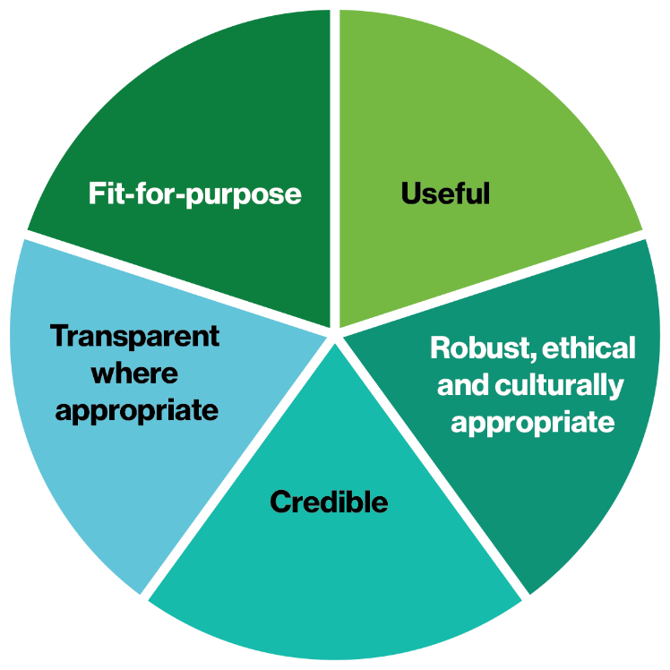




office@allenandclarke.com.au
www.allenandclarke.com.au

Department of Finance (2024), Australian Government Regulatory Policy, Practice and Framework, p.7
Australian Qualifications Framework define AQF Level 5 as Diploma and AQF Level 6 as Advanced Diploma, Associate Degree.
Australian Qualifications Framework define AQF Level 7 as Bachelor Degree, AQF Level 8 as Bachelor Honours Degree, Graduate Certificate, Graduate Diploma and AQF Level 9 as Master’s degree.
Client contact involves the provision of therapy within a therapeutic relationship for which client consent has been obtained.
Australian Qualifications Framework define AQF Level 7 as Bachelor Degree, AQF Level 8 as Bachelor Honours Degree, Graduate Certificate, Graduate Diploma and AQF Level 9 as Master’s degree.
Practice hours include time with clients, session preparation, note taking and follow-up. For the purposes of Recency of Practice calculations, 1 client contact hour can be converted into 2 practice hours.
The British Association of Counselling and Psychotherapy defines private practice as when a practitioner is self-employed and, for a fee, offers therapeutic services directly to clients either through self-referral or via a third party.
More details about the licensing program for private practice will be considered in the implementation phase.
More details about the licensing program for private practice will be considered in the implementation phase.
More details about the licensing program for private practice will be considered in the implementation phase.
The Treasury (n.d.), Commonwealth Evaluation Policy, Australian Government.

