

National Consumer  
Engagement Strategy for   
Health and Wellbeing

An implementation initiative for the:

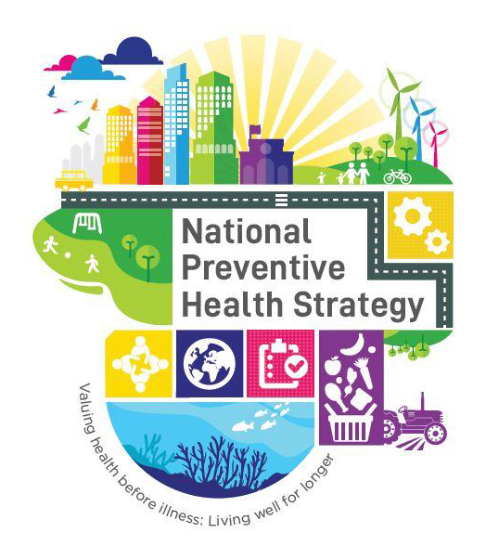

Acknowledgements

Many individuals and organisations have given their time and expertise to the development of this National Consumer Engagement Strategy for Health and Wellbeing and HELP Toolkit. This included an extensive program of consultations with key stakeholders and working closely with a broad range of consumers, many representing priority population groups, who provided lived experience expertise and insights that were integral to the development process. It also included numerous consultations with policy-makers from different levels of government, consumer and community organisations, digital health and technology organisations and various other non-government organisations. All contributed their time and expertise generously.

Development of this Strategy was undertaken by the Mitchell Institute at Victoria University, with support from the Consumers Health Forum of Australia and the consultancy 89 Degrees East. The project team included Professor Rosemary Calder, Mitchell Institute and Ms. Leanne Wells, Consumers Health Forum of Australia, as Project Co-directors; Ms. Erin Bowen, Mitchell Institute, Project Lead; and Professor Mark Morgan, Expert advisor and Professor of General Practice, Bond University. Additional content-specific expert advisors also contributed to and informed the development of this Strategy.

Design work on the Strategy and Toolkit documents was completed by 89 Degrees East.

© Commonwealth of Australia as represented by the Department of Health, Disability and Ageing 2025

Title: National Consumer Engagement Strategy for Health and Wellbeing

Creative Commons Licence

**CC BY ICON
A grey and black sign with a person in a circle

**

This publication is licensed under the Creative Commons Attribution 4.0 International Public License available from https://creativecommons.org/licenses/by/4.0/legalcode (“Licence”). You must read and understand the Licence before using any material from this publication.

Restrictions

The Licence may not give you all the permissions necessary for your intended use. For example, other rights (such as publicity, privacy and moral rights) may limit how you use the material found in this publication.

The Licence does not cover, and there is no permission given for, use of any of the following material found in this publication:

* the Commonwealth Coat of Arms (by way of information, the terms under which the Coat of Arms may be used can be found on the Department of Prime Minister and Cabinet website https://www.pmc.gov.au/government/commonwealth-coat-arms);
* any logos and trademarks;
* any photographs and images;
* any signatures; and
* any material belonging to third parties.

Attribution

Without limiting your obligations under the Licence, the Department of Health, Disability and Ageing requests that you attribute this publication in your work. Any reasonable form of words may be used provided that you:

* include a reference to this publication and where, practicable, the relevant page numbers;
* make it clear that you have permission to use the material under the Creative Commons Attribution 4.0 International Public License;
* make it clear whether or not you have changed the material used from this publication;
* include a copyright notice in relation to the material used. In the case of no change to the material, the words “© Commonwealth of Australia (Department of Health, Disability and Ageing) 2025” may be used. In the case where the material has been changed or adapted, the words: “Based on Commonwealth of Australia (Department of Health, Disability and Ageing) material” may be used; and
* do not suggest that the Department of Health, Disability and Ageing endorses you or your use of the material.

Enquiries

Enquiries regarding any other use of this publication should be addressed to the Branch Manager, Communication Branch, Department of Health, Disability and Ageing, GPO Box 9848, Canberra ACT 2601, or via e-mail to copyright@health.gov.au

Table of contents



Glossary 3

Summary 5

Strategy overview 7

About this Strategy 8

Purpose and objectives 8

Target audience 8

Health and wellbeing in Australia 9

Policy co-design with consumers and communities 10

Building this Strategy 11

Rapid evidence review 11

Consultations 12

Good practice consumer engagement 13

Consumer Engagement Fundamentals 14

Good Practice Guidelines 20

Understanding and applying the Guidelines 21

Consumer engagement approaches 31

Engagement methods 32

The policy cycle: consumer engagement touchpoints 36

Using a Guideline throughout the policy cycle: an illustration 37

What will this Strategy achieve? 38

Policy action areas to support implementation 39

Other resources 43

References 47

Table of figures

Figure 1: Engagement touchpoints across the policy cycle 36

Figure 2: Applying a Good Practice Guideline to the policy cycle 37

# Glossary



|  |  |
| --- | --- |
| Carer | Carers are people, often family members, who provide informal care, assistance and support with daily living activities to a person living with a disability, chronic health condition, terminal illness or frailty [1]. |
| Co-design | In the context of this Strategy, co-design refers to an iterative and participatory engagement process in which policy-makers, consumers and other relevant stakeholders work collaboratively to develop and implement health policy solutions. Existing definitions of co-design can vary slightly, however they consistently emphasise a process of active (rather than passive) consumer participation in creating mutually acceptable outcomes [2-4]. Co-design processes aim to build equal and reciprocal relationships between consumers and policy-makers, and assist in aligning policy design with community needs [5]. |
| Community | A community can be defined as a group of people sharing something in common. This could include interests, location, culture, language, beliefs, values, traditions, and/or shared experiences, which contribute to an individual’s sense of identity and the connections between members of the community [6]. |
| Consumer | Within the health sector, ‘consumer’ is used to refer to anybody who has lived experience of a health issue [7]. This includes all people who are affected by health policy, use health services or have a health condition, and extends to their families, carers and friends [7, 8]. Consumers can play various roles when participating in engagement activities, including person with lived experience, expert advisor or consumer representative, right through to policy, program or service co-designer [7, 9, 10]. |
| Consumer engagement | Consumer engagement refers to the practice of involving members of the public in developing and implementing the policies that will affect them as health consumers [11]. This includes agenda setting, decision making and other policy development activities undertaken by governments, government agencies and other policy-making organisations [12]. In the context of this Strategy, consumer engagement is used broadly to include various related terms and concepts such as community consultation, public participation and citizen involvement. |
| Consumer representative | Consumers can participate in engagement activities as individuals, or as consumer representatives who are nominated by, and accountable to, a consumer group or organisation [13]. Consumer representatives often feature in government and non-government led committees, advisory groups and other engagement activities to represent consumer perspectives and ensure they are considered in policy development and decision-making processes [13, 14]. |
|  |  |
| Engagement process | In the context of this Strategy, ‘engagement process’ is used to describe the overarching engagement initiative, which can include multiple different engagement approaches and a variety of engagement methods. |
| Hard-to-engage | In the context of this Strategy, ‘hard-to-engage’ describes the population groups or individuals who have been shown in evidence and recent experience to be those that policy-makers are least likely to successfully engage. The responsibility for diverse and representative engagement lies with policy-makers, not communities and individuals. The barriers to engagement exist between policy-makers and those who are hard-to-engage, not within the individuals and communities themselves [15]. |
| Health policy | Health policy refers to the decisions, plans, and actions that are undertaken by governments and other organisations to promote health [16]. Health policy processes involve setting health-related goals, designing systems and programs to meet those goals, implementing these systems and programs, and monitoring their outcomes [14, 16]. Outputs of health policy can include legislation, regulation, standards, practice guidelines or position statements [17]. |
| Policy-makers | In the context of this Strategy, policy-makers are recognised as those involved in developing and/or influencing policy, in both government and non-government organisations and settings. |
| Preventive health | Preventive health is any action taken to keep people healthy and well, and prevent or avoid risk of poor health, illness, injury and early death. This includes both population-level policy interventions and individual-based actions which aim to minimise disease burden and associated risk factors. Preventive health is of fundamental importance to overall population health and wellbeing [18]. |
| Priority population groups | There are a range of different population groups within society who experience a disproportionate burden of disease and disparities in health. The National Preventive Health Strategy 2021-2030 identifies these ‘priority populations’ as including, but not limited to [18]:   * Aboriginal and Torres Strait Islander people; * culturally and linguistically diverse (CALD) populations; * lesbian, gay, bisexual, transgender, intersex, queer, asexual and/or other sexuality and gender diverse people (LGBTIQA+); * people with mental illness; * people of low socioeconomic status; * people with disability; and * rural, regional and remote populations.   In this Strategy, these groups, and others who may experience health disparities, are referred to collectively as ‘priority population groups’. |

# Summary





Improving health and wellbeing across the population is a national policy priority of Australian governments. Good health and wellbeing, including physical, mental, social and cultural wellbeing, enables Australians to lead fulfilling and productive lives, participate in education and employment and contribute positively to their community [18].

The National Preventive Health Strategy 2021-2030 (NPHS), emphasises that preventive health action, informed and co-designed by consumers, is central to achieving a healthier Australia [18].

The development of a National Consumer Engagement Strategy for Health and Wellbeing (this Strategy) is one of the 8 priority actions included in the NPHS [18]. It has been developed to support and inform consumer engagement in health policy-making and to strengthen partnerships between policy-makers and consumers [18]. Trusted partnerships between policy-makers and consumers (and communities more broadly), are integral to ensure that policy is responsive to the diverse social, economic and cultural needs and circumstances that influence the health and wellbeing across the population.

Development of this Strategy has been informed by consultations with key stakeholders, underpinned by a review of the evidence relevant to effective consumer engagement and best practice co-design. The primary target audience for this Strategy is policy-makers (both government and non-government).

3 objectives, 5 Consumer Engagement Fundamentals and 10 Good Practice Guidelines make up the core elements of this Strategy (see Strategy overview on next page for further detail). Aligning with the 3 primary objectives are 3 priority policy action areas to support effective implementation of this Strategy. These are to:

1. Develop resources to support good practice consumer engagement in health policy-making.
2. Strengthen operational capability to achieve good practice consumer engagement across government and non-government organisations involved in health policy-making.
3. Build the capacity and capability of consumers, particularly those from priority population groups, to engage in health policy-making processes.

The *Health Engagement Learning Platform (HELP)* *Toolkit* is a supplementary resource to support policy-makers to implement this Strategy. It provides practical guidance to assist with designing, implementing and evaluating consumer engagement activities in health policy development.   
This includes a high-level overview of common consumer engagement approaches relevant to policy-making and detailed checklists for applying the Good Practice Guidelines.

This Strategy and the HELP Toolkit both provide an extensive list of existing resources that may further inform and guide consumer engagement in Australian health policy-making. Links to these can be found in the ‘Other resources’ section at the end of this Strategy and the HELP Toolkit.

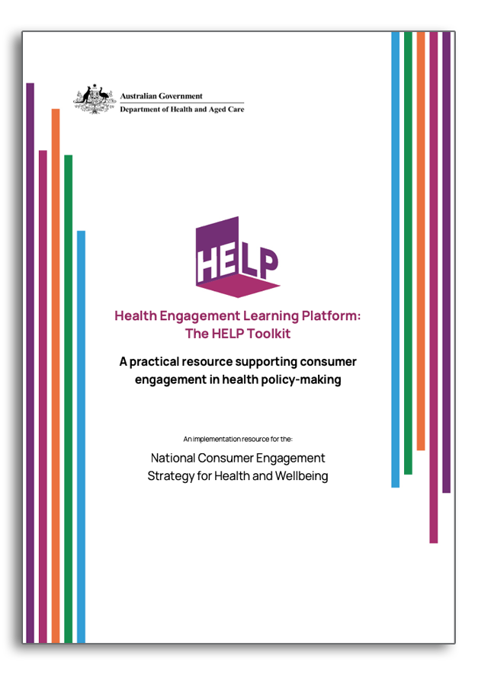

|  |  |  |  |  |  |  |  |  |  |  |  |
| --- | --- | --- | --- | --- | --- | --- | --- | --- | --- | --- | --- |
| |  | | --- | | Strategy overview | | | | | | | | | | | |
| Purpose | | | | | | | | | | |
| To enable and support consumer and community participation in all aspects of health policy-making and decision making, for improved policy and health and wellbeing outcomes. | | | | | | | | | | |
| Objectives | | | | | | | | | | |
| Strengthen partnerships and build trust between consumers and policy-makers to facilitate consumer participation and engagement at all levels of health policy-making. | | | Build capability of policy-makers to achieve trusted engagement with consumers and communities for better informed health policy-making. | | | | | Empower and support consumers and community organisations to engage in and co-design health (including preventive health) policies and programs. | | |
| Consumer Engagement Fundamentals | | | | | | | | | | |
| Purposeful | Inclusive | | | Respectful | | Transparent | | | | Collaborative |
| Shared understanding of purpose and outcomes.  Objectives agreed and clearly communicated.  Consumers engaged from the start and throughout. | Easy and accessible for all consumers to engage.  Diversity of voices, perspectives and modes of engagement.  Providing cultural, physical, ethical, psychological and emotional safety for all consumers involved. | | | Valuing lived experience, recognising consumers as equals and experts.  Consumers and organisations resourced appropriately.  Engagement occurs in a way and at a pace that suits the consumers. | | Early framing and communication of expectations and limitations.  Two-way feedback loops are available and actively used.  Consumers have access to appropriate training and supports. | | | | Commitment to ongoing relationships with consumers and their organisations.  Genuine partnerships with trust, collaboration and participatory engagement.  Engagement embedded in all policy-making. |
| Good Practice Guidelines | | | | | | | | | | |
| Build and sustain relational partnerships | | Treat people and communities with respect and value their contributions and development. Work with communities even when this does not immediately translate into policy outcomes – actively listen and seek to understand the needs of consumers and communities. | | | | | | | | |
| Develop a detailed understanding of the context | | Consider the social, demographic, cultural, political, psychological and physical environments influencing the policy context and possible consumer engagement approaches, including any limitations or constraints. | | | | | | | | |
| Identify who to engage | | Consider who the community and stakeholders are and your purpose for engaging. Identify trusted intermediaries and other stakeholders with existing community networks and local expertise. | | | | | | | | |
| Seek and support diverse engagement participation | | Employ inclusive processes that invite diverse participation and engage differences productively. Aim to include voices normally excluded from decision making due to a lack of engagement, active disengagement or existing barriers that prevent participation. | | | | | | | | |
| Meet people where they are | | Explore where, when and how consumers will be most receptive to engagement approaches; adapt your approach to meet the needs of consumers. | | | | | | | | |
| Understand different people require different approaches | | Utilise multi-modal engagement approaches that are fit for purpose including a range of engagement mechanisms to reach all consumers. | | | | | | | | |
| Engage with humility and empathy | | Recognise lived experience as valuable subject matter expertise and be open to learning from consumers. Be a facilitator, not a driver of the engagement. Remain responsive to potential power imbalances that may exist between lived experience and other forms of expertise. | | | | | | | | |
| Don’t let ‘perfect’ be the enemy of good | | Understand the iterative and adaptive nature of successful consumer engagement, recognising that there is not a ‘one size fits all’ approach to consumer engagement. If an approach isn’t working, seek feedback on how to better facilitate engagement and whether to try a different approach. | | | | | | | | |
| Seek and act on feedback | | Provide and sustain two-way feedback loops to provide participants with timely and iterative information and opportunities to inform the process and outcomes and to ensure a transparent and accountable process. | | | | | | | | |
| Monitor and evaluate engagement and impact | | Consumers should be actively engaged in policy monitoring and evaluation to assess the implementation outcomes of the policy approach. Indicators of effective engagement and evaluation/monitoring processes should be co-designed with consumers and included in all engagement approaches and processes. | | | | | | | | |
|  | | | | | | | | | | |
| HELP Toolkit | | Engagement approaches | | | Engagement touchpoints | | ‘How to’ checklists | | Other resources | |

# About this Strategy



### Purpose and objectives

The purpose of the National Consumer Engagement Strategy for Health and Wellbeing (this Strategy) is to enable and support consumer participation in all stages of health policy-making and decision making, including policy development, implementation and evaluation activities. This Strategy provides a framework to inform, guide and support policy-makers in achieving consistent, good practice consumer engagement in all relevant health policy-making processes, leading to improved policy and health and wellbeing outcomes.

3 objectives frame this Strategy. These are to:

1. Strengthen partnerships and build trust between consumers and policy-makers to facilitate consumer participation and engagement at all levels of health policy-making;
2. Build capability of policy-makers to achieve trusted engagement with consumers and communities for better informed health policy-making; and
3. Empower and support consumers and community organisations to engage in and co-design health (including preventive health) policies and programs.

### Target audience

The primary target audience for this Strategy and the accompanying HELP Toolkit is policy-makers, both those working in government and non-government settings. Policies relevant to health and wellbeing are developed at all levels of government and are influenced by various non-government stakeholders, including health service providers, non-government organisations (NGOs), community organisations, business and industry. In addition to contributing to public policy development, these non-government stakeholders also develop internal policies relevant to health and wellbeing. Throughout this Strategy, ‘policy-makers’ is used in its broad sense to include all of these stakeholders.



### Health and wellbeing in Australia

Improving population health and wellbeing in Australia is a national policy priority, highlighted in both the Australian Government’s national wellbeing framework - Measuring What Matters, the National Preventive Health Strategy 2021-2030 (NPHS), and further emphasised by the recent Strengthening Medicare reforms [18-20].

The health of individuals and communities is multifaceted, encompassing physical, mental, social and cultural health and wellbeing [21]. Good health and wellbeing enable Australians to lead fulfilling and productive lives, participate in education and/or employment, and contribute positively to their community.

Despite having one of the longest life-expectancies and best health care systems in the world [18, 22], approximately 1 in 2 Australians are living with preventable chronic health conditions, often for many years [23]. The number of people living with one or more chronic condition has increased considerably over the last 30 years and continues to rise [23, 24].

People in Australia, on average, live almost 11 years in poor health [25], but this number is considerably higher for Aboriginal and Torres Strait Islander people and other priority population groups due to disproportionately high rates of chronic conditions and poorer overall health [26, 27]. Health systems are often not designed to meet the diverse needs of different communities and consumers, and this can subsequently drive health disparities, particularly in priority population groups [28, 29].

There is a close relationship between people’s health and wellbeing, and the environments in which they live, work, play and age [30]. Social, environmental, structural, economic, cultural, biomedical, commercial and digital factors are often outside the control of individuals and can either strengthen or undermine health and wellbeing [18, 30]. These factors are referred to as the wider determinants of health [18, 30]. Lived experiences of stigma, trauma and racism or discrimination are also among the wider determinants of health that can have adverse impacts on health and wellbeing [31, 32].

The wider determinants of health often underpin the major risk factors for chronic conditions, particularly high levels of physical inactivity, poor dietary intakes and obesity, smoking and tobacco use, and alcohol consumption [23, 30]. At least one third of chronic conditions could be prevented by reducing these risk factors in the population [33].

The development of health policy initiatives in Australia must include a strong focus on prevention, reducing health inequities, and seek to address the wider determinants of health. The NPHS identifies strong prevention partnerships and community engagement as a policy priority for improving health and wellbeing across Australia [18].

### Policy co-design with consumers and communities

In the context of this Strategy, co-design refers to an iterative and participatory engagement process in which policy-makers, consumers and other relevant stakeholders work collaboratively to develop, design or improve policies, programs and services [2-4]. Co-design processes should emphasise active (rather than passive) consumer participation, include opportunities for shared decision-making and aim to build equal and reciprocal relationships between consumers and policy-makers, to achieve mutually acceptable outcomes [2-5]. Best practice co-design represents a shift from engaging consumers after an agenda has already been set, to seeking consumer knowledge and leadership from the outset so that consumers are involved in both describing the problem and designing the solution [2-4].

The active participation of consumers in co-design policy-making processes is associated with increased consumer satisfaction and approval of these processes [34]. While the evidence base for co-designed policies and programs being more effective in achieving positive policy outcomes is limited, evidence and experience demonstrate that the direct involvement of consumers and communities is associated with a range of benefits in policy-making processes [3, 34]. Co-design processes are recognised as a way to generate more innovative ideas, foster cooperation and trust between different stakeholders, meaningfully engage priority population groups and achieve community support for change [3]. Ensuring the active participation of consumers with relevant lived experience in policy-making processes, also makes it more likely that the policy solution will meet their needs [35].

Consumer experience, perspectives and knowledge can be effective in promoting the active participation of consumers in initiatives for improved health and wellbeing [11]. This ranges from increasing participation in cancer screening [36], to community-based prevention efforts needed to alter environmental, socioeconomic and cultural conditions in ways that promote health equity and generate healthier environments [37].

**We heard from consumers contributing to development of this Strategy:**

“We have to move at the speed of trust – can’t work within the same time pressures as policy-makers. Co-design doesn’t happen neatly within a financial year – it doesn’t fit into traditional decision-making structures.”

This Strategy emphasises the importance of strengthening partnerships and building trust between consumers and policymakers to facilitate effective consumer participation approaches in health policy. It is important to consider priority populations and their specific requirements when it comes to consumer engagement.

This Strategy works in parallel with the Aboriginal and Torres Strait Islander Partnership and Engagement Framework (the framework), which focuses on fostering meaningful partnerships and engagement with Aboriginal and Torres Strait Islander communities to improve health outcomes. The framework outlines actionable steps that staff can take to effectively plan, engage and partner with stakeholders to achieve genuine partnership, and ensure that programs, policies and services best suit the needs of Aboriginal and Torres Strait Islander people.

# Building this Strategy



This Strategy was developed using the perspectives of policy-makers, consumers, community organisations and communications and engagement experts. These were gathered through an extensive program of consultations with relevant stakeholders which aimed to identify what good practice consumer engagement looks like and how best to support it in practice. Alongside this, a review and analysis of contemporary evidence (the rapid evidence review) further informed this Strategy’s development.

**We heard from consumers that:**

“It is important not to reinvent the wheel and tap into the high quality existing consumer engagement tools and resources already available.”

### Rapid evidence review

The purpose of the rapid evidence review was to draw together and analyse evidence of what works to achieve effective consumer engagement relevant to health policy development. This included analysing various Australian and international consumer engagement frameworks and considering the evidence for effective consumer engagement processes and characteristics in a health policy context. It also investigated use of co-design in policy development, when consumers collaborate in partnerships with policy-makers [2].

The design and content of this Strategy takes into account and complements existing consumer engagement frameworks and resources, particularly those of the International Association for Public Participation (IAP2) [38], and the Australian Public Service (APS) [39, 40]. Most importantly, this Strategy draws from existing well regarded, co-designed frameworks generated by the health consumer sector, including priority population groups [2, 38, 39, 41-44]. All of these frameworks identify the benefits of public participation and consumer engagement in policy-making [2, 38, 39, 41-43] and promote accountability and responsiveness to consumers.

The rapid evidence review highlighted the growing recognition of the importance of consumer engagement for effective policy-making. It confirmed that consumer engagement approaches must be inclusive, responsive and empowering to effectively and appropriately involve consumers in shaping policies that impact their health and wellbeing [2, 38, 39, 41-43].

A separate, targeted rapid review focussed specifically on engaging with Aboriginal and Torres Strait Islander people was also undertaken to help inform relevant priority population group consultations.

**We heard from consumers that:**

“I might not have a PhD, but I have a PhD in lived experience”.

### Consultations

Consumers with a broad range of lived experience and engagement expertise provided guidance throughout the development of this Strategy. A diverse mix of consumer participants, including many from priority population groups were reached by working with community organisations and trusted intermediaries.

Priority population groups were engaged through a range of tailored approaches that were co-designed in collaboration with trusted intermediaries. This included:

* community discussions with Aboriginal and Torres Strait Islander people and organisations in far north Queensland undertaken by a trusted intermediary;
* a large in-person workshop in Western Sydney, facilitated by the local Primary Health Network (PHN), which brought together various consumers and organisations from priority population groups within the community; and
* a series of small online workshops facilitated by the Consumers Health Forum of Australia (CHF) with specific priority population groups.

Both government and non-government policy-makers and organisations and experts across various sectors including preventive health, communications and engagement, technology and digital health and community development were consulted in online stakeholder workshops.

To cater for the diverse circumstances and preferences of consumers and stakeholders, various engagement approaches were used, spanning from formal and structured consultations to informal community conversations and underpinned by a range of online and in-person engagement methods. This included:

* online consultation workshops;
* consumer-led ‘kitchen table conversations’ facilitated by trusted local leaders; and
* face-to-face consultation workshops convened by community organisations and PHNs.

A ’produce and test’ phase of consultations with policy-makers and a range of consumers considered the outcomes of the synthesis of evidence, existing frameworks and initial consultations to finalise the development of this Strategy.

**We heard from policy-makers that:**

“Listening and unlearning is as important as the learning. As bureaucrats we often go in with preconceived ideas. We need to go in open to raw, authentic conversations, unlearning our beliefs and being open to just listening to the community.”

# Good practice consumer engagement



The strong, consistent advice of all stakeholders who contributed to the development of this Strategy is that trust in the connection and relationships between consumers and policy-makers is essential for effective engagement. This requires sustained effort over and investment in consumer relationships, as trust is not an instantly attainable goal – it is established through ongoing interactions and connection. Sustained and reciprocal partnerships are built over time, and are predicated on placing consumers and communities at the heart of policy development and decision making. Strengthening partnerships and building trust requires engagement approaches that are purposeful, inclusive, respectful, transparent and collaborative [11].

For some engagement processes, especially those targeting priority population groups, establishing collaborative partnerships with appropriate intermediaries is essential to achieve trusted engagement and long-term consumer relationships [45].

Good practice consumer engagement does not summon consumers and their representatives, it meets them where they are, geographically, culturally, socially and economically. Outcomes of effective consumer engagement include mutual agreement about and understanding of the engagement purpose and potential; empowerment of consumers to participate in policy co-design activities; and confidence in the results of the engagement process [46].

Good practice engagement also requires that policy-makers are informed,   
trained and resourced to:

* understand the characteristics of effective engagement and how to contribute to the development of trust with consumers and communities;
* develop a detailed understanding of the context and consumer and community perspectives related to various policy issues;
* demonstrate humility and empathy throughout the engagement process, recognising lived experience as expertise and acknowledging the policy-maker’s role as facilitator, not driver, of the engagement;
* embed opportunities for iterative consumer feedback throughout the engagement process and adapt approaches accordingly; and
* collaboratively evaluate engagement activities and their subsequent impact on policy design and outcomes.

**We heard from consumers that:**

“Power and empowerment of consumers is important. Power needs to sit with the community, then you can build collaborative, respectful, transparent and trusting relationships. Consumers need to feel empowered by the engagement process that they can influence change.”

## Consumer Engagement Fundamentals



To support effective consumer and community participation in all engagement activities related to health policy-making, 5 elements have been identified as fundamental. The term ‘fundamental’ has been deliberately chosen as it describes something that affects “the basic nature of other things or are the most important element[s] upon which other things depend” and serve “as the basis of an idea or system” [47].

The Fundamentals are the foundational building blocks for effective consumer engagement approaches. They are essential for engagement activities at any point of the policy-making process and are applicable to engagement with all consumer and population groups. Applying these Fundamentals in all engagement activities relevant to health policy development is essential for building trust and supporting and strengthening equitable partnerships between consumers and policy-makers.

The 5 Fundamentals require consumer engagement in health policy-making to be:

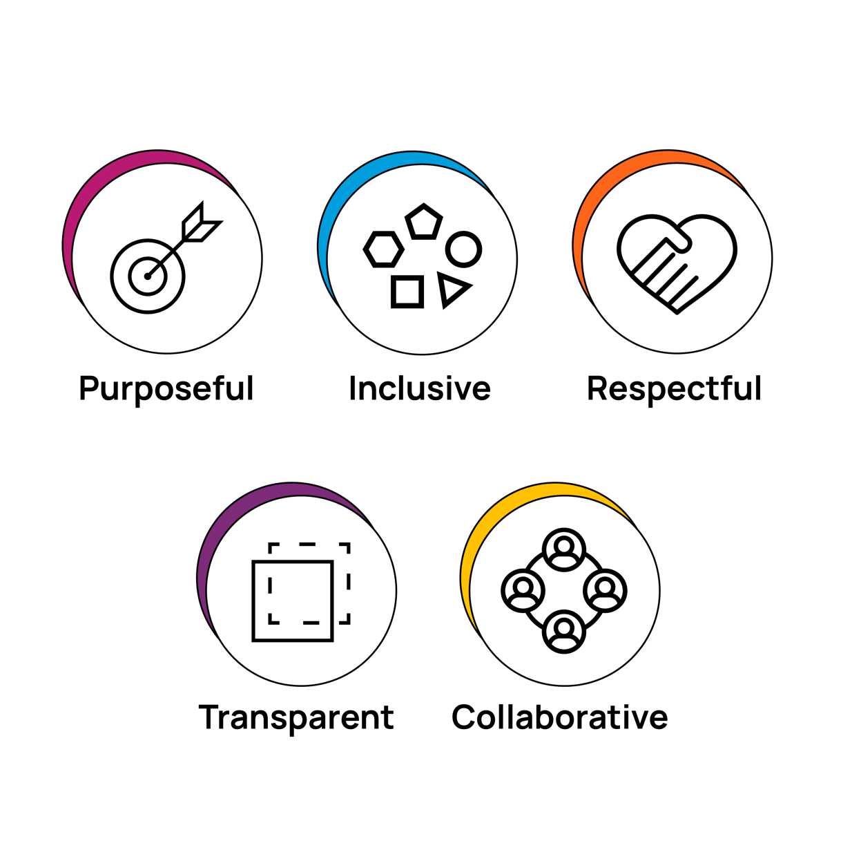

**We heard from consumers that:**

“You have to truly value people with lived experience or they won’t engage.”

|  |  |  |
| --- | --- | --- |
| Purposeful | |  |
|  | | |
| Ensure there is a clear and shared understanding of the purpose and expectations of the engagement | Be responsible and accountable for securing an unambiguous, shared understanding of the objectives, method/s and level of engagement with participants at the outset of the engagement process. | |
| Engage with consumers and incorporate lived experience from the outset | Consumers should be involved across all stages of the policy-making process. They can help to refine and evolve the policy or program as it develops, as well as shape a fit-for-purpose engagement process that works for all. | |
| Negotiate the process and timelines for the engagement | Talk with consumers and community organisations to jointly determine the engagement process, best methods of engagement and project timelines to manage expectations and optimise participation.  Sometimes a more focused period of engagement over a shorter timeframe can be more appropriate, particularly where there is a risk of over-engagement which is often experienced by various priority population groups. | |
| Identify different engagement touchpoints across the policy-making cycle | Carefully consider when and how consumers can be engaged throughout the policy-making process to maximise the value of their contributions. The engagement approaches best suited to the policy design phase may be different to those of most benefit to policy implementation and/or evaluation. | |

|  |  |  |
| --- | --- | --- |
| Inclusive | |  |
|  | | |
| Ensure the engagement process is accessible for all consumers | Create environments and platforms where a diverse range of consumers can equitably participate in safe and appropriate ways. Be empathetic, kind and gracious in your interactions. | |
| Recognise the diverse and varied circumstances and needs of different consumers and priority population groups | The circumstances and experiences of individuals varies greatly, both across and within communities. It is important to recognise this diversity when engaging, and to be mindful of how different consumers and population groups may be affected by the wider determinants of health, including intergenerational trauma, racism, poverty, marginalisation, language barriers, or reduced mobility. All of these factors can influence individual consumer needs and must be considered when planning an engagement process. Consumers may also identify with more than one priority population group and this intersectionality can further amplify health disparities. | |
| Embed, plan and cater for diversity and inclusion | Undertake research to ensure diversity and inclusion are catered for in accordance with established best practice and expert guidance. Prioritise safety, including cultural, physical, psychological and emotional safety for all consumers in any engagement activity. Ensure policy-makers are sufficiently trained in cultural safety, inclusivity and trauma-informed best practice. Avoid the convenience of approaching the same individuals or groups who are always willing to participate. | |
| Use a range of engagement approaches and methods to reach all targeted consumers | Remember that different people engage at different levels and in different ways. Include a variety of engagement approaches and methods in the overarching engagement process to encourage broad and diverse participation. Maintain ongoing monitoring and evaluation throughout the engagement process to assess whether participants are reflective of the full spectrum of consumers being targeted. | |

|  |  |  |
| --- | --- | --- |
| Respectful | |  |
|  | | |
| Value lived experience, recognising consumers as equals and experts | Consumer perspectives can be enormously valuable to ensure the policy or program being developed is robust, appropriately targeted, fit-for-purpose and implemented effectively. Consumers should be recognised as equals, with complementary expertise to policy-makers and other stakeholder groups. | |
| Acknowledge and formally recognise the contributions of consumers | Build into all engagement processes systematic respect for consumer participation through formal means such as remuneration, terms of reference, regular correspondence (including acknowledgements of contributions) and appropriate attribution in publications and other documentation. | |
| Appropriately resource engagement approaches | Provide consumers and communities with access to the resources and engagement supports to participate meaningfully. This could include remuneration, travel reimbursements, access to interpreters, training or inductions and various other supports specific to the group being engaged. | |
| Undertake engagement activities in a way and at a pace that suits consumers | When planning an engagement process, seek input from consumers regarding their needs and preferences, to ensure it is designed with, not for, the group you wish to work with. | |
| Adhere to relevant organisational policies and professional standards | Ensure that engagement processes are undertaken with a high-level of professionalism and diligence. Consider how existing organisational policies and procedures need to be integrated into engagement activities. | |
| Ensure policy outputs are reflective of consumer insights and contributions | Regularly review policy-making and engagement outputs to ensure consumer insights and perspectives are reflected in the policy or program being developed or implemented. | |

|  |  |  |
| --- | --- | --- |
| Transparent | |  |
|  | | |
| Be open, transparent and accountable | Empower consumers to participate in a meaningful and equitable way by ensuring they have all necessary information.  Ensure any perceived or actual conflicts of interest are identified, declared and managed throughout the engagement process.  Describe what, if any, personal information and/or data will be collected throughout the engagement process and how it will be used. Ensure any personal data is stored and managed appropriately to maintain consumer confidentiality. | |
| Explain the intent, expectations and limitations of engagement | Clearly communicate and ensure that consumers understand the level of participation being proposed in any engagement initiative, how their input will be used and the level of influence they will have in the policy development process. | |
| Facilitate dynamic and comprehensive feedback loops | Prioritise transparency and accountability to build trust in the engagement relationship by providing timely and iterative information to participants and embedding regular opportunities for participant feedback on the engagement process. | |
| Establish relationships with trusted intermediaries | Where appropriate, work through trusted intermediaries, including community leaders, cultural organisations and other NGOs, to establish open communication and engagement with consumers and community groups. | |
| Build consumer confidence in engagement processes | Facilitate continued engagement and ensure consumers can see the purpose and outcomes of an engagement process. Participants need to see their voice in the end-product. | |

|  |  |  |
| --- | --- | --- |
| Collaborative | |  |
|  | | |
| Facilitate genuine participatory engagement where power and knowledge are shared | Establish long-term trust and collaborative practice between policy-makers, consumers and community organisations.  Factor into engagement planning and processes the time that it takes to develop trust to foster equal collaboration, consumer empowerment and effective co-design, particularly for hard-to-reach and hard-to engage population groups. | |
| Put local community-controlled organisations and trusted intermediaries at the centre of engagement | Work in partnership with trusted intermediaries, individuals and organisations that have established relationships with specific groups of consumers and communities.  Identify trusted intermediaries through community leaders, local service providers, representative peak bodies and local/regional government agencies. Trusted intermediaries spend time building long-term community relationships and can facilitate connections between health consumers and policy-makers undertaking engagement activities. | |
| Build an organisational culture that supports and values consumer engagement and collaborative practice | Establish leadership responsibility for good practice consumer engagement at the most senior level of an organisation.  Systematically embed information and guidance on good practice consumer engagement into organisational culture, policies, procedures, systems and training. | |
| Ensure consumer engagement is a core component of all policy-making processes | Embed consumer engagement activities into all stages of the policy-making cycle, including the design, implementation and evaluation of health policies and programs. | |

## Good Practice Guidelines



The Good Practice Guidelines (the Guidelines) provide a framework of the critical features of effective engagement processes in health policy development. They are underpinned by the 5 Fundamentals and will support policy-makers in achieving meaningful consumer engagement throughout the policy-making process.

The Guidelines were developed through analysis of how consumer engagement in policy-making has been undertaken in practice, across a diverse range of settings, to identify the key characteristics of successful engagement approaches. This was underpinned by the rapid evidence review and extensive program of consultations, which included targeted workshops with priority population groups to specifically develop and refine the Guidelines.

They are purposefully presented as ‘Good Practice Guidelines’ because there is no one ‘best’ way to engage with consumers. The Guidelines provide policy-makers with descriptors and strategies to assist with the development and implementation of engagement approaches likely to be most appropriate for the policy issue and the consumer cohort being engaged.

|  |  |  |  |
| --- | --- | --- | --- |
|  |  |  |  |
| A black and yellow circle with circles and dots | Build and sustain  relational partnerships | A white circle with black arrows and blue and white background | Understand different people require different approaches |
| A light bulb in a circle | Develop a detailed understanding of  the context | A purple and black talking bubbles | Engage with humility  and empathy |
| A group of people in a circle | Identify who  to engage | A purple hand making a gesture | Don’t let ‘perfect’ be  the enemy of good |
| A blue and black circle with 4 shapes inside | Seek and support diverse engagement participation | A logo of a chat bubble with a star | Seek and act  on feedback |
| A blue and black triangle symbol | Meet people where  they are | A purple and black circle with a checklist | Monitor and evaluate engagement and impact |

### Understanding and applying the Guidelines

|  |  |  |
| --- | --- | --- |
|  | | |
| Guideline | Description | Strategies |
| Build and sustain relational partnerships | Recognise consumers as experts in lived experience and value their contributions as equal collaborators in an engagement process.  Establish and nurture ongoing relationships with trusted intermediaries and respect their advice regarding consumer and community engagement activities.  Work with communities even when this does not immediately translate into policy outcomes – actively listen and seek to understand the needs of consumers and communities.  Prioritise building rapport in early interactions and show a willingness to learn about the community group or individuals that you are trying to engage with. | * Meet with consumers/ communities to hear their concerns and needs outside of specific policy development – provide opportunities to engage more broadly on the issues that are important to them. * Value the time of consumers and ensure their participation is appropriately resourced and remunerated. * Empower consumers by developing their engagement, advocacy, and leadership skills. Provide information, training and mentoring as appropriate in policy-making and health and wellbeing. * Establish two-way communication channels between policy-makers and consumers. * Do not ‘tokenise’ engagement. Consumer partnerships need to be mutually beneficial and reciprocal, with give and take. * Explore ways to maintain continuity of relationships between consumers, consumer and community organisations and policy-makers. |

|  |  |  |
| --- | --- | --- |
|  | | |
| Guideline | Description | Strategies |
| Develop a detailed understanding of the context | Consider the social, demographic, economic, cultural, political and physical factors influencing the engagement context and policy environment of the consumer cohort or community being engaged.  Develop an understanding of the major contextual issues and barriers to engagement within a specific community.  Be aware of siloed consumer engagement and over-engagement (i.e. where the same consumers or community groups are approached to participate in multiple engagement activities on the same or similar issues), as this can result in engagement fatigue and be a barrier to establishing sustained, trusted relationships with consumers and communities. | * Prior to engagement, take time to understand the politics and unique structure and characteristics of the community being engaged. * Identify resource and time constraints – consider these from both the policy-making perspective and from the perspective of the consumers and communities you are wanting to engage with. * Consider the diverse needs and circumstances specific to the target population group/s and identify any potential limitations or constraints to engagement. Mitigate these by fostering a safe and inclusive environment for all consumers. * Investigate any other engagement activities that are under way or have been undertaken in the community previously to inform engagement planning and avoid over-engagement with certain communities and population groups. * Talk to community leaders, local stakeholders and consumers directly (where appropriate), to canvass their views on the policy issue/s being considered. |

|  |  |  |
| --- | --- | --- |
| ­ | | |
| Guideline | Description | Strategies |
| Identify who to engage | Consider who the community and stakeholders are and your purpose for engaging.  Identify and utilise trusted intermediaries to assist with connecting to consumers who have lived experience that is most relevant to the engagement topic. Trusted intermediaries can include community and cultural leaders,  local community organisations, consumer organisations and other relevant NGOs. | * Identify where potential engagement participants place their trust and connect through these networks. This could include social media influencers that have built trust with their followers, active online or in-person support groups or multicultural and other community organisations that have their own consumer communication channels or that use locally trusted social media networks to connect with people. * Identify ‘engagement allies’ or ‘critical friends’ from consumer peak bodies and other community organisations who can be directly involved in informing and guiding engagement approaches. * Seek advice from relevant collaborators, organisations and consumers within your existing networks, on which communities or population groups are most affected by the policy issue/s in question. |

|  |  |  |
| --- | --- | --- |
| ­ | | |
| Guideline | Description | Strategies |
| Seek and support diverse engagement participation | Employ inclusive and culturally appropriate processes and language that enable diverse participation and productive engagement with various individuals and population groups.  Aim to include voices commonly excluded from decision making either because they are actively disengaged, or because existing barriers prevent participation.  Offer flexibility in methods of engagement to enhance accessibility for a diverse range of consumers. | * Consider using cultural advisers to facilitate engagement participation. * Engage with multiple ‘voices’, don’t assume that one person can speak for a whole community or cultural group. * Ensure in-person engagement activities are physically accessible for all and employ the use of accessibility aids where appropriate (e.g. interpreters, assistive technologies). * Provide capacity building opportunities within engagement activities, including consumer training, inductions and other support, to encourage and enhance participation – e.g. digital literacy training could be offered to consumers prior to participating in a digital engagement activity. |



|  |  |  |
| --- | --- | --- |
| ­ | | |
| Guideline | Description | Strategies |
| Meet people where they are | Explore where, when and how consumers will be most receptive to engagement approaches.  Adapt your engagement approach to meet the needs of consumers, rather than bringing consumers into a policy-making process that is familiar to policy-makers and organisations, but not to them.  Be aware that some engagement approaches may be less accessible for consumers than others and can reduce the capacity and/or willingness, for consumers to participate effectively or safely. | * Wherever possible, facilitate community-led engagement and adapt your approach to meet people’s needs, capacity and expectations. * Work at the pace of consumers and provide skill development and capacity building where needed. * Identify with consumers how to support their health literacy needs. * Utilise existing settings (social media, community networks, community events), where people feel more comfortable, safe and empowered and are more likely to engage. * Provide flexible participation options so that consumers can contribute at a time and place that is convenient for them (i.e. at their home or on a mobile device), rather than having to attend a certain venue at a certain time. * Ensure that consumers are able to contribute through multiple formats and media - e.g. Easy Read, simple English or non-written communication. |

|  |  |  |
| --- | --- | --- |
| ­ | | |
| Guideline | Description | Strategies |
| Understand different people require different approaches | How you engage with consumers depends on the scale and complexity of the issue, the scope of policy solutions being considered, the group/s of consumers affected by the policy issue and the options available.  The design of engagement approaches can be informed by local intelligence and exploring what has worked for a particular community or population group previously.  Inflexible approaches to engagement, and policy development more broadly, can result in the exclusion of some consumers and population groups. | * A good way to start an engagement process is to ask people in the community “what are some of the ways we can talk with you?” * No single method or approach has all the answers – utilise multi-modal engagement approaches that are fit-for-purpose and include a range of engagement methods to maximise participation within the target population group. * Be mindful of the ‘digital divide’. Online platforms have their place but there are many in the community for whom this is not an optimal, natural or accessible way to engage with policy-making. Provide additional familiarisation and training for those less confident with digital engagement methods and platforms. * If an approach is not working, try a different approach – allow for adaptation in engagement processes to ensure they are flexible and responsive to participant feedback. * Avoid generic or one size-fits-all engagement approaches and processes. Approaches should be tailored to the community or priority population group being engaged and be appropriate for all participants in the target group. |

|  |  |  |
| --- | --- | --- |
| ­ | | |
| Guideline | Description | Strategies |
| **Engage with humility and empathy** | Humility enables better listening, increased collaboration, and a more compassionate engagement process.  Trying to properly understand and relate to the circumstances and perspectives of participants is likely to correlate to more authentic engagement and better consumer input.  Recognise that the lived experiences and contributions of all participants are valuable and should be respected equally. Be open to learning from consumers. | * Acknowledge the power imbalances between consumers and policy-makers, particularly those in government. Redistribute power and foster shared ownership of the process through a commitment to co-design. * Take time to actively listen without feeling compelled to provide answers and enable authentic conversations that allow consumers and communities to be open and frank. * Recognise the inherent imbalances of information and understanding of government priorities between policy-makers and consumers. Work to address these through transparent and open communication regarding the context and purpose of the engagement. * Be a facilitator, not a driver of the engagement. * Suspend judgement and be open to the unlearning of any pre-conceived notions. * Be mindful and respectful of the diverse needs and sensitivities of the group being engaged. |

|  |  |  |
| --- | --- | --- |
| ­ | | |
| Guideline | Description | Strategies |
| Don’t let ‘perfect’ be the enemy of good | Embrace the unpredictable and be agile and innovative in your approach to consumer engagement.  Agility in consumer engagement for policy-making can lead to the development of highly practical and responsive policy outcomes, either to meet immediate needs or as part of a longer-term planning process. | * Understand the iterative and adaptive nature of successful consumer engagement and be flexible with your approach. * Be adaptable and willing to change engagement approaches or policy design based on unanticipated engagement outcomes. * Be open to innovative ideas and new ways of engaging. * Avoid being overly risk averse when planning engagement activities and don’t be afraid to share significant decision-making responsibilities with consumers. |



|  |  |  |
| --- | --- | --- |
| ­ | | |
| Guideline | Description | Strategies |
| Seek and act on feedback | Ensure open and accessible communication channels between the people being engaged and those undertaking the engagement. Consumers are more likely to continue to engage if they feel they have been listened to.  Actively seek and facilitate feedback opportunities throughout the engagement process. Two-way feedback loops enable engagement to be transparent and responsive to consumer and policy-maker needs and issues.  Complete the feedback loop – if community expectations cannot be fully met, be transparent and accountable. Demonstrate to participants that their concerns and aspirations have been heard and ensure they are fully informed of the engagement outcome/s. | * When you collect information or data from community consultation, ensure that it is reported back to participants and clearly communicate what it is being used for. * Be flexible with your approach – embed capacity to modify engagement processes in line with consumer feedback. * Ensure that engagement participants can see that consumer perspectives are being heard and acted on to build trust in the process. * Provide education and training to policy-makers on how to engage in feedback from, to, and with consumers – feedback in real time is critical for transparency and effectiveness. |

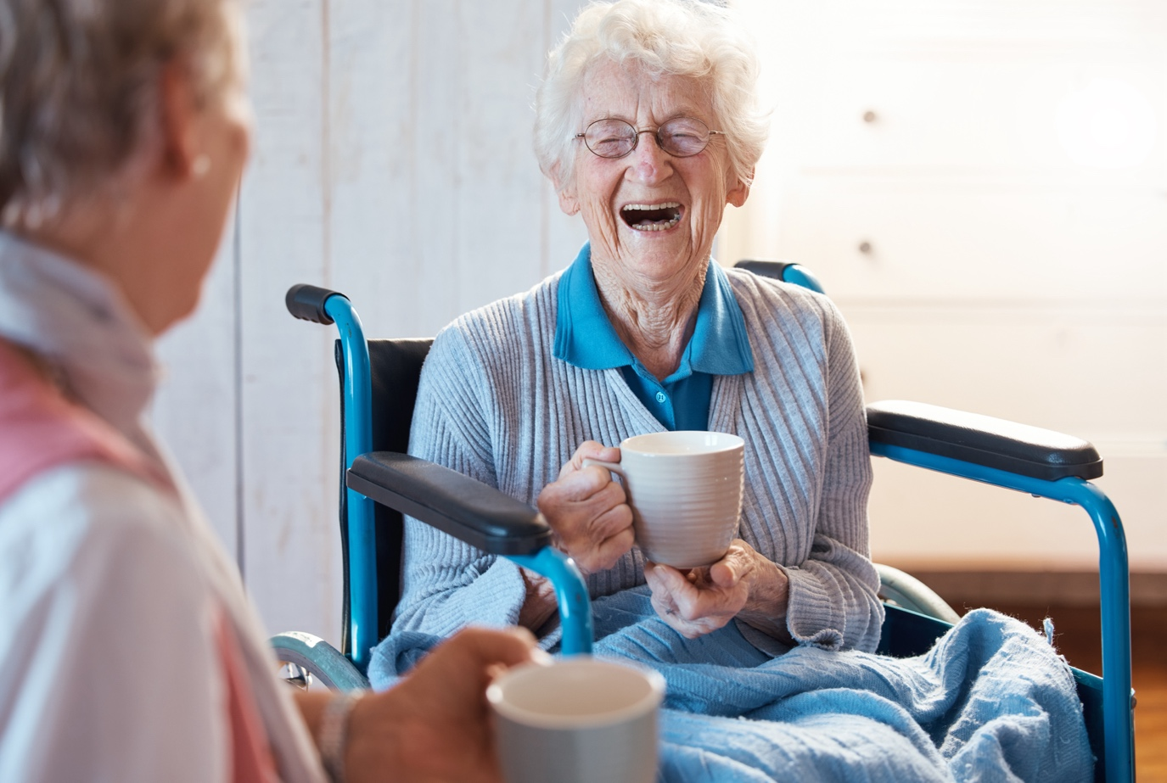

|  |  |  |
| --- | --- | --- |
| ­ | | |
| Guideline | Description | Strategies |
| Monitor and evaluate engagement and impact | Indicators of effective engagement and monitoring/evaluation processes should be developed for individual engagement approaches and for the engagement process more broadly.  Consumers should be included in evaluation of engagement activities to assess engagement outcomes and the impact on final policy design. | * Agree on shared expectations and measures (indicators) early in engagement process, including consumer perspectives on what success would look like. * Embed multiple feedback opportunities across various feedback mediums throughout the engagement process. * Employ relevant indicators and evaluation measures to assess the engagement processes. * Ensure engagement objectives are aligned with any evaluation measures. |



# Consumer engagement approaches



Consumer engagement approaches can involve varying levels of participation, and it’s important to be clear on what level of participation any approach or process is planning to entail. Commonly understood levels of participation are based on the IAP2 Spectrum of Public Participation which identifies the levels as: inform, consult, involve, collaborate and empower [38]. These have been adapted in numerous consumer engagement frameworks in Australia and elsewhere [8, 35, 48].

The effectiveness of any engagement approach is contingent on implementing the Fundamentals and Good Practice Guidelines identified in this Strategy. This Strategy is designed to provide policy-makers with a wider range of effective options beyond the standard consultation approaches that are often used in public policy-making.

Engagement approaches can be direct or indirect.

Features of **direct engagement** include:

* Structured and purposeful activities
* Seeking input from specific consumers or consumer representatives
* Seeking input from consumers at specific times
* Often through a combination of in-person and digital means
* Consumer input captured directly by policy-makers

Features of **indirect engagement** include:

* Widely seeking input from consumers via opportunistic engagement
* Fluid and flexible activities
* Consumers can provide input at any time
* Predominantly through online platforms and digital engagement methods

When developing an engagement process, policy-makers should consider the use of both direct and indirect approaches, to cater for the diverse needs and circumstances of different consumers and provide optimal flexibility for participants. An engagement process can feature multiple direct and indirect approaches, underpinned by variety of engagement methods. This can include digital, place-based, experience-based and deliberative engagement methods. In 2019, the Australian Government Department of Industry, Science and Resources developed the [APS Guide to the right engagement](https://www.industry.gov.au/sites/default/files/2022-10/guide-to-the-right-engagement_0.pdf) for use by policy-makers in the Australian Public Service (APS), which provides detailed advice to assist with selecting the most appropriate engagement methods and approaches to use in a variety of different circumstances.

**We heard from policy-makers that:**

“If you’re thinking about perfect, you can’t even think about engagement. Best advice is to embrace the chaos, because people throw things at you and you have to take the time to listen – that’s where you get the real value from community engagement.”

## Engagement methods

|  |  |  |
| --- | --- | --- |
|  | |  |
| Digital engagement | |  |
|  | | |
| Description | Examples | |
| Digital engagement methods can provide far greater reach than other types of engagement, enabling participation by a greater number and a more diverse range of consumers [49]. This includes by providing a platform to consumers who may otherwise be hard-to-reach or engage [50].  Digital engagement methods are also often associated with improved time and cost efficiencies, for both policy-makers and participants [49]. Despite these positive features, it is important to be mindful of the ‘digital divide’ and to mitigate engagement barriers related to digital literacy or digital access. | **Social media** is any online platform that allows users (not just site owners or managers) to create content and interact with each other.Social media can be useful to engage consumers that are unlikely to engage otherwise. Social media platforms and their communication channels allow consumers to engage directly without an intermediary [51].  **Crowdsourcing** isa participative online activity by individuals who respond to an online call by another individual, group, or organisation. It is increasingly common for government organisations to adopt crowdsourcing for activities such as deliberation, policy-making and open innovation [52].  **Digital engagement hubs** are designed to expand consumer participation and capture local intelligence and insight. Digital engagement hubsserve as a central platform for various stakeholder groups on any given issue, providing a mutual space to share ideas and communicate with each other [53].  **Digital story-telling** brings together the use of storytelling as a means to learn about and understand real-life, subjective experiences relevant to policy-making, with multi-media such as videos, graphics, audio and animation to amplify the voices of people who experience marginalisation [54]. | |

|  |  |  |  |
| --- | --- | --- | --- |
|  | |  | |
| Place-based engagement | | |  |
|  | | | |
| Description | Examples | | |
| Similar to place-based health interventions, place-based engagement activities recognise that the place where someone grows up and/or lives influences their health and wellbeing, as well as their access to opportunities [55]. Place-based engagement can range from small, locally resourced engagement activities, to wide-ranging government-led initiatives that aim to engage with large numbers of consumers and communities on various issues [56]. Place-based methods aim to engage local consumers as active participants in policy development and implementation [56] and give particular consideration to the unique built environments, social networks, economic conditions and demographics in a community [57]. | Place-based **collective impact initiatives** are an intensive example of place-based engagement that involves organising a broad system of stakeholders, which can include local community organisations, consumers, governments and industry representatives, to collaborate across sectors to address complex social issues in local communities [58]. Collective impact initiatives establish a common agenda, shared progress and outcome measures, foster mutually reinforcing activities to maximise impact, build trust and strengthen relationships [58].  **Community touchpoints** are points of contact or interaction, with a range of people from across that community. Community touchpoints can be people or places within the community, such as community leaders, influencers and mentors. Places might include health or community hubs, places of worship, or gathering places such as local markets, schools, sporting clubs and parks [59].  **Social innovation labs for policy** design are used to support co-design with specific communities, by catering for diverse cultural sensitivities and local social dynamics and emphasising the role of local communities in the innovation process. They aim to rebalance power between policy-makers and consumers and generally promote community-centred engagement with flexible timelines and approaches that cater to consumer needs and preferences[60, 61]. | | |

|  |  |  |  |
| --- | --- | --- | --- |
|  | |  | |
| Experience-based engagement | | |  |
|  | | | |
| Description | Examples | | |
| Every person has a story to tell about their health and their experiences of health policy and the healthcare system.  Lived experience is a principle of co-design. It enables policy-makers to understand what is working for people and what is not. Sharing and listening to these stories provides potential launch pads for policy-makers to partner with consumers to identify and make changes that are sought and accepted [3, 43]. | **Consumer journey mapping and story-telling** can create a strong evidence base to shape better decision-making about policies, services and spending – gathering, analysing and using consumer experience to drive better health outcomes.  **Story cards and storyboards** are a written or audio-visual summary of relevant experience of a person or group and are used as tools by policy-makers and consumers to promote positive conversations about specific health-related topics [54, 57, 62].  **Kitchen table discussions** are small, informal meetings that take place in someone's home or a local café and use trusted intermediaries to hear community views on varied subjects [63]. They are effective in reaching and engaging diverse groups of people, including consumers from priority population groups and those less likely to participate in more structured, traditional engagement approaches [63]. | | |



|  |  |  |  |
| --- | --- | --- | --- |
|  | |  | |
| Deliberative engagement | | |  |
|  | | | |
| Description | Examples | | |
| Deliberative engagement brings people together to talk about a problem that is important across a community or population group, exploring options together and weighing the costs and consequences of decisions in the context of the views of others [64-66]. It involves people with an interest or who are affected by a particular issue listening to each other, refining options, seeking common ground, and making careful considerations to reach consensus or judgment [66]. | A **Citizens’ Jury** is an innovative means of involving everyday people in the process of government decision-making. They are an in-person deliberative process where community members (citizens) are chosen randomly or by democratic lottery to jointly consider a given topic and provide a collective decision or recommendation on a policy issue [67, 68].  **Community deliberative forums** include and prioritise community voice in policy development, leading to policy that is more likely to reflect community values and priorities [53]. | | |



# 

# The policy cycle: consumer engagement touchpoints



The policy cycle is a framework developed to articulate and organise the process of public policy-making. While there are multiple iterations of the policy cycle framework that differ slightly, they all share the same primary purpose of illustrating the various stages of the policy-making process. For this Strategy, the policy cycle framework has been adapted to also include the array of possible engagement touchpoints throughout the cycle (see Figure 1 below). It is important to note that the stages are not necessarily followed sequentially and some may even be skipped or repeated. Identifying emerging issues can include issues raised by participants in formal engagement activities or arise outside of an engagement process through consumer-initiated advocacy.

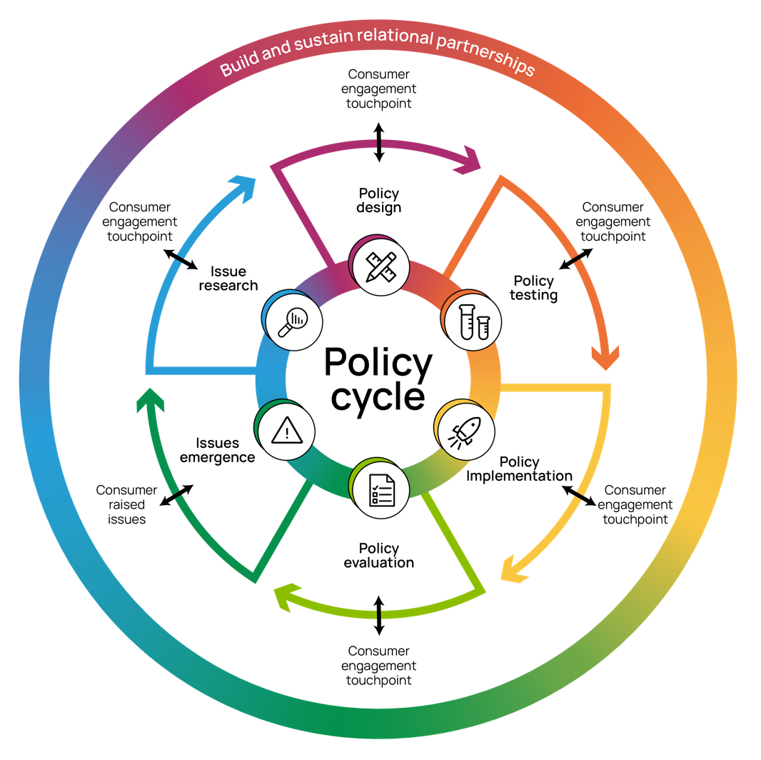The policy cycle diagram is a useful tool for planning and structuring policy projects, communicating processes and supporting better understanding of policy-making in the broader population. It also provides a ready aid for embedding consumer engagement activities as part of business-as-usual in health policy-making.

Figure 1: Engagement touchpoints across the policy cycle

# 

# Using a Guideline throughout the policy cycle: an illustration



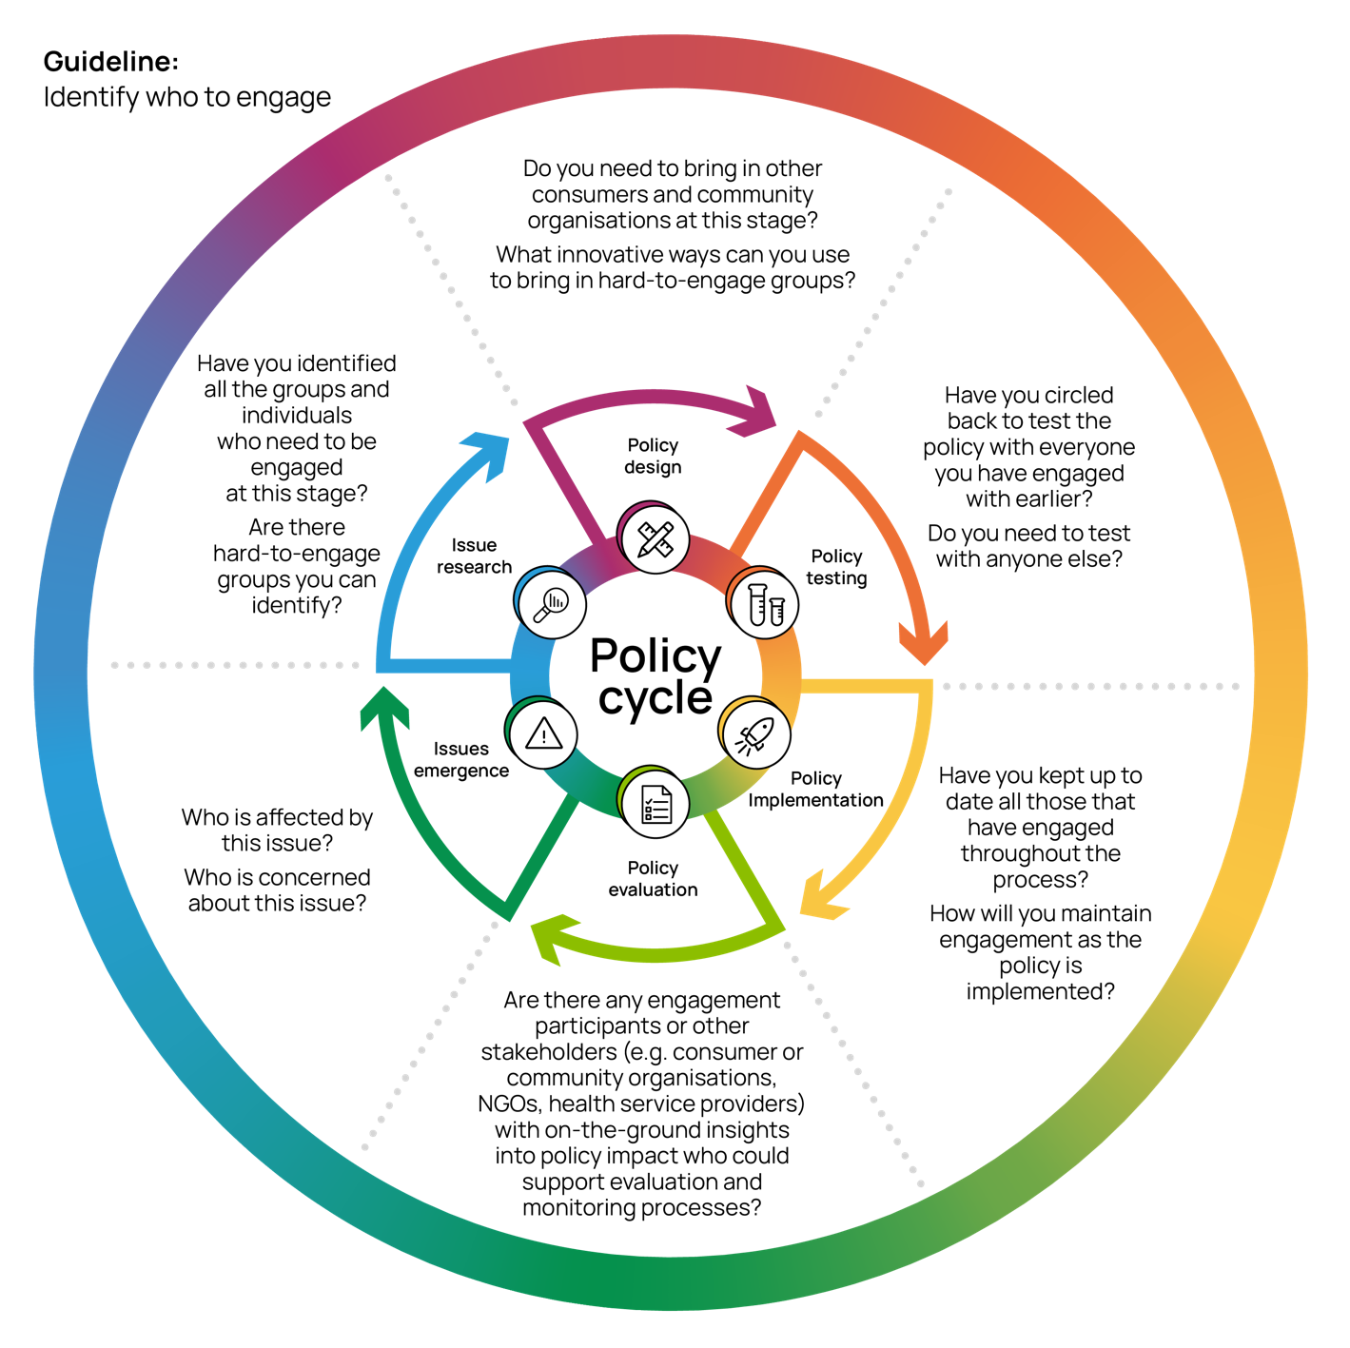

Figure 2: Applying a Good Practice Guideline to the policy cycle

# What will this Strategy achieve?



Long-term systematic commitment to improved consumer engagement in health policy-making will improve policy development processes. Over time, it will also contribute to reducing the incidence and impact of preventable diseases.

Implementation of this Strategy will enhance the capacity of governments and other policy-making organisations to build trusted consumer engagement into health policy development, implementation and evaluation processes. Consumers and consumer organisations will have confidence in engagement initiatives that are underpinned by the 5 Fundamentals and 10 Good Practice Guidelines. The contextual and practical barriers to participation that inhibit the engagement of consumers in health policy-making will be recognised and addressed.

Effective implementation of this Strategy will contribute to robust and evidence-based consumer engagement in health policy-making that:

* is purposeful, inclusive, respectful, transparent and collaborative;
* facilitates and supports co-design in all engagement initiatives;
* supports ongoing partnerships between policy-makers, consumers and trusted intermediaries;
* enables the participation of priority and hard-to-engage population groups using engagement approaches and methods appropriate to their particular social, economic, and cultural circumstances and needs;
* empowers consumers with varying health literacy levels to participate in engagement activities by providing the necessary resources and health literacy supports; and
* promotes the use of contemporary information, digital technologies, and innovative engagement approaches that are relevant to current and emerging health issues.

Furthermore, the Guidelines, tools and resources in this Strategy will assist policy-makers to:

* build trusted and sustained relationships with consumers and communities;
* establish collaborative partnerships with trusted intermediaries for priority and hard-to-engage population groups; and
* co-design policy initiatives with consumers to address specific health policy opportunities or challenges.

# Policy action areas to support implementation

C:\Users\e5109705\AppData\Local\Microsoft\Windows\INetCache\Content.MSO\A88B99C.tmp

3 policy action areas are recommended to achieve consistent good practice consumer engagement in health policy-making nationally. These are to:

1. Develop resources to support good practice consumer engagement in health policy-making.
2. Strengthen operational capability to achieve good practice consumer engagement across government and non-government organisations involved in health policy-making.
3. Build the capacity and capability of consumers, particularly those from priority population groups, to engage in health policy-making processes.

The policy action areas provide a high-level, broad description of the areas requiring sustained policy focus from governments and other policy-making organisations to support the implementation of this Strategy. The policy action areas were informed by the evidence review and extensive consultation process underpinning the development of this Strategy. Within each of the action areas, some immediate, specific actions are identified for consideration. However, additional ongoing measures related to each action area will be required for long-term, sustained improvements to consumer engagement in policy-making.

National leadership, including by governments, is required to promote good practice consumer engagement in health policy-making and support the successful implementation of this Strategy. The Fundamentals and Good Practice Guidelines should underpin all engagement activities undertaken by government agencies and other policy-influencing organisations.

The HELP toolkit, developed alongside this Strategy, provides practical guidance to support good practice consumer engagement in health policy-making. It should be used by policy-makers, and promoted by governments, as a resource to support the implementation of this Strategy. Education, training, information and resources relating to good practice consumer engagement should also be readily accessible to policy-makers in all settings.

Policy action area 1

C:\Users\e5109705\AppData\Local\Microsoft\Windows\INetCache\Content.MSO\A88B99C.tmp

|  |
| --- |
| Develop resources to support good practice consumer engagement in health policy-making. |

This could be supported by ensuring resources and tools for consumer engagement in health policy-making are made available to promote consistent good practice engagement nationally.

This includes:

1. information, education and training resources and tools relevant to health policy-making that are accessible to all government agencies and other policy-making organisations, consumers and community organisations; and
2. reporting of existing and completed engagement activities undertaken across the health sector to help inform future engagement initiatives.

|  |
| --- |
| **Priority actions:**   1. Government agencies and other policy-making organisations should develop and publish resources and tools to support contemporary consumer engagement knowledge and practice in the health sector. |

Policy action area 2

C:\Users\e5109705\AppData\Local\Microsoft\Windows\INetCache\Content.MSO\A88B99C.tmp

|  |
| --- |
| Strengthen operational capability to achieve good practice consumer engagement across government and non-government organisations involved in health policy-making. |

Undertake education and training to ensure policy-makers have the required skills and knowledge to undertake evidence-informed, good practice consumer engagement.

Government agencies and departments, and other policy-making organisations should consider how they would:

* champion and promote the implementation of the Consumer Engagement Fundamentals and Good Practice Guidelines in all engagement activities undertaken by the organisation;
* establish and maintain ongoing connections, semi-structured networks and collaborative partnerships with consumers, trusted intermediaries and relevant community organisations;
* provide evidence-based information, education, training and support to policy-makers within the organisation; and
* evaluate and monitor consumer engagement outcomes and impact on policy outputs, and regularly report evaluation outcomes to organisational leadership and the public.

|  |
| --- |
| **Priority actions:**   1. Government agencies and other policy-making organisations should adopt the HELP Toolkit as ‘business as usual’ practice in health policy development. |

Policy action area 3

C:\Users\e5109705\AppData\Local\Microsoft\Windows\INetCache\Content.MSO\A88B99C.tmp

|  |
| --- |
| Build the capacity and capability of consumers, particularly those from priority population groups, to engage in health policy-making processes. |

There is a need for policy-making organisations to build thecapacity and capability of consumers to participate in engagement activities at varying levels of engagement, including as partners in policy co-design. This should be facilitated by using methods, approaches and timing appropriate to the diverse needs and circumstances of consumers. Policy-makers also need to work to establish partnerships with priority population groups and their trusted intermediaries, maintaining and adjusting these relationships over time.

Resources, education and training opportunities targeted at building consumer capability and capacity should co-designed with consumers, adapted for all levels of health literacy and aim to redress barriers limiting the engagement and participation of priority population groups. They must also be inclusive to the diverse range of consumers in the community and should include access to engagement supports, such as translating and interpreting services where required.

Engagement activities must be culturally safe and employ trauma-informed best practice to ensure they are inclusive of the wide array of consumers and population groups with valuable lived experience expertise.

Engagement with Aboriginal and Torres Strait Islander people should be based on and implemented in accordance with the National Agreement on Closing the Gap 2020 (National Agreement) [69]. This should be informed by the Aboriginal and Torres Strait Islander Partnership and Engagement Framework.

|  |
| --- |
| **Priority actions:**   1. Government agencies and other health policy-making organisations should support consumers to participate in co-design processes and establish genuine partnerships with priority population groups. 2. Government agencies and other health policy-making organisations should collaborate with Aboriginal and Torres Strait Islander community-controlled organisations and trusted intermediaries to develop tailored engagement resources. |

# Other resources[1]



* [Partnering with Consumers: A guide for consumers](https://www.safetyandquality.gov.au/sites/default/files/2022-10/partnering_with_consumers_a_guide_for_consumers_-_web_accessible.pdf). Australian Commission on Safety and Quality in Health Care (ACSQHC). 2023.
* [Public Participation Spectrum.](https://iap2.org.au/resources/spectrum/) International Association for Public Participation (IAP2). 2018.
* [The Australian Public Service Framework for Engagement and Participation](https://www.industry.gov.au/sites/default/files/August%202021/document/aps-framework-for-engagement-and-participation.pdf)**.** Australian Public Service (APS), Australian Government. 2019.
* [A Guide To The Right Engagement](https://www.industry.gov.au/sites/default/files/2022-10/guide-to-the-right-engagement_0.pdf) (APS). Australian Government, Department of Industry, Science and Resources. 2019.
* [Health Stakeholder Engagement Framework](https://www.health.gov.au/resources/publications/stakeholder-engagement-framework)**.** Australian Government, Department of Health. 2017.
* [National Framework for Consumer Involvement in Cancer Control](https://www.canceraustralia.gov.au/sites/default/files/publications/national_consumer_framework_web_504af020f2184.pdf). Cancer Australia; Australian Government. 2011.
* [Engaging Canberrans: A guide to community engagement](https://hdp-au-prod-app-act-yoursay-files.s3.ap-southeast-2.amazonaws.com/2614/6724/4263/communityengagement_FINAL.pdf). ACT Government. 2011.
* [Community engagement techniques.](https://www.health.qld.gov.au/__data/assets/pdf_file/0029/425576/33487.pdf) Queensland Government, Department of Health. n.d.
* [Community engagement toolkit for planning](https://dilgpprd.blob.core.windows.net/general/Communityengagementtoolkit.pdf). Queensland Government, Department of Infrastructure, Local Government and Planning. 2017.
* [Consumer, Carer and Community Engagement Strategic Framework 2021-2025](https://www.sahealth.sa.gov.au/wps/wcm/connect/22029756-c7ec-4f5d-be11-af0ded43f58c/ConsumerCarerCommunityEngagementStrategicFramework_Feb+2021.pdf?MOD=AJPERES&amp;CACHEID=ROOTWORKSPACE-22029756-c7ec-4f5d-be11-af0ded43f58c-nYE-nAr). SA Health, South Australian Government. 2020.
* [Consumer engagement action plan and online toolkit](https://vcccalliance.org.au/our-work/consumer-engagement/)**,** Victorian Comprehensive Cancer Care Alliance. n.d.
* [Experience-based co-design: A toolkit for Australia.](https://ahha.asn.au/resource/experience-based-co-design-toolkit/) Consumers Health Forum of Australia (CHF); Australian Healthcare and Hospitals Association (AHHA); Dawda P; Knight A. 2017.
* [Consumer engagement resources](https://hic.org.au/consumer-engagement-resources-october-2021/). Health Issues Centre. 2021.
* [Online community engagement guideline](https://www.forgov.qld.gov.au/information-and-communication-technology/qgea-policies-standards-and-guidelines/online-community-engagement-guideline). Queensland Government, Department of Public Works. 2010.
* [Working with consumers and carers](https://www.health.vic.gov.au/mental-health/working-with-consumers-and-carers). Victorian Government, Department of Health. n.d.

Engaging with Aboriginal and Torres Strait Islander communities

* [Aboriginal Cultural Inclusion Framework 2015–2018](https://media.opengov.nsw.gov.au/pairtree_root/a3/e5/f7/05/76/a0/48/c0/a2/6d/f2/3d/08/a1/b9/0e/obj/Aboriginal_Cultural_inclusion_Framework_2015_2018.pdf). NSW Family and Community Services. 2014.
* [Aboriginal Health Impact Statement and Declaration for WA Health](https://www.health.wa.gov.au/~/media/Corp/Policy-Frameworks/Clinical-Services-Planning-and-Programs/Aboriginal-Health-Impact-Statement-and-Declaration-Policy/Supporting/User-Guide-for-Aboriginal-Health-Impact-Statement-and-Declaration.pdf). WA Health. 2014.
* [Aboriginal Services and Practice Framework 2016–2018.](https://www.wa.gov.au/system/files/2021-11/Aboriginal-Services-and-Practice-Framework.pdf) WA Government, Department of Child Protection and Family Support. 2016.
* [Engaging Queenslanders: Introduction to working with Aboriginal and Torres Strait Islander communities](https://documents.parliament.qld.gov.au/com/AREC-56F5/RN3154PNSI-A863/tp7-ph30Oct2013.pdf). Queensland Government. 2005.
* [National Aboriginal and Torres Strait Islander Health Plan 2013–2023.](https://www.health.gov.au/sites/default/files/documents/2021/02/national-aboriginal-and-torres-strait-islander-health-plan-2013-2023.pdf) Australian Government. 2013.
* [Engaging Aboriginal and Torres Strait Islander people in guideline development,](https://www.nhmrc.gov.au/guidelinesforguidelines/plan/engaging-aboriginal-and-torres-strait-islander-people-guideline-development#toc__333) National Health and Medical Research Council (NHMRC). n.d.
* [Working with Aboriginal Peoples and Communities: a practice resource](http://www.community.nsw.gov.au/__data/assets/pdf_file/0017/321308/working_with_aboriginal.pdf). NSW Government, Department of Community Services. 2009.
* [SA Health Guide for Engaging with Aboriginal People](https://www.sahealth.sa.gov.au/wps/wcm/connect/b9a2f58042371fd89d6ffdef0dac2aff/SA+Health+Guide+to+Engaging+with+Aboriginal+People.pdf?MOD=AJPERES). SA Health. 2013.
* [Consumer, Carer and Community Engagement Strategic Framework 2021-2025](https://www.sahealth.sa.gov.au/wps/wcm/connect/22029756-c7ec-4f5d-be11-af0ded43f58c/ConsumerCarerCommunityEngagementStrategicFramework_Feb+2021.pdf?MOD=AJPERES&amp;CACHEID=ROOTWORKSPACE-22029756-c7ec-4f5d-be11-af0ded43f58c-nYE-nAr). SA Health. 2021.
* [WA Aboriginal Health and Wellbeing Framework 2015–2030](https://www.health.wa.gov.au/Improving-WA-Health/About-Aboriginal-Health/WA-Aboriginal-Health-and-Wellbeing-Framework-2015-2030). WA Health. 2015.

Engaging with CALD communities

* [Involving consumers from culturally and linguistically diverse background](https://consumerinvolvement.canceraustralia.gov.au/sites/default/files/doc-lib/accessible/service_managers/m6-38_guide_involvingconsumerscaldbackgrounds.pdf). Australian Government; Cancer Australia. n.d.
* Chauhan A, Walpola RL, Manias E, et al. [How do health services engage culturally and linguistically diverse consumers? An analysis of consumer engagement frameworks in Australia](https://doi.org/10.1111/hex.13315). Health Expect. 2021;24:1747-1762.
* [Consumer participation strategies](https://www.ceh.org.au/wp-content/uploads/2017/05/consumer-participation-strategies.pdf). Centre for Culture, Ethnicity & Health. n.d.
* [Delivering for diversity: Cultural diversity plan 2016–2019](https://pcvpallcarevic.blob.core.windows.net/assets/contentpage_htmlcontent/Delivering-for-diversity-cultural-diversity-plan-2016-19-DHHS.pdf). Victorian Government. 2016.
* [Engaging Culturally and Linguistically Diverse Communities: A guide for the Western Australian Public Secto](https://www.omi.wa.gov.au/docs/librariesprovider2/resources/engaging_communities.pdf?sfvrsn=b45ee785_3)r. WA Government, Department of Local Government and Communities, Office of Multicultural Interests. 2020.
* [Health care providers’ guide to engaging multicultural communities and consumers](https://www.health.qld.gov.au/__data/assets/pdf_file/0037/158599/com-engage-guide.pdf). Queensland Government. 2012.
* [Framework for Mental Health in Multicultural Australia: Towards culturally inclusive service delivery](https://www.mentalhealthcommission.gov.au/sites/default/files/2024-03/framework-for-mental-health-in-multicultural-australia---towards-culturally-inclusive-service-delivery.pdf). Mental Health in Multicultural Australia (MHiMA). 2014.
* [Implementing the Principles of Multiculturalism Locally: A planning guide for Western Australian local governments](https://www.omi.wa.gov.au/docs/librariesprovider2/resources/implementing-the-principles-of-multiculturalism-locally.pdf?sfvrsn=a6a49e1d_1). WA Government, Department of Local Government, Office of Multicultural Interests. 2010.

Engaging with rural, regional and remote communities

* [National Strategic Framework for Rural and Remote Health](https://www.health.gov.au/sites/default/files/documents/2020/10/national-strategic-framework-for-rural-and-remote-health.pdf). Australian Health Ministers Advisory Council (AHMAC). 2012.
* [Queensland Health Rural and Remote Health and Wellbeing Strategy 2022 – 2027. Handbook](https://www.health.qld.gov.au/__data/assets/pdf_file/0020/1142066/Rural-and-Remote-Health-and-Wellbeing-Strategy-2022-2027.pdf). Queensland Government. 2021.
* [WA Country Health Service Consumer and Community Engagement Strategy 2021-26.](https://www.wacountry.health.wa.gov.au/~/media/WACHS/Documents/About-us/Publications/Strategic-plans/WACHS-Consumer-and-Community-Engagement-Strategy-2021-26.PDF) WA Government, WA Country Heath Service. 2020.

Engaging with people with disability

* [Disability Gateway. Follow good practice engagement principles](https://www.disabilitygateway.gov.au/engagement-principles). Australian Government. n.d
* [Count Me In: A better future for everyone](https://parliament.wa.gov.au/publications/tabledpapers.nsf/displaypaper/3911246a6775e4b217b2d91e48257c370029ee80/$file/1246.pdf). WA Disability Services Commission, 2013.
* [Towards a 10-year ACT Disability Strategy. Listening Report 2022.](https://www.communityservices.act.gov.au/__data/assets/pdf_file/0003/2216091/Towards-a-10-year-ACT-Disability-Strategy-Listening-Report-2022.pdf) ACT Government. 2022.
* [National Disability Strategy 2010–2020](https://www.dss.gov.au/sites/default/files/documents/05_2012/national_disability_strategy_2010_2020.pdf). Australian Government. 2011.
* [WA Disability Health Framework 2015-2025: Improving the health care of people with disability](https://www.health.wa.gov.au/~/media/Corp/Documents/Health-for/Health-Networks/Disability/Disability-health-framework.pdf). 2nd edition Department of Health State of Western Australia 2021.
* [Disability Health Network Commitment to Inclusive Engagement.](https://www.health.wa.gov.au/~/media/Files/Corporate/general-documents/Health-Networks/Disability/PDF/Disablity-Health-Network-Commitment-to-Inclusive-Engagement.pdf) WA Government, Department of Health. 2014

Engaging with people with mental illness

* [Consumer and carer engagement: a practical guide](https://www.mentalhealthcommission.gov.au/lived-experience/consumer-and-carers/consumer-and-carer-engagement-(1)). National Mental Health Commission. 2019.
* [Consumer and Carer Engagement and Participation](https://www.health.gov.au/sites/default/files/documents/2021/04/primary-health-networks-phn-mental-health-care-guidance-consumer-and-carer-engagement-and-participation.pdf). PHN Primary Mental Health Care Flexible Funding Pool Implementation Guidance. Australian Government, Department of Health. n.d.
* [Consumer Participation Framework](https://healthsciences.unimelb.edu.au/__data/assets/pdf_file/0005/3392132/Consumer-Participation-Framework.pdf). Neami National. 2014
* Daya, I., Hamilton, B. and Roper, C. (2020), [Authentic engagement: A conceptual model for welcoming diverse and challenging consumer and survivor views in mental health research, policy, and practice.](https://doi.org/10.1111/inm.12653) Int J Mental Health Nursing, 29: 299-311.
* [Mental health lived experience engagement framework](https://www.health.vic.gov.au/publications/mental-health-lived-experience-engagement-framework). Victorian Government, Department of Health and Human Services. 2019.
* [My Mental Health. The consumer and carer movement](https://mymentalhealth.org.au/consumers-and-carers/further-information-about-the-consumer-movement). Brisbane North PHN. n.d.

Engaging with older people

* [Better Together. A Practical Guide to Effective Engagement with Older People.](https://www.sahealth.sa.gov.au/wps/wcm/connect/efc56a004efc69f1b7ccf79ea2e2f365/Better+Together+-+A+Practical+Guide+to+Effective+Engagement+with+Older+People.pdf?MOD=AJPERES&amp;CACHEID=ROOTWORKSPACE-efc56a004efc69f1b7ccf79ea2e2f365-nwLmRMW)   
  South Australian Government. 2017.
* [Community of Practice – Engagement with Older Australians](https://www.theenergycharter.com.au/community-of-practice-engagement-with-older-australians/). The Energy Charter. 2023
* [Consumer engagement in aged care. Literature review.](https://www.agedcarequality.gov.au/sites/default/files/media/acqsc_consumer_engagement_in_aged_care_-_literature_review.pdf) Aged Care Quality and Safety Commission. 2020.
* [Queensland Stay on Your Feet ® Toolkit Phase 2 – Community Engagement](https://www.health.qld.gov.au/stayonyourfeet/toolkits/phase2/engagement)

Engaging with children and young people

* [Youth Engagement Evaluation Framework](https://www.vichealth.vic.gov.au/-/media/PDFs/YEEF/youth-engagement-evaluation-framework-full-report.pdf),Victorian Health Promotion Foundation. 2022.
* [Citizen Me! Engaging children and young people in your organisation.](https://www.acyp.nsw.gov.au/participation-resources/citizen-me) NSW Commission for Children and Young People. 2012.
* [Involving Children and Young People. Participation Policy](https://www.ccyp.wa.gov.au/media/4733/policy-participation-for-website-june-2020.pdf). Commissioner for Children and Young People WA. 2020.
* [Understanding and supporting children and young people’s participation.](https://www.acyp.nsw.gov.au/participation-resources/understanding-and-supporting-children-and-young-peoples-participation) NSW Advocate for Children and Young People. 2015.
* [Yerp. Young people making change. A toolkit to support one big idea – that young people have an important role in shaping the present and future of Victoria](https://yerp.yacvic.org.au/about). Youth Affairs Council Victoria. 2013.

Engaging with LGBTQIA+ people

* [Inclusive communication with LGBTIQ+ clients](https://aifs.gov.au/sites/default/files/publication-documents/2110_inclusive_communication_with_lgbtiq_clients_e2pg_0.pdf). Australian Institute of Family Studies. 2022
* [Beyond a rainbow sticker: A report on How2 create a gay, lesbian, bisexual, transgender and intersex inclusive service, 2012-2013](https://www.rainbownetwork.com.au/content/3-resources/0-beyond-a-rainbow-sticker/beyondarainbowsticker.pdf). Gay and Lesbian Health Victoria. 2013.
* [LGBTI Inclusive Practice](https://rainbowhealthaustralia.org.au/rainbow-tick). Rainbow Tick. n.d.
* [Queensland public sector LGBTIQ+ inclusion strategy 2017-2022](https://www.forgov.qld.gov.au/__data/assets/pdf_file/0029/183926/lgbtiq-inclusion-strategy.pdf). Queensland Government. 2017.
* [Pride in inclusion programs](https://www.prideinclusionprograms.com.au/). ACON. n.d.

# References



1. Carers Australia, *The economic value of informal care in Australia in 2015*. 2015, Deloitte Access Economics: Canberra, Australia.
2. Agency for Clinical Innovation, *Patient Experience and Consumer Engagement: A Framework for Action - Understand, Act, Empower*. 2015, NSW Government Department of Health,.
3. Blomkamp, E., *The Promise of Co-Design for Public Policy.* Australian Journal of Public Administration, 2018. **77**(4): p. 729-743.
4. SA Health, *SA Health Consumer, Carer and Community Engagement Strategic Framework 2021-2025*. 2021, Government of South Australia,.
5. Agency for Clinical Innovation, *A Guide to Build Co-design Capability: Consumers and staff coming together to improve healthcare.* 2019, NSW Government, : Sydney.
6. Tasmanian Government, *Tasmanian Government Framework for Community Engagement*. 2013.
7. National Health and Medical Research Council, *NHMRC Guidelines for Guidelines Handbook: Consumer involvement*. 2018, NHMRC.
8. Health Consumers Queensland, *Consumer and Community Engagement Framework*. 2017, Health Consumers Queensland: Brisbane, Queensland,.
9. David, O. and R. Adela, *Tasmanian alcohol, tobacco and other drug treatment services: A Guide to Consumer Engagement*. 2011.
10. Health Issues Centre, *Consumer Model – Partnering with healthcare organisations*. 2023.
11. Gregory, J., *Conceptualising consumer engagement: A review of the literature*, in *Melbourne, Australia: Australian Institute of Health Policy Studies*. 2007.
12. Rowe, G. and L.J. Frewer, *Evaluating Public-Participation Exercises: A Research Agenda.* Science, Technology, & Human Values, 2004. **29**(4): p. 512-556.
13. Consumers Health Forum of Australia. *Consumer Representation*. Available from: <https://chf.org.au/representation>.
14. World Health Organization, *WHO Health Systems Strengthening Glossary*. 2011: Geneva.
15. Davies, R.L., et al., *Effective support for those who are “hard to engage”: a qualitative user-led study.* Journal of Mental Health, 2014. **23**(2): p. 62-66.
16. Danis, M. and R. Nayak, *Health Policy*, in *Encyclopedia of Global Bioethics*, H. ten Have, Editor. 2016, Springer International Publishing: Cham. p. 1458-1468.
17. Wiles, L.K., et al., *Consumer engagement in health care policy, research and services: A systematic review and meta-analysis of methods and effects.* PLoS ONE, 2022. **17**(1): p. e0261808.
18. Australian Government Department of Health, *National Preventive Health Strategy 2021–2030*. 2021.
19. Australian Government Department of Treasury, *Measuring What Matters: Australia's First Wellbeing Framework*. 2023, Commonwealth of Australia: Canberra, Australia.
20. Australian Government Department of Health and Aged Care, *National Cabinet Statement on a better future for the federation*. 2023, Commonwealth of Australia,: Canberra, Australia.
21. Svalastog, A.L., et al., *Concepts and definitions of health and health-related values in the knowledge landscapes of the digital society.* Croat Med J, 2017. **58**(6): p. 431-435.
22. Schneider, E.C., et al., *Reflecting Poorly: Health Care in the US Compared to Other High-Income Countries.* 2021.
23. Australian Institute of Health and Welfare, *Chronic conditions and multimorbidity*. 2022, AIHW: Canberra, Australia.
24. de Looper, M. and K. Bhatia, *Australian health trends 2001*, Australian Institute of Health and Welfare, Editor. 2001, AIHW: Canberra, Australia.
25. Australian Institute of Health and Welfare, *Australia’s Health 2020: Data Insights*. 2020, AIHW Canberra, Australia.
26. Australian Government Department of Health, *National Aboriginal and Torres Strait Islander Health Plan 2021–2031*. 2021, Commonwealth of Australia, : Canberra, Australia.
27. Australian Institute of Health and Welfare, *Australia's health 2022: in brief*. 2022, AIHW: Canberra, Australia.
28. Dune, T., K. McLeod, and R. Williams, *Culture, diversity and health in Australia: Towards culturally safe health care*. 2021: Routledge.
29. De Zilva, S., et al., *Culturally safe health care practice for Indigenous Peoples in Australia: A systematic meta-ethnographic review.* Journal of Health Services Research & Policy, 2022. **27**(1): p. 74-84.
30. Australian Institute of Health and Welfare, *Social determinants of health*. 2022, AIHW: Canberra, Australia.
31. Subica, A.M. and B.G. Link, *Cultural trauma as a fundamental cause of health disparities.* Soc Sci Med, 2022. **292**: p. 114574.
32. Evans, R.G., M.L. Barer, and T.R. Marmor, *Why are some people healthy and others not?: The determinants of health of populations*. 2021: Walter de Gruyter GmbH & Co KG.
33. Australian Institute of Health and Welfare, *Australian Burden of Disease Study 2015*. 2019, AIHW: Canberra, Australia.
34. Ball, S. and R. Rejón, *Unlocking policy success: is codesign the key to achieving effective policy outcomes?* Policy Design and Practice, 2024. **7**(3): p. 251-264.
35. Dawda, P. and A. Knight. *Experience Based Co-design: a toolkit for Australia*. 2017.
36. Harrison, R., et al., *Codesigning consumer engagement strategies with ethnic minority consumers in Australian cancer services: the CanEngage Project protocol.* BMJ open, 2021. **11**(8): p. e048389.
37. National Academies of Sciences Engineering and Medicine, *Communities in action: Pathways to health equity.* 2017.
38. International Association for Public Participation (IAP2), *IAP2 Public Participation Spectrum*. 2014.
39. Australian Government, *Australian Public Service Engagement Framework for Engagement and Participation*. 2019: Canberra, Australia.
40. Australian Government Department of Prime Minister and Cabinet, *Practice place-based initiatives: a better practice guide.* . 2012: Canberra, Australia,.
41. Aston, R. and J. Tse, *Youth Engagement Evaluation Framework*. 2022, VicHealth.
42. Australian Government Department of Health, *Stakeholder engagement framework*. 2017: Canberra, Australia,.
43. National Mental Health Commission, *Consumer and carer engagement: A practical guide*. 2019, NMHC: Canberra, Australia.
44. Queensland Health, *Healthcare Providers' Guide to Engaging Multicultural Communities and Consumers*. 2012, Queensland Government,: Brisbane, QLD.
45. Maker, Y., N. Hudson, and B. McSherry, *Sensitive and appropriate engagement with consumers experiencing vulnerability: guidance and principles for action.* 2021.
46. DeBortoli, E., et al., *Measurable outcomes of consumer engagement in health research: A scoping review.* Frontiers in Public Health, 2022. **10**: p. 994547.
47. Collins English Dictionary. *'Fundamental' definition*. Available from: collinsdictionary.com/dictionary/english/fundamental
48. the Co-design Initiative, *Co-design: Shared perspectives on authentic co-design: Putting consumers and carers at the centre of mental health reform*. 2016: Melbourne, Australia.
49. Tacchi, J., *Digital engagement: Voice and participation in development*, in *Digital anthropology*. 2020, Routledge. p. 225-241.
50. Sarrami-Foroushani, P., et al., *Implementing strategies in consumer and community engagement in health care: results of a large-scale, scoping meta-review.* BMC Health Services Research, 2014. **14**: p. 402.
51. Rathore, A.K., D. Maurya, and A.K. Srivastava, *Do policymakers use social media for policy design? A Twitter analytics approach.* Australasian Journal of Information Systems, 2021. **25**.
52. Liu, H.K., *Crowdsourcing: Citizens as coproducers of public services.* Policy & Internet, 2021. **13**(2): p. 315-331.
53. Street, J., et al., *Supporting youth wellbeing with a focus on eating well and being active: views from an Aboriginal community deliberative forum.* Australian and New Zealand Journal of Public Health, 2018. **42**(2): p. 127-132.
54. Mourik, R., G. Sonetti, and R. Robison, *The same old story–or not? How storytelling can support inclusive local energy policy.* Energy Research & Social Science, 2021. **73**: p. 101940.
55. Murphy, K., *Understanding place-based approaches*, in *QCOSS*.
56. Victorian Government, *A framework for place-based approaches*, Department of Premier and Cabinet, Editor. 2020: Melbourne, Australia.
57. McGowan, V., et al., *Examining the effectiveness of place-based interventions to improve public health and reduce health inequalities: an umbrella review.* BMC Public Health, 2021. **21**: p. 1-17.
58. Smart, J., *Collective impact: evidence and implications for practice - Child Family Community Australia Project*. 2017, Australian Institute of Family Studies: Melbourne, Australia.
59. Cavaye, J., *Community capacity building toolkit for rural and regional communities.* 2005.
60. Whicher, A., *Evolution of policy labs and use of design for policy in UK government.* Policy Design and Practice, 2021. **4**(2): p. 252-270.
61. Lewis, J.M., *Policy design labs and innovation*, in *Research Handbook of Policy Design*. 2022, Edward Elgar Publishing. p. 372-387.
62. Fadlallah, R., et al., *Using narratives to impact health policy-making: a systematic review.* Health research policy and systems, 2019. **17**: p. 1-22.
63. Health Consumers Queensland. *Kitchen Table Discussions* Available from: <https://www.hcq.org.au/kitchentablediscussions/>.
64. Holmes, B., *Citizens' engagement in policymaking and the design of public services*. 2011: Parliamentary Library Canberra.
65. Gregory, J., R. Watson, and J. Hartz-Karp, *Using deliberative techniques to engage the community in policy development.* Australia and New Zealand Health Policy, 2008. **5**(1).
66. Bone, Z., J. Crockett, and S. Hodge. *Deliberation forums: a pathway for public participation*. in *Australasia Pacific Extension Network (APEN) International Conference*. 2006. The Regional Institute Ltd.
67. *What is a Citizens' Jury?*, in *newDemocracy Foundation*.
68. *Citizens' Jury – Participedia.*
69. Council of Australian Governments, *National Indigenous Reform Agreement (Closing the Gap)*. 2009, CoAG Canberra, Australia.

**The National Consumer Engagement Strategy   
for Health and Wellbeing**



1. Other resources current at January 2024