National Aged Care Quality Indicator Program (QI Program)

Manual – Part B
November 2025

National Aged Care Quality Indicator Program Manual Part B
This publication is published by the Australian Government Department of Health, Disability and Ageing as a manual to support the National Aged Care Quality Indicator Program (QI Program).
Copyright Notice
© 2025 Commonwealth of Australia as represented by the Department of Health, Disability and Ageing.
This work is copyright. You may copy, print, download, display and reproduce the whole or part of this work in unaltered form for your own personal use or, if you are part of an organisation, for internal use within your organisation, but only if you or your organisation:
do not use the copy or reproduction for any commercial purpose; and
retain this copyright notice and disclaimer as part of that copy or reproduction.
Apart from rights as permitted by the Copyright Act 1968 (Cth), or allowed by this copyright notice, all other rights are reserved, including (but not limited to) all commercial rights. Unauthorised use of a copy or reproduction is strictly prohibited.
This licence does not cover, and there is no permission given for, use of the Commonwealth Coat of Arms or any logos and trademarks (including the logo of the Department of Health, Disability and Ageing) contained within this publication.
Disclaimer
The information in this manual does not constitute, and must not be relied upon as, medical or clinical advice. Any medical questions must be referred to, and obtained from, an independent medical or clinical adviser.
Assistance
For further assistance, please contact the My Aged Care provider and assessor helpline on 1800 836 799. The helpline is available between 8am and 8pm Monday to Friday, and between 10am and 2pm on Saturday local time across Australia, except for public holidays.
Acknowledgements

The Commonwealth would like to acknowledge the work undertaken by the Victorian Department of Health from 2006 to 2021 which assisted the Commonwealth to establish the National Aged Care Quality Indicator Program.
Contents
1 Introduction to the National Aged Care Quality Indicator Program 3
2 Introduction to quality improvement 7
3 Pressure injuries 12
4 Restrictive Practices 18
5 Unplanned weight loss 24
6 Falls and major injury 31
7 Medication management — polypharmacy 39
8 Medication management — antipsychotics 46
9 Activities of daily living 53
10 Incontinence care 62
11 Hospitalisation 71
12 Workforce 78
13 Consumer experience 85
14 Quality of life 92
15 Enrolled Nursing 100
16 Allied Health 104
17 Lifestyle Officers 109
18 Endnotes 113

Introduction to the National Aged Care Quality Indicator Program
Participation in the National Aged Care Quality Indicator Program (QI Program) has been a requirement for all registered providers (providers) of approved residential care homes (aged care homes) since 1 July 2019. The QI Program requires quarterly reporting against 14 quality indicators across crucial care areas. These areas are: pressure injuries, restrictive practices, unplanned weight loss, falls and major injury, medication management, activities of daily living, incontinence care, hospitalisation, workforce, consumer experience, quality of life, enrolled nursing, allied health and lifestyle officers.

QI Program objectives
The objectives of the QI Program are:
- for providers to have robust, valid data to measure and monitor their performance. To also support continuous quality improvement in the care they provide to residents accessing funded aged care services
- to give older people, residents and the community transparent information about quality in aged care to support decision-making; and
- for government to have system-level measures of quality in aged care and an evidence base to inform policy and regulation.
FIGURE 1: SUMMARY OF QI PROGRAM OBJECTIVES
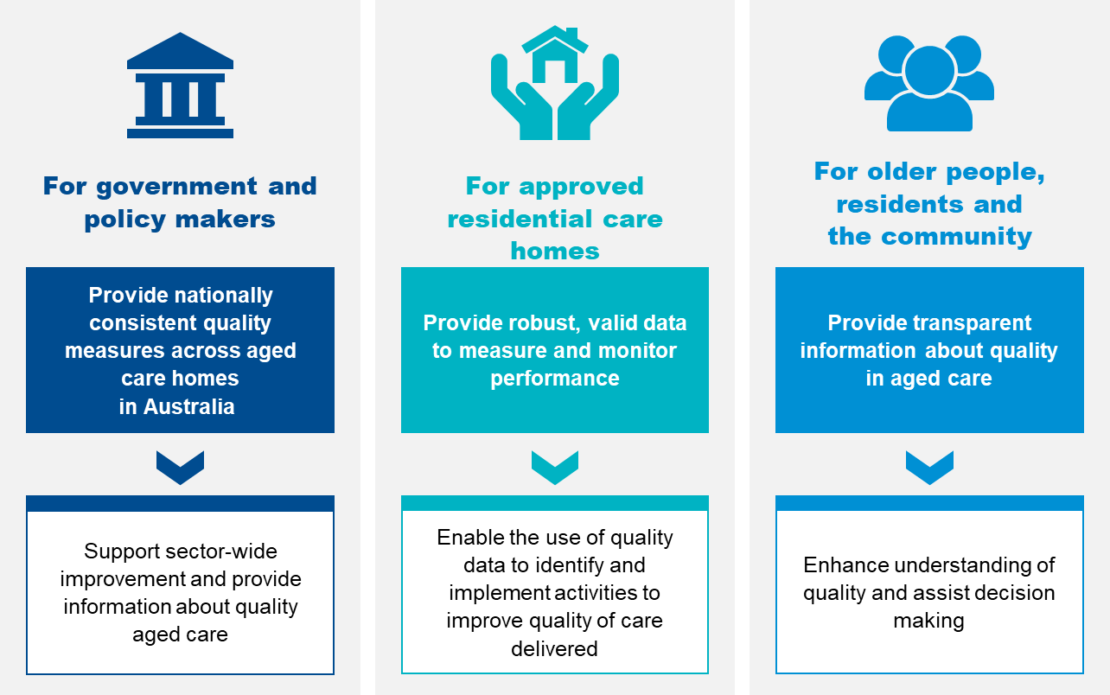

Quality indicators in the QI Program
The QI Program requires the collection and reporting of quality indicators that relate to the main aspects of quality of care across 14 crucial care areas. Providers collect data for each quality indicator through measurements and assessments in each of the categories set out in Figure 2. Providers then compile or derive the information and provide it to the Secretary of the Australian Government Department of Health, Disability and Ageing (System Governor), or the System Governor’s delegate, in accordance with the Aged Care Act 2024 (the Act).
The Aged Care Quality and Safety Commission (Commission) is responsible for QI Program compliance. The Commission uses QI Program data reported by providers, to guide their regulatory activities. The Commission’s Compliance and Enforcement Policy details the approach to non-reporting of information.
All providers must collect data across the 14 quality indicators outlined in Figure 2.
FIGURE 2: SUMMARY OF QI PROGRAM QUALITY INDICATORS
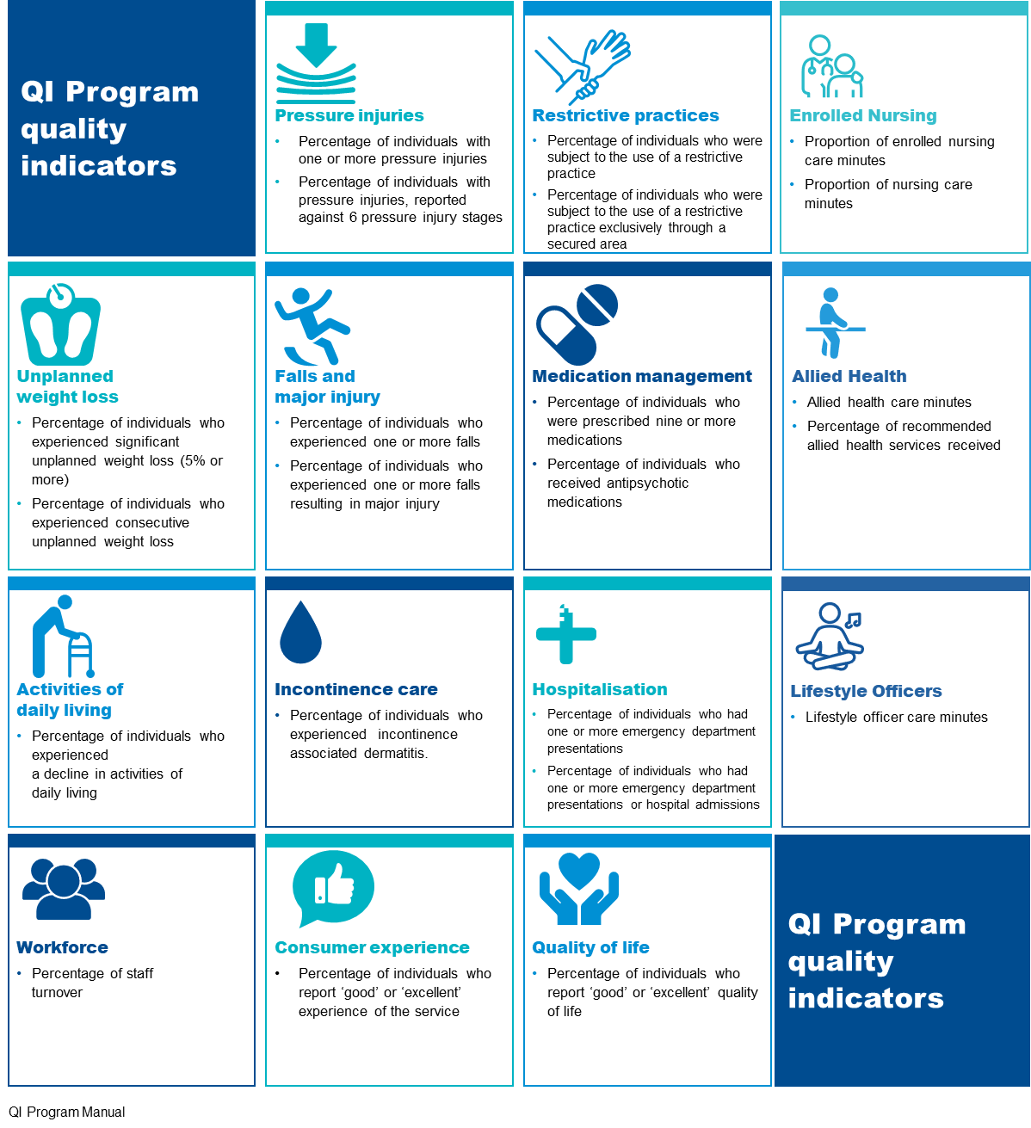

The QI Program Manual
The QI Program Manual consists of three parts, all available on the Department of Health, Disability and Ageing website. QI Program Manual– Part A (Part A) provides legislated requirements for collecting, recording and submitting data in addition to definitions of each quality indicator.
QI Program Manual – Part B (this document) aims to support providers with tools and resources to support continuous quality improvement across each quality indicator. Part B is not legislated.
The Government Provider Management System User Guide: Quality Indicators application is a guide for providers to access and use the Quality Indicators application in the Government Provider Management System (GPMS) as well as submit quality indicator data and access QI Program reports.


Introduction to quality improvement

Quality improvement leads to improvements in the quality and experience of care, as well as improving outcomes for residents. Quality improvement is an important part of everyone’s job and should be understood and accepted by all levels of management and staff. The QI Program aims to support providers of aged care to understand and use quality indicator data to be able to continuously improve quality of care and services.

What is quality improvement?

Quality improvement is a systematic, coordinated and ongoing effort to improve the quality of care and services.
Quality is described as care that is effective and safe, and provides a positive experience by being caring, responsive and person-centred.

Quality improvement works to identify how well systems are working and to understand the quality of care and services being delivered to improve outcomes for residents^{.1F}
Providers should aim to answer three main questions throughout the quality improvement process:
- What are we trying to accomplish?
- How will we know that a change is an improvement?
- What changes can we make that will lead to improvement?
An understanding of quality improvement is important for anyone who delivers or manages care. It can lead to improvements in the quality, experience, productivity and outcomes of care and services.

Supporting a culture of quality improvement
Building a culture of improvement is critical in supporting quality improvement in your organisation. Leadership and management play a crucial role in establishing an improvement culture, helping staff understand the importance of quality improvement, and ensuring that they feel safe and able to raise issues about the quality of services or care. It is also important that clear governance arrangements are established so there is a consistent approach to identifying quality issues and engaging in quality improvement activities.

FIGURE 3: QUALITY IMPROVEMENT BENEFITS
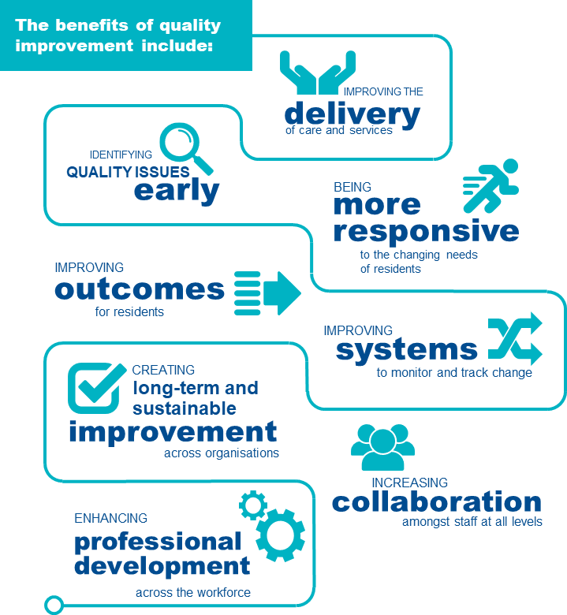

When should quality improvement be undertaken?
Quality improvement is ongoing and aims to make a difference to residents by improving the safety, effectiveness and experience of care and services.
QI Program data and reports assist providers in understanding the quality of services and help to identify opportunities to continuously improve the care they deliver.
FIGURE 4: STEPS TO ENABLE QUALITY IMPROVEMENT
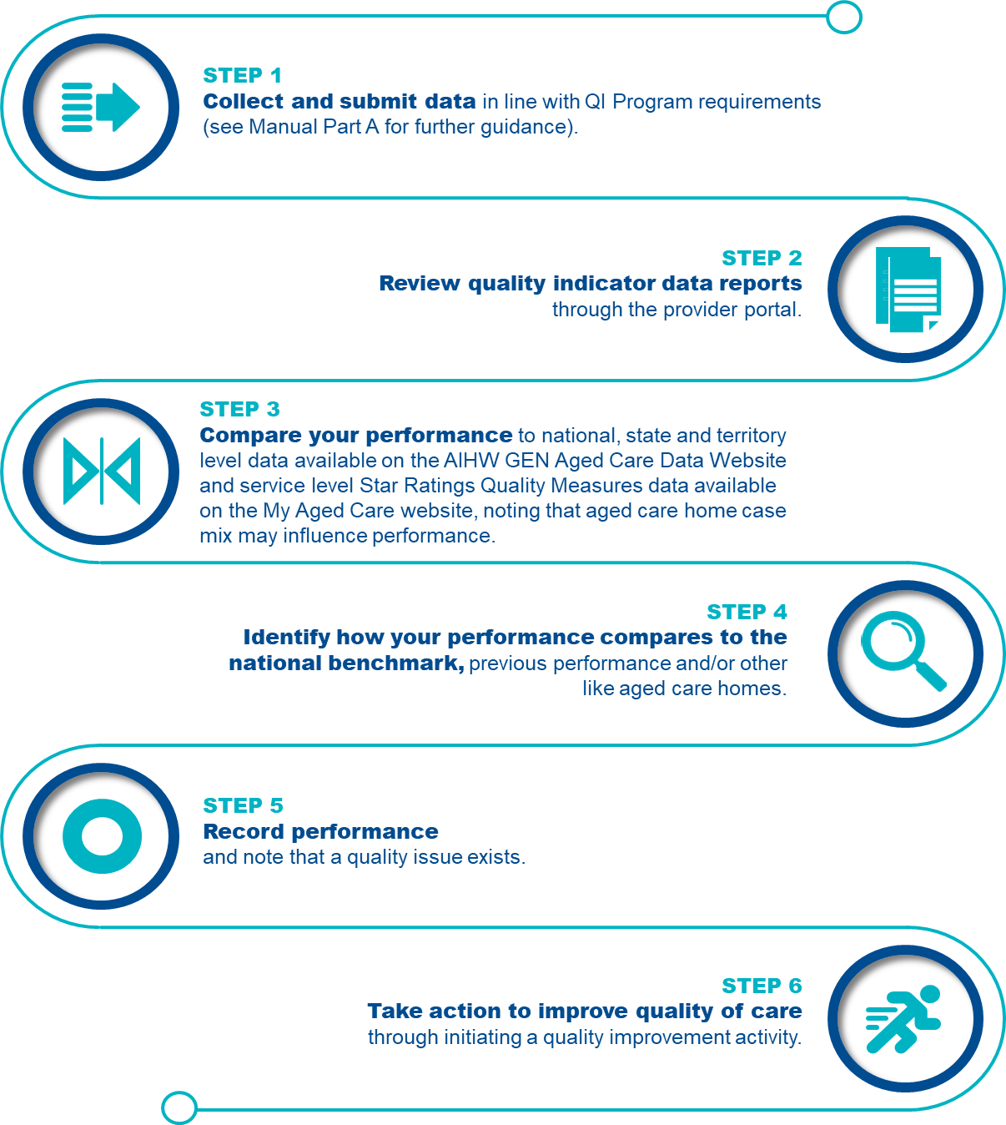
It is important to note that quality improvement should be an ongoing focus for all providers of aged care homes, regardless of performance.

How to undertake quality improvement in aged care
Quality improvement approaches can help aged care services to improve the quality of care for residents.

Quality improvement approaches
There are a range of different approaches to quality improvement. One option is the Plan-Do-Check-Act tool which uses evidence to help organisations deliver quality improvement activities through four steps. The Plan-Do-Check-Act tool allows organisations to identify quality issues and trial a quality improvement activity at a small scale. This helps organisations to understand if the activity works before implementing the activity across the entire system.
The Plan-Do-Check-Act tool can be used across all 14 quality indicators in order to make improvements in the delivery of care. Examples of how the Plan-Do-Check-Act tool can be used across each quality indicator are outlined in this Manual.
FIGURE 5: PLAN-DO-CHECK-ACT TOOL
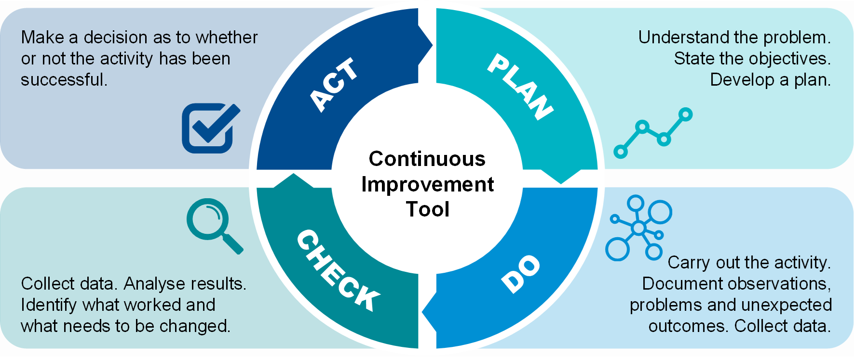

PLANNING is an important first step in quality improvement.
- Gather information to understand the current situation and identify what is causing the quality issue. This includes reviewing quality indicator data and may also include collecting additional data.
- Establish goals for your quality improvement activity. Goals should be measurable and have a set timeframe to be achieved.
Make a plan for how the quality improvement activity will be carried out. This process should be collaborative and include different levels of staff, as well as residents where possible. The plan should be detailed, define who is affected by the activity, outline the tasks required and who is required to deliver them.
DOING focuses on implementing and delivering the quality improvement activities you have planned.
- Allocate resources to deliver the quality improvement activity.
- Test the activity at a small scale and adjust as needed.
- Inform stakeholders.
- Document observations, including any decisions made while delivering the activity and if any changes are made to the plan.
Collect data based on the measures agreed in the planning phase.
CHECKING involves evaluating what you are doing to check if it is working using qualitative and quantitative information.
- Qualitative information involves asking questions to understand what did and did not work well, and how further improvement can occur.
- Quantitative information involves collecting data to measure outcomes from a quality improvement activity. A validated quality improvement tool is a helpful way to collect this data.
Once information and data has been collected, the results should be analysed to understand if any changes should be made to your plan.
ACTING involves making a decision to decide if a quality improvement activity has been successful.
- If the activity is successful, organisations should work to embed the new activity at a larger scale. This includes training and educating staff, updating policies and procedures, and informing stakeholders.
- If the activity is not successful, it is important to identify why this might be and what can be done differently. The PlanDoCheckAct tool should be used again, but this time with a different quality improvement activity.


Pressure injuries
Pressure injuries are a major and prevalent health concern for older people, with evidence demonstrating that pressure injuries are an important and recognised issue in aged care homes.

Overview of pressure injuries
Figure 6 below provides an overview of the prevalence of pressure injuries in aged care homes. The data and references have been reviewed March 2025.
FIGURE 6: PRESSURE INJURIES IN AGED CARE HOMES 2F 3F 4F 5F 6F 7F
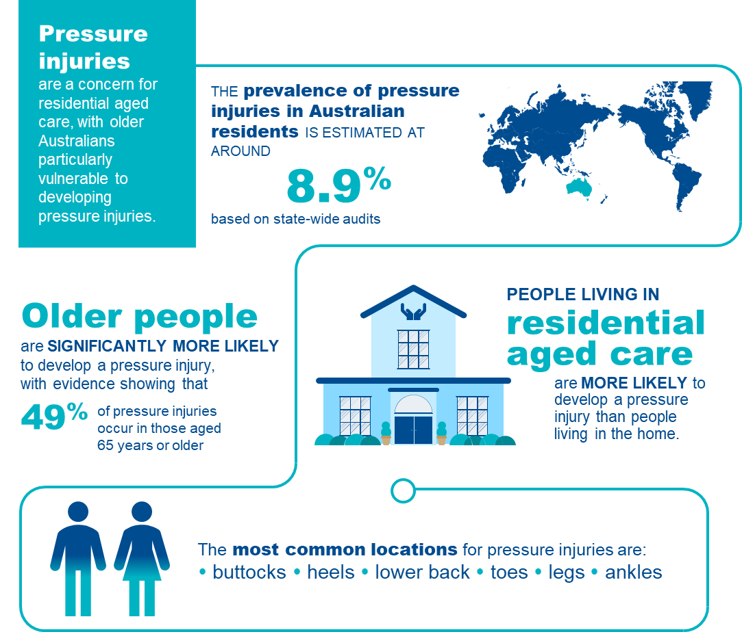

Pressure injuries in aged care homes
A pressure injury is an injury to the skin and/or underlying tissue caused by unrelieved pressure, friction or shearing.^{8F} Pressure injuries usually occur over a bony prominence but may also be caused by an object, such as a medical device.^{9F}
The ICD 10 Australian Modified (AM) pressure injury classification system outlined in the Prevention and Treatment of Pressure Ulcers/Injuries: Clinical Practice Guideline 2019^{10F} includes the following six pressure injury stages:
- Stage 1 Pressure Injury
- Stage 2 Pressure Injury
- Stage 3 Pressure Injury
- Stage 4 Pressure Injury
- Unstageable Pressure Injury
- Suspected Deep Tissue Pressure Injury
Details of the collection and reporting requirements for the pressure injuries quality indicator can be found in Part A.

Causes of pressure injuries
Pressure injuries may occur when an area of skin and the tissues underneath it is damaged by being under enough pressure that the blood supply is reduced.^{11F} Pressure injuries have three core causes^{:12F 13F 14F}
- Pressure: the force of a person’s body weight or an external object compressing on the skin for a period of time, causing a wound to form. This commonly occurs in people with poor mobility who are unable to easily shift their weight to relieve pressure.
- Friction: when two surfaces rub against each other, causing a wound to develop. This may occur when a person is pulled across bed linen. Moisture also increases friction.
- Shearing: downward pressure or sliding that creates friction and causes a wound to develop. This may occur when a person is positioned upright in bed and they slide downward.

Adverse clinical events and pressure injuries
Pressure injuries can have long and short-term impacts on residents’ health and wellbeing, including reduced quality of life, increased disability and even death^{.15F 16F 17F} They can take many months to heal and, in some cases, may never heal completely. Common complications associated with pressure injuries include^{:18F 19F 20F 21F 22F}
- pain and discomfort
- infection and sepsis
- stress, anxiety and depression
- reduced physical and social functioning
- limb-threatening injuries, including amputation.
Pressure injuries are also expensive to manage and cause a financial burden to aged care homes^{23F}

Risk factors for pressure injuries
Older people are significantly more vulnerable to developing a pressure injury due to age-related issues. Figure 7 describes the key risk factors for developing pressure injuries in aged care homes. Having a strong understanding of the risk factors is crucial to identify residents who are at risk of developing pressure injuries.
FIGURE 7: RISK FACTORS AND RELEVANCE TO PRESSURE INJURY DEVELOPMENT AND RESIDENTIAL AGED CARE24F 25F 26F 27F 28F 29F 30F 31F 32F 33F 34F 35F 36F 37F 38F 39F 40F 41F 42F
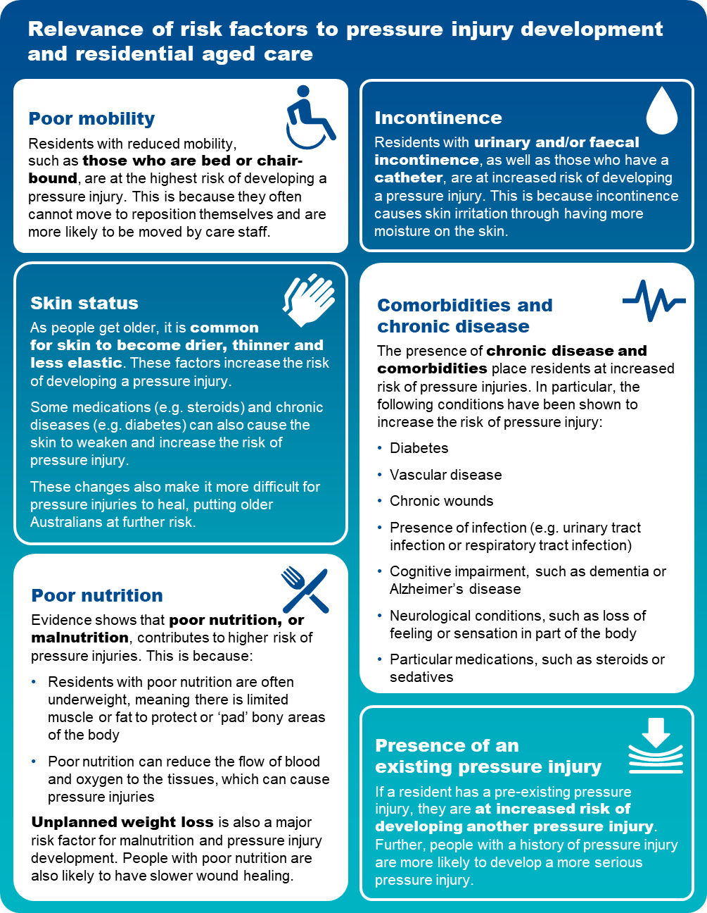

Prevention and management of pressure injuries
Awareness of risk factors and some simple steps can reduce the chance of pressure injuries occurring. Figure 8 below outlines some important aspects of care that can be considered to prevent and manage pressure injuries.
FIGURE 8: PRESSURE INJURY PREVENTION AND MANAGEMENT
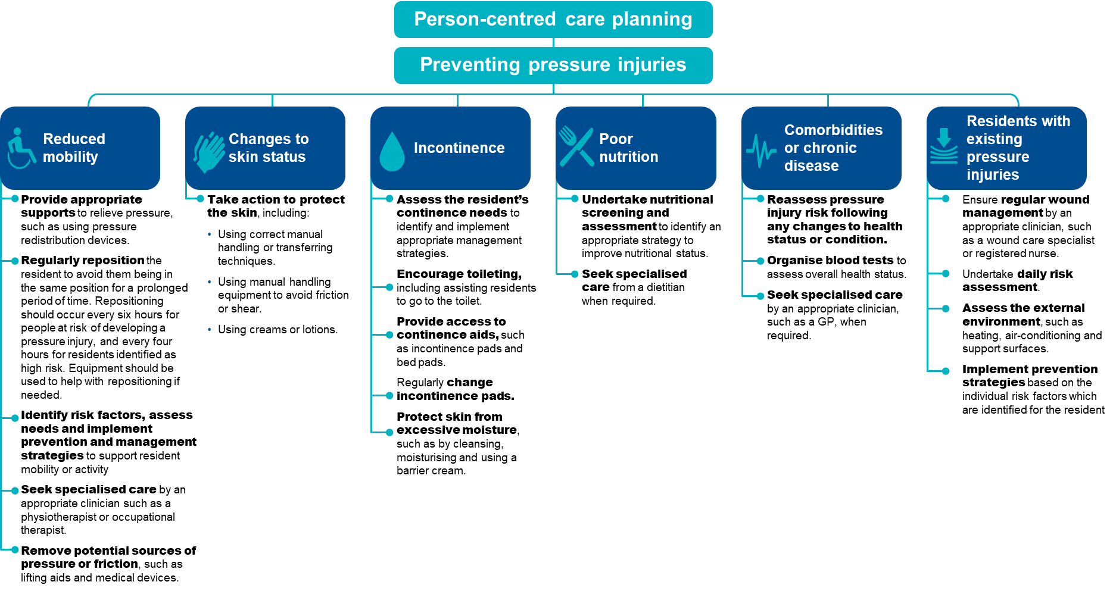
The checklist below will help assess residents who are at risk of pressure injuries and identify prevention strategies to reduce the risk of pressure injuries occurring.
FIGURE 9: CHECKLIST FOR THE PREVENTION OF PRESSURE INJURIES

Checklist for the prevention of pressure injuries

Conduct a skin assessment

- A head-to-toe assessment with a focus on skin at bony prominences.
- Examine for any changes in skin colour, including redness, blanching and inflammation.
- Assess for:
- dryness, changes and thinning of the skin
- moist skin such as from sweating or incontinence


- areas of localised pain.
Undertake pressure injury risk assessments regularly
- When a resident is first admitted to an aged care home.
- When a resident returns from a different care setting, such as a hospital or rehabilitation service.

- If a resident’s health or condition changes, such as change in mobility, nutrition status, continence status, medication or increased frailty.
- Following surgery, other medical procedures or investigation.
- On a daily basis for residents considered to be high risk and those who have an existing pressure injury.
Document findings in a care plan
- Activities to be undertaken to prevent a pressure injury developing.
- Frequency and timing of prevention activities.
- Preferences, including ability of resident to reposition themselves.
- Risk factors, including comorbidities and mobility status.
Implement appropriate prevention strategy
Focus on key risk factors, such as:
- Reduced mobility
- Changes to skin status
- Incontinence
- Poor nutrition
- Comorbidities or chronic disease
- residents with existing pressure injuries.
Undertake frequent reassessment
- Perform regular reassessment to monitor risk and check for early signs of pressure damage.
- Reassess prevention strategies to adjust care plans.

Quality improvement for pressure injuries
Quality improvement can help providers increase the quality of care for residents at risk of developing pressure injuries.^{43F} Quality improvement activities should be ongoing and part of business-as-usual for providers.
The QI Program will help prompt when a specific quality improvement activity should be undertaken. It is important to review QI Program data reports through GPMS and compare against national averages and other services to understand where quality improvement activities should be focussed.
The Plan-Do-Check-Act tool (section 2.3) is a useful tool to plan, deliver and monitor quality improvement activities focused on preventing and reducing pressure injuries.^{44F 45F}

Example tools, guidance and resources to
support continuous quality improvement
- Prevention and Treatment of Pressure Ulcers/Injuries: Clinical Practice Guideline and Quick Reference Guide — the International Guideline 2019 and new 2025 guidelines.
- Waterlow Pressure Ulcer Scale — available online on the New South Wales Agency for Clinical Innovation website
- Braden Scale for Predicting Pressure Sore Risk — available online in the AN-ACC Reference Manual on the Australian Department of Health, Disability and Ageing website, or this example from SA Health
- Pressure injuries: Standardised care process — an evidence-based approach in the assessment, management and prevention of pressure injury wounds for older people who live in a residential aged care setting — Victorian Department of Health and Human Services
- Assessment and Management of Pressure Injuries — provides an online learning module on the assessment and management of pressure injuries — Wound Innovations
- Preventing pressure ulcers — accessible article detailing interventions to prevent pressure ulcers — Institute for Quality and Efficiency in Health Care
Some tools, guidance and resources may be updated over time; it is important to ensure you are looking at the most recent version.

Restrictive Practices
There are significant concerns about the overuse of restrictive practices in aged care homes. While restrictive practices are used with the intention of supporting the safety of residents and others it can be associated with negative impacts and outcomes for residents. The use of restrictive practices needs to be considered on a case-by-case basis, used as a last resort and for the shortest time possible.

Overview of Restrictive practices
Figure 10 below provides an overview of restrictive practices in aged care homes. The data and references have been reviewed March 2025.
FIGURE 10: RESTRICTIVE PRACTICES IN AGED CARE HOMES
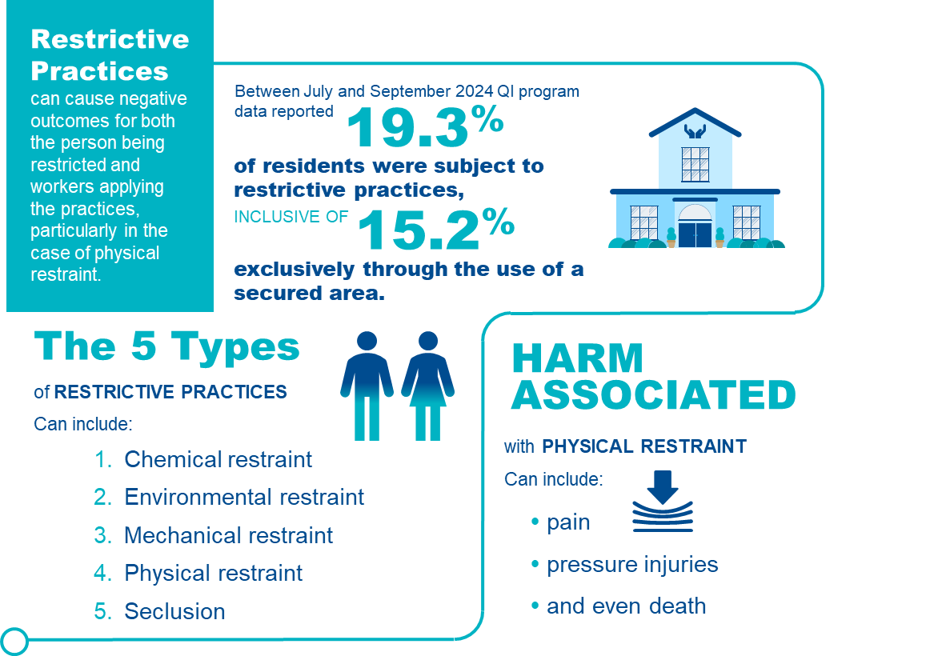

Restrictive practices in aged care homes
Section 17 of the Act define restrictive practices as any practice or intervention that has the effect of restricting the rights or freedom of movement of an individual.
- For the purposes of the QI Program, restrictive practices includes all forms of restrictive practice, excluding chemical restraint, as follows:
- Mechanical restraint is a practice or intervention that is, or that involves, the use of a device to prevent, restrict or subdue a resident’s movement for the primary purpose of influencing the resident’s behaviour, but does not include the use of a device for therapeutic or non-behavioural purposes in relation to the resident.
- Physical restraint is a practice or intervention that:
- Is or involves the use of physical force to prevent, restrict or subdue movement of a resident’s body, or part of a resident’s body, for the primary purpose of influencing the resident’s behaviour, but
- Does not include the use of a hands-on technique in a reflexive way to guide or redirect the resident away from potential harm or injury if it is consistent with what could reasonably be considered to be the exercise of care towards the resident.
- Environmental restraint is a practice or intervention that restricts, or that involves restricting, a resident’s free access to all parts of the resident’s environment (including items and activities) for the primary purpose of influencing the resident’s behaviour.
- Seclusion is a practice or intervention that is, or that involves, the sole confinement of a resident in a room or a physical space at any hour of the day or night where:
- Voluntary exit is prevented or not facilitated, or
- It is implied that voluntary exit is not permitted
for the primary purpose of influencing the resident’s behaviour.
For the purposes of the QI Program, restraint through the use of a secure area includes only environmental restraint, as defined above.
All listed forms of restrictive practice, including instances the resident or their representative instigate or request the restrictive practice, are considered restrictive practices for the purposes of the QI Program. Details of the collection and reporting requirements for the restrictive practices quality indicator can be found in Part A.

Adverse clinical events and restrictive practices
Restrictive practices can cause physical and psychological harm and can have a significant impact on the quality of life of residents. These include:
- Psychological consequences, such as fear, shame, anxiety, anger, loneliness, boredom, loss of dignity, agitation, depression, and lower cognitive performance.
- Physical consequences, such as bruising, direct skin injuries, pressure injuries, contractures, respiratory complications, urinary and faecal incontinence and constipation, undernutrition, reduced mobility and increased dependence in activities of daily living, impaired muscle strength and balance, reduced cardiovascular endurance, serious injury and death.
Restrictive practices can also result in death, for example restrictive practices applied for falls prevention may lead to neck compression and entrapment causing asphyxia.^{47F}

Prevention and management of restrictive practices
Sections 162-15 and 162-20 of the Rules outline that restrictive practices in approved residential care homes should only be used as a last resort and only when necessary to prevent harm to the resident or another person, and after consideration of the likely impact of the restrictive practice on the resident. Restrictive practices can be used only if:
- an approved health practitioner with day-to-day knowledge of the resident has assessed the resident as posing a risk of harm to themselves or others and assessed that the use of restrictive practice is necessary
- the requirement to have a behaviour support plan in place for every resident who has restrictive practices considered, applied or used as part of their care has been fulfilled. The use of the restrictive practice complies with any provisions of the behaviour support plan
- the use of the restrictive practice complies with the Strengthened Aged Care Quality Standards and the Aged Care Code of Conduct and is not inconsistent with the Statement of Rights
- best practice alternatives have been used to the extent possible and alternative strategies that have been considered or used have been documented in the resident’s behaviour support plan
- the restraint used is the least restrictive form and for the shortest time needed
- informed consent has been obtained from the resident or, if they do not have capacity to consent, their restrictive practices substitute decision maker.
FIGURE 11: PREVENTING RESTRICTIVE PRACTICES48F
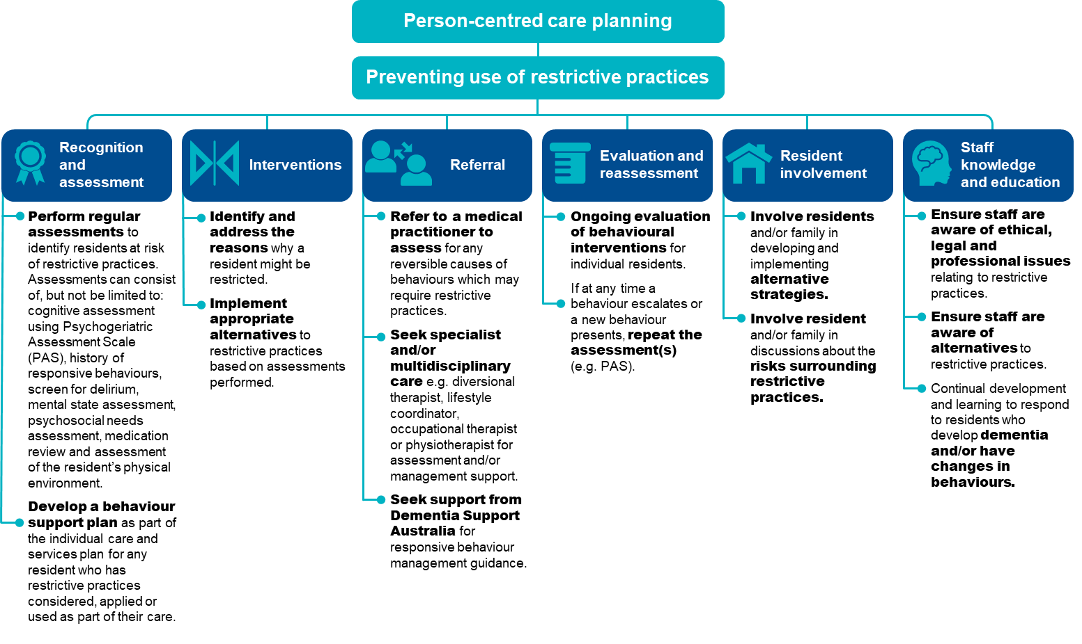

Providers can reduce the need for restrictive practices in an aged care setting. The checklist below outlines steps that providers can undertake to help identify alternatives to restrictive practices. ^{49F}
FIGURE 12: CHECKLIST FOR THE PREVENTION OF RESTRICTIVE PRACTICES50F
Checklist for the prevention of restrictive practices

Assess environmental factors
- Reduce the risk of physical trauma to the resident, such as using non-slip flooring, non-slip footwear, improved lighting, appropriate bed and seating for comfort, mobility aids
- Reduce environmental noise, for example where a resident becomes agitated due to the TV volume in a common area, guide the resident away from the area or turn the TV volume down.
- Alter the layout of the aged care home to support ease of navigation for residents, such as having a straight hallway from the bedroom to a recreational area.
Assess psychosocial factors
- Ensure familiar staff engage with residents.
- Foster companionship for residents with staff and other residents.
- Encourage participation in activities with residents that they enjoy or are meaningful to them.
- Identify opportunities for engagement with familiar loved ones and friends through visits and phone calls.
Assess care approach factors
- Ensure individualised routines to meet specific needs of residents.
- Increase supervision and staff interaction.
- Evaluate and monitor conditions affecting behaviour.
- Ensure staff liaise with family or resident’s representative and seek professional assistance to guide responses as needed.
Assess physiological factors
- Review medications, in particular for medications that may contribute to worsening cognitive function, restlessness and agitation.
- Manage nutrition and hydration.
- Manage pain and / or infection, for example urinary tract infections or viral infections can often cause agitation.
- If restrictive practices is used in an aged care home, it is important that staff review this checklist and reflect on factors that were not appropriately managed and may have contributed to the use of restrictive practice.

Quality improvement for restrictive practices
Quality improvement can help providers increase the quality of care for residents at risk of restrictive practices.^{51F} Quality improvement activities should be ongoing and part of business-as-usual for providers.
The QI Program will help prompt when a specific quality improvement activity should be undertaken. It is important to review QI Program data reports through GPMS and compare against national averages and other aged care homes to understand where quality improvement activities should be focussed.
The Plan-Do-Check-Act tool (section 2.3) is a useful tool to plan, deliver and monitor quality improvement activities focused on preventing and reducing restrictive practices.^{52F 53F}

Example tools, guidance and resources to support continuous quality improvement
- Cognitive Decline Scale — this scale is part of the Psychogeriatric Assessment Scales (PAS) and is suitable for use to test cognitive impairment in residential aged care — available on the Department of Health, Disability and Ageing website
- Minimising the use of restrictive practices — Information on restrictive practices, behaviour support plans and consent – Aged Care Quality and Safety Commission
- Restrictive practices provider resources — Factsheets, tools, videos and other resources for providers – Aged Care Quality and Safety Commission
- Reportable incidents: inappropriate use of restrictive practices — Factsheet designed to inform providers about identifying and reporting the inappropriate use of restrictive practices to the Serious Incident Response Scheme (SIRS)
- Severe Behaviour Response Teams (SBRT) — 24/7 contact with a Dementia Consultant on 1800 699 799 to access SBRT service — Dementia Support Australia
- Dementia Behaviour Management Advisory Service (DBMAS) — 24/7 contact with a Dementia Consultant on 1800 699 799 for advice or to make a referral — Dementia Support Australia
- Behaviour support plan resources — a toolkit of resources to support aged care homes to meet new behaviour support plan requirements aimed at minimising the use of restraints in aged care homes — Dementia Support Australia
Some tools, guidance and resources may be updated over time; it is important to ensure you are looking at the most recent version.

Unplanned weight loss
Unplanned weight loss is common among residents, with approximately half either being malnourished or at risk of malnutrition. It is important to understand and recognise where residents are experiencing unplanned weight loss, and to respond with actions to minimise or eliminate the cause.

Overview of unplanned weight loss
Figure 13 below provides an overview of unplanned weight loss in aged care homes. The data and references have been reviewed March 2025.
FIGURE 13: UNPLANNED WEIGHT LOSS IN AGED CARE HOMES 54F 55F, 56F
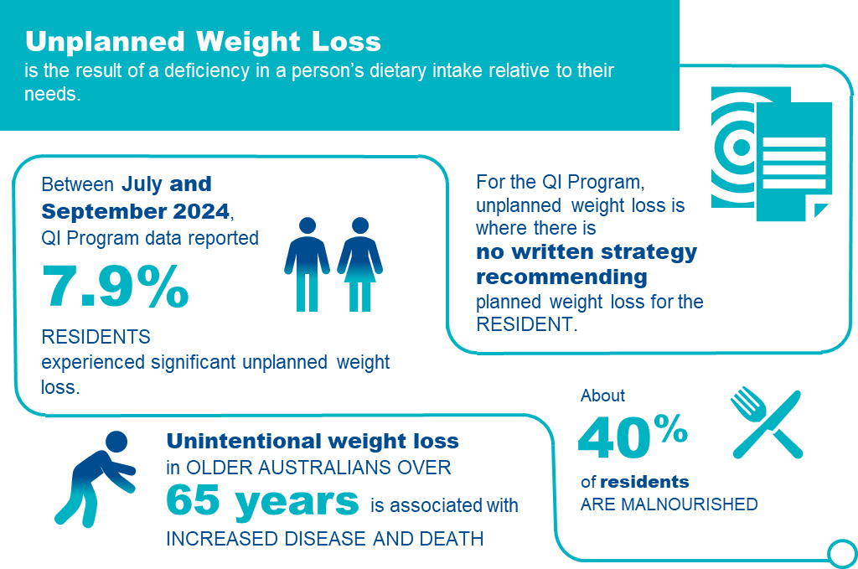

Unplanned weight loss in aged care homes
For the purposes of the QI Program, unplanned weight loss is the result of deficiency in a person’s dietary intake relative to their needs and may be a symptom or consequence of disease.
Note: If a resident has a written record from a medical doctor or dietitian, which includes intentional weight loss (for example, body fat or fluid), this weight loss will not be counted as unplanned weight loss. Where no such record exists, all weight loss must be considered unplanned regardless of the body size or any other characteristic of the resident.
There are two categories of unplanned weight loss:^{57F}
- Significant unplanned weight loss is weight loss equal to or greater than 5 per cent of body weight over a three-month period.
- Consecutive unplanned weight loss is weight loss of any amount of weight every month over three consecutive months.
Details of the collection and reporting requirements for the unplanned weight loss quality indicator can be found in Part A.

Causes and risk factors of unplanned weight loss
There are many causes of unplanned weight loss in adults over the age of 65, including food choice and quality, negative dining experiences, limited staff training and support, difficulty eating, poor appetite and mood. Residents may experience multiple causes, which may be curable or treatable.
Risk factors for unplanned weight loss may be due to a range of causes, including social, physical, psychological, emotional or the care setting, as described in Figure 14^{.58F 59F 60F 61F}
FIGURE 14: RISK FACTORS FOR UNPLANNED WEIGHT LOSS AND MALNUTRITION
SOCIAL CAUSES | PHYSICAL CAUSES | PSYCHOLOGICAL AND EMOTIONAL CAUSES | CARE SETTING CAUSES
Reduced social engagement  Loss of choice, social withdrawal, eating alone, limited communication  Cultural factors  Different life experiences of food and the mealtime environment, dining in institutional settings  Dining experience  Lighting, sound and smell, social interaction, staff activity, task-focussed service | Disease related  Acute illness, cancer, pain, pressure injury, constipation, and increased nutritional requirements  Medication related  Cardiac, neurologic, polypharmacy, nausea  Functional issues  Dexterity, mobility impairment, vision, chewing and swallowing, eating support needs  Reduced intake  Food quality, oral health, dentition/dentures, appetite, changes in taste or smell, restricted diets (e.g. texture modified), early satiety | Mood disorders  Anxiety, depression  Cognitive impairment  Alzheimer’s disease, Lewy body dementia, stroke  Bereavement  Grief, loss  Other  Loss of enjoyment | Staff  Limited staff to assist with eating, limited skills to identify and respond to weight loss, task focussed, workload  Food service mode  Limited food choices, mealtime requirements, plating and service approach  Food preparation  Inadequate nutritional content, insufficiently enriched foods

Adverse clinical events and unplanned weight loss
Unplanned weight loss is a sign of malnutrition, which affects every system in the body and results in increased vulnerability to illness, loss of independence, frailty, increased complications, higher risk of hospital admissions and, in extreme cases, even death^{.62F 63F 64F 65F} It contributes to a reduced quality of life.
FIGURE 15: IMPACT OF UNPLANNED WEIGHT LOSS
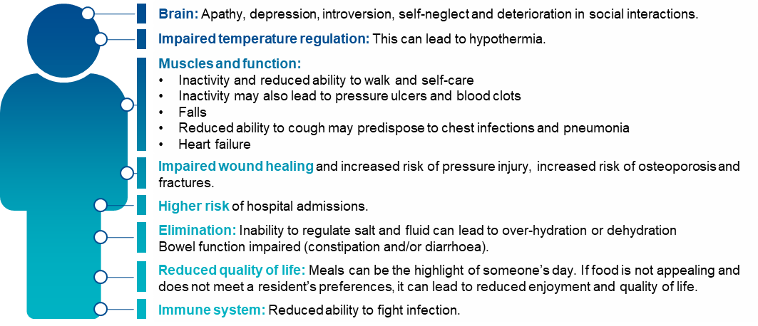

Prevention and management of unplanned weight loss
Preventing unplanned weight loss in residents requires a tiered approach, recognising and responding to the needs, preferences, and cultural requirements of each resident^{:66F 67F 68F}
There are three core methods to address unplanned weight loss through primary prevention, secondary prevention and tertiary prevention.

Primary prevention of unplanned weight loss
Primary prevention seeks to reduce health risks before they occur. This means ensuring each resident has the opportunity and support to maintain appropriate nutritional intake using a food-first approach. The food-first approach helps to support nutritional intake through using every-day nourishing foods and drinks that each consumer likes, and ensuring they are actually consumed^{.69F 70F 71F}
To support a food-first approach, and deliver a positive mealtime environment, it is important that different professionals come together to create a multidisciplinary nutrition policy in the context of the resident’s preferences, choices and cultural factors. This should include assessment of why appetite is poor or food is not being eaten, and considering food, nutrition, and a mealtime experience all together to help residents maintain a healthy weight.^{72F}

Secondary prevention of unplanned weight loss
Secondary prevention seeks to reduce the impact of risk or threats to health. For unplanned weight loss, this means ensuring staff have the right training, residents are screened for early identification of causes of poor intake, weight loss and implementing strategies that improve health and day-to-day life. All residents should be routinely screened for malnutrition using a validated malnutrition screening tool (see section 5.7 for examples).

Tertiary prevention of unplanned weight loss
Tertiary prevention seeks to minimise the impact of ongoing threats to health. This may involve strategies that reduce the risk of the negative effects of unplanned weight loss, such as minimising the risk of acquiring pressure injuries and discomfort.
Residents experiencing unplanned weight loss should be under the care of an appropriately skilled team of health professionals including a dietitian. Care should include a robust, monitored individualised nutrition care plan, completion of appropriate risk assessments, and the development and implementation of plans to manage the adverse consequences of unplanned weight loss.

Prevention strategies for unplanned weight loss
The checklists below provide strategies that may be used to prevent unplanned weight loss.
FIGURE 16: CHECKLIST FOR THE PREVENTION OF UNPLANNED WEIGHT LOSS
Checklist for the prevention of unplanned weight loss

Primary prevention of unplanned weight loss and malnutrition
- Taking a food-first approach
- Developing and implementing an integrated food and nutrition policy that covers hospitality, allied health, clinical care and quality professionals
- Consider the mealtime environment, including understanding if:
the dining area is clean, tidy, and well-lit
the dining area is arranged in a communal or family-like way
residents who require meal-time support are provided this support
residents have enough time to eat at a time and pace of their choosing
snacks are provided when residents need to eat more frequent smaller meals
- Residents are provided with tailored advice and information on maintaining a healthy weight
- The provider uses and acts on a holistic food, nutrition, and meal-time experience tool
A mechanism to monitor and detect when sufficient food is not consumed, and to respond early
- Ongoing consultation and feedback from each resident about their food and eating experience and responding to issues identified
Secondary prevention of unplanned weight loss and malnutrition
- Residents are screened for risk of malnutrition using a validated screening tool at assessment prior to entry, at the beginning of care, and on a regular basis
- Residents who are malnourished, or at risk of malnutrition, have a multidisciplinary management care plan that aims to meet their needs using a food-first approach
- Each resident who is screened for malnutrition (or their family or representative) have their results and nutrition support goals documented in writing
- Residents have their nutrition support goals and needs reviewed at planned intervals
- Residents who manage their own artificial feeding support or those caring for them have training to manage their nutrition needs
- Staff receive annual training on identifying and managing risk of malnutrition and malnutrition using a validated tool
- Policies and guidelines support compliance with aged care standards, and governance processes monitor this compliance
Tertiary prevention of unplanned weight loss and malnutrition
- Residents experiencing negative effects of unplanned weight loss are under the care of an appropriately skilled, multidisciplinary team of health professionals including a Dietitian.
- Residents are receiving treatment for the adverse consequences of unplanned weight loss

FIGURE 17: PREVENTION STRATEGIES FOR UNPLANNED WEIGHT LOSS73F
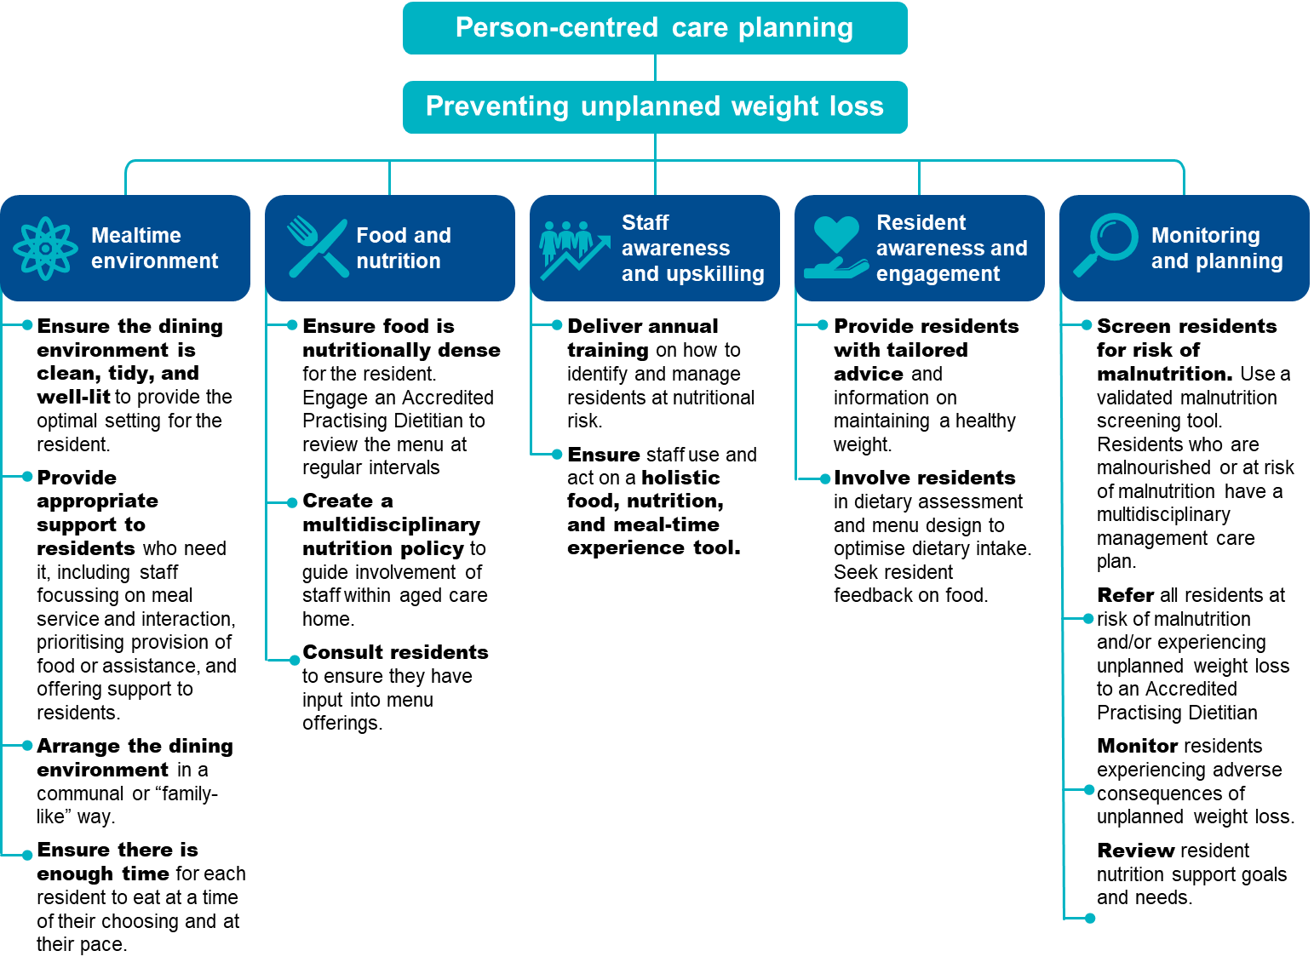

Quality improvement mechanisms
Quality improvement can help providers reduce the risk of residents experiencing unplanned weight loss and malnutrition.
Quality improvement activities should be ongoing and part of business-as-usual for providers. QI Program data can help prompt when a specific quality improvement activity should be undertaken. It is important to review QI Program data reports through GPMS and compare against national averages and other services to understand if unplanned weight loss and malnutrition is an issue within your organisation.
The Plan-Do-Check-Act tool (section 2.3) is a useful tool to plan, deliver and monitor quality improvement activities focused on unplanned weight loss.

Example tools, guidance and resources to support continuous quality improvement
Validated malnutrition screening tools and guidance
- The Malnutrition Universal Screening Tool (MUST) — Bapen
- Malnutrition Universal Screening Tool Calculator — calculator used to establish nutritional risk using objective measurements to obtain a score and a risk category — Bapen
- Mini Nutritional Assessment — Short Form (MNA®-SF) — Nestle
- Validated Malnutrition Screening and Assessment Tools: Comparison Guide — Queensland Health
- AutoMal research paper – study describing the development and internal validation of an automated malnutrition screening tool for use in residential aged care
- Food, nutrition & dining information for providers - Aged Care Quality and Safety Commission – includes a range of reference guides, tools and discussion papers. Includes a flyer listing all the Commission’s food, nutrition and dining resources
- Malnutrition in Aged Care — position statement — Dietitians Australia
- The Lantern Project — an online community seeking to improve food and the meal-time experience for residents in residential aged care settings
- Best Practice Food and Nutrition Manual for Aged Care — manual providing guidance on best practice food and nutrition for residential aged care — New South Wales Central Coast Local Health District
- Eating well: A Nutrition Resources for Older People and their Carers — short book providing simple advice on provide good nutrition — New South Wales Central Coast Local Health District
- Online training to help older people eat well — two free online training packages with videos, interactive activities and practical tips — Tasmanian Government Department of Health
- An evidence-based guide for the identification and nutritional management of malnutrition and frailty in the Australian and New Zealand community — evidence-based guide providing practical guidance for healthcare professionals to identify and manage malnutrition and frailty among adults in the community setting — Griffith University
Some tools, guidance and resources may be updated over time; it is important to ensure you are looking at the most recent version.

Falls and major injury
Falls are currently the leading cause of unintentional injury in older people in Australia. While not all falls can be prevented, there is strong evidence to suggest that falls can be reduced through screening, monitoring and prevention activities.

Overview of falls and major injury
Figure 18 below provides an overview of falls and major injury in aged care homes. The data and references have been reviewed March 2025.
FIGURE 18: FALLS AND MAJOR INJURY IN AGED CARE HOMES74F 75F 76F 77F 78F 79F 80F
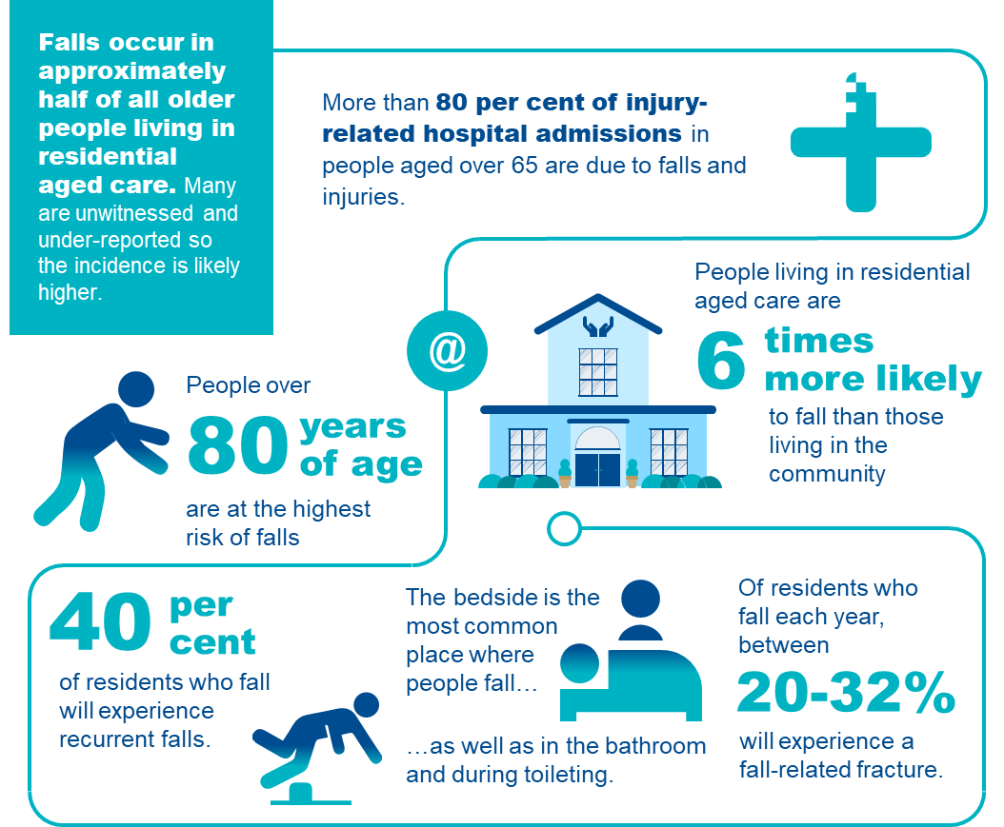

Understanding falls and major injury in aged care homes
Consistent with the World Health Organization’s definition of a fall, the QI Program defines a fall as an event that results in a person coming to rest inadvertently on the ground or floor or other lower level^{81F} This includes falls from a low bed and onto a crash mat.^{82F} Under the QI Program, a fall resulting in major injury is a fall that meets the definition above and results in one or more of the following:
- bone fractures
- joint dislocation
- closed head injuries with altered consciousness
- subdural haematoma.^{83F}
Falls commonly occur as a result of a person tripping, slipping or stumbling.^{84F}
Details of the collection and reporting requirements for the falls and major injury quality indicator can be found in Part A.

Adverse clinical events associated with falls and major injury
Falls and major injury are a significant safety and quality risk across aged care homes.
There are many negative consequences of falls, including minor and major injury, pain, reduced physical functioning, decreased independence, psychological impacts, and occasionally death.94 Figure 19 below outlines the common complications associated with falls in aged care homes.

FIGURE 19: COMMON COMPLICATIONS OF FALLS85F 86F 87F
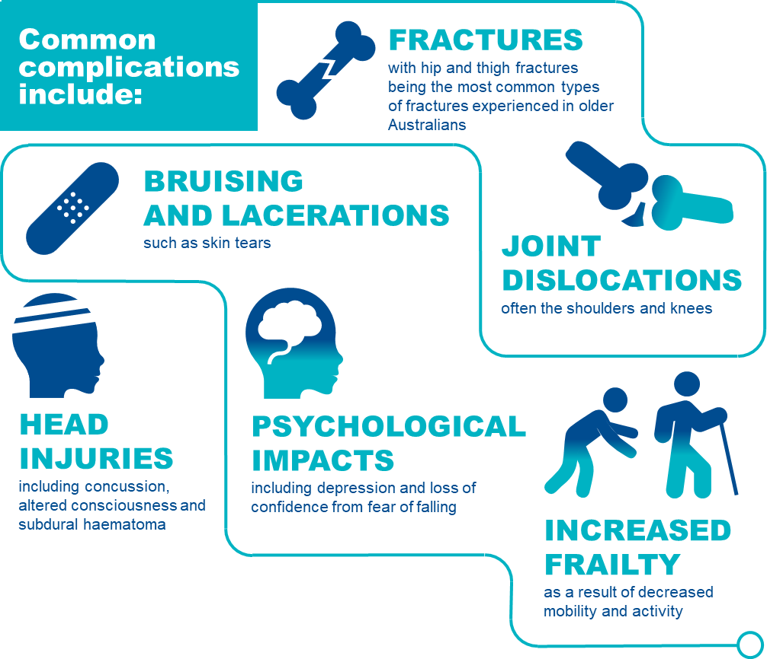

Risk factors of falls and major injury
Older people are at increased risk of falls and are also more likely to suffer an injury as a result of a fall. This is due to increased frailty, reduced mobility and muscle tone, as well as conditions commonly associated with older age, such as osteoporosis and osteopenia, which weaken bones and increase the risk of injuries occurring from a fall.^{88F} Poor nutrition also increases the risk of falls and major injury^{.89F} 94
There is a range of risk factors that place residents at increased risk of falling (see Figure 20 below).^{90F 91F 92F 93F 94F} Having a strong understanding of the risk factors is crucial to identify residents who are at risk of falling.

FIGURE 20: PERSONAL RISK FACTORS THAT INCREASE A RESIDENT’S RISK OF FALLING
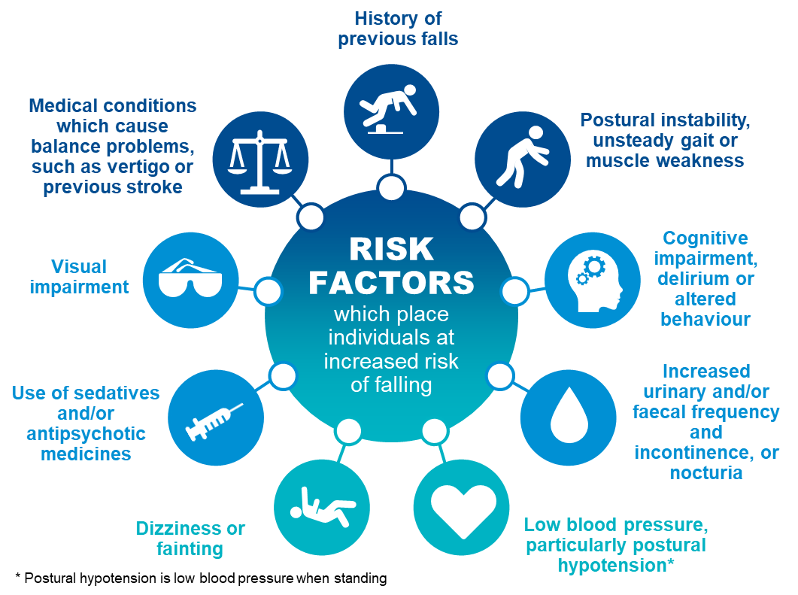

Prevention and management of falls and major injury, including prevention checklist
While not all falls (with and without injury) can be prevented, awareness of risk factors and some simple steps can reduce the risk of falling and an injury occurring.
There are three key focuses of falls prevention:
- To assess a resident’s risk of falling through identifying specific risk factors.
- To implement specific prevention programs or interventions to target these specific risk factors.
- To prevent injuries in those people who do fall.
There are important aspects of care that can be considered to prevent and manage falls and injuries. Figure 21 on the following page provides simple steps to identifying a resident’s falls risk and preventing falls and injuries from occurring.

FIGURE 21: RISK FACTORS AND PREVENTION AND MANAGEMENT STRATEGIES FOR FALLS
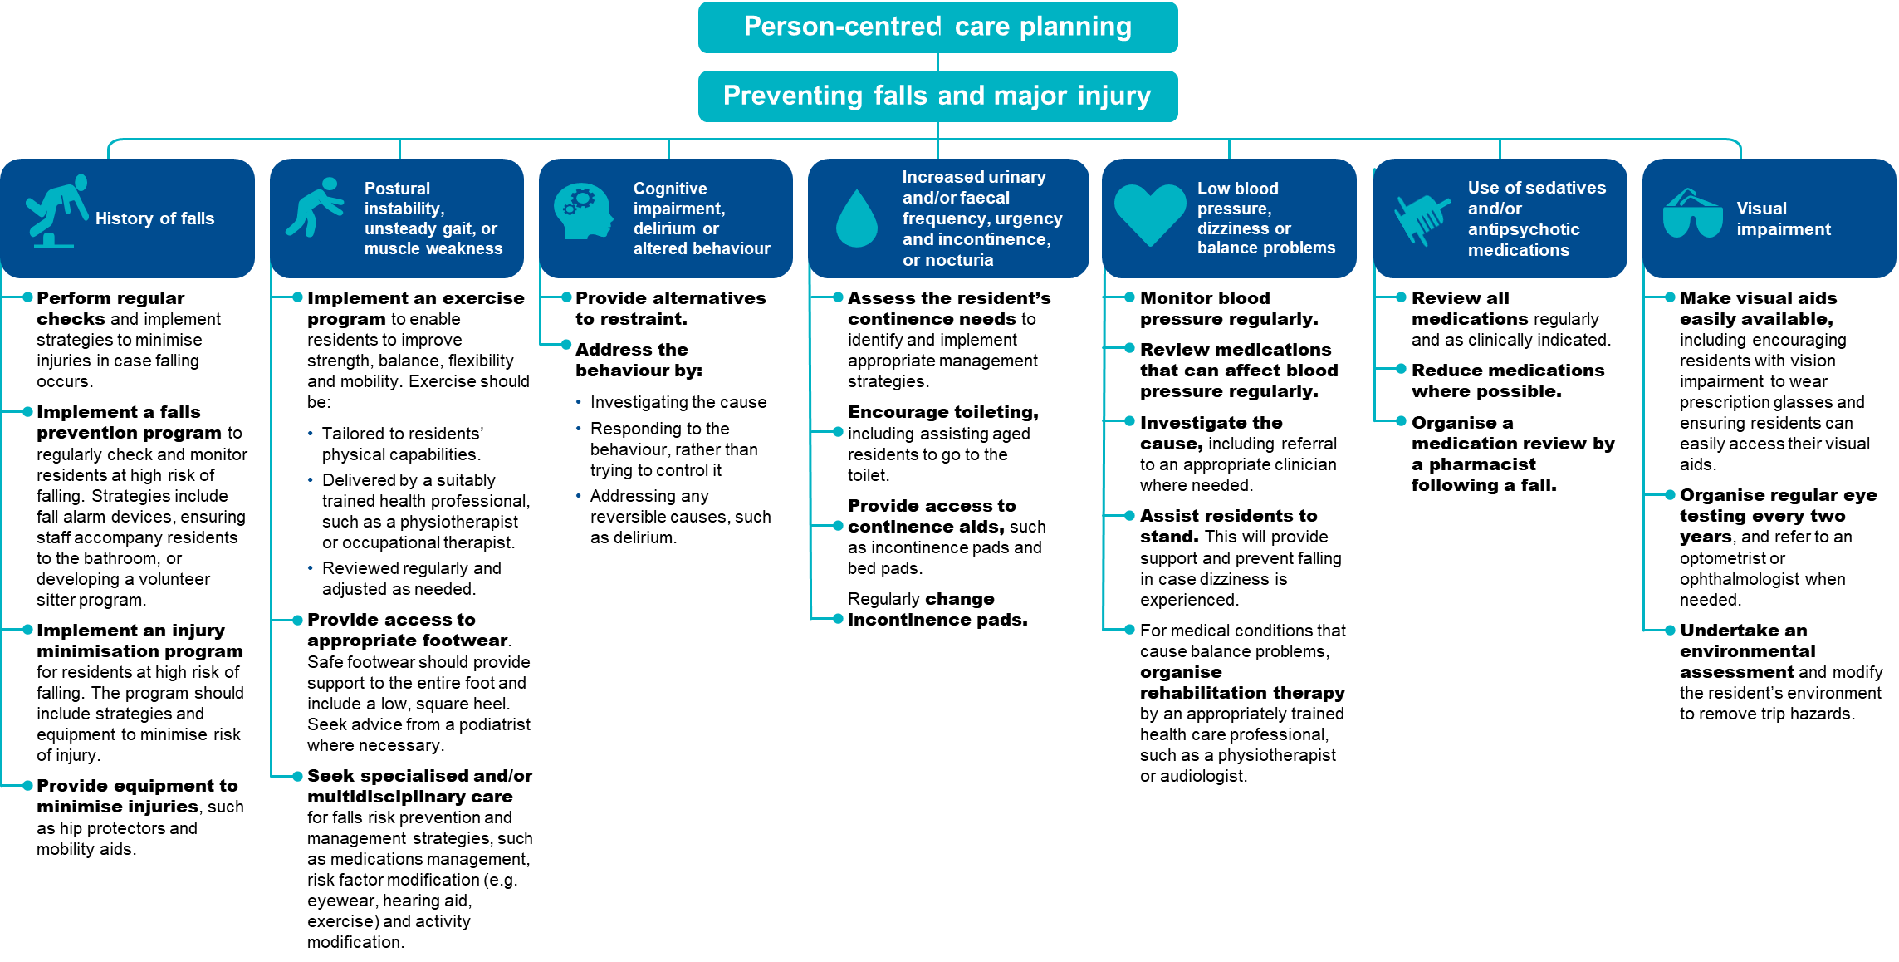

The checklist below will help to assess residents who are at risk of falls and major injury and identify prevention strategies to reduce the risk of falls and major injury occurring.
FIGURE 22: CHECKLIST FOR THE PREVENTION OF FALLS AND MAJOR INJURY
Checklist for the prevention of falls and major injury
Undertake an environmental review and modify as needed
- Conduct a quarterly environmental review at the aged care home (e.g. in common areas or hallways).
- Conduct a quarterly review at the individual level (e.g. in bedrooms and bathrooms).
- Make modifications where hazards are identified.
Undertake a falls risk assessment using a validated tool
- When a resident is first admitted to an aged care home.
- After a resident has a fall.
- After a change in health status.
- On an annual basis for all residents.
Document findings in a care plan
- Outline the activities that will be undertaken to reduce the resident’s risk of falling.
- Document risk factors, including comorbidities and mobility status.
- Consider the resident’s personal preferences.
Implement an appropriate prevention strategy based on the resident’s risk factors
- Previous or history of falls: Implementing a falls surveillance program and/or injury minimisation program.
- Postural instability, unsteady gait or muscle weakness: Implement exercise programs and provide access to appropriate footwear.
- Cognitive impairment, delirium or altered behaviour: Provide alternatives to restraint and address the behaviour.
- Urinary and/or faecal frequency, urgency and incontinence, or nocturia assess continence needs to identify and implement appropriate management strategies, support toileting, provide continence aids and change incontinence pads regularly.
- Low blood pressure and postural hypotension: Regularly monitor and manage blood pressure.
- Dizziness or fainting: Assist with standing and seek advice from GP.
- Use of sedative and/or antipsychotic medications: Regularly review and reduce medications, including seeking advice from a pharmacist or GP. Reducing psychotropic use and polypharmacy
- Visual impairment: Provide access to visual aids and undertake regular environmental assessment.
- Medical conditions and medications which impair balance: Provide access to rehabilitation therapy.
Undertake frequent reassessment to monitor risk
- When new or changing risk factors are evident.
- Following any change to health status or wellbeing.
- After a resident has a fall.
- At least annually for all residents.
- Reassess prevention strategies and adjust care plans as needed.

Quality improvement mechanisms
Quality improvement can help providers increase the quality of care for residents at risk of falling.^{95F} Quality improvement activities should be ongoing and part of business-as-usual for providers.
The QI Program will help prompt when a specific quality improvement activity should be undertaken. It is important to review QI Program data reports through GPMS and compare against national averages and other services to understand where quality improvement activities should be focused.
The Plan-Do-Check-Act tool (section 2.3) is a useful tool to plan, deliver and monitor quality improvement activities focused on preventing falls and minimising injuries.

Example tools, guidance and resources to support
continuous quality improvement
- Preventing Falls and Harm from Falls in Older People - Best practice guidelines and Fact Sheet — guidelines for managing the various risk factors that make residents in aged care homes vulnerable to falling — Australian Commission on Safety and Quality in Health Care (2025 update)
- Don’t fall for it. Falls can be prevented! — a booklet detailing ways to prevent falls — Australian Government Department of Health, Disability and Ageing
- Falls: Standardised care process — an evidence-based approach in the prevention of falls for older people who live in a residential aged care setting — Victorian Department of Health and Human Services
- Falls risk assessment tools, Victorian Department of Health — range of assessment tools aimed at falls prevention — available online on the Victorian Department of Health website
- Falls Prevention Online Workshops — online learning modules for GPs and health professionals featuring evidence-based processes to help health professionals prevent falls in older people — Integrated SOLutions for Sustainable Fall PreVEntion - iSOLVE
- World guidelines for falls prevention and management for older adults: a global initiative — a journal article providing a set of evidence and expert consensus-based falls prevention and management recommendations and guidelines — Journal of Age and Ageing
Some tools, guidance and resources may be updated over time; it is important to ensure you are looking at the most recent version.

Medication management — polypharmacy
Medication management plays a critical role in achieving quality of care for aged care residents. The two categories within this quality indicator are:
- Medication management — polypharmacy (this section), and
- Medication management — antipsychotics (see Section 8 of this manual).

Overview of polypharmacy
In aged care homes, polypharmacy describes when residents are taking more medications than can be practically and safely consumed. Polypharmacy in older people can increase negative health outcomes. The data and references in Figure 23 have been reviewed March 2025.
FIGURE 23: POLYPHARMACY IN AGED CARE HOMES96F 97F

Polypharmacy in aged care homes
Medication is defined as a chemical substance given with the intention of preventing, diagnosing, curing, controlling or alleviating disease or otherwise enhancing the physical and/or mental welfare of people. For the QI Program, it includes prescription and nonprescription medicines, despite the administered route.
The QI Program defines polypharmacy as the prescription of nine or more medications to a resident.
For the QI Program, any medication with an active ingredient is counted in the polypharmacy quality indicator. Except for those listed below which must not be included in the count of medications:
- Lotions, creams or ointments used in skin and wound care;
- Dietary supplements, including those containing vitamins;
- Short-term medications, such as antibiotics or temporary eye drops; and
- PRN medications.
Providers must not count different dosages of the same medicine as different medications.
Details of the collection and reporting requirements for the polypharmacy category of the medication management quality indicator can be found in Part A.

Causes of polypharmacy
Polypharmacy is an increasing concern amongst residents in aged care homes, and older people in general. Older people are often prescribed several medications to manage comorbidities and extend life, but there is evidence that the prevalence of polypharmacy is increasing amongst older people in Australia.

FIGURE 24: RISK FACTORS ASSOCIATED TO POLYPHARMACY98F
Older people are at risk of polypharmacy for a variety of reasons:
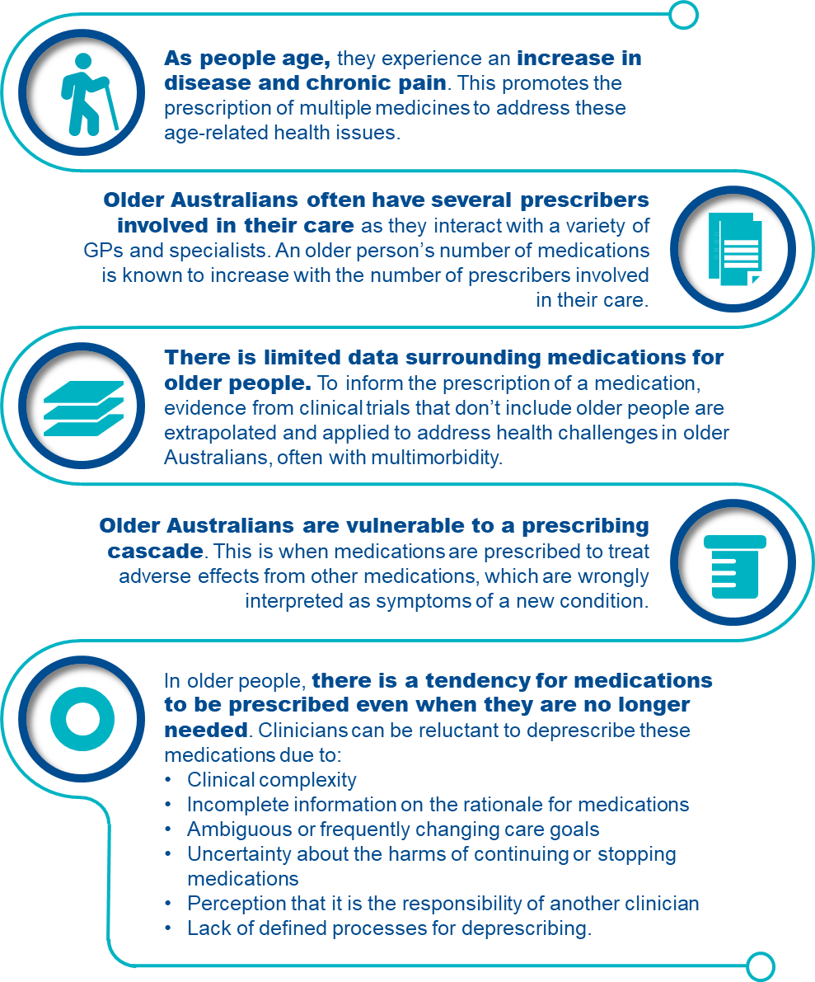

Adverse clinical events of polypharmacy
As people age, they are more sensitive to the effects of medication. This is exacerbated when they are prescribed multiple medications. Older people have an increased risk of experiencing adverse drug reactions (ADRs) due to physiological changes impacting how medicine is absorbed, distributed, metabolised and eliminated. An older person’s risk of an ADR increases with the number of medications they are prescribed.
FIGURE 25: COMMON COMPLICATIONS ASSOCIATED WITH POLYPHARMACY

Prevention and management of polypharmacy, including prevention checklist
The prescription, supply and administration of medicines is strictly regulated for safety and quality of care. Various health professionals are involved in this process to promote safe and quality use of medicines in aged care homes. Residents should understand and be involved in their own medication management and consent.
Figure 26 below discusses strategies to manage and prevent polypharmacy.

FIGURE 26: PREVENTION STRATEGIES FOR POLYPHARMACY
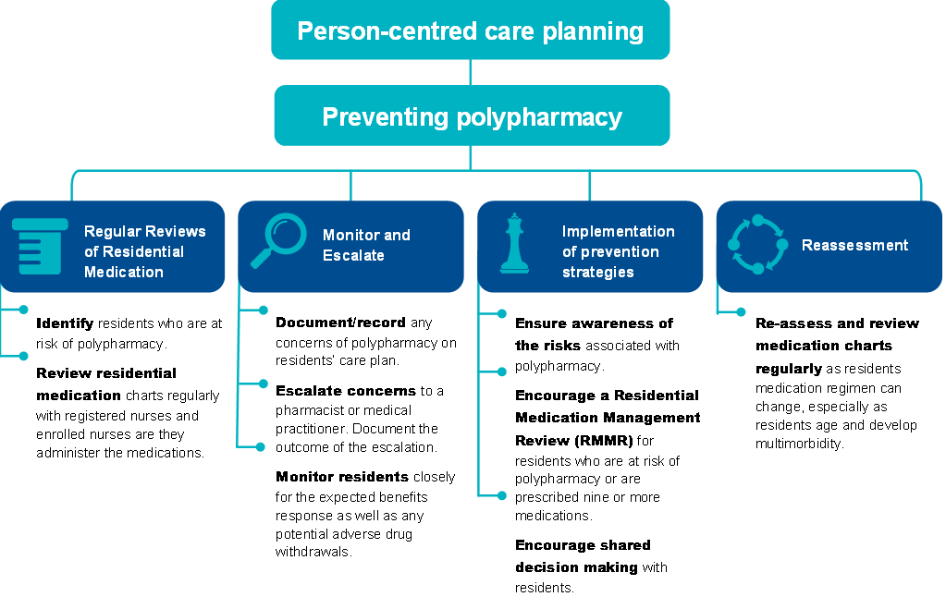
The checklist below will help to assess and involve residents who are at risk of polypharmacy and identify prevention strategies to reduce the risk of polypharmacy from occurring.

FIGURE 27: CHECKLIST FOR THE PREVENTION OF POLYPHARMACY
Checklist for the prevention of polypharmacy

Complete regular reviews of residential medication charts
- Aged care home staff are key to identifying residents who are at risk of polypharmacy or are already prescribed nine or more medications.
- Regular review of residential medication charts and/or administration records by registered nurses and enrolled nurses as they administer medications. Escalate to pharmacist or medical practitioner where appropriate.
- Review resident’s medication charts and/or administration records for medication changes upon return from hospital admissions.
Document, monitor and escalate instances of polypharmacy
- Document/record concerns of polypharmacy on a resident’s care plan and escalate to a pharmacist or medical practitioner. The outcome of this escalation should also be documented and planned for in the resident’s care plan.
- Monitor the resident closely for the expected benefits response as well as potential adverse drug withdrawals. A carer or enrolled nurse should discuss concerns of polypharmacy with the registered nurse so the escalation process to the pharmacist or medical practitioner is initiated for review.
Implement prevention strategies
Educate staff and promote awareness about polypharmacy
- Remain aware of the risks associated with polypharmacy. Programs supporting awareness and understanding of deprescribing and polypharmacy are effective in promoting safer medication regimens as staff play an active role in monitoring residents’ residential medication charts.
Encourage Residential Medication Management Reviews (refer to “Example tools, guidance and resources to support continuous quality improvement”)
- Encourage a Residential Medication Management Review (RMMR) for residents who are at risk of polypharmacy or are prescribed nine or more medications.
- Collaborate with medical practitioners and pharmacists to perform a RMMR for a resident. These medication management services are subsidised by Medicare.
Encourage shared decision making with residents
- Discuss medication needs with the resident to understand their perspective and support their participation in making decisions (where possible).
Escalate concerns of polypharmacy for consideration of deprescribing (where appropriate)
- Escalate concerns of polypharmacy to a pharmacist or medical practitioner. The purpose of this is to target medications no longer beneficial to the resident, reduce complexity in their medication regime and prevent consequences of a high-risk medication.
- Deprescribing can only be actioned by a medical practitioner and must be reflected in the resident’s medication chart.
Undertake frequent reassessment of residential medication charts
- Re-assess and review regularly as a resident’s medication regimen can change regularly, especially as residents age and develop multimorbidity.

Quality improvement for polypharmacy
Quality improvement can help providers increase the quality of care for residents at risk of polypharmacy. Quality improvement activities should be ongoing and part of business-as-usual for providers.
The QI Program will help prompt when a specific quality improvement activity should be undertaken.
It is important to review QI Program data reports through GPMS and compare against national averages and other services to understand where quality improvement activities should be focussed.
The Plan-Do-Check-Act tool (section 2.3) is a useful tool to plan, deliver and monitor quality improvement activities focused on preventing and reducing polypharmacy.

Example tools, guidance and resources to support
continuous quality improvement
- Australian Medicines Handbook — online resource providing information on current medications used in Australia
- Monthly Index of Medical Specialties (MIMS) Australia — online resource providing Australian medications information
- The Fourth Australian Atlas of Healthcare Variation: Polypharmacy, 75 years and over — chapter explores the effects of polypharmacy in older people — Australian Commission on Safety and Quality in Health Care
- Handbook of tools to support medicine management in multimorbidity and polypharmacy – developed by the University of SA for the Department of Health, Disability and Ageing
- Medications it’s your choice — video providing information about the rights and responsibilities of older people about their care, including their medication — Older Persons Advocacy Network
Some tools, guidance and resources may be updated over time; it is important to ensure you are looking at the most recent version.

Medication management — antipsychotics
Medication management plays a critical role in achieving quality of care for aged care residents. The two categories within this quality indicator are:
- Medication management — polypharmacy (see Section 7 of this manual); and
- Medication management — antipsychotics (this section).

Overview of antipsychotics
Medication management is critical for aged care homes as residents are often prescribed several medications to manage comorbidities and extend life, being particularly vulnerable to the significant risks of antipsychotics. The data and references in Figure 28 have been reviewed March 2025.
FIGURE 28: ANTIPSYCHOTICS IN AGED CARE HOMES99F 100F
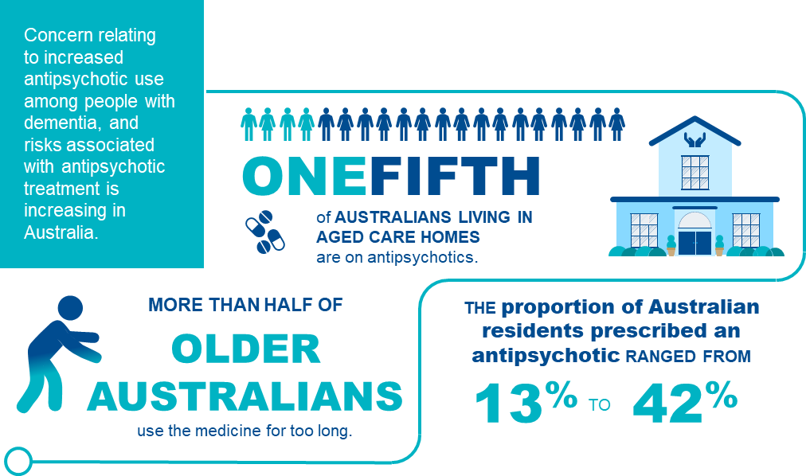

Antipsychotic use in aged care homes
Antipsychotics are medications prescribed for the treatment of a diagnosed condition of psychosis. Antipsychotic medication is often prescribed to aged care residents to manage the behavioural and psychological symptoms of dementia.
The following is a non-exhaustive list of antipsychotics:

- Amisulpride
- Aripiprazole
- Asenapine
- Brexpiprazole
- Cariprazine
- Chlorpromazine
- Clozapine
- Droperidol
- Flupentixol
- Haloperidol
- Lurasidone
- Olanzapine
- Paliperidone
- Periciazine
- Quetiapine
- Risperidone
- Trifluoperazine
- Ziprasidone
- Zuclopenthixol.

* List of antipsychotics approved for use in Australia can be updated at any time so reviewing the list alongside updated evidence-based sources is advised.
Regular monitoring of the use of antipsychotics is important because the inappropriate use of certain medication classes, such as antipsychotics, has been shown to be associated with poor health outcomes.
Details of the collection and reporting requirements for the antipsychotics category of the medication management quality indicator can be found in Part A.

Adverse clinical events of antipsychotics
The adverse effects of antipsychotic medications range from those that are relatively minor to others that are very unpleasant, painful, disfiguring or life-threatening. Figure 29 below explores the adverse clinical effects of antipsychotic use.
FIGURE 29: SIGNIFICANT ADVERSE EFFECTS OF ANTIPSYCHOTICS
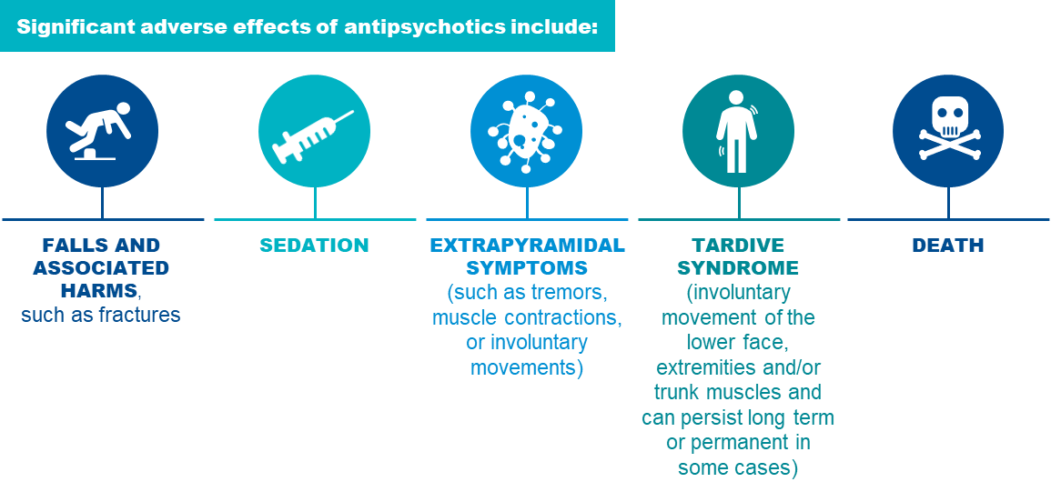
Research suggests that antipsychotic medications are frequently prescribed off-label for the behavioural and psychological symptoms of dementia.^{101F 102F} However, antipsychotics that are not beneficial or are not required should be discontinued.

Risk factors of antipsychotic use
Older people are significantly more vulnerable to the significant risks associated with antipsychotic use due to age-related issues. Having a strong understanding of the risk factors is crucial to identify residents who are particularly at risk with antipsychotic use. The risk factors associated with the use of antipsychotics in aged care homes are explored in Figure 30 below.
FIGURE 30: RISK FACTORS ASSOCIATED WITH ANTIPSYCHOTIC USE IN AGED CARE HOMES103F 104F 105F 106F 107F 108F
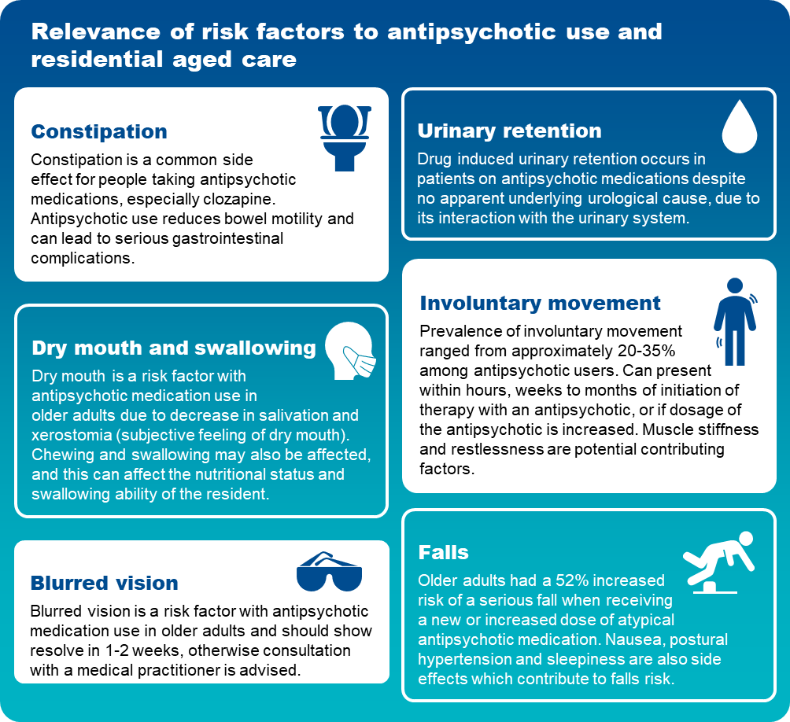

Prevention and management of antipsychotic use, including prevention checklist
Antipsychotic prescribing increases markedly once a person is admitted into aged care homes, and there is evidence that up to 42 per cent of residents in aged care homes are regularly prescribed an antipsychotic^{.109F 110F}
Figure 31 below explores strategies for managing antipsychotics use.
FIGURE 31: PREVENTION STRATEGIES FOR ANTIPSYCHOTICS USE
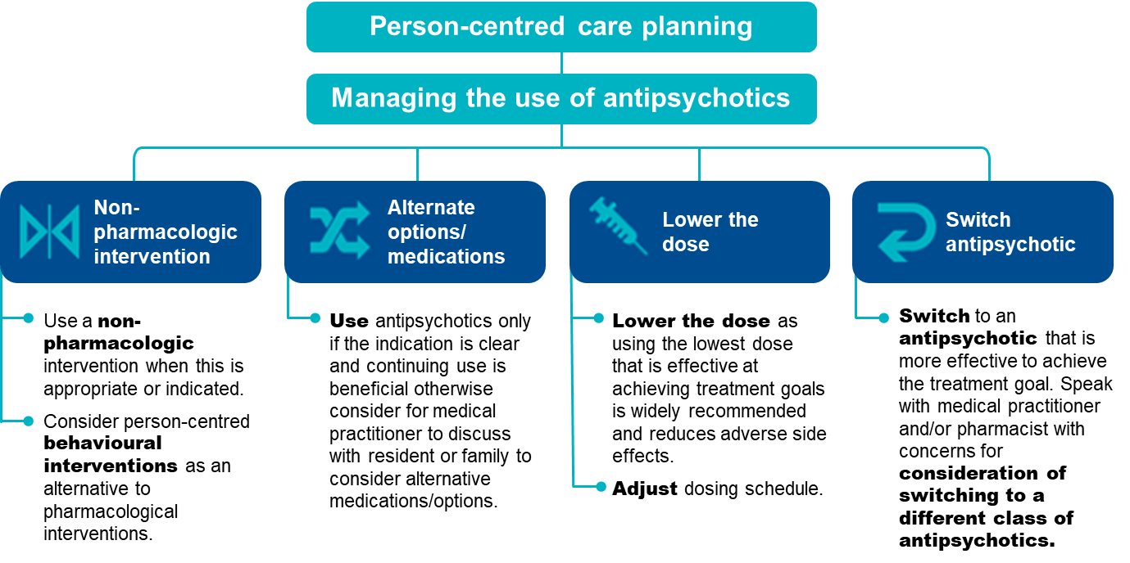
Complications from antipsychotics are treatment dependent. Complications can arise from the choice of antipsychotic, the dose used, the duration of exposure, the other medications the person is taking and the particular sensitivity of the individual to complications.
If the intended use of antipsychotics is for chemical restraint, providers are required to have a behaviour support plan in place. Section 4 of this Manual provides further information about restrictive practices.
The checklist overleaf will help to assess residents who are at risk of antipsychotic use and identify prevention strategies to reduce the risk of antipsychotic use from occurring:
FIGURE 32: CHECKLIST FOR THE PREVENTION OF ANTIPSYCHOTIC USE
Checklist for the prevention of antipsychotic use
Complete regular reviews of residential medication charts
- Identify residents who are taking antipsychotic medications.
- Regular review of resident’s medication charts and/or administration records by registered nurses and enrolled nurses as they administer medications. Escalate to pharmacist or medical practitioner where appropriate.
- Ensure residents’ medication charts and/or administration records are reviewed upon returning from the hospital as there could be significant medication changes.
Document, monitor and escalate instances of antipsychotic use
- Document/record concerns of antipsychotic use on a resident’s care plan and escalate to a pharmacist or medical practitioner. The outcome of this escalation should also be documented and planned for in the resident’s care plan.
- Monitor the resident closely for changes in behaviour. A carer or enrolled nurse should discuss concerns of antipsychotic use with the registered nurse so the escalation process to the pharmacist or medical practitioner is initiated for review.
Implement prevention strategies
Educate staff and promote awareness about antipsychotic use
- Remain aware of the risks associated with antipsychotic use. Programs supporting awareness and understanding of antipsychotic use are effective in promoting safer medication regimens as staff play an active role in monitoring residents’ residential medication charts.
Encourage Residential Medication Management Reviews (refer to “Example tools, guidance and resources to support continuous quality improvement”)
- Encourage a Residential Medication Management Review (RMMR) for residents who are at risk with antipsychotic use.
- Collaborate with medical practitioners and pharmacists to perform a RMMR for a resident. These medication management services are subsidised by Medicare.
Encourage shared decision making with residents
- Discuss antipsychotic needs with the resident to understand their perspective and support their participation in making decisions (where possible).
Escalate concerns of antipsychotic use for consideration of deprescribing or change in medication (where appropriate)
- Escalate concerns of antipsychotic use to a pharmacist or medical practitioner. The purpose of this is to assess if the antipsychotic medication is no longer beneficial to the resident, reduce complexity in their medication regime and prevent consequences of a high risk medication.
- Deprescribing and change in medications can only be actioned by a medical practitioner or nurse practitioner and must be reflected in the resident’s medication chart.
Undertake frequent reassessment of residential medication charts
- Re-assess and review regularly resident’s medication charts as regimen can change regularly, especially as residents age and develop multimorbidity.

Quality improvement for antipsychotic use
Quality improvement can help providers increase the quality of care for residents at risk of antipsychotic use. Quality improvement activities should be ongoing and part of business-as-usual for providers.
The QI Program will help prompt when a specific quality improvement activity should be undertaken. It is important to review QI Program data reports through GPMS and compare against national averages and other services to understand where quality improvement activities should be focussed.
The Plan-Do-Check-Act tool (section 2.3) is a useful tool to plan, deliver and monitor quality improvement activities focused on preventing and reducing antipsychotic use.

Example tools, guidance and resources to support
continuous quality improvement
- Deprescribing guide for antipsychotics for treatment of behavioural and psychological symptoms of dementia — a guide providing information to support deprescribing of antipsychotics — Northern Sydney Local Health District, New South Wales Government
- Antipsychotic Tracking Tool — a tool to monitor antipsychotic usage in aged care settings — Dementia Training Australia
- Six steps for safe prescribing antipsychotics and benzodiazepines in residential aged care — poster providing guidance on managing behaviours and psychological symptoms of dementia — Aged care Quality and Safety Commission
- Australian Medicines Handbook — online resource providing information on current medications used in Australia
- Monthly Index of Medical Specialties (MIMS) Australia — online resource providing Australian medications information
- Severe Behaviour Response Team (SBRT) — 24/7 contact with a Dementia Consultant on 1800 699 799 to access SBRT service — Dementia Support Australia
- Dementia Behaviour Management Advisory Service (DBMAS) — 24/7 contact with a Dementia Consultant on 1800 699 799 for advice or to make a referral — Dementia Support Australia
- Downloadable behaviour resources — a variety of resources to both inform and assist healthcare professionals and family members who are supporting a person living with dementia — Dementia Support Australia
Some tools, guidance and resources may be updated over time; it is important to ensure you are looking at the most recent version.

Activities of daily living

Activities of daily living (ADLs) can be used to measure people’s ability to move and care for themselves. ADLs are essential, routine tasks such as personal hygiene, dressing, going to the toilet and eating. ADLs are important to maintain independence, health status and quality of life. Screening, monitoring and prevention activities may reduce decline in ADLs and improve independence.

Overview of activities of daily living
Figure 33 below provides an overview of the activities of daily living in aged care homes. The data and references have been reviewed March 2025.
FIGURE 33: ACTIVITIES OF DAILY LIVING IN AGED CARE HOMES111F 112F
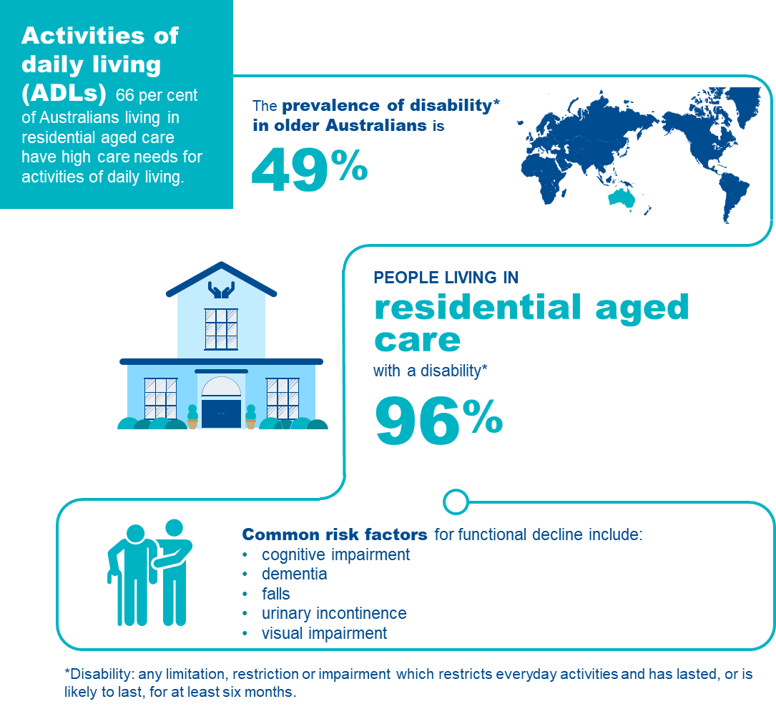

Activities of daily living in aged care homes
ADLs are self-care activities such as managing grooming and personal hygiene, dressing, toileting and eating. ADLs are important to maintain independence, health status and quality of life. Aged care services can assist residents to actively participate in these activities to improve or maintain function or slow the rate of decline.
ADLs are categorised under two sub-groups:^{113F}

Basic
- ambulating (walking/moving around)
- eating
- dressing
- personal hygiene (oral, hair & skin care)
- continence
- toileting

Instrumental
- transport
- shopping
- managing finances
- meal preparation
- house cleaning
- home maintenance
- communication
- managing medications.
A number of conditions (e.g. dementia and Parkinson’s disease) experienced by residents can cause a decline in their ability to perform ADLs.^{114F} However, a decline in a resident’s function should not be considered inevitable. It is important to appreciate that poor quality care can accelerate the rate of decline, and that a good program of care will help to maintain or potentially improve independent function.^{115F} 117
Basic ADLs are most relevant to aged care homes, as residents in aged care homes generally do not maintain responsibility for many of the instrumental ADLs such as grocery shopping, meal preparation or house cleaning. Residents should be encouraged to contribute to these activities, even when they are only partially able to do so.
The focus of this quality indicator is on basic ADLs.
Details of collection and reporting requirements for the activities of daily living quality indicator can be found in Part A.

Causes of decline in activities of daily living
ADL decline is usually associated with illness that may occur suddenly (e.g. stroke or fractures) or progressively (e.g. dementia or Parkinson’s disease).^{118F} While many of these illnesses are associated with gradual loss of ADL function, the rate of change may be prevented or slowed by good care and therapy.^{119F} An important goal of care should be to improve function, to stabilise or to slow decline.
Where there has been a sudden decline in ADL function, due to an acute illness or injury, residents should be supported to recover as much as possible. This might involve a rehabilitation or restorative care program, within the aged care home, or in some cases, in a rehabilitation facility.

Risk factors for decline in activities of daily living
The majority of residents in aged care homes have limitations in their ADL function.^{120F} Many have conditions associated with progressive decline. Some experience incidents that lead to abrupt loss of ADL function.
However, decline in ADLs is not inevitable, and the rate of decline can be influenced by good care.^{121F} By reducing or slowing decline, residents are likely to enjoy a greater proportion of their lives as ‘good days’. Knowing the risk factors will help identify residents who are most likely to experience decline in ADLs. Risk factors associated with decline in ADLs in aged care homes are explored in Figure 34.
FIGURE 34: RISK FACTORS FOR DECLINE IN ACTIVITIES OF DAILY LIVING122F 123F
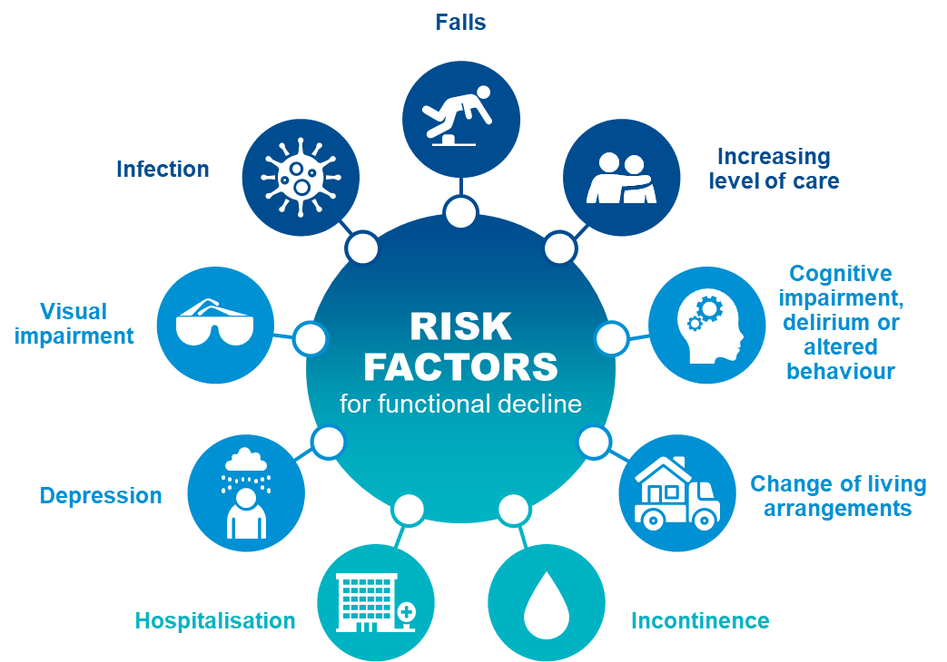

Adverse clinical events and activities of daily living
ADL decline has a complex impact on wellbeing and is associated with a loss of independence. This may result in increased reliance on people or technology to maintain quality of life, wellbeing, and safety. Early detection of decline in ADLs leads to improved outcomes, slowing, stopping, or reversing progression, and avoiding consequences such as:
- loss of mobility
- confusion and discomfort with change of living environments
- increasing level of care needs
- increased hospitalisation
- depression, withdrawal, and social isolation
- delirium
- malnutrition
- incontinence.

Prevention and management of decline in activities of daily living
ADL decline can evolve in two ways:
- Gradual loss: independence is lost progressively, usually due to one or several degenerative disorders (e.g. dementia or osteoarthritis)
- Sudden loss: a major health event results in a loss of ADL function often with only partial recovery (e.g. stroke, falls or pneumonia).
Awareness of risk factors and some simple steps can slow ADL decline and improve quality of life. ADL performance should be closely monitored and recorded. Review should occur regularly each time the person’s care plan is reviewed and when their health status changes, e.g. following a serious illness or injury. Any change in ADL performance should prompt consideration of strategies to slow decline and/or promote recovery. In the case of sudden ADL decline, there is a need for careful assessment and prescription of rehabilitative strategies for recovery.^{124F}
Specific interventions targeted at encouraging mobility and promoting independence can improve outcomes, including:
- Physical rehabilitation and reablement:^{125F} Rehabilitation can restore ADL function and minimise adverse events. Interventions should be designed according to current best-practice for maximum sustainability, cost-effectiveness and suitability. Rehabilitation is critically important for residents who sustain an injury or experience a major medical illness.
- Specialist care:^{126F} Consultation with geriatricians or other external specialists will inform ongoing care, preventive programs and recovery programs.
- Early identification and assessment:^{127F} Careful consideration of the likely trajectory of function, and the extent to which this can be influenced requires a multidisciplinary perspective that should be offered at entry to aged care homes and periodically with individual care plan review. These assessments can be enhanced by the use of formal assessment tools to help define, measure, and monitor ADL function, which may assist in outcome prediction. Examples include frailty assessment, cognitive assessment, nutritional evaluation, mobility assessment, continence assessment and functional activity assessment.
- Targeted intervention and care planning:^{128F} Proactive prevention of ADL decline may improve cost-effectiveness of care provision and improve independence. Targeting interventions to assessment findings and using collaborative care planning can improve care appropriateness and care outcomes. Examples include prescription of assistive devices, physical activity, falls prevention strategies, toileting programs and nutritional interventions.
- An enabling environment:^{129F} ^{130F}A service level program should be in place that is designed to promote and preserve ADL independence. This might include group approaches (e.g. exercise classes) or individual level approaches (e.g. ensuring that residents are supported to retain mobility or dress themselves as much as possible).
- Workforce planning and professional development:^{131F} Education and training programs designed for carers and staff can significantly improve resident function. Examples include training in reablement and ADL preservation, depression and apathy management, manual handling, and continence assessment, management and care. Programs for residents run by trained staff can improve ADLs with a lasting effect (changes sustained over six months).
Figure 35 outlines important aspects of care that can improve or maintain function.
FIGURE 35: ACTIVITIES OF DAILY LIVING IMPROVEMENT FRAMEWORK132F 133F 134F 135F 136F 137F 138F
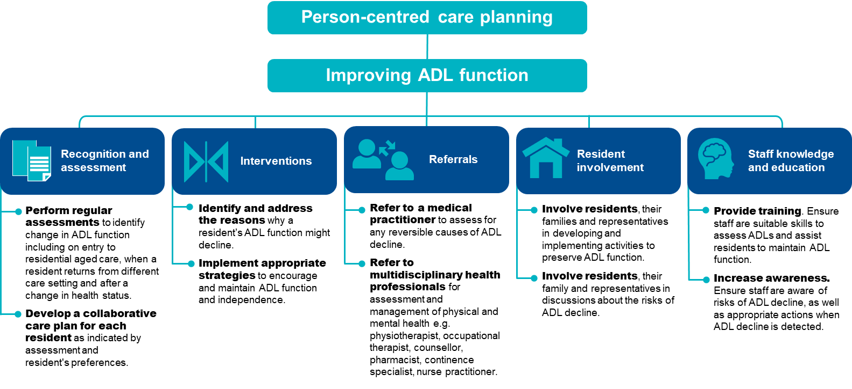

The checklist below will help assess residents who are at risk of ADL decline and identify support and prevention strategies to reduce ADL decline and mitigate consequences.
FIGURE 36: CHECKLIST FOR THE PREVENTION OF ACTIVITIES OF DAILY LIVING DECLINE
Checklist for the prevention of activities of daily living decline
Undertake ADL assessments regularly
- Conduct ADL assessments at least quarterly, or more frequently in response to changes, including:
- on entry to an aged care home
- when a resident returns from different care setting
- after a change in health status.
- Identify any recent changes in ADL function.
- Identify and assess any risk factors for future ADL decline, such as:
- cognition
- nutrition
- mobility
- continence.
Document findings in a care plan
- Document the findings from the resident’s ADL assessment in their care plan, including any changes.
- Identify and document suitable prevention strategies, including their proposed frequency and timing.
- Undertake collaborative care planning, ensuring alignment with the resident’s preferences for management.
- Document goals for improving or maintaining ADL function.
- Monitor for risk factors of ADL decline.
Implement appropriate support strategies that prevent ADL decline
- Undertake collaborative care planning.
- Promote autonomy in routine day to day activities.
- Provide therapy and deliver interventions where required, for example:
- occupational therapy, physiotherapy, nutrition, continence professional and dietetics
- exercise and physical activity
- prescription of assistive devices
- medication management.
- Implement restorative interventions following acute illness or deterioration.
Ongoing monitoring between ADL assessments
- Monitor ADL function.
- Monitor risk factors.
- Assess appropriateness of current strategies to maintain ADLs and quality of life.

Quality improvement for activities of daily living
Quality improvement can help providers increase quality of care for residents experiencing ADL decline. Quality improvement activities should be ongoing and part of business-as-usual for providers.
The QI Program will help prompt when a specific quality improvement activity should be undertaken. It is important to review the QI Program data reports through GPMS and compare against national averages and other services to understand where quality improvement activities should be focused.
The Plan-Do-Check-Act tool (section 2.3) is a useful tool to plan, deliver and monitor quality improvement activities focused on preserving ADL function.

Example tools, guidance and resources to support continuous quality improvement
- Barthel Index — an ordinal scale used to measure performance in activities of daily living, and the selected assessment tool that must be used in the QI Program — available in Part A: Appendix A
- AN-ACC Reference Manual — provides additional ADL related assessment tools including the Resource Utilisation Groups — Activities of Daily Living (RUG-ADL), Rockwood Clinical Frailty Scale, Australia-modified Karnofsky Performance Status (AKPS), De Morton Mobility Index (DEMMI) and the Australian Functional Measure, available online in the ANACC Reference Manual on the Australian Department of Health, Disability and Ageing website
- About rehabilitation, reablement and restorative care — overview of terminology and references from Aged Care Research & Industry Innovation Australia
- Services and supports for daily living: Standard 4 — provides guidance and resources relating to services and supports for daily living — Aged Care Quality and Safety Commission
Some tools, guidance and resources may be updated over time; it is important to ensure you are looking at the most recent version.

Incontinence care
Incontinence is the loss of bladder and bowel control, which can impact independence, health and quality of life. Incontinence Associated Dermatitis (IAD) is an irritant contact dermatitis associated with incontinence. Aged care providers can ensure access to treatment and care to support continence and deliver appropriate incontinence care.

Overview of incontinence care
Figure 37 below provides an overview of incontinence in aged care homes. The data and references have been reviewed March 2025.
FIGURE 37: INCONTINENCE IN AGED CARE HOMES139F 140F
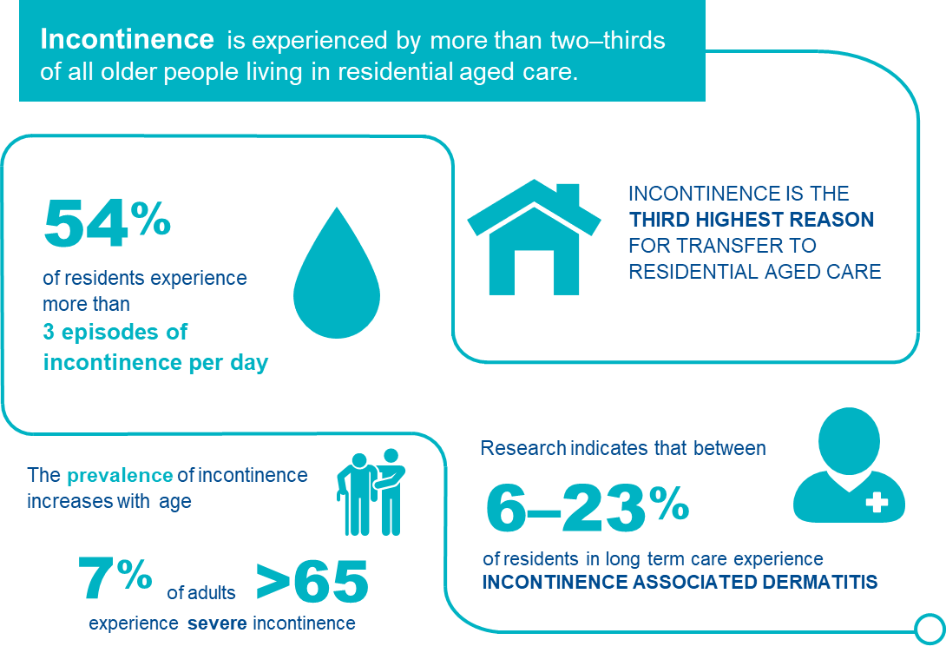

Understanding incontinence in aged care homes
For the purposes of the QI Program, incontinence is any accidental or involuntary loss of urine from the bladder (urinary incontinence) or faeces from the bowel (faecal incontinence). Incontinence can range in severity from a small leak to complete loss of bladder or bowel control. Under the QI Program, a resident has incontinence if urinary incontinence occurs more than once a day or faecal incontinence more than once a week, or if they require urinary catheters for passing urine.
IAD is a type of irritant contact dermatitis arising primarily from inadequate incontinence management.
Aged care providers can ensure people have access to the right treatments and support to assist bladder and bowel control and reduce risk factors for the development of IAD.
Incontinence is the third highest reason for transfer to aged care homes.^{141F} Inappropriate management of incontinence consistently ranks amongst the top ten consumer complaints made to the Aged Care Quality and Safety Commission (ACQSC), a clear indication that incontinence management in aged care homes can be improved.^{142F}
Prevalence of incontinence in Australian aged care homes is estimated between 75 and 81 per cent.^{143F} In 2009, 67 per cent of residents in aged care homes required care for urinary incontinence, and 55 per cent were reported to require care for faecal incontinence.^{144F} Prevalence of IAD in Australian aged care homes is currently unknown, however is likely to be similar to pressure injuries.^{145F} A review of the literature on prevalence estimates of IAD in residential aged care settings varies, but has been reported between 6 and 23 per cent.^{146F} The frequency of IAD with good continence management and skin care can be reduced.
Reliable quality indicators that measure the outcomes of incontinence care are not available. However, quality of incontinence care may be measured by the prevalence of poor outcomes. IAD can be reliably measured and is suitable as an indirect measure of incontinence care quality.
Factors that drive the frequency of IAD also affect the rate of pressure injury — incontinence management and skin care.
Details of collection and reporting requirements for the incontinence care quality indicator can be found in Part A.

Causes of incontinence
There are a wide variety of causes of incontinence, including general health, neurological conditions, and muscular dysfunction. For many residents, the cause of their incontinence is multi-dimensional.
Commonly associated conditions are:^{147F}
- pelvic floor weakness/dysfunction/damage
- rectal dysfunction/damage
- pregnancy and childbirth
- menopause
- prostate enlargement
- urinary or faecal obstruction
- neurological disorders
- pain
- cognitive impairment
- mobility and functional impairment.

Risk factors for incontinence
There are many risk factors for incontinence in older adults, including social, physical, psychological, emotional, and environmental (the care facility), as described in Figure 38.^{148F}
FIGURE 38: RISK FACTORS FOR INCONTINENCE
SOCIAL CAUSES | PHYSICAL RISK FACTORS | COGNITIVE, PSYCHOLOGICAL AND EMOTIONAL RISK FACTORS | CARE SETTING RISK FACTORS
Cultural factors  Around condition, sensitivity seeking help, support from carers of a different gender, or deficient cultural safety | Physiological changes of ageing  Comorbidities  Acute illness, cancer, pain, constipation  Medication related  Polypharmacy, diuretic medicines, analgesics  Functional issues  Dexterity, mobility impairment, vision  Communication issues  Deafness, aphasia | Mood disorders  Anxiety, depression  Cognitive impairment  Alzheimer’s disease, Lewy body dementia, vascular dementia, stroke | Staff  Limited staff to assist with toileting, limited skills to identify and respond to incontinence, limited access to specialist continence care, deficient cultural safety  Continence aids  Limited choices or access

Adverse clinical events associated with incontinence
Incontinence exposes residents to complications that can have significant impact on health and wellbeing, including:^{149F}
- decreased quality of life
- social withdrawal and depression
- increased falls risk
- functional decline from disuse atrophy
- skin and tissue breakdown (e.g. pressure injury and incontinence associated dermatitis)
- urinary tract infections.

Prevention and management of incontinence
Residents should be assessed for incontinence regularly, including risk factors and effectiveness of current incontinence care. These assessments should be carried out by trained staff as part of the resident’s routine personal care.
Quality incontinence care is achieved through a systems approach with consideration of service level factors and a resident’s individual circumstances. A range of active and passive continence management strategies should be discussed in consultation with residents to ensure a person-centric management strategy is implemented that meets resident needs without compromising physical, emotional or social wellbeing. Examples of incontinence care interventions include:^{150F}
- Active treatment
- lifestyle interventions (e.g. fluid and dietary modifications)
- physical therapies (e.g. pelvic floor exercises)
- behavioural therapies (e.g. bladder training, toileting regimes, double voiding)
- assistive devices (e.g. commodes, female and male urinals, vaginal pessaries, electrical stimulators, biofeedback devices)
- medication (e.g. those that regulate stool form, hormones, overactive bladder)
- surgical or interventional procedures.
- Containment
- absorbent continence aids (e.g. pads and absorbent underwear)
- catheters (e.g. supra-pubic catheter, indwelling urethral catheter and intermittent catheter)
- external urinary drainage (e.g. condom catheter)
- bed or surface protection.
Figure 39 outlines important aspects of high quality incontinence care in aged care homes.

FIGURE 39: INCONTINENCE MANAGEMENT151F 152F 153F 154F 155F 156F 157F 158F
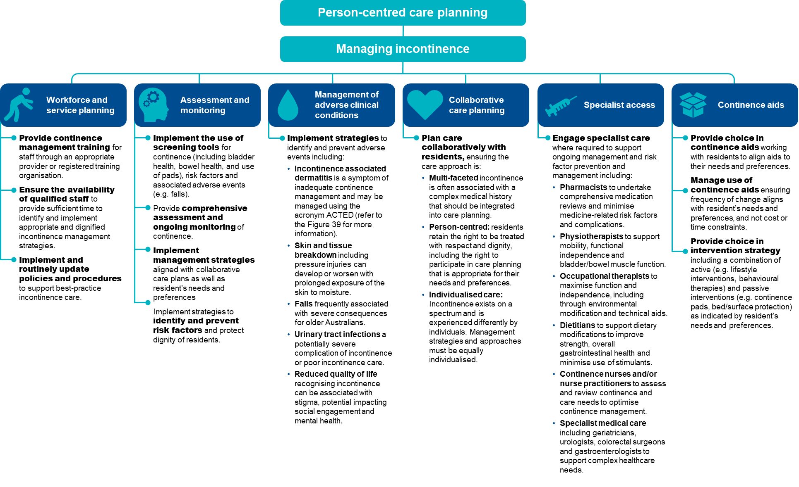
FIGURE 40: INCONTINENCE ASSOCIATED DERMATITIS MANAGEMENT USING THE ACTED FRAMEWORK159F
Incontinence associated dermatitis (IAD) is defined as a specific type of irritant contact dermatitis characterised by erythema and oedema of the peri-anal or genital skin. In some cases, IAD is accompanied by bullae, erosion or secondary cutaneous infection. IAD is often associated with poor quality incontinence care, often as a result of prolonged exposure to soiled pads. For the purposes of the QI Program, it must be evaluated using the Ghent Global IAD Categorisation Tool. IAD may be managed using the ACTED framework.
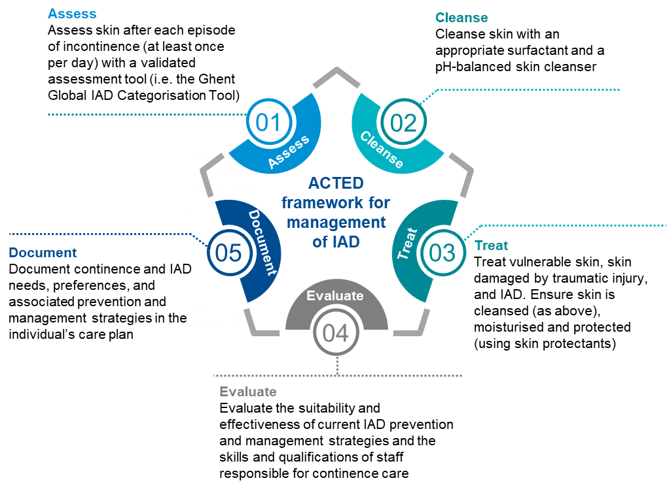

The checklist below will help assess residents who are at risk of incontinence and identify support and prevention strategies.
FIGURE 41: CHECKLIST FOR THE MANAGEMENT OF INCONTINENCE AND PREVENTION OF IAD
Checklist for the management of incontinence and prevention of IAD

Undertake a baseline assessment
- Assess incontinence using a suitable assessment tool.
- Identify any changes in continence and note the specific area of change.
- Identify any risk factors for incontinence (e.g. comorbidities, medications, mobility issues).
Undertake ongoing screening and comprehensive assessment
- Screen residents regularly and provide comprehensive assessment in response to changes, including:
- when first admitted to an aged care home (full assessment)
- at pad change or when emptying bladder/bowels (assess skin integrity, assess frequency of incontinence e.g. daily, greater than 3 times)
- after a change in health status
- on return from a different care setting (e.g. following hospital admission or homestay).
Document findings in care record and undertake collaborative care planning
- Document resident’s assessment findings in their care record (e.g. changes in continence, mobility, cognition, other adverse clinical events).
- Document risk factors for incontinence.
- Undertake collaborative care planning, ensuring alignment with resident’s needs and preferences for management.
- Identify and document suitable prevention strategies.
Implement appropriate multi-faceted strategies aligned with resident’s need and preferences
- Implement a continence management strategy including toileting regime/plan
- Select suitable continence aids and management strategy, considering
- skin integrity
- frequency of changes
- severity and type of incontinence
- level of independence, mobility and dexterity
- resident’s abilities and preferences.
- Engage appropriate clinical care:
- pharmacist
- physiotherapist
- occupational therapist
- dietitian
- continence nurse
- geriatrician
- urologist/colorectal surgeon.
Recognise and manage adverse clinical events associated with incontinence
- Skin and tissue breakdown (e.g. pressure injury and incontinence associated dermatitis).
- Falls.
- Activity of daily living decline.
- Infection.
- Social withdrawal.
- Reduced quality of life.

Quality improvement for incontinence
Quality improvement can help providers increase quality of care for residents experiencing incontinence and/or IAD. Quality improvement activities should be ongoing and part of business-as-usual for providers. The QI Program will help prompt when a specific quality improvement activity should be undertaken. It is important to review the QI Program data reports through GPMS and compare against national averages and other services to understand where quality improvement activities should be focused.
The Plan-Do-Check-Act tool (section 2.3) is a useful tool to plan, deliver and monitor quality improvement activities focused on managing incontinence.

Example tools, guidance and resources to support continuous quality improvement
- Ghent Global IAD Categorisation Tool — provides standardised approach to IAD recognition, management, documentation and is the selected IAD assessment tool that must be used in the QI Program — Ghent University — available in Part A: Appendix B
- Best Practice Model of Continence Care for Residential Aged Care (previously Continence SMART Care) — an evidence-based, person centred, clinically informed practice model of continence care for aged care — National Aging Research Institute
- Incontinence-associated dermatitis: Moving prevention forward: Addressing evidence gaps for best practice — practical guidance on how to assess, prevent and manage IAD based on available evidence and expert opinion — Wounds International
- Incontinence Associated Dermatitis Best Practice Principles — best practice principles providing information about IAD risk factors, recognition, assessment, prevention and management — New South Wales Health Clinical Excellence Commission
- Incontinence in Australia — report providing background information and prevalence of incontinence in Australia, as well as hospital and residential aged care admissions relating to continence — Australian Institute of Health and Welfare
- Literature Review of Incontinence Associated Dermatitis — journal article discussing best practice strategies for managing IAD — Advances in Skin & Wound Care
- National Continence Helpline — a free confidential hotline providing information, advice and support from continence nurses — call 1800 33 00 66 Monday to Friday 8am-8pm AEST/AEDT— Continence Health Australia
- Continence Resources for Aged Care — free resources to help guide best practice continence assessment and management — Continence Health Australia
- Continence Support Now — a free pocket guide for disability and aged care workers providing bladder and bowel support — Continence Foundation of Australia
- Continence Learning — courses and information to support learning in relation to continence — Continence Health Australia
Some tools, guidance and resources may be updated over time; it is important to ensure you are looking at the most recent version.

Hospitalisation
Many emergency department presentations or admissions to hospital are avoidable if residents have timely access to appropriate healthcare services. Excessive transfers of residents to the emergency department may indicate poor care quality or access.

Overview of hospitalisation
Residents are often transferred to a hospital to receive care that may not be available in the aged care home. Some of these transfers are considered avoidable, either through prevention of the illness that results in the need for transfer, or by management of the problem locally at the aged care home. The data and references have been updated October 2025.
FIGURE 42: HOSPITALISATION OF AGED CARE RESIDENTS160F 161F 162F 163F
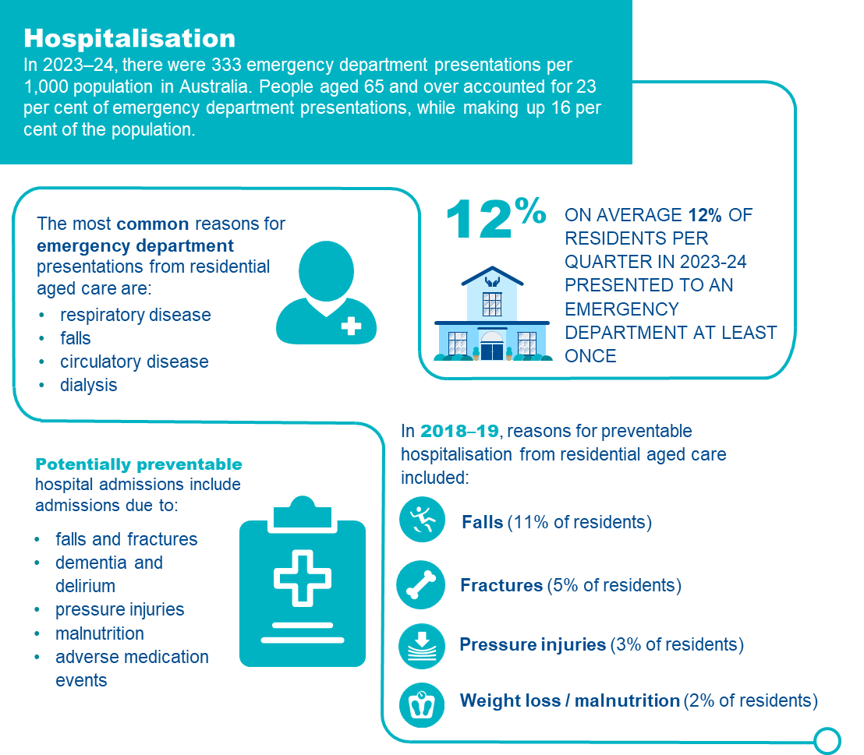

Hospitalisation from aged care homes
Many emergency department presentations and admissions to hospital are avoidable if residents have timely access to appropriate care. Excessive transfers to hospital may indicate poor care quality and access. However, aged care services should never avoid or prevent hospital transfer or emergency department presentation if it is required.^{164F}
To support quality of care, it is important to identify and monitor emergency department presentations that could be avoided with appropriate care. There are two circumstances that give rise to inappropriate hospitalisations:^{165F}
- Inadequate expertise and/or resources at the aged care home: Many illnesses or incidents are best managed at the aged care home. This includes conditions that are relatively minor, where transfer to hospital is inconsistent with the resident’s preferences, or where hospital care offers limited value, or
- Avoidable illnesses or injuries: This occurs when the condition results from inadequate provision of care or services (e.g. falls resulting in injury, poorly maintained vaccination program, or development of a pressure injury).
Details of collection and reporting requirements for the hospitalisation quality indicator can be found in QI Program Manual Part A.

Causes of hospitalisation
Hospitalisation is necessary when:^{166F 167F}
- there is a requirement for investigation or treatment available exclusively at the hospital
- the appropriate type and/or standard of care is not available at the aged care home
- hospitalisation is the preference of the resident or surrogate decision makers and is appropriate.
Common causes of emergency department presentation or unplanned hospitalisation from aged care are homes:^{168F}
- cognitive decline
- dementia and delirium
- activity of daily living decline
- falls
- fractures
- reduced mobility
- malnutrition
- medication mismanagement
- inadequate ambulatory care
- inadequate assistance with activities of daily living
- chronic conditions that are not adequately monitored or managed.

Risk factors for hospitalisation
Individual risk factors
Rates of hospitalisation are influenced by the characteristics of the resident, the aged care home, access to and provision of timely healthcare services, and the broader health system.^{169F}
In Australia, the strongest predictors of unplanned hospitalisation or emergency department presentation from residential aged care at the individual resident level are:^{170F}
- Resident needs and attributes — being male, higher age, history of delirium, higher activity of daily living needs, complex behaviour and complex care needs
- Healthcare support — number and recency of healthcare use (including hospital and general practitioner attendance)
- Medication — use of a high sedative load or polypharmacy.
Service risk factors
Risk factors at the organisational level include poor access to specialist medical and nursing expertise, poor contingency planning for minor acute illnesses and lack of ongoing coordination with local specialist services and hospitals.
Of these risk factors, several may be measured, monitored and/or influenced by services, at both the organisational and individual level, and these should be the focus of risk mitigation.

Adverse clinical events and hospitalisation
Hospitalisation exposes residents to hospital-acquired complications.^{171F} These can have significant impacts on the resident, and their subsequent independence and care requirements. Common hospital acquired complications include:
- infection
- malnutrition
- cardiac complications
- delirium
- depression
- deconditioning
- falls
- reduced independence and mobility.

Prevention and management of hospitalisation
Emergency department presentations and admissions to hospital can be reduced with a systematic, person-centred approach. This includes focusing on access to resources to provide appropriate care such as skilled staff; primary, specialist and preventive healthcare; and practices to identify, manage, monitor and escalate care needs. Care planning and management should align with resident preferences, including for end-of-life care.
The rates of avoidable hospitalisations can be minimised by strategies at two levels:
- organisation level to ensure that expertise, resources and systems are available to manage minor conditions within the facility.
- care delivery level to ensure that illnesses and incidents that require hospitalisation are minimised.
Strategies to minimise avoidable hospitalisations at a care delivery level may include:
- Early identification of risk factors: Unmet healthcare needs are commonly cited as the underlying factor for emergency department presentations. Identifying health and care needs and providing interventions before conditions deteriorate can reduce both cost and burden of care.^{172F} This is supported by understanding which residents have the strongest predictors for unplanned hospitalisation or emergency department presentation. For example, this could include residents that are older age, have a history of delirium, higher activity of daily living needs, have recently required healthcare and who use high sedative load or polypharmacy.
- Monitoring resident progress: Early identification of risk factors and changes in health status guides decisions about further monitoring requirements, facilitates communication with primary care providers, identifies appropriate hospital transfer requirements and informs management strategies to maintain quality care.^{173F}
- Care provision by appropriately skilled providers: Access to skilled carers, nurses and other healthcare providers with appropriate education and training, combined with skilled staff to provide appropriate interventions, is associated with lower hospitalisation rates.^{174F 175F}
- Using multidisciplinary teams coordinated by aged care home staff: Access to primary and specialist care networks to provide care specific to individual care needs (communication channels, telehealth, transport to outpatient appointments) can prevent the requirement for hospitalisation.^{176F} Trained staff provide guidance to embed changes in daily practices and improve care outcomes.
- Support with appropriate resources: Including appropriately integrated communication systems such as:
- Health information technology improves communication and outcomes, offering access to care staff that facilitate effective early identification and continued monitoring of the resident’s health condition, leading to improvements in safety and reduced hospitalisation.177F 178F
- In-reach and outreach specialist care teams to optimise access to care and care integration.
- Telehealth provides expanded access to care and addresses coverage gaps, particularly in rural/remote areas, reducing staff burnout and costs, providing timely access to specialist input and improving outcomes.179F 180F 181F
- Collaborative care planning, including advance care planning: Completion of advanced care planning with residents, their families and carers is associated with reduced hospitalisation and care provision that aligns with resident preferences.^{182F} ^{183F} ^{184F} ^{185F}
FIGURE 43: PREVENTING AVOIDABLE HOSPITALISATION
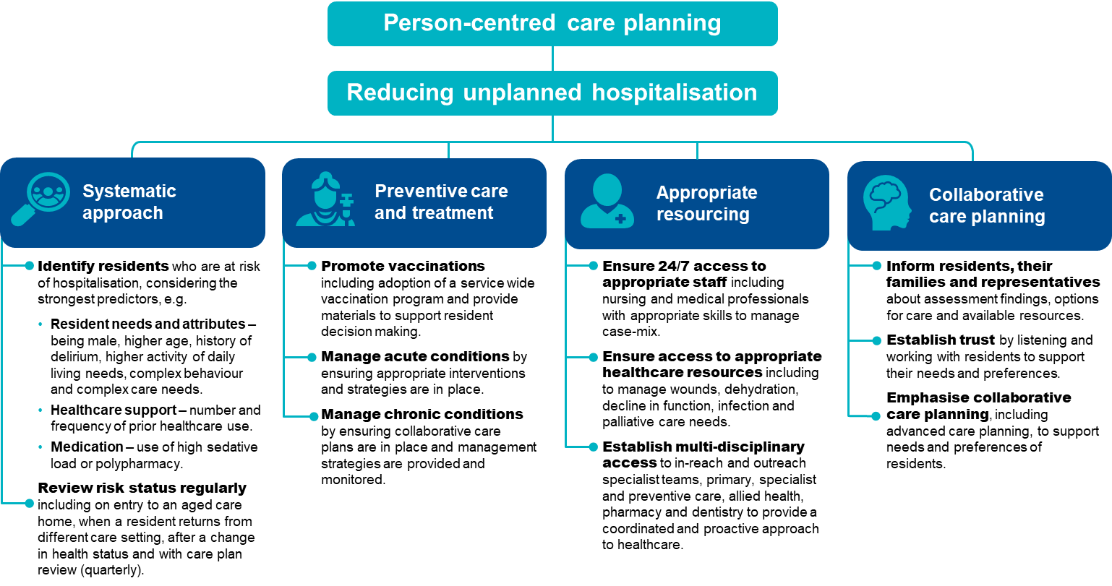

The checklist below will help assess residents who are at risk of hospitalisation and identify support and prevention strategies to reduce the risk of avoidable hospitalisation.
FIGURE 44: CHECKLIST FOR THE PREVENTION OF AVOIDABLE HOSPITALISATION
Checklist for the prevention of avoidable hospitalisation
Use a systems approach
- Routinely check and monitor risk factors for hospitalisation.
- Ensure appropriate management strategies are in place to optimise health and wellbeing.
- Provide collaborative multidisciplinary care.
- Use integrated health information technology systems for improved communication and information sharing.
Deliver preventive care and treatment
- Coordinate timely vaccination.
- Ensure preventive measures are in place to avoid acute episodes.
- Provide evidence-based care for chronic health conditions.
- Undertake collaborative care planning, ensuring alignment with the resident’s needs and preferences for management.
Provide appropriate resourcing
- Enable access to skilled staff at appropriate times.
- Ensure appropriate equipment and resources are available.
- Establish suitable programs to access hospital in-reach/outreach services.
- Develop and use collaborative networks using local primary healthcare providers.
- Provide access to relevant specialist care, including via outpatient services and telehealth.
Undertake collaborative care planning
- Document all relevant information clearly in an individual care plan, providing clarity for all care providers and decision makers.
- Provide care and documented interventions as per care plan to meet care needs.
- Regularly review (quarterly or when health status changes) care plan with the resident, their family or representative.
- Identify and document service and the resident’s expectations.

Quality improvement for hospitalisation
Quality improvement can help providers increase the quality of care for residents who are at elevated risk of avoidable hospitalisation. Quality improvement activities should be ongoing and part of business-as-usual activities for providers.
The QI Program will help prompt when a specific quality improvement activity should be undertaken. It is important to review the QI Program data reports through GPMS and compare against national averages and other services to understand where quality improvement activities should be focused.
The Plan-Do-Check-Act tool (section 2.3) is a useful tool to plan, deliver and monitor quality improvement activities focused on reducing avoidable hospital admissions.

Example tools, guidance and resources to support continuous quality improvement
- Aged Care Emergency (ACE) Manual provides guidance in the care of acutely unwell residents.
- Engage with your Primary Health Network for support to develop afterhours care plans
- Agency for Healthcare Research and Quality — online training modules for improving patient safety in long term care facilities (USA based)
- Advance care planning resources — planning documents, training and education resources are available at Advanced Care Planning Australia or End of Life Directions for Aged Care
- Study identifies how to minimise resident infection-related hospitalisations — news article describing Monash University study on prevention of infection related hospitalisations — Australian Ageing Agenda
- A guide to the potentially preventable hospitalisations indicator in Australia — guide providing information on potentially preventable hospital admissions — Australian Commission on Safety and Quality in Health Care
- Potentially preventable hospitalisations in Australia by small geographic areas, 2017-18 to 2022-23 — report providing information and data on hospital admissions and differences between demographic groups — Australian Institute of Health and Welfare
Some tools, guidance and resources may be updated over time; it is important to ensure you are looking at the most recent version.

Workforce
The aged care workforce is critical to providing quality services to meet the needs of older people. There are well established links between the capacity of aged care staff and the quality of care provided. Many residents, their families and carers have reported that continuity of care is the critical element for resident wellbeing in aged care homes.

Overview of workforce
Australian-government funded aged care homes are expected to have ‘a workforce that is sufficient, and is skilled and qualified, to provide safe, respectful and quality care and services’.^{186F}
The Royal Commission into Aged care Quality and Safety highlighted the significance of workforce continuity and stability to deliver high-quality, person-centred care.^{187F}
The aged care workforce is a vast network of people who work together to deliver a continuum of care to older people.^{188F}
In 2023, there were over 217,000 direct care workers or 111,000 full time equivalent positions employed in aged care homes in Australia.
FIGURE 45: WORKFORCE IN AGED CARE HOMES189F 190F
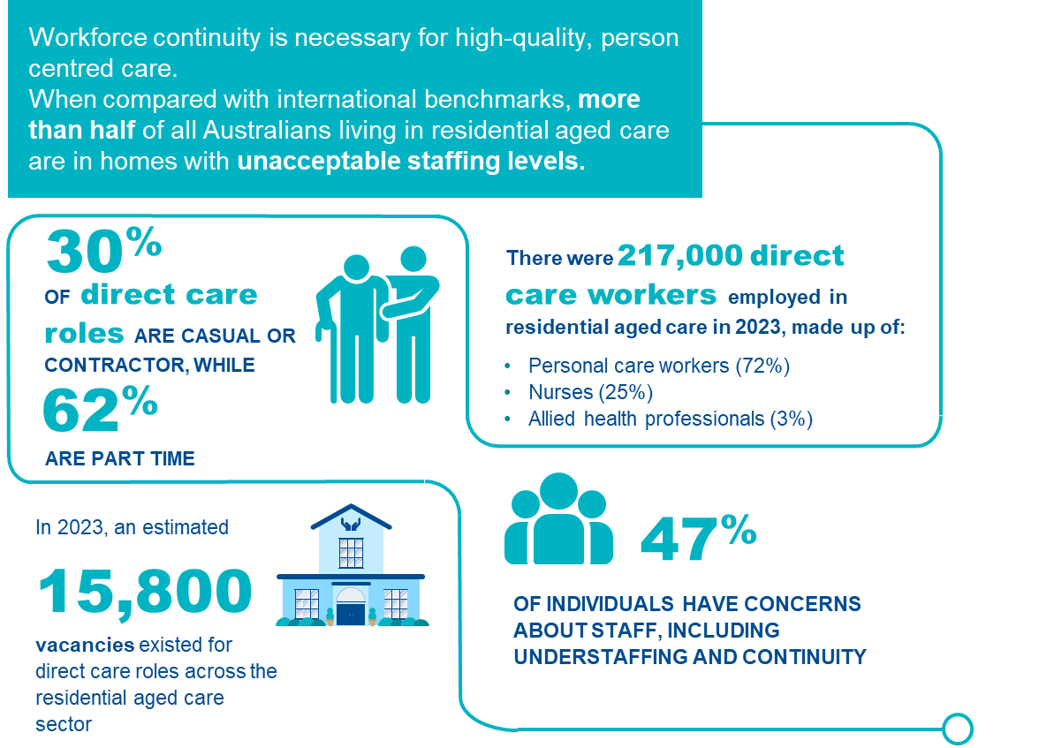

The residential aged care workforce
For the purposes of the QI Program, workforce turnover measures employed staff who stopped working during the reporting period.
While many dedicated and compassionate people work in aged care, it is recognised that systemic workforce issues exist, reducing capacity to provide quality care. Seventy per cent of submissions to the Royal Commission into Aged Care Quality and Safety identified staff shortages as the principal barrier to having resident care needs met, the consequences of which can be serious or fatal.
Workforce shortages and other factors contribute to higher staff turnover, which subsequently exacerbates workforce shortages and disrupts continuity of care, filtering down to impact on quality of care and quality of life due to workers’ reduced familiarity with residents.
Details of collection and reporting requirements for the workforce quality indicator can be found in Part A.

Causes of workforce shortages
Factors that impact workforce shortages and increase staff turnover are multi-faceted and diverse. Common workplace features associated with high staff turnover include:
- organisational funding and design
- insufficient staff numbers
- misalignment of residents’ needs and staff skill-mix
- shortage of professional clinical staff (e.g. registered nurses and allied health)
- undervalued and underpaid staff
- inadequate staff training and professional development.

Risk factors for high staff turnover
The main risk factors for staff turnover result from staff feeling unsupported or undervalued at work. These feelings and perceptions can arise from multiple factors, including:
- inadequate leadership
- poor workplace culture
- staff shortages
- inadequate time to complete tasks
- inadequate training
- absence of career framework or opportunities for progression
- lack of professional development.

Adverse clinical events and workforce
There are well established links between the capacity of aged care staff, both in sufficiency and skill, and the quality of care provided. To provide high quality care, staff must feel supported, valued and fairly remunerated. If staff needs are not met, disengagement, inattention and low motivation is likely to occur. Staffing shortages and misaligned skill-mix can lead to poor care and unmet care needs. Standard 2 (Outcome 2.8) of the Strengthened Aged Care Quality Standards requires residents to receive quality care and services by a skilled and qualified workforce who are knowledgeable, capable and caring.^{191F}

Prevention and management of workforce turnover
Aged care is reliant upon appropriately trained and engaged staff who feel valued and supported in their role, and who are given sufficient time to provide effective care.
Specific areas that can be targeted to improve staff retention and care continuity can be understood through worker satisfaction surveys and by ensuring information is encouraged to be shared across all levels in the organisation, providing opportunities for staff to raise concerns. Interventions to support workforce retention could include establishing both formal and informal forums where staff can provide regular feedback, enabling participation in mentoring programs or providing staff with access to training programs (both internal and external), preferably during working hours.
Examples of areas where management could focus and where interventions may be required to mitigate workforce turnover include:^{192F 193F 194F}
- Working conditions: Staff must be appropriately remunerated, valued and invested in. The workforce must be sufficient and suitably skilled to provide quality care.
- Job satisfaction: Staff who are satisfied with their work and feel valued, supported and empowered will generally stay active and engaged, improving care quality along with staff and resident wellbeing.
- Supportive and visionary management: Staff shortages may require investment and innovation to improve working conditions and identify alternative approaches to deliver care e.g. through optimised use of line management structures and incorporation of supportive technologies such as health information technology (HIT).
- Supervision and mentorship: Supervision and mentorship can support skill development and practice. It can improve working conditions, resulting in improved performance and overall wellbeing of staff.
- Empowering work culture: Staff who feel empowered have higher levels of self-worth, greater wellbeing and are more invested in their work.
- Collaborative teams: Involvement in team structures and care planning has a beneficial effect on team output, leading to efficiencies in resource use.
- High quality and relevant education: Professional development ensures the right training for the right staff at the right time that leads to provision of high-quality care. Service-wide investment in professional development affords opportunities for staff to develop capacity, feelings of belonging, and value as well as providing currency and relevancy to skill sets.

The checklist below will help assess risk of staff turnover and assist in identification, reporting and mediation of workforce issues.
FIGURE 46: CHECKLIST FOR DEVELOPING A POSITIVE WORKPLACE CULTURE
Checklist for developing a positive workforce culture

Provide focused leadership
- Develop collaborative service goals and articulate roles and responsibilities to achieve them.
- Support staff to work towards service goals.
- Monitor, evaluate and share progress towards service goals.
- Use management frameworks to structure reporting activities.
- Ensure appropriate staff supervision and mentorship.
Create a positive work environment
- Promote staff engagement.
- Collaborate with staff to develop and achieve service goals.
- Establish community and professional networks (e.g. with local services or professionals).
- Implement processes allowing for the escalation of staffing issues by any staff member e.g. reporting of shortages to professional line managers if and as they arise.
- Proactively seek assistance to resolve any workplace issues.
- Consider new and innovative ways of mitigating challenges.
- Ensure frequent, honest and fair communication between staff and management.
Ensure enough of the right staff in the right roles
- Ensure staff have the training and skills to meet the needs and preferences of residents including relevance to individual and organisational scope of practice.
- Seek support and assistance from trained professionals whenever there is uncertainty.
- Maintain a flexible and balanced approach to rostering that considers the case-mix and appropriate skill mix required.
- Where possible, adopt an approach to rostering that supports care continuity allowing residents to become more familiar with staff.
Prioritise education and training
- Identify areas of need or knowledge gaps and arrange appropriate training.
- Undertake professional development planning with staff, including career planning.
- Collaborate with staff and line managers to identify areas for professional development investment.
- Ensure relevant registrations, qualifications and competencies associated with staff roles are maintained and recorded.
Promote job satisfaction
- Promote staff engagement through team building and social activities.
- Create a safe space to discuss workplace concerns without fear of retribution or punishment.
- Prioritise staff culture and values.

Quality improvement for workforce
Quality improvement can help services reduce staff turnover and improve continuity of care. Quality improvement activities should be ongoing and part of business-as-usual for providers.
The QI Program will help prompt when a specific quality improvement activity should be undertaken. It is important to review the QI Program data reports through GPMS and compare against national averages and other services to understand where quality improvement activities should be focused.
The Plan-Do-Check-Act tool (section 2.3) is a useful tool to plan, deliver and monitor quality improvement activities focused on workforce.

Example tools, guidance and resources to
support continuous quality improvement
- Workforce Advisory Service —free, independent and confidential advice for aged care providers to improve workforce planning — Department of Health, Disability and Ageing
- Equip Aged Care Learning Packages — free online learning modules for anyone interested in the aged care sector, including personal care workers, nurses, allied health professionals, volunteers and families — Department of Health, Disability and Ageing
- Aged Care Transition to Practice Program (ACTTP) — mentoring, training and support for new aged care nurses — Department of Health, Disability and Ageing
- Aged Care Nursing and Allied Health Scholarships – provides funding for a range of scholarship opportunities for nurses, personal care workers and allied health workers. Preference is given to applicants living and working in rural, regional and remote areas – Department of Health, Disability and Ageing
- Research Paper 1: How Australian residential aged care staffing levels compare with international and national benchmarks — research paper investigating international and national staffing profiles for aged care homes in order to better understand how staffing can be improved in Australia — Royal Commission into Aged Care Quality and Safety
- Aged Care Quality and Safety Commission — educational resources and workshops for aged care providers, new workforce entrants and pre-existing staff — Aged Care Quality and Safety Commission
- Nursing guidelines for continuing professional development — guidelines providing information for nurses regarding the expectations and requirements of the Nursing and Midwifery Board Australia — AHPRA
- Aged Care Award — Fair Work Commission (previously fair work Australia)
- The national imperative to improve nursing home quality: Honoring our commitment to residents, families and staff — e-book discusses relevant workforce issues including administration, leadership, licensing, professional development, health and wellbeing of care workers and different types of care workers — National Academies of Sciences, Engineering and Medicine, USA
Some tools, guidance and resources may be updated over time; it is important to ensure you are looking at the most recent version.

Consumer experience

Consumer experience represents the perspective of residents, or their proxies, to support services tailor and improve quality of care.

Overview of consumer experience
Figure 47 provides an overview of consumer experience in aged care homes. The data and references have been reviewed March 2025.
FIGURE 47: CONSUMER EXPERIENCE IN AGED CARE HOMES195F 196F 197F
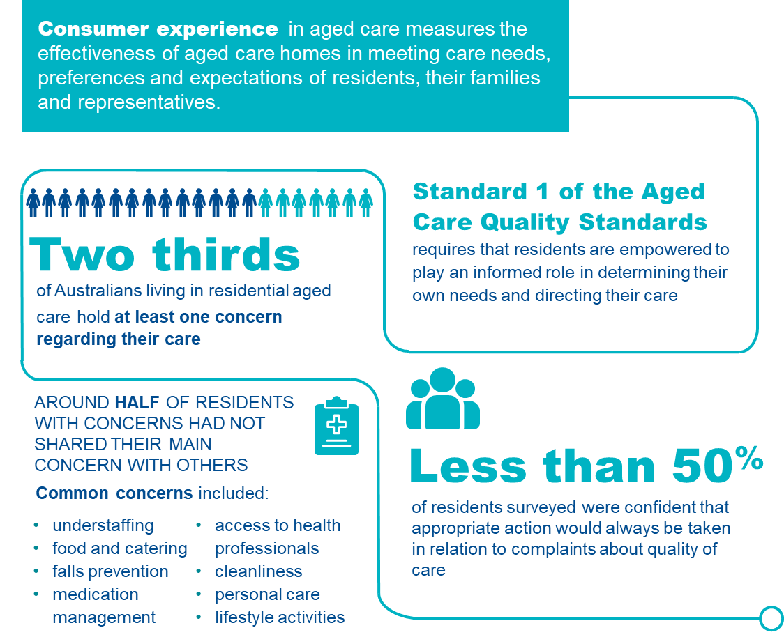

Consumer experience in aged care homes
Collecting, monitoring and responding to consumer experience is necessary to appropriately listen to the voice of residents and understand the effectiveness of aged care. For the purposes of the QI Program, six elements of consumer experience are sought from residents, or their families and carers, these are:^{198F}
- Being treated with respect and dignity
- Support to make decisions about care
- Care and support provided by staff with appropriate skills and training
- Services and supports for daily living positively impact on overall health and wellbeing
- Support and encouragement to maintain social relationships and community connections
- Comfort in lodging complaints, with confidence that issues will be appropriately addressed.
Details of collection and reporting requirements for the consumer experience quality indicator can be found in Part A.

Risk factors affecting consumer experience
In aged care homes, consumer experience can be negatively impacted when:^{199F 200F}
- transparent processes are not in place for feedback or complaints
- residents are afraid of negative consequences if they complain or speak
- residents feel their opinion is not listened to or valued
- information sharing is not collaborative
- care does not feel personalised or culturally appropriate
- residents feel inferior to their carers
- opportunities to participate in community-based activities are not available.

Adverse clinical events and consumer experience
Negative experiences in aged care homes can lead to a range of physical, psychological and social issues for residents, their families and carers, including:^{201F}
- reduced engagement/withdrawal
- resentment
- loss of autonomy
- distrust
- withholding constructive feedback for fear of retribution
- depression
- neglect
- abuse.

Management of consumer experience
Awareness of factors that contribute to poor consumer experience reduces the risk of adverse clinical events and improves quality of life. Measurement and reporting by service providers can prompt recognition and management of consumer experience and assist with promoting and monitoring the progress of service-wide quality improvement.^{202F}

Families and carers
Some residents may require a proxy to complete consumer experience assessments.^{203F} This includes residents who have severe cognitive or communication issues impacting their ability to express their wishes and feelings. The proxy should know the resident well and see them regularly. When completing the consumer experience assessment, the proxy should respond based on their own knowledge of the resident and their quality of care experience at the time of completion, noting:
- Every attempt should be made to elicit the wishes and opinions of the resident, recognising these may differ to the proxy. Residents may communicate in non-verbal ways, and their feelings may be elicited by observing their responses to care and various recreational and social activities. These responses form part of collaborative care planning and should be documented following aged care home procedures.
- Proxies, including family and carers such as substitute decision makers, are often highly sensitive to the needs of residents. Their needs may be closely aligned with those of the resident. Recognition of the views and needs of these proxies should form part of the program of the aged care home, ensuring that they are welcome, can participate in the life of the resident, and that their voice is heard in arranging care.
Figure 48 outlines important aspects of care that optimise consumer experience.
FIGURE 48: MANAGING CONSUMER EXPERIENCE204F 205F 206F 207F
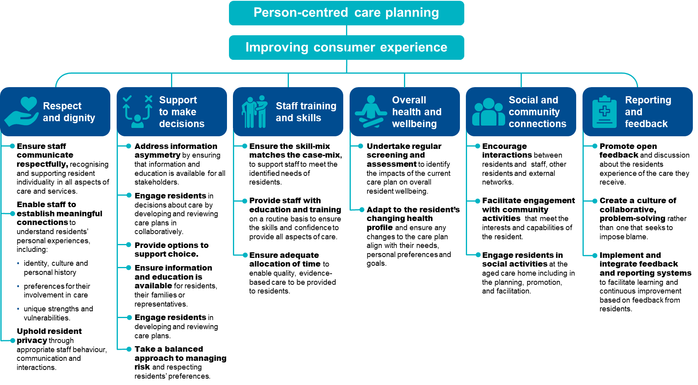

The checklist below will help assess residents who are at risk of poor or declining consumer experience and identify support and prevention strategies:
FIGURE 49: CHECKLIST FOR IMPROVING CONSUMER EXPERIENCE
Checklist for improving consumer experience

Educate staff about consumer exp
- Explore opportunities for advancing staff skills and knowledge.
- Ensure alignment of staff skill-mix and case-mix.
Assessment and reassessment using QCE-ACC tool
- Assess with the QCE-ACC assessment tool.
- Identify any baseline indications of diminished consumer experience.
- Identify any risk factors for future deterioration of consumer experience.

Support active participation of the resident in care planning
- Foster trust and open communication about resident needs, preferences and goals.
- Provide options and information to support resident choice.
- Encourage and respect the resident’s participation in care planning.
- Incorporate collaborative care planning principles into workplace policies and procedures.
Broaden opportunities for residents’ involvement in activities
- Explore opportunities for residents to contribute to activity program development.
- Provide relevant, timely information about available activities and services.
- Maximise level of the resident’s participation, including through use of proxy or advocacy where indicated.
- Adjust activities to suit the resident’s health profiles.
Strengthen community culture
- Adapt service specific engagement strategies.
- Encourage social interaction between residents, staff and the outside community.
- Include residents in plans for community engagement activities.
Create enabling and supportive environments to improve health and wellbeing
- Promote open disclosure and encourage sharing of any health and wellbeing challenges.
- Promote feedback systems, including informing residents of follow up actions and outcomes when complaints are handled.
- Integrate systems to facilitate seamless monitoring, identification and management of poor quality care, as evidenced by low quality indicator performance.

Quality improvement for consumer experience
Quality improvement can help providers increase quality of care experience for residents in aged care homes. Quality improvement activities should be ongoing and part of business-as-usual for providers.
The QI Program will help prompt when a specific quality improvement activity should be undertaken. It is important to review the QI Program data reports through GPMS and compare against national averages and other services to understand where quality improvement activities should be focused.
The Plan-Do-Check-Act tool (section 2.3) is a useful tool to plan, deliver and monitor quality improvement activities focused on optimising consumer experience.

Example tools, guidance and resources to
support continuous quality improvement
- QCE-ACC Quality of Care Experience Aged Care Consumers© — measure identifying aspects of care most important to senior Australians, and the selected assessment tool that must be used in the QI Program — available in Part A: Appendix C
- Care that is right for me: A resource for working with aged care consumers — resource has been designed to support providers of aged care to partner and engage with consumers to drive the delivery of consumer-centred care — Aged Care Quality and Safety Commission
- Research Paper 20: The quality of care experience and community expectations — research paper investigating understanding of older Australian’s experience of aged care and provides guidance on monitoring resident’s satisfaction with overall care provided — Royal Commission into Aged Care Quality and Safety
- Guidance and resources for providers to support the Strengthened Aged Care Quality Standards — online guidance and resources to support aged care providers with implementation of the strengthened Quality Standards — Aged Care Quality and Safety Commission
- Strengthened Aged Care Quality Standards - Poster for older people — poster describing the intent of the strengthened Aged Care Quality Standards — Aged Care Quality and Safety Commission
- Quality of Care — information and resources to support provision of high quality healthcare, including strategies on consumer engagement — World Health Organization
Some tools, guidance and resources may be updated over time; it is important to ensure you are looking at the most recent version.

Quality of life
The Royal Commission into Aged Care Quality and Safety noted quality of life should be the constant and predominant aim of aged care. Although the care needs of residents may change over time, the desire for a good quality of life does not diminish. Regular monitoring of quality of life is an important part of routine care supporting quality.

Overview of quality of life
Figure 50 provides an overview of quality of life in aged care homes. The data and references have been reviewed March 2025.
FIGURE 50: QUALITY OF LIFE IN AGED CARE HOMES208F 209F
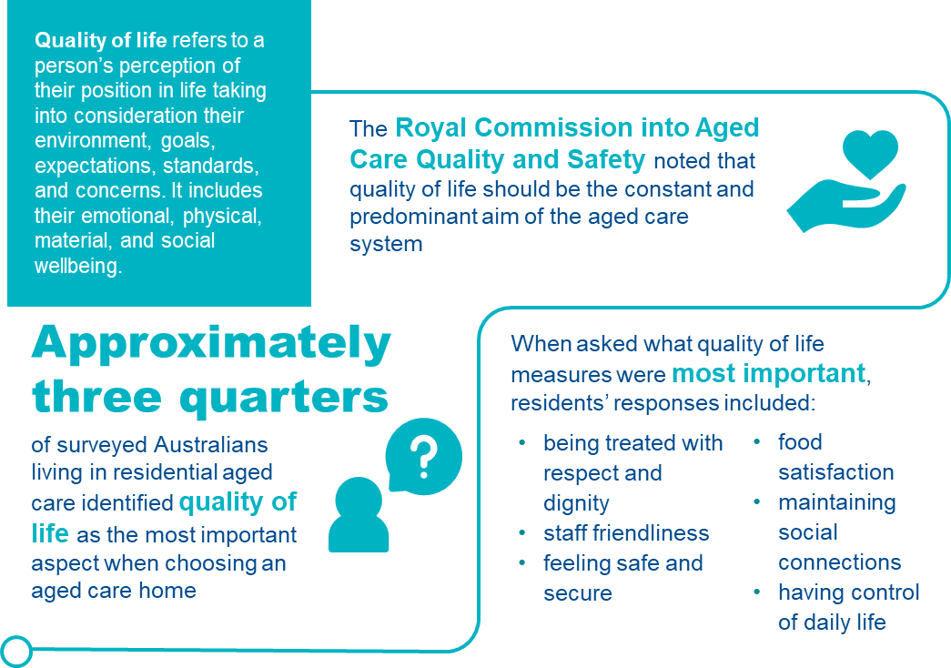

Quality of life in aged care homes
For the purposes of the QI program, quality of life is defined by a person’s perception of their position and purpose, including emotional, physical, material and social wellbeing. It is an important element of aged care, providing consideration for the environment, goals, expectations, standards, and concerns that residents may have. The Royal Commission into Aged Care Quality and Safety identified large deficits in the collection of quality of life information and recommended implementation of a quality of life measure.^{210F}
Quality of life is linked to aspects of an individual’s care and experience; including physically, mentally, emotionally, and environmentally.^{211F} Tools to measure quality of life recognise that values change over the life course, and older people, while valuing health, also value independence, safety and control.^{212F 213F}
Optimal quality of life is perceived when care and services promote:^{214F}
- enjoyment
- participation
- expression and creative activities
- maximum physical, mental and psychological function
- ongoing opportunities, stimulation and rehabilitation
- mitigation of displeasure, anxiety and boredom
- creation of legacy and life review
- expression of spirituality and religious practices.
Details of collection and reporting requirements for the quality of life quality indicator can be found in Part A.

Predictors of quality of life
- There are both modifiable and non-modifiable factors that contribute to quality of life. Predisposing predictors of quality of life include:^{215F}
- demographic factors (such as age, gender, geographic location, socio-economic status)
- social factors (such as marital status and social participation)
- individual factors (such as mobility, independence, health and healthcare requirements).
- Modifiable factors can be influenced by services and staff through collaborative care planning, appropriate care provision and access to healthcare.

Risk factors for diminishing quality of life
There are many risk factors for diminishing quality of life across physical, mental and social domains, including:^{216F}
- Physical
- functional decline and mobility loss
- hearing and vision loss
- oral health
- continence
- pain.
- Mental
- depression
- cognitive impairment
- dementia.
- Social
- inadequate financial resources
- social isolation
- boredom
- anxiety.
The majority of risk factors are able to be influenced by the provision of high-quality care in aged care homes. Factors identified by older people in a survey conducted in 2018 as being important to quality of life are illustrated in Figure 51.
FIGURE 51: RELATIVE IMPORTANCE TO QUALITY OF LIFE IN AGED CARE HOMES217F
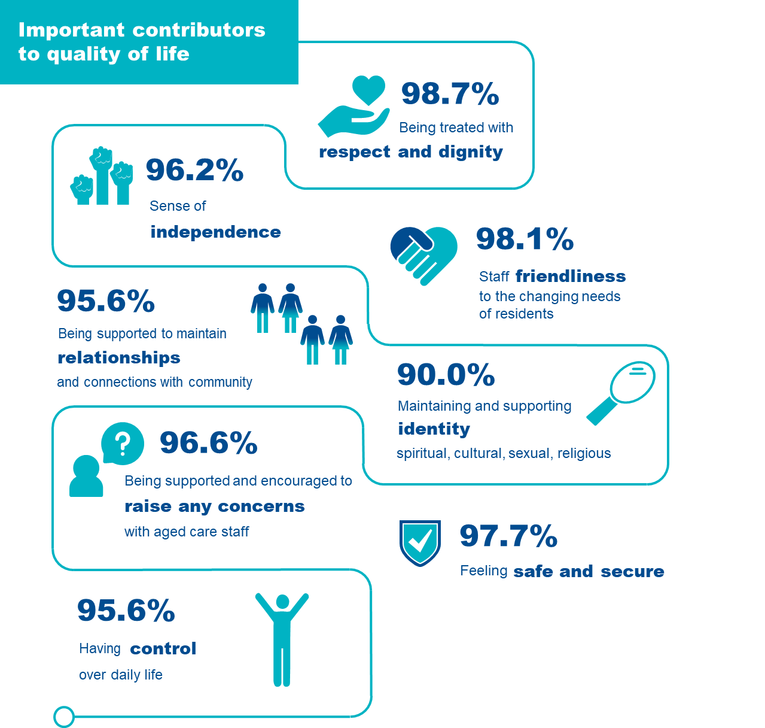

Adverse clinical events and quality of life
Poor quality of life is associated with depression and can impact a resident’s ability to respond to life circumstances.^{218F} Reduced quality of life and general dissatisfaction can deepen depressive states and reduce resilience. While improvements in quality of life can improve attitudes and behaviours associated with overall wellbeing, reducing healthcare burden and associated costs.

Improvement and maintenance of quality of life
Awareness of contributors to quality of life can reduce the risk of adverse clinical outcomes and improve overall wellbeing.
Common areas of need influencing quality of life as identified in aged care homes include:
- hearing and vision
- oral health
- continence
- functional ability
- pain
- psychological health
- cultural preferences
- spirituality.
These needs should be incorporated into a comprehensive, collaborative care plan.^{219F}
Physical activity has been shown to reduce depression, improve or maintain functional ability and improve quality of life.^{220F} Reducing loneliness without the need for physical activity has also shown improvements in overall quality of life, including therapies such as:^{221F}
- reminiscence therapy
- laughter
- horticulture
- videoconferencing family and friends
- robotics and artificial intelligence interaction
- logotherapy (a form of psychotherapy encouraging participation through doing, creating, experiencing and attitude modulation)
- pet therapy.
Multi-targeted strategies have shown improvements in global and executive function as well as memory in persons with dementia, including combinations of:^{222F}
- exercise
- cognitive training
- ADL practice
- activity interventions.
Activities allowing expression can include:^{223F}
- wellness (e.g. tai-chi and yoga)
- physical activity
- art
- recreational strategies and activities that assist residents to socialise with others
- music therapy
- observance of cultural and religious practices.
Figure 52 outlines important aspects of care that maximise quality of life for residents living in aged care homes.

FIGURE 52: MANAGEMENT OF QUALITY OF LIFE224F
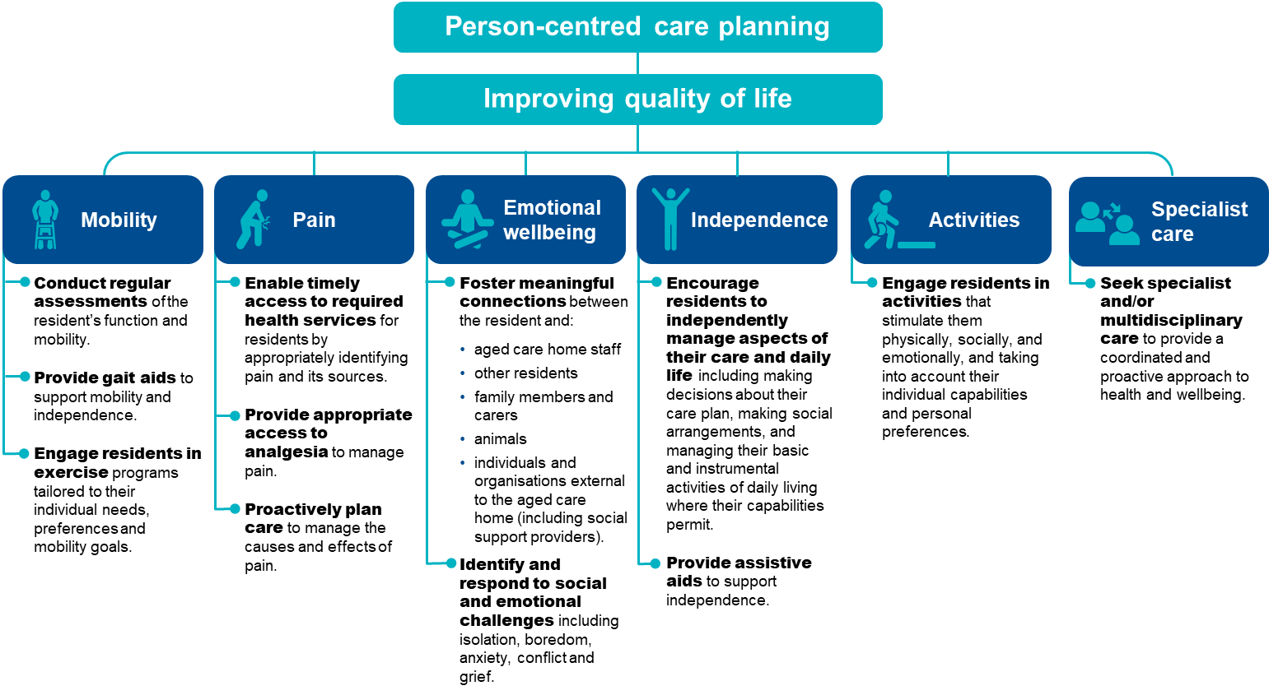

The checklist below will help assess residents who are at risk of reduced quality of life and identify support and prevention strategies.
FIGURE 53: CHECKLIST FOR IMPROVING QUALITY OF LIFE
Checklist for improving quality of life
Assessment and reassessment using QOL-ACC tool
- Assess with the QOL-ACC assessment tool.
- Identify any baseline indications of diminished quality of life.
- Identify any risk factors for future deterioration of quality of life.
Review the care plan
- Review and document in the care plan:
- resident’s preferences for care and care goals
- resident’s current health status
- identified risk factors for reduced quality of life
- quality of life improvement strategies
- undertake collaborative care planning.
- Frequency and timing of improvement strategies.
Implement enabling strategies with a focus on strategies to prevent diminished quality of life such as:
- Ensure involvement of the resident in decision-making about their circumstances.
- Promote appropriate and timely access to health-related interventions, analgesia, medication reviews etc.
- Use appropriate and individualised exercise and activity plans.
- Encourage resident engagement in available activities that match identified interests.
- Foster community interactions and engagement.
Action items identified in assessment
- Check for withdrawal, increase in disruptive behaviours or expression of dissatisfaction.
- Assess appropriateness of current strategies to maintain quality of life.

Quality improvement for quality of life
Quality improvement can help providers improve quality of life for residents in aged care homes. Quality improvement activities should be ongoing and part of business-as-usual for providers.
The QI Program will help prompt when a specific activity should be undertaken. It is important to review the QI Program data reports through GPMS and compare against national averages and other services to understand where quality improvement activities should be focused.
The Plan-Do-Check-Act tool is a useful tool to plan, deliver and monitor quality improvement activities focused on relevant quality of life aspects.

Example tools, guidance and resources to support continuous quality improvement
- QOL-ACC Quality of Life Aged Care Consumers© — measure identifying aspects of quality of life most important to senior Australians, and the selected quality of life assessment tool that must be used in the QI Program — available in Part A: Appendix D
- Good Spirit Good Life — is a quality of life assessment tool and framework for use by health and aged care services to identify and enhance the quality of life of older Aboriginal Australians — Aboriginal Ageing Well Research
- The integration of mixed methods data to develop the Quality of Life – Aged Care Consumers (QOL-ACC) instrument — journal article describing the collection and integration of mixed methods data to facilitate the final selection of items for the QOL-ACC
- Services and supports for daily living: Standard 4 — provides guidance and resources relating to services and supports for daily living — Aged Care Quality and Safety Commission
- Measurement tools for assessing quality of life, consumer satisfaction and consumer experience across residential and in-home aged care: a summary report — evidence review of validated tools to measure quality of life, consumer experience or consumer satisfaction — Caring Futures Institute, Flinders University
- Quality of life tools to support measurement of aged care quality — research paper evaluating quality of life tools to support and measure aged care quality — Deeble Institute for Health Policy Research
- What does quality of life mean to older adults? A thematic synthesis — journal article providing a systematic reviews qualitative studies exploring the meaning of quality of life for older adults
- Quality of life factors for older Australians — a news article describing what factors are important for good quality of life factors from the perspective of the older Australian — Aged Care Guide
- Health Related Quality of Life Page — website with links to tools, guidance and resources that support quality of life improvement — Centers for Disease Control and Prevention
- GEN Aged Care Data —repository of information about aged care, including capacity and activity in aged care with a focus on people, assessments and services — Australian Institute of Health and Welfare
Some tools, guidance and resources may be updated over time; it is important to ensure you are looking at the most recent version.

Enrolled Nursing

Overview of Enrolled Nursing
FIGURE 54: ENROLLED NURSING IN AGED CARE HOMES225F 226F 227F
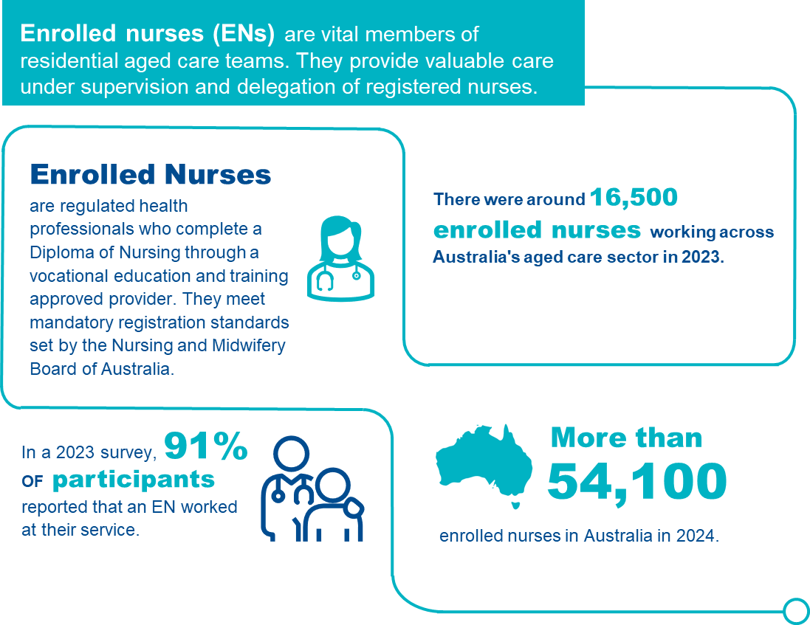

Enrolled Nursing in aged care homes
Enrolled nurses (ENs) provide nursing care under the supervision of a Registered Nurse (RN) or Nurse Practitioner (NP)^{228F}. ENs have the knowledge and skills to:
- provide physical and emotional care,
- engage in reflective and analytical practice,
- administer medication,
- maintain infection prevention and control,
- perform clinical assessments, and;
- contribute to care planning.
ENs are essential members of the aged care team, providing valuable contributions to the care of older people. They collaborate closely with other healthcare workers and provide important clinical expertise, working under the supervision of RNs and within multidisciplinary teams.

Adverse clinical events and insufficient enrolled nursing staff
There are well established links between the capacity of aged care staff and the quality of care provided. Standard 2 (Outcome 2.8) of the Strengthened Aged Care Quality Standards requires residents to receive quality care and services by a skilled and qualified workforce who are knowledgeable, capable and caring. The main duties of an EN encompass direct care, clinical care, and care coordination. Therefore, the loss of ENs in aged care can negatively impact both the safety of residents and other aged care staff.
Reducing EN staffing in favour of other care staff such as Personal care workers (PCWs) can pose risks for clinical safety and quality of care^{229F}. Providing safe, high quality, person-centred care for older people involves the ability to:
- respond to an older person’s preferences and needs,
- work closely with other health professionals,
- accurately assess, plan, treat and respond,
- identify and respond to signs of physical and psychological deterioration, and;
- appropriately escalate concerns^{230F}.
The lack of effective surveillance of older people’s health and wellbeing contributes to poor outcomes when those needs are not promptly addressed, possibly leading to avoidable hospital admissions or further loss of independence.

Preventing insufficient enrolled nursing staff in aged care
FIGURE 55: CHECKLIST FOR PROMOTING ADEQUATE ENROLLED NURSING STAFFING
Checklist for promoting adequate enrolled nursing staffing
 | Ensure enough of the right nursing staff in the right roles  - Ensure nursing staff have the training and skills to meet the needs of residents.  - Ensure RNs are rostered on the same shifts to supervise ENs.  - Maintain a flexible and balanced approach to rostering that considers the case-mix and appropriate skill-mix required.  Prioritise education and training  - Identify areas of need or knowledge gaps of staff and arrange appropriate training.  - Ensure personal care workers are appropriately skilled to undertake tasks and the task has been appropriately delegated and supervised by the registered nurse.  - Collaborate with staff and line managers to identify areas for nursing continuing professional development.  - Ensure relevant registrations, qualifications and competencies associated with staff roles are recorded and maintained.  Create a collaborative work environment  - Collaborate with nursing staff to develop and achieve service goals.  - Ensure appropriate nursing staff supervision and mentorship.  - Develop collaborative service goals and articulate roles and responsibilities to achieve them.  - Establish nursing professional networks (e.g. with local services or professionals).  - Promote staff engagement through team building and social activities. |  | Act on staff and resident concerns about nursing care capacity and quality  - Create a safe space to discuss workplace concerns without fear of retribution or punishment.  - Implement processes allowing for the escalation of staffing issues by any staff member, resident or carer e.g. reporting of staff shortages to line managers if they arise.  - Ensure frequent, honest and fair communication between staff and management, including concerns such as staff working outside scope of practice.  - Conduct surveillance of resident concerns relating to nursing care capacity and quality by monitoring themes from resident experience and quality of life surveys.  - Monitor nursing staff burnout and workforce turnover.  - Provide access to Employee Assistance Programs to assist staff wellbeing.  Monitor care minutes delivery according to staffing category  - Track the proportion of care minutes delivered by RNs, ENs and PCWs as a proportion of the total workforce and evaluate how the staffing and skills mix continues to meet assessed care needs of residents. Reflect on how this fits case-mix.  - Meet up to 10% of service-level RN minutes targets with care time provided by EN, where possible.

Quality improvement for enrolled nursing staffing
Quality improvement can help services provide optimal enrolled nursing staffing and improve continuity of care. Quality improvement activities should be ongoing and part of business-as-usual for providers.
The QI Program will help prompt when quality improvement activities may be needed. It is important to review all QI Program data reports through GPMS and compare against national averages and other services to understand where quality improvement activities should be focused.
The Plan-Do-Check-Act tool (section 2.3) is a useful tool to plan, deliver and monitor quality improvement activities focused on workforce.

Example tools, guidance and resources to support continuous quality improvement
- Nursing and Midwifery Board of Australia - Fact sheet: Scope of practice and capabilities of nurses (nursingmidwiferyboard.gov.au) – includes full description of all capabilities and scope of practice for enrolled nurses, registered nurses and nurse practitioners.
- Nursing and Midwifery Board of Australia - Fact sheet: What do nurses and midwives do? (nursingmidwiferyboard.gov.au) - provides an overview of the varying roles and core activities of midwives, registered nurses, enrolled nurses and nurse practitioners.
- Nursing and Midwifery Board of Australia - Fact sheet: Enrolled nurse standards for practice (nursingmidwiferyboard.gov.au) – outlines the core practice standards that provide the framework for assessing EN practice.
- Nursing and Midwifery Board of Australia - Registered nurse standards for practice (nursingmidwiferyboard.gov.au) - registered nurse standards for practice in full which includes delegation to enrolled nurses and others (6.3)
- Nursing and Midwifery Board of Australia – Decision Making Framework (DMF) -– The DMF supports nurses and midwives to make decisions in practice, particularly about scope of practice and delegation.
- Nursing and Midwifery Board of Australia - Professional standards (nursingmidwiferyboard.gov.au) – includes all nursing divisions codes of conduct and practice standards.
- Nursing and Midwifery Board of Australia - Continuing professional development (nursingmidwiferyboard.gov.au) – guidelines and resources on continuing professional development for nurses.
- Education and training for workers | Aged Care Quality and Safety Commission – includes learning content for aged care providers and workers via the ‘ALIS’ platform.
- Nursing and allied health scholarships | Australian Government Department of Health, Disability and Ageing - outlines funded scholarship opportunities through the Australian College of Nursing.

Allied Health

Overview of allied health
Figure 56 below provides an overview of allied health in aged care homes. The data and references have been reviewed March 2025.
FIGURE 56: ALLIED HEALTH STAFFING IN AGED CARE HOMES^{231F} ^{232F} ^{233F}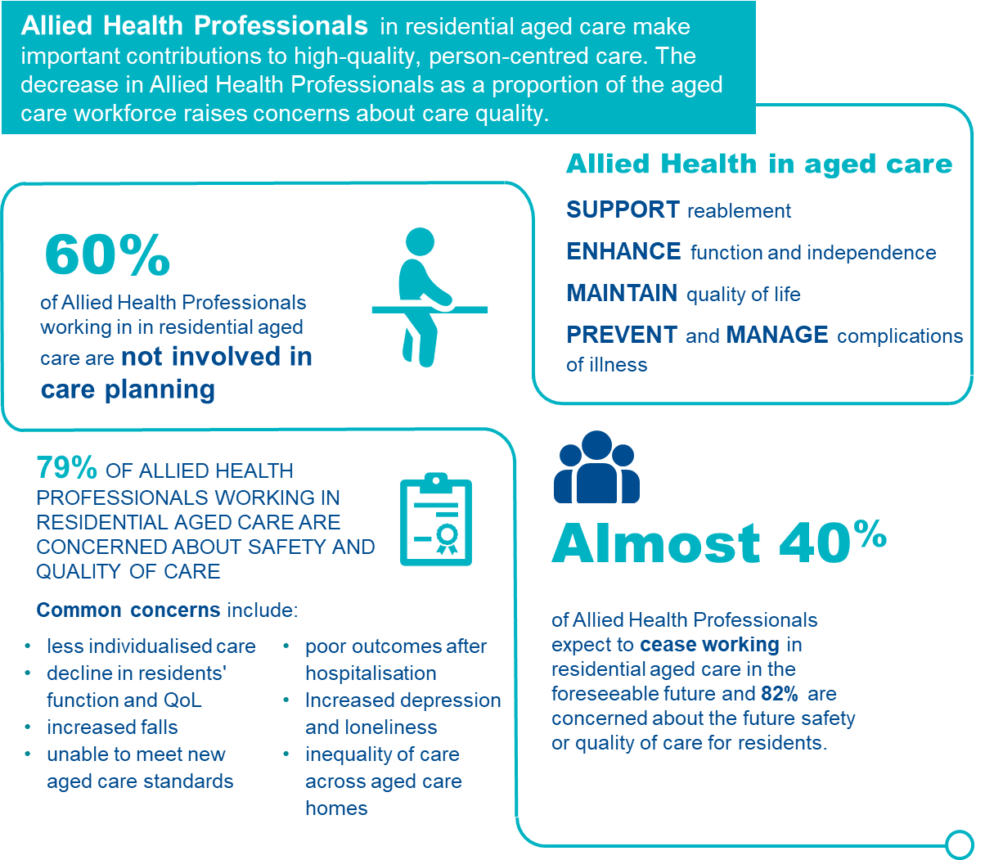

Allied health in aged care homes
Allied health professionals play a critical role in enhancing functional health and quality of life for people living in aged care homes. They use specialised knowledge and skills to enable older people to function well physically, socially and emotionally. In aged care homes, allied health professionals apply knowledge, skills and expertise to:
- prevent and manage common issues (e.g. swallowing issues, falls, malnutrition, chronic pain, wounds)
- support reablement to enhance function and independence
- help maintain the residents’ quality of life,
- educate and upskill the aged care workforce.
For the purposes of the QI program, allied health and therapy services delivered by an allied health professional are defined in line with current definitions from the Quarterly Financial Report (QFR)^{234F}:
- physiotherapist,
- occupational therapist,
- speech pathologist,
- podiatrist,
- dietitian,
- allied health assistant,
- ‘other’ allied health professionals, including:
- art therapists,
- audiologists,
- chiropractors,
- counsellors,
- diabetes educators,
- exercise physiologists,
- music therapists,
- osteopaths,
- psychologists,
- social workers.
Allied health assistants (AHAs) perform a valuable role in aged care. Benefits of an AHA service may include:
- increasing clinical capacity and allowing allied health professionals to focus on more high-level tasks,
- providing improved access and continuity of service to residents^{235F}.
However, AHAs must work under the supervision of allied health professionals and be subject to a delegation framework. Employing AHAs without these checks in place may have negative implications for quality and safety^{236F}.
The allied health quality indicators measure allied health care minutes per resident per day, and the percentage of recommended allied health services received. Details of the collection and reporting requirements for the allied health quality indicator can be found in Part A.

Allied health staffing in aged care homes
In Australia and internationally, the delivery of allied health services is highly variable in aged care homes. Service delivery is impacted by many factors - including funding, facility size, rurality, service demand, and health status of residents. Overall, data quality on allied health staffing and the relationship with outcomes for residents in Australia is limited.

Consequences of insufficient allied health staff in aged care
The Royal Commission concluded that allied health service provision is essential for reablement. Under-provision and undervaluing of allied health care negatively impacts morbidity, mortality and quality of life^{237F}. Due to incidents such as falls, or simply because of the ageing process, older people can experience loss of capacity. Reablement is about preventing such losses where possible. Allied health practitioners provide clinical care with a focus on preventing functional decline, along with early intervention and treatment to support function and quality of life.
Increased allied health staffing levels are linked with positive outcomes for older people in aged care homes. Examples from international studies include the following positive outcomes associated with increased hours per resident per day of physiotherapy and occupational therapy staffing^{238F}:
- improved performance in activities of daily living;
- decreased frequency of falls; and
- increased care quality.
Additionally, higher levels of dietitian staffing have also been linked to improved nutritional outcomes, meal satisfaction and quality of life^{239F240F241F}.
Inappropriately assigning allied health clinical roles and duties to unqualified staff may have negative implications for care quality and safety^{242F}. Examples include the replacement of individual care by group sessions, and the inability of a reduced workforce to provide in-depth care, including time for care planning and restorative approaches. Limits on providing high quality care for residents also contributes to lower morale of allied health professionals and could compound the decision to stop working in aged care.
To improve care quality in aged care homes, health systems need to collect data on allied health service provision and identify links to care quality and outcomes for older people.

Adverse clinical events and insufficient allied health services
The Royal Commission received numerous submissions identifying unmet needs of people living in residential aged care, including nutritional, physical, social, cognitive, and communication needs^{243F}. Only 2% of people were reported to be living in homes that provided the 22 minutes of allied health services per day recommended to the Royal Commission as best practice internationally^{244F}.
Failure to adhere to evidence-based clinical practice can result in unsafe care for people living in aged care homes^{245F.} Concerns about how reduced allied health staffing and care provision impact care quality and safety were highlighted in a 2023 survey of allied health professionals^{246F}, including:
- lack of involvement of allied health professionals in care planning resulting in less individualised services provided,
- increases in pain and frequency of falls,
- poor outcomes following hospitalisation post-surgery, stroke or falls, and;
- reduced quality of life and increased loss of function.

Management of allied health staffing
FIGURE 57: ALLIED HEALTH STAFF247F ,248F 249F
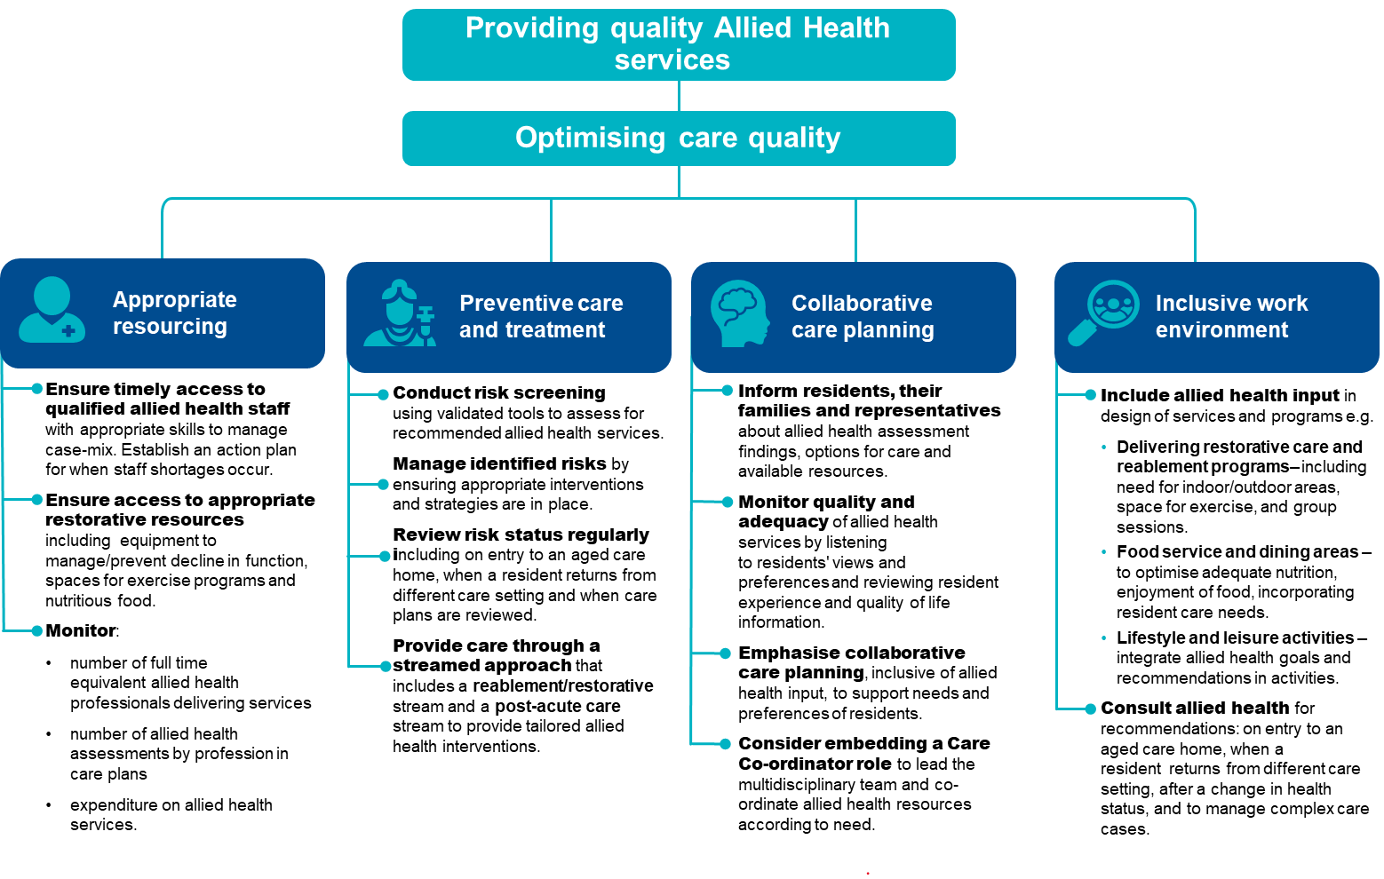

Quality improvement for allied health
Quality improvement can help services provide optimal allied health services and improve continuity of care. Quality improvement activities should be ongoing and part of business-as-usual for providers.
The QI Program will help prompt when quality improvement activities may be needed. It is important to review all QI Program data reports through GPMS and compare against national averages and other services to understand where quality improvement activities should be focused.
The Plan-Do-Check-Act tool (section 2.3) is a useful tool to plan, deliver and monitor quality improvement activities focused on workforce.

Example tools, guidance and resources to support continuous quality improvement
- Allied health professions - Allied Health Professions Australia – information about allied health professions and what they do.
- Enabling Clinical Education Skills - ClinEdAus – resources to support high quality clinical placement experiences for allied health students and supervisors through the provision of open access, contemporary, evidence-based clinical education resources.
- Australian Health Practitioner Regulation Agency - About registration – Includes information about registration for health professionals, including allied health practitioners.
- National Alliance of Self Regulating Health Professions (NASRHP) – supports member organisations of self-regulating health professions (over 60% of allied health professions are self-regulating).
- Who can provide allied health care | Australian Government Department of Health, Disability and Ageing – information about regulation of allied health care, the professional organisations involved and allied health in each state and territory.
- Aged Care - Allied Health Professions Australia – includes an overview of how allied health professionals can help improve the health and wellbeing of older people living in aged care homes.

Lifestyle Officers

Overview of lifestyle services
Figure 58 below provides an overview of lifestyle officers in aged care homes. The data and references have been reviewed March 2025.
FIGURE 58: LIFESTYLE OFFICERS IN AGED CARE HOMES
^{251F 252F}
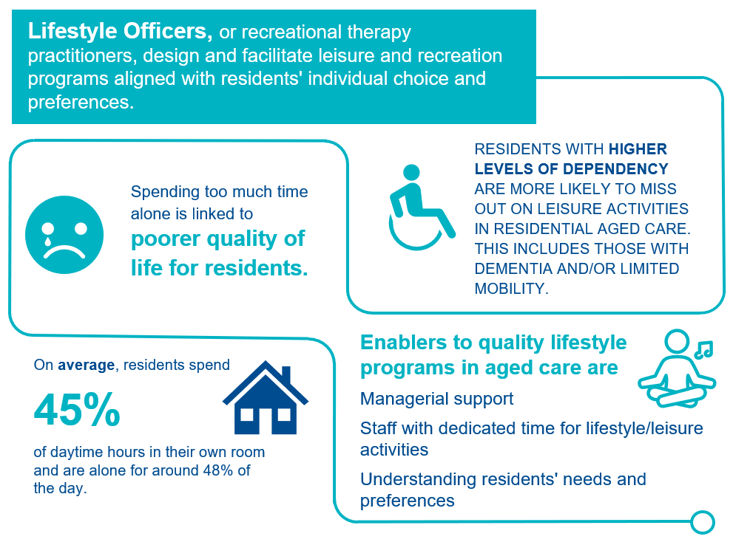

Lifestyle officers and recreational therapy in aged care homes
Lifestyle officers, or recreational therapy practitioners, work with people of all ages and abilities to design and facilitate leisure and recreation programs. Activities are designed to support, challenge and enhance individuals' psychological, spiritual, social, emotional and physical wellbeing. Lifestyle and leisure, or recreational therapy, in aged care homes recognises the right of all residents to access and engage in leisure and recreational experiences of their choosing.
The lifestyle officer quality indicator measures lifestyle officer care minutes per resident per day, using the labour hours data of diversional/lifestyle/recreation/activities staff submitted through the Quarterly Financial Report (QFR). Details of the collection and reporting requirements for the lifestyle officer quality indicator can be found in Part A.

Benefits of lifestyle and recreational therapy services in aged care
Australian data indicates that residents spend a large part of daytime hours sitting alone in their rooms, often engaging in limited social interactions and little activity^{253F}. In a 2022 survey^{254F}, the aged care workforce nominated ‘meaningful lifestyle activities’ as a priority concern for the sector. Evidence on the benefits of meaningful lifestyle activities in aged care exists for specific interventions. Meaningful lifestyle activities may be ones that older people:
- are familiar with,
- have participated in previously, and;
- align with their personal preferences and identity.
Lifestyle and recreational therapy programs may offer resident benefits in terms of improving mobility and depression, and provide more benefit when individualised to specific interests and physical and cognitive abilities. Providing meaningful or individualised activities for people with dementia living in aged care homes may improve behavioural issues associated with dementia and enhance quality of life^{255F}.
Enablers to leisure provision in aged care homes can include^{256F}:
- managerial support,
- availability of staff with dedicated time for lifestyle/leisure activities,
- ability of staff to identify opportunities to implement person-centred leisure activities, and;
- staff having a good understanding of the residents’ needs and preferences.
Barriers to leisure provision in aged care homes can include:
- lack of appropriate staff,
- competing role demands, and;
- prioritisation of clinical over physical and social aspects of care.
Additionally, significant cognitive impairment is often considered a barrier to leisure participation, and residents requiring significant physical assistance to join activities are more likely to miss out.
Where competing work demands are a barrier, facilitating leisure in a more informal way may create opportunities for more person-centred approaches. This requires staff to adopt a broad understanding of what activities may be considered leisure, in consideration of individual preferences^{257F}.
Checklist for lifestyle and leisure services in aged care
FIGURE 59: CHECKLIST FOR LIFESTYLE AND LEISURE SERVICES IN AGED CARE
Checklist for lifestyle and leisure services in aged care
 | Educate staff about lifestyle and leisure activities and practice  - Provide lifestyle and leisure education internally to all staff, including managers.  - Ensure lifestyle and leisure education includes best practice approaches and considers psychological, spiritual, social, emotional and physical wellbeing domains.  - Ensure alignment of staff skill-mix and case-mix, to include dedicated time for lifestyle and leisure programs. |  | Assessment and reassessment of lifestyle and leisure needs  - Assess for resident needs, preferences and goals in psychological, spiritual, social, emotional and physical wellbeing domains.  - Reassess at regular intervals, adhering to best practice recommendations.  - Identify any risk factors for limited participation.
 | Support active participation of residents in planning lifestyle and leisure programs  - Explore opportunities for residents to contribute to lifestyle and leisure program development.  - Provide relevant, timely information about available activities and services.  - Provide options and information to support residents’ choices.  - Maximise level of resident participation in planning, including through use of proxy or advocacy where indicated. |  | Strengthen links between the service and the community  - Adapt service specific engagement strategies.  - Encourage social interaction between residents, staff and the outside community.  - Include residents in plans for community engagement activities.
Create enabling environments to improve participation in lifestyle and leisure activities
- Adjust activities to suit resident health profiles.
- Regularly update care plans to include mitigation of any barriers to activity attendance.
- Promote open disclosure and encourage sharing of any health and wellbeing challenges.
- Consider available space, equipment and design to remove physical barriers to participation.

Quality improvement for lifestyle officer staffing
Quality improvement can help services provide optimal lifestyle officer services and improve continuity of care. Quality improvement activities should be ongoing and part of business-as-usual for providers.
The QI Program will help prompt when quality improvement activities may be needed. It is important to review all QI Program data reports through GPMS and compare against national averages and other services to understand where quality improvement activities should be focused.
The Plan-Do-Check-Act tool (section 2.3) is a useful tool to plan, deliver and monitor quality improvement activities focused on workforce.

Example tools, guidance and resources to support continuous quality improvement
- Australian Recreational Therapy Association [ARTA] – website of Australia’s peak membership body supporting recreational therapy practice.
- Barriers and enablers to leisure provision in residential aged care: personal care attendant perspectives | Ageing & Society | Cambridge Core – a descriptive study investigating barriers and enablers to the provision of leisure activities for people living in three Australian RACFs.
- Social interactions and quality of life of residents in aged care facilities: A multi-methods study | PLOS ONE – a multi methods study focusing on the frequency and duration of interpersonal interactions among residents in RACFs
- Meaningful Lifestyle Activities | Aged Care Research and Industry Innovation Australia – The ARIIA Knowledge and Implementation Hub has brought together the research evidence on meaningful lifestyle activities in aged care with Australian online learning, practice tools and resources.
Health.gov.au
All information in this publication is correct as at November 2025

Endnotes

Batalden PB and Davidoff F. What is “quality improvement” and how can it transform healthcare? BMJ Quality & Safety 2007; 16(2-3).
Aged Care Quality and Safety Commission. 2021. Continuous improvement. Sourced. https://www.agedcarequality.gov.au/providers/assessment-processes/continuous-improvement
Bogaisky M, Dezieck L. Early hospital readmission of nursing home residents and community-dwelling elderly adults discharged from the geriatrics service of an Urban teaching hospital: Patterns and risk factors. J Am Geriatr Soc, 2015; 63(3): 548-552.
Jeon Y-H, Casey A-N, Fethney J, Poole B, Vo K, Rogers K. Associations between clinical indicators of quality and aged-care residents' needs and consumer and staff satisfaction: the first Australian study. Aust Health Rev. 2019;43(2):133-41.
Ferguson C, Prentice J, Crouchley K, Ling A, Mason L. Pressure injury point prevalence: state-wide survey to identify variability in Western Australia hospitals. Australian Journal of Advanced Nursing, 2019; 36(4): 31.
Stevenson R, Collinson M, Henderson V, Wilson L, Dealey C, McGinnis E, Briggs M, Nelson EA, Stubbs N, Coleman S, Nixon J. The prevalence of pressure ulcers in community settings: An observational study. Int J Nurs Stud, 2013.
Clinical Excellence Commission. 2018 NSW Pressure Injury Point Prevalence Survey Report, 2019; Sydney: 9.
Jorgensen M, Siette J, Georgiou A, Westbrook J. Longitudinal variation in pressure injury incidence among long-term aged care facilities. International Journal for Quality in Health Care, 2018; 30(9): 684-691.
Australian Commission on Safety and Quality in Health Care. National Safety and Quality Health Service Standards. 2nd ed. – version 2. Sydney: ACSQHC; 2021
European Pressure Ulcer Advisory Panel, National Pressure Injury Advisory Panel and Pan Pacific Pressure Injury Alliance. Prevention and Treatment of Pressure Ulcers/Injuries: Clinical Practice Guideline. The International Guideline. Emily Haesler (Ed.). EPUAP/NPIAP/PPPIA: 2019.
Prevention and Treatment of Pressure Ulcers/Injuries: Clinical Practice Guideline 2019.
National Institute for Health and Care Excellence. Helping to prevent pressure ulcers. A quick guide for registered managers of care homes. Sourced: https://www.nice.org.uk/Media/Default/About/NICE-Communities/Social-care/quick-guides/Pressure-Ulcers-quick-guide.pdf .
Baharestani MM, Ratcliff CR. Pressure ulcers in neonates and children: an NPUAP white paper. Adv Skin Wound Care, 2007; 20(4): 208.
Shaked E, Gefen A. Modeling the effects of moisture-related skin-support friction on the risk for superficial pressure ulcers during patient repositioning in bed. Front Bioeng Biotechnol, 2013; 14(1): 9.
Royal Children’s Hospital. Clinical Guidelines (Nursing). Nursing Clinical Effectiveness Committee. 2019; Melbourne.
Jackson DE, Durrant LA, Hutchinson M, Ballard CA, Neville S, Usher K. Living with multiple losses: Insights from patients living with pressure injury. Collegian, 2017.
Gorecki C, Brown JM, Nelson EA et al (2009) Impact of pressure ulcers on quality of life in older patients: a systematic review. J Am Geriatr Soc 57:1175–1183.
Black JM, Berke CT. Deep Tissue Pressure Injuries: Identification, Treatment, and Outcomes Among Critical Care Patients. Crit Care Nurs Clin North Am. 2020; 32(4): 563-572.
Labeau SO, Afonso E, Benbenishty J, et al. Prevalence, associated factors and outcomes of pressure injuries in adult intensive care unit patients: the DecubICUs study. Intensive Care Med. 2021;47(2):160-169. doi:10.1007/s00134-020-06234-9.
Haesler E, Cuddigan J, Kottner J, Carville K. Guideline Governance Group, International consumer engagement in pressure injury/ulcer guideline development: Global survey of patient care goals and information needs, in National Pressure Ulcer Advisory Panel 2019 Annual Conference. 2019: St Louis.
A pressure injury can provide an inlet for bacteria to enter the body and cause osteomyelitis. Osteomyelitis is an infection of the bone and may be acute or chronic.
Galhardo VAC, Magalhaes MG, Blanes L, Juliano Y, Ferreira LM. Health-related quality of life and depression in older patients with pressure ulcers. Wounds: A Compendium of Clinical Research & Practice, 2010; 22(1): 20-26.
Essex HN, Clark M, Sims J, Warriner A, Cullum N. Health-related quality of life in hospital inpatients with pressure ulceration: assessment using generic health-related quality of life measures. Wound Repair and Regeneration, 2009; 17(6): 797-805.
Nguyen BEcon, MEcon, PhD K-H, Chaboyer RN, PhD W, Whitty BPharm, GradDipClinPharm, PhD JA. Pressure injury in Australian public hospitals: a cost-of-illness study. Aust Heal Rev. 2015;39(3):329-336.
Perneger T, Gaspoz J, Borst F, Vitek O. Screening for pressure ulcer risk in an acute care hospital: development of a brief bedside scale. J Clin Epidemiol, 2002; 55(5): 498-504.
Tescher AN, Branda ME, Byrne TJ, Naessens JM. All at-risk patients are not created equal: Analysis of Baden pressure ulcer risk scores to identify specific risks. J Wound Ostomy Continence Nurs, 2012; 39(3): 282-291.
Braden B, Bergstrom N. A conceptual schema for the study of the etiology of pressure sores. Rehabil Nurs, 1987; 12(1): 8-12.
Lin S, Hey HWD, Lau ETC, Tan KA, Thambiah JS, Lau LL, Kumar N, Liu KPG, Wong HK. Prevalence and predictors of pressure injuries from spine surgery in the prone position. Spine (Phila Pa 1976), 2017; 42(22): 1730-1736.
Smith IL, Brown S, McGinnis E, Briggs M, Coleman S, Dealey C, Muir D, Nelson EA, Stevenson R, Stubbs N, Wilson L, Brown JM, Nixon J. Exploring the role of pain as an early predictor of category 2 pressure ulcers: A prospective cohort study. BMJ Open, 2017; 7(1): e013623.
Dobos F, Gefen A, Blume-Peytavi U, Kottner J. Weight-bearing-induced changes in the microtopography and structural stiffness of human skin in vivo following immobility periods. Wound Repair Regen, 2015; 23(1): 37-43.
Verbrugghe M, Beeckman D, Van Hecke A, Vanderwee K, Van Herck K, Clays E, Bocquaert I, Derycke H, Geurden B, Verharghe S. Malnutrition and associated factors in nursing home residents: A cross sectional, multi-centre study. Clin Nutr, 201; 32(3): 438-443.
White J. Consensus Statement: AND and ASPEN: Characteristics recommended for the identification and documentation of adult malnutrition (undernutrition). J Acad Nutr Diet, 2012; 112(5): 730-738.
Saghaleini SH, Dehghan K, Shadvar K, Sanaie S, Mahmoodpoo A, Ostadi Z. Pressure ulcer and nutrition. Indian J Crit Care Med, 2018; 22(4): 283-289.
Unplanned weight loss is defined as weight loss equal to or greater than 5 per cent over a three-month period, or weight loss of any amount every month over three consecutive months.
Dorner B, Posthauer ME, Thomas D; National Pressure Ulcer Advisory Panel. The role of nutrition in pressure ulcer prevention and treatment: National Pressure Ulcer Advisory Panel white paper. Adv Skin Wound Care 2009; 22:212-21.
Vilhena L, Ramalho A. Friction of human skin against different fabrics for medical use. Lubricants, 2016; 4(1): doi.org/10.3390/lubricants4010006.
Klaassen M, Schipper D, Masen M. Influence of the relative humidity and the temperature on the in-vivo friction behaviour of human skin. Biotribology, 2016; 6: 21-28.
Nassaji M, Askari Z, Ghorbani R. Cigarette smoking and risk of pressure ulcer in adult intensive care unit patients. Int J Nurs Pract, 2014; 20(4): 418-23.
Nixon J, Nelson EA, Cranny G, Iglesias CP, Hawkins K, Cullum NA, Phillips A, Spilsbury K, Torgerson DJ, Mason S, PRESSURE Trial Group. Pressure relieving support surfaces: a randomised evaluation. Health Technol Assess, 2006; 10(22): iii-x, 1.
Ranzani OT, Simpson ES, Japiassu AM, Noritomi DT, Amil Critical Care G. The challenge of predicting pressure ulcers in critically ill patients. A multicentre cohort study. Annals of the American Thoracic Society, 2016; 13(10): 1775-1783.
de Souza D, de Gouveia SV. Incidence of pressure ulcers in the institutionalized elderly. Journal of Wound, Ostomoy and Continence Nursing: Official Publication of the Wound, Ostomy and Continence Nurses Society / WOCN, 2010; 37(3): 272-276.
Smith IL, Brown S, McGinnis E, Briggs M, Coleman S, Dealey C, Muir D, Nelson EA, Stevenson R, Stubbs N, Wilson L, Brown JM, Nixon J. Exploring the role of pain as an early predictor of category 2 pressure ulcers: A prospective cohort study. BMJ Open, 2017; 7(1): e013623.
Nixon J, Nelson EA, Cranny G, Iglesias CP, Hawkins K, Cullum NA, Phillips A, Spilsbury K, Torgerson DJ, Mason S, PRESSURE Trial Group. Pressure relieving support surfaces: a randomised evaluation. Health Technol Assess, 2006; 10(22): iii-x, 1.
Abrampah NM, Syed SB, Hirschhorn LR, Nambiar B, Iqbal U, Garcia-Elorrio E, Chattu VK, Devnani M, Kelley E. Quality improvement and emerging global health priorities. International Journal for Quality in Health Care, 2018; 30(1): 5-9.
Nelson EC, Batalden PB, Godfrey MM. Quality by design. San Francisco, CA: Jossey-Bass; 2007.
Institute for Healthcare Improvement. How to improve, 2021. Sourced at http://www.ihi.org/resources/Pages/HowtoImprove/default.aspx.
Family and Community Services. Restrictive Practices Guidance Physical Restraint. Sourced at Restrictive Practices Resources physical restraint guidance (nsw.gov.au).
Bellenger E, Ibrahim JE, Bugeja L, Kennedy B. Physical restraint deaths in a 13-year national cohort of nursing home residents. Oxford Academic, 2017, 46(4): 688-693.
Aged Care Quality and Safety Commission. Minimising restrictive practices. Sourced at https://www.agedcarequality.gov.au/older-australians/safety-care/minimising-restrictive-practices.
Department of Veterans’ Affairs, 2019, Veterans’ Mates—Helping your patients with cognitive impairment to live well at home. Sourced https://www.veteransmates.com.au/documents/10184/49607/Topic-1-2019_TherBrief%2BInsert%2BRef.pdf/938c6e3d-4df1-4dd3-bc00-8299078993f7?version=1.0&inheritRedirect=true.
Burns K, Jayasinha R, Tsang R, Brodaty H. Behaviour Management: A Guide to Good Practice Managing Behavioural and Psychological Symptoms of Dementia (BPSD). 2012, Dementia Collaborative Research Centre: Kensington, NSW.
Abrampah NM, Syed SB, Hirschhorn LR, Nambiar B, Iqbal U, Garcia-Elorrio E, Chattu VK, Devnani M, Kelley E. Quality improvement and emerging global health priorities. International Journal for Quality in Health Care, 2018; 30(1): 5-9.
Nelson EC, Batalden PB, Godfrey MM. Quality by design. San Francisco, CA: Jossey-Bass; 2007.
Institute for Healthcare Improvement. Model for improvement, 2021. Sourced at http://www.ihi.org/resources/Pages/HowtoImprove/default.aspx.
O’Shea M-C, Bauer J, Barrett C, Corones-Watkins K, Kellett U, Maloney S, Williams LT, Osadnik C, Foo J. Malnutrition Prevalence in Australian Residential Aged Care Facilities: A Cross-Sectional Study. Healthcare. 2024; 12(13):1296. https://doi.org/10.3390/healthcare12131296
Mayo Clinic. Senior health: How to prevent and detect malnutrition, 2019. Sourced at https://www.mayoclinic.org/healthy-lifestyle/caregivers/in-depth/senior-health/art-20044699.
Hugo C, Isenring E, Sinclair D, Agarwal E. What does it cost to feed aged care residents?. Nutrition and Dietetics, 2018, 75: 6-10.
Flanagan D, Fisher T, Murray M, Visvanathan R, Charlton K, Thesing C, Quigley G, Walther K. Managing undernutrition in the elderly Australian Family Physician. Australian Family Physician, 2012, 41(9): 695-699.
Huffman GB. Evaluating and treating unintentional weight loss in the elderly. American Family Physician, 2002, 65(4): 640-50.
Mayo Clinic. Senior health: How to prevent and detect malnutrition, 2019. Sourced at https://www.mayoclinic.org/healthy-lifestyle/caregivers/in-depth/senior-health/art-20044699.
Hugo C, Isenring E, Sinclair D, Agarwal E. What does it cost to feed aged care residents?. Nutrition and Dietetics, 2018, 75: 6-10.
Agarwal E, Marshall S, Miller M, Isenring E. Optimising nutrition in residential aged care: A narrative review. Maturitas, 2016, 92: 70-78.
Huffman GB. Evaluating and treating unintentional weight loss in the elderly. American Family Physician, 2002, 65(4): 640-50.
Mayo Clinic. Senior health: How to prevent and detect malnutrition, 2019. Sourced at https://www.mayoclinic.org/healthy-lifestyle/caregivers/in-depth/senior-health/art-20044699.
Hugo C, Isenring E, Sinclair D, Agarwal E. What does it cost to feed aged care residents?. Nutrition and Dietetics, 2018, 75: 6-10.
Agarwal E, Marshall S, Miller M, Isenring E. Optimising nutrition in residential aged care: A narrative review. Maturitas, 2016, 92: 70-78.
Wang D, Everett B, Brunero S, Northall T. Perspectives of residents and staff regarding food choices in residential aged care. Journal of Clinical Nursing, 2019, 29(3-4): 626-37.
Health and Human Services (Victoria). Unplanned weight loss, 2016. Sourced at https://www2.health.vic.gov.au/ageing-and-aged-care/residential-aged-care/safety-and-quality/participating-with-consumers.
Agarwal E, Marshall S, Miller M, Isenring E. Optimising nutrition in residential aged care: A narrative review. Maturitas, 2016, 92: 70-78.
Wang D, Everett B, Brunero S, Northall T. Perspectives of residents and staff regarding food choices in residential aged care. Journal of Clinical Nursing, 2019, 29(3-4): 626-37.
Victorian Department of Health. Unplanned weight loss, 2016. Sourced at https://www.health.vic.gov.au/residential-aged-care/participating-with-consumers
Agarwal E, Marshall S, Miller M, Isenring E. Optimising nutrition in residential aged care: A narrative review. Maturitas, 2016, 92: 70-78.
Bauer J, Biolo G, Cederholm T, Cesari M, Cruz-Jentoft AJ, Morley JE, Phillips S, Sieber C, Stehle P, Teta D, Visvanathan R, Volpi E, Boirie Y. Evidence-based recommendations for optimal dietary protein intake in older people: a position paper from the PROT-AGE Study Group. J Am Med Dir Assoc. 2013,14(8):542-59.
Agarwal E, Marshall S, Miller M, Isenring E. Optimising nutrition in residential aged care: A narrative review. Maturitas, 2016, 92: 70-78.
Victorian Department of Health and Human Services. Quality indicators in public sector residential aged care services: Resource materials. Victoria: State Government; 2015.
Nasir Wabe, Karla L Seaman, Amy D Nguyen, Joyce Siette, Magdalena Z Raban, Peter Hibbert, Jacqueline C T Close, Stephen R Lord, Johanna I Westbrook, Epidemiology of falls in 25 Australian residential aged care facilities: a retrospective longitudinal cohort study using routinely collected data, International Journal for Quality in Health Care, Volume 34, Issue 3, 2022, mzac050, https://doi.org/10.1093/intqhc/mzac050
Butler M, Kerse N and Todd M (2004). Circumstances and consequences of falls in residential care: the New Zealand story. The New Zealand Medical Journal 117(1202):1076–1088.
Johannson E, Jonsson H, Dahlberg R. The efficacy of multifactorial falls-prevention programme, implemented in primary health care. British Journal of Occupational Therapy; 2018.
Synergia. Reducing Harm from Falls Programme Evaluation: A report for the Health Quality & Safety Commission. New Zealand. 2016.
Hitcho E, Krauss M, Birge S, Dunagan W, Fischer I, Johnson S, Nast P, Costantinou E and Fraser V (2004). Characteristics and circumstances of falls in a hospital setting: a prospective analysis. Journal of Geriatric Internal Medicine 19(7):732–739.
National Institute for Health and Care Excellence. NICE impacts falls and fragility fractures. United Kingdom; 2018.
World Health Organisation (2007), WHO global report on falls prevention in older age, WHO, France.
World Health Organisation (2007), WHO global report on falls prevention in older age.
RTI International. MDS 3.0 Quality Measures USER’S MANUAL. RTI International; 2019; Xu D, Kane R, Arling G. Relationship between nursing home quality indicators and potentially preventable hospitalisation. BMJ Qual Saf. 2019;28(7):524-33.
Australian Commission on Safety and Quality in Health Care (ACSQHC) 2009, Preventing falls and harm from falls in older people. Best practice guidelines for Australian residential aged care facilities, ACSQHC, Sydney.
Synergia. Reducing Harm from Falls Programme Evaluation: A report for the Health Quality & Safety Commission. New Zealand. 2016.
World Health Organization (WHO) 2007, WHO global report on falls prevention in older age, WHO, Geneva.
AIHW (Australian Institute of Health and Welfare) (2008). Hospitalisations due to falls by older people, Australia 2005-06, Australian Institute of Health and Welfare, Australian Government, Canberra.
National Institute for Health and Care Excellence. NICE impacts falls and fragility fractures. United Kingdom; 2018.
Commonwealth of Australia. Royal Commission into Aged Care Quality and Safety, 2021.
Falls prevention | Australian Commission on Safety and Quality in Health Care.
Hshieh TT, Yue J, Oh E, Puelle M, Dowal S, Travison T, et al. Effectiveness of multi-component non-pharmacologic delirium interventions: a meta-analysis. JAMA Intern Med 2015;175(4):512–20.
Huang SCC, Forster AJ. Adverse events and falls. Medication-Related Falls in Older People. 2016, 75-89.
AIHW (Australian Institute of Health and Welfare) (2008). A Picture of Osteoporosis in Australia, Australian Institute of Health and Welfare, Australian Government, Canberra.
NARI (National Ageing and Research Institute) (2004). An Analysis of Research on Preventing Falls and Falls Injury in Older People: Community, Residential Care and Hospital Settings (2004 update), Australian Government Department of Health and Ageing, Department of Health and Ageing, Injury Prevention Section, Canberra.
Abrampah NM, Syed SB, Hirschhorn LR, Nambiar B, Iqbal U, Garcia-Elorrio E, Chattu VK, Devnani M, Kelley E. Quality improvement and emerging global health priorities. International Journal for Quality in Health Care, 2018; 30(1): 5-9.
Page AT, Falster MO, Litchfield M, Pearson SA and Etherton-Beer C. Polypharmacy among older Australians, 2006-2017: a population-based study. Medical Journal of Australia. 2019; 211(2): 71-75.
Hoel RW, Giddings Connolly RM and Takahashi PY. Polypharmacy in Management in Older Patients. Thematic Review on Aging. 2021; 96(1): 242-256.
Halli-Tierney AD, Scarbrough C and Carroll D. Polypharmacy: Evaluating Risks and Deprescribing. American Family Phycian. 2019, 100: 32-38.
Westaway K, Sluggett J, Alderman C, Moffat A, Procter N and Roughhead E. The extent of antipsychotic use in Australian residential aged care facilities and interventions shown to be effective in reducing antipsychotic use: a literature review. Dementia. 2018, 1-14.
Philpott L. AJP. The Aged Care Dementia, 2020. Sourced at https://ajp.com.au/features/the-aged-care-dilemma-2/.
Macfarlane S, Cunningham C. Limiting antipsychotic drugs in dementia. Aust Prescriber. 2021, 44: 8-11.
Westaway K, Sluggett J, Alderman C, Moffat A. The extent of antipsychotic use in Australian residential aged care facilities and interventions shown to be effective in reducing antipsychotic use: A literature review. Dementia. 2018, 0(0): 1-14.
Cochrane. Drug treatment for constipation caused by antipsychotic medications, 2017. Sourced at https://www.cochrane.org/CD011128/SCHIZ_drug-treatments-constipation-caused-antipsychotic-medications.
Walker NF, Brinchmann K and Batura D. Linking the evidence between urinary retention and antipsychotic or antidepressant drugs: a systematic review. Neurourol Urodyn. 2016, 35: 866-874
Tan ECK, Lexomboon D, Sandborgh-Englund G, Haasum Y and Johnell K. Medictions that cause dry mouth as an adverse effect in older people: a systematic review and metaanalysis. Journal of the American Geriatrics Society. 2017, 66: 76-84.
Sydney and South Western Sydney LHD Mental Health Services. Antipsychotic Medications. 2008. Sourced at https://www.dhi.health.nsw.gov.au/ArticleDocuments/304/Antipsychotic_Medications2013.pdf.aspx.
Ward KM and Citrome L. Antipsychotic-related movement disorders: drug-induced parkinsonism vs. tardive dyskinesia – key differences in pathophysiology and clinical management. Neurology and therapy. 2018, 7: 233-248.
Fraser LA, Liu K, Naylor KL et Al. Falls and fractures with atypical antipsychotic medication use. JAMA Internal Medicine. 2015, 175: 450-452.
Macfarlane S, Cunningham C. Limiting antipsychotic drugs in dementia. Aust Prescriber. 2021, 44: 8-11.
Westaway K, Sluggett J, Alderman C, Moffat A. The extent of antipsychotic use in Australian residential aged care facilities and interventions shown to be effective in reducing antipsychotic use: A literature review. Dementia. 2018, 0(0): 1-14.
Australian Institute of Health and Welfare. People’s care needs in aged care. Sourced at https://www.gen-agedcaredata.gov.au/topics/people-s-care-needs-in-aged-care.
Australian Bureau of Statistics. (2024). Disability, Ageing and Carers, Australia: Summary of Findings. https://www.abs.gov.au/statistics/health/disability/disability-ageing-and-carers-australia-summary-findings/latest-release.
Edemekong PF, Bomgaars DL, Sukumaran S, Levy SB. Activities of Daily Living. In: StatPearls [Internet]. Treasure Island (FL): StatPearls Publishing; 2022 [cited 2022 Jun 1]. Available from: http://www.ncbi.nlm.nih.gov/books/NBK470404/
Edemekong PF, Bomgaars DL, Sukumaran S, Levy SB. Activities of Daily Living. In: StatPearls [Internet]. Treasure Island (FL): StatPearls Publishing; 2022 [cited 2022 Jun 1]. Available from: http://www.ncbi.nlm.nih.gov/books/NBK470404.
Lewis, L. K., Henwood, T., Boylan, J., Hunter, S., Lange, B., Lawless, M., Milte, R., & Petersen, J. (2021). Re-thinking reablement strategies for older adults in residential aged care: A scoping review. BMC Geriatrics, 21(1), 667. https://doi.org/10.1186/s12877-021-02627-7.
Palese, A., Menegazzi, G., Tullio, A., Zigotti Fuso, M., Hayter, M., & Watson, R. (2016). Functional Decline in Residents Living in Nursing Homes: A Systematic Review of the Literature. Journal of the American Medical Directors Association, 17(8), 694–705. https://www.sciencedirect.com/science/article/abs/pii/S1525861016300871?via%3Dihub.
Edemekong PF, Bomgaars DL, Sukumaran S, Levy SB. Activities of Daily Living. In: StatPearls [Internet]. Treasure Island (FL): StatPearls Publishing; 2022 [cited 2022 Jun 1]. Available from: http://www.ncbi.nlm.nih.gov/books/NBK470404.
Lewis LK, Henwood T, Boylan J, Hunter S, Lange B, Lawless M, et al. Re-thinking reablement strategies for older adults in residential aged care: a scoping review. BMC Geriatr. 2021 Dec;21(1):667.
Australian Institute of Health and Welfare. People’s care needs in aged care. Sourced at https://www.gen-agedcaredata.gov.au/topics/people-s-care-needs-in-aged-care.
Jerez-Roig J, de Brito Macedo Ferreira LM, Torres de Araújo JR, Costa Lima K. Functional decline in nursing home residents: A prognostic study. PLoS ONE. 2017 May 11;12(5): e0177353.
Palese, A., Menegazzi, G., Tullio, A., Zigotti Fuso, M., Hayter, M., & Watson, R. (2016). Functional Decline in Residents Living in Nursing Homes: A Systematic Review of the Literature. Journal of the American Medical Directors Association, 17(8), 694–705. https://doi.org/10.1016/j.jamda.2016.04.002
Fedecostante, M., Onder, G., Eusebi, P., Dell’Aquila, G., Zengarini, E., Carrieri, B., Manes Gravina, E., Falsiroli, C., Corsonello, A., Luzi, R., Lattanzio, F., Bernabei, R., & Cherubini, A. (2020). Predictors of Functional Decline in Nursing Home Residents: The Shelter Project. The Journals of Gerontology: Series A, 75(8), 1600–1605. https://academic.oup.com/biomedgerontology/article/75/8/1600/5681689.
Crocker T, Forster A, Young J, Brown L, Ozer S, Smith J, et al. Physical rehabilitation for older people in long-term care. Cochrane Stroke Group, editor. Cochrane Database Syst Rev [Internet]. 2013 Feb 28 [cited 2022 May 4]; Available from: https://www.cochranelibrary.com/cdsr/doi/10.1002/14651858.CD004294.pub3/full.
Lewis LK, Henwood T, Boylan J, Hunter S, Lange B, Lawless M, et al. Re-thinking reablement strategies for older adults in residential aged care: a scoping review. BMC Geriatr. 2021 Dec;21(1):667.
Fedecostante M, Onder G, Eusebi P, Dell’Aquila G, Zengarini E, Carrieri B, et al. Predictors of Functional Decline in Nursing Home Residents: The Shelter Project. Newman A, editor. J Gerontol Ser A. 2020 Jul 13;75(8):1600.
Laffon de Mazières C, Morley JE, Levy C, Agenes F, Barbagallo M, Cesari M, et al. Prevention of Functional Decline by Reframing the Role of Nursing Homes? J Am Med Dir Assoc. 2017 Feb;18(2):105–10.
Laffon de Mazières C, Morley JE, Levy C, Agenes F, Barbagallo M, Cesari M, et al. Prevention of Functional Decline by Reframing the Role of Nursing Homes? J Am Med Dir Assoc. 2017 Feb;18(2):105–10.
Palese, A., Menegazzi, G., Tullio, A., Zigotti Fuso, M., Hayter, M., & Watson, R. (2016). Functional Decline in Residents Living in Nursing Homes: A Systematic Review of the Literature. Journal of the American Medical Directors Association, 17(8), 694–705. https://doi.org/10.1016/j.jamda.2016.04.002.
Poulos, C. J., & Poulos, R.G. (2019). Primary care for older people with functional decline. Australian Journal of General Practice, 48(7), 434–439.
Bauer, M., Fetherstonhaugh, D., Haesler, E., Beattie, E., Hill, K. D., & Poulos, C. J. (2018). The impact of nurse and care staff education on the functional ability and quality of life of people living with dementia in aged care: A systematic review. Nurse Education Today, 67, 27–45. https://doi.org/10.1016/j.nedt.2018.04.019.
Lewis LK, Henwood T, Boylan J, Hunter S, Lange B, Lawless M, et al. Re-thinking reablement strategies for older adults in residential aged care: a scoping review. BMC Geriatr. 2021 Dec;21(1):667.
Fedecostante M, Onder G, Eusebi P, Dell’Aquila G, Zengarini E, Carrieri B, et al. Predictors of Functional Decline in Nursing Home Residents: The Shelter Project. Newman A, editor. J Gerontol Ser A. 2020 Jul 13;75(8):1600.
Laffon de Mazières C, Morley JE, Levy C, Agenes F, Barbagallo M, Cesari M, et al. Prevention of Functional Decline by Reframing the Role of Nursing Homes? J Am Med Dir Assoc. 2017 Feb;18(2):105–10.
Laffon de Mazières C, Morley JE, Levy C, Agenes F, Barbagallo M, Cesari M, et al. Prevention of Functional Decline by Reframing the Role of Nursing Homes? J Am Med Dir Assoc. 2017 Feb;18(2):105–10.
Palese, A., Menegazzi, G., Tullio, A., Zigotti Fuso, M., Hayter, M., & Watson, R. (2016). Functional Decline in Residents Living in Nursing Homes: A Systematic Review of the Literature. Journal of the American Medical Directors Association, 17(8), 694–705. https://doi.org/10.1016/j.jamda.2016.04.002.
Poulos, C. J., & Poulos, R.G. (2019). Primary care for older people with functional decline. Australian Journal of General Practice, 48(7), 434–439.
Bauer, M., Fetherstonhaugh, D., Haesler, E., Beattie, E., Hill, K. D., & Poulos, C. J. (2018). The impact of nurse and care staff education on the functional ability and quality of life of people living with dementia in aged care: A systematic review. Nurse Education Today, 67, 27–45. https://doi.org/10.1016/j.nedt.2018.04.019.
Lim DS. 2016. Management of urinary incontinence in residential care. Australian Family Physician. Vol 45. no.7; p498-508.
Continence Health Australia. Key statistics on incontinence. https://www.continence.org.au/about-us/our-work/key-statitics-incontinence.
Incontinence in Australia, Summary [Internet]. Australian Institute of Health and Welfare. [cited 2022 Apr 18]. Available from: https://www.aihw.gov.au/reports/disability/incontinence-in-australia/summary.
Michael John Murray. Statement of Michael John Murray [Internet]. Royal Commission into Aged Care Quality and Safety; 2019 [cited 2022 May 9]. Available from: https://agedcare.royalcommission.gov.au/system/files/2020-06/WIT.0273.0001.0001.pdf.
Hibbert PD, Wiles LK, Cameron ID, Kitson A, Reed RL, Georgiou A, Gray L, Westbrook J, Augustsson H, Molloy CJ, Arnolda G, Ting HP, Mitchell R, Rapport F, Gordon SJ, Runciman WB, Braithwaite J. CareTrack Aged: the appropriateness of care delivered to Australians living in residential aged care facilities: a study protocol, BMJ Open, 2019. http://dx.doi.org/10.1136/bmjopen-2019-030988.
Continence Foundation of Australia. Understanding incontinence. https://www.continence.org.au/incontinence/understanding-incontinence.
Beeckman, Dimitri, et al. Towards an international language for incontinence‐associated dermatitis (IAD): design and evaluation of psychometric properties of the Ghent Global IAD Categorization Tool (GLOBIAD) in 30 countries. British Journal of Dermatology 178.6 (2018): 1331-1340.
Kayser SA, Phipps L, VanGilder CA, Lachenbruch C. Examining Prevalence and Risk Factors of Incontinence-Associated Dermatitis Using the International Pressure Ulcer Prevalence Survey. Journal of Wound, Ostomy, and Continence Nursing. 2019 Jul/Aug;46(4):285-290.
INCONTINENCE 6TH EDITION - EBOOK [Internet]. ICS. [cited 2022 Apr 18]. Available from: https://www.ics.org/news/887
INCONTINENCE 6TH EDITION - EBOOK [Internet]. ICS. [cited 2022 Apr 18]. Available from: https://www.ics.org/news/887
Australian Department of Health. (2019). Royal Commission into Aged Care Quality and Safety—Statement of Michael John Murray. Australian Department of Health. Retrieved 13 April 2022, from https://agedcare.royalcommission.gov.au/royal-commission-aged-care-quality-and-safety.
Lim, D. S. (2016). Management of urinary incontinence in residential care. 45(7), 498–502.
McNichol LL, Ayello EA, Phearman LA, Pezzella PA, Culver EA. Incontinence-Associated Dermatitis: State of the Science and Knowledge Translation. Adv Skin Wound Care. 2018 Nov;31(11):502–13.
Wu ML (Winnie), Pu L, Grealish L, Jones C, Moyle W. The effectiveness of nurse-led interventions for preventing urinary tract infections in older adults in residential aged care facilities: A systematic review. J Clin Nurs. 2020;29(9–10):1432–44.
Van den Bussche K, Verhaeghe S, Van Hecke A, Beeckman D. The Ghent Global IAD Monitoring Tool (GLOBIAD-M) to monitor the healing of incontinence-associated dermatitis (IAD): Design and reliability study. Int Wound J. 2018;15(4):555–64.
Wagg AS. 106 - Urinary Incontinence. In: Brocklehurst’s Textbook of Geriatric Medicine and Gerontology. 8th ed. Netherlands: Elsevier; p. 895–903.
INCONTINENCE 6TH EDITION - EBOOK [Internet]. ICS. [cited 2022 Apr 18]. Available from: https://www.ics.org/news/887.
National Academies of Sciences E. The National Imperative to Improve Nursing Home Quality: Honoring Our Commitment to Residents, Families, and Staff [Internet]. 2022 [cited 2022 May 5]. Available from: https://nap.nationalacademies.org/catalog/26526/the-national-imperative-to-improve-nursing-home-quality-honoring-our
Academic resources [Internet]. Continence Foundation of Australia. [cited 2022 Apr 18]. Available from: https://www.continence.org.au/professionals/academic-resources.
Michael John Murray. Statement of Michael John Murray [Internet]. Royal Commission into Aged Care Quality and Safety; 2019 [cited 2022 May 9]. Available from: https://agedcare.royalcommission.gov.au/system/files/2020-06/WIT.0273.0001.0001.pdf.
McNichol LL, Ayello EA, Phearman LA, Pezzella PA, Culver EA. Incontinence-Associated Dermatitis: State of the Science and Knowledge Translation. Adv Skin Wound Care. 2018 Nov;31(11):502–13.
Australian Institute of Health and Welfare. Emergency department care [Internet]. 2021; Available from: https://www.aihw.gov.au/reports-data/myhospitals/sectors/emergency-department-care.
Research Paper 18 – Hospitalisations in Australian Aged Care: 2014/15–2018/19 [Internet]. Royal Commission into Aged Care Quality and Safety. [cited 2022 Apr 22]. Available from: https://agedcare.royalcommission.gov.au/publications/research-paper-18-hospitalisations-australian-aged-care-201415-201819.v
AIHW. Potentially preventable hospitalisations in Australia by age groups and small geographic areas, 2017–18 to 2022-23, Overview [Internet]. Australian Institute of Health and Welfare. [cited 2022 Apr 13]. Available from: https://www.aihw.gov.au/reports/primary-health-care/potentially-preventable-hospitalisations-2017-2023/contents/about.
Registry of Senior Australians (ROSA), South Australian Health and Medical Research Institute. 2022. Scoping study on best practice multidisciplinary models of care in Residential Aged Care Facilities: ROSA data analysis report. Report prepared for the Australian Government, Department of Health, Allied Health and Service Integration Branch. May 16, 2022.
Australian Government Australian Institute of Health and Welfare (2024). Residential Aged Care Quality Indicators Annual Report 2023-24. https://www.gen-agedcaredata.gov.au/resources/publications/2024/november/residential-aged-care-quality-indicators-annual-report-2023%E2%80%9324
Falster M & Jorm L 2017. A guide to the potentially preventable hospitalisations indicator in Australia. Centre for Big Data Research in Health, University of New South Wales in consultation with Australian Commission on Safety and Quality in Health Care and Australian Institute of Health and Welfare: Sydney.
Falster M & Jorm L 2017. A guide to the potentially preventable hospitalisations indicator in Australia. Centre for Big Data Research in Health, University of New South Wales in consultation with Australian Commission on Safety and Quality in Health Care and Australian Institute of Health and Welfare: Sydney.
Research Paper 18 – Hospitalisations in Australian Aged Care: 2014/15–2018/19 [Internet]. Royal Commission into Aged Care Quality and Safety. [cited 2022 Apr 22]. Available from: https://agedcare.royalcommission.gov.au/publications/research-paper-18-hospitalisations-australian-aged-care-201415-201819.
Australian Institute Of Health And Welfare. (2020). Australia’s hospitals at a glance 2018-19. https://doi.org/10.25816/EB1N-RN89.
Research Paper 18 – Hospitalisations in Australian Aged Care: 2014/15–2018/19. (2020). Royal Commission into Aged Care Quality and Safety. Retrieved 22 April 2022, from https://agedcare.royalcommission.gov.au/publications/research-paper-18-hospitalisations-australian-aged-care-201415-201819.
Australian Institute Of Health And Welfare. Australia’s hospitals at a glance 2018-19. 2020 [cited 2022 Apr 22]; Available from: https://www.aihw.gov.au/reports/hospitals/australias-hospitals-at-a-glance-2018-19/summary.
Inacio MC, Jorissen RN, Wesselingh S STAAR-SA Study Collaborators, et al. Predictors of hospitalisations and emergency department presentations shortly after entering a residential aged care facility in Australia: a retrospective cohort study. BMJ Open 2021;11.
Australian Institute Of Health And Welfare. Australia’s hospitals at a glance 2018-19. 2020 [cited 2022 Apr 22]; Available from: https://www.aihw.gov.au/reports/hospitals/australias-hospitals-at-a-glance-2018-19/summary.
National Academies of Sciences E. The National Imperative to Improve Nursing Home Quality: Honoring Our Commitment to Residents, Families, and Staff [Internet]. 2022 [cited 2022 May 5]. Available from: https://nap.nationalacademies.org/catalog/26526/the-national-imperative-to-improve-nursing-home-quality-honoring-our.
Huckfeldt PJ, Kane RL, Yang Z, Engstrom G, Tappen R, Rojido C, et al. Degree of Implementation of the Interventions to Reduce Acute Care Transfers (INTERACT) Quality Improvement Program Associated with Number of Hospitalizations. J Am Geriatr Soc. 2018;66(9):1830–7.
National Academies of Sciences E. The National Imperative to Improve Nursing Home Quality: Honoring Our Commitment to Residents, Families, and Staff [Internet]. 2022 [cited 2022 May 5]. Available from: https://nap.nationalacademies.org/catalog/26526/the-national-imperative-to-improve-nursing-home-quality-honoring-our.
Laffon de Mazières C, Morley JE, Levy C, Agenes F, Barbagallo M, Cesari M, et al. Prevention of functional decline by reframing the role of nursing homes? J Nurs Home Res Sci [Internet]. 2017 [cited 2022 Apr 15]; Available from: https://www.jnursinghomeresearch.com/all-issues.html?article=125.
Grabowski DC, O’Malley AJ. THE CARE SPAN: Use Of Telemedicine Can Reduce Hospitalizations Of Nursing Home Residents And Generate Savings For Medicare. Health Aff (Millwood). 2014 Feb;33(2):244–50.
National Academies of Sciences E. The National Imperative to Improve Nursing Home Quality: Honoring Our Commitment to Residents, Families, and Staff [Internet]. 2022 [cited 2022 May 5]. Available from: https://nap.nationalacademies.org/catalog/26526/the-national-imperative-to-improve-nursing-home-quality-honoring-our.
Mileski, M., Pannu, U., Payne, B., Sterling, E., & McClay, R. (2020). The Impact of Nurse Practitioners on Hospitalizations and Discharges from Long-term Nursing Facilities: A Systematic Review. Healthcare, 8(2), 114. http://dx.doi.org/10.3390/healthcare8020114.
National Academies of Sciences E. The National Imperative to Improve Nursing Home Quality: Honoring Our Commitment to Residents, Families, and Staff [Internet]. 2022 [cited 2022 May 5]. Available from: https://nap.nationalacademies.org/catalog/26526/the-national-imperative-to-improve-nursing-home-quality-honoring-our.
Kaambwa B, Ratcliffe J, Shulver W, Killington M, Taylor A, Crotty M, et al. Investigating the preferences of older people for telehealth as a new model of health care service delivery: A discrete choice experiment. J Telemed Telecare. 2016;23(2):301–13.
Grabowski DC, O’Malley AJ. THE CARE SPAN: Use Of Telemedicine Can Reduce Hospitalizations Of Nursing Home Residents And Generate Savings For Medicare. Health Aff (Millwood). 2014 Feb;33(2):244–50.
National Academies of Sciences E. The National Imperative to Improve Nursing Home Quality: Honoring Our Commitment to Residents, Families, and Staff [Internet]. 2022 [cited 2022 May 5]. Available from: https://nap.nationalacademies.org/catalog/26526/the-national-imperative-to-improve-nursing-home-quality-honoring-our.
Ingber M, Zhanlian Feng, Galina Khatutsky, Joyce M. Wang, Lawren E. Bercaw, Nan Tracy Zheng, et al. Initiative To Reduce Avoidable Hospitalizations Among Nursing Facility Residents Shows Promising Results [Internet]. [cited 2022 May 5]. Available from: https://www.healthaffairs.org/doi/epdf/10.1377/hlthaff.2016.1310.
Bennett M, Treuer K, McCabe MP, Beattie E, Karantzas G, Mellor D, et al. Resident perceptions of opportunity for communication and contribution to care planning in residential aged care. Int J Older People Nurs. 2020;15(1).
Vogelsmeier A, Popejoy L, Canada K, Galambos C, Petroski G, Crecelius C, et al. Results of the Missouri Quality Initiative in Sustaining Changes in Nursing Home Care: Six-Year Trends of Reducing Hospitalizations of Nursing Home Residents. J Nutr Health Aging. 2021 Jan 1;25(1):5–12.
Standard 7, Aged Care Accreditation Standards, Australian Government Department of Health 2019.
Royal Commission into Aged Care Quality and Safety Counsel Assisting’s Submission on Workforce. Available from https://agedcare.royalcommission.gov.au/sites/default/files/2020-03/submissions-by-counsel-assisting.pdf.
Australia, Royal Commission into Aged Care Quality and Safety, Pagone, T., & Briggs, L. (2021). Section 3a, Chapter 12 Workforce. In Final report: Care, dignity and respect.
Australian Government Australian Institute of Health and Welfare. 2023 Aged Care Workforce Survey. Available from: https://www.gen-agedcaredata.gov.au/resources/publications/2024/august/2023-aged-care-provider-workforce-survey.
Centre for Health Service Development. How Australian Residential Aged Care Staffing Levels Compare with International and National Benchmarks. A research study commissioned by the Royal Commission into Aged Care Quality and Safety. Available from: https://www.palliaged.com.au/Portals/5/Documents/Australian_Context/research-paper-1-How-Australian-Residential-Aged-Care-Staffing-Levels-Compare.pdf.
Aged Care Quality and Safety Commission, Aged Care Quality Standards, 2018. Available from: https://www.agedcarequality.gov.au/providers/standards.
Australia, Royal Commission into Aged Care Quality and Safety, Pagone, T., & Briggs, L. (2021). Section 3a, Chapter 12 Workforce. In Final report: Care, dignity and respect;
Mavromaras, K., Knight, G., Isherwood, L., & Flavel, J. (2017). The 2016 National Aged Care Census and Survey—The Aged Care Workforce, 2016.
National Academies of Sciences, E. (2022). The National Imperative to Improve Nursing Home Quality: Honoring Our Commitment to Residents, Families, and Staff. https://doi.org/10.17226/26526.
J Ratcliffe, G Chen, J Khadka, S Kumaran, C Hutchinson, R Milte, et al. Research Paper 20 – The quality of care experience and community expectations [Internet]. Royal Commission into Aged Care Quality and Safety. 2021 [cited 2022 Apr 24]. Available from: https://agedcare.royalcommission.gov.au/publications/research-paper-20-quality-care-experience-and-community-expectations.
Batchelor, F., Savvas, S., Dang, C., Goh, A., Levinger, P., Peck, A., Katz, I., Dow, B., Australia, Royal Commission into Aged Care Quality and Safety, & National Ageing Research Institute (Australia). (2020). Inside the system: Aged care residents’ perspectives. https://agedcare.royalcommission.gov.au/sites/default/files/2020-10/research-paper-13.pdf.
COTA. (2018). Quality-and-Choice-in-Aged-Care-Project-Report-FINAL-Feb-2018.pdf. https://www.cota.org.au/wp-content/uploads/2018/09/Quality-and-Choice-in-Aged-Care-Project-Report-FINAL-Feb-2018.pdf.
Khadka, J., Ratcliffe, J., Chen, G., Kumaran, S., Hutchinson, C., Milte, R., Savvas, S., Batchelor, F., Australia, & Royal Commission into Aged Care Quality and Safety. (2021). A new measure of quality of care experience in aged care: Psychometric assessment and validation of the Quality of care experience (QCE) questionnaire. https://agedcare.royalcommission.gov.au/sites/default/files/2021-02/qce-and-community-expectatons.pdf.
World Health Organisation. (n.d.). WHOQOL - Measuring Quality of Life| The World Health Organization. Retrieved 5 May 2022, from https://www.who.int/tools/whoqol.
Batchelor F, Savvas S, Dang C, Goh A, Levinger P, Peck A, et al. Inside the system: aged care residents’ perspectives. 2020.
Batchelor, F., Savvas, S., Dang, C., Goh, A., Levinger, P., Peck, A., Katz, I., Dow, B., Australia, Royal Commission into Aged Care Quality and Safety, & National Ageing Research Institute (Australia). (2020). Inside the system: Aged care residents’ perspectives. https://agedcare.royalcommission.gov.au/sites/default/files/2020-10/research-paper-14.pdf.
J Ratcliffe, G Chen, J Khadka, S Kumaran, C Hutchinson, R Milte, S Savvas, & F Batchelor. (2021, February 16). Research Paper 20 – The quality of care experience and community expectations. Royal Commission into Aged Care Quality and Safety. https://agedcare.royalcommission.gov.au/publications/research-paper-20-quality-care-experience-and-community-expectations.
D’Cruz, M. J., & Kini, R. B. (2008). The Effect of Information Asymmetry on Consumer Driven Health Plans. In W. Wang, Y. Li, Z. Duan, L. Yan, H. Li, & X. Yang (Eds.), Integration and Innovation Orient to E-Society Volume 1 (Vol. 251, pp. 353–362). Springer US. https://doi.org/10.1007/978-0-387-75466-6_40.
Khadka J, Ratcliffe J, Chen G, Kumaran S, Hutchinson C, Milte R, et al. A new measure of quality of care experience in aged care: psychometric assessment and validation of the Quality of care experience (QCE) questionnaire. 2021.
D’Cruz MJ, Kini RB. The Effect of Information Asymmetry on Consumer Driven Health Plans. In: Wang W, Li Y, Duan Z, Yan L, Li H, Yang X, editors. Integration and Innovation Orient to E-Society Volume 1 [Internet]. Boston, MA: Springer US; 2008 [cited 2022 May 10]. p. 353–62. (IFIP — The International Federation for Information Processing; vol. 251). Available from: http://link.springer.com/10.1007/978-0-387-75466-6_40.
J Ratcliffe, G Chen, J Khadka, S Kumaran, C Hutchinson, R Milte, S Savvas, & F Batchelor. (2021, February 16). Research Paper 20 – The quality of care experience and community expectations. Royal Commission into Aged Care Quality and Safety. https://agedcare.royalcommission.gov.au/publications/research-paper-20-quality-care-experience-and-community-expectations.
D’Cruz, M. J., & Kini, R. B. (2008). The Effect of Information Asymmetry on Consumer Driven Health Plans. In W. Wang, Y. Li, Z. Duan, L. Yan, H. Li, & X. Yang (Eds.), Integration and Innovation Orient to E-Society Volume 1 (Vol. 251, pp. 353–362). Springer US. https://doi.org/10.1007/978-0-387-75466-6_40.
Australian Department of Health. Royal Commission into Aged Care Quality and Safety [Internet]. Royal Commission into Aged Care Quality and Safety. [cited 2022 Apr 13]. Available from: https://agedcare.royalcommission.gov.au/royal-commission-aged-care-quality-and-safety.
COTA. (2018). Quality-and-Choice-in-Aged-Care-Project-Report-FINAL-Feb-2018.pdf. https://www.cota.org.au/wp-content/uploads/2018/09/Quality-and-Choice-in-Aged-Care-Project-Report-FINAL-Feb-2018.pdf.
Australian Department of Health. Royal Commission into Aged Care Quality and Safety [Internet]. Royal Commission into Aged Care Quality and Safety. [cited 2022 Apr 13]. Available from: https://agedcare.royalcommission.gov.au/royal-commission-aged-care-quality-and-safety.
Ratcliffe J, Cameron I, Lancsar E, Walker R, Milte R, Hutchinson CL, et al. Developing a new quality of life instrument with older people for economic evaluation in aged care: study protocol. BMJ Open. 2019;9(5): e028647–e028647.
Hutchinson C, Ratcliffe J, Cleland J, Walker R, Milte R, McBain C, et al. The integration of mixed methods data to develop the quality of life – aged care consumers (QOL-ACC) instrument. BMC Geriatr. 2021 Dec;21(1):702.
Hutchinson, C., Cleland, J., McBain, C., Walker, R., Milte, R., Swaffer, K. & Ratcliffe, J. (2022). What quality of life dimensions are most important to older people in residential care? Journal of Aging and Social Policy. Published online 17 Oct 2022. doi: 10.1080/08959420.2022.2134691.
National Academies of Sciences E. The National Imperative to Improve Nursing Home Quality: Honoring Our Commitment to Residents, Families, and Staff [Internet]. 2022 [cited 2022 May 5]. Available from: https://nap.nationalacademies.org/catalog/26526/the-national-imperative-to-improve-nursing-home-quality-honoring-our.
Siette J, Jorgensen ML, Georgiou A, Dodds L, McClean T, Westbrook JI. Quality of life measurement in community-based aged care – understanding variation between clients and between care service providers. BMC Geriatr. 2021 Dec;21(1):390.
Siette J, Knaggs GT, Zurynski Y, et al. Systematic review of 29 self-report instruments for assessing quality of life in older adults receiving aged care services. BMJ Open 2021;11: e050892. doi:10.1136/ bmjopen-2021-050892.
COTA. Quality-and-Choice-in-Aged-Care-Project-Report-FINAL-Feb-2018.pdf [Internet]. 2018 [cited 2022 May 5]. Available from: https://www.cota.org.au/wp-content/uploads/2018/09/Quality-and-Choice-in-Aged-Care-Project-Report-FINAL-Feb-2018.pdf.
Siette JK Gilbert; Zurynski, Yvonne; Ratcliffe, Julie; Dodds, Laura; Westbrook, Johanna I. Systematic review of 29 self-report instruments for assessing quality of life in older adults receiving aged care services. BMJ Open. 2021;11(11):1–17.
Laffon de Mazières C, Morley JE, Levy C, Agenes F, Barbagallo M, Cesari M, et al. Prevention of functional decline by reframing the role of nursing homes? J Nurs Home Res Sci [Internet]. 2017 [cited 2022 Apr 15]
Lok, N., Lok, S., & Canbaz, M. (2017). The effect of physical activity on depressive symptoms and quality of life among elderly nursing home residents: Randomized controlled trial. Archives of Gerontology and Geriatrics, 70, 92–98. https://doi.org/10.1016/j.archger.2017.01.008.
Quan, N. G., Lohman, M. C., Resciniti, N. V., & Friedman, D. B. (2020). A systematic review of interventions for loneliness among older adults living in long-term care facilities. Aging & Mental Health, 24(12), 1945–1955.
Bennett, M., von Treuer, K., McCabe, M. P., Beattie, E., Karantzas, G., Mellor, D., Sanders, K., Busija, L., Goodenough, B., & Byers, J. (2020). Resident perceptions of opportunity for communication and contribution to care planning in residential aged care. International Journal of Older People Nursing, 15(1), e12276. https://doi.org/10.1111/opn.12276.
Heid, A. R., Van Haitsma, K., Kleban, M., Rovine, M. J., & Abbott, K. M. (2017). Examining Clinical Predictors of Change in Recreational Preference Congruence Among Nursing Home Residents Over Time. Journal of Applied Gerontology, 36(11), 1351–1369. https://doi.org/10.1177/0733464815617288.
National Academies of Sciences E. The National Imperative to Improve Nursing Home Quality: Honoring Our Commitment to Residents, Families, and Staff [Internet]. 2022 [cited 2022 May 5]. Available from: https://nap.nationalacademies.org/catalog/26526/the-national-imperative-to-improve-nursing-home-quality-honoring-our.
Australian Nursing and Midwifery Federation. (2023). ANMF National Aged Care Survey 2023 - Enrolled Nurses in Aged Care: Report anmf_aged_care_worker_survey_report_2023.pdf
Australian Government Department of Health. (2020) Aged care workforce census report. 2020 Aged Care Workforce Census | Australian Government Department of Health and Aged Care
Australian Government Department of Health and Aged Care. Health Workforce data factsheets. Accessed February 2025. FactsheetsProd | Tableau Public
Nursing and Midwifery Board Australia. (2024) Enrolled nursing standards of practice. Nursing and Midwifery Board of Australia - Enrolled nurse standards for practice
Wise, S. (2020). Staffing policy in aged care must look beyond the numbers. Australian Health Review, 44, 829-830. https://doi.org/10.1071/AH20312
Wise, S. (2020). Staffing policy in aged care must look beyond the numbers. Australian Health Review, 44, 829-830. https://doi.org/10.1071/AH20312
Data extract from the Quarterly Financial Snapshot reports of the aged care sector | Australian Government Department of Health and Aged Care
Allied Health Professions Australia. December 2022. The state of allied health in residential aged care – survey results. AHPA-Brief-State-of-Allied-Health-in-Residential-Aged-Care-Survey-Results-December-2022.pdf
Allied Health Professions Australia. October 2023. The state of allied health in residential aged care – survey results. https://www.ahpa.com.au/news-updates/summary-of-results-from-survey-of-allied-health-workforce-in-residential-aged-care-2023
Quarterly financial report data definitions template, Quarter 1, July to September 2024. QFR data definitions template
Victorian Government Department of Health (2023) Supervision and delegation framework for allied health assistants. Supervision and delegation framework for allied health assistants | health.vic.gov.au
Victorian Government Department of Health (2023) Supervision and delegation framework for allied health assistants. Supervision and delegation framework for allied health assistants | health.vic.gov.au
Royal Commission into Aged Care Quality and Safety, Final Report Volume 2 The current system, 2021, 83; and Recommendations 35–37
Meulenbroeks, I., Raban, M.Z., Seaman, K., & Westbrook, J. (2022). Therapy-based allied health delivery in residential aged care, trends, factors, and outcomes: a systematic review. BMC Geriatrics 22:712. https://doi.org/10.1186/s12877-022-03386-9
Meulenbroeks, I., Raban, M.Z., Seaman, K., & Westbrook, J. (2022). Therapy-based allied health delivery in residential aged care, trends, factors, and outcomes: a systematic review. BMC Geriatrics 22:712. https://doi.org/10.1186/s12877-022-03386-9
Skinnars Josefsson M, Nydahl M, Persson I, Mattsson SY. Quality indicators of nutritional care practice in elderly care. J Nutr Health Aging. 2017; 21(9): 1057-1064. doi:10.1007/s12603-017-0970-8
Beck AM, Christensen A, Hansen BS, Damsbo-Svendsen S, Kreinfeldt Skovgaard Møller T. Multidisciplinary nutritional support for undernutrition in nursing home and home-care: a cluster randomized controlled trial. Nutrition. 2016; 32(2): 199-205. doi:10.1016/j.nut.2015.08.009
https://ahpa.com.au/advocacy/summary-of-results-from-survey-of-allied-health-workforce-in-residential-aged-care-2023/.
Gibson, D. & Isbel, S. (2023). Reform and reverberation: Australian aged care policy changes and the unintended consequences for allied health.
Eagar, K., Westera, A.B., Snoek, M., Kobel, C., & Loggie, C.L. (2019). How Australian residential aged care staffing levels compare with international and national benchmarks. Centre for Health Service Development, AHSRI, University of Wollongong.
The quality of care delivered to residents in long-term care in Australia: an indicator-based review of resident records (CareTrack Aged study) | BMC Medicine | Full Text
Allied Health Professions Australia. October 2023. The state of allied health in residential aged care – survey results. https://www.ahpa.com.au/news-updates/summary-of-results-from-survey-of-allied-health-workforce-in-residential-aged-care-2023
Meulenbroeks, I., Raban, M.Z., Seaman, K., & Westbrook, J. (2022). Therapy-based allied health delivery in residential aged care, trends, factors, and outcomes: a systematic review. BMC Geriatrics 22:712. https://doi.org/10.1186/s12877-022-03386-9
Gibson, D. & Isbel, S. (2023). Reform and reverberation: Australian aged care policy changes and the unintended consequences for allied health.
Australian Government Department of Health and Aged Care (2022). Scoping study on multidisciplinary models of care in residential aged care homes – Summary. Scoping study on multidisciplinary models of care in residential aged care homes – Summary | Australian Government Department of Health and Aged Care
Stoddart, S.R, Courtney-Pratt, H., & Andrews, S. (2024). Barriers and enablers to leisure provision in residential aged care: personal care attendant perspectives. Ageing & Society, 44, 1308-328. doi:10.1017/S0144686X2200071X
Aged Care Research and Industry Innovation Australia, Knowledge and Implementation Hub. ‘Meaningful lifestyle activities. Meaningful Lifestyle Activities | ARIIA
Data extract from the Quarterly Financial Snapshot reports of the aged care sector | Australian Government Department of Health and Aged Care
Siette J, Dodds L, Surian D, Prgomet M, Dunn A, Westbrook J (2022) Social interactions and quality of life of residents in aged care facilities: A multi-methods study. PLoS ONE 17(8): e0273412. https://doi.org/10.1371/journal.pone.0273412
Aged Care Research and Industry Innovation Australia, Knowledge and Implementation Hub. ‘Meaningful lifestyle activities. Meaningful Lifestyle Activities | ARIIA
Lam MHS, Chow B, Cheung S, et al. (2017), A Systematic Review of Recreation Therapy for Depression in Older Adults. Journal of Psychology & Psychotherapy. doi:10.4172/2161-0487.1000298
Stoddart, S.R, Courtney-Pratt, H., & Andrews, S. (2024). Barriers and enablers to leisure provision in residential aged care: personal care attendant perspectives. Ageing & Society, 44, 1308-328. doi:10.1017/S0144686X2200071X
Stoddart, S.R, Courtney-Pratt, H., & Andrews, S. (2024). Barriers and enablers to leisure provision in residential aged care: personal care attendant perspectives. Ageing & Society, 44, 1308-328. doi:10.1017/S0144686X2200071X

