Service and Support Portal User Guide – The client record
This user guide is for Staff Members or Team Leaders within the My Aged Care Service and Support Portal.
It explains how to search for and view information in the client record.
The client record contains client details, service referral details, assessment information, documents attached to the client record, care approval information, service delivery information, client interactions with My Aged Care and all notes created about the client.
A Team Leader can also perform all the functions of a Staff Member.
This guide contains the following topics:

Finding a client 2
Viewing client information 4
What information is in the client record? 5
Client Summary 6
Client Details 7
Support Network 8
Referrals for my organisation 8
Plans 9
Attachments 11
Approvals 12
Services 13
My Aged Care interactions 14
Notes 14
Viewing and adding client notes 15
Tasks and notifications 16
Residential Care 17
For more information or support 17

Finding a client
Follow these steps to find a client who has been referred to or accepted to service by your organisation.
- Select Find a client from the home page.
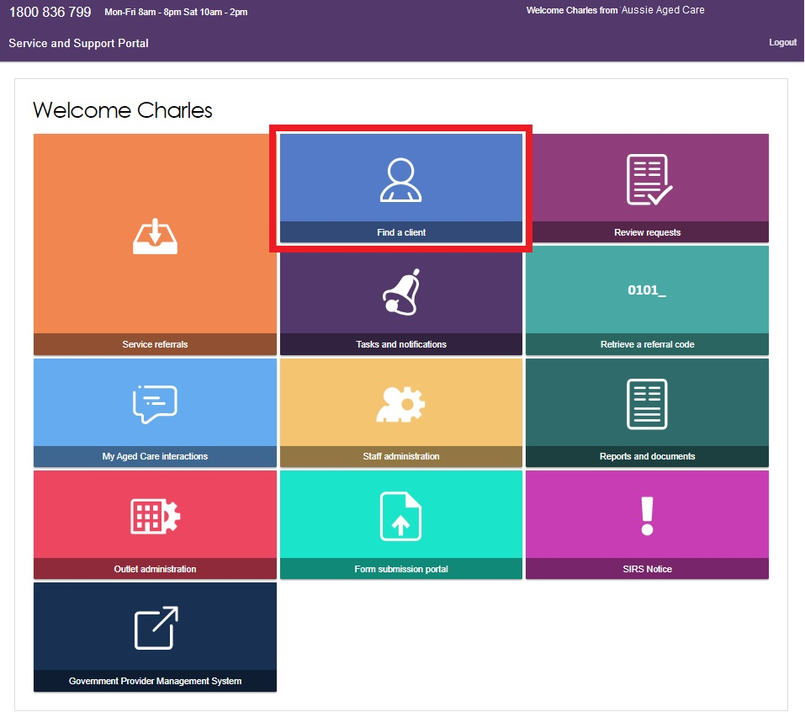
- You can do a basic search by entering First Name, Last Name or Aged Care User ID and selecting SEARCH. To display more search fields, you can select ADVANCED SEARCH.
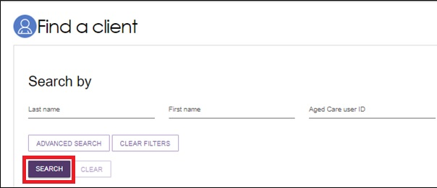
- Any recently viewed clients will be displayed under the heading Recently Viewed Persons on the Find a client page. Selecting a client’s name will take you directly to the client record.
Any matching results will be displayed.
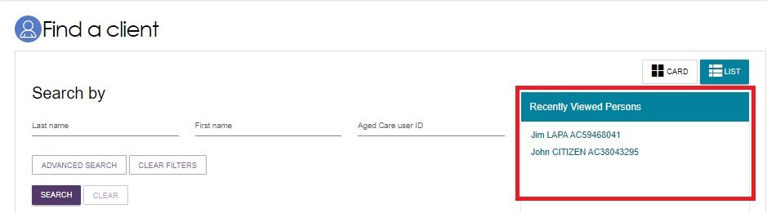
- The Advanced Search allows you to search using more filters, and to combine filters.
The filters available include:
- Aged Care Management Payment System (ACMPS) number
- Centrelink Customer Reference Number (CRN)
- Client status
- Date of birth
- Department of Veterans’ Affairs (DVA) card number
- Home contact number
- Locality
- Medicare Card number
- Postcode
- Preferred name
- State
- Suburb
- System for the Payment of Aged Residential Care (SPARC) number.
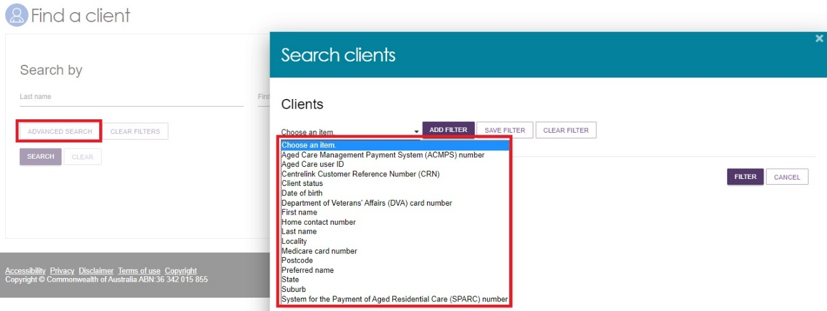

Viewing client information
Once you have located the relevant client’s details, you can view information contained in the client record.
You can view all information about a client, except their contact details, prior to accepting a referral.
- Select the client record using one of three ways.
- Select the client’s name from the list of search results.
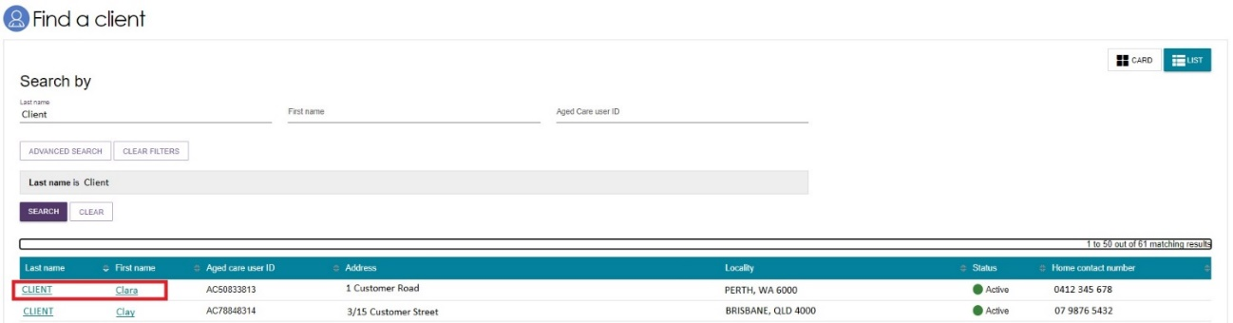
- In the Find a client section by selecting the client’s name when in card view.
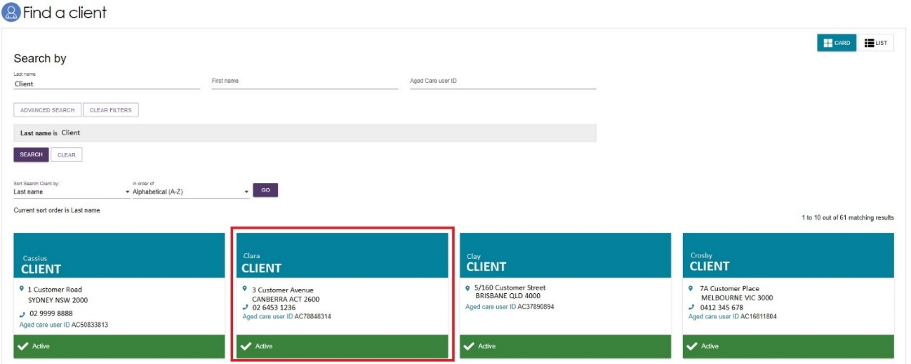
- By selecting Service referrals, selecting the expansion arrow on the client card in card view, or to the left of the expanded record in list view, and selecting VIEW CLIENT RECORD.
Card view
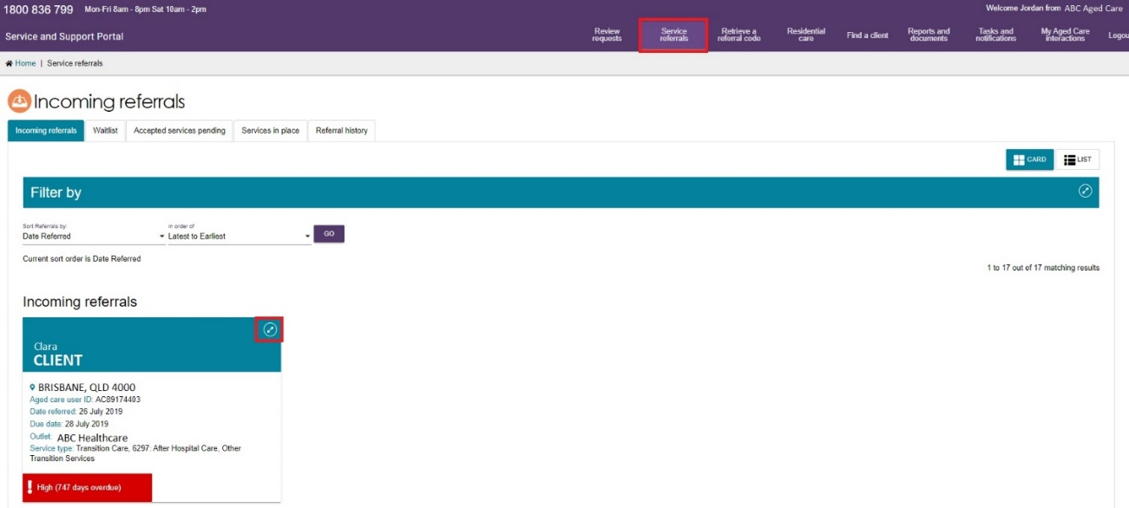
List view
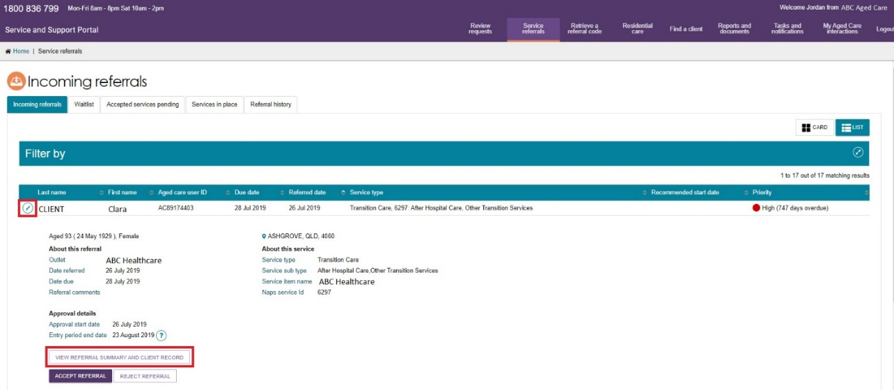
- The Referrals for my organisation page will be displayed.
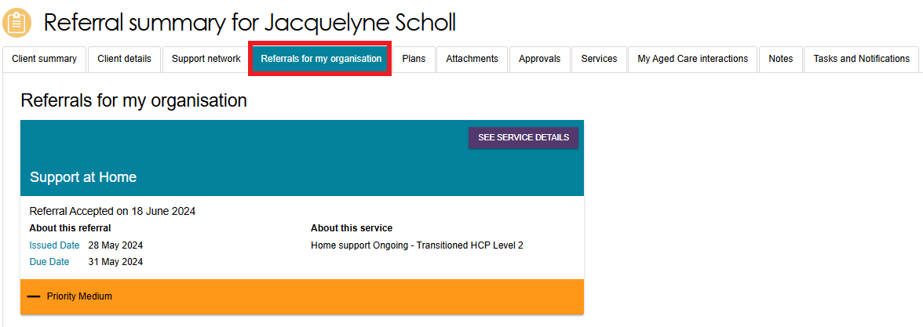

What information is in the client record?
The client record contains client information displayed across 12 tabs, which are described in more detail below.
The client record contains tabs with the following information:

- Client Summary
- Client Details
- Support network
- Referrals for my Organisation
- Plans
- Attachments
- Approvals
- Services
- My Aged Care interactions
- Notes
- Tasks and Notifications
- Residential Care.

Client Summary
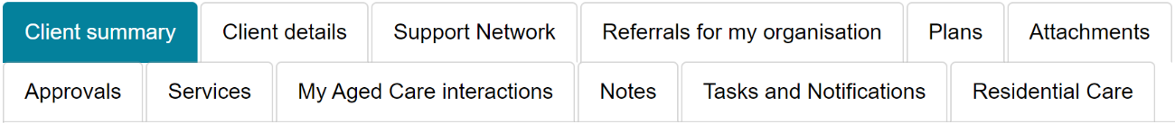
The Client summary tab contains a dashboard of key information (Client summary) about the client’s interactions with My Aged Care.
The Client summary provides information about the client’s interactions with My Aged Care, including:
- Assessments.
- Recommendations and Approvals. (For Residential Care it will also include Urgency and Priority categories)
- Service recommendations.
- Service delivery status.
- Client goals.
- Reablement and linking support periods (where available).
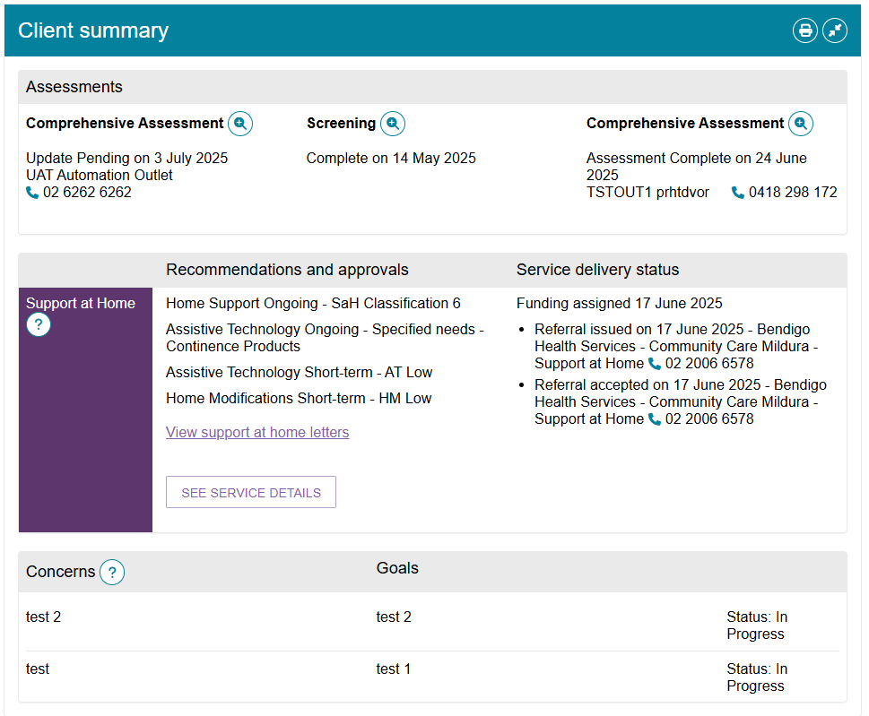
The Client summary information can be printed in a similar format as it is displayed within the portal by using the print page button on the right-hand side of each heading.
The Client summary section, like any other tabs on the client record page, can be expanded using the double arrow icon to the right of the heading.

Client Details
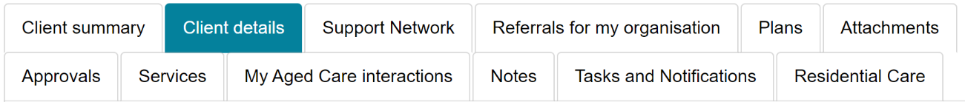
The Client details page contains basic demographic and contact information about the client. It is where you can view high-level details about any active support plans, services, current notes and the client’s primary contact details.
The page also contains an option to notify My Aged Care when the client is deceased.
The Primary contact is usually the client, but can also be nominated by the client through their agent or registered supporters. This information allows assessors, My Aged Care contact centre staff, Aged Care Specialist Officers and service providers to identify the key contact details for a client. This field does not have a bearing on system generated mail correspondence the client may receive in relation to their care.
To update client details, select the pencil icon to the right of each section where editing is available.
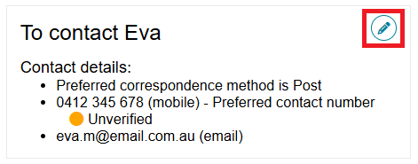
My Aged Care clients and their support network (except for Supporters Lite) can also receive email and/or SMS notifications when a client reaches the following key stages of their My Aged Care journey.
- Client registration is complete.
- The client’s assessment is finalised.
- The client is approved for care after a comprehensive assessment.
- A client is assigned a Home Support service under the Support at Home Program, and at all stages where a Home Support letter would be generated for a client, such as an assignment letter or withdrawal letter. Clients, their registered supporters who are authorised to automatically receive the client’s information, and relevant support people are automatically opted in to receive copies of Home Support letters. Registered supporters can opt out of receiving these letters by calling My Aged Care. When such a letter is generated, a notification will be sent to the affected client, authorised registered supporter and/or agent.
- A Support Plan Review request has been submitted.
- A support relationship is activated, declined, inactivated or expiring, and the submission or action of documents relating to support relationships.

! If a client’s status is Deceased, the client’s record will be read-only, and you will not be able to edit any client information. Additional notes and attachments can be attached to the client record and assessments can be finalised after the status is changed.
A banner will be displayed on all tabs of the client record indicating the client’s new deceased status If the client’s status is incorrect, please contact the Service Provider and Assessor Helpline on 1800 836 799.

Support Network
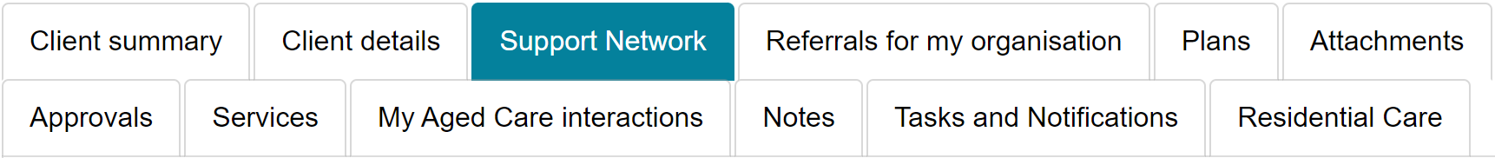
The Support Network tab contains information about current relationships between the client and people who assist them in their aged care journey.
The relationships that could be considered part of a client’s Support Network are as follows:
- Registered supporters (individuals and organisations) (and supporter ‘Lite’)
- Agents (organisations)
- Carers
- Emergency Contacts
- GPs
- Support Persons
Supporter guardians are able to opt the client out from receiving letters but they themselves cannot opt out.
The Support Network tab also allows providers to notify My Aged Care of the death of a person with a listed relationship with the client.
Any carer relationships made in the Support Network tab are able to request call backs from the Carer Gateway and the Dementia Australia - National Dementia Helpline.

Referrals for my organisation
The Referrals for my organisation tab display service referrals that have been issued to or accepted by your organisation.
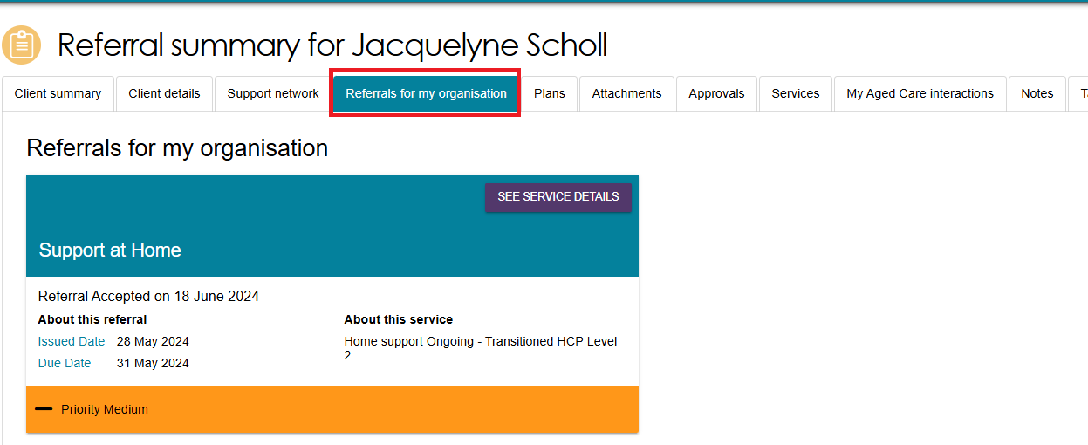
Example of a referral requiring an action:
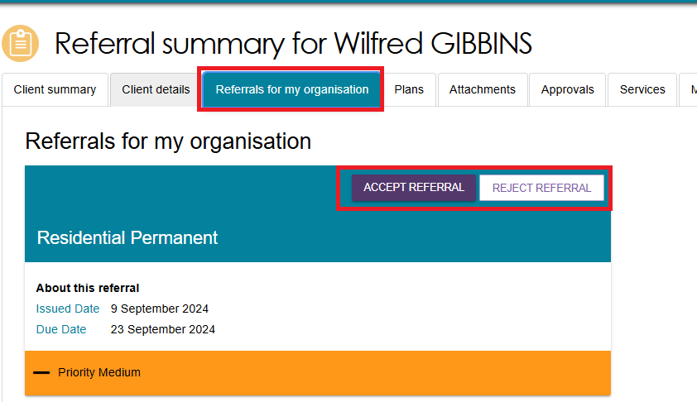

Plans
The Plans tab contains detailed information about current and previous screening and assessments the client may have had, including client goals, recommendations and motivations, as well as the support plan.
Select the double arrow icon next to each heading to display detailed information captured during the assessment.
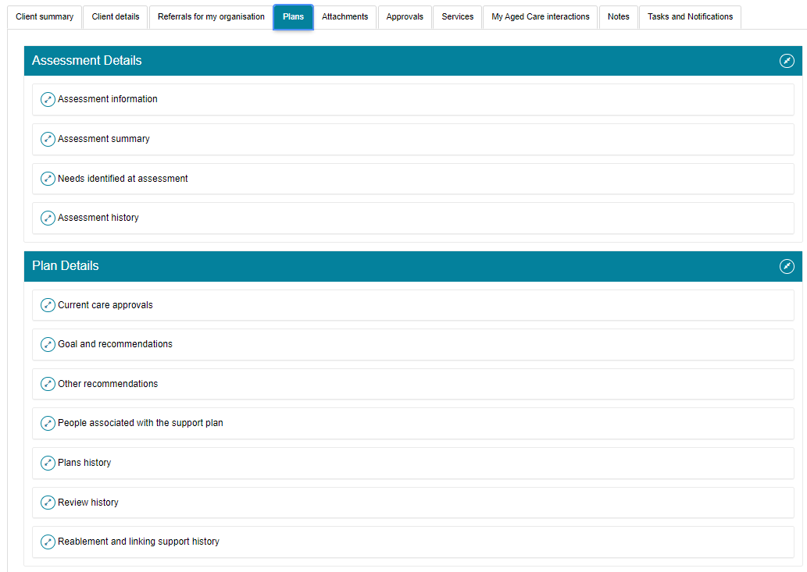
Providers will be able to access read-only versions of a client’s support plan and previous screening and assessments. This information can be printed, if required.
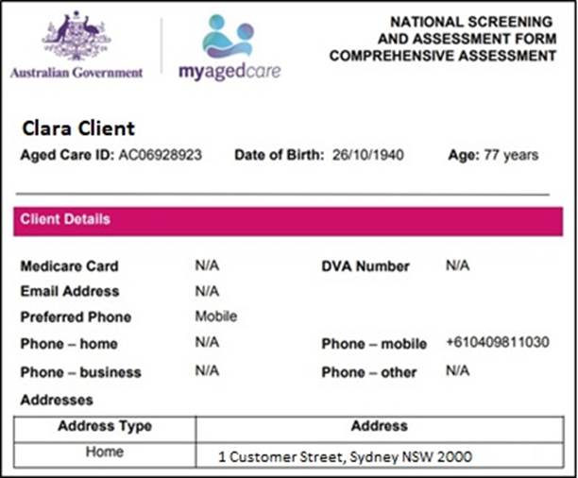

Attachments
The Attachments tab contains documents that have been attached to the client record. This is also where service providers can add an attachment to the client record.
To upload an attachment to the client record, select ADD AN ATTACHMENT from this tab.
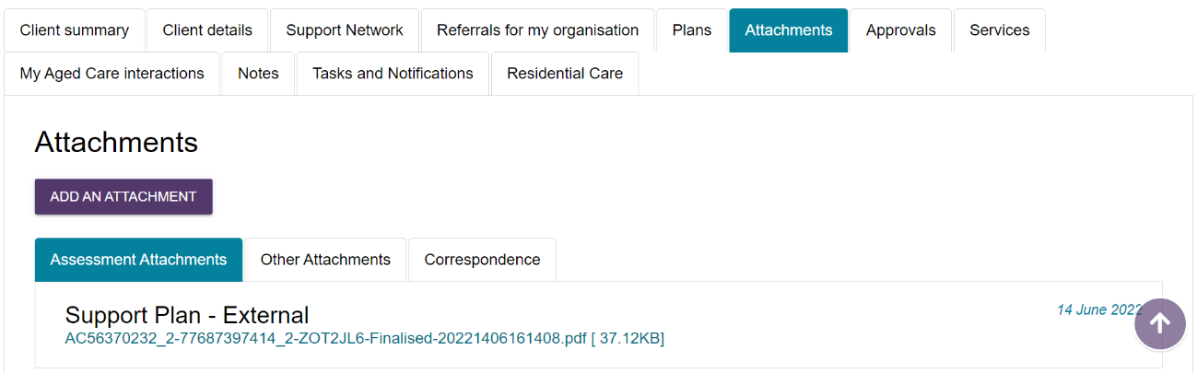
Add the attachment by selecting Browse. Enter the required information, including name of the attachment and the type of document. Select UPLOAD to add it to the client record.
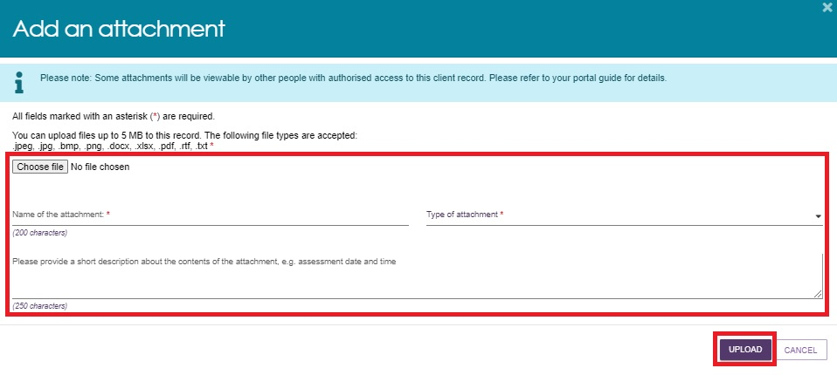
There are many types of attachments available from the Type of attachment drop down menu:
Assessment Attachments are any documents that are relevant to the client’s assessment, for example, clinical notes or a discharge summary.
Other Attachments are documents that relate to the client’s general circumstances, for instance, documents related to the establishment of a support relationship (including legal documentation and the Appointment of Support Person or Organisation Form); Occupational Therapist drawings used in home modifications, etc.
Correspondence are documents or letters that are generated in My Aged Care, related to Home Support services or Residential care services. There are a number of letters sent to clients related to these services at different stages. Copies of these letters may also be sent to their registered supporter/s.
Sensitive Attachments are documents that contain client information of a sensitive nature. For example, documents about a client’s financial situation, safety concerns and legal issues that may impact provision of services.

! Where a client record has a Sensitive Attachment, provider(s) who have received a referral for or are providing services to a client will be notified that a Sensitive Attachment exists for the client.
Contact the assessor, or the My Aged Care provider and assessor helpline to obtain further information about the Sensitive Attachment.
If an attachment has been uploaded in error, please contact the My Aged Care service provider and assessor helpline on 1800 836 799 for deletion.

Approvals
The Approvals tab contains a view of a client’s approvals for aged care services under the current Aged Care Act 2024 and the previous Aged Care Act 1997. This includes previous approvals that existed prior to the start of My Aged Care where the record has been linked with Services Australia (DHS) systems (such as Centrelink and Medicare).
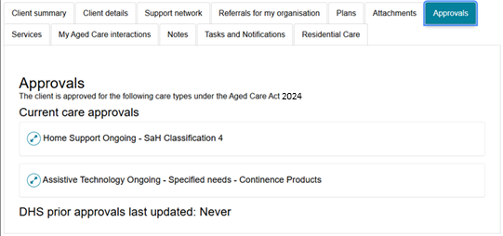
! If a client has Home Support service approval, the details of approved classifications and any short-term pathways will be displayed underneath Current care approvals.
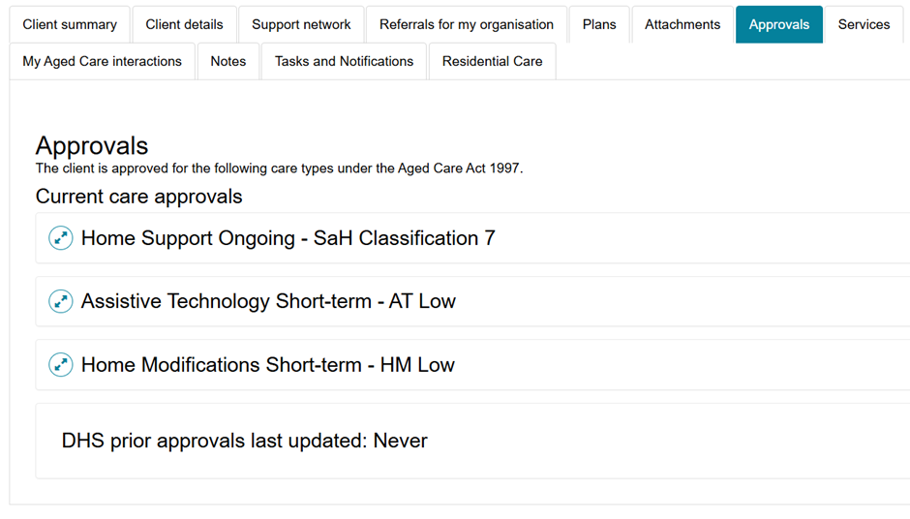

Services
The Services tab contains a record of the following. Select the expand icon  next to each item to view the details:
- Services the client is currently receiving
- Services that are pending (Not yet in place)
- Service referrals yet to be accepted
- Previous services the client has received
- Services from other systems (not managed by My Aged Care).
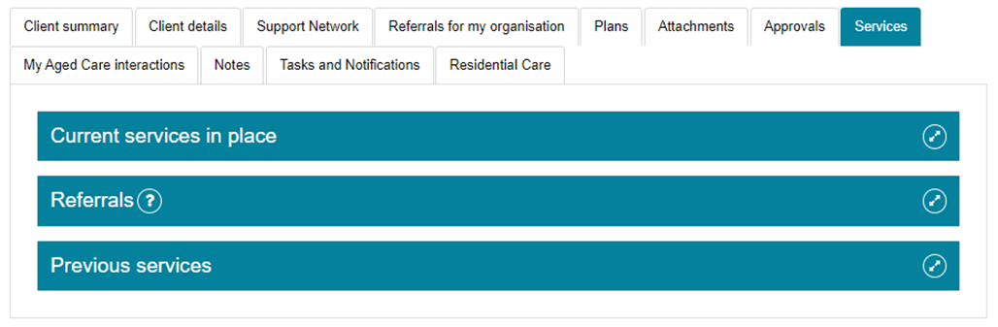
! The Update Service Information button, which allows assessors to modify service details such as start/end dates and frequency without conducting a Support Plan Review (SPR), will no longer be available for clients under the Support at Home program.
The following screenshots show an example of a client’s Residential Permanent service in place, and a Support at Home service in place.
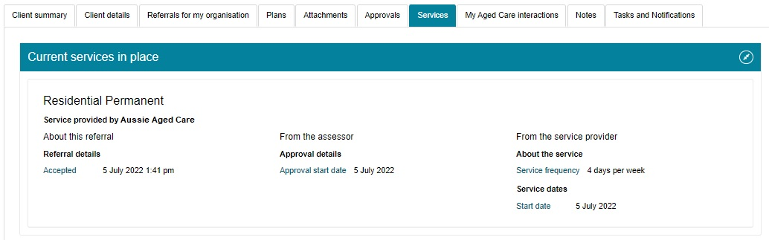
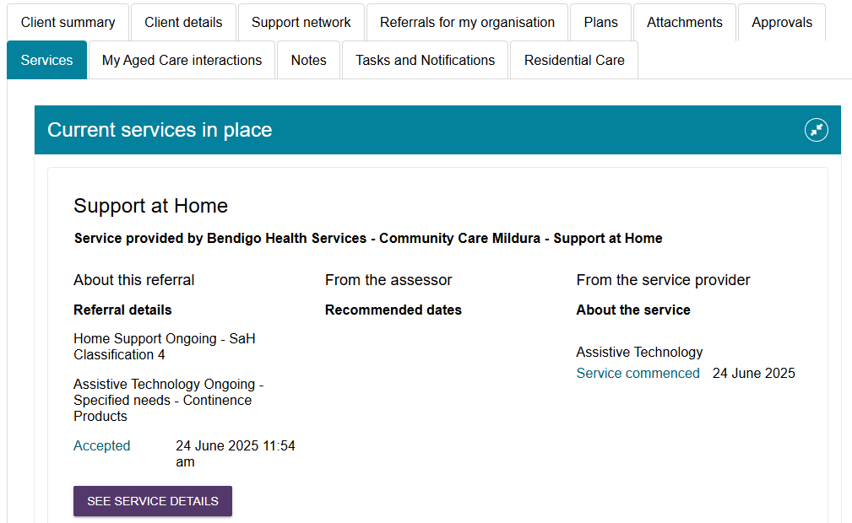

My Aged Care interactions
The My Aged Care Interactions tab will show the client’s history of interactions with My Aged Care, for example, a phone call to the My Aged Care contact centre.
For clients and carers, it may also show the history of interactions with the Carer Gateway and the National Dementia Helpline.

Notes
The Notes tab contains notes that have been created about the client.
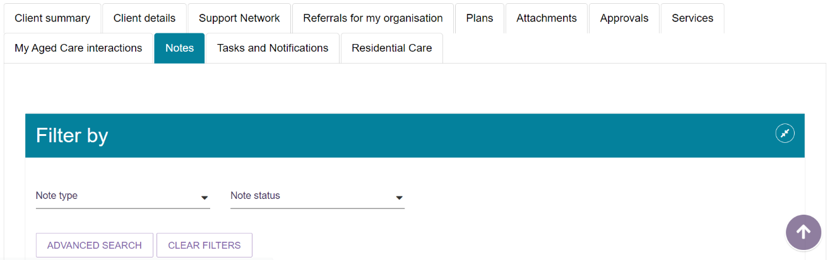
There are different types of notes, listed in the table below.
Note type | Who can add? | Who can view? | Description | Examples
Client story | Assessor | Client Assessor Provider | A summary of the client’s current circumstances. | Mrs Jones has just been discharged from hospital and is seeking help at home.  Lives with her husband and has early onset dementia.
Observations | Provider Assessor | Provider Assessor | Observations from service provider and/or assessors’ interactions with the client. | There is a dog on the property.  Mrs Smith seems more energetic than she did during my last visit.
Other | Client Provider Assessor | Client Provider Assessor | Additional information about the client. | Jennifer has planned respite on 01/08/2017.
! When the My Aged Care contact centre staff or assessors add a Sensitive note about a client from their respective portals, all service providers who are sent a referral will see a flag informing them that there is a sensitive note about the client and instructing them to call the My Aged Care contact centre for more information.

Viewing and adding client notes
Follow these steps to add client notes:
- Navigate to the Notes tab from the client record.
- From the Notes tabs, you can view notes about the client, and select ADD A NOTE.
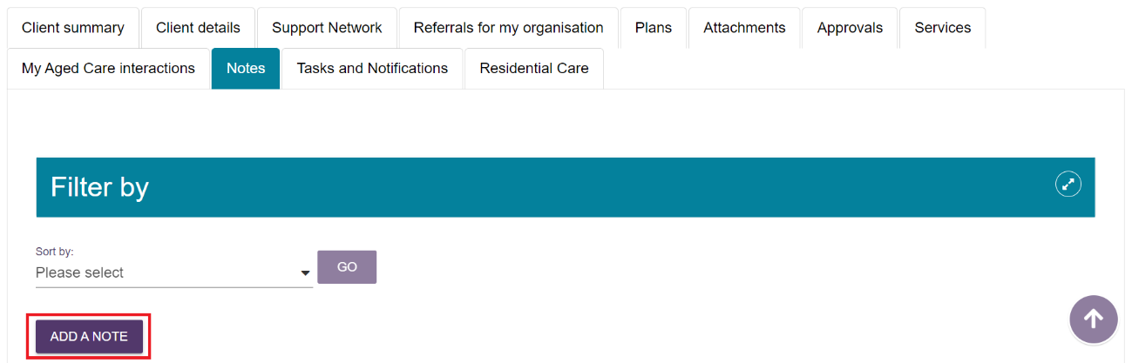
- From the pop-up box, select a note type, and add a description of the note. Select SAVE once complete.
A help icon in the pop-up box provides information about the different types of notes to help assessors and service providers select the appropriate category.
Providers, staff members and team leaders using the Service and Support Portal cannot edit, delete or inactivate notes.

Tasks and notifications
The Tasks and Notifications tab will display all tasks and notifications for a single client.
You will only be able to see tasks and notifications that are associated to your outlet and for clients you are providing services to.
Assessors will be able to see all tasks and notifications for clients.
An example of a notification is of a New Referral between a client and their Service and Support outlet.
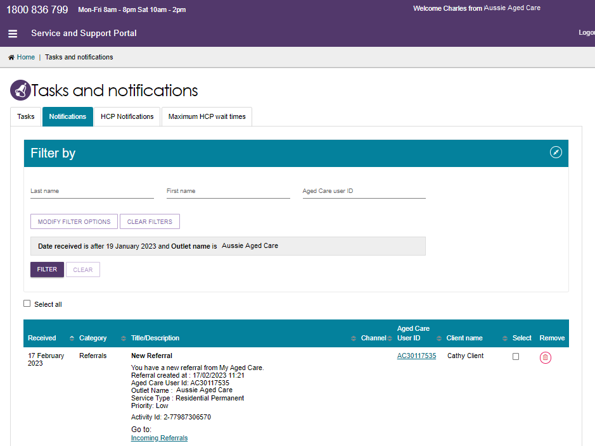

Residential Care
This section shows information for clients who are in Residential Permanent Care or Residential Respite Care and has received an Australian National Aged Care Classification (AN-ACC) assessment or is currently undergoing an AN-ACC assessment.
For more information refer to the department’s Residential aged care funding reform website.
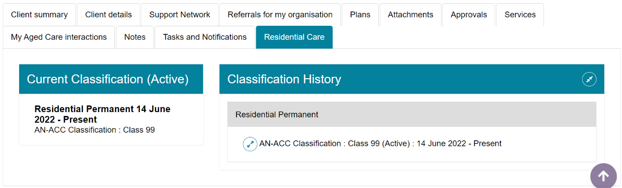

For more information or support
Further information is available from the My Aged Care for service providers page on the Department’s website.
The My Aged Care service provider and assessor helpline is available by calling 1800 836 799 from 8 am to 8 pm Monday to Friday or 10 am to 2 pm on Saturday.

