Service and Support Portal User Guide – Tasks and Notifications
The My Aged Care Service and Support Portal includes a tasks and notifications feature to inform users and prompt action.
The first part of this guide explains the how to view and action tasks and notifications.
An Administrator can also configure preferences for email alerts.
The final section of this guide let Administrators know how to manage and update task and notification preferences for their outlet or organisation.
Table of contents

What is the difference between a Task and a Notification? 2
Viewing and actioning tasks 2
Viewing notifications 4
Managing task and notification preferences 8
For more information and support 10

What is the difference between a Task and a Notification?
A task is an activity that a provider needs to action (finalise or close), for example a task reminding a team leader to action an overdue referral.
A notification is an activity that informs the provider of an event, for example when a new referral is received by an outlet. The provider may need to complete an action as a result of the notification.
All staff with access to the Service and Support portal will have access to view tasks and notifications.
! | You will receive a notification when a client’s status has changed to ‘Deceased'.  You should review the client record to see if further action is required, for example you may need to close or finalise any active referrals or cease services for the client.

Viewing and actioning tasks
- From the Portal homepage select Tasks and notifications.
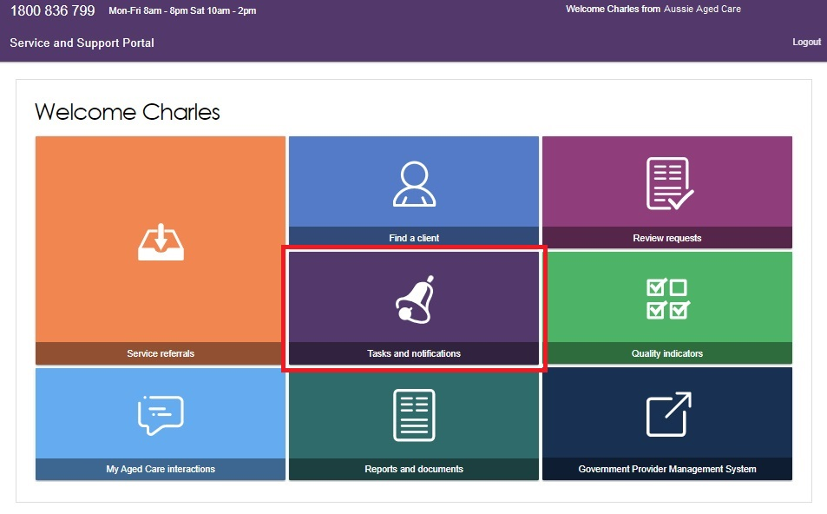
- The Tasks tab will open by default.
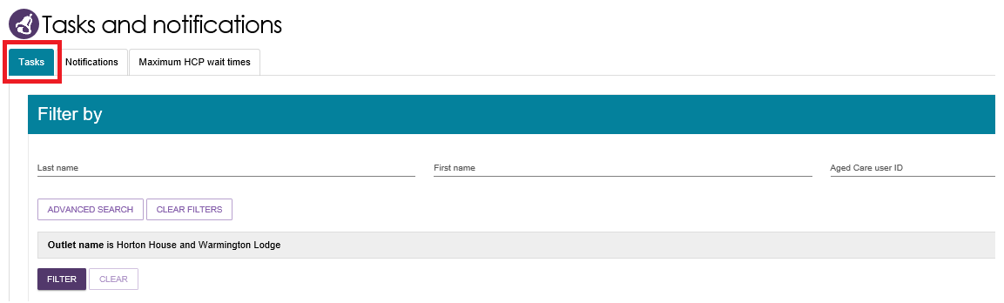

In the Tasks tab, you will be able to view all tasks that are relevant to your role. You can sort tasks by:
- Received
- Category
- Title/Description
- Aged Care User ID
- Client name
- Activity ID
! | Tasks that have been marked as important for your outlet by your outlet administrator will be displayed with a visual indicator.  See Managing task and notification preferences for more information.
Alternatively, if you want to see all tasks and notifications for a single client, navigate to the Tasks and Notifications tab in the client’s record to see all relevant tasks and notifications for that client.
You will only be able to see tasks and notifications that are associated to your outlet and for clients you are providing services to.
Assessors will be able to see all tasks and notifications for clients.
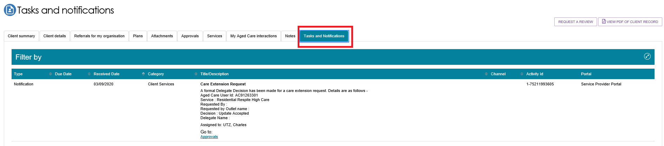
- You can search for specific tasks using the filter options or using custom filters in Advanced Search.
Select the arrows to the right to expand or collapse the filter options.
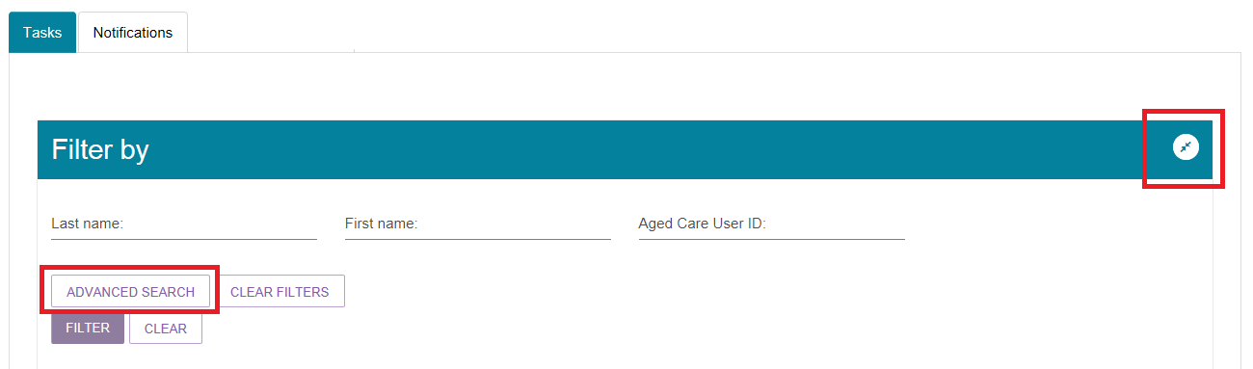

To apply custom filters, select ADVANCED SEARCH and choose filters from the drop-down menu and select ADD FILTER for each filter you want to apply.
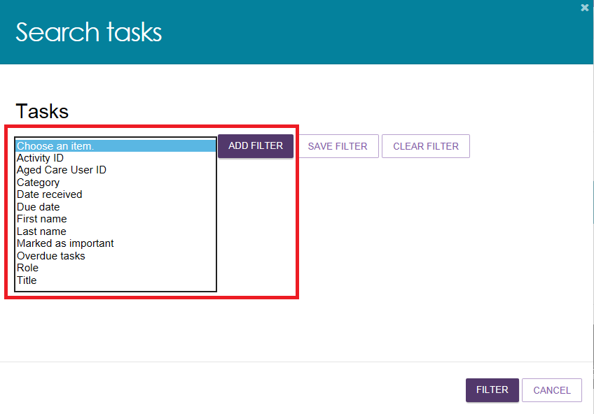
The hyperlink under the task description will take you directly to the individual record and the section of the portal where you can action the task.
Alternatively, you can navigate to the client’s record by selecting the client’s Aged Care User ID from the tasks list.
For example, selecting the link in an Overdue referral task will take you directly to the Incoming referrals tab where you can review the referral and determine whether to accept or reject the referral or place the client onto a waitlist, where appropriate.
Once the action required from the task has been completed, the task will automatically be removed from your task list.

Viewing notifications
- From the portal homepage select Tasks and notifications and select the Notifications tab.
- In the Notifications tab, you will be able to view notifications from the last 30 days that are relevant to your role. Any notifications older than 30 days will be removed and will no longer be visible in the portal.
The earliest date that the notifications are displayed from is visible under the filter options.
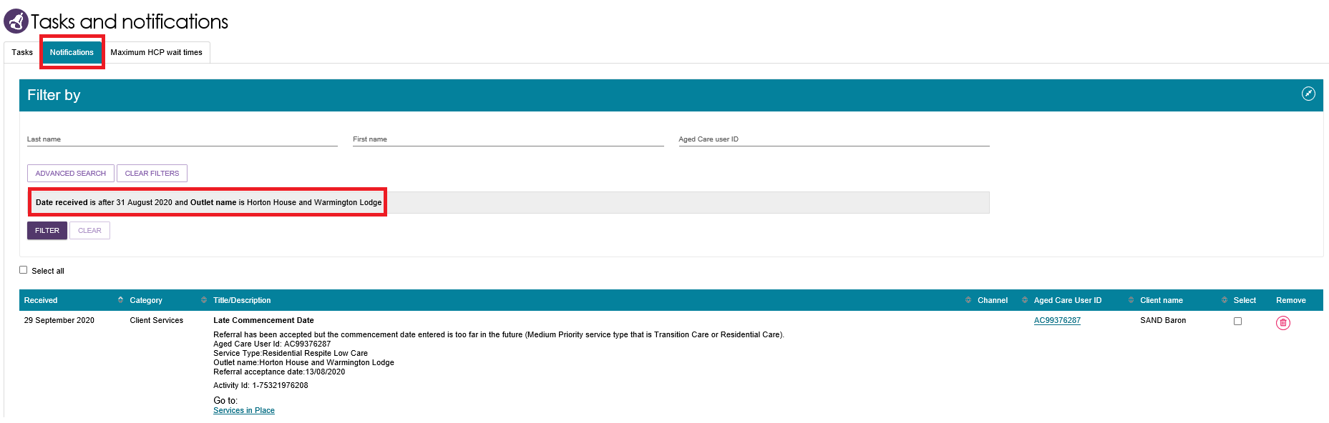
Alternatively, if you want to see all tasks and notifications for a single client, navigate to the Tasks and Notifications tab in the client’s record to see all relevant tasks and notifications for that client.
You will only be able to see tasks and notifications that are associated to your outlet and for clients you are providing services to. Assessors will be able to see all tasks and notifications for clients.
In the Notifications tab, you can sort notifications by:
- Received date
- Category (activity subtype)
- Title/Description
- Aged Care User ID
- Client name
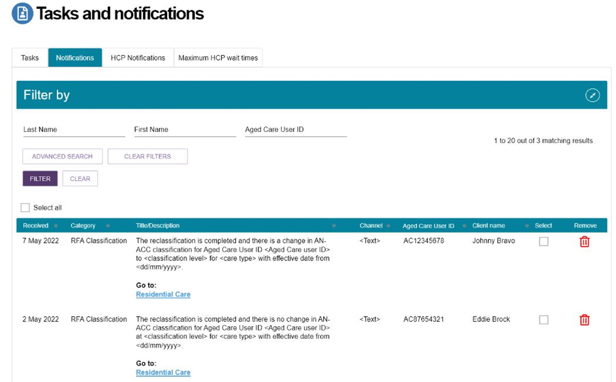
! | Notifications that have been marked as important for your outlet by your outlet administrator will be displayed with a visual indicator.  The managing preferences section in this guide explains how to set notifications as important.  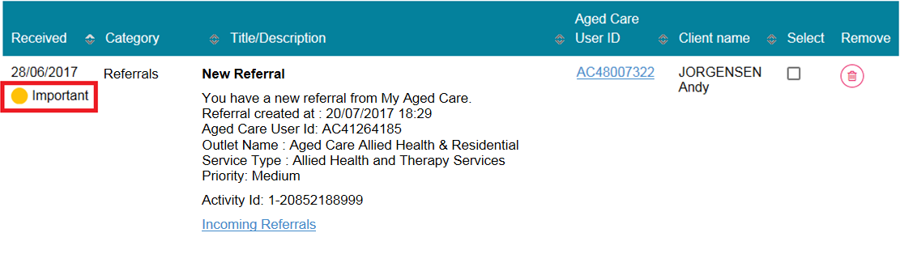
- You can also remove individual or bulk notifications from your portal by selecting the Remove icon, then select ACCEPT.
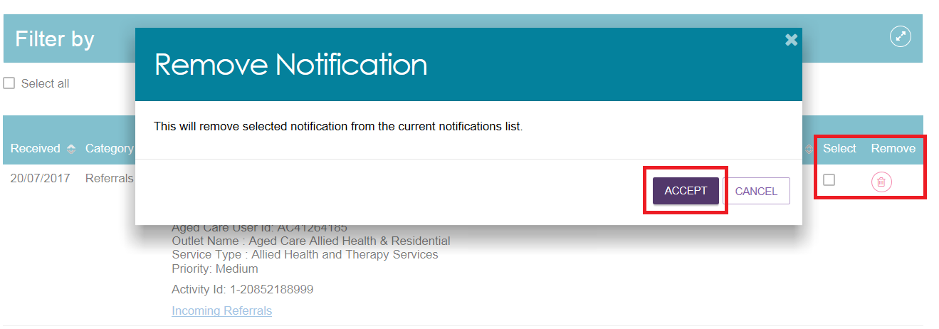

- You can search for specific notifications using the filter options or using custom filters in Advanced Search.
Select the arrows to the right to expand or collapse the filter options.
To apply custom filters, select ADVANCED SEARCH and choose filters from the drop-down menu.
Select ADD FILTER for each filter you want to apply.
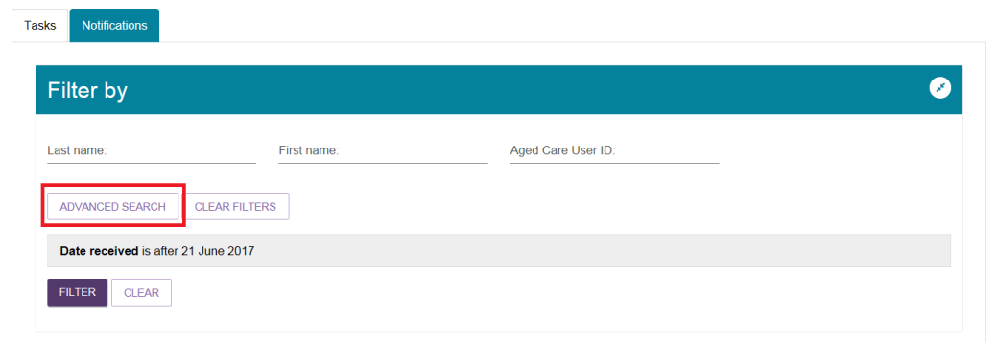
- The hyperlink under the notification description will take you directly to the individual record and the section of the portal where you can view more information about the notification or complete any action that may be required.
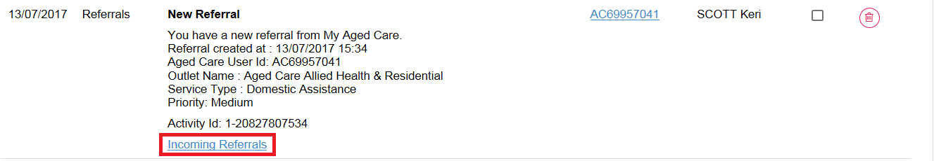
For example, selecting the link in a New referral notification will take you directly to the Incoming referrals tab where you can view and action the new referral.
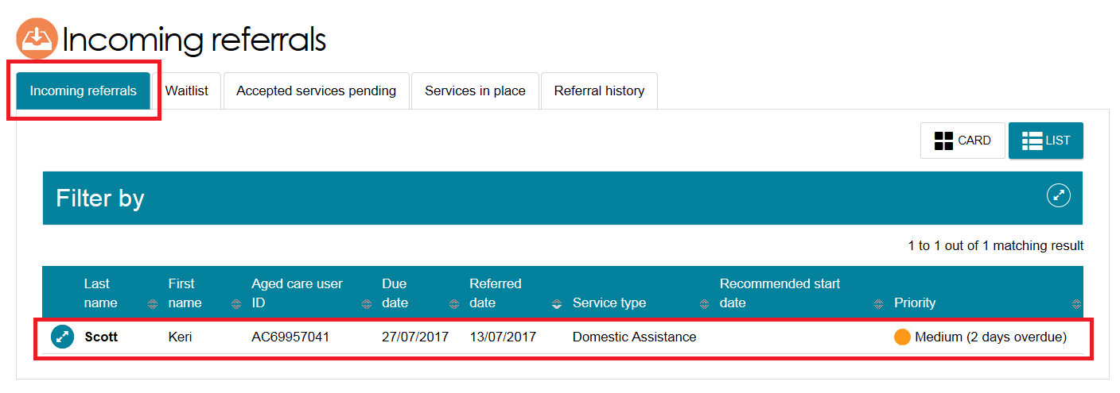

Managing task and notification preferences
You must be an Administrator to manage task and notification preferences for your organisation or outlet. If you need to add this role to your user account, please see your organisation administrator.
As an administrator, you will be able to:
- edit email address and email frequency for new task and notifications
- turn off visibility of notifications in the assessor portal
- view descriptions of each task and notification, including which user types will be able to see them
- edit individual task and notification preferences
- mark a task or notification as important to your outlet.
These settings will affect all staff assigned to your outlet, so please ensure all staff are made aware of any changes you make.
- From the Service and Support portal homepage select Tasks and notifications.
- Select the Manage Preferences tab for your outlet, then the Change Preferences button.
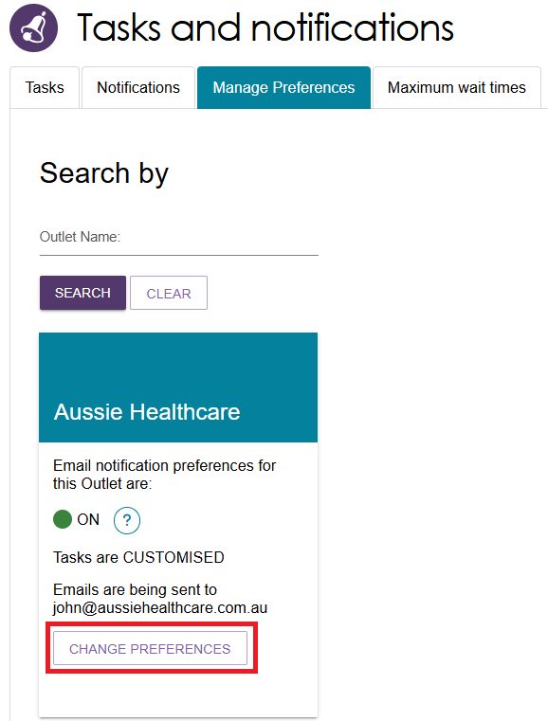
! | If you are the Organisation Administrator, you will be able to select which outlet you want to configure task and notification preferences for.  If you are the Outlet Administrator, you will only be able to see your outlet’s preferences.
- The preferences page for the outlet will open. At the top of the page, you can configure the overall preferences for email preference, email address, email frequency and notification visibility in the portal.
You can choose to hide all notifications or hide individual notification types for the outlet.
Selecting No to hide all means that no notifications for the outlet will be visible to staff associated with the outlet.
Selecting No for an individual notification type means that only notifications of that type will be hidden for staff associated with the outlet.
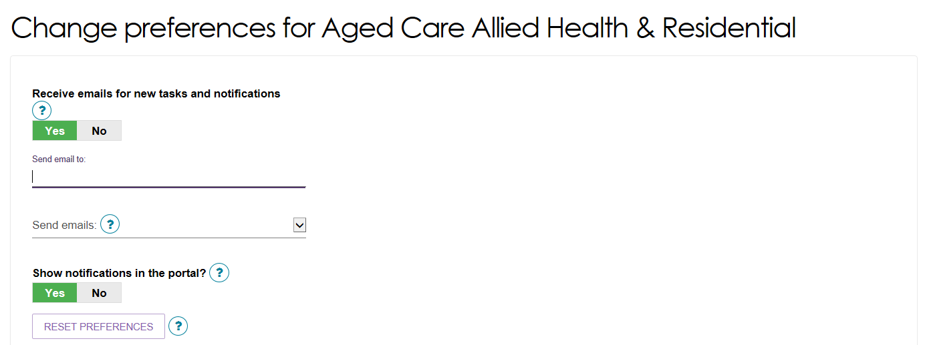
- Tasks and notifications are sorted by category. Select the expander (double arrow) icon to expand or collapse each category.
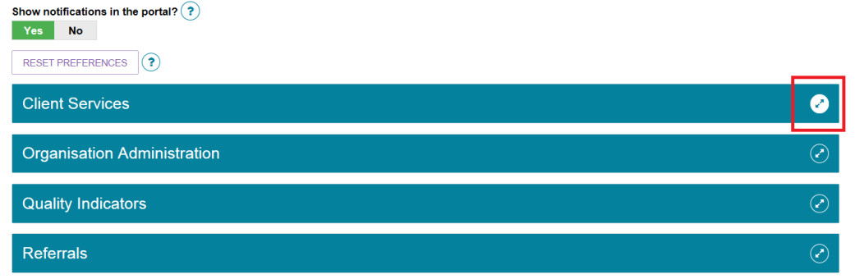
For each task or notification you will be able to view:
- Type (e.g. task or notification).
- Title and brief description of the why the task or notification has triggered.
- User type who can view or action the task or notification.

For each task or notification you will be able to individually configure:
- Whether to send an email when a task or notification generates.
- Frequency of email notification, if enabled.
- Whether to display a task or notification as important in the portal.
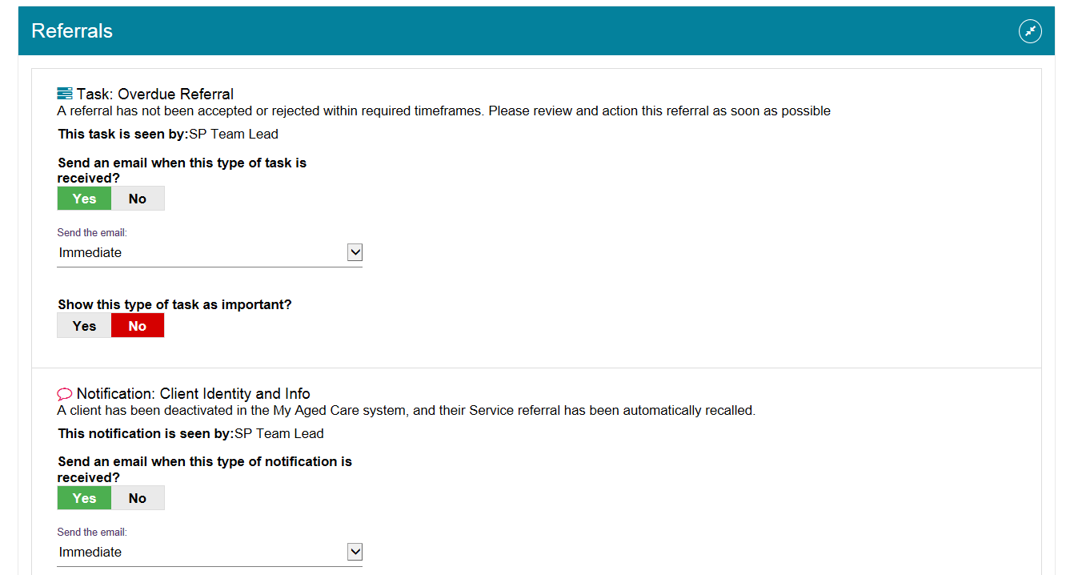
If you choose to mark a task or notification as important, staff within your outlet who can view that particular task/notification will see a visual indicator in their portal.
For example, a notification of home care correspondence.
- Select SAVE when all changes have been made. You can reset the preferences by selecting RESET PREFERENCES at the top of the page.
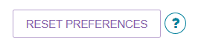

For more information and support
Further information is available from the My Aged Care for service providers website.
If you require further assistance, please contact the My Aged Care Service Provider and Assessor helpline on 1800 836 799, Monday to Friday (8am to 8pm) and Saturday (10am to 2pm) local time across Australia.

