Assessor Portal User Guide –
Residential Respite Classification Referrals
(for assessment organisation Team Leaders)
This user guide outlines how assessment organisation team leaders interact with the My Aged Care assessor portal (assessor portal) to manage Residential Respite Classification referrals (referrals).
This user guide does not contain detailed instructions on functions that assessment organisations perform. Those activities are described in the Aged Care Assessor Application User Guide.
Table of contents
Privacy requirements 2
Assessment organisation team leader view for Residential Respite Classification referrals 2
Accepting Referrals 4
Assigning Referrals 5
Rejecting Referrals 7
Transferring Referrals 8
Clients who are in Hospital or in the community/home 9
Clients who are in a Residential Service Facility 11
Reassigning Referrals 13
Viewing Historical Residential Funding Referrals 14
Viewing Progress of Respite Classification Assessments 15

Privacy requirements
Assessment organisations are required to comply with the legislative requirements under the Privacy Act 1988 (Privacy Act), including the Australian Privacy Principles when using the assessor portal. The Privacy Act regulates personal information about individuals, including the collection, use, storage and disclosure of personal information, and access to and correction of that information.
For aged care needs assessors (assessors), information collected on My Aged Care for purposes of assessment is also subject to the Aged Care Act 2024 (Aged Care Act) which they operate under while carrying out their assessment functions.
For more information refer to the My Aged Care Assessment Manual.

Assessment organisation team leader view for Residential Respite Classification referrals
- Select the Residential Funding Referrals tile from the assessor portal home page.
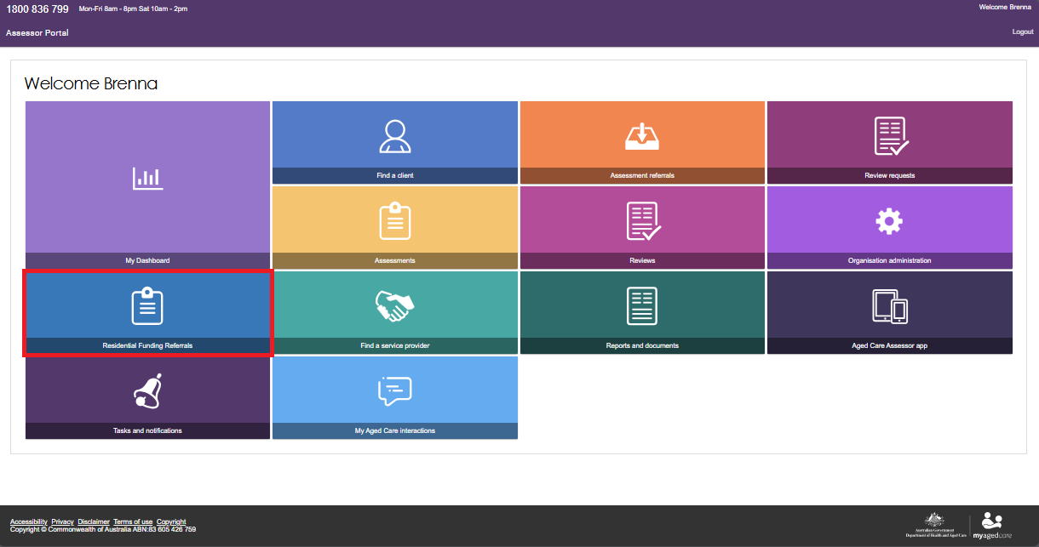
If you are a team lead of both a Residential Funding and assessment organisation outlet, you will be asked to select which outlets referrals you would like to view.
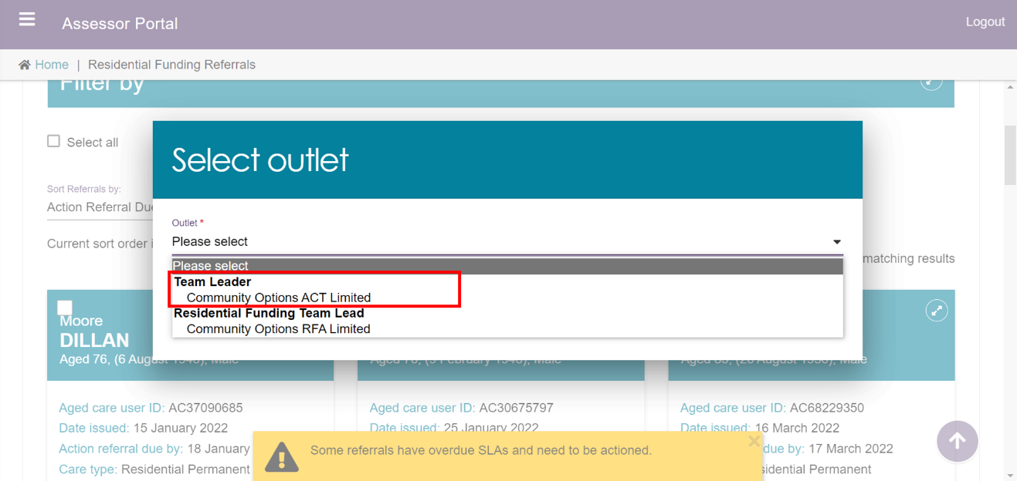
The Incoming referrals tab will be displayed. Scroll down the page to view all the incoming referrals for the organisation/outlet.
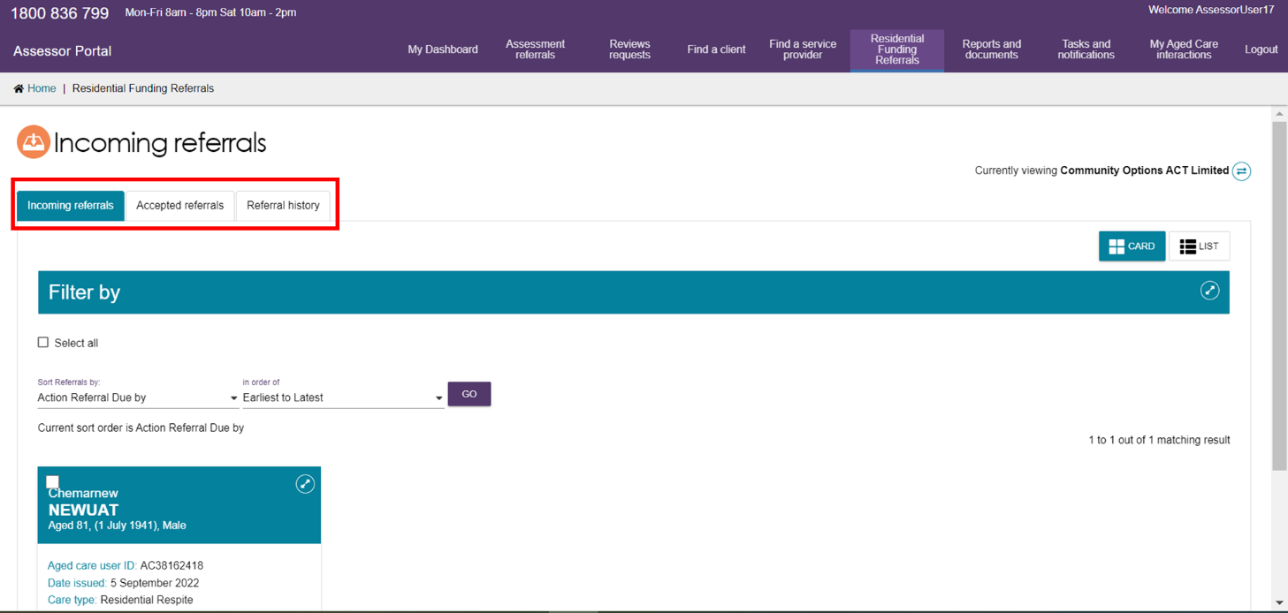
- Advanced searches can also be conducted to refine the list of referrals by selecting the Advanced Search button.
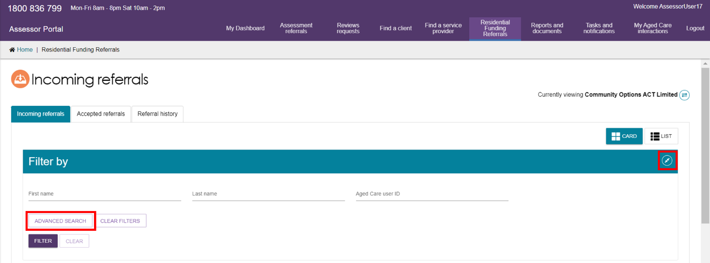
A pop-up will open which will allow you to select from a drop-down list of filters for the list of incoming referrals. To further refine the results, multiple filters can be applied.
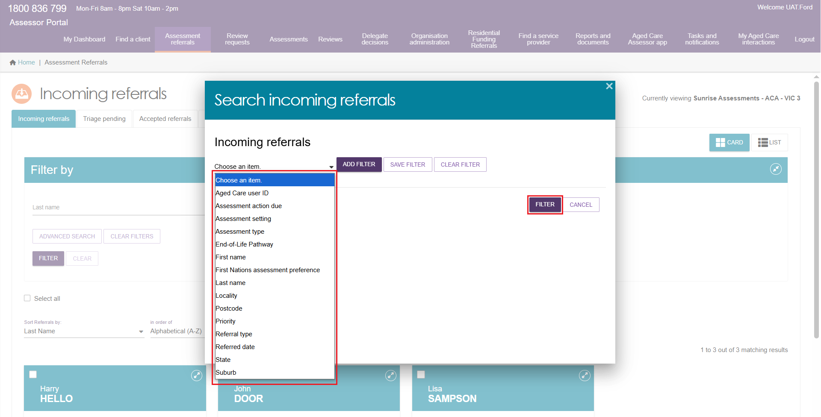

Accepting Referrals
- Select the Residential Funding Referrals tile from the assessor portal home page.
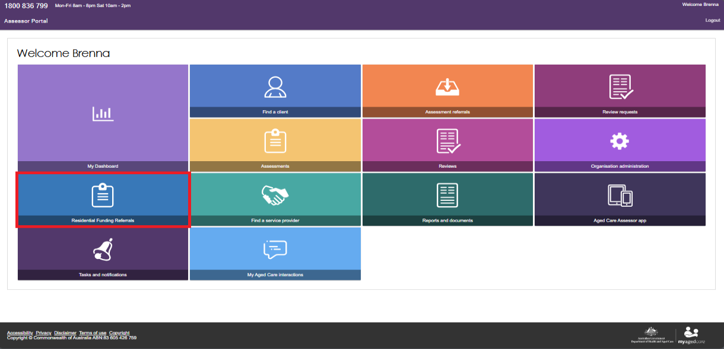
- Navigate to the Incoming Referrals tab. You can conduct a basic search or an advanced search to refine the list of incoming referrals.
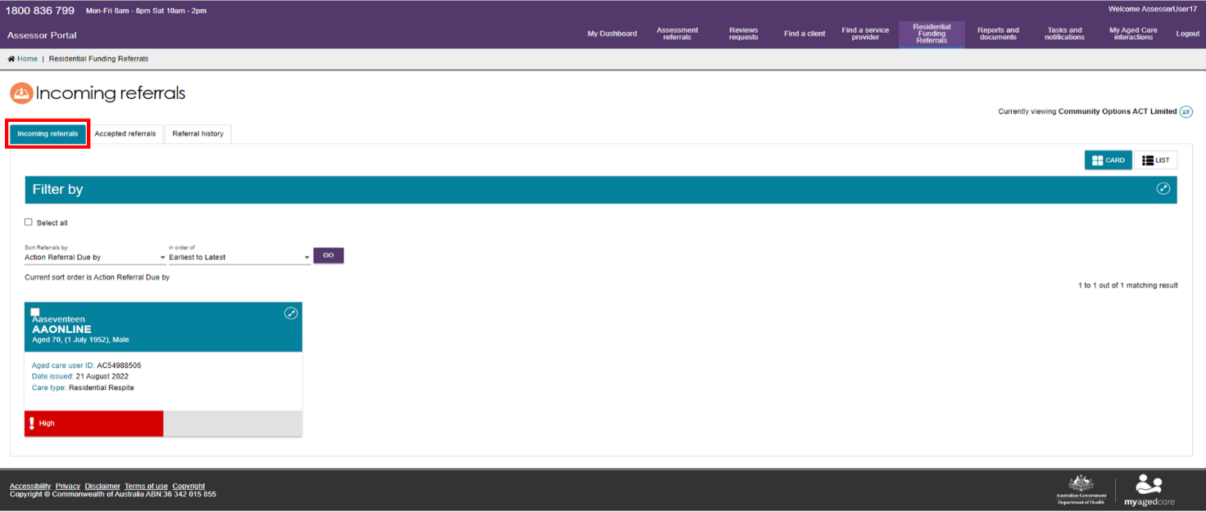
- To bulk accept referrals, select the tick box on the upper left-hand side of the client tile for the clients whose referrals you wish to accept and select the Accept button. You can also accept a referral for only one client. Referrals selected in bulk will need to be assigned to assessors from the Accepted referrals tab.
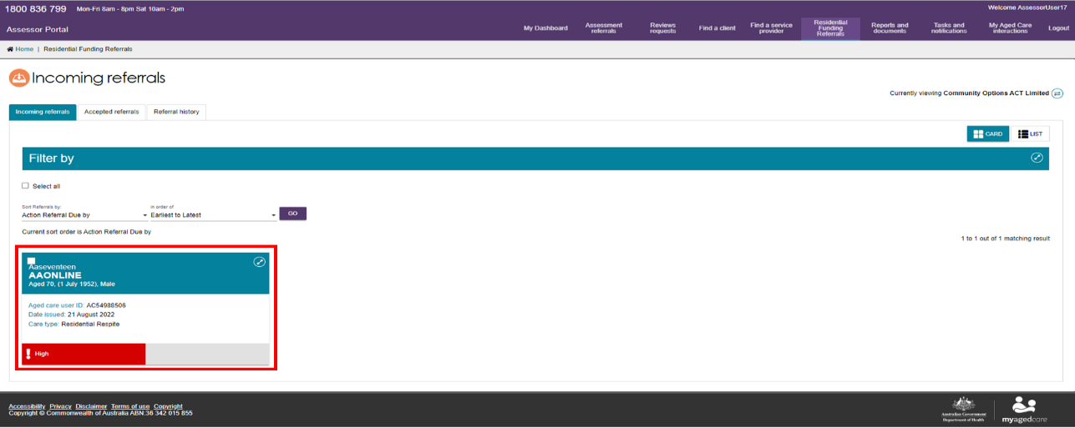
- When accepting a referral for a single client, a pop-up box will appear confirming the client whose referral you wish to accept.
Once you have confirmed, select the Accept button.
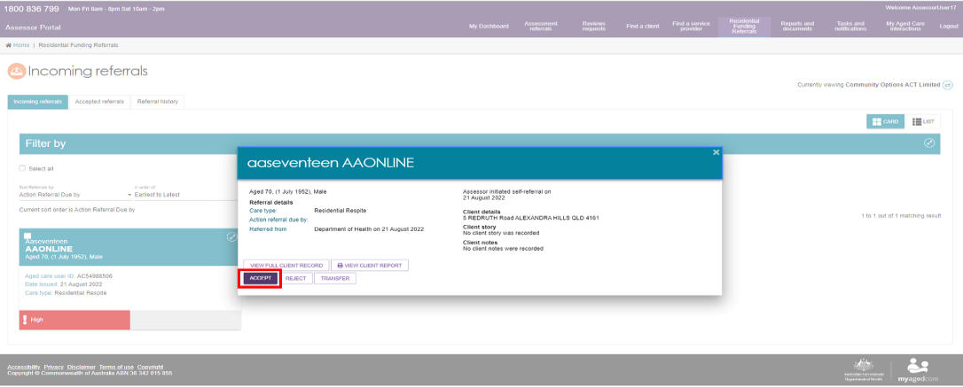
The referral will now be in an Accepted or Assigned state and will be visible on the Accepted Referrals tab.

Assigning Referrals
Assessment organisation team leads can assign referrals to assessors.
- From the assessor portal home page, select the Residential Funding Referrals tile.
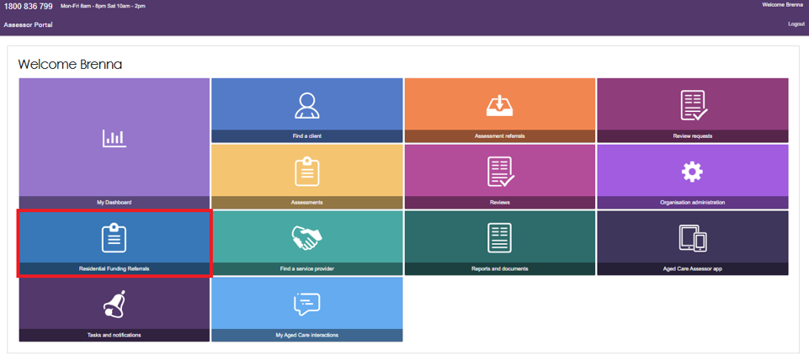
- Navigate to the Accepted Referrals tab. You can filter the list of referrals or conduct an advanced search to refine the list of unassigned referrals.
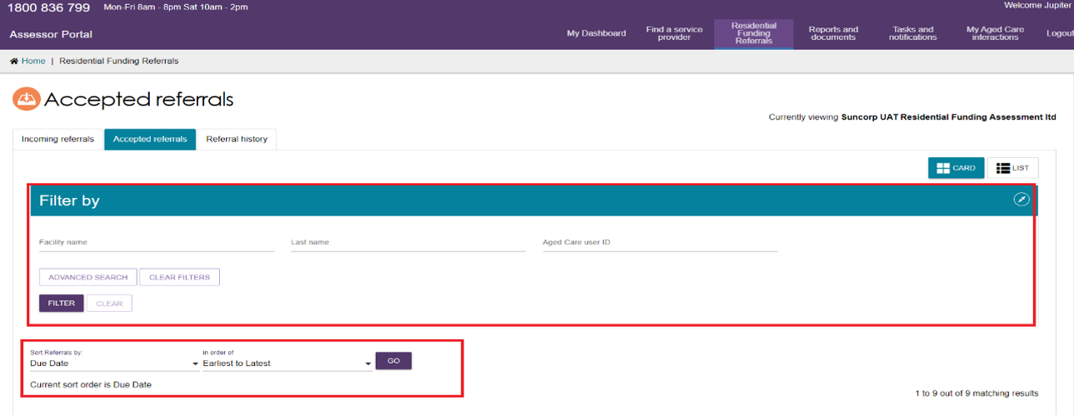
- Select the referral you wish to assign from the unassigned list of referrals.
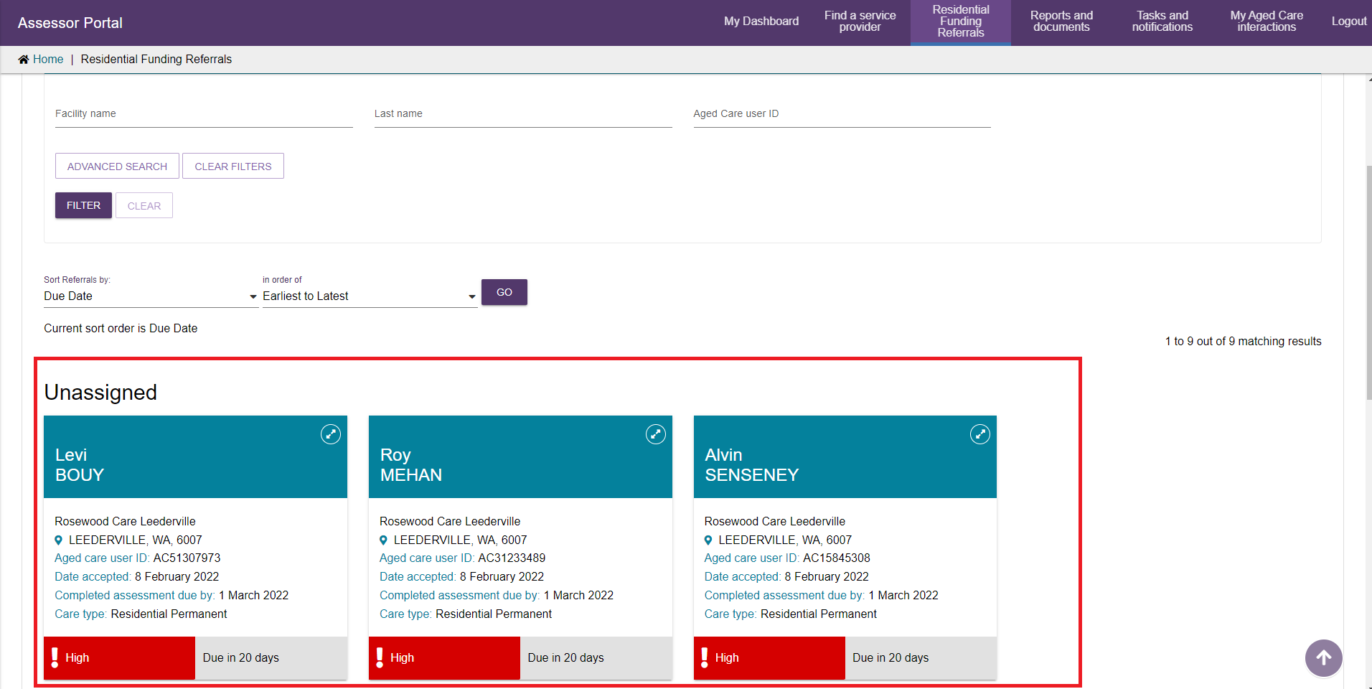
- A pop-up will appear, select the assign button.
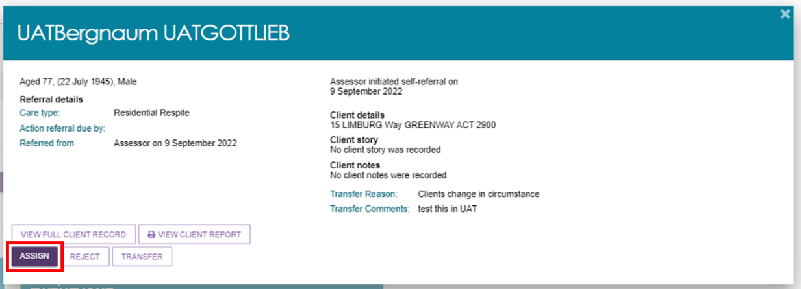
- A pop-up will appear, select the assessor that the referral will be assigned to and select the assign button.
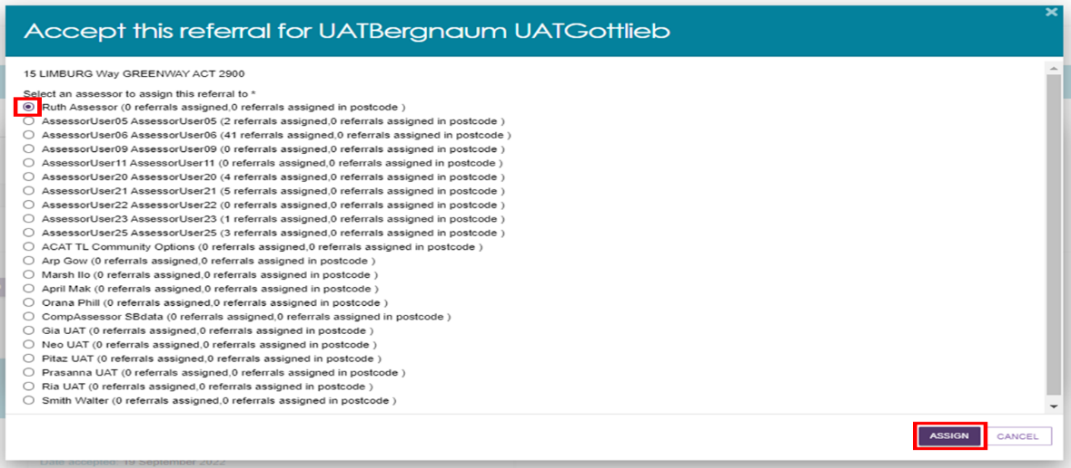
The referral will now be assigned to the assessor selected.

Rejecting Referrals
Assessment organisation team leaders can reject referrals that are both incoming and assigned.
- From the assessor portal home page, select the Residential Funding Referrals tile.
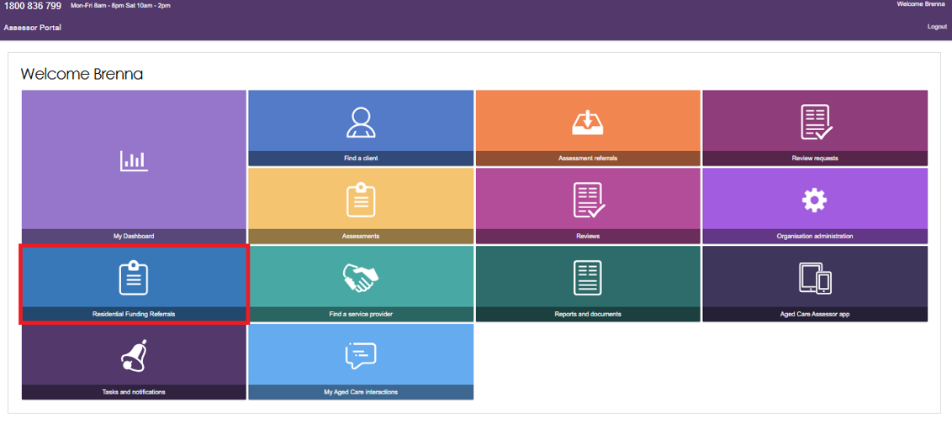
- Select the referral you wish to reject.
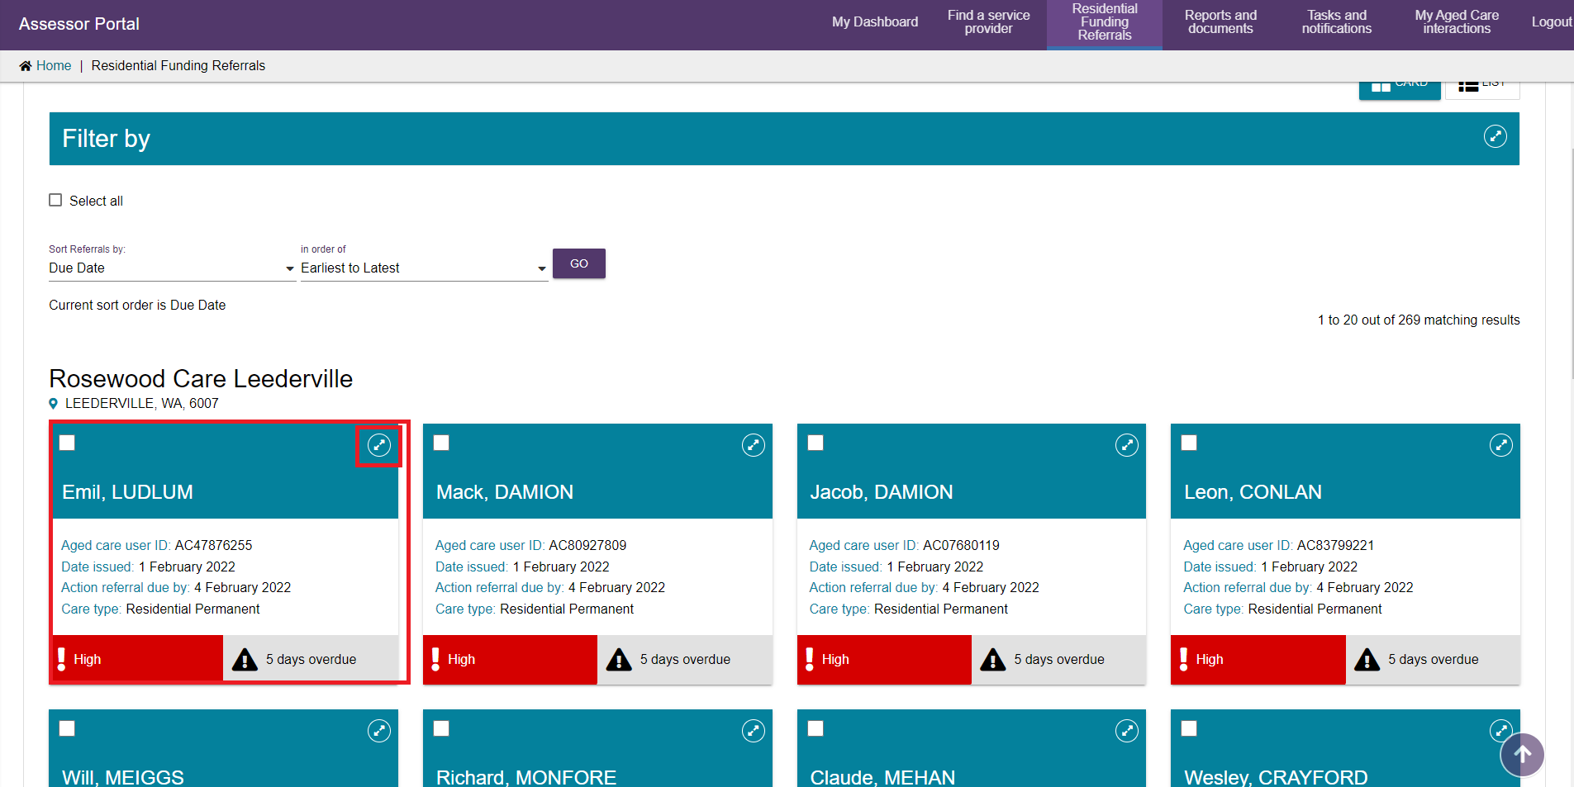
- A pop-up will appear. Confirm this is the referral you wish to reject and select the reject button.
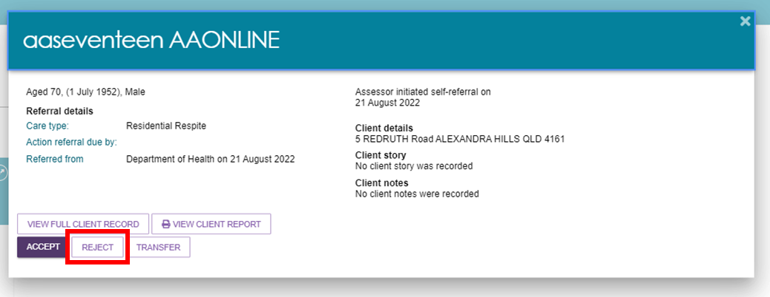
- A pop-up will appear, select the reason for the referral rejection and provide details in the free text field. Referrals can be rejected for the following reasons:
- Client Deceased: You will be required to provide additional information in regards to the circumstances that surround the client.
- Entered a Residential Facility: This will transfer the referral to a residential aged care funding assessor, please refer to Transferring Referrals for guidance.
- Outlet Insufficient Capacity: This will transfer the referral back to the department to assign to another outlet.
- Other: Additional details will be required.
Additional details can be provided in the Details text box.
Once complete, select the reject button.
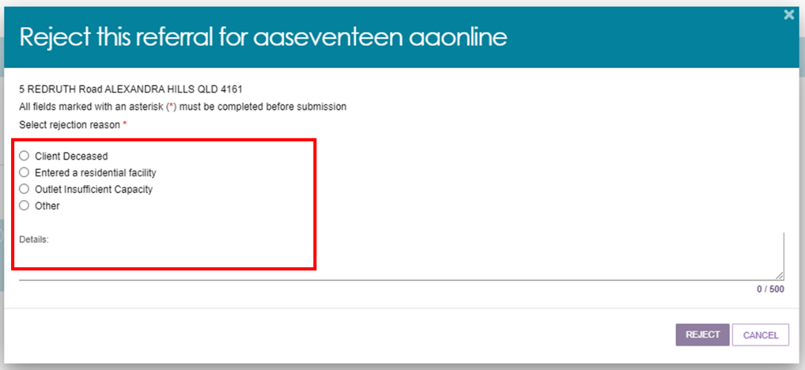

Transferring Referrals
Assessment organisation team leaders are able to transfer referrals that are both incoming and assigned.
- From the assessor portal home page, select the Residential Funding Referrals tile.
Select the referral you wish to transfer.
- A pop-up will appear. Confirm this is the referral you wish to transfer and select the Transfer button.
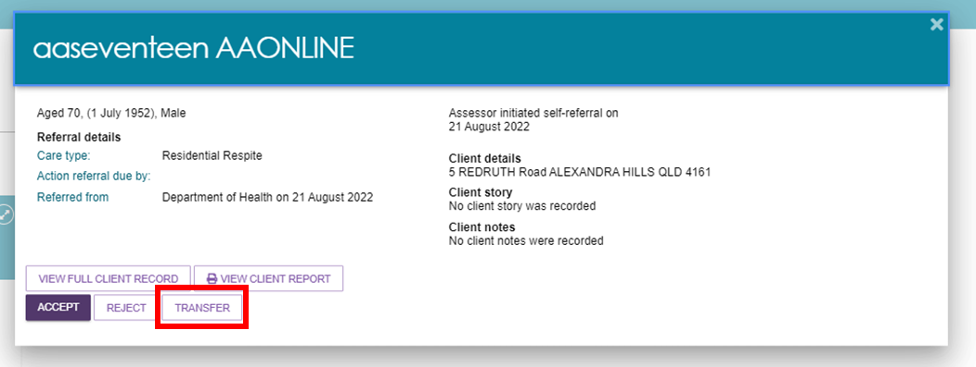
Referrals can be transferred to another assessment organisation outlet or to an RFA outlet where the client has entered a Residential Service facility.

Clients who are in Hospital or in the community/home
- Select assessment setting as either Home or Hospital.
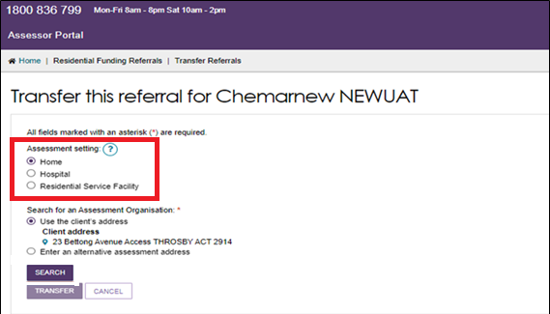
- Search for an assessment organisation based on either the client’s address or the alternative assessment address and select Search.
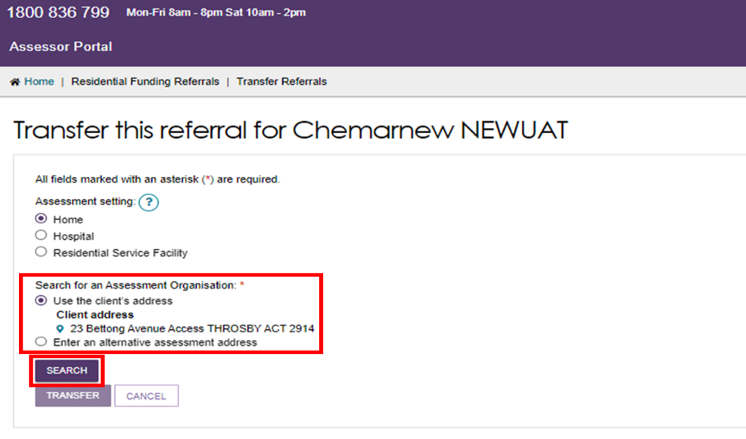
A list of assessment organisations will be displayed.
Select the appropriate assessment organisation and select Transfer.
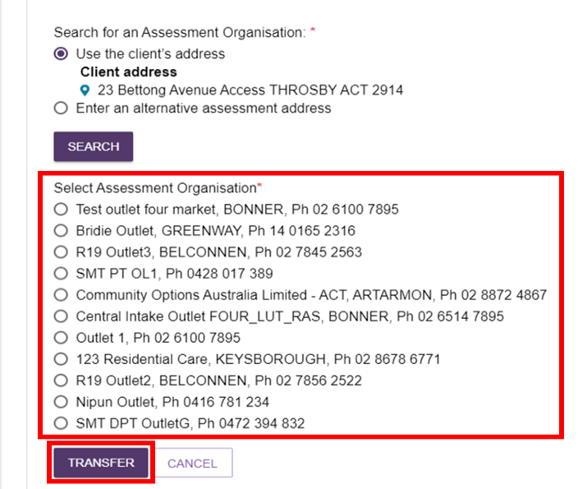

Clients who are in a Residential Service Facility
- Select the Assessment setting as Residential Service Facility.
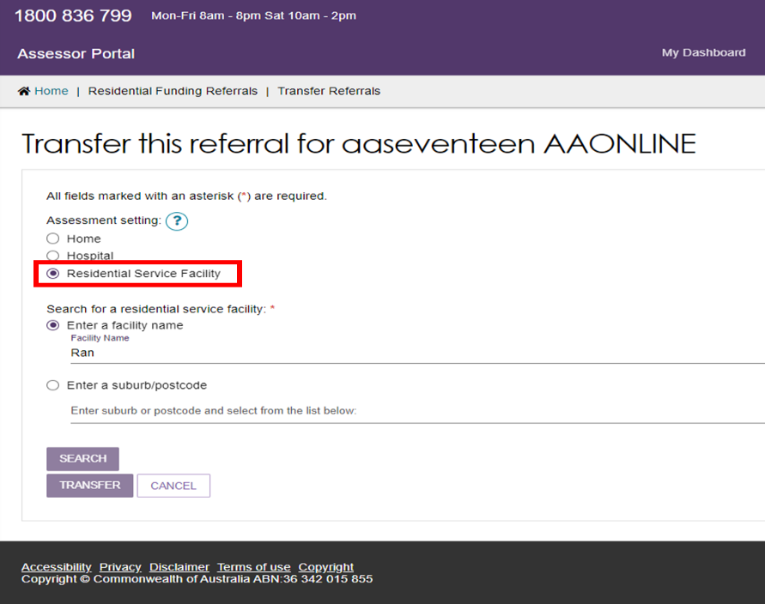
- Search using either the service facilities name or based on the suburb/postcode.
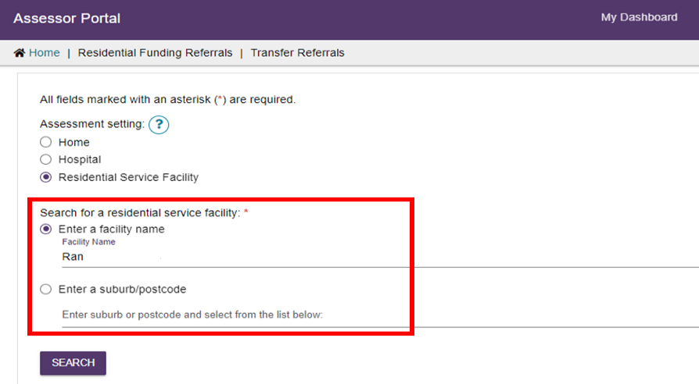

- Select search and a list of services will appear, select the correct service and enter a reason for transferring the client.
For Referrals transferred to RFA Outlets this should be Other.
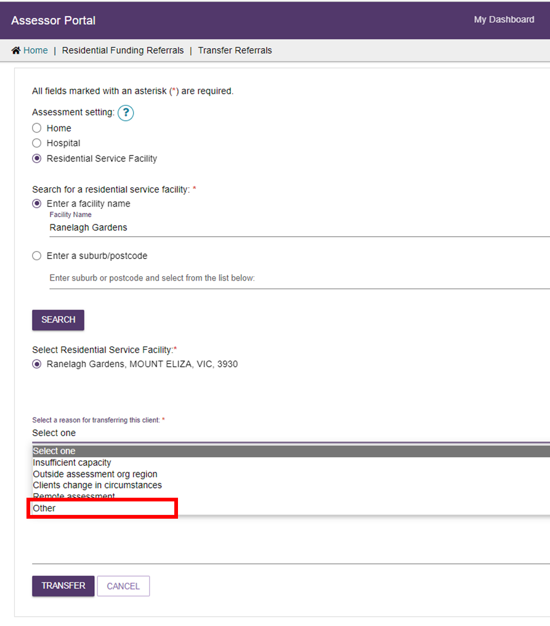
Provide comments on why the referral is being transferred and select Transfer.
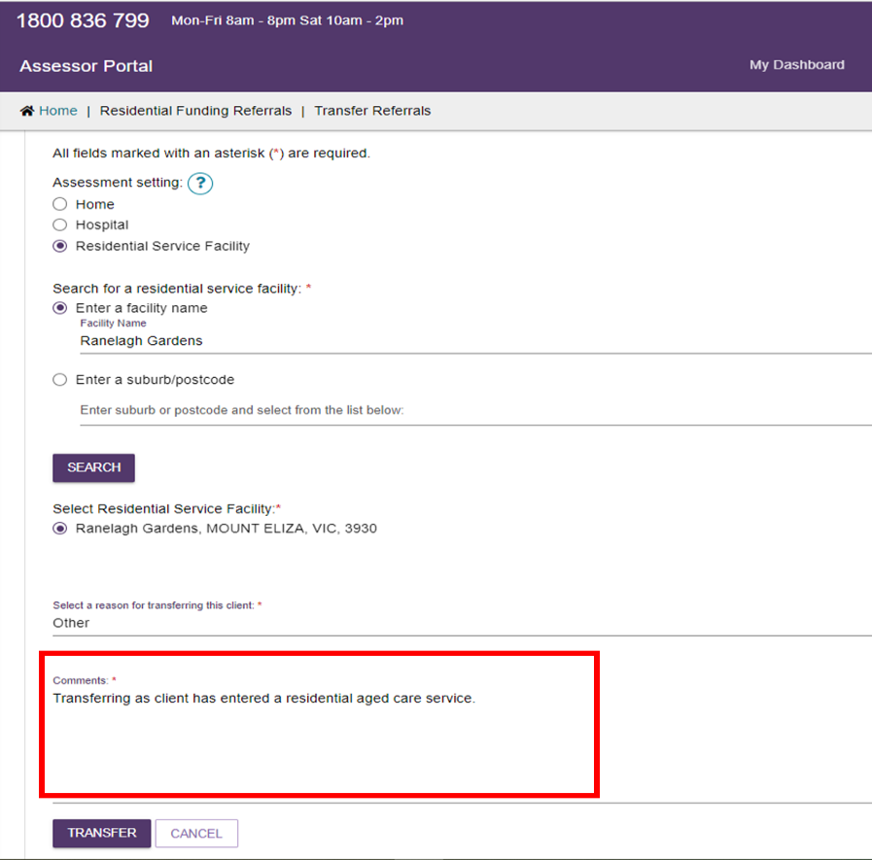
- When a referral has been successfully transferred, you will be navigated back to the referrals tab and a green success message will appear.

Reassigning Referrals
Assessment organisation team leaders can re-assign referrals that have been assigned to assessors.
- From the assessor portal home page, select the Residential Funding Referrals tile.
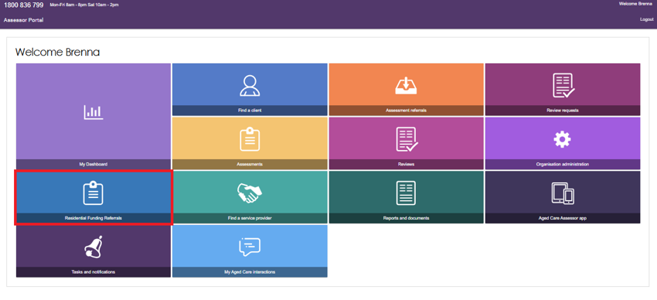
- Navigate to the Accepted Referrals tab. You can search for the referral you wish to re-assign or scroll to the assessors referrals that you wish to re-assign.
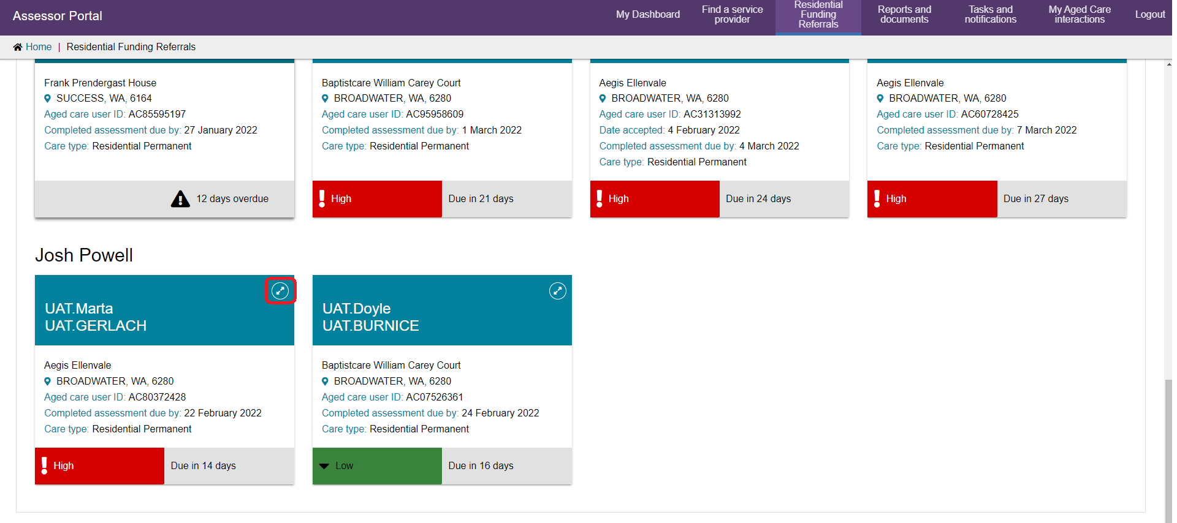
- A pop-up will appear, select the Reassign button.
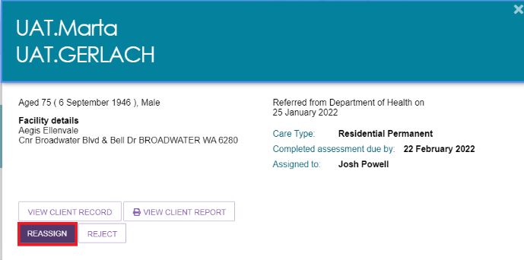
- A pop-up will appear. Select the assessor you wish to re-assign the referral to and select the Reassign button.
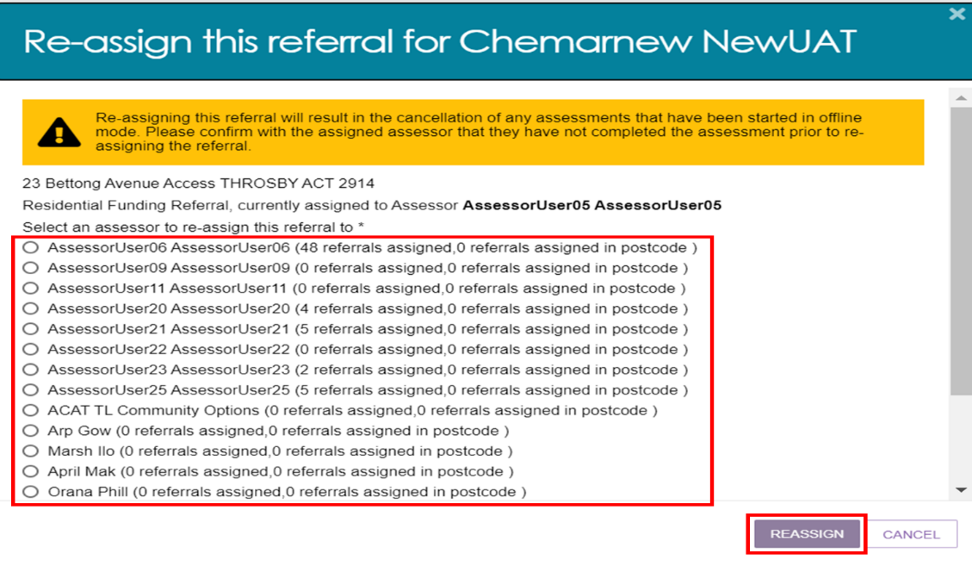
The referral will now be reassigned to the assessor selected to action.

Viewing Historical Residential Funding Referrals
Assessment organisation team leaders can view historical Residential Funding Referrals for their organisation/outlet.
Referral history will display all completed and rejected referrals.
- From the assessor portal home page, select the Residential Funding Referrals tile.
Navigate to the Referral History tab. You can search or filter the list of referrals or scroll down to see the finalised referrals for your outlet/organisation.
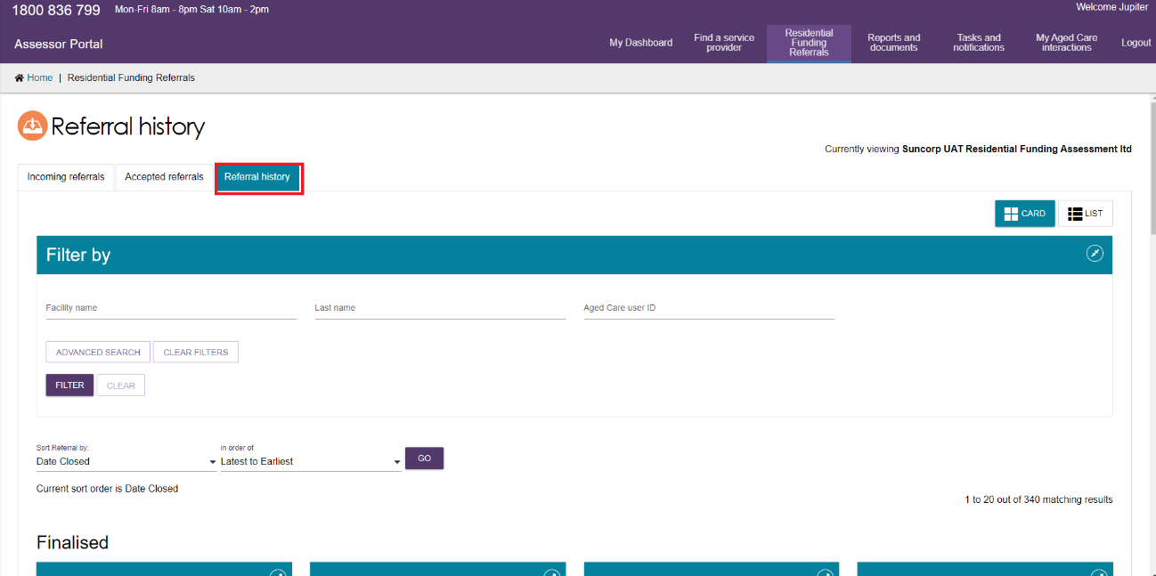

Viewing Progress of Respite Classification Assessments
Assessment organisation team leaders can view the progress of Residential Funding Assessments for their outlet/organisation.
- From the assessor portal home page, select the My Dashboard tile.
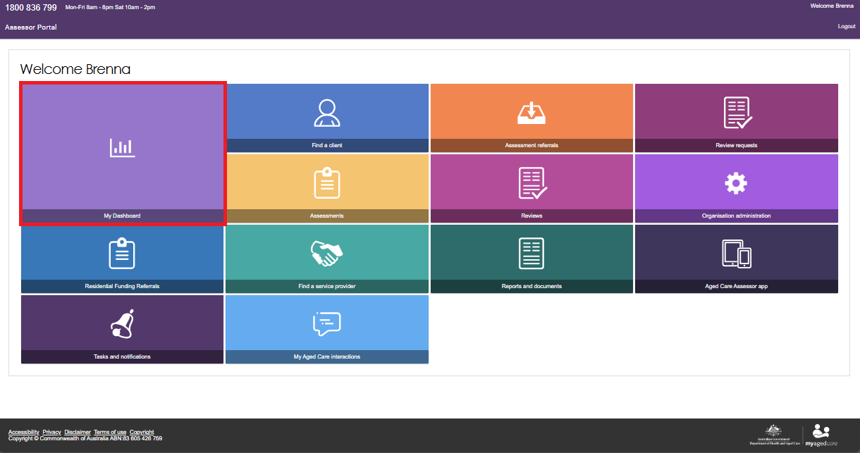
- Select the blue Residential funding referrals tile.
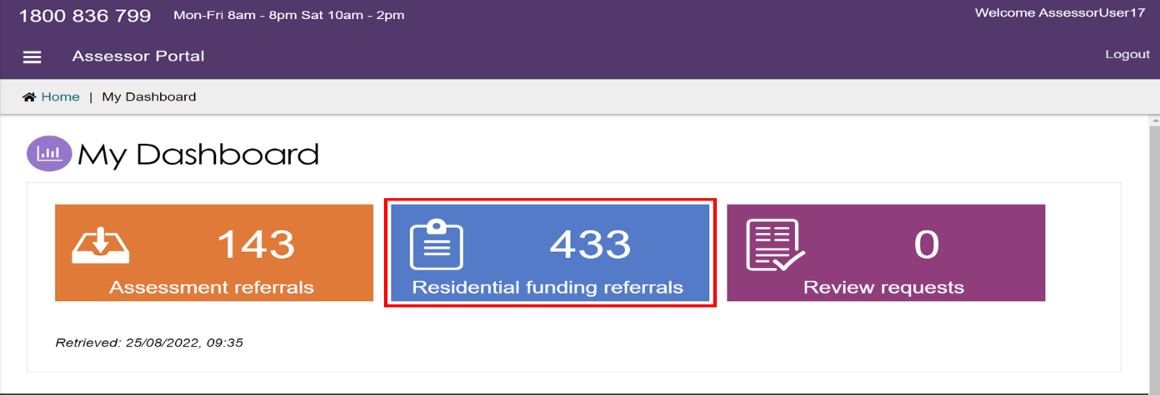

- You will now be able to see an overview of the Residential Funding Referrals for your assigned outlets.
To see a detailed breakdown select the referral highlighted count next to the desired outlet.
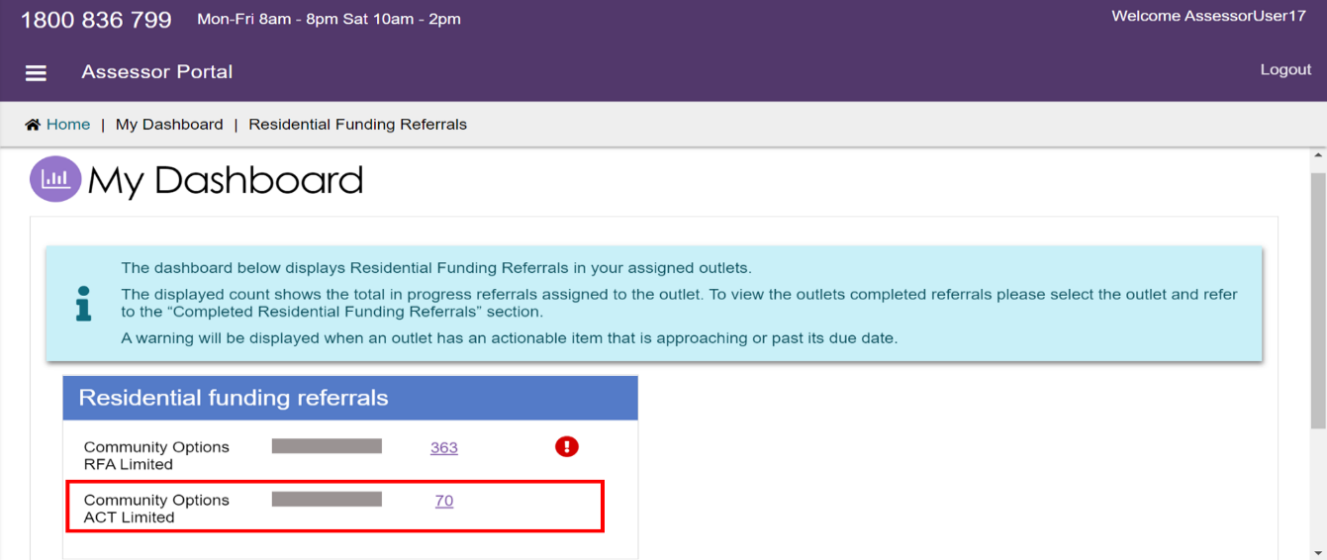
- The top section will display the breakdown of all in progress assessments, these are the referrals that your outlet has been assigned.
The bottom section will show a count of referrals completed in the current calendar month and the previous calendar month.
Each count is a link that will take you to the list of referrals with the corresponding filter applied.
