My Aged Care Assessor Portal User Guide for Residential Aged Care (RAC) Funding Assessor Team Leaders
This user guide is for RAC funding assessor team leads and describes activities that they can perform.
Table of contents
RAC Funding Assessor Functions 2
Viewing Referrals 2
Accepting Referrals 4
RAC Funding Assessor Team Lead Functions 5
Viewing Referrals 6
Accepting Assigned Referrals 6
Bulk Accepting Referrals 6
Assigning Referrals 6
Bulk Assigning Referrals 8
Rejecting Referrals 9
Transferring Referrals 11
Reassigning Referrals 15
Viewing historical Residential Funding Referrals 16
Viewing progress of Residential funding assessments 17
Generating a Training or Quality Assurance Assessment Report 18

RAC Funding Assessor Functions
Users assigned the RAC Funding Assessor role will have the below view in the My Aged Care Assessor Portal. From here, they can view the residential aged care funding assessment (assessment) referrals they have been assigned to undertake, and the assigned referrals that have been closed. They can also accept and assign referrals.
RAC Funding Assessor Team Leads can also access the roles of the RAC Funding Assessor.

Viewing Referrals
Select the Residential Funding Referrals tile from the assessor portal home page.
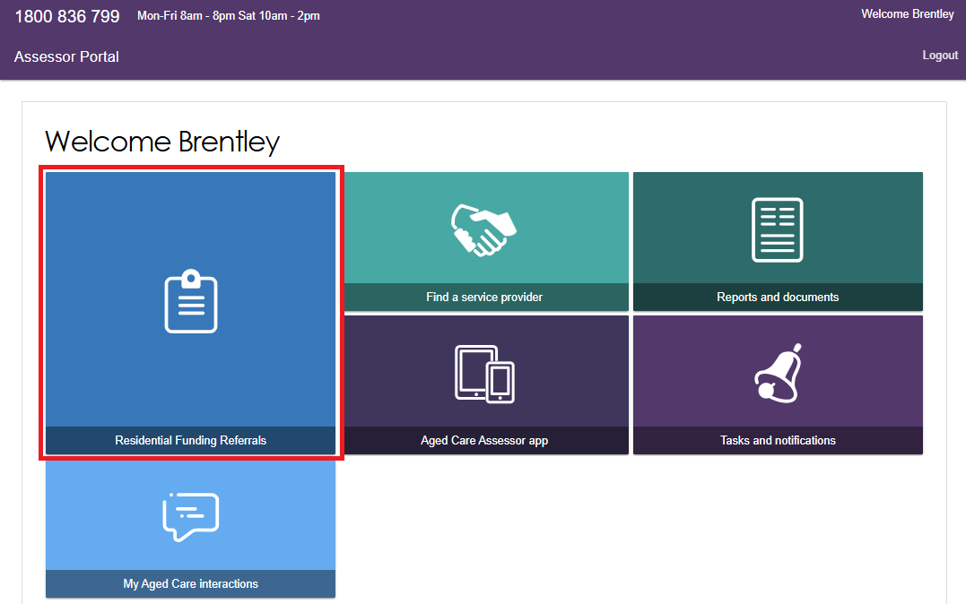
Select the Current work or Recent work tabs.
The Current work screen lists all the open referrals that are assigned to a RAC Funding Assessor.
The Recent work screens lists all the closed referrals that were assigned to a RAC Funding Assessor.
Users can refine these lists by using the Filter by and ADVANCED SEARCH functions.
! | The Funding Assessor team lead will also have access to the Incoming Referrals, Accepted Referrals, and Referral History tabs.

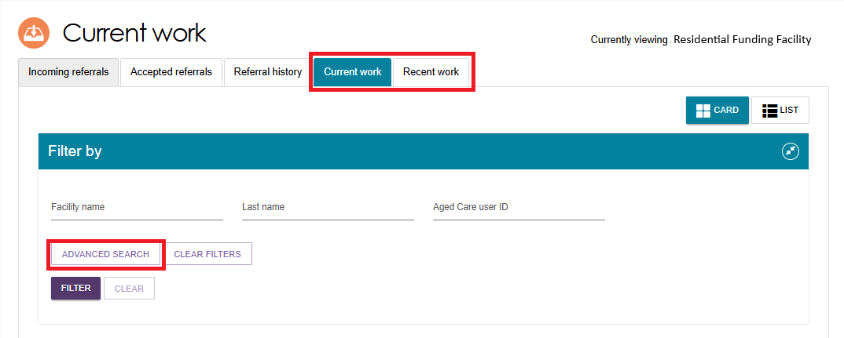
View the different referral priorities in each client card (or list) as outlined below. You can also sort them based on these priorities.
Card View:
Low: White text in a green background
Medium: Black text in a yellow background
High: Exclamation mark followed by white text, in a red background
Urgent: (for Residential Permanent Referrals only) - White exclamation mark inside a red triangle, followed by red text, in a white background.
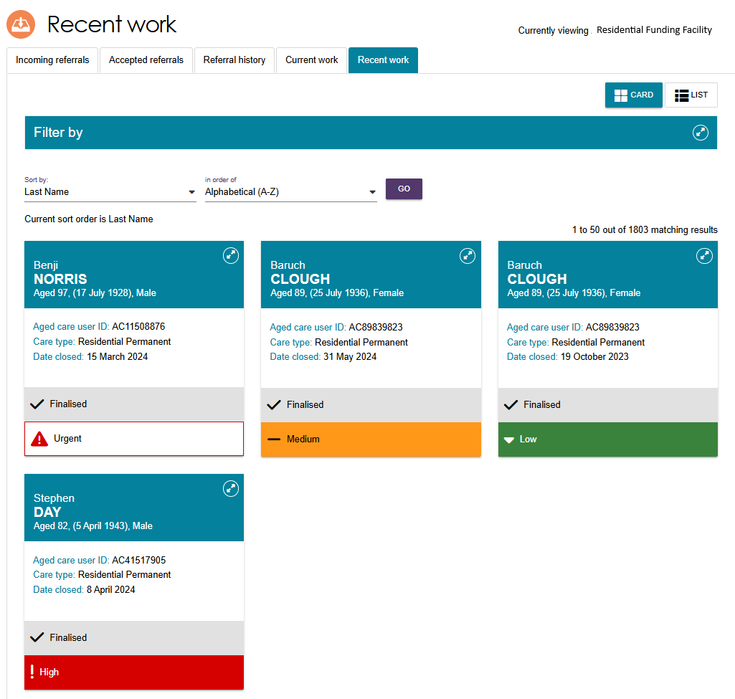
List View:
Low: Green circle
Medium: Yellow circle
High: Red circle
Urgent: White circle with a red outline.
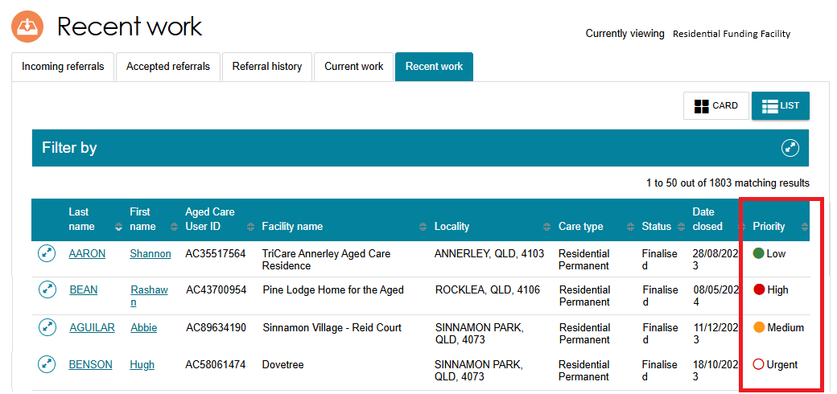

Accepting Referrals
Select the Residential Funding Referrals tile from the Assessor portal home page.
Navigate to the Accepted Referrals tab. You can conduct a search or an advanced search to refine the list of accepted referrals.
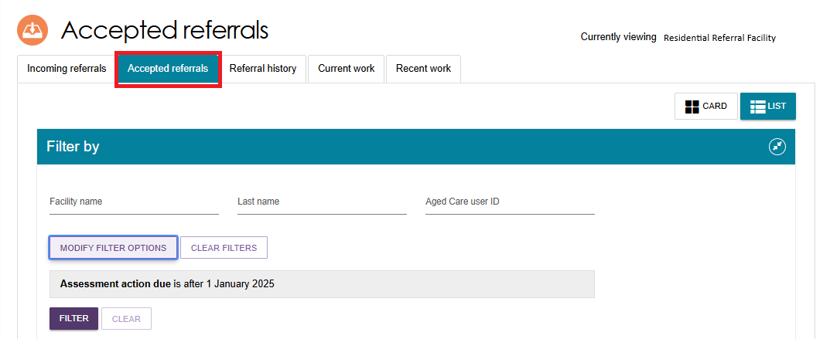
A pop-up box will appear confirming the client/s whose referral you wish to accept. Once you have confirmed, select the ACCEPT button.
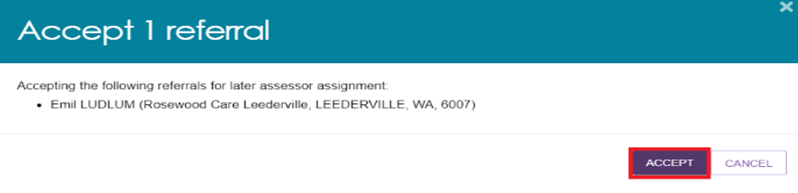

RAC Funding Assessor Team Lead Functions
RAC Funding team leads will have the following view in the My Aged Care Assessor Portal.
From here team leads are able to view Residential Funding Referrals, generate reports and documents, find service providers and conduct other functions in their role.
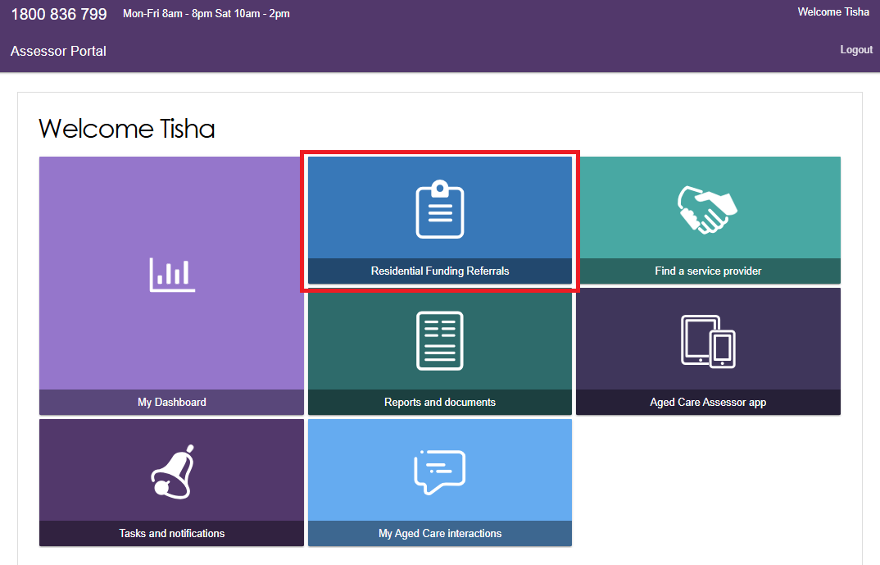

Viewing Referrals
Refer to Viewing Referrals.

Accepting Assigned Referrals
Refer to Accepting Assigned Referrals.

Bulk Accepting Referrals
To bulk accept referrals, select the Incoming referrals tab, then select the tick box next to each of the clients’ names that you want to assign, then select the ACCEPT button. The Select All tickbox is also available.
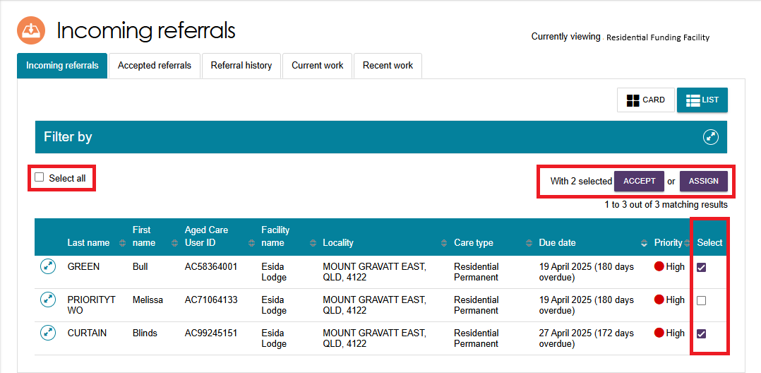

Assigning Referrals
Residential Funding Team Leads can assign referrals to assessors.
From the Assessor portal home page, select the Residential Funding Referrals tile.
Navigate to the Accepted Referrals tab. You can filter the list of referrals or conduct an advanced search to refine the list of unassigned referrals.
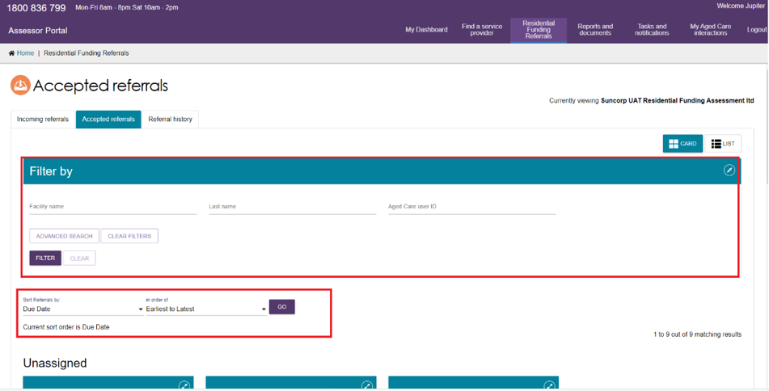
Select the referral you wish to assign from the unassigned list of referrals.
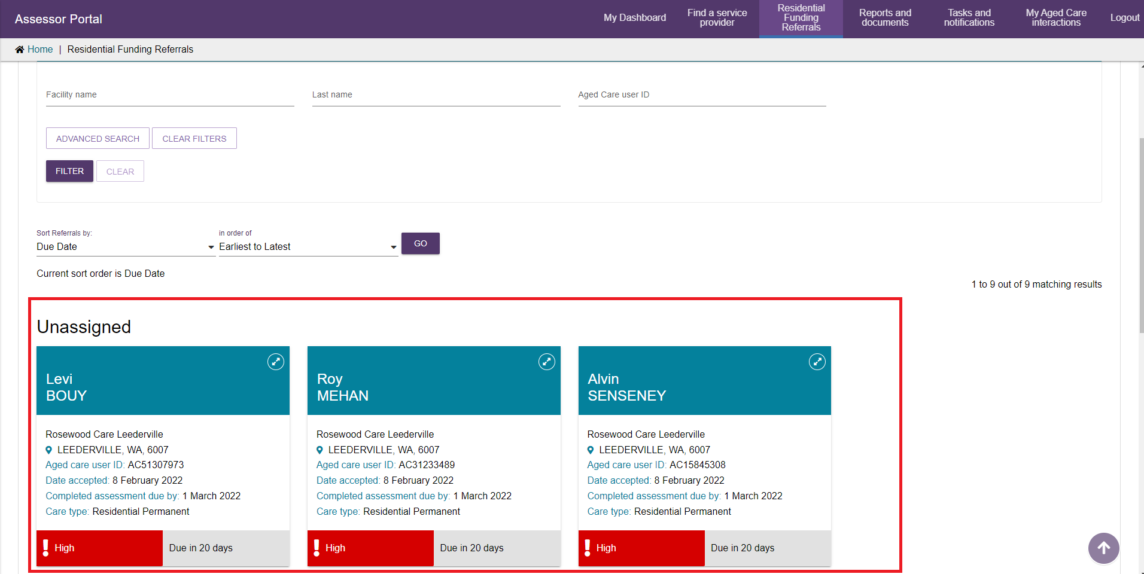
A pop-up will appear confirming the referral you wish to assign.
Select the ASSIGN button.
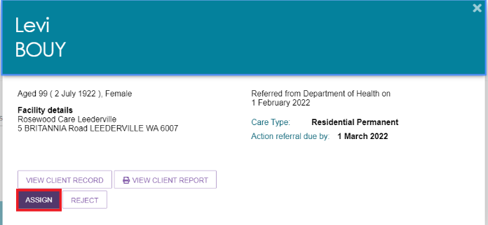
Another pop-up will appear.
Select the assessor you wish to assign the referral to and select the ASSIGN button.
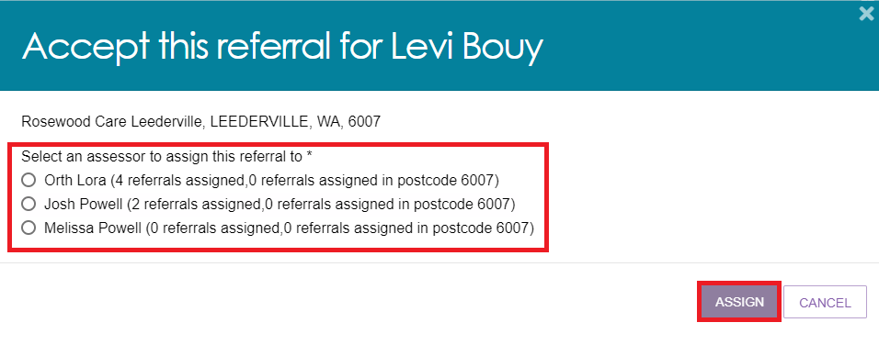
The referral will now be assigned to the assessor/s selected.

Bulk Assigning Referrals
To bulk assign referrals, go to the Incoming referrals tab.
Select two or more checkboxes against the client card or line, then select ASSIGN.
The Select all checkbox is also available.
The text to the left of the ASSIGN button will show the number of clients selected. The below screenshot shows the text as ‘With 2 selected’.

A pop up appears confirming the number of referrals being assigned for assessor assessment.
It shows the name of the client followed by information of their outlet or facility, suburb, state and postcode.
Select CONTINUE TO ASSIGNMENT.
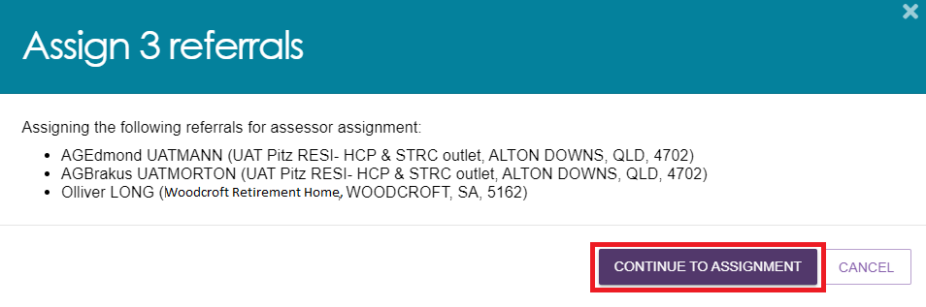
Another pop up lists available assessor/s, and how many referrals they are assigned already.
Select an assessor, then select ASSIGN or ACCEPT AND ASSIGN ASSESSOR LATER.
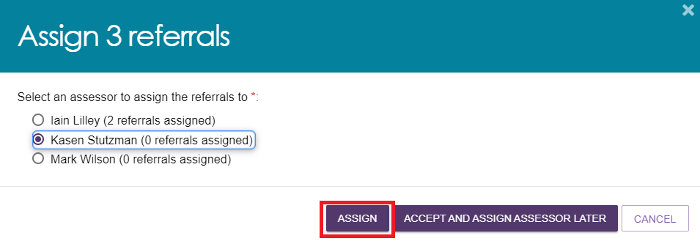

Rejecting Referrals
RAC funding team leads are able to reject referrals that are both incoming and assigned.
From the Assessor portal home page, select the Residential Funding Referrals tile.
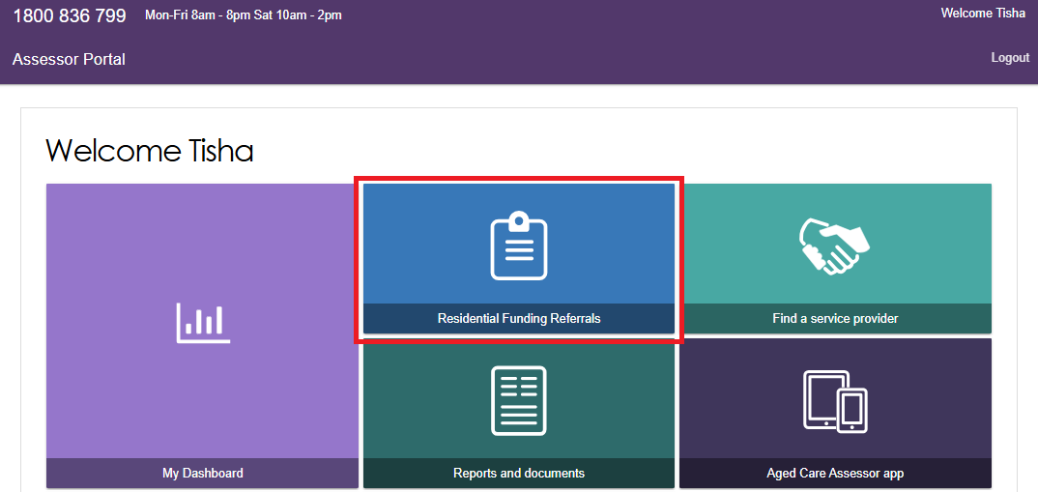
Select the referral you wish to reject.
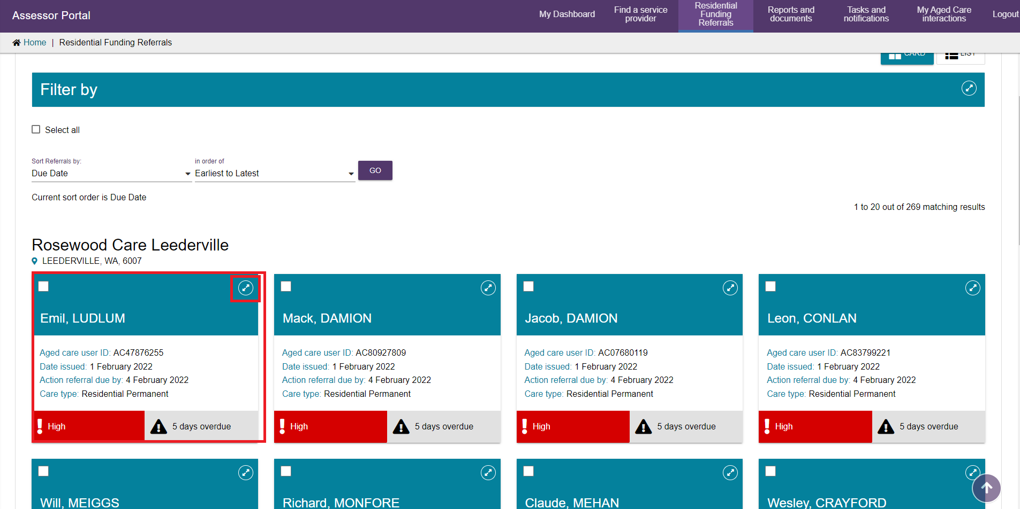
A pop-up will appear.
Confirm this is the referral you wish to reject, and select the REJECT button.
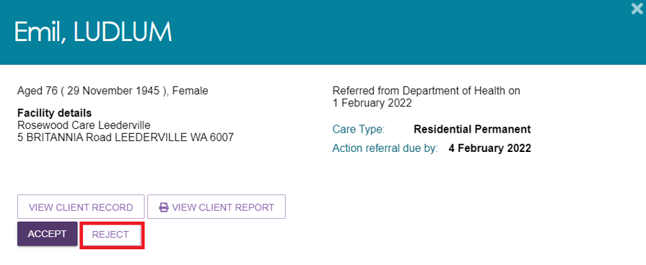
Another pop-up will appear.
Select the reason for the referral rejection and provide details in the free text field.
Once complete, select the REJECT button.
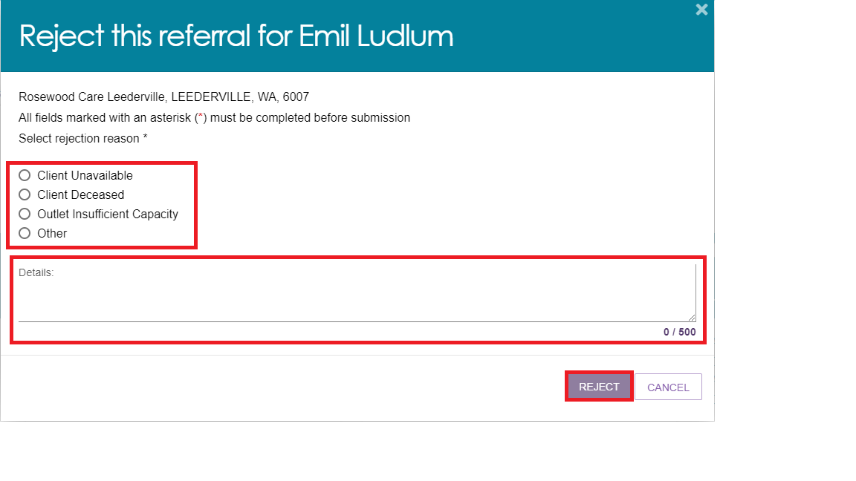

Transferring Referrals
Both departmental staff and RAC Funding Assessor Team Leads can transfer Residential Permanent referrals between Assessment Outlets (Assessment Organisations) without needing to recall the referrals first.
! | RAC funding team leads can transfer a new referral where an unrestricted assessment is not in progress, in the case their outlet/organisation unexpectedly does not have the capacity to accept the referral.  For example, the outlet/organisation has received an urgent referral but does not have any assessors available to complete the referral in the required timeframe.  Prior to completing the transfer, the Team Lead must contact the organisation they want to transfer the referral to and confirm they have the capacity and are willing to accept the referral.  (The receiving organisation must be in the same ACPR - Aged Care Planning Region).
In the Assessor Portal, go to the Residential Funding Referrals tile.
Go to the Accepted Referrals tab and select a care recipient by expanding the client card or listing, then select TRANSFER.
CARD VIEW
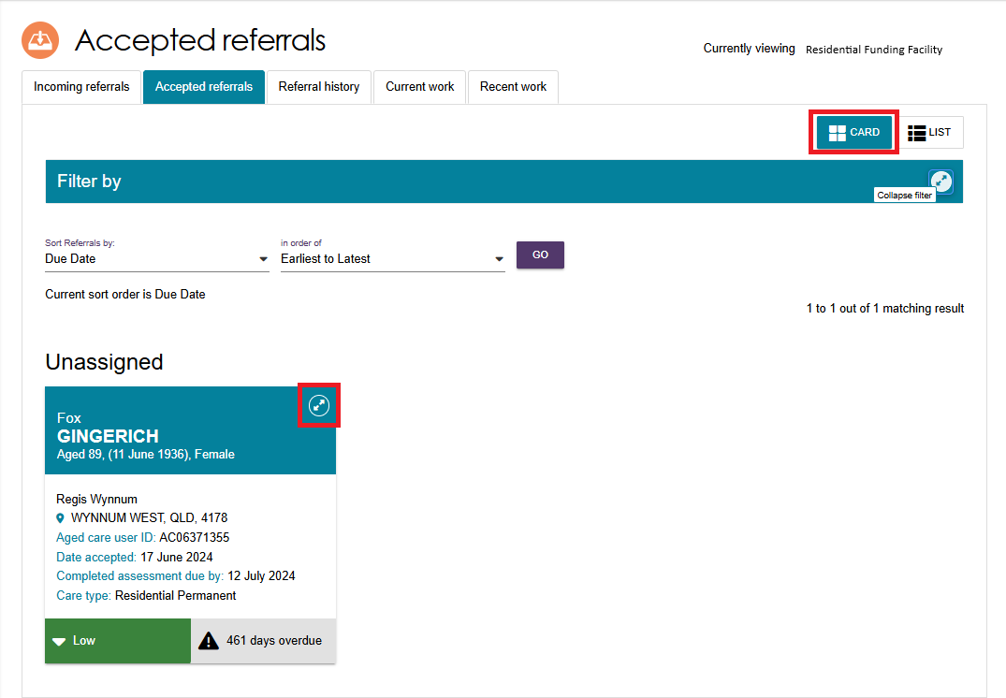
A pop up appears. Select the TRANSFER Button.
Note: Only Residential Permanent clients have the Transfer option available.
If an assessor has already started an assessment on this client, there will be a red error banner and the transfer will be disabled.
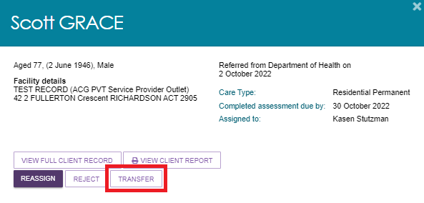
LIST VIEW
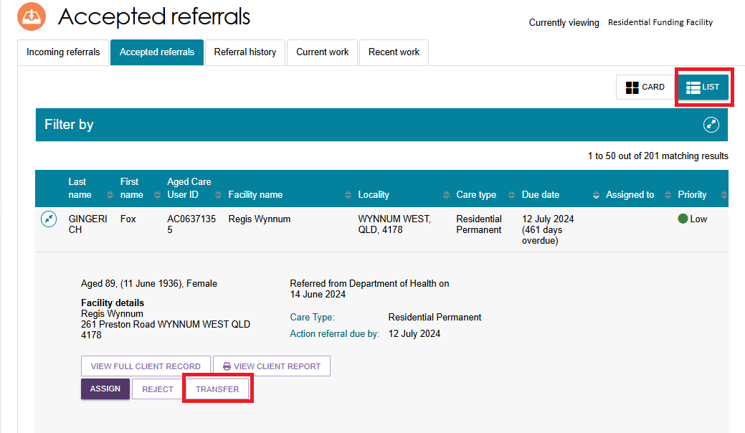
The Transfer this referral page appears. Fill in all mandatory fields denoted with a red asterix. This includes the assessment organisation, reason for transferring, etc.
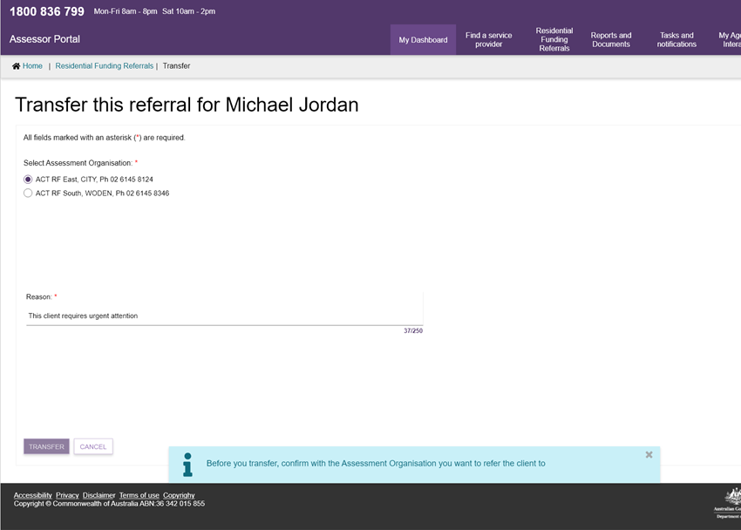
A reminder banner appears to remind you that before you transfer, to confirm with the Assessment Organisation that you want to refer the client to.
! | If there are no assessment organisations in the same Aged Care Planning Region, then the transfer pop-up will appear with No matching results found.  In this case, the TRANSFER button will be disabled, and you must contact the Department to transfer the referral for you.  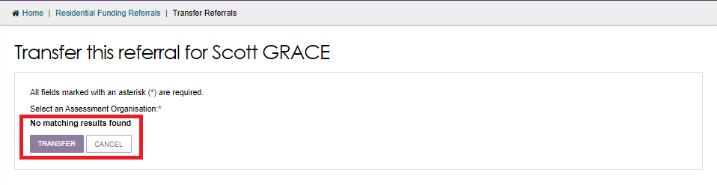
Transferred referrals will appear in Referral History tab.
The client card will show a Rejected status, and a reason of Transferred.
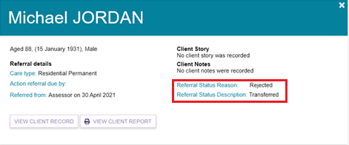
The receiving assessment organisation will be able to view the referral in their incoming referrals.
Your transfer comments will then be visible to the receiving assessment organisation.
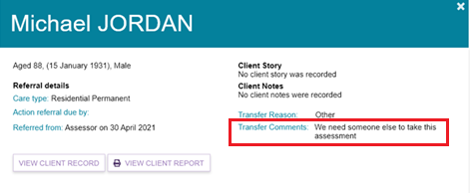

Reassigning Referrals
RAC funding team leads can re-assign referrals that have been assigned to assessors.
From the Assessor portal home page, select the Residential Funding Referrals tile.
Navigate to the Accepted Referrals tab. You can search for the referral you wish to re-assign or scroll to the assessors’ referrals that you wish to re-assign.
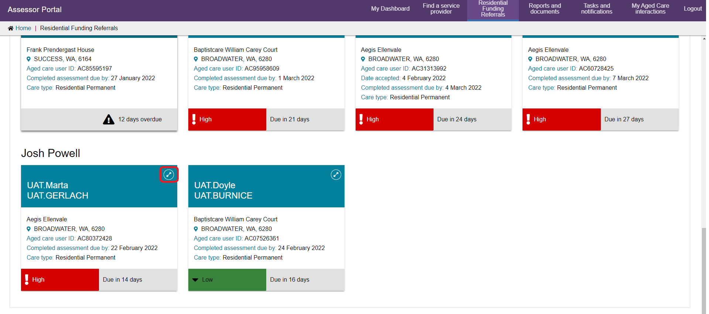
A pop-up will appear. Select the REASSIGN button.
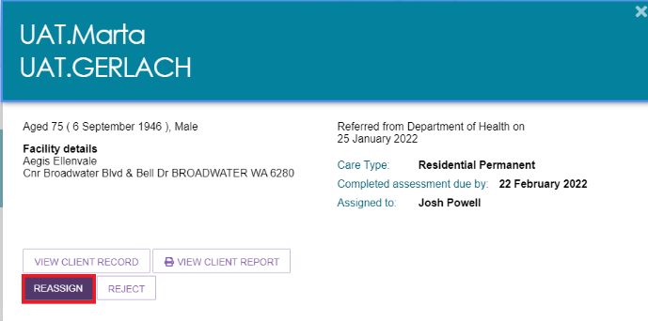
Another pop-up will appear. Select the assessor you wish to re-assign the referral to and select the REASSIGN button.
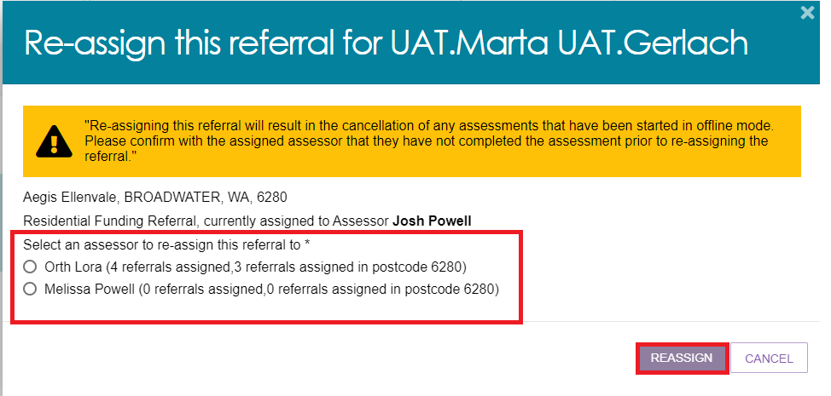

Viewing historical Residential Funding Referrals
RAC Funding team leads can view historical Residential Funding Referrals for their organisation or outlet.
From the Assessor portal home page, select the Residential Funding Referrals tile.
Navigate to the Referral History tab. You can either search or filter the list of referrals, or scroll down to see the finalised referrals for your outlet/organisation.
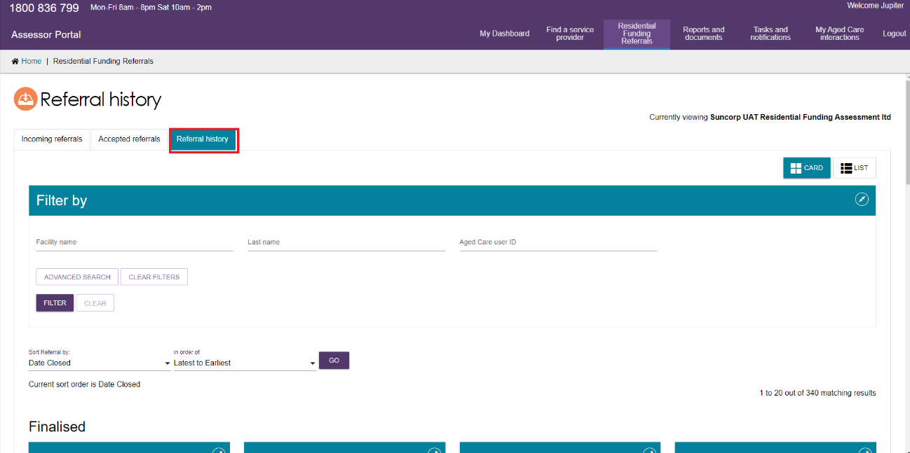

Viewing progress of Residential funding assessments
RAC Funding Team leads are able to view the progress of RAC Funding Assessments for their outlet or organisation.
- From the Assessor portal home page, select the My Dashboard tile.
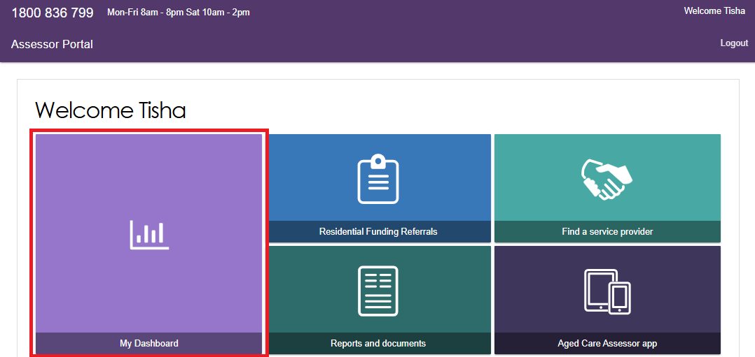
Select the blue Residential funding referrals tile.
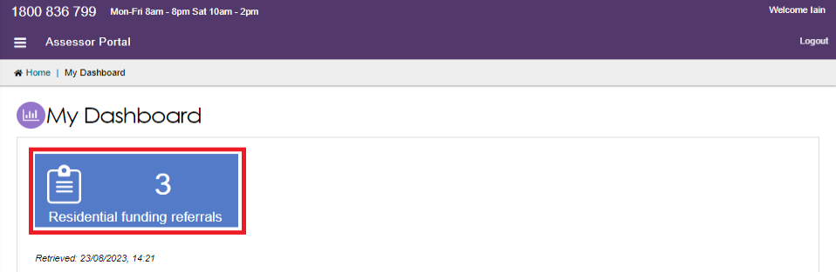
- You will now be able to see an overview of the Residential Funding Referrals for your organisation/outlet.
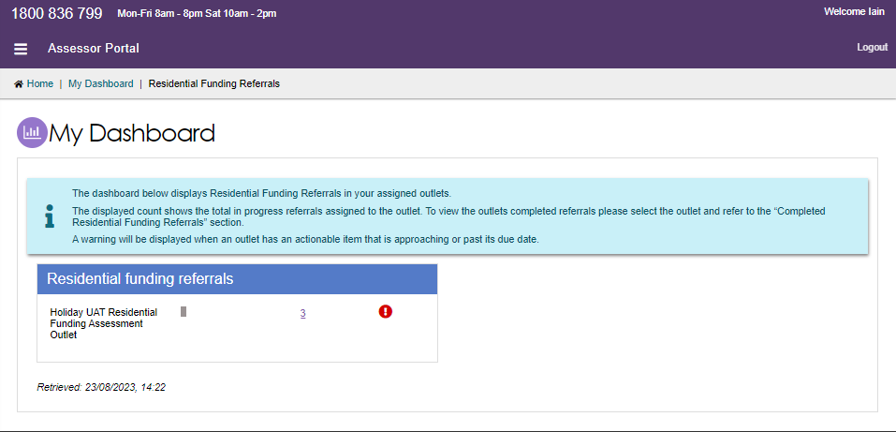

Generating a Training or Quality Assurance Assessment Report
RAC funding team leads can monitor when an unrestricted assessor last participated in a Quality Assurance assessment. The results of Quality Assurance and Training assessments can also be compared to improve the quality of assessments as required.
To view these reports, follow the below steps:
From the home page of the Assessor portal, select the Reports and Documents tile.
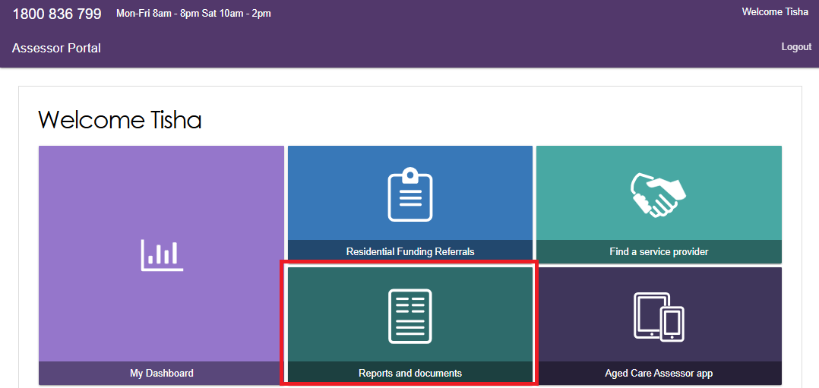
Select the hyperlink for the AR-2-13 – Residential Funding Assessment Quality Assurance and Training Report.
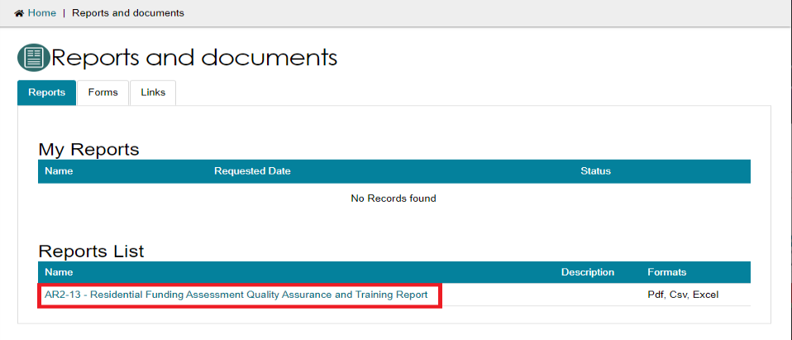
Fill in all the mandatory fields.
You must select whether you would like a report for Quality Assurance or Training Assessments and choose the output type of the report (PDF, CSV or Excel).
Select Request Report button.
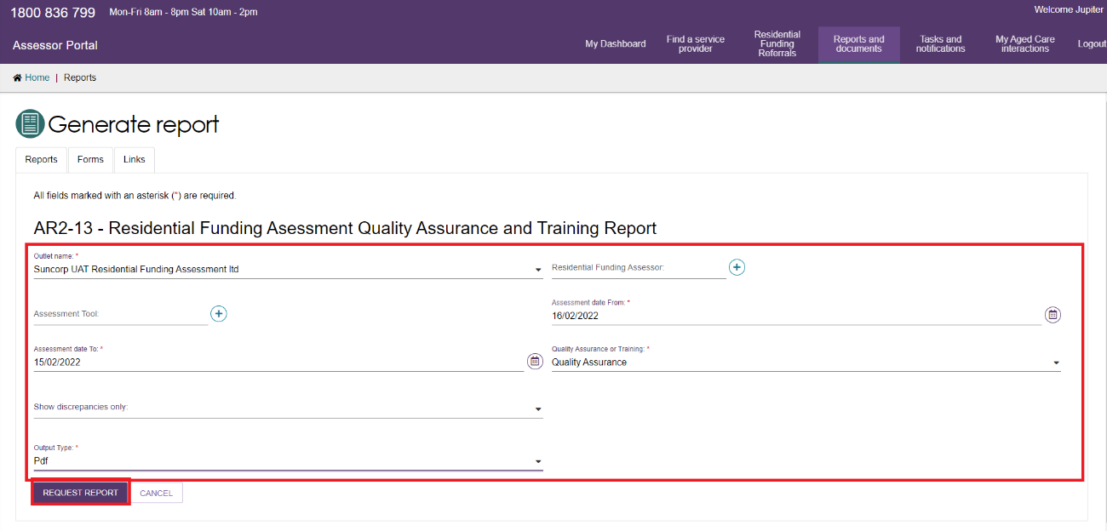
A report will be generated that you will be able to download and view.
The example below is a Quality Assurance report for one outlet in PDF format.