Assessor Portal User Guide 9 – Tasks and Notifications
A task is an activity that an aged care needs assessor (assessor) needs to action (finalise/close).
A notification is an activity that informs the assessor of an event. The assessor may need to complete an action as a result of the notification.
The My Aged Care assessor portal (assessor portal) contains notifications and prompts users to action tasks.
Preferences can also be configured by your outlet’s Administrator to enable an email alert to be sent for tasks and notifications.
You can also manage your task and notification preferences.
All staff with access to the assessor portal will have access to view tasks and notifications.
You will receive a notification when a client’s status has changed to ‘Deceased'.
You should review the client record to see if further action is required, for example you may need to close any active referrals or assessment records for the client.

Table of contents
Viewing and actioning tasks 1
Viewing notifications 7
Viewing and reassigning Support at Home (SaH) notifications 11
Managing task and notification preferences 12
Notification of Support at Home correspondence 16
Support at Home correspondence sent to clients 18
Notification of Residential Permanent correspondence 34
Confirming client contact information is accurate 36

Viewing and actioning tasks
Assessors will be able to see all tasks and notifications for clients in the tasks and notifications tab, however service providers will only be able to see tasks and notifications that are associated to their outlet and for clients they are providing services to.
- From the assessor portal homepage select Tasks and notifications.
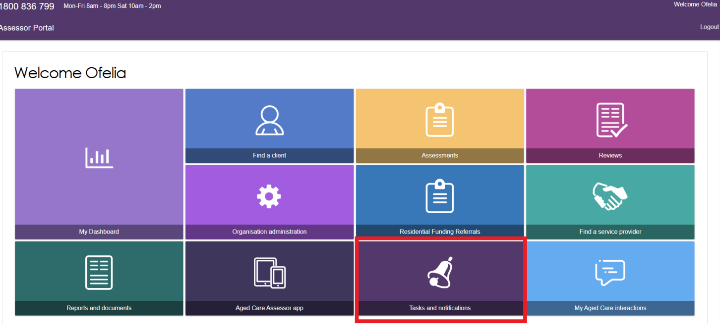
- The Tasks and notifications screen will be displayed as shown below. This layout will be same for all assessor types (i.e. Clinical and Non-clinical).
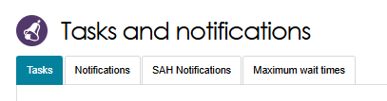
- In the Tasks tab, you will be able to search the tasks by typing either one of the below options.
- Last Name
- First Name
- Aged Care User ID
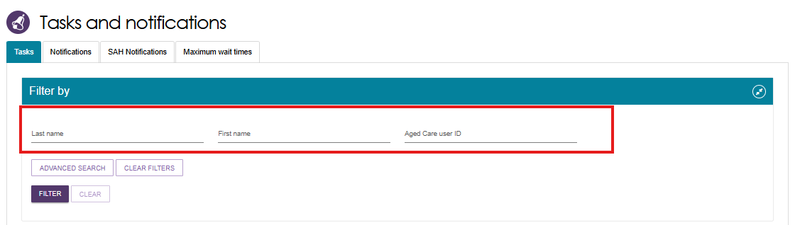
You can further filter the task by selecting the ADVANCED SEARCH button.
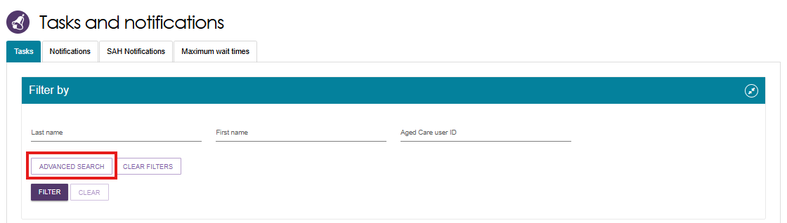
- A pop-up screen will be displayed. To sort the tasks by specific order, choose value from the dropdown list. Select ADD FILTER button.
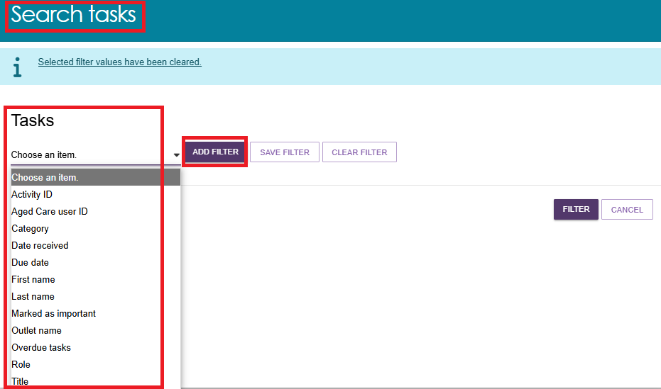
Below example shows the tasks to be sorted by Outlet name, Marked as important, Last Name and First Name. Select FILTER.
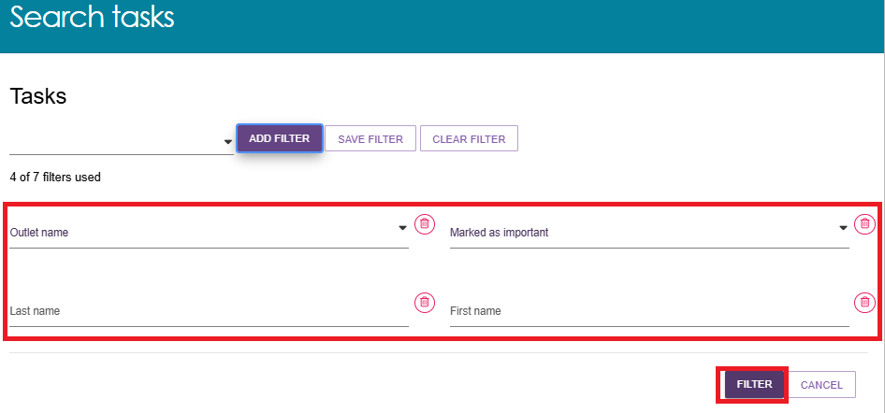
A list of all the tasks as per the requested criteria will be displayed in the TASKS AND NOTIFICATIONS screen.
- You can choose the order to be displayed (i.e. ascending or descending, Category, etc.) by clicking the UP/DOWN  arrow next to each column title.
! | Certain types of tasks can be marked as important for your outlet by your outlet administrator.  When these tasks are created, they will be displayed with a visual indicator. The Managing task and notification preferences section in this guide explains how to set tasks as important.  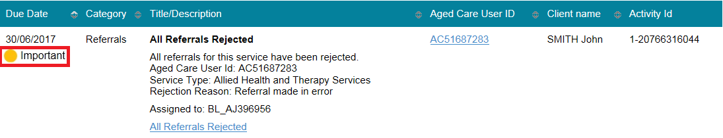
- Alternatively, if you want to see all tasks and notifications for a single client, navigate to the Tasks and Notifications tab in the client’s record to see all relevant tasks and notifications for that client.
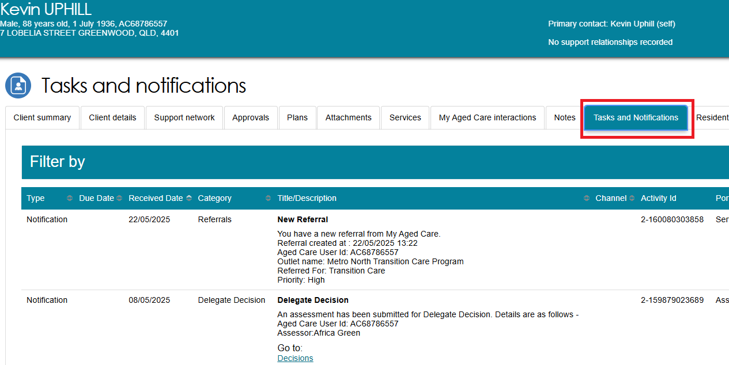
- The hyperlink under the task description will take you directly to the individual record and the section of the portal where you can action the task. Alternatively, you can navigate to the client’s record by selecting the client’s Aged Care ID from the tasks list.
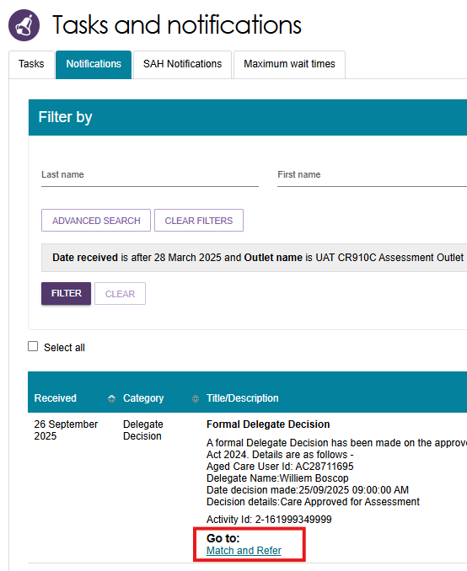
- Selecting the hyperlink will take you directly to the client’s support plan where you can review the referral and take further action as required.
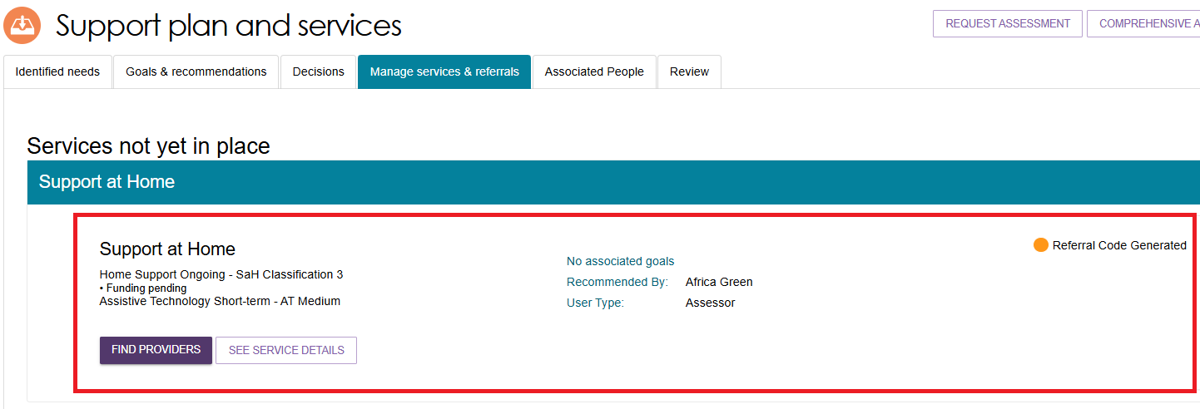
- Once the action required from the task has been completed, the task will be removed from your task list. Certain tasks may close automatically once an action has been taken by another My Aged Care user (e.g. when a service provider accepts a referral that has triggered a task for assessor to follow up, the task is automatically closed in the assessor portal).
! | If you believe you have completed a task and it has not been removed from your portal, please call the My Aged Care Service Provider and assessor helpline on 1800 836 799 who will be able to assist in completing the task.
- Assessors can also change the client’s status to deceased by opening the Client details tab and selecting NOTIFY MY AGED CARE OF A DEATH.
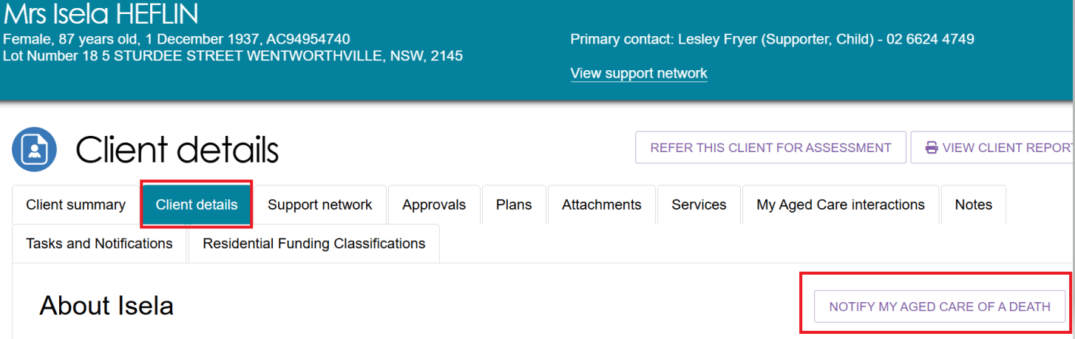
- When NOTIFY MY AGED CARE OF A DEATH is selected you will be taken to Notify My Aged Care that person is deceased screen where you will have to complete relevant information.
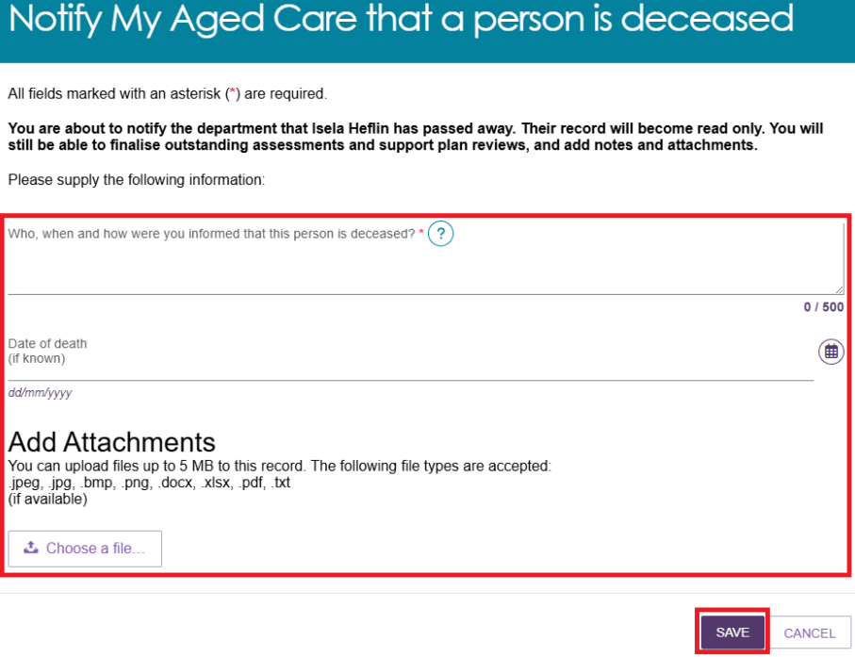
A dialogue box will be displayed. To confirm, select OK.
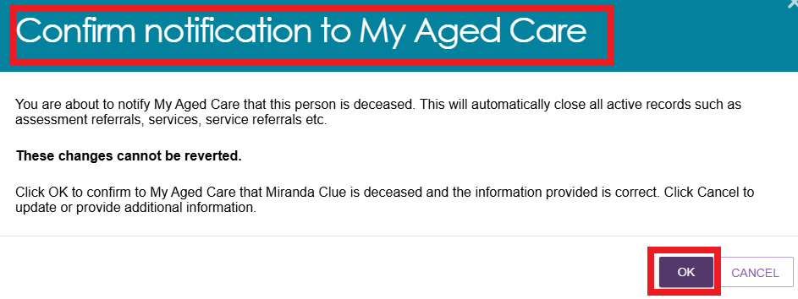
You will be directed to the CLIENT DETAILS page where the following banners will be displayed.
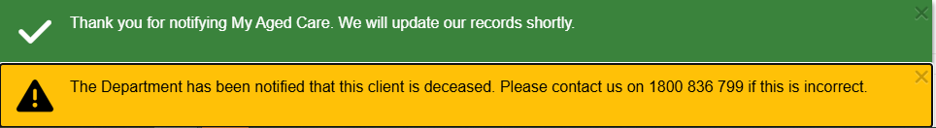
The client status will be updated to Deceased on the records. The client card will appear as shown in the example below. If there are any in-progress assessments for the client, a notification will be sent to the associated assessor and provider advising them to close or finalise the in-progress tasks.
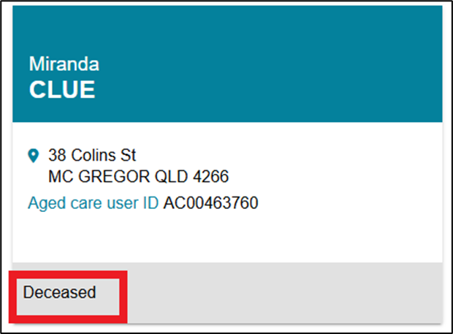

Viewing notifications
Assessors will be able to see all tasks and notifications for clients, however service providers will only be able to see tasks and notifications that are associated to their outlet and for clients they are providing services.
- From the assessor portal homepage select Tasks and notifications and select the Notifications tab.
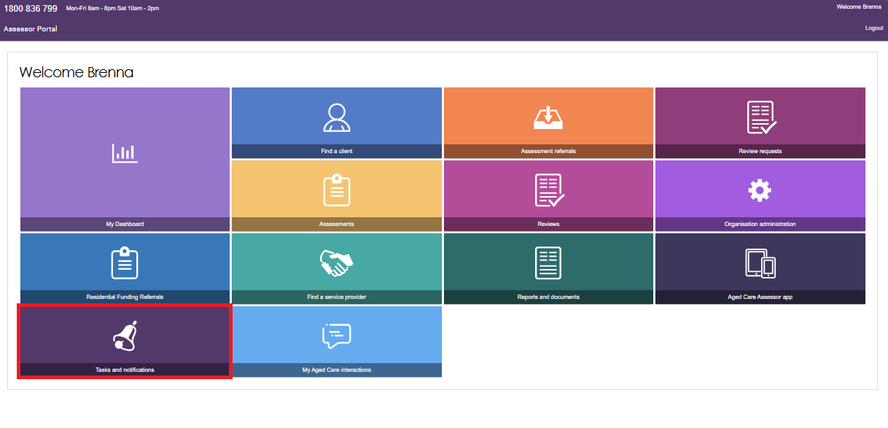
In the Notifications tab, you will be able to view all notifications relevant to your role.
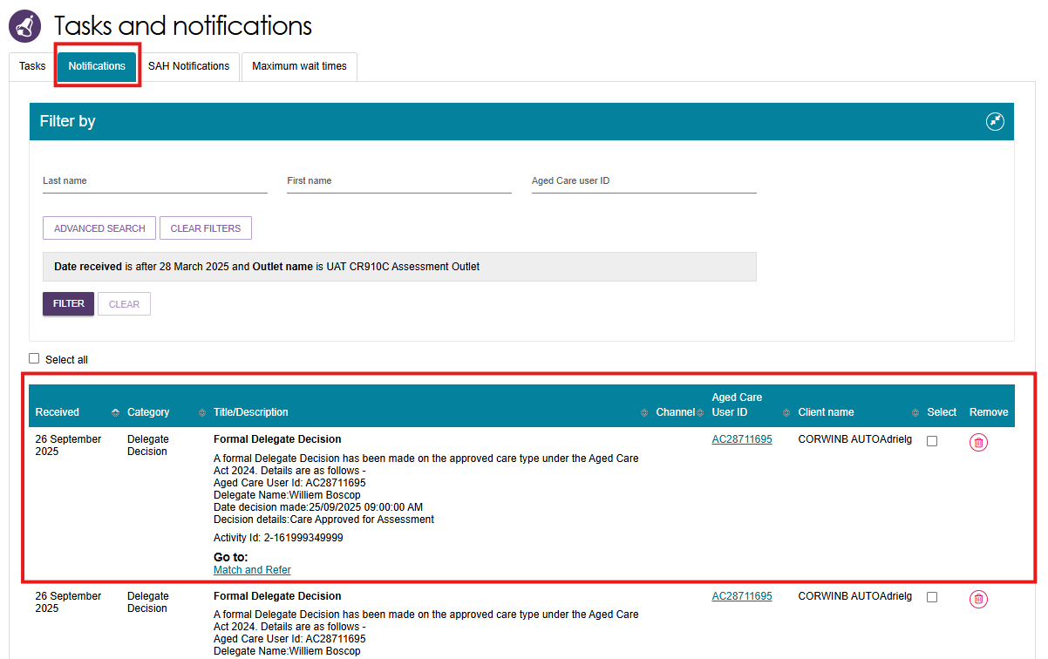
- Alternatively, if you want to see all tasks and notifications for a single client, navigate to the Tasks and Notifications tab in the client’s record to see all relevant tasks and notifications for that client.
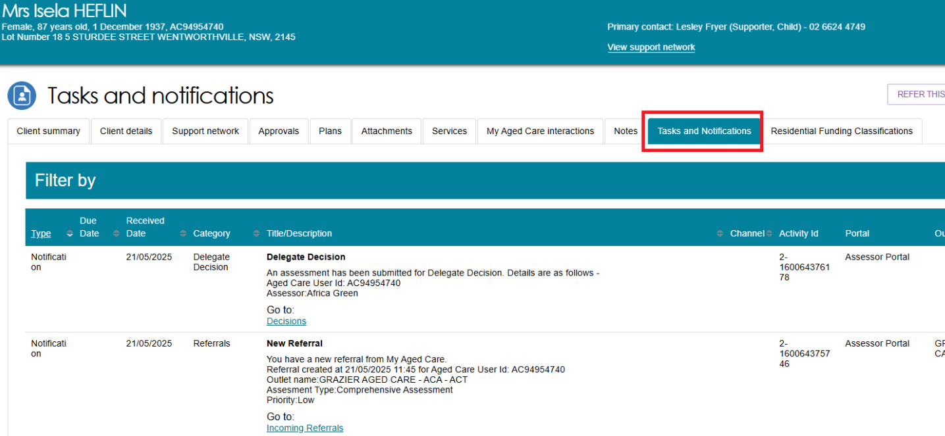
- In the Notifications tab, you can sort notifications by any of the columns on the table by selecting the UP/DOWN arrow next to the column title.

! | As with tasks, certain types of notifications can be marked as important for your outlet by your outlet administrator.  When these notifications are created, they will be displayed with a visual indicator.  The Managing task and notification preferences section in this guide explains how to set notifications as important.  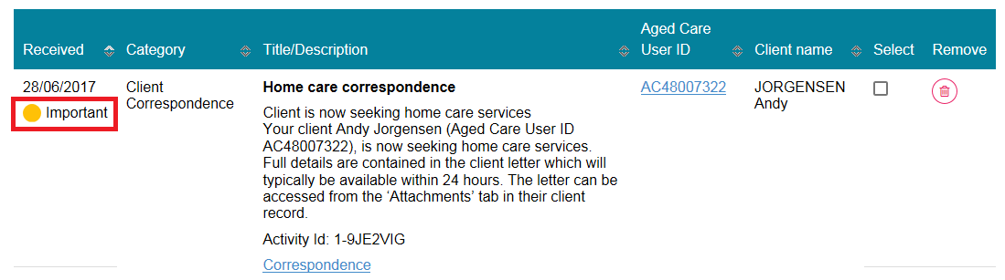  Home Support notifications will display in the Notifications tab if enabled in the client’s support plan or on the Approvals tab in the client record.
- You can also remove individual or bulk notifications from your portal by selecting the Remove icon or Select all checkbox.
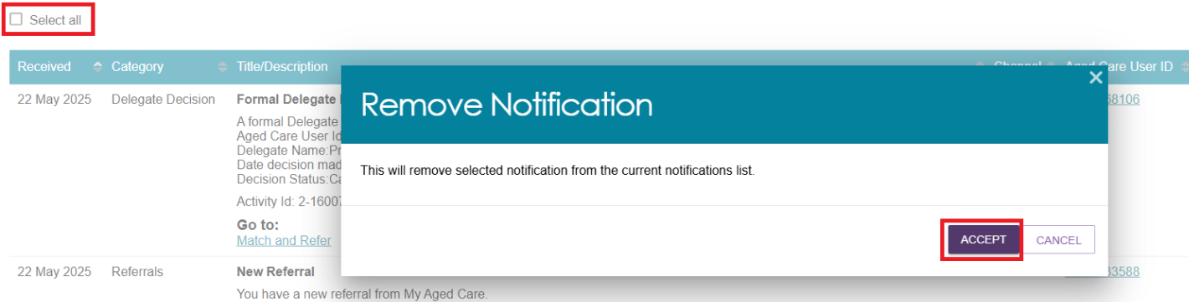
- You can search for specific notifications using the filter options or using custom filters in Advanced Search. Select the arrows to the right to expand or collapse the filter options.
- To apply custom filters, select ADVANCED SEARCH and choose filters from the drop-down menu and select ADD FILTER for each filter you want to apply.
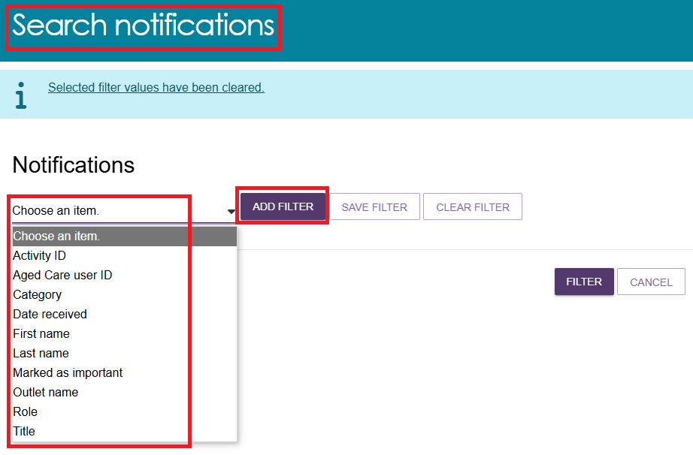
Below example will sort all notifications received between 01/01/2025 to 22/05/2025.
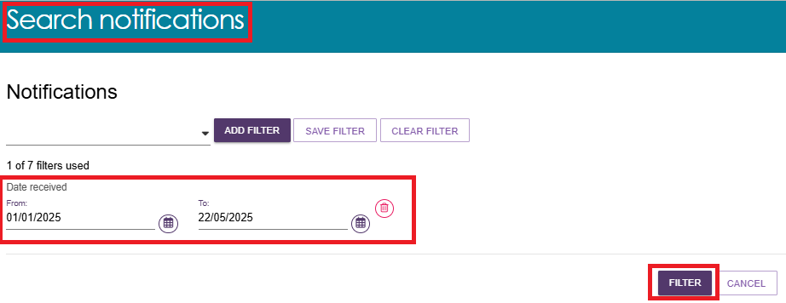
- The list of all notifications meeting the above criteria will be displayed under the NOTIFICATIONS tab as shown in the example below.
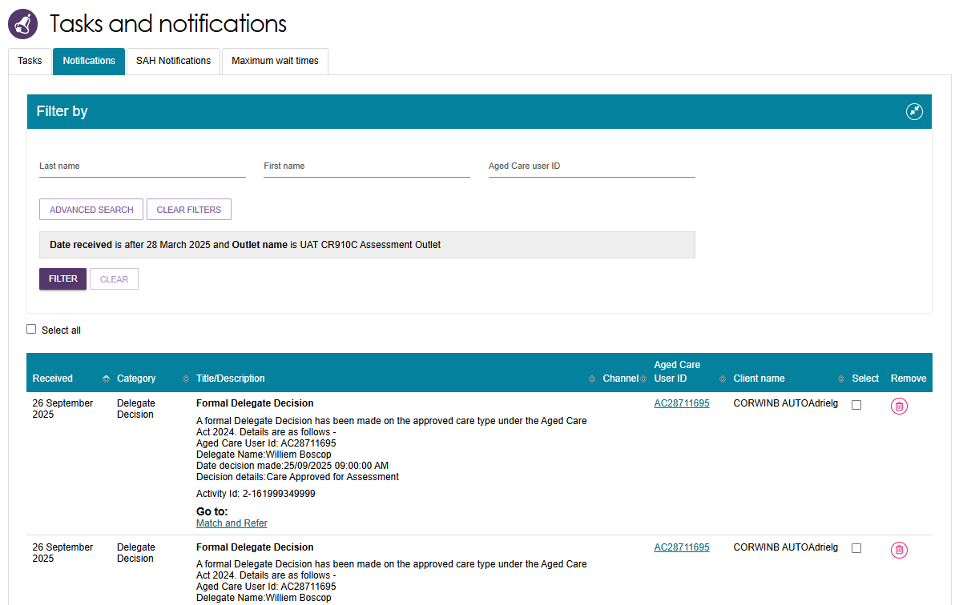
- The hyperlink under the notification description will take you directly to the individual record and the section of the portal where you can view more information about the notification or complete any action that may be required.
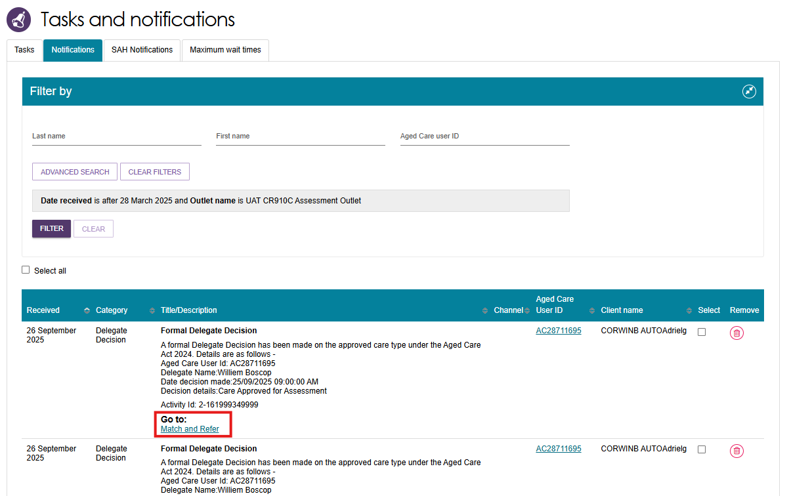
- For example, selecting the link in a Formal Delegate Decision notification will take you directly to the client’s support plan where you can match and refer for the recently approved care type.
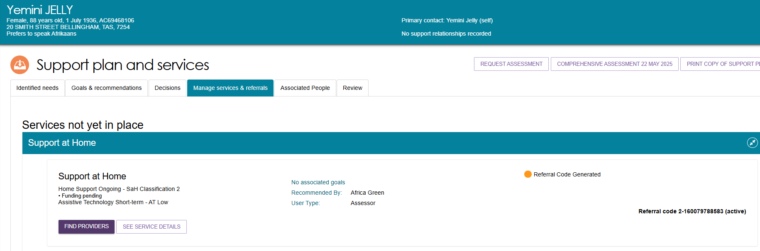

Viewing and reassigning Support at Home notifications
You must be assigned in the team leader role to view which assessor or delegate is currently receiving the client’s Support at Home correspondence notifications.
You will also have the ability to reassign a client or an individual or make bulk reassignment changes to a different assessor or delegate within an outlet.
- In the Tasks and Notifications tab select SAH Notifications tab. If you manage more than one outlet you may choose which outlet to view from the dropdown.
Select GO after choosing the outlet.
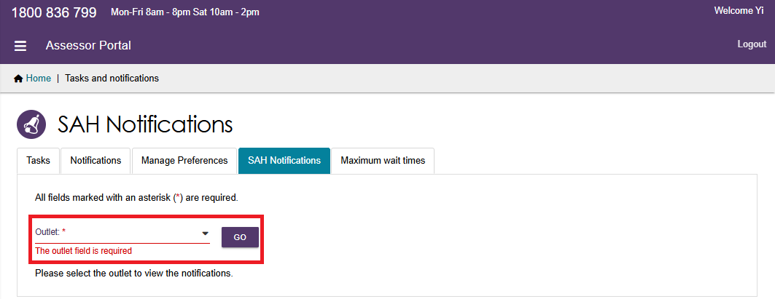
- The last column is a select tick box which allows the team lead to complete individual or bulk reassignments:
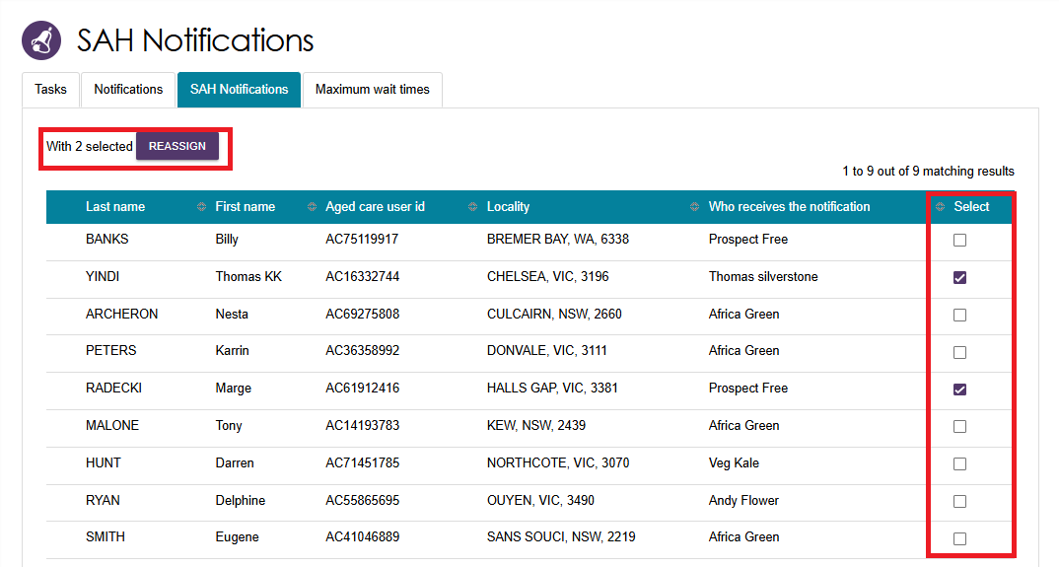
By selecting the REASSIGN button, the Re-assign Home Care correspondence notifications pop up will be displayed where you can select the new recipient and finalise by clicking the SAVE button.
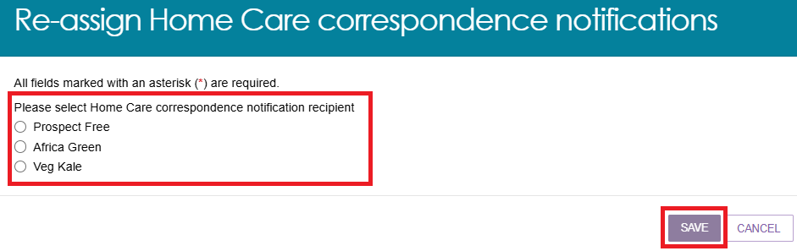

Managing task and notification preferences
You must be assigned an administrator role to manage task and notification preferences for your organisation or outlet.
If you need to add this role to your user account, please see your organisation administrator.
As an administrator, you will be able to:
- edit email address and email frequency for new task and notifications
- turn off visibility of notifications in the assessor portal
- view description of each task and notification, including which user types will be able to see them
- edit individual task and notification preferences
- mark a task or notification as important to your outlet.
These settings will affect all staff assigned to your outlet, so please ensure all staff are made aware of any changes you make.
- From the assessor portal homepage select Tasks and notifications.
- Select the Manage Preferences tab.
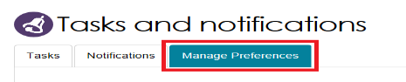
- If you are the administrator for your organisation, you will be able to select which outlet you want to configure task and notification preferences for. Select CHANGE PREFERENCES. If you are the administrator for your outlet, you will only be able to see your outlet’s preferences.
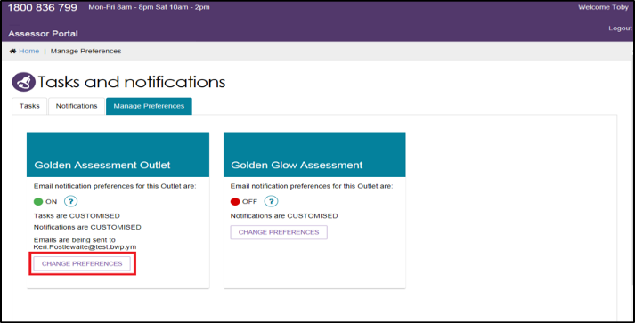
- The preferences page for the outlet will open. At the top of the page, you can configure the overall preferences for email preference, email address, email frequency and notification visibility in the portal.
You can choose to hide all notifications or hide individual notification types for the outlet. Selecting No to hide all means that no notifications for the outlet will be visible to staff associated with the outlet.
Selecting No for an individual notification type means that only notifications of that type will be hidden for staff associated with the outlet.
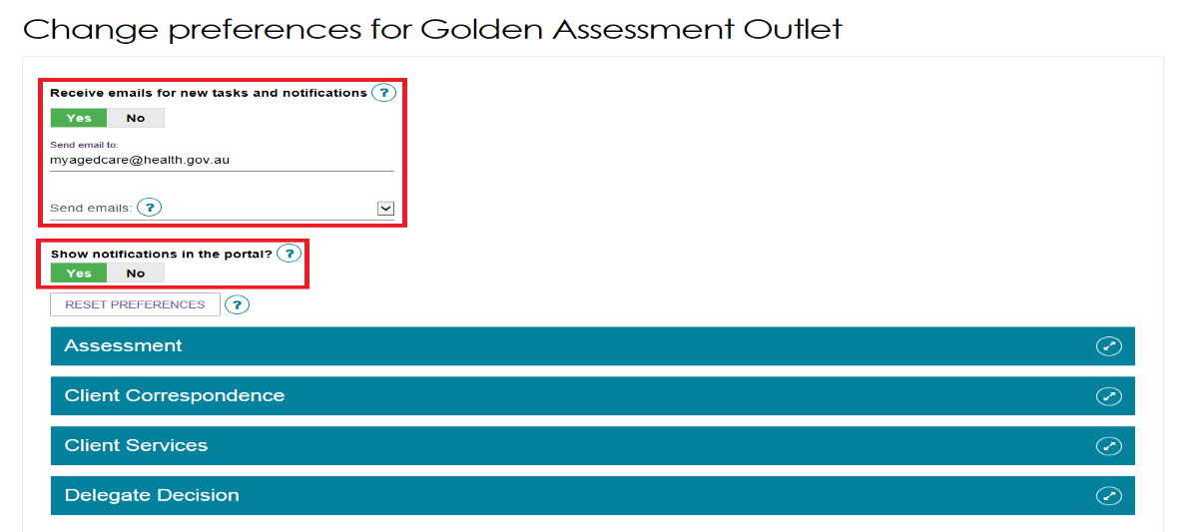

Tasks and notifications are sorted by category. Select the Expand (double arrow) icon to expand/collapse each category.
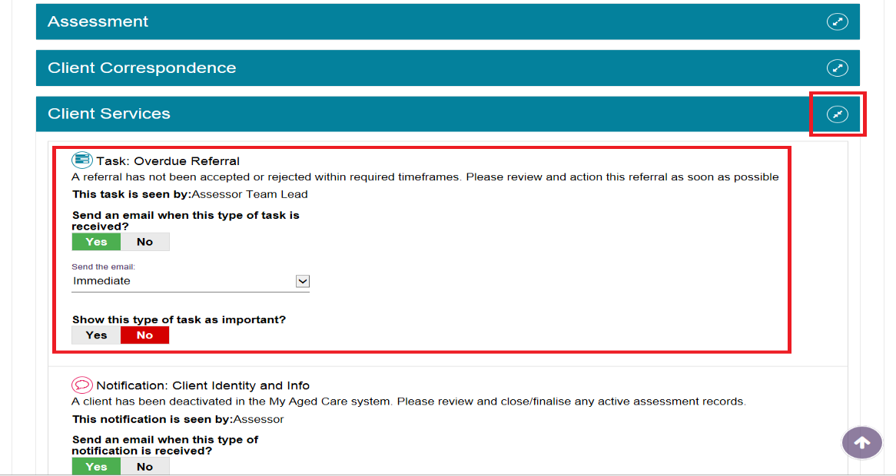
For each task or notification you will be able to view:
- Type (e.g. task or notification)
- Title and brief description of the why the task or notification has triggered
- User type who can view or action the task or notification.
For each task or notification you will be able to individually configure:
- Whether to send an email when a task or notification generates
- Frequency of email notification, if enabled
- Whether to display a task or notification as important in the portal.
! | If you choose to mark a task or notification as important, staff within your outlet who can view that particular task/notification will see a visual indicator in their portal.  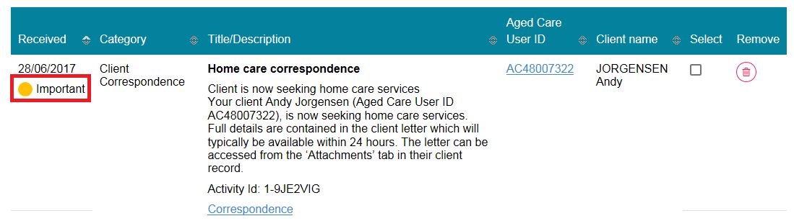

- Select SAVE when all changes have been made. You can reset the preferences by selecting RESET PREFERENCES at the top of the page.
Selecting the arrow in the bottom right of the screen will automatically take you to the top of the page.
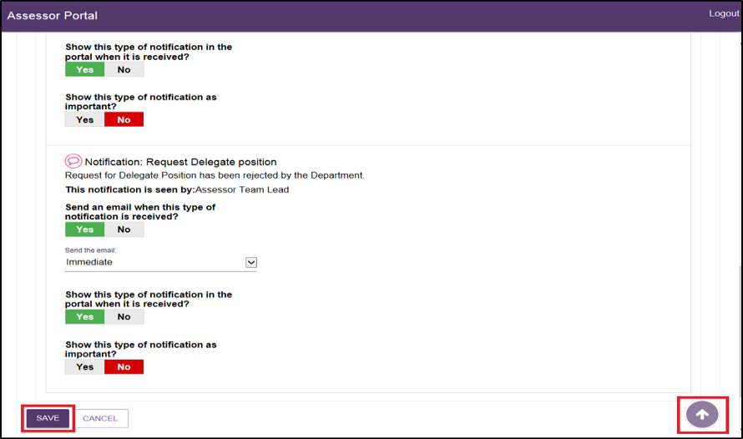

Notification of Support at Home correspondence
For those clients that a clinical assessor wishes to monitor more closely, clinical assessors can elect to be notified of Support at Home correspondence sent to the client. This notification can be enabled from any tab in the clients support plan or on the Approvals tab in the client record. This option is only visible if there is a recommendation for Support at Home services.
The notification link will only be enabled if the client has been marked as Seeking services or a Support at Home recommendation has been made. This is also available when viewing Home Care Approvals in the client record, as shown below.
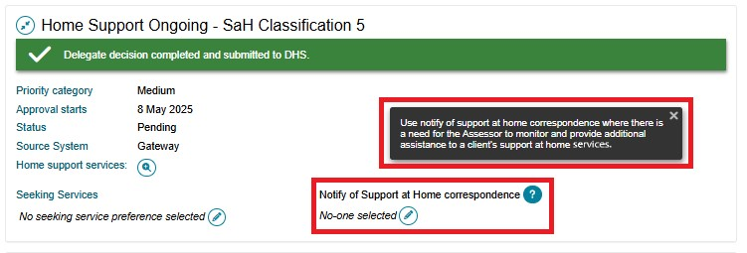
Only one person from an outlet can be selected to receive this notification. The preference is shown below. All clinical assessors and assessment delegates from the assessment outlet will be displayed in a drop-down menu.
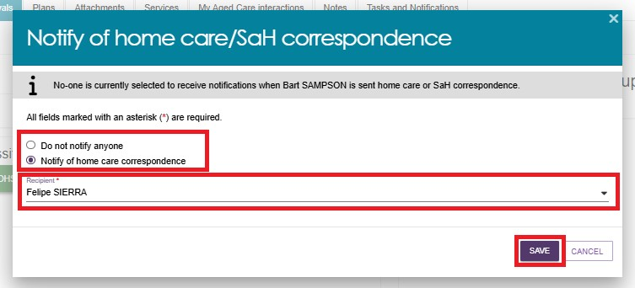
Team Leader role
In the team leader role, you can view which clinical assessor or Assessment Delegate is currently receiving the client’s Support at Home correspondence notifications. You will also have the ability to reassign a client or an individual or make bulk reassignment changes to a different clinical assessor or Assessment Delegate in an outlet.
In the Tasks and Notifications tab select Notifications tab. If you manage more than one outlet you may choose which outlet to view from the dropdown.
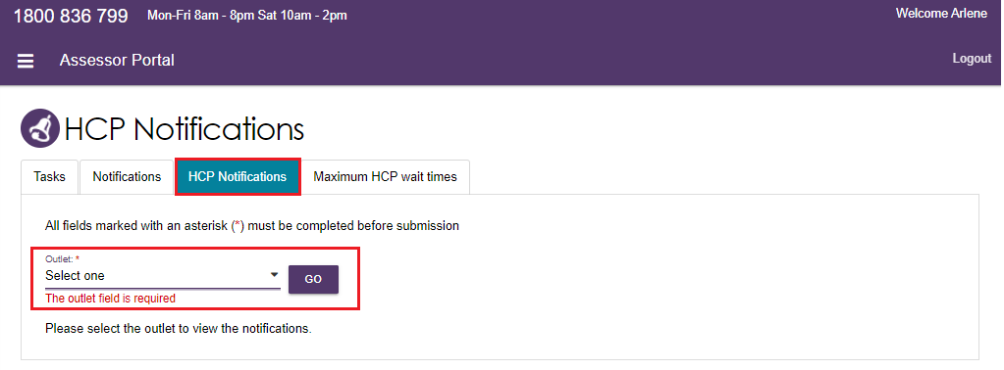
- Once you have chosen the outlet to view you will see the following details:
- Last Name
- First Name
- Aged Care User ID
- Locality
- Who receives the notification (First name, Last name)
- tick box which allows the team lead to complete individual or bulk reassignments.
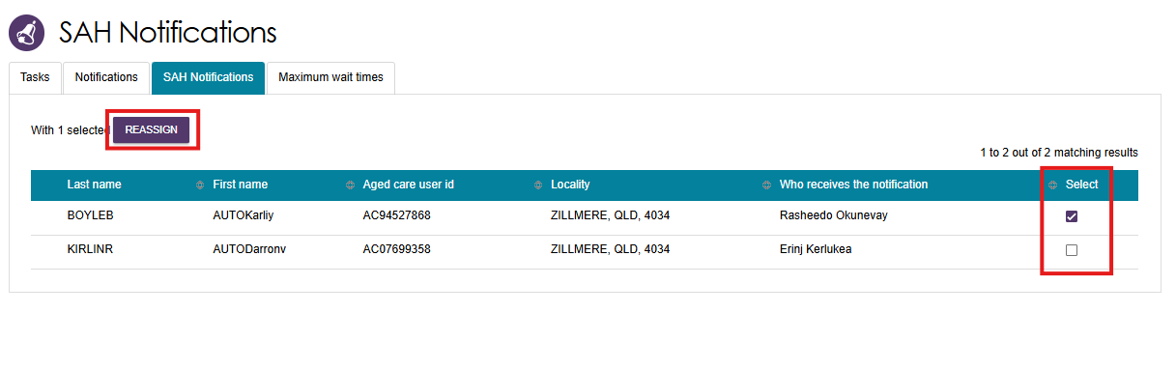
- By selecting the REASSIGN button, the Re-assign Home Care correspondence notifications pop-up will be displayed where you can select the new recipient and finalise by clicking the SAVE button.
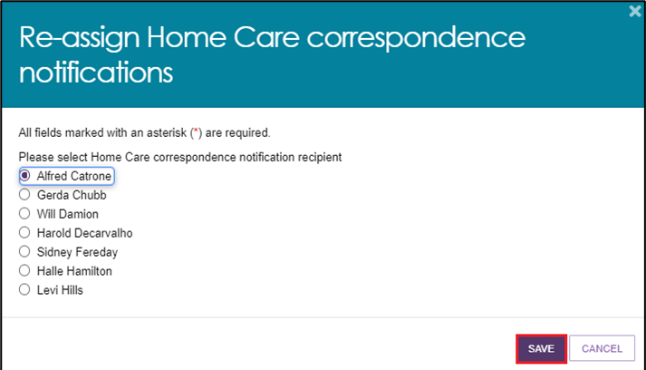
! | Refer to the Support at Home correspondence sent to clients section for actual letter templates.

Notification of Residential Permanent correspondence
Clients and/or their registered supporters will be notified about their Residential Permanent place allocation, including waiting for a place, and being allocated a place. These notifications are sent by email, SMS and mail.
If nominated, the assessor can also receive system notifications on behalf of the client.
Notifications of residential care correspondence for assessors can be set during the Delegate Decision stage. Alternatively, go to the client’s profile and select the Approvals tab.
For each residential care approval, select the Edit (pencil) icon under the Notify of Residential care correspondence section.
Select the assessor to be notified in the pop up and then select Save.
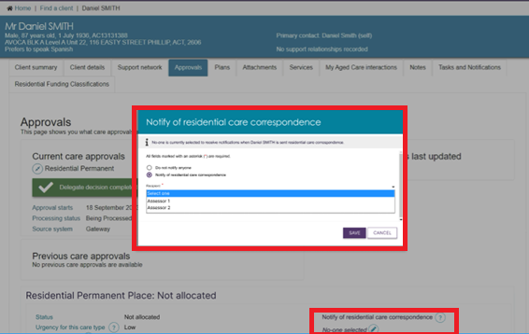
Outlet administrators can manage Residential care correspondence preferences.
To manage preferences:
- select the outlet, then go to its Tasks and Notifications tile, then the Manage Preferences tab. Select Change Preferences inside the pop up.
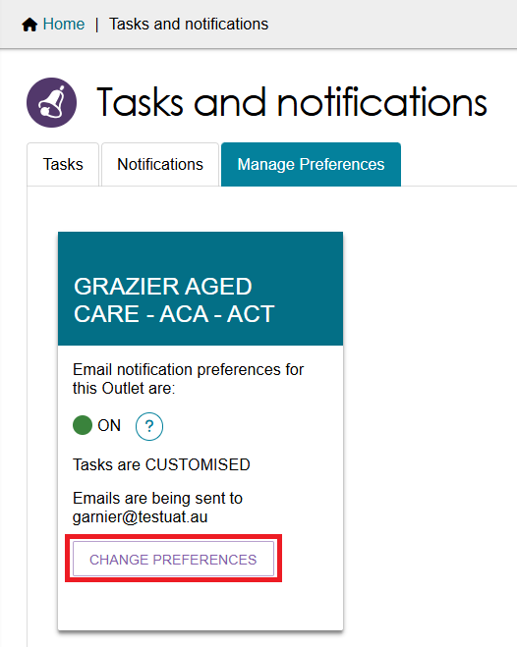
- Scroll down to the relevant section and adjust the settings by selecting the Yes/No toggles. The following shows an example of the RAC Place Restriction notification underneath the Delegate Decision heading. Toggles available are:
- Send an email when this type of notification is received?
- Show this type of notification in the portal when it is received?
- Show this type of notification as important?
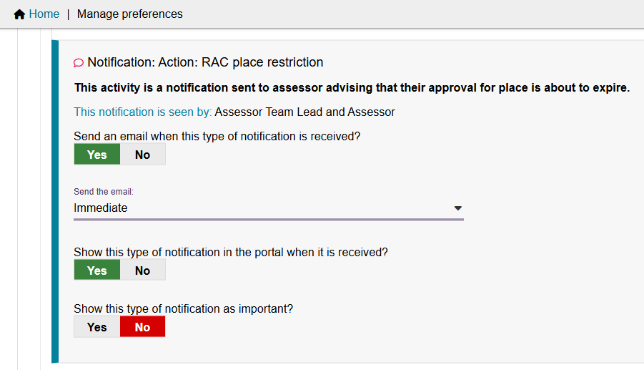
To view Residential Permanent correspondence notification for a client, go to the Tasks and Notifications tile, then go to the Notifications tab.
The below screenshot shows an example of a RAC Place Restriction notification.
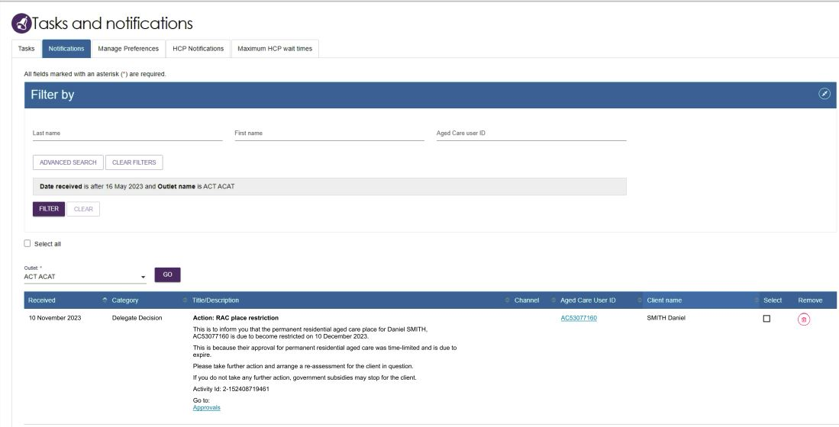

Confirming client contact information is accurate
To ensure correspondence is received, the client’s address details need to be correct. This is particularly important for Support at Home participants as they have 56 days in which to enter a Support at Home Service Agreement, with an additional 28 days if required. To view and edit client’s contact details within the assessor portal follow the below instructions.
- From the client card, select Client Details.
- At the bottom of the client details page, select the pencil (edit) icon to then edit the client’s home and/or correspondence address.
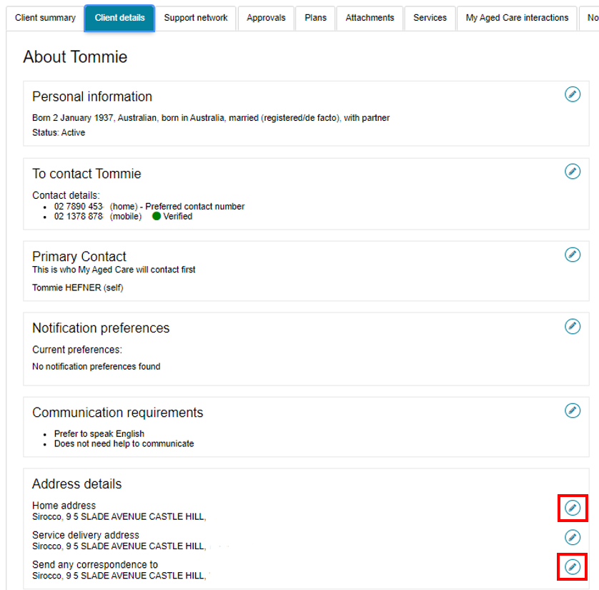

Creating Reports
Clinical assessors and assessment delegates and are able to create a report at the outlet level. The report will display the list of clients who have been nominated either by clinical assessors or assessment delegates and wish to receive notifications related to Support at Home.
- This report is accessed in Reports and documents tab.
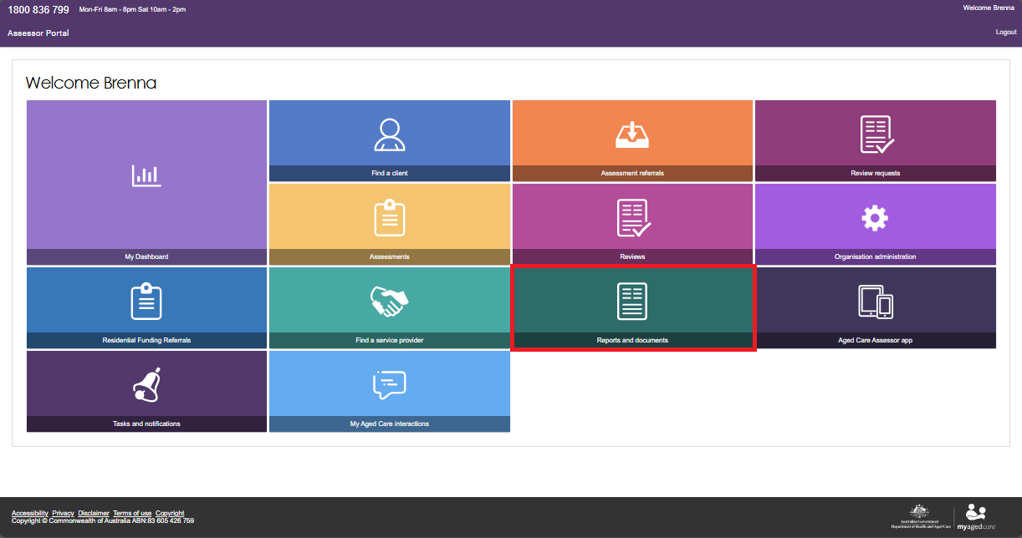
- Select the BIP Home Care Correspondence Notifications Report.
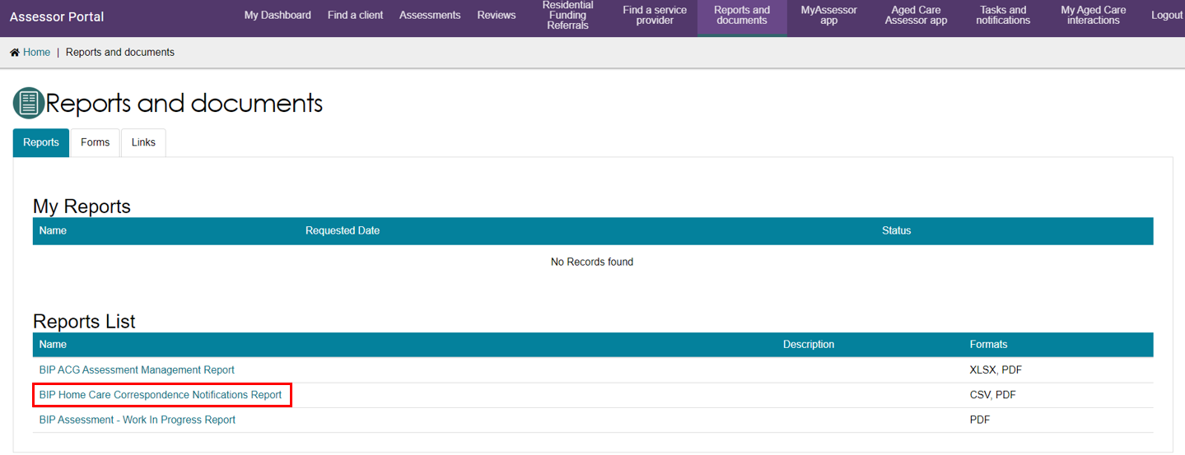
Select the Outlet, Recipient and Output Type being either CSV file (comma separate values) or PDF (portable document format).
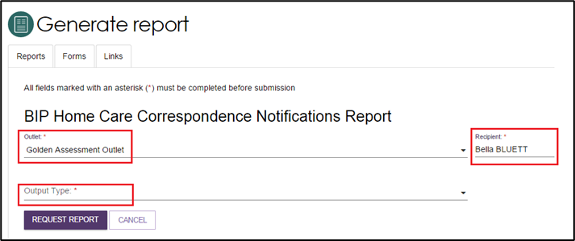

Support at Home correspondence sent to clients
There are a number of letters sent to clients related to Support at Home at different stages. Copies of these letters will also be sent to their supporter/s. Full details are contained in the client letter which will typically be available within 24 hours. The letter can be accessed from the Attachments tab in their client record.

Support at Home Funding Assignment Notice
Dear [name]
Home Support section –
I am pleased to advise that you have been assigned the [Program] classification funding below:
Classification Type: [Classification Type]
- Classification: [Classification]
This is based on your approval for this classification on [delegate decision date].
If you have not received your approval letter, it will arrive shortly.
For your assigned classification the Australian Government will contribute:
- A yearly funding amount of up to approximately <value as per assigned SaH classification>.
- This amount will be allocated quarterly towards the cost of your care.
- This amount is used to pay your service provider for the services you receive.
You may also be asked to pay a contribution to the cost of your care.
Full-service offer (FSO) section –
You can now choose a service provider and enter into a service agreement to start receiving services. A service agreement outlines your rights and responsibilities and what services you will receive by your service provider.
If you were previously offered sixty percent of the classification value, the remaining amount is now available for you to continue receiving services. We have notified your service provider of the change in your funding.
Minimum Funding Offer (MSO) section –
Sixty percent of the classification value (<indicate 60% of classification amount>) is now available for you to start to receive Support at Home services. This is lower than the approved amount allocated to your classification. While waiting for your full-service offer, this will let you choose a service provider and enter into a service agreement to start receiving services. A service agreement outlines your rights and responsibilities and what services you will receive by your service provider.
If you take up the available funding now, there will be no impact to the rest of the sum allocated to your classification. The remaining funding amount will be released as soon as it is available. We will let you know when this happens.
AT-HM1 section –
The following service/s have also been assigned to you with the corresponding government funding amount and expiry date. This funding is used to pay your service provider for the services you receive.
You may also be asked to pay a contribution to the cost of your care.
Service Group | Classification Type | Classification | Amount | Expiry Date
[AT Service Group] | [AT Classification Type] | [AT Classification] | [AT classification amount] | <Depends>
[HM Service Group] | [HM Classification Type] | [HM Classification] | [HM classification amount] | 12 months from signing with a provider
If you have a specified progressive condition noted in the Assistive Technology – Home Modifications (AT-HM) Scheme guidelines, then the expiry date is 24 months from signing with a provider.
Only AT-HM section –
I am pleased to advise that you have been assigned the following <Program> service/s below with the corresponding government funding amount and expiry date. This is based on your approval on [delegate decision date]. This funding is used to pay your service provider for the services you receive.
You may also be asked to pay a contribution to the cost of your care.
Service Group | Classification Type | Classification | Amount | Expiry Date
[AT Service Group] | [AT Classification Type] | [AT Classification] | [AT classification amount] | <Depends >
[HM Service Group] | [HM Classification Type] | [HM Classification] | [HM classification amount] | 12 months from signing with a provider
If you have a specified progressive condition noted in the Assistive Technology – Home Modifications (AT-HM) Scheme guidelines, then the expiry date is 24 months from signing with a provider.
If you would like to talk through the information and next steps in this letter, I suggest that you show this letter to a family member, friend or trusted person.
If you prefer, you can talk through the information and next steps in this letter with a person who is independent from service providers and your support network. Advocates understand aged care and provide free and confidential support. You can contact the Older Persons Advocacy Network (OPAN) https://opan.org.au/ to speak with an advocate.
Vulnerable Client section –
We have told your assessor that you have been assigned a Support at Home classification so they can help you with the next steps. You can call <Assessor Name> of the <Team Name> assessment organisation on <Outlet_Telephone_Number>.
If you don’t feel you need any help from your assessor, you can follow the steps below.
To use your Support at Home classification you need to:
- Find out what you may be asked to pay for your Support at Home services:
- If you’re receiving an income tested payment e.g. aged pension or Department of Veterans’ Affairs pension, you don’t need to do anything for this step. You will receive a letter once you enter into a service agreement telling you about the fees you may be asked to pay.
- If you’re receiving a pension that is not means tested e.g. blind pension or war widow pension or you’re not receiving an income tested payment, you should call Services Australia on
- 1800 227 475 and ask if you need a formal income assessment. Services Australia answers calls Monday to Friday from 8am to 5pm.
- If you’re a full pensioner or part pensioner, your Support at Home contributions will be determined by your existing Age Pension income and assets assessment. Non pensioners will need to provide information about their income and assets to Services Australia to have their Support at Home contribution rate assessed.
2. Find service providers in your area:
- Use the Find a Provider tool on the My Aged Care website at www.myagedcare.gov.au/find-a-provider to search and compare providers, including their prices for some common services you may receive through your Support at Home classification; or
- You can call My Aged Care on 1800 200 422 or book a face-to-face appointment with an Aged Care Specialist Officer at select Services Australia centres. The person you speak to can give you a list of local service providers or send it to you in the post.
3. Talk to providers:
- You can contact as many providers as you like before you choose one.
- The checklist has questions you can ask service providers to help you choose the right provider for you.
4. Give your preferred providers your referral code:
- This lets them see information about your assessment and support plan.
- They can then discuss with you if they can meet your care needs.
Your referral code is [referral code]
Home Support2 section –
5. Once you’ve chosen a service provider you’ll need to set up a service agreement by [Classification expiry date]. Use the enclosed Entering into a Service Agreement - Considerations and Checklist:
- Your provider must tell you about any fees you need to pay.
- You should read your Agreement carefully before you agree to receive services.
- You may also want to ask a family member, friend, advocate or a lawyer to read your Agreement.
- You should work with your provider to develop a care and services plan and budget to make the best use of your assigned classification funding.
Home Support3 section –
What happens if you don’t enter into a service agreement with a service provider within 56 days?
- Your classification funding will be withdrawn if you haven’t entered into a service agreement with a service provider by <Classification Expiry Date>. If you need more time to find a service provider, you can call My Aged Care before <Classification Expiry Date> to ask for an extension of 28 days.
Please tell us if you don’t want the assigned classification funding now so someone else can use it
If you don’t want your Support at Home classification funding now, call My Aged Care on 1800 200 422 or book an appointment with an Aged Care Specialist Officer at select Services Australia centres as soon as possible. You will not lose your place because the Support at Home priority system is based on when you are approved for your Support at Home classification and the priority that was assigned to you. There will be no disadvantage to you if you choose not to take it up now.
You can contact My Aged Care at any time in the future and ask for your Support at Home classification funding to be reinstated.
Accessing your information online
You and your registered support network can also access information about your Support at Home classification, including approvals and letters, through the My Aged Care Online Account via my.Gov.au. More information about creating a myGov account and accessing your My Aged Care Online Account is available at www.myagedcare.gov.au/access-your-online-account.
Not sure what to do next?
For more information about Support at Home, search Support at Home on the My Aged Care website at www.myagedcare.gov.au.
If you have any questions about what you need to do next, you can call My Aged Care on 1800 200 422. My Aged Care answers calls between 8am and 8pm on weekdays and 10am and 2pm on Saturdays. Alternatively, you can visit www.servicesaustralia.gov.au/aged-care-specialist-officer-my-aged-care-face-to-face-services or book an appointment with an Aged Care Specialist Officer at select Services Australia centres or by calling 1800 227 475 Monday to Friday 8am to 5pm.

Support at Home Funding Assignment – Consecutive
Dear [name]
I am writing about your request to have a re-assessment of your funded aged care services. This assessment was completed by <Assessor Name> of the <Team Name> assessment organisation on <assessment date>.
If you have not received your approval letter, it will arrive shortly.
Home Support section –
Prior to this reassessment, you were previously approved for a <Program> <Classification Type> - <Classification>. However, you had not yet been assigned funding for this classification.
I am happy to tell you that a higher classification is now available to offer you more support to remain living at home. This decision was made under Section 78 of the Aged Care Act 2024 (the Act).
You have now been assigned funding for the classification below:
Classification Type: [Classification Type]
- Classification: [Classification]
If you have not already done so, you now have until <Classification Expiry Date> to enter a service agreement. A service agreement outlines your rights and responsibilities and what services you will receive by your service provider.
For your assigned classification the Australian Government will contribute:
- A yearly funding amount of approximately <value as per assigned SaH classification>
- This amount will be allocated quarterly towards the cost of your care.
- This funding is used to pay your service provider for the services you receive.
You may also be asked to pay a contribution to the cost of your care.
Full-service offer (FSO) section –
This is based on your approval for this classification on <delegate decision date>. You can now choose a service provider and enter into a service agreement to start receiving services.
Minimum Funding Offer (MSO) section –
Sixty percent of the classification value (<indicate 60% of classification amount>) is now available for you to start to receive services according to your needs. This is lower than the approved amount allocated to your classification, but this will let you start to choose a service provider and enter into a service agreement to start receiving services.
If you take up the available funding now, there will be no impact to the rest of the funding amount allocated to your classification. The remainder will be released as soon as it is available. We will let you know when this happens.
AT-HM1 section –
The following service/s have also been assigned to you with the corresponding government funding amount and expiry date. This funding is used to pay your service provider for the services you receive.
You may also be asked to pay a contribution to the cost of your care.
Service Group | Classification Type | Classification | Amount | Expiry Date
<Assistive Technology > | <AT Classification Type> | <AT Classification> | <AT Classification> | <Depends>
<Home Modifications > | <Home Modifications > | <HM Classification> | <HM classification amount> | 12 months after signing with a provider
If you have a specified progressive condition noted in the Assistive Technology – Home Modifications (AT-HM) Scheme guidelines, then the expiry date is 24 months from signing with a provider.
Only AT-HM section –
I am pleased to advise that you have been assigned the following <Program> service/s below with the corresponding government funding amount and expiry date. This funding is used to pay your service provider for the services you receive.
You may also be asked to pay a contribution to the cost of your care.
Service Group | Classification Type | Classification | Amount | Expiry Date
<Assistive Technology > | <AT Classification Type> | <AT Classification> | <AT Classification> | <Depends>
<Home Modifications > | <Home Modifications > | <HM Classification> | <HM classification amount> | 12 months after signing with a provider
If you have a specified progressive condition noted in the Assistive Technology – Home Modifications (AT-HM) Scheme guidelines, then the expiry date is 24 months from signing with a provider.
If you would like to talk through the information and next steps in this letter, I suggest that you show this letter to a family member, friend or trusted person.
If you prefer, you can talk through the information and next steps in this letter with a person who is independent from service providers and your support network. Advocates understand aged care and provide free and confidential support. You can contact the Older Persons Advocacy Network (OPAN) https://opan.org.au/ to speak with an advocate.
Vulnerable Client section –
We have told your assessor that you have been assigned a Support at Home classification so they can help you with the next steps. You can call <Assessor Name> of the <Team Name> assessment organisation on <Outlet_Telephone_Number>.
If you don’t feel you need any help from your assessor you can follow the steps below.
To use your Support at Home classification you need to:
- Find out what you may be asked to pay for your Support at Home services:
- If you’re receiving an income tested payment e.g. aged pension or Department of Veterans’ Affairs pension, you don’t need to do anything for this step. You will receive a letter once you enter into a service agreement telling you about the fees you may be asked to pay.
- If you’re receiving a pension that is not means tested e.g. blind pension or war widow pension or you’re not receiving an income tested payment, you should call Services Australia on 1800 227 475 and ask if you need a formal income assessment. Services Australia answers calls Monday to Friday from 8am to 5pm.
- If you’re a full pensioner or part pensioner, your Support at Home contributions will be determined by your existing Age Pension income and assets assessment. Non pensioners will need to provide information about their income and assets to Services Australia to have their Support at Home contribution rate assessed.
- Find service providers in your area:
Use the Find a Provider tool on the My Aged Care website at www.myagedcare.gov.au/find-a-provider to search and compare providers, including their prices for some common services you may receive through your Support at Home Classification; or
- You can call My Aged Care on 1800 200 422 or book a face-to-face appointment with an Aged Care Specialist Officer at select Services Australia centres. The person you speak to can give you a list of local service providers or send it to you in the post.
- Talk to providers:
- You can contact as many providers as you like before you choose one.
- The enclosed checklist has questions you can ask service providers to help you choose the right provider for you.
- Give your preferred providers your referral code:
- This lets them see information about your assessment and support plan.
- They can then discuss with you if they can meet your care needs.
Your referral code is [referral code]
Home Support2 section –
- Once you’ve chosen a service provider you’ll need to set up a service agreement by [Classification expiry date]. Use the enclosed Entering into a Service Agreement - Considerations and Checklist:
- Your provider must tell you about any fees you need to pay.
- You should read your Agreement carefully before you agree to receive services.
- You may also want to ask a family member, friend, advocate or a lawyer to read your Agreement.
- You should work with your provider to develop a care and services plan and budget to make the best use of your assigned classification funding.
CHSP Client section –
What about the home care services you are currently getting?
We are aware that you are receiving care services through the Commonwealth Home Support Programme (CHSP). Your Support at Home classification will meet your care needs better because your service provider will coordinate your services. Your current service provider has been told you have been allocated a Support at Home classification.
Home Support3 section –
What happens if you don’t enter into a service agreement with a service provider within 56 days?
- Your classification assignment will be withdrawn if you haven’t entered into a service agreement with a service provider by <Classification Expiry Date>.
- If you need more time to find a service provider you can call My Aged Care before <Classification Expiry Date> to ask for an extension of 28 days.
Please tell us if you don’t want the assigned classification funding now so someone else can use it
If you don’t want your Support at Home classification now, call My Aged Care on 1800 200 422 or book an appointment with an Aged Care Specialist Officer at select Services Australia centres as soon as possible. You will not lose your place because the Support at Home priority system is based on when you were approved for your Support at Home classification funding and the priority that was assigned to you. There will be no disadvantage to you if you choose not to take it up now.
You can contact My Aged Care at any time in the future and ask for your Support at Home classification funding to be reinstated.
Accessing your information online
You and your registered support network can also access information about your Support at Home classification, including approvals and letters, through the My Aged Care Online Account via my.Gov.au. Further information about creating a myGov account and accessing your My Aged Care Online Account is available at www.myagedcare.gov.au/access-your-online-account.
Not sure what to do next?
For more information about Support at Home, search Support at Home on the My Aged Care website at www.myagedcare.gov.au.
If you have any questions about what you need to do next, you can call My Aged Care on 1800 200 422. My Aged Care answers calls between 8am and 8pm on weekdays and 10am and 2pm on Saturdays. Alternatively, you can visit www.servicesaustralia.gov.au/aged-care-specialist-officer-my-aged-care-face-to-face-services or book an appointment with an Aged Care Specialist Officer at select Services Australia centres or by calling 1800 227 475 Monday to Friday 8am to 5pm.

Upgrade Notice or Upgrade Notice (consecutive)
Dear [Name]
I am writing about your re-assessment by <Assessor Name> of the <Team Name> assessment organisation.
If you have not received your approval letter, it will arrive shortly.
Home Support section –
You are receiving a <Program> <Current Classification Type – Classification> but I am happy to advise that a higher classification is now available to offer you more support to remain living at home.
If you have already been told this, but were previously offered only part of your funding, the remaining amount is now available for you to continue receiving services.
You have now been assigned the <Program> classification below:
Classification Type: [new Classification Type]
- Classification: [new Classification]
For your assigned classification the Australian Government will contribute:
- A yearly funding amount of up to approximately <value as per assigned SaH classification>
- This amount will be allocated quarterly towards the cost of your care.
- This amount is used to pay your service provider for the services you receive.
You may also be asked to pay a contribution to the cost of your care. [Full-Service Offer (FSO) section
What has changed?
You have now been assigned a <Program> <Classification Type – Classification> allowing you to receive additional funding.
If you were previously offered sixty percent of the classification value, the remaining amount is now available for you to continue receiving services. We have notified your service provider of the change in your funding.
Minimum Service Offer (MSO) section –
What has changed?
You have now been assigned a <Program> <new Classification Type - Classification>.
Sixty percent of the classification amount (<indicate 60% of the new classification amount>) is now available for you to receive Support at Home services according to your needs.
New MSO GT current funding section –
This amount is lower than what is allocated for your new classification, but this is higher than what you are currently receiving (<value as per current SaH classification>) and will allow you to get services according to your needs.
New MSO LE current funding section –
You are currently receiving <value as per current SaH classification>, which is lower than the value offered now. You have the option to stay in your current classification until the full funding for your new classification becomes available.
If you take up the available funding now, there will be no impact to the rest of the funding amount allocated to your classification. The remaining amount will simply be released as soon as it is available. We will let you know when this happens.
AT-HM1 section –
The following service/s have also been assigned to you with the corresponding government funding amount and expiry date. This funding is used to pay your service provider for the services you receive.
You may also be asked to pay a contribution to the cost of your care.
Service Group | Classification Type | Classification | Amount | Expiry Date
<Assistive Technology > | <AT Classification Type> | <AT Classification> | <AT Classification> | <Depends>
<Home Modifications > | <Home Modifications > | <HM Classification> | <HM classification amount> | 12 months after signing with a provider
If you have a specified progressive condition noted in the Assistive Technology – Home Modifications (AT-HM) Scheme guidelines, then the expiry date is 24 months from signing with a provider.
Only AT-HM section –
I am pleased to advise that you have been assigned the following <Program> service/s below with the corresponding government funding amount and expiry date. This funding is used to pay your service provider for the services you receive.
You may also be asked to pay a contribution to the cost of your care.
Service Group | Classification Type | Classification | Amount | Expiry Date
<Assistive Technology > | <AT Classification Type> | <AT Classification> | <AT Classification> | <Depends>
<Home Modifications > | <Home Modifications > | <HM Classification> | <HM classification amount> | 12 months after signing with a provider
If you have a specified progressive condition noted in the Assistive Technology – Home Modifications (AT-HM) Scheme guidelines, then the expiry date is 24 months from signing with a provider.
What do you need to do?
If you would like to talk through the information and next steps in this letter, I suggest that you show this letter to a family member, friend or trusted person.
If you prefer, you can also talk through the information and next steps in this letter with a person who is independent from service providers and your support network. Advocates understand aged care and provide free and confidential support. You can contact the Older Persons Advocacy Network (OPAN) https://opan.org.au to speak with an advocate.
We will tell your service provider about this upgrade to your Support at Home classification. You need to talk to your provider about the changes you need to make to your:
- Service Agreement
- budget
- care and services plan.
This will help you make the best use of your higher classification and budget.
What if you want to change service providers?
You can change service provider at any time. You’ll need to give the referral code below to any new provider you are interested in. This lets them see information about your assessment and support plan and discuss with you if they can meet your care needs.
Your referral code is [Referral Code]
More information about changing service providers is provided in the enclosed fact sheet Changing Providers: Considerations and Checklist.
HS section only –
What if you no longer want your approved classification?
If you find you are coping well with the current <Program> <Current Classification Type – Classification>, you may not want the approved <new Classification Type – Classification>.
If this is the case, please call My Aged Care on 1800 200 422 and let them know you don’t want the higher classification at the moment.
If you change your mind about wanting a higher classification or feel you need a new assessment for home care, you can call My Aged Care on 1800 200 422 at any time and let them know.
Your place in the Support at Home priority system will not be affected, because it is based on when you were approved for you classification and the priority that was assigned to you.
Vulnerable Client section –
For more information about this change to your Support at Home classification you can call <Assessor Name> of the <Team Name> assessment organisation on <Outlet_Telephone_Number>. ]
Accessing you information online
You and your registered support network can also access information about your Support at Home classification, including approvals, waiting times and letters, through the My Aged Care Online Account via myGov. More information about creating a myGov account and accessing your My Aged Care Online Account is available at www.myagedcare.gov.au/access-your-online-account.
Not sure what to do next?
For more information about Support at Home, search Support at Home on the My Aged Care website at www.myagedcare.gov.au.
If you have any questions about what you need to do next, you can call My Aged Care on 1800 200 422. My Aged Care answers calls between 8am and 8pm on weekdays and 10am and 2pm on Saturdays. Alternatively, you can visit www.servicesaustralia.gov.au/aged-care-specialist-officer-my-aged-care-face-to-face-services or book an appointment with an Aged Care Specialist Officer at select Services Australia centres or by calling 1800 227 475 Monday to Friday 8am to 5pm.

Withdrawal Notice
Dear [name 2]
We are writing to advise you that your Support at Home funding offer has been withdrawn. You were assigned the following service/s with the corresponding classification funding uptake period (where applicable):
Service Group | Classification Type | Classification | Assignment Date | Uptake Date
<Service Group=Home Support> | <SaH Classification Type> | <SaH Classification> | < SaH Classification Assignment Date> | <Classification expiry date>
Permanent Residential care section –
Why has your funding been withdrawn?
Your funding was withdrawn because you have permanently entered residential care.
What if you decide you want to re-enter Support at Home?
If you are ready to re-enter care under Support at Home, you will need to call My Aged Care on 1800 200 422 or book an appointment with an Aged Care Specialist Officer at a select Services Australia centre. Advise them that you want to re-enter Support at Home so that you can be placed in the Support at Home priority system. Your place in the priority system will be based on when you were approved for your original classification and priority for service. This means that you won’t have to wait long to receive the help that you need.
Services not commenced: Full funding offer section –
Why has your funding offer been withdrawn?
You needed to have chosen a service provider and entered into a service agreement by the specified uptake date.
As we have not been told by a service provider that you have entered into a service agreement the funding offer has been withdrawn.
What if you are receiving Support at Home services?
You should call your provider immediately and tell them about this letter.
What if you are waiting for your full funding and don’t want your current funding offer withdrawn?
If you are waiting for your <Program> <Classification Type – Classification> funding offer, you do not need to do anything to stay in the Support at Home priority system. You will receive a letter when the full funding is available for your assigned classification.
Services not commenced: Minimum Service Offer section –
Why has your funding offer been withdrawn?
You needed to have chosen a service provider and entered into a service agreement by the specified uptake date.
As we have not been told by a service provider that you have entered into a service agreement the funding offer has been withdrawn.
What if you are receiving Support at Home services?
You should call your provider immediately and tell them about this letter.
What if you are waiting for your full funding and don’t want your current funding offer withdrawn?
If you are waiting for your <Program> <Classification Type – Classification> funding offer, you do not need to do anything to stay in the Support at Home priority system. You will receive a letter when the full funding is available for your assigned classification.]
Classification Declined: Client Not Seeking Services section
Thank you for advising My Aged Care that you no longer need a <Program> <Classification Type – Classification>. As a result:
- your <Program> <Classification Type – Classification> funding offer has been withdrawn
- you have been removed from the Support at Home priority system.
What if you decide you want your Support at Home funding offer reinstated?
If you are ready to receive care, you need to call My Aged Care on 1800 200 422 or book an appointment with an Aged Care Specialist Officer at select Services Australia centres and tell them you still want a <Program> <Classification Type – Classification> so you can be placed in the Support at Home priority system. Your place in the Support at Home priority system will be based on when you were approved for the classification and priority for service. This means you won’t have to wait long to receive your classification assignment
Vulnerable Client section –
We have told your assessor about the change to your assigned Support at Home classification so they can help you with the next steps. You can call <Assessor Name> of the <Team Name> assessment organisation on <Outlet_Telephone_Number>.]
You and your nominated support network can also access information about your Support at Home classification, including approvals and letters, through the My Aged Care Online Account via my.Gov.au. Further information about creating a myGov account and accessing your My Aged Care Online Account is available at www.myagedcare.gov.au/view-your-my-aged-care-online-account.
Not sure what to do next?
For more information about Support at Home, search Support at Home on the My Aged Care website at www.myagedcare.gov.au.
If you have any questions about what you need to do next, you can call My Aged Care on 1800 200 422. My Aged Care answers calls between 8am and 8pm on weekdays and 10am and 2pm on Saturdays. Alternatively, you can visit www.servicesaustralia.gov.au/aged-care-specialist-officer-my-aged-care-face-to-face-services or book an appointment with an Aged Care Specialist Officer at select Services Australia centres or by calling 1800 227 475 Monday to Friday 8am to 5pm.

Referral code reactivation
Dear [name]
You recently asked for your referral code to be reactivated.
I am pleased to advise that your referral code has now been reactivated and can be used to change your service provider.
Your referral code is [referral code]
If you would like to talk through the information and next steps in this letter, I suggest that you show this letter to a family member, friend or trusted person.
If you prefer, you can also talk through the information and next steps in this letter with a person who is independent from service providers and your support network. Advocates understand aged care and provide free and confidential support. You can contact the Older Persons Advocacy Network (OPAN) at https://opan.org.au to speak with an advocate.
How do you use your referral code?
You can give your referral code to your preferred home care service providers.
- This lets them see information about your assessment and support plan.
- They can then discuss with you if they can meet your care needs.
What happens if you have a service provider, but want to change?
To change your service provider you need to:
- tell your current provider you want to end your service agreement with them.
- agree a date their services will stop.
Follow these steps to find a new service provider
- Find service providers in your area:
- Use the Find a Provider tool on the My Aged Care website at www.myagedcare.gov.au/find-a-provider to search and compare providers; or
- You can call My Aged Care on 1800 200 422 or book an appointment with an Aged Care Specialist Officer at select Services Australia centres. The person you speak to can give you a list of local service providers over the phone or send it to you in the post.
- Read the enclosed fact sheet ‘Changing Providers – Considerations and Checklist’ for tips on how to move providers.
- You can contact as many providers as you like before you choose one.
- The checklist has questions you can ask service providers to help you choose the right provider for you.
Accessing your information online
You and your registered supporter can also access information about your Support at Home classification, including approvals and letters, through the My Aged Care Online Account via my.Gov.au. Further information about creating a myGov account and accessing your My Aged Care Online Account is available at www.myagedcare.gov.au/view-your-my-aged-care-online-account.
Not sure what to do next?
For more information about Support at Home, search Support at Home on the My Aged Care website at www.myagedcare.gov.au.
If you have any questions about what you need to do next, you can call My Aged Care on 1800 200 422. My Aged Care answers calls between 8am and 8pm on weekdays and 10am and 2pm on Saturdays. Alternatively, you can visit www.servicesaustralia.gov.au/aged-care-specialist-officer-my-aged-care-face-to-face-services or book an appointment with an Aged Care Specialist Officer at select Services Australia centres or by calling 1800 227 475 Monday to Friday 8am to 5pm.

