Assessor Portal User Guide 8 – Referring for services
A client may require services to support their needs as a result of an assessment.
Aged care needs assessors (assessors) may refer the client (with consent) for service recommendations made in the client’s support plan, based on the client’s preferred service provider (or prioritised list of service providers) and location preferences.
They can then send electronic referrals for services or provide the client with a referral code that allows them to visit providers prior to selecting their preferred provider.
! | For CHSP only: For guidance on the interim process explaining Manual Delegate Approval for CHSP only for comprehensive and home support assessments, and how it impacts assessors during issuance of referral code(s) and support plan finalisation from 1 November 2025, refer to Manual Delegate Approval for CHSP – Standard Operating Procedure and instructional videos for comprehensive and home support assessments. This is available from your Assessment Organisation (via Assessment and the new Aged Care Act Sharepoint page).
Contents
Referral Types 2
Sequential Mode 2
Broadcast Mode 2
Referral Codes 2
No Care Approval 3
Issuing a referral for service 3
Recalling a referral 13
Issuing a referral code 14
Viewing Delegate decisions 17
Referring for Support at Home services 18
Referring Support at Home services with the Support at Home Priority System 20
Managing rejected service referrals 22

Referral Types
For service recommendations made in the client’s support plan, you can search for and match a client to a preferred service provider (or prioritised list of service providers) based on the client’s preferred location and/or preferences.
! | You must obtain consent from the client and/or their supporter guardian prior to issuing a referral. This is complete by using the referral for services components of the My Aged Care Assessment Consent Form, which is available for download in the Documents & Reports tile in the My Aged Care assessor portal (assessor portal).
There are three types (modes) of referrals. You can:
- send a Sequential referral for service
- send a Broadcast referral for service or
- provide the client with a referral code that allows them to visit providers prior to selecting their preferred provider.
You can also decline to refer, by issuing a “No Care Approval”.
! | For CHSP only: From 1 November 2025 under the Manual Delegate Approval for CHSP interim process, No Care Approval can be used to add CHSP services for comprehensive assessments.

Sequential Mode
The assessor will send the client’s referral to their chosen provider/s in the order of their preference. The client can limit their preference to one or more providers. If their first preference is not available, the referral is automatically sent to the next preference.
! | From 1 November 2025, All Residential Permanent service referrals are only sent via Broadcast mode.

Broadcast Mode
The assessor will send the client’s referral to all available providers. In agreeing to a broadcast referral, multiple providers could contact the client to see if they can provide them with the service/s. If a provider accepts their referral, the other provider/s will no longer see their information.

Referral Codes
For residential aged care services, assessors will normally generate a referral code for the client rather than issuing an electronic referral to service through the assessor portal. If a client has indicated preference or has been in discussions with particular provider/s, assessors can issue an electronic referral.
For Support at Home, once a client is assigned a Home Support service from the Support at Home Priority System, they will also be assigned a referral code. This code will be mailed to the client with their service assignment/upgrade letter. Alternatively, assessors can provide this code (available in the client’s support plan) to the client to allow them to visit Support at Home program providers prior to selecting their preferred provider. In addition, where the client has indicated a preference or discussed options with a Support at Home provider, assessors can issue an electronic referral.

No Care Approval
If you have recommended ‘No Care Approval’ due to the client withdrawing their application for care or not wishing to apply for care under the Act, you can select COMPLETE SUPPORT PLAN AND CONTINUE TO MATCH AND REFER from any tab in the client’s support plan.
! | From 1 November 2025, there are changes to how the No Care Approval option is used under the interim Manual Delegate Approval process for CHSP only approvals for comprehensive assessments.  For more information on the detailed interim process, please refer to Support at Home – Manual Delegate Approval for CHSP – Standard Operating Procedure and instructional videos for comprehensive assessments. This is available from your Assessment Organisation (via Assessment and the new Aged Care Act Sharepoint page).

Issuing a referral for service
! | Prior consent required  You must obtain consent from the client or their supporter guardian in their support network prior to issuing a referral. You should use the My Aged Care Assessment Consent. The Consent includes the consent scripts and fields to record the consent for service referrals. It is located via the Reports and documents tile within the assessor portal.
- When you have finished developing the support plan with the client, select COMPLETE SUPPORT PLAN AND CONTINUE TO MATCH AND REFER.
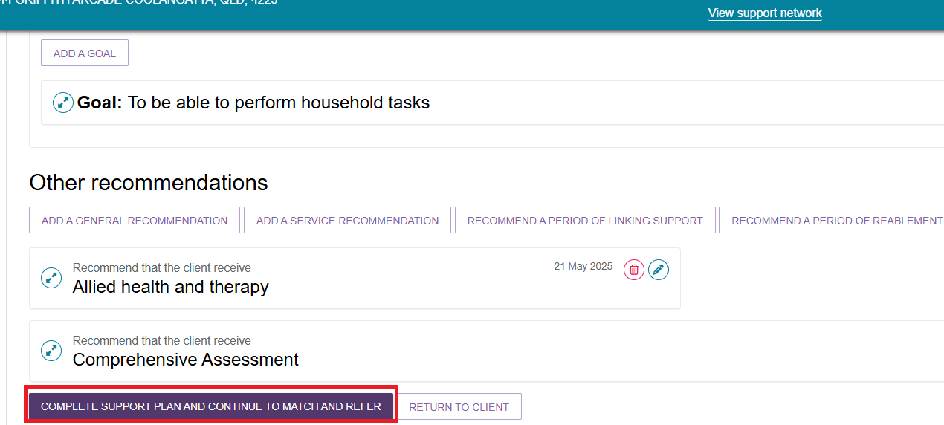
- You will be taken to the Manage services & referrals tab. The services added in the Goals and recommendations tab of the support plan will be displayed under Services not yet in place. Select FIND PROVIDERS to search and create electronic referrals for services.
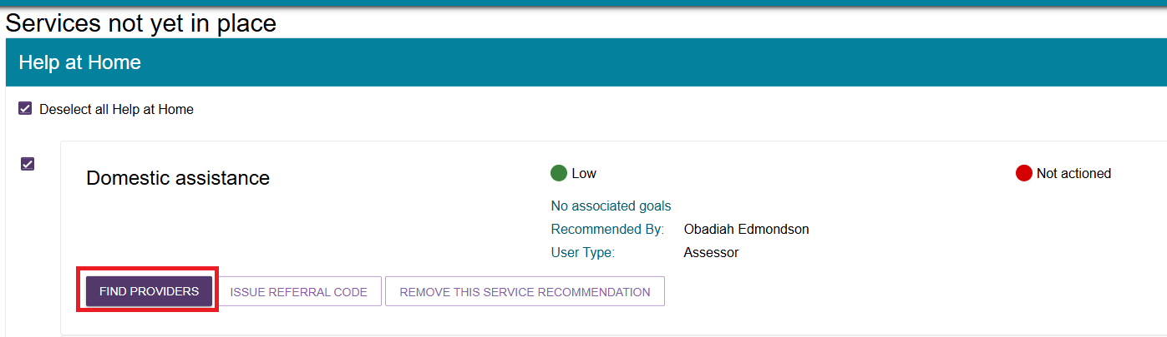
Below is an example of a client assessed for Support at Home services:
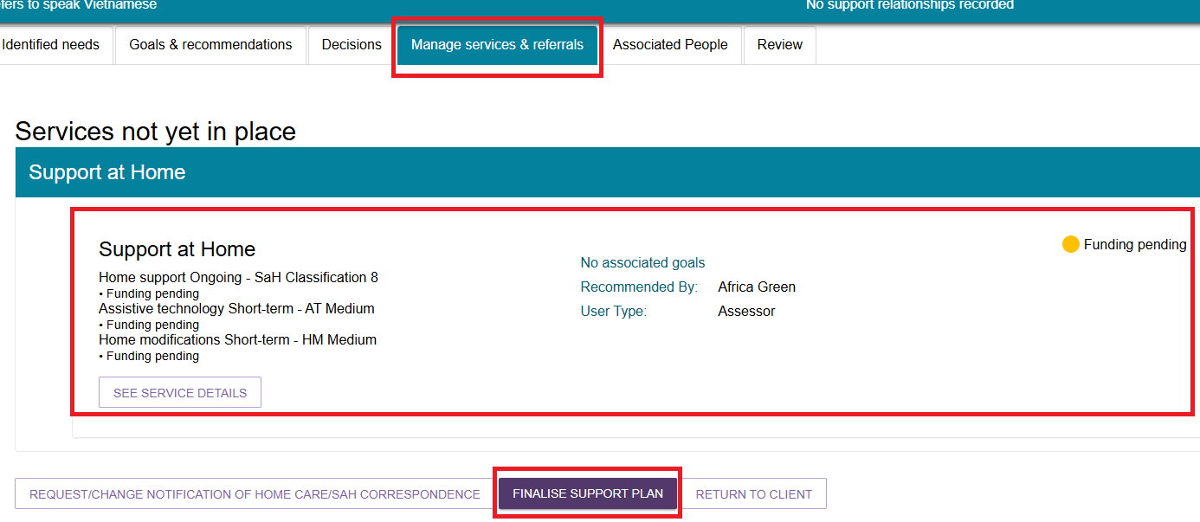
- To search for multiple services at the same time, select the services you wish to search for and click FIND HELP AT HOME PROVIDERS.
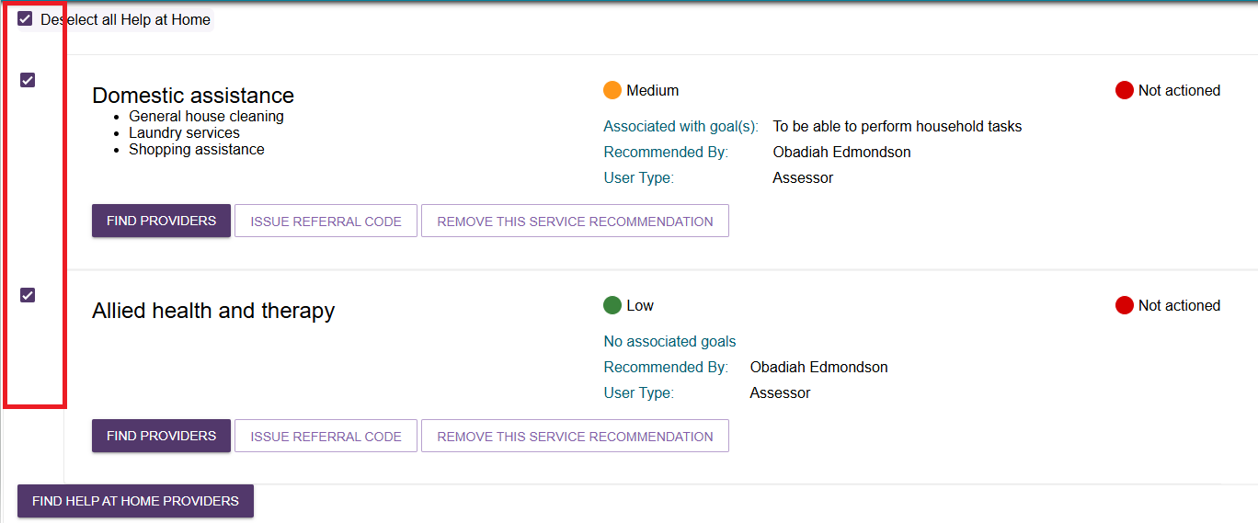

- A page will be displayed that displays the services you ticked in the previous step. It allows you to enter the search criteria for the service. Depending on the service type you are searching for, the search criteria may include, but not necessarily be limited to, the following:
- The list of services that are available for the service type selected, to further refine the search for a specific client need. For example, the ‘shopping assistance’ service under the ‘Domestic assistance’ service type.
- The client’s service delivery address for location-based searches
- Preferred service delivery setting: client location or service provider location
- Direct search for service providers by name or by proximity on a map.
Depending on the service selected, a location search may either be region/area based (e.g. domestic assistance services delivered to the client’s home) or proximity based (e.g. a centre or facility).
Detailed search options are available, including whether the client has previously received services with the service provider, or any specialisations required to cater for a client’s diverse or specialised needs.
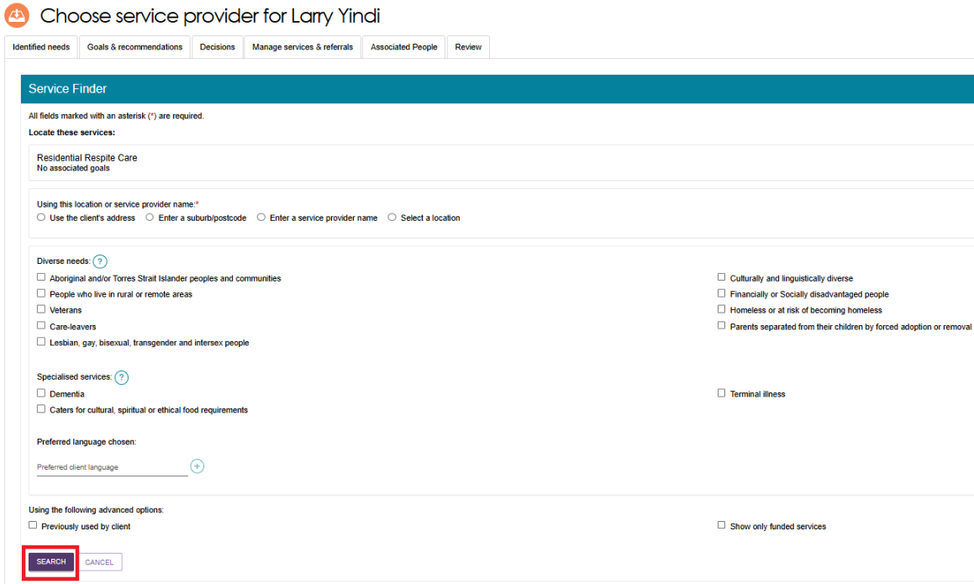
- For Support at Home services, you are able to search for service providers by specific attributes including Diverse needs, Specialised services, Language, Culture, Religion, Out of Hours service and Case management availability.
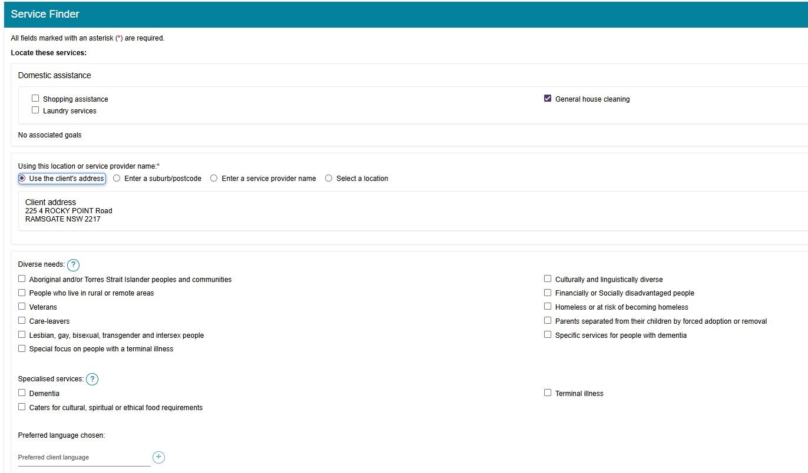
Enter the search criteria. Some further criteria display, depending on previous selections, such as how a service is delivered. Then, select the SEARCH button.
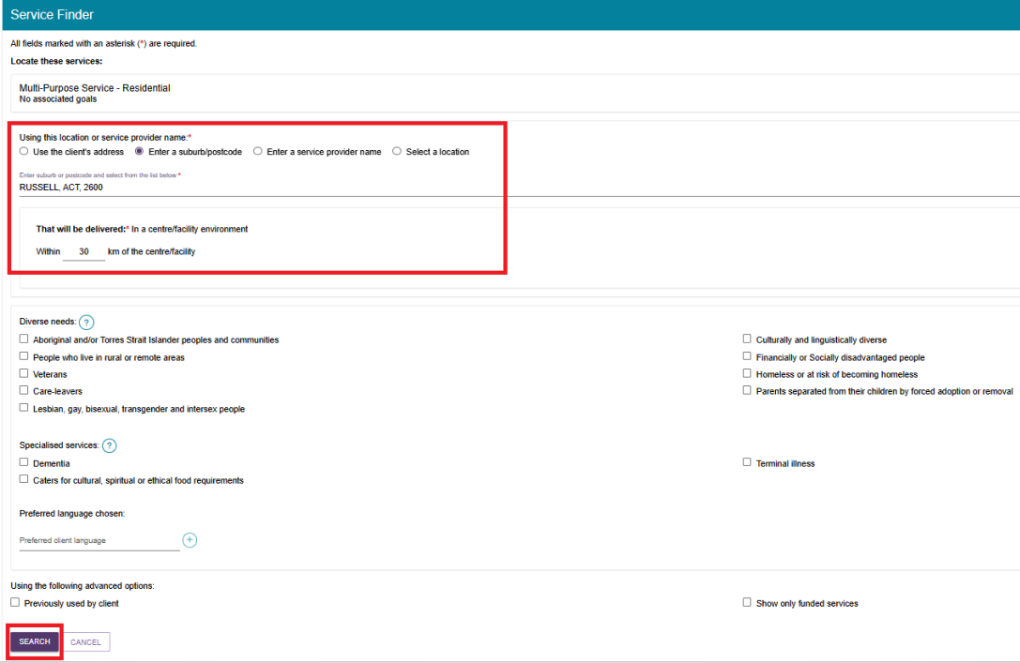

- When searching for services provided at a centre/facility, assessors are also able to select a location on a detailed visual map when matching and referring a client for service.
Select a location on the map by placing a pin, this pin may be moved to select a different location, and assessors can navigate around the map to view areas adjacent to the one currently displayed.
When searching by using the map functionality, the search results displayed will contain a list of service providers who provided services at a service delivery address within the search radius entered.
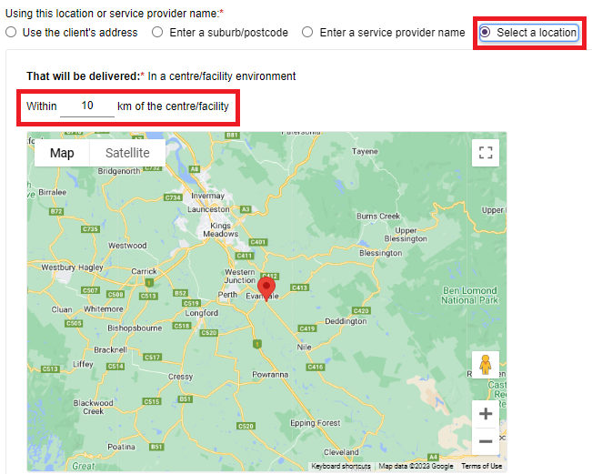
- View the search results. The search results will be sorted to display the most relevant service providers first or randomised in the case of equal relevance.
By default, you will be able to view the search results of service providers plotted on a detailed, interactive map. You can click Hide Map to switch to the list view and click Show Map when in the list view to revert to the map view.
The search results will display search results in the following configuration depending on the criteria used when searching for services.
Search method | Service delivery location | Map View | List View
Client Address; or  Suburb/Postcode | At Client Location | Outlet Address | Outlet Address
Client Address; or  Suburb/Postcode; or  Select A Location | At Provider Location | Address where services will be delivered | Outlet Address and service delivery address (under the individual service)
Service provider name | N/A | Map will be hidden for all services except Residential Care services | Outlet Address and service delivery address (under the individual service)
As services can be offered at both provider and client location in a service delivery outlet (with the exception of residential care services) the map will be hidden when searching by service provider name, as these results will not display consistently on the map.
The availability of services, service sub-types and waitlist options are displayed for each service provider.
Map View
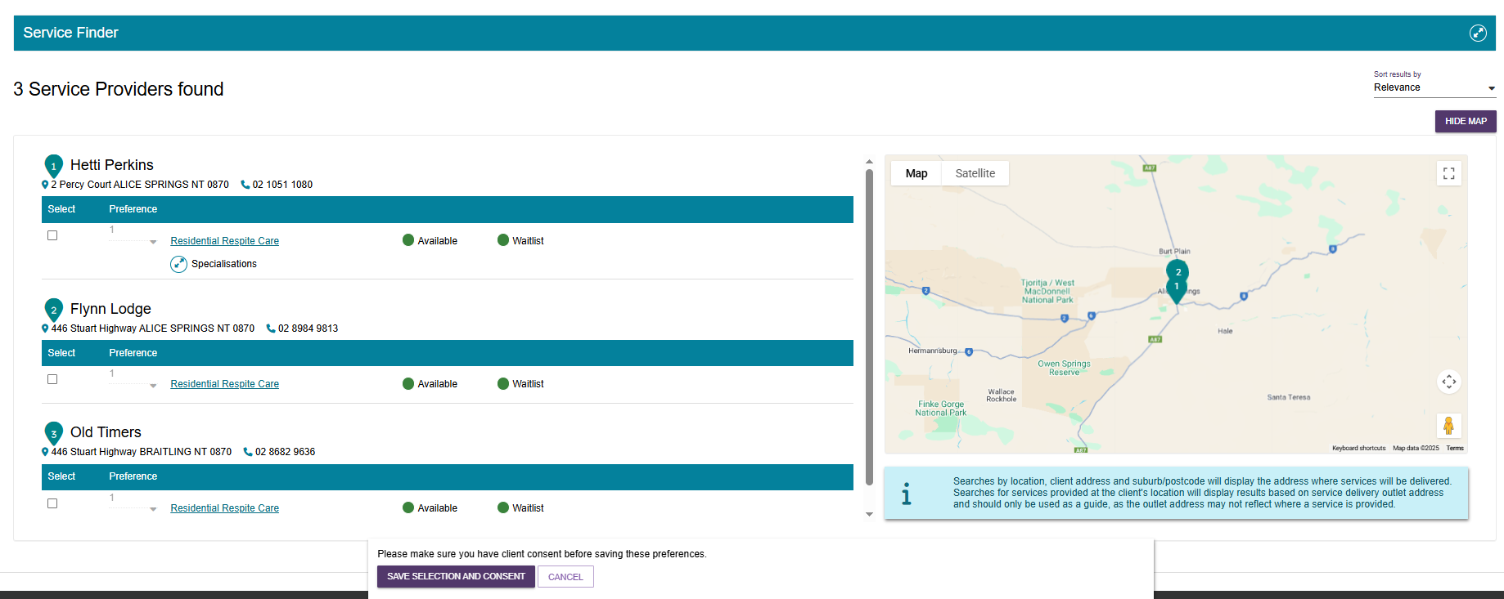
List View
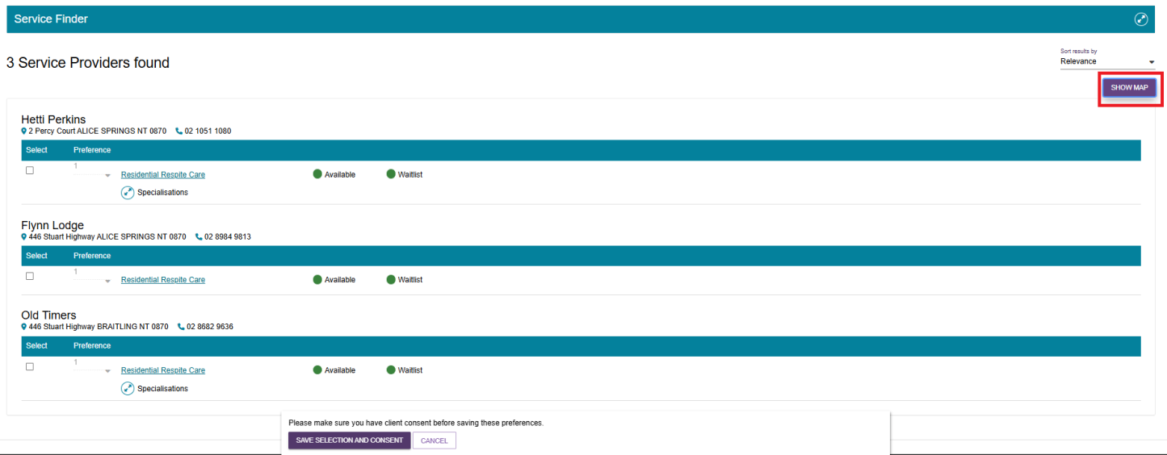
- Specialisations can be expanding the arrows next to service availability or Specialisations to view more detailed information about the services (including availability and wait list availability) and specialised service offerings of each service provider. For Diverse Needs, only verified diverse needs specialisations will be shown.
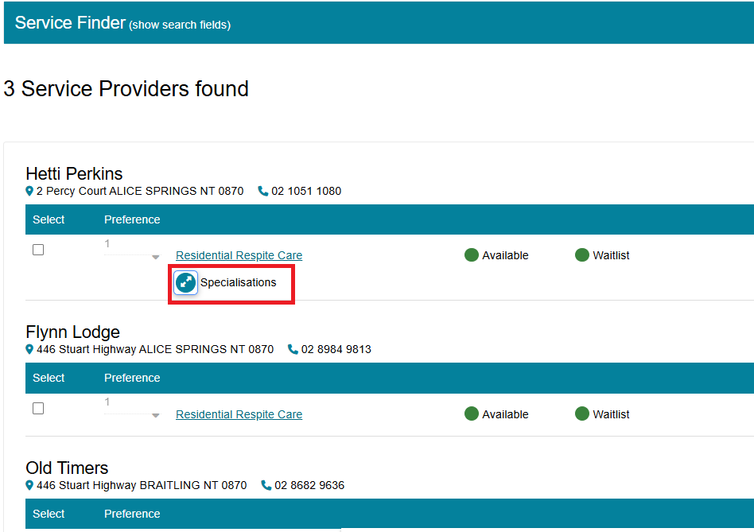
- Assessors can access a detailed page that replicates the information on the My Aged Care service finder by selecting the service name hyperlink under the service provider’s name. Assessors can view any regulatory decisions made against the provider by selecting the Regulatory decisions are available here hyperlink under the provider’s contact details. For care types under the Act, this page will also include information around the status of the service, costs of service etc. For example, Residential Permanent services outline information around the facility’s accreditation and costs for different room types.
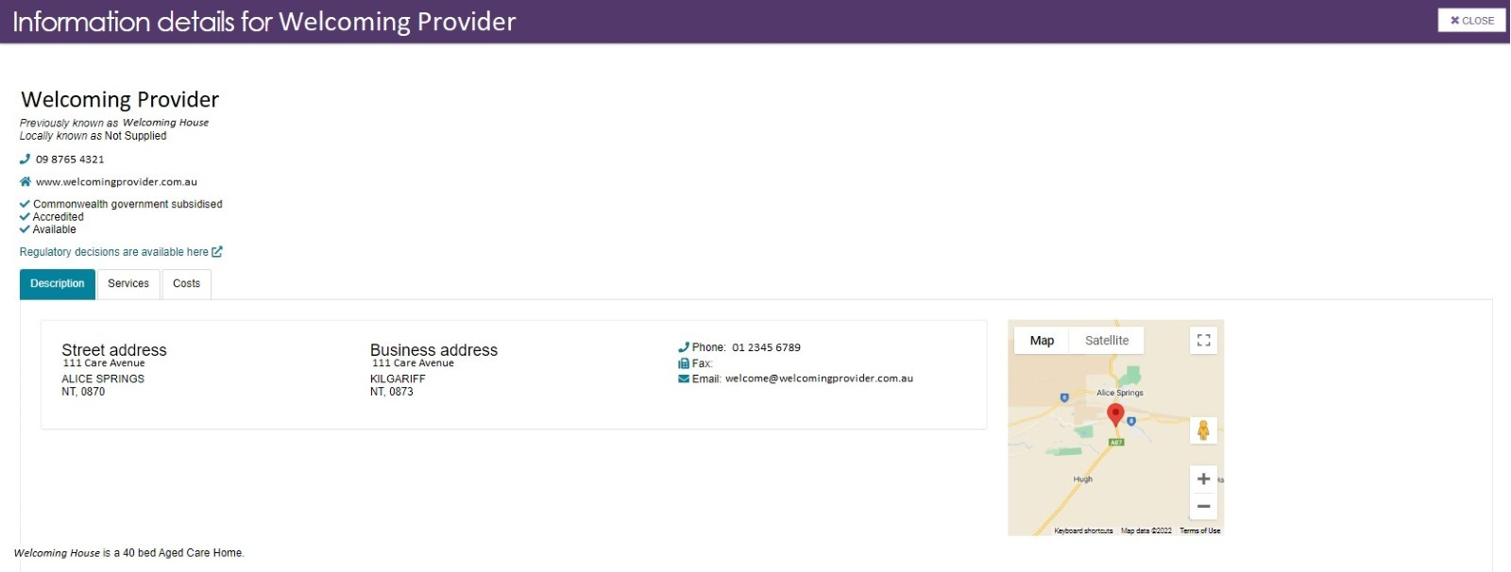
- The following message will be displayed if an appropriate service provider is not found:


- Select the client's preferred service provider(s), ensure that you have the client’s consent to send the referrals, and select SAVE SELECTION AND CONSENT.
- For broadcast referrals, set preferences for all service providers to 1st. In agreeing to a broadcast referral, the client needs to be aware that multiple providers could contact them about their service referral.
- For sequential referrals, set preferences for service providers in order of the client’s preference.
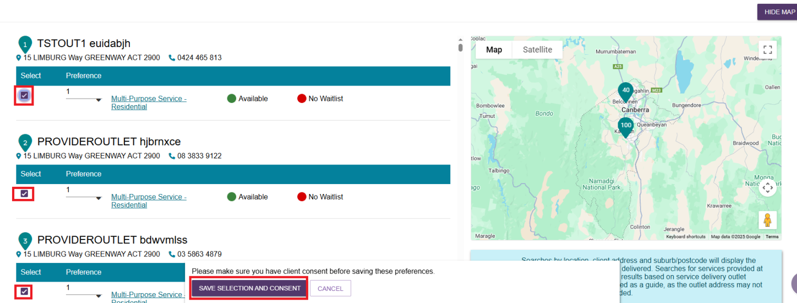
! | Waitlisting  If none of the client’s preferred service providers are available, they may wish to be placed on a waitlist. The search results will indicate whether a service provider has a waitlist available.  When referrals are sent sequentially and a provider accepts a client on to a waitlist, this will automatically trigger a referral to be issued to the next preference.  Clients may choose to be on multiple waitlists at the same time.  Clients will remain on a provider’s waitlist until the provider indicates services are available and accepts the client referral.  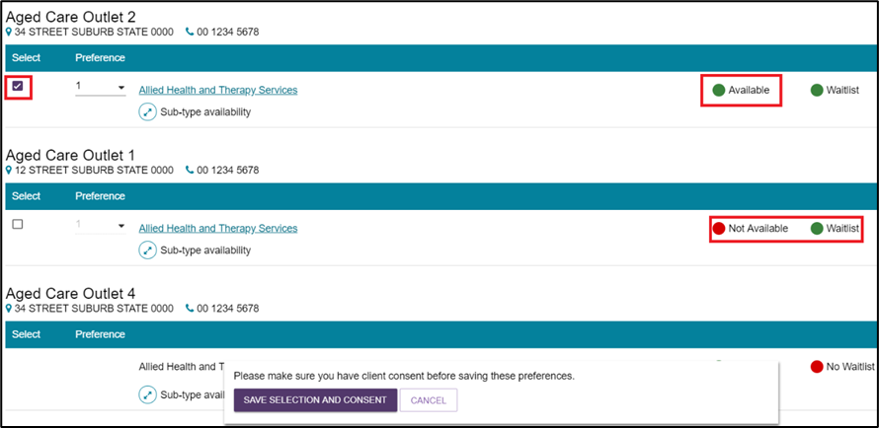
- The selected service provider(s) will now display as saved against the recommended service.
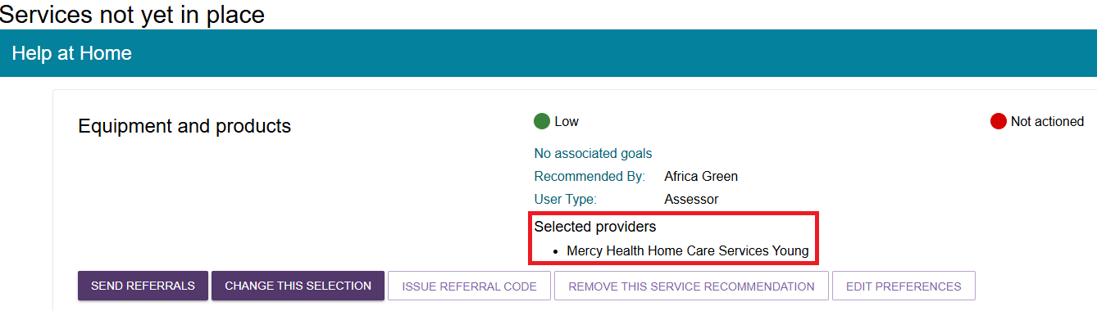
- To edit or remove existing provider preferences, select EDIT PREFERENCES.
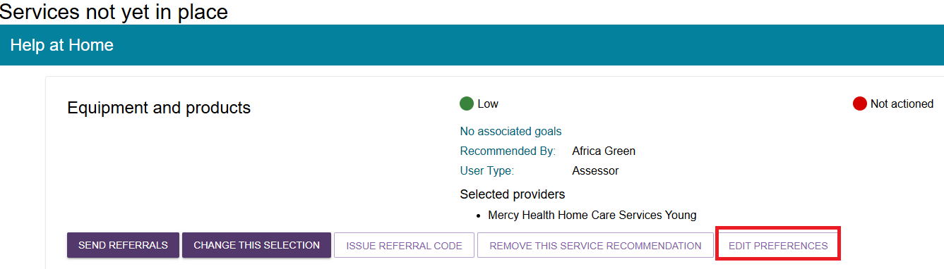
- To issue electronic referrals, select SEND REFERRALS.
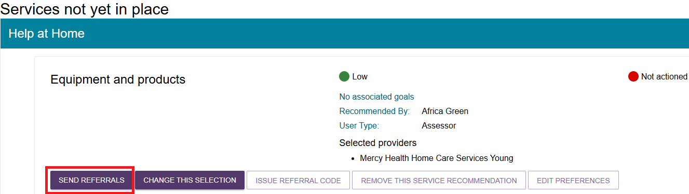
- Select CHANGE THIS SELECTION to choose additional provider preferences.
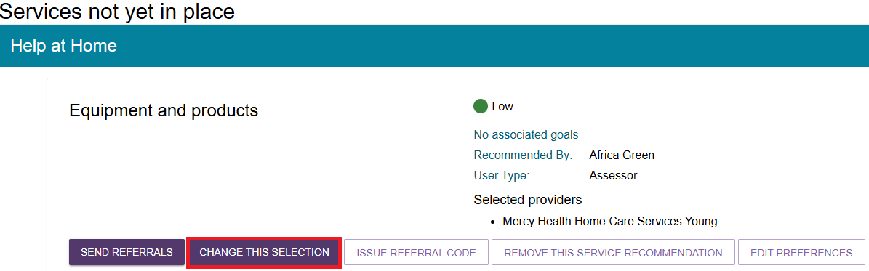
- A screen will be displayed for you to review preferences and capture any other information relevant to the service provider prior to issuing the referrals. You can also REMOVE a service provider in this screen by ticking the relevant checkbox. Once all information has been reviewed, select SEND REFERRALS.
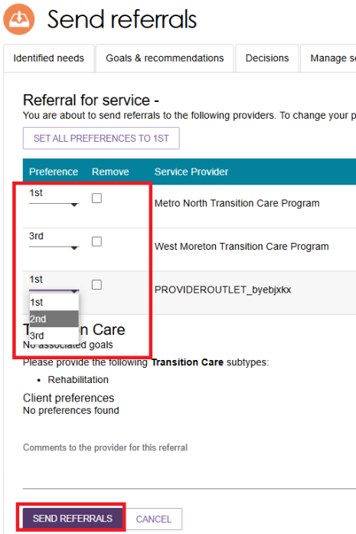
- You will receive a confirmation message that referrals have been sent. You will also be able to see a visual indicator of the status of the referrals.
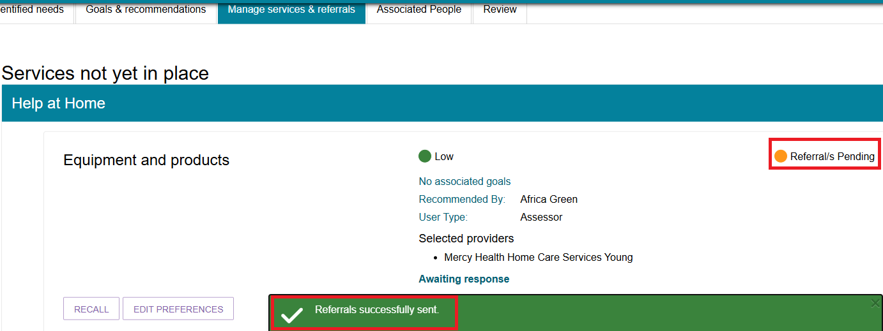
- Once the referral has been accepted, the service will be displayed under Services in place.
The referral statuses that will display are:
Category | Status
Service not yet in place | Not actioned, Rejected referral, Recalled referral, Referral/s pending, Accepted to waitlist
Services pending | Referral code generated, Referral accepted but services have not commenced
Service in place | Services are being provided
Home Care | Package Unassigned, Package Assigned, Package Committed, Package Withdrawn, Package Declined.

Recalling a referral
When a referral for service is issued, it is expected that the service provider will action the referral by accepting or rejecting it. You can recall the referral before the service provider actions it.
- On the Manage services & referrals tab, select the RECALL button to recall the referral.
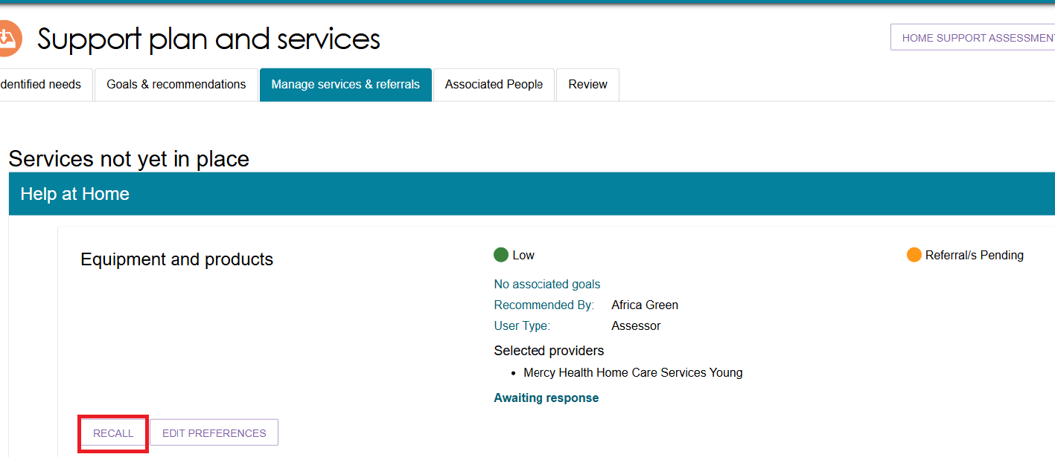
A pop up box will be displayed. Select which provider to recall the referral from and select RECALL REFERRALS.
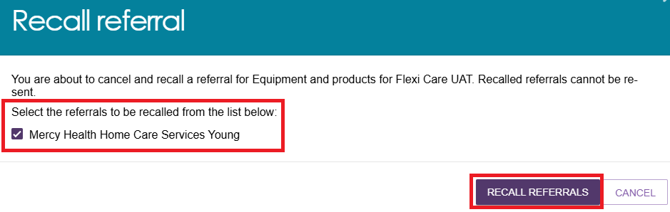
- You will receive a banner confirming that the referral/s are successfully recalled.
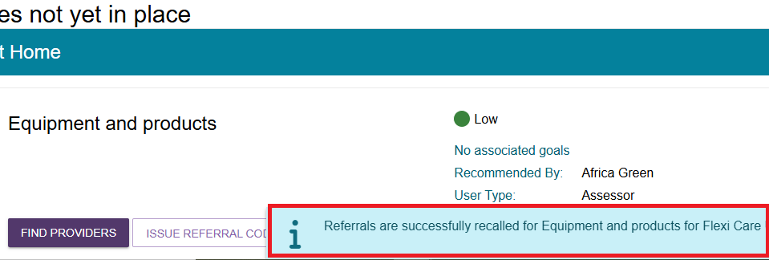
- The referral status will be updated to Recalled Referrals. In the case of sequential preference referrals, the status of the referral will not change to Recalled Referrals until the final preference has been recalled. If you recall a referral, you cannot send it to the same provider again. You can send referrals to different providers for that service.
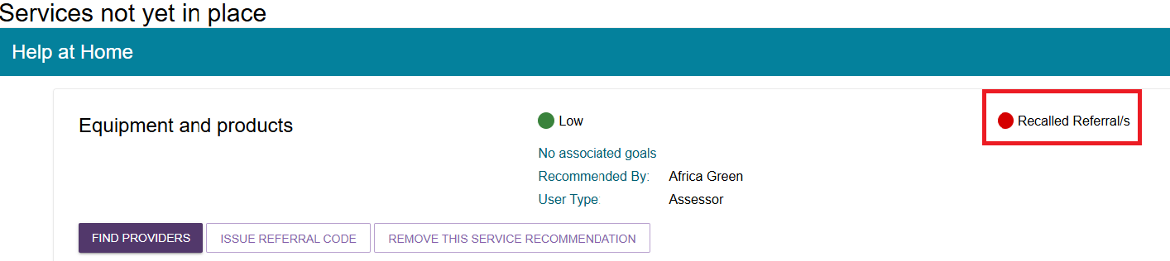

Issuing a referral code
! | Assessors cannot issue referral codes to the older person or service providers for all service referrals (including for CHSP) until after the Assessment Delegate has completed and signed a Notice of Decision.  For more information, please refer to Chapter 9: Finalising the Assessment and Service Referral of My Aged Care Assessment Manual.
- Select the Manage services & referrals tab from the client’s Support Plan and select ISSUE REFERRAL CODE for the service.
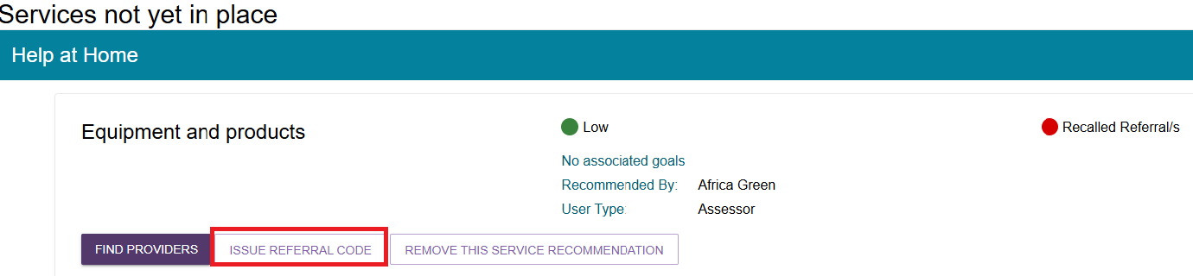
- A confirmation message will be displayed. Select ISSUE REFERRAL CODE.
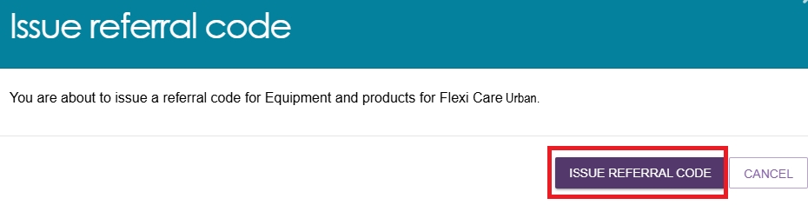
- You will receive a confirmation message that the referral code has been generated, and the details of the referral will appear under the Services pending section. The referral code will be displayed on the referral list, and the referral code letter should be printed and provided to the client.
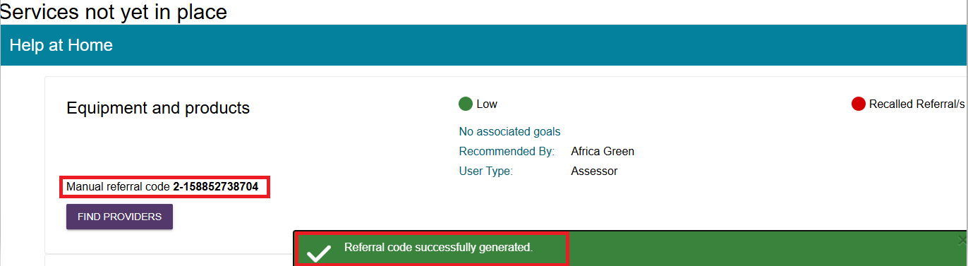
- Select GENERATE REFERRAL CODE LETTER to print the referral code letter.
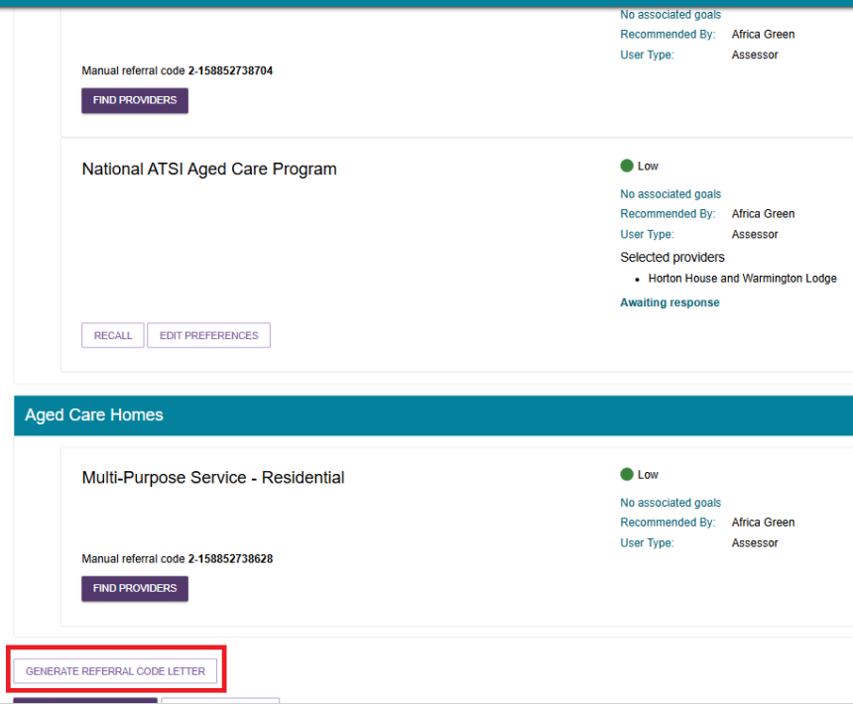
- A processing window will be displayed indicating the letter being generated.
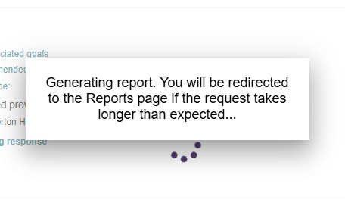
- The generated report will be available under the REPORTS AND DOCUMENTS page ready to be downloaded.
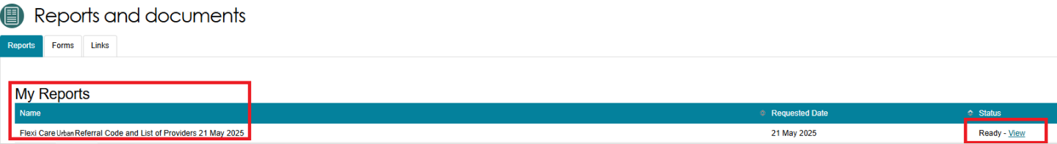
- Below is a copy of the generated referral code letter.
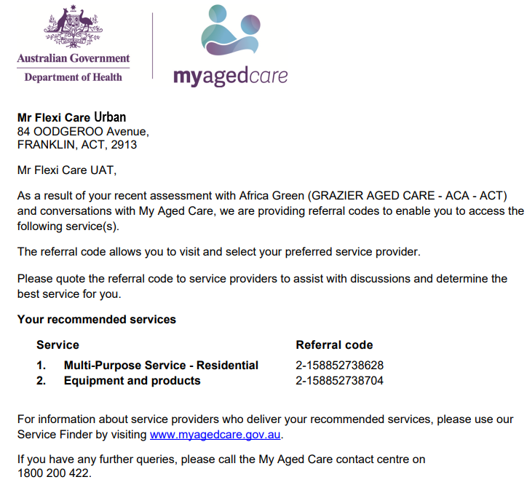
! | A client can change providers without changing their referral code. Against a Support at Home in Manage Services & Referrals you will see a status displayed next to the referral code. This could be one of the following:  - Active – a client is assigned a Support at Home classification, and the referral code can be used.  - Used – an old referral code for a previous approval that can no longer be used by the client or the service provider for referrals.  - Inactive – this status will display if a client has notified that they are not seeking services and/or has had an assigned Support at Home classification withdrawn and not replaced or upgraded.  - Disabled – this status will display once a service referral is accepted. The referral code is disabled and unable to be used by other providers until it is reactivated.  If a client wishes to reactivate their referral code, for example they might be changing providers, a client or supporter can do this via the My Aged Care online account or by contacting the My Aged Care contact centre. Clinical assessors can also perform this function in the Manage Services & Referrals tab of the support plan. The following screenshots demonstrate the reactivation of the referral code.  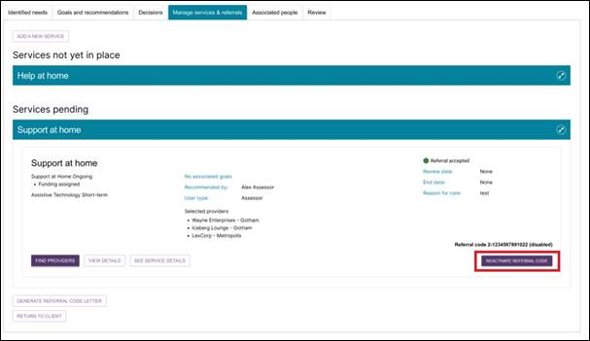

Viewing Delegate decisions
- Go to the Tasks and notifications tile in the assessor portal.
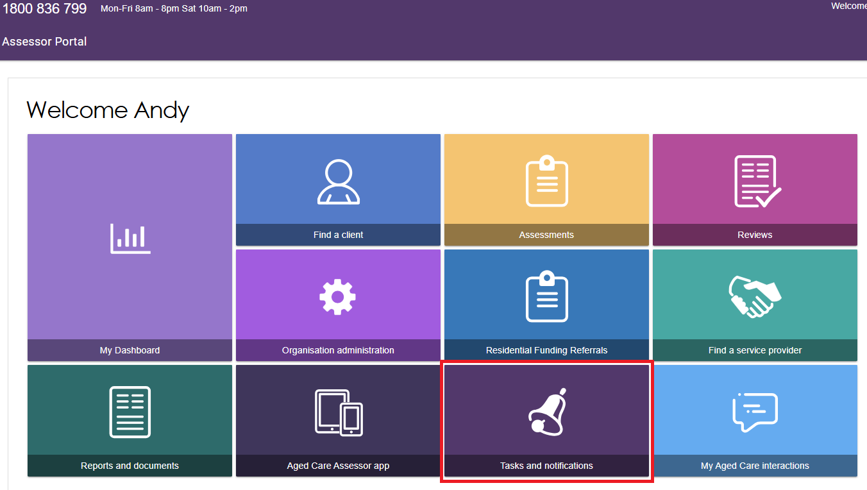
- Go to the Notifications tab, and filter for your client if necessary. A Formal Delegate Decision notification will look like this:
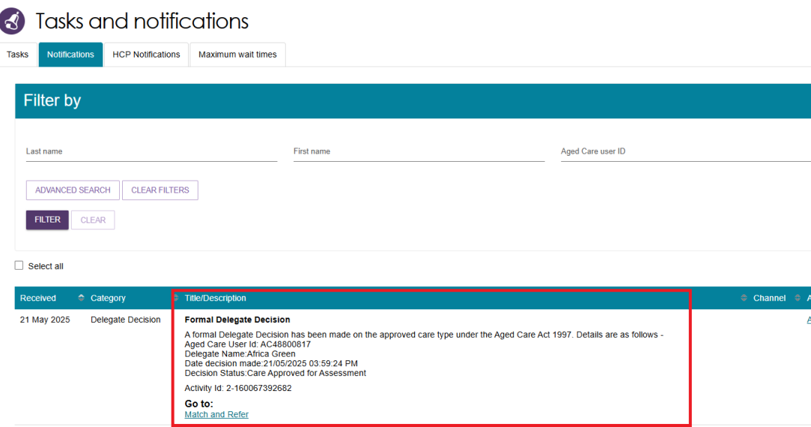
- Alternatively, go to the Assessments tile of the assessor portal home page. You will be able to see that the Delegate has made a decision in the Current assessments tab. The client’s assessment will appear under Delegate decision complete section in card view, or with a status of Delegate Decision Complete in list view.
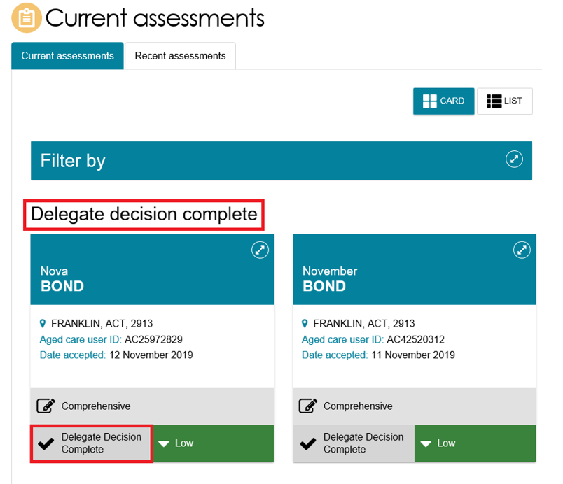

Referring for Support at Home services
- Select the Assessments tile from the assessor portal home screen.
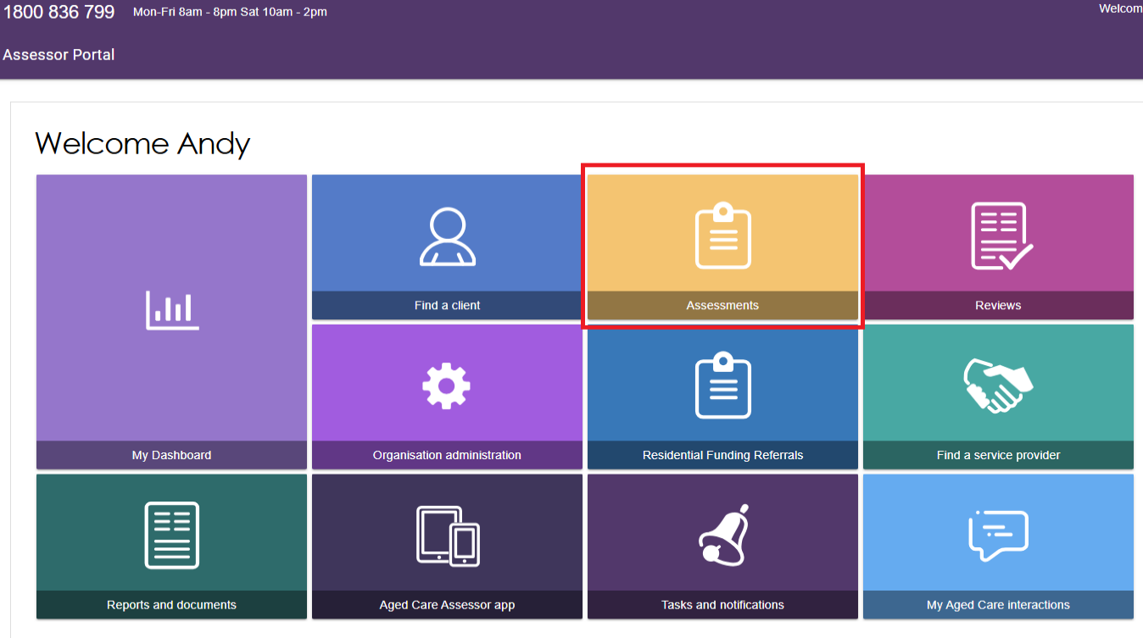
- Select a client within your Current assessments tab and then go to the client’s support plan.
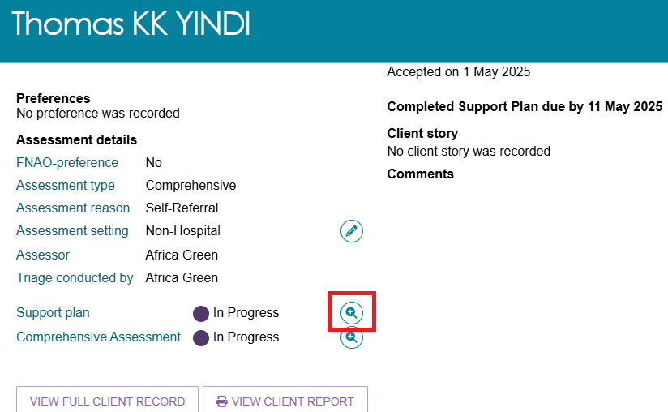
Alternatively, you can also go directly to the client’s support plan from the Notifications tab by selecting on the Match and Refer link.
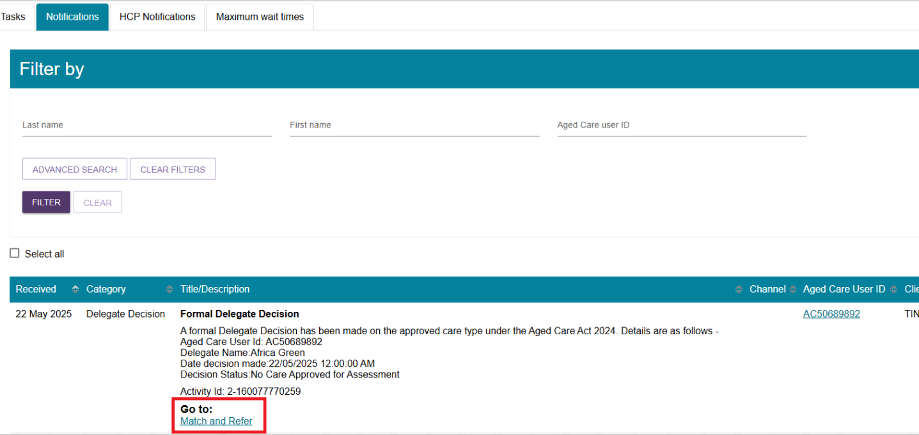
- Select the Manage services & referrals tab. The services added in the Goals and recommendations tab of the support plan will be displayed under Services not yet in place. Select FIND PROVIDERS to search and create electronic referrals for services.
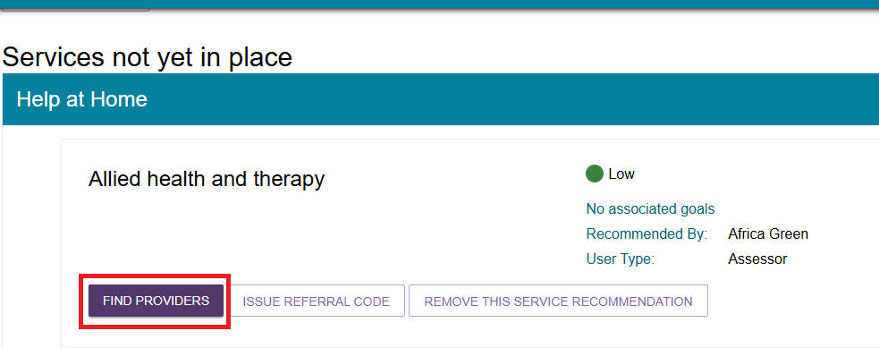
- For Support at Home recommendations, you will be able to send electronic referrals for service when the client has been assigned funding from the Support at Home priority system and the status is Package Assigned.
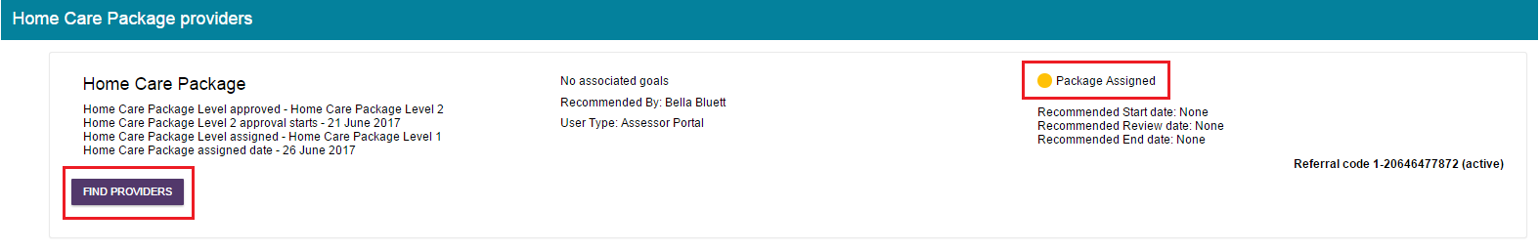

Referring Support at Home services with the Support at Home Priority System
For Home Support services, you will be able to match and refer for service when the client has been assigned a classification from the Support at Home Priority System. On allocation of funding, a referral code is generated, and a letter is sent to the client, with a copy to their supporter/s, instructing them that they can use the referral code to seek services prior to the take-up deadline.
If the client and/or their supporter has elected to receive email notifications, they will also receive an email notification on assignment of their classification.
For more information about setting up and configuring email notifications for clients and/or their supporters, refer to My Aged Care - Assessor Portal User Guide 2 - Registering support people and adding relationships.
If you have elected to receive notification of Support at Home correspondence for the client, you will receive a notification of this and you can proceed to matching and referral if you wish. All electronic referrals should be issued in the client’s support plan under Manage services & referrals.
- Select the FIND PROVIDERS button to search for Support at Home providers. For Home Support services, you can search for service providers by specific service attributes including Diverse needs, Specialised services, Languages, and Cultural and Religion. This can be done by selecting Advanced search when selecting a service provider.
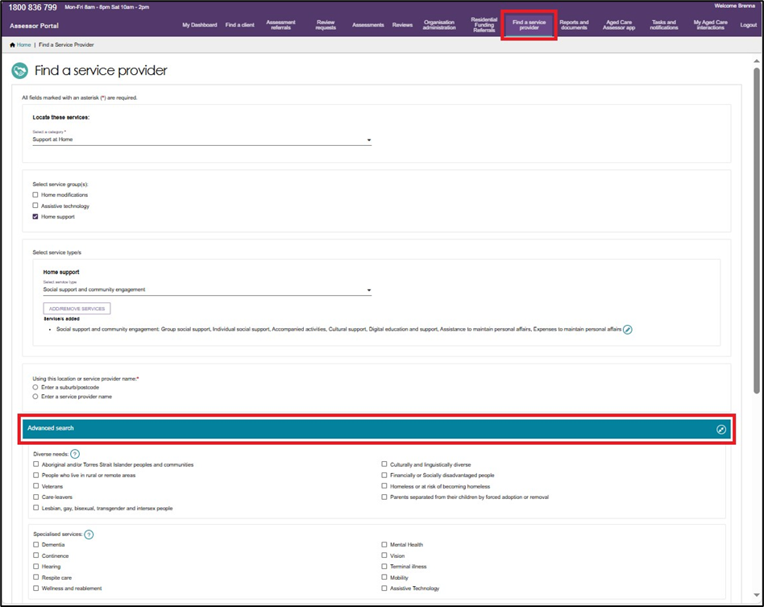
Any providers that offer verified Diverse Needs specialisations, as well as any cultural specialisations and specialised services, will be shown under the Specialisations section of the Service Finder listing.
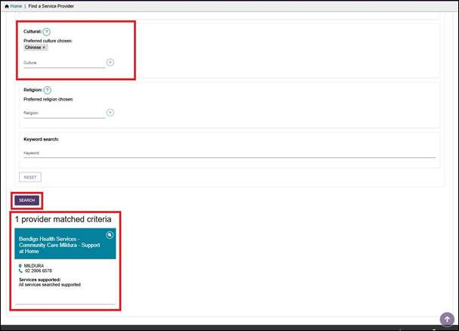

Managing rejected service referrals
To connect clients to appropriate service providers and ensure consistency for clients, any referrals sent by you will be returned to you for actioning if they are rejected and there are no referral preferences for the client remaining.
Where a referral for service is rejected, and it is the client’s final preference, assessors will:
- Receive a notification that the referral was rejected (an All Referrals Rejected task); and
- Be able to reissue referrals to different providers or accept a provider’s offer to waitlist, based on discussion with the client.
Follow these steps to follow up a rejected referral:
- Navigate to the Tasks tab in the Tasks and notifications section and select the All Referrals Rejected link to navigate directly to the client’s support plan or the Aged Care User ID link to navigate to the client record.
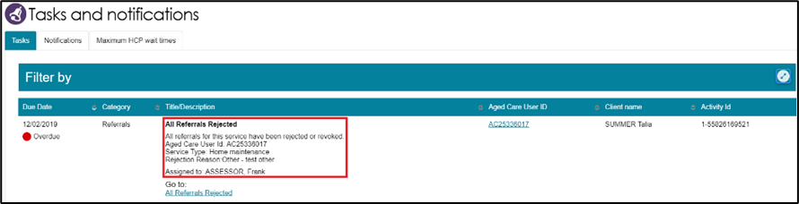
Alternatively, if you know the client’s name you can view all tasks and notifications for an individual client in the Tasks and Notifications tab in the client record.
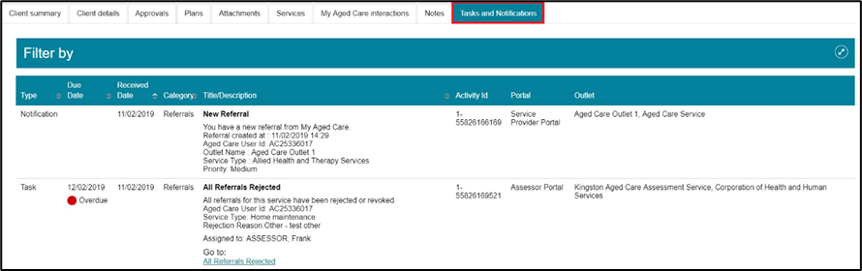
- If navigating directly from the notification, the Manage services & referrals tab in the client’s support plan will open, where the rejected service type will be displayed with Rejected Referral/s on the recommendation.
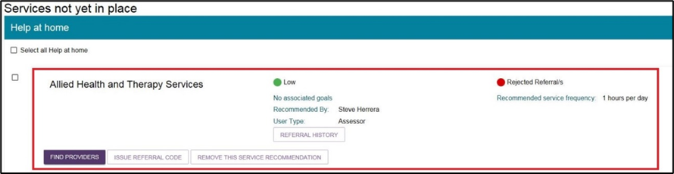
You will also be able to see the status of any other of the client’s referrals.
- Navigate to the Manage services & referrals tab to see the status of the client’s referrals.
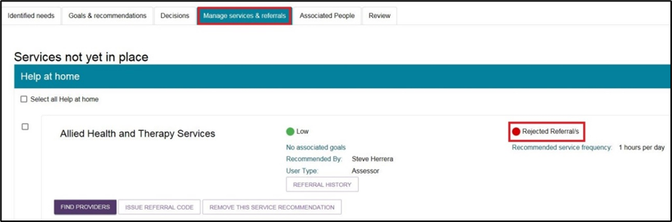
For Rejected Referrals, select Referral history to see the further detail about the reason the referral was rejected.
- You can now send referrals to new providers or generate a referral code for the client, following the steps described earlier in this guide. Based on the referral rejection reason, you may be required to add further information to a client’s referral or need to discuss alternative options with the client prior to issuing another referral.

