Assessor Portal User Guide 3 – Managing referrals for assessment and Support Plan Reviews
Referrals for assessment from My Aged Care are managed by the person(s) assigned the Team Leader or Triage Delegate role in the My Aged Care assessor portal (assessor portal).
This guide is intended to help staff manage assessment referrals as well as distinguish what functions sit within each role.
Team leaders can accept or reject assessment referrals. After accepting an assessment referral Triage Delegates can assign and complete triage. If the client is found to be ineligible for an assessment the Triage Delegate is required to record and send an Ineligible for Assessment letter to the client. If the client is eligible for assessment, the Triage Delegates and Team Leaders can assign the referral to an aged care needs assessor (assessor). Team Leaders can reassign or unassign the triaged referrals as required.
Team leaders can also transfer incoming and accepted (but not yet commenced) referrals to other assessment organisations. Before accepting referrals, team leaders can change the priority of assessment referrals.
! | On 1 November 2025, the Aged Care Act 2024 and the Support at Home program come into effect with changes to the functionality of support plans in the IAT.  To ensure the right IAT is used, and triage can continue for priority referrals, any assessments in the following statuses already started prior to 1 November 2025 and in progress on 1 November 2025 must be restarted:  - Triage complete, main assessment not started  - Triage complete, main assessment in progress (includes incomplete support plan)  - Main assessment completed, awaiting delegate decision (comprehensive assessments)  For information on the Restart Assessment Process, please refer to Management of active assessments for 1 November 2025 transition - Standard Operating Procedure and Restarting In Progress Assessments for Support at Home (instructional video).
Contents
Team Leader and Triage Delegate functions 3
Viewing incoming assessment referrals and client information 3
Accepting incoming assessment referrals and changing the priority 7
Assigning Triage 10
Completing Triage 13
Triage Pre-population options 17
Triage completed - Not eligible for assessment 22
Viewing triage information 25
Referring to Urgent Services 25
Converting Assessment 26
Assigning an assessment referral to an assessor 27
Unassigning or reassigning an assessment referral 29
Rejecting an assessment referral 31
Rejecting an assessment with the reason of Client deceased 32
Flagging the assessment as End-of-Life Pathway 33
Transferring an assessment referral to another outlet or Organisation 36
Client records from inactive outlets 40
Residential Funding Referrals 40
Support Plan Reviews 42
Viewing Support Plan Reviews 43
Assigning a Support Plan Review 45
Transferring a Support Plan Review 46
Reassigning a Support Plan Review 47
Cancelling a Support Plan Review 49
Cancelling a Support Plan Review with the reason of Client deceased 50
Change priority for a Support Plan Review 51

Team Leader and Triage Delegate functions
This guide will provide guidance for various functions that both Triage Delegates and Team Leaders can perform, please refer to the table below for specific functions:
Function | Team Leader | Triage Delegate
Viewing incoming, accepted and assigned assessment referrals | ü
Viewing triaged assessment referrals | ü | ü
Accept an incoming assessment referral | ü
Reject or transfer an incoming, accepted or triaged assessment referral | ü
Assign an accepted assessment referral to myself (if a triage delegate) or another triage delegate for triage |  | ü
Complete triage (if applicable generate and upload Ineligibility Letter) |  | ü
Reassign an accepted assessment referral or an assessment while triage is in progress |  | ü
Refer a client for urgent services before starting triage and once triage is completed |  | ü
Convert the assessment between Home Support and Comprehensive |  | ü
Assign an assessment to an assessor once triage is completed | ü | ü
Reassign or unassign triaged assessment referrals. | ü

Viewing incoming assessment referrals and client information
Team Leaders can follow the steps below to view incoming referrals for clients assigned to the outlet.
- Select My Dashboard from the home page. You can also select Assessment referrals on the homepage.
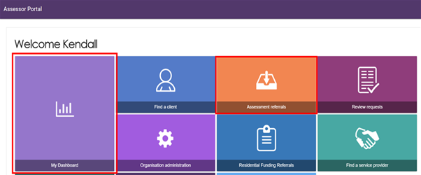
- Alternatively, select Assessment referrals from the tool bar at the top right-hand corner of the portal.
- Select the Assessment referrals in the My Dashboard page.
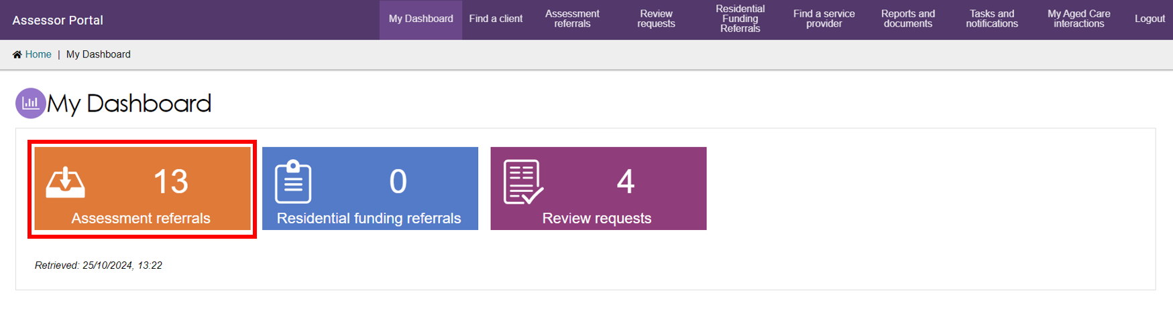
- You can view referrals depending on your assigned role. Select the hyperlink corresponding to the referral origin to view more details.
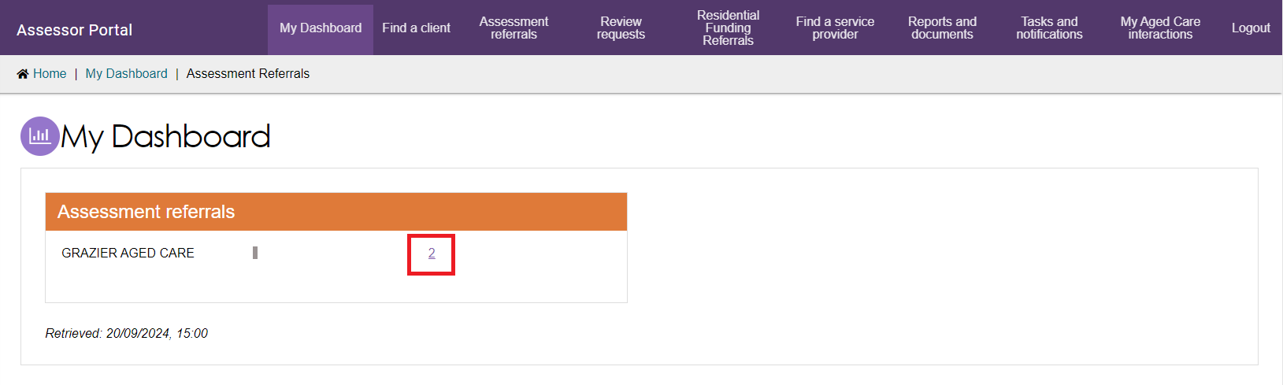
- The Incoming referrals and Unassigned assessment referrals will be displayed.
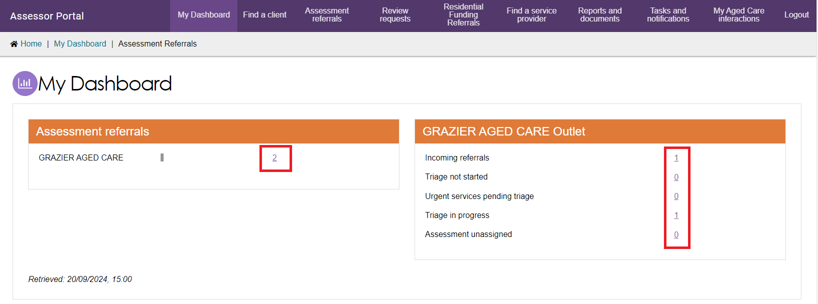
! | A warning notification will be displayed if there are referrals that have not been actioned within the priority timeframes.
- To view referrals, select the Incoming referrals tab under the Assessment referrals page. You can select to view assessment referrals in a card or list view by selecting the card or list icon. Your selection will be retained for the next time you log in to the portal.
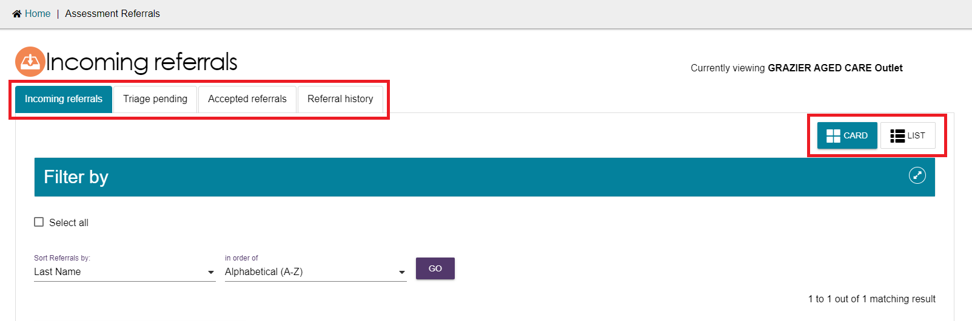
- In the card view, referrals can be filtered or sorted by Last name, First name or Aged Care user ID.
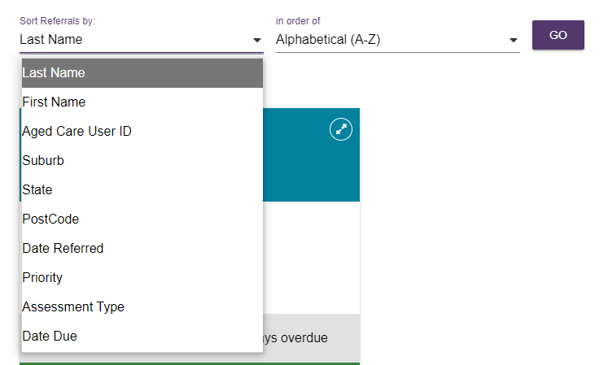
- You can view more information on the referred client, including client notes and assessment history by selecting the double arrow icon  on the top right-hand corner of the client card.
! | Upon receiving an urgent request, the Team Leader must click the double arrow icon to expand the referral card, verify whether it relates to the End-of-Life pathway, and prioritise it accordingly.  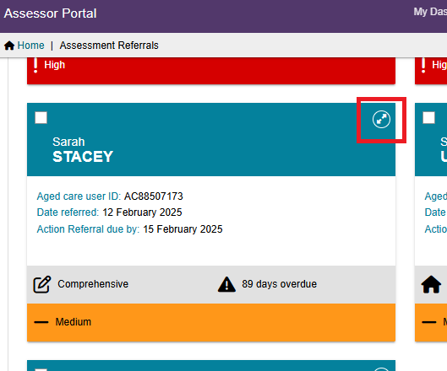
- A Pop-up screen will appear as below. You can choose to Accept, Reject or Transfer the referral as required.
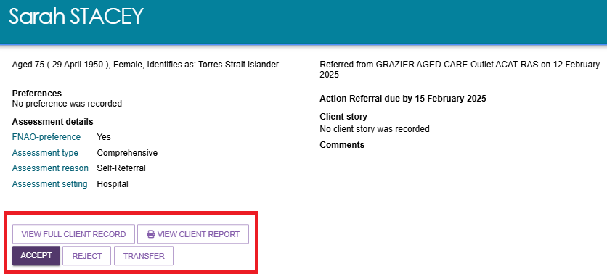
- The same referral and client information is available in list view. Select the double arrow icon  to the left of the client’s name to expand the view.
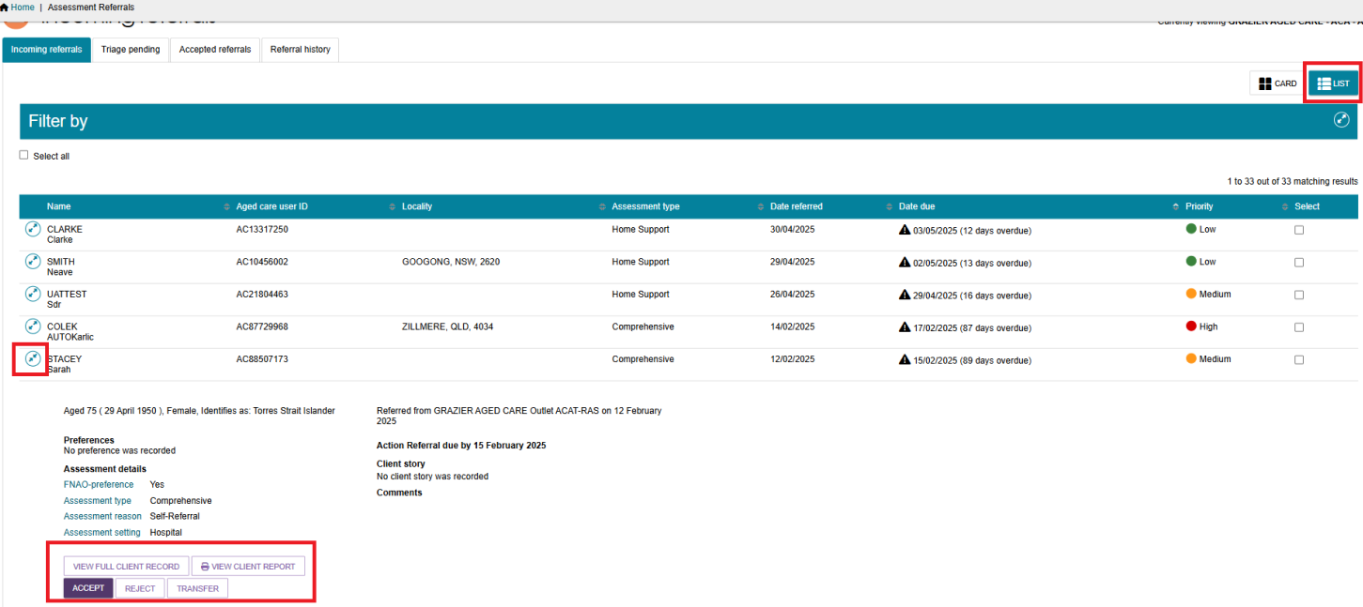
! | A banner will be displayed on the referral if additional attachments have been added to the client’s record as part of an inbound referral.
! | If the client has pending support relationships, a banner will be displayed on the referral. Team Leaders and Triage Delegates are able to confirm pending support relationships for clients The process is described in My Aged Care - Assessor Portal User Guide 2 - Registering support people and adding relationships.  A banner will be displayed on the referral if it was issued as a Direct referral.  Direct referrals have the same key performance indicators as regular referrals. The word ‘direct’, indicates that the client did not receive a Support Plan Review before being referred.  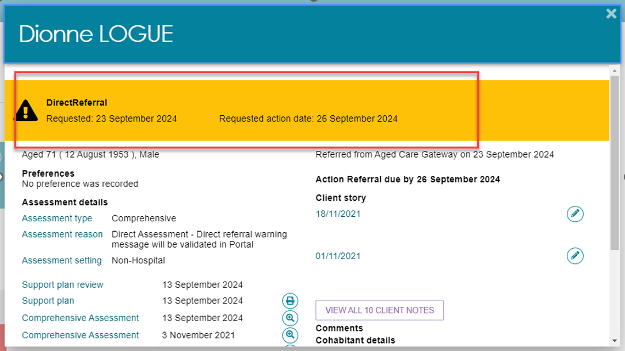
- If you want to view the information available in the client record you can either go back on your internet browser to return to the Incoming referrals page or choose the Incoming referrals option from the tool bar.
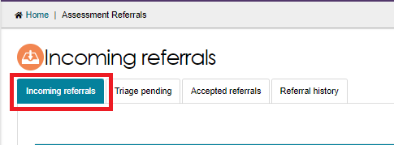

Accepting incoming assessment referrals and changing the priority
Once a Team Leader has viewed the client record, they can accept or reject the referral. Follow the steps below to accept a referral and change the priority of a referral if required.
- Select ACCEPT from the expanded card or list view.
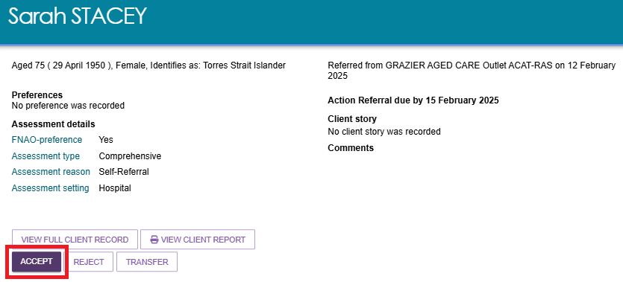
! | Team Leaders can bulk-accept assessment referrals by selecting the tick box next to each client they would like to accept, or by using SELECT ALL for all client referrals assigned to their outlet.  The bulk-accepting function defaults the clients’ priority to medium. Team leaders will be unable to change the priority when bulk-accepting referrals. Bulk-accepting will default assessment setting to Non-Hospital. Team Leaders can then change the setting to Hospital as required.  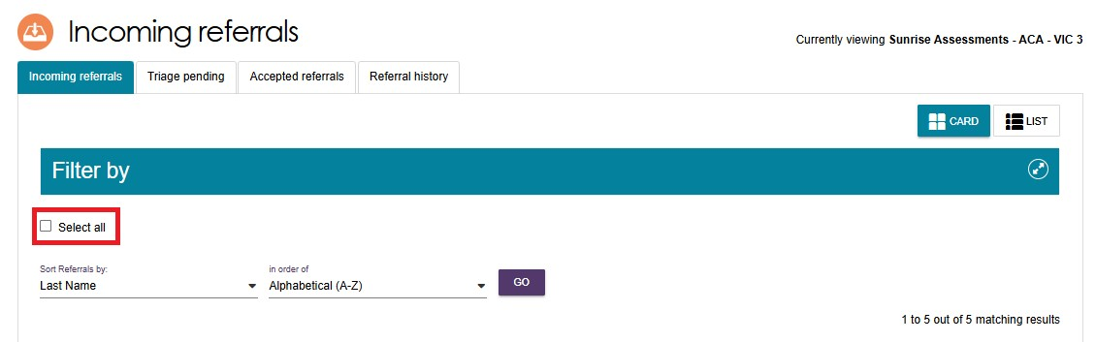
- Confirm that the priority of the assessment referral is correct and select the Assessment setting. To change the assessment priority, choose from the options provided in the drop down.
! | When accepting a referral, team leaders can add a free text information into the Triage category. Once the referral has been accepted, the information can be used to assist with finding referrals via the search function. This free text option is not to be confused with the triage process that is a required process for accepting referrals.
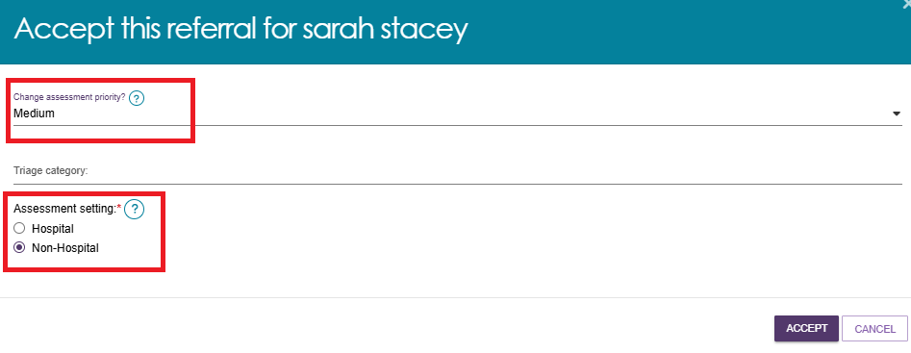
Team leaders can change the assessment priority as well as the assessment setting for a referral as required.
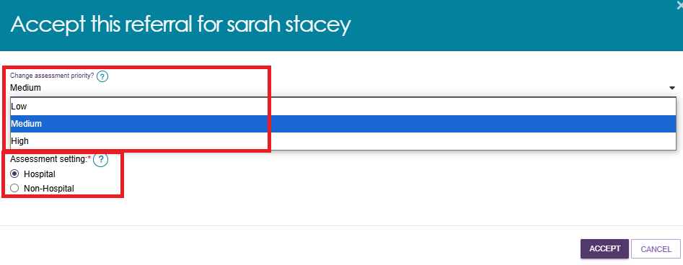
! | Direct referrals priority default to being high when issued. Team leaders can change the priority of direct referrals when accepting if they determine the client can safely access the assessment at a lower priority level.
- When updating the assessment priority, a relevant reason for changing the priority will need to be selected from the dropdown list with a reason to be provided in the free text box. If the assessment priority is changed, a new priority timeframe will be calculated and applied to the referral.
A reason for changing priority is mandatory if the priority is changed. Users can select from the following options before accepting the referral.
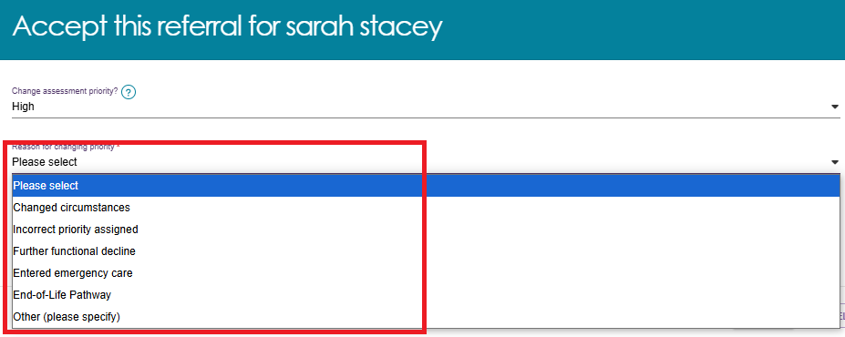
- To change the assessment setting, You can update the assessment setting by selecting Edit Assessment Setting in the expanded client card, depending on your role:
- the team leader on the accepted referrals view, or
- the assessor on the current work view.
! | The timeframe will continue to be calculated from the date the referral was issued, not the date the priority was changed.
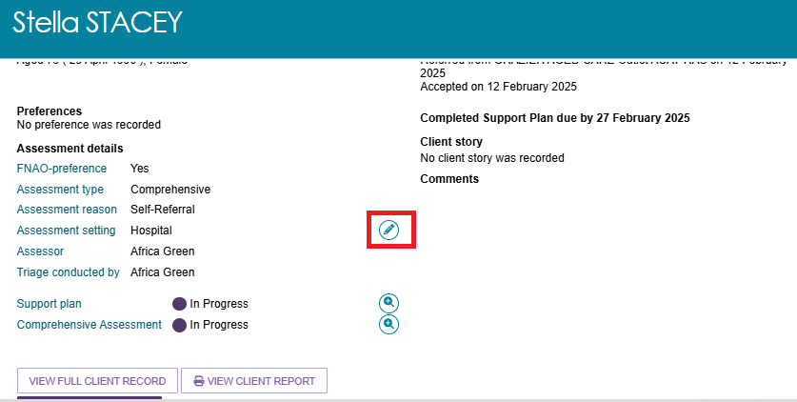
- Once the assessment setting is selected. Click SAVE. Once the referral has been accepted, the referral will move into the Triage pending tab under Unassigned.
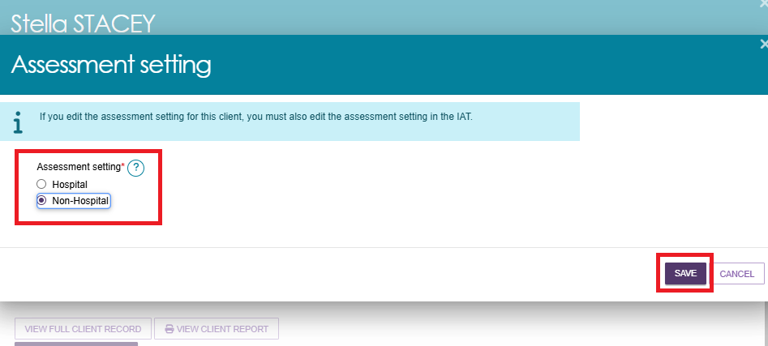
! | As part of the Single Assessment System Program contract, key performance indicators will consider the setting in which the interaction with the client takes place, specifically a Non-Hospital or Hospital setting.  Team leaders can select the assessment setting while accepting the referral.  Before commencing the assessment, assessors should verify the information entered by the team leader, noting that the assessment setting may have changed since between the time of the acceptance of the referral and when the assessment takes place.  When the assessment is finalised, the Assessment setting field on the expanded client card or list view must align with the type of assessment setting recorded within the Intergrated Assessment Tool (IAT). Assessment setting fields can be edited if required, until the Support Plan is completed.

Assigning Triage
! | Triage must be completed by a clinical staff member who holds the Triage Delegate role in the My Aged Care assessor portal.  For further information on the Triage Delegate role, visit Assessor Portal User Guide 12 - Managing Delegate Roles.
Once an assessment referral has been accepted, it will display with a Triage pending status. A Triage Delegate will then need to assign the referral to themselves or to another Triage Delegate for triage.
Once an assessment has been assigned to a Triage Delegate, they can proceed with the triage, reassign the triage to another Triage Delegate or unassign themselves and place the accepted referral back into the triage pending queue.
- To access triage pending referrals, select the Triage pending tab within the ASSESSMENT REFERRALS tile.
! | If the Triage delegate has access to multiple outlets, one will need to be selected before continuing with triage.
- Once a referral has been accepted it will be under Triage pending and unassigned. You will have to filter the Assigned to drop down and select unassigned, then select FILTER.
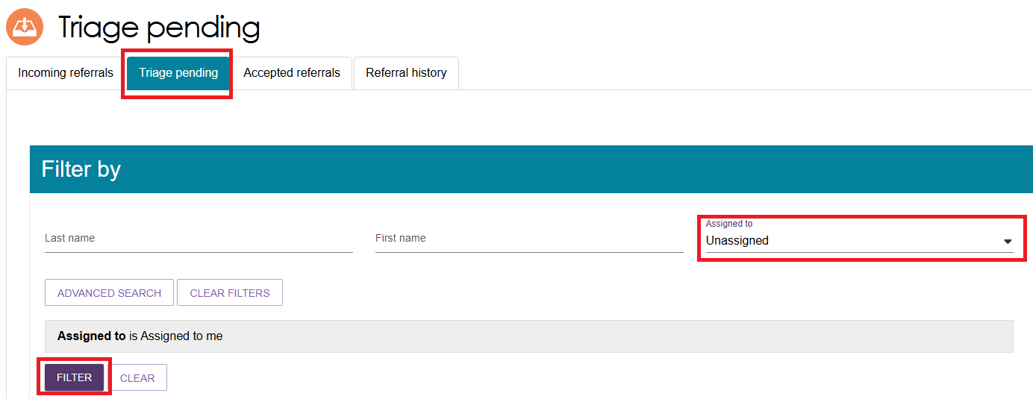
- Expand the client card which you would like to assign triage for. To assign to yourself or another Triage Delegate for action select ASSIGN.
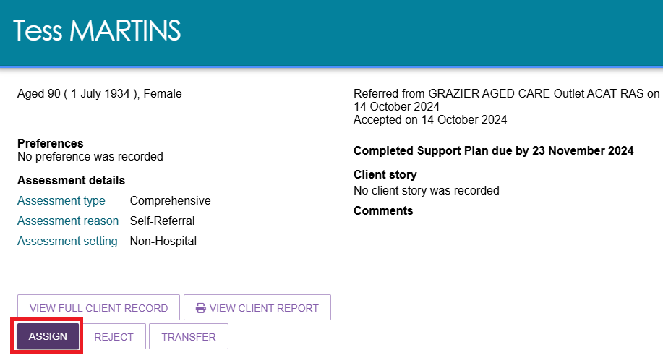
! | To transfer the referral to another outlet for triage select TRANSFER, for further information on transferring a referral see the section Transferring an assessment referral to another outlet or organisation.  To reject the referral, select REJECT. For further information on rejecting a referral see the section Rejecting an assessment referral.
- When selecting ASSIGN a pop up will appear. From this you will be able to assign the triage decision for the client either to yourself or other Triage Delegates from the selected outlet. Once this has been chosen, select ASSIGN.
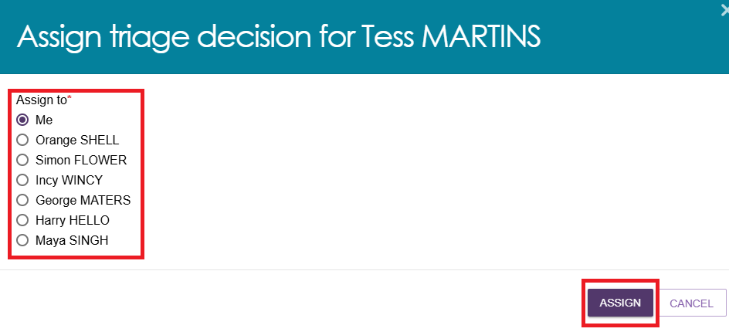
- Once the triage has been assigned, the client card will appear under the Triage pending tab., Ensure that the Assigned filter is set to Assigned to me so that clients assigned to you can be found under the Triage Not Started heading.
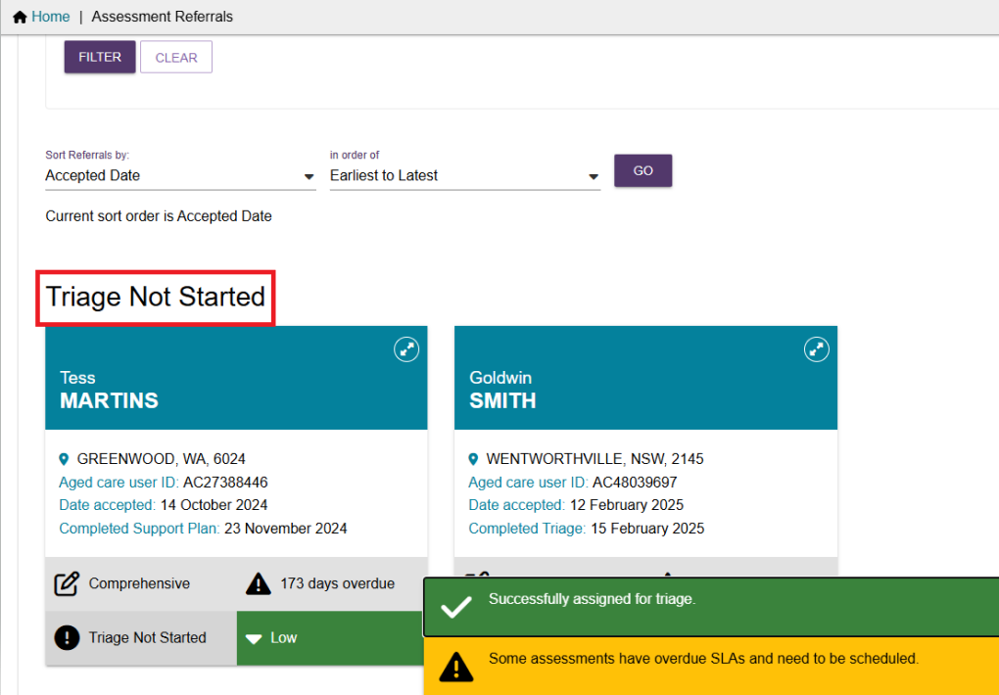
- Click on the expand card icon  on the client tile. The expanded client card will have the options to:
- Start triage
- Reassign, for further information on reassigning a referral, refer to Unassign or reassign referral to an assessor.
- Refer to urgent services.
- Reject an assessment referral.
- Transferring an assessment referral to another outlet or organisation.
- Flag as End of Life.
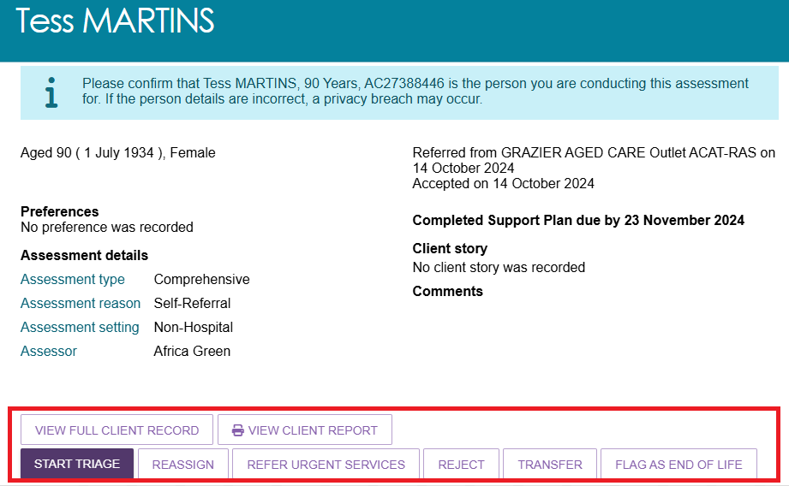
- When selecting REASSIGN, alternative Triage Delegates will be provided as well as the option to Place back in the delegate queue this will place the client back into a Triage pending status and in the queue for allocation.
! | A client can also be flagged as End-of-Life if there is a recommendation from a qualified medical professional from this screen. The steps to complete an End-of-Life process is explained in this document as well as in Assessor Portal User Guide 6 – Completing an Assessment.

Completing Triage
In the Assessments tile under the Triage pending tab, clients that triage has not been completed for will display under the Triage Not Started heading.
- Expand the client card to see the assessment details such as the Assessment Type, Assessment Reason, Assessment setting, Assessor, Eligibility at Screening and Latest screening (if any).
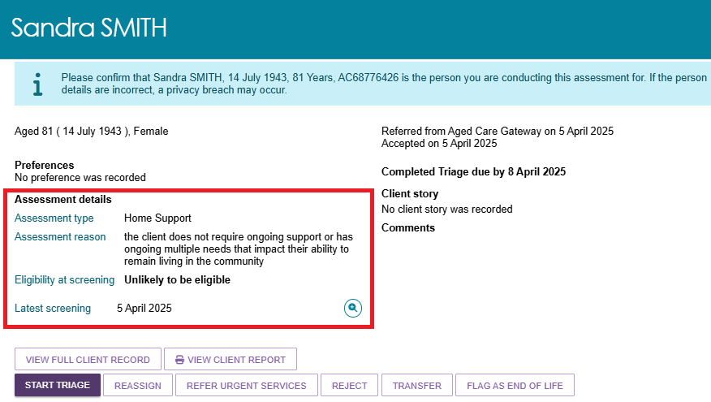
- Select START TRIAGE to begin the triage.
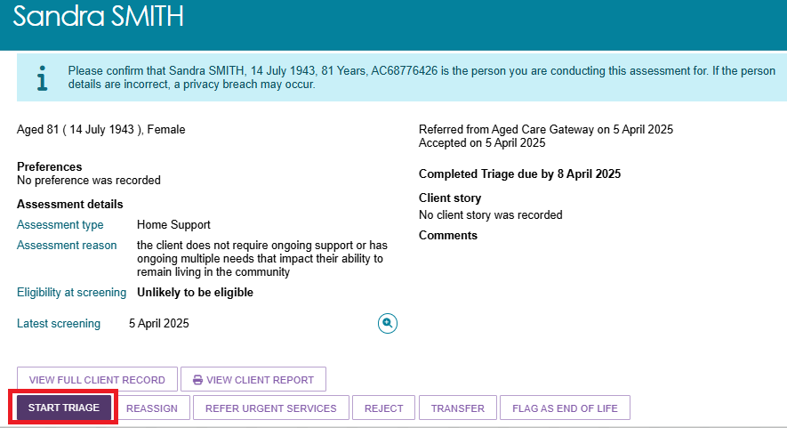
! | The Eligibility at Screening is not a formal eligibility decision under the Aged Care Act 2024. It serves as an indication that the client may not meet the eligibility criteria for an assessment. The final eligibility decision for assessment must be made by the Triage Delegate.
- Before commencing triage, consent from the client must be received using the consent script. The Consent for Triage script should be read out to the client.
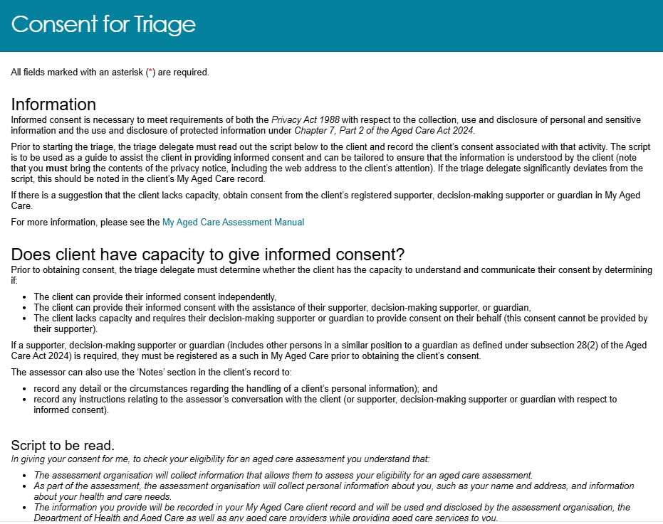
- This will require the Triage Delegate to record who the Consent was obtained from. Options provided will be:
- the client
- the client with support person
- consent was not given
- the supporter guardian.
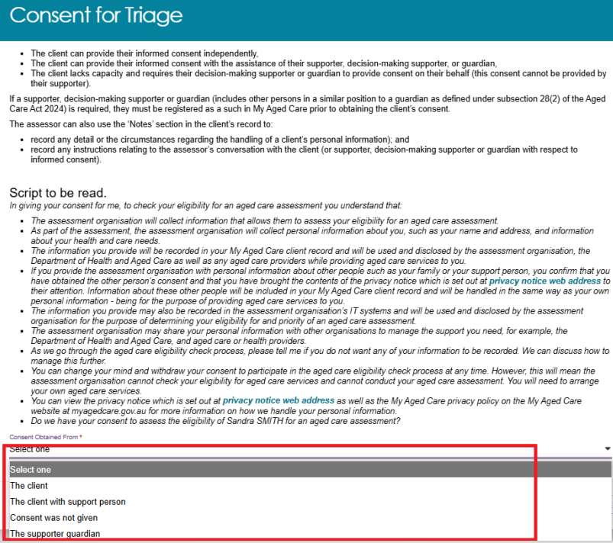
- Once the selection is made, click CONTINUE to progress.
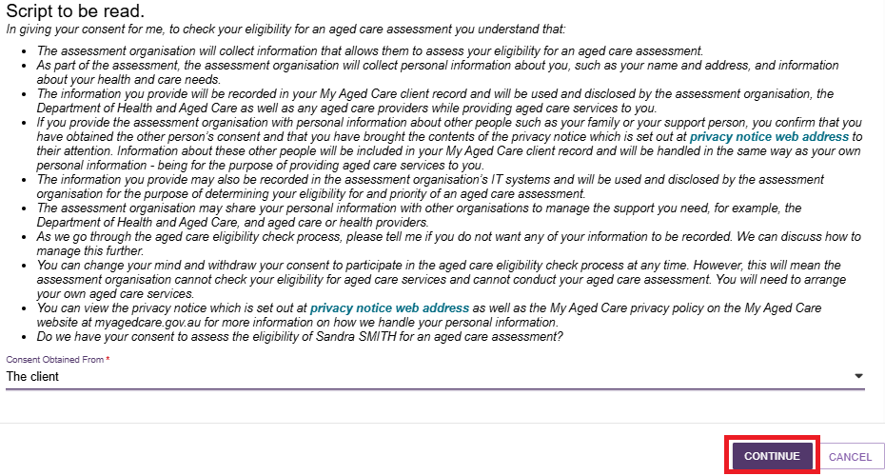

- If the client or their supporters choose to not give consent, the triage process is to end. The Triage Delegate is required to provide a reason for refusal. Options provided will be:
- the assessment is no longer required
- client’s support person is not available
- client does not have the capacity to understand and communicate consent
- client’s supporter withdraws consent
- client’s supporter not available to give consent
- other reasons that can be specified further in a free text format.
! | The use of the ‘Other, please specify’ value should be limited to rare and unusual situations that are not captured by existing values.
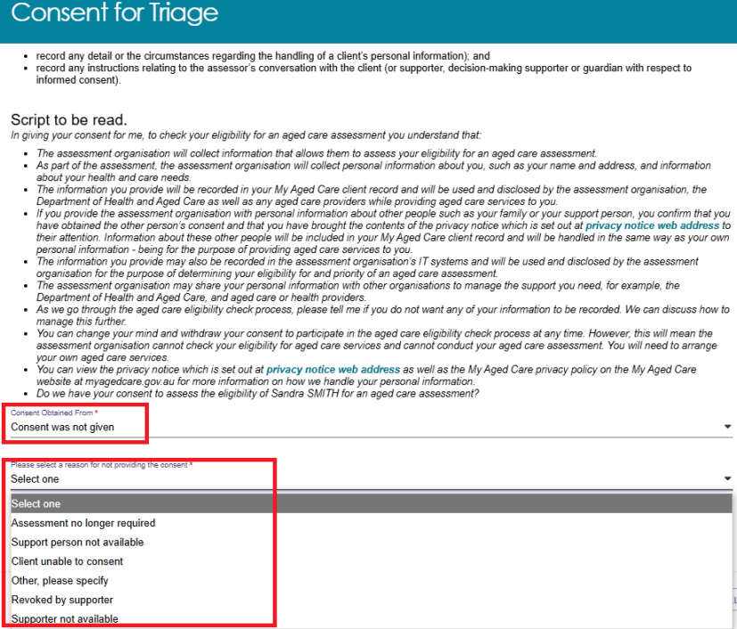
- Once a reason for not providing consent is given, select SAVE AND CLOSE.
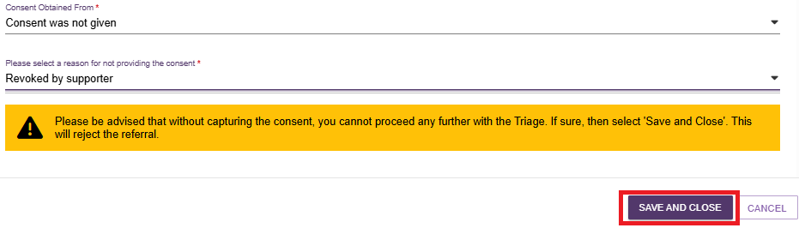

Triage Pre-population options
Triage Delegates will have the option to pre-populate responses from the client’s previously finalised assessment.
- Select the COMFIRM PRE-POPULATION button to pre-populate the relevant previous screening/assessment. Select the BLANK TRIAGE button to begin the triage without pre-populated responses. Selecting the CANCEL button will navigate the Triage Delegate back to the expanded view.
In exceptional cases when the client’s previous referral was rejected after triage was completed, the Triage Delegate will only be able to complete the triage with the pre-populated rejected referral.
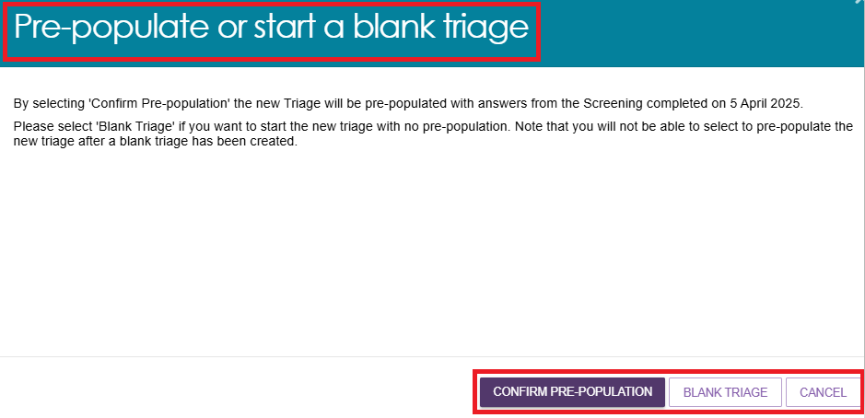
- The Triage Delegate will confirm the Demographic details of the client. Once confirmed, to progress select SAVE AND CONTINUE TO TRIAGE.
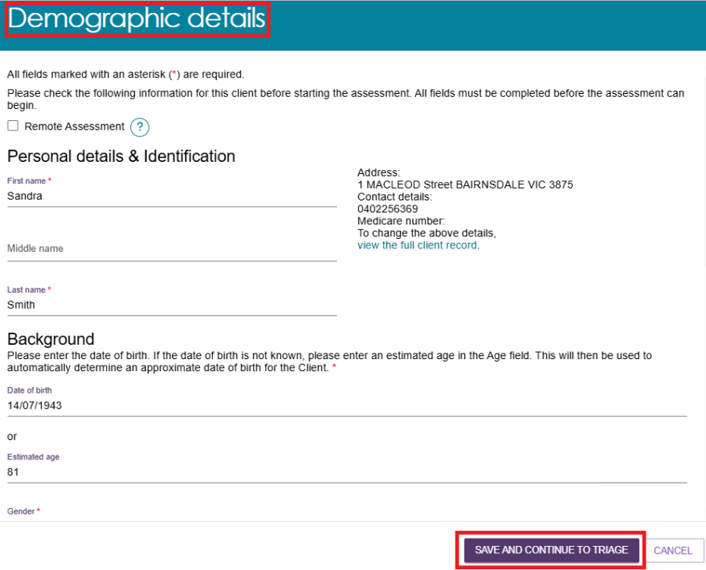
- During screening, if the client identifies as an Aboriginal or Torres Strait Islander, they can request to have their assessment completed by a First Nations Assessment Organisation.
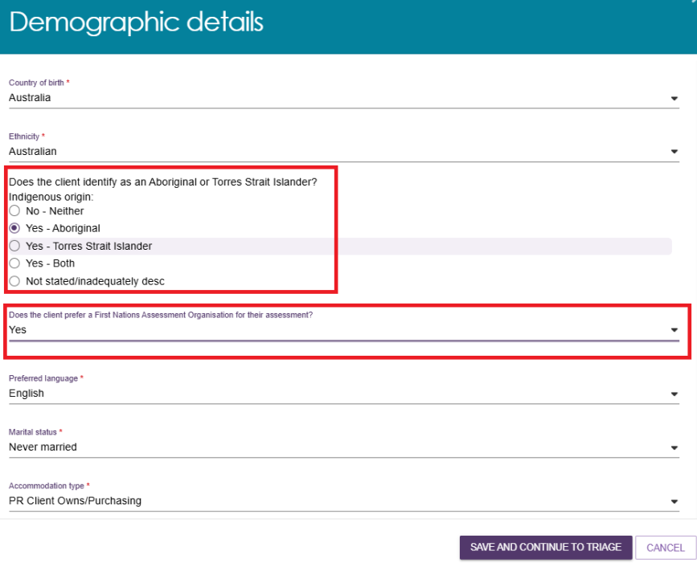
- Once the above step is completed, the Triage Delegate will be directed to the Triage screen. Follow the prompts for the pre-populated or blank triage. All mandatory questions must be answered before completing triage by selecting COMPLETE TRIAGE button.
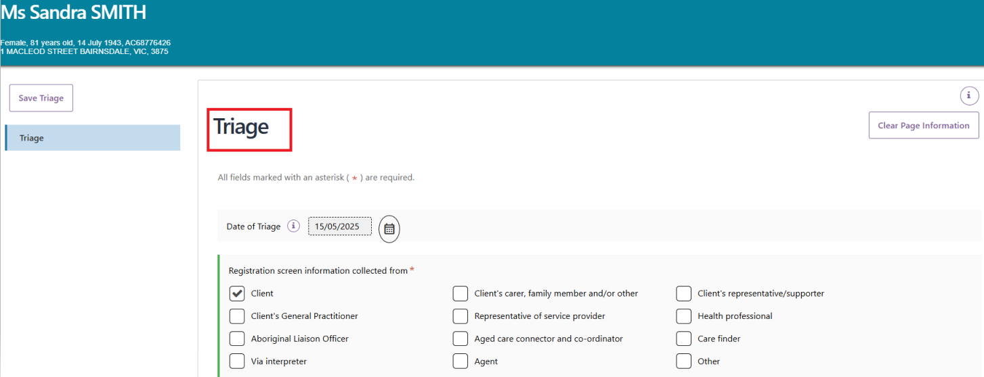

- Triage Delegates will be required to respond to the question What type of needs assessor is recommended for client assessment. The Triage Delegate will be provided with the options of Clinical, Non-clinical and not eligible for assessment. The option that is selected will display in the portal showing:
- comprehensive (clinical) assessment required
- home support (non-clinical) assessment required
- not eligible for an aged care assessment (refer to the Not eligible for assessment section for further information).
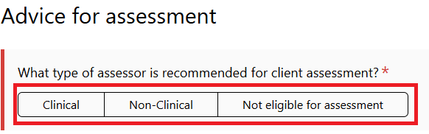
- It is mandatory for the Triage Delegate to record if the client is requiring an urgent assessment. The options that are available are the following:
- High urgency – Client is in Hospital
- High urgency – Client is at immediate risk of self harm or in a crisis situation (e.g. client care incapacitated)
- High urgency – Client from a vulnerable cohort and/or has complexity
- Medium urgency – Client at home but needing services
- Urgent assessment not required.
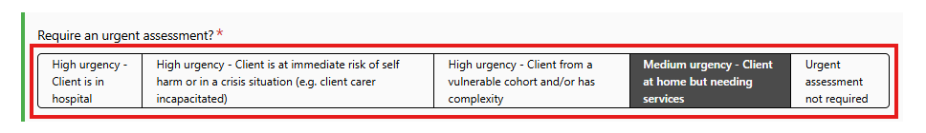
- Triage Delegates should provide the Priority of assessment. The input for this question should align with the previous question on urgency of the assessment.
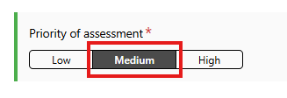
The COMPLETE TRIAGE button will be disabled until all mandatory questions have been answered in the triage.
- Triage Delegates are required to specify if the client requires urgent services.
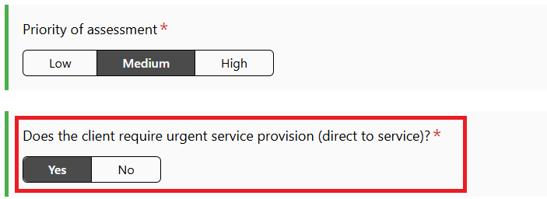
- To save the recorded information but not complete the triage select the SAVE TRIAGE button. This button is displayed on top of the Navigation pane as well as bottom of the page.
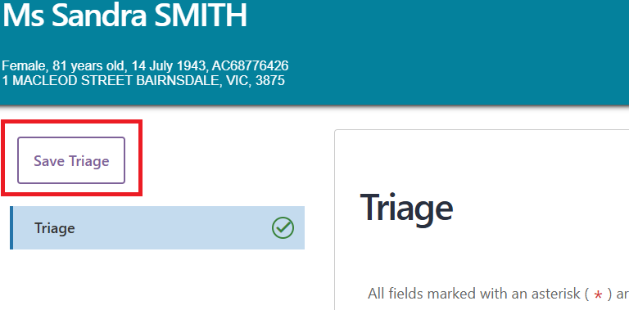
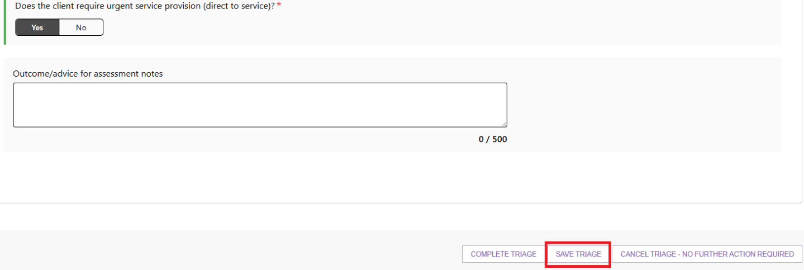
- If the triage needs to be cancelled, select the CANCEL TRIAGE – NO FURTHER ACTION REQUIRED button. The reason for cancellation must be provided by the Triage Delegate. A list of options will be provided under Reason for ending the triage. Once the cancellation has been confirmed the referral will be rejected and the Triage Delegate will be navigated back to the client summary page.
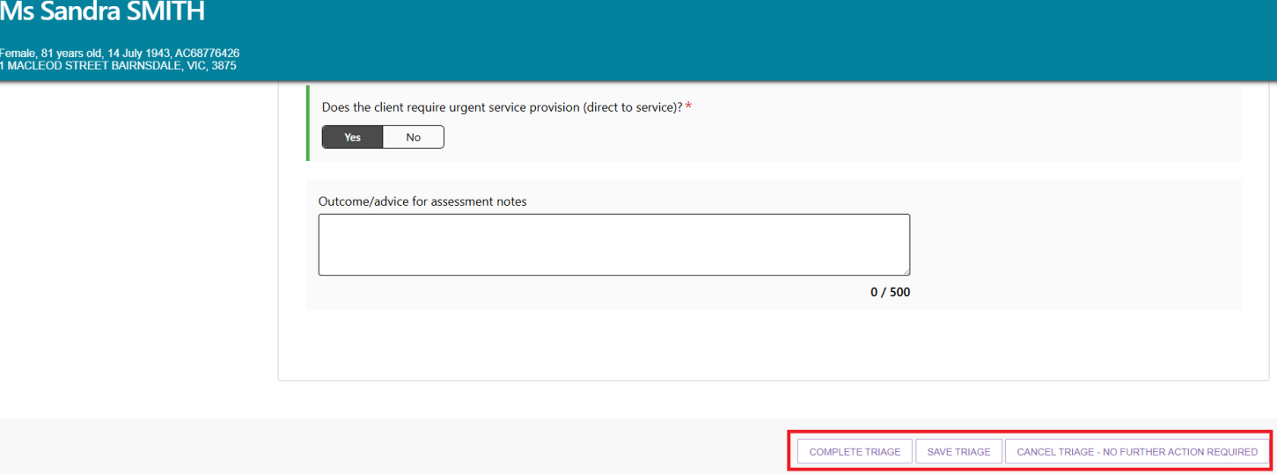
- Once COMPLETE TRIAGE has been selected, a pop up will confirm that you would like to complete the triage. Select COMPLETE TRIAGE to finalise.
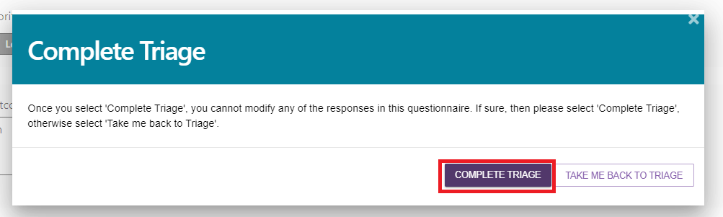
- Once the client’s triage has been completed, the referral for that client will remain on the Triage pending screen, under the Triage Completed heading.
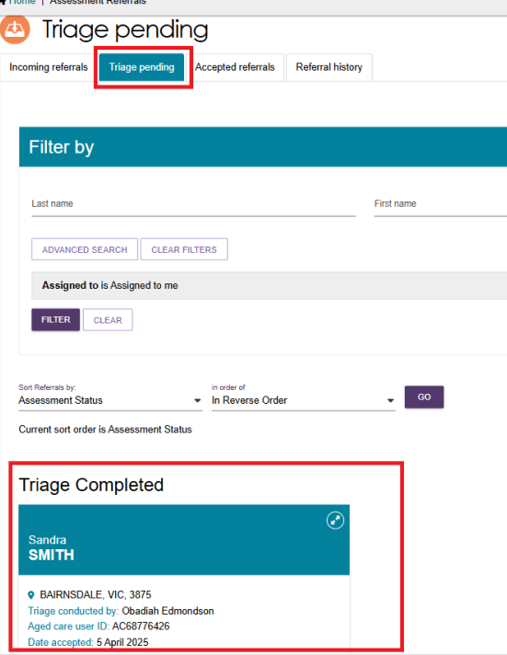
- The Triage Delegate will be able to expand the client card and view the following information.
- view full client record
- view client report.
- assign to assessor
- refer urgent services
- convert to home support assessment or comprehensive assessment
- reject
- transfer
- flag as End of Life.
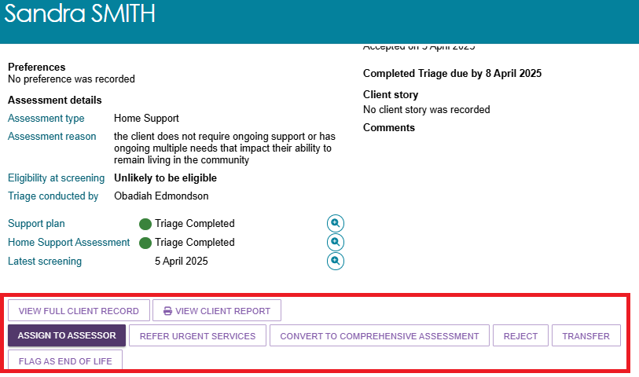
Once the Complete triage action is completed, the above information will load as a pop-up screen automatically.

Triage completed - Not eligible for assessment
During the Triage process, if a client is deemed as Not eligible for assessment, the Triage Delegate must notify the client with a formal decision letter.
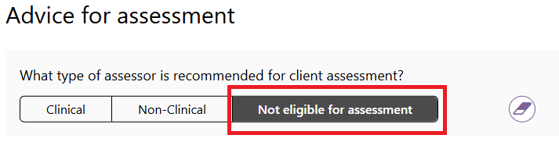
- Upon completion of the triage where a client is found to be not eligible for assessment, the triage delegate will be taken to the ATTACHMENTS tab on the Client record screen with the following message (as shown in the example) displayed at the bottom of the page.
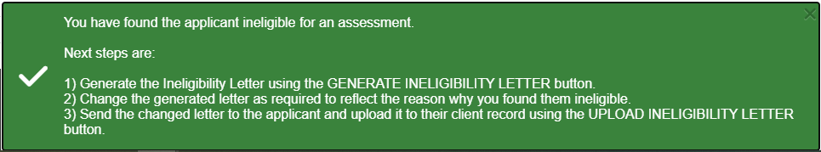
- To generate the ineligibility letter for the client, on the client's expanded card view, select VIEW FULL CLIENT RECORD button.
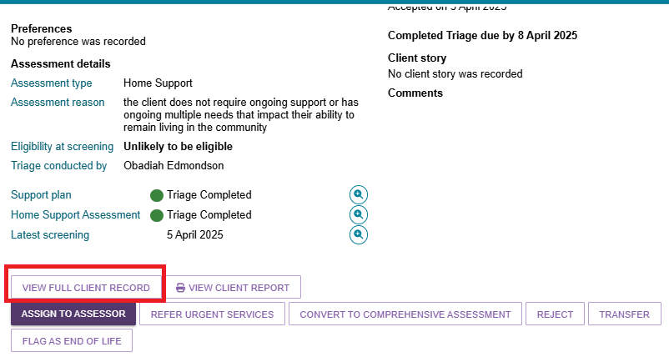
- Click the Generate Ineligibility Letter button.
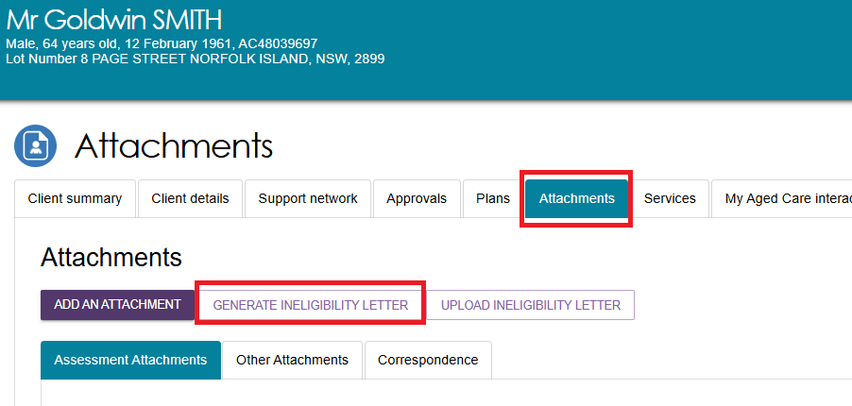
- This will redirect you to the My Reports section, which will contain the Ineligible for Assessment Letter template. Wait until the Status is Ready and click View.
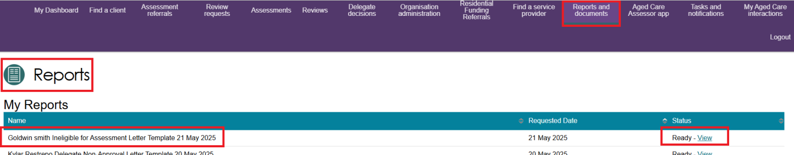
Update and change the generated letter template as required to reflect the reason why you have found the client ineligible during triage. Once you have completed the changes, save the letter template as a PDF or DOCX format. Click Close to return to the client’s profile.
! | The system supports a maximum file size of 5MB. Using Rich Text Format (RTF) files may exceed this limit. To avoid this issue, it is recommended to convert your files to PDF or DOC formats.
- Upload the updated Ineligible for Assessment Letter via the Upload Ineligible Letter button.
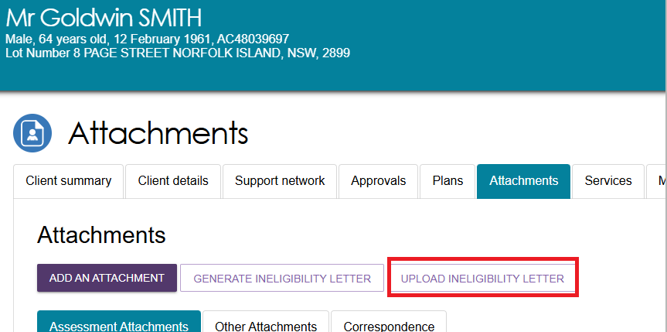
- A popup will appear, click CHOOSE FILE and select the file. Once selected, click UPLOAD.
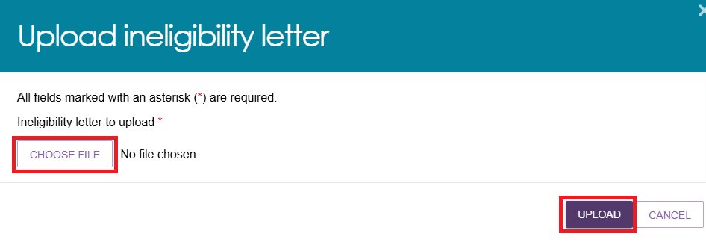
- If the document is successfully uploaded, you will receive a green banner indicating the attachment has been successfully uploaded. The letter will appear on the Attachments tab.
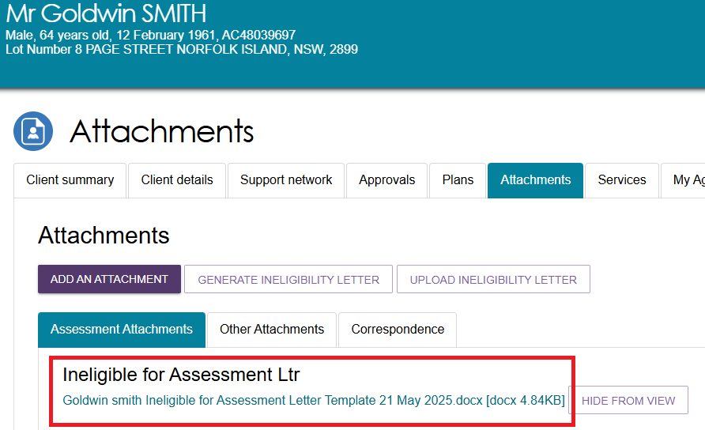

Viewing triage information
Triage Delegates and Team Leaders can view the client’s triage information from the client’s summary page. This is done by selecting the magnifying glass icon next to Home Support Assessment or Comprehensive Assessment.
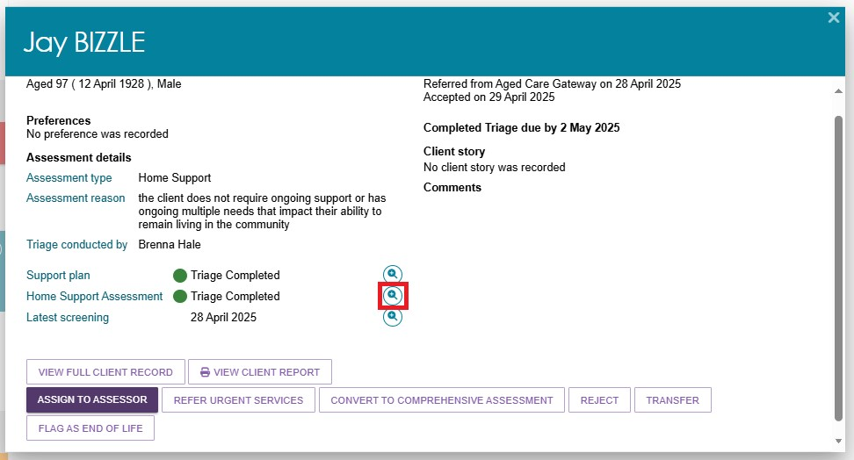

Referring to Urgent Services
Triage Delegates can refer a client for urgent services once an assessment referral has been accepted. This can occur before or after triage.
- To refer urgent services before conducting triage, in the Triage pending tab, the Triage Delegate will select the card for the client they are referring to for urgent services. Then select the button REFER URGENT SERVICES.
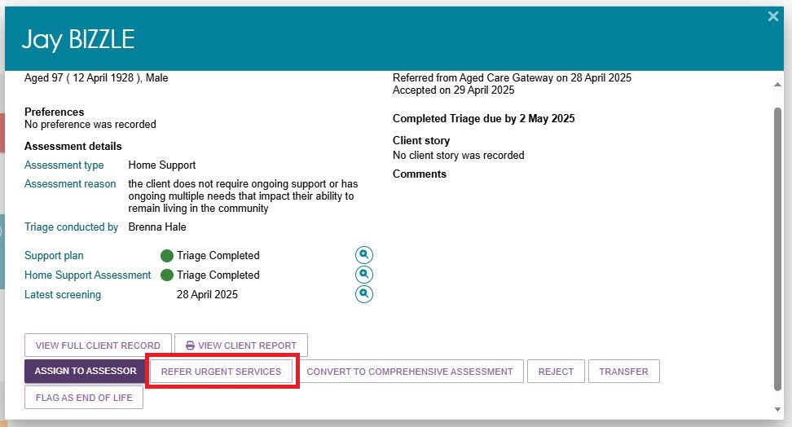
- The Triage Delegate will then be navigated to the Goals & recommendations tab under Support Plan and services.
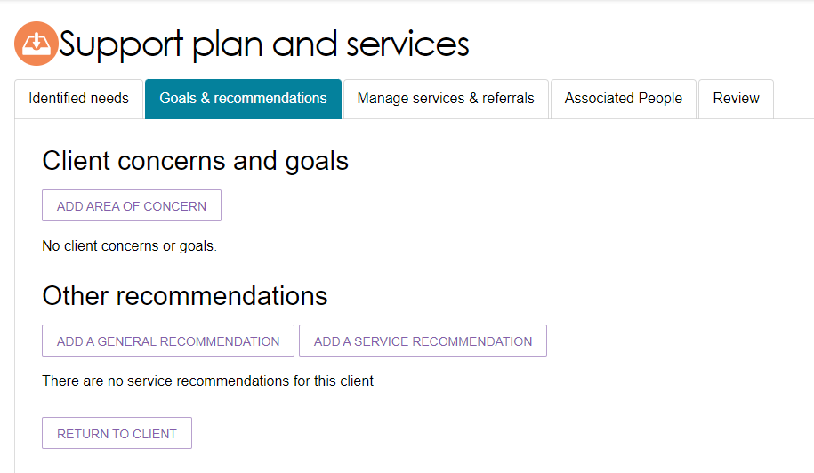
- When a client has been referred for urgent services, Urgent Services Pending Triage will be shown on the client’s card.

Converting Assessment
Triage Delegates can convert a client’s assessment from Comprehensive to Home Support, or Home Support to Comprehensive.
- Once triage has been completed and based on their clinical judgement, the Triage Delegate can convert the assessment by selecting the CONVERT TO HOME SUPPORT ASSESSMENT or CONVERT TO COMPREHENSIVE ASESSESSMENT.
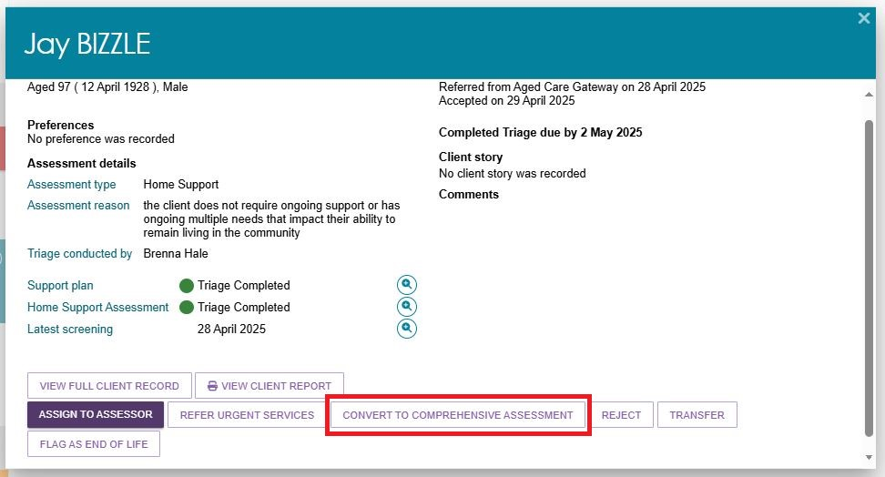
- When converting from a Comprehensive Assessment to a Home Support Assessment, Triage Delegate will need to enter the Reason for change as being Low level care needs.
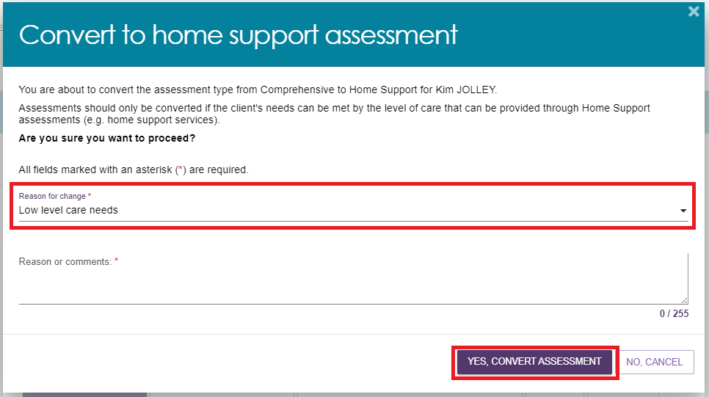
- When converting from a Home Support Assessment to a Comprehensive Assessment, Triage Delegates will need to enter the Reason for change as being High level care needs.
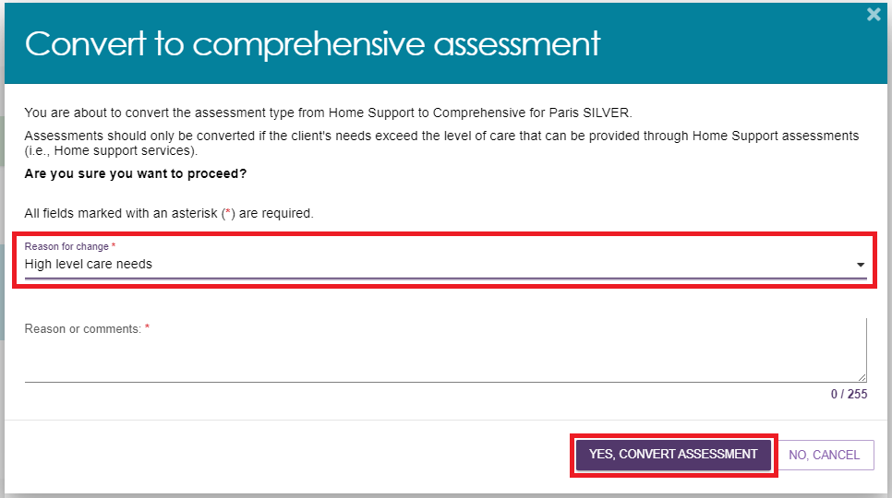

Assigning an assessment referral to an assessor
Before a Triage Delegate assigns an assessment referral to an assessor, triage must be completed.
- Referrals that can be assigned are located in the Triage pending tab, under the Triage Completed heading. Expand the client card for the referral you wish to assign, select ASSIGN TO ASSESSOR.
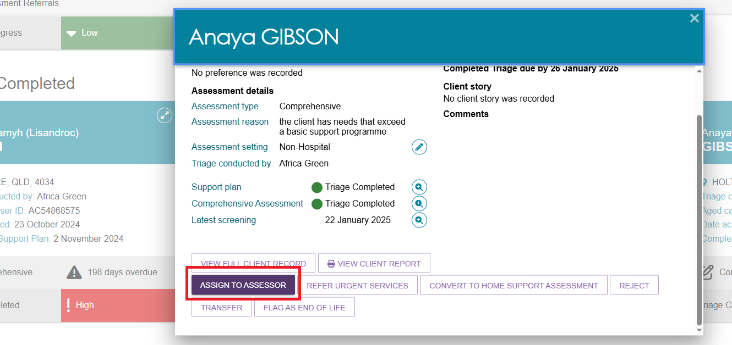
- The Triage Delegate can Change assessment priority before assigning the referral. Respond Yes or No to the question Assign now, if you wish to assign now, and then choose the assessor. You can also search for a specific assessor. To proceed select ASSIGN. If you do not wish to assign now, this referral will remain under the Triage pending tab, under the Triage Completed heading.
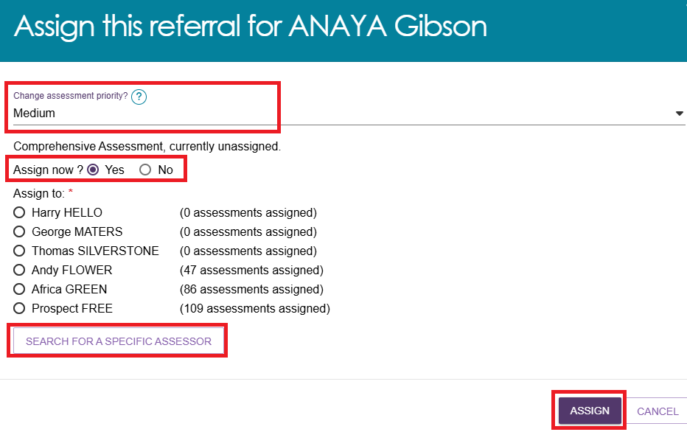
- The assessment referral will appear in the Accepted referrals list, under the name of the assessor the referral was assigned to. The referral will also appear in the assigned assessor’s Current assessments list for action.
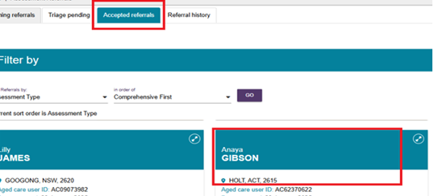

Unassigning or reassigning an assessment referral
Team Leaders can unassign an assessment referral and reassign the referral to another assessor in the same outlet. There is no limit on the number of times referrals can be unassigned or reassigned.
- From the Accepted referrals tab, access the expanded referral view by selecting the arrow on the client card.
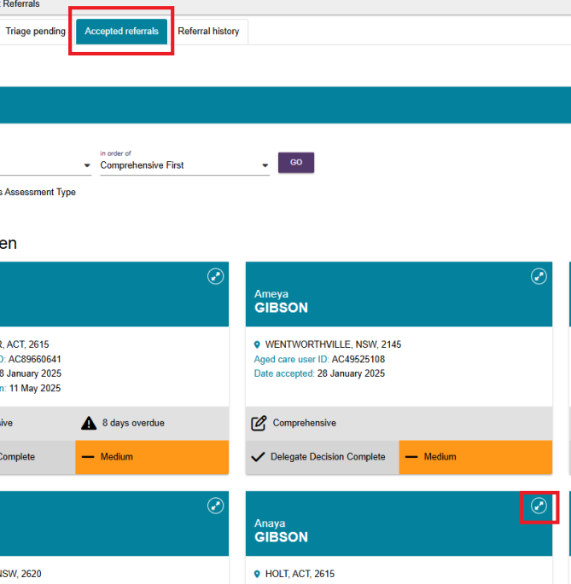
- Select REASSIGN. If using list view, select REASSIGN from the expanded view.
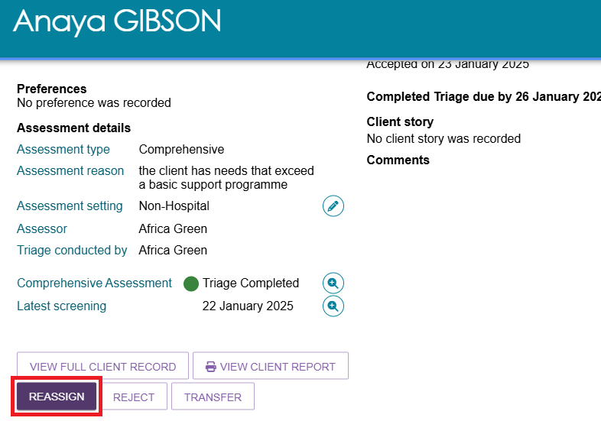
- Select the assesor that the referral is being assigned to and select SAVE. If the referral is going to be unassigned and added back to the queue, select Unassign and add to the queue. You can also re-assign to a specific assessor from here.
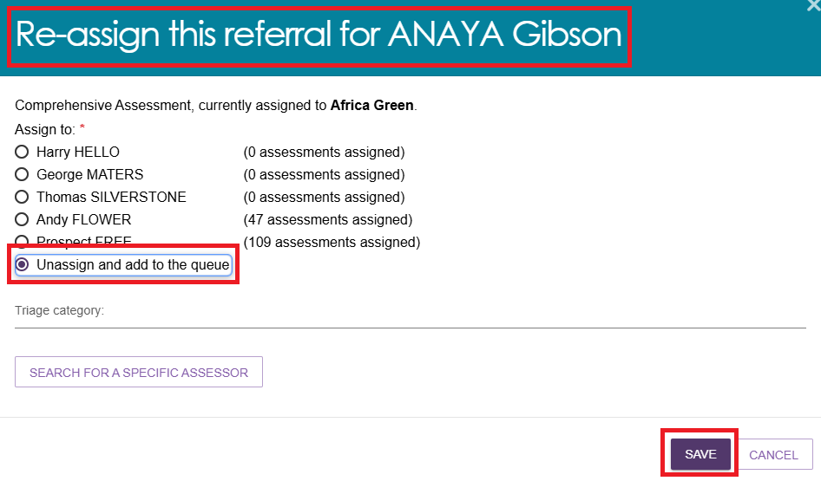
- If reassigned, the assessment referral will appear under the relevant assessor in the list of Accepted referrals.
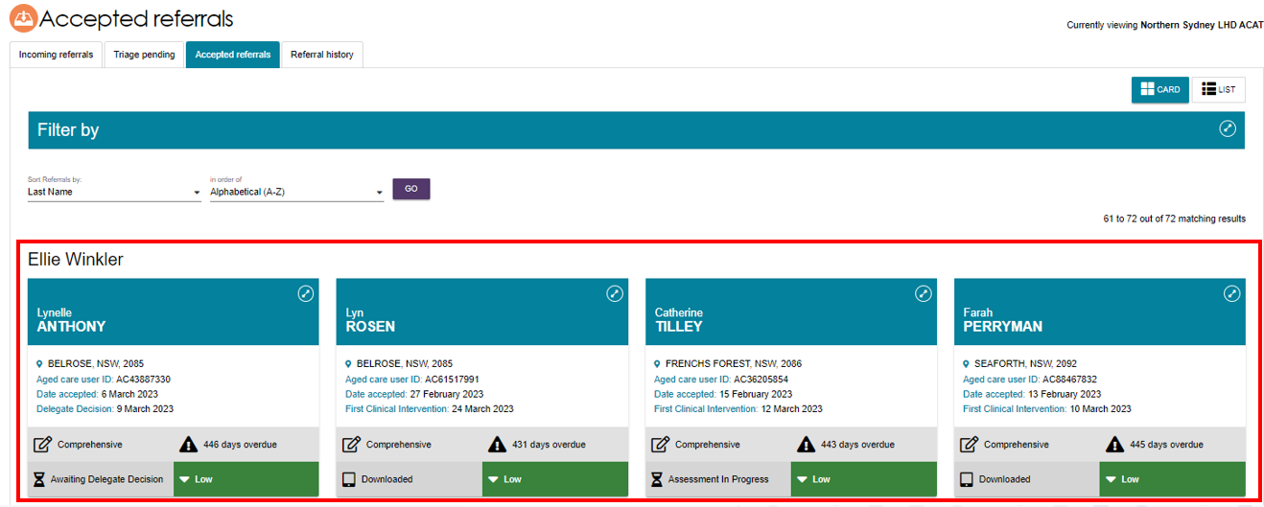
- If unassigned, the referral will appear under Unassigned in the list of Accepted Referrals.
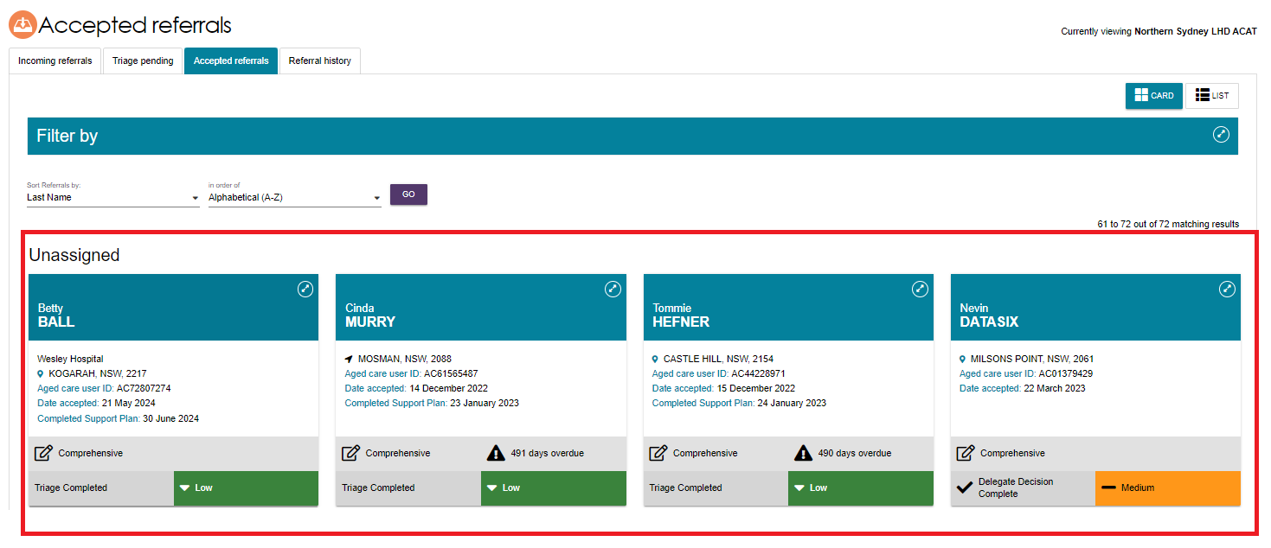

Rejecting an assessment referral
If an outlet is unable to accept an assessment referral and cannot transfer it, a Team Leader can reject the referral. Referrals may also be rejected after acceptance, but only before the assessment has commenced.
- Select REJECT on the expanded card view of the referral information.
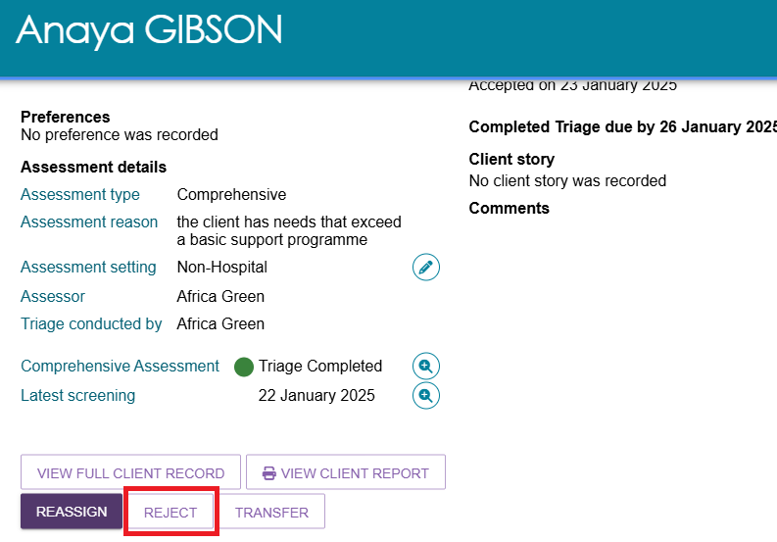
- Enter a reason for rejecting the assessment referral, and then select REJECT. The rejected referral will automatically be sent to My Aged Care to action.
! | The use of the ‘Other’ value when rejecting referrals should be limited to rare and unusual situations that are not captured by existing values. If an existing value primarily captures the nature of the rejection reason, please utilise that option. The free text field will be available for further information for any rejection reason selected.
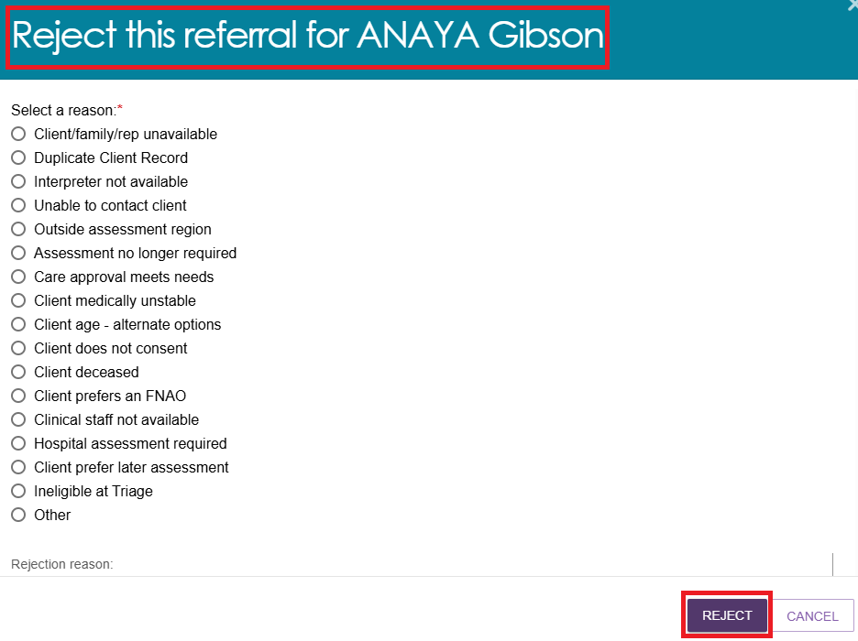
! | An older Aboriginal and/or Torres Strait Islander person should not be rejected based on a client’s preference (e.g. under the reason “Client prefers an FNAO”) unless it is a last resort. A transfer prior to the assessment is preferable to a rejection. For more information please refer to the My Aged Care Assessment Manual.

Rejecting an assessment with the reason of Client deceased
! | Rejecting an assessment with the reason of Client deceased will change the client’s status to Deceased and make the client record read-only. Any unaccepted service referrals will be recalled, services in place will be ceased, assessments will be cancelled and the client’s access to the client portal will be revoked. My Aged Care will not send correspondence to the client or their supporters after the status is changed to Deceased.
- If a client is deceased during an assessment referral period, team leaders will need to provide the following information:
- who, when and how you were informed that this person is deceased e.g. “Mrs Smith rang to inform us that Mr Smith has passed away on Saturday”
- date of death (if known)
- attachments (e.g. death certificate, hospital discharge documents).
- When a client is marked as deceased, a notification will be sent to the client’s associated assessor and provider, telling them to close or finalise any in-progress tasks.
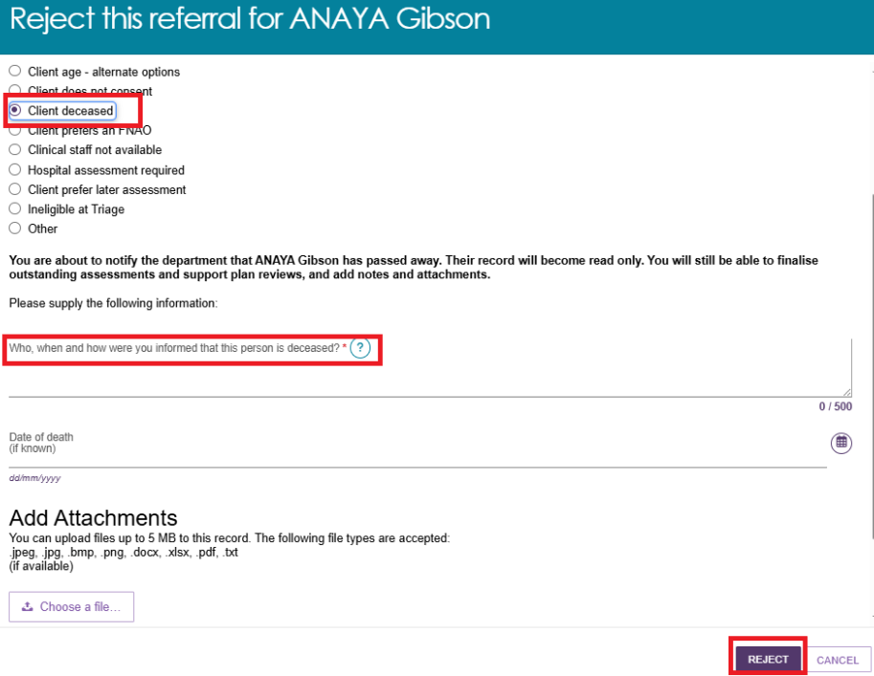
- When a client is marked as deceased, if they have an in-progress assessment or have commenced services, a notification will be sent to the associated assessor in the assessor portal advising the assessor to close or finalise the in-progress tasks.

Flagging the assessment as End-of-Life Pathway
If the client has provided the Triage Delegate with a completed End-of-Life Pathway Form, they can flag the assessment referral to be considered for the End-of-Life Pathway, which is given a high priority. Please note that this process can be completed before and after triage is completed.
- Click the Flag as End-of-Life button.
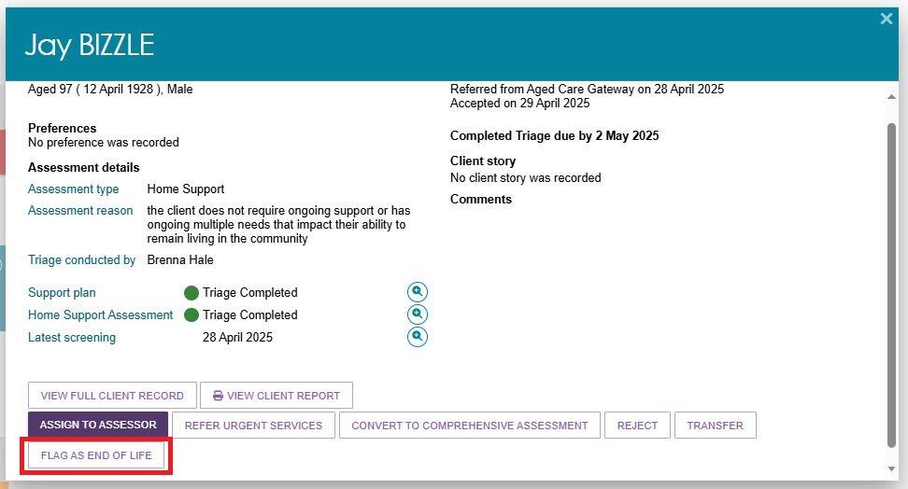
- Review the provided documents, carefully examining the End-of-Life Pathway Form and any supporting documentation submitted by the client. Select the most appropriate value for verifying the End-of-Life Pathway Form and supporting documents.
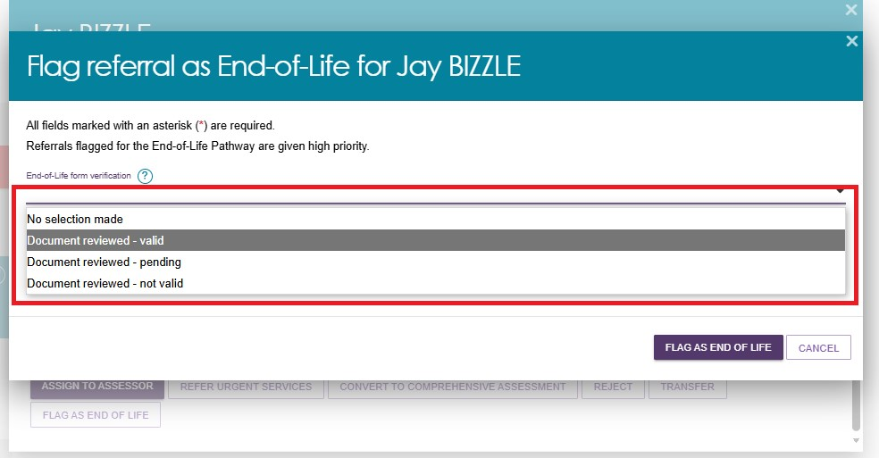
! | It is crucial to review and upload the End-of-Life Pathway Form and any supporting documentation to ensure the client meets the eligibility requirements under the End-of-Life Pathway. If the documentation is incomplete or missing, select Document reviewed – pending.
- Complete the Details field by entering the necessary details, then click the UPLOAD ATTACHMENT button to attach the form.
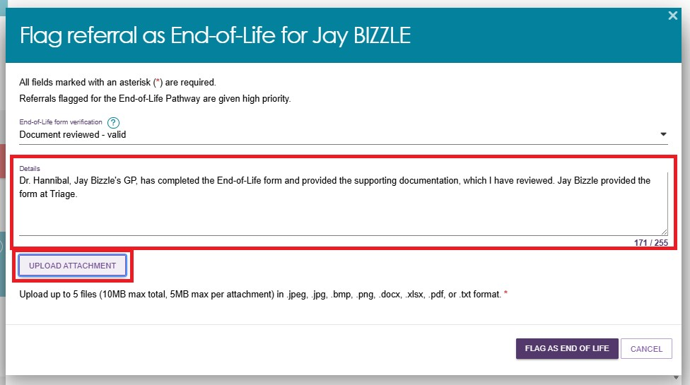
- Click the CHOOSE FILE button to select the form from your device, fill in the Attachment type, Attachment name, and Attachment description fields, and then click the UPLOAD button to upload the form.
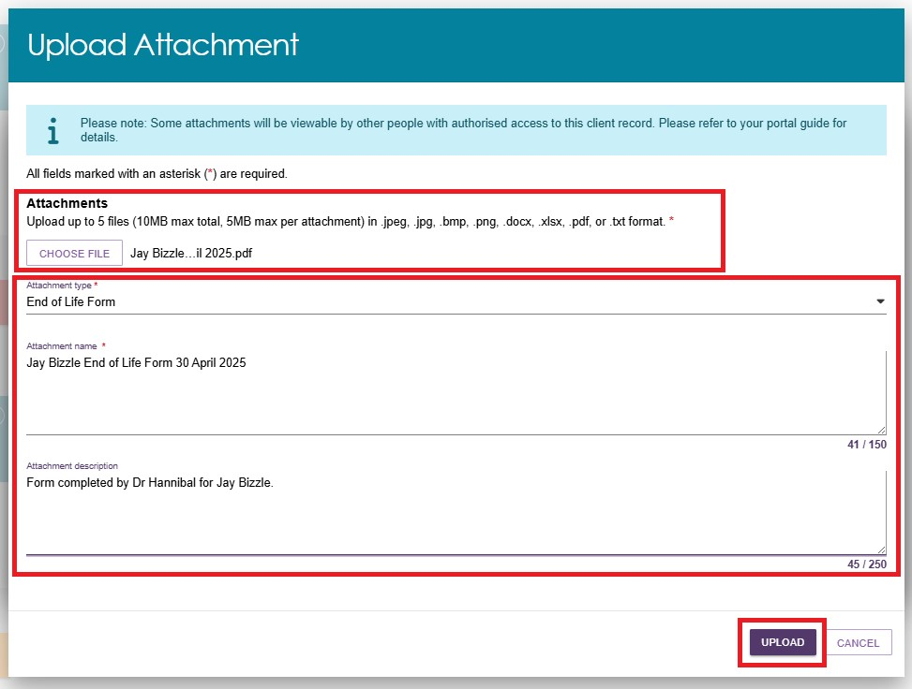
- A confirmation screen will appear. Review or delete the attachment or details if necessary, and then click the FLAG AS END-OF-LIFE button to complete the process.
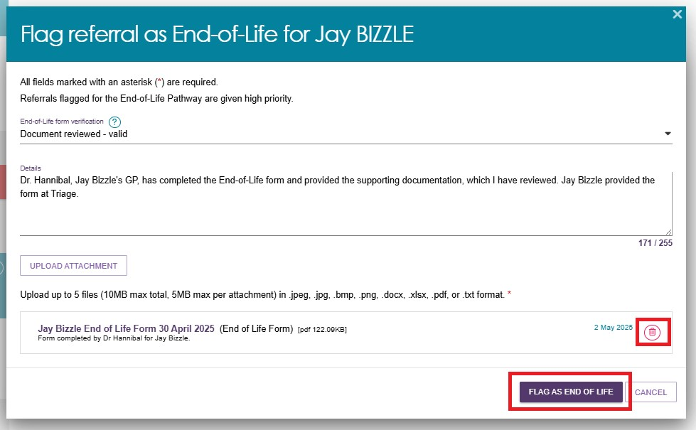
- Once completed you will receive a green confirmation banner at the bottom and the assessment referral card will show the End-of-Life Pathway symbol.
 | End-of-Life Pathway
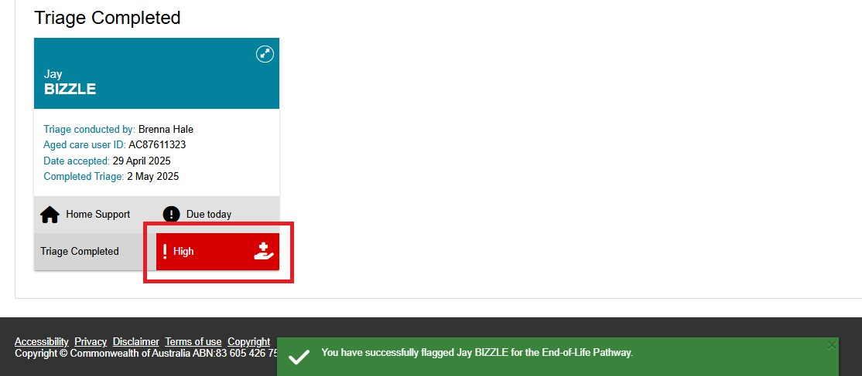

Transferring an assessment referral to another outlet or Organisation
Only incoming, accepted or triaged referrals may be transferred to another outlet or organisation. A referral can only be transferred to another organisation or outlet once.
Follow these steps to transfer assessment referrals to an alternative assessment organisation or outlet:
! | Before transferring a referral, the Team leader must ensure:  - The client understands why their referral is being transferred and consents to the transfer of the referral to the new assessment organisation.  - They have contacted the assessment organisation that will be receiving the client referral to confirm that they will accept the referral.  A referral should not be transferred before confirmation has been obtained that it will be accepted by the receiving assessment organisation.
- From either the Incoming referrals, Triage pending or Accepted referrals tab of the Assessment Referrals tile, select the arrow next to the client’s name and then select TRANSFER in the expanded view.
CARD view example:
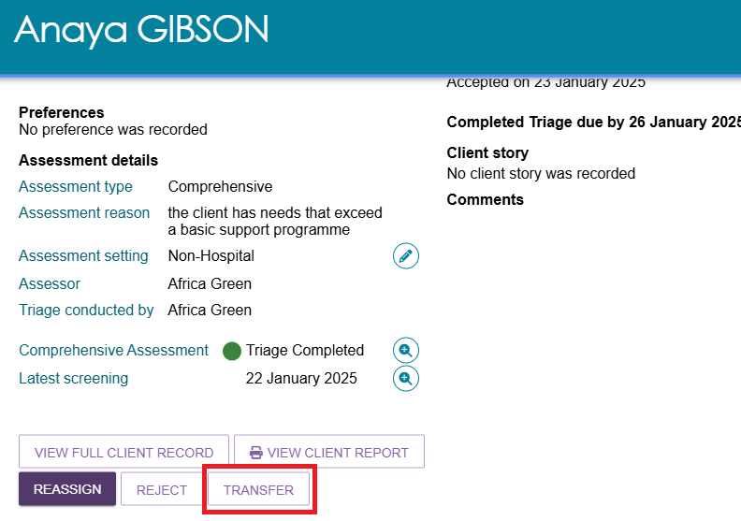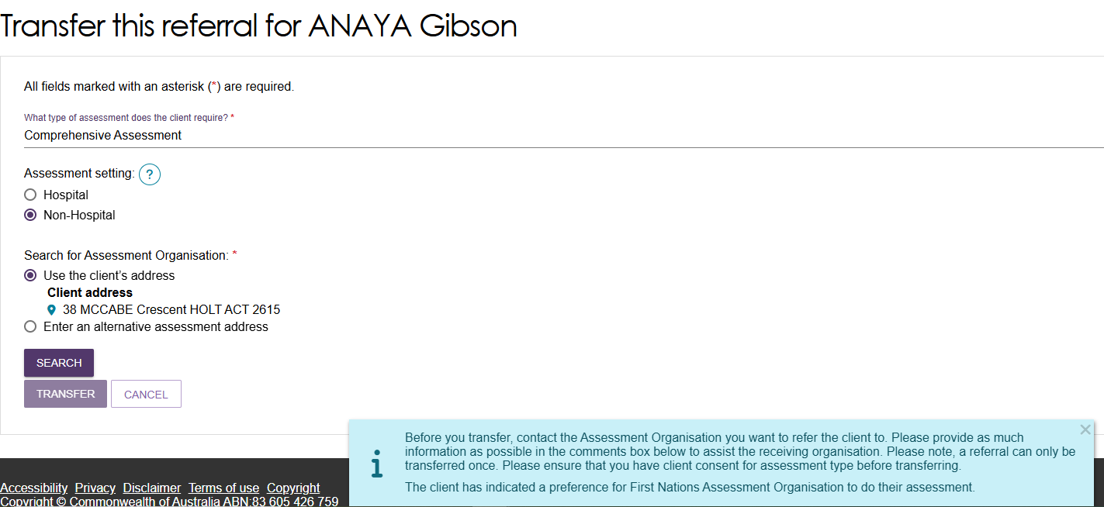
LIST view example:
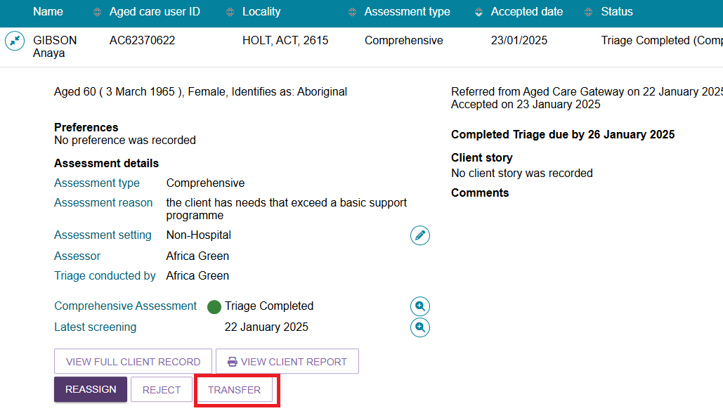
- The following warning will appear when you select TRANSFER.
- In the pop-up box the type of assessment required must be selected from a drop-down list, either Home Support or Comprehensive Assessment. For Comprehensive assessment, it will provide an Assessment setting of Hospital or Non-Hospital whereas if Home Support Assessment is selected, the assessment setting will disappear. Once these have been selected, select the button ADD ADDRESS to search the address.
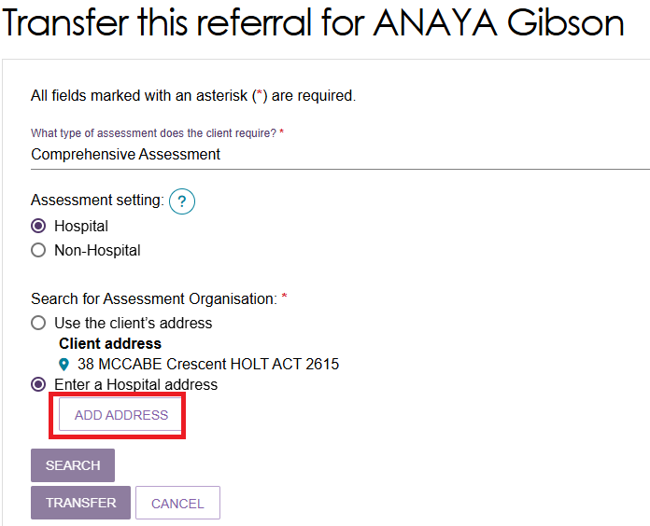
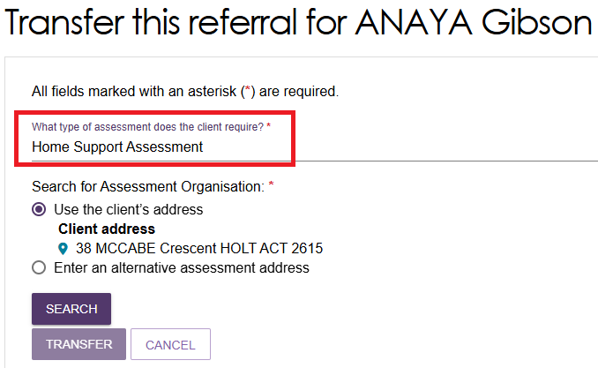
- A pop-up will appear and address details of the client’s address, or the hospital address will need to be entered. Select VALIDATE THIS ADDRESS. Below a list of addresses will be provided, select the most relevant address. To finalise the address, select SAVE ADDRESS.
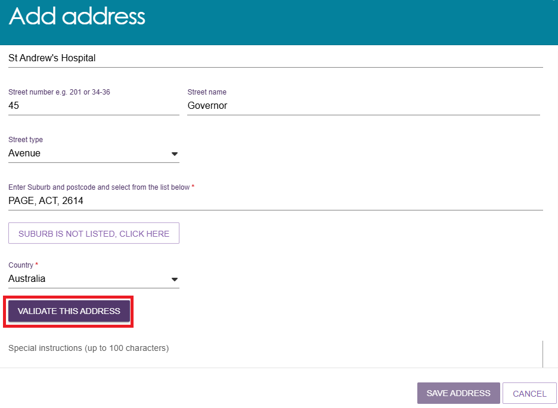
- If the assessment setting is non-hospital, you can either use the client’s address or add an alternative assessment address depending on the client’s/representative’s preference. Select the appropriate assessment organisation for referral transfer and then select the reason from the drop-down menu.
If the transfer reason is OTHER, you will be prompted to add a comment explaining the reason.
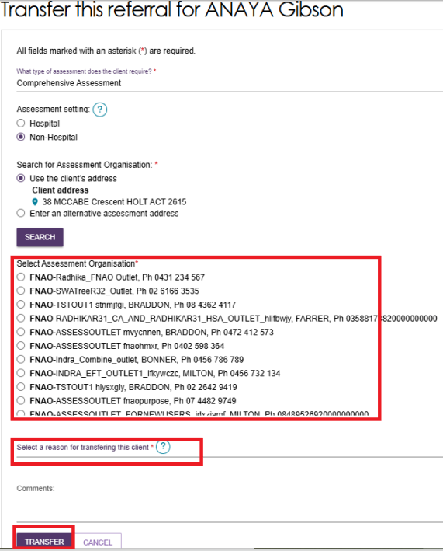
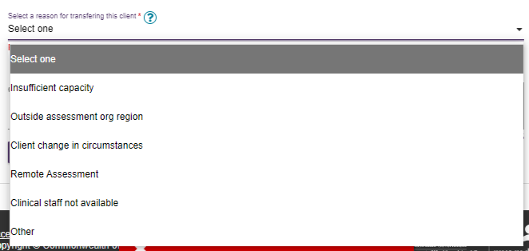
- Once the TRANSFER button is selected, a green banner will be displayed confirming the transfer has been completed successfully.
! | If the client has preference to be assessed by a First Nations Assessment Organisation a yellow banner will be displayed advising so.

Client records from inactive outlets
Departmental staff can transfer client records linked to an inactive outlet to an active outlet in the same assessment organisation, or to another assessment organisation.
Future Support Plan Review requests or new assessment referrals will be issued to the active outlet. Care extension requests transferred to the active outlet will appear as ‘unassigned’ in the delegate queue.
The assessors and the contact centre will see a note of the transfer in the My Aged Care client record. The client’s online account includes a notification of the transfer.
In the assessor portal, the notification of the transfer can be seen in the Notes tab of the client record.
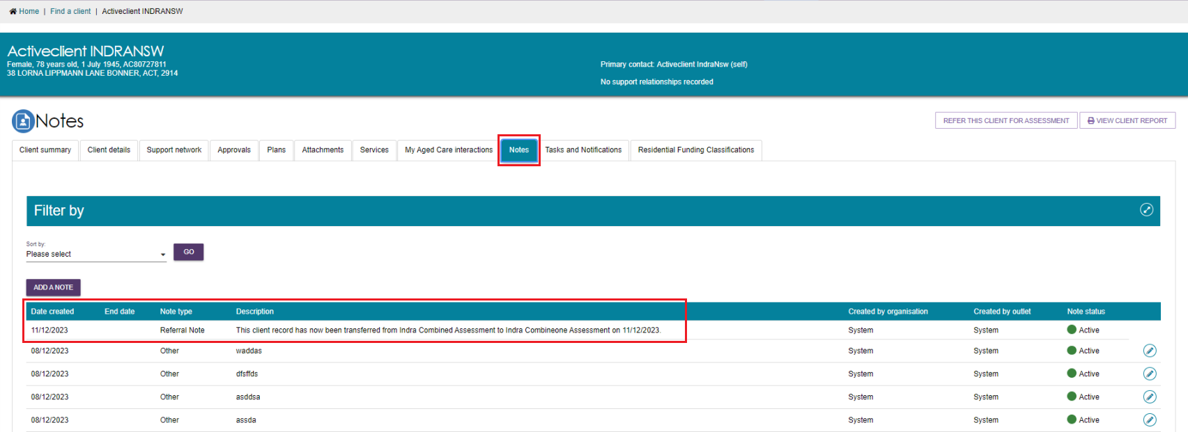

Residential Funding Referrals
The Residential Funding Referrals tile is available to accept any residential funding referrals.
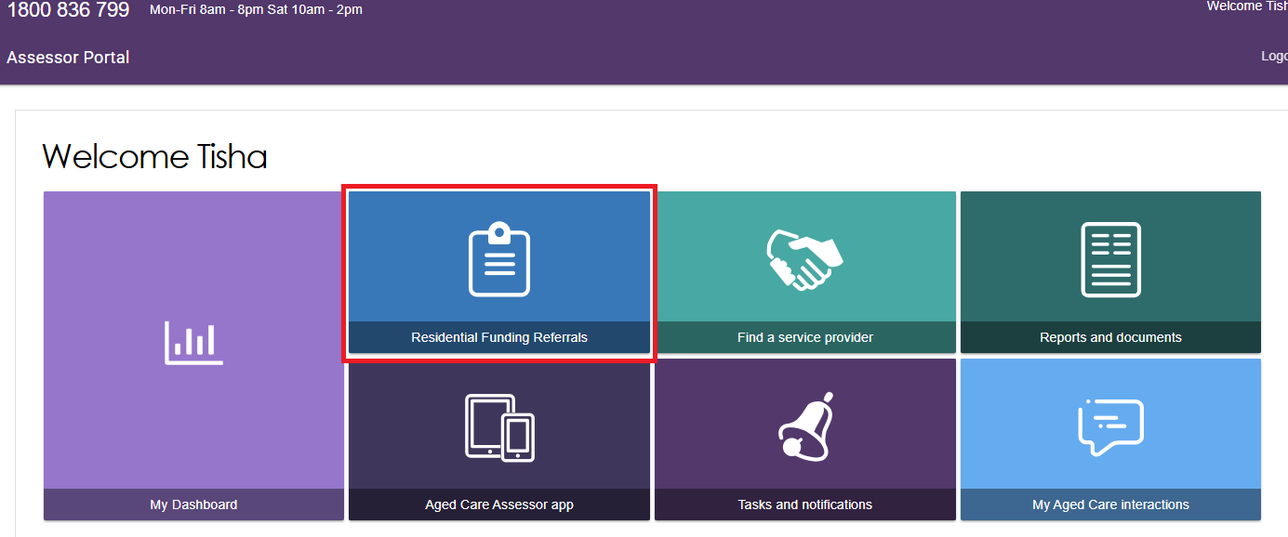
- A clinical aged care needs assessor (clinical needs assessor) will have access to the Current Work and Recent Work tabs.
The Current Work tab contains Residential Respite Assessments that are assigned to you.
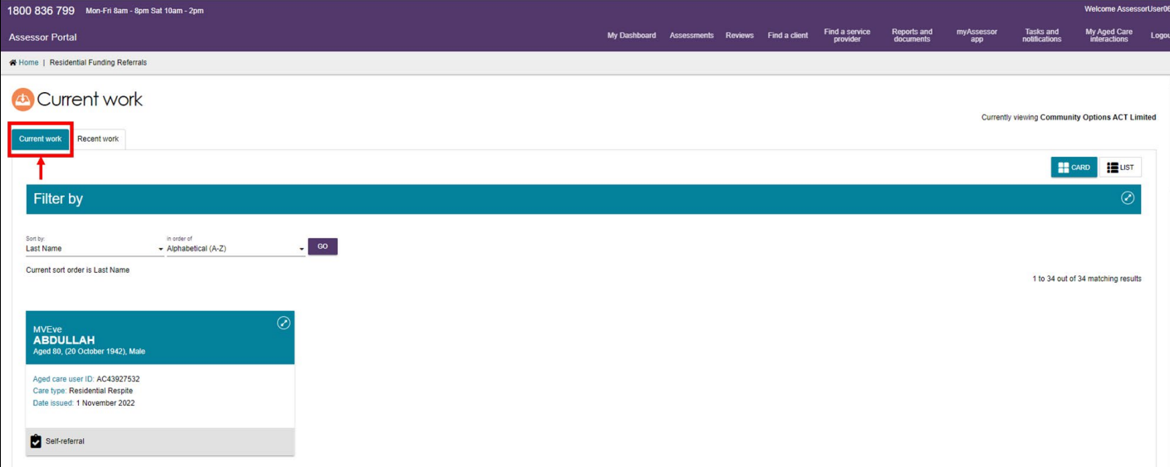
- The Recent Work tile contains Residential Respite Assessments that you have completed in the past 2 years.
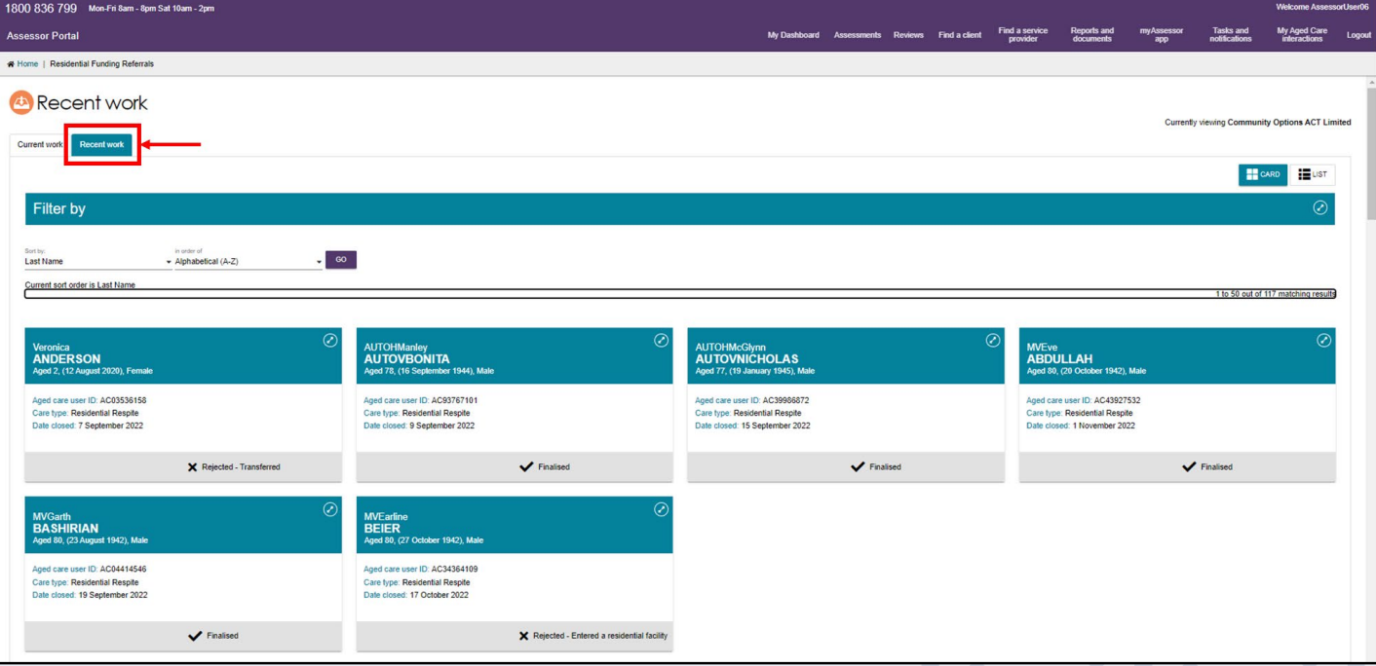
- Filters can be applied to both the Current and Recent work tabs.
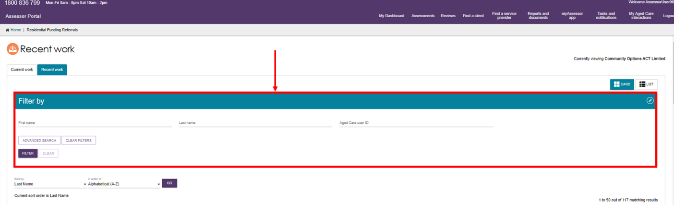
For more information on self-referring a client and starting a Residential Respite Assessment, please refer to the Aged Care Assessor Application User Guide.

Support Plan Reviews
! | When a new assessment is raised for a client, the assessment referral will be required to undergo triage. This includes new assessments which have resulted from a Support Plan Review where it has been identified that the client's needs have changed to the point of needing a new assessment.  More information about conducting a Support Plan Review for Support at Home clients can be found on My Aged Care User Guide 7.
- Team leaders can manage Support Plan Reviews via the Review requests tile on the assessor portal home page.
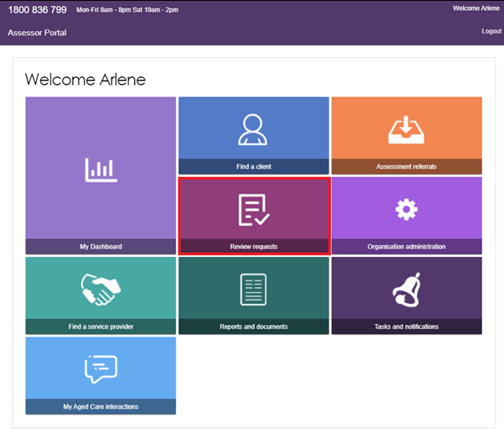
- In the Review requests section, team leaders can view Upcoming reviews, Assigned reviews and Review history.
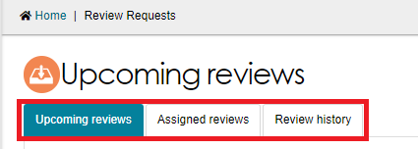
- In the Upcoming reviews tab team leaders can:
- view scheduled reviews
- view reviews requested by service providers
- assign reviews to assessors
- change review priority
- cancel reviews.
- In the Assigned reviews tab team leaders can reassign reviews to different assessors.
- In the Review history tab team leaders can view a history of completed and cancelled reviews.

Viewing Support Plan Reviews
- A Support Plan Review request will contain the following information:
- The person/organisation requesting the Support Plan Review
- The assessor who last conducted the assessment
- The urgency for the review to be completed
- Reasons for request including:
  - Client’s change in circumstances
  - Impact on client’s needs
  - Primary reason for request
  - Services client is currently receiving
  - Options explored to increase the client’s current support.
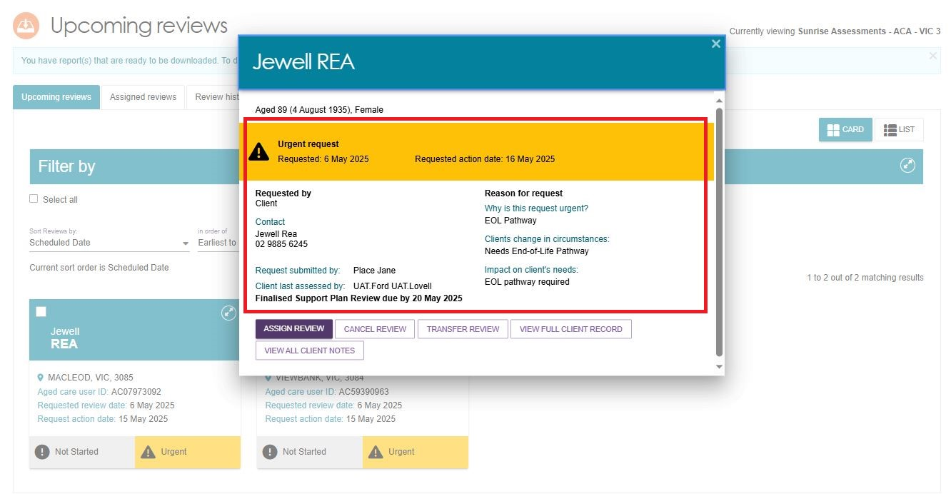
- A banner will be displayed on the request if additional attachments have been added to the client’s record as part of the Support Plan Review request.
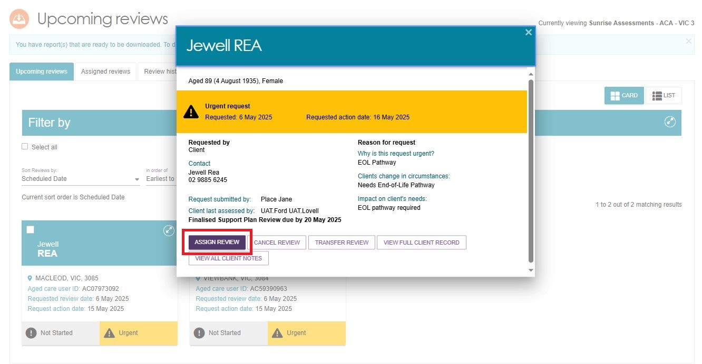
! | If the client has pending support relationships, a banner will be displayed on the review. Team leaders are able to confirm pending support relationships for clients, this process is described in My Aged Care – Assessor Portal User Guide 2 – Registering support people and adding relationships.  
- Team leaders can sort, and filter Support Plan Reviews based on several categories.
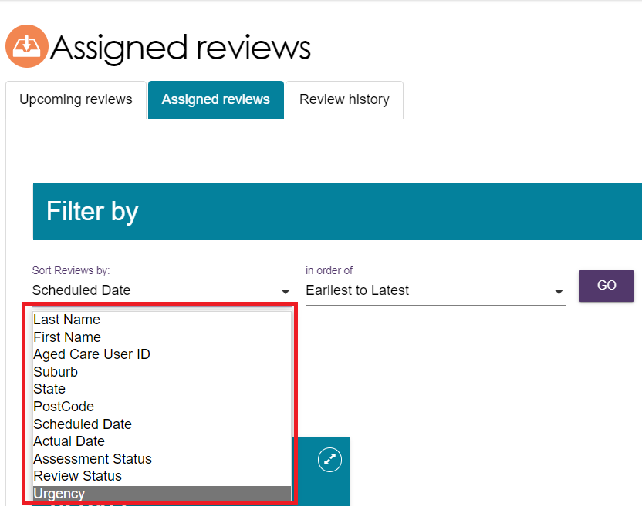

Assigning a Support Plan Review
Team leaders will only be able to assign the Support Plan Review request that has the parent assessment type as Home Support assessment to non-clinical aged care needs assessors (non-clinical assessor) within the outlet. If the client is undergoing support, the team leader contacts the assessor to determine whether to end the support period or cancel the review.
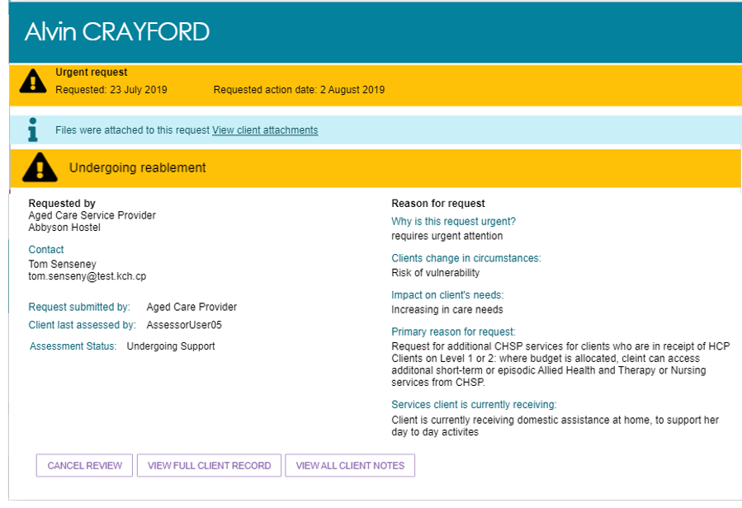
Follow these steps to assign a Support Plan Review:
- Navigate to the Upcoming reviews tab and select ASSIGN REVIEW on the expanded client card.
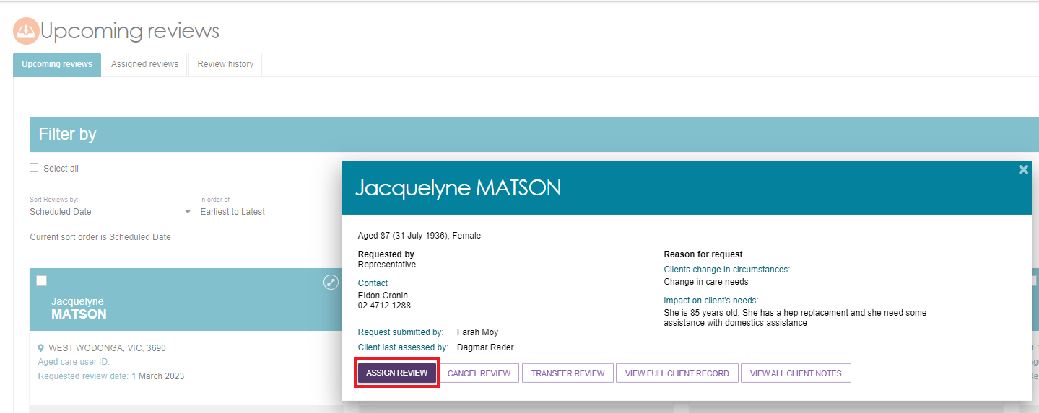
- Before assigning to an assessor, you can change the Support Plan Review priority. Select an assessor to assign the Support Plan Review to and select ASSIGN.
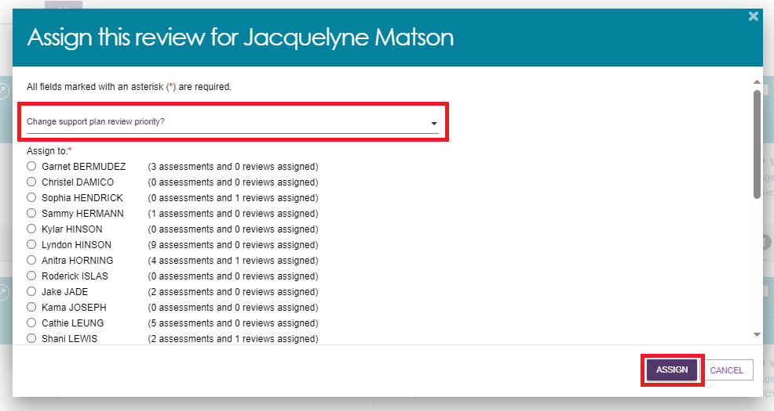
- Once assigned, a banner will appear on the bottom of your screen.
- The Support Plan Review will now appear in the Assigned reviews tab. Assigned reviews will also appear in the Current reviews tab of the assessor the review was assigned to.

Transferring a Support Plan Review
Team leaders can transfer Support Plan Reviews to other assessment organisations.
- To begin transferring a Support Plan Review, go to Upcoming reviews and select the client card you wish to transfer for the Support Plan Review. Select TRANSFER REVIEW.
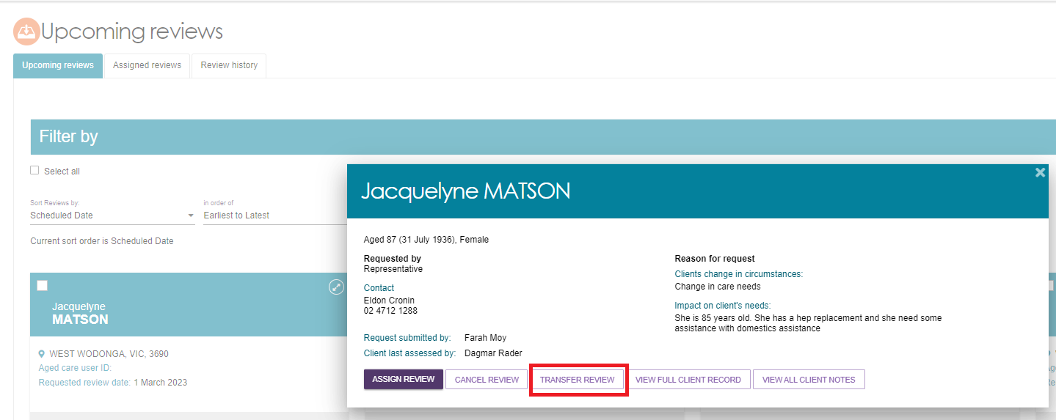
- You will need to enter a What is the reason for the transfer and search and select the Assessment Organisation which the Support Plan Review will be transferred to. Once the reason for transfer and organisation has been selected, select TRANSFER.
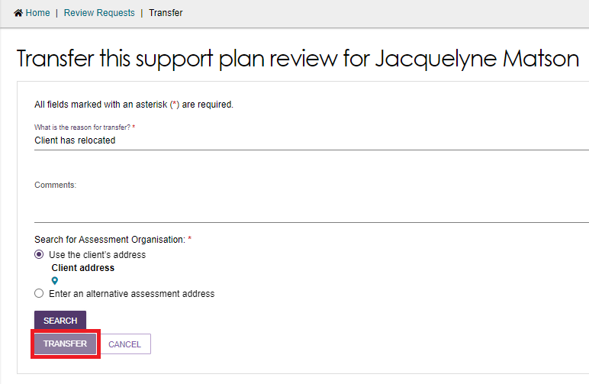

Reassigning a Support Plan Review
Follow these steps to reassign a Support Plan Review:
- From the Assigned reviews tab, expand the client card using the expand icon  and select REASSIGN REVIEW on the Support Plan Review to be reassigned or unassigned.
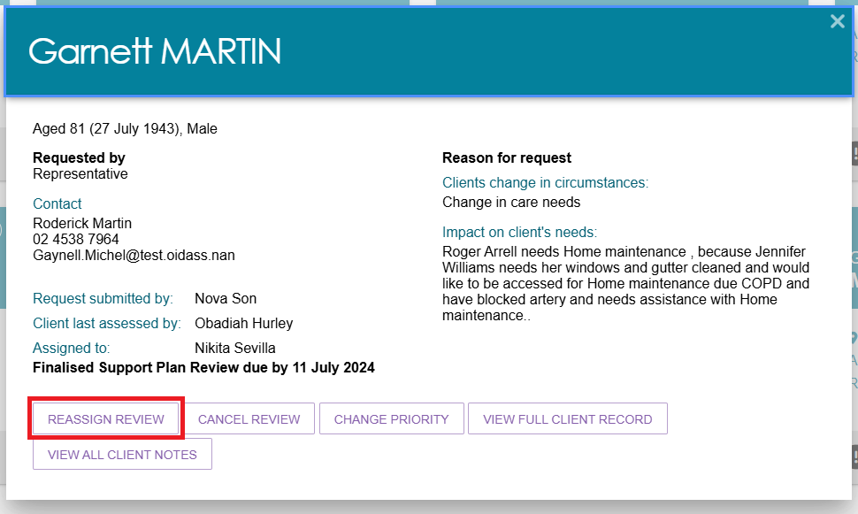
- Select another assessor and REASSIGN.
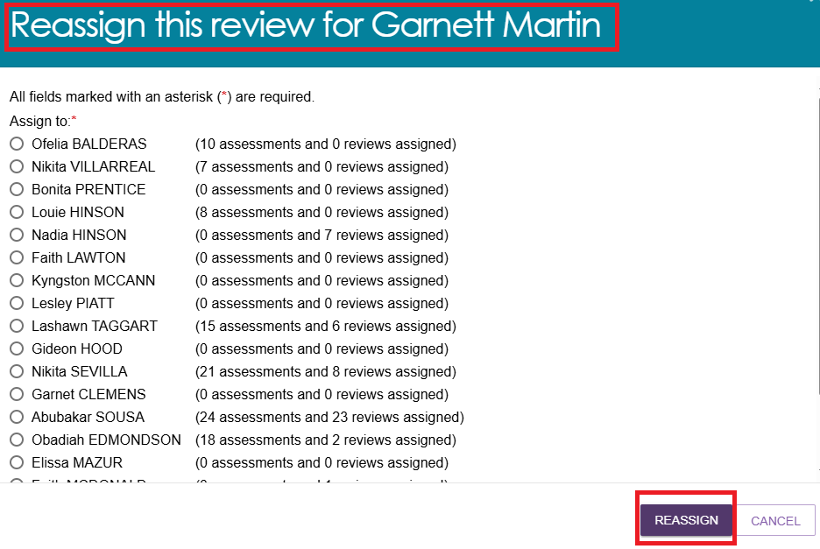
- The Support Plan Review will now be reassigned to the selected assessor and the review will appear in their Current reviews tab.
! | Team leaders can also reassign Home Care correspondence notifications, by going to Tasks and notifications in the assessor portal homepage and clicking on the HCP Notifications tab. More information on this can be found on My Aged Care - Assessor Portal User Guide 9 - Tasks and notifications.  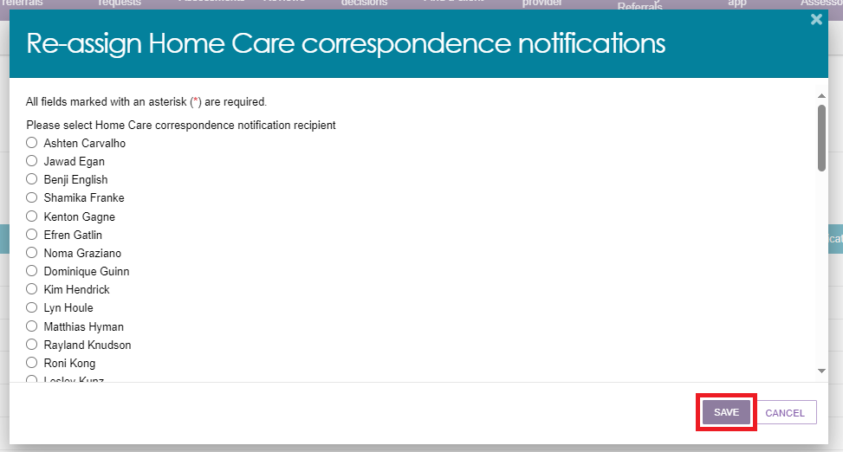

Cancelling a Support Plan Review
In either the Upcoming reviews tab or Assigned reviews tab, select CANCEL REVIEW from the expanded view of the client card for the review to be cancelled.
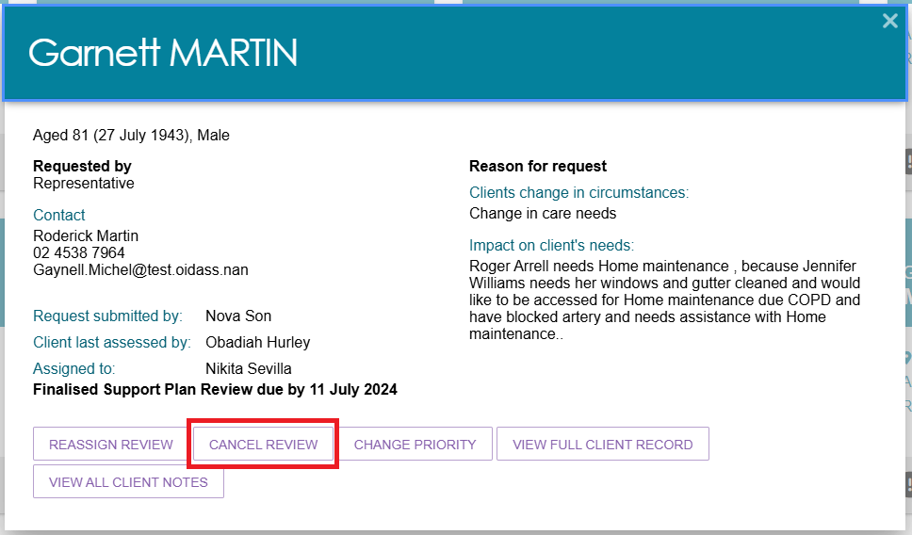
Select a reason for the cancellation from the with a brief explanation on the details field and click CANCEL REVIEW REQUEST.
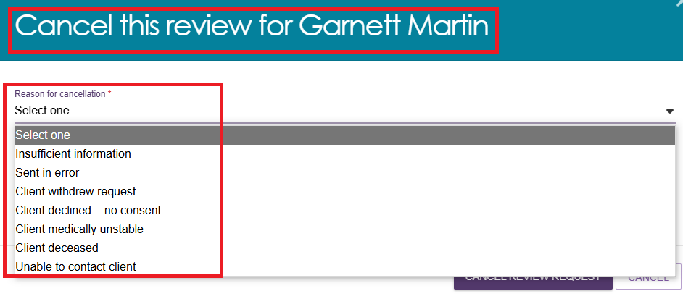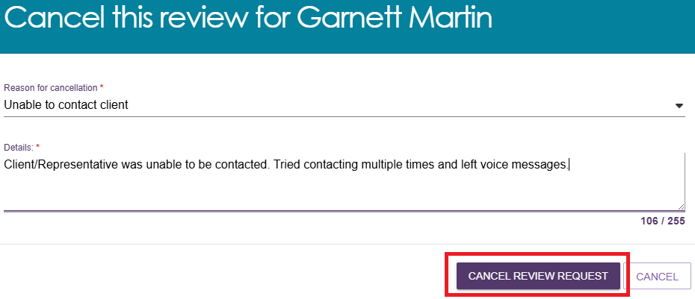
The review will be removed from the Upcoming reviews tab. Completed and cancelled Support Plan Reviews will also appear in the Recent reviews tab of the assessor who completed the review. Support Plan Reviews will also be cancelled automatically where a new assessment referral is issued and accepted for the client. This will allow the new assessment to commence without requiring the Support Plan Review to be completed.

Cancelling a Support Plan Review with the reason of Client deceased
! | Cancelling a Support Plan Review with the reason of Client deceased will change the client’s status to Deceased and make the client record read only. Any unaccepted service referrals will be recalled, services in place will be ceased, assessments will be cancelled and the client’s access to the client portal will be revoked. My Aged Care will not send correspondence to the client or their supporters after the status is changed to Deceased. My Aged Care will send a notification to the client’s assessor and provider advising them to close or finalise any in-progress items. Where a client is active in the Support at Home Priority System or has been allocated funding, this will remove the client from the Support at Home Priority System and withdraw any allocated funding.
- When cancelling a Support Plan Review with the reason of Client deceased, you will need to provide the following information:
- who, when and how you were informed that this person is deceased
e.g. “Mrs Smith rang to inform us that Mr Smith has passed away on Saturday”
- date of death (if known)
- attachments (e.g. eath certificate, hospital discharge documents).
- Support Plan Reviews will also be cancelled automatically where a new assessment referral is issued and accepted for the client. This will allow the new assessment to commence without requiring the Support Plan Review to be completed.
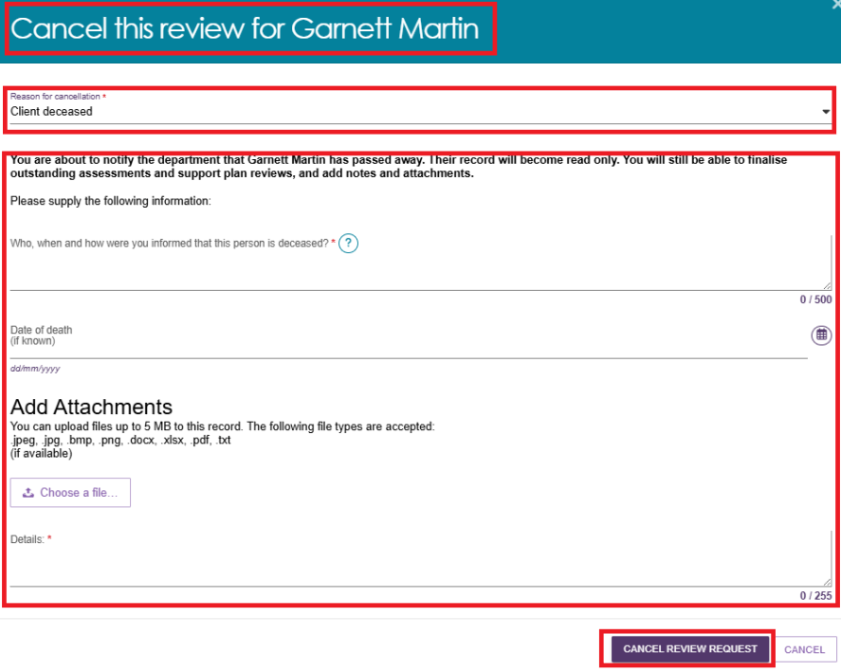
- Notes and attachments can be attached to the client record after the status is set to Deceased.
- When a client’s status is changed to Deceased, if they have an in-progress assessment or has commenced services, a notification will be sent to the associated assessor in the assessor portal, advising the assessor to close or finalise the in-progress tasks.

Change priority for a Support Plan Review
Team leaders can change the priority of a Support Plan when assigning a review to an assessor in the Upcoming reviews.
! | Note that if the Support Plan has been requested as for the Support at Home End-of-Life Pathway, that the request will be classed as an Urgent request and the circumstances will be Needs End-of-Life Pathway. The urgency should not be modified.  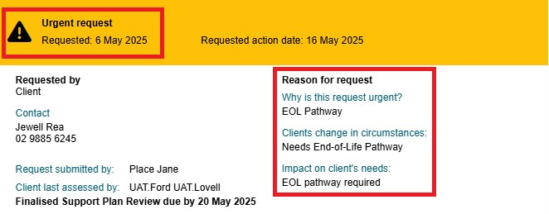
Follow these steps to change Support Plan Review priority after it has been assigned:
- Navigate to Assigned reviews tab, open a client card and select CHANGE PRIORITY.
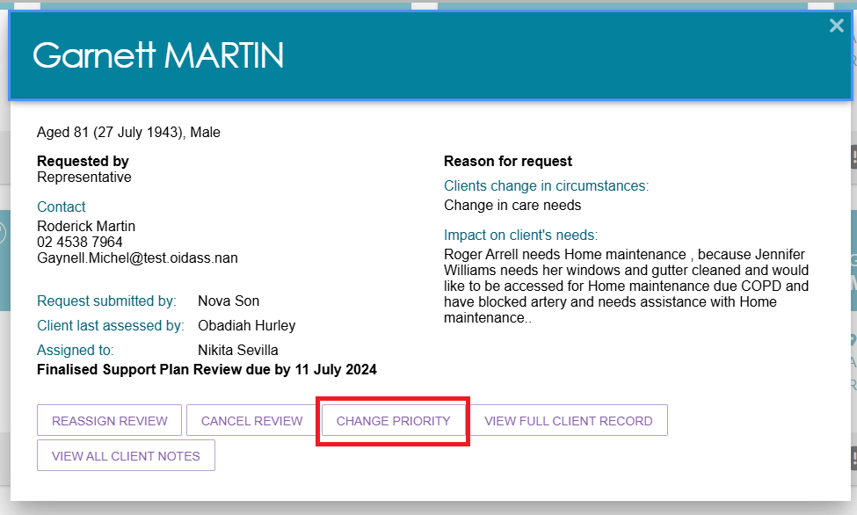
- Select the new priority from the drop-down list then click CHANGE PRIORITY. When changing priority to Urgent you must add the reason for changing the priority in Reason description then select CHANGE PRIORITY.
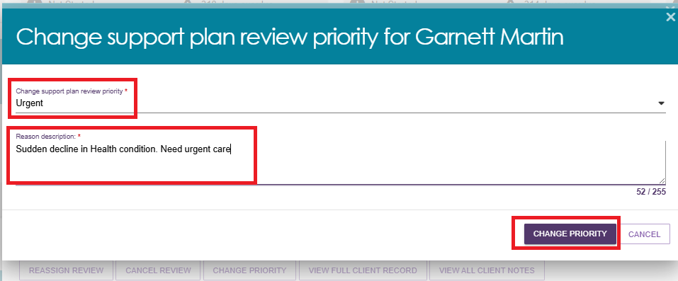
- A confirmation message will be displayed, and the review’s priority will be displayed in the Assigned review tab.

