Assessor Portal User Guide 11 – Assessment Delegate Support Role
The Delegate Support role in the My Aged Care assessor portal (assessor portal) enables anyone assigned the role to perform administrative functions to support the Assessment Delegate. For example, the Assessment Delegate Support will be able to print support plans, as well as generate, print and upload referral code letters and approval letters. The Assessment Delegate Support operates under the instructions of the Assessment Delegate.
Clinical Assessment Delegates are able to approve an older person for all service groups, classification types and classification levels under the Aged Care Act 2024. Non-clinical assessment delegates are restricted to approving entry level home support, Assistive Technology (AT) or Home Modification (HM) services (i.e. with classification levels of CHSP class, AT CHSP or AT-HM).
! | From 1 November 2025, there are changes to assessment delegations under the Aged Care Act 2024, for both Clinical and Non-clinical Assessment Delegates.  To understand Assessment Delegate changes, refer to ‘Chapter 7: Delegations and Approvals under the Act’ of My Aged Care Assessment Manual.  For guidance on the interim process explaining Manual Delegate Approval for CHSP only for comprehensive and home support assessments, and how it impacts Clinical and Non-clinical Assessment Delegates from 1 November 2025, refer to Manual Delegate Approval for CHSP – Standard Operating Procedure and instructional videos for comprehensive and home support assessments.
This guide contains the following topics:
Accessing client information 2
Printing the support plan and generating referral code letters 4
Printing approval/non-approval letters 5

Accessing client information
- To locate information about a client and print a copy of the client record, select the Find a client tile from your homepage.
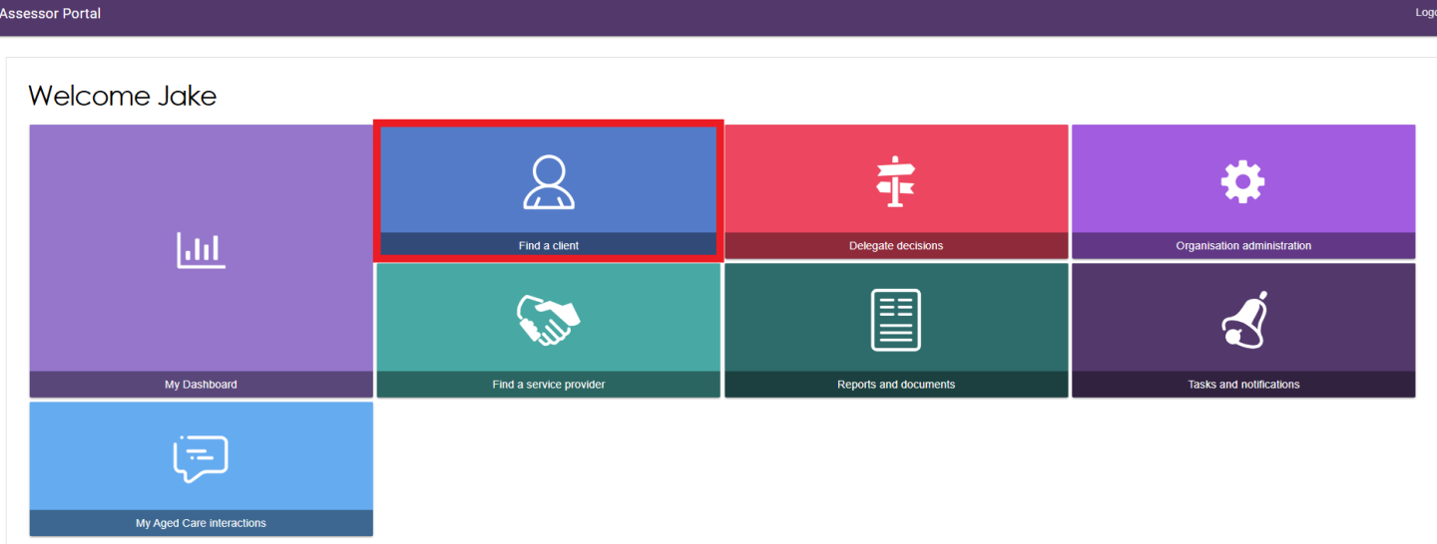
- Use the Find a client function to search for the client. Client records you have recently viewed will appear in the Recently Viewed Persons section, and depending on your browser, this will either appear on the right side or the bottom section of the page.
The ADVANCED SEARCH functionality allows you to search by additional fields. Refer to the My Aged Care – Assessor Portal User Guide 1 – Registering and referring clients for more information on using this functionality.
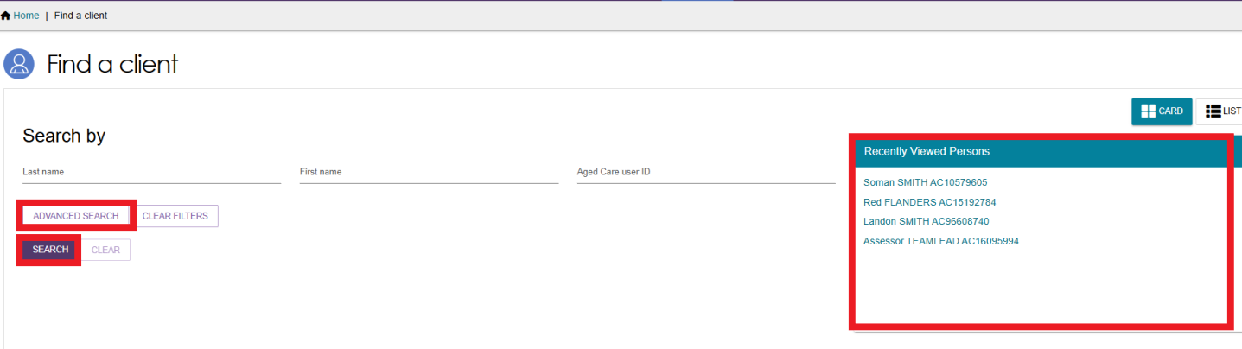
- Any matching search results will be displayed. Select the client’s name.
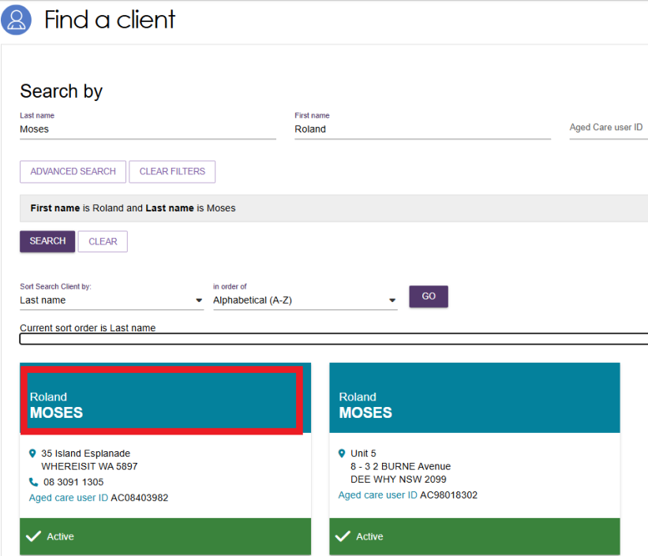
- You will be able to sort the matching results by a number of criteria including last name, first name, Aged Care User ID, suburb, state, post code, date of birth and more. Select the criteria, the order of display as required and select GO.
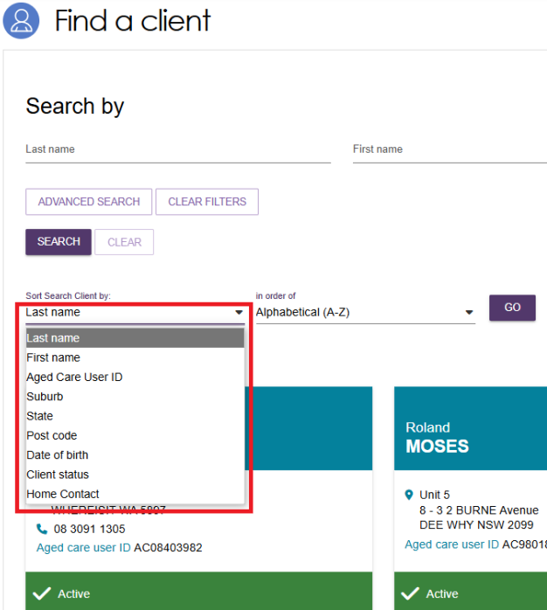
- Selecting the client’s name tile will take you to the Client Summary. You can view and print a RTF (Rich Text File) of the client record by selecting the VIEW CLIENT REPORT button.
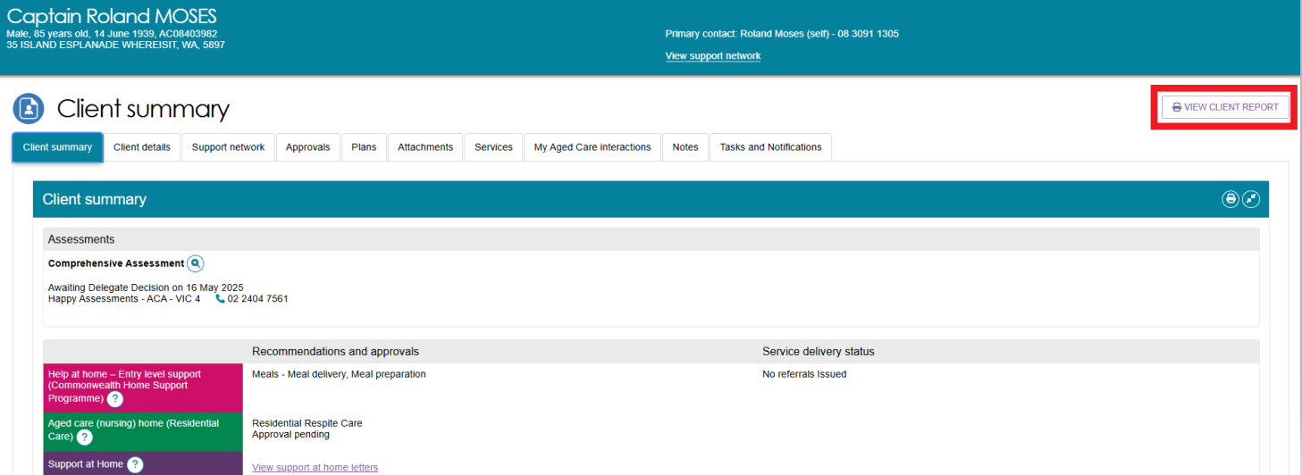
- A Generating Report pop up appears, then the Rich Text File (RTF) appears on your browser ready to be downloaded or opened.
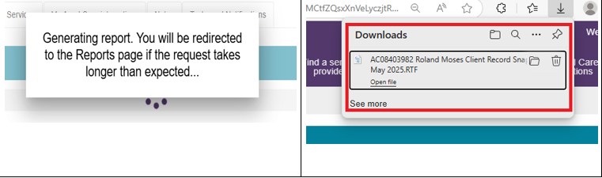
- Opening the RTF shows a Copy of the Client Record.
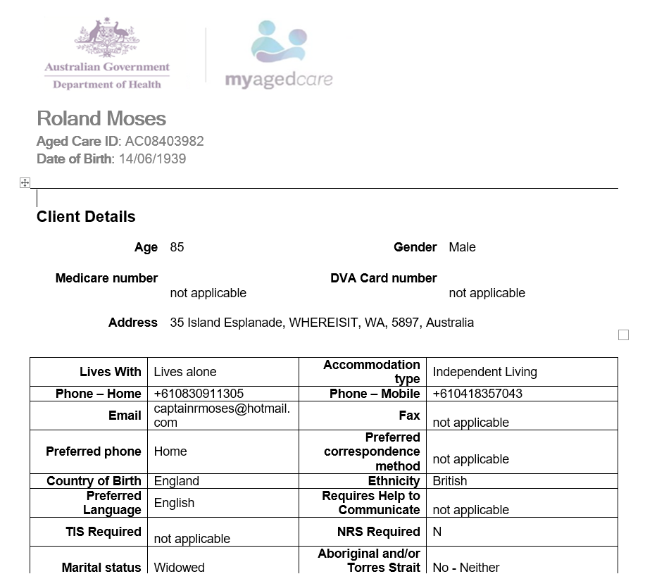

Printing the support plan and generating referral code letters
- To view and print the support plan, navigate to the Plans tab in the client record. From here, select SUPPORT PLAN.
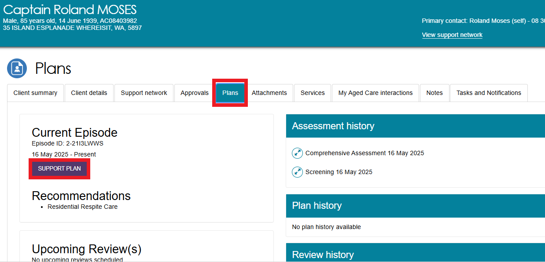
- The Goals & recommendations tab will be displayed. You can print a copy of the support plan by selecting PRINT COPY OF SUPPORT PLAN.
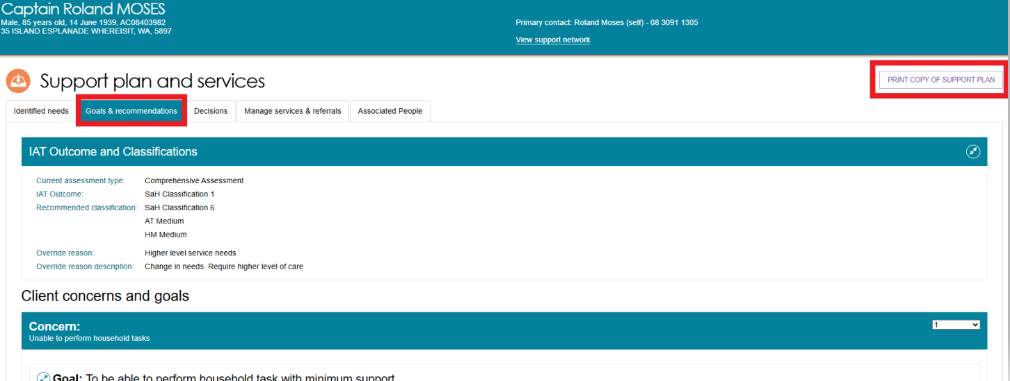
- Navigate to the Manage services & referrals tab. From here, you can view the client’s service referrals and generate a copy of the referral code letter.
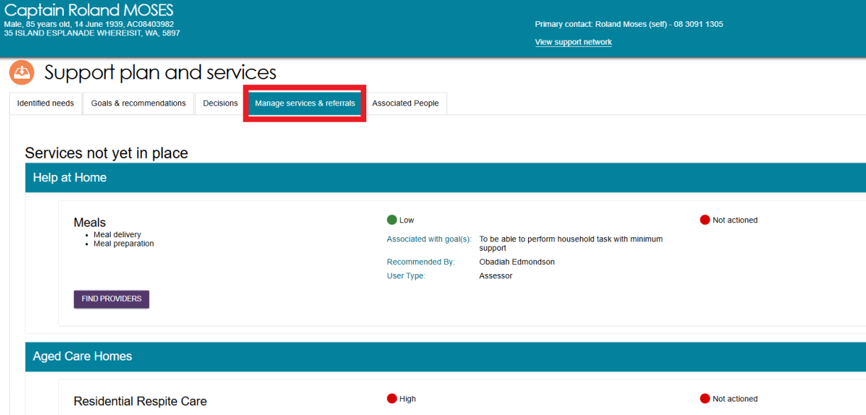

Printing approval/non-approval letters
- To generate and print approval or non-approval letters, navigate to the Decisions tab in the client record. At the bottom of the page, you will be able to generate the Approval or Non-Approval letter.
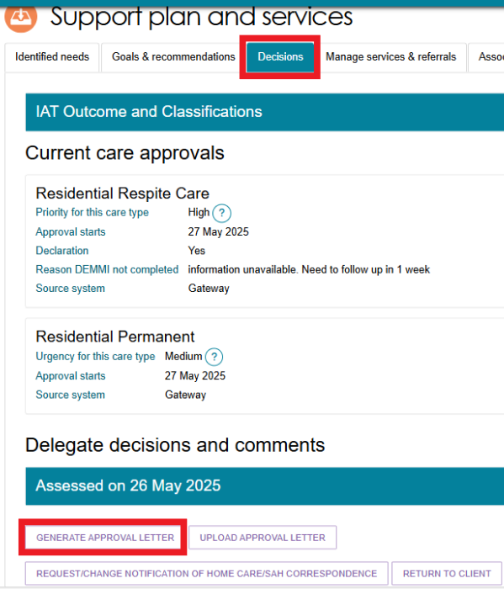
- You will be asked to enter information in a pop-up modal regarding the assessment and the evidence supporting the approved care types. This information will display in the approval letter. Select GENERATE APPROVAL LETTER button.
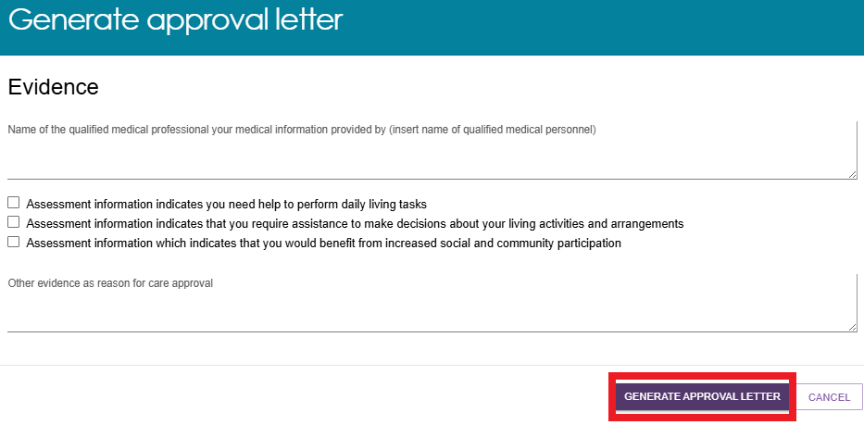
- A processing screen will pop-up as shown below.
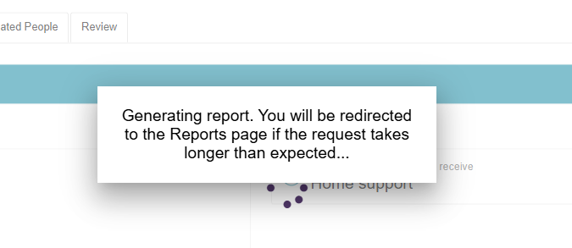
! | Like any reviewable decision, ensure that the decision letter includes:  - the decision  - the reason for the decision  - the supporting evidence  - the right of review.  This is to ensure the high quality and consistency in letters that clients receive.
- You will be redirected to the Reports tab of the Reports and documents page where you will be able to select View to download a copy of the letter for signing.
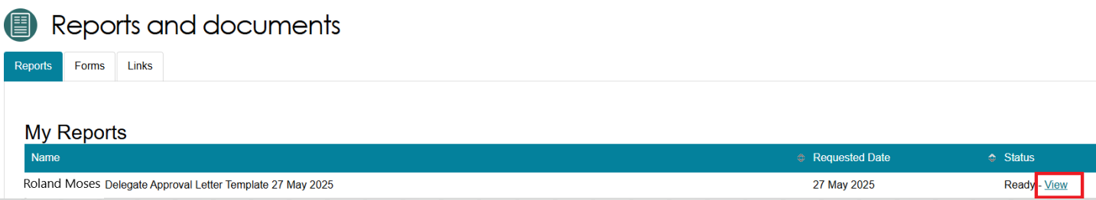
! | Certain user generated documents, including Approval/Non-Approval letters and Referral Code letters will only be retained in Recently Requested Reports for seven days, after which they will be cleared from this screen. They can be regenerated as per the original process.
- Opening the file shows a copy of the approval letter.
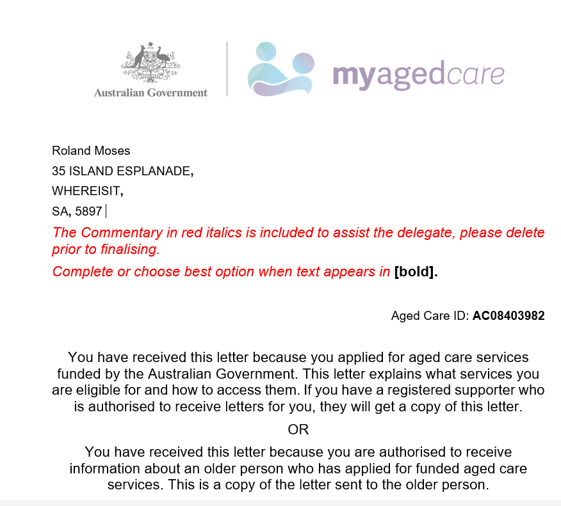
- The Assessment Delegate has signed the letter, you can use the Upload approval letter button in the Decisions tab of the support plan to upload the letter to the client’s record. Alternatively, you can upload this through the Attachments tab on the client record.
! | The system supports a maximum file size of 5MB. Using Rich Text Format (RTF) files may exceed this limit. To avoid this issue, it is recommended to convert your files to PDF or DOCx formats.
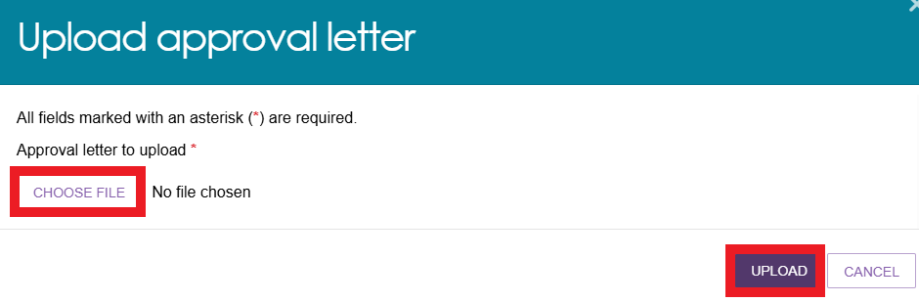
- A green banner will be displayed upon successful uploading.
- This document will be stored under the Attachments tab.
