Assessor Portal User Guide 1 - Registering and referring clients for assessment
This user guide is to assist aged care needs assessors (assessors) in using the My Aged Care assessor portal (assessor portal) or the Aged Care Assessor App (the App) to register clients and refer them for assessment.
This guide is divided into the following topics:

Assessor Portal User Guide 1 - Registering and referring clients for assessment 1
Finding a client in the Portal 2
Normal Search 2
Advanced Search 3
Client summary 5
Registering a client in the Portal 6
Email and SMS Notifications 7
Registering or assessing a client in the App 8
Verifying a client’s identity 8
Self-referring a client 9
Facilitating a referral for a potential client 13

Finding a client in the Portal
Before you register a person, you need to confirm that they do not already have a client record. Follow the steps below to determine if the client has an existing record.
- Select Find a client from the home page.
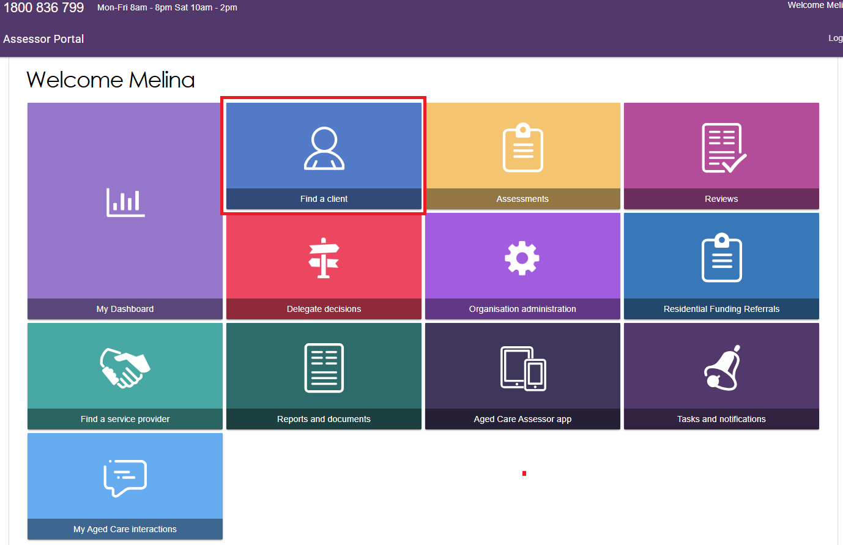
- Next, search for the client. There are two ways to search: Normal or Advanced.

Normal Search
Enter the client’s first name, last name and/or Aged Care User ID and select SEARCH.
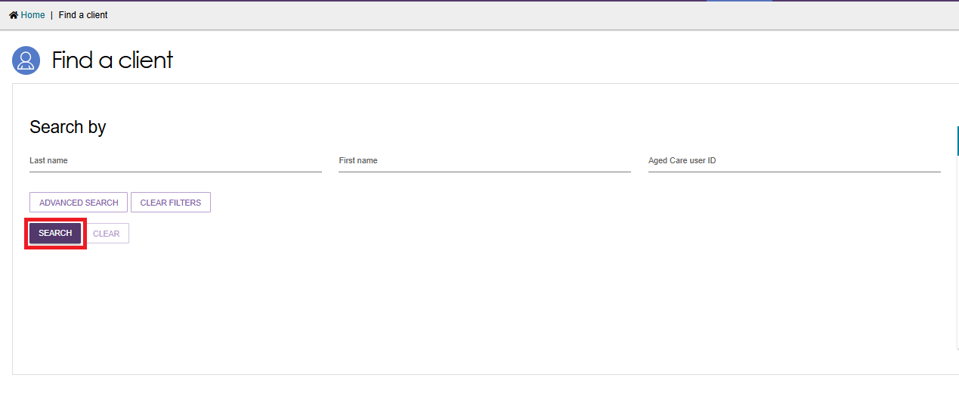

Advanced Search
Alternatively, you can select ADVANCED SEARCH to conduct a custom or refined search.
The Advanced Search functionality allows you to search by additional fields, such as date of birth, Medicare number, suburb, etc. This filter can be applied across various sections within the portal. Choose the required filter item from the dropdown menu and select ADD FILTER.
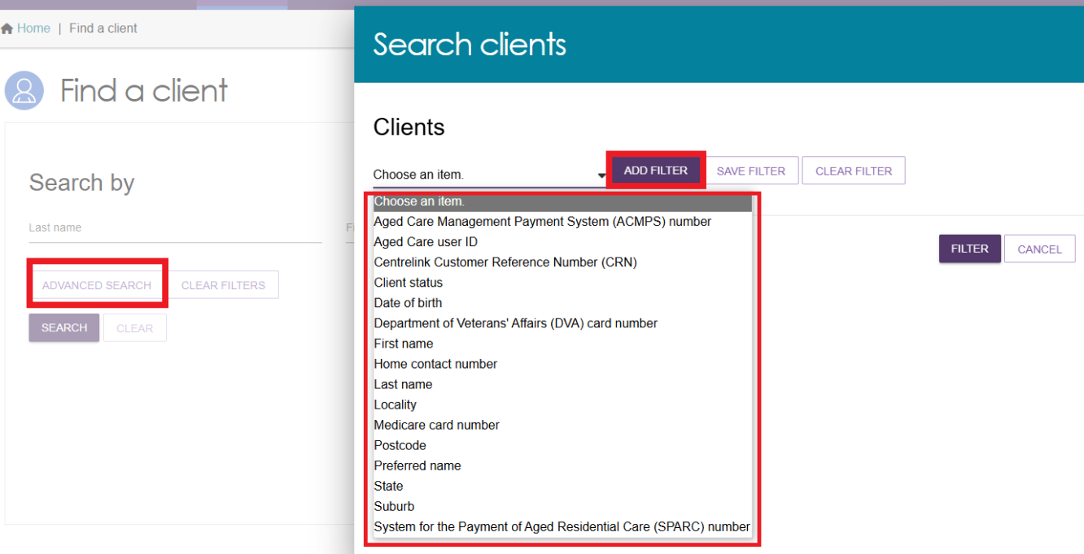
You can save a filter for future use by choosing the item and selecting SAVE FILTER.
This will display the custom filter (shown below) so it can be easily accessed in the future.
To remove a filter, select the red Recycle Bin button next to the filter you wish to remove. You can choose to add that filter back again.
To apply your chosen settings, select the FILTER button.
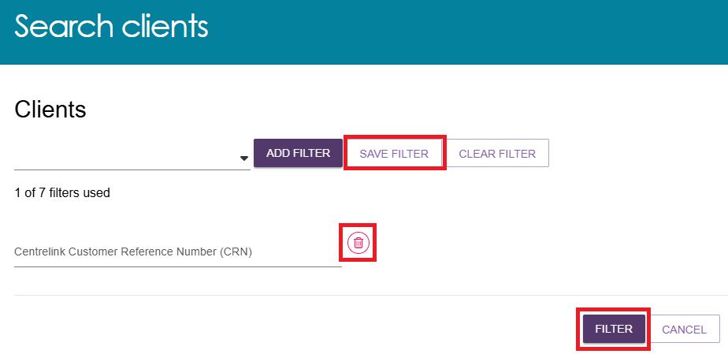

When filters have been applied, the Advanced Search link changes to MODIFY FILTER OPTIONS.
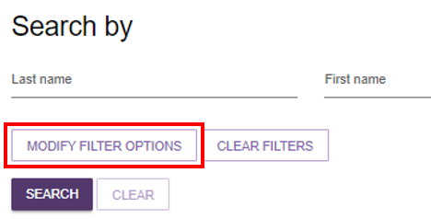
Selecting CLEAR FILTERS will clear the information entered.
Selecting CLEAR will clear any current search results.
Any matching search results will be displayed.
The results will be shown either in Card view or List view, depending on your selection.
Example of card view
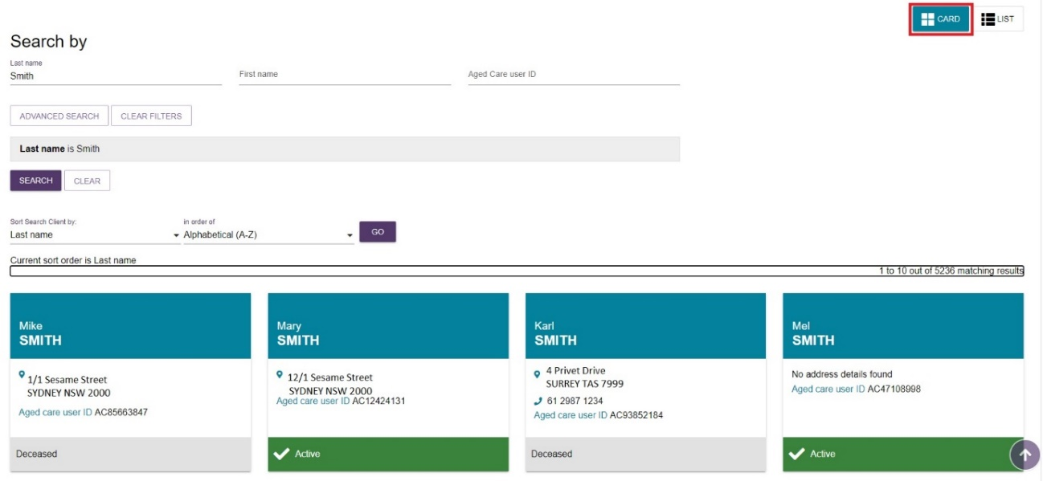
Example of list view
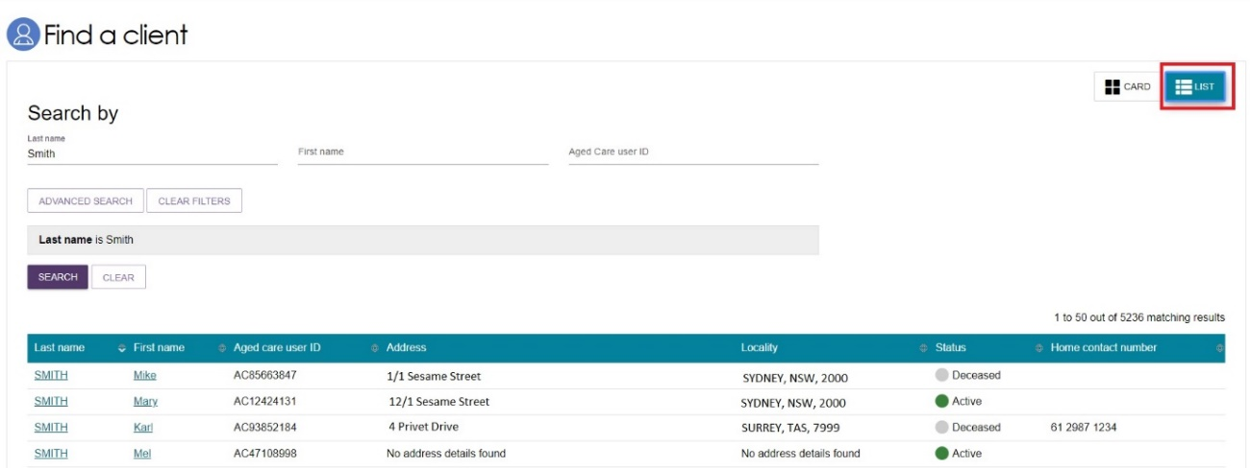
Where there are multiple search results, please ensure you review the records first to determine the appropriate client.

Client summary
- After selecting the appropriate client, the Client summary tab will display. This tab aims to provide a snapshot view of where a client is in their aged care journey. It contains key information of the client, such as Assessment information, Recommendations and approvals, Service delivery status, any concerns and goals and their statuses
Information will only be displayed where it is applicable to the client.
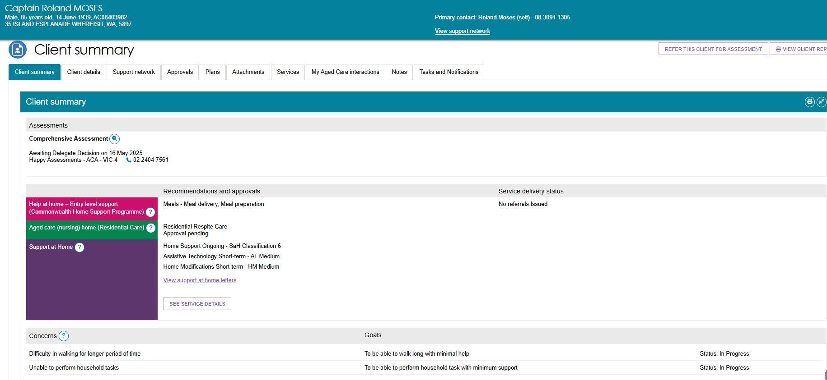
- If there are No records returned (as shown below), you can select Register new client for immediate assessment only.
! | You must have the client’s consent to successfully complete registration.
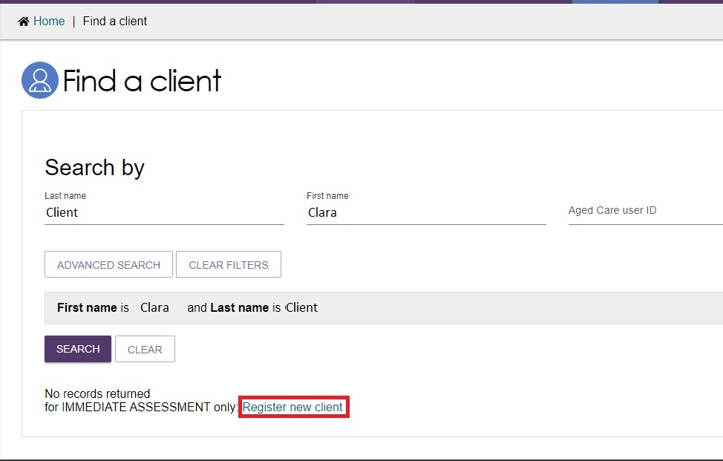

Registering a client in the Portal
      - After the search for a client returns no records (see above), the Register a client link will be displayed. Enter client details and select REGISTER.
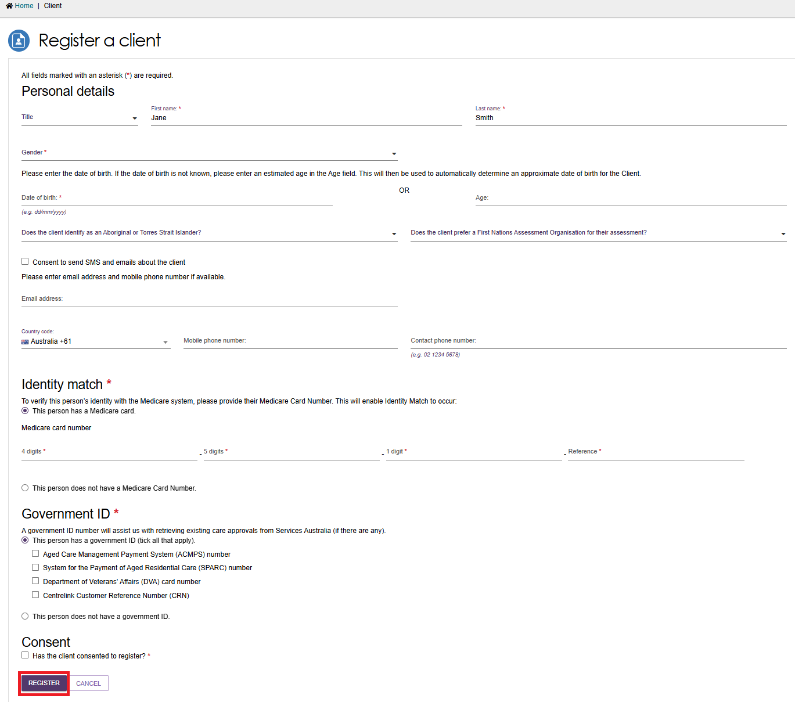
      - The details include Name, contact details, if the client identifies as Aboriginal or Torres Strait Islander, if the client prefers an Aboriginal and Torres Islander Assessment Organisation (if available), Medicare number and status, government ID and status, and consent status.
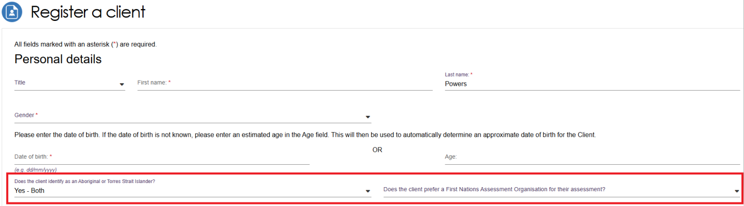
! | Aboriginal and Torres Strait Islander assessment organisations will be standing up slowly over time to offer a choice for Aboriginal and Torres Strait Islander people from 1 November 2025. Over time, the service will extend its reach and work towards covering more areas across Australia.

! | Remember to validate the address when you enter a new address or when you edit an existing address. This will ensure that any correspondence will be sent to the correct address, and that the client will be allocated to the correct address category (MMM Classification) for assessment purposes.  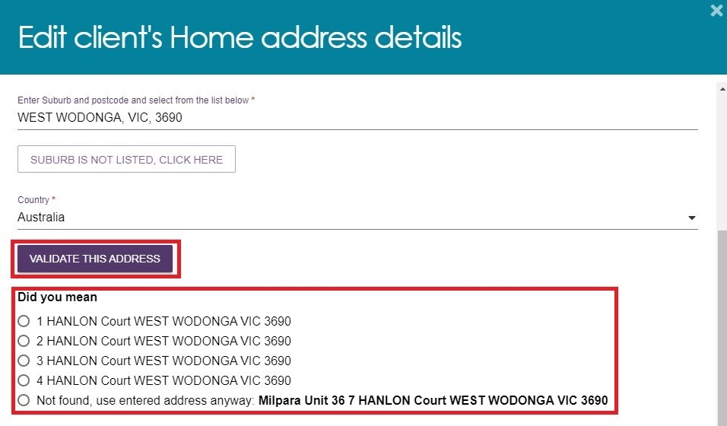

Email and SMS Notifications
! | Client email addresses and/or mobile phone numbers can be captured at registration.  You must have the client’s consent to receive email and/or SMS notifications.
Clients and/or their supporters can nominate an email address and/or mobile phone number to receive notifications when they reach key stages of their My Aged Care journey.
To set up email and/or SMS notifications for a client at registration, select the Consent to send SMS and emails about the client checkbox and input an email address and/or mobile phone number.
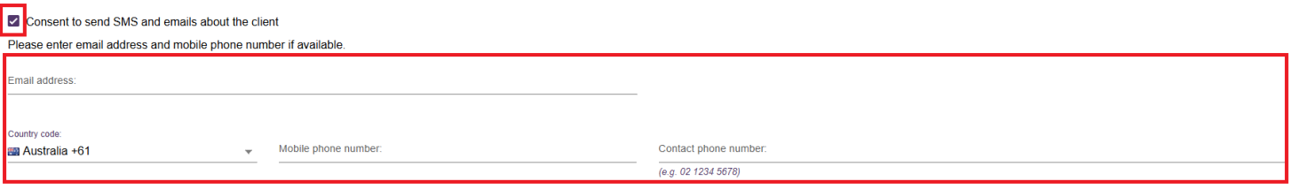
Email and/or SMS notification preferences can be can be viewed or modified on the Client details tab in the assessor portal. Refer to the My Aged Care – Assessor Portal User Guide 2 – Registering support people and adding relationships for information about enabling email notifications for existing clients and supporters.

Registering or assessing a client in the App
If you are using the App and you need to undertake an assessment for a client who has not been referred to your organisation, you can use the Add offline client function. See the Aged Care Assessor App User Guide for this process.
When you are reconnected to the Internet, you will need to register the client if they do not have an existing record and facilitate a referral for assessment via the contact centre before linking the offline client to the registered record.

Verifying a client’s identity
- From the Client Record in Find a client, you can verify the client’s identity by selecting Conduct a wallet check now. The wallet check can also be conducted through the App or at other stages of the assessment.
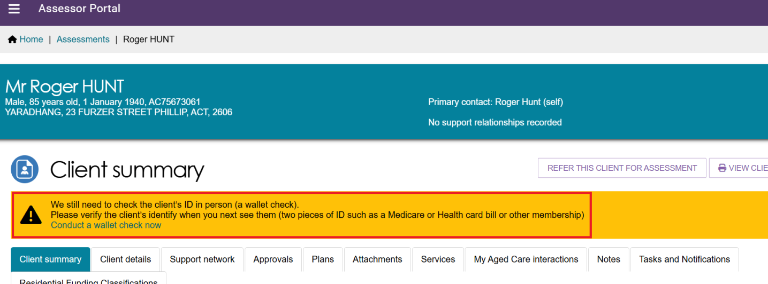
- A dialog box appears. Select the appropriate scenario and then select SAVE DETAILS.
If you select My client has identification, you will then be prompted to enter two types of ID and the date that you have performed the check.
If you select My client has no valid identification this time, you will then be prompted to ask the client for ID in the future.
If you select My client will be unable to produce valid identification, you will not be prompted to ID-check this client in the future.
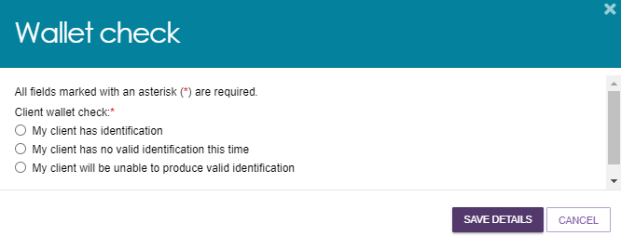

Self-referring a client
! | Triage must be completed by a clinical staff member who holds the Triage Delegate role in the My Aged Care assessor portal.  For further information on the Triage Delegate role, visit My Aged Care Assessor Portal User Guide 12 – Managing Delegate Roles.
! | Assessors can self-refer clients for assessment as long as the assessment type is support by their outlet. For example, non-clinical aged care needs assessors (non-clinical assessors) can self-refer for both Home Support and Comprehensive assessments if their outlet supports both assessment types.

! | On 1 November 2025, the Aged Care Act 2024 and the Support at Home program come into effect with significant change to support plans in the IAT.  To ensure the right IAT is used, and triage can continue for priority referrals, any assessments in the Triage complete, main assessment not started status already started prior to 1 November 2025 and in progress on 1 November 2025 must be restarted.  For information on the Restart Assessment Process, please refer to Management of active assessments for 1 November 2025 transition – Standard Operating Procedure and Restarting In Progress Assessments for Support at Home (instructional video).
- From the Client record in Find a client, you can self-refer the client for assessment by selecting REFER THIS CLIENT FOR ASSESSMENT.
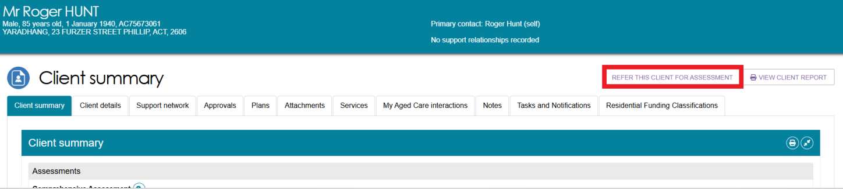
- In the pop-up box you will need to:
- assign the client to Myself or to My Organisation (for guidance on when to refer to yourself or your organisation, see the My Aged Care Assessment Manual)
- select the assessment type (comprehensive or home support)
- select the outlet for this referral
- select the assessment setting (for comprehensive assessments only)
- choose the assessment priority rating (High, Medium, Low)
- the reason for self-referring (remote assessment, first nations, in-hospital, homeless or at risk of or vulnerable).
- Then, select CREATE REFERRAL.
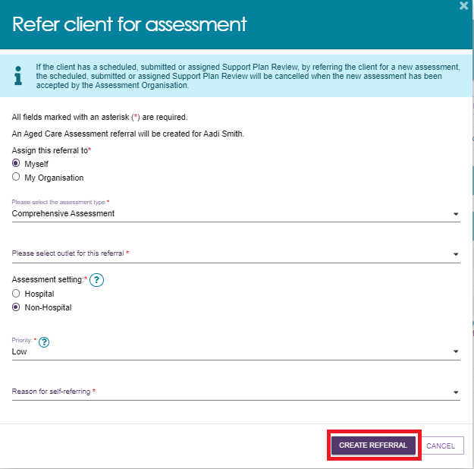
- Please note: ASSESSMENT SETTING option will not be available for HOME SUPPORT ASSESSMENT.
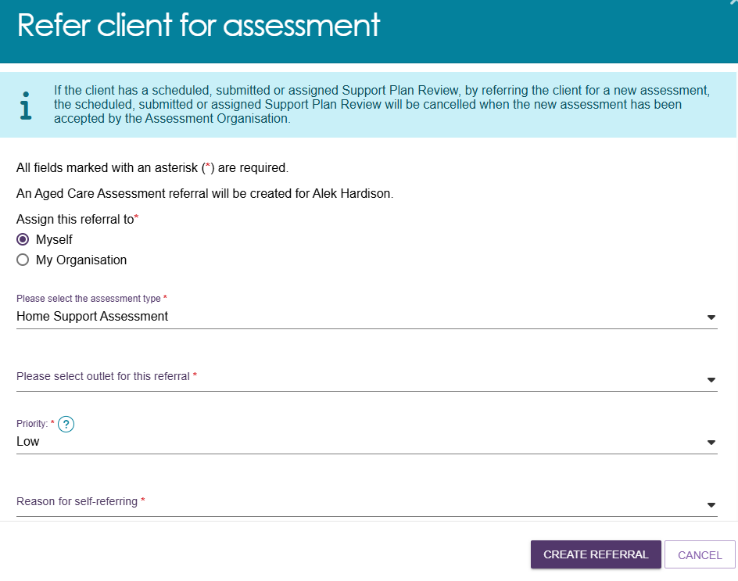
! | If the client prefers their assessment to be completed by an Aboriginal and Torres Strait Islander Assessment Organisation, this will be displayed in both the blue banner and the amber banner. 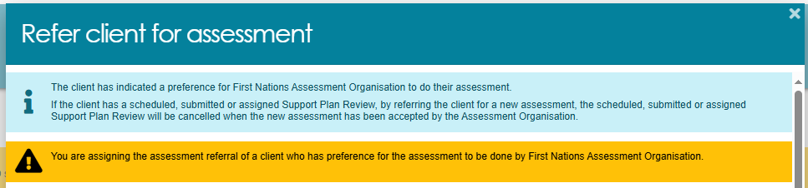
! | Cohabitants  If you identify a potential client with aged care needs that is cohabitating with the current client at the time of the assessment, you may wish to encourage that person to contact My Aged Care to request screening which will determine eligibility for an assessment referral. For more information, please refer to Facilitating a referral for a potential client.
- If you have selected to assign the referral to yourself, you will then be re-directed to the Current assessments page. To complete the assessment, you must first undertake triage.
To begin triage, select the expand button at the top right of the client card.
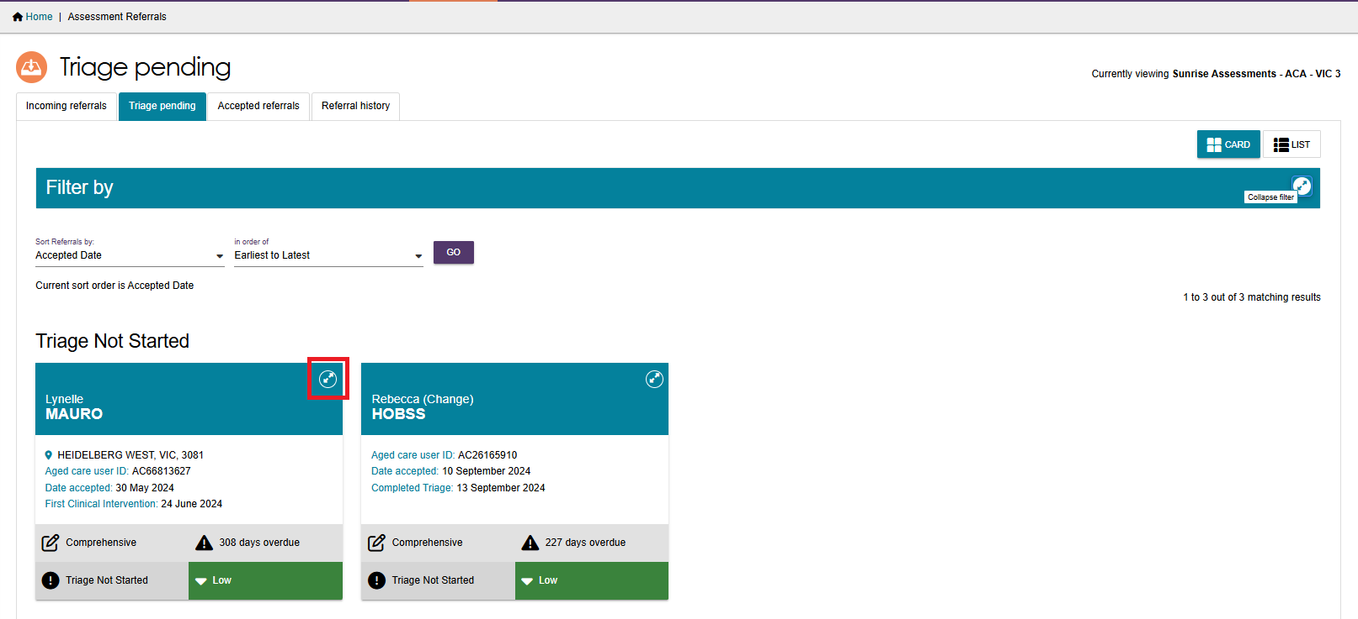
- Next, select START TRIAGE and complete the relevant consent and demographic fields.
For information on how to complete a triage, refer to the My Aged Care – Assessor Portal User Guide 3 – Managing Referrals for Assessment and Support Plan Reviews.
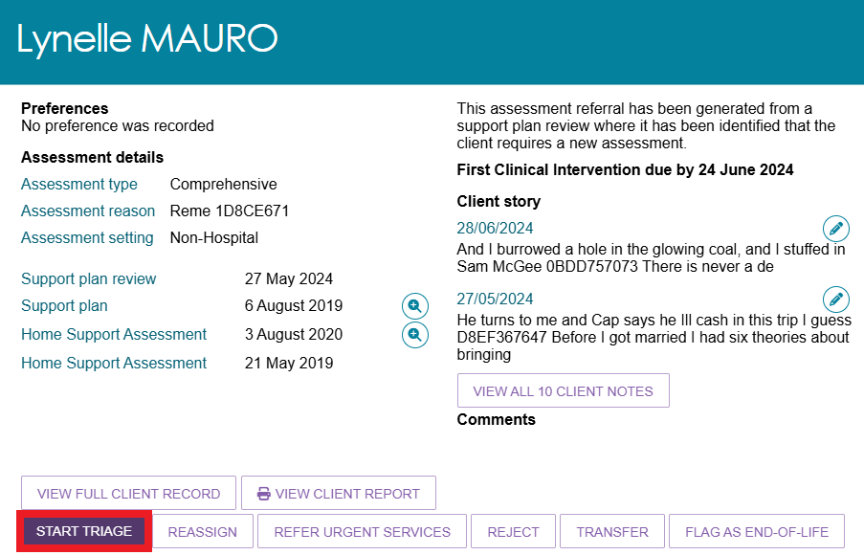
- If you have assigned the referral to Yourself and you are also a Triage Delegate, you can complete triage and then proceed to the assessment using the IAT.
If you have selected to assign the referral to Yourself and you are not a Triage Delegate, then you will only be able to complete triage with the supervision of a Triage Delegate. This must be captured in the portal at the time of triage.
To record the details of your supervision, at the bottom of the triage questions is a Details of the supervised Triage section. Select the relevant supervisor and then select SAVE TRIAGE. You will then be able to proceed with completing the assessment using the IAT.
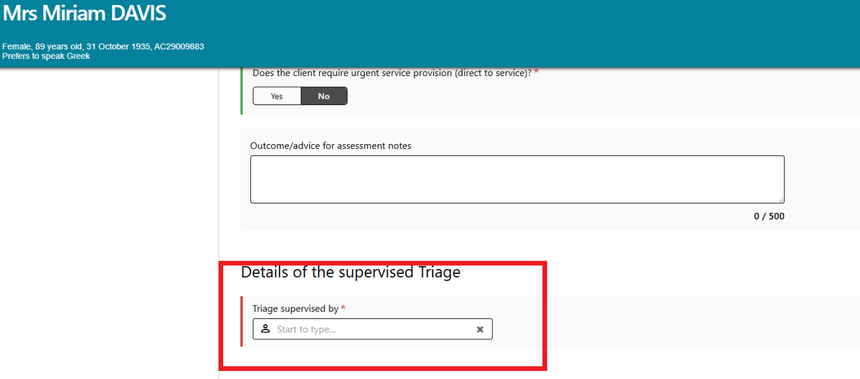
For more information on completing a supervised triage, refer to the My Aged Care Assessment Manual.

Facilitating a referral for a potential client
A client referral must be assigned to you in the assessor portal before you can complete an assessment for that client. If the potential client has aged care needs that is cohabitating with the current client at the time of the assessment and who has not been referred to you, follow the steps below.
- Encourage the person to contact My Aged Care contact centre on 1800 200 422 to request screening which will determine eligibility for an assessment referral.
- Once eligibility is determined, a team leader will need to accept the referral in the assessor portal.
- A Triage Delegate will then need to complete triage.
- Following this the Triage Delegate or a Team Leader can then assign it to an assessor.
- If the referral is assigned to you, it will appear in your Current assessments list in the Assessments tile. From here, you will be able to begin the assessment.
