
MRFF Report 2022-2024
Snapshots from the Financial assistance to support the Australian Medical Research and Innovation Priorities 2022-2024
Between 6 November 2022 and 5 November 2024, the Medical Research Future Fund (MRFF) invested $1.38 billion across 578 grants in new health and medical research.
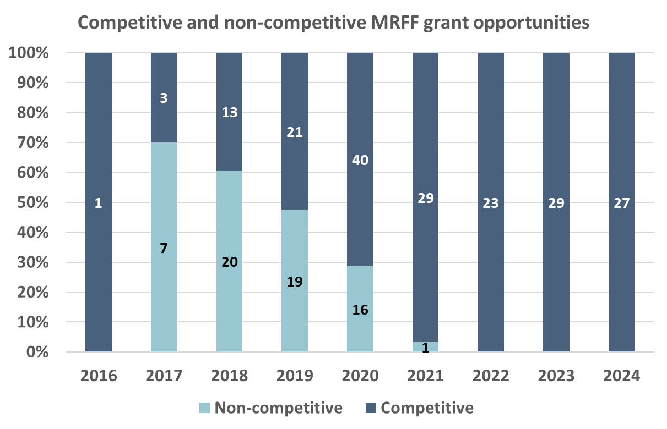
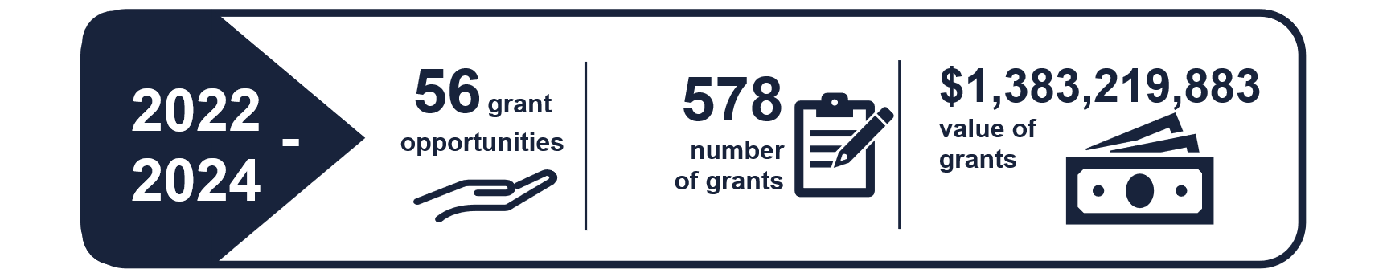
All grants during this period were awarded via open or targeted competitive processes (‘grant opportunities’)
Funding reached all states and territories, with an average funded rate of 21.5%

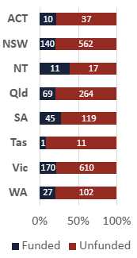
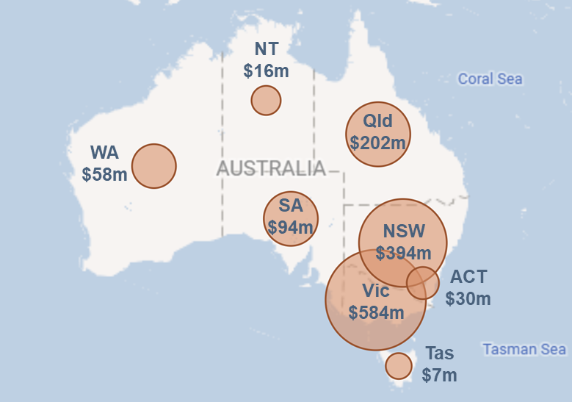
Priority Populations
 | Health inequity remains a significant challenge in Australia. The MRFF 2022-2024 priority ‘Priority Populations’ aimed to support research with people who are under-represented in research, improving health outcomes and promoting equity in healthcare access and delivery. Through collaboration with consumers and a focus on inclusive research practices, the MRFF continues to work towards a healthier, more equitable future for all Australians.
Grant opportunities, grants and funding awarded and announced up to 1 June 2025
Population |  | Grant opportunities | Grants awarded | Total value of grants
Rural, regional or remote health |  | 72 | 196 | $570,263,383
Aboriginal and Torres Strait Islander health |  | 69 | 195 | $407,119,268
Women’s health |  | 75 | 132 | $271,354,184
Older people experiencing diseases of ageing |  | 52 | 148 | $336,699,183

  Areas of key investment in rural, regional and remote health |  | Enabling Clinical Trials  Clinical trials are an essential component of health and medical research, playing an important role in validating new treatments and approaches for the prevention, management, detection, and diagnosis of health conditions.  The MRFF has funded Australian clinical trials across many different health conditions:  via the Clinical Trials Activity initiative  257 projects  $531.5 million  via other initiatives  396 projects  $1.1 billion

Research workforce and consumer-driven research
 | MRFF funding supports the health and medical research workforce to develop capacity and capability in all areas of research from basic to full translation. This includes targeted support through funding opportunities such as the Early to Mid-Career Researchers and the Clinician Researchers Initiatives. Additionally, the MRFF is committed to fostering collaboration between researchers and consumers, including patients, caregivers, and community members, to address the needs of those most affected by health conditions. The Emerging Priorities and Consumer-Driven Research Initiative and the consumer-led grant opportunities under the Preventive and Public Health Research Initiative exemplify this commitment.
Grant opportunities, grants and funding awarded and announced up to 1 June 2025
Researcher group |  | Grant opportunities | Grants awarded | Total value of grants
EMCRs |  | 3 | 72 | $129,780,917
Aboriginal and Torres Strait Islander researchers |  | 25 | 68 | $130,181,422
Clinician researchers |  | 6 | 159 | $153,486,798
Consumer investigators |  | 2 | 29 | $19,750,934
Rural, regional, remote researchers |  | 49 | 69 | $151,548,997

Under the Preventive and Public Health Research Initiative, 29 grants across 2 grant opportunities shared $19,750,934 funding for research in these areas: |  | 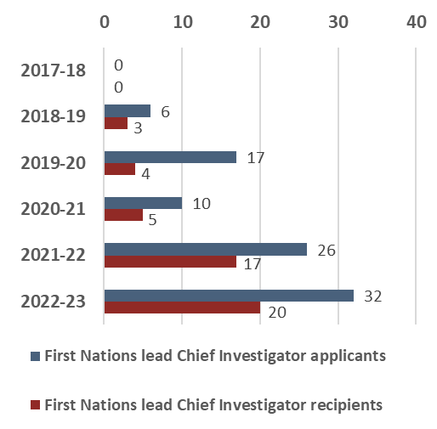  The number of Aboriginal and Torres Strait Islander lead Chief Investigators has increased over time:  Data from the MRFF Report on Chief Investigator Data, data for 2022-23 are incomplete.

Increasing support for medical research commercialisation
There are opportunities for leveraging Australia’s research strengths, capabilities, and successes to support the commercialisation of new drugs, devices, and digital technologies.
MRFF funding has been disbursed through a range of grant opportunities that will support projects with commercialisation potential, particularly from Small and Medium Enterprises (SMEs). The focus has been supporting research discoveries as they progress from proof of concept through to clinical implementation.

BioMedTech Incubator    $198.9 million committed to 5 incubators that will be managed by organisations with expertise in research commercialisation.  BMTI supports Australian SMEs undertaking early-stage medical research and innovation projects with commercial potential. |   Biomedical Translation Bridge  21 projects  $22.3 million  Nurtured innovations through to the proof-of-concept stage with expert industry support and mentoring. Key applications included unmet needs, priority indications or rare diseases, and COVID-19 diagnostics, vaccines and therapeutics.
Early Stage Translation and Commercialisation Support

Supports early-stage Australian medical research and medical innovation projects with commercial potential. Australian SMEs provided with specialist support and expertise with the aim of de-risking project outputs and progressing towards commercialisation.
$79 million
75 projects
BioMedTech Horizons

The BioMedTech Horizons program, running from 2017-2023, has significantly advanced Australia's biomedical and medical technology sectors. Across four funding rounds, it has supported projects in fields such as 3d anatomical printing, precision medicine, assistive or rehabilitation devices, diagnostics and monitoring devices, decision support devices, and implanted medical devices.
11
new products launched
​159
new patent, trademark applications and licenses
​$50.7 million
industry cash and in-kind co-contributions to the BMTH projects
49
projects shared $45 million of total MRFF funding
Grant opportunities, grants and funding awarded and announced up to 1 June 2025

