Monthly statement guide for older people
October 2025

Introduction
The Support at Home program has been designed to support you to make informed choices on how to best use your Support at Home quarterly budget. So you can receive the services and items needed to remain and live well at home.
Your Support at Home provider is required to give you a monthly statement that shows how your quarterly budget is used. This statement needs to list the details and cost of each service and item, so you can see if your quarterly budget is being used in the best way possible and in accordance with the program rules. You should be issued a statement each month for any services delivered in the previous month.
An overview of our monthly statement template is shown below. This template has detailed information to help you understand each section.
It is important to note that this template is not mandatory and your provider can choose to present the required information in a different format. We also strongly recommend you talk to your provider if you do not understand a charge or have not agreed to one in your statement.
Figure 1. Overview of Support at Home monthly statement template
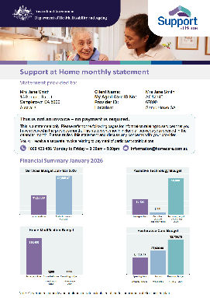  1. Statement overview | 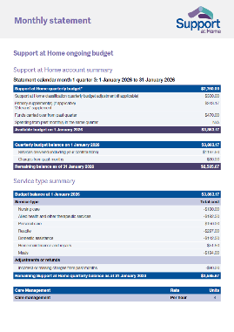  2. Summary income and expenses | 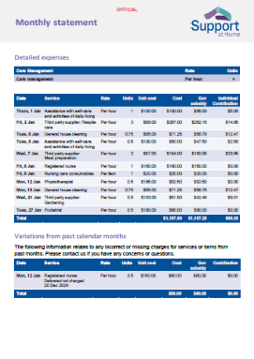  3. Detailed expenses and adjustments | 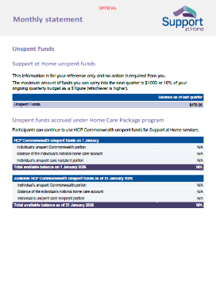  4. Other package information



1. Statement overview
Your monthly statement intends to help you understand:
- how your quarterly budget is spent on services and items every month
- the money left in your budget, which may be used for extra services and items to support you to live well at home.
The first page of your statement gives you a summary of the above information to help you track your budget easily.
Figure 2. Support at Home statement overview
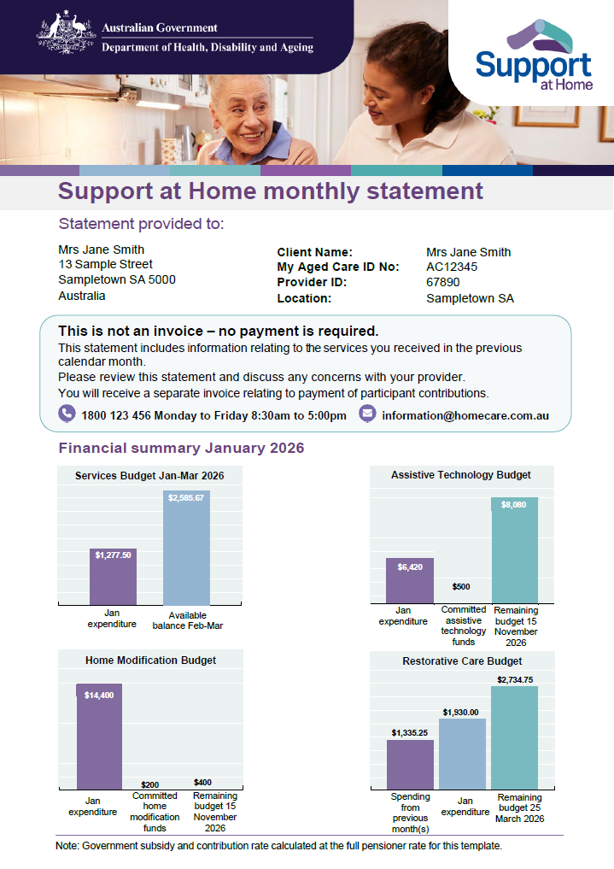

2. Ongoing budget summary income and expenses
This section provides a breakdown of your income and expenses. At a glance, you can see what makes up your quarterly budget and how it is spent on services and items during the month.
Your quarterly budget consists of your Support at Home classification funding, supplements, unspent funds and participant contributions.

(a) Quarterly budget account summary
Government subsidies are based on your assessed needs and include:
- Support at Home quarterly budget: This is the amount available at the start of the quarter in your home care account. This amount might change during the month, for example, if your classification funding changes.
- Supplements (if any): Primary and other supplements provide extra funding for specific care needs. For some supplements, we automatically check eligibility for you. For others, you or your provider may need to apply.
- Unspent funds: If you don’t use all your ongoing budget, you can save up to $1,000 or 10% (whichever is higher) for the next quarter.
- Spending from past month(s) in the same quarter: This is not applicable for the first month of the quarter for this template. However, if it’s the second or third month of a quarter, this section would tell you the total spending on services delivered in the earlier month(s) of the same quarter.
- Available budget at the beginning of the month: This reflects the amount available in your home care account at the beginning of the month.
- Services delivered: The total amount you have spent on services. This allows you to see the total amount deducted from your quarterly budget balance for the month.
- Charges from past months: This includes any adjustments made to the budget, including refunds or a charge for a missed service.
- Remaining balance at the end of the month: This reflects the amount available in your home care account at the end of the month.
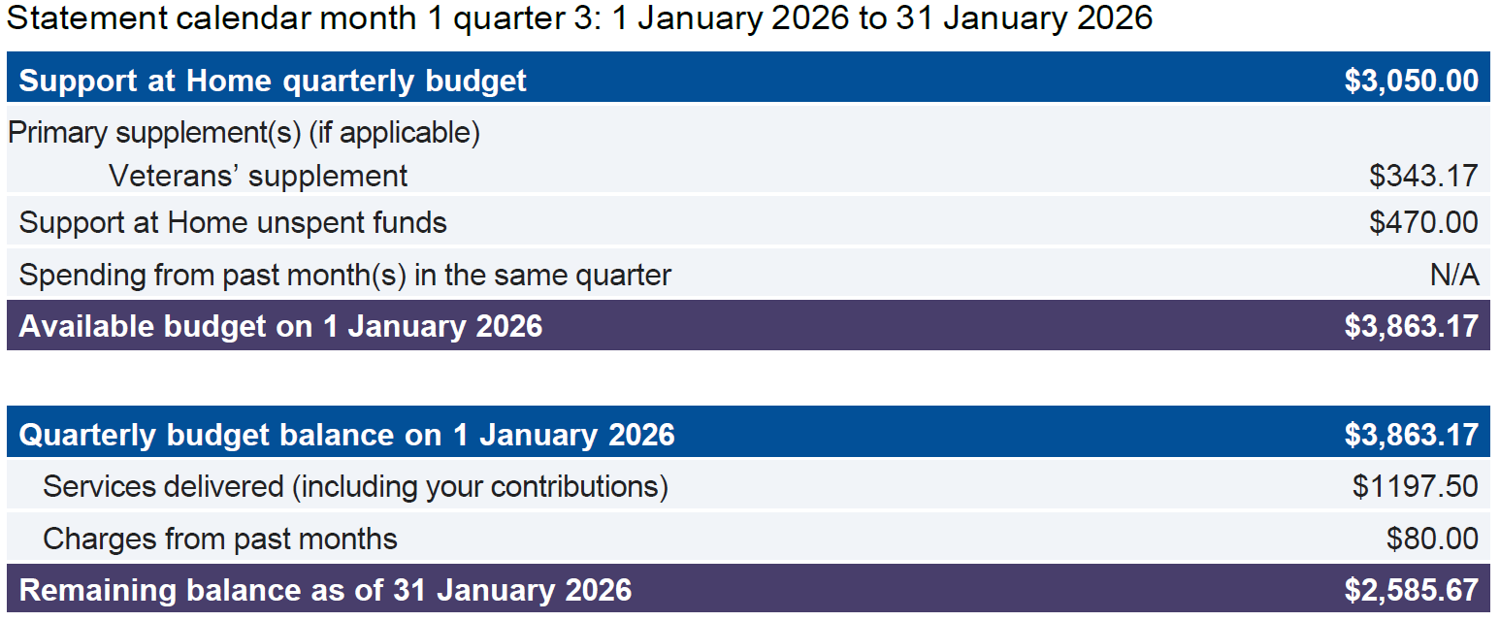
Figure 3. Support at Home ongoing budget account summary
You can view the daily basic subsidy rates in the Schedule of Subsidies and Supplements. The rates are adjusted every year on 1 July.

(b) Service type summary
This section gives you a basic overview of the types of services you have received and where your budget is being spent. While this breakdown is not required by law, it has been included to show what kinds of support you are getting and to help you understand how your budget is used for these services.
Your care needs may change over time, so it is important you review your services regularly to ensure that you are making the best choices to live well at home.
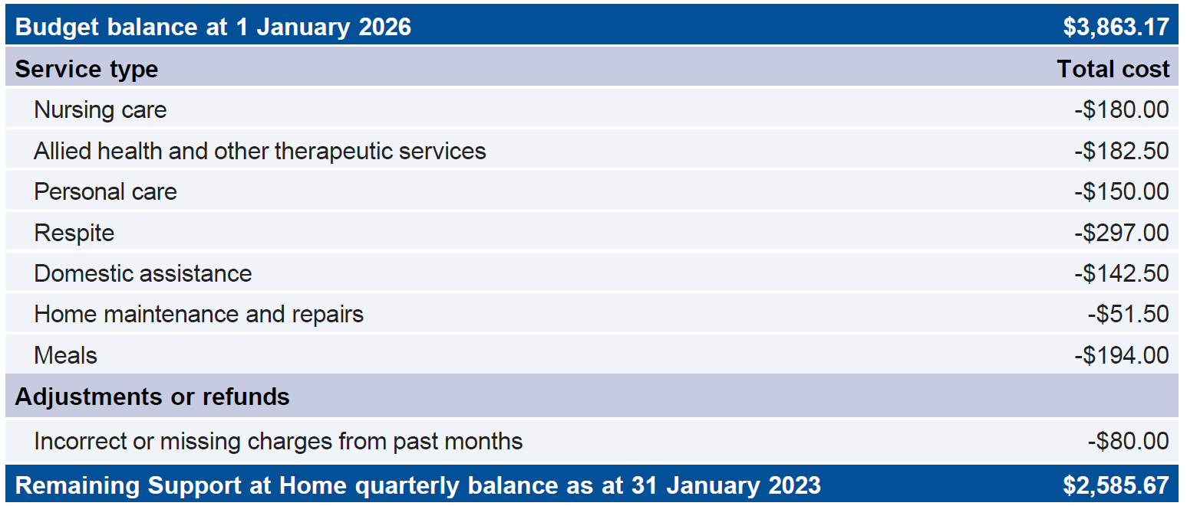
Figure 4. Summary by service type

(c) Unspent funds

Unspent Support at Home quarterly budget
When you have unspent quarterly budget at the end of a quarter, the funds will be carried over and added to the next quarterly budget. The maximum amount of funds you can carry into the next quarter is $1000 or 10% of your ongoing quarterly budget as a $ figure (whichever is higher).
Figure 5. Support at Home unspent funds

Home Care Packages unspent funds
This section only applies if you were a care recipient of the Home Care Packages (HCP) Program and the balance of your unspent funds at the time of transition was greater than zero. The table below gives a breakdown of the three types of unspent funds.
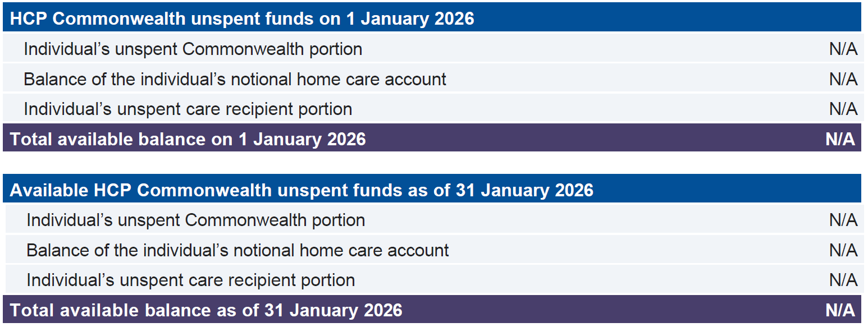
Figure 6. HCP unspent funds
For more information on how to use HCP unspent funds, please refer to the Support at Home program manual.

3. Short term budgets

(a) Assistive technology budget
This section provides a breakdown of your income and expenses for assistive technology. At a glance, you can see what makes up your assistive technology budget and how it is spent on items during the month.
Your assistive technology budget consists of your assistive technology tier funding, supplements and client contributions. It will show:
- the maximum amount of the approved funding tier
- the available funding
- any funding expended
- the remaining balance for the month
- the remote supplement, if it is applicable.

(b) Home modifications budget
This section provides a breakdown of your income and expenses for home modifications. At a glance, you can see what makes up your home modifications budget and how it is spent on items during the month.
Your home modification budget consists of your home modification tier funding, supplements and your contributions. It will show:
- the maximum amount of the approved funding tier
- the available funding
- any funding expended
- the remaining balance for the month
- the remote supplement, if it is applicable.

(c) Restorative Care Pathway and End-of-Life Pathway
This section provides a breakdown of your income and expenses for a Restorative Care Pathway or End-of-Life Pathway budget. Your Restorative Care Pathway or End-of-Life Pathway budget consists of your funding, supplements and participant contributions and will be presented in the same way as the quarterly account summary for ongoing budgets. Your monthly statement will include an itemised list of services, including care management, that you received throughout the month.
If you are receiving ongoing Support at Home services at the same time as the Restorative Care Pathway, the statement should clearly outline what funding amount applies to each classification.


4. Detailed expenses
This section provides an itemised account of any items and services purchased during the month, so you can check it for accuracy, and see if the services and items are still right for your care needs.

(a) Services
Your statement includes an itemised list of services (excluding care management for ongoing services) or items delivered during the calendar month, including:
- the name of the service or item as per the service list
- the price charged by the provider
- the date the service was delivered
- the number of hours or units of each service delivered
- the amount of government subsidy paid to the provider for each service
- whether any services or items delivered by third-party suppliers
- any Assistive Technology or Home Modification (AT-HM) services or items purchased or delivered or committed if applicable
- the total number of hours or units of care management delivered for ongoing classifications
- the price charged and amount of government subsidy paid to the provider for restorative care management and end-of-life care management for participants receiving the Restorative Care Pathway and End-of-Life Pathway.
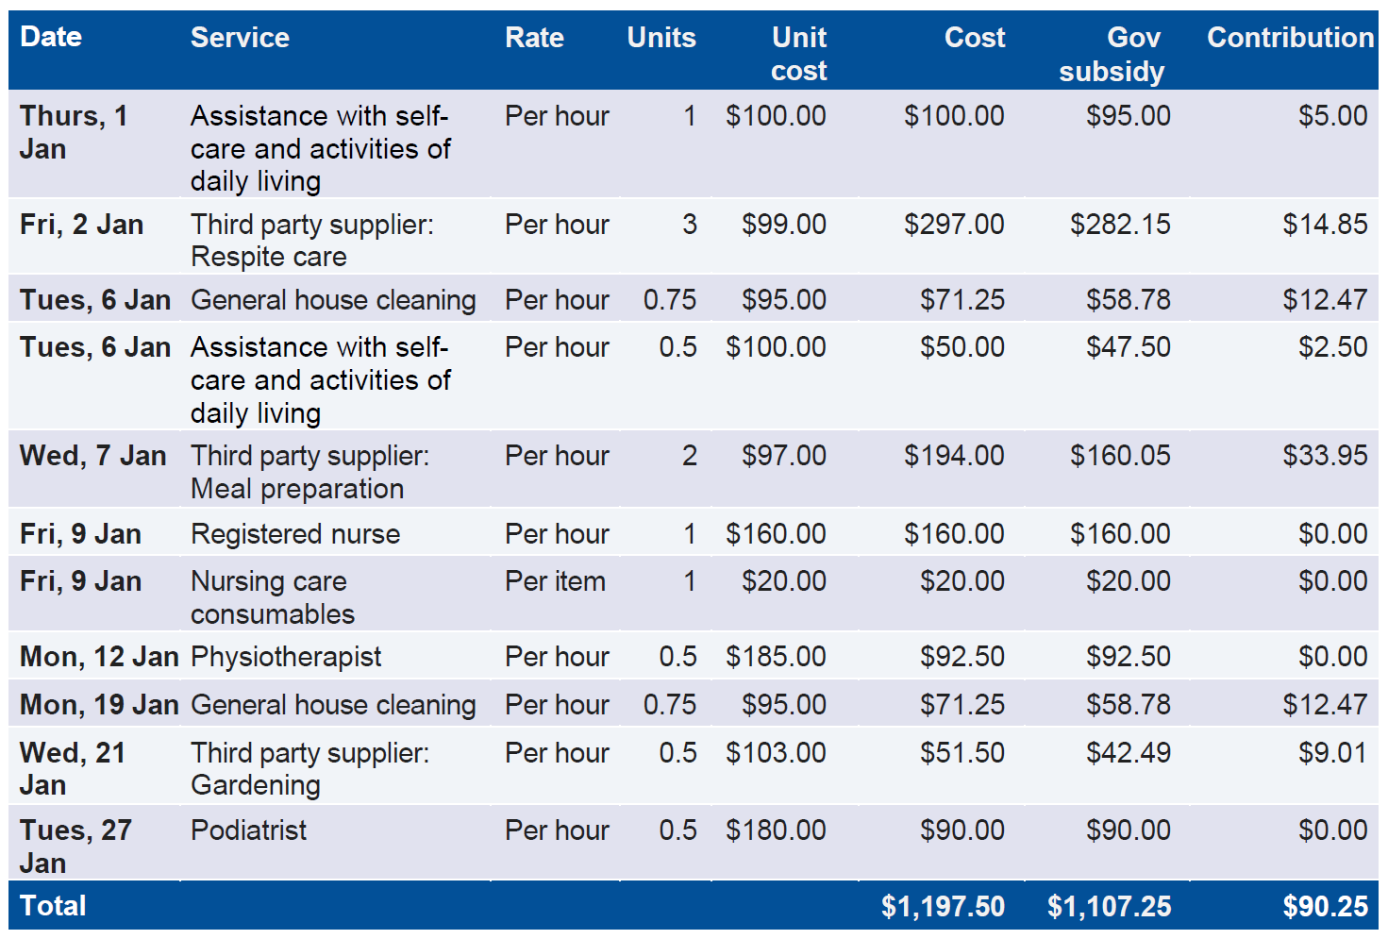
Figure 7. Detailed expenses
Please note: All prices shown in Figure 7 are example figures only.

Participant contributions
Contribution rates will be based on your income and assets and vary by the amount and type of services you have received. An income and asset assessment similar to the Age Pension means-test will be used to determine your contribution rates.

(b) Cancellations and ‘no show’
A late cancellation occurs when you tell your provider less than 2 business days before your scheduled service that you cannot attend. A ‘no show’ is when you are not present at the agreed place or time of a scheduled service.
If you had reasonable grounds for a late cancellation or ‘no show,’ you should let your provider know and provide evidence to support your claim. Some examples of reasonable grounds include, but are not limited to:
- you were in hospital
- you experienced a health incident
- your informal support arrangements changed unexpectedly.
If your provider determines there are reasonable grounds for the late cancellation or ‘no show,’ they may adjust the charges for that service. Your provider should include their cancellation and no-show policies in your service agreement.

(c) Variations from past calendar months
Sometimes you may find errors in your Support at Home statement. For example, your provider charged you for 2 hours of a service when it was only for an hour; or you might have been charged the wrong amount.
Your provider is required to display any adjustments or refunds from previous months in your statement. These adjustments or refunds could either increase or decrease your Support at Home quarterly budget. As these changes relate to previous months they are shown separately in the statement. This makes it is easier for you to understand what the charge or refund is for and how it affects your overall budget.
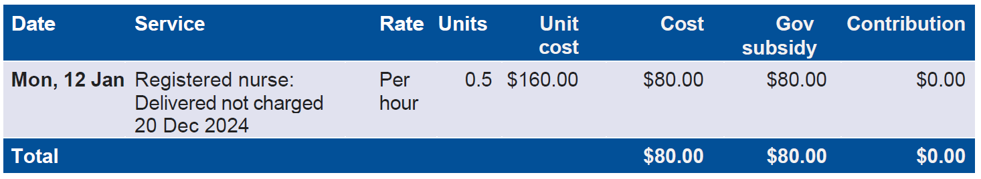
Figure 8. Adjustments or refund budget from previous months


Frequently asked questions

I have a question about my statement, who can I ask?
Please contact your provider if you have any questions about your statement.

Why are there costs on my statement for services I did not receive?
The information reflects services and/or items delivered during the month and/or adjustments from previous calendar months. There may be differences to what was delivered (in terms of hours delivered or dates). Please contact your provider to let them know about this charge.
If any adjustments are needed that would result in additional costs or refunds to your budget, your provider will adjust this in the next statement.

Where are my payments shown?
This is a statement of services only. For detailed information on your previous payments, please refer to your latest invoice or request this from your provider.

What are ‘wraparound services’?
Wraparound services in the AT-HM scheme can include:
- delivery or set-up of assistive technology equipment
- training and education on the safe use of products or equipment
- follow-up visits from a health professional to check whether the assistive technology or home modifications effectively meet your needs
- repairs and maintenance of assistive technology.

What can I use my HCP unspent funds for?
You can use your HCP Commonwealth unspent funds to access additional services if your Support at Home quarterly budget is fully allocated, or assistive technology and home modifications, if approved.
You are required to use the HCP Commonwealth unspent funds on AT-HM items before accessing the Support at Home AT-HM scheme.

What are ‘committed funds’?
Committed funds are AT-HM scheme costs that you have agreed to pay and the process of sourcing or installing the AT-HM items or services has started, however the items and services have not yet been delivered within the calendar month.

I still have unresolved questions, who can help me?

If you have been unable to resolve your question with your provider and would like to discuss your contributions and services with an independent third party, you are welcome to contact the Older Persons Advocacy Network (OPAN) who can connect you to a representative to discuss your needs on a confidential basis. Please refer to their website (www.opan.org.au) or call them on 1800 700 600.
111
Improving Australia’s aged care system
The Australian Government has delivered major changes to improve aged care.
Visit MyAgedCare.gov.au
Phone 1800 200 422 (My Aged Care’s free-call phone line)
For translating and interpreting services, call 131 450 and ask for 1800 318 209.
To use the National Relay Service, visit nrschat.nrscall.gov.au/nrs to choose your preferred access point on their website, or call the NRS Helpdesk on 1800 555 660.

