Managing volunteers in aged care
  - A guidance handbook for Volunteer Managers
November 2025
Contact us at agedcarevolunteer@Health.gov.au for questions or feedback.
Contents
Terminology 4
Definitions 4
Overview 5
General volunteer management 6
Where can I speak to other Volunteer Managers in aged care? 7
Volunteer management resources 8
Understanding volunteers and aged care 9
What volunteers should not do in an aged care setting: 9
Recruitment 10
Writing role descriptions 11
Writing effective role advertisements 14
Sample role advertisement 17
Recruitment avenues 18
Inclusive volunteer engagement 19
Onboarding 24
Key stages of onboarding 24
Regulatory Requirements for Onboarding Aged Care Volunteers 26
Interviewing and selecting applicants 27
Advising on the outcomes of applications 28
How to advise an applicant if they are found suitable for a role 28
How to advise an applicant if they are not found suitable for a role 28
Explaining the volunteer role 29
Other people who may need information about the volunteer role: 30
Complaints, concerns, and incident reporting 31
Training 32
Retention 33
The volunteer-manager relationship 33
Supporting volunteers 35
Recognising volunteers 36
Communicating changes 38
Public health events: volunteer activities and visitor restrictions 39
Meeting volunteer motivations 40
Reviewing volunteer needs 41
When to discuss concerns with a volunteer 42
Exiting volunteers 43
Administration 44
Business basics 44
Reporting tips 45
Keeping up to date with news 46

Terminology
In this document, ‘older people’ refers to individuals in Australia receiving government-funded aged care services, including:
- Residential aged care
- Short-term care (respite, restorative, transition)
- Support at Home
- Commonwealth Home Support Program (CHSP)

Definitions
Topic links throughout this document often include relevant definitions. For broader terminology, refer to the Aged Care Quality and Safety Commission’s glossary.
Access the glossary at www.agedcarequality.gov.au/about-us/corporate-documents/aged-care-quality-and-safety-commission-glossary.

Overview
This resource is for aged care Volunteer Managers, as well as providers and volunteer-involving organisations that support them. It complements, rather than replaces, existing volunteer management materials and is designed to help you access relevant optional and suggested training and information.
An introduction to engaging volunteers in aged care from an organisational perspective is provided in the guidance handbook for providers. You may find the overview and Frequently Asked Questions in that handbook useful.
You may be interested in a broader range of optional and suggested topics relevant to aged care. Access these in the ‘volunteers in aged care training and resource kit’ that this manager handbook complements.

In that kit, you can find information on:

Self-care and mental health support for you and your volunteers
Aged care basics, including system overviews, palliative care, end-of-life care, and advance care planning.

Understanding older people, including person-centred care, communication skills, diversity fundamentals, hearing health, blindness or low vision and trauma.

Looking out for older people, including elder abuse, advocacy, infection control, first aid, grief, loneliness, and social isolation, counselling and suicide, fire safety, food safety, and support with technology and mobility.

Includes privacy, confidentiality, and professional boundaries. Some behaviours are set by organisations; others are required by legislation, such as the Code of Conduct for Aged Care (for volunteers with registered providers)

General volunteer management
Volunteer Managers in aged care.
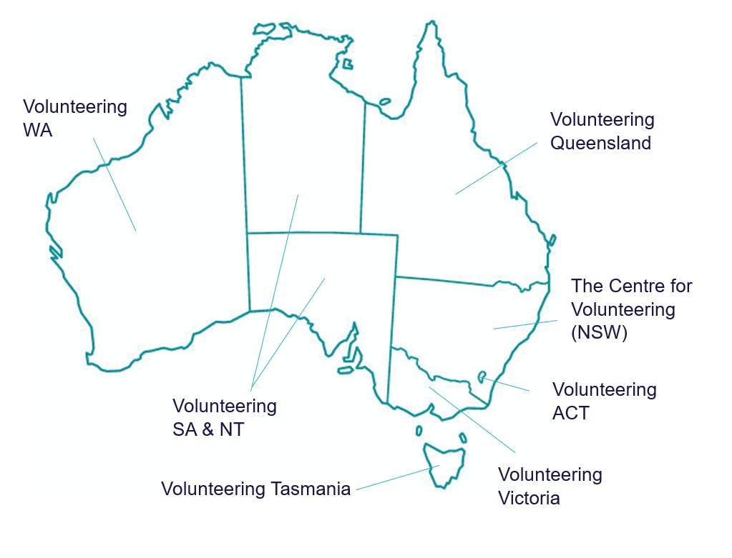
Volunteer Managers play a vital role in supporting older people through volunteering. Under the strengthened Aged Care Quality Standards, providers in Categories 4, 5, and 6 must ensure a skilled and sufficient workforce to deliver safe, respectful, and quality care—including planning, resourcing, and supporting volunteer management.
Your local volunteering peak body provides general volunteer management resources and training. Volunteering Australia is the national peak body. The distribution of Volunteering Australia peak bodies is visualised below.

These links will connect you to each Volunteering Australia state and territory peak body training and resources for Volunteer Manager’s page:
- Queensland: volunteeringqld.org.au/training-events/
- New South Wales: www.volunteering.com.au/workshops-events/volunteer-management/
- The Australian Capital Territory: www.volunteeringact.org.au/services/training-and-events/
- Victoria: www.volunteeringvictoria.org.au/professional-development/training-and-workshops/
- South Australia and the Northern Territory: vsant.org.au/upcoming-learning-and-development/
- Tasmania: volunteeringtas.org.au/training-events/
- Western Australia: www.volunteeringwa.org.au/volunteer-management

Where can I speak to other Volunteer Managers in aged care?

It can be helpful to connect with other Volunteer Managers who have similar experiences to share learnings, compare approaches, and learn about local or national opportunities.
- General volunteer management: Volunteering Australia peak bodies in each state and territory often host Volunteer Manager meetings. Find more information at each peak body website.
- Program-specific meetings: If you are a manager within a larger volunteering program, it may have a Community of Practice and/or regular meetings. You should have a central program-specific contact to enquire about this.
- Sector-specific meetings: Sectors within volunteering may have Volunteer Manager meetings. For example, the NSW Network of Managers of Palliative Care Volunteer Services is open to palliative care Volunteer Manager from NSW and the ACT. The Community Transport Volunteering Network is another example and is open to providers of transport with the Commonwealth Home Support Programme.
We encourage Volunteer Managers to create their own formal or informal networks to connect with peers. You may wish to create a local social media site, meet in person or explore other ways to connect and share your experiences.

Volunteer management resources
Description | Location | Mode
The National Strategy for Volunteering, co-created by stakeholders across the volunteering ecosystem, provides a blueprint enabling volunteering in Australia to thrive. | volunteeringstrategy.org.au/the-strategy/ | Webpage
Volunteering Australia’s Volunteering Resource Hub is useful to search for advice, information, and guides on volunteer management and other broad topics in volunteering, including the National Standards for Volunteer Involvement.  This link will take you to the ‘Quick Guide to Volunteer Management’. It’s a great place to start exploring topics of interest. | volunteeringhub.org.au/the-guide/ | Webpage
Not-For-Profit Law has created a great set of resources for anyone managing volunteers, including a self-help tool. Their ‘National Volunteering Guide’ covers the differences between volunteers and employees, volunteer safety, unlawful workplace behaviour and privacy. | www.nfplaw.org.au/free-resources/managing-people/managing-volunteers | Webpage
This factsheet on volunteer program management, published by Swan Volunteer Resource Centre, is a quick guide on how to involve volunteers, particularly through the recruitment process and how to advocate for volunteer involvement within an organisation. | volunteeringhub.org.au/achieving-excellence-in-your-volunteer-program-volunteer-program-management-guidelines/ | Factsheet
Volunteering Victoria has created a comprehensive guide on best practice volunteer management. | volunteeringhub.org.au/volunteer-management-toolkit/ | Guide

Understanding volunteers and aged care
Volunteers in aged care can undertake a variety of roles in many settings. However, it is important they understand their role and maintain certain boundaries. Some key considerations are listed below.

What volunteers should not do in an aged care setting:

Volunteers do not and should not replace the role of paid workers or undertake roles would ordinarily be those of a paid worker.
Volunteers should not undertake tasks and activities beyond the boundaries of their agreed role description, including clinical or other tasks not captured by the agreed role description.
Volunteers must not act in a way conflicting with the Code of Conduct for Aged Care.
Volunteers must not undertake tasks and activities endangering themselves or others, in alignment with organisations’ work health and safety obligations.
Find more information about aged care:
Description | Location | Mode
A summary of the Australian aged care system by the Australian Institute of Health and Welfare, with links to more information. | www.aihw.gov.au/reports/australias-welfare/aged-care | Webpage
Aged care providers registered in Provider Categories 4-6 must be aware legal obligations under the Quality Standards extend to volunteers. In addition, you should familiarise yourself with provider obligations under Aged Care Act 2024 | www.agedcarequality.gov.au/providers/standards | Webpage

Recruitment
The next two sections will discuss role descriptions and role advertisements.
These are discussed together because while they are used at different stages of the engagement process, the role description will inform the role advertisement.
A volunteer role description is the formal written description of the role.
- It outlines the purpose of the role, tasks and activities a volunteer will be asked to do, as well as what experience and skills they will need.
- It includes what supports the organisation offers, and other key facts a volunteer must know such as their obligations to comply with a code of conduct and their reporting duties.
- It will be part of the formal onboarding stage after a volunteer has undergone the necessary background screening checks and is ready to be inducted into a role.
A volunteer role advertisement is the way you will attract potential volunteers and let them know about the role.
- This could be a call-out on a library poster or on an online role listing.
- It is intended to capture a person’s interest, let them know the key facts about a role, and direct them to act like contacting a Volunteer Manager.
You will attract more interest and the right person if you are clear on the qualities and skills the volunteer will need to have.
It is difficult to write an accurate role advertisement without first having a role description drafted. This is because you will have to include key facts about the role in the advertisement and be ready to answer questions about the role.
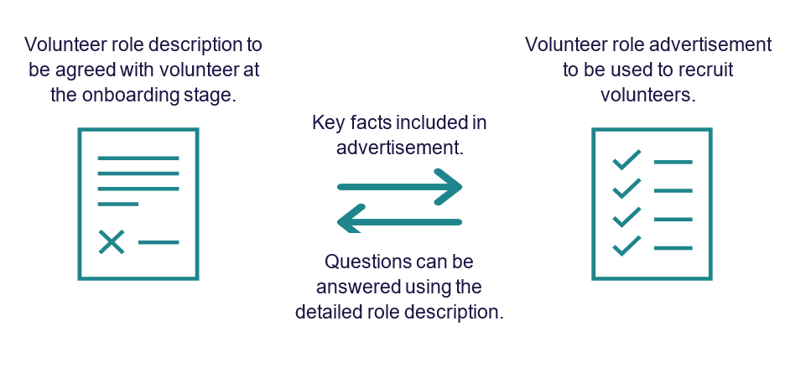

Writing role descriptions
It is important to have a role description because it defines the role of the volunteer, outlines what training needs to be undertaken, time commitments, and helps other people in your organisation to know what the volunteer will be doing.
The role description will be discussed and agreed to between a Volunteer Manager and volunteer at the onboarding and induction stage. Read more at ‘Explaining the volunteer role’ later in this handbook.
Key information to include in a role description:

The purpose of the role and anticipated outcomes or goals, including both goals for the older person/s receiving support and volunteer.
Key tasks and activities the volunteer will be undertaking.
The rights and responsibilities of the volunteer.
Expected time commitment, including start and end dates if known.
Skills, qualifications, or experience needed. This includes screening requirements.
Agreement to adhere to certain behaviours, for example an internal code of conduct.
Any supports you provide, including any policy for covering out of pocket expenses and expectations regarding training.
Any risks (including health and safety risks) as well as agreed mitigation strategies.
Reporting responsibilities, including main supervisor, procedures for emergencies, and methods to maintain contact.
A clear list of rights and responsibilities helps set mutual expectations between volunteers and the organisation. It should be used during onboarding.
The following factsheet can be used as a starting point, but should always be adapted for the specific requirements of each organisation and volunteer role: www.volunteeringaustralia.org/wp-content/files_mf/1376971192VAVolunteerRightsandchecklist.pdf
The following table lists resources provide further detail around how to design volunteer role descriptions. These include sample templates.
Templates provided in these resources should not be used unless they are updated to align with each organisation’s program requirements and procedures.
Role descriptions should also be discussed with each volunteer with an opportunity for questions and amendments.
Find more information:
Description | Location | Mode
A guide on how to write a general volunteer role description. | volunteeringhub.org.au/writing-a-role-description/ | Factsheet
This is an example of a volunteer role description template. It can be useful to use as a starting point. It is important to tailor a description to each role, organisation, sector and jurisdiction. | volunteering.freshdesk.com/support/solutions/articles/51000310660-volunteer-role-description | Template
This guide takes you through the volunteer role design process in more depth, as well as providing templates for position descriptions. | www.volunteeringaustralia.org/wp-content/uploads/Volunteering_Australia_Volunteer_Roles_Toolkit+1-1.pdf | Guide
This 1 hour video explains how to write an effective volunteer position description. | www.youtube.com/watch?v=w5EYxN39Zcs | Longer video


Writing effective role advertisements
Clear, accurate role ads help attract and retain volunteers. Here are some tips:
Checklist | Tips for advertising for a role
 | Use plain English. If you are using jargon or abbreviations, explain what the word or abbreviation means first. If you are recruiting volunteers who speak other languages, consider presenting your advertisement in that language.
Volunteering in aged care is more than a role—it’s a chance to bring connection, dignity, and joy to older people’s lives. As a volunteer, you’ll help build trust, share moments of meaning, and uphold values of respect, inclusion, and compassion. In return, you’ll gain purpose, community, and the deep reward of making a real difference.
For example: Join us—your time matters..
Be clear and honest about tasks, time commitment, and any required experience. While ads don’t need every detail, consider linking to FAQs to help volunteers make informed choices.
Frequently asked questions for aged care volunteers are available at www.health.gov.au/resources/publications/frequently-asked-questions-for-potential-volunteers-in-aged-care is a good starting point for each individual role.
Targeted Recruitment
Start with the skills, interests, or backgrounds you're seeking. Framing roles around shared passions—like music, gardening, or storytelling—can attract people who may not identify as “volunteers” but want to contribute meaningfully.
Application Process
Requirements may vary by role but can include forms, screening checks, vaccinations, driver’s licence, interviews, and references.
Volunteer Support
Clear support builds confidence. This can include:
- Practical help: Onboarding assistance, cost reimbursements, transport support
- Flexible options: Buddy systems or trial periods
Emotional & safety support:
- A contact person for concerns
- Guidance on incident management
- Optional training to build confidence and skills
 | Let potential volunteers hear from current volunteers. This could be from a written testimony, case study, video, or opportunity to meet current volunteers.
Highlight - Volunteering Builds Community
Volunteering is a shared effort that connects people through purpose. It strengthens relationships, fosters belonging, and creates meaningful impact, for older people, volunteers, and the wider community.

Find more information:
Description | Location | Mode
Volunteer West has created some factsheets on recruitment and writing role descriptions (style similar to role advertisement). | www.volunteerwest.org.au/organisations | Factsheet
GCF Global has self-paced tutorials about common media platforms with no login required. Explore simple instructions on using platforms such as Instagram, Facebook and Twitter. | edu.gcfglobal.org/en/topics/socialmedia/# | Webpage

Sample role advertisement
Sample text | Annotations
It can take as little as 2 hours a week for you to make a real difference in an older person’s life. | Time is a significant perceived barrier. This addresses it early.
At [organisation name], we are looking for enthusiastic volunteers to help us support older people in [location]. | Values of the volunteer and organisation
There are roles available to suit lots of interests, including helping in our community garden, transport to and from [name of local community centre], and assisting with arts and crafts activities. | What roles are available.
Get active and meet new people while knowing you’re giving back to the community and bringing some happiness to someone in your community. | The benefits of volunteering, including the community aspect.
You just need to be over 18. We will help you complete the necessary screening checks and basic training. If you decide to help in a transport role, you may need a current [state/territory] drivers’ licence. | Key criteria and supports.  Training
You will be supervised by Volunteer Manager and can be matched with a volunteer buddy.
Come down to meet the team between 9-5pm Tuesdays to Wednesdays at [physical address] or call [phone number].  We will be able to talk you through the roles available and what you will need to get started, including a short application form. | Call to action and how to contact the organisation.
Learn more about what we do, including hearing from some of our current volunteers, at [site name]. | Link to further information
We look forward to meeting you!

Recruitment avenues


The most effective recruitment is often tailored to your local community. Here are some ideas:

Inclusive volunteer engagement
Volunteers can be diverse, from a variety of backgrounds, life experiences, cultures, and characteristics. These can include, but are not limited to:
- people from Aboriginal and Torres Strait Islander communities
- people from culturally and linguistically diverse backgrounds
- people from LGBTQIA+ communities (this includes lesbian, gay, bisexual, transgender, queer, intersex, and asexual people as well as other diverse gender identities and sexualities)
- people who live in rural or remote areas
- people who are financially or socially disadvantaged
- veterans
- people living with disability
- people who are Deaf or hard of hearing
- people who are blind or have low vision
- people living with cognitive impairment, including dementia
- Forgotten Australians and Care Leavers
Quick tip:

Empower volunteers and communities to lead you in what they share about themselves, what they can offer in their roles, what their strengths are and what supports they might need. The best way to do this is by fostering trust between yourself, the volunteer, and community, including by:
- avoiding assumptions or stereotypes
- ensuring the volunteer environment is safe and comfortable
- maintaining respectful conversations.


Inclusion occurs when people feel valued, respected and have equal or equitable access to participate as a volunteer.
Here are some ideas for inclusive volunteer engagement:
Engage with communities directly.
If you're unsure how to involve a particular community, reach out to local leaders or established groups. They can help spread the word, offer insights, and guide you in tailoring your approach to better connect with the community’s values and needs.
Show that your organisation is inclusive and welcoming to all.
Public perceptions can be a barrier to volunteering. People may assume they’re not the “right fit” based on age, background, or identity. Actively signalling inclusion helps break down these assumptions.
For example:
- If people think only young volunteers are welcome, clarify age requirements and share a story or testimonial from an older volunteer.
- Use inclusive language and imagery, such as community flags or photos that reflect diversity.
- Share stories from volunteers of different backgrounds and experiences.
- Include an inclusive volunteering statement on your website or promotional materials.
Most importantly, be genuine. Inclusion should be reflected not just in your messaging, but in your actions and culture.
Identify and address barriers to volunteering.
Some people may face challenges that make it harder to step into a volunteer role. Being aware of these barriers—and actively working to reduce them—can help create a more inclusive and supportive environment.
Consider the following questions:
- Are applications explicitly welcoming to people from all backgrounds and lived experiences?
- Is the application process accessible, including for those with disabilities or limited digital access?
- Is support available for those who may need help during onboarding or while volunteering?
- Do volunteers have clear opportunities to request adjustments or support throughout the application, onboarding, and ongoing involvement?
By understanding and addressing these barriers, you can better communicate the supports you offer and make volunteering more accessible to everyone.
Match volunteers thoughtfully.
Take time to understand each volunteer’s motivations, interests, and skillsets. Assign them to roles that not only suit their strengths but also positively impact the older person they’ll be supporting.
Where possible, tailor roles to the individual and check in regularly to ensure the role continues to be a good fit. Flexibility and ongoing communication help volunteers feel valued and supported, and lead to better outcomes for everyone involved.

Find more information:
Description | Location | Mode
The Department of Health, Disability and Ageing offers a free translation service to help eligible aged care providers and peak bodies communicate with older people in their preferred language. This supports culturally safe and inclusive care by translating written and audio materials into languages other than English. | diversityagedcare.health.gov.au/ | Webpage
Anglicare Southern Queensland’s Inclusive Engagement Toolkit is a great starting point for inclusive care. It includes short factsheets (available in multiple languages) on:  - Inclusive care and communication  - LGBTQIA+ communities  - Culturally and linguistically diverse backgrounds  - Aboriginal and Torres Strait Islander peoples  - Diverse older people  Videos are also available in several languages to support understanding and engagement | anglicaresq.org.au/about-us/inclusive-engagement-toolkit/# | Webpage factsheets, videos
Volunteering Australia’s Knowledge Base  Find practical guidance on inclusive volunteering, including how to engage respectfully with Aboriginal and Torres Strait Islander peoples and culturally diverse communities. | volunteering.freshdesk.com/support/solutions | Webpage
Volunteer West has a Culturally Inclusive Volunteer Toolkit to help Volunteer Managers looking to implement culturally responsive practices. | www.volunteerwest.org.au/culturally-inclusive-volunteer-toolkit-1 | Factsheet
Volunteering Victoria offers guidance on involving volunteers from culturally diverse backgrounds, covering key stages like recruitment, induction, and training. | volunteeringhub.org.au/managing-volunteers-from-a-cald-background/ | Factsheet
Volunteering Australia has a guide on how to involve culturally and linguistically diverse volunteers, covering recruitment tips, motivations and addressing common concerns organisations may have. | volunteeringhub.org.au/involving-volunteers-from-culturally-and-linguistically-diverse-backgrounds/ | Factsheet
Volunteering Victoria has a factsheet on how to create a safe and inclusive volunteering environment for LGBTQIA+ volunteers. | volunteeringhub.org.au/lgbtiq-volunteers-inclusive-practice/ | Factsheet
Volunteering Queensland has a factsheet on the main considerations when involving older volunteers. | volunteeringhub.org.au/working-with-older-volunteers/ | Factsheet
The ‘Every WORD Counts’ guide provides helpful tips on how to avoid ageism in your language.  Explore the resources on the campaign materials page or scroll down to access the guide directly. | www.everyagecounts.org.au/campaign_materials | Factsheet
Volunteering Victoria (for the Victoria ALIVE project) has a factsheet on how to involve older volunteers living with disability. | volunteeringhub.org.au/aged-friendly-volunteering/ | Factsheet
Victoria ALIVE has a checklist to assist organisations be accessible to volunteers living with disability. | volunteeringhub.org.au/is-your-organisation-accessible/ | Factsheet


Onboarding
Stay connected during onboarding. The onboarding process can be one of the most challenging parts of volunteering, and it often takes time—sometimes even months. To keep volunteers engaged and motivated, maintain regular communication throughout the process
Simple check-ins, updates, or words of encouragement can help sustain their enthusiasm and reassure them that their involvement is valued.

Key stages of onboarding
A checklist can help organise the various onboarding elements. The below list covers key stages you should consider. However, it is not a full list and should only be used to begin thinking about all the stages in each program.
Check the volunteer meets the program’s eligibility criteria. For example, age, location, and availability.
If the volunteering role is with another organisation, check the role is still available and for any additional onboarding requirements.
Confirm and undertake the screening checks a volunteer will need or may already have. For example, a National Police Check or NDIS Worker Screening Check.
Undertake any additional screening requirements, such as interviews or qualification checks (e.g., driving licences).
Discuss and agree to a volunteer role description.
Prepare an on-site onboarding plan, training plan, list of key contacts, and Frequently Asked Questions.
Quick tip:

Explain the reasons for screening checks, training, and other onboarding processes. For example, screening and reporting is important to protect older vulnerable people, while work health and safety procedures are important to protect the safety of the volunteer.
Find more information:
Description | Location | Mode
VolunteeringACT has created a comprehensive guide to onboarding volunteers, covering planning, policies and procedures, induction, training and evaluation. This guide provides information, checklists and templates relevant to both volunteers and employees.  The resource is for volunteers generally. You should always consider the needs of each particular aged care volunteer and program. This includes taking note of aged care regulatory requirements (see next section). | volunteeringhub.org.au/guide-to-onboarding/ | Guide and supporting resources.
Not-for-Profit Law has created a guide on some legal obligations involved in engaging volunteers. Find information on volunteer safety (negligence, work health and safety, managing risk, insurance etc), and unlawful workplace behaviour (for example, sexual harassment, discrimination, bullying and victimisation). | www.nfplaw.org.au/free-resources/managing-people/managing-volunteers#owe | Webpage

Regulatory Requirements for Onboarding Aged Care Volunteers
Volunteers in aged care are considered part of the workforce. Under the Aged Care Act 2024, an aged care worker includes a volunteer engaged by a registered aged care provider. Read the definitions of ‘volunteer’ and ‘workforce’ in the Aged Care Quality and Safety Commission’s glossary at: https://www.agedcarequality.gov.au/about-us/corporate-documents/aged-care-quality-and-safety-commission-glossary "
Description | Location | Mode
The Department of Health, Disability and Ageing issued Worker Screening Guidelines, applies to volunteers. | www.health.gov.au/resources/publications/aged-care-worker-screening-guidelines?language=en | Guidance
This website will introduce you to the responsibilities of registered aged care providers.  Where a provider has responsibilities related to staff and the care and services those staff deliver, these also extend to volunteers. | www.health.gov.au/topics/aged-care/providing-aged-care-services/responsibilities#record-keeping-in-aged-care | Webpage
Registered aged care providers registered in Provider Categories 4-6 must comply with the Aged Care Quality Standards. Guidance on the Standards is available. | Strengthened Aged Care Quality Standards – February 2025 | Australian Government Department of Health and Aged Care | Webpage
The Aged Care Quality and Safety Commission has created a resource package for volunteers and Volunteer Managers on the Code of Conduct for Aged Care, the Serious Incident Response Scheme (SIRS), and their complaints handling process. It includes videos, factsheets, and online learning modules (no certificates).  Registered aged care providers have a responsibility to train and support staff, including volunteers, on the Code of Conduct and information management systems. | www.agedcarequality.gov.au/resources/volunteers-aged-care | Webpage

Interviewing and selecting applicants
If your organisation requires interviews for volunteer applicants, it’s important to have clear and consistent procedures in place. This helps ensure that all interviews are conducted fairly, effectively, and in line with your organisation’s values. Standardised guidelines also support transparency and help interviewers assess candidates equitably.
Key considerations for interviews:

Explain to the applicant an interview will be taking place. Agree on a time and place working for both of you.
Ask if they will need any adjustments made to ensure accessibility such as time, location or format of the interview.
Explain to the applicant the purpose of the interview. Consider letting the applicant know what questions will be asked so they can be prepared and less worried. Interviews can be a stressful experience for many people.
Prepare the questions you will be asking to ensure consistency between interviews. You could prepare a list of criteria to assess each applicant against, split between ‘essential’ and ‘desirable’ attributes. Ask yourself what it would take to pass or fail an interview, and what the key things you are looking for in an interview.
Check the interview questions and selection criteria relate to the responsibilities, and requirements written in the prepared role description.
On the interview day, be punctual and polite. Use everyday language and avoid acronyms. Ensure you set aside enough time for the interview so you are not rushed or interrupted.
Allow time for the applicant to ask questions about the role and organisation. This is a good chance to see what questions they may have and any worries they may want to raise.
Find more information:
Description | Location | Mode
A brief guide on how to conduct an interview with potential volunteers | volunteeringhub.org.au/guide-to-interviewing-volunteers/ | Factsheet

Advising on the outcomes of applications
Regardless of the outcome of each application, it is important to always follow up in a timely manner. Ensure you set aside some time after an interview to adequately review your interview notes, reflect on the interview and record the results with an outcome and reasoning.

How to advise an applicant if they are found suitable for a role
Advise them in a timely manner and provide them with some time accept or decline the offer. An offer may be conditional on their completion of screening checks and training.
Explain what the next steps would be if they did accept the offer, including time expected to complete the onboarding process. This includes potential delays around screening and administrative processes.
Agree on the next steps, for example the next meeting or the review and completion of paperwork.

How to advise an applicant if they are not found suitable for a role
Advise them in a timely manner. Thank them for their interest in the role. Be clear, polite and respectful.
Provide the reasons why they were unsuccessful. It is useful to have your records on hand to refer to the interview notes made against each selection criteria.
If appropriate in the circumstances, you may be able to refer them to another organisation or volunteering role.

Explaining the volunteer role
It is important volunteers understand their role. Sometimes they will have clear, straightforward duties. However, sometimes the lines between a volunteer’s and paid staff’s duties may become blurred. It is important to be prepared for grey areas. Guidance should be provided to a volunteer early on.

Here are some things to consider when you are onboarding volunteers.
Checklist | Things to consider
 | Explain the volunteer role and put this in writing. Give the volunteer a copy of their role description and give them an opportunity to raise questions or adjust their duties. Explain what they can and cannot do in the aged care setting as a volunteer, and their rights and responsibilities. As explained in the volunteer role description section, these should be written clearly as well as explained verbally.
 | Explain the boundaries between the volunteer role and paid staff. Volunteers do not replace paid staff. Instead, they complement the work of paid staff and work together to raise the quality of life for older people receiving volunteer support.
 | Explain the role of the volunteer in the aged care provider’s incident management system and complaint management system. The volunteer must understand their responsibilities in these systems, and who to report relevant information to in the organisation. They may also be provided with the key contacts for clinical questions or changes they notice (aged care provider staff such as registered nurses, lifestyle coordinators etc.)
 | Give the volunteer the contact details of key organisations. This can help them provide advice if an issue arises beyond their set role or they may want to pass on to older people receiving volunteer support. This could include the details of the Older Person’s Advocacy Network (OPAN) (advocacy services), and the Aged Care Quality and Safety Commission (complaints and incidents).


Quick tip:
Give a clear explanation of who is responsible for what in the organisation. This will help a volunteer understand who to talk to in certain circumstances. It could look like an organisational flowchart and in-person introductions.

Other people who may need information about the volunteer role:
The following groups should also understand the volunteer’s role and boundaries:

The older person receiving volunteer support
Another organisation who supervises the volunteer
Aged care staff
An older person’s legal family, carers, and/or family of choice

Complaints, concerns, and incident reporting

Communication is not just from an organisation and/or manager to a volunteer. It is also from a volunteer to their manager, care staff, nurses, general practitioners, and family carers.
A volunteer is often well positioned to notice changes in an older person’s health, mood and living circumstance. They may want to raise concerns or discuss changing care needs.
Aged care providers must have procedures in place to provide a clear process for staff, including volunteers, to raise and escalate concerns (of their own, or on behalf of the older person). It must be clear to a volunteer that appropriate reporting is within their role as part of an organisation’s incident and complaint management systems.
Find volunteer and Volunteer Manager resources on complaints and reporting requirements, including the Serious Incident Response Scheme, at www.agedcarequality.gov.au/resources/volunteers-aged-care
Other ways to facilitate effective communication could be:
- Providing briefings or advice from care staff familiar with an older person receiving volunteer support.
- Guidance on the provider’s processes for raising concerns, changes, or issues. This could be a mechanism (like forms, a centralised register) or a contact person (a manager, a clinical staff member).
- Looping back with updates on actions taken when a volunteer raises any issues or concerns.
Find out more here:
- the Older Person’s Advocacy Network (OPAN)
- the Aged Care Quality and Safety Commission.

Training

The new legal and regulatory requirements in aged care mean registered providers need to provide volunteers with suitable training and support to help them undertake their volunteer role confidently and safely and protect older people in aged care.
The department is currently consulting with the aged care volunteer sector, to ensure safety, quality, and consistency in volunteer involvement across aged care services in alignment with the rights of older people.

You can also access a collection of optional free, publicly available suggested training resources that you can use for volunteer training. Use of these resources is entirely optional. These can be found here https://www.health.gov.au/resources/publications/volunteers-in-aged-care-training-and-resource-kit-for-volunteers-and-volunteer-managers

If you have questions about volunteer training please speak to your organisation, or contact us at agedcarevolunteer@health.gov.au

Retention

The volunteer-manager relationship

Volunteers often say their relationship with a direct supervisor is a key reason they either became involved in volunteering or remain in their volunteering role. A good relationship also encourages the early identification of any issues and provides an opportunity for effective feedback.
Here are some quick tips for setting up and maintaining a good volunteer-manager relationship:
Checklist | Quick tips on setting up good relationships
Identify yourself or someone else as a volunteer’s direct supervisor and main contact. This should happen as soon as you know who the direct supervisor, manager or coordinator will be.
Volunteers should know who they will be reporting to and should not feel isolated or left to their own devices.
Provide contact numbers or emails they can use in an emergency or to discuss issues (for example if they cannot attend a volunteering session).
Set up regular meetings between a volunteer and their manager or direct supervisor.
These can be formal or informal, online or in-person. Regular contact means a volunteer has an opportunity to raise any questions or concerns and has an easy way to get in contact with their supervisor.
Give feedback to volunteers. Feedback should include whether the volunteer has completed their duties well. Sometimes this goes unsaid and volunteers can be left uncertain.
Feedback can also be a way to suggest changes without becoming too negative, or a chance to give positive feedback, recognition, and gratitude.

Supporting volunteers

It is important to look out for both the physical and mental safety of volunteers. Sometimes, volunteers can face challenging situations. They must understand who and where they can go to for support in these situations.
Some situations where a volunteer may need extra support and/or supervision include where an older person they support:
  - has experienced trauma and could behave in unexpected ways.
  - is experiencing health conditions requiring different supports.
  - has passed away.
Volunteers can also have challenges in their personal lives affecting their mental and physical health.
Ensure volunteers know they can speak to you, or another key contact person, if any issues arise or if they want to discuss something.
Depending on your organisation’s policies, you may be able to connect a volunteer to your Employee Assistance Program or a similar service.
End of Life Directions for Aged Care (ELDAC) has a virtual ‘self-care room’ for aged care workers (including volunteers) with opportunities to:
  - pause and reflect,
  - learn about self-care,
  - cope with death and dying,
  - create a self-care plan.
Encourage volunteers to explore this room at www.eldac.com.au/tabid/7117/Default.aspx.
Head to Health can connect volunteers to mental health support and resources. Explore information, resources, and links to services at www.headtohealth.gov.au/
More self-care resources, mental health supports, and training in several topics including trauma and dementia are available at https://www.health.gov.au/resources/publications/volunteers-in-aged-care-training-and-resource-kit-for-volunteers-and-volunteer-managers.

Recognising volunteers
While many volunteers give their time without expectations of recognition, they always appreciate gestures of thanks from their manager, the organisation, and older people receiving volunteer support.

Recognition can happen on an everyday basis or as a one-off formal event and can come from many different people. People can say thank you to volunteers in simple ways every day to show appreciation. Here is a simple breakdown of recognition types:
Formal recognition looks like official award nominations, certificates of appreciation and written articles in newsletters or websites.
Semi-formal recognition includes morning teas, lunches, coffee, volunteer dinners, small gifts, and gift vouchers. This can also include badges, pins and uniforms.
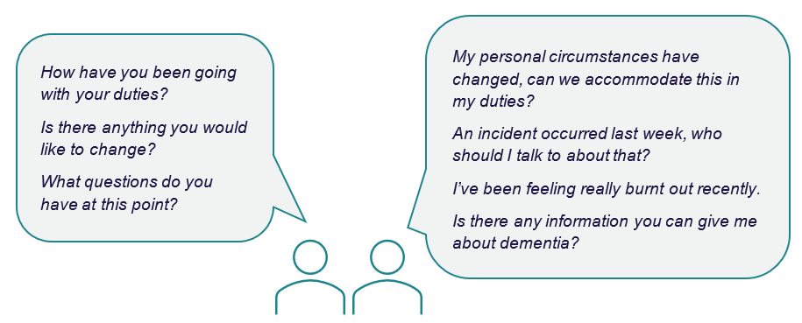
Informal recognition includes everyday expressions of gratitude such as verbal thanks, greeting volunteers by their names and including them in staff meetings or communications.

Genuine recognition also relies on a volunteer’s feelings of belonging in an organisation. Volunteers want to be recognised and respected by their organisation, manager, staff, older people receiving volunteer support and their families. Here are some quick tips:
Checklist | Quick tips for recognising volunteers
 | Ensure the organisation (top management) understands the importance of volunteers and takes actions to show this appreciation. Culture comes from the top.
 | Ensure staff are aware of volunteers, know what a volunteer’s duties are, and who the volunteers are (names, responsibilities, days volunteering, support needed etc.) Looping in staff will stop potential tension between staff and volunteers.
 | Ensure older people receiving volunteer support know who volunteers are and they are not paid staff. Volunteers sometimes report older people they are supporting treat them like paid staff and request things beyond their role. This should be avoided.
Find more information:
Description | Location | Mode
Volunteering Australia has a comprehensive list of ways to recognise volunteers. | volunteeringhub.org.au/101-ways-to-recognise-your-volunteers/ | Factsheet
Volunteering Victoria has a high-level guide on best practice volunteer management to support higher retention rates. | volunteeringhub.org.au/managing-volunteers-for-retention/ | Factsheet

Communicating changes

Effective communication is critical to volunteer management, from the onboarding process, the beginning of a volunteering role, through to the end of a volunteering role. Here are some quick tips:
Checklist | Effective communication tips
 | Check how your volunteers would like to be contacted. Some people would rather be sent emails, while others may like to be contacted by phone or text. Alternatively, you may have a group Facebook or WhatsApp chat. Where reasonable, it is best to check and keep records of preferred contact methods. This is particularly important in emergency or unexpected situations such as last-minute roster changes.
 | Notify volunteers of changes in your availability and contact preferences. If you will be unavailable for a period of time or prefer to be contacted by email only etc., let your volunteers know. Where possible, let them know an alternative contact person who they could reach out to.
 | Ensure volunteers are on relevant email distribution lists. For example, the organisation’s email distribution list for staff could include updates on service delivery, one-off training events, recognition events etc.
 | Notify volunteers as soon as possible if there are changes to their volunteering role. For example, if an aged care service is experiencing a shutdown period or quarantine and the volunteer may have reduced hours of visitation, changed Personal Protective Equipment (PPE) procedures etc.
 | Notify volunteers as soon as possible if an older person they volunteer with regularly or provide support to has rapidly deteriorating health conditions or has passed away. Offer support and let them know if there is an opportunity to visit (or attend the funeral in the case of a death). In all circumstances, consider factors such as whether it is appropriate and whether the family consents etc.

Public health events: volunteer activities and visitor restrictions
Outbreaks of infectious illnesses, like COVID-19, in residential aged care homes or in the community, can be a risk to the health and wellbeing of older people, volunteers, staff and families. If an outbreak occurs volunteer activities could be restricted.
In the case of residential aged care, The Sector Code for Visiting in Aged Care Homes (‘the Code’) includes volunteers as Essential Visitors; a volunteer may be a Named Visitor where an aged care resident does not have a Partner-in-Care.
The Code can be read at cota.org.au/policy/aged-care-reform/agedcarevisitors/
Residential aged care providers should familiarise themselves with guidance on screening and managing visitors, available at www.health.gov.au/topics/aged-care/managing-covid-19/prevent-and-prepare-in-residential-aged-care#screening-and-managing-visitors.
Both providers and volunteers should familiarise themselves with COVID-19 advice for visitors to residential aged care homes, available at www.health.gov.au/topics/aged-care/managing-covid-19/for-older-people-and-carers/for-people-in-residential-aged-care-homes-and-visitors#advice-for-visitors.
Home care providers can read corresponding COVID-19 advice for in-home aged care at www.health.gov.au/topics/aged-care/managing-covid-19/for-in-home-providers.
Find more information:
Description | Location | Mode
This factsheet summarises key COVID-19 takeaways for Volunteer Managers and provides tips for communicating with and engaging volunteers. Similar guides for volunteers, potential volunteers, and staff working alongside volunteers is available on Volunteering WA’s website. | www.volunteeringwa.org.au/resources/aged-care | Factsheet
Volunteering WA has published a basic excel template for record keeping of volunteer details. | volunteeringhub.org.au/volunteer-database/ | Template

Meeting volunteer motivations
Volunteers support others, but they also have personal goals, social connection, skill-building, or career development. Understanding these motivations helps you manage effectively and retain volunteers.
 | Needs include: | How you could meet them:
 | Emotional: the volunteer wants to do good and give back to the community. | Give feedback on how their volunteering has affected older person/s or the community. This could be an update, good news stories, statistics etc.
 | Social: the volunteer wants to become part of a community or create friendships. | Create opportunities for volunteers to meet and interact with each other regularly. This could be morning teas, lunches or group chats.
 | Intergenerational interest: the volunteer wants to connect with people from another generation or people who are different from themselves. | Design roles and match volunteers based on their expressed interests or motivations.
 | Professional: the volunteer wants to develop their professional skills, practice their skills or is undertaking a study placement. | Create opportunities for volunteers to upskill or use existing skills. Understand the vocational requirements for students.
 | Financial: the volunteer needs to volunteer in order to receive a welfare payment (or believes they have to). | Understand the regulatory framework and processes in these situations, and keep in mind their interest levels may be apparent to older people receiving volunteer support. Match volunteers to their interests.  Learn more about mutual obligations at Services Australia.

Reviewing volunteer needs
It can be helpful to have a regular review of volunteer progress and needs. This could be annual, quarterly, or monthly depending on the volunteer and role.
Reviews can provide a space for volunteers to raise topics of concern. For example, volunteers may want:
- More information or training on subjects not included in their orientation. A training and resources kit is available at https://www.health.gov.au/resources/publications/volunteers-in-aged-care-training-and-resource-kit-for-volunteers-and-volunteer-managers
- To explore a career in aged care. It could be useful to:
  - provide certificates for completed training they can add to a resume.
  - direct them to job opportunities available in the organisation or sector.
  - connect them to more information about working in aged care, available at www.health.gov.au/topics/aged-care-workforce

When to discuss concerns with a volunteer

Sometimes you will need to initiate a discussion with a volunteer. It is important to have a timely and respectful conversation if any concerns arise. Also keep in mind the need to carefully balance the safety and rights of the older person receiving volunteer support and those of the volunteer.
Circumstances when a conversation may need to happen include where:
- a volunteer may be acting beyond their role
- the safety of an older person receiving volunteer support has been or is likely to be placed at risk
- there has been a complaint made about a volunteer
- a volunteer may be unable to fulfil their volunteer duties
Remember registered aged care providers must comply with their obligations under the Aged Care Act 2024 and the Quality Standards.
Volunteers engaged by aged care providers must comply with the Code of Conduct for Aged Care.
What you should do if an issue arises:
Respond in a timely manner.
Have a respectful conversation, allowing all involved parties to communicate their perspectives.
Identify all current and anticipated risks.
Document and implement risk management strategies.
Reiterate their role, rights and responsibilities. Ensure they understand what is expected of them and the steps forward.


Exiting volunteers
When a volunteer exits from a role, there is an opportunity to learn from any lessons and improve the experience of existing and future volunteers.
Checklist | Exit tips
 | Thank the volunteer for the time and help they have given. Volunteers are valuable members of an aged care team.
 | Undertake exit interviews with volunteers who leave. Ask for the reasons they leave a role, program or organisation. Ask what could have been improved. An alternative to an exit interview could be a survey, feedback form or informal chat.
 | Assess whether any reasons given for leaving could be preventable and whether there can be anything done to address them now. Where appropriate, let the exiting volunteer know of any action being undertaken. This helps them feel heard and may help community support through word of mouth.
 | Record and plan for longer term and/or organisational improvements. These could include volunteer role design, organisational resourcing, recruitment strategies or relationships between staff and volunteers. Keep a record of how any large issues are being raised and make a practical plan for how improvements could be implemented.
Find more information:
Description | Location | Mode
A template for recording and evaluating data from exiting volunteer interviews. | volunteeringhub.org.au/exit-interview-spreadsheet/ | Template

Administration

Business basics
business.gov.au is a whole-of-government website for the Australian business community. It is a simple and convenient entry point for information, services, and support to help businesses succeed in Australia. Key pages of interest are provided below:
Description | Location | Mode
The ‘Financial tools and templates’ page provides concise information to help you manage, understand, and keep track of your business finances. It includes pages on key financial terms and how to’s on setting up a balance sheet, profit and loss statement, cash flow statement, budget and finance checklist. Find instructions and downloadable excel templates as well as links to more information. | business.gov.au/finance/financial-tools-and-templates | Webpage
The ‘Finance’ page is a broader page with information on finance basics, payments and invoicing, funding, taxation and yearly financial tasks. | business.gov.au/finance | Webpage
The ‘Marketing’ page provides basics of business marketing, and how to’s to identify your target market, research your market and develop a marketing plan, advertise your business and find the right tools and software to undertake marketing activities. | business.gov.au/marketing | Webpage
The ‘Grants and programs finder’ page can be a useful tool for finding grants, funding and support programs from across government. | business.gov.au/grants-and-programs?resultsNum=10 | Webpage

Reporting tips
Description | Location | Mode
Volunteering Australia has a factsheet on how to include the contribution of volunteers into the narrative and budgeting of grant applications. | volunteeringhub.org.au/including-volunteer-contributions-in-grant-applications/ | Factsheet
The Centre for Volunteering (NSW) ‘cost of volunteering calculator’ is easy to use and can help in communicating the financial impact of volunteers. | www.volunteering.com.au/resources-tools/cost-of-volunteering-calculator/ | Webpage
Volunteering Victoria, Queensland, and Tasmania have a guide to business continuity planning during a pandemic looking at the impacts of volunteer involvement as well as operations, communication, finances and social impact. It can be applied beyond COVID-19 to other extreme events such as climate and health emergencies. | volunteeringhub.org.au/covid-19-business-continuity-planning/ | Factsheet
This guide on how to demonstrate the impact of volunteer involvement to your organisation has been created by Volunteer Scotland and may provide some useful tips. | volunteeringhub.org.au/so-what-volunteering-impact-measurement-top-tips-to-get-you-started/ | Factsheet

Keeping up to date with news

You may find it helpful to keep informed about news in the aged care sector and the volunteering sector. This can be done by joining networks discussed earlier in this handbook and by subscribing to key newsletters
- Aged care newsletters from the Department of Health, Disability and Ageing include Your Aged Care Update and EngAged, providing news and updates to aged care providers, the aged care sector, and the public. They include information on new programs, training, grant opportunities, reforms and ageing well. Learn more and subscribe here: www.health.gov.au/using-our-websites/subscriptions/subscribe-to-aged-care-newsletters-and-alerts.
- The Aged Care Quality and Safety Commission publishes a Quality Bulletin and Regulatory Bulletin. Learn more and subscribe to their newsletters at www.agedcarequality.gov.au/news-centre.
- Volunteering Australia’s monthly newsletter provides information about the volunteering community and developments in the sector. Learn more and subscribe here: www.volunteeringaustralia.org/news-events/.
- Volunteering Australia peak bodies in each state and territory may also have newsletters. To learn more and subscribe, visit the relevant website in your state or territory.

