**Interim Evaluation #2 of the Prescribed List Reforms**

19 September 2025

#### *Grey background including an artwork developed by Marcus Lee Design.***Nous Group** acknowledges Aboriginal and Torres Strait Islander peoples as the First Australians and the Traditional Custodians of country throughout Australia. We pay our respect to Elders past, present and emerging, who maintain their culture, country and spiritual connection to the land, sea and community.

This artwork was developed by Marcus Lee Design to reflect Nous Group’s Reconciliation Action Plan and our aspirations for respectful and productive engagement with Aboriginal and Torres Strait Islander peoples and communities.

*Disclaimer:*

*Nous Group (****Nous****) has prepared this report for the benefit of the Department of Health, Disability and Ageing (the* ***Client****).*

*The report should not be used or relied upon for any purpose other than as an expression of the conclusions and recommendations of Nous to the Client as to the matters within the scope of the report. Nous and its officers and employees expressly disclaim any liability to any person other than the Client who relies or purports to rely on the report for any other purpose.*

*Nous has prepared the report with care and diligence. The conclusions and recommendations given by Nous in the report are given in good faith and in the reasonable belief that they are correct and not misleading. The report has been prepared by Nous based on information provided by the Client and by other persons. Nous has relied on that information and has not independently verified or audited that information.*

© Nous Group

Contents

Glossary of commonly used terms and acronyms 2

Background on the Prescribed List 3

Executive summary 4

Current state of the reforms 7

1 About this Report 11

2 Findings of *Interim Evaluation #2* report 13

2.1 Objective 1: Improve the alignment of the scheduled benefits of the PL with the prices paid in more competitive markets 14

2.2 Objective 2: Maintain no additional out-of-pocket costs associated with the PL devices for consumers 24

2.3 Objective 3: Maintain clinician choice of appropriate prostheses for their patients 28

2.4 Objective 4: Improve the affordability and value of PHI for privately insured Australians 31

2.5 Objective 5: Clarify the purpose, definition and scope of the PL in legislation 39

2.6 Objective 6: Implement new PL assessment pathways aligned to Health Technology Assessment principles and streamline the application process through simple and robust IT infrastructure 49

2.7 Objective 7: Develop and implement PL post-listing reviews and PL compliance frameworks to safeguard the PL Reforms 57

2.8 Objective 8: Ensure ongoing financial sustainability of PL administration through effective and efficient cost recovery arrangements that are compliant with the AGCF 66

Appendix A Methodology 70

A.1 Purpose and key objectives 70

A.2 Evaluation plan and theory of change 70

A.3 Overall approach and KEQs 74

A.4 Approach to data collection and engagement 76

Appendix B List of external stakeholders consulted for *Interim Evaluation #2 report* 77

Appendix C Overview of indicators and measures 78

Appendix D Measures detail 81

D.1 Indicator 1: Reduction in benefits 81

D.2 Indicator 2: Change in the size of the gap between PL benefits and prices paid in more competitive markets 82

D.3 Indicator 3: Change in out-of-pocket expenses related to PL items 86

D.4 Indicator 6: Change in PHI premium increases 88

D.5 Indicator 7: Change in PHI coverage and for whom 89

D.6 Indicator 9: Implementation of PL regrouping 89

# Glossary of commonly used terms and acronyms

|  |  |
| --- | --- |
| CIED | Cardiac Implantable Electronic Device |
| Consumers | Also alternatively referred to as *patients* |
| ECAG | Expert Clinical Advisory Committee |
| GUI | General Use Item |
| HPP | Health Products Portal |
| HTA | Health Technology Assessment |
| IHACPA | Independent Health and Aged Care Pricing Authority |
| IECT | Industry Employed Cardiac Technician |
| MDHTAC | Medical Device and Human Tissue Advisory Committee |
| Medical device sponsor | Also alternatively referred to as *medical technology company, medical technology sponsor or industry* |
| MOU | Memorandum of Understanding |
| MSAC | Medical Servies Advisory Committee |
| PHI | Private Health Insurance |
| PL | Prescribed List (previously known as the *Prostheses List*) |
| Private hospitals | Also alternatively referred to as *private healthcare providers* |
| Public benchmark | Benchmark pricing for PL items sold to Australian public hospitals – alternatively referred to as *Weighted Average Price (WAP)* |
| TSS | Technical Support Services (for CIEDs) |

# Background on the Prescribed List

|  |
| --- |
| **The Prescribed List of Medical Devices and Human Tissue Products**  The Prescribed List (PL), (previously known as the Prostheses List) is a schedule to the Private Health Insurance (Medical Devices and Human Tissue Products) Rules 2024 that sets the minimum price a private health insurer must pay a hospital for medical devices and human tissue products received by private patients in privately insured episodes of care. This is a legislative instrument made under the Private Health Insurance Act 2007.  The Minister of Health, Disability and Aged Care is responsible for administration of the PHI Act, including the PL. A range of stakeholders are involved in the provision, acquisition, funding and receipt of medical devices. These include the Department, private health insurers, private healthcare providers (i.e., private hospitals and day hospitals), medical technology companies, clinicians, and consumers. Their interactions in respect of the Prescribed List are summarised in Figure 1 below.  Since its introduction in 1985, the PL has undergone several reforms, reviews and changes. The PL is currently in four parts. For a device or product to be listed on the PL it must satisfy the criteria for listing for one of the four parts of the PL.   * Part A – consists of medical devices used for specific therapy (not general use) that must be either surgically implantable devices or be essential and specifically designed as an integral single-use aid for implanting a device or be critical to the continuing function of the surgically implanted device. * Part B – consists of human tissue products. * Part C – covers the specified groups of medical devices stated in the Rules that do not meet the listing criteria for Part A, but which the Minister considers suitable for benefit payments by private health insurers. * Part D – consists of General Use Items (GUIs). GUIs include items not originally intended for the PL, including surgical consumables such as surgical glues.   The Department accepts applications on a continuous basis, and from 2019, the Prescribed List is typically published three times per year (effective 1 March, 1 July and 1 November). |

Figure 1 | Mechanism of the Prescribed List

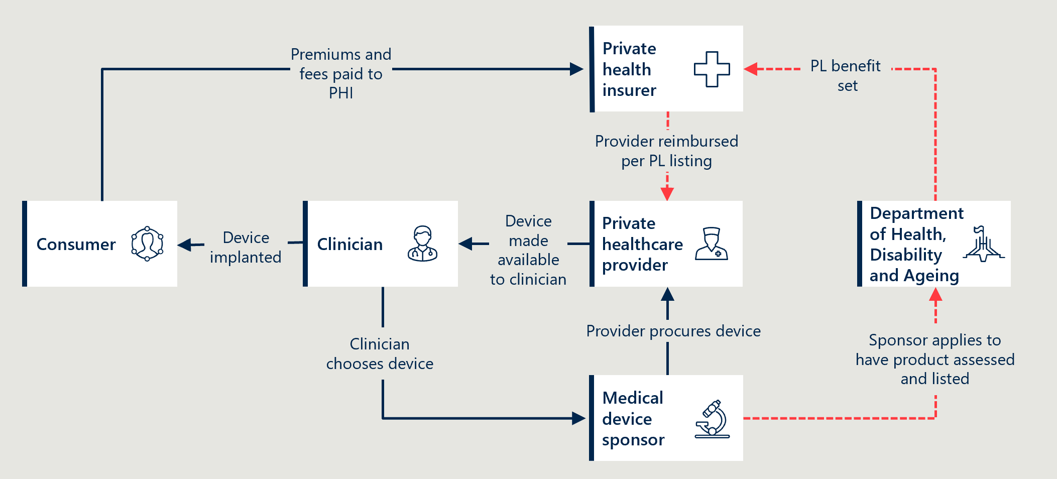

# Executive summary

The Department of Health, Disability and Aged Care commissioned the Nous Group to evaluate the reforms to the PL reforms between 2022 and 2026. The reforms were introduced in the 2021-22 Federal Budget, seeking to “reduce the cost of medical devices used in the private health sector and streamline access to new medical devices.”

To date, Nous has developed an Evaluation Framework, a Baseline Evaluation report and Interim Evaluation #1 report, which covered the implementation of the reforms until June 2024.

This *Interim Evaluation #2* *report* broadly covers the period from July 2024 to June 2025 and builds on the first interim report. The various timeframes for the data used in this report are:

* Reform activity from July 2024 to June 2025, with additional commentary on ongoing implementation.
* Stakeholder consultations undertaken between April and June 2025.
* Measures based on published data are reported up to June 2024, unless otherwise stated, due to standard delays in data availability.

Like *Interim Evaluation #1 report*, this report is structured by the eight stated reform objectives from the original Evaluation Framework which sit alongside the series of reform projects identified to achieve them.

#### Findings from this report

Findings from *Interim Evaluation #2 report* reinforce and provide further commentary on many of the findings from *Interim Evaluation #1 report*.

Findings that indicate the reforms are continuing to achieve their objectives include:

* Overall, benefit reductions were implemented as planned, although the benefit reductions for CIED were amended (Objective 1).
* The Objectives of no additional out of pocket costs and maintaining clinician choice continued to be broadly achieved (Objectives 2 and 3) although concerns were expressed at the margin. Concerns relate to the risk of cost-shifting behaviour on out of pockets and potential limitations on clinician choice related to high cost/more advanced technologies.
* The benefit reductions have continued to place downward pressure on the affordability of private health insurance. But while the benefit reductions have resulted in PHI premiums being lower than they otherwise would have been, premiums have continued to rise due to other forces, particularly the growth in volume of devices listed on the PL (Objective 4).
* Changes to governance have improved the efficiency of decision-making. There are calls for greater transparency by some stakeholders and more opportunity to impact decisions (Objective 6).
* Post Listing reviews have continued, with two reviews completed and a further two still underway over an extended period. A new framework for future reviews has been developed (Objective 7).
* Cost recovery fees and a cost recovery levy have been implemented (Objective 8).

Reform activities that have not achieved their planned objectives include:

* Benefit reductions for CIEDs remain unresolved due to the complexity of arrangements for technical support services (Objective 1).
* Regrouping of the PL was formally discontinued in May 2025, following the previous pause in implementation (Objective 5).
* The proposal to remove GUIs from the PL was abandoned in May 2024 (Objective 5).
* Reforms to the assessment pathways have been challenged by resourcing limitations (Objective 6).
* Post listing reviews have taken excessive time in two cases (Objective 7).
* Compliance activities have stalled, with the current level of compliance activity likely insufficient to safeguard the PL (Objective 7).

#### Stakeholder perspectives remain divided

Consumer representatives reported broad support for the PL mechanism and for the reform process, which they believe contribute to constraining the cost of private health insurance and maintaining safety and quality of care.

The reforms are largely viewed as a contest between private sector stakeholders, who hold divergent views on the pace, depth, rationale for and impact of benefit reductions. These divergent views are set out in this report against each objective of the reforms. The feedback received from stakeholders has been summarised for the purpose of clarity and brevity. Whilst efforts have been made to capture the essential content and key themes, the summaries in this report may not reflect all the nuances and particulars of the written feedback provided to the evaluation.

#### Recommendations

Table 1 outlines recommendations based on the analysis undertaken for this report. These are interim recommendations that will be tested and expanded upon for the final evaluation report in 2026.

Table 1 | *Interim Evaluation #2 report* recommendations

|  |  |
| --- | --- |
| Recommendation | Reform project |
| 1. Review the potential role of international benchmarking in benefit setting and future reforms  While PL benefits are now better aligned with public sector prices, there is limited transparency around how they compare with international markets. A methodology could be developed to establish international benchmarks that include an appropriate Australian market premium – similar to how the 7% price floor was applied above public sector benchmarks during the reforms. This methodology could be applied to develop and update a comprehensive reference list that could be used to review a subset of products (e.g. high-cost devices) or used on an ad hoc basis. If established, these international benchmarks could provide a useful additional input into PL application assessments, post-listing reviews and future reform decisions. | Benefit reductions (Objective 1) |
| 2. Explore alternative funding models that separate CIED device and service costs  In the medium term, the Department and the sector should explore alternative funding models that separate device and service costs, including the benefits and risks of the alternatives. Unbundling would support greater transparency and allow each component to be priced appropriately. Reform efforts could also include continued support for remote monitoring – in line with technological advances – and the potential development of a national CIED registry to improve oversight and service quality. | Benefit reductions (Objective 1) |
| 3. Monitor the impact of PL conditions on clinician choice and access to advanced devices  Ongoing monitoring is needed to assess whether recent PL changes are limiting clinician choice or affecting timely access to advanced devices such as CIEDs, surgical guides and biomodels. This will help ensure that reforms do not unintentionally compromise clinical decision-making or patient care. | Clinician choice (Objective 3) |
| 4. Revisit the objective to regroup the PL by clinical use  There is an opportunity to build on previous regrouping work to improve transparency and simplify the structure of the PL. Without the constraint of the former MOU ban on savings, a renewed effort could also help reduce pressure on PHI premiums. Any future regrouping would require updated analysis and consultation with stakeholders. | Regrouping (Objective 5) |
| 5. Continue to explore development of a sustainable funding model for general use items  The work undertaken during the reform process to explore alternative funding approaches for GUIs should be leveraged in the post-reform context. There is an opportunity to build on this investment to develop a workable, clinically appropriate model that reduces system costs without adverse outcomes. Any future approach should align with the broader policy objective of streamlining the PL’s scope to reduce cost pressures on private health insurers. | General use items (Objective 5) |
| 6. Regularly review resourcing needs to strengthen application pathways and inform cost recovery planning  The effectiveness of the application pathways would benefit from a review of resourcing requirements, including the level of expertise required, appropriate service standards, and the staffing structure needed to meet those standards. The findings should directly inform the design of the cost recovery model to ensure it supports a fit-for-purpose workforce. | Assessment pathways (Objective 6)  Financial sustainability (Objective 8) |
| 7. Review application pathways and update guidance to reflect experience and clarify processes  Following two years of implementation, the revised application pathways should be reviewed to identify targeted improvements that enhance clarity, efficiency and alignment with evidence. This review should inform updates to the PL Guide, including clearer guidance on assessment pathways, criteria for Ministerial recommendations, and the focused HTA process. Drawing on international experience may also support improvements. Clearer, more detailed guidance will help sponsors better navigate the system and reduce delays or confusion. | Assessment pathways (Objective 6) |

## Current state of the reforms

Table 2 | Overview of reform objectives, their baseline position and current progress

|  |  |  |  |  |  |  |
| --- | --- | --- | --- | --- | --- | --- |
| Reform objective | Baseline state | Rationale for objective | How it is intended to be achieved | Progress status | Progress against reform timetable | Outcome to date |
| 1. Improve the alignment of the scheduled benefits of the PL with the prices paid in more competitive markets | PL benefits are significantly higher than prices in comparable markets. | High PL benefits contribute to PHI costs and issues of affordability. | PL benefits to be reduced incrementally over reform period in reference to IHACPA’s public benchmark prices (by 80% of the gap or within a 7% floor for most items). | Tick outline | On track – All scheduled benefit reductions for Part A and the device portion of CIEDs have occurred as of 1 July 2025. | Benefits have been reduced across eligible sections of the PL.  Benefits are more closely aligned with prices in Australian public hospitals.  Case studies comparing PL benefits with prices paid for the same products in New Zealand and France indicate a closer alignment with international markets. However, the case studies also indicate the gap in prices remains substantial in some instances.  CIED reductions have been completed for the device portion only, and future funding arrangements for technical support services (TSS) are unresolved. |
| 2. Maintain no additional out-of-pocket costs associated with the PL devices for consumers | Out-of-pocket costs for devices are charged in <1% of episodes. | Minimising out-of-pocket expenses is important for maintaining access to devices. | Maintaining minimal out-of-pocket costs establishes guardrails for the benefit reduction exercise and other policy decisions. | Tick outline | On track – Policy settings that drive ‘no out-of-pocket costs’ have largely been maintained. | Out-of-pocket costs for devices continue to be rare, however stakeholders have reported some instances. Overall, gaps are evident in <1% of episodes for most categories of the PL. This suggests that the PL continues to meet the goal of minimising consumer out-of-pocket costs. |
| 3. Maintain clinician choice of appropriate prostheses for their patients | Clinicians have a choice of PL-listed items. | Ensuring clinician choice is a core principle of the PL design. | Maintain policy position enabling clinician choice of appropriate prostheses. | Tick outline | On track – Policy settings that embed clinician choice have largely been maintained. | There are no clear patterns that indicate clinicians’ choice of devices have been systemically impacted by the reforms.  Stakeholders have reported some instances where clinician choice has been either constrained or is at risk, particularly for advanced devices. The extent of this should be examined over time. |
| 4. Improve the affordability and value of PHI for privately insured Australians | PHI affordability is currently an issue of concern, participation rates are decreasing and risk profiles increasing. | Low PHI participation places strain on the rest of the health system. | Reduction in PL benefits while maintaining device availability and access. | Tick outline | On track – Progress achieved through objectives 1-3. | Savings gained through benefit reductions have placed downward pressure on PHI premiums for consumers. Over $300 million in estimated savings were achieved from FY23 to FY24.[1]  Despite this, premiums have continued to rise due to factors unrelated to the reforms. Prostheses utilisation growth has partially offset the effect of benefit reductions, and insurance claims have increased at a rate above inflation.  The value of PHI in relation to PL access has been maintained for consumers. PHI coverage has increased marginally since baseline. |
| 5. Clarify the purpose, definition and scope of the PL in legislation | Only high-level definition of PL in legislation.  Expanding PL scope over time is seen as a major driver of costs.  PL structure has become complex and difficult to navigate. | Lack of clarity and complex structure leads to reduced effectiveness and unwanted outcomes. | Establishment of new legislation regarding the PL.  PL groups to be reviewed and restructured.  General use items (GUIs) to be removed from the PL. | Tick outline  Cross outline  Cross outline | On track – Legislation addressing the purpose, definition and scope of the PL has been achieved during the reforms. The decision to retain GUIs has required a subsequent update to the PL Rules to permit these items to remain on the PL.  Not achieved – Regrouping has not been implemented, and the project has been discontinued.  Not achieved – GUIs have not been removed from the PL (however, benefits were aligned with public benchmarks). | Legislated changes have incorporated new terminology and definitions of PL scope. However, the decision to retain GUIs on the PL, and having no long-term position for the services attached to CIEDs has diluted the impact of this reform project.  The proposed PL regrouping framework introduced mixed benefit groupings that added complexity to the regrouping process. This led to the decision to withdraw the project from the reform program. The expected benefits of reduced grouping complexity and increased alignment with clinical use have not been achieved.  GUIs will remain on the PL and will not be part of the reforms’ aim to clarify the PL scope. |
| 6. Implement new PL assessment pathways aligned to Health Technology Assessment principles and streamline the application process through simple and robust IT infrastructure | No distinct assessment pathways based on complexity.  Assessment process has mixed alignment with HTA principles. | Effective and efficient assessment crucial to maintain integrity of the PL. | Multi-tiered application process to be established.  Changes to assessment governance processes. | Horizontal dash outline | Ongoing – New governance arrangements and tiered assessment pathways have been implemented, though some elements remain in an interim state. | New PL assessment pathways and governance arrangement are in operation. However, challenges with the new assessment pathways and application processes means the expected efficiency gains have not yet been realised. |
| 7. Develop and implement PL listing reviews and PL compliance frameworks to safeguard the PL Reform | No formal compliance strategy.  No formal post-listing review framework. | Effective compliance crucial to safeguard the PL reform.  Post-listing review mechanisms important to maintaining the integrity of the PL. | Development of formal compliance strategy and associated functions.  Development of post-listing review framework and completion of pilots. | Horizontal dash outline  Horizontal dash outline | Ongoing – Planned legislative changes to increase compliance powers have not yet been implemented.  Ongoing – The Post-Listing Review Framework has been finalised, and two of the four pilot post-listing reviews have been completed. | Implementation of compliance measures has not progressed sufficiently to assess impact.  While two of the four reviews are still ongoing, the post-listing review framework has been updated to provide increased clarity and certainty surrounding the process of future reviews.  Stakeholders have expressed concerns about the Department’s capacity to effectively operate compliance and post-listing activities. |
| 8. Ensure ongoing financial sustainability of PL administration through effective and efficient cost recovery arrangements that are compliant with the Australian Government Charging Framework | Historically established cost recovery arrangements are non-sustainable and misaligned with Australian Government Charging Framework. | PL administration should be cost-neutral to Government. | Cost recovery arrangements to be revised. | Tick outline | On track – Revised cost recovery arrangements have been implemented, and the first PL Levy occurred for 2024-25. | The Department’s revised cost recovery arrangements have been implemented and are aligned with the modernised PL and the Australian Government Charging Framework.  The Department should continue to review activity to ensure that the cost-recovery model sustainably supports the PL. |

# About this Report

The Prescribed List reforms were introduced in the 2021-22 Australian Federal Budget to “reduce the cost of medical devices used in the private health sector and streamline access to new medical devices”. The Department of Health, Disability and Ageing (the Department) implemented the reforms from 1 July 2021 to 30 June 2025.

The Department commissioned Nous Group (Nous) to conduct an independent evaluation of the reforms from September 2023 to June 2026, using the Prostheses List Evaluation Framework (see Appendix A.2). The evaluation seeks to understand the extent to which reform activities have delivered the objectives of the Prescribed List reforms and to provide formative insights into implementation. To support this, Nous developed an evaluation plan that articulates the program theory of change, defines a set of Key Evaluation Questions (KEQs), and outlines indicators and measures to guide the evaluation.

Further detail on the evaluation methodology is provided in Appendix A.

Nous has previously delivered two reports: the *Baseline Evaluation report*[2] and *Interim Evaluation #1 report*[3], which covered the period from May 2021 to June 2024.

#### Building on earlier findings, this second interim evaluation focuses on reform activity through 2024-25

This *Interim Evaluation #2 report* extends the analysis to include reform activity undertaken between July 2024 and June 2025.

The report draws on multiple timeframes to present a comprehensive view of progress and impacts:

* Primary focus: Reform activity from July 2024 to June 2025, with additional commentary on ongoing implementation, stakeholder perspectives, and emerging outcomes across the full span of the reforms.
* Stakeholder insights: Consultations for this report took place between April and June 2025. As a result, stakeholder perspectives may not fully reflect developments occurring in the final weeks of the reporting period.
* Data reporting: Measures based on published data are reported up to June 2024, unless otherwise stated, due to standard delays in data availability.

This report follows the established structure, organised around the eight reform objectives set out in the Department’s original Evaluation Framework. Figure 2 maps these objectives to the key reform projects intended to achieve them.

Figure 2 | Reform objectives and associated reform projects

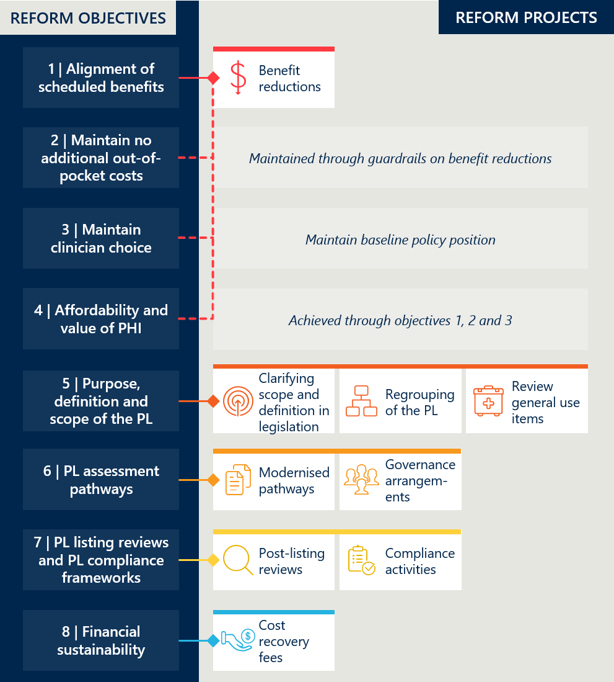

# Findings of *Interim Evaluation #2* report

#### Multiple reform projects have progressed over the year to June 2025

In the period July 2024 to June 2025 new activities under the reforms included:

* The third and final benefit reduction of 20% of the gap for Part A devices that occurred as planned on 1 July 2024.
* The second benefit reduction of 20% of the gap for the device component of CIEDs (estimated as 56.3%) that occurred on 1 July 2024.
* Stakeholder consultation on how to implement the MSAC advice and reduce benefits for technical support services for CIEDs, via Consultation paper 9 between 12 July and 6 September 2024.[4]
* Stakeholder consultation on various aspects relating to integrity, utilisation and growth in expenditure of General Use Items (GUIs) on the PL between 9 August 2024 and 20 September 2024. A summary of the feedback and individual responses were published on 20 January 2025.[5]
* The removal of 26 billing codes (medicines and accessories to medicines) from the PL on 1 November 2024.[6]
* The release of the updated PL post-listing review framework on 12 December 2024.[7]
* An announcement by the Department that the measures for compliance, assurance and information sharing proposed in Consultation Papers 8a and 8b would not be legislated, on 9 January 2025.[8]
* The first instance of the Prescribed List cost recovery levy, with the levy date for the 2024-25 PL occurring on 15 March 2025.[9]
* An announcement by the Department that the regrouping of Part A of the PL will not be continued as a reform measure on 12 May 2025.[10]
* The third and final benefit reduction of 20% of the gap for the device component of CIEDs occurred on 1 July 2025.
* Two of four post-listing reviews have been finalised, while two are ongoing.

Section 2 documents and evaluates the implementation of reform activity conducted over the past year and builds on the *Interim Evaluation #1 report* to assess the evolving impact of activity conducted over the full reform period.

## Objective 1: Improve the alignment of the scheduled benefits of the PL with the prices paid in more competitive markets

*This section considers the reduction of benefits and the resulting change in the size of the gap between PL benefits and prices paid in more competitive markets. It includes an estimate of the overall savings associated with benefit reductions and related stakeholder perspectives.*

Figure 3 | Reform projects related to reform objective 1

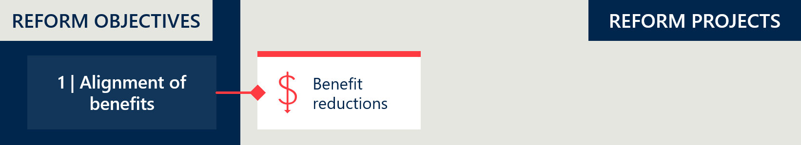

### Implementation progress: benefit reductions

|  |
| --- |
| At baseline, there was a notable gap between PL benefits and prices in the Australian public health system (where compared to IHACPA’s Weighted Average Prices, public benchmarks of PL items[11]) despite a series of benefit reductions between 2018 and 2020.  As outlined in the *Interim Evaluation #1 report*, the Department reduced benefits to Part A of the list according to an agreed schedule of benefit reductions over three years documented in the Memorandum of Understanding (MOU) between the then Minister and the Medical Technology Association of Australia (MTAA).[12] Figure 4 summarises the timeline of benefit reductions.  The third and final reduction was implemented in July 2024, a further reduction of 20% of the gap between the current benefit and the public benchmark. This has resulted in all eligible benefits being reduced by 80% of the gap.  The following PL items were subject to an alternative schedule of reductions:   * General Use Items (GUIs) – With the removal of GUIs initially delayed, the Department reduced GUI benefits by 60% of the gap followed by the remaining 40% of the gap. In May 2024, the Minister announced GUIs would not be removed from the PL but would be remain at the reduced benefit levels (see Figure 22). GUIs are considered in Objective 5. * Cardiac Implantable Electronic Devices (CIEDs) – As agreed in the MOU, the Department deferred benefit reductions to CIEDs by one year to allow for further consultation on the value of technical support services. The final benefit reduction for CIEDs (20% of the gap on the device only amount) occurred on 1 July 2025. No benefit reductions on the technical support services component of CIEDs occurred during the reforms. CIEDs are considered separately in Section 2.1.5.   The reductions methodology was discussed in Section 2.3.4 of the *Interim Evaluation #1 report*, which includes an overview of stakeholder perspectives at the time.[13]  The estimate of savings from the reductions is discussed under Objective 4. IHACPA has not updated its estimates of savings from benefit reductions since November 2023. However, these projections based on the scheduled reductions and modelled prostheses utilisation growth remain relevant. |

Figure 4 | Timeline of benefit reductions

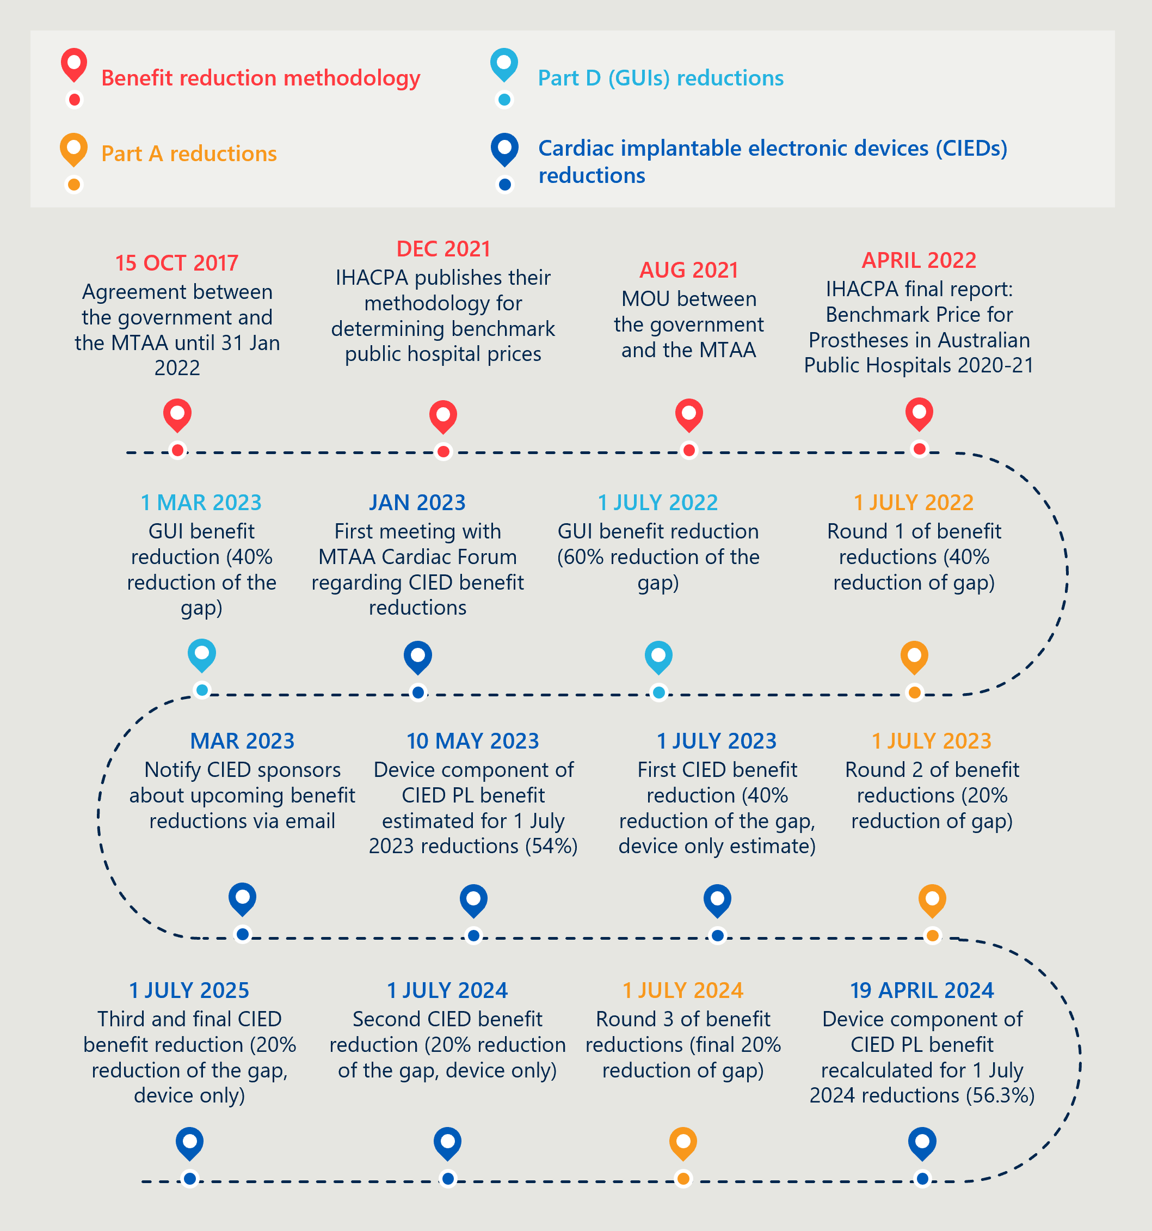

### The reforms delivered benefit reductions to of 51% of PL items

51% of all items on Parts A, C and D of the PL were subject to benefit reductions during the reforms.[14] These items had benefits that were at least 7% higher than public sector benchmarks at the commencement of the reforms. This represents a significant alignment in pricing.

Part C was out of scope for reductions (~1% of items), leaving ~48% of items already at or below the 7% price floor established by the MOU, and therefore not subject to reductions.[15] Figure 5 below shows the breakdown of items subject to reductions by PL category.

Figure 5 | PL items subject to reform reductions (Parts A and D, excluding CIED items)[16]

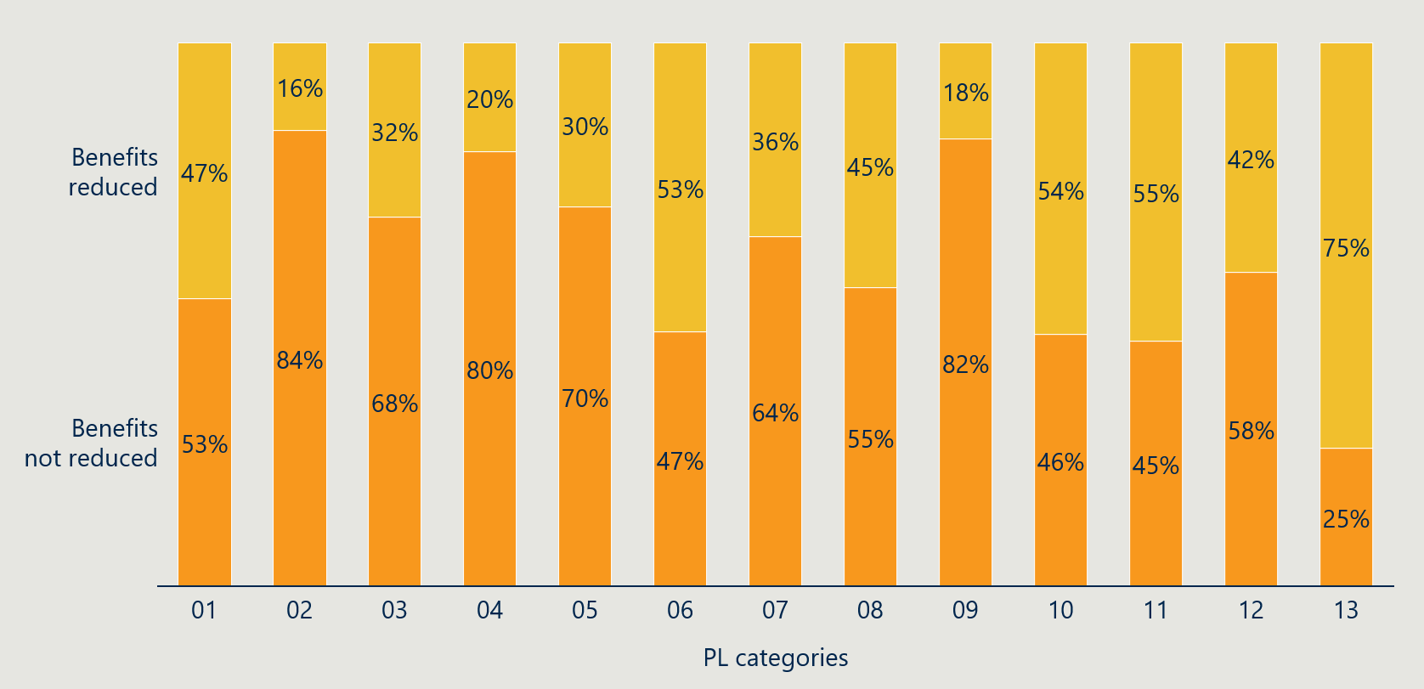

Table 23 in Appendix D.1 lists the benefit groups and items that were subject to reductions across the 13 PL categories. Over half of the 5006 items subject to reductions were in the Specialist Orthopaedic or Spinal categories.

### The benefit reductions have reduced the gap between PL benefits and comparable prices

Objective 1 of the reforms is to “Improve the alignment of the scheduled benefits of the PL with the prices paid *in more competitive markets*”. The evaluation assessed the median gap against Australian public sector benchmark prices as well as limited international comparisons.

#### For items subject to reductions, the median gap above Australian public sector prices decreased from $177 to $35

The narrowing gap between PL benefits and public sector benchmarks (as reflected in IHACPA’s Weighted Average Prices) suggests that the reforms are improving price alignment with more competitive markets. Figure 6 shows that, across all items, the median gap fell from $24 to $8 following the three rounds of reductions. Among the items specifically targeted for reductions – around half of the PL – the median gap decreased from $177 to $35.

Figure 6 | Median gap with public benchmark prices (Parts A and D, excluding CIEDs)[17]

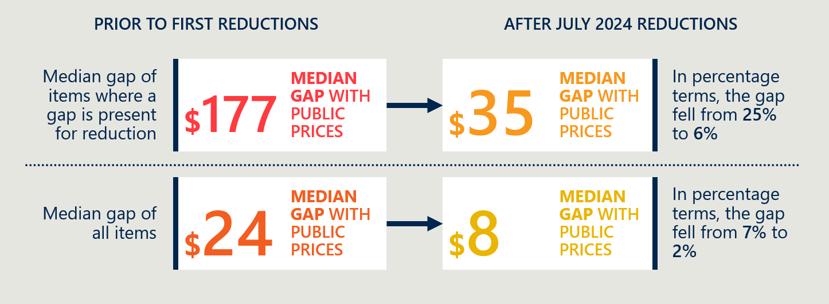

Table 26 in Appendix D.2 shows the median dollar and percentage gaps across PL categories before and after the reforms. All but one category now has a median gap of less than 12% above public benchmark prices. The exception is the Cardiac category (excluding CIEDs),[18] which, although it had the largest percentage price reduction, still has a median gap of 42%.

Figure 7 shows the distribution of PL items according to their gap above public benchmarks – the orange bar represents the gaps following the July 2024 reductions and the dark blue bars represent the gaps at baseline. The number above each bar is the change in the number of items with that percentage gap. The absence of orange areas on the higher percentage gaps demonstrate there has been a significant reduction in items with large gaps. Since the baseline, 491 fewer PL items have a gap above 91%, and 2,360 additional items now have a reduced gap of less than 7%.[19]

Figure 7 | Percentage gap between PL benefits and public benchmark prices (excluding CIED items)[20]

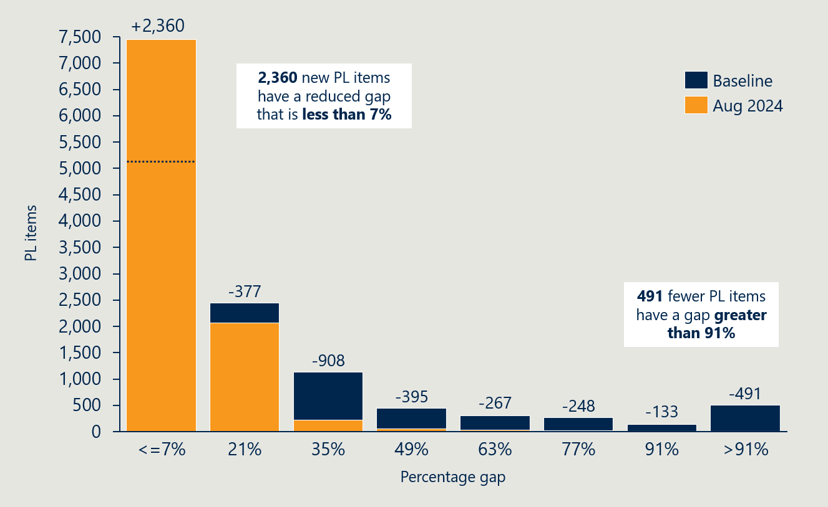

#### PL benefits are also better aligned with some international markets

An updated case study comparison with New Zealand and France, outlined in Appendix D.2, shows that prices in those markets have continued to remain stable throughout the reform period, while the Australian PL benefits have declined. This has narrowed the price gap, indicating that the reforms are achieving their goal of improving alignment with prices in more competitive markets.

As was discussed in Section 2.3.6 of the *Interim Evaluation #1 report*, the reforms have had mixed success in meaningfully reducing the absolute gap with the French market. While alignment has improved in some areas, the price differential with the French *Liste des Produits et Prestation (LPP)* remains substantial in others:

* A case study of knee implants (12.08.01 PL benefit group, see Figure 31) shows a noteworthy improvement in alignment. The gap between the French and Australian benefits decreased from $321 (a 158% difference) in 2021 to $134 (66%) in 2023.[21]
* In contrast, a case study of spinal fusion cages (13.10.01.02 PL benefit group, see Figure 33) shows limited change. The PL benefit remains approximately six times higher than the French LPP price at the end of reform period.[22]

As the reforms were based on benefit reductions on public sector pricing, improved alignment with those benchmarks was expected.[23] However, while market conditions vary between countries, the limited international comparisons available suggest that Australian prices – in both the public and private sectors – remain among the highest globally. While there are many factors that cloud a comparative assessment (as outlined in Appendix F of the *Baseline evaluation of the Prostheses List Reforms report[24])*, further work could be undertaken to understand the differences and highlight where reductions could be achieved.

|  |
| --- |
| RECOMMENDATION 1  Review the potential role of international benchmarking in benefit setting and future reforms  While PL benefits are now better aligned with public sector prices, there is limited transparency around how they compare with international markets. A methodology could be developed to establish international benchmarks that include an appropriate Australian market premium – similar to how the 7% price floor was applied above public sector benchmarks during the reforms. This methodology could be applied to develop and update a comprehensive reference list that could be used to review a subset of products (e.g. high-cost devices) or used on an ad hoc basis. If established, these international benchmarks could provide a useful additional input into PL application assessments, post-listing reviews and future reform decisions. |

* + 1. Stakeholders have expressed varied perspectives on the reductions

Consumers have limited visibility over the PL and benefit reductions, as these transactions occur at arm’s length from them. Their primary concerns relate to the cost of private health insurance and the safety and quality of medical devices. Consumer representatives expressed broad support for the PL mechanism – which they believe contributes to these objectives – as well as for the overall reform process.

Among private sector stakeholders, the reforms are largely seen as contested. Private hospitals raised concerns that benefit reductions have shifted financial pressure onto hospitals, potentially compromising care quality and limiting access to advanced devices. Some private hospital representatives were of the view that the 7% margin above public benchmarks is insufficient to cover private sector costs.

Medical technology representatives acknowledged that benefit levels are now better aligned with public pricing but cautioned that inflation and the lack of mechanisms to increase benefits may undermine innovation and limit patient access.

Private health insurers argued that the savings from modest reductions in per-episode costs are insufficient to reduce premiums and raised concerns about what they see as ongoing gaming of the system. They also criticised the use of public sector averages, claiming this approach preserves ‘supra-economic’ profits for some sponsors and fails to deter high-volume listings.

Clinicians were broadly supportive of the 7% price floor and the use of public benchmarking but stressed the importance of preserving clinician choice. They warned against restricting access to devices as a means of reducing prices, drawing comparisons to more limited choice in public systems.

These perspectives are presented in Table 3 below.

Table 3 | Stakeholder perspectives on improving benefit alignment with comparable markets[25]

|  |  |
| --- | --- |
| Stakeholder group | Perspectives on reform project |
| Private hospital sector | * The phased reductions reflect a clear fiscal objective, but stakeholders are concerned that their pace and depth may affect access to essential devices, particularly in complex care. * Reductions have increased financial pressure on private hospitals and made listing new devices more burdensome. Some advanced devices may now be more accessible in the public sector, potentially reducing consumer choice in the private system. * The 7% margin above public benchmarks is seen as insufficient to cover private sector costs, particularly for high-cost devices. This could compromise providers’ ability to offer certain treatments and may impact care standards and innovation. * Stakeholders also questioned whether projected savings account for provider costs, warning that realising benefits without impacting care quality may be difficult. |
| Private health insurance representatives | * Insurers noted that benefit reductions for devices align with the MOU, except in the case of CIEDs.   *Insurer perspectives related to medical device spending and savings are included in Objective 4.* |
| Medical technology representatives  *Icon of a microscope* | * The benefit reductions were consistent with the MOU, and prices are now better aligned with the only relevant comparator – the public market. * The scale of reductions was seen as appropriate given the reform goal of narrowing the gap between private and public prices. However, stakeholders noted that public markets often achieve lower prices through guaranteed volume, which is not appropriate in a private market where clinician-led choice is critical. This dynamic was not accounted for in the treatment of general use items. * There is currently no meaningful mechanism to allow benefit increases where supply costs have risen significantly – for example, due to freight or input costs. Cost inflation has affected the medical device sector as it has other sectors. |
| Clinician representatives  Icon of a person with a stethoscope | * Clinicians identified a number of issues with public price benchmarking and noted it reasonable for PL pricing to be somewhat higher than public sector pricing. The 7% threshold is broadly supported. * While international markets are of limited relevance to PL pricing, stakeholders are supportive of continued use of public sector benchmarks. |

* + 1. Cardiac implantable electronic devices proved complex, with only partial reductions achieved

As discussed in the *Interim Evaluation #1 report*, Australia has an unusual model for funding CIEDs. For patients in private hospitals, the benefit for CIEDs has covered the cost of the device and the ongoing costs of the technical services that come with managing the devices after implantation. While these two components are not separately identified on the PL, sponsors advise that CIED benefits are at a level that enables them to provide industry-employed cardiac technicians (IECTs) to ensure CIEDs are functioning correctly – and the surplus benefit enables this workforce to review any alerts sent by CIEDs at no additional cost to the consumer.

Some public cardiac clinics and public hospitals also rely on technical support services (TSS) provided by privately-employed IECTs, creating cross-sector subsidisation. This means that funding via the PL intended for the private sector is also supporting some services in the public system. Reliance on IECTs is reportedly more common in areas with service gaps such as rural and regional areas of Australia, and for services involving highly complex CIED patients.[26]

#### Benefit reductions to CIEDs required a tailored approach

Early in the reform process, the Department identified that CIEDs would need a separate pathway for benefit reductions. The March 2022 MOU between the Minister and MTAA confirmed that CIEDs would follow an alternative schedule to allow Medical Services Advisory Committee (MSAC) to assess the value of associated technical support services.[27]

Consultation and an MSAC review confirmed that standard benefit reduction methods would not suit CIEDs, as the PL benefits for these devices include bundled funding for technical support services. While the PL does not provide for reimbursement of support services, MSAC and the Department adopted industry’s language of 'components' within the CIED benefit – acknowledging that device and service costs are not easily separated.

To avoid disrupting patient care, the Department took a cautious approach. It ultimately adopted the key elements of MSAC’s short-term recommendation, applying benefit reductions to the device component only – estimated to be 56.3% of the total benefit.[28] Multiple rounds of CIED-specific benefit reductions were implemented, with the second reduction of 20% of the gap on the device only, applied in July 2024, as shown in Figure 8.

#### The current gap between CIED PL benefits and public prices was not available

The evaluation has not been provided data showing the gap between PL benefits and public prices for CIED items. CIED items were additionally excluded from aggregated gap analysis provided to Nous for the evaluation (see Table 26). As a result, progress towards aligning CIED benefits with more competitive markets cannot be quantified.

However, as outlined in Section 2.3.5 of the *Interim Evaluation #1 report*, the evaluation estimated the median gap of the CIED items (device component only) to be approximately $19,600 (188% gap) and no less than $17,600 (144% gap) at the commencement of the reforms.

Figure 8 | Reform timeline of CIED related activities

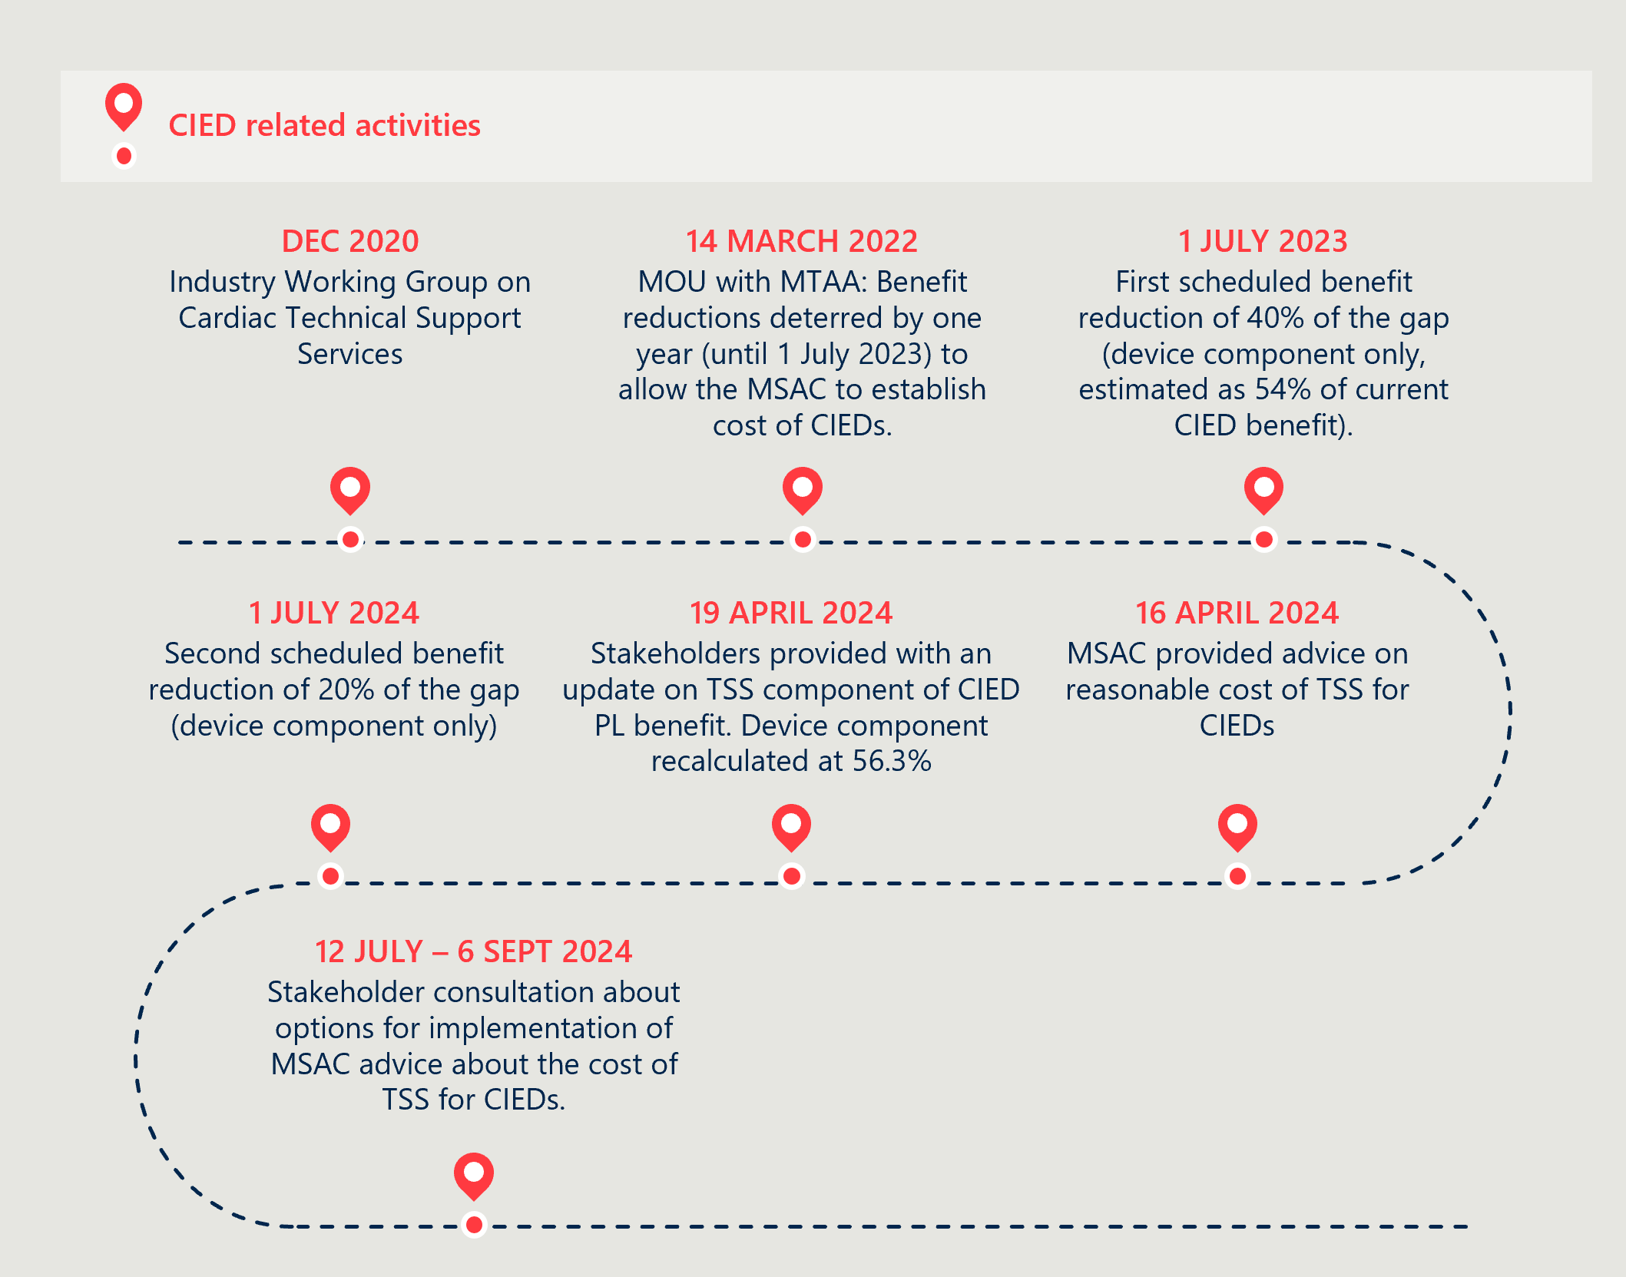

Concerns remain that CIED benefit reductions have had unintended consequences on patient care

Some sponsors have reported reducing their IECT workforce or scaling back services in response to CIED benefit reductions, citing financial viability pressures.[29] While the PL does not separately reimburse technical support services, there is a widely acknowledged need to maintain these services to ensure safe and timely care.

The Cardiac Society of Australia and New Zealand (CSANZ) has raised concerns about emerging service gaps, particularly in regional, rural and remote areas. They note that while the public system does employ cardiac technicians, the workforce is limited and often relies on industry support for complex procedures and broad geographic coverage. These unintended consequences risk reducing access to essential CIED support services across both private and public settings, at least in the short to medium term.

The model for funding CIEDs requires further reform

Temporarily shielding technical support services from staged benefit reductions has helped protect patient care and avoided sudden out-of-pocket costs for people with CIEDs.

However, service gaps have still emerged, and this protection is not guaranteed in the long term. In the meantime, the impacts of uncertainty are being felt. The unintended consequences point to the need for broader reform of how CIEDs and their support services are funded.

Future reform must be staged, data-informed and focused on preserving patient outcomes. Without adequate preparation or viable alternatives for service delivery, further change could reduce access and increase costs for patients.

|  |
| --- |
| RECOMMENDATION 2  Explore alternative funding models that separate CIED device and service costs  In the medium term, the Department and the sector should explore alternative funding models that separate device and service costs, including the benefits and risks of the alternatives. Unbundling would support greater transparency and allow each component to be priced appropriately. Reform efforts could also include continued support for remote monitoring – in line with technological advances – and the potential development of a national CIED registry to improve oversight and service quality. |

#### Stakeholder perspectives

Stakeholder feedback on CIED reforms highlights a core tension between achieving cost savings and maintaining service continuity. While the Department’s phased approach to benefit reductions on the device component only was broadly viewed as pragmatic, many stakeholders identified the lack of a sustainable funding model for technical support services as a major risk.

Private health insurers were critical of the existing approach, arguing that technical support services should not be bundled within device rebates, calling for immediate price reductions and clearer accountability for service provision.

In contrast, medical technology representatives, particularly the MTAA Cardiac Forum, opposed changes to the current model. They argued that it is already cost-effective and warned that further reforms could disrupt service delivery and shift costs onto consumers.

Private hospital and clinician representatives expressed mixed views on separating device and service costs. Some supported the model for its potential to improve transparency, provided it maintained access to technical support and did not compromise care. Others opposed it, arguing coupling of devices and follow-up services is cost-efficient and that decoupling would increase costs for consumers and hospitals.

Table 4 summarises further stakeholder views.

Table 4 | Stakeholder perspectives on reductions to CIEDs[30]

|  |  |
| --- | --- |
| Stakeholder group | Perspectives on reform project |
| Private hospital sector | * Stakeholders generally viewed the Department’s decision to apply benefit reductions only to the device component as a considered approach that balanced cost containment with patient safety and service continuity. Some stakeholders did not support any reduction. * Concerns were raised about the proposed removal of TSS from the PL benefit structure, which stakeholders said risks undermining sponsors’ ability to deliver these services via trained technicians. They noted this could lead to reduced access, increased out-of-pocket costs for patients and increased financial pressure on hospitals. As such, some hospital representatives oppose the decoupling of TSS funding from the device benefit. * However, other hospital representatives support developing a new funding mechanism that unbundles device and service costs in the short term – with the goal of preserving access to TSS without inflating device benefits. In the longer term, they support full separation of follow-up services from the PL, underpinned by a sustainable mechanism for TSS. Any such reform would require broad input to clarify how costs would be distributed. |
| Private health insurance representatives | * Insurers were disappointed by the deferral of benefit reductions for CIEDs, stating it contributed to lower-than-expected cost savings. They were also critical of sponsors’ engagement with the MSAC application (1724). * Insurers acknowledged the role of TSS but noted that not all patients receive these services. They argue that prices are excessively high and should be reduced immediately. * Stakeholders expressed concern about the appropriateness of funding TSS through the PL. They noted that there is limited visibility over who delivers TSS, how long services are provided for, or whether they are effective – contributing to concerns about the transparency and value of the current approach. * Insurers reported they were not aware of any other implantable devices on the PL where assumed TSS costs are embedded in the benefit, suggesting the CIED pricing structure is inconsistent with other listings. |
| Medical technology representatives  *Icon of a microscope* | * Stakeholders agreed that the Department’s approach to benefit reductions for CIEDs was appropriate in principle but raised concerns about the lack of clarity around TSS and its implications for service delivery. * They emphasised that CIEDs involve a unique care model that was not fully reflected in the PL benefit structure, particularly the embedded service component. * The inclusion of CIEDs in the adjustment model without consideration of TSS created unrealistic expectations around potential savings. * Stakeholders acknowledged the Department’s efforts to understand the delivery model and minimise adverse impacts on patients but warned that further cuts could affect the industry’s ability to continue delivering TSS. * They maintained that the current model is still the most cost-effective for delivering outcomes across comparable healthcare systems and noted that manufacturers have already absorbed multiple rounds of reductions. |
| Clinician representatives  Icon of a person with a stethoscope | * Clinicians emphasised that any reformed approach to TSS must ensure it is adequately funded to avoid out-of-pocket costs for patients. In the absence of an alternative, they supported continuing to fund TSS through the PL. * They proposed establishing a national CIED register as a first step to improve understanding of service delivery models and to inform more accurate costings of TSS currently provided by industry. * One clinician group advocated for developing a workforce of fully trained independent cardiac physiologists to deliver TSS currently performed by device companies. They stressed the need to design such a model in a way that ensures continuity of services for patients during any transition. |

## Objective 2: Maintain no additional out-of-pocket costs associated with the PL devices for consumers

*This section considers any change in out-of-pocket costs related to PL items. It examines the prevalence of a gap payment for PL items and the average gap payment for PL-listed items.*

Figure 9 | Reform projects related to reform objective 2

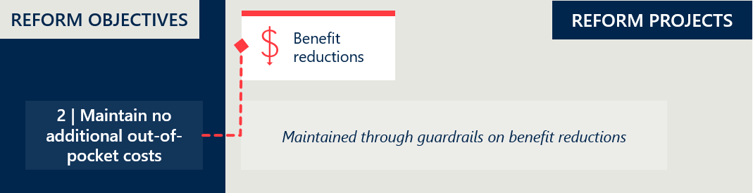

### Implementation progress: out-of-pocket costs

|  |
| --- |
| There were no specific activities associated with the maintenance of out-of-pocket costs during this period. The findings remain similar to those in the *Interim Evaluation #1 report*. |

### The reforms maintain minimal out-of-pocket costs for PL items

The PL reforms have successfully maintained low out-of-pocket costs for consumers. Health Casemix Protocol (HCP) data shows that direct gap payments for prostheses remain rare.[31],[32] However, stakeholders have reported occasional cases where consumers were financially worse off, and there remains a risk of increased cost-shifting behaviour.

#### Gap payments for PL items remain consistently rare

Figure 10 shows that gap payments are uncommon across the PL, with only 0.24% of PL items used in FY24 incurring a gap payment over $1. Table 27 (Appendix D.3) shows the prevalence of gap payments is around 1% or lower across all Part A categories, except for cardiothoracic items, which have a slightly higher rate of 2.63%. These consistently low rates – similar to pre-reform levels – suggest the reforms are largely meeting their goal of minimising consumer out-of-pocket costs.

Figure 10 | Prevalence of gap payments greater than $1

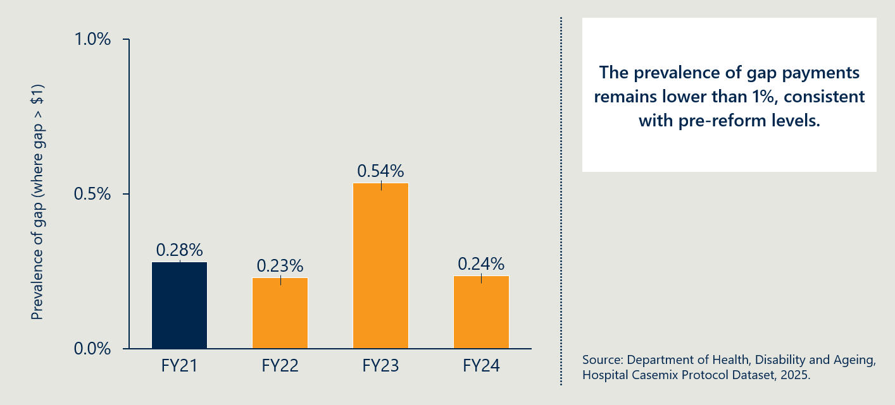

Feedback from consumer representatives and clinicians did not raise any concerns about increased out-of-pocket costs. The evaluation also sought input from the Office of the Commonwealth Ombudsman, who confirmed it had not observed any systemic trends of concern. Between July 2022 and May 2024, the Ombudsman received 35 complaints related to PL items – accounting for less than 1% of all PHI-related complaints received in this period. These complaints mostly involved unexpected costs incurred by private hospitals or privately insured consumers. Common issues included:

* Insulin pumps with manufacturer warranties (typically four years) shorter than the insurance replacement cycle (typically five years)
* Partial coverage of custom-made prostheses
* Claim rejections for items with newly introduced conditions on use (e.g. surgical guides or biomodels).

#### Gap payments average $212 when they occur

Figure 11 shows that while gap payments remain rare, they are significant in size when they do occur. In FY24, the average gap payment (where one is charged) was $212 – equivalent to around 33% of the item’s benefit.[33] Table 28 (Appendix D.3) shows significant variability across Part A categories. For example, in the Plastic and Reconstructive category, the average gap payment exceeds 200% of the associated PL benefit.

The FY24 average represents a sharp increase from FY23, though it is lower than FY21 and FY22 and broadly in line with historical norms. Moreover, given the very low incidence of gap payments over $1, a high degree of year-to-year variability is expected. As outlined in Section 2.4.1 of the *Interim Evaluation #1 report*, there is no clear evidence that links these changes to the PL reforms.

Figure 11 | Average gap payment when gap payment is greater than $1

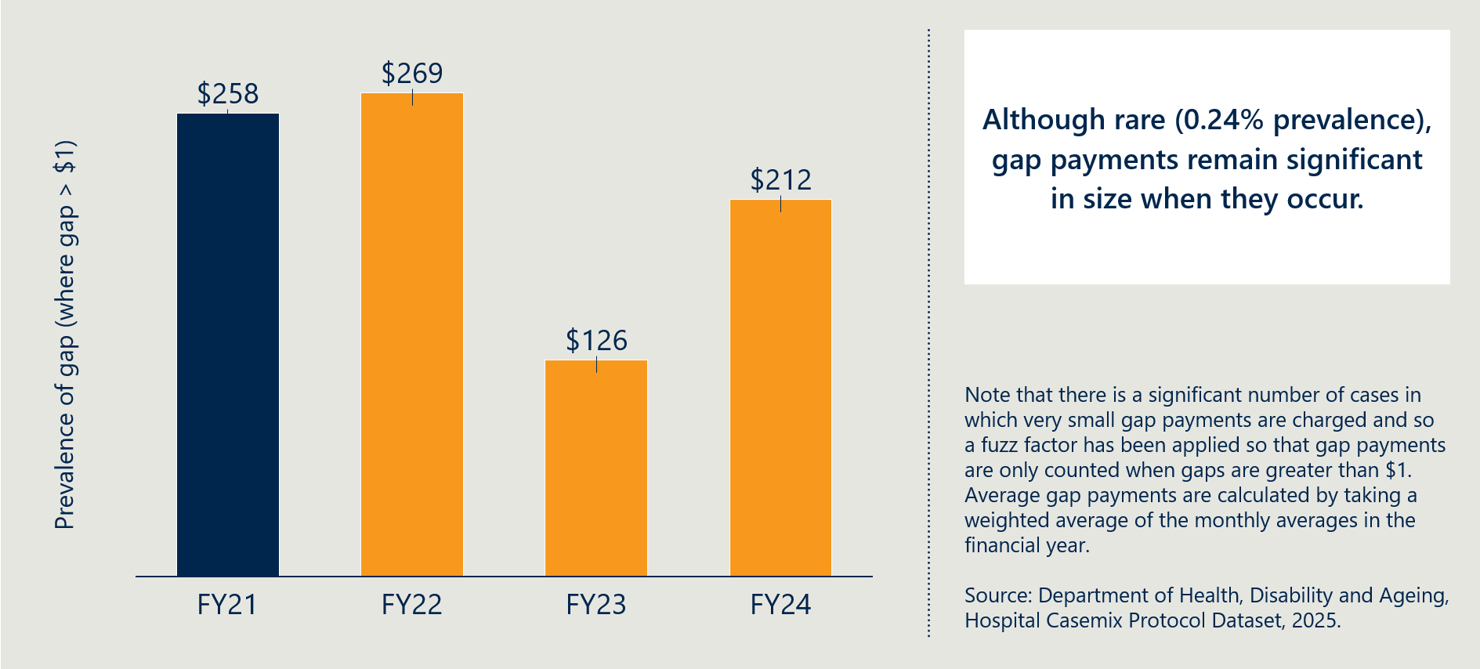

### Stakeholders expressed concerns about indirect financial impacts on consumers

#### Lack of price alignment between PL benefits and sponsor charges may raise affordability concerns

While the PL sets the maximum reimbursement from insurers, device sponsors are permitted to charge hospitals more than the listed benefit. This creates the potential for out-of-pocket costs for consumers, as insurers will not reimburse amounts above the PL benefit, placing pressure on hospitals to absorb or pass on the difference.

The prevalence of this practice is unclear. In May-June 2024, the Department consulted on Consultation Paper 8b, which proposed limiting sponsor charges to the PL benefit. However, based on stakeholder feedback and a lack of supporting evidence, the measure was not included in the Compliance, Assurance and Data Sharing Bill.[34] The Department has indicated it will continue to monitor this issue and consult on potential consumer protections.

Stakeholders from the private hospital sector reported that some sponsors had indicated they could not viably invoice at PL benefit levels, citing cases where invoices exceeded the benefit by $2,000-$3,000. These stakeholders argued that absorbing these costs is not financially sustainable for providers, while passing them on to patients is also problematic and may undermine efforts to keep private health insurance affordable.[35]

#### Stakeholders have flagged emerging out-of-pocket cost risks, noting that cost shifting behaviour may become more prevalent

Stakeholders agreed on the importance of protecting consumers from additional costs, though views differed on the current and potential impacts of the reforms.

Several stakeholders raised concerns about what they saw as emerging cost-shifting behaviours. The concern was that device sponsors might be passing on costs that were previously absorbed within product margins. For example, hospitals reported that some sponsors now charge separately for services and consumables that were once bundled with devices.

Hospitals also noted reduced sponsor willingness to provide individualised items, such as 3D-printed models, at no cost.[36] Hospitals also raised concerns that payments from insurers have sometimes been delayed and that delayed payments and reimbursement disputes contribute to financial shortfalls.[37]

Cost-shifting behaviours may also emerge within hospitals themselves, as they seek to manage tighter margins resulting from reduced PL benefits – for example, through additional patient charges or revised billing practices. While the evaluation has not seen evidence that this is happening, it does present a potential area of risk.

Table 5 below outlines additional stakeholder perspectives.

Table 5 | Stakeholder perspectives on maintaining no additional out-of-pocket costs for consumers[38]

|  |  |
| --- | --- |
| Stakeholder group | Perspectives on reform project |
| Private hospital sector | * Hospitals reported experiencing significant delays in payments from private health insurers. While hospitals say they currently absorb these shortfalls to shield patients from increased out-of-pocket costs, they consider this arrangement unsustainable. They cautioned that if funding gaps remain unaddressed, costs may ultimately be passed on to patients through gap payments or reduced access to advanced technologies. * Stakeholders noted that benefit reductions – particularly those implemented between 2017 and 2020 – have left them increasingly out of pocket, reporting that suppliers continue to charge above PL benefit levels. * Higher patient gap payments were reported, especially for cochlear implants and neurostimulators, which were seen to undermine affordability. * In response to reduced benefits, hospitals observed that some suppliers have begun charging separately for services and consumables that were previously bundled with implants at no additional cost. Hospitals report this has resulted in a financial burden on them. |
| Private health insurance representatives | *No response provided.* |
| Medical technology representatives  *Icon of a microscope* | * Industry representatives stated that benefit reductions alone have not had a material impact on out-of-pocket costs for existing products. |
| Clinician representatives  Icon of a person with a stethoscope | * Clinicians generally reported no awareness of increased out-of-pocket costs for patients or changes in clinical outcomes as a result of the reforms. * However, some clinicians noted that certain companies appeared less willing to supply individualised 3D printed models free of charge, which they attributed to reduced profit margins on medical devices. |

## Objective 3: Maintain clinician choice of appropriate prostheses for their patients

*This section focuses on examining any change in clinicians’ experience of being able to choose the prostheses they wish to use. It also considers changes in the utilisation of PL items as a potential indicator for changes in clinician choice and consumer access.*

Figure 12 | Reform projects related to reform objective 3

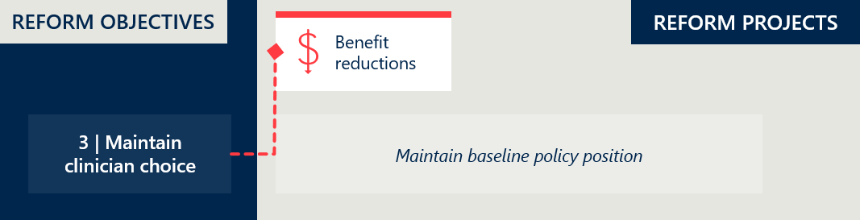

### Implementation progress: clinician choice

|  |
| --- |
| No specific activities in relation to clinician choice were implemented during this period. |

### There is a trade-off between maintaining clinician choice and improving PHI affordability

A core principle of the reforms is preserving clinician choice. Any item on the PL can be used and funded in a procedure with a privately-insured patient, provided it meets the requirements set out in the PL Guide.[39]

There is no strong evidence that the reforms to date have significantly constrained device choice. However, ongoing monitoring is warranted, given concerns raised by some industry sponsors that lower PL benefits may discourage the listing of innovative technologies. Private hospitals and clinicians have also expressed apprehension about continued access to more advanced, higher-cost devices.

#### There has been a slight decrease in the number of items on the PL over time

The number of items listed on the PL has declined by 5.7% over the four years since baseline (see Figure 36 in Appendix D.6). Between July 2023 and August 2024, the reduction was a 0.9% reduction across Part A, C and D.[40]

Industry stakeholders have suggested that reduced benefits have placed pressure on sponsors to maintain listings amid rising supply costs.[41] Some removals may also be linked to the anticipated introduction of the cost recovery levy, with clinician stakeholders noting that sponsors may be rationalising less frequently used items – a trend they expect to continue.[42]

While these factors may be contributing, the modest reduction in items does not appear to have materially affected clinician choice. Evaluation analysis of recently removed items showed a typical distribution of utilisation, with delisted items including both high- and low-use devices.[43] Items are removed for various reasons, and the scale and pattern of removals do not raise concern.

#### There are mixed views on the impact of the reforms on clinician choice, with most stakeholders stating the overall impact has been minimal

While some stakeholders reported early signs of constrained choice, others suggested it is still too soon to determine any significant impact.

Clinician representatives generally observed that they had not observed any major changes in device availability, with ongoing better access to devices than in the public system. Likewise, private health insurance representatives reported that they believe clinician choice remains intact, citing the continued breadth of devices listed on the PL.

Medical technology sponsor peak bodies felt that while it is too early to fully assess the impact of the reforms on clinician choice, benefit reductions have placed pressure on the industry sponsors which could lead to delisting or withholding new product launches, especially for innovative or low-volume devices on the PL.

Some clinicians and private hospital representatives were of the view that there is a risk that clinician choice is compromised for high-cost more advanced devices

Private hospital sector representatives reported that in their view clinician choice has been compromised in relation to certain advanced devices, particularly for CIED and spinal implants. Some clinicians were concerned that, in some cases, hospitals had limited access to these advanced devices due to reimbursement uncertainty and pricing constraints. While some private hospitals acknowledged that uncertainty was restricting clinician autonomy, others rejected any suggestion that private hospitals were restricting access.

They argue that while percentage reductions for CIEDs appear small, the absolute monetary reductions are significant enough to threaten procurement, leading to potential device shortages. They explained that if private hospitals are unable to procure devices at a viable price, leading suppliers may withdraw some products from the market thereby restricting clinician choice of device. While the evaluation has not cited any evidence that this has been occurring, the risk should continue to be monitored.

This risk was endorsed by consultation with the MTAA Cardiac Forum who stated that benefit reductions have, and in the event of more reductions will continue, to make it less attractive for cardiac device sponsors to bring new CIED technology available to the Australian market on the PL.

#### Clinicians were concerned about the restrictions on surgical guides and biomodels due to the post-listing review process

Oral and maxillofacial surgeons expressed concern about the impact on patient care of the new conditions applied to surgical guides and biomodels following stage one of the post-listing review (see Section 2.7). While these devices remain on the PL, reimbursement was restricted following the review to use in certain procedures and capped at a maximum number of billing codes.

Clinicians reported that these restrictions have made it more difficult to perform major surgeries in a single session. Instead, they are sometimes required to stage procedures across multiple occasions to access the necessary surgical guides and biomodels. This has increased the treatment burden for patients and delayed recovery times.[44]

Although the conditions apply to the private sector through the PL, some clinicians noted a flow-on effect in the public system. They reported that public hospitals – which had not previously imposed restrictions on these items and typically left decisions to clinician discretion – have become more cautious, with access now subject to additional scrutiny and high-level approvals.

These developments suggest that the conditions may have had unintended consequences for a subset of surgeons, potentially limiting clinician choice and access to necessary devices.

|  |
| --- |
| RECOMMENDATION 3  Monitor the impact of PL conditions on clinician choice and access to advanced devices  Ongoing monitoring is needed to assess whether recent PL changes are limiting clinician choice or affecting timely access to advanced devices such as CIEDs, surgical guides and biomodels. This will help ensure that reforms do not unintentionally compromise clinical decision-making or patient care. |

Table 6 | Stakeholder perspectives on maintained clinician choice[45]

|  |  |
| --- | --- |
| Stakeholder group | Perspectives on reform project |
| Private hospital sector | * Hospital representatives expressed concern that the PL reforms have affected clinician choice, as hospitals are reconsidering product selection due to pricing constraints. This was seen to limit access to certain advanced devices. * Some hospital reported difficulty in sourcing newer models of CIEDs, attributing this to pricing pressures following benefit reductions. * Reductions in PL benefits for spinal implants were noted as potentially limiting access to minimally invasive treatment options. * Hospital representatives reported that clinician were increasingly cautious in selecting particular devices, even those listed on the PL, due to uncertainty about reimbursement from private insurers. Some products were said to be removed from preferred use based solely on reimbursement concerns, rather than clinical performance or patient outcomes. |
| Private health insurance representatives | * Insurer representatives stated that clinician choice of medical devices has been maintained under the reforms, regardless of quality, efficacy, effectiveness or safety. * They highlighted the breadth of devices listed across most PL categories and noted that each four-month PL cycle includes a high volume of devices seeking listing. |
| Medical technology representatives  *Icon of a microscope* | * Industry stakeholders noted that it is too early to fully assess the impact of the reforms on clinician choice; however, they raised concern that benefit reductions have placed sponsors under pressure to maintain PL listings, potentially leading to delisting of products if costs increase. * Benefit reductions were also said to discourage some sponsors from launching new products in Australia, particularly for innovative and low-volume high-cost devices. * Representatives argued that the prohibition on adding new product groups for GUIs under Part D limits innovation, resulting in some technologies becoming unavailable to patients. * Several broader dynamics – whether due to the reforms or other PL issues – were said to be reducing the range of available options, with stakeholders reporting growing access barriers, especially in the public system. Industry warned that these cumulative effects may become more significant for clinical outcomes over time. |
| Clinician representatives  Icon of a person with a stethoscope | * Clinicians reported that, for the specialties they are familiar with, the PL reforms have not affected their medical device choices. * However, some rationalisation of less commonly used items was observed, which clinicians speculated may be due to the unviability of certain product lines under reduced benefit levels. Despite this, clinicians reiterated that appropriate access to devices has been maintained. |

## Objective 4: Improve the affordability and value of PHI for privately insured Australians

*Foundational to the reforms is the objective to improve the affordability and value of PHI. This section examines the estimated savings from the reforms and considers changes in PHI premium increases to examine the affordability of PHI. It looks at premium price changes over time and any changes in PHI premiums that can be related to PL expenditure. This section also considers changes in PHI coverage and for whom to examine the value of PHI. It looks at coverage by demographic group and utilisation of PL items.*

Figure 13 | Reform projects related to reform objective 4

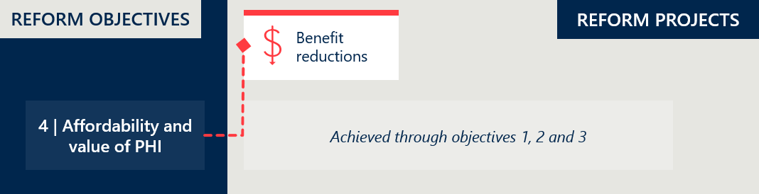

### Implementation progress: affordability of PHI

|  |
| --- |
| The benefit reductions which aim to improve the affordability of private health insurance are outlined in Objective 1. |

### The reforms generated $300 million in savings from FY23 to FY24

According to IHACPA estimates, the PL reforms generated $302 million in savings in the two years from July 2022 to June 2024.[46]

Based on projections made in November 2023, IHACPA estimates that the reforms will generate over $1 billion in total savings over the five years from July 2022 to June 2027.[47]

The reforms are achieving their intended effect of sustaining lower benefit levels across the PL. These lower benefits reduce the insurance payments made for medical devices used in private hospitals, placing downward pressure on PHI premiums.

The relative impact of these savings is explored in Section 2.4.3 below.

#### Savings have been limited by several factors

The extent of savings achieved through the PL reforms has been limited by structural and policy parameters. Notably, benefit reductions were determined under the MOU between the then Australian Government and the MTAA to reference public sector pricing only, rather than broader market benchmarks.[48] Under these arrangements, benefit reductions were capped at a maximum of 80% of the gap between the PL benefit and public reference prices, with a 7% price floor above public prices applied.

Stakeholders have expressed varied perspectives about the validity of these parameters, as outlined in Section 2.3.3 (page 14) of the *Interim Evaluation #1 report*.[49] In particular, some consider the 80% cap and 7% price floor to limit the extent of achievable savings, while others view these conditions as protections to account for differences between public and private hospital pricing.

In addition, the delayed implementation of benefit reductions for certain items has limited savings. IHACPA estimated that the decision to defer benefit reductions of CIEDs by one year would result in $94 million in foregone savings over the five-year period from July 2022 to June 2027.[50] The implications of this delay, as well as other factors impacting the timing and scope of benefit reductions, are discussed further in Section 2.3.2 of the *Interim Evaluation #1 report*.[51]

### The benefit reduction savings have contributed to PHI affordability

All else being equal, lower PL benefit levels have undoubtedly resulted in reduced benefits paid out by insurers. Figure 14 illustrates the impact of these savings.

As 80-85% of premium revenue is typically returned to consumers in the form of insurance benefits, even modest reductions in benefit outlays can meaningfully improve insurer cost structures.[52] This, in turn, supports downward pressure on premiums and improves PHI affordability, one of the key objectives of the reforms. The evaluation notes that some private hospital representatives expressed a strong view that the reforms should be less concerned with PHI costs and instead be targeting better equilibrium between providers and payers through an improved flow of funds to the hospital sector.

Figure 14 | Estimated insurer benefit outlays with and without reform savings ($M, based on 5% annual growth)[53],[54]

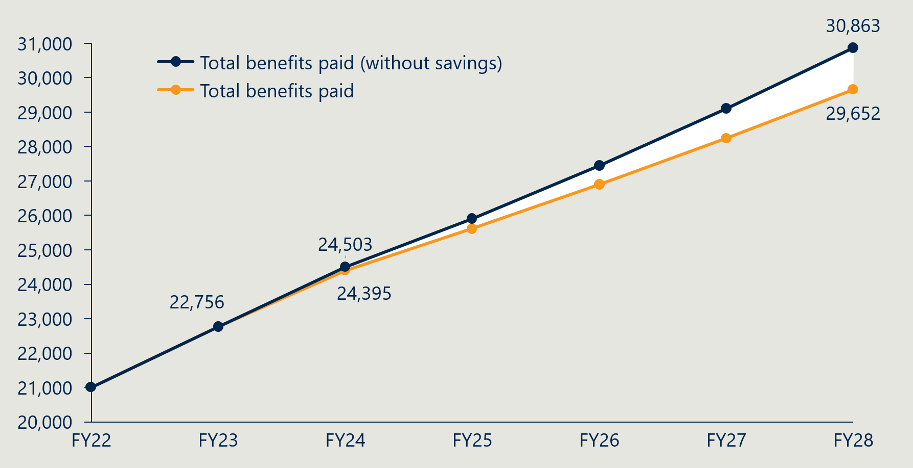

### Growth in the use of prostheses clouds the direct impact of the benefit reductions on premiums

While the benefits paid for items on the PL have been reducing, prostheses utilisation has been increasing across PL categories (see Figure 15). The highest growth occurred in the two largest categories by volume – General Miscellaneous and Specialist Orthopaedic.

Figure 15 | Prostheses utilisation per 1000 HT PHI members by PL category[55]

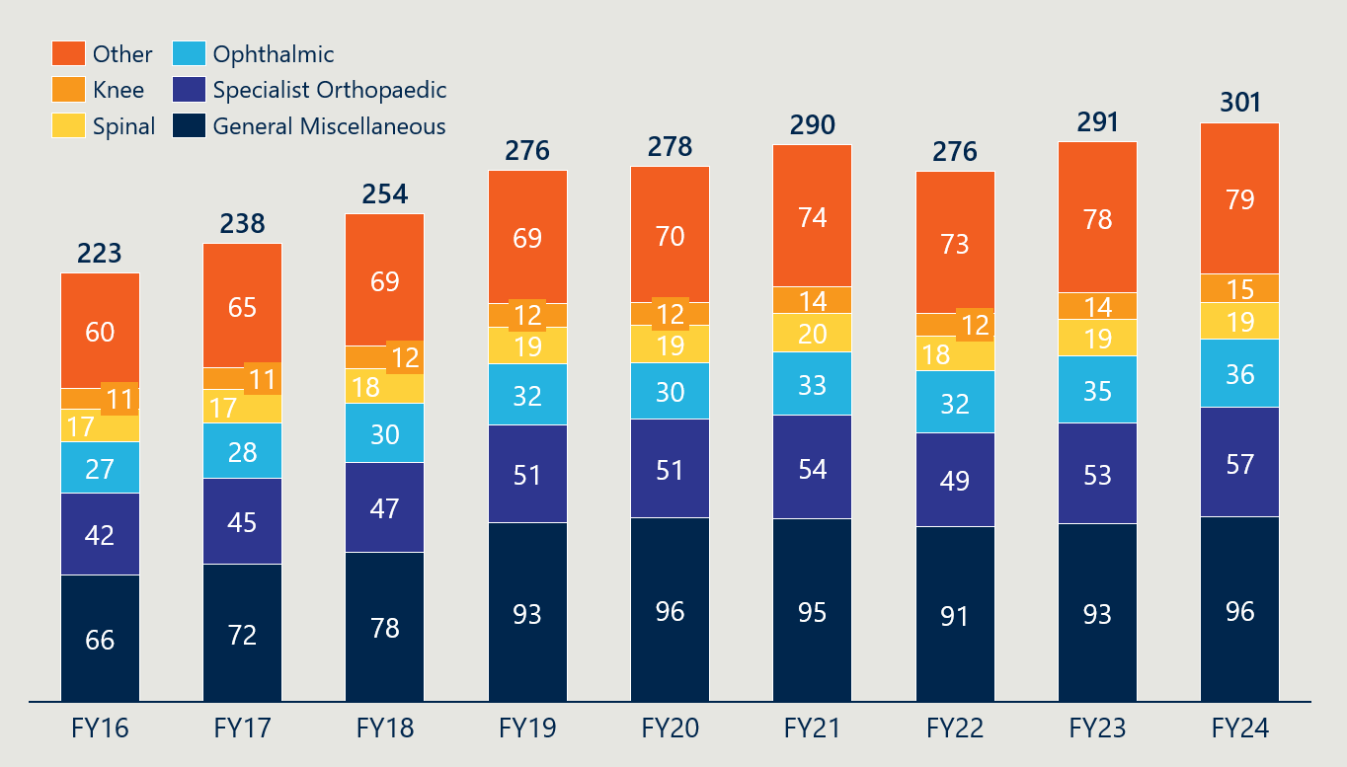

This growth in utilisation cannot be solely attributed to an ageing population. Figure 35 in Appendix D.5 shows that – with the exception of 35-49-year-olds – all age groups are using prostheses more. Some of this growth is likely driven by advances in technology and a higher standard of care. However, this view is not shared by private health insurers, who hold a view that more items are being used than clinically necessary in hospitals. Given that clinicians select and use the items, this assertion cannot be substantiated.

This growth in utilisation partially offsets the savings achieved through lower PL benefits.

Figure 16 | Total prostheses benefits paid ($’000)[56]

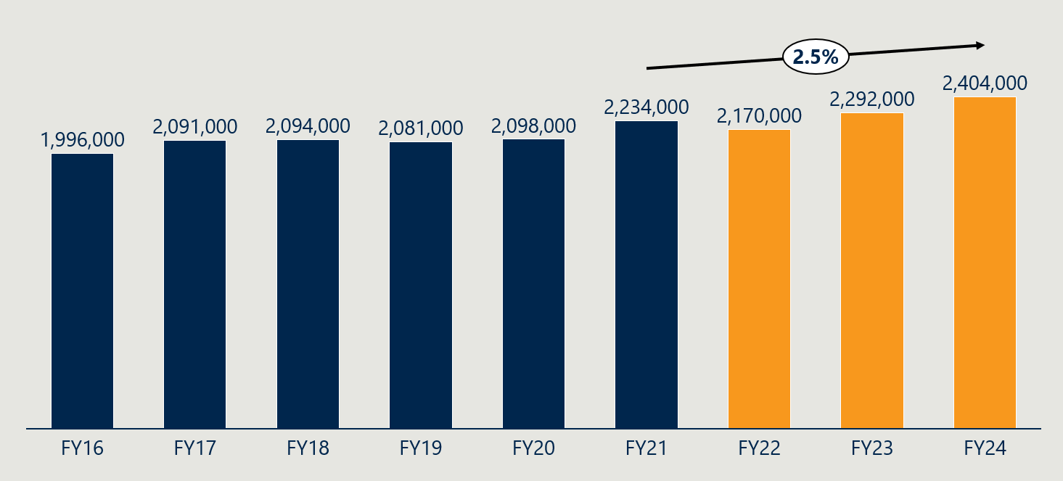

Figure 16 shows that total prostheses benefits paid increased by 2.5% from FY21 to FY24. However, over the same period, total HT benefits paid by insurers grew by 12.9%.[57] In relative terms, prostheses benefit growth has been far more moderate than overall HT benefit growth.

Consistent with this, Figure 17 (below) shows that the share of total HT benefits accounted for by prostheses has declined modestly – from 14.1% in FY21 to 13.4% in FY24.[58]

Figure 17 | Prostheses benefits paid as a percentage of total HT benefits[59]

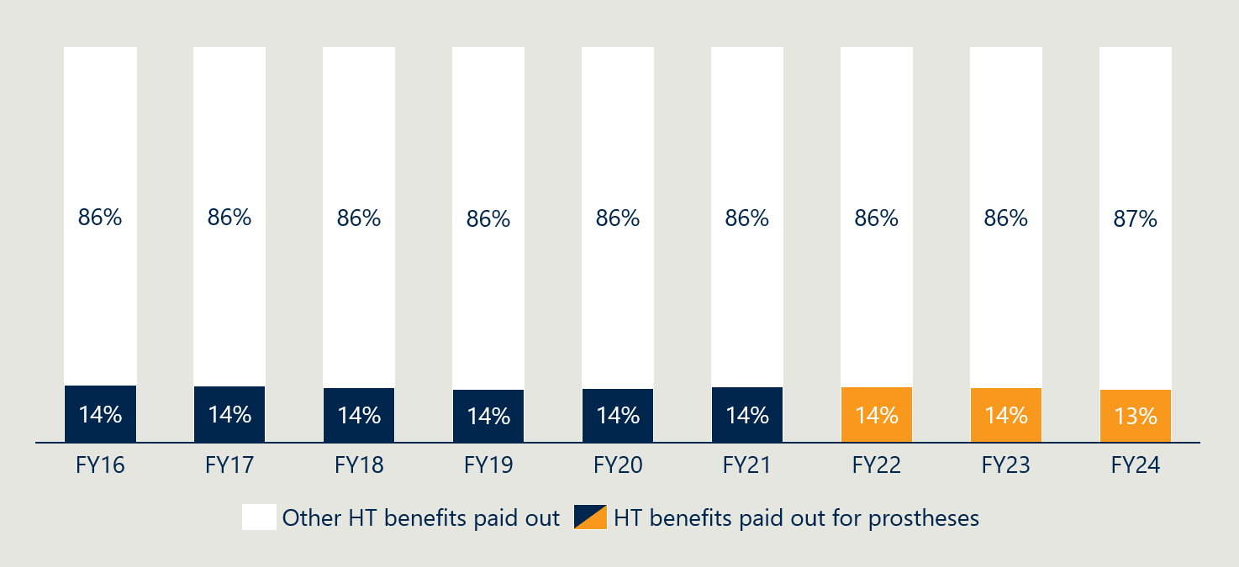

#### The PL reforms did not aim to address the volume of items used

While the PL reforms were deliberately designed to reduce benefit levels, they did not seek to limit the volume of items used.

Managing growth in utilisation would require strategies beyond pricing. Experience to date shows that even when restrictions are based on clear clinical or economic evidence, they can be contentious. For example, the introduction of conditions on surgical guides and biomodels prompted strong feedback from some clinicians, including reports of unintended impacts extending into the public system.[60]

### PHI premiums continue to rise

Despite efforts to contain costs through the PL reforms, PHI premiums have continued to increase. As shown in Figure 18 below, average premium growth declined in the years leading up to the reforms, reaching a low of 2.7% in FY21 and FY22. Since then, the rate of increase has edged upward – reaching 3.0% in FY24.

Figure 18 | Average year-on-year insurance premium price changes (as % of prior year premiums)[61]

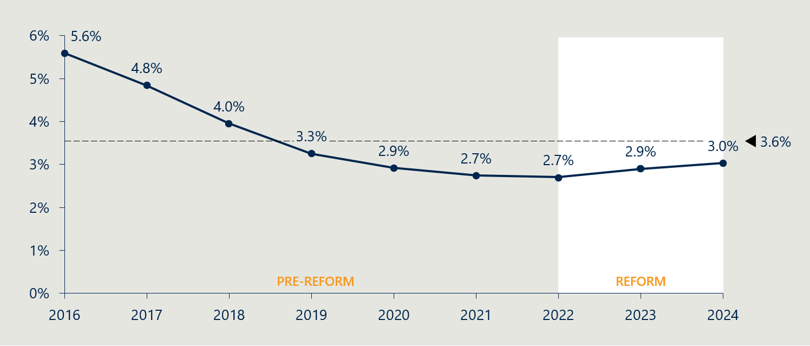

Stakeholders have pointed to several contributors to these upward pressures. Hospitals and medical device representatives have argued that growing PHI management fees and profits are absorbing savings that could otherwise be passed on to consumers.[62] Additionally, recent data indicates that growth in hospital treatment benefits – as explored in 2.4.4 – are a primary driver of rising premiums.[63] This reinforces the broader point that while the PL reforms are moderating device-related benefits, further system-wide strategies may be needed to manage overall health insurance cost growth.

The evaluation will examine this issue in a more fulsome way in the final report.

#### PHI coverage has remained stable despite rising premiums

Despite ongoing increases in premiums, PHI coverage for hospital treatment has remained steady. As shown in Figure 19 below, the proportion of the Australian population with hospital treatment PHI increased slightly – from 44.6% in June 2021 to 45.0% in June 2024.

This suggests that recent cost pressures have not significantly affected overall participation in private health insurance. Stakeholders suggested that COVID-19 stabilised PHI coverage after years of decline – perhaps due to concern about public hospital access – and that in recent years, savings to premiums are helping consumers maintain their cover.[64]

Figure 19 | Percentage of Australian population with Hospital Treatment PHI[65]

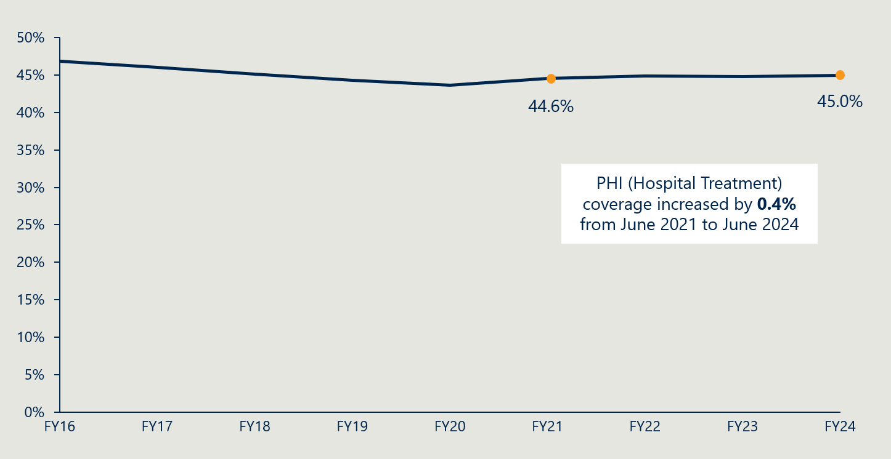

### Stakeholders hold differing views on affordability and value, but agree the impact of the reforms is difficult to isolate

Stakeholders expressed mixed views on whether the PL reforms have improved the affordability or value of private health insurance. There is broad agreement, however, that the impact of the reforms on premiums is hard to separate from other cost drivers.

Private hospitals and medical device representatives question the extent to which insurers have passed reform saving to consumers, pointing to continued premium increases and rising insurer costs. Clinician representatives share concerns about rising premiums, while acknowledging the reforms may have modestly slowed growth.

By contrast, the PHI sector emphasises that medical devices account for a small share of total PHI spending and that increased volumes have offset price reductions (as explored in Section 2.4.4, above). They argue this has limited any impact on premiums and support further reform to manage future cost pressures.

Table 7 below summarises these stakeholder perspectives in more detail.

Table 7 | Stakeholder perspectives on the affordability and value of private health insurance[66]

|  |  |
| --- | --- |
| Stakeholder group | Perspectives on reform project |
| Private hospital sector | * Hospital representatives acknowledged that the PL reforms aimed to reduce private health insurance (PHI) premiums by lowering benefits paid for medical devices. While they recognised that insurers have benefited from reductions in PL benefit outlays – particularly for high-use categories – they questioned whether these savings have been meaningfully passed on to consumers in the form of lower premiums or improved coverage. * They note that PHI premiums and insurer costs have continued to increase year-on-year, raising concerns about whether consumers are receiving value for money. |
| Private health insurance representatives | * Insurer representatives reported that since the MOU commenced, both the average cost of medical devices per insured person and overall medical device expenditure have increased. * While medical devices represent a small share of total PHI spending, insurers argued that savings from price reductions have been offset by rising utilisation. * Despite this, they emphasised the importance of continued reform to support a viable PHI market. They noted that further changes to PL pricing could ease premium pressure and help reduce the risk of people dropping their coverage. * Insurers pointed to early signs that pricing reforms are beginning to yield savings. In 2024, the average cost of medical devices per episode declined from $480 to $478, generating savings of approximately $13 million, which they reported was passed on to members through premium adjustments. * They argued that it is unsustainable to expect medical device savings to drive lower premiums when total spending on devices is more than before the MOU commenced. |
| Medical technology representatives  *Icon of a microscope* | * Industry representatives argued that PL savings have been offset by increases in insurer costs. They claimed that PL benefit reductions have been the only meaningful downward pressure on premiums. * Since the COVID-19 pandemic, PHI participation has risen and then stabilised after a long period of decline. Industry attributed this trend partly to consumer concerns about access to public hospitals. * They suggested that lower premium increases in the early 2020s were supported by PL-related savings, which may have helped maintain PHI coverage despite broader affordability pressures. |
| Clinician representatives  Icon of a person with a stethoscope | * Clinicians suggested that PHI premiums continue to rise due to increasing claim costs and insurer costs. * They observed that while PL device costs per service have declined, these savings have not translated into lower PHI premiums and have only marginally constrained premium growth. * Clinicians noted that PHI coverage declined for five years prior to the pandemic but has since increased. They attributed this shift primarily to consumer concern about public hospital access, rather than perceptions of better value from private health insurance. |

## Objective 5: Clarify the purpose, definition and scope of the PL in legislation

*This section considers legislative changes in support of the PL’s defined purpose and scope, implementation of a new grouping structure and implementation of alternative funding arrangements for GUIs.*

Figure 20 | Reform projects related to reform objective 5

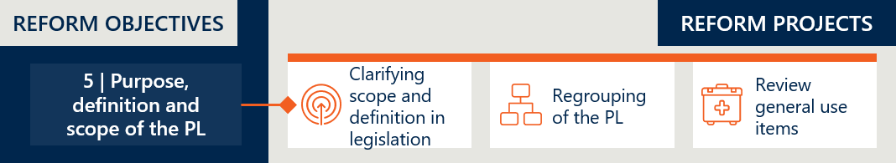

The three reform projects designed to achieve this objective discussed with separately below.

### Implementation progress (a): clarifying scope and definition in legislation

|  |
| --- |
| At baseline, the PL lacked clear scope and a legislative definition of ‘prostheses’, allowing items that may be better suited to other funding mechanisms to be listed. As outlined in *the Interim Evaluation #1 report*, amendments were made to the PHI Act in 2023. This included renaming the list, replacing the use of ‘prostheses’ with ‘medical devices’, inserting definitions and revising the device listing criteria to clarify product eligibility.  The Private Health Insurance (Medical Devices and Human Tissue Products) Rules have since been updated to accommodate the retention of GUIs on the PL.[67] The new rules, which came into effect on 1 November 2024 omitted the provision that would repeal Part D (GUIs) of the list and new listing criteria for devices in Part D were added with the intent of maintaining the existing scope of the Part D grouping scheme.[68],[69] Specifically:   * New listings for GUIs on the PL must have a comparative GUI already listed in Part D. * No new categories, subcategories, groups, subgroups or suffixes will be added to Part D. |

As discussed in the *Interim Evaluation #1 report*, the inclusion of definitions in the legislation further defined the scope of the PL. New definitions were inserted, and listing criteria was updated in the Act as parameters to provide better clarity around what products are eligible for inclusion on the PL. The updated legislation precluded items that were previously listed on the PL, such as GUIs and medicines, from being listed on the PL, however the removal of GUIs was reversed by the November 2024 rules, noted above. The GUI reform project is discussed further in Section 2.5.7.

*Interim Evaluation #1 report* also identified that some ambiguity on boundary products remained in the legislation. ‘Boundary products’ are defined as therapeutic goods with attributes that make it challenging to determine whether they belong to the category of medical device or medicine, or both.[70] This issue has been particularly relevant in the consideration of reductions to CIEDs, discussed in Section 2.1.5.

### Implementation progress (b): regrouping of the PL

|  |
| --- |
| At baseline, PL groupings and benefit levels were based on device characteristics and clinical benefits. The PL reforms aimed to align groupings with clinical use, simplifying navigation for insurers and hospitals. An external consultant report by Hereco was delivered to the Department in 2022 however concerns arose with the multitude of products considered to comprise a “mixed benefit group” in the proposed new structure, which added significant complexity to regrouping. The requirement in the MOU with the MTAA which required that regrouping not result in additional savings was a complicating issue. As a result, the proposed regrouped PL structure recommended by Hereco was not finalised and as discussed in the *Interim Evaluation #1 report*, the regrouping project was paused. The regrouping project has since been discontinued. On 12 May 2025, the Department announced to stakeholders that the regrouping of Part A of the PL would not be continued as a reform measure.[71] |

Figure 21 | Timeline of PL regrouping reform project

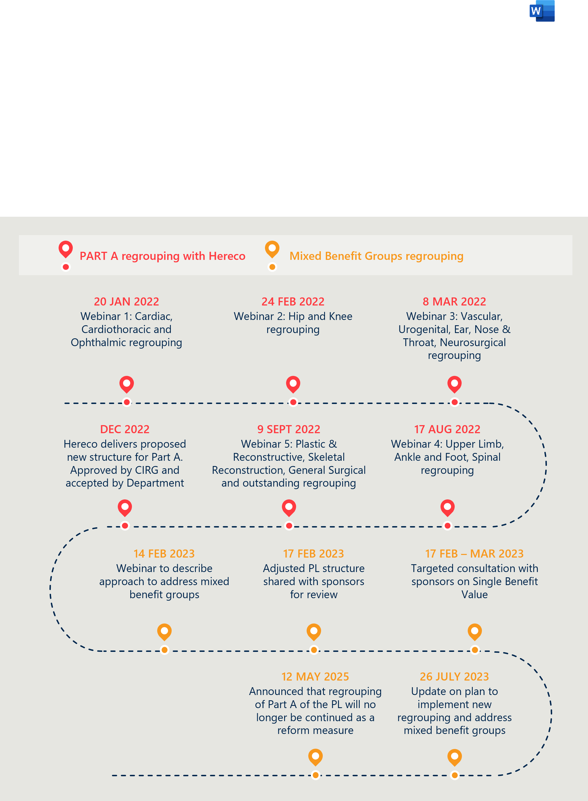

### The re-grouping aimed to provide transparency and simplicity

Regrouping of the PL was intended to provide transparency around PL items and increase the PL’s ease of use.[72] This was in response to the PL being considered unwieldy, alongside a notion that this made the PL more difficult to administer, driving cost and unnecessary complexity. As of 2021, the PL contained 11,600 billing codes and 1,700 unique groupings.[73] Some stakeholders believe the current PL item groupings contribute to a variety of issues that result in some PL items being overpriced, such as:

* Inclusion of items in sections of the PL inconsistent with their actual or intended use.
* Differences in benefit amounts that are not explainable by clinically relevant product differences.
* The use of inappropriate comparator products, or reclassification of existing products into higher benefit subgroups or suffix groupings, which is viewed to be evidence of gaming.[74]

Stakeholders who supported this change believed it would potentially reduce ‘gaming’ – whereby sponsors might list devices with minor changes to gain higher benefits without added clinical value.

### Achieving a pure clinical use-based regrouping was challenging, especially in the context of the mandate that it should not produce savings

The context that led to the decision to pause the regrouping project is explored in *Interim Evaluation #1 report*. The decision to cease work on regrouping was made when “it was evident that implementing the proposed PL grouping structure would require re-assessing all mixed benefit groups in line with a full health technology assessment”.[75]

The consideration that every item on the PL would be subject to a HTA to justify any resulting changes to benefits, finally led to abandonment of this reform project on the balance that the cost involved would outweigh any potential gains of efficiency and clarity.

The plan to implement the external consultant’s proposed grouping structure – based on clinical outcomes and independent of device benefits – was stalled when it resulted in some groupings containing a wide range of benefits.[76] Regrouping those into single-benefit groups became unworkable because the MOU with the MTAA prohibits using regrouping to make further reduction savings on benefits beyond those already specified in the agreed reform benefit reduction schedule.[77]

### The decision to discontinue work on regrouping was not universally supported – past work could still inform future reform

The evaluation finds that the regrouping approach was undermined by early design constraints, including a mandated ban on any resultant savings.[78] The methodology used was also seen as too rigid to allow for a practical and clinically meaningful restructuring. As noted in the stakeholder section (Table 8), several stakeholders argued that mixed benefit groups should not have prevented regrouping. They proposed more flexible solutions, such as accepting mixed benefits within categories or subdividing categories to accommodate variation.

Although the MOU with MTAA will end on 30 June 2026, the opportunity to implement the regrouping settings developing during the reforms has passed. The addition of hundreds of items to the PL in recent years means the prior restructuring work is now outdated.

Nonetheless, the Department has indicated that the previous regrouping work remains valuable. It will inform post-listing reviews and assurance activities, helping to guide future consideration of PL structure and category logic.[79]

|  |
| --- |
| RECOMMENDATION 4  Revisit the objective to regroup the PL by clinical use  There is an opportunity to build on previous regrouping work to improve transparency and simplify the structure of the PL. Without the constraint of the former MOU ban on savings, a renewed effort could also help reduce pressure on PHI premiums. Any future regrouping would require updated analysis and consultation with stakeholders. |

### Stakeholder views on the regrouping project

Stakeholders expressed broad concern over the stalled regrouping project, citing missed opportunities for simplification, clarity, and alignment with clinical practice. While most stakeholders supported the principle of regrouping, they called for a more flexible and consultative approach to completing the project.

The private hospital sector emphasised that regrouping is inherently complex and would have benefited from clearer governance, phased implementation, and sustained engagement with clinicians and hospitals. They noted that the current PL structure remains administratively burdensome and disconnected from real-world care delivery, contributing to disputes and delays in claims.

The private health insurance sector criticised the decision to abandon regrouping, arguing that tighter alignment of device descriptions and groupings could improve transparency and accountability. They supported regrouping based on clinical function and expressed frustration over what they viewed as opaque decision-making and limited consultation during the regrouping process.

Medical technology bodies warned that regrouping based solely on intended use or outcomes risks oversimplifying device distinctions, potentially stifling innovation and limiting clinician choice. They also highlighted the Department’s rigid approach to consultant recommendations as a barrier to progressing the project.

Clinical representatives agreed that regrouping could improve consistency but stressed the need for deeper stakeholder engagement to avoid unintendedcommercial and clinical consequences.

Stakeholder views are summarised in more detail in Table 8.

Table 8 | Stakeholder perspectives on regrouping of the PL[80]

|  |  |
| --- | --- |
| Stakeholder group | Perspectives on reform project |
| Private hospital sector | * Hospital representatives noted that the regrouping project was inherently complex but could have benefited from clearer governance, more realistic timelines, stronger resourcing, and earlier engagement with clinicians, sponsors, and providers to ensure the model reflected clinical practice. * They described the existing PL structure as administratively burdensome and disconnected from models of care, with unclear grouping boundaries complicating procurement, coding, and benefit eligibility. These issues were seen to contribute to claims delays and disputes. * Stakeholders highlighted the need for clearer benefit rules when devices are used outside their designated groups and suggested that a phased implementation approach could have allowed for refinement over time. * While acknowledging that device regulation is the responsibility of the TGA, hospital representatives emphasised that PL structuring must balance standardisation with flexibility to accommodate real-world clinical use. |
| Private health insurance representatives | * Insurer representatives expressed strong disappointment that the regrouping project was discontinued. They believed the proposed approach – aligning groups more closely with clinical indications – would have improved pricing transparency and accountability for sponsors. * They supported grouping devices by clinical function or intended use, as recommended in the Hereco report, and raised concerns about pricing inconsistencies where devices are used beyond their originally intended purpose. * Representatives viewed the rationale for cancelling the reform project as unclear and questioned whether the required HTA approach for all “mixed benefits groups” was the only viable option. They noted that alternative or phased approaches had not been adequately explored. |
| Medical technology representatives  *Icon of a microscope* | * Industry stakeholders cautioned that regrouping primarily for insurer and hospital benefit could have reduced clinicians’ ability to select the most appropriate device. They emphasised that suffixes on the PL already account for technological and clinical differences. * They viewed grouping devices solely by intended use or health outcomes as overly simplistic, potentially stifling innovation and limiting access to advanced technologies. * Some expressed frustration that the regrouping project was halted despite the provision of alternative models that would have consolidated groupings without breaching the MOU. They saw the process as rigid, requiring all consultant recommendations to be accepted for reforms to proceed. |
| Clinician representatives  Icon of a person with a stethoscope | * Clinician representatives acknowledged that regrouping offered potential benefits in aligning the PL to a clearer and more consistent logic based on use or outcome. However, they considered the process to have lacked adequate consultation and insufficient consideration of commercial implications. * They supported further discussion of grouping structures but noted that this would require greater capacity for detailed stakeholder engagement to prevent unintended impacts. |

### Implementation progress (c): review general use items

|  |
| --- |
| As reported in *Interim Evaluation #1 report*, the Government confirmed on 1 May 2024 that GUIs would remain on the PL after 1 July 2024. The announcement cited stakeholder concerns and increased financial pressures on private hospitals affecting their viability as key factors in this decision.[81]  While GUIs have been retained in Part D of the PL, 26 specific billing codes were removed on 1 November 2024 as they are regulated by the Therapeutic Goods Administration as medicines and accessories to medicines and therefore do not meet the PL eligibility requirements.[82] |

Figure 22 | Timeline of general use items (GUIs) reform project

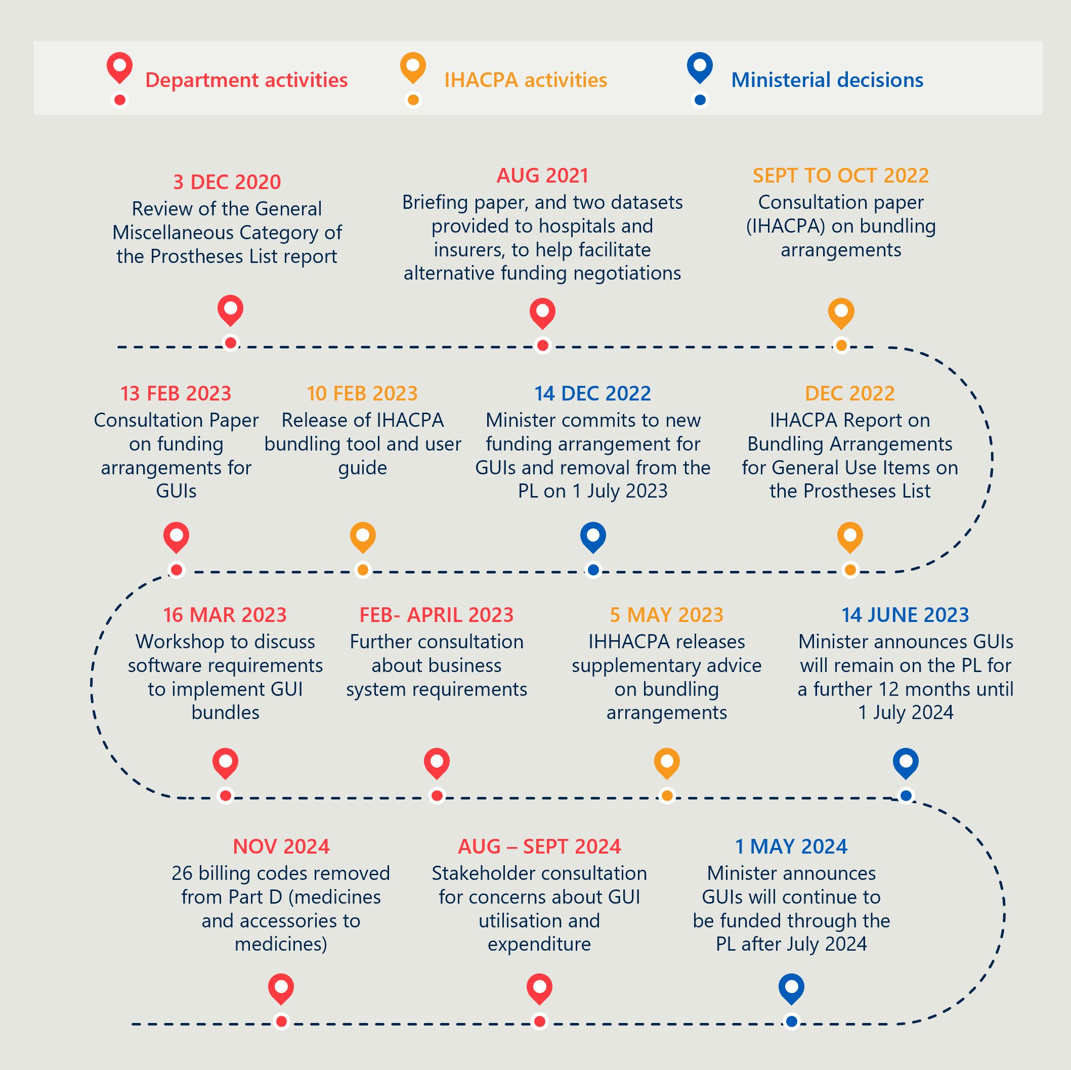

### The objective to move GUIs to an alternative more appropriate funding mechanism was not realised

*“The Government has listened to the concerns about the pressure removing general use items would have caused and decided that this achieves the best outcome for patients”*

**Minister Mark Butler, 1 May 2024**

**MTAA, 2017 Senate Submission**

The reform originally intended to remove general use items (GUIs) from the PL by 1 March 2022, which was then deferred multiple times to accommodate preparations for alternative funding arrangements. The aim of this reform was to address ongoing concerns about the high utilisation of certain groups of products in the General Miscellaneous category of PL and elsewhere, and whether these items met the PL list criteria.[83]

The Department identified a group of over 500 general use and consumable products that that either failed to meet the pre-reform listing criteria or would not qualify under the new definitions agreed during the reform process. Their removal would have streamlined the PL’s scope and range of products and put further downward pressure on private health insurance by taking cost out of the system. Advice from the then Clinical Implementation Reference Group (CIRG) was that products could be removed from the PL with no clinical implications or adverse outcomes so long as the products were still available for use by clinicians under an alternative funding agreement.[84]

Attempts to negotiate a bundled funding arrangement between insurers and hospitals were aided by advice from IHACPA, with a consultation paper and final report on potential bunding arrangements delivered in late 2022. While private health insurers had committed to the alternative funding arrangement, concerns were raised by private hospitals about potential negative clinical implications or adverse outcomes for patients as well as the compatibility of the proposed funding arrangements with existing data systems. A fundamental concern remained that private hospitals might be financially worse off under the new arrangements. *Interim Evaluation #1 report* provides a full description of the failure of the negotiation process and the resultant decision, taken in May 2024, to no longer proceed with the removal of GUIs from the PL. The decision, announced by the Minister, was based on the need to balance patient safety and hospital viability with savings and reform commitments.

### Despite the failure to remove GUIs, benefit reductions resulted in reduced overall expenditure on GUIs

Although GUIs were not removed from the PL planned, benefit reductions to these items occurred during the reform period:

* From 1 July 2022: a 60% reduction of the gap between the PL benefit and the weighted average price.
* From 1 March 2023: a further 40% reduction of the remaining gap.

While GUI utilisation has remained constant throughout the reforms, benefit reductions have resulted in reduced expenditure on GUIs overall. This can be seen in Table 9 below.

Table 9 | Utilisation and value of GUIs between FY21 and FY24[85],[86]

|  |  |  |  |  |
| --- | --- | --- | --- | --- |
|  | FY21 | FY22 | FY23 | FY24 |
| Total utilisation | 1,020,932 | 990,720 | 1,023,011 | 1,019,798 |
| Total value | $216,888,306 | $206,887,692 | $192,765,478 | $174,392,258 |
| Weighted average benefit | $212 | $209 | $188 | $171 |

Annual utilisation of GUIs remained relatively stable between FY21 and FY24. Despite this, overall expenditure declined by 20% over the period, alongside a steady reduction in the weighted average benefit – from $212 in FY21 to $171 in FY24. This suggests that lower benefits were the primary driver of reduced total value.

### Previous investment in GUI funding models presents a valuable platform for future reform

Although the proposed removal of GUIs from the PL did not proceed, the reform process generated substantial design work and sector engagement that remains highly relevant. Stakeholders – including the Department, IHACPA and industry – invested time and resources into exploring alternative bundling models, with one insurer estimating over $250,000 in unrecoverable development costs.[87]

This work presents a foundation for future reform. The original objective – to reduce complexity and take cost out of the system without clinical impact – remains valid and aligned with broader reform goals. Revisiting alternative funding approaches for GUIs in the post-reform environment offers an opportunity to build on prior efforts. Any further work would need to consider the financial sustainability of private hospitals.

|  |
| --- |
| RECOMMENDATION 5  Continue to explore development of a sustainable funding model for general use items  The work undertaken during the reform process to explore alternative funding approaches for GUIs should be leveraged in the post-reform context. There is an opportunity to build on this investment to develop a workable, clinically appropriate model that reduces system costs without adverse outcomes. Any future approach should align with the broader policy objective of streamlining the PL’s scope to reduce cost pressures on private health insurers. |

### Stakeholder perspectives on GUIs

Debate amongst stakeholders about the inclusion of GUIs on the PL centres on funding mechanisms and the evolving scope of the PL itself. Overall, while GUI retention preserved short-term stability, stakeholders highlighted unresolved tensions around the PL’s scope, its alignment with modern surgical practice, and the need for systemic reform.

Private hospital representatives supported retaining GUIs on the PL, citing their essential role in surgical care and the absence of viable alternative funding mechanisms. They acknowledged that while benefit reductions created challenges, the decision to retain GUIs helped preserve clinical stability and access.

Similarly, clinician representatives supported GUI retention in the absence of alternative funding but called for broader reforms to the PHI system to address structural issues.

Medical technology peak bodies agreed with the retention of GUIs on the PL but criticised the freeze on new groupings, arguing it undermined innovation and created competitive inequity. They warned that the PL’s narrowing scope, and removal of medicines marks a departure from its original intent to support access to innovative technologies. Additionally, they pointed out that GUIs did not receive the same consideration as devices listed in Part A, which had their prices reduced by up to 80% of the gap between public and private pricing. In contrast, GUI prices were reduced by the full 100% of that gap. They argued this dynamic should have also been accounted for in the treatment of general use items.

By contrast, the private health insurance sector opposed the retention of GUIs, raising concerns about misuse. In their view, GUIs are a source of profit for hospitals and are therefore inflated. They argued that if GUIs were taken off the PL, the reimbursement price would be negotiated down, or have conditions attached, so that GUI use would decline as well, resulting in savings in the system. The insurance sector advocated for a shift to case-based funding aligned with public system models.

Stakeholder perspectives are outlined in Table 10 below.

Table 10 | Stakeholder perspectives on general use items[88]

|  |  |
| --- | --- |
| Stakeholder group | Perspectives on reform project |
| Private hospital sector | * Hospitals supported retaining GUIs on the PL, citing their essential role in maintaining access to critical devices and avoiding disruption to clinical services. * They viewed the revised listing rules – requiring comparators on Part D – as a pragmatic way to maintain structure and predictability while preserving clinical utility. * Concerns were raised about how the PL defines scope, especially regarding high-cost disposable items essential to modern care but not classified as medical devices. Hospitals reported increased administrative burden due to the need to justify GUI use on a case-by-case basis. * Hospitals advocated for a coordinated approach to long-term funding, involving government and insurers, to ensure continued access to GUIs and alignment with surgical care practices. |
| Private health insurance representatives | * Insurer representatives did not support the continued inclusion of GUIs on the PL, citing concerns over weak quantity controls and disconnects between PL funding and clinical appropriateness. * They supported a shift toward a Diagnosis-Related Group (DRG) payment model, consistent with public sector practice, and considered the decision to retain GUIs contrary to earlier reform advice. * They noted that consumer protection measures proposed during consultations have not progressed. * The removal of fibrin sealants from Part D was seen as an isolated but important example of successful reform, though they emphasised that more comprehensive changes are needed. |
| Medical technology representatives  *Icon of a microscope* | * Industry stakeholders argued that GUI reforms were poorly managed and misunderstood, particularly the implications of removal on hospital operations. * While supportive of the decision to retain GUIs, they noted that the list is now effectively frozen, limiting access to new technology and entrenching competitive inequities. * The remaining price gap between public and private systems was said to reflect public sector volume guarantees – a factor, stakeholders said, was not recognised for GUIs. * Some believed the Department incorrectly assumed that new technology costs could be absorbed through hospital-insurer contracts, warning this may restrict patient access in private settings. * They called for clearer and more flexible criteria for listing and updating GUIs, particularly to reflect clinical use rather than regulatory classification (e.g. TGA class). |
| Clinician representatives  Icon of a person with a stethoscope | * Clinicians broadly supported the intent of GUI reforms but stated that implementation is not feasible without an alternate funding model that protects hospitals from financial harm. * They argued that GUI items must remain on the PL unless and until a viable funding mechanism is agreed and called for price reviews in the meantime. * This issue was seen to stem from the structure of hospital-insurer contracts, and clinicians emphasised the need for reforms to consider the broader PHI system. |

## Objective 6: Implement new PL assessment pathways aligned to Health Technology Assessment principles and streamline the application process through simple and robust IT infrastructure

*This section considers the implementation of new applications pathways and the governance processes involved in their assessment. It documents the volume of PL application by tier and considers stakeholder perspectives on the assessment pathways and listing processes.*

Figure 23 | Reform projects related to reform objective 6

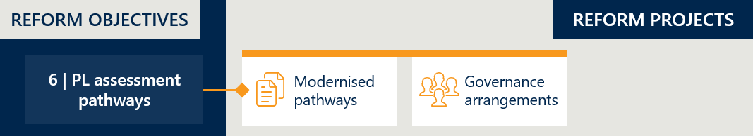

### Implementation progress (a): modernised pathways

|  |
| --- |
| Prior to the reforms, applications for listing items on the PL followed a single assessment pathway. As outlined in *Interim Evaluation #1 report*, multiple assessment “tiers” for PL devices were established under the reforms (Tier 1, 2a, 2b and 3), aiming to increase the efficiency of the assessment process by distributing resources across applications according to their relative complexity.  No major changes in implementation have occurred since the new pathways were introduced on 1 July 2023. |

### The revised assessment pathways have been maintained since their introduction

The updated assessment pathways are structured into three distinct tiers, each with tailored evidence requirements.

These revised pathways are designed to accommodate applications of varying complexity, ensuring that simpler and more complex submissions are processed through appropriate channels.[89] They apply to a range of application types, including new listings, amendments, compressions, and expansions.

The three tiers are set out in Table 11 below.

Table 11 | PL assessment pathways[90]

|  |  |  |
| --- | --- | --- |
| Pathway | Description | Appropriate for the following applications: |
| Tier 1 | Department assessment pathway | * Part A applications that will be assessed only by the Department and are not expected to be presented to MDHTAC for consideration. * Applications for devices that are classified by the TGA as Class IIb or lower, and devices with established technology (“relatively simple, well-understood and stable designs and limited variations, and with proven records of satisfactory safety and performance”). * New applications to list a device within an existing PL grouping. * Amendment applications that do not request a changed PL grouping. |
| Tier 2 | Clinical / focused HTA assessment pathways  (2a: clinical assessment only, 2b: clinical and economic assessment) | * Part A applications involving technology that is not well established; and/or have high variability in design and characteristics; and/or claims novel features, characteristics and functionality. * Applications for devices classified by the TGA as Class III, or any Part C applications. * Applications that require a new grouping. * Amendment applications that request a changed grouping. |
| Tier 3 | Full HTA assessment pathway (MSAC assessment) | * Applications for devices that are novel or first-in-class technology; and/or there are no appropriate comparators on the PL. * Applications where there is no relevant MBS item associated with the use of the device, requiring a new MBS item or an MBS descriptor to be modified. * Applications where listing the device will cause significant financial impact on overall PL expenditure and therefore requires detailed financial assessment. |

### Tier 2 applications have increased over the recent 18-month period

Table 12 and Table 13 show the number of applications for Parts A and C and GUIs in each of the tiers across an eighteen-month period. The data below includes three types of applications:

* New applications.
* Amendment applications[91]: For changing the details of the existing billing code, including: deletion/addition of catalogue numbers, amending product name, description or size stated for billing code, addition or replacement of ARTG entries, changing the grouping the billing code is listed in. Amendment applications do not delete or create any existing billing codes.
* Expansion applications[92]: For expanding the billing code covering multiple devices into two or more new billing codes.

Other application types (applications to delist, compress or transfer) have not been included in this analysis.

For Parts A and C of the list, 76% of applications are new applications to list. Tier 2 is the most utilised pathway for new applications, closely followed by Tier 1. Tier 3 is very rarely used. For Part D (GUIs), 81% of applications are new applications to list.

Figure 24 shows the change in number of applications in each pathway over the same period.

Table 12 | Part A and C applications by tier and assessment pathway – September 2023 to May 2025[93]

|  |  |  |  |  |
| --- | --- | --- | --- | --- |
|  | Tier 1 – Department pathway | Tier 2 – Clinical HTA pathway | Tier 3 – Full HTA pathway | All assessment pathways |
| New | 3896 | 4794 | 3 | 8693 |
| Amendment | 1575 | 1028 | 0 | 2603 |
| Expansion | 120 | 52 | 0 | 172 |
| All application types | 5591 | 5874 | 3 | 11468 |

Table 13 | Part D (GUIs) applications by tier and assessment pathway – September 2023 to May 2025[94]

|  |  |  |  |  |
| --- | --- | --- | --- | --- |
|  | Tier 1 – Department pathway | Tier 2 – Clinical HTA pathway | Tier 3 – Full HTA pathway | All assessment pathways |
| New | 80 | 66 | 0 | 146 |
| Amendment | 21 | 4 | 0 | 25 |
| Expansion | 7 | 2 | 0 | 9 |
| All application types | 108 | 72 | 0 | 180 |

For both Part A & C and Part D, most applications for amendment are submitted through the Tier 1 pathway.

Figure 24 | Number of PL applications between September 2023 and May 2025 (Part A, C and D)

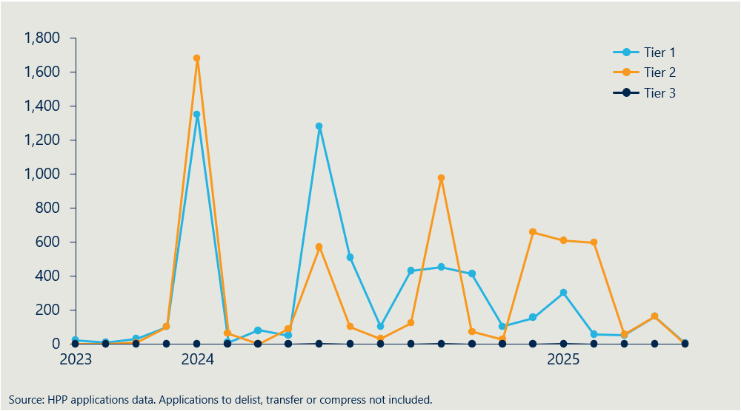

Figure 24 shows a spike in all application pathways in early 2024 followed by a declining trend over the remainder of 2024. This initial spike can be explained by implementation of the new Health Products Portal (HPP) enabling PL applications to be accepted again after applications were closed from May to September 2023. The volume of applications has settled to more normal levels since then.

The pathway trend indicates that Tier 2 applications have increased over time while Tier 1 applications have trended downwards. This may be due to sponsors gaining more familiarity with the tiers and their requirements. It may also be due to sponsor experience with the process and the extent to which Tier 1 assessments by the Department are able to be dealt with expertly and smoothly. Stakeholder feedback reported below suggests that the latter explanation may be key.

### In practice, the tiered assessment pathways have faced operational challenges

Stakeholder feedback indicates that the expected efficiency benefits of the tiered application pathways have not been fully realised, largely due to resourcing constraints – particularly in relation to staff capacity and expertise.

Under the tiered model, Department staff assess Tier 1 applications and prepare Tier 2 applications for MDHTAC. These roles require managing a high volume of technically complex submissions. Recruiting and retaining staff with the necessary skills and knowledge has been difficult, and limited resourcing has drawn criticism from stakeholders, especially representatives of medical technology companies.

*“MDHTAC Members are faced with additional requests to be assessed in real time or delay the application until the next round of ECAG meetings. A harder deadline and better resources for the department would be the obvious solution”*

**MDHTAC member, June 2025**

One consequence has been the reassignment of some Tier 1 applications to Tier 2, suggesting that the Department may lack the capacity or capability to appropriately assess Tier 1 submissions. This reinforces the need for increased staffing and higher levels of technical expertise for Tier 1 assessments.

Staff have also faced challenges managing late or complex responses from sponsors shortly before MDHTAC meetings, further straining an already stretched system.

|  |
| --- |
| RECOMMENDATION 6  Regularly review resourcing needs to strengthen application pathways and inform cost recovery planning  The effectiveness of the application pathways would benefit from a review of resourcing requirements, including the level of expertise required, appropriate service standards, and the staffing structure needed to meet those standards. The findings should directly inform the design of the cost recovery model to ensure it supports a fit-for-purpose workforce. |

### Alignment with HTA principles

The Department is guided by a set of Health Technology Assessment (HTA) principles that define the way that assessment processes like the PL pathways should occur.[95] These principles are outlined below:

|  |
| --- |
| HTA principles:   * Sustainable * Transparent, accountable and independent * Consultative and reflective of Australian community values * Administratively efficient * Flexible and fit for purpose * Informed by robust and relevant evidence |

Some stakeholders do not believe the PL application assessment pathways are well aligned with various HTA principles, raising concerns about sustainability, transparency, administrative efficiency, accountability and consultative engagement.

Medical technology representatives discussed issues with administrative efficiency in depth in their response. Whilst they regard Tier 1 as a step in a positive direction, they stated that evidence requirements for some of the tiers are too stringent compared to overseas markets. They were also concerned that the absence of minimum response times impedes commercial planning, and the progress of applications is often slow due to lack of Departmental resources.

Specific stakeholder feedback and views on this reform project are contained in Table 14 in Section 2.6.7.

### Potential improvements to the pathways process could improve efficiency

While medical technology representatives were broadly supportive of the pathway reforms (see stakeholder perspectives in Section 2.6.7), they identified areas for refinement that could reduce barriers and strengthen alignment with the evidence. A close examination of these suggestions could be undertaken with a view to further embedding the objective of the pathway reforms.

In particular, concerns were raised about the PL Guide issued in December 2023. The guide had not been finalised as of mid-2025 and lacks detailed guidance on several elements, including the focused HTA process.

Stakeholders also pointed to the absence of a clear process for listing new technologies on Part C and criteria for Ministerial recommendations. These gaps are seen as limiting the PL’s ability to support timely access to emerging technologies.

Updating the guide to reflect practical experience with the new pathways could help ensure the reforms achieve their intended impact.

|  |
| --- |
| RECOMMENDATION 7  Review application pathways and update guidance to reflect experience and clarify processes  Following two years of implementation, the revised application pathways should be reviewed to identify targeted improvements that enhance clarity, efficiency and alignment with evidence. This review should inform updates to the PL Guide, including clearer guidance on assessment pathways, criteria for Ministerial recommendations, and the focused HTA process. Drawing on international experience may also support improvements. Clearer, more detailed guidance will help sponsors better navigate the system and reduce delays or confusion. |

### Stakeholder perspectives

Stakeholders raised concerns about the transparency and functionality of the PL application assessment pathways, with private hospitals and insurers noting unclear processes and administrative inefficiencies.

Medical technology representatives provided detailed critiques, welcoming the Tier 1 pathway but highlighted that many applications remain excluded, and that they believe Tier 2b requirements are misaligned with the evidence typically available for medical devices. They argued that the current evidence standards are disproportionately stringent compared to international benchmarks, contributing to delays and rejections for new technologies in the private sector, even when those devices are already available publicly. They also pointed to persistent issues with departmental responsiveness, lack of service standards, and the absence of a clear pathway for listing new technologies on Part C.

Clinician representatives supported the tiered model in principle but acknowledged the Department’s staffing challenge, the need for clearer guidance and better-resourced implementation.

Table 14 | Stakeholder perspectives on PL assessment pathways[96]

|  |  |
| --- | --- |
| Stakeholder group | Perspectives on reform project |
| Private hospital sector | * Private hospitals do not submit PL applications, but some reported concerns about the complexity, inefficiency and limited transparency of assessment processes. They noted reports of challenges in alignment with HTA principles and called for clearer governance, stronger accountability, and improved consultative engagement. |
| Private health insurance representatives | * Insurers expressed concern about the cumulative financial impact of device listings over time, such as drug-eluting stents and Transcatheter Aortic Valve Implantation (TAVI), noting limited transparency on expected volumes or outcomes. * They also criticised aspects of decision-making that appeared inconsistent with HTA principles. |
| Medical technology representatives  *Icon of a microscope* | * Industry welcomed the introduction of the Tier 1 assessment pathway but noted that many applications are excluded, and few applications for new groups or higher benefits succeed. * Evidence requirements were seen as more stringent than in other markets, leading to rejected or delayed listings. Industry representatives reported difficulty obtaining guidance from ECAGs, even for products with established comparators. * Some members have reported that they are not launching products in the private market which are available in the public due to assessment hurdles. * Concerns were raised that the updated PL Guide remains in draft form since December 2023 and that the focused HTA process remains poorly defined. Fit-for-purpose guidelines were seen as essential to reduce delays and confusion. * Stakeholders called for Tier 2b and Tier 3 assessments (particularly for devices without procedure codes) to be completed within one cycle, noting that pharmaceuticals are routinely assessed within 100 days. * The Department was reported to lack sufficient staffing and responsiveness to manage the increased application volume and cost recovery pressures. Written queries were said to face delays, slowing down the process. * Industry representatives stated there is no clear process for listing new technologies – or updating existing listings – on Part C, which limits flexibility and restricts patient access to new devices. |
| Clinician representatives  Icon of a person with a stethoscope | * Clinicians broadly supported the tiered assessment pathways and acknowledged that the Department is still transitioning to full implementation. They supported a gradual approach to allow sponsors time to adjust. * Concerns were raised about the Department’s ability to recruit and retain suitably qualified staff with the clinical and technical expertise required to manage the volume and complexity of applications. |

### Implementation progress (b): governance arrangements

|  |
| --- |
| As outlined in *Interim Evaluation #1 report*, the previous PL governance arrangements were replaced with the Medical Devices and Human Tissue Advisory Committee (MDHTAC) and five associated sub-committees known as Expert Clinical Advisory Groups (ECAGs) to encourage the right level of clinical expertise for the consideration of each application. Representatives from private hospitals, the MTAA and health insurers were not included in the MDHTAC.  No major changes in implementation have occurred since the revised arrangements commenced on 1 July 2023. This section primarily seeks to understand how these governance arrangements are operating and if they have increased the effectiveness of assessments. |

### Representation is appropriate and prioritises the clinical lens, but some governance challenges remain

Overall, governance arrangements appear to be operating as intended in terms of enabling clinically focused assessment.

*“PLAC meetings would often degenerate into long disagreements between hospitals, insurers and industry factions which did not allow the key clinical and health economic issues to be resolved satisfactorily”*

**MDHTAC member, June 2025**

**MTAA, 2017 Senate Submission**

Representatives from MDHTAC noted that the removal of industry, hospital and insurer representatives from governance proceedings has improved efficiency, allowing clinicians to focus on clinical and health economic issues without distraction from commercially interested parties. This change has also minimised the potential for conflicts of interest in decision-making.

One member of the MDHTAC, while supporting the exclusion of these stakeholders from meeting participation, also noted that in certain instances the absence of direct input from private hospitals was a concern.

They valued the opportunity to understand how decisions affect hospital operational processes and, therefore, patient care. This view was echoed by some hospital stakeholders, who noted the value of better engagement on implementation and funding implications.

The decision to remove industry representatives from governance is not supported by industry representatives, as it reduces the opportunity for dialogue and increases the possibility of misunderstandings. However, the evaluation believes these concerns can be addressed within the current arrangements – particularly if resourcing of the listing process is improved and clearer communication channels are established.

#### Greater transparency is needed to align the assessment process with HTA principles

Private health insurance representatives expressed concern over the lack of transparency surrounding the assessment pathways and subsequent decisions. While they acknowledged the decision to remove health insurance, device, and private hospital representatives from MDHTAC meetings and deliberations, they emphasised that they have a legitimate interest in understanding potential cost drivers prior to PL listings, as well as the rationale behind decision outcomes.

#### Applying appropriate clinical expertise through the ECAGs is key to sound decision-making

MDHTAC and ECAGs provide improved clinician coverage across specialty areas of device use compared to previous PL governance structures. Several opportunities for further improvement were identified by stakeholders. Some were of the view that professional organisations should provide the representation rather than particular individuals being appointed. Other concerns included insufficient representation from vascular surgery and concerns regarding the decision to group knee and hip specialists within the same ECAG. These concerns could be alleviated on an ad hoc basis depending on the devices for consideration. The key issue is that the best available expertise is applied to decision-making.

### Stakeholder perspectives

Stakeholders generally acknowledged improvements in governance through the transition to the MDHTAC structure, but some stakeholders raised concerns about transparency, efficiency, and representation.

The private hospital sector noted that while broader expertise is now included, they believe that the multi-layered governance structure slows decision-making and risks prioritising economic considerations over clinical value, especially for high-cost or niche devices.

Private health insurance representatives supported the removal of commercially interested parties from MDHTAC but called for stronger transparency, accountability and faster correction of listing errors.

In contrast, medical technology peak bodies criticised the exclusion of industry from attending governance meetings, arguing that written feedback cannot replace dialogue and that reintroducing industry participation would improve transparency and confidence in the process.

Some clinical representatives viewed recent changes as superficial and recommended more robust representation from professional bodies, better departmental expertise, and mechanisms to ensure timely listing post-TGA approval. Others were more satisfied with current arrangements, but flagged issues with ECAG groupings, such as the hip and knee committee, which may result in less relevant specialist input on some applications.

Stakeholder perspectives are outlined in Table 15 below.

Table 15 | Stakeholder perspectives on PL governance arrangements[97]

|  |  |
| --- | --- |
| Stakeholder group | Perspectives on reform project |
| Private hospital sector | * Hospitals welcomed the shift from the Prostheses List Advisory Committee to MDHTAC, recognising the broader expertise now involved. However, concerns remain about the multi-layered governance structure, which is seen to slow decision-making. * Stakeholders noted that economic and pricing considerations appear to be increasingly prioritised under the guise of value-based assessment, potentially limiting access to innovative or niche devices. * There was frustration that the rationale behind listing decisions is not publicly disclosed, making it difficult to understand or challenge inclusion and exclusion decisions. |
| Private health insurance representatives | * Insurers reported that listing decisions lack transparency, limiting their ability to understand key cost drivers. While they accepted the removal of insurers and hospitals from MDHTAC due to perceived conflicts of interest, they stressed that funds should still have visibility over key inputs into decision-making. * They called for stronger Departmental accountability and greater transparency from MDHTAC and ECAGs to ensure listing decisions are aligned with HTA principles and can be appropriately reviewed if errors occur. |
| Medical technology representatives  *Icon of a microscope* | * Industry stakeholders raised concerns about being excluded from advisory groups and MDHTAC, limiting their ability to clarify or respond to issues from a device perspective. * Written feedback on MDHTAC papers was seen as inadequate compared to direct participation, particularly when misunderstandings arise. * They argued that industry involvement is critical for providing technical input, especially in contentious discussions. Increased transparency and opportunities to observe or present to committees would help rebuild confidence. |
| Clinician representatives  Icon of a person with a stethoscope | * Clinicians felt current governance reforms were superficial and advocated for further changes to ensure robustness and appropriate professional representation, including input from peak bodies. * Concerns were raised about the structure of some ECAGs (e.g. combining hip and knee expertise), which may limit relevant input and reduce meeting attendance by specialists. * They recommended establishing a review mechanism for listed items and prices to reflect technological advances and clinical data and stressed the importance of timely PL listing for TGA-approved items to avoid access gaps between public and private systems. |

## Objective 7: Develop and implement PL post-listing reviews and PL compliance frameworks to safeguard the PL Reforms

*This section considers developments related to post-listing reviews, including the implementation of a guiding framework and pilot reviews. This section also considers the implementation of a compliance strategy and associated compliance activities. It documents the types of compliance activities conducted and summarises stakeholder perspectives on the reform project.*

Figure 25 | Reform projects related to reform objective 7



### Implementation progress (a): post-listing reviews

|  |
| --- |
| A listing decision for the PL is made based on the available evidence and clinical context at the time of assessment. Over time, new information about a device may become available creating uncertainty about the eligibility or benefits payable for a device. Post listing reviews assess the comparative clinical and cost effectiveness of a device, evaluating the evidence of its benefits and determining whether it continues to meet current eligibility criteria for listing on the PL.  As outlined in *Interim Evaluation #1 report*, post-listing reviews were piloted through the reforms. Of these four pilot reviews, two were completed in the past period and two are ongoing. The Department also released an updated post-listing review framework in December 2024, updating the post-listing review framework released on 1 July 2022, to incorporate their learnings, clarify their processes and promote consistency of these reviews.[98] |

### The review process has been resource-intensive and sometimes lengthy

Two of the four pilot reviews were completed in 2023, taking seven months and eight months respectively. The two remaining reviews were still underway in June 2025, having so far taken two years and nine months each. Table 16 provides details of progress and outcomes of the four post-listing reviews.

The primary reasons for the length of the reviews appear to be changes in staffing, upskilling staff and the complexity of the stakeholder engagement, particularly with clinical stakeholders. The benefit setting stage is sensitive in relation to cost effectiveness.

Many stakeholders have expressed frustration at the length of the post-listing review process. One of the issues highlighted about the length of the reviews is the state of uncertainty and disruption in clinical practice that occurs when these reviews are underway. There is undoubtedly a cost to reviews taking a long time as the uncertainty undermines the existence of the PL mechanism which locks in clinical choice so that hospitals and surgeons can adapt their practice and training to the listed devices. By contrast, some stakeholders support a more deliberate and comprehensive review process, despite the time involved, as it better reflects the complexity of assessing comparative clinical and cost effectiveness relative to other medical interventions. This approach aligns with standard practice for other types of post-market reviews, which are similarly extensive.

Shortening the process is heavily dependent on more resources being available. The efficient cost of post listing reviews was not recovered from sponsors during the PL reform period.[99] From 1 July 2025, industry will be charged for the cost of the reviews, with the levy is set to increase from $150 to $355 per device to include compliance and post listing review costs, as well as increased IT costs.[100]

Table 16 | Summary of pilot post-listing reviews

|  |  |  |  |  |  |
| --- | --- | --- | --- | --- | --- |
| PL review | Duration | Purpose | Review(s) | Key finding | Outcome |
| Metal-backed patellae (MBP) | Seven months  (August 2022 – March 2023) | To compare comparative clinical effectiveness and cost-effectiveness of MBP compared to all-polyethylene patellae (APP), as MBP attracted higher benefit amounts despite reported inferior safety and performance.[101] | Internal department review with advice from former Knee Prostheses Clinical Advisory Group (KPCAG). | Based on available evidence, there should be no benefit difference between MBP and APP. | March 2023 – The PL benefit for MPP was reduced to the PL benefit assigned to APP. |
| Surgical guides and biomodels | Ongoing (September 2022 – Present) | To review rapid growth in use of surgical guides and biomodels, reports of overuse and inappropriate use, uncertainty about eligibility on the PL and comparative clinical effectiveness and cost effectiveness.[102] | Stage 1: Health Technology Assessment (HTA) through an external provider  Stage 2: Comparative economic analysis | Stage 1: Surgical guides and biomodels are clinically effective when used for insertion of a medical device in complex craniomaxillofacial surgery, however there is insufficient evidence to support the listings for other types of surgeries. | November 2023 – Stage 1 – A implement a new condition to PL reimbursement: limit use to craniomaxillofacial procedures and restrict the total to six benefits per procedure[103] (From 1 February 2024).  Review of the condition presented to MDHTAC for advice May 2025.  Stage 2: Hereco report to the department to inform Stage 2 received 5 June 2025. |
| Spinal cord stimulators | Ongoing  (September 2022 – Present) | Assess the comparative clinical effectiveness and cost effectiveness of SCS as neurostimulation therapy for complex chronic pain management. | Focused HTA through an external provider | Stage 1: Uncertain comparative clinical effectiveness and insufficient evidence to inform alternative PL listing settings.  Stage 2: Assessed two components (implantable pulse generators and leads) of SCS systems that make up the majority of the benefit.  Stage 3: Reviewing benefit settings for the two components separately.[104] | Two focused commentaries received from Hereco and presented to MDHTAC for advice (May 2025). |
| Mid urethral sling (MUS) – Urogynaecological mesh device | Eight months (February 2023 – October 2023) | Assess the comparative clinical effectiveness and cost effectiveness of MUS for the treatment of stress urinary incontinence (SUI) following the removal of two other types of urogynaecological mesh devices from being supplied in Australia.[105] | Focused HTA through an external provider | MUS demonstrates comparable effectiveness and cost-effectiveness to alternative surgical interventions for the treatment of SUI. | October 2023 – Retained existing listings and benefits for urogynaecological mesh devices currently listed on the PL. |

### A revised framework for post-listing reviews was released in December 2024

A new version of the post-listing review framework was released in December 2024, updating the initial framework that was published in July 2022. The updated framework was developed from stakeholder feedback and internal department experience with the four pilot post-listing reviews.[106]

Advice from the Department suggests that the key lessons taken into account in the new framework were:

* Communicating the scope with external stakeholders
* Clearly written Terms of Reference, and
* Clear articulation of the research questions before collecting information.

In response to feedback from some stakeholders advocating for more transparency regarding the evidence base for the decision to initiate reviews, and a timetable that provides advance notice, the Department has committed to publishing an annual plan of post-listing reviews. No new reviews under the new framework have been announced.

The evaluation notes that advance notice would likely improve the uncertainty caused by a device being listed for review. Figure 26 presents the revised process, as outlined in the new framework.

Figure 26 | PL post-listing review process from new framework

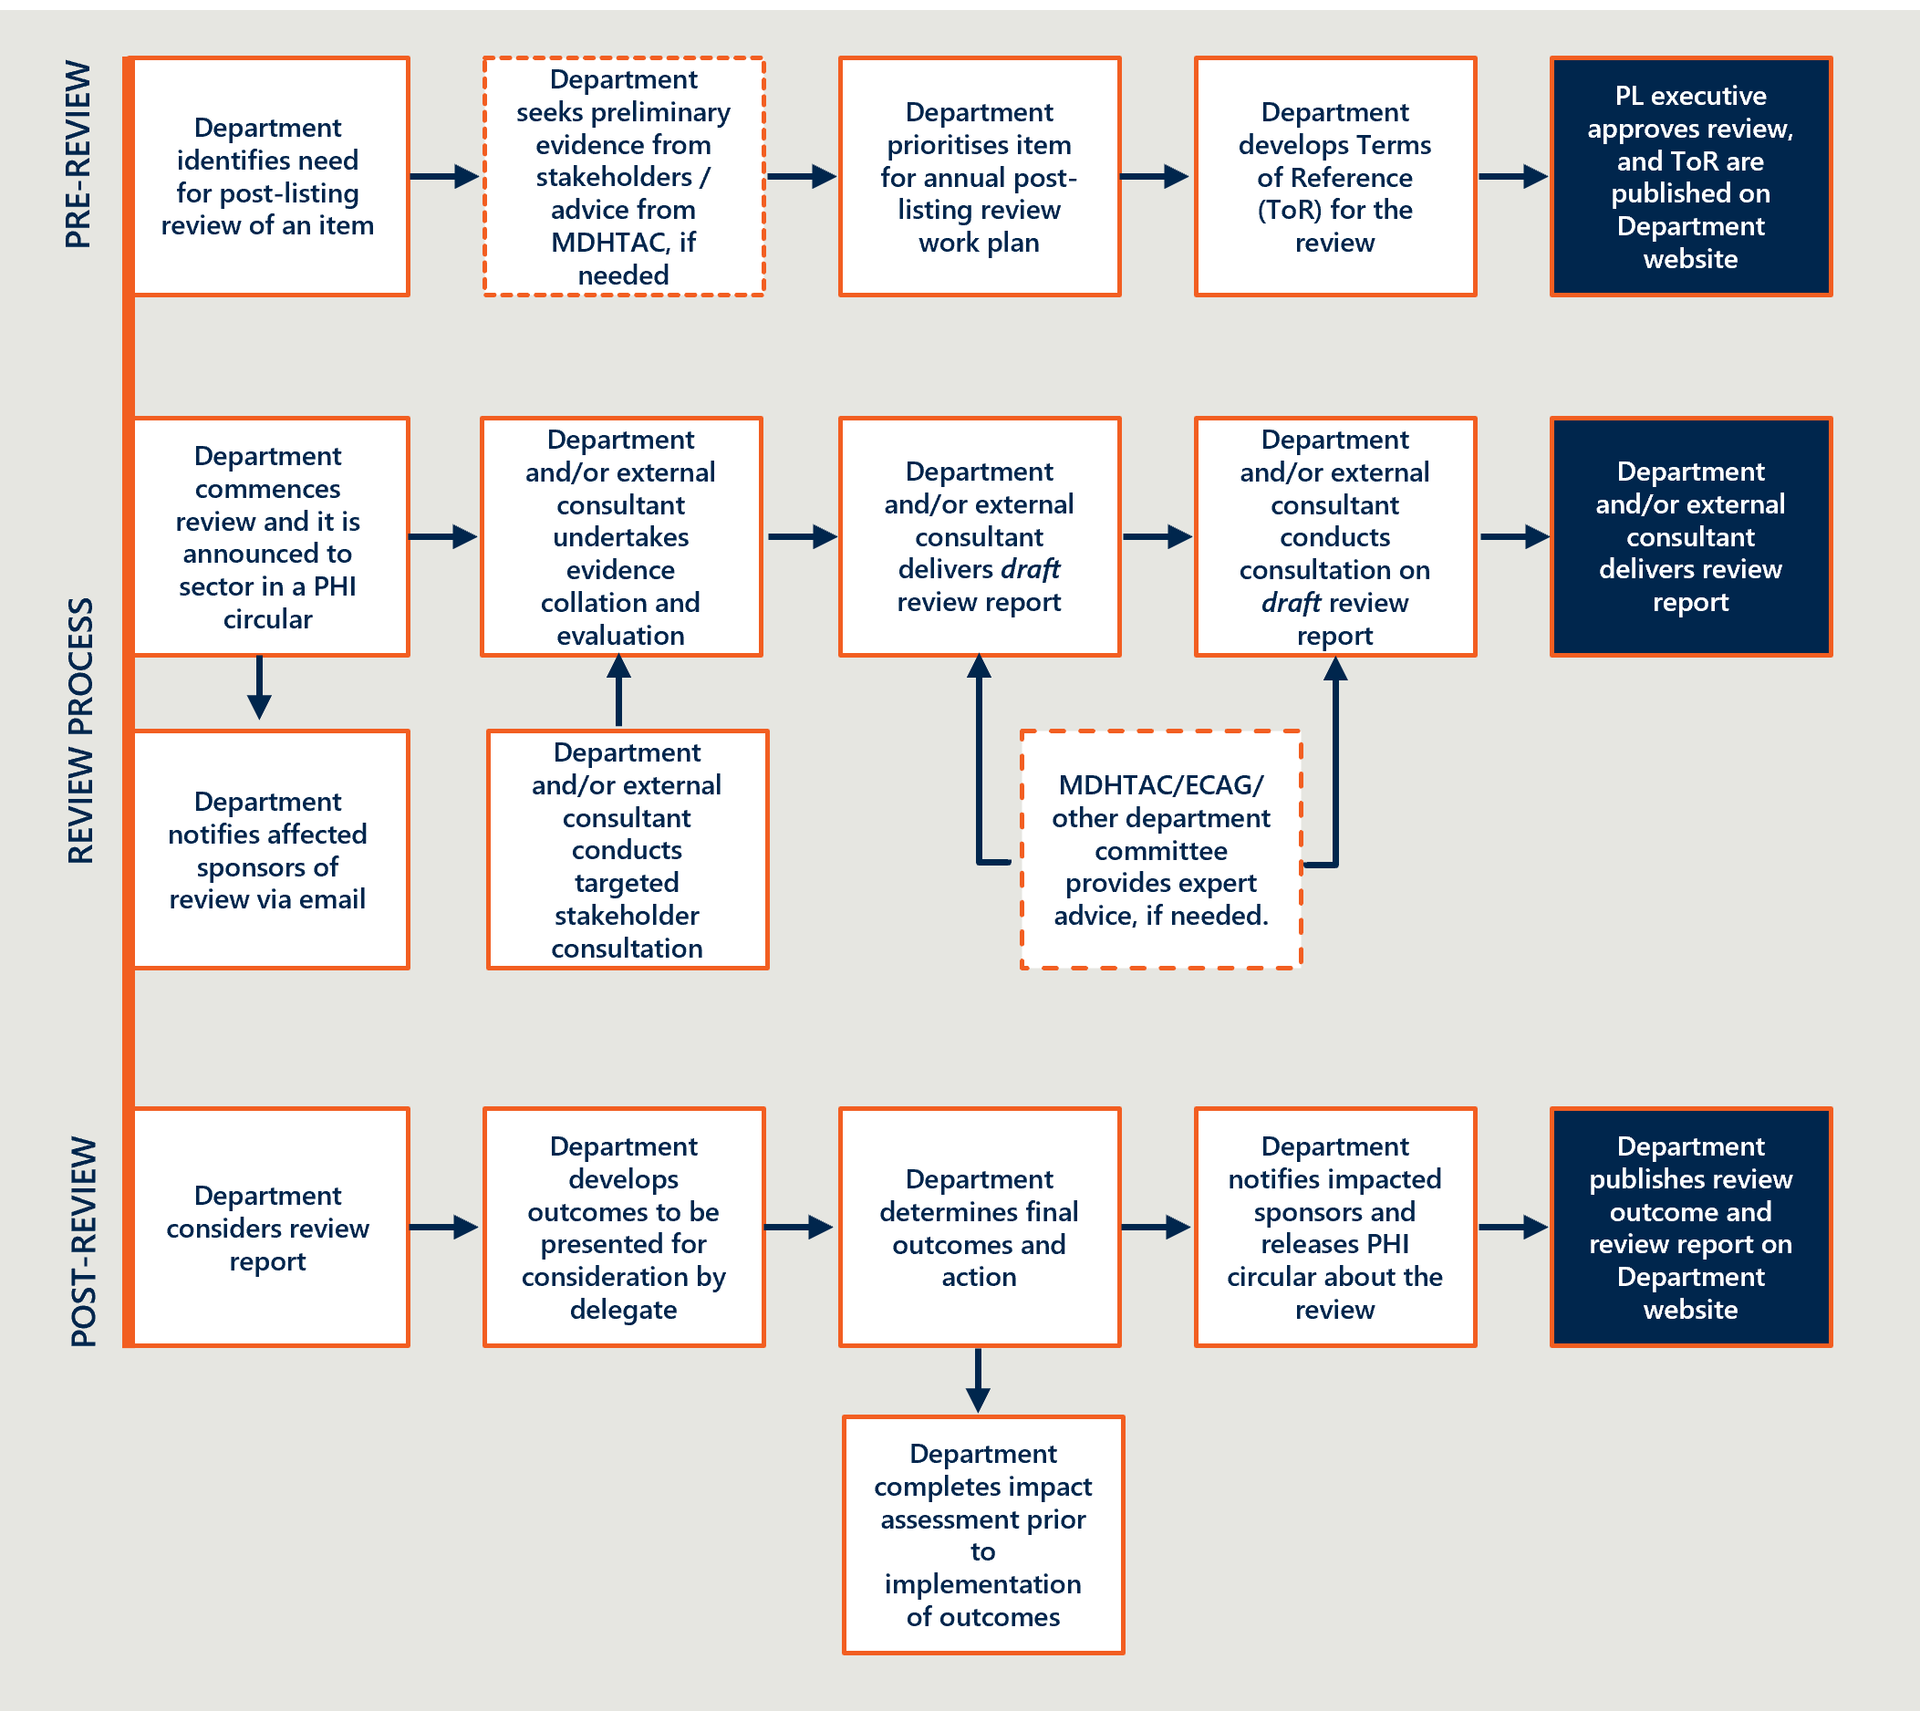

### Stakeholder perspectives

Stakeholders broadly supported the principle of post-listing reviews as a mechanism to maintain the integrity and value of the PL. However, they raised concerns about the execution, transparency, and impact of the reviews.

Private hospital representatives emphasised the need for meaningful stakeholder engagement, adequate resourcing, and a forward program of reviews to avoid disruption and mistrust, citing unresolved disputes from the ongoing surgical guides and biomodels pilot as a cautionary example.

Private health insurance representatives saw the reviews as essential to curbing waste and returning value to consumers, but criticised delays and what they viewed as non-implementation of recommendations made in reports by independent consultants commissioned for the reviews into spinal cord stimulators and surgical guides and biomodels.

The medical technology sector warned that reviews are resource-intensive and offered a view that they are often initiated without sufficient justification. They called for clearer guidelines, early consultation, and recognition that limited evidence does not equate to low performance.

Clinician representatives stressed the importance of preserving clinical discretion and cautioned against overreach by external reviewers, particularly in setting usage caps that may not reflect patient needs.

Overall, stakeholders called for a more transparent, consultative, and balanced approach to the reviews that supports innovation while ensuring accountability.

Table 17 | Stakeholder perspectives on post-listing reviews[107]

|  |  |
| --- | --- |
| Stakeholder group | Perspectives on reform project |
| Private hospital sector | * Hospitals noted the post-listing review framework as a critical component of the PL reforms but stressed that the legitimacy of post-listing reviews depends on appropriate resourcing, stakeholder engagement and clear justification. Without this, confidence may erode, and clinical value may be deprioritised. * Some reviews, in particular the review of surgical guides and biomodels, were seen to trigger prolonged disputes between stakeholders, with pilot reviews noted to have caused confusion or disruption rather than clarity. * Concerns were raised by some private hospital representatives about delays in review activity and perceived prioritisation of new listings over post-listing work. Hospitals called for a clearer forward program, stronger consultation processes, and adequate support to ensure timely and transparent delivery. |
| Private health insurance representatives | * Private health insurer representatives argued that post-listing reviews should be designed to deliver value to consumers and taxpayers and emphasised the importance of timely implementation. They stated that when reviews result in the removal of substantial costs from a Prostheses List (PL) grouping; such as resetting benchmarks, the outcome is not just cost-neutral but represents a net gain on the investment made. * Insurer representatives expressed frustration with the Department’s decision not to implement recommendations from the external consultant report on spinal cord stimulators. They viewed this as undermining the purpose of the review. Concerns were raised about permanent leads being funded by private health insurance during trials, despite trial leads being globally provided by the same manufacturers. They suggested that delays or decisions not to proceed have led to wasted resources. * **Insurers described** the significant cost increase for surgical guides and biomodels on the PL as a policy failure that has enabled the growth of an industry delivering low-value care, costing consumers and taxpayers tens of millions of dollars. However, they also acknowledged that some surgeons use surgical guides appropriately for complex CMF procedures and stated their willingness to continue supporting reimbursement in these specific cases. |
| Medical technology representatives  *Icon of a microscope* | * Industry stakeholders cautioned that reviews may be initiated without sufficient cause, risking commercial disruption and increasing costs for both industry and government (particularly with the introduction of cost recovery from FY26). * They called for a published program of upcoming reviews, with early opportunities for input to help prioritise topics and align evidence development. * Several reviews, including those on surgical guides and biomodels, were seen as slow-moving and poorly communicated, contributing to prolonged uncertainty and limited consultation on key stages such as benefit reductions. Other reviews, such as for metal backed patella, were seen as rushed, with minimal time for sponsor response. * Stakeholders noted that some devices are unlikely to meet Incremental Cost Effectiveness Ratio (ICER) thresholds due to inherent limitations in evidence generation and argued for flexible pricing mechanisms in such cases. |
| Clinician representatives  Icon of a person with a stethoscope | * Clinicians supported the principle of post-listing reviews but called for greater recognition of how early-stage innovation may carry higher costs while delivering long-term value. * They raised concerns that some reviews have imposed restrictions that exceeded their scope, particularly on surgical guides and biomodels, and noted negative impacts on clinical choice. * The importance of allowing clinicians to tailor decisions to individual patient needs was emphasised. |

### Implementation progress (b): compliance activities

|  |
| --- |
| The Department committed to developing a formal compliance strategy and associated compliance mechanisms to safeguard the PL as part of the reforms.  A compliance strategy was published by the Department and consultations were conducted on various proposed measures for compliance, assurance and information sharing. These were discussed in *Interim Evaluation #1 report*. Since then, the Department has consulted on two additional proposed compliance measures:   * Consultation Paper 8a *Gifts, benefits and discount reporting requirements*: a compliance measure that would require hospitals or sponsors to maintain and report a register of gifts, benefits and discounts. * Consultation Paper 8b *Alignment of amount charged for supply of a device with corresponding PL benefit*: a compliance measure that would restrict sponsors from charging an amount higher than the PL benefit for the supply of medical devices on the PL.   The Department concluded in January 2025 that there was insufficient evidence to justify legislating these two measures and they would not be included in the proposed Compliance, Assurance and Data Sharing Bill.[108] |

### A compliance program was an essential element of the reforms

At the outset of the reforms, the establishment of a compliance program was considered essential for safeguarding the integrity of the PL. This would encompass arrangements that would ensure robust administration of the PL, limit opportunities for gaming, and have power to address types of non-compliance actions and make compliance decisions. In May 2023, the Department released Prescribed List Compliance Strategy (The Strategy), which incorporated stakeholder feedback on the draft strategy that was open for consultation in September and October 2022.[109]

The Strategy set out the compliance approach according to a responsive enforcement model, with steps the Department may take when there are concerns about inappropriate practices that:

* Distort the benefit price settings
* Encourage artificial listing structures
* Establish benchmark benefit pricing for discontinued or dormant devices
* Support fraudulent listing and/or utilization
* Result in unfair listing arrangements (e.g. applying for incorrect grouping)
* Drive increases to patient out-of-pocket expenses.[110]

The evaluation is aware that the Strategy hosted on the Department’s website was updated in July 2025,[111] and this will be considered in the final report.

### Additional proposed compliance measures were not supported

Additional compliance measures, proposed in Consultation Papers 8A and 8B were considered unjustified based on the evidence.[112] These measures would have required hospitals or sponsors to maintain and report a register of gifts, benefits and discounts and would have restricted sponsors from charging an amount higher than the PL benefit for the supply of medical devices on the PL. The decision not to proceed with these additional measures was supported by most stakeholders.

### As a result of delays to legislative reform, the adequacy of compliance activity to safeguard the PL remains unclear.

As of June 2025, the proposed Compliance, Assurance and Data Sharing Bill remains in draft form, and has not commenced the legislative process. The Department initially advised that the draft bill was expected to be finalised in 2025.[113] In July 2025, the Department updated the estimate to be 2026 or 2027.

As a result of the delays to the legislation, the Department does not yet possess any additional powers to compel stakeholders to comply with the majority of compliance measures outlined in Consultation Paper 7. Subsequent investigation by the Department found that some of these measures may already be covered by existing legislation or found in existing industry practice.

The compliance mechanisms currently available include PL device utilisation monitoring, post listing reviews and communication and education. The Department also has the ability to place conditions on the use of PL listed devices, as occurred as a result of post-listing review into surgical guides and biomodels. However, placing conditions of use is a highly uncommon action, with less than twenty devices on Part A currently having a condition restricting its reimbursement.

The evaluation will continue to monitor developments and progress for the compliance reform project.

### Existing dispute resolution arrangements are considered adequate

Private hospital representatives raised concerns about the absence of a formal PL dispute resolution pathway between insurers and hospitals, identifying this as a gap the Department should consider addressing.[114]

The evaluation consulted the Office of the Commonwealth Ombudsman, which confirmed it receives a small number of complaints related to PL items, some involving hospital-insurer disputes. In carrying out its role, the Ombudsman may make recommendations on individual cases, report on systemic issues or refer matters to the Department with a view to protecting the interests of private health insurance consumers. However, as outlined in Section 2.2.2, the Ombudsman has not observed any systemic trends of concern related to PL items.

The evaluation was advised that some hospitals do not pursue disputes with insurers through the Ombudsman, perceiving the process to be ineffective or burdensome. This indicates that the number of Ombudsman cases likely underrepresents the extent of disputes between PL parties.

The evaluation notes that the PL does not govern the contractual relationships between PL parties. The addition of a dispute resolution function, as advocated by some stakeholders, could be considered by the contractual parties.

### Stakeholder perspectives

Stakeholders raised widespread concern about the adequacy, clarity, and fairness of compliance arrangements under the PL reforms.

The private hospital sector raised issue with what they view as under-resourcing within the Department, as well as a lack of enforceable obligations on insurers, leading to claim rejections and costly dispute resolution processes. They expressed concerns about the overall compliance strategy, particularly regarding balance, transparency, and administrative burden, stating that the current compliance approach disproportionately focuses on hospitals while failing to address insurer-related issues, such as the nonpayment of what they believe are valid prostheses claims. One representative called for a comprehensive compliance framework that ensures equitable accountability across all stakeholders, while another requested greater transparency and reporting requirements, as well the addition of a dispute resolution function within the Department.

Private health insurance representatives criticised the slow progress and weak enforcement of compliance measures, warning that the absence of additional legislative backing may leave the PL susceptible to fraud and system gaming. They advocated for full visibility of claimed device product codes and a centralised, auditable register.

Medical technology representatives were concerned that compliance efforts appear to disproportionately target industry while failing to address insurer non-payment. They supported the Department’s decision not to proceed with earlier proposals (measures 8a and 8b) to mandate discount disclosures and price caps.

Clinician representatives acknowledged stakeholder concerns and noted that the compliance strategy is under revision.

Table 18 | Stakeholder perspectives on PL compliance[115]

|  |  |
| --- | --- |
| Stakeholder group | Perspectives on reform project |
| Private hospital sector | * Hospitals viewed the Department as under-resourced, limiting its ability to effectively implement and enforce compliance activities. * Stakeholders welcomed the decision not to proceed with the proposed compliance measures related to gifts, benefits and discounts, citing a lack of robust evidence and disproportionate regulatory burden. * Concerns were raised that some private health insurers are unilaterally determining ‘reasonable use’ and rejecting claims for PL-compliant items, imposing administrative and financial burdens on hospitals. * Stakeholders expressed that the current system lacks a neutral, enforceable dispute resolution pathway, forcing parties to pursue costly mediation and exacerbating tensions between hospitals and insurers. * Hospitals argued that insurers should be required to report when they do not pay a benefit, pay less than listed, or delay payment pending clinical notes. * Compliance measures were also seen by some private hospital representatives as necessary to monitor the impact of financial incentives that may influence clinicians’ device choices, noting hospitals’ limited visibility over these arrangements. |
| Private health insurance representatives | * Insurers considered compliance efforts under the PL reforms inadequate, particularly due to insufficient transparency and lack of enforceability. * They argued that without legislative backing, compliance activity will remain weak and ineffective. * To improve oversight, they proposed that all PL product codes be mapped to billing codes and maintained in a central, publicly accessible register. |
| Medical technology representatives  *Icon of a microscope* | * Industry noted that compliance requirements have yet to be implemented, and that draft proposals appear imbalanced, without adequate consultation or clarity. * Industry expressed concern about the lack of enforcement mechanisms, and what they believe is the Department’s unwillingness to enforce compliance specifically related to ongoing insurer non-payment of PL items. * Stakeholders welcomed the decision not to proceed with requirements for disclosure of discounts and gifts, viewing the original proposals as misdirected and overly burdensome. |
| Clinician representatives  Icon of a person with a stethoscope | * Clinicians acknowledged that hospital and industry stakeholders had raised significant concerns about the original compliance strategy, particularly regarding lack of clarity and administrative burden. * They noted the strategy is now being revised and supported efforts to update it in line with practical needs. |

## Objective 8: Ensure ongoing financial sustainability of PL administration through effective and efficient cost recovery arrangements that are compliant with the AGCF

*This section considers the implementation of cost recovery arrangements at a high level, noting a formal assessment of cost recovery is out of scope for the evaluation. This section also considers the financial sustainability of the PL’s administration, outlining any change in PL administrative effort and documenting stakeholders’ perspectives on its resulting financial sustainability.*

Figure 27 | Reform projects related to reform objective 8



### Implementation progress: cost recovery fees

|  |
| --- |
| PL cost recovery arrangements have been updated through the reform process and include application fees per device for Part A, C and D[116] and the introduction of an annual levy payable for each billing code listed in Part A, C and D.[117]  With the passage in March 2023 of legislative amendments to provide authority for the revised cost recovery arrangements, the revised cost recovery model commenced on 1 July 2024.  The updated PL cost recovery fees for PL listings include a standard application fee, and any additional payable fees required, depending on which assessment pathway (tier) is relevant for the medical device or product application.  The new annual levy charges industry sponsors who have items listed on the PL for costs which cannot be assigned to a specific sponsor, such as PL administration costs and IT system costs. The levy is payable once annually for each item (billing code) that a sponsor has listed on the Prescribed List, excluding Part B[118]  From 1 July 2025, the levy will also cover compliance activities and post-listing review costs.  Since the publication of *Interim Evaluation #1 report*, the new cost recovery levy (for FY 2024-25) has been charged to sponsors for the first time.[119] This occurred on 15 March 2025, later than anticipated and is planned to occur annually on the 15th of September going forward.[120]  Initially, the new levy was estimated to cost medical device sponsors between $350-$400 per billing code they had listed on the PL. This first instance of the levy was reduced to $150, as compliance and post-listing review costs for 2024-25 were funded through the reform process for this period.[121] |

### Balancing efficient administration with cost recovery and financial sustainability of the PL is challenging

A key aim of the cost recovery policy is to support the financial sustainability of the PL. As discussed in *Interim Evaluation #1 report*, prior to these changes, PL cost recovery arrangements had been unchanged since 2009. The arrangements did not align with the Australian Government Charging Framework (AGCF), as they were not adequately reflective of the size and complexity of the Department’s administration activities related to the PL.[122]

While the changes are intended to bring cost recovery fees into line with the cost of administration, all stakeholders, including departmental staff, are concerned that the resources available to administer the PL are inadequate and do not represent efficient administration. Creating a balance between adequate resources and the fees and levies charged is challenging as many stakeholders do not welcome increases in fees.

For 2025-26 the Department has reviewed the fees and charges and increased fees in line with indexation. This includes a modest increase in staffing costs (3%) and increases for Tier 2 and 2a application pathways (between 6-33%) due to an increase in committee costs and costs of externally contracted health technology assessments for economic evaluations.[123] From 1 July 2025, the levy will increase from $150 to $355 per device as a result of including compliance, post listing review costs and increased IT costs.[124]

The cost recovery charging model is dynamic and will require continuous improvement to reflect policy and activity changes. The Department has communicated they are progressing an independent review of the Prescribed List cost recovery arrangements during 2025.[125]

### Some administrative practices may be compromising cost recovery

The evaluation was informed that there have been cases where applications submitted as Tier 1 are determined by departmental staff to require clinical assessment as per Tier 2, but no additional fees are requested or paid when the application is elevated to Tier 2.[126] Given that the clinical assessment fee for a Tier 2 application is $3,970 (and for Tier 2b an additional economic evaluation fee of between $9,250 and $28,920), this movement between the tiers may represent a significant shortfall in potential cost recovery revenue. The reason given for this movement between the tiers is a lack of appropriately skilled resources to undertake the Tier 1 assessments within the Department. In March 2025, the Department introduced additional internal controls to address the impact of PL administrative practices on cost recovery. The evaluation will continue to monitor this area and provide any update in the final report in 2026.

### Stakeholder perspectives

Stakeholder feedback on the financial sustainability of the PL reveals tensions between rising administrative costs and the need to preserve equitable access to medical technologies.

Private hospital representatives stressed that under-resourcing within the Department has led to delays, errors, and cash flow disruptions, and called for arbitration mechanisms to resolve pricing disputes.

Private health insurance representatives questioned the continued viability of the PL model, advocating for a shift to bundled payment systems to reduce costs and administrative burden.

The medical technology industry raised concerns about escalating cost recovery fees, particularly for smaller and Australian-based companies, warning that the financial burden may discourage listings and limit innovation. They advocated matching fees with service commitments and considering fee relief for domestic firms.

Clinician representatives supported continued investment in the PL, warning that inadequate funding could delay access to new technologies and undermine the value of private health insurance for patients.

Table 19 | Stakeholder perspectives on cost recovery and financial sustainability of the PL[127]

|  |  |
| --- | --- |
| Stakeholder group | Perspectives on reform project |
| Private hospital sector | * Hospitals stressed that the sustainability of the PL depends on adequate departmental resourcing, particularly during critical points in the PL cycle. They reported delays in list publication and errors that affect claims processing and cash flow. * They supported introducing an arbitration mechanism to resolve pricing disputes, especially when sponsors charge above the listed benefit, to ensure fairness and reduce administrative burden. * Stakeholders warned that under-resourcing may undermine the broader objectives of the reform by deprioritising essential activities. |
| Private health insurance representatives | * Insurers argued against the continued operation of the PL in its current form, viewing it as outdated and resource-intensive. * They advocated for a transition to a DRG or bundled payment model to support a more sustainable, value-based system. |
| Medical technology representatives  *Icon of a microscope* | * Industry representatives expressed concern about rising costs due to fee increases, the introduction of cost recovery, and charges related to the National Joint Replacement Registry (NJRR). These were seen as particularly burdensome for smaller or Australian-based companies. * They highlighted that previously free listing amendments now incur fees between $1,420 and $5,390, which may discourage sponsors from making necessary amendments, such as updated ARTG details on the PL as a result of changes made by the TGA. * While supportive of the Department’s financial sustainability goals, some stakeholders called for cost recovery measures to be proportionate to business size and capacity and recommended waiving or reducing fees for smaller companies to support local innovation and biotech development. This position was not supported by other industry parties. * They also noted a lack of service level commitments despite increased costs. |
| Clinician representatives  Icon of a person with a stethoscope | * Clinicians emphasised that the PL must be adequately funded to support sound decision-making and ensure timely access to new technologies in private hospitals. * They warned that underfunding may increase costs elsewhere in the system or reduce access for patients, ultimately diminishing the value of private health insurance. |

1. Methodology
   1. Purpose and key objectives

#### The evaluation seeks to understand the extent to which PL reform activities have delivered the objectives of the reform

The purpose of the evaluation is to understand the extent to which PL reform activities have delivered the objectives and provide formative insight into their delivery. The key objectives of the evaluation are:

* Documenting the implementation of PL reform activities, enabling and constraining factors, and the degree to which the PL reform is implemented as intended.
* Determining whether PL reform activities are achieving their intended objectives, and where possible, indicating the extent to which the desired outcomes have been achieved.
* Identifying unintended consequences of reform activities and provide insight into how negative unintended consequences can be mitigated.
* Providing ongoing insight into additional activities to support the objectives of the program and findings to inform the future direction of PL management.
  1. Evaluation plan and theory of change

#### Nous planned the PL evaluation using the Department’s framework

The Department established the Prostheses List Evaluation Framework in 2021 to inform a consistent monitoring and evaluation approach that is applicable from the conceptualisation of the PL reforms through to its implementation and beyond. Nous was commissioned to evaluate the PL reforms using the evaluation framework. Nous has independently reviewed the Department’s evaluation framework, and the evaluation team is satisfied it outlines an appropriate structure by which the reforms should be evaluated.

Nous delivered its evaluation plan to the Department on 14 August 2023, detailing the evaluation context, objectives, approach, methodology and project plan. This is summarised in sub-sections below. The evaluation plan maintained the Framework’s overarching program logic and key evaluation questions (KEQs), while developing an explicit theory of change, and including its own evaluation activities, sub-research questions, indicators and measures.

The program logic and theory of change outline the reasoning between completion of evaluation activities and measurable changes in outcomes

The Federal Government has allocated $22 million and provided additional resources, including the establishment of the Prescribed List Taskforce within the Department, to drive the successful implementation of the reform program. The reform utilises various inputs such as PL data, reference pricing, clinical data, technological systems, and existing research, which support a series of targeted activities designed to refine documentation, engage stakeholders, enhance systems, and create a robust monitoring and evaluation framework.

Activities conducted are expected to lead to distinct outcomes in the short term (e.g., reduced pricing disparities, legislative clarity, streamlined processes), medium term (e.g., improved compliance activities, transparent administration), and long term (e.g., better access to cost-effective prostheses, more affordable private health insurance). The program logic diagram depicted in Figure 28 provides a summary of the reform program as described above

The theory of change posits that cost reduction in PL-listed items and PL administration will translate into better value for the public, with no adverse effects on patients' clinical outcomes, aligning spending on more valuable initiatives and improving value-for-money in private health cover.

The activities, outcomes, and long-term objectives of the reform are linked causally, with these relationships detailed in the causal logic diagram in Figure 29 and encapsulated within the broader theory of change:

*If costs associated with the purchase of PL-listed items and with the administration of the PL are reduced, then this value will be passed to the public in the form of improved allocation of tax revenue to other valuable initiatives, reduced private health insurance premiums, or otherwise improved value-for-money in private health insurance. These cost reductions can be achieved without any negative impacts to consumers and their clinical outcomes.*

Figure 28 | Prescribed List Reform Program Logic

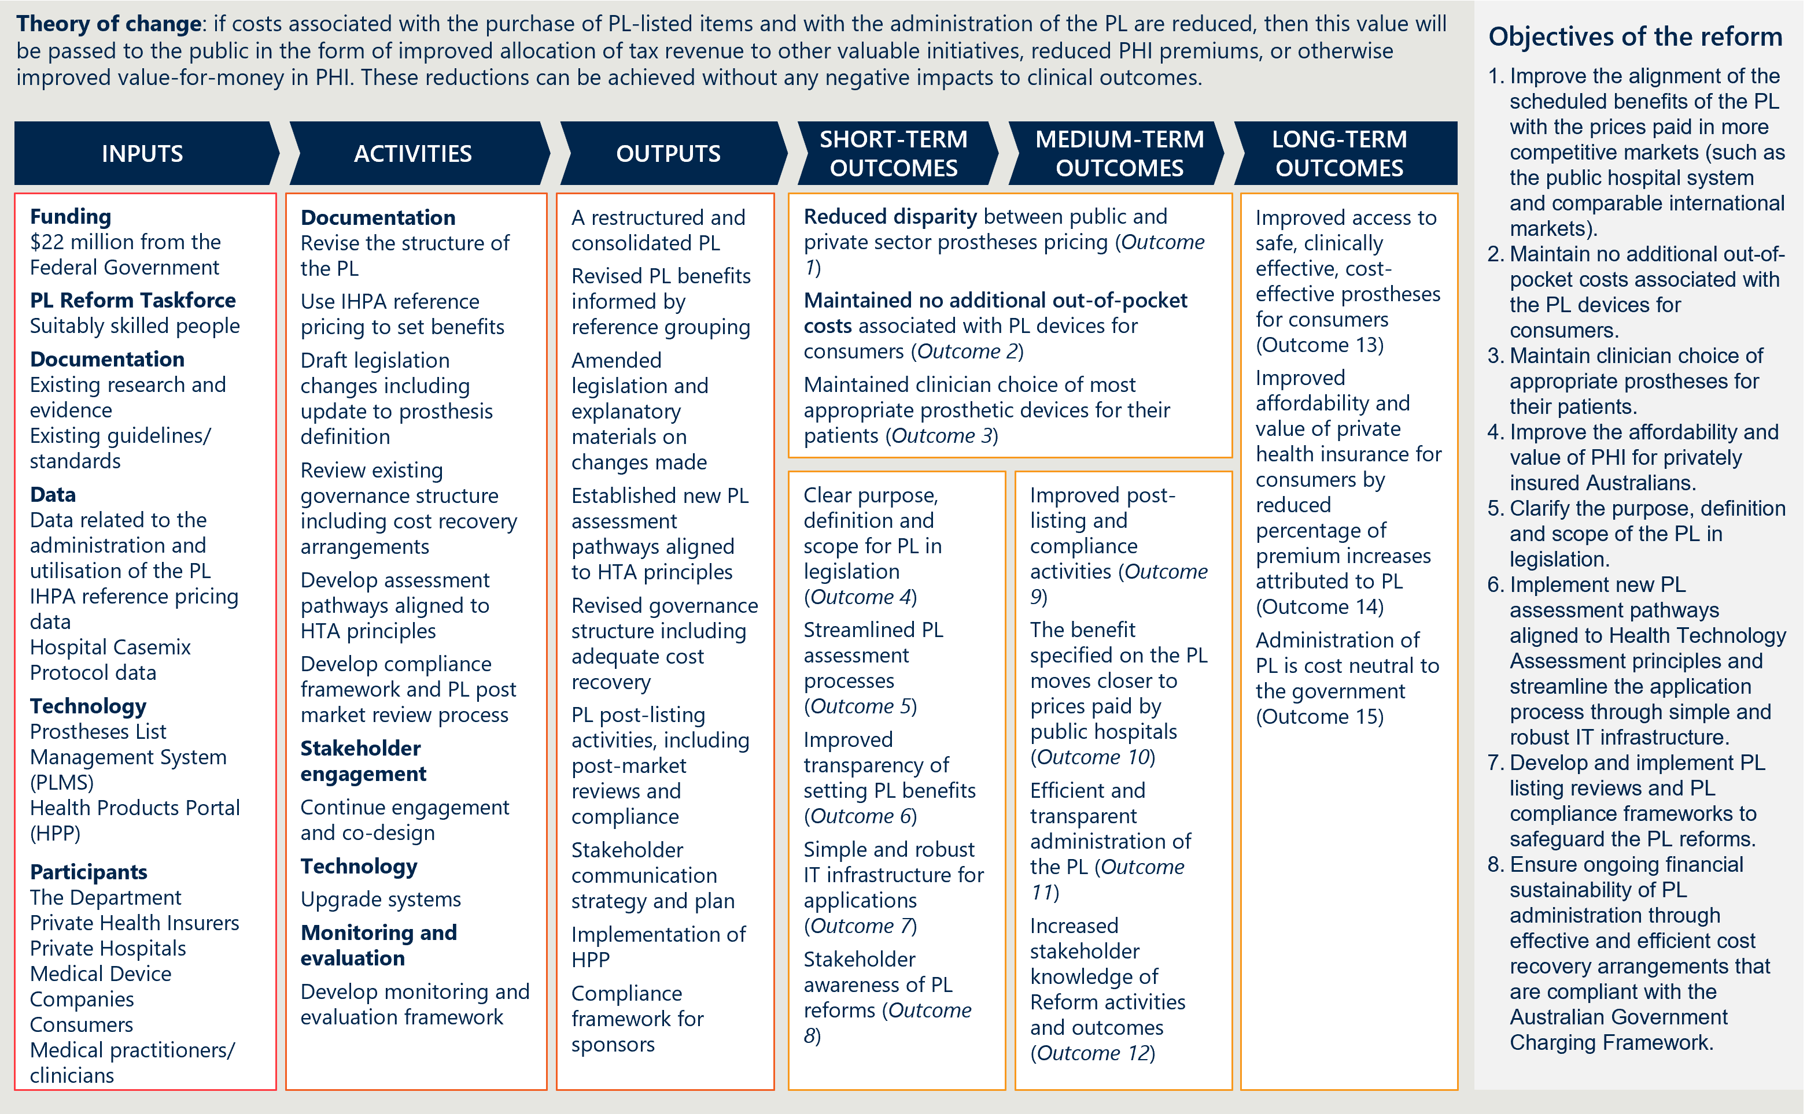

Figure 29 | Causal logic diagram

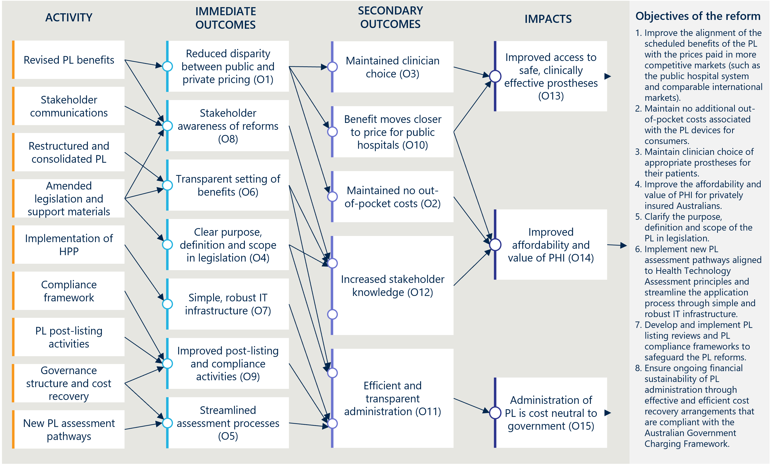

The scope of this evaluation is informed by both a formative and summative evaluation approach

The evaluation consists of three components – a baseline report, interim reports and a final report. Each of the reports that the evaluation produces will have a distinct purpose. This first interim report is a key milestone in the progress monitoring stage of the evaluation. As the evaluation is occurring at a time where PL reform activities are ongoing and where some outcomes are yet to be realised, Nous will share ongoing findings with the Department. These formative aspects of the evaluation are in the interest of improving PL reform activities and outputs to achieve the desired outcomes and mitigate against any unintended negative consequences.

The evaluation will also have summative components to understand the actions that have already been done (and will be done) and to assess early outcomes. This report contains some summative analysis of early activities, and the final evaluation report will provide more substantial summative analysis of the PL Reforms. The evaluation will also consider the extent to which the reform activities have been implemented as planned at completion and will distil lessons learned from the implementation experience to inform ongoing monitoring and evaluation of the PL itself.

Key elements of the evaluation’s scope are outlined below in Table 20.

Table 20 | Scope of the evaluation

|  |  |  |
| --- | --- | --- |
| In-scope aspects of the evaluation | * PL reform implementation, effectiveness and impact (extent to which intended outcomes were achieved). * Unintended positive or negative consequences beyond the expected outcomes. * Experiences of consumers, private health insurers, private hospitals, public hospitals, medical device sponsors and clinicians. | |
| Out-of-scope aspects of the evaluation | * Full cost-benefit analysis and/or economic evaluation, beyond that required to establish the suitability/sustainability of cost recovery efforts. * Evaluation of the Department’s wider PHI reforms. * Evaluation or analysis of PL components not impacted by the scope of the reforms. |
| Any context or related activities that need to be considered | * Understanding of the Government’s PHI reforms and policy agenda. * Understanding of stakeholder consultations and input to the PL Reforms that have already taken place and how reform activities have changed as a result. | |

* 1. Overall approach and KEQs

#### The evaluation is guided by three KEQs

There are three key evaluation questions (KEQs) for the evaluation:

1. Is the PL reform program being implemented as intended?
2. Is the PL reform program achieving the expected outcomes?
3. What are the ongoing and future directions, opportunities and priorities for the PL reforms?

#### Nous has structured the evaluation by the eight objectives of the PL reforms

The evaluation team developed a structure for the ongoing reporting of the evaluation that is adapted to the evolving projects and priorities of the reform program, while still aligning with the KEQs and evaluation plan. The structure is centred around the eight objectives of the PL reforms established by the Department’s PL Evaluation Framework, with nine key projects summarising the primary actions of the reforms.

Figure 30 | PL reform objectives and reform projects

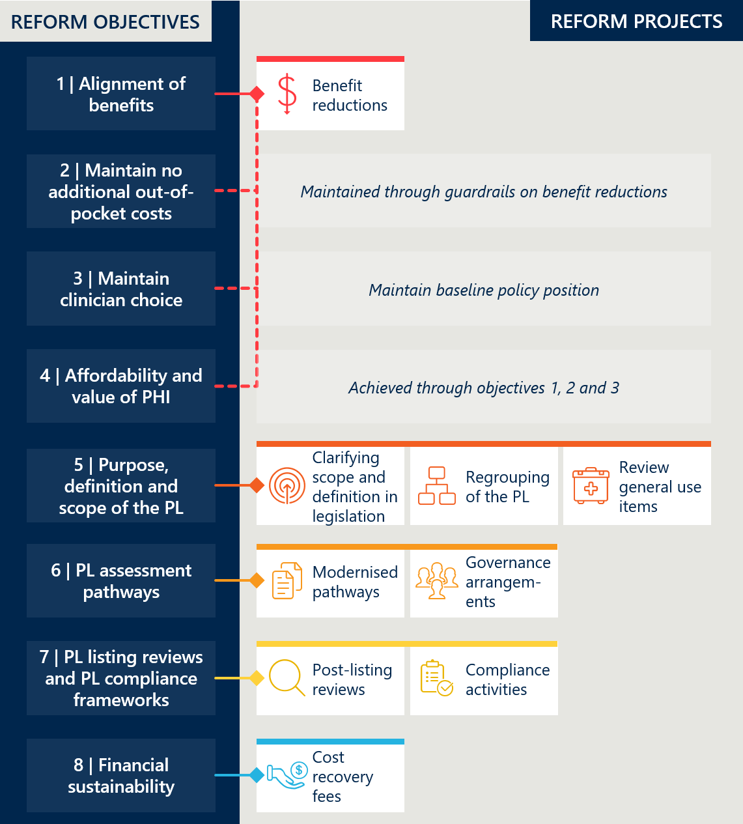

#### A set of indicators and measures guide the data collection, analysis and reporting

The evaluation team developed a set of indicators and measures that sit under each of the eight objectives of the PL reforms (see Appendix C). The indicators and measures cover KEQ 1 and KEQ 2 and resemble the key evaluation sub-questions introduced in the Department’s PL Evaluation Framework. Since the Baseline Evaluation, the indicators and measures have guided the evaluation team’s data collection, analysis and reporting.

* 1. Approach to data collection and engagement

#### The evaluation is using a ‘mixed methods’ approach

Evaluating the PL reforms involves a large and diverse group of stakeholders, a nuanced prostheses market, intertwined reform initiatives, and several intangible outcomes. To address this complexity, this evaluation is using a principles-based approach with KEQ and a program logic to focus the evaluation on the intentions of the reform.

This interim report uses a ‘mixed methods’ approach, collecting both qualitative and quantitative data from interviews, focus groups, desktop research, surveys and existing datasets. Data analysis has involved thematic, descriptive, and inferential techniques with triangulation of findings from various sources to validate the evidence.

#### Quantitative analysis is informing an assessment of reforms’ outcomes

The performance of the PL reforms is being assessed through an analysis of a range of quantitative indicators. This involved compiling and assessing relevant descriptive statistics to develop hypotheses related to the sub-research questions and categorised under the indicators and measures. Where feasible, inferential methods, such as regression models are also being used to add rigour to the analysis and support efforts to attribute changes to the reforms. As part of this, graphs have been included to visualise, develop, and convey important findings and analysis.

#### Qualitative analysis is crucial to answering the evaluation’s research questions

On its own, quantitative analysis is unable to satisfactorily answer all the evaluation’s sub-research questions. In many circumstances, quantitative data is missing or is of inadequate quality, requiring a qualitative approach that allows the evaluation team to hear directly from stakeholders. In circumstances where sufficient quantitative data has been available, qualitative evidence bolsters the evidence base underpinning the evaluation’s findings, by allowing insights to be triangulated from different sources of information.

Qualitative research methods – including surveys, interviews and workshops – are also ideal for understanding individual stakeholder perspectives, experiences and sensitivities in depth, especially in relation to the “how” and “why” elements of our KEQs which cannot be adequately answered with reference to quantitative data. This process also continues to help to build buy-in for the evaluation’s findings and recommendations, by facilitating forums for those impacted by the reforms to have their perspective heard.

The evaluation has drawn on several different qualitative data sources including Departmental documentation and PL planning documentation, published stakeholder submissions and perspectives, stakeholder interviews and stakeholder information requests.

1. List of external stakeholders consulted for *Interim Evaluation #2 report*

A few external stakeholders were consulted for this evaluation report and are detailed in Table 21. Their perspectives and input have been included in a summarised form throughout the report.

Table 21 | External stakeholders consulted for *Interim Evaluation #2 report*

|  |  |
| --- | --- |
| Stakeholder group | Organisation |
| Consumers representatives | * Consumer Health Forum (CHF) |
| Independent and advisory bodies | * The Office of the Commonwealth Ombudsman – Industry Investigations * Medical Devices and Human Tissue Advisory Committee (MDHTAC) |
| Clinician representatives | * Australian and New Zealand Association of Oral and Maxillofacial Surgeons (ANZAOMS) * Australian Medical Association (AMA) * Australian Orthopaedic Association (AOA) * Cardiac Society of Australia and New Zealand (CZANZ) |
| Private health insurer representatives | * Australian Health Service Alliance (AHSA) * Private Healthcare Australia (PHA) |
| Hospital sector representatives | * Australian Private Hospitals Association (APHA) * Catholic Hospitals Australia (CHA) |
| Medical device and technology industry representatives | * AusBiotech * Medical Technology Association of Australia (MTAA) * Medical Technology Association of Australia (MTAA) Cardiac Forum |

1. Overview of indicators and measures

Table 22 | Overview of indicators and measures

|  |  |  |  |
| --- | --- | --- | --- |
| Objective | KEQ | Indicators | Key evaluation sub-questions |
| 1. Improve alignment of the scheduled benefits of the PL with the prices paid in more competitive markets such as the public hospital system and comparable international markets | 1 | Indicator 1: Reduction in benefits | * Measure 1.1: Change in PL benefits * Measure 1.2: Benefit reduction methodology |
| 2 | Indicator 2: Change in the size of the gap between PL benefits and prices paid in more competitive markets | * Measure 2.1: Overall savings associated with benefit reductions * Measure 2.2: Gap between PL benefits and prices in Australian public hospitals * Measure 2.3: Gap between PL benefits and prices on the Liste des Produits et Prestations (LPP) and Pharmac Hospital Medical Devices Schedule * Measure 2.4: Stakeholder perspectives on the gap between PL benefits and prices in more competitive markets |
| 2. Maintain no additional out-of-pocket costs associated with the PL devices for consumers | 1 | *No activity directly associated* |  |
| 2 | Indicator 3: Change in out-of-pocket expenses related to PL items | * Measure 3.1: Prevalence of a gap payment for PL items * Measure 3.2: Average gap payment for PL-listed items |
| 3. Maintain clinician choice of appropriate prostheses for their patients | 1 | *No activity directly associated* |  |
| 2 | Indicator 4: Change in clinician experience of choosing prostheses | * Measure 4.1: Clinician perspectives on the level of clinician choice |
| Indicator 5: Change in utilisation of PL items | * Measure 5.1: Utilisation of PL items |
| 4. Improve the affordability and value of private health insurance for privately insured Australians | 1 | *No activity directly associated* |  |
| 2 | Indicator 6: Change in PHI premium increases | * Measure 6.1: PHI premium price changes over time * Measure 6.2: Change in PHI premiums related to PL item expenditure * Measure 6.3: Stakeholder perspectives on the drivers of change in PHI premiums |
| Indicator 7: Change in PHI coverage and for whom | * Measure 7.1: PHI coverage by demographic group * Measure 7.2: Utilisation of PL items by privately insured patients * Measure 7.3: Stakeholder perspectives on the drivers of change in PHI coverage |
| 5. Clarify the purpose, definition, and scope of the PL in legislation | 1 | Indicator 8: Legislative changes to the PL | * Measure 8.1: Description of the PL's purpose, definition and scope in legislation |
| Indicator 9: Implementation of PL regrouping | * Measure 9.1: Changes made to the PL grouping structure and PL item categorisation * Measure 9.2: Number of PL items and benefit groups |
| Indicator 10: Implementation of changes to general use items | * Measure 10.1: Description of changes to general use items |
| 2 | Indicator 11: Assessment of legislative changes to the PL | * Measure 11.1: Stakeholder perspectives on the level of clarity in the PL's purpose, definition and scope |
| Indicator 12: Assessment of PL regrouping | * Measure 12.1: Stakeholder perspectives on PL regrouping |
| Indicator 13: Assessment of changes to general use items | * Measure 13.1: Stakeholder perspectives on changes to general use items |
| 6. Implement new PL assessment pathways aligned to Health Technology Assessment Policy Branch principles and streamline application process through simple and robust IT infrastructure | 1 | Indicator 14: Implementation of new assessment processes | * Measure 14.1: Description of assessment pathways * Measure 14.2: Description of governance processes |
| 2 | Indicator 15: Assessment of new assessment processes | * Measure 15.1: Volume of PL applications per tier * Measure 15.2: Stakeholder perspectives on the assessment pathways and listing process |
| 7. Develop and implement PL listing review and PL compliance frameworks to safeguard the PL reforms | 1 | Indicator 16: Change in listing review and compliance frameworks | * Measure 16.1: Description of post-listing review framework * Measure 16.2: Description of compliance strategy |
| 2 | Indicator 17: Assessment of listing review and compliance frameworks | * Measure 17.1: Description of post-listing reviews conducted * Measure 17.2: Stakeholder perspectives on post-listing reviews * Measure 17.3: Description of compliance activities conducted * Measure 17.4: Stakeholder perspectives on PL compliance |
| 8. Ensure ongoing financial sustainability of PL administration through effective and efficient cost recovery arrangements that are compliant with the AGCF | 1 | Indicator 18: Implementation of cost recovery arrangements | * Measure 18.1: Description of cost recovery arrangements |
| 2 | Indicator 19: Financial sustainability of PL administration | * Measure 19.1: Change in PL administrative effort * Measure 19.2: Stakeholder perspectives on the financial sustainability of PL administration |

1. Measures detail
   1. Indicator 1: Reduction in benefits

#### Measure 1.1: Change in PL benefits

Table 23 | Benefit groups and items subject to reform reductions (Parts A and D, excluding CIED items)[128]

|  |  |  |
| --- | --- | --- |
| Categories | Benefits groups subject to reductions | Items subject to reductions |
| 01 – Ophthalmic | 26 | 170 |
| 02 – Ear, Nose & Throat | 6 | 25 |
| 03 – General Miscellaneous | 68 | 232 |
| 04 – Neurosurgical | 23 | 88 |
| 05 – Urogenital | 10 | 55 |
| 06 – Specialist Orthopaedic | 173 | 1,845 |
| 07 – Plastic and Reconstructive | 73 | 248 |
| 08 – Cardiac | 3 | 23 |
| 09 – Cardiothoracic | 8 | 17 |
| 10 – Vascular | 36 | 202 |
| 11 – Hip | 43 | 378 |
| 12 – Knee | 16 | 306 |
| 13 – Spinal | 51 | 1,417 |
| Total | 536 | 5,006 |

* 1. Indicator 2: Change in the size of the gap between PL benefits and prices paid in more competitive markets

#### Measure 2.1: Overall savings associated with benefit reductions

The evaluation relies on analyses conducted by IHACPA in December 2023 to report on estimates of overall savings associated with benefit reductions:

* *‘Updated estimates of projected benefits and savings associated with Prescribed List reforms’* (13 December 2023) estimates projected savings from July 2022 to June 2027.
* *‘Analysis on prescribed list benefit reductions for general use items (GUIs) and projected savings’* (20 January 2025) estimates savings from July 2022 to June 2024.

The Department provided instructions and advice to IHACPA to conduct these analyses, including miscellaneous adjustments to account for additional factors.[129] As discussed in Appendix B.2 of the *Interim Evaluation #1 report*,[130] the Nous evaluation team has not been able to independently validate these estimates through analysis of the same data sources following only the policy parameters of the MOU.

The evaluation anticipates that the Department and IHACPA will provide stakeholders a further update to these savings estimates prior to the end of the evaluation period.

Table 24 | Projected savings (based on IHACPA’s December 2023 analysis)[131]

|  |  |  |  |
| --- | --- | --- | --- |
| Scope of items | Savings period | Lower savings estimate  (0% annual growth) | Upper savings estimate  (5% annual growth) |
| All items | Savings to date  (July 2022 to June 2025) | $514 million | $547 million |
| Five-year projected savings  (July 2022 to June 2027) | $1,042 million | $1,173 million |
| All items excluding CIEDs | Savings to date  (July 2022 to June 2025) | $431 million | $457 million |
| Five-year projected savings  (July 2022 to June 2027) | $782 million | $873 million |

Table 25 | Estimated savings for FY23 and FY24 (IHACPA’s January 2025 analysis)[132]

|  |  |  |
| --- | --- | --- |
| FY23 savings | FY24 savings | FY23 – FY24 savings |
| $106 million | $196 million | $302 million |

#### Measure 2.2: Gap between PL benefits and prices in Australian public hospitals

Table 26 | Gap between PL benefits and public benchmark prices for items where a gap is present for reduction (Parts A and D, excluding CIEDs)[133]

|  |  |  |  |  |
| --- | --- | --- | --- | --- |
| Categories | Median gap $ | Gap $ change | Median gap % | Gap % change |
| 01 – Ophthalmic | $25 | -$33 | 11% | -16% |
| 02 – Ear, Nose & Throat | $6 | -$38 | 6% | -12% |
| 03 – General Miscellaneous | $4 | -$25 | 2% | -10% |
| 04 – Neurosurgical | $49 | -$169 | 6% | -15% |
| 05 – Urogenital | $17 | -$27 | 7% | -24% |
| 06 – Specialist Orthopaedic | $28 | -$137 | 8% | -36% |
| 07 – Plastic and Reconstructive | $24 | -$116 | 8% | -20% |
| 08 – Cardiac (excluding CIEDs) | $323 | -$1,174 | 42% | -145% |
| 09 – Cardiothoracic | $61 | -$595 | 3% | -20% |
| 10 – Vascular | $64 | -$209 | 6% | -39% |
| 11 – Hip | $69 | -$145 | 6% | -9% |
| 12 – Knee | $78 | -$154 | 7% | -3% |
| 13 – Spinal | $34 | -$205 | 4% | -14% |
| Total | $35 | -$142 | 6% | -19% |

Table 26 shows that there is a closer alignment of benefits with public hospital prices across all PL categories. The median gap (for items where a gap is present for reduction) has fallen below 10% for all categories except for the ophthalmic category and the cardiac category (CIEDs excluded). For non-CIED cardiac items, there remains a median gap of 42% ($323) after all three rounds of reductions.

#### Measure 2.3: Gap between PL benefits and prices on the Liste des Produits et Prestations (LPP) and Pharmac Hospital Medical Devices Schedule

The evaluation uses three PL benefit groups as case studies to compare with the same products on the Liste des Produits et Prestations (LPP)[134] and the Pharmac Hospital Medical Devices Schedule (Pharmac)[135]. The methodology for this measure is outlined in the *Interim Evaluation #1 report*.[136]

Figure 31 | International case study 1 (knee implant) – Benefit group comparison over time[137]

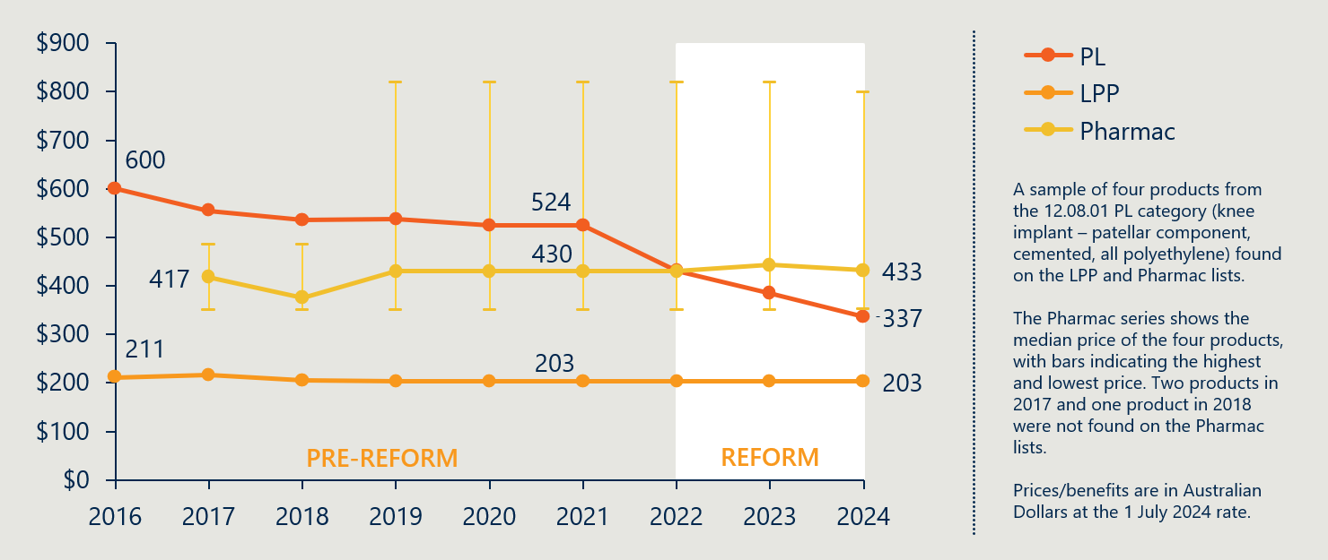

Case study 1 (Figure 31) shows the benefit and pricing history of four knee implants products from the 12.08.01 PL benefit group from 2016 to 2024. Prior to the reforms, the PL benefit was higher than the LPP and Pharmac prices on average. As a result of the benefit reductions, the PL benefit has fallen below the New Zealand median price and remains higher than the French price.

Figure 32 | International case study 2 (hip joint implant) – Benefit group comparison over time[138]

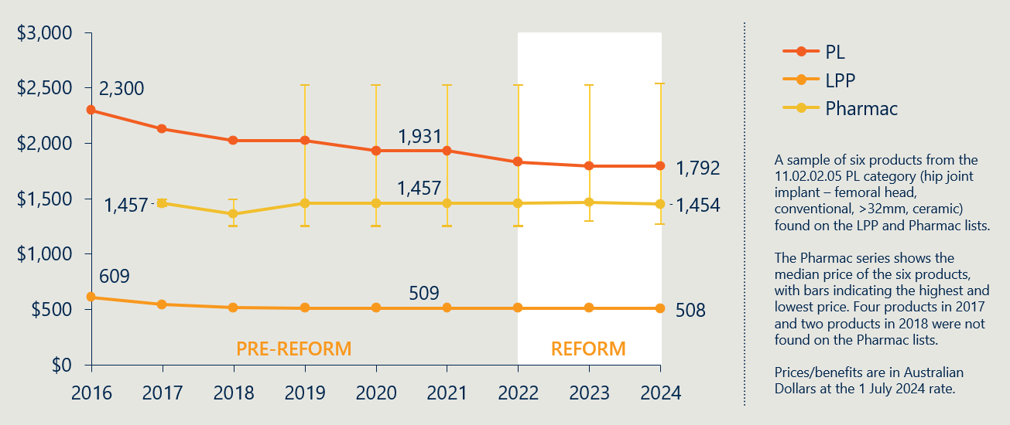

Case study 2 (Figure 32) compares the international benefits and prices of six hip joint implant products from the 11.02.02.05 PL benefit group. The reforms have resulted in a PL benefit that is more closely aligned with New Zealand and French pricing. However, the PL benefit remains $338 higher than the Pharmac median price (though lower than the highest priced product in the Pharmac category) and $1,284 higher than the LPP price.

Figure 33 | International case study 3 (spinal fusion cage) – Benefit group comparison over time[139]

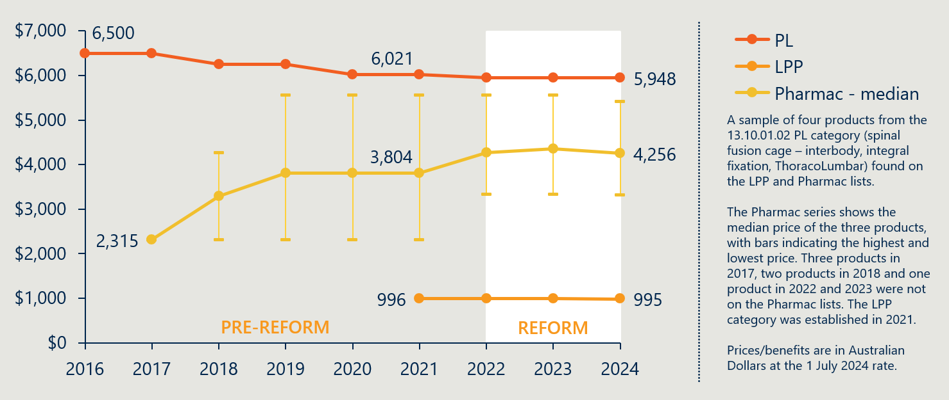

Case study 3 (Figure 33) compares the international benefits and prices of four spinal fusion cage products from the 13.10.01.02 PL category. The reforms have resulted in a marginal decrease in the PL benefit, while the median Pharmac price has increased and the LPP price has held steady. The PL benefit remains around six times the LPP price for the same products.

* 1. Indicator 3: Change in out-of-pocket expenses related to PL items

#### Measure 3.1: Prevalence of a gap payment for PL items

Table 27 | Prevalence of gap by PL category for items in Part A[140]

|  |  |  |  |  |  |  |  |
| --- | --- | --- | --- | --- | --- | --- | --- |
|  | FY23 | | | FY24 | | |  |
| Categories | # of items | # of items with a gap | Rate of gap | # of items | # of items with a gap | Rate of gap | Change in rate of gap |
| 01 – Ophthalmic | 377,388 | 3,797 | 1.01% | 393,400 | 2,488 | 0.63% | -0.37% |
| 02 – Ear; Nose & Throat | 40,863 | 20 | 0.05% | 42,029 | 30 | 0.07% | 0.02% |
| 03 – General Miscellaneous | 134,350 | 217 | 0.16% | 145,991 | 202 | 0.14% | -0.02% |
| 04 – Neurosurgical | 24,182 | 85 | 0.35% | 25,263 | 22 | 0.09% | -0.26% |
| 05 – Urogenital | 44,738 | 148 | 0.33% | 47,955 | 73 | 0.15% | -0.18% |
| 06 – Specialist Orthopaedic | 654,345 | 2,505 | 0.38% | 679,617 | 1,346 | 0.20% | -0.18% |
| 07 – Plastic and Reconstructive | 139,605 | 550 | 0.39% | 144,054 | 328 | 0.23% | -0.17% |
| 08 – Cardiac | 77,932 | 824 | 1.06% | 81,282 | 961 | 1.18% | 0.12% |
| 09 – Cardiothoracic | 9,098 | 185 | 2.03% | 9827 | 258 | 2.63% | 0.59% |
| 10 – Vascular | 36,389 | 85 | 0.23% | 37,223 | 47 | 0.13% | -0.11% |
| 11 – Hip | 150,559 | 296 | 0.20% | 154,886 | 124 | 0.08% | -0.12% |
| 12 – Knee | 182,625 | 513 | 0.28% | 196,533 | 170 | 0.09% | -0.19% |
| 13 – Spinal | 138,810 | 229 | 0.16% | 142,190 | 384 | 0.27% | 0.11% |

#### Measure 3.2: Average gap payment for PL-listed items

Table 28 | Value of gap in Part A categories[141]

|  |  |  |  |  |  |  |  |
| --- | --- | --- | --- | --- | --- | --- | --- |
|  | FY23 | | | FY24 | | |  |
| Categories | Avg benefit | Avg gap where gap was paid | Avg gap relative to avg benefit | Avg benefit | Avg gap where gap was paid | Avg gap relative to avg benefit | Change in avg gap to avg benefit |
| 01 – Ophthalmic | $290 | $40 | 14% | $290 | $40 | 14% | 0% |
| 02 – Ear; Nose & Throat | $680 | $10 | 1% | $650 | $300 | 46% | 45% |
| 03 – General Miscellaneous | $310 | $30 | 10% | $300 | $20 | 7% | -3% |
| 04 – Neurosurgical | $2,500 | $770 | 31% | $2,500 | $2,100 | 84% | 53% |
| 05 – Urogenital | $770 | $130 | 17% | $880 | $130 | 15% | -2% |
| 06 – Specialist Orthopaedic | $370 | $70 | 19% | $360 | $100 | 28% | 9% |
| 07 – Plastic and Reconstructive | $370 | $410 | 111% | $360 | $790 | 219% | 109% |
| 08 – Cardiac | $4,600 | $470 | 10% | $4,200 | $410 | 10% | 0% |
| 09 – Cardiothoracic | $2,400 | $360 | 15% | $2,300 | $280 | 12% | -3% |
| 10 – Vascular | $1,300 | $460 | 35% | $1,300 | $150 | 12% | -24% |
| 11 – Hip | $1,600 | $270 | 17% | $1,600 | $400 | 25% | 8% |
| 12 – Knee | $1,700 | $540 | 32% | $1,600 | $780 | 49% | 17% |
| 13 – Spinal | $840 | $240 | 29% | $840 | $100 | 12% | -17% |

* 1. Indicator 6: Change in PHI premium increases

#### Measure 6.1: PHI premium price changes over time

Figure 34 | Average year-on-year premium revenue changes for HT PHI per policy and person (as % of prior year)[142]

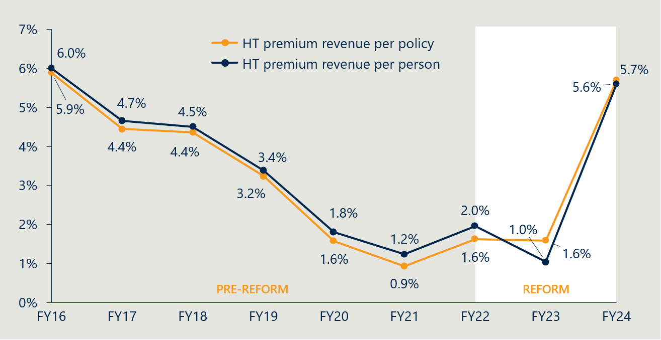

* 1. Indicator 7: Change in PHI coverage and for whom

#### Measure 7.2: Utilisation of PL items by privately insured patients

Figure 35 | Average prostheses utilisation per 1000 HT PHI members by age[143],[144]

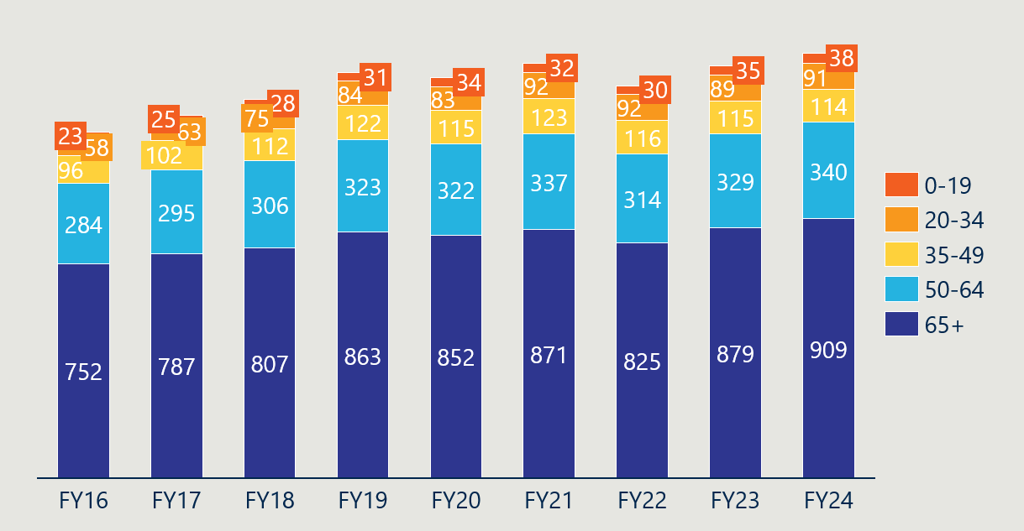

* 1. Indicator 9: Implementation of PL regrouping

#### Measure 9.2: Number of PL items and benefit groups

Table 29 below summarises the number of items per category in the August 2024 PL. The overall number of items declined from the July 2021 and July 2023 PLs (see Figure 36). Part C was the only part with an increase in the number of items, growing from 116 in July 2023 to 140 in August 2024.

Table 29 | Number of items per category in the August 2024 PL[145]

|  |  |  |  |  |  |  |
| --- | --- | --- | --- | --- | --- | --- |
|  | Category | Part A | Part B | Part C | Part D | Total |
| Parts A, C and D | 01 – Ophthalmic | 361 | - | - | - | 361 |
| 02 – Ear, Nose & Throat | 155 | - | - | - | 155 |
| 03 – General Miscellaneous | 327 | - | 11 | 397 | 735 |
| 04 – Neurosurgical | 437 | - | - | 4 | 441 |
| 05 – Urogenital | 182 | - | 1 | - | 183 |
| 06 – Specialist Orthopaedic | 3,464 | - | - | - | 3,464 |
| 07 – Plastic and Reconstructive | 695 | - | - | - | 695 |
| 08 – Cardiac | 334 | - | 106 | - | 440 |
| 09 – Cardiothoracic | 96 | - | 18 | - | 114 |
| 10 – Vascular | 314 | - | 4 | 62 | 380 |
| 11 – Hip | 688 | - | - | - | 688 |
| 12 – Knee | 724 | - | - | - | 724 |
| 13 – Spinal | 1,899 | - | - | - | 1,899 |
| Part B | 01 – Cardio-thoracic | - | 11 | - | - | 11 |
| 02 – Ophthalmic | - | 20 | - | - | 20 |
| 03 – Orthopaedic | - | 615 | - | - | 615 |
| 04 – Dermatologic | - | 18 | - | - | 18 |
|  | Total | 9,676 | 664 | 140 | 463 | 10,943 |

Figure 36 | Number of PL items (Parts A, C and D)[146]

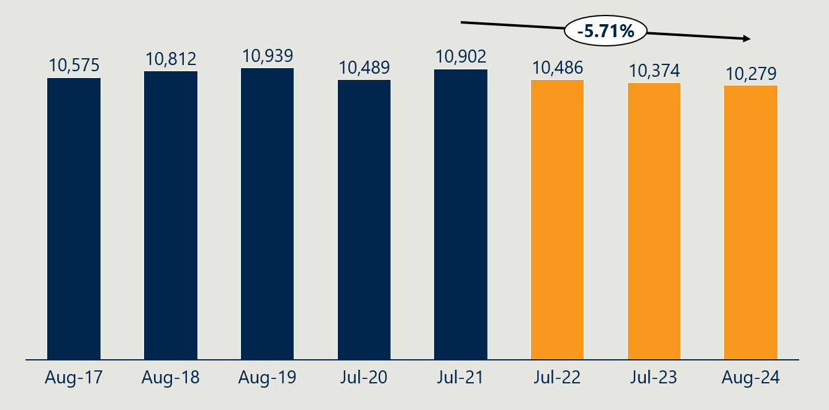

Figure 36 shows that the number of PL items in Parts A, C and D declined by 5.71% from the July 2021 PL to the August 2024 PL. This reflects a reversal of the trend in the 10 years preceding the July 2021 baseline, where the number of items increased by 1.09% per annum.

Figure 37 | Number of benefit groups (Parts A, C and D)[147]

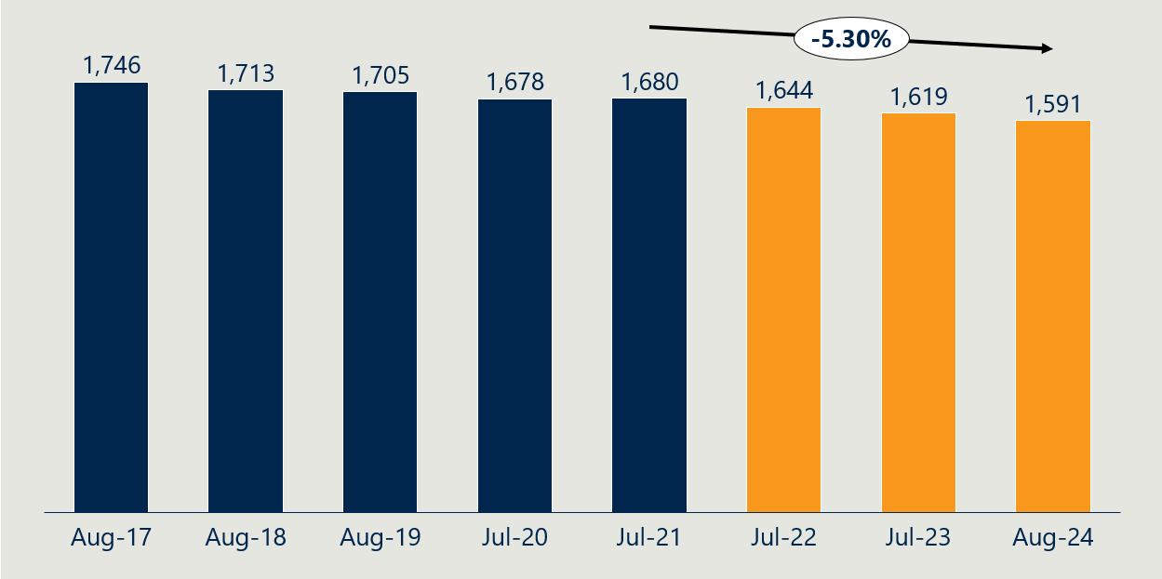

Likewise, Figure 37 shows that the number of benefit groups declined by 3.64% from the July 2021 PL to the August 2024 PL.

Figure 38 | Average items per benefit group (Parts A, C and D)[148]

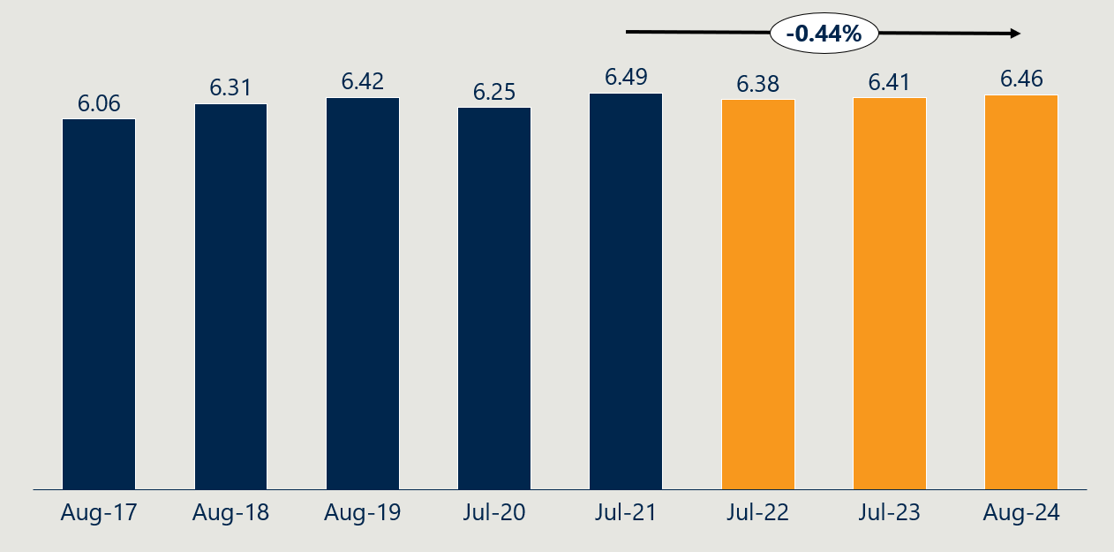

Figure 38 shows that the average items per benefit group has held relatively steady over the reform period. This reflects both the number of items and the number of benefit groups decreasing.

1. Independent Health and Aged Care Pricing Authority, Analysis on prescribed list benefit reductions for general use items (GUIs) and projected savings, 20 January 2025.
2. Department of Health, Disability and Ageing, Baseline evaluation of the Prostheses List reforms – Final report, 2024, https://www.health.gov.au/resources/publications/baseline-evaluation-of-the-prostheses-list-reforms-final-report?language=en.
3. Department of Health, Disability and Ageing, Interim Evaluation #1 of the Prescribed List Reforms, 2024, https://www.health.gov.au/resources/publications/interim-evaluation-1-of-the-prescribed-list-reforms?language=en.
4. Department of Health, Disability and Ageing, PHI 49/24 Cardiac implantable electronic devices and the cost of technical support services, 12 July 2024. https://www.health.gov.au/news/phi-circulars/phi-4924-cardiac-implantable-electronic-devices-and-the-cost-of-technical-support-services
5. Department of Health, Disability and Ageing, PHI 09/25 Release of stakeholder feedback summary – CIED and the cost of TSS stage 1, 20 January 2025. https://www.health.gov.au/news/phi-circulars/phi-0925-release-of-stakeholder-feedback-summary-cied-and-the-cost-of-tss-stage-1?language=en
6. Department of Health, Disability and Ageing, PHI 72/24 Removal of medicines and accessories to medicines from the Prescribed List, 11 October 2024. https://www.health.gov.au/news/phi-circulars/phi-7224-removal-of-medicines-and-accessories-to-medicines-from-the-prescribed-list?language=en
7. Department of Health, Disability and Ageing, PHI 96/24 Prescribed List post-listing review framework, 12 December 2024. https://www.health.gov.au/news/phi-circulars/phi-9624-prescribed-list-post-listing-review-framework?language=en
8. Department of Health, Disability and Ageing, PHI 05/25 – Outcome of Consultation Papers 8a and 8b, 9 January 2025. https://www.health.gov.au/news/phi-circulars/phi-0525-outcome-of-consultation-papers-8a-and-8b?language=en.
9. Department of Health, Disability and Ageing, PHI 12/25 – Updates to the 2024-25 Prescribed List CRIS and cost recovery levy, 10 February 2025. https://www.health.gov.au/news/phi-circulars/phi-1225-updates-to-the-2024-25-prescribed-list-cris-and-cost-recovery-levy?language=en
10. Department of Health, Disability and Ageing, PHI 41/25 Regrouping of Part A of the Prescribed List, 12 May 2025. https://www.health.gov.au/news/phi-circulars/phi-4125-regrouping-of-part-a-of-the-prescribed-list?language=en
11. Independent Health and Aged Care Pricing Authority, Benchmark Price for Prostheses in Australian Public Hospitals 2020-21, 2022.
12. The Honourable Greg Hunt MP & the Medical Technology Association of Australia Limited, Memorandum of Understanding for the policy parameters of the Prostheses List Reforms, 2022.
13. Department of Health, Disability and Ageing, Interim Evaluation #1 of the Prescribed List Reforms, 2024, https://www.health.gov.au/resources/publications/interim-evaluation-1-of-the-prescribed-list-reforms?language=en.
14. Based on data provided by the Department on 31 July 2025 that excluded Part C and CIED items, comparing the benefits of the August 2024 PL to the benefits prior to the reforms. The evaluation supplemented this data with analysis of Part C and CIED items to calculate the total.
15. While Nous is unable to verify whether every item with a benefit above 7% of its public benchmark was reduced (or above 0% for GUIs), the 51.1% figure aligns with other aggregate data provided to us by the Department of the prevalence of gaps between PL benefits and public benchmarks.
16. Data supplied by the Department, 31 July 2025.
17. Data supplied by the Department, 31 July 2025.
18. The Department omitted CIEDs from data and analysis shared with the evaluation.
19. Analysis of the gap between Weighted Average Prices and August 2024 PL benefits, supplied by the Department on 31 July 2025.
20. Ibid.
21. Department of Health, Disability and Ageing, Prescribed List of Medical Devices and Human Tissue Products, August 2016, August 2017, August 2018, August 2019, July 2020, July 2021, July 2022, July 2023 and August 2024 editions (Part A); Pharmac, Hospital Medical Devices Schedule, July 2016, July 2017, July 2018, July 2019, July 2020, July 2021, July 2022, July 2023 and July 2024 editions; l'Assurance Maladie, Liste des Produits et Prestations, http://www.codage.ext.cnamts.fr/codif/tips/index.php?p_site=AMELI.
22. Ibid.
23. Indeed, the same set of IHACPA benchmarks the Department used to calculate the benefit reductions were then used to evaluate their success, with only a summary of the gap supplied to the evaluation for use in reporting.
24. Department of Health, Disability and Ageing, Baseline evaluation of the Prostheses List reforms – Final report, 2024, https://www.health.gov.au/resources/publications/baseline-evaluation-of-the-prostheses-list-reforms-final-report?language=en.
25. The feedback received from stakeholders has been summarised in the table below for the purpose of clarity and brevity. While efforts have been made to capture the essential content and key themes, these summaries may not fully reflect the nuances and particulars of the original feedback.
26. Stakeholder engagements, 2025.
27. The Honourable Greg Hunt MP & the Medical Technology Association of Australia Limited, Memorandum of Understanding for the policy parameters of the Prostheses List Reforms, 2022.
28. Department of Health, Disability and Ageing, PHI Circular 27/24 Benefit reductions to Cardiac Implantable Electronic Devices, 2024.
29. Stakeholder engagements, 2025.
30. The feedback received from stakeholders has been summarised in the table below for the purpose of clarity and brevity. While efforts have been made to capture the essential content and key themes, these summaries may not fully reflect the nuances and particulars of the original feedback.
31. Department of Health, Disability and Ageing, Hospital Casemix Protocol Dataset, 2025.
32. Note that the incidence of gap payments cannot always be equated with out-of-pocket charges. In some instances, third parties, such as the Department of Veterans' Affairs, workers' compensation insurers, or motor vehicle insurance providers, cover the gap for consumers (therefore, not representing an ‘out-of-pocket’ cost). Conversely, there are out-of-pocket charges related to PL-listed items that are not included in these gap payments. As the HCP1 data set is from PHI reporting, it does not capture instances where consumers are charged out-of-pocket for PL-listed items as a result of a surgery or procedure not being uncovered under their policy.
33. Department of Health, Disability and Ageing, Hospital Casemix Protocol Dataset, 2025. Note that 33% is the FY24 weighted monthly average gap payment (were a gap was paid) relative to the FY24 weighted monthly average benefit.
34. Department of Health, Disability and Ageing, PHI 05/25 – Outcome of Consultation Papers 8a and 8b, 9 January 2025. https://www.health.gov.au/news/phi-circulars/phi-0525-outcome-of-consultation-papers-8a-and-8b?language=en.
35. Stakeholder submission, 2025.
36. Stakeholder submission, 2025.
37. Stakeholder submission, 2025.
38. The feedback received from stakeholders has been summarised in the table below for the purpose of clarity and brevity. While efforts have been made to capture the essential content and key themes, these summaries may not fully reflect the nuances and particulars of the original feedback.
39. Department of Health, Disability and Ageing, The Prescribed List of Medical Devices and Human Tissue Products Guide (Draft), 2023.
40. Department of Health, Disability and Ageing, Prostheses List Part A (Prostheses), Part C (Other), and Part D (General Use Items), August 2024 edition.
41. Stakeholder submission, 2025.
42. Stakeholder consultation, 2025.
43. Department of Health, Disability and Ageing, Hospital Casemix Protocol Dataset, 2025.
44. Stakeholder consultations, 2025.
45. The feedback received from stakeholders has been summarised in the table below for the purpose of clarity and brevity. While efforts have been made to capture the essential content and key themes, these summaries may not fully reflect the nuances and particulars of the original feedback.
46. Independent Health and Aged Care Pricing Authority, Analysis on prescribed list benefit reductions for general use items (GUIs) and projected savings, 20 January 2025.
47. Independent Health and Aged Care Pricing Authority, Updated estimates of projected benefits and savings associated with Prescribed List reforms, 13 December 2023. Note that these estimates are limited to insurer savings and do not reflect any offsetting costs that may have emerged elsewhere in the health system.
48. The Honourable Greg Hunt MP & the Medical Technology Association of Australia Limited, Memorandum of Understanding for the policy parameters of the Prostheses List Reforms, 2022.
49. Department of Health, Disability and Ageing, Interim Evaluation #1 of the Prescribed List Reforms, 2024, https://www.health.gov.au/resources/publications/interim-evaluation-1-of-the-prescribed-list-reforms?language=en.
50. Independent Health and Aged Care Pricing Authority, Updated estimates of projected benefits and savings associated with Prescribed List reforms, 13 December 2023.
51. Department of Health, Disability and Ageing, Interim Evaluation #1 of the Prescribed List Reforms, 2024, https://www.health.gov.au/resources/publications/interim-evaluation-1-of-the-prescribed-list-reforms?language=en.
52. Australia Prudential Regulation Authority, Annual private health insurance performance statistics database - 2023-24, December 2024.
53. Australia Prudential Regulation Authority, Annual private health insurance membership and benefit statistics, December 2024; Independent Health and Aged Care Pricing Authority, Updated estimates of projected benefits and savings associated with Prescribed List reforms, November 2023.
54. Benefit reduction savings are based on IHACPA’s *Updated estimates of projected benefits and savings associated with Prescribed List reforms* (Table 3 – 5% annual growth in utilisation). A 5% annual growth rate is also applied to benefit outlays in both the base and counterfactual scenarios.
55. Australia Prudential Regulation Authority, Annual private health insurance membership and benefit statistics, December 2024; Australian Prudential Regulation Authority, Quarterly Private Health Insurance Medical Device Or Human Tissue Products, March 2025.
56. Australia Prudential Regulation Authority, Annual private health insurance membership and benefit statistics, December 2024.
57. Australia Prudential Regulation Authority, Annual private health insurance membership and benefit statistics, December 2024.
58. Australia Prudential Regulation Authority, Annual private health insurance membership and benefit statistics, December 2024.
59. Australia Prudential Regulation Authority, Annual private health insurance membership and benefit statistics, December 2024.
60. Stakeholder consultation, 2025.
61. Department of Health, Disability and Ageing, List of historical premium price changes by insurer for 2024, 2024.
62. Stakeholder submissions, 2025.
63. Australia Prudential Regulation Authority, Annual private health insurance membership and benefit statistics, December 2024 (prostheses benefits data); Australia Prudential Regulation Authority, Annual private health insurance performance statistics database - 2023-24, December 2024 (FY24 data); Australian Prudential Regulation Authority, Operations of Private Health Insurers Annual Report, 2022-23 (FY23 data).
64. Stakeholder submission, 2025.
65. Australia Prudential Regulation Authority, Annual private health insurance membership and benefit statistics, December 2024.
66. The feedback received from stakeholders has been summarised in the table below for the purpose of clarity and brevity. While efforts have been made to capture the essential content and key themes, these summaries may not fully reflect the nuances and particulars of the original feedback.
67. Department of Health, Disability and Ageing, PHI 77/24 – Private Health Insurance (Medical Devices and Human Tissue Products) Rules (No. 2) 2024, 24 October 2024. https://www.health.gov.au/news/phi-circulars/phi-circular-7724-private-health-insurance-medical-devices-and-human-tissue-products-rules-no-2-2024
68. Parliament of Australia, Private Health Insurance (Medical Devices and Human Tissue Products) Rules (No. 1) 2024 [replacement explanatory statement], 4 October 2024. https://www.aph.gov.au/Parliamentary_Business/Tabled_Documents/7627
69. Department of Health, Disability and Ageing, PHI 30/24 – General use items on the Prescribed List, 1 May 2024. https://www.health.gov.au/news/phi-circulars/phi-3024-general-use-items-on-the-prescribed-list
70. Therapeutic Goods Administration, Guidance on boundary and combination products, 2023.
71. Department of Health, Disability and Ageing, PHI 41/25 – Regrouping of Part A of the Prescribed List, 12 May 2025. https://www.health.gov.au/news/phi-circulars/phi-4125-regrouping-of-part-a-of-the-prescribed-list
72. Department of Health, Disability and Ageing, Prostheses List Compliance Strategy, 2022. https://consultations.health.gov.au/technology-assessment-access-division/prostheses-list-compliance-and-assurance-strategy.
73. House of Representatives, Explanatory Memorandum, Private Health Insurance Legislation Amendment (Medical Device And Human Tissue Product List And Cost Recovery) Bill 2022, 2022.
74. Response to stakeholder information request for evaluation, 2024.
75. Department of Health, Disability and Ageing, PHI 41/25 – Regrouping of Part A of the Prescribed List, 12 May 2025, https://www.health.gov.au/news/phi-circulars/phi-4125-regrouping-of-part-a-of-the-prescribed-list.
76. Department of Health, Disability and Ageing, PHI 51/23 – Regrouping of Part A of the Prescribed List, 26 July 2023, https://www.health.gov.au/news/phi-circulars/phi-5123-regrouping-of-part-a-of-the-prescribed-list
77. The Honourable Greg Hunt MP & the Medical Technology Association of Australia Limited, Memorandum of Understanding for the policy parameters of the Prostheses List Reforms, 2022.
78. Ibid.
79. Department of Health, Disability and Ageing, PHI 41/25 – Regrouping of Part A of the Prescribed List, 12 May 2025. https://www.health.gov.au/news/phi-circulars/phi-4125-regrouping-of-part-a-of-the-prescribed-list
80. The feedback received from stakeholders has been summarised in the table below for the purpose of clarity and brevity. While efforts have been made to capture the essential content and key themes, these summaries may not fully reflect the nuances and particulars of the original feedback.
81. The Hon Mark Butler MP, Ensuring lower surgery costs and continued access to healthcare through general use items, 1 May 2024. https://www.health.gov.au/ministers/the-hon-mark-butler-mp/media/ensuring-lower-surgery-costs-and-continued-access-to-healthcare-through-general-use-items
82. Department of Health, Disability and Ageing, PHI 71/24 – Removal of medicines and accessories to medicines from the Prescribed List, 11 October 2024. https://www.health.gov.au/news/phi-circulars/phi-7224-removal-of-medicines-and-accessories-to-medicines-from-the-prescribed-list
83. Department of Health, Disability and Ageing, Historical background of the 2021-2025 Prostheses List reform, 18 March 2022. https://www.health.gov.au/resources/publications/historical-background-of-the-prostheses-list-reform-2021-2025?language=en.
84. IHACPA, Consultation Paper on Bundling Arrangements for the General Use Items on the Prostheses List, 2022.
85. Department of Health, Disability and Ageing, Hospital Casemix Protocol Dataset, 2025.
86. GUI population is based on item codes listed in Part D on the August 2024 PL. Benefits used in calculations are from the PL update at the start of the period (e.g. July 2020 update for FY21). Items without all four years of benefit levels were removed from the analysis. Value is calculated as utilisation * PL benefit; weighted average benefit is calculated as total value / total utilisation.
87. Response to stakeholder information request for the evaluation, 2024.
88. The feedback received from stakeholders has been summarised in the table below for the purpose of clarity and brevity. While efforts have been made to capture the essential content and key themes, these summaries may not fully reflect the nuances and particulars of the original feedback.
89. Department of Health, Disability and Aged Care, Prostheses List Reforms - Consultation Paper 3 - A modernised fit-for-purpose listing process, 14 January 2022.
90. Department of Health, Disability and Ageing, Prescribed List of Medical Devices and Human Tissue Products Guide – Draft, 21 December 2023. https://www.health.gov.au/resources/publications/prescribed-list-of-medical-devices-and-human-tissue-products-guide-draft?language=en.
91. Department of Health, Disability and Ageing, Prescribed List Application Training, 27 November 2023. https://www.health.gov.au/resources/publications/prescribed-list-application-training?language=en.
92. Ibid.
93. HPP applications data. Applications to delist, transfer or compress not included.
94. Ibid.
95. Department of Health and Ageing, Review of health technology assessment in Australia, 2009.
96. The feedback received from stakeholders has been summarised in the table below for the purpose of clarity and brevity. While efforts have been made to capture the essential content and key themes, these summaries may not fully reflect the nuances and particulars of the original feedback.
97. The feedback received from stakeholders has been summarised in the table below for the purpose of clarity and brevity. While efforts have been made to capture the essential content and key themes, these summaries may not fully reflect the nuances and particulars of the original feedback.
98. Department of Health, Disability and Ageing, Prescribed List post-listing review framework, 12 December 2024. https://www.health.gov.au/resources/publications/prescribed-list-post-listing-review-framework?language=en.
99. Department of Health, Disability and Ageing, PHI 12/24 – Updates to the 2024-35 Prescribed List CRIS and cost recovery levy, 10 February 2025. https://www.health.gov.au/news/phi-circulars/phi-1225-updates-to-the-2024-25-prescribed-list-cris-and-cost-recovery-levy.
100. Department of Health, Disability and Ageing, Cost Recovery Implementation Statement Administration of the Prescribed List of Medical Devices and Human Tissue Products 1 July 2025 to 30 June 2026 Version 1.1, 2025. https://www.health.gov.au/sites/default/files/2025-07/cost-recovery-implementation-statement-administration-of-the-prescribed-list-of-medical-devices-and-human-tissue-products.pdf
101. Department of Health, Disability and Ageing, Metal-backed patellae – Prescribed List post-listing review, 5 July 2024. https://www.health.gov.au/our-work/metal-backed-patellae-prescribed-list-post-listing-review.
102. Department of Health, Disability and Ageing, Surgical guides and biomodels – Prescribed List post-listing review, 23 June 2025. https://www.health.gov.au/our-work/surgical-guides-and-biomodels-prescribed-list-post-listing-review
103. Department of Health, Disability and Ageing, PHI 74/23 – Prescribed List – Private Health Insurance (Medical Devices and Human Tissue Products) Amendment Rules (No. 2) 2023, 13 November 2023. https://www.health.gov.au/news/phi-circulars/phi-7423-prescribed-list-private-health-insurance-medical-devices-and-human-tissue-products-amendment-rules-no-2-2023
104. Department of Health, Disability and Ageing, Spinal cord stimulators – Prescribed List post-listing review, 14 March 2025, https://www.health.gov.au/our-work/spinal-cord-stimulators-prescribed-list-post-listing-review.
105. Department of Health, Disability and Ageing, Urogynaecological mesh devices (mid-urethral slings) – Prescribed List post-listing review, 5 July 2024. https://www.health.gov.au/our-work/urogynaecological-mesh-devices-mid-urethral-slings-prescribed-list-post-listing-review.
106. Department of Health, Disability and Ageing, Prescribed List post-listing review framework, 12 December 2024. https://www.health.gov.au/resources/publications/prescribed-list-post-listing-review-framework?language=en.
107. The feedback received from stakeholders has been summarised in the table below for the purpose of clarity and brevity. While efforts have been made to capture the essential content and key themes, these summaries may not fully reflect the nuances and particulars of the original feedback.
108. Department of Health, Disability and Ageing, PHI 05/25 – Outcome of Consultation Papers 8a and 8b, 9 January 2025. https://www.health.gov.au/news/phi-circulars/phi-0525-outcome-of-consultation-papers-8a-and-8b.
109. Department of Health, Disability and Ageing, Prescribed List Compliance Strategy – Safeguarding the Prescribed List, 18 May 2023. https://www.health.gov.au/resources/publications/prescribed-list-compliance-strategy-safeguarding-the-prescribed-list
110. Department of Health, Disability and Ageing, Prostheses List Compliance Strategy, 2022.
111. Department of Health, Disability and Ageing, Prescribed List Compliance Strategy – Safeguarding the Prescribed List, https://www.health.gov.au/resources/publications/prescribed-list-compliance-strategy-safeguarding-the-prescribed-list, accessed 19 September 2025.
112. Department of Health, Disability and Ageing, PHI 05/25 – Outcome of Consultation Papers 8a and 8b, 9 January 2025. https://www.health.gov.au/news/phi-circulars/phi-0525-outcome-of-consultation-papers-8a-and-8b.
113. Stakeholder input to the evaluation, 2025.
114. Stakeholder input to the evaluation, 2025.
115. The feedback received from stakeholders has been summarised in the table below for the purpose of clarity and brevity. While efforts have been made to capture the essential content and key themes, these summaries may not fully reflect the nuances and particulars of the original feedback.
116. There is no cost recovery fees and charges for Part B applications (human tissue products) and billing codes listed under Part B are exempt from the levy.
117. Department of Health, Disability and Ageing, Cost recovery fees and charges for the Prescribed List, 3 July 2025. https://www.health.gov.au/our-work/the-prescribed-list/cost-recovery.
118. Ibid.
119. Federal Register of Legislation. Private Health Insurance (Medical Devices and Human Tissue Products Levy) Rules 2025. https://www.legislation.gov.au/F2025L00284/asmade/text
120. Department of Health, Disability and Ageing, PHI 12/24 – Updates to the 2024-35 Prescribed List CRIS and cost recovery levy, 10 February 2025. https://www.health.gov.au/news/phi-circulars/phi-1225-updates-to-the-2024-25-prescribed-list-cris-and-cost-recovery-levy.
121. Ibid.
122. Department of Health, Disability and Ageing, Regulation Impact Statement (RIS): Improving the Private Health Insurance Prostheses List, 2021.
123. Department of Health, Disability and Ageing, Cost Recovery Implementation Statement: Administration of the Prescribed List of Medical Devices and Human Tissue Products 1 July 2025 to 30 June 2026, Version 1.1.
124. Ibid.
125. Ibid.
126. Confirmed in consultation as an interim arrangement that is ongoing as of June 2025.
127. The feedback received from stakeholders has been summarised in the table below for the purpose of clarity and brevity. While efforts have been made to capture the essential content and key themes, these summaries may not fully reflect the nuances and particulars of the original feedback.
128. Data supplied by the Department, 31 July 2025. For indicators 1 and 2, the evaluation has used ‘benefit groups’ to refer to all items within a category, sub-category, group and sub-group that share the same benefit, within $2 (e.g., two items in A.01.01.01.01 with a benefit of $100 are considered as being in one benefit group, even if they have different suffix values). This is to align with IHACPA’s methodology for calculating the Weighted Average Prices and benefit reductions.
129. Evaluation team conversations with the Department, 2024. Additional factors included historical billing code changes, corrections to an error on the August 2022 PL update (~$1.6 million adjustment), and corrections to fix some date-related errors. The parameters and advice given to IHACPA has not been shared with the evaluation.
130. Department of Health, Disability and Ageing, Interim Evaluation #1 of the Prescribed List Reforms, 2024, https://www.health.gov.au/resources/publications/interim-evaluation-1-of-the-prescribed-list-reforms?language=en.
131. Independent Health and Aged Care Pricing Authority, Updated estimates of projected benefits and savings associated with Prescribed List reforms, 13 December 2023.
132. Independent Health and Aged Care Pricing Authority, Analysis on prescribed list benefit reductions for general use items (GUIs) and projected savings, 20 January 2025.
133. Data supplied by the Department, 31 July 2025. Comparison made to baseline figures.
134. l'Assurance Maladie, Liste des Produits et Prestations, http://www.codage.ext.cnamts.fr/codif/tips/index.php?p_site=AMELI. The Liste des Produits et Prestations (LPP) is a list of medical device and human tissue products that guides reimbursement for the French national health insurance system. It has a comparable scope to the PL and it prices products at a higher level of grouping than the PL.
135. Pharmac, Hospital Medical Devices Schedule, multiple editions. The Pharmac Hospital Medical Devices Schedule (Pharmac) is a list of contracted medical devices products for New Zealand public hospitals. It has a narrower scope than the PL at baseline, and it prices products on an individual basis, not in concert with equivalent products within a group like the PL and LPP.
136. Department of Health, Disability and Ageing, Interim Evaluation #1 of the Prescribed List Reforms, 2024, https://www.health.gov.au/resources/publications/interim-evaluation-1-of-the-prescribed-list-reforms?language=en.
137. Department of Health, Disability and Ageing, Prostheses List Part A (Prostheses), August 2016, August 2017, August 2018, August 2019, July 2020, July 2021, July 2022, July 2023 and August 2024 editions; Pharmac, Hospital Medical Devices Schedule, July 2016, July 2017, July 2018, July 2019, July 2020, July 2021, July 2022, July 2023 and July 2024 editions; l'Assurance Maladie, Liste des Produits et Prestations, http://www.codage.ext.cnamts.fr/codif/tips/index.php?p_site=AMELI.
138. Ibid.
139. Ibid.
140. Department of Health, Disability and Ageing, Hospital Casemix Protocol Dataset, 2025.
141. Department of Health, Disability and Ageing, Hospital Casemix Protocol Dataset, 2025.
142. Australia Prudential Regulation Authority, Annual private health insurance membership and benefit statistics, December 2024; Australia Prudential Regulation Authority, Annual private health insurance performance statistics database - 2023-24, December 2024 *(for FY24 HT premium revenue)*; Australian Prudential Regulation Authority, Operations of Private Health Insurers Annual Report; 2014-15 to 2022-23 editions *(for FY15-23 HT premium revenue)*.
143. Australia Prudential Regulation Authority, Annual private health insurance membership and benefit statistics, December 2024; Australian Prudential Regulation Authority, Quarterly Private Health Insurance Medical Device Or Human Tissue Products, March 2025.
144. Utilisation is calculated by dividing HT prostheses benefits for each category by the average prostheses benefit across all categories for the relevant financial year, as APRA does not publish prostheses utilisation by age. HT population coverage for each age bracket is then divided by the utilisation figure to obtain the average.
145. Department of Health, Disability and Ageing, Prostheses List Part A (Prostheses), Part B (Human Tissue), Part C (Other), and Part D (General Use Items), August 2024 edition.
146. Department of Health, Disability and Ageing, Prostheses List Part A (Prostheses), Part C (Other), and Part D (General Use Items), August 2024 edition.
147. Ibid. The evaluation has used ‘benefit groups’ here to refer to all items within a category, sub-category, group and sub-group that share the same benefit.
148. Ibid.