Implementation of sex, gender, variations of sex characteristics and sexual orientation in the grant program – application and assessment
Sex, gender, variations of sex characteristics and sexual orientation (the Variables) are important factors in individual and population care and health outcomes. Appropriate consideration of these Variables is fundamental to scientific rigour, reproducibility, quality, equity and applicability but is often overlooked in research. As outlined in the Statement on Sex, Gender, Variations of Sex Characteristics and Sexual Orientation in Health and Medical Research, research funded by NHMRC and the MRFF:
- must consider sex, gender, variations of sex characteristics and sexual orientation at all stages of every research project
- should use consistent definitions and classifications according to the Australian Bureau of Statistics’ 2020 Standard for Sex, Gender, Variations of Sex Characteristics and Sexual Orientation (ABS 2020 Standard).
NHMRC and MRFF funding applicants are expected to integrate sex, gender, variations of sex characteristics and/or sexual orientation in their research where appropriate. By “integrating” or “accounting for” sex and gender, we mean that the Variables are appropriately incorporated in the question setting, design, conduct, analysis, reporting and/or translation and implementation of the research, where relevant. Implicit in this is being clear about and justifying when one or more of the Variables have not been integrated.
A small number of grant opportunities may be exempted from the new requirement due to their nature and focus and this will be specified.

Applying for a grant
The application form includes a question on integration of the Variables. To answer the question, applicants:
- must indicate which of the Variables are integrated in the proposed research and summarise how they will be integrated
- or provide a scientifically sound and evidence-based justification for why any/all of the Variables have not been integrated.
If the relevant Variables are being integrated into the proposed research, then this should also be detailed within the grant proposal (in addition to the application form question).
Where relevant, a description of how sex, gender, variations of sex characteristics and/or sexual orientation are integrated in a research project should include:
- which of the Variables are relevant to the research question(s) and which research participants/subjects will be included to reflect this
- the target distribution of participants/subjects by the relevant Variable(s) and why this distribution has been selected to answer the research question(s)
- planned strategies for meeting the target distribution of population groups (e.g., inclusive eligibility criteria, strategies for recruiting and retaining participants or procuring, managing and storing/housing subjects)
- the plan for collecting, analysing and presenting data by the relevant Variable(s), including use of the ABS 2020 Standard, where appropriate.
The above should be summarised in response to the application question with more detail provided in the grant proposal as required. The flowchart below outlines the process that applicants should follow for each of the Variables to ensure they meet the new requirement.
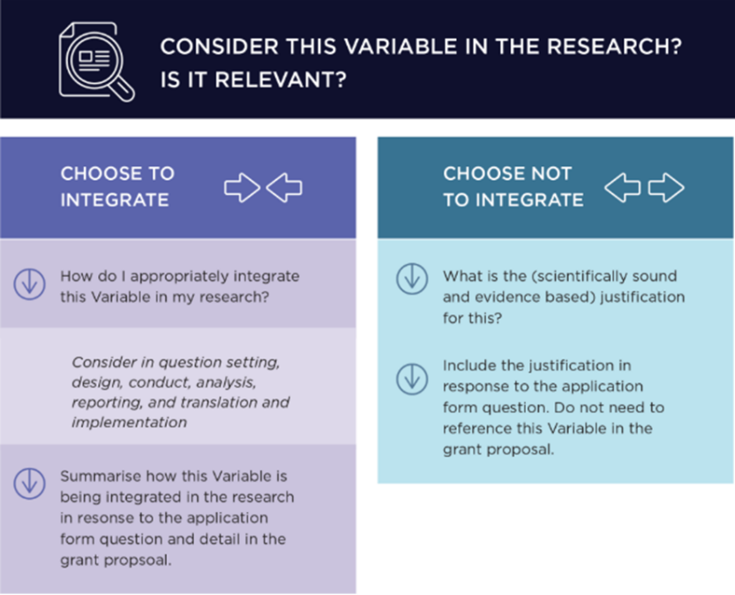

Assessment of grant applications
For most NHMRC and MRFF grant opportunities, the integration of the Variables will be incorporated into the assessment criteria and associated score descriptors. Assessors are asked to consider the appropriateness of how sex, gender, variations of sex characteristics and/or sexual orientation are integrated in the proposed research and/or the strength of the justification for why any of the Variables are not integrated when scoring applications against the assessment criteria.
Assessors are advised to consider the information provided on the Variables in both the response to the application form question and, where applicable, the grant proposal.
Applicants may include or exclude the Variables in their proposed research, provided they offer a sound, evidence-based justification for their decision. Assessors should give equal consideration to both approaches, focusing on the strength and validity of the rationale rather than the presence or absence of the Variables.
For more information, refer to the relevant grant opportunity guidelines and peer review guidelines available at GrantConnect and the FAQ resource.

