Guide to navigating and adapting to change

A guide for aged care workers

Australia’s aged care reforms will require a shift in workforce practices, behaviours, and capability to deliver care that upholds the rights of older people.

# Introduction

## Context

The *Aged Care Act 2024* delivers fundamental changes to aged care, and places older people’s rights at the centre. This will require changes across the way aged care services are delivered – the behaviours, processes, operations, data and systems. As an aged care worker, your ability to adapt to these changes is essential. While not everything is changing, there are key areas where practice will need to align with new expectations.

## Purpose

The purpose of this guide is to support you to understand what’s changing, how to apply it in your daily work, and how to use training, reflection, and feedback to continually improve the way you deliver care.

By using this guide, you can strengthen your ability to respond to changes in policies, processes, and the needs of older people, while ensuring that care remains person-centred and continuously improving.

# Understanding change

Understanding the process of change and your role in it, is essential. Everyone responds to change differently, and that’s okay. What helps most is staying open-minded, curious, and willing to listen and engage in the process.

Resilience and adaptability during times of change is key. Resilience means staying grounded and moving forward even when things feel uncertain. Always reach out to your team leader or provider if you need more support. Adaptability means being flexible to change and learning as you go. Together, these help you grow and improve the way you deliver care every day.

Change can bring excitement and opportunity, and it is natural to also experience feelings of overwhelm, uncertainty, or resistance as you and your team adjusts. These feelings show that you are actively processing and adapting to something new. Taking a moment to notice and name what you are feeling can help you stay grounded and maintain perspective. You can support yourself by sharing your thoughts with colleagues or your manager. Focusing on wellbeing through connection with others and taking time to reflect on how you have responded to recent changes strengthens resilience and builds your capacity to navigate change successfully.

Change is easier when divided into smaller, meaningful steps. This guide aims to help you navigate change with confidence and purpose.

# Understanding and implementing change

|  |  |
| --- | --- |
| **1. Understand the changes** | Take time to learn what is changing and what is staying the same.   * **What this means:** Familiarise yourself with the updates to policies and procedures. These changes are designed to improve care and support you in your role. * **How to do this:** Ask questions, attend briefings, and review the updated policies with your team leader or supervisor.   ***Remember:*** *Focus on what is new and what it means for your daily work and how it fits in with what is staying the same* |
| **2. Build new skills, habits and mindsets** | Building new skills, habits and mindsets enables you to meet new requirements, adjust to changing processes and be equipped to deliver your role.   * **What this means:**   There is support for you to develop new skills and ways of working. Training and resources are available to help you adapt with confidence.   * **How to do this:** Engage in the training, seek feedback, and be open to trying new ways of working. There are learning opportunities that suit your needs.   ***Remember:***  *Being equipped with the right skills empowers you and your team to embrace change.* |
| **3. Implementing your learning to daily care** | Small actions lead to meaningful improvements in daily care.   * **What this means:** Start thinking about how the changes and your learning apply to your daily care routines and interactions with older people. * **How to do it:** Reflect on each part of your day from conversations to support tasks and look for ways to embed what you have learned.   ***Remember:*** *You leave your home to go to theirs. Your care should always reflect respect, dignity, and person-centred principles.* |
| **4. Reflect, review, and refine** | Reflection helps you grow and improve even when things go well.   * **What this means:** Use the self-reflection tool to review a recent care experience. This helps you identify what worked, where you’ve grown, and what you can still improve. * **How to do this:** Think about a real-life scenario. Write down how you responded and how it might be different from what you would have done before. Be honest — this is about learning, not judgment.   ***Remember:*** *You likely deliver care well, but that is only half the story – its true impact lies in how it is experienced. Feedback and reflection help us understand how the older person felt.* |

1. Understand
2. build
3. implement
4. reflect

# You are integral to successfully implementing change

As an aged care worker, you have regular, direct contact with older people, and you’re also closely connected to your provider and team. This means you play a vital role in making sure change is meaningful and successfully implemented.

As everyone moves through these changes, your insight and actions make a real difference. By having regular, open conversations, you can help create a safe space, build trust, and ensure care is shaped around what matters most to the older person. Every moment of care shapes someone’s quality of life. These conversations humanise the experience and place the older person at the centre of their care.

## Using feedback to adapt to change

Feedback is one of the most important tools you can use to successfully navigate change.

The feedback you receive from older people, your provider, or your team leader gives you early insight into what is working and what needs to shift. By listening carefully and acting on feedback, you can adapt your practice more quickly, avoid repeating mistakes, and contribute to smoother transitions during times of change.

When shared in handovers or team discussions, feedback helps identify patterns or emerging concerns. This allows the team to adjust together, align on new approaches, and make sure that the changes being introduced actually improve care. Responding to feedback in this way reduces the likelihood of formal complaints and creates a culture where change is embraced rather than resisted.

Feedback is not only about improvement in the moment, it is a signal of how you can keep evolving as the aged care sector itself evolves. Positive feedback reinforces what practices should remain in place as change occurs, while constructive feedback highlights where new ways of working may be needed. Both types help you build confidence and capability to adapt.

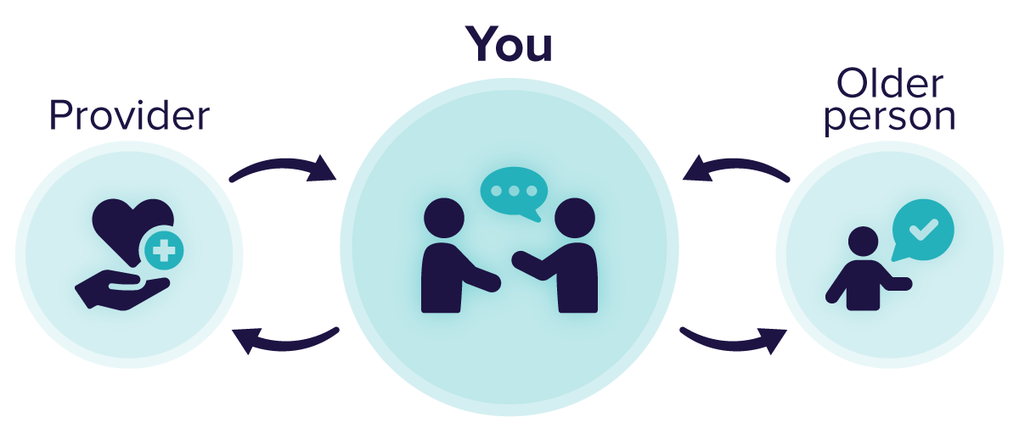

### How to receive feedback

|  |  |
| --- | --- |
|  | **Actively listen**  Focus on the message and what it means for adapting your care approach. |
|  | **Be aware of your response and reactions**  Staying calm and open shows you are willing to work with change rather than resist it. This makes others more likely to share feedback that supports your adaptation. |
|  | **Be open to what is being said**  Recognise that feedback often highlights how change is being experienced by others. Being open allows you to adjust your own perspective and try new approaches. |
|  | **Reflect on what you are told**  Consider how the feedback connects to current or upcoming changes. Does it point to a new skill you need to build, a habit to change, or a different way of working with your team? |
|  | **Ensure you understand correctly**  Ask questions that link feedback to the broader change. After the verbal feedback is complete ask clarifying questions and repeat key points and check if this is accurately understood. |
|  | **Follow up**  Take concrete actions to apply the feedback as part of the change process. Let people know how you have adapted, which builds trust and demonstrates that change leads to improvement. |

# There is support for you

[Example text]

## Outline how you will support your team through the change process. This might include setting up regular Communities of Practice to review a recent care experience, highlight good practice, and identify improvement opportunities. You could also encourage closer collaboration with the training manager to develop tailored training plans that build capability and confidence.

[Remove the example text box once you have completed the section below]

# Attachment: Self-reflection template

Think of a recent situation where you were involved in implementing a **new process or change** in your workplace. This could be related to a new care routine, a change in documentation, the introduction of new standards, or an adjustment in how your team works together. Use that real-life example to complete the self-reflection template below.

This tool is designed to help you:

* reflect on how you adapted to the change
* identify what supported a smooth transition and what made it harder
* recognise areas for improvement in how you respond to change
* explore opportunities to apply feedback and deliver better care as changes continue.

## Scenario

|  |  |
| --- | --- |
| How did you adjust your communication with the older person during this change?  *Consider body language, tone, or whether alternate communication tools were needed.* | |
| Your approach | What I will do differently next time |
|  |  |
| **What was your initial response to the change? Did it help or hinder how you supported the older person?** | |
| Your approach | What I will do differently next time |
|  |  |

|  |  |
| --- | --- |
| Did you make any assumptions about how the change would work, or how the older person would respond to it? | |
| Your approach | What I will do differently next time |
|  |  |
| **Was a support person or colleague needed to help you apply the change effectively?** | |
| Your approach | What I will do differently next time |
|  |  |
| **What were the older person’s preferences during this change? How did you identify them?** | |
| Your approach | What I will do differently next time |
|  |  |
| **How did you meet their preferences?**  (If you were unable to, what were the alternate options that you offered?) | |
| Your approach | What I will do differently next time |
|  |  |
| **Organisational culture**  One thing I’ll aim to apply this week to support change is… | |
| Your approach | What I will do differently next time |
|  |  |