A guide to determining when accommodation reforms apply to new residents
This resource helps registered residential aged care providers determine whether RAD/RAC retention and DAP indexation apply when a new resident enters their home.

What are the accommodation reforms?
Residents that enter permanent residential care for the first time after 31 October 2025 will be subject to the new accommodation reforms of:
- refundable accommodation deposit (RAD)/refundable accommodation contribution (RAC) retention; and
- daily accommodation payment (DAP) indexation.
A resident entering a new service who has previously been a permanent resident at another service, may be protected from these arrangements.

When will RAD/RAC retention and DAP indexation apply?
This flow chart helps identify whether RAD/RAC retention and DAP indexation may apply to an individual. It should be considered on the day of entry to an aged care home as a permanent resident. Registered providers may use this as a form of questions to ask individuals entering their aged care home.

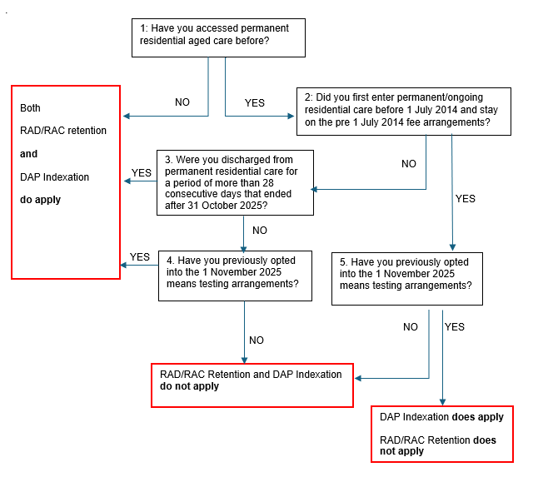

Question 1: Determine whether resident has previously been in permanent/ongoing residential aged care.

Guidance
Most residents will be entering ongoing residential care for the first time, the resident or their family will be able to confirm this. This is generally a reliable indicator.
Having previously received short term residential (respite) care does not affect RAD/RAC retention or DAP indexation. Only previous ongoing residential care admissions may affect whether these apply.
If you have access to a Services Australia fee advice letter for the resident, it may contain information that confirms whether a resident had entered permanent care before 1 November 2025 - see Attachment A.
Prompt question:
Have you been admitted to permanent residential aged care before?
Note: A previous admission to ongoing residential care must be in a residential care home under the same funding arrangements as your service to be recognised. If not, then entry to your service in this situation is considered a first admission and RAD/RAC retention and DAP indexation apply. More information is provided at Attachment B.

Response/action to question 1:
- No - This is the first admission to ongoing residential aged care: RAD/RAC retention and DAP indexation apply.
- Yes - go to 2.
- Unsure - go to 6.

Question 2: Determine if the resident was a permanent resident before 1 July 2014 and if so, still under the pre-1 July 2014 fee arrangements.

Guidance
Where a resident was determined to have been in permanent residential care previously there are some differences in how the application of RAD/RAC retention and DAP indexation apply for residents who entered care before 1 July 2014 and remained under the pre-1 July 2014 fee arrangements.
While most residents entering your care that have been in residential care previously are likely to have entered sometime after 1 July 2014, it is important to determine which fee arrangements the person was last under.
If you have access to a Services Australia fee advice letter for the resident, it may contain information about the type of fees that were payable which can confirm whether a resident entered before 1 July 2014. For example, accommodation bond, accommodation charge or income tested fee - see Attachment A.
Prompt questions:
When did you first enter permanent residential aged care? (before 1 July 2014 vs after 1 July 2014)?
If it was before 1 July 2014:
Did you previously opt into the 1 July 2014 fee arrangements?
Or
Were you previously discharged or did you leave permanent residential care for more than 28 consecutive days and re-enter care under the 1 July 2014 fee arrangements?

Response/action to question 2:
- No - go to 3.
- Yes - go to 5.
- If unsure - go to 6.

Question 3: Determine if resident was discharged from care for more than 28 consecutive days before re-entering on/after 1 November 2025.

Guidance
Most residents who entered permanent residential care between 1 July 2014 and 31 October 2025 are likely to have transferred from another aged care home (possibly via a hospital setting) with no gap or a gap of less than 28 days. In this case, providers should proceed to Question 4.
Prompt question:
How long has it been since you were discharged from your previous aged care home (more than or less than 28 consecutive days)?
Residents will be subject to RAD/RAC retention and DAP indexation if they were discharged/not receiving permanent residential care for more than 28 consecutive days before re-entering after 31 October 2025 other than because the resident was on approved leave (i.e. hospital leave, social leave etc)

Response/action to question 3:
- Yes – RAD/RAC retention/DAP indexation applies.
- No – go to 4.

Question 4. Determine if resident has opted into the post-2025 fee arrangements before or at the time of entering your service.

Guidance
Residents who entered permanent residential care between 1 July 2014 and 31 October 2025 have the option of opting into the 2025 fee arrangements before or at the time of entering a new service.
It is expected that most residents in this category will not choose to do this and therefore will not be subject to RAD/RAC retention or DAP indexation. If they do opt to do this before entering your service they will be subject to RAD/RAC retention and DAP indexation.
Providers will be aware if they have assisted a resident to opt into the new arrangements as they will need to submit the opt in form with the aged care entry record.
If you have access to a Services Australia fee advice letter for the resident, it may contain information that confirms whether a resident’s fees are calculated under the 1 November 2025 arrangements - see Attachment A.
Prompt questions:
Have you previously opted into the 1 November 2025 means testing arrangements?
Were you paying a hotelling contribution or did RAD/RAC retention or DAP indexation apply to you at your previous service? If yes, they have opted in.

Response/action to question 4:
- Yes – RAD/RAC retention/DAP indexation applies.
- No – RAD/RAC retention and DAP indexation do not apply. The person entered care before 1 November 2025, has not had a break of greater than 28 days and has not opted into the November 2025 fee arrangements before re-entering care.
- Unsure - go to 6.

Question 5. Determine if resident is moving to your service after opting into the post- 2025 fee arrangements.

Guidance
Residents that entered permanent residential care before 1 July 2014 and were still under the pre 1 July 2014 fee arrangements as at 31 October 2025 have the option of opting into the 2025 fee arrangements before or at the time of entering the service.
It is expected that most residents in this category will not choose to do this and therefore not be subject to RAD/RAC retention or DAP indexation.
If they do opt into the 2025 fee arrangements at the time of or before entry to your residential care home, they will be subject to DAP indexation. They will NOT be subject to RAD/RAC retention.
Providers will be aware if they have assisted a resident to opt into the new arrangements.
If you have access to a Services Australia fee advice letter for the resident, it may contain information that confirms whether a resident’s fees are calculated under the 1 November 2025 arrangements - see Attachment A.
Prompt question:
Have you opted into the 1 November 2025 means testing or fee arrangements?

Response/action to question 5:
- Yes – DAP indexation applies. RAD/RAC retention does NOT apply.
- No – RAD/RAC retention and DAP indexation do NOT apply.
- If unsure go to 6

Question 6: If you are unable to confidently determine whether RAD/RAC retention and DAP indexation apply.
In some rare circumstances, a provider may be unable to determine whether RAD/RAC retention and DAP indexation do apply. This may, for example, be due to a lack of clarity over the duration of periods out of care or the precise start date of a resident in another aged care home.
Providers should make every reasonable effort using the guidance above and any other information they have available to them. If they are unable to determine whether the arrangements apply they can contact Services Australia via the Aged Care provider line 1800 195 206.

Attachment A
Type of fee/contribution listed |  |  | Possible Accommodation Cohort | RAD/RAC retention | DAP indexation
Pre commencement letter (dated on or after 1 November 2025)
Fee advice letter – initial for your service
(not applicable to individuals accessing funded aged care services under specialist aged care programs)
Fee advice letter – previous service
(not applicable to individuals accessing funded aged care services under specialist aged care programs)
Accommodation Payment |  |  | 2014  2025 | Not definitive | Not definitive
Daily Accommodation Contribution |  |  | 2014  2025 | Not definitive | Not definitive
Means tested Care Fee |  |  | 2014  2025 ** | Not definitive | Not definitive
Hotelling Contribution | 2025 | Yes | Yes
Non Clinical Care Contribution | 2025 | Yes | Yes
Fee advice letter – initial for your service
Fee advice letter – previous service
(not applicable to individuals accessing funded aged care services under specialist aged care programs)
Accommodation charge*** |  |  | Pre 2014 | No | Generally no.  Yes: if resident enters a service after opting into the 2025 fee arrangements.
Income tested fee***  Note: this is the pre 1 July 2014 income tested fee (not the post 1 July 2014 Home Care income tested care fee) |  |  | Pre 2014 | No | Generally no  .  Yes: if resident enters a service after opting into the 2025 fee arrangements.

Note: The absence of fee types in a Services Australia letter does not, on its own, confirm that a resident has not entered prior to 1 November 2025.
Note: **Individuals who were receiving a home care package or approved and on the wait list for a home care package allocation on 12 September 2024 are assessed under the post 1 July 2014 means testing arrangements for their resident contributions and the 1 November 2025. accommodation arrangements for their accommodation costs. RAD/RAC retention and DAP indexation arrangements apply to these individuals. ￼
Note: *** when either an accommodation charge or income tested fee appear on the initial fee advice letter for your service, the person is still on the pre 1 July 2014 fee arrangements. If the fee advice letter was from a previous service, DAP indexation will apply from entry to an aged care home only if the individual has opted into the 1 November 20205 means testing arrangements before entering that aged care home.

Attachment B
A previous admission to ongoing residential care must be in a residential care home under the same funding arrangements as your service to be recognised as per the table below.

Your service | Previous admission | Is this considered a first admission
You are a registered provider delivering services through a multi-purpose service under a specialist aged care program | Your service  OR  Another multi-purpose service | No
 | Another service that is not a multi-purpose service under the specialist aged care program | Yes
You are a registered provider delivering services but not a multi-purpose service under the specialist aged care program | Your service  OR  Another service | No
 | Another service that is a multi-purpose service under the specialist aged care program | Yes

For example: for residents entering permanent aged care:
If you are a registered provider delivering services through a multi-purpose service under a specialist aged care program:
- Where the resident has had:
  - A previous admission to your service or another multi-purpose service this admission is not considered a first admission.
  - A previous admission to a service that is not a multi purpose service under the specialist aged care program this is considered a first admission.
If the registered provider delivering services but not under the specialist aged care program:
- Where the resident has had:
  - A previous admission to your service or another service that is not a multi-purpose service this admission is not considered a first admission.
- A previous admission to a multi purpose service under the specialist aged care program is considered a first admission.

