
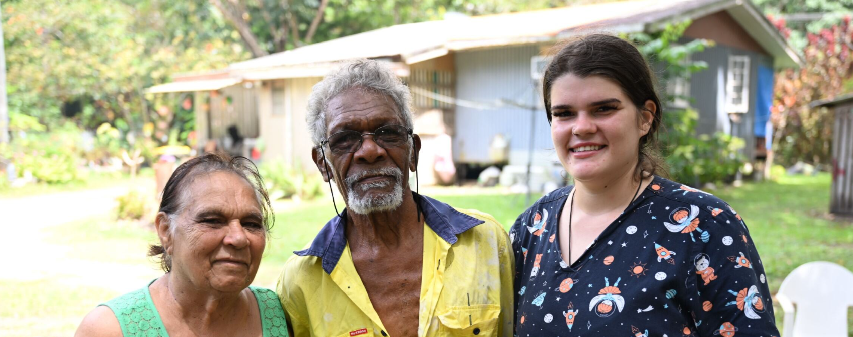

Supporting the rollout of Aboriginal and Torres Strait Islander aged care assessment organisations

Guidance and FAQs for Single Assessment System assessors

The pilot phase of Aboriginal and Torres Strait Islander assessment organisations

This guide draws out relevant excerpts from the My Aged Care Assessment Manual, to create a focused overview on the relevant changes.
About
Aboriginal and Torres Strait Islander aged care assessment organisations commenced a phased rollout from August 2025.
Aboriginal and Torres Strait Islander aged care assessment organisations will provide culturally safe, trauma aware and healing informed aged care assessments.
They will provide Aboriginal and Torres Strait Islander people:
- an improved assessment experience
- options to stay independent at home for longer
- more choice when seeking a culturally safe aged care assessment.
Timeline
Aboriginal and Torres Strait Islander assessment organisations commenced rolling out from August 2025. The rollout will begin with a small number of Aboriginal and Torres Strait Islander organisations to pilot the systems and approach.
Over time, the service will extend its reach and work towards covering more areas across Australia.
System functionality
The clients’ demographic details within the portal will now contain a field where the client’s preference for an Aboriginal and Torres Strait Islander assessment organisation can be recorded.
The preference will display in the client details as well as on the client’s card. This preference will be captured at registration and, confirmed when they are talking to an assessment organisation

- From February 2025, the recording of the persons preference went live. My Aged Care contact centre, ACSO’s and assessment teams record the preference, and it will be confirmed at triage.
- From Nov 2025, consumers and system navigators will be able to select the preference in the My Aged Care Online account, by checking the preference box. GP’s will be able to record the preference using the GP portal.
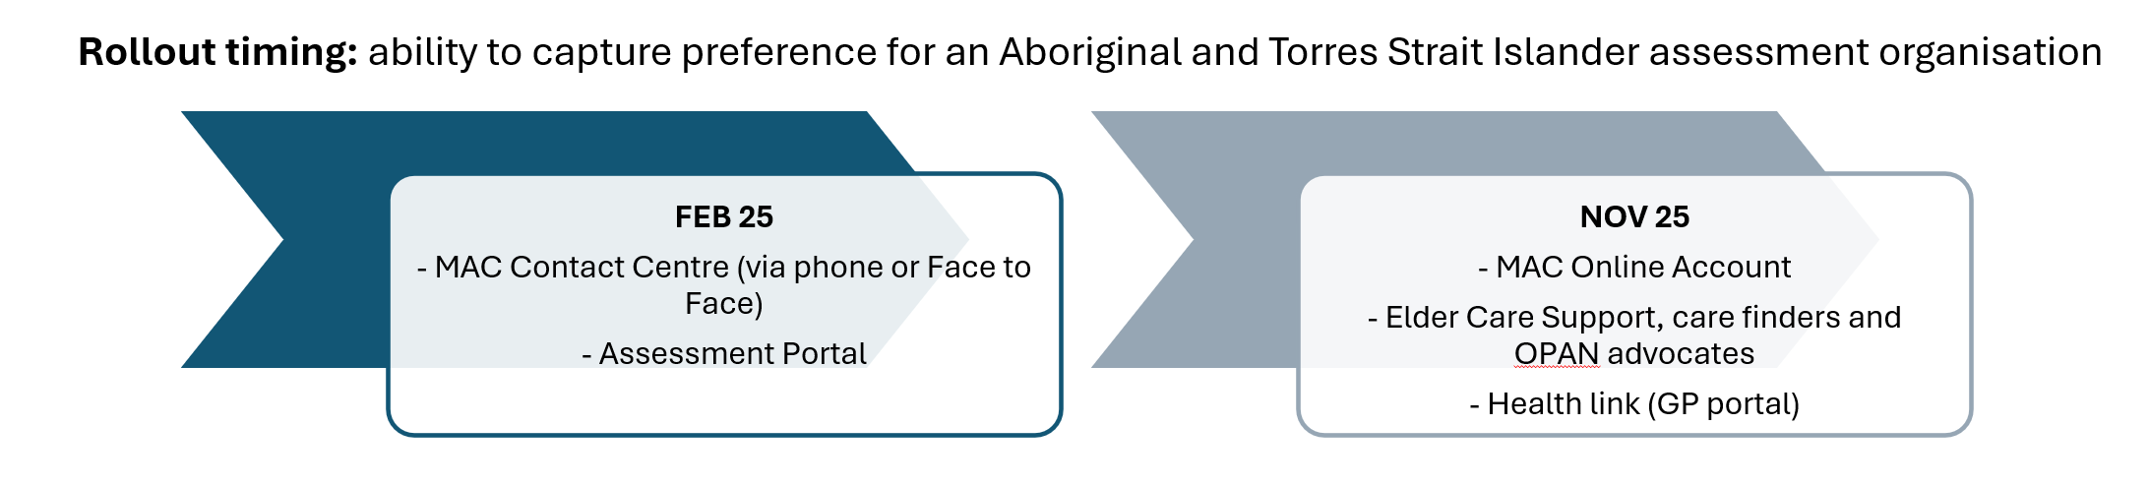
How will SAS assessors be impacted:
Older Aboriginal and Torrres Strait Islander people need to have the choice to transfer their assessment to an Aboriginal and Torres Strait Islander assessment organisation as they become available.
Single Assessment System assessors will need to be aware of where and when the Aboriginal and Torres Strait Islander assessment organisations are rolling out, in order to refer interested clients.
All Single Assessment System Organisations will need to continue to provide a culturally safe assessment experience for older Aboriginal and Torres Strait Islander people.

Triage delegates: Confirm the preference at triage
A client’s preference for an Aboriginal and Torres Strait Islander assessment organisation, will usually be captured at registration. The client’s preference will be visible on their client card.
It will need to be confirmed when completing the client’s demographic details at triage.
- When a triage delegate receives a referral, they should view the client information to gain a preliminary understanding of the client’s situation.
- If there is no preference listed, please record the preference after having a conversation with the older person.
It is important to have a conversation with the older person about their preference. It should not be assumed that all Aboriginal and Torres Strait Islander people will want their assessment with an Aboriginal and Torres Strait Islander assessment organisation.
- The client’s preference will determine whether the referral is accepted, transferred or rejected.
- If a transfer is required, this wll need to be managed with the support of a Team Leader.
- It will also ensure that the assessment process is responsive to the person’s individual situation.

All assessors:

1. Review and confirm the preference in your pre-assessment planning
As it is a phased rollout, Aboriginal and Torres Strait Islander people who are booked with a Single Assessment System organisation need to have the choice to transfer their assessment to an Aboriginal and Torres Strait Islander assessment organisation if one commences in their area.
Preferences for an Aboriginal and Torres Strait Islander assessment organisation should be uncovered during the assessor’s pre-assessment planning. This allows the assessor time to contact the client, discuss their preference and organise transferring the client prior to the assessment meeting.
- This must occur prior to the assessment. Once the assessor starts the assessment, it will need to be cancelled it they are not proceeding with the assessment. The general recommendation would be that the assessor with the booking continues with the assessment as planned, with the agreement of the client.
- The client’s condition needs to be taken into consideration, that their health condition and care needs would not be adversely impacted by a delay in assessment if they were to be referred to another organisation.
- A conversation with the client prior to the assessment is recommended to ensure that they have choice and control and the ability to make decisions regarding their care.
- If the client’s preference is to be assessed by the Aboriginal and Torres Strait Islander assessment organisation; and they understand the timing impacts; then the assessor can ensure a warm referral as per the processes in the My Aged Care assessor manual.
- A new rejection reason ‘client prefers a FNAO’ is available in the IT system. An older Aboriginal and Torres Strait Islander person should not be rejected based on a client’s preference unless it is a last resort. A transfer prior to the assessment is preferable to a rejection.
  - If the referral is cancelled by the assessor at the point of assessment, this may slow down the process for the client which is not the desired outcome.
- This above process also applies to Support Plan Reviews, and subsequent new assessments.
- Scenarios and scripts are available in the My Aged Care assessment manual.

2. Take note of whether the older person is being supported by a system navigator (ECS, care finder, OPAN advocate)
Many Aboriginal and Torres Strait Islander people are supported by a system navigator. System navigators often have built a trusted relationship with the older person to support their cultural safety and can contact them when needed.
All SAS Organisations will need to continue to provide a culturally safe assessment experience for older Aboriginal and Torres Strait Islander people.
System navigators put their information in the notes section of the client card. It’s important for all assessors to work with the system navigators to support the client, especially in the case that it’s difficult to contact the client.
Please ensure you have engaged with the system navigator prior to cancelling.

Share Feedback
Assessors are a voice from the ground to the Department, expressing the need and experiences on the ground; and can use their knowledge and position to:
- share stories (including positive ones as they emerge),
- feedback information about how the rollout is going,
- provide advice on what can be improved, and/or
- point to regions/communities that require some support or attention to have a service stood up.
Assessors can share feedback with your organisation, who can pass it onto the Department.
Single Assessment System assessors should:
- Stay up to date and share information about the availability of Aboriginal and Torres Strait Islander assessment organisations, to promote the service and generate referrals based on the preferences of the older person.
To stay up to date:
  - Keep an eye on your regular communication channels
  - The department will share updates of new organisations as they become available in the monthly Aged Care Assessment Update newsletter at the end of each month.
  - They will be listed on the Single Assessment System assessment organisation list.
Registering the preference
There will be a drop-down box available where you can record their preference in the My Aged Care Gateway portal and assessor portal.

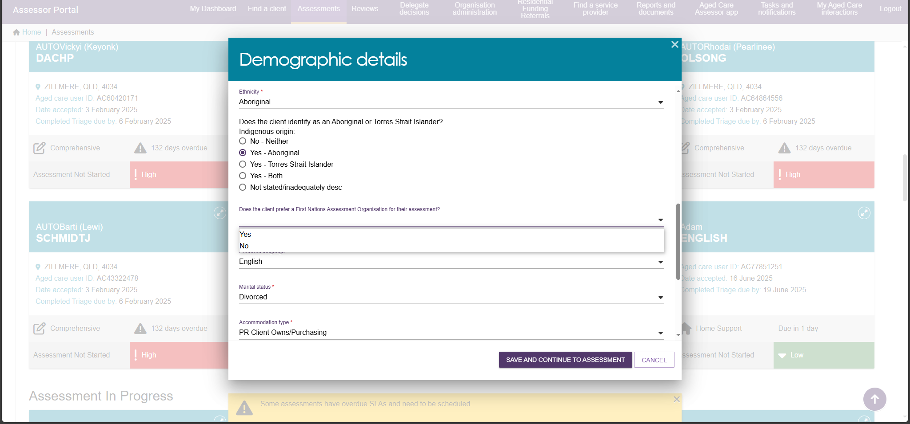

Suggested script
Here is a suggested script for your adaptation and use.
Please note as it’s a phased rollout; it’s important to manage expectations that it will take time for organisations to scale up across Australia.
“Some Aboriginal and Torres Strait Islander assessment organisations are starting to provide aged care assessments from this year.
If an Aboriginal and Torres Strait Islander assessment organisation became available in your area, would you prefer that?”

Resources available
The following resources are available to support you:
Resource | Description | Link
Assessor Portal User Guides | Details on registering preferences and managing referrals for Aboriginal and Torres Strait Islander assessment organisations are in the assessor portal user guides. | My Aged Care – Assessor Portal Resources | Australian Government Department of Health and Aged Care
Resources for community | Resources will become available to share with older Aboriginal and Torres Strait Islander people to help raise awareness of the new pathway. | Aboriginal and Torres Strait Islander Aged Care Assessment Organisations | Australian Government Department of Health, Disability and Ageing
Support systems
If you have questions about your role, or how your organisation will support the rollout, please:

- Engage with your team leader, or organisation
- Check the Aboriginal and Torres Strait Islander aged care assessment website
- Check the My Aged Care Assessment Manual for specific questions
- Check the Assessor Portal User Guides for system questions
Frequently asked questions for assessors:
What’s the correct terminology, First Nations assessment organisation or Aboriginal and Torres Strait Islander assessment organisation? | Originally, the term 'First Nations assessment organisations' was used. Moving forward, to suit the preference of older Aboriginal and Torres Strait Islander people; we will migrate to new terminology ‘Aboriginal and Torres Strait Islander assessment organisations.  Both will be acceptable in the transition period, however, please ensure you use the updated language when communicating with the older person or their supporter. Many older Aboriginal and Torres Strait Islander people do not identify with the ‘First Nations’ language.  The My Aged Care portals will initially include the term ‘First Nations’ and the new terminology will be introduced in a future release.
Will all older Aboriginal and Torres Strait Islander people want an Aboriginal and Torres Strait Islander assessment organisation? | Not necessarily. While some people may prefer an Aboriginal and Torres Strait Islander assessment organisation, others may prefer the first available appointment from any organisation in the Single Assessment System, and some may prefer to use a mainstream organisation.  The new option will provide a choice for older Aboriginal and Torres Strait Islander people based on their own individual preferences.
Do existing clients have a preference for an Aboriginal and Torres Strait Islander assessment organisation recorded in the system? | For existing clients who have not previously been asked their preference, the new field to record the client’s preference is blank.  When they have a reassessment/assessment their preference will be updated when their next assessment is arranged.
Where will the organisations commence? | Aboriginal and Torres Strait Islander assessment organisations will be added to the Single Assessment System assessment organisation list once available.
Who will provide the services? | Primarily the Department expects to work with existing ACCOs, ACCHO’s, and organisations which specialise in providing aged care services to Aboriginal and Torres Strait Islander people to scale up nationally.
If asked, why is there not one available in my area? | This initiative will begin with a small number of organisations in 2025. It will build over time. It is important that this rollout builds slowly, to scale at a pace that supports the participating Aboriginal and Torres Strait Islander assessment orgs; the aged care workforce and giving the space to truly learn from each phase and get it right.  Suggested script (for your adaptation and use)  “Some Aboriginal and Torres Strait Islander assessment organisations are starting in 2025 to provide aged care assessments in parts of Australia.  It will take time for organisations to grow, recruit and train staff across Australia.  There is not one available in this area yet.  I will record your preference for future interactions. In the meantime, you can continue with [insert mainstream organisation] who has assessment spots available now. You can bring a family member, supporter or Elder Care support worker if that helps you feel more culturally safe.
If asked, when will there be one available in my area? | Suggested script (for your adaptation and use), in addition to the above context about the phased rollout.  “We don’t have the information about when more are coming, but we know they will scale up slowly over time.  I will record your preference for future interactions. In the meantime, you can continue with [insert organisation] who has assessment spots available now.”
Why should the older person give their preference (data) when there is no Aboriginal and Torres Strait Islander assessment organisation in the region? | - The service preferences of your community are often not visible to government in the data that they have. This is your opportunity to let government know what you want.  - If an Aboriginal and Torres Strait Islander assessment organisation is established in your area and a review of your care (a Support Plan Review) is needed, having this preference in the system will help to flag that you need a transfer to the new Aboriginal and Torres Strait Islander organisation.  - Collecting the preferences helps us understand demand in the community and will help inform the future rollout.
What if a person wishes to remove their preference? | They can withdraw this preference at any time and uncheck the box in the My Aged Care portal, on the phone or when talking to a system navigator or assessment organisation.
When transferring a referral, how will I know which organisations are Aboriginal and Torres Strait Islander assessment organisations? | When transferring a client, any Aboriginal and Torres Strait Islander assessment organisation available in the area will be prefixed with “FNAO-” and appear at the top of the list.  If there isn’t one available, then no organisation will have the prefix.  Users will get a warning when they try to transfer if the client has indicated a preference, if the assessment organisation is not an Aboriginal and Torres Strait Islander assessment organisation.
What if an organisation comes up as both an Aboriginal and Torres Strait Islander and part of the broader Single Assessment System for the region? | The Aboriginal and Torres Strait Islander assessment organisation will be prioritised at the top of the list if there is a preference recorded in the system.  The Aboriginal and Torres Strait Islander assessment organisation will have ‘FNAO-’ prefix at the front of the title, and the mainstream organisation will be listed as they have been in the past.
Can an older person find out about the Aboriginal and Torres Strait assessment organisation before being referred?  What if they do not wish to be referred to any of the ones that come up? | Yes, an older person has a right to decide if they want to be referred to a specific organisation. At the point of referral, the older person can ask about which Aboriginal and Torres Strait Islander assessment organisations are available.  If an older person doesn’t want to be referred to a specific organisation, they can ask to be connected with another assessment organisation if one is available.  The individual may wish to remove their preference in the system or keep it as more organisations may be available in the future.
Where can assessors find more information about Aboriginal and Torres Strait Islander assessment organisations? | More information can be found on the Department of Health and Aged Care website. OR  The enquirer (or their organisation) can email their question to the Department of Health and Aged Care (department) at: firstnationsagedcareassessment@health.gov.au
Phone 1800 200 422
(My Aged Care’s free call phone line)

Visit agedcareengagement.health.gov.au

For translating and interpreting services, call 131 450 and ask for My Aged Care on 1800 200 422. To use the National Relay Service, visit nrschat.nrscall.gov.au/nrs or call 1800 555 660.

