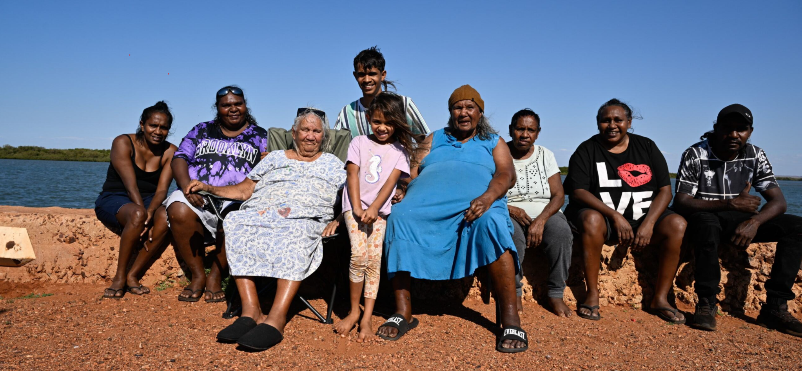


Aboriginal and Torres Strait Islander aged care assessment organisations

Guidance and FAQs for older people, their families and communities

Aboriginal and Torres Strait Islander aged care assessment organisations will give you more choice of who you have your aged care assessment with.
About
Aboriginal and Torres Strait Islander aged care assessment organisations commenced a phased rollout from August 2025.
As part of our commitment to improve aged care, we now support Aboriginal and Torres Strait Islander aged care assessment organisations to provide you with culturally safe, trauma aware and healing informed aged care assessments.
They will provide you:
- an aged care assessment experience tailored to your needs
- options to stay independent at home for longer
- more choice when seeking a culturally safe aged care assessment.

We have listened and are making changes to how you can access aged care providing culturally safe, trauma aware and healing informed aged care assessments. We are working to give you more choice about who you have your aged care assessment with, and where you have your assessment.

A list of Aboriginal and Torres Strait Islander assessment organisations can be found on our web site and on the Single Assessment System list of assessment organisations. To find out if one is near you, enter your postcode into the interactive map of assessment organisations.

Your local ACCO will also know where they are available.
Timeline
Aboriginal and Torres Strait Islander assessment organisations started rolling out in August 2025, with a small number to begin with. Over time, the service will extend its reach and the number of organisations available will increase.
What is an aged care assessment?
If you’re 50 and over, aged care services can help you live independently to stay at home for longer and find more time for the things you enjoy. Aged care services can help you with getting around, cleaning, cooking and more.
To find out more about registering for aged care:
Web: myagedcare.gov.au
Phone: 1800 200 422
Visit: your local Services Australia Service Centre or Health Clinic
If you need a bit more assistance, aged care could also give you the option of moving into an aged care home.
To get help at home or if you need to talk about going to an aged care home, you need to have an aged care assessment. This is a yarn with an assessor from an aged care assessment organisation to help them understand what you need.
To book an aged care assessment, you need to contact ‘My Aged Care’. My Aged Care is where all aged care services are organised. It’s run by the Department of Health, Disability and Ageing, and has a website with lots of information about aged care. You can talk to a My Aged Care staff member on the phone, or see them face to face at Services Australia service centres.
Below are the first steps to get aged care, visit My Aged Care or talk to a support organisation for more information. (More information on these below).
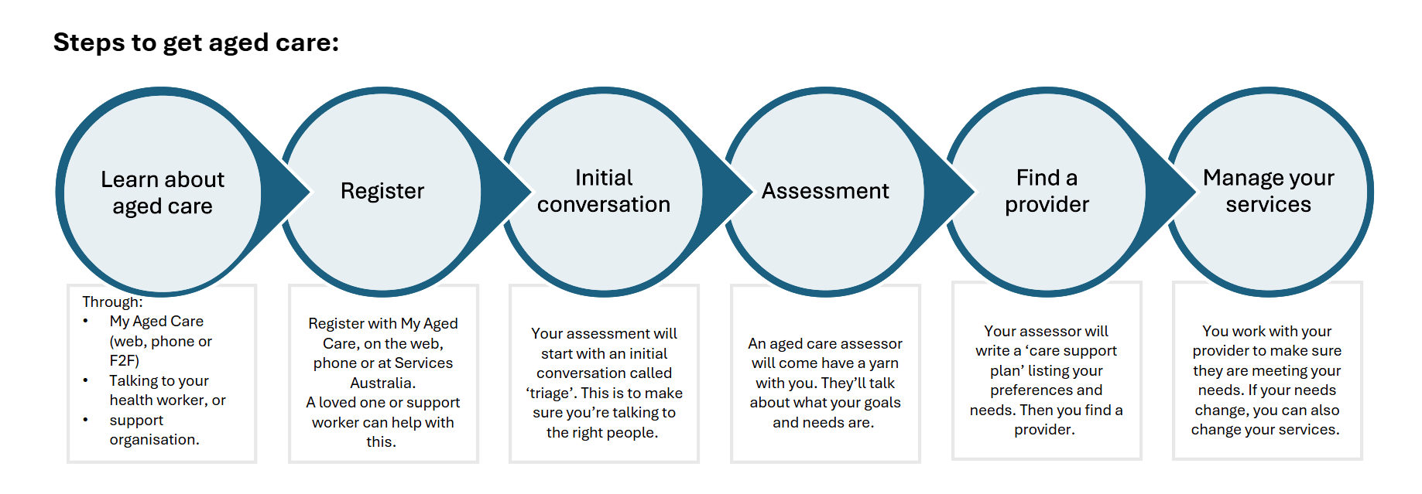
Who can support me through this process?
Aged care can be confusing and complicated. There are many ways to get some support with this process. You can speak to someone who understands your community. There is a big network of free services available to you and your loved ones who can provide advice and support at every step along the way.
- Elder Care Support workers are a trusted workforce that can help you navigate the aged care system. They can be found through your local Aboriginal Community Controlled Organisation, or via this list on the Elder Care Support web page.
- Another option is your local care finder to help support you. Visit the My Aged Care website to find a list of care finders in your area.
- The Older Persons Advocacy Network can help you find care that meets your needs. They have a national network of Aboriginal and Torres Strait Islander advocates. Call OPAN on 1800 700 600.
How to record my preference
Once there is an Aboriginal and Torres Strait Islander aged care assessment organisation in your region, you have the choice of whether you’d prefer to have your assessment with them.

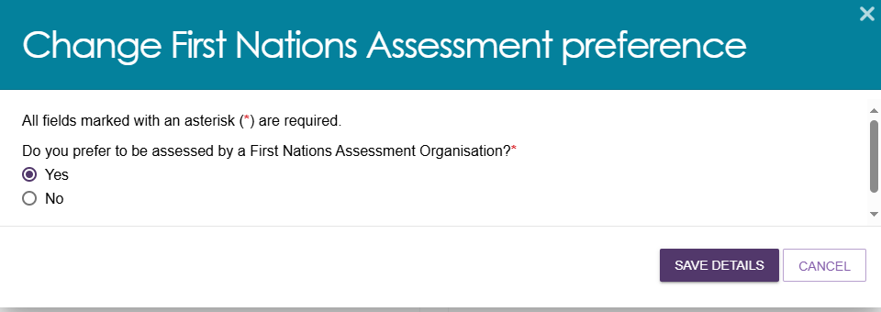

You can register your preference when you speak to My Aged Care on the phone or Face-to-Face at Services Australia or when you speak to any assessment organisation.
The support organisations above can also help you do this.

From November 2025, you’ll be able to register this yourself in the My Aged Care web site. This is known as your My Aged Care Online Account (pictured right)
Your preference will display in your personal details on your My Aged Care client record.

What will I be asked?
When you speak to My Aged Care, to an assessment organisation or to someone helping you with the assessment process; you will be asked for your preference. It’s important to remember that there may not be one in your area yet, so you may still be referred to a mainstream organisation for your assessment. It’s helpful to have your preference in the system in case one becomes available in the future, and future assessments can be transferred to them if you want.

They will ask you something like this:
“Some Aboriginal and Torres Strait Islander assessment organisations are starting to provide aged care assessments from this year.
If an Aboriginal and Torres Strait Islander assessment organisation became available in your area, would you prefer that?”

What can I expect?
Aboriginal and Torres Strait Islander aged care assessment organisations will be local to the community where possible. They will be able to support the local customs, kinship structures, protocols and needs of each community.
Assessors will either be Aboriginal and Torres Strait Islander or trained to be culturally safe by the Aboriginal and Torres Strait Islander organisation.

A yarning approach to assessment
You can have a yarn wherever you want.
It is best to have it at home, but it could be anywhere; for example at a community centre or outside.
With an Aboriginal and Torres Strait Islander aged care assessment organisation, you can:
- have a yarn, wherever you want
- take the time to work through your need, wants and goals
- bring someone with you (whoever you want)
- have an interpreter, you can choose the language you yarn in.

What if an Aboriginal and Torres Strait Islander aged care assessment organisations is not available yet?
If there is no Aboriginal and Torres Strait Islander aged care assessment organisation in the community yet, you can still receive an assessment from any Single Assessment System service.
Elder Care Support workers, care finders and OPAN advocates can support you to feel culturally safe through this process. They can answer questions about the aged care process and attend the assessment with you if required and available.
Resources available
The following resources are available to support you:
Resource | Description | Link
Support for Aboriginal and Torres Strait Islander people | A web page to help Aboriginal and Torres Strait Islander people navigate the aged care system. | Support for older Aboriginal and Torres Strait Islanders | My Aged Care
Resources for community | Resources to share with older Aboriginal and Torres Strait Islander people to help raise awareness of the new pathway. | Aboriginal and Torres Strait Islander aged care programs and reforms | Australian Government Department of Health, Disability and Ageing

Frequently asked questions for older people, their families and communities:
Where and when will the organisations commence? | We do not have a list of all the Aboriginal and Torres Strait Islander aged care assessment organisations yet. Organisations who participate will have to apply and be approved, so this will be determined by who applies. Once they are successful, they’ll be added to the list of Single Assessment System assessment organisations.
Who will provide the assessments? | Organisations which specialise in providing aged care services to Aboriginal and Torres Strait Islander people will provide the assessments. We expect these will mostly be Aboriginal community-controlled organisations.
Do I have to use an Aboriginal and Torres Strait Islander aged care assessment organisation? | No. We understand that some people may prefer an Aboriginal and Torres Strait Islander assessment organisation, where others may prefer the first available appointment from any organisation. The new option will provide a choice based on your preferences.
Why is there not one in my area? | This initiative will begin with a small number of organisations from 2025. It will build over time. We also need to learn and adapt from each prior phase to make sure we get it right. It is important that this rollout builds slowly, at a pace that supports our Aboriginal community-controlled organisations and their workforce.
When will there be one in my area? | We don’t have the information about when more are coming, but they will scale up slowly over time.
Why should the older person give their preference (data) when there is no Aboriginal and Torres Strait Islander assessment organisation in the region? | - The service preferences of your community are often not visible to government in the data that they have. This is your opportunity to let government know what you want.  - If an Aboriginal and Torres Strait Islander assessment organisation is established in your area and a review of your care (a Support Plan Review) is needed, having this preference in the system will help to flag that you need a transfer to the new Aboriginal and Torres Strait Islander organisation.  - Collecting the preferences helps us understand demand in the community and will help inform the future rollout.
How can my local ACCO help me get an aged care assessment? | Your local ACCO will know what assessment organisations are available in the region. They will be able to help you get an aged care assessment, whether it is with an Aboriginal and Torres Strait Islander Organisation or another organisation.
Can my local ACCO do my aged care assessment? Why / Why not? | Many ACCOs can help you with aged care services but not all of them can give aged care assessments. To do assessments, your health worker will need to do specific training to qualify to be an aged care assessor and support you the right way.  If your local ACCO can’t do the assessment, they will be able to help connect you with another organisation that can get it done for you.
If I am an existing aged care client, do I still get to record my preference? | If you are an existing aged care client who has not already been asked their preference, the box on My Aged Care to record the preference will be blank. At the time of your next reassessment / assessment your preference will be updated.
What if I want to remove my preference? | You can withdraw your preference at any time and uncheck the box in the My Aged Care portal, on the phone or when talking to a system navigator or assessment organisation.
Can I find out about the Aboriginal and Torres Strait assessment organisation before being referred?  What if I don’t want to be referred to the ones that come up? | Yes, you have the right to decide if you want to be referred to a specific organisation. At the point of referral, you can ask about which Aboriginal and Torres Strait Islander aged care assessment organisations are available. If you don’t want to be referred to a specific organisation, you can ask to be connected with another assessment organisation if one is available.  You may want to remove your preference in the system or keep it as more organisations may be available in the future.
Where can I find more information? | More information can be found on the Department of Health, Disability, and Ageing website OR You can email questions to the Department of Health, Disability and Ageing at: firstnationsagedcareassessment@health.gov.au
Who else can I talk to? | If you want to provide feedback about your experiences, in a way that you feel safe and comfortable you can contact the National Aboriginal and Torres Strait Islander Ageing and Aged Care Council, at info@natsiaacc.org.au. They can pass on your feedback to the Department.  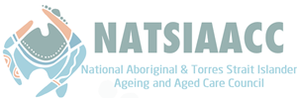

Phone 1800 200 422
(My Aged Care’s free call phone line)

Visit agedcareengagement.health.gov.au

For translating and interpreting services, call 131 450 and ask for My Aged Care on 1800 200 422. To use the National Relay Service, visit nrschat.nrscall.gov.au/nrs or call 1800 555 660.

