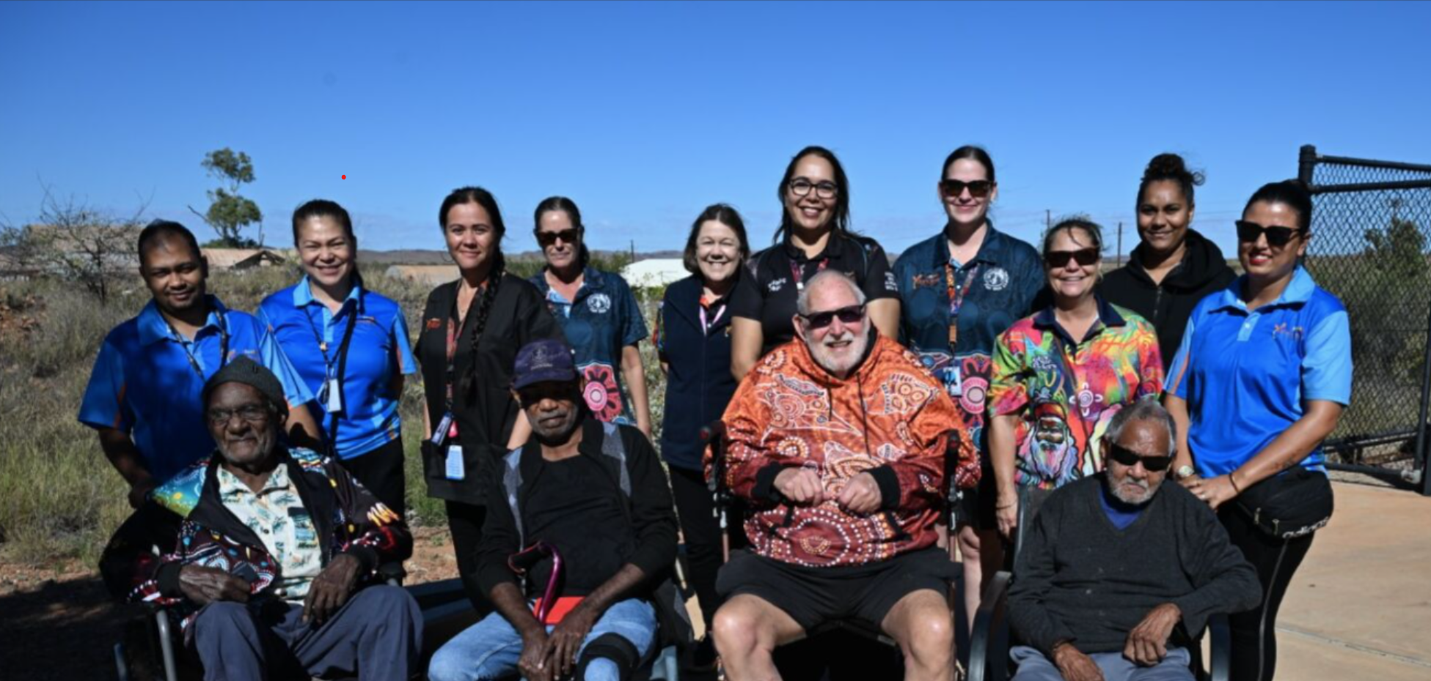


Supporting your community with the rollout of Aboriginal and Torres Strait Islander aged care assessment organisations

Guidance for NATSIFAC and MPSP providers

The pilot phase of Aboriginal and Torres Strait Islander assessment organisations

This guide draws out relevant excerpts from the My Aged Care Assessment Manual, to create a focused overview on the relevant changes.
About
Aboriginal and Torres Strait Islander aged care assessment organisations commenced phased rollout from August 2025
Aboriginal and Torres Strait Islander assessment organisations will provide culturally safe, trauma aware and healing informed aged care assessments.
They will provide Aboriginal and Torres Strait Islander people:
- an improved assessment experience
- options to stay independent at home for longer
- more choice when seeking a culturally safe aged care assessment.
Timeline
Aboriginal and Torres Strait Islander aged care assessment organisations commenced from August 2025. The rollout will begin with a small number of Aboriginal and Torres Strait Islander organisations to pilot the systems and approach. Over time, the service will extend its reach and work towards covering more areas across Australia.
System functionality
A ‘preference box’ will support older Aboriginal and Torres Strait Islander people to record their preference for an Aborigininal and Torres Strait Islander assessment organisation.
The preference will display in the client details as well as on the client’s card. This preference will be captured at registration and, confirmed when they are talking to an assessment organisation.

- From February 2025, the recording of the persons preference went live. My Aged Care contact centre, ACSO’s and assessment teams record the preference, and it will be confirmed at triage.
- From Nov 2025, consumers and system navigators will be able to select the preference in the My Aged Care Online account, by checking the preference box. GP’s will be able to record the preference using the GP portal. 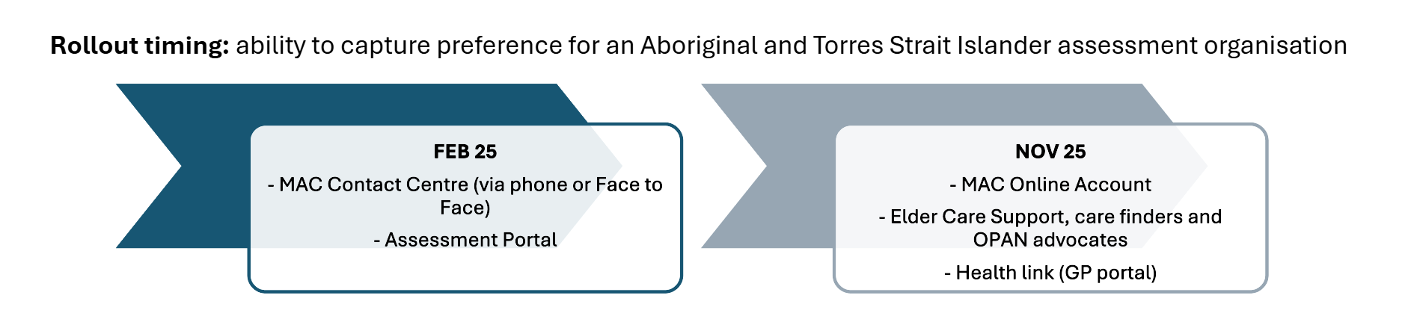
What does this mean for NATSIFAC and MPSP providers:
NATSIFAC and MPSP providers will play a critical role to support the rollout.
As trusted members of the community who are respected and embedded in the health and aged care systems, NATSIFAC and MPSP providers will be critical to the success of this rollout

Support clients, the community and new organisations
As trusted members of the community who are already respected and embedded in the health and aged care systems, NATSIFAC and MPSP providers will support the rollout through:
- connecting with the new assessment organisations as they commence
- raising awareness of the new Aboriginal and Torres Strait Islander assessment organisations as they become available
- directing new clients to register their preference for an Aboriginal and Torres Strait Islander assessment organisation through My Aged Care
- conducting initial assessments where appropriate in order to commence providing services
- maintaining a connection with the older person if needed, while they wait for assessment outcome and service commencement.

Share Feedback
NATSIFAC and MPSP providers are a voice from community to the Department for this project, expressing the need and experiences on the ground; and can use their knowledge and position to:
- share stories (including positive ones as they emerge)
- feedback information about how the rollout is going
- provide advice on what can be improved, and/or
- point to regions/communities that require some support or attention to have a service stood up.

NATSIFAC and MPSP providers can provide feedback through their usual channels including the NATSIFAC inbox, MPSP inbox or the Aboriginal and Torres Strait Islander aged care assessment organisation project inbox.
Summary of reform impacts related to assessment for NATSIFAC and MPSP providers:
- All government funded aged care services will become Act based from 1 November 2025, including services that an older person may receive from CHSP and specialised aged care programs such as NATSIFAC and MPSP.
- These changes will:
    - ensure NATSIFAC service providers can continue to deliver flexible, culturally safe care to meet the individual needs of older Aboriginal and Torres Strait Islander people and local communities
    - support the transition of clients in cases they need to move or change providers
- From 1 November, anyone seeking services through NATSIFAC and MPSP will require an aged care assessment; through the Single Assessment System.
  - New clients can be referred to Aboriginal and Torres Strait Islander aged care assessment organisations as they become available.
- If the alternate entry pathway is used, NATSIFAC and MPSP providers will continue to conduct initial assessments for clients, so they can commence providing services where there is an urgent need or where there is a delay in accessing a culturally safe aged care assessment.
  - NATSIFAC and MPSP providers will need to register new clients on My Aged Care for an aged care assessment within 30 days. This does not mean an assessment needs to be completed within 30 days, just the act of registration.
- Existing NATSIFAC and MPSP clients who have been receiving services in the past 12 months, can continue to access services without re-assessment.
What can NATSIFAC and MPSP providers do next?
- Share information about the availability of Aboriginal and Torres Strait Islander assessment organisations, with clients and during outreach activities.
To stay up to date:
  - Keep an eye on your existing communication channels.
  - The department will share updates of new organisations as they become available in the regular aged care sector newsletters.
  - They will be listed on the Single Assessment System assessment organisation list.
- Record the preference for an Aboriginal and Torres Strait Islander assessment organisation if helping the older person complete their registration.
- Consider this preference when referring an older person for a Support Plan Review (SPR), as their SPR will be referred back to the previous organisation; and an Aboriginal and Torres Strait Islander organisation may have become available.
  - The older person will have a choice to transfer their SPR if they prefer.
- Attend the assessment with the older person (with consent, if required and available)

Registering the preference
When working with an older person to register them for My Aged Care, there will be a preference box available where you may be able to:

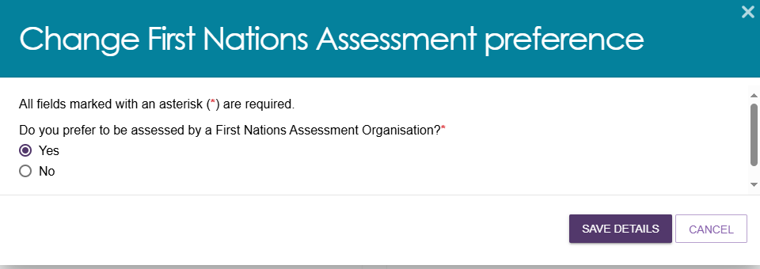

- help them record their preference in the My Aged Care Online Account (pictured right),
- support them on the phone with the contact centre
- or connect them with a system navigator.
Suggested script
Here is a suggested script for your adaptation and use if you are supporting a client to register their preference.

Please note as it’s a phased rollout; it’s important to manage expectations that it will take time for organisations to scale up across Australia.
“Some Aboriginal and Torres Strait Islander assessment organisations are starting to provide aged care assessments from this year.
You can register your preference for an Aboriginal and Torres Strait Islander assessment organisation.
If an Aboriginal and Torres Strait Islander assessment organisation became available in your area, would you prefer that?”

Resources available
The following resources are available to support you:
Resource | Description | Link
Resources to share with community | Resources to share with older Aboriginal and Torres Strait Islander people to help raise awareness of the new pathway. | Aboriginal and Torres Strait Islander Aged Care Assessment Organisations | Australian Government Department of Health, Disability and Ageing
NATSIFAC reform webinar | A webinar highlighting the reform impacts to NATSIFAC providers that discussed changes to assessment. Contains webinar slides, a recording and Q and A | Reform readiness for NATSIFAC providers – Webinar | Australian Government Department of Health, Disability and Ageing
MPSP resources and webinars | A series of resources and webinars for MPSP providers | Multi-Purpose Services Program (MPSP) resources for providers | Australian Government Department of Health, Disability and Ageing
NATSIFAC program manual | Program manual for NATSIFAC providers | National Aboriginal and Torres Strait Islander Flexible Aged Care Program Manual | Australian Government Department of Health, Disability and Ageing
Support systems
If you have questions about your role, or how your organisation will engage with the community and support the rollout, please:
- Engage with your team leader, or organisation
- Check the Aboriginal and Torres Strait Islander aged care assessment website
- Check the My Aged Care Assessment Manual for specific questions about aged care assessments, if required.
Frequently asked questions about assessment:
What’s the correct terminology, First Nations assessment organisation or Aboriginal and Torres Strait Islander assessment organisation? | Originally, the term 'First Nations assessment organisations' was used. Moving forward, to suit the preference of older Aboriginal and Torres Strait Islander people; we will migrate to new terminology ‘Aboriginal and Torres Strait Islander assessment organisations.  Both will be acceptable in the transition period, however, please ensure you use the updated language when communicating with the older person or their supporter. Many older Aboriginal and Torres Strait Islander people do not identify with the ‘First Nations’ language.
Who will provide the services? | Primarily the Department expect to work with existing ACCOs, ACCHO’s, and organisations which specialise in providing aged care services to Aboriginal and Torres Strait Islander people to scale up nationally.
Will all older Aboriginal and Torres Strait Islander people want an Aboriginal and Torres Strait Islander assessment organisation? | Not necessarily. While some people may prefer an Aboriginal and Torres Strait Islander assessment organisation, others may prefer the first available appointment from any organisation in the Single Assessment System, and some may prefer to use a mainstream organisation.  The new option will provide a choice for older Aboriginal and Torres Strait Islander people based on their own individual preferences.
If asked, why is there not one available in my area? | This initiative will begin with a small number of organisations in 2025. It will build over time. It is important that this rollout builds slowly, to scale at a pace that supports our ACCOs and the workforce and giving the space to truly learn from each phase and get it right.  Suggested script (for your adaptation and use)  “Some Aboriginal and Torres Strait Islander assessment organisations are starting in 2025 to provide aged care assessments in parts of Australia.  It will take time for organisations to grow, recruit and train staff across Australia.  There is not one available in this area yet.  I will record your preference for future interactions. In the meantime, you can continue with [insert mainstream organisation] who has assessment spots available now. You can bring a family member, supporter or Elder Care support worker if that helps you feel more culturally safe.
If asked, when will there be one available in my area? | Suggested script (for your adaptation and use), in addition to the above context about the phased rollout.  “We don’t have the information about when more are coming, but we know they will scale up slowly over time.  I will record your preference for future interactions. In the meantime, you can continue with [insert organisation] who has assessment spots available now.
Do existing clients have a preference for an Aboriginal and Torres Strait Islander assessment organisation recorded in the system? | For existing clients who have not previously been asked their preference, the new field to record the client’s preference is blank.  When they have a reassessment/assessment their preference will be updated when their next assessment is arranged.
Why should the older person give their preference (data) when there is no Aboriginal and Torres Strait Islander assessment organisation in the region? | - The service preferences of your community are often not visible to government in the data that they have. This is your opportunity to let government know what you want.  - If an Aboriginal and Torres Strait Islander assessment organisation is established in your area and a review of your care (a Support Plan Review) is needed, having this preference in the system will help to flag that you need a transfer to the new Aboriginal and Torres Strait Islander organisation.  - Collecting the preferences helps us understand demand in the community and will help inform the future rollout.
What if a person wishes to remove their preference? | They can withdraw this preference at any time and uncheck the box in the My Aged Care portal, on the phone or when talking to a system navigator or assessment organisation.
How can I work with Single Assessment System organisations to support their assessments? | If you are helping a client, with the client’s consent; you can support the older person by sitting in on the assessment with them. They can help make the process feel more culturally safe for the older person. The client can make this request to the assessment organisation.  Alternatively, you could suggest that assessment organisations may reach out to ECS workers, care finders or OPAN advocates to find a support person for the client.
Can an older person find out about the Aboriginal and Torres Strait assessment organisation before being referred?  What if they do not wish to be referred to any of the ones that come up? | Yes, an older person has a right to decide if they want to be referred to a specific organisation. At the point of referral, the older person can ask about which Aboriginal and Torres Strait Islander assessment organisations are available.  If an older person doesn’t want to be referred to a specific organisation, they can ask to be connected with another assessment organisation if one is available.  The individual may wish to remove their preference in the system or keep it as more organisations may be available in the future.
Where can NATSIFAC and MPSP providers find more information about Aboriginal and Torres Strait Islander assessment organisations? | More information can be found on the Department of Health, Disability and Ageing website.  OR  The enquirer can email their question to the Department of Health, Disability and Ageing at: firstnationsagedcareassessment@health.gov.au

Phone 1800 200 422
(My Aged Care’s free call phone line)

Visit agedcareengagement.health.gov.au

For translating and interpreting services, call 131 450 and ask for My Aged Care on 1800 200 422. To use the National Relay Service, visit nrschat.nrscall.gov.au/nrs or call 1800 555 660.

