

Government Provider Management System
User Guide: Quality Indicators Application
National Aged Care Quality Indicator Program (QI Program) Manual

November 2025

Version 1.5

This Government Provider Management System (GPMS) User Guide provides instructions on how to submit data and access reports using the Quality Indicators Application.

Contents

1. Introduction 4
1.1 Purpose 4
1.2 Before proceeding 4
1.3 Login to the GPMS portal 5
2. Further information and support 5
3. Accessing GPMS and the Quality Indicator Application 7
4. Quality Indicator Data Entry & Submission home page 8
4.1 Report due dates tab 8
4.2 Supporting Material tab 9
4.3 Search and display filters 10
4.4 Starting a quality indicator data submission 10
4.5 Submission status 12
5. Manual data entry submission page 14
5.1 Banner 15
5.2 Data entry stepper 15
5.3 Previous button 17
5.4 Check Complete Data button 17
5.5 Next button 17
6. File upload/bulk data entry submission page 25
6.1 Downloading and completing the file upload template 25
6.2 Submitting the file upload template 27
6.3 File upload post-submission page 27
6.4 File upload success message 27
6.5 File upload pending message 29
6.6 Failed upload error message 29
6.6.1 Scenario 1 - No error file produced 29
6.6.2 Scenario 2 - Error file produced 30
6.7 File upload partial success message 31
6.8 Error files 32
6.9 Re-uploading file template 33
6.10 Viewing upload history 35
6.11 File upload history page 35
7. Reporting Dashboard 36
7.1 Accessing the Quality Indicator Reporting Dashboard 36
7.2 Overview of report types and display formats 37
7.2.1 Key reports 37
7.2.2 Key displays 39
7.3 Functionality of the Quality Indicator Reporting Dashboard 42
7.3.1 Sharing the entire dashboard report 42
7.3.2 Sharing a singular report graph or table 43
7.4 Navigating the Quality Indicator Reporting Dashboard 44
7.4.1 Using Filters 44

Introduction
The Department of Health, Disability and Ageing released a Government Provider Management System (GPMS) portal to make it easier for providers to access and report information.
The GPMS Quality Indicators Application supports submission of quarterly data as required by the National Aged Care Quality Indicator Program (QI Program).
In accordance with the legislation, all aged care homes must collect quarterly quality indicator data consistently using the methods prescribed in the QI Program Manual – Part A for submission via GPMS.

Purpose
This user guide has been designed to support registered providers (providers) and organisations submitting quality indicator data on behalf of providers, with the following actions:
- accessing the QI Program tile in the GPMS Portal
- submitting quality indicator data
- accessing QI Program dashboard and reports, where authorised.

Before proceeding
The Department of Health, Disability and Ageing will keep records of your access to GPMS and when prompted, you must accept the GPMS Terms of Use to be able to access the system.
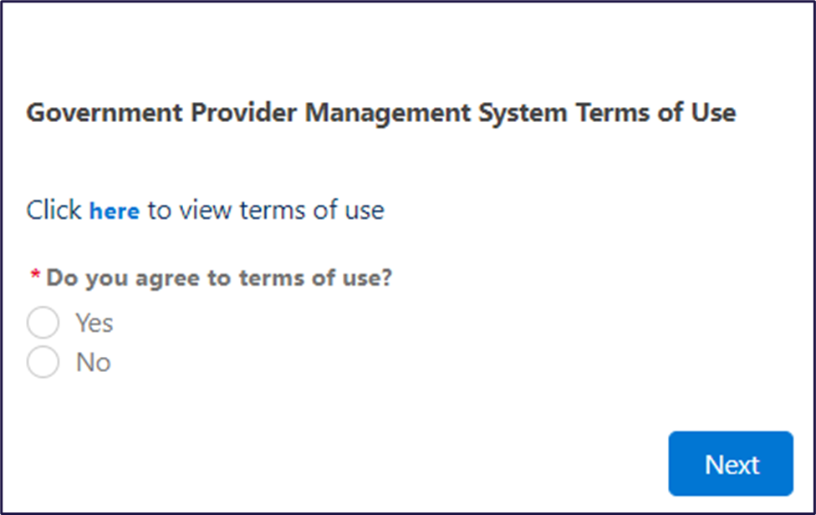

Login to the GPMS portal
To log into the GPMS portal please visit Log In Using | Service Provider Portal.
If you require assistance logging into the GPMS portal, please refer to the GPMS Logging in to the Aged Care Systems.
From 3 November 2025 there will be two provider portals when logging in to GPMS. You will see options to report via the GPMS Approved Provider Portal and the GPMS Registered Provider Portal. Access the GPMS Approved Provider Portal for reporting and amending Quarter 1 2025-26 (July to September) QI Program reporting. Additionally, if any approved providers are operational in October 2025 but ceasing operation prior to 1 November 2025, they must use the Approved Provider Portal to report and amend Quarter 2 2025-26 (1-31 October 2025) QI Program reporting.
The GPMS Registered Provider Portal will be available from 3 November 2025 to commence reporting and amending QI Program data for Quarter 2 2025-26 (October to December) onwards.
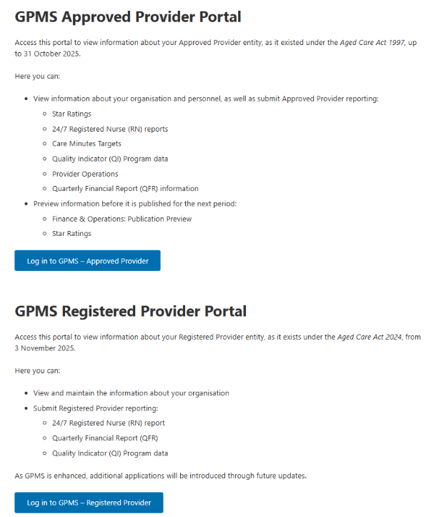

Further information and support
To view additional QI Program resources, please visit the QI Program website.
For more information on GPMS please refer to the Government Provider Management System webpage.
If you require further assistance to login to GPMS please contact the My Aged Care service provider and assessor helpline on 1800 836 799, Monday to Friday (8am to 8pm) and Saturday (10am to 2pm) local time across Australia.
For translating and interpreting services, call 131 450 and ask for My Aged Care service provider and assessor helpline on 1800 836 799.
To use the National Relay Service, visit About the National Relay Service (NRS) | Access Hub or call 1800 555 660.
To access sign language interpreting and captioning services through Deaf Connect, call 1300 773 803 or email interpreting@deafconnect.org.au.

Accessing GPMS and the Quality Indicator Application
To log into the GPMS portal please visit Log In Using | Service Provider Portal. When you log into GPMS, you will be taken to the home page.
You will only be able to see the tiles that you, as an assigned user, have access to.
Select the Quality Indicators tile by selecting the arrow in the top right-hand corner of the tile.
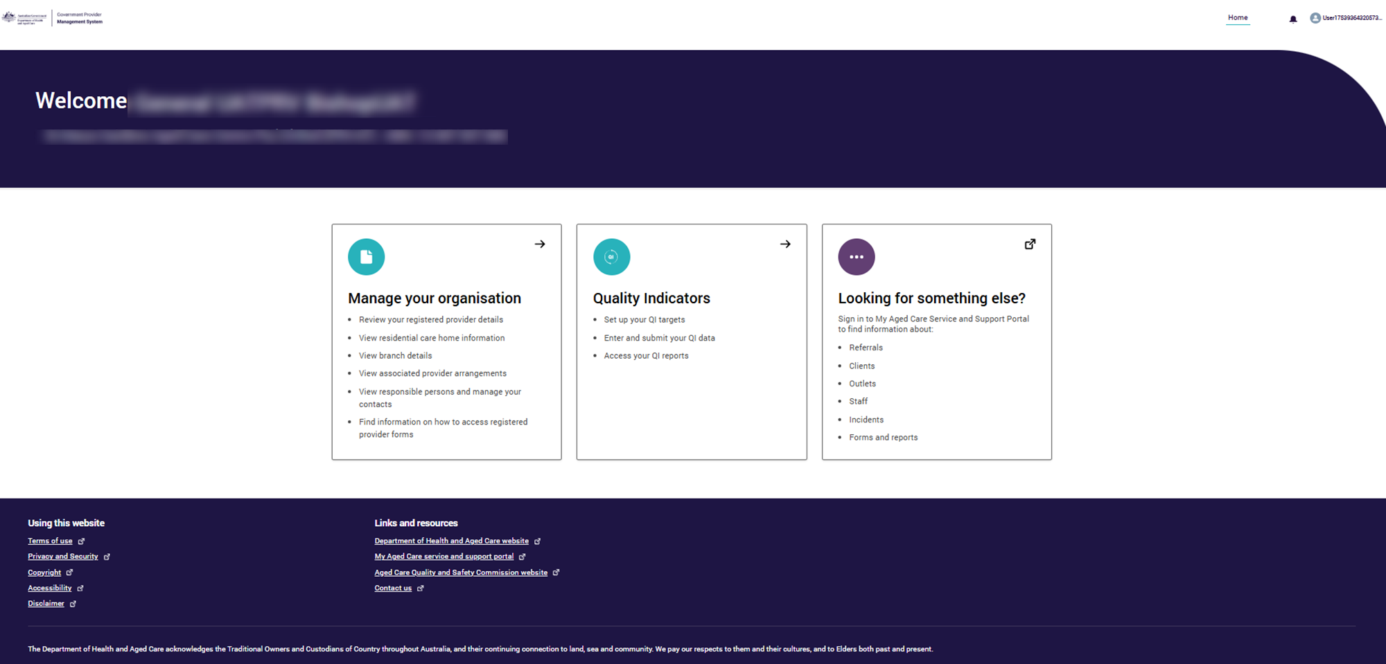

Please note:

If you cannot see the Quality Indicators tile, please speak to your Organisation Administrator to get access.

Quality Indicator Data Entry & Submission home page
When you select the Quality Indicators tile, you will be taken to the Quality Indicator Data Entry & Submission home page.
On this page you will see a number of tabs and buttons, including the:
- Report due dates tab
- Supporting Material tab
- Search and display filters
- Start, Continue, Amend and View buttons
- View Upload History buttons
- Upload File button
- Submission status notifications
Each of these sections, and the corresponding functions are described below.

Report due dates tab
Select the Report due dates tab to see a list of the reporting due dates for the QI Program across the current financial year.

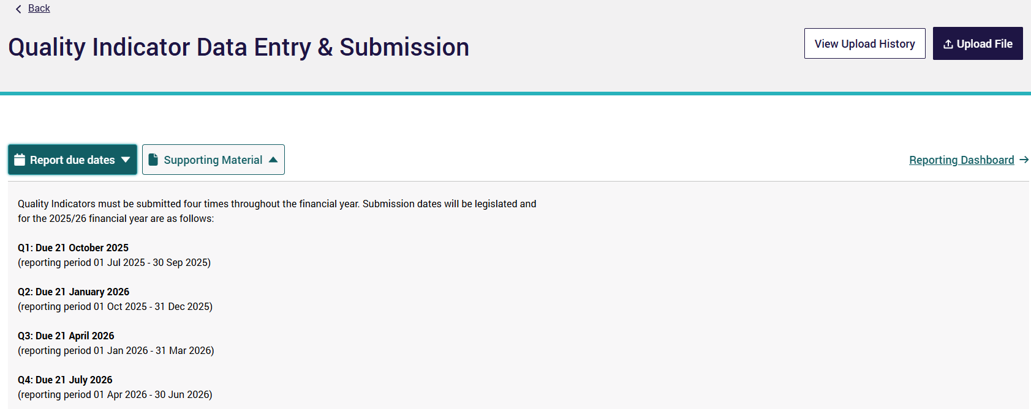

Supporting Material tab
Select the Supporting Material tab to access various resources to help you collect and report quality indicator data.
Resources include:
- National Aged Care Quality Indicator Program Manual - Part A.
- National Aged Care Quality Indicator Program Manual - Part B.
- National Aged Care Quality Indicator Program FAQs.
- QI Program Quick Reference Guides.
- QI Program Interactive Modules.
- GPMS User Guide: Quality Indicators Application.

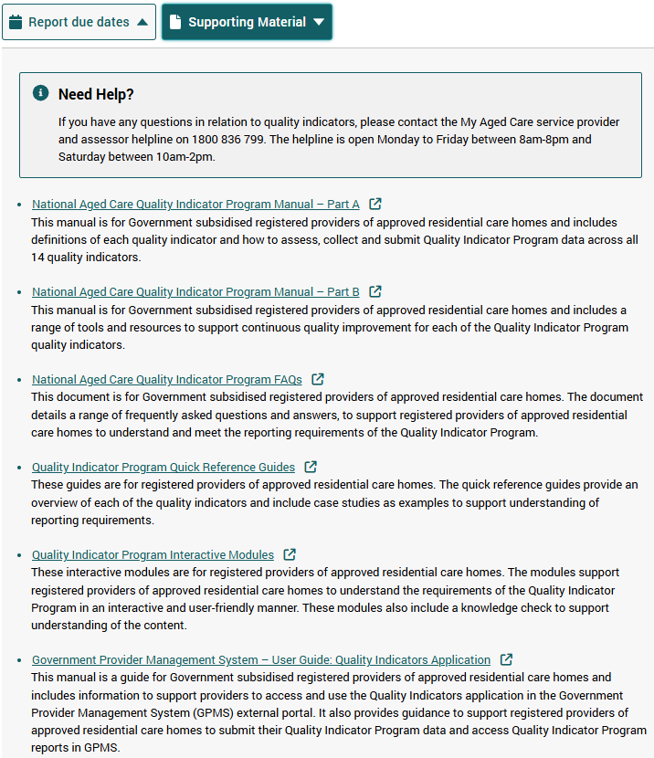

Search and display filters
To find an approved residential care home (aged care home), enter the aged care home name or ID in the Search by service ID or Service name field.
You can also search by Period Ending and Status of your quality indicator data submission (Status) by selecting from the drop down menus and clicking Apply Filters.
For more details of the ‘Status’ of an aged care home, refer to Submission status.
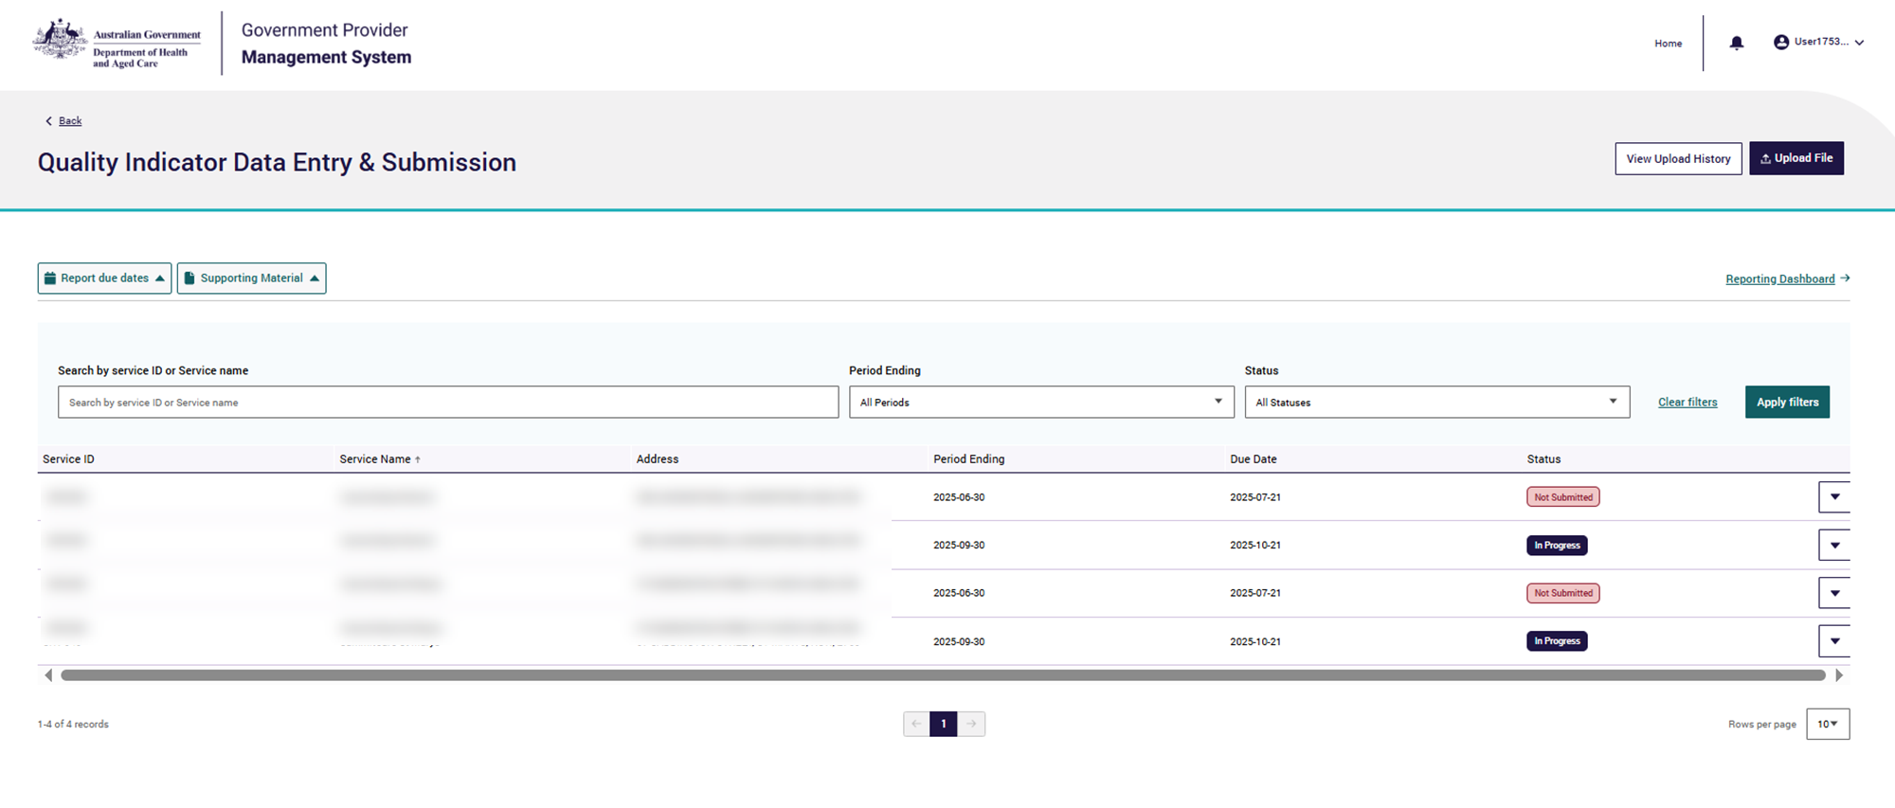

Starting a quality indicator data submission
From the Quality Indicator Data Entry & Submission page a quality indicator data submission can be started or updated using the:
- Manual data entry function (see Manual data entry submission page) by selecting the drop down function on the far right to:
  - Start to start a new submission,
  - Continue to continue a submission in progress,
  - Amend to make changes to a previous submission, or
  - View to see a read only version of a previous submission.
- File upload function (see File upload/bulk data entry submission page) by selecting the Upload File button.

Please note:

‘Start’ and ‘Continue’ will only be available prior to the submission due date for the reporting period.
‘Amend’ and ‘View’ will only be available after the submission due date for the reporting period.

Submission status
The Quality Indicator Data Entry & Submission page provides information on the status of your quality indicator submissions.

Submission statuses are explained in the table below.

Status | Definition
Not Started | No quality indicator data has been entered or saved for the reporting period.
In Progress | Quality indicator data has been entered and has not been submitted for the reporting period.
Submitted | Quality indicator data has been submitted for the reporting period.
Submitted (Updated) | Quality indicator data has been submitted on time and updates have made after the submission due date for the reporting period.
Not Submitted | Quality indicator data has not been submitted, and the reporting period due date has passed.
Late Submission | Quality indicator data was submitted after the reporting period due date.  Note: Amendments to a late submission will remain as a late submission following the update.
Offline | Aged care home has been offline for the whole reporting period and is not required to submit quality indicator data as they are not providing care.

You can Start or Continue quality indicator data submissions for the current reporting period, as detailed in the screenshot below.
The data for the previous reporting period can be amended.
View only access is available for quality indicator data recorded in earlier reporting periods.

Please note:

The data for the enrolled nursing, lifestyle officer and allied health care minutes data points will be pulled from the Quarterly Financial Report (QFR) and does not need to be submitted through the QI Program application.
As QFR reporting due dates are a few weeks after QI Program due dates, you will not see your enrolled nursing, lifestyle officer and allied health care minutes data until you have submitted your QFR.

Manual data entry submission page
This section in the user guide provides introductory information on manually entering quality indicator data in GPMS.
Quality indicator data should be collected and reported consistently using the methods prescribed in the QI Program Manual – Part A.
The below screenshot shows an example of the manual data entry submission page.
Additional resources to support data collection and reporting can be found in the Supporting Material tab on the Quality Indicator Data Entry & Submission home page.
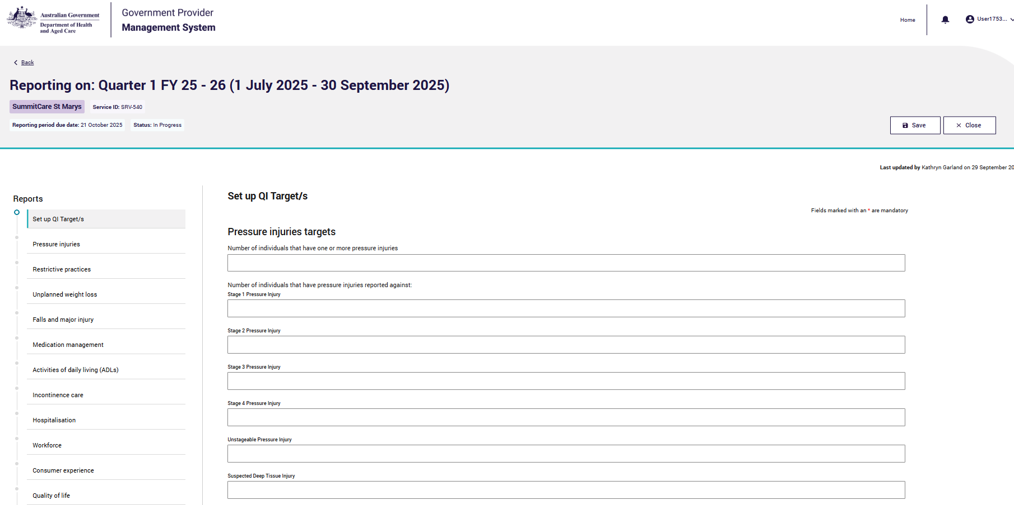
If you need to access the Supporting Material while completing the forms, be sure to first save your data (accessing the Supporting Material will take you outside the data entry form).

Banner
This banner appears at the top of every page on each data entry form.
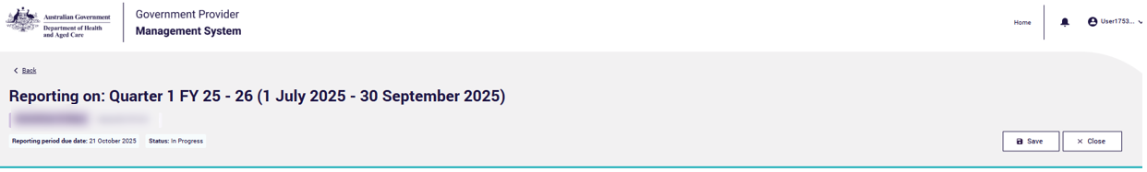

It indicates the name of the aged care home (top left), Service ID, Reporting period due date and the Status of the form (such as In Progress).
At the top right of the banner you can save your data entry by selecting the Save
button.

Data entry stepper
On the left-hand side of Data Entry Submission page, is a stepper for the data entry form for each quality indicator, including:
- Set up QI Target/s
- Pressure injuries
- Restrictive practices
- Unplanned weight loss
- Falls and major injury
- Medication management
- Activities of daily living (ADLs)
- Incontinence care
- Hospitalisation
- Workforce
- Consumer experience
- Quality of life
- Allied health
- Submission
The data entry stepper is a useful navigation tool and will highlight whether the data entry forms have been completed correctly for each quality indicator.
The screenshot of the data entry stepper is shown on the following page:

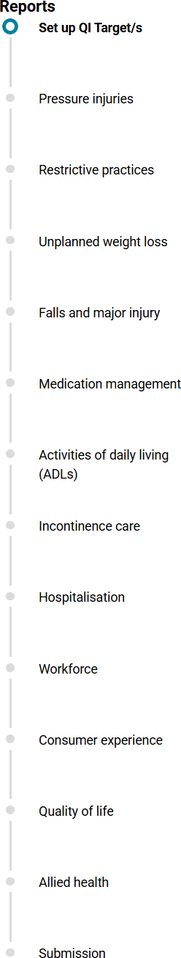
You can move between sections in the stepper in any order, but you will not be able to access the Submit button in the Submission section until data for all quality indicators is entered.
Within the data entry stepper, there are a number of icons, as explained below:

Icon | Name and Meaning
 | Green circle with white tick confirms the section is complete.
 | Blue circle with white center shows that you are currently in this section.
 | Grey circle shows the section has not yet been started.
 | Red circle warns the section is incomplete and contains quality indicator data errors (this means data submission cannot proceed).
 | Yellow warning symbol shows quality indicator data may contain errors and review is suggested (however, data submission can still proceed).
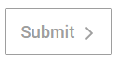 | If any Sections are incomplete the Submit button will not be accessible.
Once all required data forms are complete the Submit button will activate on the Submission step.

Previous button
The Previous button will take you to the previous quality indicator data entry form as noted in the data entry stepper.
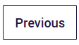

Check Complete Data button
The Check Complete Data button applies the validations built into each data entry form against your quality indicator data.
This will notify you of any quality indicator data that may have been entered incorrectly within each form (see Manual entry of quality indicator data and Error messages whilst entering quality indicator data).
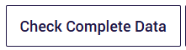

Next button
The Next button will take you to the quality indicator data entry form as noted in the data entry stepper.
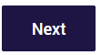
  - Setting quality indicator targets
After selecting the Start button in the Quality Indicator Data Entry & Submission home page, the Set up QI Target/s page will appear, where you can enter aspirational targets for an aged care home.

Set up targets by entering data against each quality indicator in the form and selecting Save. Setting targets is optional.
If you previously entered quality indicator targets these will be displayed. Select Next to go to the first quality indicator data recording form. Alternatively,
navigate to the relevant data form by selecting the quality indicator from the data entry stepper on the left-hand side.

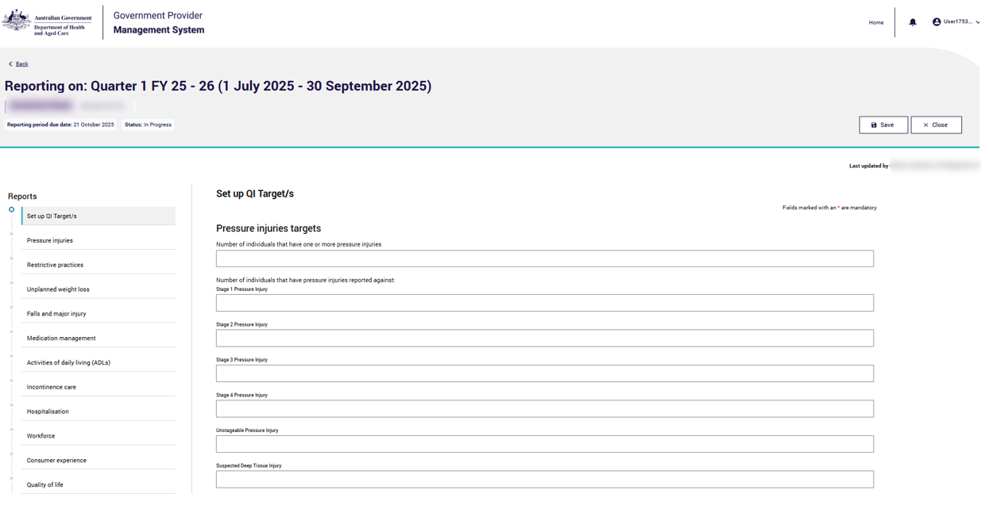
  - Manual entry of quality indicator data
An example screenshot of entering quality indicator data is after these instructions:
- Select the quality indicator you wish to enter data for in the data entry stepper.

- Enter the relevant quality indicator data into the fields within the form. All fields marked with an asterix must be completed.
- Once data is entered for the given quality indicator, you can select Next to move onto the subsequent quality indicator form to continue entering data for your submission.
The data entry stepper will show your location and progress within the submission with colour coded notifications (see the Data entry stepper section).
- Select Save to save your data after entering data in each page.

Please note:

If you need to exit the data forms or access the Supporting Material at any stage, be sure to first save your data by selecting the Save button, as these resources will take you outside of the data entry form.

  - Error messages whilst entering quality indicator data
When entering quality indicator data, if required fields are not completed, error messages will appear.
You may not be able to submit the data without resolving these error messages. Errors will also be highlighted in the Data entry stepper.
Error | Correction | Example
This is required | This is mandatory, please provide an entry.  If the response is zero, please ensure you enter 0. | 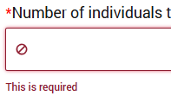
Number cannot be higher than your total number of individuals assessed. | Please ensure the number you have entered is correct.  Data entered for quality indicator reporting must be less than or equal to the number of individuals assessed. | 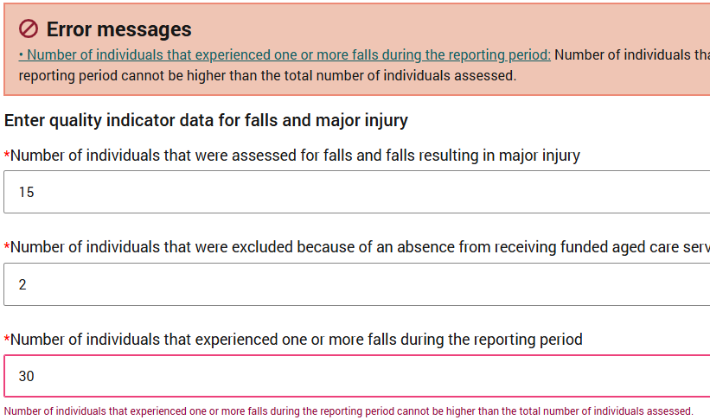
Number of  {quality indicator question A} cannot exceed  {quality indicator question B}. | Please ensure the number you have entered is correct.  Some questions ask for a subset of data from earlier questions. | 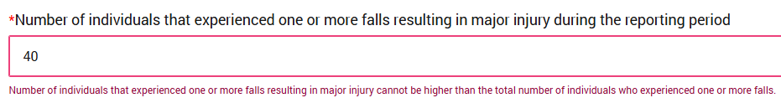
Must be an Integer between 0 –  999 (both inclusive) | Please ensure the number you have entered is correct.  The number must be a whole number (integer) between 0 and 999. | 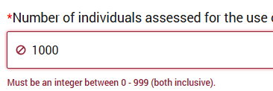
Date falls outside of reporting period. | Please ensure the date you have entered is correct.  The collection date must fall inside of the reporting period being reported on. | 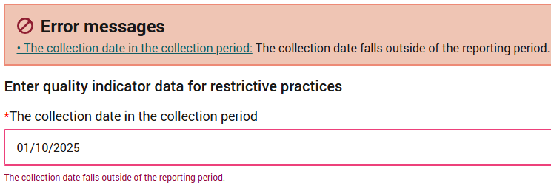
Text value cannot exceed 1000 characters | Please ensure the comments made are fewer than 1000 characters and do not contain personal information about any individuals, as defined by the Privacy Act 1988. | 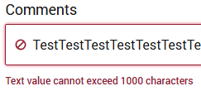

  - Data entry ready for submission
By selecting Check Complete Data, the entered data will be checked against the in- built validations in each quality indicator data entry form.
(See image in Post Submission).
The screen below shows data for all quality indicators is entered correctly and ready for submission.
In the left-hand data entry stepper, this is represented by green circle icons with ticks next to each quality indicator.
You can continue to the Submission page by selecting the relevant button in the data entry stepper or by clicking the Next button at the bottom of the quality indicator data entry form.

Please note:

Red circles in the stepper will prevent you from submitting the quality indicator data. Review and update the relevant data before continuing to Submission.

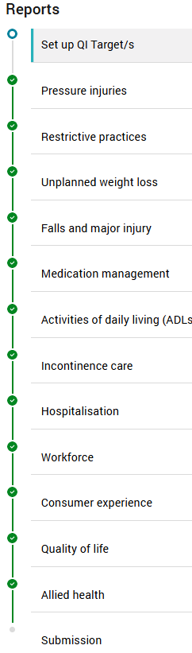
  - Submission
This page is where you submit the quality indicator data.
- Read the Submission Declaration Statement.
- Select Submit to formally submit your quality indicator data.
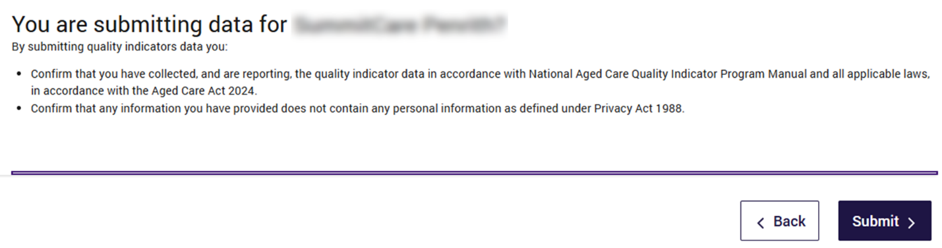
  - Post submission
You will be redirected to your Quality Indicator Data Entry & Submission page with a message displayed on your screen to let you know that your quality indicator data entry has been successfully submitted. The submission status will then update to reflect a green Submitted button.


File upload/bulk data entry submission page
This section in the user guide provides introductory information on entering quality indicator data for multiple aged care homes using the file upload function in GPMS.
Quality indicator data should be collected and reported consistently using the methods prescribed in the QI Program Manual – Part A.
Additional resources to support data collection and reporting can be found in the Supporting Material tab on the Quality Indicator Data Entry & Submission home page.

Downloading and completing the file upload template
- To begin, click the Upload File button on the top-right of the screen to go to the Quality Indicator File Upload page.
- Select the reporting period being reported against.
- Select Download the QI Program file upload template.
- Fill out the QI Program file upload template with quality indicator data for the relevant aged care homes for the given reporting period.
To ensure successful submission of your quality indicator data please ensure:
  - you are using the most up to date file upload template
  - the template is saved as a Microsoft Excel file (xlsx)
  - all required data fields are completed.
The formula for dates does not allow leading zeros for the day of the month. For example, for 1 January 2023, you must reflect the date as 1/01/2023 and not 01/01/2023.
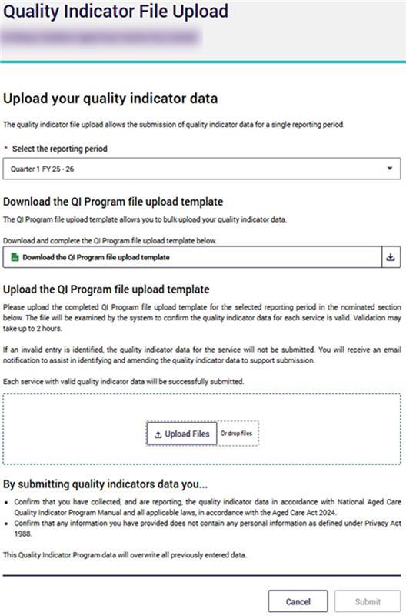

Submitting the file upload template
Progress through the fields on the page by following these steps:
- Select the reporting period using the dropdown option - only current and previous reporting periods are available.
- Upload the file by pressing Upload File and selecting the relevant file, or by dragging and dropping the file into the box (example pictured below).
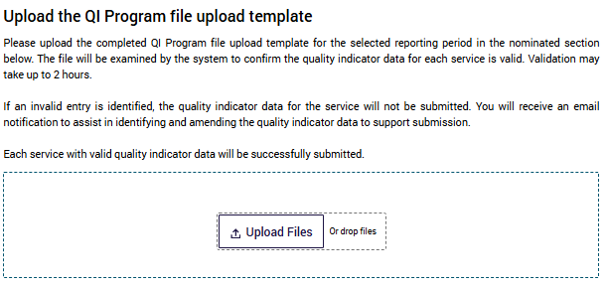
- Read the Submission Declaration Statement.
- Submit the file by selecting the Submit button.

Please note:

The Submit button at the bottom of the page will be locked until the file is uploaded.

File upload post-submission page
After selecting submit, the post submission page will appear, showing the status of the upload. File upload statuses are displayed below and defined accordingly:
- Submitted (‘Submitted’ in green text) = Successful (no error file)
- Pending (‘Pending’ in teal text) = Waiting for processing (no error file)
- Failed (‘Failed’ in red text) = Not Uploaded (no error file), OR all rows have errors (error file)
- Partial (‘Partial’ in black text) = Some successful and some failed (error file)

File upload success message
When the file upload status is Submitted, the Success banner will appear.
This signals that the uploaded file was successfully submitted, and no further action is needed.
You can return to the home page via the Back to main page button in the bottom right corner.
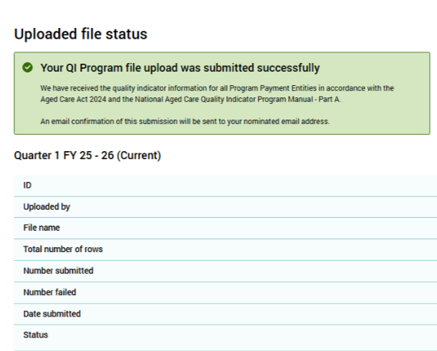

File upload pending message
When the file upload status is Pending, the banner will be titled Pending, meaning that the file is still undergoing validation.
Pending files can take up to two hours to be validated.
Whilst this is occurring, the Re-upload button in the bottom right is locked until the file validation is complete.
Once the file validation is complete, the pending status will update to Submitted, Failed or Partial.

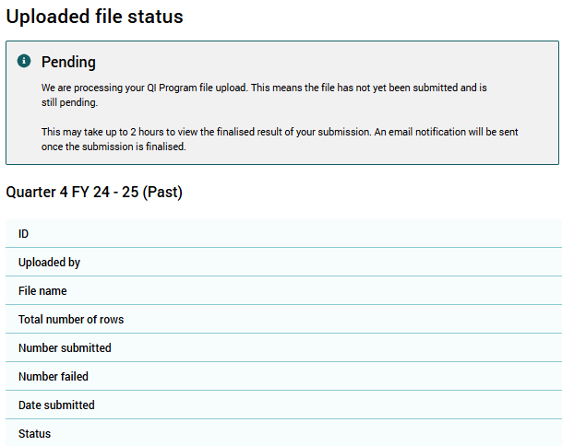

Failed upload error message
When the file upload status is Failed, the banner will be titled Error, meaning there was an error whilst processing the file and the submission is unsuccessful.
There are two scenarios where this is possible:

Scenario 1 - No error file produced
This could be because of a processing fail, system outage, file corruption or having a pending status greater than 24 hours.
No error file is produced, but the Re-upload button unlocks and is activated.
Go to the re-uploading file template section for detailed instructions on re-uploading your file.

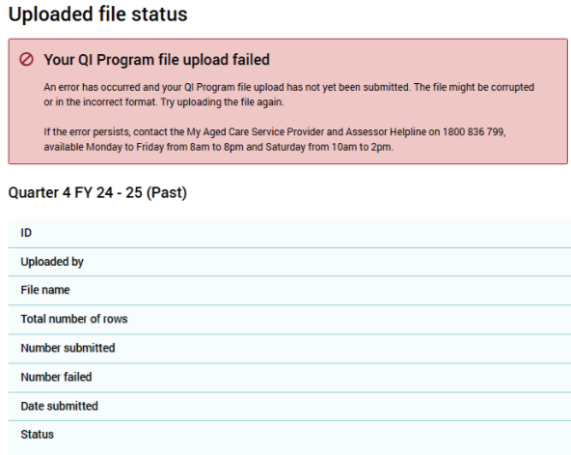

Scenario 2 - Error file produced
This will be because all the service lines within the file have errors. This will produce an error file, which is found next to the Failed status. The Re-upload button unlocks and is activated.
For further instructions, refer to the links for Error files and Re-uploading file template.

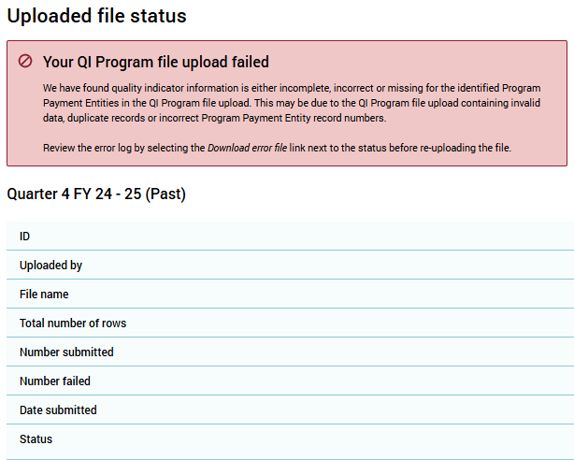

File upload partial success message
When the file upload status is Partial, the banner will be titled Partial Success, meaning there were some errors found within the file upload.
This will produce an error file, which is found next to the Partial status. The Re-upload button unlocks and becomes selectable.
For further instructions, refer to the links for Error files and Re-uploading file template.

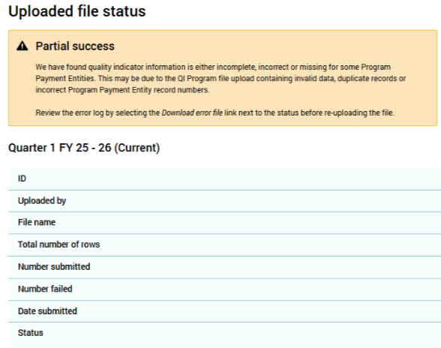

Error files
- After selecting the error file for a Failed (Error file produced) or Partial submission, click Download error file.

- This will open another tab, with the header allowing you to Download.
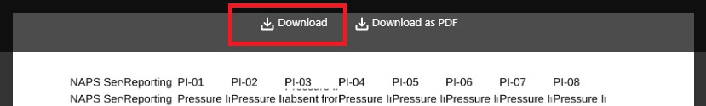

Please note:

Select Download to access an easy to review Microsoft Excel spreadsheet.

- The error column will display all the errors and their specific location in the last/far right column of the Microsoft Excel spreadsheet.
The errors could include:
  - invalid data,
  - service not found
  - record duplication (partially)
  - ‘user not authorized’ to submit data for this service.
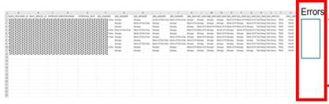
- Correct the errors. Once completed, save the file locally and re-upload.

Re-uploading file template
After amending the quality indicator data errors found in the file upload, select the Re-upload button on the relevant status screen. Progress through the Submission page by following these steps:
- Select the relevant reporting period from the dropdown, this should be preselected.
- Upload the updated file by pressing Upload File and select the relevant file, or by dragging and dropping the file into the box, as pictured below.
- Read the Submission Declaration Statement.
- Submit the file by pressing the Submit button.

Please note:

The Submit button at the bottom of the screen will be locked until the file is uploaded successfully.

For more information for the messages following the re-upload, please see File upload post-submission page and following sections.

Viewing upload history
On the Quality Indicator Data Entry & Submission page select the View Upload History button to see all the earlier files uploaded.
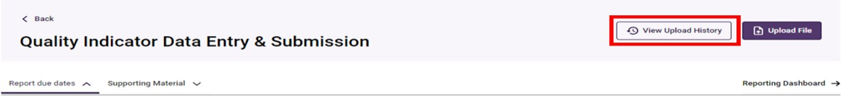

File upload history page
All files uploaded will be displayed on this page. Within this page, you can find a specific upload searching by upload ID or file name, Reporting period or Status by selecting the fields and clicking Apply filters.
The various statuses of file uploads below include:
- Submitted (‘Submitted’ in green text) = The file upload was successfully submitted
- Failed (‘Failed’ in red text) = The file upload was not uploaded correctly or has errors in every row
- Pending (‘Pending’ in teal text) = The file upload is being processed
- Partial (‘Partial’ in black text) = The file upload had some successful and some failed rows
For further information, refer to Error files.
Information on the status of the file upload is shown in the Total, Submitted and
Failed fields in the screenshot below.
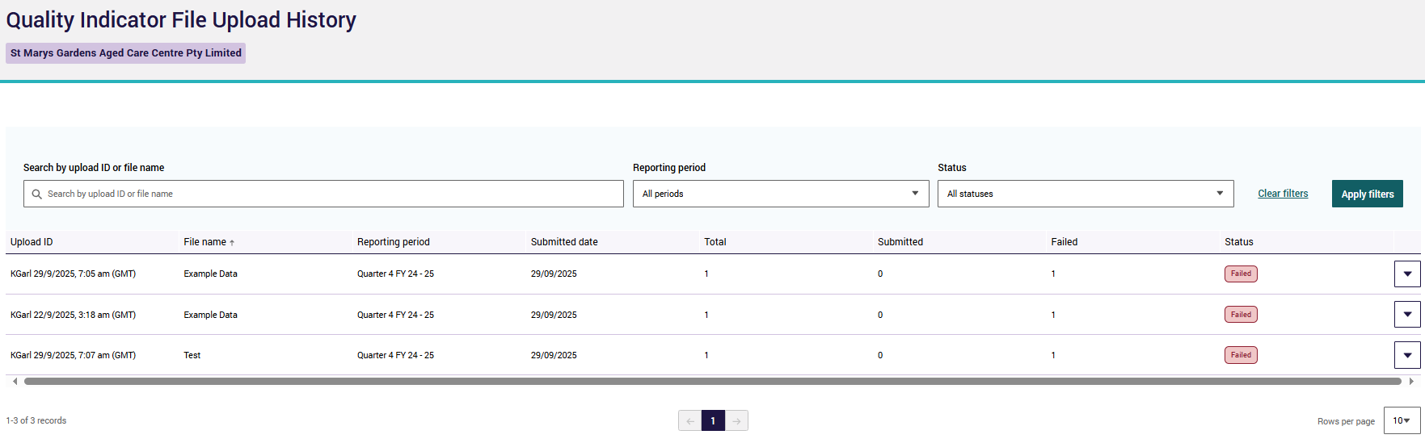


Reporting Dashboard
This section provides information on the Quality Indicator Reporting Dashboard and associated reporting capabilities.
These functions are available to registered providers of approved residential care homes with access to the Quality Indicators Application. These functions are not available for organisations submitting quality indicator reporting on behalf of providers.
The included screenshots support navigating the functionality of the GPMS Registered Provider Portal for QI Program reporting for Quarter 2 2025-26 and onwards. Dashboards for QI Program reporting for Quarter 1 2025-26 and prior will continue to be accessible via the GPMS Approved Provider Portal. This will continue to be the process to navigate across the two Portals where appropriate, until the GPMS Registered Provider Portal fully transitions to the new entity structure under the Aged Care Act 2024.

Accessing the Quality Indicator Reporting Dashboard
- On the Quality Indicator Data Entry & Submission page, select the Reporting Dashboard button in the top-right hand section.
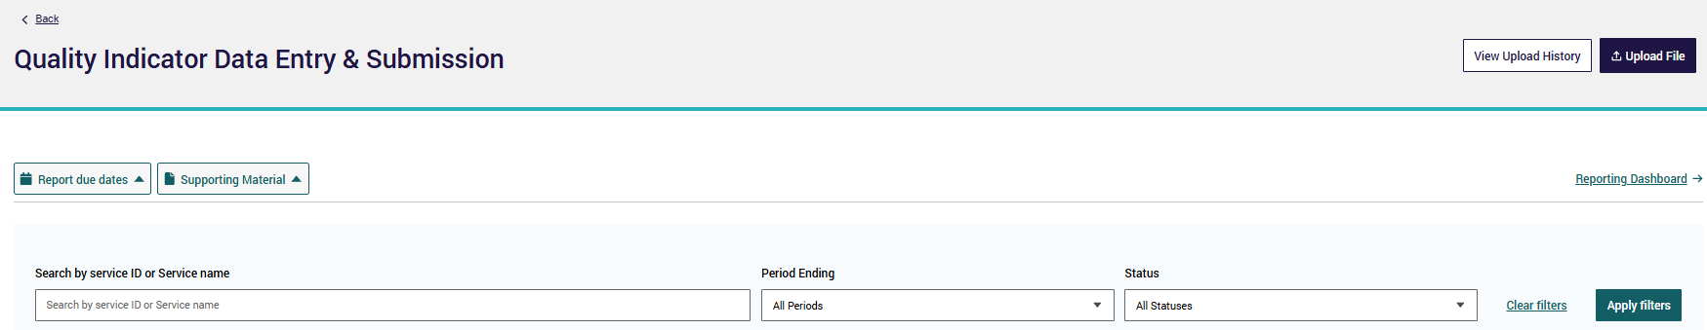

- A new tab will open in Analytics Studio with the Quality Indicator Reporting Dashboard page.
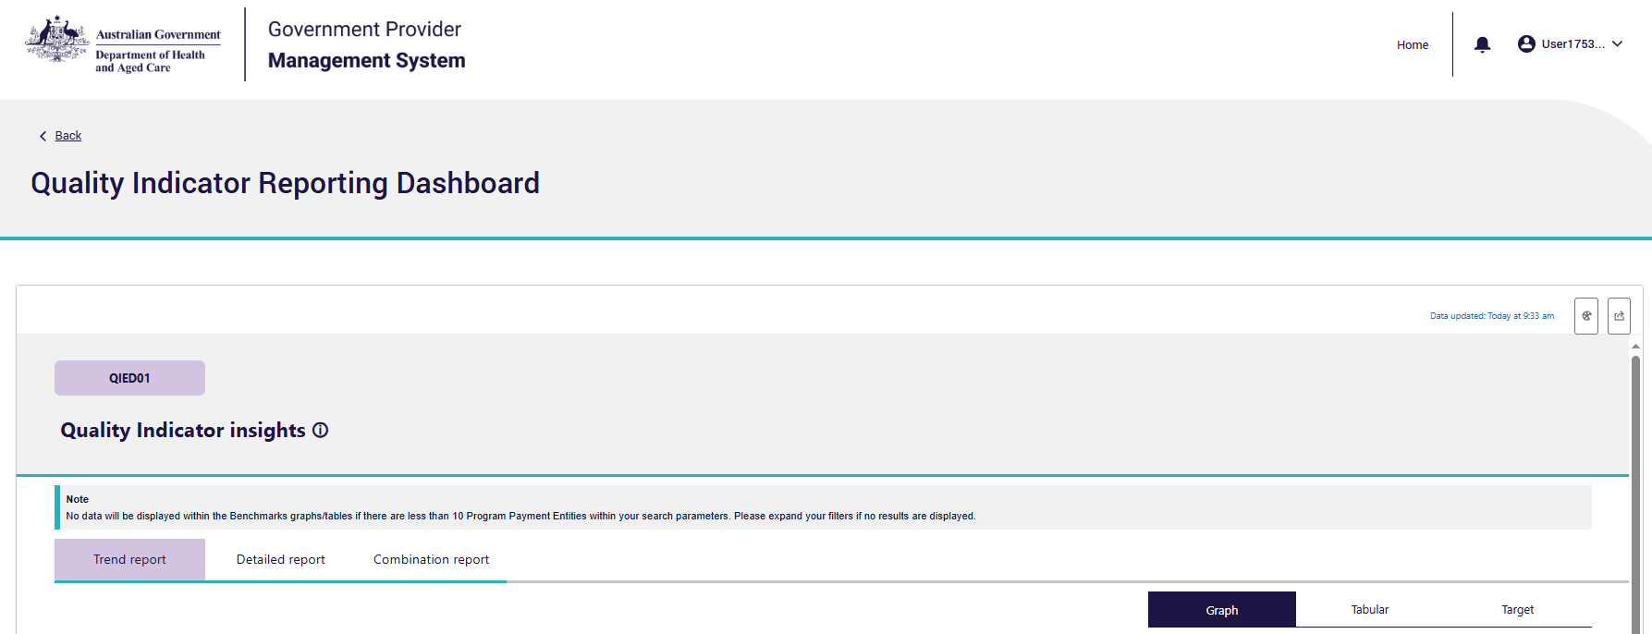

Overview of report types and display formats
The Quality Indicator Reporting Dashboard allows you to create three key reports (Trend, Detailed and Combination) with three key report displays (Graph, Tabular and Target).

Key reports
- Trend Report: Displays data trends and patterns over time to provide high level insights into quality indicator data.
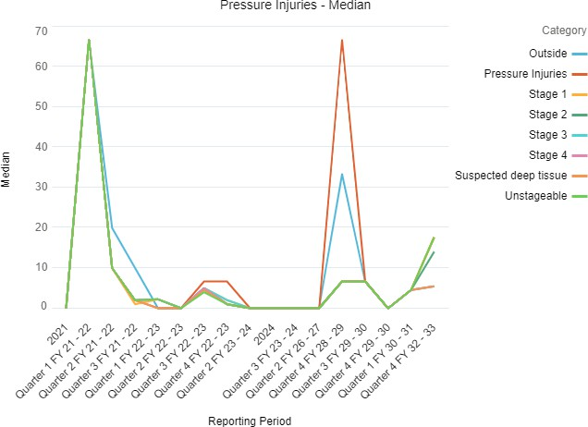

- Detailed Report: Displays an in-depth view of quality indicator data from a service, focusing on individual outcomes rather than progress over time.
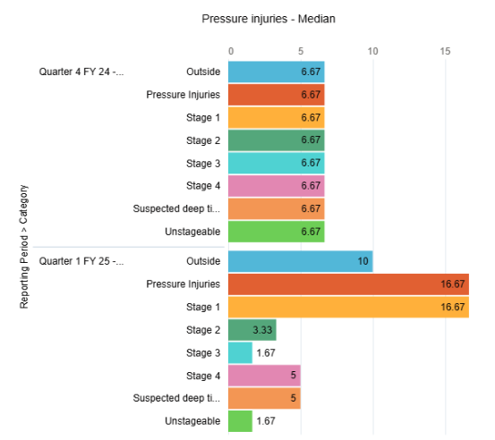

- Combination Report: Displays trends and an in-depth view of quality indicator data, merging the two previous report formats to provide a comprehensive view of different data in a unified format.
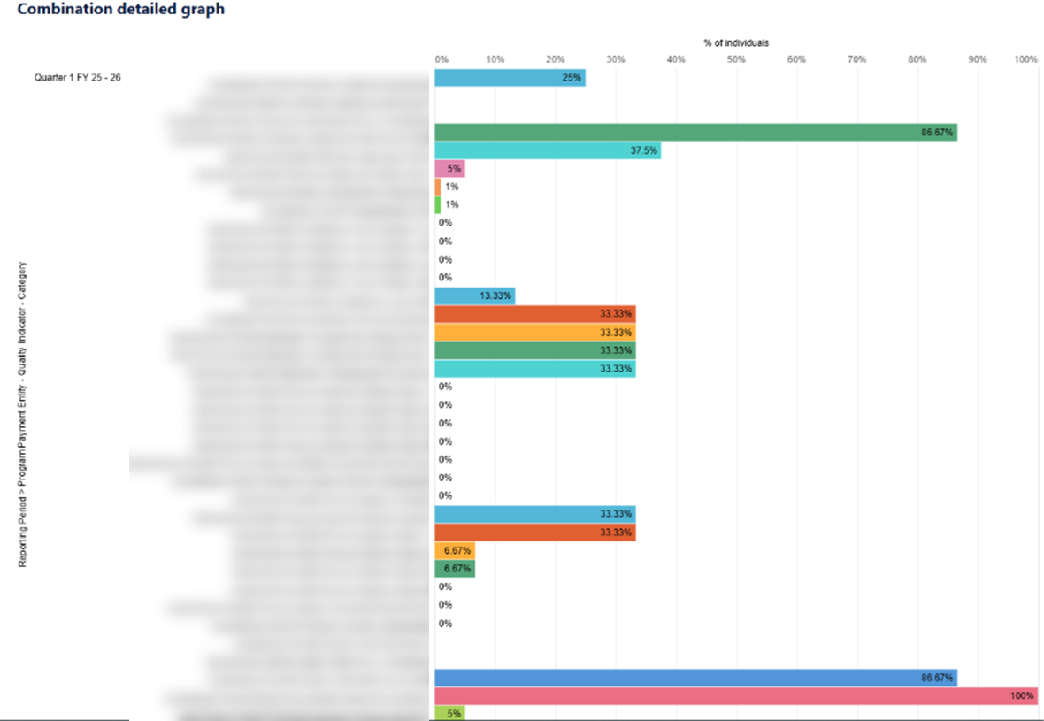
This report will not have benchmark options.

Key displays
- Graph: Displays quality indicator data for an aged care home in a line (displayed below) and bar chart format. The Graph view provides visual representation of your data to support easier analysis and interpretation, enables you to identify patterns, spot anomalies, and understand the overall trajectory of data.

- Tabular: Displays quality indicator data for an aged care home in a table.
The Tabular view provides a comprehensive and structured representation of data, organised tabular format, making it easier for you to export your data.
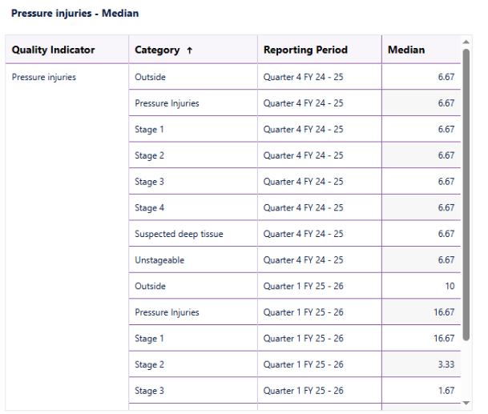

- Target: Displays quality indicator data against the targets set by the aged care home in a graphical format.
The Target view is designed to help you understand and evaluate your quality indicator data against your aged care home targets (see Setting quality indicator targets).
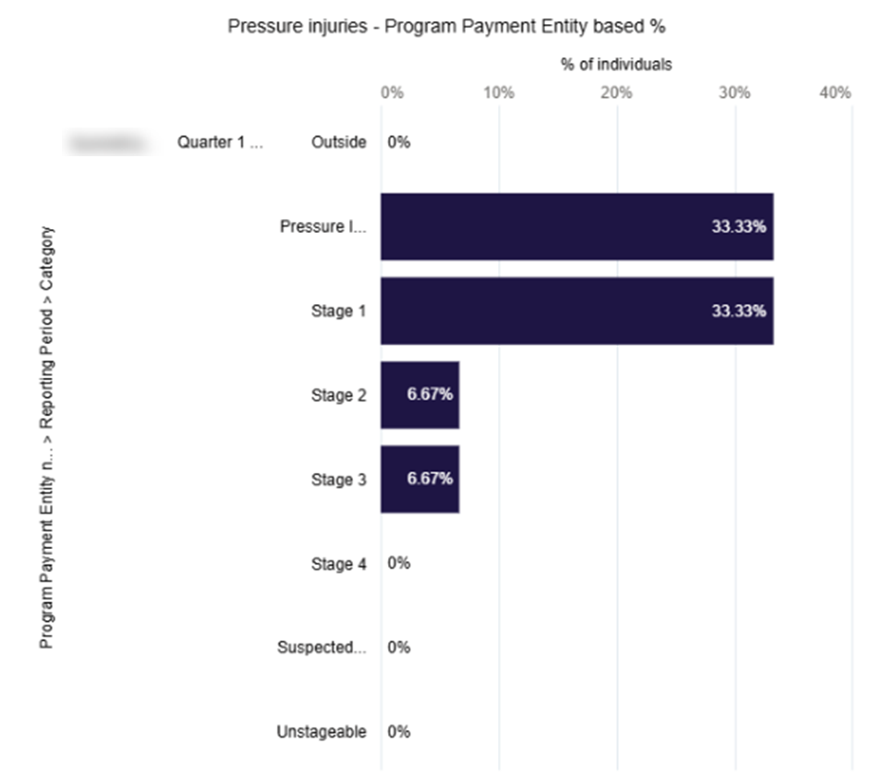

Please note:

In the QI Reporting Dashboard, scroll down to view data for all quality indicators in your selected format and display.

Functionality of the Quality Indicator Reporting Dashboard
You can download and share reports from the Quality Indicator Reporting Dashboard.
An explanation of the icons available are below.

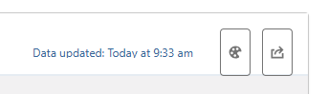


High Contrast
The colour palette icon is the high contrast button which is an accessibility feature allowing users of all abilities to view the dashboard more effectively.

Please note:

To support accessibility, adjust the colour palate of your reports using the High Contrast icon.

 Share
The share button allows you to download and share the reports you are viewing. This can be used for the entire dashboard report or for singular reports.
The entire dashboard report can be downloaded to view and share as an image. This image reflects the dashboard wide view found on the home screen of the Quality Indicators Reporting Dashboard.

Sharing the entire dashboard report
- Select the Share button in the top right hand corner (shown above).
- A pop-up will appear displaying an image preview of the report.
- Select download button in the top left corner.
- Select download as image to view the .PNG file to save locally.

Sharing a singular report graph or table
- Hover your mouse over the graph you want to export.
- Click on the small arrow that appears on the right-hand side of the graph.
- Select the Share button.
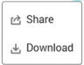
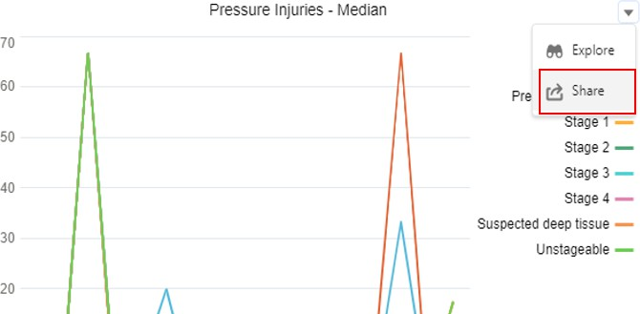
- Select your preferred file type. A preview of the file will appear and will be automatically downloaded on your local device.
The available file types are:
  - .PNG – Download as Image
  - .XLSX – Download in Excel Format
  - .XML – Download in Excel Format with Metadata
  - .CSV – Download in CSV Format.
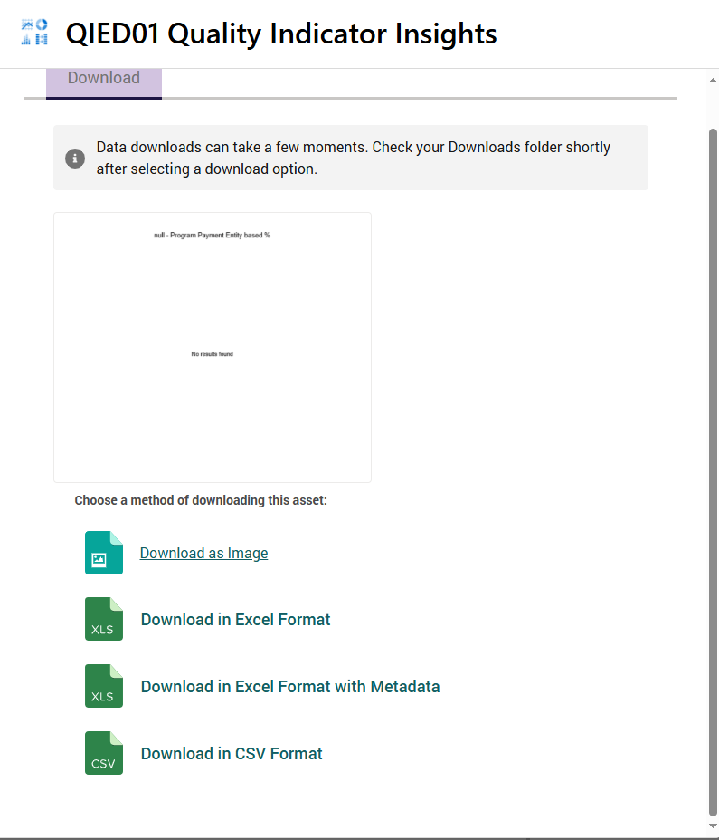

Navigating the Quality Indicator Reporting Dashboard
From the Quality Indicators Reporting Dashboard, select your preferred reporting type and display.
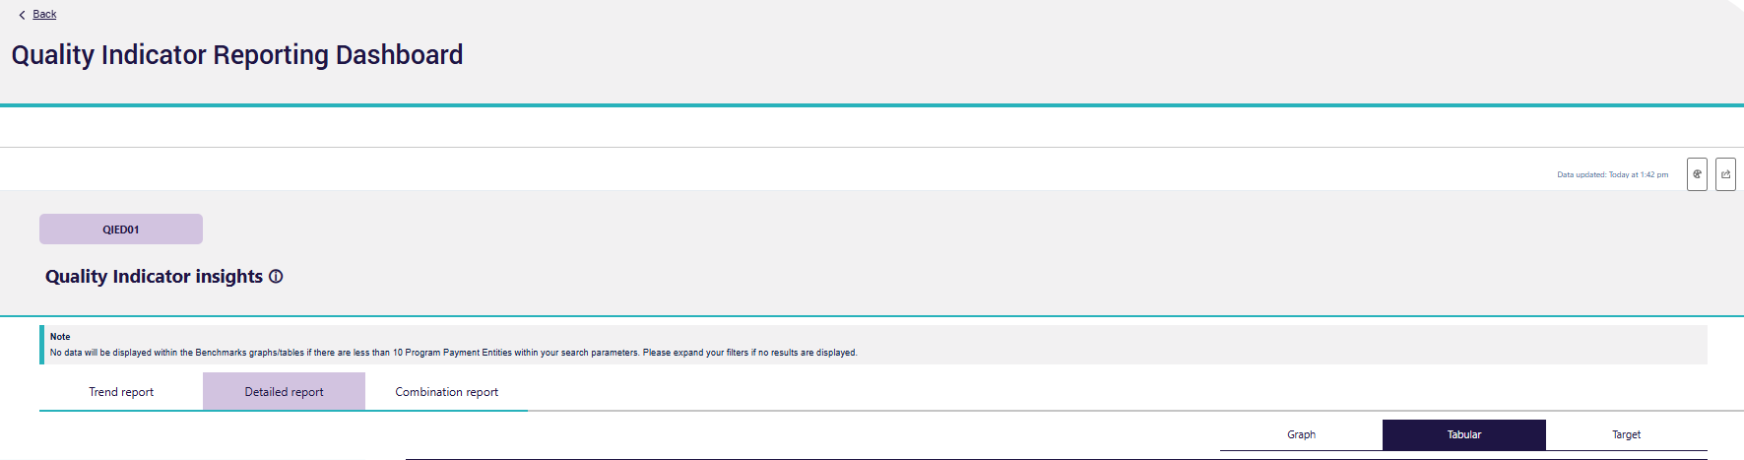
This should automatically generate a report in your selected format and display.

Using Filters
Filters are found on the left-hand side of the Quality Indicator Reporting Dashboard. These will allow you to refine your reports to support further analysis of your quality indicator data.
The Quality Indicator Reporting Dashboard has four types of filters.
- Program Payment Entity filters: Allows you to filter your reports by Program Payment Entity name, Payment ID, RACS ID, State, and Categories of the specific fields within the selected quality indicator.
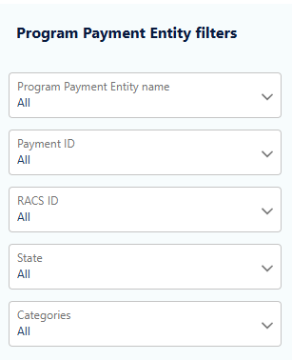

- Reporting Period: Allows you to filter your reports by reporting periods.
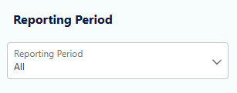
- Compare filters: Allows you to compare your quality indicator data against sector median results. Note: if the filters applied result in a comparison of less than 10 aged care homes, no data will appear.
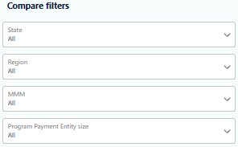

- Benchmarks: Allows you to compare your quality indicator data against aggregated national results.
