# End-of-Life Pathway (from 1 November 2025)

**Fact sheet for doctors and nurse practitioners**

## What is the End-of-Life Pathway?

The End-of-Life Pathway is a short-term pathway under the Support at Home program. It supports participants who have been diagnosed with 3 months or less to live and wish to remain at home, by providing more funding to access in-home aged care services.

On the End-of-Life Pathway, an older person will have access to a budget of $25,000 over 12 weeks. If the older person requires services beyond 12 weeks, an urgent Support Plan Review can be undertaken to transfer the participant to an ongoing Support at Home classification. The End-of-Life Pathway budget can be used up to the 16-week mark to support continuity of care.

## Who is eligible for the End-of-Life Pathway?

An older person is eligible to access the End-of-Life Pathway if they meet the following criteria:

* a doctor or nurse practitioner advises estimated life expectancy of 3 months or less to live; and
* Australian-modified Karnofsky Performance Status (AKPS) score (mobility/frailty indicator) of 40 or less.

Note that participants will also need to meet general entry criteria for accessing funded aged care services, including being aged 65 or over (or age 50 or over for an Aboriginal or Torres Strait Islander person or homeless or at risk of homelessness).

## How do I support my patient to access the End-of-Life Pathway?

You will need to fill in and sign an End-of-Life Pathway form for your patient. The End-of-Life Pathway form captures the medical eligibility for accessing the pathway. This will include details of their prognosis and their Australian-modified Karnofsky Performance Status (AKPS) score.

The End-of-Life Pathway form will be available on the department’s website from the commencement of Support at Home on 1 November 2025. Example screenshots are provided below for reference.

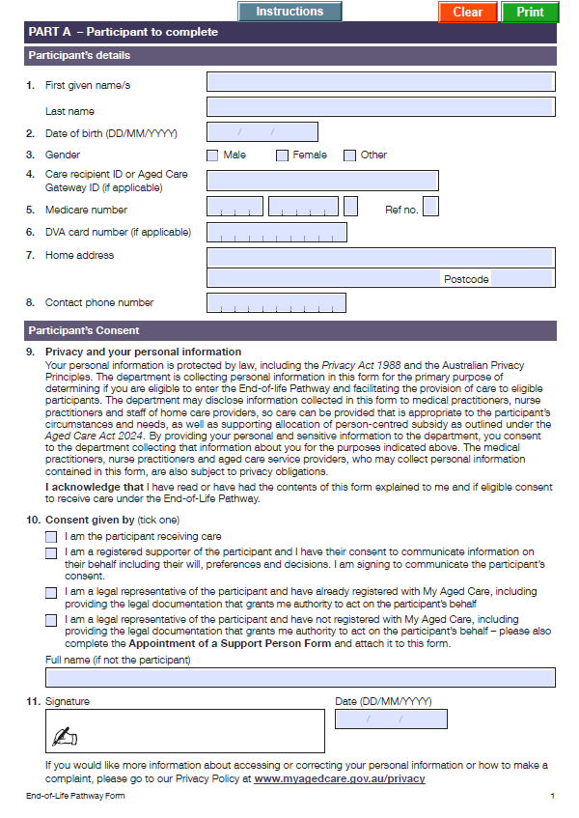

**Part A** (page 1 of the form) is completed by the participant or their registered supporter or legal representative

Participant’s details

Privacy and consent

Signature

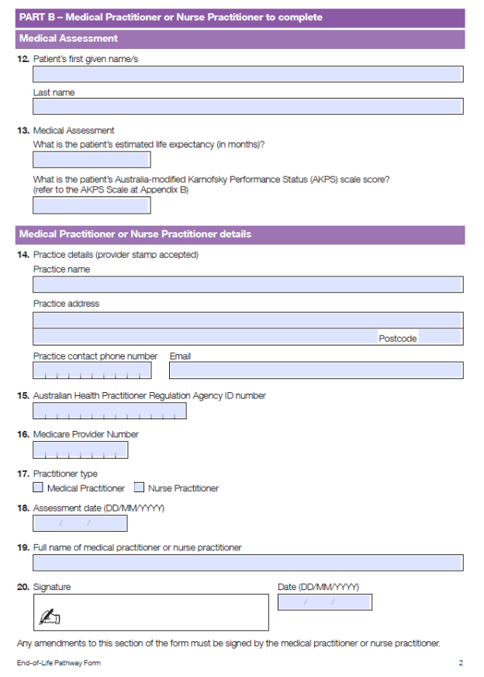

You as the medical practitioner or nurse practitioner complete **Part B** (page 2 of the form)

Patient life expectancy in months

Patient AKPS score

Provider and practice details

Signature

## How do I submit the End-of-Life Pathway form?

If your patient is already receiving in-home aged care services through Support at Home, you can provide a copy of the signed form to your patient’s carer or representative, who can provide it to their aged care provider.

If your patient is not currently receiving in-home aged care services through Support at Home, you can:

* complete and sign a copy of the End-of-Life Pathway form and upload through the ‘Make a Referral’ or ‘GP e-referral’ channels (this triggers a request for an aged care assessment)
* complete and sign a hard copy of the End-of-Life Pathway form and give it to the patient’s carer or representative to submit. They will then need to contact My Aged Care to request an assessment, or they can use the [My Aged Care Apply Online tool](https://www.myagedcare.gov.au/assessment/apply-online).

**If you are unsure whether your patient is currently receiving aged care services, please provide them with a copy of the signed End-of-Life Pathway form and ask them to contact My Aged Care on 1800 200 422 for assistance.**

## What is the Australian-modified Karnofsky Performance Status (AKPS) score?

The AKPS score is a measure of an individual’s overall performance status or ability to perform their daily activities. It is a single score assigned by a clinician based on observations of a patient’s ability to perform common tasks relating to activity, work and self-care. An AKPS score of 100 signifies normal physical abilities with no evidence of disease. Decreasing numbers indicate a reduced ability to perform activities of daily living.

You will need to make an assessment that best represents the current status of your patient, and include this score on the End-of-Life Pathway form.

|  |  |
| --- | --- |
| **AKPS ASSESSMENT CRITERIA** | **SCORE** |
| Normal; no complaints; no evidence of disease | 100 |
| Able to carry on normal activity; minor sign of symptoms of disease | 90 |
| Normal activity with effort; some signs or symptoms of disease | 80 |
| Cares for self; unable to carry on normal activity or to do active work | 70 |
| Able to care for most needs; but requires occasional assistance | 60 |
| Considerable assistance and frequent medical care required | 50 |
| In bed more than 50% of the time *(****note****: can also mean ‘in a chair’)* | 40 |
| Almost completely bedfast | 30 |
| Totally bedfast and requiring extensive nursing care by professionals and/or family | 20 |
| Comatose or barely rousable | 10 |

*Abernethy AP, Currow DC, Shelby-James T, Fazekas BS & Woods D (2005) The Australia modified Karnofsky Performance Status (AKPS) scale: A revised scale for contemporary palliative care clinical practice. BMC Palliative Care, 4 (1)*

## How will I be kept informed?

Support at Home participants are assigned a care partner by their aged care provider. Care partners ensure the mix of services under Support at Home is complementary, coordinated and in the best interests of the older person.

Under the End-of-Life Pathway, care partners must liaise and coordinate with the participant’s doctor, medical team and any state or territory palliative care services.

## What else do I need to do?

The End-of-Life Pathway is designed to complement services received through states and territories, including palliative care services.

If your patient is not currently receiving palliative care supports, learn more about the [referral pathways](https://www.health.gov.au/topics/palliative-care).

Find further information on the [Support at Home program](https://www.health.gov.au/our-work/support-at-home).

## Final checklist

1. Confirm eligibility

Rectangle 1, ShapePatient meets **general entry criteria for accessing funded aged care services** (aged 65 or over, or aged 50 or over for an Aboriginal or Torres Strait Islander person or homeless or at risk of homelessness).

Rectangle 1, ShapeRectangle 1, ShapePatient has a **life expectancy of 3 months or less**, confirmed by a GP, non-GP specialist, or nurse practitioner.

Patient has an **Australian-modified Karnofsky Performance Status (AKPS) score of 40 or less**.

1. Rectangle 1, ShapeComplete the End-of-Life Pathway form

Fill out the **End-of-Life Pathway form** (available from 1 November 2025 on the department’s website).

Rectangle 1, ShapeInclude the **AKPS score** and relevant clinical details.

**Rectangle 1, ShapeSign the form**.

1. Submit the form based on whether the patient is currently received aged care services

Rectangle 1, ShapeAs a minimum for all patients, **provide the completed form to the patient** or their carer/representative, AND/OR

**Rectangle 1, ShapeLodge the completed form** through GP e-referral for patients who are NOT currently receiving aged care services, OR

Rectangle 1, ShapeEncourage patients who ARE currently receiving aged care services to **take the form to their provider**.