Electronic National Residential Medication Charts (eNRMC) – Transition to electronic prescribing and end of Transitional Arrangement

October 2025

The Department of Health, Disability and Ageing and the Australian Digital Health Agency are working with eNRMC software vendors to ensure electronic prescribing enabled eNRMC systems are available by October 2025.

An eNRMC system is a type of electronic medication management system used in residential aged care to electronically prescribe, supply, and track medicine administration. This provides increased flexibility, coordination, and access to real-time medicine information across multiple care settings, reducing the burden on care teams and patient safety risks. We have undertaken work on initial eNRMC trials and implementation across aged care since 2018 with substantial benefits demonstrated.

These systems currently operate under a temporary Transitional Arrangement. This allows the use of these systems without full electronic prescribing capability and connection to the National Prescription Delivery Service (NPDS). Once electronic prescribing capability for eNRMC systems is available, the workflows of prescribers, residential aged care staff and pharmacies will be significantly enhanced and streamlined.

# Benefits of electronic prescribing enabled eNRMC systems

* **Streamlined dispensing workflows for pharmacists** – chart-based electronic prescriptions will be available from the NPDS removing the need for manual transcription.
* **Reduced administrative burden for GPs** – increased chart duration from four to **six months** (previously four months for paper and Transitional eNRMC).
* **Alignment of chart review and renewal with bi-annual care planning sessions**, funded by the [General Practice Aged Care Incentive](https://www.health.gov.au/our-work/gpaci).
* **Flexible chart management options** – Prescribers and RACH staff can better manage chart end dates, reviews and renewals. Charts no longer need to finish at the end of a month (as was the case for paper and Transitional eNRMC).
* **Enhanced medication safety and improved functionality through** updated clinical and system functionality requirements.

# Revised Timeframes

To ensure these benefits are realised as soon as possible, we initially required eNRMC software to achieve electronic prescribing conformance by 30 June 2025 to allow the Transitional Arrangement to end. Engagement with industry in early 2025 highlighted that extra time was required for:

* essential eNRMC system changes
* ensuring aged care services can safely transition to electronic prescribing enabled versions of their eNRMC products.

As a result, we have extended the timeframes for eNRMC systems to achieve electronic prescribing conformance and for aged care services to transition, as outlined in the diagram and Table 1 below.

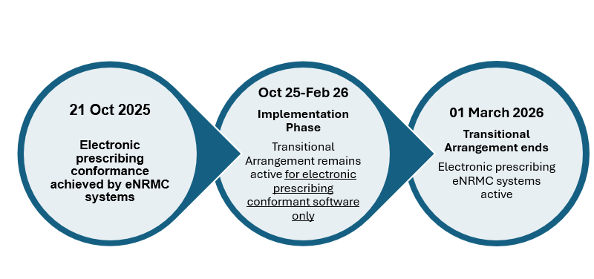

Table 1 eNRMC electronic prescribing conformance revised timeframes

|  |  |
| --- | --- |
| 21 Oct 2025 | eNRMC systems MUST achieve electronic prescribing conformance |
| eNRMC systems must complete electronic prescribing conformance testing and be registered on the Australian Digital Health Agency’s Electronic Prescribing Conformance Register by 21 October 2025**.**  If electronic prescribing Conformance is NOT achieved by this time, the system:   * will be removed from the [eNRMC Transitional Conformance Register](https://www.digitalhealth.gov.au/about-us/policies-privacy-and-reporting/registers) * will no longer be a valid PBS prescribing system * will no longer be considered an eNRMC system (instead known as an Electronic Medication Management system).   **Where an EMM system has been removed from the eNRMC Transitional Conformance Register:**   * Medication charts and orders created up to and including 21 October will continue to be valid PBS medication charts and orders under the Transitional Arrangement until they end. * Any new orders added to an existing chart after 21 October must be supported by a PBS prescription/ paper NRMC. * Any medication chart that starts after 21 October 2025 must be supported by a PBS prescription/ paper NRMC. * Residential Aged Care Homes can continue to use an EMM system for administration purposes. * Pharmacists will need to dispense from separate PBS prescriptions or paper NRMC. * Prescribers must:   + continue to review the resident’s whole EMM system chart when prescribing * use a paper NRMC or create separate PBS prescriptions to support use of the EMM system. | |

|  |  |
| --- | --- |
| 22 Oct 2025 to 28 Feb 2026 | Implementation phase |
| For eNRMC systems which complete electronic prescribing conformance testing and are registered on the Australian Digital Health Agency’s Electronic Prescribing Conformance Register by 21 October 2025:   * Continue operating under the Transitional Arrangement until all residential aged care homes using that system have safely transitioned to the conformant version of the eNRMC. * eNRMC software vendors should support users to transition by 28 February 2026. | |
| 01 Mar 2026 | Completion of electronic prescribing eNRMC systems rollout |
| * Transitional Arrangement ceases for all vendors/eNRMC systems. * New charts should not be created under the Transitional Arrangement after this date. * All Residential Aged Care Homes using an eNRMC should be finished transitioning to the electronic prescribing conformant eNRMC version by 01 March 2026. | |

# Next Steps

**Residential Aged Care Homes** should contact their eNRMC software vendor about their planned:

* timelines for electronic prescribing conformance
* available support and training to safely transition to an electronic prescribing conformant eNRMC.

We will continue to monitor the progress of vendors and aged care homes. We will publish information resources to support prescribers, aged care staff and pharmacists in utilising electronic prescribing enabled eNRMC systems within their work.

# Contact

If you have further questions, please email [enrmc@health.gov.au](mailto:enrmc@health.gov.au?subject=eNRMC%20electronic%20prescribing%20and%20cessation%20of%20transitional%20arrangement).