Discussion cards: What rights-based care looks like
You have a right to discuss your care preferences and share what is important to you in your care.

Understanding your rights in care
The Aged Care Act 2024 (the Act) puts the rights of older people first. The Act includes a Statement of Rights, detailing the rights that you can expect when accessing Australian Government-funded aged care services. The rights help to ensure that you and your preferences are considered in your care.
You have the right to feel safe and respected in your care, no matter your background, culture, or beliefs. The rights include support for your identity, culture, spirituality, and personal needs.
Everyone’s background, identity and life experiences shape who they are, as well as their preferences and needs. Your individual needs and preferences must be recognised and supported as part of safe, person-centred care.
Aged care providers are required by law, to make sure that you feel safe in your environment, supported and included.

Why this document is important
This document is here to help you, your family and carers understand what rights-based care looks like. This document is here to help start conversations with workers or providers about your care and your preferences. It is important to share what is important to you and, if you feel comfortable, to explain why it is important and to ask how your provider will work to understand and meet your individual preferences and needs.

How to use this document
Read through what rights-based care looks like to understand the rights and what they look like day to day. The discussion cards have been developed for in-home care participants and aged care residents. Use the discussion cards to help you to start conversations with workers and providers to share what is important to you in your care.
What rights-based care looks like
- Autonomy and freedom of choice – I have the right to make my own choices, with support if necessary, about my care, relationships, lifestyle, finances and personal possessions, including taking personal risks.
Example: A resident chooses when to eat their meals and is able to make their own cup of tea using a safe tea station, with help available if needed.
Equitable access – I have the right to have my needs assessed in a way that works for me including having my cultural background, past trauma or cognitive conditions, such as dementia, respected.
Example: A person living with dementia is given an assessment that takes into account their history, culture, and support needs, so they receive the right aged care services for them.
- Safe, quality care – I have the right to be treated with dignity and respect by experienced aged care workers who value my identity, culture, spirituality and diversity.
Example: A resident who observes daily prayer is given time and space to do so, and workers ask about and follow the resident’s spiritual preferences when providing personal care or planning activities.
- Privacy and confidentiality – I have the right to have my privacy respected, and my personal information kept confidential. I must be in control of who my information is shared with.
Example: An older person is given a copy of their care plan and can access all information about their service. Information is not provided to anyone else unless the older person consents or the disclosure is otherwise authorised by law.
- Communication and complaints – I have the right to be informed in a way I understand and to raise concerns without fear of reprisal. My feedback must be dealt with fairly and promptly.
Example: An older person who speaks Mandarin is provided with an interpreter who can explain the care options available to them.
- Support and social connections – I have the right to stay connected to important people, animal companions and culture. As an Aboriginal or Torres Strait Islander person, I can stay connected to Country and/or Island Home.
Example: A Greek-speaking older person is supported to attend cultural events and celebrate traditional holidays with their community, if they wish. A Veteran is supported to attend the ANZAC Day march or commemorate the day with other veterans.

Discussion cards to start a conversation about your in-home care
The following questions are suggestions to help you and anyone supporting you, like your registered supporters, family and friends, and carers start a conversation with your provider or aged care worker about what is important to you in your care.
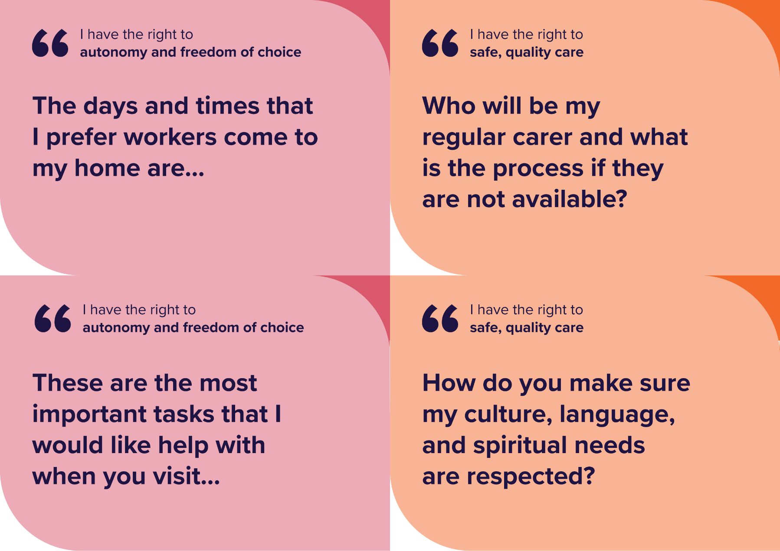

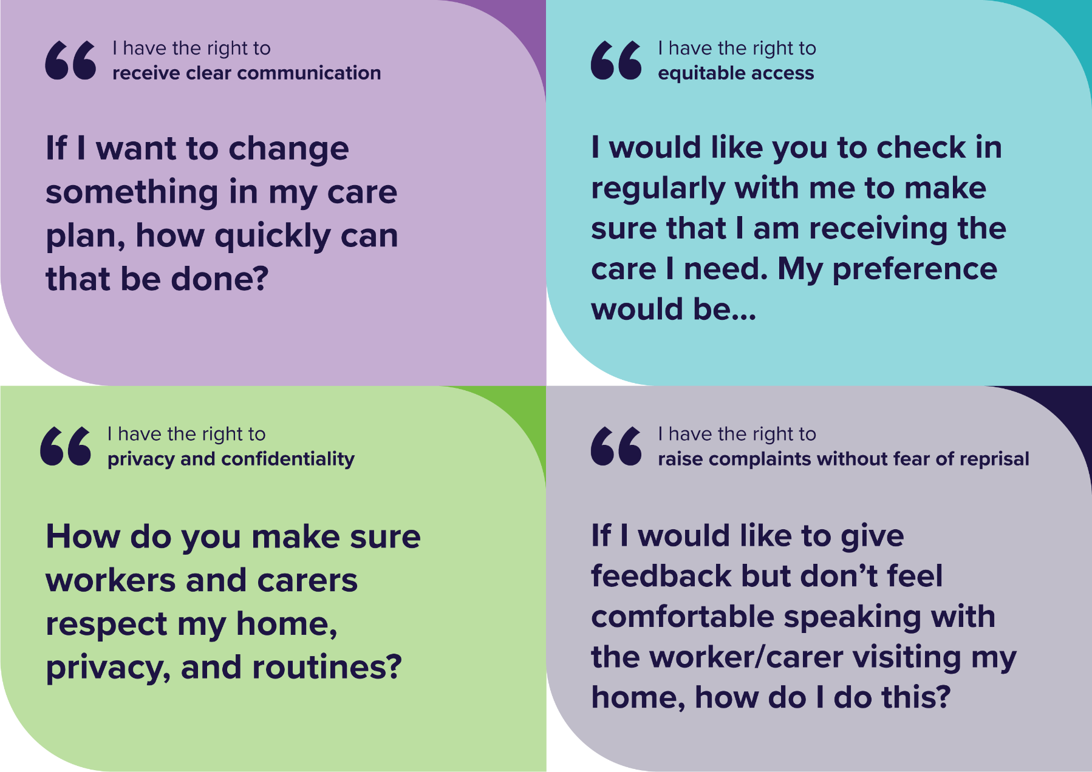

Discussion cards to start a conversation about your residential care
The following questions are suggestions to help you and anyone supporting you (your registered supporters, family, friends, and carers) to start a conversation with your provider or personal care worker about what is important to you, in your care.
