

1
October 2025

Delivering Inclusive Aged Care

Tools and services for supporting diversity

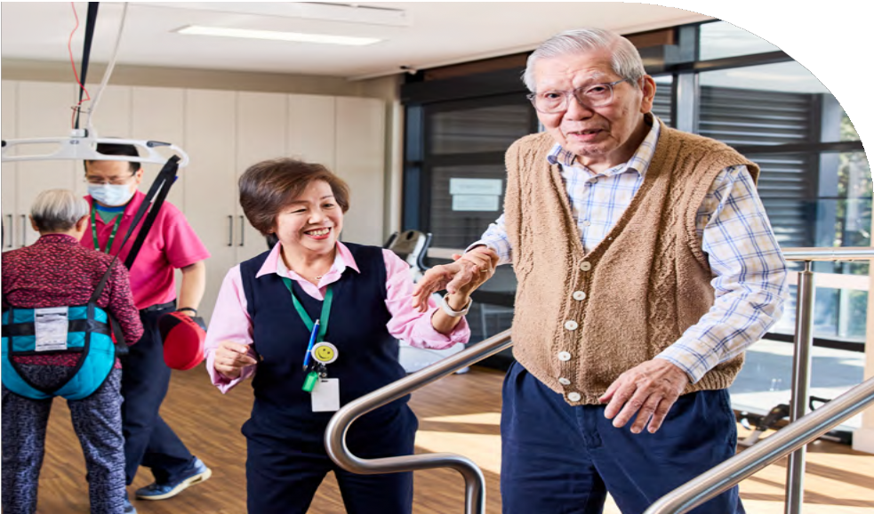

This booklet provides essential information and resources to help aged care providers deliver culturally responsive and inclusive services to older people from diverse backgrounds.
2
2
- Aged Care Diversity Framework
- Different languages, same aged care
- Aboriginal and Torres Strait Islander languages free translation service
- Translating and Interpreting Service National
- The National Sign Language Program
- Free diversity training and support for aged care providers and workers
- Aged care support networks
- Specialisation Verification
- Resources

1

Australia is a diverse country. As the population ages, it’s important that everyone has fair and equal access to aged care.

Aged Care Diversity Framework

The Diversity Framework aims to include diversity into the design and delivery of aged care services. It:
  - takes a broad approach to embrace and recognise human rights
  - supports aged care providers in enhancing quality of care
  - encourages consumers to actively participate as partners in the design of aged care services
  - acknowledges that, like the broader community, older people possess diverse characteristics and life experiences, requiring tailored approaches to the care they receive.
The framework aims to make sure our aged care services are safe and respectful of people’s diverse backgrounds and life experiences.

For more information visit:
 Health.gov.au/Aged-Care-Diversity- Framework-Initiative

3

Different languages, same aged care
2

The Australian Government funds a translation service to help aged care providers communicate with older people from culturally and linguistically diverse backgrounds.

Aged care providers can use this free service to produce translated versions of print and digital materials in different languages, as well as Easy Read or Plain English versions. Translation specialists will work with you to understand your requirements. Your materials will be translated and returned to you in the desired formats.





How the service works

Step 1
Fill in the online request form

Step 2
Our friendly team will respond within 48 hours, Monday to Friday.

Step 3
Translation specialists will work with you to understand your requirements
Step 4
We’ll translate your eligible materials and return them in the required formats

This service can be used to communicate with older people from culturally and linguistically diverse backgrounds.

For more information about this service or to request a translation, visit:
 DiversityAgedCare.health.gov.au

4


5

3

The Australian Government funds a translation service to help aged care providers communicate with Aboriginal and/or Torres Strait Islander people in language. Aged care providers, peak bodies

Aboriginal and Torres Strait Islander languages free translation service
and PICACs can use this free service to produce translated versions of print and digital materials in Aboriginal and Torres Strait Islander languages, as well as Easy Read versions.
To request a translation, visit:
DiversityAgedCare.health.gov.au

Translating and Interpreting Service (TIS) National
4

The Australian Government funds aged care providers to access TIS National. Services are available 24 hours a day, every day of the year including:
- immediate phone interpreting
- Automated Telephone Interpreting Service (ATIS)
- pre-booked phone interpreting
- on-site interpreting
- video remote interpreting.
Aged care providers can use TIS National free of charge to communicate with people from culturally and linguistically diverse backgrounds.
If you have a registered account with TIS National you can access interpreting for aged care. To register, you will need to complete the online form in TIS Online.
- TIS National will email you the client code after you register.
- You will need your client code each time you request TIS National services.
- If your organisation delivers aged care services under multiple government programs, you must use a separate code for each program.
Always check that you’re using the correct code for the specific program you’re requesting services for.

For more information on TIS National for aged care:
 Health.gov.au/TIS-Aged-Care-Providers

6

The National Sign Language Program (NSLP)
5

The NSLP provides free sign language interpreting and captioning for Deaf, Deafblind and hard of hearing older people to help them engage with the aged care system. It can also be used for health and medical appointments that have a Medicare rebate.
Services are provided through Deaf Connect 7 days a week, including emergencies and after business hours.
Services include:
- face-to-face and video remote sign language interpreting
- Auslan, Aboriginal and Torres Strait Islander languages, American Sign Language, International Sign Language and Signed English
- tactile signing and hand-over-hand signing for Deafblind people
- live captioning either onsite or remotely.
As a service provider, you must register your organisation via the booking platform: Bookings.DeafConnect.org.au before contacting Deaf Connect to make an appointment for the first time.
Once registered, you will receive a booking code, which you must use each time you book a NSLP service.

For more information on Deaf Connect call 1300 773 803 or visit:
 Health.gov.au/Aged-Care-Sign-Language-Service

7



8
8


9
9

Australia has a wonderful, diverse population of different communities who speak and understand many different languages. In a country with such diversity, aged care providers can help make people from all communities feel more at home.

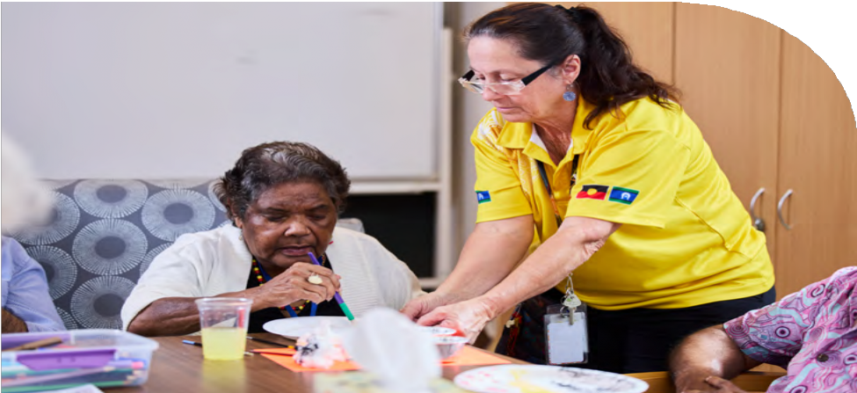
Free diversity training and support for aged care providers and workers
10
10
6

Planning for Diversity workshop series
The Planning for Diversity workshop series, delivered by the Older Persons Advocacy Network (OPAN), can help you make your services more inclusive of older people from diverse and marginalised groups.
Planning for Diversity is especially beneficial for aged care staff responsible for quality improvement, service planning and compliance.
The training includes practical information and tools through
e-learning modules, face-to-face workshops and follow-up support.

For more information visit the Older Persons Advocacy Network’s website:
 OPAN.org.au/Education/Diversity-Education/



Silver Rainbow: LGBTIQ+ Aged Care Awareness Training
Silver Rainbow awareness training offers information and support to help you deliver inclusive and respectful care to older people who are LGBTIQ+. Silver Rainbow is beneficial for aged care services, assessment teams, allied health services and others in the aged care sector.

To find training in your area,
visit LGBTIQ+ Health Australia’s website:
 LGBTIQHealth.org.au/Silver-Rainbow-Training

11
11


Aged care support networks
12
12
7

Older Persons Advocacy Network (OPAN)
OPAN provides free advocacy and support for older people seeking or receiving government-funded aged care. It can also provide support to families and other representatives with the older person’s consent. Their work aims to ensure all older Australians experience a high-quality aged care system that ensures equality and that embraces their diverse characteristics and life experiences.

To find out more about OPAN, visit:
OPAN.org.au


13
13

Partners in Culturally Appropriate Care (PICAC)
PICACs are organisations that can support you to provide aged care that meets the needs of older people from Culturally and Linguistically Diverse (CALD) backgrounds.
PICAC organisations provide face-to-face and online workshops, training and information sessions, and resources such as fact sheets and guides. They help ensure aged care staff have the skills and knowledge to meet the needs of CALD older people in their care.

To find a PICAC organisation in your state or territory, visit:
 PICACAlliance.org

Specialisation Verification
8

Specialisation Verification
Specialisation Verification is a voluntary process where you can apply to be formally recognised for offering tailored services to older people with diverse backgrounds and life experiences. This helps
older Australians, their families and carers to identify which aged care providers might best suit their needs.

For more information on eligibility and the application process visit:
Health.gov.au/Specialisation-Verification

9 Resources

Subscribe to our aged care newsletters and alerts to stay up-to-date with the latest news in the aged care sector:
Health.gov.au/Aged-Care-Newsletter- Subscribe
These resources support aged care service providers in delivering inclusive care that not only supports lived experience but meets the diverse cultural and linguistic needs of older Australians.
Use these tools to create care environments that respect and reflect the varied backgrounds and experiences of those in your care.

14

Aged care translation service
 1800 271 034
DiversityAgedCare.health.gov.au

Aboriginal and Torres Strait Islander languages free translation service
DiversityAgedCare.health.gov.au

Interpreter connect
 1800 200 422

The National Sign Language Program (NSLP)
 1300 773 803
Health.gov.au/Aged-Care-Sign-Language-Service

TIS National
131 450
Health.gov.au/TIS-Aged-Care-Providers

LGBTIQ+ Health Australia
 LGBTIQHealth.org.au/Silver-Rainbow-Training

Partners in Culturally Appropriate Care (PICAC)
PICACAlliance.org

Older Persons Advocacy Network (OPAN)
OPAN.org.au

15


Aged care in Australia should be as diverse as the people it supports, creating environments where every older person, regardless
of background, can feel connected, respected and cared for.

16
16

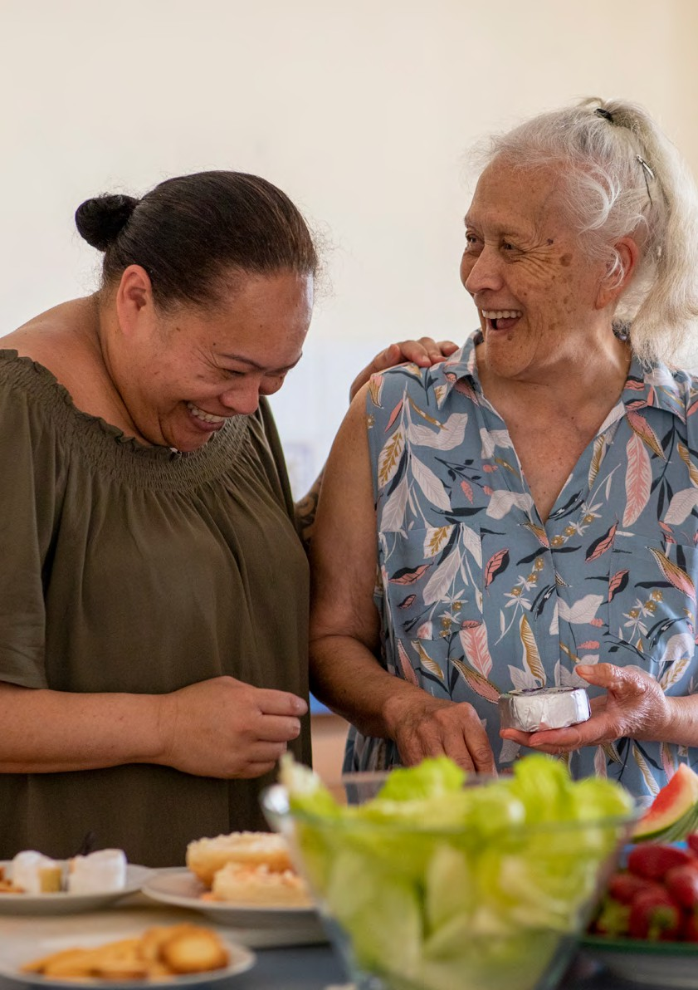

17

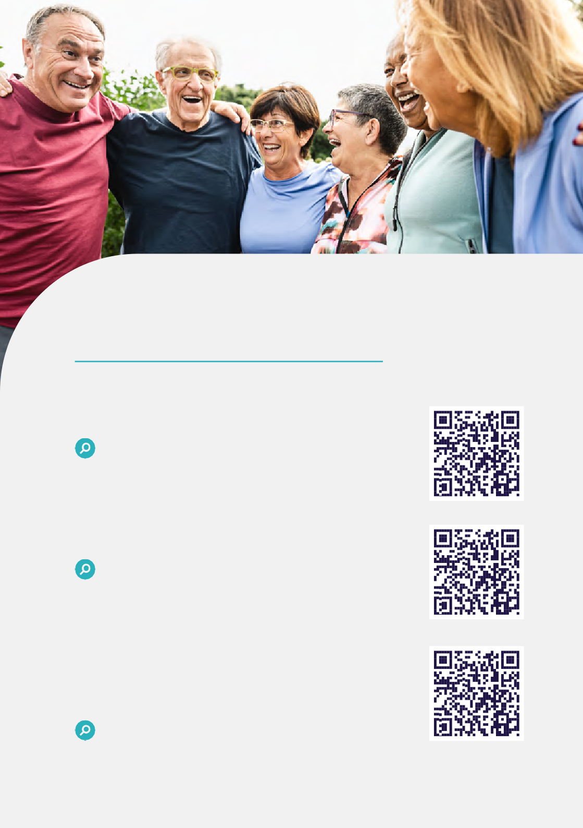

For more information:

Exploring aged care
health.gov.au/resources/publications/ exploring-aged-care

Aged care reforms — A guide for providers and the sector
health.gov.au/resources/publications/aged- care-reforms-a-guide-for-providers-and-the- sector

Working in aged care — A guide for workers about the new Aged Care Act
health.gov.au/resources/publications/ working-in-aged-care-a-guide-for-workers- about-the-new-aged-care-act
DT0004555-01025
18

