Bulk Billing Practice Incentive Program Healthdirect and Signage Requirements

As of 1 November 2025

Contents

Introduction 2

Healthdirect Requirements 3

Registering and Updating Details on Healthdirect 4

Registration Details 5

Ongoing Maintenance 6

Signage Requirements 6

Signage Principles 6

Access to Signage 7

Onboarding Timeframes 8

Entrance Signage Requirements 8

Internal Signage Requirements 9

Co-location Requirements 10

Use of Medicare Bulk Billing Practice Products 11

Signage Exemptions 11

Optional Promotional Materials 12

Website Promotion 12

Social Promotion 12

Additional Materials 13

Offboarding Requirements 13

# Introduction

### About the Bulk Billing Practice Incentive Program

[The Bulk Billing Practice Incentive Program](https://www.health.gov.au/our-work/upcoming-changes-to-bulk-billing-incentives-in-general-practice) (BBPIP) (https://www.health.gov.au/our-work/upcoming-changes-to-bulk-billing-incentives-in-general-practice) aims to improve the affordability and accessibility of primary healthcare in Australia by incentivising general practitioners (GPs) and practices to bulk bill all Medicare-eligible patients for all [eligible services](https://www.health.gov.au/resources/publications/bulk-billing-practice-incentive-program-eligible-services?language=en) (https://www.health.gov.au/resources/publications/bulk-billing-practice-incentive-program-eligible-services?language=en). Practices participating in BBPIP must register as a fully bulk billing practice in [Healthdirect Australia’s National Health Services Directory](https://www.healthdirect.gov.au/australian-health-services) (NHSD) (https://www.healthdirect.gov.au/australian-health-services) and display Medicare Bulk Billing Practice signage (signage) on-site, to be eligible for the BBPIP incentive payment.

### Purpose and scope of this document

This document outlines the Healthdirect and signage requirements for practices participating in BBPIP, ensuring:

* National consistency in signage and patient recognition
* Compliance with BBPIP requirements
* Clear navigation and communication within co-located settings.

### Purpose of Healthdirect and signage requirements

The Healthdirect and signage requirements will:

* Improve awareness of bulk billing services for patients
* Help patients easily identify and access fully bulk billing (BBPIP registered) practices, reducing the need to research and compare options
* Provide assurance that participating practices will bulk bill, increasing patient confidence
* Support practices in attracting and retaining patients through clear identification of their bulk billing status.

This document should be read in conjunction with the BBPIP Program Guidelines issued by the Australian Government Department of Health, Disability and Ageing (the department) available prior to 1 November 2025.

### Roles and responsibilities

| **Entity** | **Responsibilities** |
| --- | --- |
| Practice participating in BBPIP | Meet and maintain all Healthdirect and signage requirements as outlined in this document. |
| Primary Health Network (PHN) | Support practices in implementing and maintaining specified Healthdirect and signage requirements. |
| Australian Government Department of Health, Disability and Ageing | Outline Healthdirect and signage requirements for practices participating in BBPIP. Provide ongoing clarification and support on BBPIP requirements for on-site signage. |
| Healthdirect Australia | Ensure practice registrations and updates are processed and made available on the Healthdirect website. |

### Compliance

The BBPIP Healthdirect and signage requirements are subject to change at any time.

By meeting these requirements, along with all other practice BBPIP eligibility requirements, practices and providers will have fulfilled the requirements to register and participate in BBPIP. Full details on BBPIP eligibility and guidance on maintaining compliance are outlined in the BBPIP Program Guidelines.

# Healthdirect Requirements

### About Healthdirect and NHSD

[Healthdirect](https://www.healthdirect.gov.au/) (https://www.healthdirect.gov.au/) Australia is jointly funded by the Commonwealth and all State and Territory governments, providing 24/7 trusted health information and advice to Australians.

Healthdirect’s [Service Finder](https://www.healthdirect.gov.au/australian-health-services) (https://www.healthdirect.gov.au/australian-health-services) allows users to search for nearby health services (e.g. GPs, hospitals, dentists, pharmacies) and filter their search by service type, location, billing type, appointment type and accessibility features. The service finder uses a comprehensive online directory of healthcare professionals and services – the National Health Services Directory (NHSD).

To meet eligibility for BBPIP, practices must ensure they are listed as fully bulk billing on NHSD by confirming or modifying their billing type to **‘bulk billing only’**. This ensures users can easily search for bulk billing practices in their area at a single source. Patients can be confident they will be bulk billed for eligible services when attending a participating practice. Two methods can be used to register or update details on NHSD; directly through NHSD, or indirectly via Provider Connect Australia™ (PCA™).

Additional resources, guidance and tools to support registration are available on the department website [health.gov.au/BBPIP](http://www.health.gov.au/BBPIP) (http://www.health.gov.au/BBPIP).

## Registering and Updating Details on Healthdirect

**Within 24 hours** of a practice registering for BBPIP in the Organisation register:

* Practices **not yet registered** on Healthdirect, must submit a [Service Registration form](https://healthdirect-serviceline.atlassian.net/servicedesk/customer/portal/3/group/12/create/13) (https://healthdirect-serviceline.atlassian.net/servicedesk/customer/portal/3/group/12/create/13).
* Practices **already registered** on Healthdirect, must review and update existing practice details, if required, by submitting a [Service Update form](https://healthdirect-serviceline.atlassian.net/servicedesk/customer/portal/3/group/12/create/53) (https://healthdirect-serviceline.atlassian.net/servicedesk/customer/portal/3/group/12/create/53).

A healthcare service record is required in NHSD for each practice participating in BBPIP. The record should reflect the practice as registered in the Organisation register and BBPIP, and should not include other practices not participating in BBPIP. Links to the forms can be accessed at <https://about.healthdirect.gov.au/nhsd/about/register-with-the-nhsd>.

Please note that NHSD registration updates may not appear on the healthdirect website within 24 hours, and there may be delays before the website reflects these changes. This will not affect a practice’s ability to meet requirements.

If a practice has commenced bulk billing prior to registering for BBPIP, they can register and/or update their details on the NHSD at any time.

### Registering and Updating Details on Healthdirect via PCA™

Practices can also register and update their NHSD details by linking to the NHSD via [Provider Connect Australia™](https://www.digitalhealth.gov.au/healthcare-providers/initiatives-and-programs/provider-connect-australia/provider-connect-australia-register/register-as-an-organisation) (PCA™) (https://www.digitalhealth.gov.au/healthcare-providers/initiatives-and-programs/provider-connect-australia/provider-connect-australia-register/register-as-an-organisation).

PCA™ is a digital service platform that enables registered healthcare organisations to maintain their business information in one place and share it with multiple partners in their healthcare service delivery.

Once organisations register via PCA™, it will automatically link to Healthdirect’s NHSD and Service Finder, as well as other selected health service delivery partners, such as Primary Health Networks, healthcare directories, communication services, and more. Similarly, any updates will automatically be reflected across linked platforms.

PCA™ is an initiative of the Australian Digital Health Agency.

If using this method, **within 24 hours** of a practice registering for BBPIP in the Organisation register:

* Practices **not yet registered** on PCA™, must [register](https://www.digitalhealth.gov.au/healthcare-providers/initiatives-and-programs/provider-connect-australia/provider-connect-australia-register/register-as-an-organisation) (https://www.digitalhealth.gov.au/healthcare-providers/initiatives-and-programs/provider-connect-australia/provider-connect-australia-register/register-as-an-organisation) and then add or update their practice details.
* Practices **already registered** on PCA™, must review and [update](https://www.digitalhealth.gov.au/healthcare-providers/initiatives-and-programs/provider-connect-australia/provider-connect-australia-register/register-as-an-organisation/maintain-organisation-details/update-publication-of-healthcare-services-and-practitioners-to-partner-services) (https://www.digitalhealth.gov.au/healthcare-providers/initiatives-and-programs/provider-connect-australia/provider-connect-australia-register/register-as-an-organisation/maintain-organisation-details/update-publication-of-healthcare-services-and-practitioners-to-partner-services) existing practice details, if required.

When registering or updating details on NHSD via PCA™, practices must ensure the **“Publish to National Health Services Directory”** checkboxes at the bottom of the screen are ticked.

Please allow 24 hours for NHSD registration updates via PCA™ to appear on the Healthdirect website. This will not affect a practice’s ability to meet requirements.

## Registration Details

When registering or updating practice details on Healthdirect, practices participating in BBPIP are required to provide and maintain accuracy of the below information.

### Billing type

Practices participating in BBPIP are required to list their practice as fully bulk billing on NHSD, by listing their billing type as **‘bulk billing only’** using the drop-down menu.

### Other required details

When registering on NHSD, practices are also required to provide details of their:

* Business name
* Healthcare service type i.e. general practice service, Aboriginal and Torres Strait Islander service
* Service delivery method i.e. physical location, home visits, virtual
* Physical location address
* Service contact details
* Whether appointments are required
* Operational hours
* Public holiday operational hours
* After-hours operation
* Number of practitioners, along with their name and specialty.

### Additional information

Practices participating in BBPIP are encouraged to provide additional information about their practice on Healthdirect, including:

* Service facilities i.e. accessible parking, accessible toilet, braille signage, wheelchair access
* Other practitioner details, including gender and languages spoken
* Specific population service restrictions
* Practice appointment booking details i.e. integration with booking platform to display appointment availability
* Practice website.

Providing these additional details can support accessibility for all users, including people with disabilities and culturally and linguistically diverse groups and non-English speaking backgrounds.

## Ongoing Maintenance

Practices must ensure that all practice details, such as address, contact details and opening hours, are accurate on the NHSD at all times.

Any changes to practice details must be submitted via a Service Update form **within 24 hours**.

Practices are required to actively maintain NHSD registration for the entire period of participation in BBPIP by reviewing their listing every 3-6 months and making updates as required.

# Signage Requirements

## Signage Principles

Practices participating in BBPIP operate in diverse physical settings, including standalone practices, GP co-locations, or multi-disciplinary health hubs. Signage plays a key role in helping patients identify participating practices and navigate services confidently. Signage also increases public awareness of where bulk billing services are available, helping patients make informed decisions about accessing affordable care.

The following core principles apply to signage requirements for practices participating in BBPIP:

* **Visible and Prominent** – Medicare Bulk Billing Practice signage must be clearly visible and prominently displayed, ensuring it can be seen from multiple angles and a reasonable distance. It should be positioned in a way that minimises glare, reflection or visual distortion.
* **Maintaining Practice Branding** – Medicare Bulk Billing Practice signage has been developed to allow practices to maintain their own branding and signage while meeting the BBPIP signage requirements.

## Access to Signage

From 1 November 2025, practices can request signage from [health.gov.au/BBPIP](http://www.health.gov.au/BBPIP) (http://www.health.gov.au/BBPIP). Signage packages can also be requested via the [BBPIP Expression of Interest](https://www.health.gov.au/our-work/upcoming-changes-to-bulk-billing-incentives-in-general-practice/bulk-billing-practice-incentive-program-expression-of-interest-form) (https://www.health.gov.au/our-work/upcoming-changes-to-bulk-billing-incentives-in-general-practice/bulk-billing-practice-incentive-program-expression-of-interest-form) form prior to 1 November 2025.

Signage materials include:

* **‘Medicare Bulk Billing Practice’** Large Decal (1000mm x 680.7mm)
* **‘Medicare Bulk Billing Practice’** Small Decal (600mm x 408.4mm)
* **‘We Bulk Bill Every Eligible Patient’** A3 Poster (420mm x 297mm)
* **‘We are a Medicare Bulk Billing Practice’** A3 Poster (420mm x 297mm).

Decals are printed on white vinyl with removable adhesive backing and can be used on large internal or external glass windows and internal walls. Posters are printed on 170gsm satin paper.

These signage materials can be requested in three packages:

* Pack A: Large decal and both A3 rolled posters
* Pack B: Small decal and both A3 rolled posters
* Pack C: Small decal, large decal and both A3 rolled posters.

Signage materials may change over time, with additions or removals as needed.

Large Decal

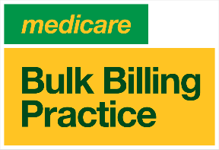

Small Decal

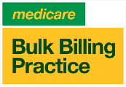

Posters

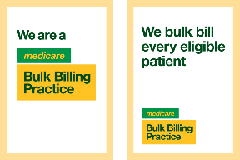

## Onboarding Timeframes

Practices are expected to order their desired signage materials within 24 hours of registering for BBPIP in the Organisation register. Practices are encouraged to order signage in advance of registration for BBPIP to allow for postage timeframes (insert link to order).

Once received, practices must display their Medicare Bulk Billing Practice signage **within 5 business days** in alignment with the signage requirements.

Practices are required to display signage only when they commence bulk billing all eligible services.

## Entrance Signage Requirements

Entrance signage should help patients to easily identify a Medicare Bulk Billing Practice from outside the practice. Entrance signage may also promote bulk billing practices to passersby.

Practices are required to display at least one Medicare Bulk Billing Practice sign near the main public entrance to the practice. Practices are encouraged to display decals on external windows or entrance doors. The signage, where possible, must:

* be visible from 5-10m outside the practice,
* be placed at eye level,
* not be fully or significantly obstructed by any other signage or items; and
* direct patients through the entrance of the practice.

In addition, practices may display Medicare Bulk Billing Practice signage on the exterior of the building, including but not limited to the building façade, exterior entrance, lifts, stairwells, common areas and carparks.

Examples of signage placement on external windows

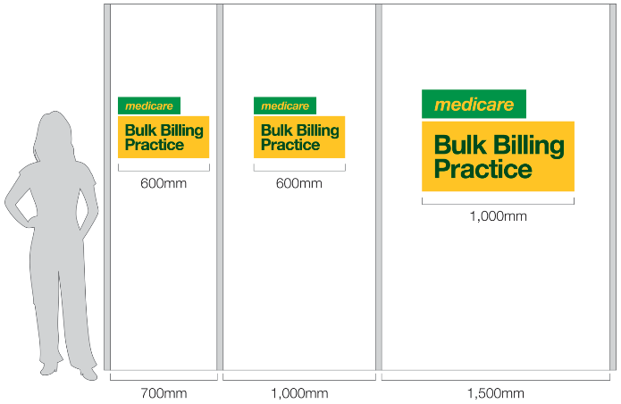

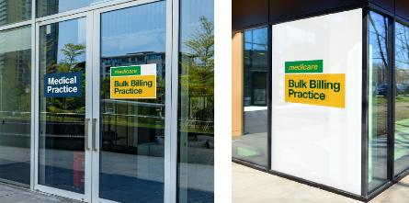

## Internal Signage Requirements

Internal signage should promote that patients are visiting a Medicare Bulk Billing Practice and provide confidence that they will be bulk billed for eligible services. Practices are required to display at least one Medicare Bulk Billing Practice sign in the interior of the practice, at or near the main reception area or reception desk. The signage, where possible, must:

* be visible from 1-2m inside the practice,
* be placed at eye level, or on the reception desk; and
* not be fully or significantly obstructed by any other signage or items.

In addition, practices may also display Medicare Bulk Billing Practice signage throughout their practice, including but not limited to the waiting room, practice floor, consult room and ancillary services.

## Co-location Requirements

Bulk billing practices will sometimes be co-located with different organisations or other health services within the same building. Signage must be used to support patients to easily identify a Medicare Bulk Billing Practice and provide confidence that they will be bulk billed at those locations.

When practices are co-located with other health services, practices must use signage to clearly distinguish between the services. Practices, where possible, must distinguish between services by:

* Ensuring shared signage clearly differentiates the Medicare Bulk Billing Practice from the other health service
* Directing patients through a separate entrance
* Establishing separate receptions and/or waiting areas.

Reception signage example

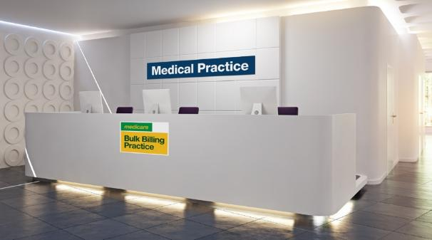

Co-location signage example

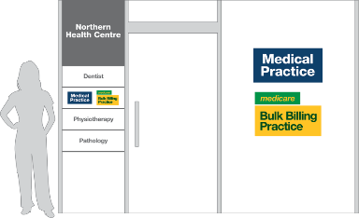

## Use of Medicare Bulk Billing Practice Products

Practices that use the Medicare Bulk Billing Practice products must meet the following requirements for use:

* The Medicare logo and Medicare Bulk Billing Practice products are not altered in any way.
* The Medicare Bulk Billing Practice products can only be used by participating practices for the period of participation in BBPIP.
* Practices are not to use the Medicare logo or Medicare Bulk Billing Practice products to create any new materials.

The department may request practices to remove or correct non-compliant use of signage or other products. Non-compliance may impact a practice and providers eligibility to participate in BBPIP.

## Signage Exemptions

For some practice types, the use of physical signage may not be appropriate or practical for their business model. These practice types include:

* Aboriginal Community Controlled Health Organisations (ACCHOs),
* Aboriginal Medical Services (AMS),
* Mobile and outreach services and,
* Other practices without a physical location.

These practice types participating in BBPIP are not required to meet the above signage requirements, however, are **still required to meet the Healthdirect requirements**.

In certain circumstances, the use of digital signage and other promotional materials may be used to promote bulk billing status.

Text and graphics cannot appear within the designated clear space area. The height of the uppercase ‘B’ determines the minimum clear space at different sizes.

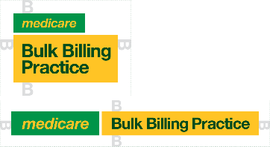

Align, reproduce in a similar size and maintain a space where possible.

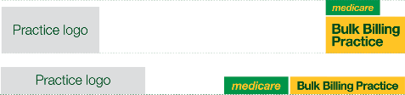

The Medicare logo and Medicare Bulk Billing Practice products are not altered in any way.

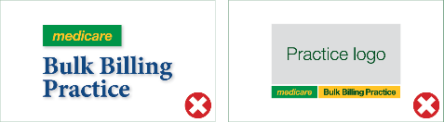

# Optional Promotional Materials

In addition to practices registering as a bulk billing practice on NHSD and displaying Medicare Bulk Billing Practice signage, practices participating in BBPIP can access a range of additional materials to help promote their participation in the program.

These additional promotional materials are **optional** and are not required to meet eligibility requirements for BBPIP.

## Website Promotion

Practices are encouraged to use the Medicare Bulk Billing Practice web tile on their website to identify themselves as a bulk billing practice. Participating practices will be able to access Bulk Billing Practice web tiles at [health.gov.au/BBPIP](http://www.health.gov.au/BBPIP) (http://www.health.gov.au/BBPIP) from 1 November 2025.

The web tile must only be used in alignment with the requirements set out in this document, or directions by the department.

The web tile must only be used to identify practices participating in BBPIP. Where a practice has multiple locations, the web tile must only be used in reference to the locations that are participating in BBPIP and not in overall reference to the organisation. The web tile must not be used within a branded header.

The practice is responsible for any costs associated with using the Medicare Bulk Billing Practice web tile on their website.

## Social Promotion

Social media tiles can be used to promote your practices participation in the

BBPIP and increase public awareness that bulk billing services are available at practices, helping patients make informed decisions about accessing affordable care. Practices will be able to access Medicare Bulk Billing Practice social media tiles at [health.gov.au/BBPIP](http://www.health.gov.au/BBPIP) (http://www.health.gov.au/BBPIP) from 1 November 2025.

Example of social media tiles

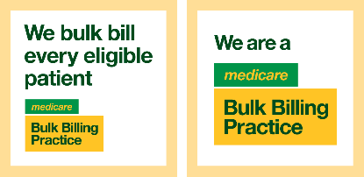

## Additional Materials

### Promotional material requests

Requests for the development of additional promotional materials can be sent to the department at [BulkBillingPractice@health.gov.au](mailto:BulkBillingPractice@health.gov.au) (mailto: BulkBillingPractice@health.gov.au) for consideration.

Practices are welcome to continue promoting their bulk billing status using their own advertising materials. However, the Medicare logo and the Medicare Bulk Billing Practice signage must only be used within official products developed by the department.

# Offboarding Requirements

Practices that are no longer participating in BBPIP, or those directed by the department to commence offboarding, are required to complete all offboarding activities within the specified timeframes outlined below. The practice shall bear all costs associated with the removal of Medicare Bulk Billing Practice signage and products, and any related offboarding activities.

### Updating Healthdirect

Practices are required to review their Healthdirect listing and ensure their billing type is correct. If required, practices must update their details by submitting an NHSD [Service Update form](https://healthdirect-serviceline.atlassian.net/servicedesk/customer/portal/3/group/12/create/53) (https://healthdirect-serviceline.atlassian.net/servicedesk/customer/portal/3/group/12/create/53) within 24 hours of a change in circumstances. This ensures NHSD practice details remain accurate.

Practices are encouraged to continue to maintain their NHSD registration if they are no longer participating in BBPIP.

### Removing Medicare Bulk Billing Practice signage

Practices are required to remove all physical Medicare Bulk Billing Practice signage within 5 business days.

The department reserves the right to verify the complete removal of signage. The practice must cooperate fully and provide evidence of compliance upon request.

### Removing other Medicare Bulk Billing Practice products

Any additional Medicare Bulk Billing Practice products, including web tiles and social media tiles, must be removed within 5 business days.

There is no requirement to remove generic bulk billing promotional materials if a practice continues to bulk bill.

### Change of business structure

If there is a change of a practice’s business structure, including a merger, sale or amalgamation, participating practices will need to re-register for BBPIP under the new organisation arrangement and meet the BBPIP Healthdirect and signage requirements under the new business name and structure.