ATAGI 2025 annual statement on immunisation

October 2025

About ATAGI 2

Immunisation landscape in Australia in 2024 3

Key immunisation highlights 3

Ongoing challenges 3

Key developments in immunisation strategies and evaluation 4

National Immunisation Strategy for Australia 2025–2030 4

Health Technology Assessment Policy and Methods Review 4

COVID-19 Response Inquiry Report 5

Immunisation issues in Australia in 2024 6

Emerging and re-emerging vaccine-preventable diseases 6

Prevention and control of other vaccine-preventable diseases 7

Highlights of immunisation coverage of other vaccine-preventable diseases 12

Immunisation policy and practice across Australia 15

New vaccines and potential vaccination programs 16

Vaccine safety 17

Challenges and priorities for immunisation in Australia in 2025 and beyond 19

Key challenges for preventing and controlling vaccine-preventable diseases through immunisation 19

ATAGI’s priority actions for 2025 19

# About ATAGI

The [Australian Technical Advisory Group on Immunisation (ATAGI)](https://www.health.gov.au/committees-and-groups/australian-technical-advisory-group-on-immunisation-atagi) advises the Minister for Health and Ageing on the National Immunisation Program (NIP) and other immunisation issues.

ATAGI’s vision is to protect the Australian population from vaccine-preventable diseases (VPDs). This is shown in [ATAGI’s strategic intent](https://www.health.gov.au/resources/publications/atagi-strategic-intent).

ATAGI’s purpose is to provide evidence-based advice to the Minister for Health and Ageing and other key policymakers on:

* immunisation policies
* immunisation programs
* future research priorities.

This includes identifying and prioritising gaps in the immunisation landscape to improve:

* the impact of immunisation programs
* confidence in immunisation programs, as well as in the vaccines used in the programs
* equity in access to, and outcomes of, immunisation programs.

The National Centre for Immunisation Research and Surveillance (NCIRS) provides technical support to ATAGI and the Australian Government Department of Health, Disability and Ageing. ATAGI works with NCIRS to develop and publish the [Australian Immunisation Handbook](https://immunisationhandbook.health.gov.au/).

The ATAGI 2025 Annual Statement on Immunisation is the 5th publication in this series. It highlights the key successes, trends and challenges in the use of vaccines and control of VPDs in Australia in 2024. It also signals ATAGI’s priority advice on actions to address key issues for 2025 and beyond.

Copyright

© 2025 Commonwealth of Australia as represented by the Department of Health and Aged Care

This work is copyright. You may copy, print, download, display and reproduce the whole or part of this work in unaltered form for your own personal use or, if you are part of an organisation, for internal use within your organisation, but only if you or your organisation:

* do not use the copy or reproduction for any commercial purpose; and
* retain this copyright notice and all disclaimer notices as part of that copy or reproduction.

Apart from rights as permitted by the Copyright Act 1968 (Cth) or allowed by this copyright notice, all other rights are reserved, including (but not limited to) all commercial rights.

Requests and inquiries concerning reproduction and other rights to use are to be sent to the Communication Branch, Department of Health and Aged Care, GPO Box 9848, Canberra ACT 2601, or via email to [copyright@health.gov.au](mailto:copyright@health.gov.au).

# Immunisation landscape in Australia in 2024

## Key immunisation highlights

Three processes critical in shaping Australia’s future immunisation strategies, policies and programs were developed in 2024 – the National Immunisation Strategy for Australia 2025–2030 (NIS 2025–2030), the Health Technology Assessment Policy and Methods Review report, and the national COVID-19 Response Inquiry Report. Key areas identified for improvement include vaccination coverage, equitable access, pandemic preparedness, assessment and appraisal of vaccines, and transparent and actionable use of data, including linked datasets for analyses of vaccine impact.

Two new respiratory syncytial virus (RSV) vaccines and a long-acting RSV monoclonal antibody were introduced in Australia, which will help prevent severe RSV disease in both infants and older people. The funding for free [shingles vaccination](https://www.health.gov.au/resources/publications/national-immunisation-program-shingles-vaccination-program-advice-for-health-professionals?language=en) under the National Immunisation Program (NIP), using the recombinant herpes zoster vaccine Shingrix, was expanded to include people aged ≥18 years who are immunocompromised with moderate to high risk of severe infection or complications from shingles.

An updated COVID-19 vaccine formulation was also made available during 2024, which assisted in protecting people in Australia against the most common circulating COVID-19 variants. The COVID‑19 vaccination program also started the transition from a pandemic response approach to become one that is integrated with a national vaccination program for controlling important vaccine-preventable respiratory viral diseases.

## Ongoing challenges

Preparing for and/or managing emerging or re-emerging vaccine-preventable disease (VPD) threats – such as measles, mpox, pertussis and potentially highly pathogenic avian influenza (HPAI) in humans – that continue to present challenges in Australia has been a key focus since 2024.

Vaccination coverage remains generally very high in Australia by global standards, but modest declines in coverage have occurred in most age groups for the past few years for several vaccines, including those funded under the NIP. There are also challenges associated with people accessing vaccination within the recommended timeframes.

# Key developments in immunisation strategies and evaluation

The [National Immunisation Strategy for Australia 2025–2030](https://www.health.gov.au/resources/publications/national-immunisation-strategy-for-australia-2025-2030?language=en), [Health Technology Assessment Policy and Methods Review report](https://www.health.gov.au/resources/publications/health-technology-assessment-policy-and-methods-review-final-report?language=en) and [COVID-19 Response Inquiry Report](https://www.pmc.gov.au/resources/covid-19-response-inquiry-report) were all developed in 2024. These are critical in shaping the development and decision-making processes of Australia-wide immunisation strategies, policies and programs.

## National Immunisation Strategy for Australia 2025–2030

The [NIS 2025–2030](https://www.health.gov.au/resources/publications/national-immunisation-strategy-for-australia-2025-2030?language=en) builds on two previous national immunisation strategies (2013 to 2018 and 2019 to 2024). The [NIS 2025–2030](https://www.health.gov.au/resources/publications/national-immunisation-strategy-for-australia-2025-2030?language=en) aims to reduce the impact of VPDs to achieve a healthier Australia through safe, effective and equitable immunisation across the lifespan. The 6 priority areas are to:

* improve access to immunisation, with a focus on equity for Aboriginal and Torres Strait Islander people and other priority populations
* build trust, understanding and acceptance of immunisation in communities
* use data more effectively to target immunisation strategies and monitor performance
* strengthen the immunisation workforce
* harness new technologies to respond to the evolving communicable disease and vaccine landscape
* implement sustainable reform in vaccine program governance, program delivery and accountability

Development of the [NIS 2025–2030](https://www.health.gov.au/resources/publications/national-immunisation-strategy-for-australia-2025-2030?language=en) occurred throughout 2024, and the strategy was published in June 2025.

## Health Technology Assessment Policy and Methods Review

The [Health Technology Assessment Policy and Methods Review report](https://www.health.gov.au/resources/publications/health-technology-assessment-policy-and-methods-review-final-report?language=en), released in September 2024, makes several recommendations that are relevant for the policy and methods for assessment of health technologies, which include vaccines, for government funding in Australia. Many of the general recommendations have significant implications for the assessment framework and the methods used to assess evidence. Two recommendations specifically refer to the assessment pathway for listing vaccines on the NIP:

* Recommendation 11. Proportionate appraisal pathway to align Australian Technical Advisory Group on Immunisation assessments with the level of risk and complexity of the product: Restructure the current appraisal pathway for listing a vaccine on NIP so that the assessment processes are in line with the level of risk–benefit and complexity of a vaccine submission.
* Recommendation 12. Proactive vaccine assessment pathway: Develop a proactive vaccine assessment pathway that allows how new products or changes to the vaccine program could impact disease burden to be considered. This would include independent modelling where appropriate.

The Australian Government established the [Health Technology Assessment Review Implementation Advisory Group](https://www.health.gov.au/ministers/the-hon-mark-butler-mp/media/broad-expertise-to-lead-health-technology-assessment-reform?language=en) in November 2024 to co-design a draft government response to the Health Technology Assessment Policy and Methods Review.

## COVID-19 Response Inquiry Report

The national [COVID-19 Response Inquiry Report](https://www.pmc.gov.au/resources/covid-19-response-inquiry-report), released to the Australian Government in October 2024, identified nine recommendations on how to effectively respond to a pandemic. The report also identified several short- and medium-term actions to be implemented ahead of the next pandemic, including:

* reviewing the COVID-19 vaccination claims scheme with the aim to guide future use of similar indemnity schemes in a national health emergency
* continuing to invest in monitoring and evaluation of the long-term impacts of COVID-19, including vaccination adverse events
* developing a national strategy to rebuild community trust in vaccines and increase vaccination rates
* improving data collection, sharing, linkage and analytic capability for an effective, targeted and proportionate response to a national health emergency
* finalising the establishment of the Australian Centre for Disease Control (CDC).

# Immunisation issues in Australia in 2024

## Emerging and re-emerging vaccine-preventable diseases

In 2024, emerging and re-emerging VPDs, such as mpox, pertussis and HPAI in humans, remained risks in Australia. Although measles has been eliminated as an endemic disease in Australia since 2014, there remains a significant risk of outbreaks following importation into Australia through Australian and international travellers. Since 2022, there has been an ongoing resurgence of measles across all regions of the world, including in some countries in the Asia–Pacific region.

ATAGI continues to monitor the epidemiology of emerging and re-emerging VPDs here and overseas. ATAGI also re-assesses vaccine coverage in relevant age or population groups in Australia as needed and prepares advice to respond to changing risks and scenarios.

Source of notification data for this statement

Notification data were extracted from the National Notifiable Diseases Surveillance System for notifications with a diagnosis date between 1 January and 31 December 2024.

Pandemic-adjusted 5-year mean

Some of the data presented in this statement refer to a pandemic-adjusted 5-year mean. This statistic uses notification data from the 5 years before (2017 to 2019) and after (2022 to 2023) the peak of the COVID-19 pandemic (2020 to 2021). This adjusts for the substantially lower notifications of many VPDs during 2020 and 2021 and allows more meaningful comparisons of epidemiological data.

### Measles

Measles cases increased in 2024 (n = 57) compared with 2023 (n = 26). Of total measles notifications in 2024, most (40 of 57; 70%) were acquired overseas, and the remaining cases (17 of 57; 30%) were acquired in Australia through known links to infected travellers.

In 2024, no measles-associated deaths were notified.

### Mpox (formerly known as monkeypox)

Mpox initially emerged in Australia in 2022, when 144 cases were notified before a decline in 2023 to 26 cases. However, mpox case notifications increased again from the second quarter in 2024, peaking in September. For all of 2024, a total of 1,412 cases were notified, and no deaths were reported. Unlike in 2022, the great majority of notified cases (93%) in 2024 were acquired in Australia.

In 2024, no cases of the new, potentially more transmissible clade Ib mpox strain were detected in Australia. However, this variant has been causing increasing cases in [some African countries since 2023](https://africacdc.org/news-item/africa-cdc-declares-mpox-a-public-health-emergency-of-continental-security-mobilizing-resources-across-the-continent/), leading the World Health Organization to declare a [public health emergency of international concern](https://www.who.int/news/item/14-08-2024-who-director-general-declares-mpox-outbreak-a-public-health-emergency-of-international-concern) in August 2024.

People at a high risk of being exposed to mpox have been encouraged to take actions to reduce their risk of exposure to the virus and to get vaccinated, as outlined in the new [mpox chapter](https://immunisationhandbook.health.gov.au/contents/vaccine-preventable-diseases/mpox-previously-known-as-monkeypox) in the Australian Immunisation Handbook. ATAGI has updated the [clinical guidance on the use of vaccines for the prevention of mpox in 2024](https://www.health.gov.au/resources/publications/atagi-clinical-guidance-on-the-use-of-vaccines-for-the-prevention-of-mpox?language=en) twice, which provides more detailed and expanded advice about mpox vaccination tailored to the emerging epidemiologic situation. In the [latest version (version 3.0](https://www.health.gov.au/resources/publications/atagi-clinical-guidance-on-the-use-of-vaccines-for-the-prevention-of-mpox?language=en), published in December 2024), the list of groups at high risk of mpox exposure who are recommended to receive mpox vaccination was expanded, and includes travellers in some situations.

### Pertussis

The resurgence of pertussis notifications began in late 2023 and continued in 2024, especially from March to late June and in New South Wales and Queensland. The number of notifications of pertussis in 2024 (n = 56,919) was 7.2 times higher than the 5-year mean (n = 7,956), and exceeded those reported in previous years, including 2015 (n = 22,572), 2016 (n = 20,119) and the years from 2009 to 2011 (which ranged from 30,183 to 38,748 per year) when there were large pertussis outbreaks in Australia.

In 2024, the notification rates were highest in children aged 10 to 14 years (1,207 cases per 100,000 population), children aged 5 to 9 years (801 cases per 100,000 population), infants aged 6 to 11 months (401 cases per 100,000 population) and young infants aged <6 months (347 cases per 100,000 population). Among the notified pertussis cases in 2024, there were two reported deaths of infants (aged <12 months) and three deaths of people aged ≥65 years.

To protect young infants, who have the highest morbidity and mortality from pertussis infection compared with other age groups, ATAGI emphasises the importance of maternal pertussis vaccination during pregnancy (recommended at [between 20 and 32 weeks gestation](https://immunisationhandbook.health.gov.au/contents/vaccine-preventable-diseases/pertussis-whooping-cough#recommendations) for every pregnancy), and timely completion of pertussis vaccination according to the recommended childhood and adolescent schedule. The Australian Immunisation Handbook also recommends older adults receive pertussis-containing vaccines.

### Pandemic preparedness in the context of avian influenza in humans

Globally, there have been ongoing outbreaks of HPAI in birds and many species of mammals. Outbreaks of H7 strains in [poultry](https://www.daf.qld.gov.au/business-priorities/biosecurity/animal-biosecurity-welfare/animal-health-pests-diseases/reportable/avian-influenza-bird-flu) have [occurred](https://www.daf.qld.gov.au/business-priorities/biosecurity/animal-biosecurity-welfare/animal-health-pests-diseases/reportable/avian-influenza-bird-flu) [intermittently](https://www.daf.qld.gov.au/business-priorities/biosecurity/animal-biosecurity-welfare/animal-health-pests-diseases/reportable/avian-influenza-bird-flu), in Australia. The H5 strain that has been occurring overseas had not been detected in any animal species in Australia in or before 2024. Humans are occasionally infected with HPAI, but no zoonotic infections in humans acquired in Australia have been reported. [ATAGI continues to monitor avian influenza epidemiology in Australia](https://www.health.gov.au/resources/publications/atagi-107th-meeting-bulletin-15-and-16-august-2024?language=en) and overseas, in [collaboration with the Australian CDC](https://www.cdc.gov.au/topics/bird-flu), as well as the development of vaccine candidates against HPAI, and provide advice as required.

## Prevention and control of other vaccine-preventable diseases

Cases of some other VPDs increased in 2024 compared with 2023, and some increases in incidence, such as for influenza, were substantial in comparison with the low incidence seen during the COVID‑19 pandemic. This section highlights the most notable changes in VPD epidemiology, vaccination policies or vaccination coverage.

### Influenza

There were 365,589 notifications of laboratory-confirmed influenza in 2024, 1.6 times the 5-year mean and higher than the 289,154 notifications in 2023. Among children aged 5 to 9 years, children aged <5 years and adults aged ≥65 years there were 3,240, 3,314 and 944 notifications per 100,000 population, respectively. Of the total notifications in 2024, 96% were influenza A (93% unsubtyped, 1% H1N1 and 2% H3N2), 4% were influenza B, and less than 1% were influenza A and B co-infections or untyped. Based on vaccine effectiveness estimates from sentinel surveillance systems in the [Annual Australian Respiratory Surveillance Report – 2024](https://www.health.gov.au/resources/publications/annual-australian-respiratory-surveillance-report-2024?language=en), vaccination with the 2024 seasonal influenza vaccine reduced the likelihood of:

* influenza with symptoms that warrant visiting a general practitioner attendance by 56%
* being hospitalised with influenza by 55%.

Effective prevention of influenza in the community relies on attaining high influenza vaccination coverage before the influenza season begins (generally around July each year). For 2024, the national influenza vaccine coverage by 30 June remained suboptimal for all age groups. Additionally, influenza vaccine coverage at 30 June 2024 was lower than that at the same time point in 2022 and slightly lower than that at the same time point in 2023 for every age group for all of Australia and for First Nations people (Figures 1 and 2).

Children aged <5 years have the highest rate of influenza hospitalisation. Those in this age group who are aged ≥6 months are recommended to receive NIP-funded influenza vaccine. However, despite their eligibility for NIP-funded influenza immunisation, vaccination coverage in this age group was suboptimal and has substantially declined since 2020. By 30 June 2024, 21.1% of children in this age group had received at least 1 dose of influenza vaccine, compared with 23.0% at the same time point in 2023 (see Figure 1). For First Nations children in this age group, coverage was 14.1% by 30 June in 2024, compared with 14.8% at the same time point in 2023 (see Figure 2).

The lowest influenza vaccination coverage was in children aged 5 to <15 years (see Figures 1 and 2), noting healthy children in this age group are not on the NIP for funded influenza vaccines. However, this age group plays an important role in transmission of influenza in the community. Vaccination in this age group can provide both direct protection to vaccine recipients and [indirect (herd) protection](https://pubmed.ncbi.nlm.nih.gov/28475770/) to those who are unvaccinated.

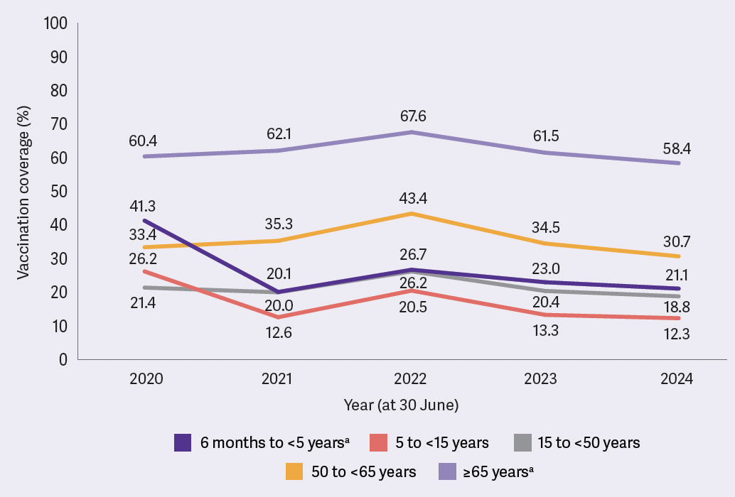

a Funded through the NIP.

Notes:

1. Mandatory reporting of influenza vaccination to the Australian Immunisation Register (AIR) was implemented from March 2021.
2. Analysis done by the National Centre for Immunisation Research and Surveillance (NCIRS) using AIR data.

Figure 1 Influenza vaccination coverage (%) by 30 June of each year, by age group, Australia, 2020 to 2024

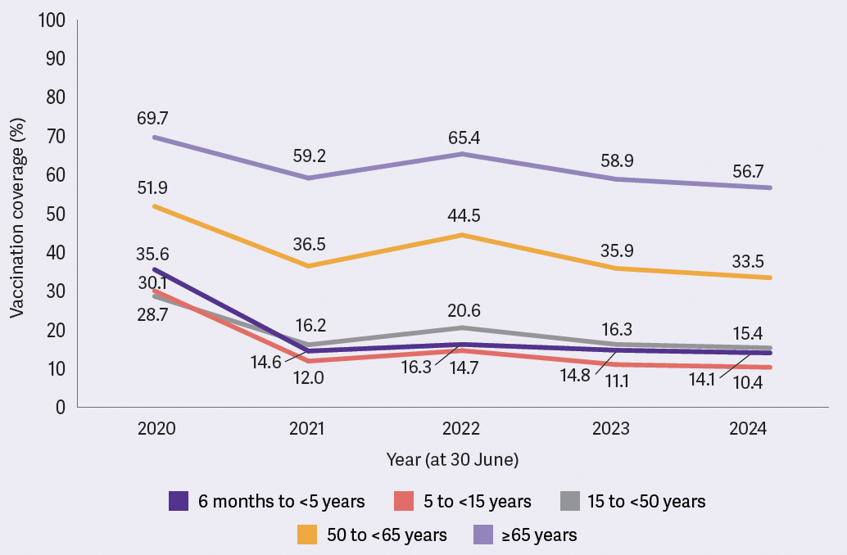

Notes:

1. Influenza vaccine is funded through the NIP for all First Nations people aged ≥6 months.

2. Mandatory reporting of influenza vaccination to the AIR was implemented from March 2021.

3. Analysis done by NCIRS using AIR data.

Figure 2 Influenza vaccination coverage (%) by 30 June of each year, by age group, First Nations people, Australia, 2020 to 2024

In 2024, [Western Australia](https://www.health.wa.gov.au/articles/f_i/influenza-immunisation-program) and [Queensland](https://www.health.qld.gov.au/clinical-practice/guidelines-procedures/diseases-infection/immunisation/service-providers/2024-free-flu-vaccination-program) temporarily funded influenza vaccination for people who were not NIP-eligible. Other jurisdictions such as [New South Wales](https://www.health.nsw.gov.au/Infectious/factsheets/Pages/influenza-vaccination-for-hcw.aspx) and [Victoria](https://chrome-extension://efaidnbmnnnibpcajpcglclefindmkaj/https:/www.vicniss.org.au/media/j0fh03r3/rfq10765-pdi-vaccination-factsheet_a4_v2.pdf) continued to fund influenza vaccination for some at-risk groups in addition to those covered under the NIP, such as public sector healthcare workers.

### Respiratory syncytial virus

RSV infection was added to the National Notifiable Disease List in July 2021 and became a notifiable disease in all states and territories in [September 2022](https://www.health.gov.au/resources/publications/annual-australian-respiratory-surveillance-report-2024?language=en).There were 175,918 notifications of RSV infections in 2024 compared with 128,123 notifications in 2023. Across the age spectrum, notification rates for RSV were highest for infants aged <12 months and children aged 1 to 4 years (8,715 and 4,999 per 100,000 population, respectively) and adults aged ≥85 years (1,194 per 100,000 population).

Since 2023, the Therapeutic Goods Administration (TGA) has assessed three new RSV vaccines for use in adults, and a long-acting monoclonal antibody preparation (nirsevimab [Beyfortus, by Sanofi]) for prevention of RSV disease in infants. The three RSV vaccines for use in adults are:

* [Arexvy](https://www.tga.gov.au/resources/auspmd/arexvy), by GSK, a protein subunit vaccine that was approved in January 2024 for use in older adults aged ≥60 years
* [Abrysvo](https://www.tga.gov.au/resources/auspmd/abrysvo-rsv-vaccine), by Pfizer, a protein subunit vaccine that was approved in March 2024 for use in older adults aged ≥60 years, and in pregnant women to protect newborn infants
* [mRESVIA](https://www.tga.gov.au/resources/artg/411450), by Moderna, an mRNA vaccine that was assessed in 2024 and approved in March 2025 for use in older adults aged ≥60 years.

ATAGI provided clinical advice on the use of Arexvy to prevent illness and severe complications associated with RSV in older adults and guidance on the use of nirsevimab for the prevention of severe RSV disease in infants in early 2024. Recommendations and clinical practice guidelines on the use of Abrysvo, in addition to the statements on Arexvy and nirsevimab, were subsequently incorporated into the new [RSV chapter](https://immunisationhandbook.health.gov.au/contents/vaccine-preventable-diseases/respiratory-syncytial-virus-rsv) in the Australian Immunisation Handbook.

Early in 2024, several states and territories introduced and funded nirsevimab programs to prevent severe RSV disease in infants, with different eligibility criteria:

* [Western Australia](https://www.health.wa.gov.au/Articles/N_R/Respiratory-syncytial-virus-RSV-immunisation) and [Queensland](https://www.health.qld.gov.au/clinical-practice/guidelines-procedures/diseases-infection/immunisation/paediatric-rsv-prevention-program) implemented nirsevimab access for all newborn infants and medically at-risk children.
* [New South Wales](https://www.health.nsw.gov.au/immunisation/pages/nirsevimab-professionals.aspx#who), the Australian Capital Territory, [Tasmania](https://www.health.tas.gov.au/newsletters/communicable-disease-prevention-unit-bulletin) and the [Northern Territory](https://health.nt.gov.au/__data/assets/pdf_file/0010/1428805/rsv-medication-in-the-nt-information-for-parents.pdf) implemented access for high-risk infants.

In November 2024, the Minister for Health and Aged Care announced that [pregnant women would have free access](https://www.health.gov.au/ministers/the-hon-mark-butler-mp/media/world-leading-approach-to-protect-babies-from-rsv) under the NIP to Abrysvo from 28 weeks gestation, as recommended by ATAGI, ahead of the 2025 RSV season. Providing maternal RSV vaccination through the NIP is complemented by the nirsevimab programs of states and territories to eligible infants (predominantly infants whose mothers did not receive RSV vaccine during pregnancy at least two weeks before giving birth or infants who have a high-risk condition), which will help to prevent severe RSV disease in all infants and medically at-risk young children in Australia.

RSV vaccination for older adults is currently not funded under the NIP.

### COVID-19

The number of notifications of laboratory-confirmed COVID-19 (n = 301,602) was 9% lower in 2024 than in 2023 (n = 331,623). Notification rates were highest in those aged ≥70 years (3,216 per 100,000 population). The rates for those aged 65 to 69 years and those aged <5 years were 1,288 per 100,000 population and 1,607 per 100,000 population, respectively, noting that severe COVID-19 occurs much more commonly in older adults than in young children.

In 2024, the national COVID-19 vaccination program started the transition from a pandemic response approach to become one that is integrated with a national vaccination program for controlling important vaccine-preventable respiratory viral diseases.

The Omicron XBB.1.5–based COVID-19 vaccine formulations were granted full registration [in Australia in October and December 2023](https://www.tga.gov.au/products/covid-19/covid-19-vaccines/covid-19-vaccines-regulatory-status) and were the main vaccines used in 2024. The Omicron JN.1–based COVID-19 vaccine formulations were [under evaluation by the TGA in 2024](https://www.tga.gov.au/products/covid-19/covid-19-vaccines/covid-19-vaccines-regulatory-status), with COMIRNATY JN.1 (bretovameran) granted full registration in October 2024.

The proportion of adults who received at least 1 dose of COVID-19 vaccine decreased in 2024 compared with 2023. Coverage was highest among adults aged ≥75 years and lowest among adults aged 18 to <50 years for both years (see Table 1). This is consistent with the differences in age-based recommendations in the updated [ATAGI statement on the administration of COVID-19 vaccines in 2024](https://www.health.gov.au/resources/publications/atagi-statement-on-the-administration-of-covid-19-vaccines-in-2024?language=en).

Table 1 Proportion (%) of adults who received at least 1 dose of COVID-19 vaccine in a calendar year, by age group, 2023 and 2024

|  |  |  |
| --- | --- | --- |
| Age group | 2023 (%)a | 2024 (%)b |
| 18 to <50 years | 6.6 | 2.3 |
| 50 to <65 years | 19.1 | 9.1 |
| 65 to <75 years | 41.2 | 24.9 |
| ≥75 years | 52.3 | 36.5 |

Note: These data include adults with Supplementary Identification Numbers (SINs) and Personal Identification Numbers (PINs) because people do not need to be eligible for Medicare registration to receive a COVID-19 vaccine. The SINPIN variable in the AIR is used to distinguish whether someone is Medicare-registered (if they have a PIN) or not (if they have a SIN).

a AIR data as at 4 February 2024.

b AIR data as at 2 February 2025.

## Highlights of immunisation coverage of other vaccine-preventable diseases

### Childhood vaccines

Fully vaccinated coverage for children continued to decrease in 2024 at all 3 age milestones (aged 12, 24 and 60 months) (see Figure 3). The largest decrease was in those aged 12 months, with coverage dropping by 3.2 percentage points since 2020. Coverage at age 24 months decreased to less than 90% for the first time since 2016. Coverage at age 60 months remained higher than for the other age milestones.

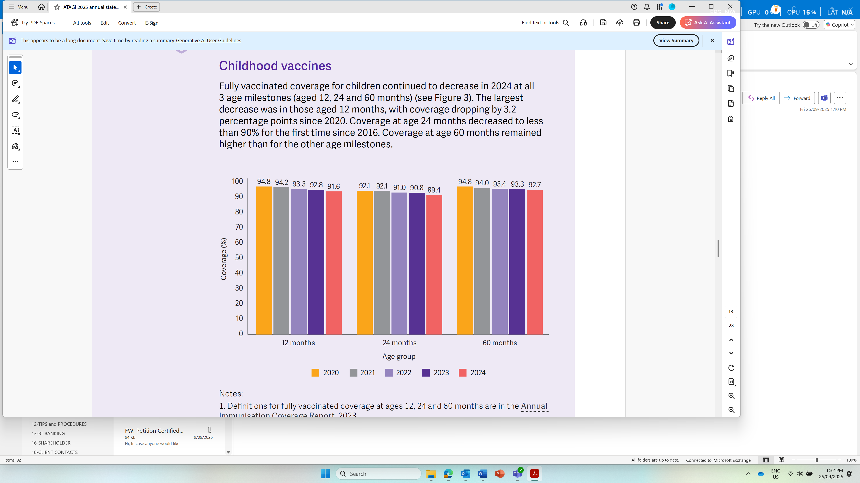

Notes:

1. Definitions for fully vaccinated coverage at ages 12, 24 and 60 months are in the [Annual Immunisation Coverage Report, 2023](https://ncirs.org.au/sites/default/files/2024-10/NCIRS%20Annual%20Immunisation%20Coverage%20Report%202023.pdf).

2. Data analysis by NCIRS using AIR data.

Figure 3 Fully vaccinated coverage (%) for children at milestone ages 12, 24 and 60 months, 2020 to 2024

In terms of timely uptake, a number of routine childhood vaccines [decreased slightly in 2024 compared with 2023](https://ncirs.org.au/sites/default/files/2024-10/NCIRS%20Annual%20Immunisation%20Coverage%20Report%202023.pdf), following a modest progressive general decline over 3 consecutive years, and remained lower than before the COVID-19 pandemic (see Figures 4 and 5). A marker of on-time vaccination in young children is the measurement of coverage within 1 month after the scheduled age of 4 months for the second dose of DTPa-containing vaccine (DTPa-2) and the scheduled age of 12 months for the first dose of MMR-containing vaccine (MMR-1).

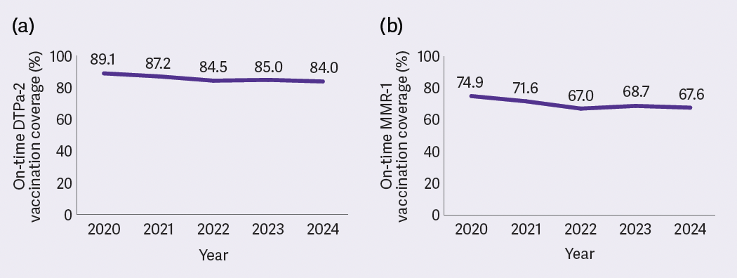

Notes:

1. On-time vaccination is within 30 days of the scheduled age (DTPa-2 is due at 4 months of age and MMR-1 is due at 12 months of age).

2. Data analysis by NCIRS using AIR data.

Figure 4 On-time vaccination coverage (%) for non-Indigenous children, 2020 to 2024: (a) DTPa-containing vaccine (second dose) and (b) MMR-containing vaccine (first dose)

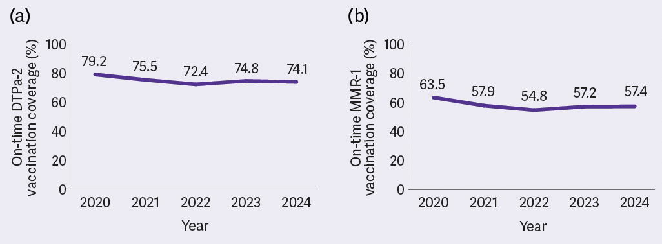

Notes:

1. On-time vaccination is within 30 days of the scheduled age (DTPa-2 is due at 4 months of age and MMR-1 is due at 12 months of age).

2. Data analysis by NCIRS using AIR data.

Figure 5 On-time vaccination coverage (%) for First Nations children, 2020 to 2024: (a) DTPa-containing vaccine (second dose) and (b) MMR-containing vaccine (first dose)

### Adolescent vaccines

Adolescent vaccines are mainly [delivered through school-based immunisation programs](https://www.ncirs.org.au/sites/default/files/2024-10/NCIRS%20Annual%20Immunisation%20Coverage%20Report%202023.pdf).

#### Human papillomavirus vaccine

The human papillomavirus (HPV) vaccination schedule under the NIP changed from 2 doses to 1 dose in 2023. From 2024, all Australian jurisdictions deliver HPV vaccination through the school-based vaccination program at year 7, after South Australia transitioned from delivery at year 8 to year 7 (noting that delivery included both year 7 and year 8 students in 2024) to align with other jurisdictions.

Coverage of at least 1 dose of HPV vaccine among adolescents turning 15 years of age showed a continual and progressive decline in 2024 compared with previous years. In 2024, coverage by 15 years of age among all adolescent females and males was 5.5 and 7.0 percentage points lower than in 2020, respectively (see Figure 6). Coverage for adolescent First Nations females and males was 11.1 and 13.8 percentage points lower than in 2020, respectively (see Figure 7).

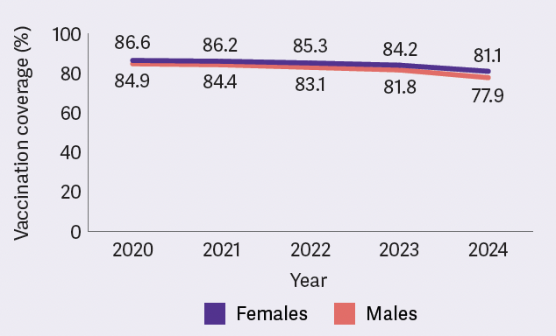

Note: Data analysis by NCIRS using AIR data.

Figure 6 HPV vaccine coverage (%) of at least 1 dose among all adolescents 15 years of age, 2020 to 2024

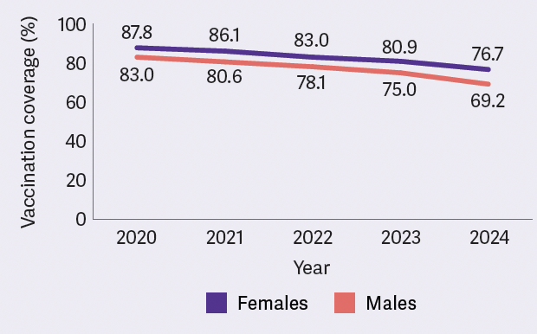

Note: Data analysis by NCIRS using AIR data.

Figure 7 HPV vaccine coverage (%) of at least 1 dose among First Nations adolescents 15 years of age, 2020 to 2024

Factors contributing to this decline likely include vaccine acceptance issues, absenteeism, access issues due to school closures during the COVID-19 pandemic, and other programmatic issues including less opportunity to receive vaccination through school-based vaccination program delivery due to the change in the HPV vaccine schedule from a 2-dose schedule to a [1-dose schedule](https://www.health.gov.au/news/changes-to-hpv-vaccine-dose-schedule-for-young-australians) from early 2023. Work is underway to better understand and address these issues.

Additionally, it is of concern that the coverage levels for these populations fell short of the national strategic target of [90% of all eligible people being vaccinated](https://www.health.gov.au/resources/publications/national-strategy-for-the-elimination-of-cervical-cancer-in-australia?language=en) against HPV by 2030, and the World Health Organization target of 90% coverage for females for attaining elimination of cervical cancer.

### Vaccines for older adults

#### Zoster (herpes zoster) vaccine

On 1 November 2023, the recombinant vaccine Shingrix (2-dose course) replaced the live attenuated vaccine Zostavax on the NIP for protection against herpes zoster. The eligible age was also lowered to ≥50 years for First Nations people and ≥65 years for other people. Adults aged ≥18 years who are immunocompromised were also included in the program in 2024, noting that Shingrix is safe for use for people in this age group at high risk, whereas Zostavax was contraindicated for use.

In 2024, 34.2% of adults ≥65 years who were eligible for NIP-funded Shingrix and 13.9% of First Nations adults aged 50 to 64 years who were eligible received at least 1 dose of Shingrix vaccine.

#### Pneumococcal vaccine

Since July 2020, the NIP offers free pneumococcal conjugate vaccine for eligible older adults, which includes all adults aged ≥70 years and First Nations people aged ≥50 years. The coverage of a single dose in all adults who turned 71 years of age progressively increased from 7.8% in 2020, to 23.9% in 2021, 33.8% in 2022, 37.6% in 2023 and 38.6% in 2024. The introduction of mandatory reporting of administration of NIP vaccines from mid-2021 likely contributed to some of these observed increases in coverage.

## Immunisation policy and practice across Australia

### Changes to the National Immunisation Program in 2024

In July 2024, the meningococcal ACWY conjugate vaccine MenQuadfi replaced Nimenrix [on the NIP schedule](https://www.health.gov.au/news/national-immunisation-program-nip-meningococcal-acwy-changes-from-1-july-2024) for adolescents aged 14 to 16 years and people aged 15 to 19 years on catch-up programs. Nimenrix will continue to be available through the NIP for children aged 12 months and for people with medical risk conditions.

In September 2024, [NIP eligibility for Shingrix vaccination was expanded](https://www.health.gov.au/resources/publications/national-immunisation-program-shingles-vaccination-program-advice-for-health-professionals-september-2024) to include all people aged ≥18 years who are immunocompromised due to an underlying health condition and or immunomodulatory/immunosuppressive treatments associated with moderate to high risk of severe infection or complications from shingles.

### Expanded pharmacist vaccination program

The [National Immunisation Program Vaccination in Pharmacy (NIPVIP) program](https://www.ppaonline.com.au/wp-content/uploads/2023/11/NIPVIP-Program-Rules.pdf) started in January 2024, and allows community pharmacies to administer NIP vaccines to eligible people aged ≥5 years without any out-of-pocket costs. The program, funded through the NIP, was expanded in April 2024 to include off-site administration of NIP vaccines in aged care facilities and specialist disability accommodation. The vaccines that pharmacists can administer depend on the [state or territory legislation](https://ncirs.org.au/fact-sheets-faqs/vaccines-from-community-pharmacy).

As the national funding for the NIPVIP expands, ATAGI considers it essential to monitor and evaluate key aspects of this policy and program, especially those aspects that improve equitable access to vaccination services for various populations.

### No-fault vaccine compensation scheme

The [COVID-19 Vaccine Claims Scheme](https://www.health.gov.au/our-work/covid-19-vaccine-claims-scheme#updates-to-the-scheme) ended on 30 September 2024. The scheme allowed people to claim compensation for injuries resulting from diagnosed clinical conditions likely to be caused by a TGA-approved COVID-19 vaccine or its administration. Such serious injuries are very rare. As proposed in the [NIS 2025–2030](https://www.health.gov.au/resources/publications/national-immunisation-strategy-for-australia-2025-2030?language=en), this period offers an opportunity to explore the feasibility of a no-fault compensation scheme that covers all vaccines on the NIP.

### Major additions or updates to the Australian Immunisation Handbook in 2024

The [mpox chapter](https://immunisationhandbook.health.gov.au/contents/vaccine-preventable-diseases/mpox-previously-known-as-monkeypox) was added, and was subsequently updated to remove the age restriction in initial mpox vaccination recommendations.

The [RSV chapter](https://immunisationhandbook.health.gov.au/contents/vaccine-preventable-diseases/respiratory-syncytial-virus-rsv) was added. This chapter consolidated and followed on from previous ATAGI clinical guidance statements to provide updated information on recommendations and guidance for use of RSV immunisation products. Recommendations include use of RSV vaccines in adults and pregnant women, and use of long-acting RSV monoclonal antibodies in infants and young children.

The [zoster (herpes zoster) chapter](https://immunisationhandbook.health.gov.au/contents/vaccine-preventable-diseases/zoster-herpes-zoster) was updated to reflect that eligibility for NIP-funded Shingrix vaccine was expanded to include people aged ≥18 years with moderate to severe immunocompromise. The new [table on risk conditions and immunosuppressive therapies for zoster vaccination and eligibility for NIP funding](https://immunisationhandbook.health.gov.au/resources/tables/table-risk-conditions-and-immunosuppressive-therapies-for-zoster-vaccination-and-eligibility-for-nip-funding) outlines the major risk categories and funding status.

The section on [vaccination for people who are immunocompromised](https://immunisationhandbook.health.gov.au/contents/vaccination-for-special-risk-groups/vaccination-for-people-who-are-immunocompromised) was updated to include new vaccine recommendations relevant for this special population group. Additional updates in this section have been published in 2025.

Readers are advised to regularly check for updated guidelines on the online [Australian Immunisation Handbook](https://immunisationhandbook.health.gov.au/).

## New vaccines and potential vaccination programs

The TGA registered three new vaccines in 2024 (see Table 2).

Table 2 New vaccines and immunisation products registered with the TGA, 2024

|  |  |  |  |
| --- | --- | --- | --- |
| Vaccine brand name | Description | Protects against | Eligible population for use |
| Arexvy | Recombinant RSV protein vaccine | Lower respiratory tract disease caused by RSV | Adults aged ≥60 years |
| Abrysvo | Recombinant RSV protein vaccine | Lower respiratory tract disease caused by RSV | Adults aged ≥60 years  Pregnant women between 24 and 36 weeks gestation, for the prevention of lower respiratory tract disease caused by RSV in infants from birth through to 6 months of age |
| COMIRNATY JN.1 | mRNA COVID-19 vaccine | COVID-19 caused by SARS-CoV-2 | People aged ≥6 months |

Note: For more information on the current status of COVID-19 vaccines in Australia, see the [TGA COVID-19 vaccines regulatory status](https://www.tga.gov.au/products/covid-19/covid-19-vaccines/covid-19-vaccines-regulatory-status).

### Combination vaccines for respiratory viruses and other immunisation products under development

Combination mRNA vaccines that target several respiratory viruses in a single vaccine are under development. Examples include combination influenza and COVID-19 vaccines, and combination RSV and human metapneumovirus (hMPV) vaccines.

ATAGI continues to monitor the development of these and many other vaccines and immunisation products, such as:

* multiple candidates of pneumococcal vaccines with extended valency, some of which include more than 30 serotypes
* additional long-acting monoclonal antibodies for the prevention of severe RSV disease in infants
* vaccines against group B Streptococcus disease
* vaccines against cytomegalovirus (CMV) disease.

## Vaccine safety

The TGA has overall responsibility for vaccine safety surveillance in Australia and oversees both active and passive vaccine safety surveillance activities. ATAGI continues to work closely with the TGA to advise on and promote the safe use of all vaccines.

No major new vaccine safety issues were identified in 2024. Noteworthy updates on safety information regarding the recombinant herpes zoster vaccine, RSV vaccine and mRNA COVID-19 vaccines are summarised below.

### Recombinant herpes zoster vaccine Shingrix

The recombinant protein subunit (non-live) herpes zoster vaccine Shingrix has been on the NIP since November 2023. No serious safety concerns with Shingrix were identified from preliminary [AusVaxSafety data](https://ausvaxsafety.org.au/vaccine-safety-data/shingrixr) (current to 31 December 2024) from more than 120,000 vaccine recipients in Australia. Less than 1% of people who received Shingrix on its own and less than 1% of people who received Shingrix with another vaccine reported visiting a doctor or the emergency department in the days after vaccination.

In October 2024, the [TGA issued a statement](https://www.tga.gov.au/news/safety-updates/shingrix-vaccine-and-very-rare-risk-guillain-barre-syndrome) recognising Guillain–Barré syndrome (GBS), a neurological condition, as a very rare adverse event after Shingrix vaccination. Post-marketing data among adults aged ≥65 years from the United States suggested an increased risk of occurrence of GBS within 42 days after Shingrix vaccination, estimated at 3 additional cases per million doses administered over the expected baseline rate. As at 18 September 2024, the TGA had received 13 reports of GBS after Shingrix vaccination. No deaths were reported.

### Respiratory syncytial virus vaccine use in older adults and pregnant women and nirsevimab use in infants

The recombinant RSV protein vaccine Arexvy was registered with the TGA in January 2024 and is available by private prescription. No serious safety concerns were identified from preliminary [AusVaxSafety data](https://ausvaxsafety.org.au/rsv-vaccines/arexvyr-rsv-vaccine-safety-data-older-adults) (current to 31 January 2025) from more than 2,400 adults aged ≥60 years who had received Arexvy. Less than 1% of these adults reported visiting a doctor or the emergency department in the days after vaccination.

AusVaxSafety did not report in 2024 on the use of the Abrysvo RSV vaccine among pregnant individuals and older adults, due to its very limited use that year. Reporting is occurring from 2025 onwards. [Clinical trials](https://pubmed.ncbi.nlm.nih.gov/37018474/) showed that between pregnant women who received Abrysvo and those who received placebo, there was little to no difference in the rates of serious adverse events among these women or their pregnancy outcomes, or serious adverse events in infants born to these women. Ongoing monitoring for select adverse events of special interest, including any differences in rates of preterm birth after vaccination – which were observed in one phase 3 clinical trial site in a non-high-income country – will continue as real-world usage increases.

[AusVaxSafety](https://ausvaxsafety.org.au/vaccine-safety-data/nirsevimab) conducted active safety surveillance of nirsevimab at participating sites in New South Wales and Queensland during the 2024 winter season. Active safety surveillance was also undertaken in the [Western Australian RSV immunisation program for infants](https://pubmed.ncbi.nlm.nih.gov/39773919/). No safety signals occurred; however, available numbers were limited, and safety monitoring continues.

**Therapeutic Goods Administration statement on misinformation about mRNA vaccines**

In October 2024, the TGA released a [statement](https://www.tga.gov.au/news/media-releases/addressing-misinformation-about-excessive-dna-mrna-vaccines) that refuted misleading claims about excessive levels of DNA in COVID-19 mRNA vaccines. The statement outlined the limitations in the methods and potential flaws in the interpretation of the scientific data that underpinned these claims, and also emphasised the importance of ongoing vaccine safety monitoring. Additionally, in November 2024, the TGA released a [statement](https://www.tga.gov.au/resources/publication/tga-laboratory-testing-reports/summary-report-residual-dna-and-endotoxin-covid-19-mrna-vaccines-conducted-tga-laboratories) on its independent testing of mRNA vaccines for residual DNA and endotoxins, which showed that the approved vaccines used in Australia are within the safe limit.

# Challenges and priorities for immunisation in Australia in 2025 and beyond

## Key challenges for preventing and controlling vaccine-preventable diseases through immunisation

Key challenges are:

* maintaining high-quality, efficient assessment of vaccines and other immunisation products, including through disease modelling where relevant, to support development of immunisation policies and impactful, cost-effective and equitable programs that maximise disease prevention in the population
* monitoring the impact of new vaccine introductions, for example, Australia’s approach to RSV prevention in infants in 2025, with a world-leading combined maternal and infant immunisation program
* maintaining rapid vaccine-related policy advice for emerging and re-emerging VPDs, such as measles, mpox and Japanese encephalitis, in collaboration with key stakeholders
* understanding the key drivers of declining vaccination coverage for a number of vaccines, and recommending evidence-informed policy and program measures to mitigate the trend
* ensuring that policies consider barriers to immunisation and address equitable access to NIP-funded vaccines in diverse settings and populations, especially those with increased risks of VPDs
* ensuring equitable access to NIP-funded vaccines for First Nations communities and developing immunisation policies that reflect the diverse experiences of First Nations communities across Australia, including through incorporating feedback from representative groups such as the National Aboriginal and Torres Strait Islander Health Protection (NATSIHP) subcommittee of the Australian Health Protection Committee (AHPC)
* acquiring and using timely and accurate data on the epidemiology of VPDs, the impacts of immunisation programs and the immunisation coverage of populations with increased risks of VPDs, to ensure the best-informed approaches to immunisation policy.

## ATAGI’s priority actions for 2025

ATAGI’s priority actions are to:

* continue working on advice on the ongoing priorities of equity and accessibility of vaccines to improve coverage in all populations including special populations, maintaining the Australian Immunisation Handbook, and scoping and horizon scanning
* advise on a national maternal and infant RSV immunisation program rollout
* review frameworks for evaluation of new products, including surveillance and development of the evidence base for new vaccines, such as CMV and hMPV
* continue to monitor the decreasing coverage trends of some vaccines to inform potential additional strategies for controlling these VPDs in Australia
* monitor development of vaccines in the pipeline, monitoring and evaluation of VPD disease prevention and control methods, and social and behavioural insights to inform immunisation policy, practice and recommendations
* continue to monitor epidemiology and availability of vaccine products and advice around an optimal schedule, particularly for RSV and pneumococcal disease
* monitor impacts of schedule changes on vaccine coverage and disease epidemiology – for example, the change to a 1-dose HPV schedule in 2023
* provide further advice on the transition from quadrivalent influenza vaccine (QIV) to trivalent influenza vaccine (TIV) for the influenza vaccination program, in the context of the global absence of the influenza B/Yamagata lineage
* prepare for providing advice on use of vaccines for prevention and control of outbreaks or pandemics of HPAI in humans, as required
* continue to recommend a review of the feasibility of establishing a vaccine compensation scheme that covers all NIP-funded vaccines, taking into account the experience of the COVID-19 Vaccine Claims Scheme and international best practice
* collaborate with key stakeholders and other committees to provide a streamlined approach for appraisal of vaccines for developing immunisation policies and evaluation of vaccination programs
* maintain, and if possible extend, engagement with the national immunisation technical advisory groups (NITAGs) of key overseas countries to enhance sharing of experience and lessons learnt with respect to developing immunisation policies and programs, such as those on RSV, pneumococcal disease or influenza – this includes working with regional NITAGs, such as the recently established [NITAG in New Zealand](https://www.health.govt.nz/information-releases/national-immunisation-technical-advisory-group-nitag).