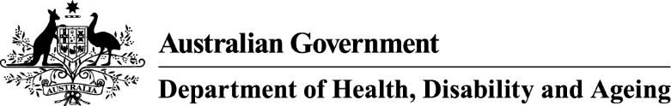

Privacy notice

AT-HM scheme data collection – APP 5 notice
Your personal information is protected by law, including the Privacy Act 1988 and the Australian Privacy Principles (APPs).

Who is collecting your personal information?
Your personal information is being collected by your aged care provider on behalf of the Department of Health, Disability and Ageing (the department/we).

Why does the department collect your personal information?
We collect your personal information for the primary purpose of assessing your assistive technology and/or home modification needs. We need to undertake this assessment in order to approve you for an Assistive Technology and/or Home Modifications (AT-HM) funding tier for the AT-HM scheme under the Support at Home program.
We may also use your personal information for research purposes to better understand the use and effectiveness of assistive technology and home modifications for Home Care Package participants transitioning to the Support at Home program from 1 November 2025.

What would happen if the department did not collect your personal information?
If you do not or are unable to provide your personal information to the department and you require funding to meet your assistive technology and or home modification needs, then you may apply for a Support Plan Review or an aged care needs reassessment to be allocated funding. However, this may mean a delay in receiving funding.

Who will the department disclose your personal information to?
We will disclose your personal information to Services Australia who will credit your AT-HM scheme account/s with any funding tier allocated as a result of the information collected in the AT-HM scheme data collection process.

Access to and correction of your personal information
The department’s privacy policy contains information about how you may access and seek correction of your personal information.

Privacy complaints
The department’s privacy policy contains information about how you may complain about a breach of the Australian Privacy Principles or the Australian Government Agencies Privacy Code and how the department will deal with complaints.

Overseas disclosure of your personal information
We will not disclose your personal information to any overseas recipients.

Further information
You can read the department’s privacy policy. You can obtain a copy of the APP privacy policy by contacting the department using the contact details set out at the end of this notice.

Consent
By providing your sensitive information to us, you consent to the Department of Health, Disability and Ageing collecting healthcare information about you for the purposes indicated above.
By providing your personal information to your aged care provider, you consent to the Department of Health, Disability and Ageing collecting this personal information about you from your aged care provider.
If you are providing the department with personal information about another individual, unless you are authorised to consent on their behalf, you will need to inform that individual of the contents of this notice, and obtain their consent to the department collecting their personal information.

Contact details
If you wish to contact the department about a privacy-related matter, including questions about this notice, please contact the department’s Privacy Officer by one of the following methods:
- Post
Privacy Officer
Department of Health, Disability and Ageing
23 Furzer Street
WODEN ACT 2606
- Email
privacy@health.gov.au
- Telephone
02 6289 1555

