Assistive Technology and Home Modifications (AT-HM) scheme

**Data collection**  
Guidance for providers

# About this document

This document provides guidance for providers on submitting funding requests for the assistive technology and home modifications needs of their Home Care Packages (HCP) care recipients transitioning to Support at Home. The guidance is for staff of approved organisations providing home care services.

Table of Contents

About this document 3

1. Summary 4

2. Data collection timeline 5

3. The AT-HM scheme 6

4. Participant scenarios 8

5. Preparation 12

6. Consolidate and submit 15

7. Department processing 19

8. Further guidance and support 20

# Summary

The Assistive Technology and Home Modifications (AT-HM) scheme commences with Support at Home from 1 November 2025. All transitioned HCP participants will have approval to access the AT-HM scheme without a new aged care assessment.

The AT-HM scheme data collection process is a temporary pathway for providers to support their transitioning participants. If a transitioned HCP participant has no or insufficient HCP unspent funds for their assistive technology or home modifications needs, providers will be able to request a funding tier for them directly with the department via the data collection instead of via an individual Support Plan Review.

Transitioned participants can request AT-HM funding to use in combination with their HCP unspent funds, or stand-alone where no HCP unspent funds remain. However, any HCP unspent funds must be fully expended before the new AT-HM funding can be drawn upon.

The AT-HM scheme data collection will runfrom **October 2025** to **February 2026.**

You can also use the AT-HM data collection to make bulk requests. This is the preferred method for accessing AT-HM funding for transitioned participants and will ensure you can get prompt funding approvals for participants and reduce pressure on the assessment system.

You will need to provide brief information on your transitioned participants in a submission spreadsheet that you will upload securely via the [Health Data Portal](https://dataportal.health.gov.au/wps/portal/register/!ut/p/z1/04_Sj9CPykssy0xPLMnMz0vMAfIjo8ziTT29PQ1MDIy8DXxdTAwcLU1NAy1NPQ3cw0z1wwkpiAJKG-AAjgZA_VGElHjpR6Xn5CdBXOOYl2Rska4fVZSallqUWqRXWgQUzigpKSi2UjVQNSgvL9dLysxL10vOz1U1wKYhI7-4RD8CWZ1-QW6EgW5UUmW5o6IiAPdYTtE!/dz/d5/L2dBISEvZ0FBIS9nQSEh/). You also need to attach supporting evidence to participants’ client records via the [My Aged Care Service and Support Portal](https://www.health.gov.au/resources/apps-and-tools/my-aged-care-service-and-support-portal).

You can only use this temporary process once for each transitioned participant. Any future requests will require a Support Plan Review.

To enable the department to process requests in a timely manner, you need to:

* nominate a collection coordinator/s, who will need to register for access to the Health Data Portal
* prepare to coordinate bulk submission spreadsheets within your organisation either at a whole-of-organisation or outlet level
* submit requests as soon as possible when submissions open
* ensure care partners/managers have uploaded supporting evidence for your requests in the My Aged Care Service and Support Portal to avoid requests for further information.

See ***Section 13.2.1 Transitioned HCP care recipients and access to AT-HM***in the [Support at Home program manual](https://www.health.gov.au/resources/publications/support-at-home-program-manual-a-guide-for-registered-providers?language=en) for further information.

# Data collection timeline

The high-level timeline and steps for the AT-HM scheme data collection.

|  |
| --- |
| **Preparation – October 2025** |
| * Identify collection coordinators within your organisation/outlet. * Collection coordinators register for the Health Data Portal and request submission folder access from [ATHMTransition@health.gov.au](mailto:ATHMTransition@health.gov.au). * Care partners/managers identify transitioning participants who are likely to have insufficient unspent HCP funds to meet their AT-HM needs under Support at Home. |
| **Consolidate and submit – from October 2025** |
| * Care partners/managers:   + confirm AT-HM needs of transitioning participants and gain consent for the data collection process   + attach supporting evidence to client records in the My Aged Care Service and Support Portal   + advise coordinators of information and AT-HM needs for transitioning participants. * Coordinators:   + submit bulk requests to the department regularly   + respond to department requests for information   + receive bulk outcome notifications from the department. * The department:   + processes requests   + notifies providers and uploads approval letters (Notices of Decision) to the client records on My Aged Care   + advises Services Australia of new AT or HM funding tiers. |
| **Process retirement – from February 2026** |
| * The department closes data collection submissions and finalises in-hand requests. * Providers move to raising Support Plan Reviews for transitioned participants requiring further AT-HM funding. |

# The AT-HM scheme

## Funding tiers

The table below summarises the AT-HM scheme funding tiers.

See *Section 13.0 Assistive Technology and Home Modifications (AT-HM) scheme* of the [Support at Home program manual](https://www.health.gov.au/resources/publications/support-at-home-program-manual-a-guide-for-registered-providers?language=en) for full details of the scheme.

| **Funding tier** | **Funding allocation cap** | **Funding period** |
| --- | --- | --- |
| **Assistive technology** | | |
| Low | $500 | 12 months |
| Medium | $2,000 | 12 months |
| High | $15,0001 + | 12 months |
| 1 Products and equipment with costs greater than $15,000 are available to participants with a prescribed need.  People with eligible progressive conditions may be allocated funding for 24 months. | | |
| **Home modifications** | | |
| Low | $500 | 12 months |
| Medium | $2,000 | 12 months |
| High | $15,000 | 12 months2 |
| 2 Funding may be extended for an additional 12 months to complete complex home modifications (24 months in total) if evidence is provided to Services Australia. | | |
| **Other funding** | | |
| Assistance dog maintenance | $2,000 per year | Ongoing3 |
| 3 Funding for assistance dog maintenance will be automatically allocated every 12 months; however, the funding cannot accrue or rollover. | | |

#### AT-HM list

The [Assistive Technology and Home Modifications list (AT-HM list)](https://www.health.gov.au/resources/publications/assistive-technology-and-home-modifications-list-at-hm-list?language=en) defines the products, equipment and home modifications that are available for Support at Home participants under the AT-HM scheme.

AT-HM funding may only be used for products, equipment and home modifications on this list where it optimises the participant’s functioning or manages their disability or age-related functional decline. Prescription and wraparound services for AT-HM may also be funded by the AT-HM scheme.

Providers should ensure funding requests are for items from the AT-HM list, prescription, wrap around services or services related to the installation of home modifications.

See *Section 13.5 AT-HM list* of the [Support at Home program manual](https://www.health.gov.au/resources/publications/support-at-home-program-manual-a-guide-for-registered-providers?language=en) and supplementary AT-HM Guidelines for full details.

# Participant scenarios

These examples illustrate some of the common scenarios that may apply to transitioning participants with AT-HM needs.

## Image of Jun who has unspent funds for Assistive Technology.Jun

**Unspent funds for AT**

Jun is a pensioner who will transition from the Home Care Packages (HCP) Program to Support at Home on 1 November 2025. He has been on his Home Care Package since 2022 and has been saving up funds for a motorised scooter that he has been prescribed to support his mobility.

Because Jun is a HCP care recipient, he will be automatically approved for the AT-HM scheme. Working with his provider, Jun needs to consider if he requires additional AT-HM funding.

Jun’s provider checks if he has adequate HCP unspent funds to pay for the item. The provider must consider wraparound services (such as training, delivery and administrative costs). The provider determines that Jun has adequate HCP unspent funds to cover the cost of the mobility scooter and wraparound services.

Jun does not need to be included in the AT-HM scheme data collection.

Jun can use his HCP unspent funds under Support at Home to buy his mobility scooter when he is ready.

If Jun’s needs change and he requires additional funding for supports, his provider can request a Support Plan Review.

Image of Bindi who has unspent funds for home modifications.
**Bindi**

**Unspent funds for HM**

Bindi is a part pensioner and will transition from the Home Care Packages (HCP) Program to Support at Home on 1 November 2025. Bindi has been saving up funds to pay for a home modification in her bathroom that she requires to shower at home safely and independently.

Bindi has a prescription outlining the home modifications that she needs. Because Bindi is a HCP care recipient she will be automatically approved for the AT-HM scheme. Bindi and her provider need to consider if she has adequate HCP unspent funds for her HM needs.

As Bindi was approved for her Home Care Package in January 2025, she also needs to understand any contribution she may need to pay.

Bindi’s provider reviews the cost of her planned home modification and determines she does not have adequate unspent HCP funds to cover the cost. The provider determines that Bindi will require a high HM funding tier to cover the full cost. Bindi’s provider gets her consent to include her in the AT-HM scheme data collection. Bindi’s provider also explains to her the lifetime limits on the high HM funding tier and her contributions.

Bindi’s provider submits her AT-HM needs as part of a bulk submission for the AT-‑HM scheme data collection. Bindi’s provider also uploads supporting evidence, including a prescription for the modifications and quote from a builder.

The department processes the request and approves the high HM funding tier, allowing Bindi to go ahead with her bathroom modification.

If Bindi’s needs change and she requires additional supports, her provider can request a Support Plan Review.

## Image of Mary who has a progressive condition.Mary

**Progressive condition**

Mary is a full pensioner and will transition from the Home Care Packages (HCP) Program to Support at Home on 1 November 2025. Following a stroke in April 2024, Mary acquired a spinal cord injury resulting in quadriplegia. Mary has a wheelchair under her HCP, but she has also been assessed as needing a powered, stair-climbing transporter to support her mobility.

Because Mary is a HCP care recipient, she will automatically be approved for the AT‑HM scheme.

Mary’s provider reviews the cost of her AT needs and determines she will not have adequate HCP unspent funds to pay for the transporter, including the cost of the occupational therapist to support her to learn to use the equipment.

As Mary was a HCP care recipient before 12 September 2024 and has not had to pay an income-tested care fee under the HCP Program, she will not pay a contribution towards her assistive technology.

Mary’s provider gains her consent to include her in the AT-HM scheme data collection, attaching her prescriptions to her record. Her provider notes Mary’s progressive condition in the form (spinal cord injury).

The department processes the request and approves the additional funding, giving Mary an increased 24-month expiry date on her funding tier due to her progressive condition.

Mary’s provider goes ahead and organises her transporter and occupational therapist.

If Mary’s needs change and she requires additional supports, her provider can request a Support Plan Review.

## Image of Sally who has recently been allocated a Home Care Package.Sally

**Recently allocated package**

Sally was approved for a Home Care Package (HCP) in 2024 and was allocated a Support at Home package at a transitioned HCP classification on 1 December 2025.  
In developing her initial Care Plan, her provider identifies that Sally likely needs some assistive technology but needs to be assessed by an Occupational Therapist to determine the right supports.

As Sally was allocated her package after 1 November 2025, she does not have any unspent HCP funds, but she is also unable to use her main Support at Home package funds for her assistive technology needs. Because her provider does not have prescription or supporting evidence for her AT needs, they cannot request a medium or high AT funding tier via the AT-HM data collection process. They request a low AT funding tier and attach her initial Care Plan in support of their request so she can get the OT assessment she needs and receive some low-risk supports from the AT-HM Service List.

The department approves the low funding tier with the initial Care Plan, allowing Sally’s provider to book her into an OT assessment where she is prescribed a range of items. Her provider requests a Support Plan Review with an assessor to seek an increase in her AT funding tier, attaching her recent prescriptions in support.

# Preparation

## Provider roles and responsibilities

The department recommends that providers nominate a coordinator to manage the AT-HM data collection process in their organisation or outlet.

Coordinators are considered equivalent to Team Leaders in the My Aged Care Service and Support Portal – see [Roles in the Service and Support Portal.](https://www.health.gov.au/sites/default/files/2025-03/my-aged-care-service-and-support-portal-user-guide-part-2-team-leader-and-staff-member.pdf)

Care partners/managers are responsible for client engagement on AT-HM needs, likely as part of care planning and service agreement development for Support at Home.

|  |  |
| --- | --- |
| Role | **Responsibilities** |
| Data collection coordinators  (Equivalent to Team Leader role in My Aged Care Service and Support Portal) | Register for Health Data Portal.Coordinate submissions from care partners/managers and seek confirmation from them that evidence has been attached to client records.Submit requests to the department regularly e.g. initial bulk submission, then weekly.Respond to department requests for information.Receive outcome notifications from the department and distribute to care partners/managers as required. |
| Care partners/ managers  (Equivalent to Team Leader or Staff roles in My Aged Care Service and Support Portal) | Confirm client AT-HM needs and gain consent to participate in AT-HM data collection process.Attach supporting evidence to client records in My Aged Care Service and Support Portal.Advise coordinators of participant information and AT-HM needs to include in the AT-HM data collection process. |

## Coordinator registration for the Health Data Portal

The [Health Data Portal](https://dataportal.health.gov.au/wps/portal/register/!ut/p/z1/04_Sj9CPykssy0xPLMnMz0vMAfIjo8ziTT29PQ1MDIy8DXxdTAwcLU1NAy1NPQ3cw0z1wwkpiAJKG-AAjgZA_VGElHjpR6Xn5CdBXOOYl2Rska4fVZSallqUWqRXWgQUzigpKSi2UjVQNSgvL9dLysxL10vOz1U1wKYhI7-4RD8CWZ1-QW6EgW5UUmW5o6IiAPdYTtE!/dz/d5/L2dBISEvZ0FBIS9nQSEh/) is used by the department to undertake data-related activities. The portal is safe, secure and authenticated through myGovID or VANguard FAS.

You can register using one of the following 2 methods, depending on your organisation’s requirements:

* **MyID/RAM** (most common method)
* **VanGuard FAS**

These 3 user guides can assist with the registration process:

* [User Guide – Set up your Organisation in the RAM (Principal Authority) – [PDF]](https://dataportal.health.gov.au/wps/wcm/connect/dataportal/de2778c3-574c-4dfb-89f2-52804df57a97/user-guide-how-to-set-up-your-organisation-in-relationship-authorisation-manager.pdf?MOD=AJPERES)
* [QRG - Register for and Log in to the Health Data Portal – [PDF]](https://dataportal.health.gov.au/wps/wcm/connect/dataportal/3831be95-bf6a-469b-8fec-ab1369b56942/QRG+-+Register+for+and+Log+in+to+the+Health+Data+Portal.pdf?MOD=AJPERES)
* [QRG – Get Started in the Health Data Portal – [PDF]](https://dataportal.health.gov.au/wps/wcm/connect/dataportal/04cf42af-3c73-47b7-b86c-1c0a7eee8518/QRG+-+Get+Started+in+the+Health+Data+Portal.pdf?MOD=AJPERES)

When registering, all users need to nominate the AT-HM folder from the dropdown list, titled ***Home Care Transition to Assistive Technology and Home Modifications scheme***, then proceed to finalise their registration. This is to ensure that the department is notified of the user’s registration.

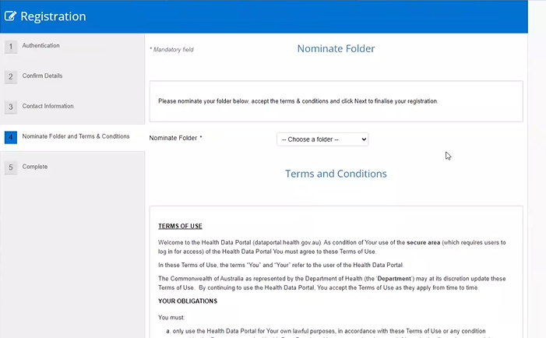

For further information and guidance on how to setup and use the Health Data Portal, please see the [User Help page](https://dataportal.health.gov.au/wps/portal/dataportalcontent/usersupport/userhelphdp/!ut/p/z1/nZFBU4MwEIX_ij30mMlCkwJHbB2htFZGa0sunQix4EBIIa3WX2-wOuNFHN3bm33ZffsFM7zBTPJjseO6qCUvjU7YeEvDKAQCdgSLKQHfozT2aAhu5OD1hwF-KB8w63__gBlmKi0ynDjEcejjCBAFy0WEjEfIc90xSh0qMo9CJjjp3KnUSuc4ybjmqm40Ly_SWmoh9RDaU6tFNYRDK5r2oLr2WeSiVHmmPvP2BGL956y7BP2WxKxwttZyAsGMwHx5TyjEENtX08ACsM2MYyFe8ErWTWUQ3_2RQAB49htV8212s5gsdmYy1zkq5FONN9-gnMUXFGMvnvd75hu4HclX0_8XXVWtKnd0QvLt8gZdr2_n_mDwDjBJuVk!/dz/d5/L2dBISEvZ0FBIS9nQSEh/).

Once you have registered, the department receives a notification of your account details and will grant you access to an Aged Care Planning Region (ACPR) Sub Folder in the AT-HM Health Data Portal. If the department identifies several locations based on your registration information, you may be granted access to more than one Sub Folder to pick from to make your submission.

This can take 24 hours to action. If you do not receive access within 24 hours, you can email [ATHMtransition@health.gov.au](mailto:ATHMtransition@health.gov.au) with the organisation name and email address included.

If multiple people in your organisation have registered, you can send through a list of email addresses to request access. The department will respond via email to confirm your access has been granted.

For guidance on uploading data to the Health Data Portal, refer to the section titled Upload forms to the Health Data Portal.

## Prepare supporting evidence

Care partners/managers should arrange required assessments from health professionals for supporting evidence ahead of time using HCP funding where possible. Supporting evidence may include prescriptions and quotes, including from health professionals like occupational therapists.

# Consolidate and submit

## Bulk submissions

Bulk submissions are preferred as this will assist the department to process requests in a timely manner via this temporary data collection process. Data collection coordinators should aim to consolidate requests and submit regularly to the department.

While providers can make multiple bulk submissions through to February 2026, providers can only include a transitioned participant in the data collection process once. For transitioned participants who require additional funding after your original data collection submission, you will need to request a Support Plan Review.

## Consent

You can only include a transitioned participant in the AT-HM data collection with their consent. You should explain the purpose of the data collection and provide the older person with a copy of the collection privacy notice (Attachment A).

## Unspent funds

If a transitioning participant has sufficient unspent HCP funds to cover their AT-HM needs under Support at Home, they do not need to be included in the data collection process. Transitioned participants must first use any remaining unspent HCP funds before they can access AT and HM funding tiers under Support at Home.

## Supporting evidence

All requests for funding tiers must be accompanied by supporting evidence to assist the department to assess requests. Evidence needs to be attached to the client record in the My Aged Care Service and Support Portal.

See [My Aged Care – Service and Support Portal user guide – The client record](https://www.health.gov.au/resources/publications/my-aged-care-service-and-support-portal-user-guide-the-client-record?language=en).

Appropriate evidence includes:

* AT-HM quotes and/or invoices.
* a prescription from a suitably qualified health professional if requesting funding for the medium or high funding tiers (over $500).

Separate evidence is not required for wraparound services for items.

Before 1 November 2025, upload evidence under the **SP Care Plan** attachment type.

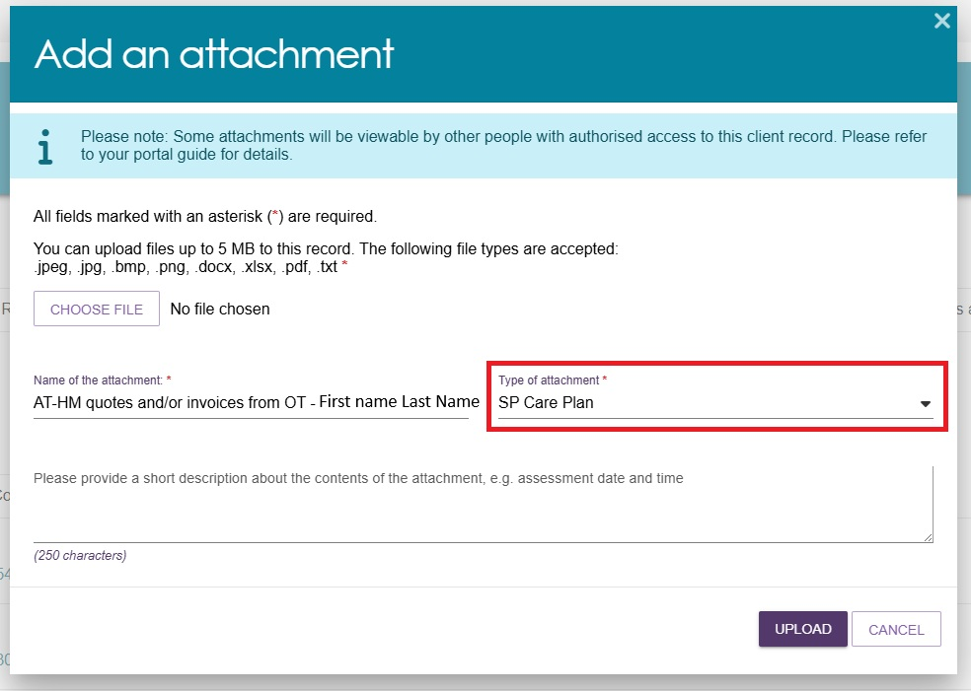

From 1 November 2025 onwards, documents can be identified more clearly using the following new attachment types:

* **AT prescription**
* **AT quote**
* **HM prescription**
* **HM quote.**

Example of new attachment types being introduced from 1 November 2025.

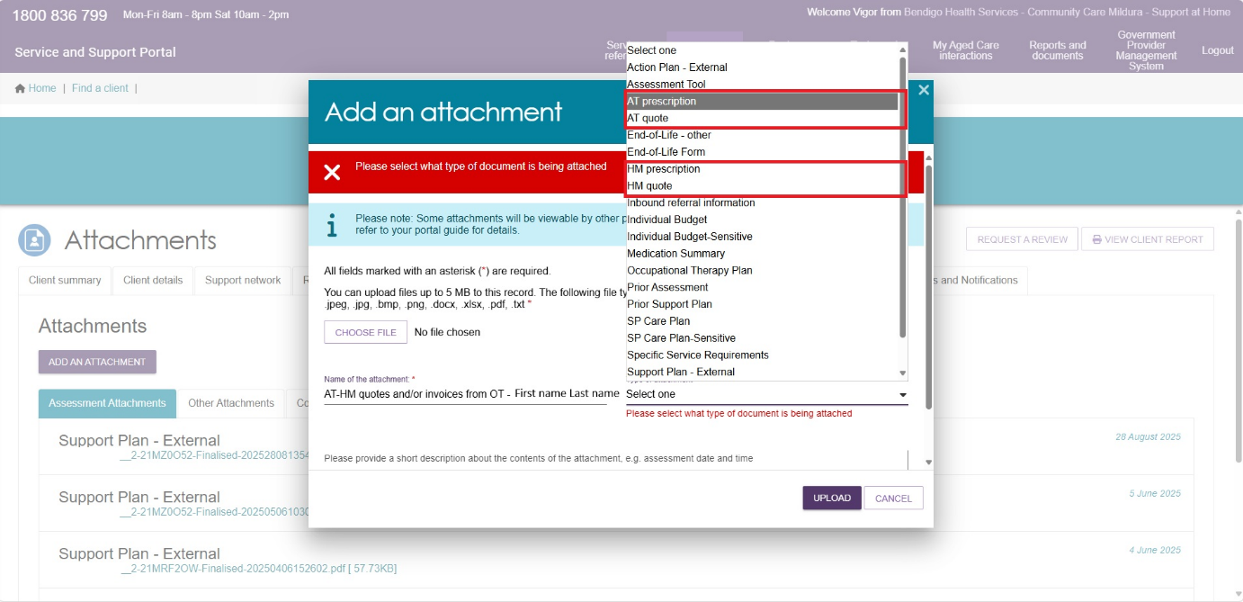

Where a transitioned participant with a recent package allocation does not have HCP unspent funds for assessments to get prescriptions (e.g. with an Occupational Therapist), a **low** funding tier can be requested, supported by the participant’s Care Plan only, to arrange these assessments.

The requirement to attach supporting evidence to client records in the My Aged Care Service and Support Portal for the data collection process is aligned to the ongoing evidence requirements for Support Plan Reviews for AT-HM funding tiers.

## Consolidating requests in the AT-HM data collection form

Ensure each participant’s name and Aged Care ID are correct and all applicable columns are complete, including information on any participants with progressive conditions or assistance dogs.

## Upload forms to the Health Data Portal

1. [Navigate to the portal](https://sso.dataportal.central.health) on your web browser and login with your credentials.
2. To the left of the screen, select **New** and select **Asset for Submission**.

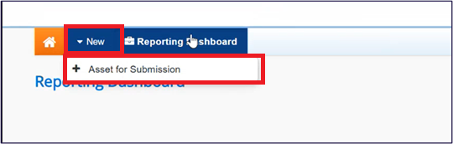

1. Complete the mandatory fields, ensuring the folder fields are entered as:

* **Folder** – Home Care Transition to Assistive Technology and Home Modifications Scheme.
* **Sub-Folder** – the state/territory of your organisation*.*
* **Sub-Sub-Folder** – the Aged Care Planning Region of your outlet. If your organisation is coordinating at a whole-of-organisation level, please select the ACPR the main coordinators work in, if your organisation is coordinating at an outlet level, coordinators should select the primary ACPR they work in.

Please note that the **Sub Folder** you upload your submission is simply an organisation step for Health Data Portal and does not influence the submission or the outcome in any way.

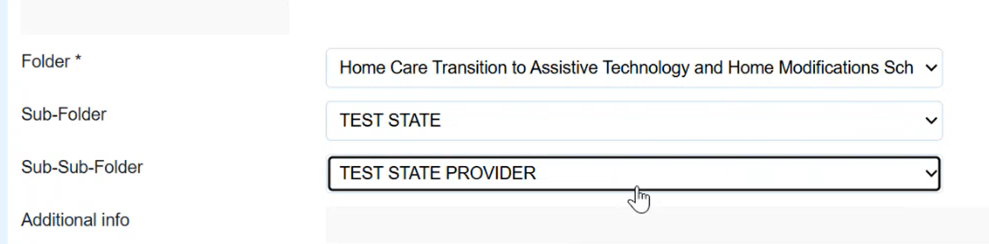

1. Once completed, select **Save**. It is important to note that in this state, your submission has been saved as a draft but has not been sent for approval.

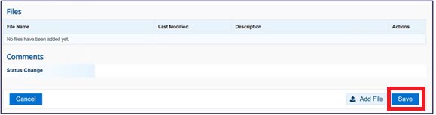

1. At the top of the page, select **Change Status.** In the **Action** field, select **Approve for Submission**, then select the **Approve for Submission** button**.** Your submission has been sent for approval.

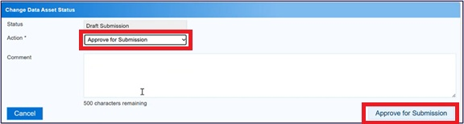

# Department processing

## Response times

The department will target processing requests within 14 calendar days of provider submissions, assuming no requests for further information. Providers should not order/purchase any items or services without approval for the required AT-HM funding. The department will update advice on processing times if required on the [data collection information site](https://www.health.gov.au/our-work/support-at-home/transitioning/athm-data-collection).

If a request is outside the target processing time, the participant requires a service urgently and they have no HCP unspent funds available, care managers/partners can contact [ATHMTransition@health.gov.au](mailto:ATHMTransition@health.gov.au) with a request for urgent processing.

## Providing additional information

The department may request further information if appropriate evidence has not been uploaded for requests. Providers must:

* respond to requests within 7 calendar days
* send the information in a supported format (Excel, CSV, JPG, Word or PDF).

If providers do not provide this information in the required timeframe, the department may decide the request based on the original submission. Management of requests for further information will slow processing for all providers; please ensure evidence is provided up front.

## Notifications

The department will send a bulk notification back to the Data Collection Coordinator with outcomes of the bulk submissions and will also attach an individual decision letter to the client’s record in the My Aged Care Service and Support Portal.

## Funding tier system availability/visibility

After approval, AT-HM funding tiers may take up to 10 days to reflect in the Services Australia Aged Care Provider Portal.

## Request a review

If the provider or participant does not agree with the department’s decision to not approve a new funding tier, care managers/partners can write to [ATHMTransition@health.gov.au](mailto:ATHMTransition@health.gov.au) with:

* a brief outline of why the decision should be reviewed, including any questions answered incorrectly in the data collection form
* any evidence in a supported format (Excel, CSV, JPG, Word or PDF).

Providers have 14 calendar days from notification of a decision to request a review. Clients and providers can also request a Support Plan Review with an Assessment Organisation through standard processes.

# Further guidance and support

## Support and resources

* The [Support at Home program manual](https://www.health.gov.au/resources/publications/support-at-home-program-manual-a-guide-for-registered-providers?language=en) and supplementary AT-HM guidelines.
* For further guidance including training on the AT-HM scheme, please see the [Support at Home provider training](https://www.health.gov.au/our-work/support-at-home/transitioning-to-support-at-home-on-1-november-2025/support-at-home-provider-training) module 3.
* [My Aged Care Service and Support Portal resources](https://www.health.gov.au/resources/collections/my-aged-care-service-and-support-portal-resources) are available for information on how to log in to the Service and Support Portal, navigate client records and attach documents to client records.
* Health Data Portal and data collection process support is available by writing to [ATHMTransition@health.gov.au](mailto:ATHMTransition@health.gov.au).
* There are further information and guidance materials available on the [Health Data Portal website](https://dataportal.health.gov.au/wps/portal/register/!ut/p/z1/04_Sj9CPykssy0xPLMnMz0vMAfIjo8ziTT29PQ1MDIy8DXxdTAwcLU1NAy1NPQ3cw0z1wwkpiAJKG-AAjgZA_VGElBTkRhikOyoqAgCi4kk6/dz/d5/L2dBISEvZ0FBIS9nQSEh/) via the [User Help pages](https://dataportal.health.gov.au/wps/portal/dataportalcontent/usersupport/userhelphdp/!ut/p/z1/nZFBU4MwEIX_ij30mMlCkwJHbB2htFZGa0sunQix4EBIIa3WX2-wOuNFHN3bm33ZffsFM7zBTPJjseO6qCUvjU7YeEvDKAQCdgSLKQHfozT2aAhu5OD1hwF-KB8w63__gBlmKi0ynDjEcejjCBAFy0WEjEfIc90xSh0qMo9CJjjp3KnUSuc4ybjmqm40Ly_SWmoh9RDaU6tFNYRDK5r2oLr2WeSiVHmmPvP2BGL956y7BP2WxKxwttZyAsGMwHx5TyjEENtX08ACsM2MYyFe8ErWTWUQ3_2RQAB49htV8212s5gsdmYy1zkq5FONN9-gnMUXFGMvnvd75hu4HclX0_8XXVWtKnd0QvLt8gZdr2_n_mDwDjBJuVk!/dz/d5/L2dBISEvZ0FBIS9nQSEh/).
* The department’s [Local Network](https://www.health.gov.au/our-work/our-local-network) operates from every capital city and nine regional sites around the county. Providers are encouraged to continue to reach out to their [local contacts](https://www.health.gov.au/contacts/local-network-contact?language=en) to discuss how the Local Network can help.



**Start a conversation about aged care**

Transforming aged care laws to put the rights of older people first.

Visit **health.gov.au**

Phone **1800 836 799** (My Aged Care service provider and assessor helpline)

For translating and interpreting services, call 131 450 and ask for 1800 836 799.   
To use the National Relay Service, visit nrschat.nrscall.gov.au/nrs to choose your preferred access point on their website, or call the NRS Helpdesk on 1800 555 660.

