**Appendix F – CHSP Compliance Framework 2025-27**

Contents

1. About the CHSP Compliance Framework 1

2. CHSP and the Aged Care Act 2024 3

3. Data Exchange (DEX) oversight 3

5. Financial acquittals 4

5.1 Unspent funds 4

5.2 Financial viability 5

5.3 Exiting the program 5

6. Sector Support and Development 5

7. DEX performance reporting review 5

8. Flexibility provisions 6

9. My Aged Care 6

9.1 Enhanced monitoring of My Aged Care client ID reporting 7

10. Wellness and reablement reporting 7

11. Complaints and Feedback Management Report 8

12. Child Safety Compliance Statement 8

## 1. About the CHSP Compliance Framework

The Commonwealth Home Support Program (CHSP) Compliance Framework (the Framework) outlines the performance and regulatory requirements for all CHSP registered providers. These include:

* performance against the grant agreement
* submitting financial and reporting information
* monitoring compliance against the [Aged Care Quality Standards](https://www.agedcarequality.gov.au/providers/quality-standards) (the Standards) for relevant providers
* complying with obligations outlined in the CHSP Manual 2025-27 and in the Aged Care Act 2024 (the Act)
* escalation of fraud related issues for investigation
* meeting requirements to maintain current and accurate information on My Aged Care, with the Community Grants Hub and with the Aged Care Quality and Safety Commission.

The Framework also covers the receipt of deliverables outlined within the grant agreement upon the expected due date, including:

* Data Exchange (DEX) monthly reporting
* financial acquittals
* Sector support and development (SSD) performance reports
* wellness & reablement reports
* Child Safety Annual Statement of Compliance.

The Department of Health, Disability and Ageing (the department) works with a number of other agencies, including:

* The Aged Care Quality and Safety Commission (ACQSC) regarding provider compliance against the Standards and conditions of registration.
* The Department of Social Services (DSS) Community Grants Hub (CGH) to manage the reporting of service delivery and expenditure against the grant agreement
* The National Indigenous Australians Agency (NIAA) for First Nation organisations.

The authority underpinning the monitoring and compliance activities in this Framework is the Act, the Aged Care Rules (the Rules) and the CHSP Grant Agreement, including the CHSP 2025-27 Manual.

**Diagram 1: Compliance model**

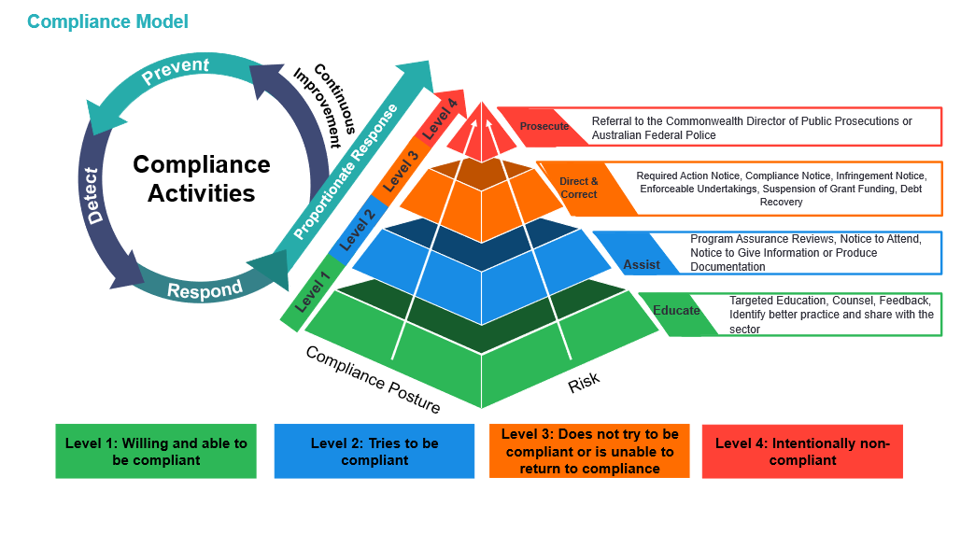

When responding to non-compliance, the department will take a risk-based approach. The department aims to adopt a tailored and flexible approach which considers the nature and severity of non-compliance.

## 2. CHSP and the Aged Care Act 2024

From 1 November 2025, the Act provides a new framework for in-home aged care, including the CHSP.

CHSP registered providers will need to register to deliver Commonwealth funded aged care services, with existing providers deemed into relevant registration categories as of 1 November 2025. They will need to comply with a set of obligations, including conditions on their registration. They will need to do this even where they subcontract the delivery of services.

All CHSP registered providers will need to comply with the Rules as they apply to the CHSP. The purpose of the Rules is to provide further detail on the requirements in the Act.

Compliance against the Act and Rules, which apply to the CHSP, will be monitored as part of the Framework.

## 3. Data Exchange (DEX) oversight

Since 1 July 2022, CHSP registered providers are contractually required to submit monthly performance reports through DEX for services delivered in the previous calendar month. This replaced the 6 monthly performance report process.

Section 166-610 of the Rules prescribes that a CHSP registered provider must give the System Governor a report about activity and performance data matters (the monthly performance report) each month.

Contractually providers must submit data for the preceding month by the 14th of the following month. Providers can submit DEX reporting more frequently if they prefer, such as daily, weekly, or fortnightly.

**Note:**

* Providers who do not meet their performance reporting requirements by the due date will be subject to non-compliance actions.
* Exemptions from compliance action will only be considered in extenuating circumstances.

The CGH and the department review the services delivered by providers and engage with providers where performance is low or of concern. This engagement gives insights into provider capacity, sector strain, workforce issues, region specific challenges and cost increases related to service delivery.

My Aged Care IDs will be required to be submitted though DEX during 2025-26, however functionality will not be available until later in the 2025-26 FY. Providers are required from 1 July 2025 to collect the My Aged Care IDs against services delivered in their client management software and provide this data once DEX My Aged Care ID collection functionality is embedded during the 2025-26 FY.

If there are concerns at any time that the provider will fail to meet their DEX data reporting obligations, providers may be placed on a Performance Improvement Plan. The Compliance team will monitor DEX outputs and performance for the following 6 months before deciding if a reduction in funding is appropriate. Furthermore, the Compliance team may request a provider to submit a business case to further outline the steps that will be undertaken to return to compliance and improve outputs.

**4. Fraud**

Any suspected fraud within CHSP is escalated to the department’s fraud area for assessment and potential investigation in accordance with s264 of the Act and the [Fraud and Corruption Control Plan 2023-25](https://www.health.gov.au/resources/publications/fraud-and-corruption-control-plan-2023-25?language=en). Further information is available on the department’s website under [Report suspected fraud](https://www.health.gov.au/about-us/corporate-reporting/report-to-us/report-suspected-fraud).

## 5. Financial acquittals

As specified in the CHSP Grant Agreement providers must spend the grant funding:

* only on carrying out the activity
* in accordance with the CHSP Grant Agreement
* on clients who have been assessed and on services as defined under the service list.

Section 166-605 of the Rules prescribes the CHSP registered provider must give the System Governor their annual financial declaration statement by 31 August after the end of the financial year, in a form approved by the System Governor. The financial declaration must also include a statement of compliance that the funding received under the grant was expended only on assessed clients and for services as defined under the service list.

The provider should, given robust accounting processes, be able to provide the financial acquittal within the required timeframe.

**Note:**

* The department requires a financial acquittal, but not an audited financial statement.
* Providers who do not meet their financial reporting requirements by the due date will be subject to non-compliance actions.

### 5.1 Unspent funds

The department has advised providers that all unspent funds are recovered at the end of the financial year. Funds are provided annually against annual service provision and are reported in financial declaration as per s166-605.

Providers are not permitted to spend or retain unspent funds. Providers **must** return unspent funds identified through the acquittal process for a financial year.

The department will issue the provider with a Debtor Tax Invoice to return any unspent funds. The repayment of these funds is monitored by the department.

**Note:** Providers who do not meet their financial obligations to repay unspent funds by the due date will be subject to non-compliance actions.

### 5.2 Financial viability

Financial viability will be monitored for further compliance action to ensure CHSP registered providers are delivering services in accordance with their Activity Work Plan and identifying options to sustainably manage their grant funds and mitigate impacts to client service continuity.

### 5.3 Exiting the program

CHSP registered providers who have relinquished funds and/or novated their funding agreement are still required to provide a financial declaration statement (as per s166-605 of the Rules) for funds received before exiting the program.

Acquittal processes, including compliance actions, are managed by DSS, with processes in place for the management of inactive providers.

## 6. Sector Support and Development

The department has administrator responsibilities for daily operations for the Sector Support and Development (SSD) Community of Practice (CoP).

The administration of the CoP includes management of access, delegation of moderators, high level reporting and analytics and management of the SSD Network meetings.

The department tracks and monitors receipt of SSD Performance Reports and Activity Work Plan deliverables. The department will take compliance action, including monitoring of the mandatory requirements under the CoP.

## 7. DEX performance reporting review

The department monitors all CHSP service providers and undertakes a performance review against the entire agreement. The department undertakes regular audits of service delivery based on DEX data submitted by providers. The department works in consultation with CGH to identify providers where potential compliance action may be appropriate.

Providers will be assessed on all information they provide to DEX to determine if changes to the grant agreement are appropriate to meet local needs within the Aged Care Planning Regions (ACPR) that they are funded within.

The department will work with providers to understand historical performance issues and potential adjustment to agreements to align to performance delivery. If the department needs further information about under delivery and/or funding spent against the agreement, additional action and reporting may be required.

## 8. Flexibility provisions

The CHSP 2025-27 Manual outlines the flexibility provision for service providers.

CHSP registered providers cannot move funds *out of or into* these service types without written approval from the department:

* Equipment and products
* Home adjustments
* Specialised support services
* Sector support and development
* Hoarding and squalor assistance.

The aim is to provide a flexible approach to:

* ensure compliance with contractual performance reporting requirements under the CHSP grant agreement
* enable CHSP service providers to meet changes in the demand for services.

Service providers that use flexibility provisions to establish service types funded in their grant agreement in an ACPR must keep a footprint of a **minimum of 50%** for the relevant service type in the ACPR. This ensures those services remain in the ACPR and align in part to the grant agreement. This came into effect from 1 July 2023.

The department monitors compliance with this requirement.

More information about flexibility provisions is in the CHSP Manual.

## 9. My Aged Care

CHSP registered providers are required to use My Aged Care to accept client referrals and update client service information.

Providers are responsible for the ongoing management of their My Aged Care profile. Each service outlet, and services associated with the outlet, needs to be actively managed by CHSP registered providers to ensure a positive user experience and reduce misinformation for clients.

It is the responsibility for providers to maintain accurate service availability information and current information related to service descriptions is essential for an efficient aged care system. Aged care assessors, care finders, advocates, clients and the public rely on accurate information on the [My Aged Care Service and Support Portal](https://www.health.gov.au/resources/apps-and-tools/my-aged-care-service-and-support-portal).

Providers should only appear available to deliver services against:

* CHSP services in areas where they are contractually funded to deliver services
* postcodes within the ACPR they can deliver services to.

To ensure compliance, the department:

* monitors CHSP registered provider availability on My Aged Care to ensure it aligns with their grant agreement and DEX reporting
* reviews analysis of provider behaviour on My Aged Care and reasons for rejecting referrals
* raise any ongoing and systemic trends with providers.

The CGH’s FAMs have access to information relating to service delivery against the agreement to guide discussions with providers where service levels are high or low. FAMs will also seek responses from providers if they are under delivering via DEX and are showing unavailability on My Aged Care.

### 9.1 Enhanced monitoring of My Aged Care client ID reporting

It is a statutory funding condition that CHSP providers deliver funded aged care services to clients who have been assessed and approved to access the services (section 267 of the Act).

Providers will be required to include a My Aged Care client ID, when reporting their monthly DEX data. The department will monitor this data against other available data to ensure services are being accurately recorded. The data exchange is being updated during 2025-26 to allow for My Aged Care ID’s to be uploaded and reported in the data exchange.

This will not be an available function in DEX from 1 July 2025, however providers will be required to capture clients My Aged Care IDs from 1 July 2025 in their own client management systems and upload this into DEX once this functionality is available.

For more information see [the](https://www.health.gov.au/resources/publications/proposed-changes-to-commonwealth-home-support-programme-chsp-data-exchange-from-1-july-2025-factsheet?language=en) [Data Exchange Toolkit (Stage 1)](https://www.health.gov.au/resources/publications/dex-exchange-toolkit-stage-1) and the [Data Exchange Dictionary (Stage 1)](https://www.health.gov.au/resources/publications/data-exchange-dictionary-stage-1).

## 10. Wellness and reablement reporting

Section 166-615 of the Rules prescribes that a CHSP registered provider must give the department a report about their progress in embedding wellness and reablement in its service delivery (the annual wellness and reablement report).

CHSP registered providers are required to submit the annual wellness and reablement report to the department by 31 July.

The department provides an online reporting template for this purpose. The report must include service level information regarding the application of wellness and reablement approaches to service delivery within their organisation.

The department will liaise with the CGH to action non-compliance in accordance with this Framework.

The [outcomes of past reports](https://www.health.gov.au/resources/collections/chsp-wellness-and-reablement-reports) are available on the department’s website.

## 11. Complaints and Feedback Management Report

In accordance with section 166-210 of the Rules, CHSP registered providers who are registered in category 4 (personal and care support in the home and community) and/or category 5 (nursing and transition care) are required to submit a report about the management of complaints and feedback to the Aged Care Quality and Safety Commission.

The complaints and feedback management report is required within 4 months after the end of the reporting period for the registered provider.

## 12. Child Safety Compliance Statement

Section 166-628 of the Rules prescribes that a CHSP registered provider must give a report (the child safety compliance statement) to the department each year.

CHSP registered providers are required to submit a Child Safety Compliance Statement to the department by 31 March each year. The statement of compliance reporting period is for the previous year. The department will provide a template for this purpose through the Funding Arrangement Managers (FAM).

The Child Safety Compliance statement must include a declaration that the registered provider has delivered grant activities consistent with the Child Safety supplementary terms of the grant agreement. If a CHSP registered provider has not complied, they must provide a description of the non-compliance and the reasons for it. provider has not complied, they must provide a description of the non-compliance and the reasons for it.

The department will liaise with the CGH to action non-compliance in accordance with this activity.