# Appendix 2 – AT-HM claiming framework

## Eligibility to claim

To claim and be paid for assistive technology and/or home modifications services, including any services provided by an allied health professional, a provider must be registered to deliver these services under the new regulatory model.

Account balances

Participants with assessed AT-HM needs will have one or more of the following accounts:

* assistive technology account
* assistive technology ongoing account (specified needs funding)
* home modifications account.

These accounts are held by Services Australia.

The funding amount credited to the AT and HM accounts consists of the standard tier amount plus any applicable supplements for participants. The AT account may also be credited with additional amounts approved through the [AT high tier over $15,000 process](https://www.health.gov.au/our-work/support-at-home/transitioning/athm-data-collection).

The funding allocation period will begin:

* for new Support at Home approvals – from the date provider submits an entry notification to Services Australia
* for funding allocated through a Support Plan Review (SPR) – upon delegate approval
* for older people reassessed for AT and/or HM – from the date of funding allocation.

## Claiming timeframes

Providers must finalise all AT-HM claims within 60 days after the last day of their funding tier allocation period (including variation days).

If a provider cannot meet this timeframe, they may request an exception to submit a late claim after day 61 of the allocation period. A request for a claiming exception will be sent to a Services Australia delegate and may be approved under specific circumstances. The specific circumstances this applies to are outlined in the Support at Home program manual (insert link).  Providers must maintain records of evidence related to requests for exceptions.

Subsidy claims against AT and HM funds will need to be at the service level with additional claims requirements to allow for data capture and for program assurance purposes.

## Accrued funds

AT-HM funding tiers (including supplements) do not accrue. Once the claim finalisation period has passed (60 days after the last day of the funding allocation period or after the time extension granted by the delegate), the AT or HM account is zeroed and the account closes (note HCP commonwealth unspent funds remain until fully exhausted).

For an AT ongoing funding allocation (assistance dogs), the AT account will be credited annually. The remaining funding from the previous year will not accrue and will be returned to the government once the claim finalisation period has passed (60 days after the last day of the funding allocation period or after the time extension granted by the delegate).

Participants will require reassessment to be allocated another AT or HM funding tier to meet their assessed needs. There are circumstances where a Support Plan Review (SPR) may be undertaken in place of a full reassessment including where additional funding is required to repair/maintain purchased AT.

## Older people transitioned from the Home Care Packages (HCP) program

Older people transitioning from HCP to Support at Home will have approval to access the AT-HM scheme and be allocated an AT transitional funding tier and a HM transitional funding tier. Neither of these funding tiers will have any funding attached but will allow any of the HCP unspent funds in the older person’s unspent funds account to be used for AT-HM.

If older people transitioning from HCP to Support at Home require AT-HM, but do not have unspent funds or enough unspent funds to access the AT-HM that they need, then the provider, with the older person’s agreement, can complete the AT-HM scheme data collection process to support the delegate to allocate an appropriate AT-HM low, medium or high funding tier that aligns with their needs.

Transitional funding tiers remain in place until such time as the older person:

* has an aged care needs reassessment
* a provider completes the AT-HM data collection process, and a new AT or HM tier is allocated
* a SPR is sought for a new AT and/or HM funding tier.
* leaves the Support at Home program.

Evidence for AT-HM claimed from HCP unspent funds must be kept by providers and provided at claiming where more than $5000 is being accessed.

**Evidence requirements**

Evidence of agreement between older people and the provider on AT-HM costs must be kept by the provider.

All evidence of claimed AT-HM costs must be kept and may be audited for assurance purposes.

All high tier AT-HM funding tier claims and claims against HCP unspent funds over $5000 require evidence to be uploaded.

Evidence may include:

* invoices
* quotes
* prescription from a suitably qualified health professional showing an assessed need for AT
* prescription from an OT showing an assessed need for HM
* home modification contracts (signed).

**Services Australia Claiming Data Guidance**

Download the Services Australia claiming guidance at the [Support at Home User Guide – submitting claims to the Aged Care Provider Portal](https://www.health.gov.au/sites/default/files/2025-04/support-at-home-user-guide-submitting-claims-to-the-aged-care-provider-portal.pdf).

Claiming for assistive technology

Providers will be required to claim funds for AT prescriptions, AT products and equipment, wrap around services, AT repairs and maintenance and any AT administration costs (under the cap) which the provider may charge, through the Services Australia portal.

Claiming for assistive technology will be against the AT-HM list and all high tier claims require an invoice/s, including prescription if claiming for prescription. Please note the [AT high tier process for claims over $15,000](https://www.health.gov.au/our-work/support-at-home/transitioning/athm-data-collection).

Assistive technology claiming flow chart

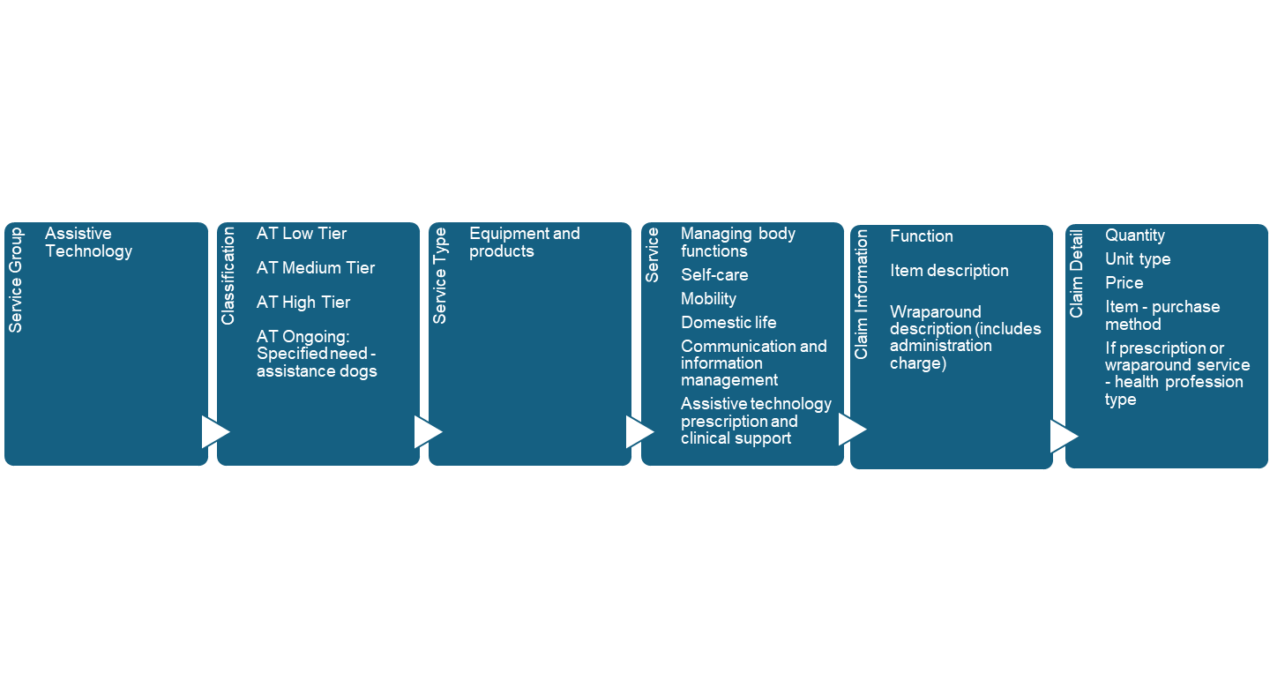

Assistive technology claiming scenario

Mary has a low AT funding tier and has been provided with a tipping kettle and a container opener to support her in making herself a cup of tea at home when her arthritis flares up. Mary’s provider will claim against:

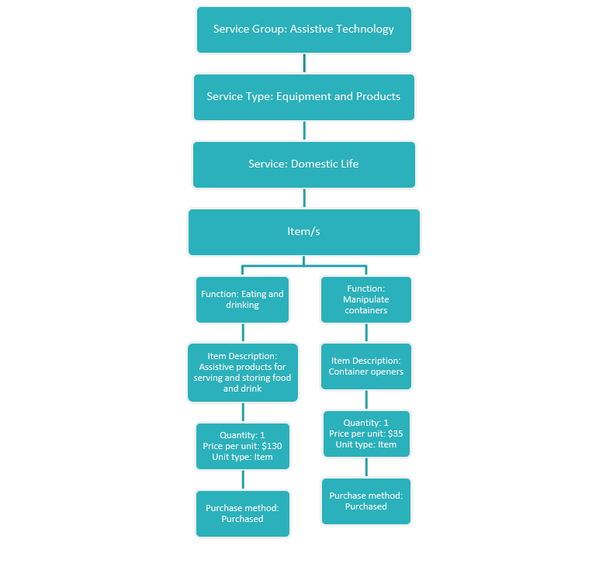

## Claiming for home modifications

Providers will be required to claim funds for home modification prescriptions, home modification products and equipment (including installation), wraparound services and any home modification co-ordination costs (under the cap) which the provider may charge, through the Services Australia Aged Care Provider Portal.

All high tier claims require evidence which may include invoices, prescription and any contractual agreements or progress payment invoices.

Home modifications claiming flowchart  
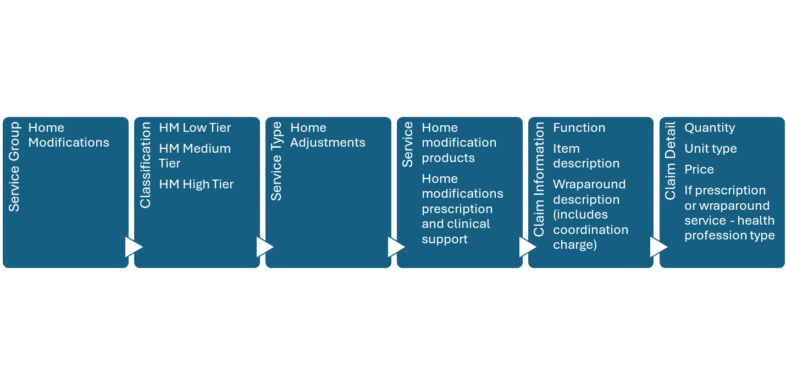

## Home modification claiming scenario

Pedro has a medium home modification funding tier and will need an occupational therapist (OT) prescription to source home modifications. The OT prescribes a grab rail to be installed in Pedro’s bathroom. Pedro’s provider discusses the prescription with Pedro and they agree on proposed costs. Pedro’s provider sources the grab rails and arranges for them to be installed by a qualified tradesperson. Pedro’s provider will claim against:

