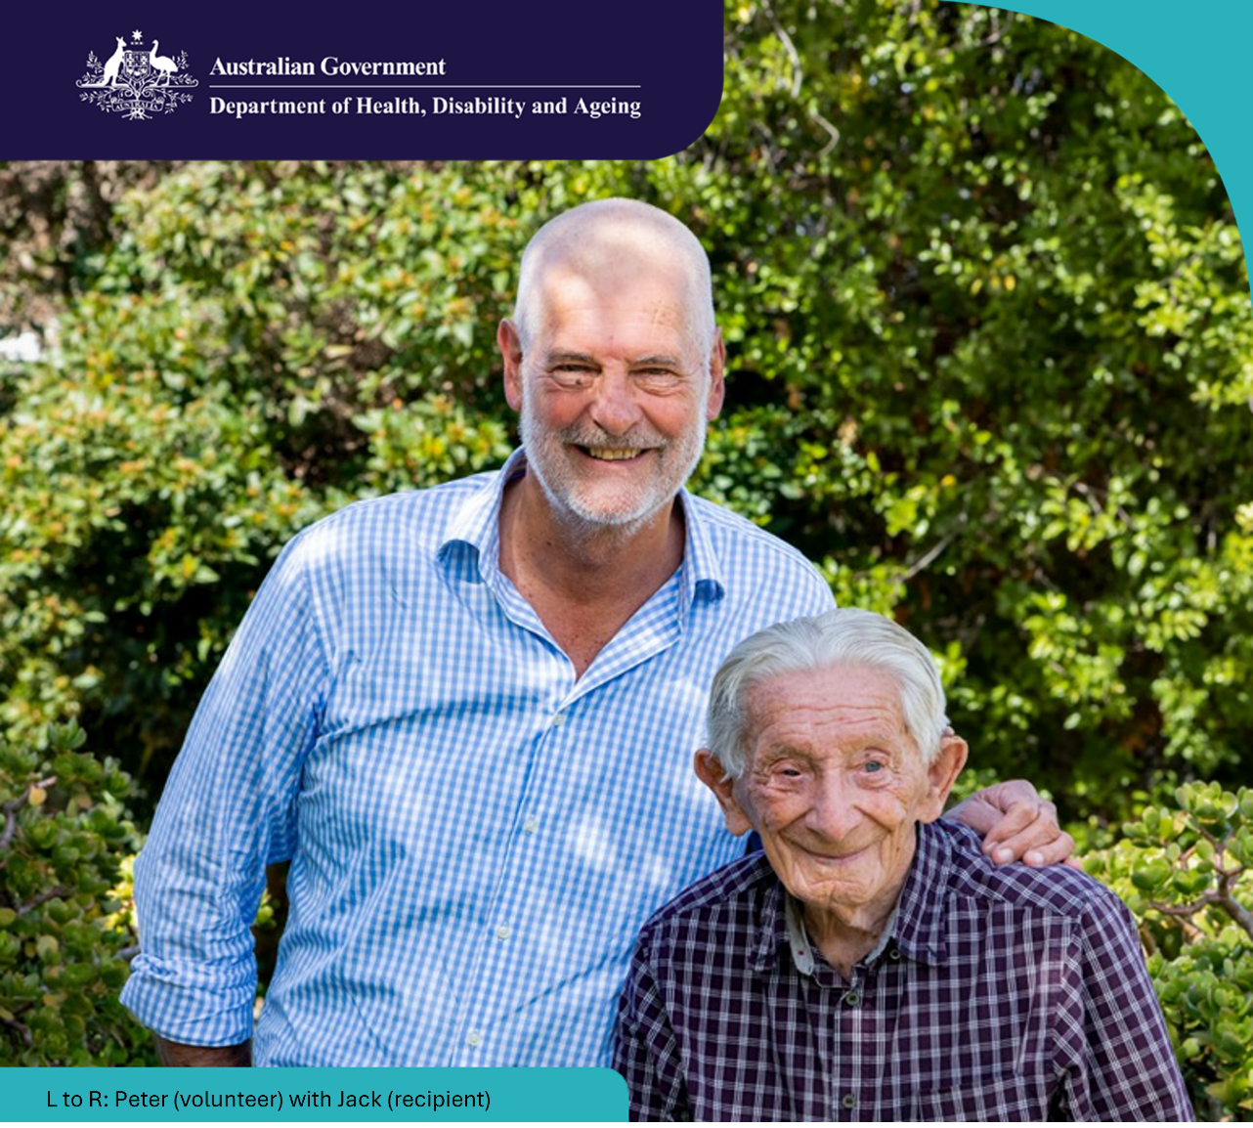

Aged Care Volunteer Visitors Scheme
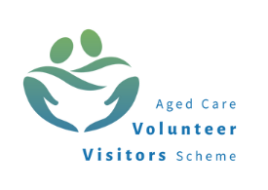
The program supports regular volunteer visits to give friendship and companionship to older people.
Visits are available to those receiving government-subsidised residential aged care or accessing the Support at Home program. This includes recipients approved or on the Support at Home Priority System.

About the Aged Care Volunteer Visitors Scheme (ACVVS)
We want volunteer visitors to be supported in their essential role in the aged care system to support older people to live meaningful lives and build social connections which prevent social isolation and loneliness.
The ACVVS:

- funds volunteering organisations to recruit, train and support volunteer visitors to provide friendship and companionship to older people
- complements services given to those in an aged care home or accessing Support at Home services
- provides standardised training resources for volunteer visitor onboarding and continual learning
- encourages new aged care volunteer visitors to join this meaningful and important program.
“Peter to me, is a godsend. Without his being here I would find it much more difficult to get on and I really look forward to his coming each week.”
– Jack, recipient

Under the Aged Care Act 2024, the ACVVS volunteer visitor is defined as an ‘aged care volunteer visitor’ with their own unique role and purpose.

Refer an older person or become a volunteer visitor
If you are interested in becoming an aged care volunteer visitor or want to access this service, please contact your state or territory Network Member by visiting health.gov.au/our-work/aged-care-volunteer-visitors-scheme-acvvs/contacts

For more information visit health.gov.au/acvvs

