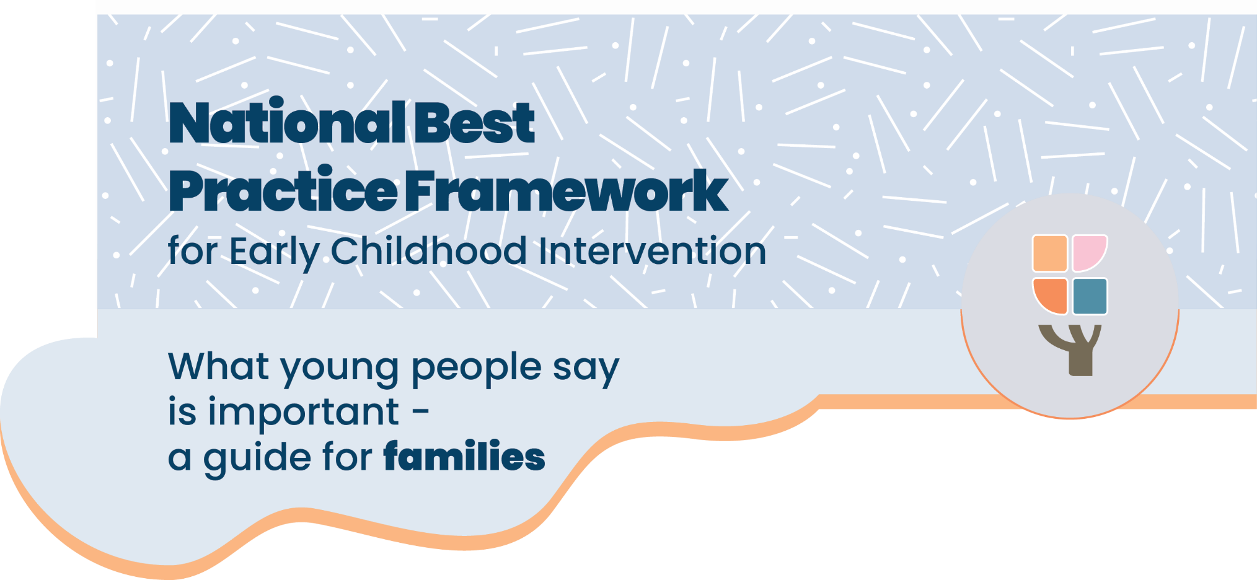

Early childhood intervention can make a big difference to your child’s development and happiness. When it’s done well, it helps your child build confidence and grow strong connections that last a lifetime. Young people who grew up with disability, and did early childhood intervention as children, shared their thoughts for this resource. Their experiences can help you understand what makes early support helpful and safe for your child and family.

# What young people want families to understand

#### “Disability does not mean there is something wrong with your child.”

Disability is just part of who your child is. It’s not something that needs to be fixed. Seeing your child for who they are helps them feel confident and strong, now and in the future.

#### “Seeking help is a strength.”

Raising a child with disability can be tough, and it’s okay to ask for support. Getting help can build skills for both you and your child.

#### “Behaviour is communication.”

When children are overwhelmed or feeling unsafe, they often show how they are feeling through their behaviour. Understanding their behaviour can help you know what’s really going on.

#### “Early childhood intervention should be done with the child not to the child.”

Your child has feelings, preferences, and the right to make choices. When they’re included in decisions, they feel safer and more involved.

#### “Having no intervention at all is better than having an unsafe intervention.”

Some interventions can be unsafe or upsetting. If something feels wrong, it’s okay to speak up or look for other options. Safe, respectful care is always best.

# What young people want families to do

#### “Be open to learning new things and different ways of thinking.”

Disability is understood in new ways all the time. Listening to people with disability can help you support your child better.

#### “Choose early intervention that is positive and supportive.”

Avoid programs that try to “fix” your child. Instead, look for support that builds on your child’s strengths and makes them feel accepted.

#### “Talk to your child about their diagnosis or disability.”

Children benefit from knowing about their disability. It helps them understand themselves and feel proud of who they are.

#### “Find positive, supportive communities.”

Connect with others who understand what you’re going through. Look for groups that support your child and celebrate disability in healthy ways.

# What young people want families to know

#### “How you think about disability matters”

Disability isn’t the problem—barriers in society are. When we change the way we see disability, we give all children more chances to succeed and feel included.

#### “Disability culture helps with identity and belonging.”

The disability community can offer support and connection. It’s a great way for families to learn, grow, and feel proud of who they are.

#### “Focus on what’s possible.”

Don’t let low expectations hold your child back. Believe in their potential and celebrate what they can do. This builds self-esteem and hope.

I got the stigma from the moment I was diagnosed at six years old. But it was worth it. I would have gotten the stigma anyway and knowing what was up was really empowering. I was able to get some aspect of disability identity and pride at a very young age.   
- young person with disability

# **The National Best Practice Framework**

* This guide is based on the National Best Practice Framework for Early Childhood Intervention.
* The framework helps you know what to expect from early childhood intervention.
* The framework will help you feel confident that you’re doing the best for your child

What is early childhood intervention?

#### Who is it for?

Early childhood intervention supports families raising children with developmental concerns, delay or disability (from birth up to 9).

#### What does it include?

Early childhood intervention services are provided by a range of professionals, for example speech pathologists, occupational therapists, physiotherapists or psychologists. In this guide we call them practitioners.

#### Who is involved?

Practitioners work closely with families, your child, and other important people in your child’s life.

#### What is the aim of early childhood intervention?

To help your child grow, learn, and enjoy life and help you as a family best support your child’s development

# Where can I find more information?

You can find more information about the National Best Practice Framework for Early Childhood Intervention online here: <https://healthy-trajectories.com.au/eci-framework/>

© UoM 2025. National Best Practice Framework for Early Childhood Intervention (a joint collaboration between Healthy Trajectories, the Melbourne Disability Institute, STRONG Kids STRONG Future at the University of Melbourne, and the Murdoch Children’s Research Institute (MCRI), Professionals and Researchers in Early Childhood Intervention (PRECI), SNAICC – National Voice for our Children, Children and Young People with Disability Australia, and ACD – Advocating for Children with Disability). Commissioned by the Department of Social Services.

This work is copyrighted to The University of Melbourne under a creative commons license, CC-BY-NC-ND. This material contains and draws upon Indigenous Cultural and Intellectual Property (ICIP) contributed by SNAICC and its members and staff and is used with their consent. Dealing with any part of the materials containing ICIP for any purpose that has not been authorised by the custodians is a serious breach of customary laws. You must handle ICIP accordingly when exercising the [Creative Commons Licence](https://creativecommons.org/licenses/by-nc-nd/4.0/) described above.

For more information about copyright please visit <https://healthy-trajectories.com.au/eci-framework/>