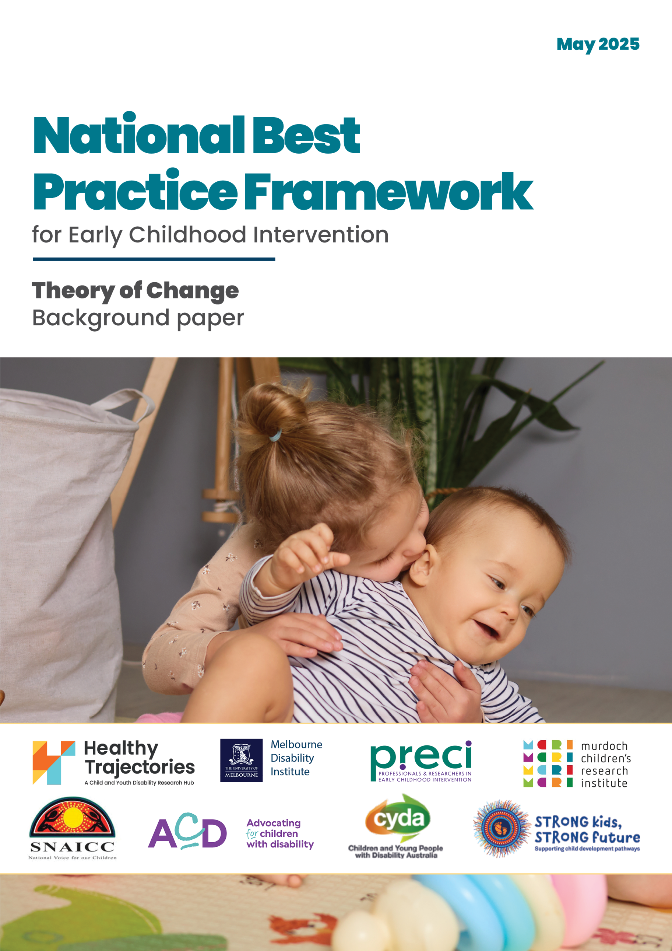
Acknowledgments
The University of Melbourne acknowledges the Traditional Owners of the unceded land on which we work, learn and live: the Wurundjeri Woi-wurrung and Bunurong peoples (Burnley, Fishermans Bend, Parkville, Southbank and Werribee campuses), the Yorta Yorta Nation (Dookie and Shepparton campuses), and the Dja Dja Wurrung people (Creswick campus).
The University acknowledges and is grateful to the Traditional Owners, Elders and Knowledge Holders of all Aboriginal and Torres Strait Islander nations and clans who have been instrumental in our reconciliation journey.
We recognise the unique place held by Aboriginal and Torres Strait Islander peoples as the original owners and custodians of the lands and waterways across the Australian continent, with histories of continuous connection dating back more than 60,000 years. We acknowledge their enduring cultural practices of caring for Country.
We pay respect to Elders past, present and future, and acknowledge the importance of Indigenous knowledge in the Academy. As a community of researchers, teachers, professional staff and students we are privileged to work and learn every day with Aboriginal and Torres Strait Islander colleagues and partners.
The University of Melbourne acknowledges the contributions of Healthy Trajectories, the Melbourne Disability Institute, STRONG Kids STRONG Future, the Murdoch Children’s Research Institute (MCRI), Professionals and Researchers in Early Childhood Intervention (PRECI), SNAICC – National Voice for our Children, Children and Young People with Disability Australia, and ACD – Advocating for Children with Disability, in developing this material for the National Best Practice Framework for Early Childhood Intervention, which was commissioned by the Department of Social Services.

© UoM 2025. This material is protected by copyright. Unless indicated otherwise, the University of Melbourne owns or has rights to use the copyright subsisting in the materials. You may use this material in accordance with Creative Commons Licence CC BY-NC-ND 4.0 Attribution - Non Commercial - No Derivatives 4.0 International – You are free to copy and redistribute the material in any medium or format for non-commercial purposes provided that you attribute the material to The University of Melbourne and its collaborators (as listed above), and that you do not make any adaptations or derivative versions of the material other than for your own personal use.
This material contains and draws upon Indigenous Cultural and Intellectual Property (ICIP) contributed by SNAICC – National Voice for our Children and its staff and Aboriginal and Torres Strait Islander community-controlled organisations across Australia and their communities and is used with their consent. Dealing with any part of the materials containing ICIP for any purpose that has not been authorised by the custodians is a serious breach of the customary laws of these organisations and their communities including SNAICC – National Voice for our Children. You must handle ICIP accordingly when exercising the Creative Commons Licence described above.
Requests and enquiries concerning reproduction and rights that are not addressed in the Creative Commons Licence should be made to the University Copyright Office, The University of Melbourne: copyright-office@unimelb.edu.au

Recommended Citation
Moore, T., Imms, C. Luscombe, D., SNAICC authors, Bonyhady, B, Dimmock, K., Deane, K, D’Aprano, A., & Kakoschke-Moore, S. (2025). National Best Practice Framework for Early Childhood Intervention: Theory of Change. The University of Melbourne. Commissioned by the Commonwealth of Australia’s Department of Social Services.
Along with the named authors of the report, the partners would like to acknowledge the contributing teams from PRECI including Kerry Bull, Susana Gavidia-Payne, Anoo Bhopti, Healthy Trajectories including Sarah Knight, Francesca Lami, Meghan Wilson, Melbourne Disability Institute including Sara Donaldson and SNAICC including Gretchen Young, the Policy and Research and Programs Teams and Lyn Allen.
The partners would also like to thank the national and international expert advisors who generously gave their time and advice over the course of the project.

Contents
The purpose of this paper 5
1 Theory of change 5
1.1 What the theory of change tells us 5
1.2 Theory of change table 6
1.3 Theory of change in more detail 9
2 Where to find more information 14
2.1 Reports 14
2.2 Resources 14

The purpose of this paper
This Background Paper is one of a series of papers and resources that accompany the National Best Practice Framework for Early Childhood Intervention (the Framework). This paper provides an overview of the theory of change that underpins the Framework’s approach.

Theory of change

What the theory of change tells us
The ultimate aim of early childhood intervention (ECI) and related services is to ensure that all children with developmental concerns, delay or disability and their families thrive in the early years. For families to thrive, they need support from connected and supportive communities, so we need communities to thrive as well. This is especially true for Aboriginal and Torres Strait Islander peoples where communities play an important role in supporting families and children.
The theory of change model shows how by implementing the Framework principles and practices, ECI and other services contribute to this ultimate aim. The theory of change is based on the following assumptions:
- Families seek the best outcomes for their children regardless of their personal circumstances
- Good outcomes can always be achieved despite conditions and services not meeting the highest standards, but are more likely when they do so
- More support is not necessarily better for children – over-servicing can be harmful for the child and family
- Children with developmental concerns, delay or disability and their families will need different supports depending on their circumstances
- Support can be provided informally as well as through universal services, foundational supports and the NDIS
The theory of change includes the following elements:
- The first level begins by identifying the different groups involved with children with developmental concerns, delay or disability - the Framework is most relevant for ECI practitioners but is relevant for all these groups in various ways
- The second level shows what these groups individually and collectively need to do to have a positive impact on children, families and communities, as well as on the services and governments that support them
- The third level shows what impact these actions have on children, families and communities, as well as on services and governments
- The fourth level shows what the outcomes are for children, families and communities
- Achieving these outcomes contributes to the ultimate aim of ensuring that all children with developmental concerns, delay or disability and their families thrive in the early years
The table below provides a highly compressed version of this sequence. The next table gives more detail of what is involved at each level. This fuller version is, in essence, a summary of how all the elements of the Framework work together to achieve the vision and aims of ECI. The Framework provides a full account of the principles and practices involved in helping children, families and communities thrive.

Theory of change table
The summarised version of the theory of change is found on the next page. In the following tables ECEC refers to Early Childhood Education and Care.

Who needs to be involved
ECI practitioners and services | Parents, carers and families | ECEC services and schools | Other child and family services | Government agencies

What we need to do
Children | Parents/carers and families | Communities | Services | Governments
Build on child strengths and interests to enhance learning, development and meaningful participation in everyday activities and settings | Build trusted relationships that use family-centred and strengths-based approaches and recognise that children’s wellbeing and development depends on the wellbeing of the family as a whole | Work together to create accessible services and spaces that understand and welcome children and families of diverse abilities and needs | Help build a collaborative and integrated network of holistic support for children, parents, carers, families, communities and colleagues | Commission and regulate services and standards according to the Framework

What impact this will have
Children | Parents/carers and families | Communities | Services | Governments
Children’s learning, development and meaningful participation in everyday activities is enhanced by building on each child’s strengths and interests | Family cultures are acknowledged and respected and their knowledge, skills and confidence are strengthened to support each child and family’s quality of life | Community members understand child development and wellbeing and create safe, welcoming, inclusive and connected communities | Collaborative and integrated service/practitioner networks provide holistic support for children, families, communities and colleagues | Regulatory standards are evaluated using data on best practice outcomes in ECI

What the outcomes will be
Children | Parents/carers and families | Communities
Children have secure and safe relationships, are participating meaningfully, and are developing new knowledge and skills | Families have positive support networks, are confident in their ability to meet their child and family needs | Communities are caring and culturally safe, and are committed to welcoming everyone

Ultimate Aim
All children with developmental concerns, delay and disability and their families thrive in the early years

Theory of change in more detail

Who needs to be involved
ECI practitioners and services | Parents, carers and families | ECEC services and schools | Other child and family services | Government agencies, program designers and relevant regulatory agencies

What we need to do
Children | Parents, carers and families | Communities | Services | Governments
Practitioners and services understand and promote children’s rights to participation and non-discrimination.  Practitioners and services recognise and support children’s need for a balanced life and support their right to have a say.  Practitioners and services optimise children’s meaningful participation in everyday home, ECEC/school and community activities.  Practitioners and services provide supports in the child’s everyday home, ECEC, school and community settings. | Practitioners prioritise building trusted relationships with children, families and other services.  Practitioners use family-centred and strengths-based approaches, and seek to enhance parents, carers and family’ confidence and capabilities to meet child and family needs.  Practitioners and services recognise that children’s wellbeing depends upon the wellbeing of the family as a whole.  Practitioners and services recognise and respect the diverse cultures and identities of children and families and foster connection with community and culture.  Practitioners and services focus on outcomes agreed with families and use evidence-informed decision-making processes and strategies.  Practitioners and services work together to help families access the social supports and material conditions they need to thrive. | Community services and facilities are readily accessible to children and families and welcome them regardless of their abilities and circumstances.  Families are supported to access community services and facilities, both formal and informal, and participate in community activities.  Community services and facilities are supported to understand and meet the needs of children and families.  ECEC services and schools welcome children and families and support their full participation, regardless of their abilities and circumstances. | Support is provided by an integrated team, and practitioners develop authentic power-sharing partnerships with families.  Services are adapted to local circumstances and needs.  Services engage with Aboriginal and Torres Strait Islander children, families and community members in ways that are safe and respectful and foster connection with their culture and community. | Government funding, whether individualised or commissioned, is based on best practice models of support.  Regulatory standards align with and support best practice ECI.  Implementation of the Framework is monitored through regular data collection.  Governments support the continual updating of the Framework, its evidence base, and resources.  Governments support the identification of workforce competencies and training, and help ensure that there is a sufficient supply of skilled practitioners.

What impact will this have
Children | Parents, carers and families | Communities | Services | Governments
Children have the same access to services and activities and the same opportunities to participate as all children.  Children are better able to participate in everyday home, ECEC, school and community activities.  Children have more opportunities to practise functional skills in the settings where they are needed.  Children have a balanced life and a greater say in matters that affect them. | Parents, carers, families and practitioners are more likely to build and sustain effective partnerships.  Families become more confident, capable and empowered, and better able to meet the needs of the child and family.  Families from diverse backgrounds are more likely to engage with and make good use of ECI and other services.  Interventions will be more effective in achieving the outcomes that parents, carers and families want.  Services address goals for parents, carers, siblings and the family as a whole as well as goals for the child.  Families are more likely to be linked to other services that can help improve the conditions under which they live. | Community members, services and facilities have a better understanding of the needs of children with developmental concerns, delay or disability and how to meet them.  Communities are more inclusive and welcoming of children with developmental concerns, delay or disability and their families. | Parents, carers and families have timely access to best practice ECI and other support services.  The services supporting families are better coordinated and are tailored for local circumstances and the needs of each child and family.  Aboriginal and Torres Strait Islander peoples feel safe to engage with ECI and other services. | Regulatory standards are evaluated using data on best practice outcomes in ECI.  There is a sufficient supply of an effective and competent workforce able to implement best practice.  Best practice is well understood and the Framework used by everyone.

What the outcomes will be
Children | Parents, carers and families | Communities
Children will  - have secure, stable and safe relationships  - be building social skills  - be participating and developing their sense of agency  - have a positive sense of belonging to their family and community  - build strong identities and connections to their culture and community | Parents, carers and families will  - be confident in their ability to provide their children with the experiences and opportunities they need  - have positive views about their child’s strengths, developmental progress and functioning  - be able to make informed choices and decisions about evidence-informed and high-quality ECI services and other supports  - have positive social support networks  - have a better family quality of life | Communities will be  - caring and culturally-safe  - confident in and committed to including everyone, regardless of abilities, backgrounds and circumstances  - accessible and providing authentic opportunities for participation  - connected and integrated, communicating and collaborating

What the ultimate outcome is
All children with developmental concerns, delay or disability and their families will thrive in the early years

Where to find more information
This paper describing the Theory of Change is one of a series of reports and resources that accompany the National Best Practice Framework for Early Childhood Intervention (the Framework). A copy of the Framework and supporting materials and resources, as listed below can be found online.

Reports
The Framework
The Framework background papers
- Development of the National Best Practice Framework for ECI: A background paper
- National Best Practice Framework for Early Childhood Intervention theory of change – this document
- The Review Report
- Consultation reports
- Desktop review reports

Resources
For practitioners
- Video: Introducing the Framework
- Practice guidance for each of 14 principles
- “Looks like-Doesn’t look like” fact sheets for each of 14 principles
- Podcasts: families and practitioners talk about the principles and practices
- Videos: experts talk about the evidence underpinning the principles
- Decision making guide
- Outcome measures guides
- Videos describing best practice with young children and families in Aboriginal and Torres Strait Islander communities
For parents, carers and families
- Video: What best practice in ECI looks like
- Guides for parents, carers and families
For others
- Guide for those working in ECEC and schools
- Guide for referrers to ECI
- Guide for policy makers and government departments



