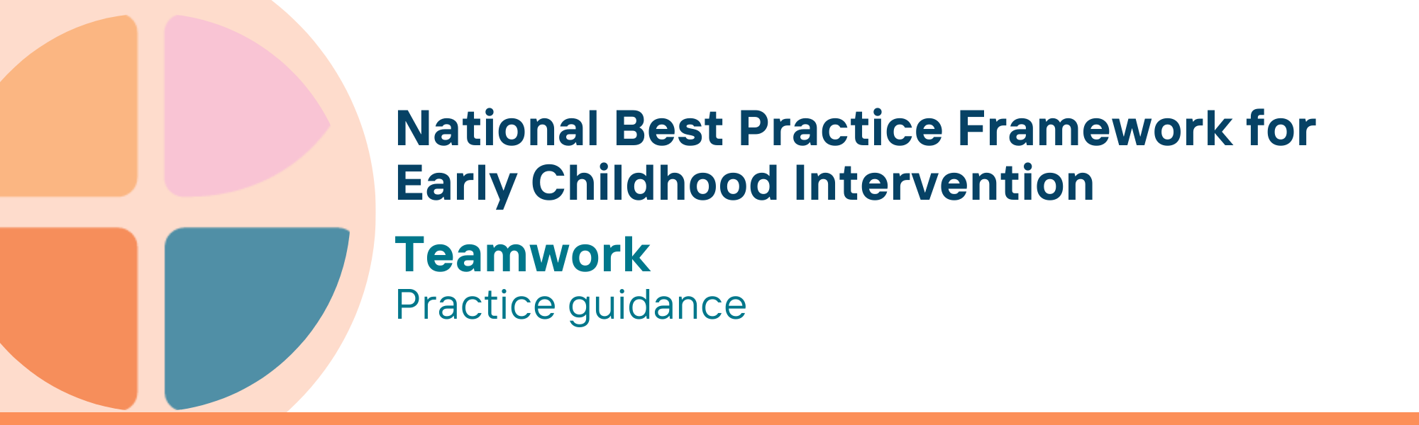

What is the Teamwork key principle?
The teamwork principle recognises the importance of forming strong, trusted relationships and collaborative partnerships between parents, carers, families and practitioners and professionals.
Building strong trusted relationships with children, parents, carers and families as well as between all practitioners and professionals involved is therefore essential to ensure positive developmental outcomes and improved wellbeing.
The team shares expertise and perspectives, to develop and support the goals of the child, parents, carers and families, and facilitate informed decision-making.
Team composition and size is individualised to the needs of the child and family. The team may include friends, relatives, representatives from community agencies, health/education sectors, as well as practitioners from a variety of disciplines and service provider models (e.g., sole practitioners or organisations).
Teamwork allows specialists from various disciplines, such as educators, therapists, and other universal and specialist service providers, to collaborate and integrate their knowledge, ensuring a consistent and coordinated approach to working with the child, parent, carer and family.
Parents, carers and families are essential members of the team and the final decision-makers.

Why is this principle important?
This principle recognises that teamwork is essential in providing comprehensive and effective supports and services for children, parents, carers and their families. This approach helps build strong relationships and partnerships to support positive outcomes.
- Parents, carers and families of children with developmental concerns, delay or disability often need and use a variety of professional services to address the diverse and often complex needs of their children. Good collaboration among all these services is necessary to provide consistent and holistic support, and to ensure best outcomes
- Effective teamwork enables service provision that is seamless and tailored to the unique needs, context, strengths, and cultural background of each child and all individual family members
- Building trusted relationships and sharing decision making also empowers parents, carers and families, leading to better developmental outcomes for their children
- Good collaborations and effective partnerships maximise resources, reduces service duplication, and fosters integrated and consistent support systems, leading to better developmental outcomes and empowering families to be informed decision-makers
- Teams with members with a variety of expertise and knowledge, have been a consistent and vital component of international practice in early childhood intervention since the 1980s
Teamwork is one of the principles of the Early Years Learning Framework (EYLF), highlighting the importance of shared responsibility and professional accountability. The Early Years Strategy 2024-2034 emphasises the importance of collaboration and partnerships among various stakeholders, including families, practitioners, and professionals, to support positive outcomes for children and families.
This principle relates to all other universal and key Framework principles, and they should be applied together in practice.

What are teamwork related practices?
Practitioners
- acknowledge parents, carers and families as experts on their child, their daily life and culture and engage families as essential members of the team
- partner with parents, carers and families in planning and implementing strategies, respecting their insights, cultural values, priorities and preferences, and recognising them as final decision makers
- foster positive, respectful team dynamics where members feel valued, supported, and open to sharing diverse perspectives
- use clear, concise, jargon-free language appropriate for all team members including parents, carers, families, children and service providers in both universal and specialist services
- ensure that knowledge and expertise is shared among team members in ways that are respectful, supportive, enhance capacity and are culturally sensitive
- work with families and other service providers to address the child’s and family’s goals and implementation of strategies holistically
- work with other practitioners and service providers to foster integrated and collaborative service delivery based on the outcomes identified by parents, carers and families regardless of programmatic and service boundaries

We know it’s working well when…
- Parents, carers and families navigate and access services easily
- Parents, carers and families are expert contributors to the team in the planning, goal development and implementation of strategies
- Practitioners and services support children, parents, carers and families through collaborative and coordinated teams and early childhood intervention (ECI) services are integrated with a wider network of community-based and specialist services.
- Team members have a shared understanding of the ways they will communicate together (e.g., email, text updates, frequency of team meetings)

Essential resources
You can find more information about the National Best Practice Framework for Early Childhood Intervention online.
- Resources for practitioners including the
- Looks like/doesn’t look like guide for the principle
- Outcome measures resources
- Resources for families and others
- The podcast where families and professionals discuss practices related to this principle
- Unpacking the Framework video/s for this principle
- The Framework including
- Decision making guide
- The Framework
- The development of the Framework
- Background papers
- Bibliography for the principles and practice guidance

© UoM 2025. National Best Practice Framework for Early Childhood Intervention (a joint collaboration between Healthy Trajectories, the Melbourne Disability Institute, STRONG Kids STRONG Future at the University of Melbourne, and the Murdoch Children’s Research Institute (MCRI), Professionals and Researchers in Early Childhood Intervention (PRECI), SNAICC – National Voice for our Children, Children and Young People with Disability Australia, and ACD – Advocating for Children with Disability). Commissioned by the Department of Social Services.
This work is copyrighted to The University of Melbourne under a creative commons license, CC-BY-NC-ND. This material contains and draws upon Indigenous Cultural and Intellectual Property (ICIP) contributed by SNAICC and its members and staff and is used with their consent. Dealing with any part of the materials containing ICIP for any purpose that has not been authorised by the custodians is a serious breach of customary laws. You must handle ICIP accordingly when exercising the Creative Commons Licence described above.
For more information about copyright please visit https://healthy-trajectories.com.au/eci-framework/

