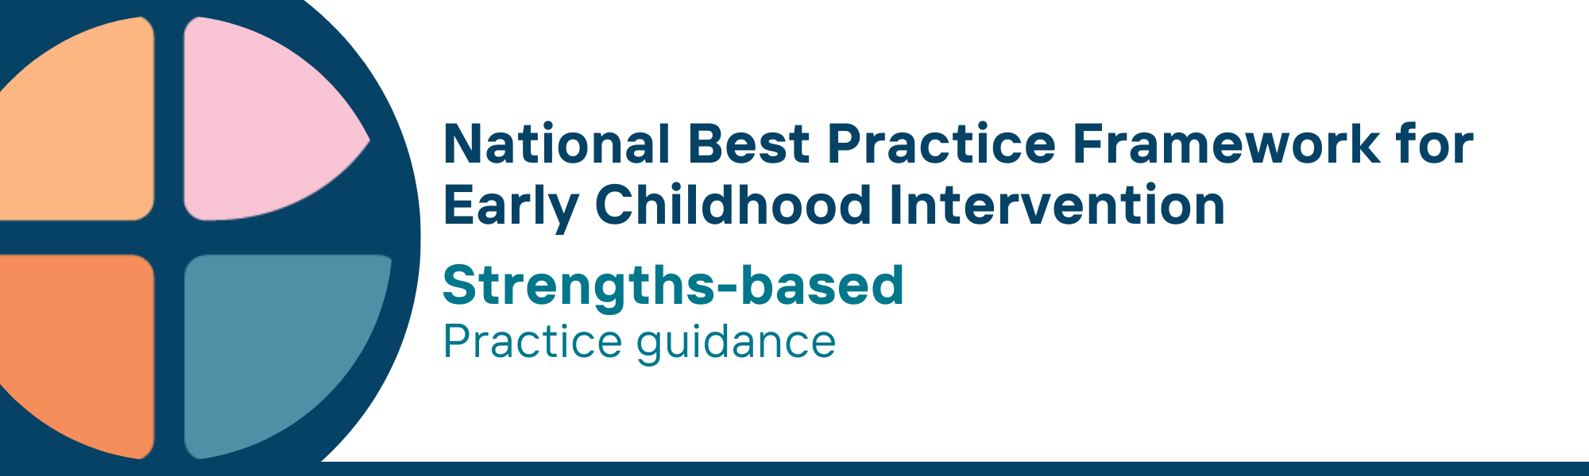

What is the strengths-based universal principle?
- The strengths-based principle acknowledges that children and families are experts in their own lives, and have existing knowledge, skills and resources to draw on. It affirms children’s, parents’, carers’ and families’ strengths, interests, and preferences in daily life to support child engagement, learning, development, participation and well-being in everyday activities
- This principle adopts a positive approach regarding the child and family’s future, hopes, and aspirations. Strengths-based practice also looks for ways to tailor support around a child’s interests, preferences and abilities, in ways that will make the child feel good about themselves. It also supports families by recognising and building on their existing abilities and support networks
- Practitioners also bring their own strengths, knowledge, skills, and confidence, which are critical to supporting families

Why is this principle important?
- Acknowledging, supporting, and building on the strengths of children, parents, carers and families is one of the defining characteristics of the strengths-based principle
- A strengths-based approach focuses on what the child and family can do and what they can build on (strengths) rather than what they cannot do or what they lack (deficits)
- Using a strengths-based approach requires practitioners to collaborate with parents, carers and families in building their capabilities
- Working with families to make use of existing family resources is an important strength-building strategy. Early childhood intervention (ECI) services should add to and strengthen the support families of young children already have, not set up interventions in isolation from families’ existing resources
- This approach is grounded in positive psychology and empowerment theory, ensuring that services and supports foster resilience, confidence, and long-term well-being. It adopts a positive approach regarding the child and family’s future, hopes, and aspirations
The strengths-based principle is a significant element of key national strategies, including Safe and Supported: The National Framework for Protecting Australia’s Children (2021-31); the Early Years Learning Framework for Australia (V2.0, 2022); Australian Government Early Years Strategy (2024-2034); and National Children’s Mental Health and Wellbeing Strategy (2021). It is embedded in all Aboriginal and Torres Strait Islander policies and strategies as a key element of individual, family and community wellbeing and cultural safety. As such it underpins service provision, workforce development and practices including authentic assessment, program planning, and the design of supports and strategies with children and their families.
This principle relates to all other universal and key Framework principles and they should be applied together in practice.

What are strengths-based practices?
Practitioners
- recognise and value the unique relationships, strengths and capabilities of children, parents, carers and families
- build on the skills and strengths that children have and are developing
- acknowledge and build on the family qualities, parenting practices, and skills that will positively support the child and other family members to achieve their aims and desired outcomes
- use culturally safe, strengths-based assessment and practices to enable children, parents, carers and families to set meaningful and functional goals
- recognise the strengths of families’ existing community connections and supports
- celebrate the strengths of children, parents, carers and families, and promote having fun and enjoyment
- communicate, document, and report using strengths-based language with families, colleagues, and broader networks

We know it’s working well when…
- Children have a positive sense of their own strengths, abilities, feeling good about themselves and belonging to their family and community
- Parents, carers and families have positive views about their child’s strengths, developmental progress and functioning
- Parents, carers and families are confident in their ability to provide their children with the experiences and opportunities they need
- Parents, carers and families continue to develop their own individual interests and life pursuits

Essential resources
You can find more information about the National Best Practice Framework for Early Childhood Intervention online.
- Resources for practitioners including the
- Looks like/doesn’t look like guide for the principle
- Outcome measures resources
- Resources for families and others
- The podcast where families and professionals discuss practices related to this principle
- Unpacking the Framework video/s for this principle
- The Framework including
- Decision making guide
- The Framework
- The development of the Framework
- Background papers
- Bibliography for the principles and practice guidance

© UoM 2025. National Best Practice Framework for Early Childhood Intervention (a joint collaboration between Healthy Trajectories, the Melbourne Disability Institute, STRONG Kids STRONG Future at the University of Melbourne, and the Murdoch Children’s Research Institute (MCRI), Professionals and Researchers in Early Childhood Intervention (PRECI), SNAICC – National Voice for our Children, Children and Young People with Disability Australia, and ACD – Advocating for Children with Disability). Commissioned by the Department of Social Services.
This work is copyrighted to The University of Melbourne under a creative commons license, CC-BY-NC-ND. This material contains and draws upon Indigenous Cultural and Intellectual Property (ICIP) contributed by SNAICC and its members and staff and is used with their consent. Dealing with any part of the materials containing ICIP for any purpose that has not been authorised by the custodians is a serious breach of customary laws. You must handle ICIP accordingly when exercising the Creative Commons Licence described above.
For more information about copyright please visit https://healthy-trajectories.com.au/eci-framework/

